Original Research Article

Serum C-Reactive Protein and Admission Hyperglycemia as Predictors of Stroke Severity and Early Outcomes in Acute Ischemic Stroke: A Prospective Observational Study

Abstract
Background
Acute ischemic stroke (AIS) is a major cause of mortality and long-term disability worldwide, with a rapidly increasing burden in developing countries including India [1]. Inflammation and stress-induced hyperglycemia play a crucial role in determining stroke severity and early outcomes [2]. This study evaluated the correlation between serum C-reactive protein (CRP), admission random blood glucose (RBG), and neurological severity in patients with acute ischemic stroke (AIS).
Methods
This prospective observational study included 100 adult patients with imaging-confirmed acute ischemic stroke admitted within 72 hours of symptom onset. Serum C-reactive protein (CRP) and random blood glucose (RBG) were measured at admission, and CRP was repeated on day seven. Stroke severity was assessed using the National Institutes of Health Stroke Scale (NIHSS) at admission and day seven. Clinical outcomes during hospitalization were categorized as stable or unstable based on changes in NIHSS score. Statistical analysis included correlation and significance testing, with p < 0.05 considered statistically significant.
Results
The mean age of participants was 56.7 ± 14.3 years. Seventy-nine patients (79%) were male and 21 patients (21%) were female. Serum CRP levels demonstrated a strong positive correlation with NIHSS scores at admission and day seven (p < 0.001). Admission random blood sugar (RBG) levels were significantly higher among patients with moderate-to-severe and severe stroke compared to those with minor stroke (p < 0.001). Patients with unstable outcomes (13 patients, 13%) had significantly higher CRP levels compared to those with stable outcomes (87 patients, 87%) (p = 0.003). Persistent elevation of CRP on day seven correlated strongly with poorer neurological recovery (r = 0.780, p < 0.001).
Conclusions
Serum CRP and admission are significant predictors of stroke severity and short-term outcomes in acute ischemic stroke. Early assessment of these biomarkers may aid in risk stratification and prognostication.

Keywords
Acute ischemic stroke; C-reactive protein; Random blood glucose; NIHSS; Inflammation; Prognosis

1. INTRODUCTION

Stroke is one of the leading causes of death and long-term disability globally, with ischemic stroke accounting for approximately 85% of all cases [3]. In India, the burden of stroke has increased significantly due to rising prevalence of hypertension, diabetes mellitus, and other vascular risk factors [4].
Inflammation plays a central role in the pathophysiology of ischemic stroke [5]. Cerebral ischemia initiates a complex inflammatory cascade involving endothelial activation, leukocyte migration, cytokine release, and acute-phase protein synthesis [6]. CRP, an acute-phase reactant synthesized by the liver, has been implicated in atherosclerosis, plaque instability, and secondary neuronal injury following ischemic stroke [7]. Elevated CRP levels have been associated with increased infarct size, greater neurological deficit, and higher mortality [8].
Hyperglycemia at the time of stroke presentation is frequently observed, even in patients without previously diagnosed diabetes mellitus, and has been consistently associated with worse neurological outcomes [9]. Stress-induced hyperglycemia exacerbates ischemic brain injury through increased anaerobic glycolysis, lactic acidosis, oxidative stress, endothelial dysfunction, and impaired cerebral autoregulation [10,11].
The National Institutes of Health Stroke Scale (NIHSS) is a validated and widely used tool for quantifying neurological deficit and predicting outcomes in acute ischemic stroke [12]. However, data correlating inflammatory and metabolic biomarkers with stroke severity using standardized scales in the Indian population remain limited.
Therefore, this study aimed to investigate the correlation between serum CRP levels and admission-day random blood sugar (RBG) with stroke severity assessed by NIHSS, and to evaluate their association with short-term in-hospital outcomes in patients with acute ischemic stroke.

2. MATERIALS AND METHODS

2.1. Study Design
A prospective observational study was conducted in the Department of General Medicine at ESIC Medical College & Post Graduate Institute of Medical Sciences and Research (PGIMSR), Rajajinagar, Bengaluru, India, from April 2023 to September 2024. The study was approved by the Institutional Ethics Committee of ESIC Medical College & PGIMSR, Bengaluru (IEC No: 532/L/11/12/Ethics/ESICMC&PGIMSR/Estt.Vol.IV). Written informed consent was obtained from all participants in accordance with the Declaration of Helsinki.

2.2 Study Population
A total of 100 adult patients (aged≥18 years)
diagnosed with acute ischemic stroke (AIS) within 72 hours of symptom onset were enrolled after obtaining written informed consent.

Participants aged 18 years or older with a clinical diagnosis of acute ischemic stroke confirmed by neuroimaging (non-contrast CT brain or MRI brain), presenting within 72 hours of symptom onset, and willing to provide informed consent were included in the study. Patients with hemorrhagic stroke, subarachnoid hemorrhage, or cerebral venous thrombosis; history of seizure disorder or connective tissue disease; acute systemic infection at presentation; chronic kidney disease stage 3 or higher (eGFR <60 mL/min/1.73 m²); known malignancy; or recent major surgery or trauma were excluded from the study.
2.3. Data Collection
A structured proforma was used to record demographic details, clinical history, risk factors, and neurological examination findings. Stroke severity was assessed using the NIHSS at admission (NIHSS1) and on day 7 of hospitalization (NIHSS2). The NIHSS score was categorized as: minor (1–4), moderate (5–15), moderate to severe (16–20), and severe (21–42) [13].
Venous blood samples were collected at admission for measurement of serum C-reactive protein (CRP) and random blood glucose (RBG). Serum CRP was measured using immunonephelometry (Beckman Coulter AU analyzer; normal <3 mg/L), and random blood glucose was measured by the hexokinase method. Internal quality control procedures were followed as per laboratory protocol. Electrocardiogram and neuroimaging (CT or MRI brain) were performed as per standard protocol. Patients were followed up until day 7 of hospitalization. Outcomes were categorized as stable, defined as improvement or no deterioration in neurological status, and unstable, defined as worsening of NIHSS score, development of complications, or death.

2.6. Sample Size Calculation
The sample size was estimated as 100 based on a previous study by Sharma et al.,assuming a correlation coefficient of 0.5, 95% confidence level, and 15% precision [14].

2.7. Statistical Analysis
Data were entered into Microsoft Excel 2016 and analyzed using IBM SPSS Statistics for Windows, Version 29.0. Continuous variables were expressed as mean ± standard deviation (SD), and categorical variables as frequency (n) and percentage (%). Comparisons between groups were performed using independent sample t-test or One-way ANOVA with Tukey’s post-hoc test for continuous variables. Pearson’s correlation coefficient was used to assess relationships between continuous variables. Chi-square test was applied for categorical data. A p-value <0.05 was considered statistically significant.

RESULTS

The study included 100 patients with Acute Ischemic Stroke at ESICMC & PGIMSR over a period of 18 months.
The mean age of the study population was 56.7 years (range: 24–86 years), with a wide distribution of ages.
CRP Day 1 levels ranged from 1 to 96 mg/L (mean: 9.3 mg/L), while CRP Day 7 levels had a mean of 7.0 mg/L.
The mean NIHSS score at admission (NIHSS 1) was 9.2 (range: 1–42), and at discharge (NIHSS 2), it was 8.4.
Admission blood sugar levels (RBS Day 1) ranged from 60 to 798 mg/dL (mean: 184 mg/dL) and demonstrated significant variability..

Descriptive Statistics
 | N | Minimum | Maximum | Mean | SD
Age | 100 | 24.0 | 86.0 | 56.7 | 14.3
CRP Day 1 | 100 | 1 | 96 | 9.3 | 13.5
CRP Day 7 | 100 | 1 | 48 | 7.0 | 10.6
NIHSS1 | 100 | 1.0 | 42.0 | 9.2 | 8.9
NIHSS2 | 100 | 0 | 42 | 8.4 | 9.7
RBG Day 1 | 100 | 60.0 | 798.0 | 184.0 | 108.0

Table 1. Baseline Clinical and Laboratory Characteristics
Fig 1 shows the age distribution of the study participants where <= 30 yrs is 3%, 31 - 40 yrs is 12%, 41 - 50 yrs is 20%, 51 - 60 yrs is 24%, 61 - 70 yrs is 22%, 71 - 80 yrs is 16%, Above 80 yrs is 3%. Most patients were aged 51–60 years (24%), followed by 61–70 years (22%).
Only 3% were below 30 years and 3% were above 80 years indicating that stroke incidence was higher in middle-aged and older adults.

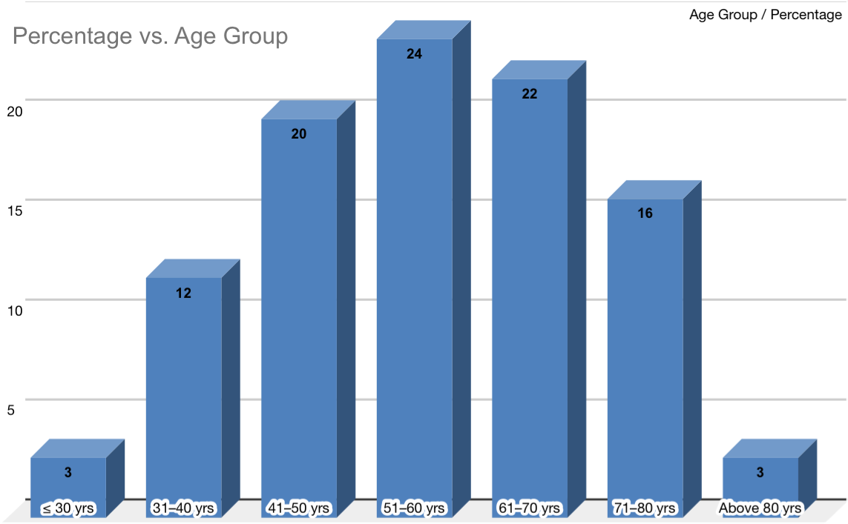 fig 1-- Age Distribution of Study Participants

Male patients were 79 (79%) and female patients were 21 (21%), suggesting a higher prevalence of stroke among males.
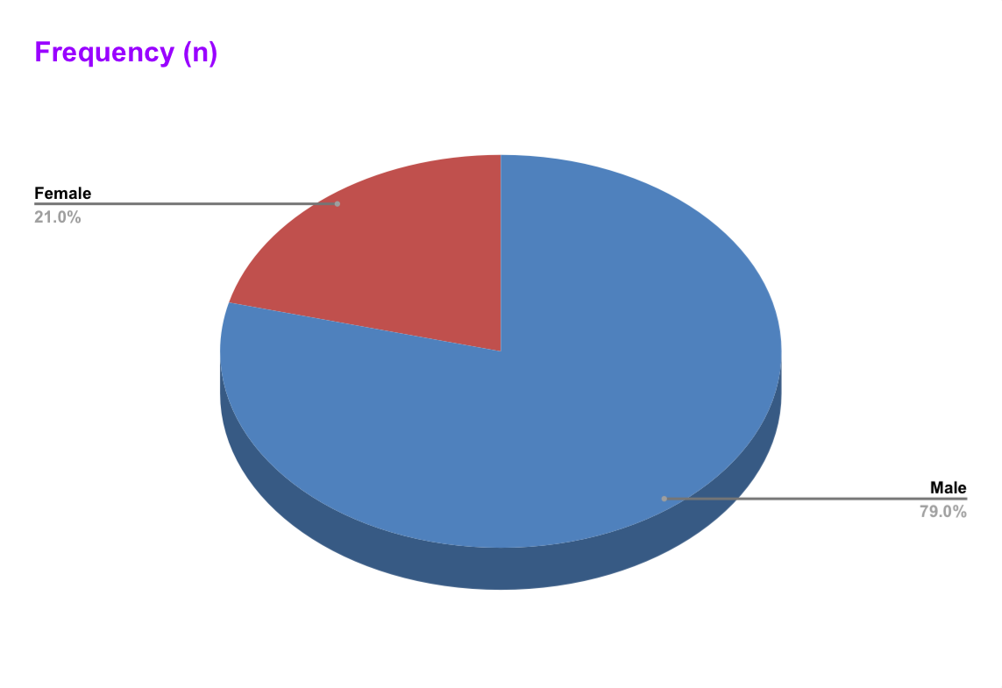
Fig 2-: Gender distribution

Eighty-seven (87%) patients had stable outcomes, while 13 (13%) had unstable outcomes during hospitalization.This indicates that most patients experienced favorable recovery, while a subset developed complications or neurological deterioration.

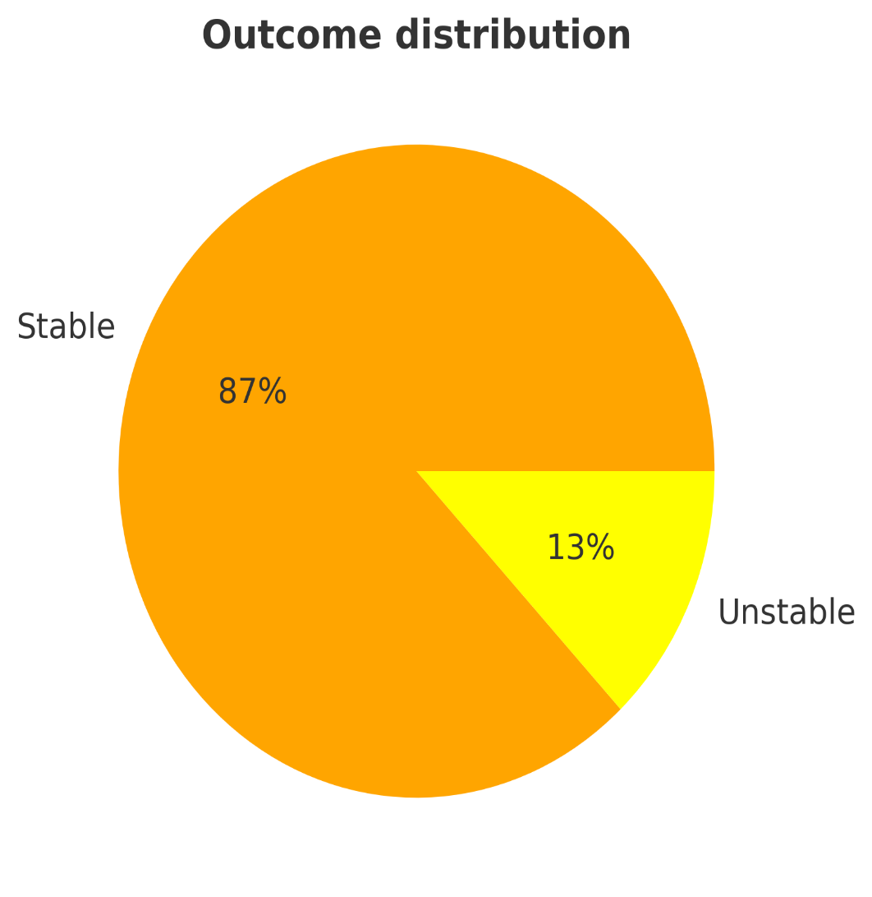
Fig 3- : Outcome distribution

Minor stroke cases were the most common (38%), followed by moderate strokes (44%). Severe strokes accounted for 12% of cases, indicating that a significant number of patients experienced serious neurological impairments.
NIHSS distribution | Frequency
Minor | 38
Moderate | 44
Moderate to Severe | 6
Severe | 12
Total | 100

Table 2: NIHSS distribution

Patients had multiple comorbidities, with hypertension and diabetes mellitus being the most common (Table 3).
Comorbidities distribution | Frequency (n)
HTN | 64
DM | 46
IHD | 13
Hypothyroidism | 6
Anemia | 3
TB | 3
CKD | 2
Asthma | 2
Vit B12 Deficiency | 2
HIV | 1
SLE | 1
Atrial fibrillation | 1
No Comorbidities | 14

Table 3: Individual Risk Factor Distribution

The significant variation in CRP levels suggests an inflammatory response, with higher CRP levels indicating more severe strokes and worse outcomes as in Table 4.
CRP Day 1  (mg/dl) | Frequency  (n)
< 3 | 35
3 - 10 | 36
11 - 30 | 24
> 30 | 5
Total | 100

Table 4:- CRP Day 1 distribution

Higher NIHSS scores were significantly associated with elevated CRP levels (p < 0.001).Patients with severe strokes had a mean CRP of 29.5 mg/L, while minor stroke patients had 2.8 mg/L as in Table 5.

Variable | NIHSS distribution | N | Mean | SD | F-value | p-value
CRP Day 1 | Minor | 38 | 2.8 | 2.4 | 19.041 | 0.0005 **
CRP Day 1 | Moderate | 44 | 8.6 | 14.3 | 19.041 | 0.0005 **
CRP Day 1 | Moderate to Severe | 6 | 15.0 | 7.3 | 19.041 | 0.0005 **
CRP Day 1 | Severe | 12 | 29.5 | 13.4 | 19.041 | 0.0005 **
** Statistically Significant at p < 0.01 level

Table 5- Comparison of CRP Day 1 Across NIHSS Severity Groups (One-way ANOVA)

Admission RBG levels differed significantly across NIHSS severity categories (F = 12.73, p < 0.001). Severe stroke patients had an average RBG of 322.2 mg/dL, while minor stroke patients had 141.9 mg/dL, suggesting an association between admission hyperglycemia and stroke severity as in Table 6.

Variable | NIHSS distribution | N | Mean | SD | F-value | p-value
RBG Day 1 | Minor | 38 | 141.9 | 52.3 | 12.736 | 0.0005 **
RBG Day 1 | Moderate | 44 | 173.3 | 81.5 | 12.736 | 0.0005 **
RBG Day 1 | Moderate to Severe | 6 | 251.8 | 85.9 | 12.736 | 0.0005 **
RBG Day 1 | Severe | 12 | 322.2 | 191.4 | 12.736 | 0.0005 **
** Statistically Significant at p < 0.01 level

Table 6- RBG Day 1 and NIHSS distribution

Table 7 Shows that Unstable patients had significantly higher CRP levels (24.5 ± 17.4 mg/L) than stable patients (6.6 ± 11.5 mg/L), t=3.578, p = 0.003.This confirms that elevated inflammation is linked to worse stroke outcomes.

Variable | Outcome | N | Mean | SD | t-value | p-value
CRP Day 1 | Stable | 87 | 6.6 | 11.5 | 3.578 | 0.003 **
CRP Day 1 | Unstable | 13 | 24.5 | 17.4 | 3.578 | 0.003 **
** Statistically Significanct at p < 0.01 level

Table 7: Comparison of CRP Day 1 between Outcome

Higher NIHSS scores were significantly associated with worse outcomes (p < 0.001).
53.8% of severe stroke patients had an unstable outcome, compared to only 7.7% of minor stroke patients.
Variable | Outcome | N | Mean | SD | t-value | p-value
NIHSS1 | Stable | 87 | 7.2 | 6.5 | 4.787 | 0.0003 **
NIHSS1 | Unstable | 13 | 22.5 | 11.2 | 4.787 | 0.0003 **
**Statistically Significant at p < 0.01 level
Table 8 : Comparison of NIHSS1 between Outcome

Although mean RBG levels were higher in unstable patients, the difference was not statistically significant (p = 0.131) as in Table 9.
Variable | Outcome | N | Mean | SD | t-value | p-value
RBG Day 1 | Stable | 87 | 172.6 | 85.0 | 1.617 | 0.131 #
RBG Day 1 | Unstable | 13 | 260.3 | 192.9 | 1.617 | 0.131 #
# No Statistical Significance at p > 0.05 level

Table 9:- Comparison of RBG Day 1 between Outcome

Higher NIHSS scores were significantly associated with worse outcomes (χ² = 35.46, p < 0.001). 53.8% of severe stroke patients had an unstable outcome, compared to only 7.7% of minor stroke patients

NIHSS1 |  | Outcome |  | Total | ꭓ 2 - value | p-value
 |  | Stable | Unstable | Total | ꭓ 2 - value | p-value
 | Minor | 37 | 1 | 38 | 35.460 | 0.0005 o**
 | Minor | 42.5% | 7.7% | 38.0% | 35.460 | 0.0005 o**
 | Moderate | 42 | 2 | 44 | 35.460 | 0.0005 o**
 | Moderate | 48.3% | 15.4% | 44.0% | 35.460 | 0.0005 o**
 | Moderate to Severe | 3 | 3 | 6 | 35.460 | 0.0005 o**
 | Moderate to Severe | 3.4% | 23.1% | 6.0% | 35.460 | 0.0005 o**
 | Severe | 5 | 7 | 12 | 35.460 | 0.0005 o**
 | Severe | 5.7% | 53.8% | 12.0% | 35.460 | 0.0005 o**
Total |  | 87 | 13 | 100 | 35.460 | 0.0005 o**
 |  | 100.0% | 100.0% | 100.0% | 35.460 | 0.0005 o**
** Statistically Significanct at p < 0.01 level

Table 10 : Comparison of NIHSS1 between Outcome

NIHSS2 showed a strong positive correlation with CRP Day 7 (r = 0.780, p < 0.001).This suggests that patients with persistent inflammation had worse neurological recovery.
NIHSS2 |  | CRP Day 7
 | r-value | 0.780**
 | p-value | 0.0005 **
 | N | 100
** StatisticalSignificanct at p < 0.01 level

Table 11 - Pearson’s Correlation Between CRP Day 7 and NIHSS
DISCUSSION
The findings of the present study are consistent with existing literature and comparable studies, including that of Sharma et al., demonstrating a significant association between serum CRP levels, admission RBG, and stroke severity as assessed by NIHSS. Elevated CRP levels reflect activation of the inflammatory cascade following cerebral ischemia, which contributes to increased neuronal injury and poorer neurological outcomes [5–8,10,11]. The strong positive correlation observed between CRP levels and NIHSS scores in this study further supports the role of inflammation as a key determinant of stroke severity and progression.
Similarly, admission hyperglycemia was found to be significantly associated with higher NIHSS scores and worse clinical status. Stress-induced hyperglycemia is known to exacerbate ischemic brain injury through mechanisms such as oxidative stress, metabolic acidosis, and blood–brain barrier disruption, ultimately leading to increased infarct size and poorer outcomes [9,12]. These findings are in agreement with previous studies that have identified hyperglycemia as an independent predictor of stroke severity and prognosis.
The demographic profile observed in this study, with a higher prevalence of stroke among individuals above 50 years of age and a male predominance, aligns with global epidemiological trends [1,3,4]. Additionally, the high burden of comorbidities such as hypertension and diabetes further supports their established role as major risk factors contributing to stroke occurrence and severity.
The distribution of NIHSS scores in the present study, with the majority of patients falling into the minor to moderate categories, is consistent with prior observations, and the significant association between NIHSS scores and clinical outcomes reaffirms its reliability as a prognostic tool in acute ischemic stroke [13]. Persistently elevated CRP levels in patients with unstable outcomes further highlight the role of ongoing inflammation in neurological deterioration and adverse prognosis.
Overall, the present study supports the growing evidence that both inflammatory and metabolic markers play a crucial role in determining stroke severity. Serum CRP and admission RBG, being simple and cost-effective investigations, can serve as valuable adjuncts in early risk stratification and clinical decision-making, particularly in resource-limited settings.
CONCLUSIONS
Elevated serum C-reactive protein and admission random blood glucose levels are significantly associated with greater stroke severity and poorer short-term outcomes in patients with acute ischemic stroke. Serum C-reactive protein demonstrated a consistent and strong correlation with neurological severity at admission and during early follow-up, indicating the role of sustained inflammation in adverse neurological recovery. Admission hyperglycemia was also associated with increased stroke severity, irrespective of prior diabetic status. Routine assessment of these readily available biomarkers at hospital admission may aid in early risk stratification, prognostication, and clinical decision-making in acute ischemic stroke. Further large, multicenter studies with long-term follow-up are required to validate these findings and to determine their impact on functional outcome.

Strengths and Limitations
Strengths of this study include its prospective design, use of standardized assessment tools (NIHSS), and measurement of biomarkers at defined time points. Limitations include the single-center design, modest sample size, lack of long-term follow-up, and non-assessment of other inflammatory cytokines or infarct volume on imaging.

Our findings reinforce the utility of CRP and admission RBG as accessible, cost-effective biomarkers for early risk stratification in AIS. Integrating these markers into clinical assessment may help identify high-risk patients who could benefit from intensified monitoring and tailored interventions, such as stricter glycemic control or anti-inflammatory agents.

ETHICAL APPROVAL
Obtained by Institution ethics committee.

No-532/L/11/12/Ethics/ESICMC&PGIMSR/Estt.Vol.IV

REFERENCES

- Feigin VL, Norrving B, Mensah GA. Global burden of stroke. Lancet. 2017;389:70–82.

- Iadecola C, Buckwalter MS, Anrather J. Immune responses to stroke: mechanisms, modulation, and therapeutic potential. Nat Rev Neurol. 2020;16:81–96.

- GBD 2019 Stroke Collaborators. Global, regional, and national burden of stroke and its risk factors, 1990-2019: a systematic analysis for the Global Burden of Disease Study 2019. Lancet Neurol. 2021;20(10):795-820.

- India State-Level Disease Burden Initiative Stroke Collaborators. The burden of stroke and its risk factors in India, 1990-2016: a systematic analysis for the Global Burden of Disease Study 2016. Lancet Glob Health. 2018;6(10):e1175-e1186.

- Lambertsen KL, Biber K, Finsen B. Inflammatory cytokines in experimental and human stroke. J Cereb Blood Flow Metab. 2012;32(9):1677-1698.
- Chamorro Á, Dirnagl U, Urra X, Planas AM. Neuroprotection in acute stroke: targeting excitotoxicity, oxidative and inflammatory pathways. Lancet Neurol. 2016;15(8):869-881.

- Whiteley W, Jackson C, Lewis S, et al. Association of circulating inflammatory markers with recurrent vascular events after stroke: a systematic review and meta-analysis. Stroke. 2011;42(1):10-16.
- Ridker PM. C-reactive protein and the prediction of cardiovascular events among those at intermediate risk. Circulation. 2007;115:928–936.
- Merlino G, Smeralda C, Gigli GL, et al. Stress hyperglycemia is predictive of worse outcome in acute ischemic stroke. Front Neurol. 2019;10:867.

- Elkind MSV, Coates K, Tai W, Paik MC, Boden-Albala B, Sacco RL. Levels of acute-phase proteins correlate with stroke severity and outcome. Neurology. 2006;67:1162–1167.
- Winbeck K, Poppert H, Etgen T, Conrad B, Sander D. Prognostic relevance of early serial C-reactive protein measurements after first ischemic stroke. Stroke. 2002;33:2459–2464.
- Capes SE, Hunt D, Malmberg K, Pathak P, Gerstein HC. Stress hyperglycemia and prognosis of stroke in nondiabetic and diabetic patients. Stroke. 2001;32:2426–2432.
- Adams HP Jr, Davis PH, Leira EC, et al. Baseline NIH Stroke Scale score strongly predicts outcome after stroke. Neurology. 1999;53:126–131.

- Saver JL. Time is brain—quantified. Stroke. 2006;37:263–266.

