Method Article
Investigation of extracellular vesicles in plasma samples: a sensitive method

Abstract:
Extracellular vesicles (EVs) are particles enclosed by a lipid bilayer and secreted by various cell types under both normal and pathological conditions. EV secretion plays a key role in maintaining normal physiological functions, while aberrant EV-mediated signaling has been associated with numerous diseases.The aim of this study was to standardize a protocol for the isolation of EVs from human plasma and their characterization by flow cytometry. To this end, peripheral blood (PB) samples were obtained from patients with pro-inflammatory conditions to standardize both the isolation procedure and the characterization method. This study demonstrated the feasibility of isolating EVs without the use of ultracentrifugation techniques, as well as their subsequent analysis using conventional flow cytometers. This approach increases the accessibility of EV research in laboratories with limited infrastructure, thereby facilitating the expansion of studies aimed at understanding these particles and their potential as disease biomarkers. Nevertheless, this method has certain limitations, including its reduced sensitivity for particles smaller than 200 nm and the exclusive detection of CD9-positive EVs, even though it is well established that not all circulating EVs express CD9.
Graphical Abstract
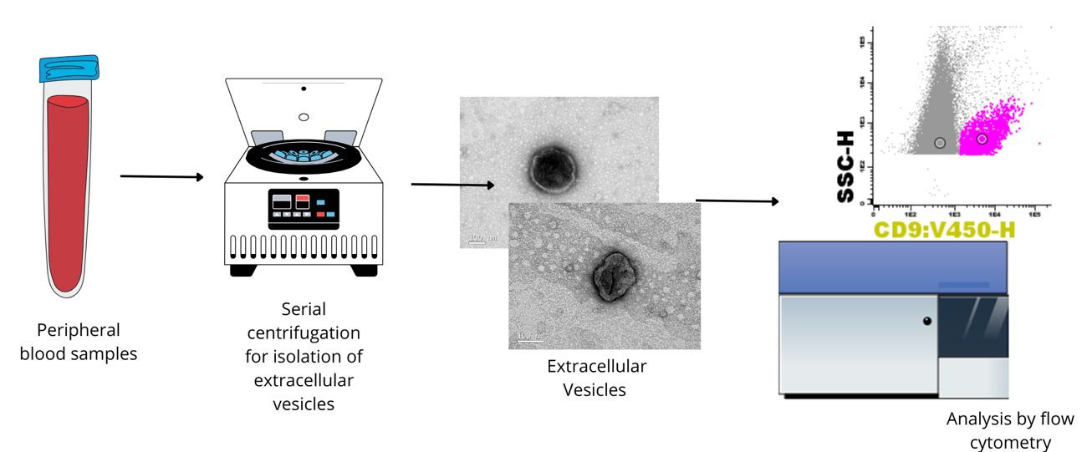
The analysis of extracellular vesicles (EV) has been proposed as a potential biomarker strategy for various pathological conditions. However, standardized methodologies are required to ensure reliable detection and quantification. Therefore, the aim of this study was to standardize a flow cytometry protocol for the analysis of EV in FACsCanto II, enabling their detection and quantification in human plasma samples.

Introduction:
Extracellular vesicles (EV) are particles delimited by a lipid bilayer, and incapable of self-replication, as they do not contain a functional nucleus^{1,2}. These particles are released by cells and play numerous roles in intercellular communication^{3,4}. EV are secreted by all cell types thus far under both normal and pathological conditions and are detected in all tissues and bodily fluids⁴.
Different types of EV have been classified based on their size and biogenesis. Small EV are often described as having a diameter <200nm, while large EV are > 200 nm in diameter. However, measured diameter varies depending on the characterization method used. Based on their biogenesis, EV are classified into apoptotic bodies, ectosomes, and endosomal. Apoptotic bodies are generated by fragmentation of cells undergoing apoptosis, ectosomes are generated by direct outward budding of the plasma membrane, and exosomes are generated by inward budding of endosomal compartments that later fuse with the plasma membrane. However, this nomenclature is discouraged unless the subcellular origin can be definitively demonstrated².
EV secretion is important for maintaining normal physiological functions, and aberrant EV-mediated signaling has been associated with numerous diseases, including cancer, cardiovascular disease, neurological and immunological disorders⁵⁻⁹. As cells and EV interact continuously, EV could have applications as liquid biopsy biomarkers, therapeutic agents, drug targeting and quality monitoring of ecosystems and food production¹⁰⁻¹³. In June 2019, the FDA granted a Breakthrough Designation to ExoDx, a test used before an initial prostate biopsy. The test analyzes RNA biomarkers found in EV from a urine sample^{14,15.} This test shows how EV can be used in clinical practice and how interest in studying there particles is increasing.
Isolating EVs from bodily fluids is challenging because they are prone to contamination with non-EV proteins, lipoproteins, and high-density lipoproteins (HDL). Such contaminants interfere with the isolation of pure EVs for therapeutic, diagnostic, or prognostic use². Several EV isolation and detection protocols have been proposed, including ultracentrifugation, size-exclusion chromatography, and precipitation-based methods. However, no single method is universally optimal and they differ considerably in yield, purity, reproducibility, required inputs and specific training. The choice of each method depends on sample type, desired EV subtype and required equipment^{1,2}.
In addition to isolation methodologies, methodologies for characterizing isolated particles are also used. EV characterization is essential for estimating EV quantity, confirming their presence, and assessing the contribution of non-EV components in each preparation. As recommended by the Minimal information for studies of extracellular vesicles 2023 (MISEV2023), EV characterization should include multiple methods depending on the type of analysis, such as dynamic light scattering (DLS), nanoparticle tracking analysis (NTA), flow cytometry (FCM), western blotting, mass spectrometry proteomics (MS) and microscopy-based techniques².
FCM is a technique that utilizes the light scattering properties of cells and/ or subcellular particles while combining fluorescence signals to detect the presence, absence, or abundance of surface and/or intracellular molecules². However, most flow cytometers are designed to detect cells, which are larger than EV. Whereas cells exceed the background noise, signals originating from EV partly overlap with the background noise, thereby making EV more difficult to detect than cells². Additionally, a major limitation is the lack of universal markers of EV biogenesis pathways, the universality of these markers remains uncertain. One of the most widely used markers is tetraspanin (CD9, CD63, and CD81), but not all EV contain these tetraspanins, so tetraspanin enrichment does not capture all EV types^{2,13,16}. As a result, standardizing EV flow cytometry experiments remains a challenge.
In clinical contexts, a workflow that is simple, rapid and sensitive and low-cost is required. An ideal biomarker should be noninvasive, cost-effective, reproducible, and enable early disease diagnosis. Using EV proteins or EV cargo found in body fluids could serve as liquid biopsies, ensuring a less invasive approach for cancer diagnosis, real-time monitoring of disease progression, and response to chemotherapeutic agents. Therefore, the aim of this study was to standardize a protocol for the isolation of EV from human plasma and their characterization by FCM, to ensure reproducibility and sensitivity in detection of these structures for future clinical applications.

2. Materials and Methods:

  - Isolation of EV

Peripheral blood (PB) samples were collected from patients after an overnight fast to minimize possible interfering factors. The first 4mL of blood were discarded, and a 20 mm needle was used. No tourniquet was applied during collection in order to minimize collection-related artifacts and prevent the generation of false EV. The tubes were not homogenized, and samples were immediately processed after collection. EV isolation was performed as described by Laurenzana et al.¹⁵ The method consists of centrifugation of PB at 3000 rpm for 15 min to obtain the platelet-rich plasma (PRP). Aliquots of 500 µL of PRP were then centrifuged at 200 × g for 5 minutes at 4 °C using a refrigerated centrifuge (Eppendorf® 5430R, rotor FA-45-30-11). The supernatant was carefully aspirated and transferred to a new 1.5 mL tube, followed by centrifugation at 14,300 × g for 1 hour at 4 °C. The supernatant was discarded, and the pellet was washed with 1 mL of 0.22 µm-filtered PBS. After washing, the pellet was resuspended in 500 µL of 0.02 µm-filtered PBS and stored at –80 °C until further analysis.

  - Dynamic Light Scattering (DLS)

Particle size and polydispersity index (PDI) were measured using photon correlation spectroscopy at 25 °C with a detection angle of 90°. All measurements were performed in triplicate of 12 runs each using a Malvern Zetasizer Nano-ZS 90 (Malvern Instruments, Malvern, UK). EV samples were diluted in 0.02 µm-filtered PBS prior to analysis (1:20).

  - Transmission Electron Microscopy (TEM)

To confirm the presence of EV in the samples, transmission electron microscopy was performed as a secondary validation method. A volume of 20 µL of the isolated EV suspension was applied onto carbon-coated nickel grids (200 mesh; Sigma-Aldrich) and incubated for 5 minutes. The grid was then rinsed with distilled water. Negative staining was carried out using 42 µL of 5% (w/v) uranyl acetate solution (TAAB Laboratories Equipment Ltd.) for 5 minutes, and the excess stain was removed with filter paper. Grids were air-dried for at least 24 hours before imaging on a JEM-1011 transmission electron microscope operating at 80 kV (JEOL USA, Inc., Peabody, MA). In addition to negative staining, positive staining using osmium vapor was also tested to evaluate contrast quality.

  - Flow cytometer calibration and EV Staining
The cytometer was abundantly washed with clean, rinse solution and distilled water before the use. When a flow rate of <40 events/seconds for PBS was registered, the cytometer was considered ready for analysis. To enable detection of small EV, the instrument was calibrated by adjusting voltages and the threshold. A polystyrene bead calibration kit (290 nm, 580 nm, 790 nm, and 1320 nm; Spherotech, IL, USA) was used to set optimal voltages for forward scatter (FSC) and side scatter (SSC) parameters. All scatter parameters (FSC and SSC) were set to logarithmic scale and high (H) sensitivity. FSC and SCC voltages were set to 600 and 415 V respectively. The threshold was set on SSC (550 value), and all samples were acquired at low flow rate. V450-H voltage was set to 950 V and the bead populations were visualized in V450-H vs. SSC dot plots to determine the optimal gating strategy.
EV samples were serially diluted to a final volume of 200 µL and stained with the following antibodies: CD9/V450, CD9/APCH7, CD63/APC, CD81/APCH7 and CD81/FITC. After antibody addition, the tubes were vortexed and incubated for 30 minutes at room temperature in the dark. After incubation, samples were immediately acquired on a FACSCanto II flow cytometer (BD Biosciences, USA) using FACS Diva 8.0 software. Data acquisition continued until the full volume of each tube was acquired. In addition to the EV-stained samples, control tubes were prepared following the MISEV recommendations. For each antibody used, a tube containing only 0.02 µm-filtered PBS and the corresponding antibody was included. A serial dilution curve of the antibody was also performed. Furthermore, a tube containing only 0.02 µm-filtered PBS, another containing only the diluted sample without antibody (blank tube), and a surfactant control tube were also prepared. Data were processed using Infinicyt 2.0 software (Cytognos, Spain), and the analysis included evaluation of technical feasibility (acquisition time and events per second) and total event count.

3. Results and discussion

3.1 The EV isolation process
Initially, it was necessary to determine the methodology for isolating EV based on the equipment available in the laboratory. Therefore, a literature review was conducted in search of isolation protocols that did not use ultracentrifuges, as this equipment was not available. Thus, the study by Laurenzana et al¹⁷ was selected, which employed serial centrifugation of platelet-rich plasma (PRP) as the isolation method.
For technical standardization, PB samples from patients with chronic inflammatory diseases (systemic lupus erythematosus and diabetes mellitus) were used as a positive control, since chronic inflammation is associated with increased release of EV into the circulation¹⁸⁻²⁰. These samples were selected to ensure an adequate amount of EV during the initial phase of protocol validation, allowing for a more efficient assessment of the method. After initial isolation of EV, particle size analysis was performed using the Dynamic Light Scattering (DLS) assay to confirm the presence of EV in the samples. However, the assay revealed particles with average sizes of 2496 nm and 3041 nm (supplementary data S1), values ​​larger than expected for EV and consistent with the size of platelets.
Therefore, the samples were stained with antibodies against CD41a, CD42a, CD9, CD81, CD45, and CD61 and analyzed by flow cytometry to verify the presence of platelets. The analysis confirmed platelet contamination (Figure 1), which led to a modification of the original protocol described by Laurenzana et al.¹⁷ Therefore, it was decided to use platelet-poor plasma (PPP) instead of PRP to minimize the interferer.

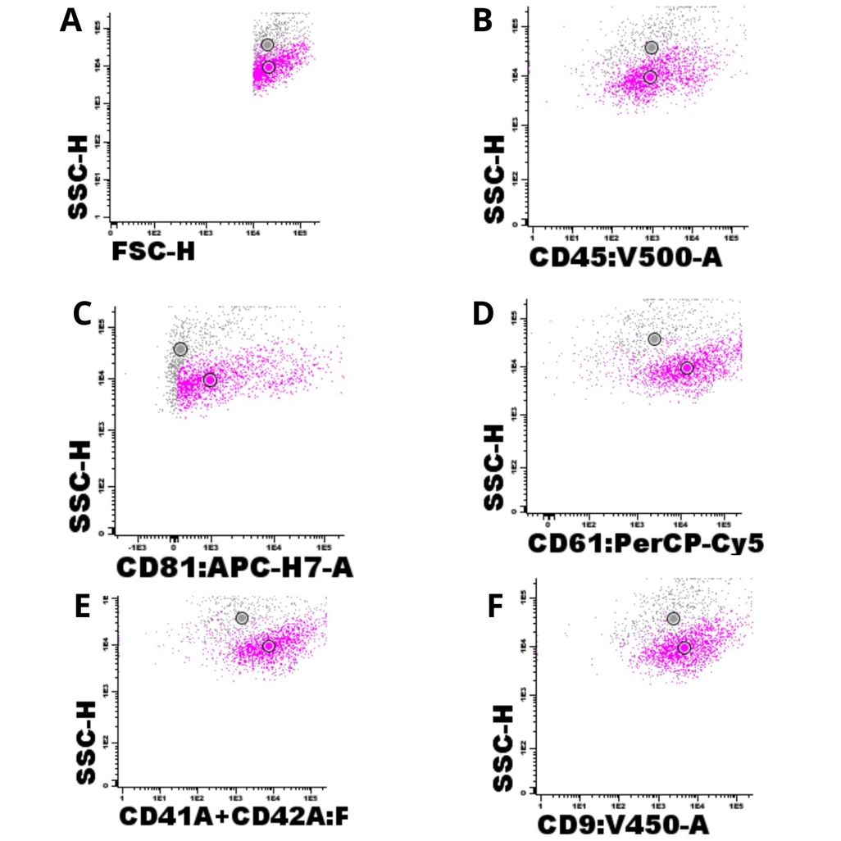
Figure 1. Gating strategy for identification of platelets. (A) Dotplot FSC vs SSC. (B) Negative staining for CD45, a leukocyte marker. Positive staining for the characteristic platelet markers: CD81 (C), CD61 (D), CD41a+CD42b, and CD9 (F). Platelets are highlighted in pink. . Data represent from five independent samples (N = 5)

After the new round of PPP isolation, the samples were analyzed again by DLS, and the results indicated particles with average sizes of 287,7 nm and 336,4 nm (supplementary data S1)), consistent with EV. Therefore, the standardized isolation methodology in this study began using PPP instead of PRP.
As a second method to confirm the presence of EV in the samples, TEM was used. EV are typically observed as round, oval, or sometimes slightly elongated particles, delimited by a lipid bilayer²¹. Additionally, they exhibit a characteristic cup-shaped morphology under TEM, primarily due to the dehydration and fixation steps during sample preparation, which may cause partial vesicle collapse and result in a central indentation^{22,23}. The analyzed samples presented structures compatible with EV, with characteristic morphology, as demonstrated in Figure 2. Moreover, the samples were examined using both positive staining (osmium tetroxide, OsO₄) and negative staining (uranyl acetate). Osmium tetroxide is a stain that binds to specific lipids, increasing their electron density and resulting in darker areas under the microscope compared to unstained regions²⁴, which is why this method is referred to as positive contrast²⁵. In this case, OsO₄ binds to phospholipids in the EV membrane, rendering them darker against a lighter background. In contrast, uranyl acetate, a negative stain, does not bind to membrane lipids but rather accumulates around the particles and in the background, producing a darker background relative to the particles themselves²⁶. In both staining methods, EV exhibited similar sizes, indicating that either contrast technique may be effective for EV analysis. However, staining with uranyl acetate produced a granular background, which can hinder the visualization of smaller vesicles. In addition, the characteristic cup-shaped morphology of the vesicles, resulting from membrane dehydration during staining, was clearly observed. On the other hand, the use of osmium tetroxide allowed for clear visualization of the lipid bilayer due to its affinity for phospholipids, and it yielded a cleaner background, facilitating the identification and analysis of smaller particles.

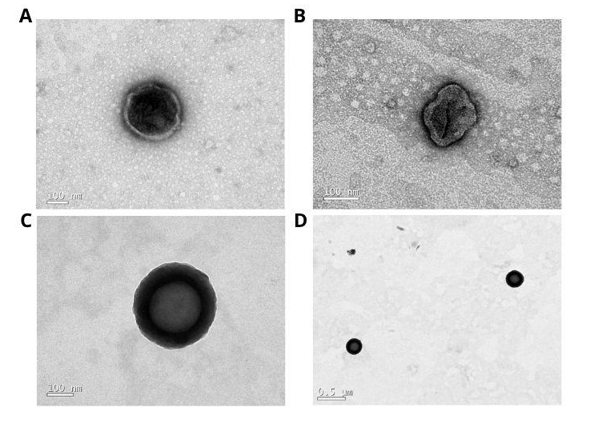
Figure 2. Images of isolated extracellular vesicles, contrasted with uranyl acetate (A and B) and osmium tetroxide (C and D). Data represent from five independent samples (N = 5)

3.2 Flow Cytometer Calibration

The equipment voltages were adjusted until the four bead sizes appeared on the V450-H/SSC dotplot (Figure 3A). The beads can be visualized in this dotplot due to their intrinsic fluorescence in the V450 fluorochrome. It was possible to observe that the FACSCanto II cytometer can detect spheres with sizes ranging from approximately 290 nm to 1320 nm, the expected range of extracellular vesicles in the analyzed samples. Furthermore, the spheres can be differentiated from each other, and the fluorescence signals do not interfere with each other, as shown in Figure 3B. Finally, it can be verified that the FACSCanto II performance was equivalent to the dotplot provided in the kit manufacturer's datasheet (Figure 4).

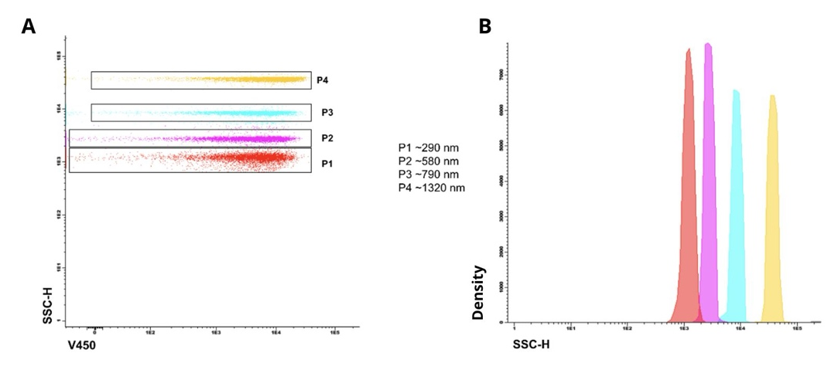
Figure 3. P4 (yellow) refers to 1230nm beads, P3 (blue) to 790nm beads, P2 (pink) refers to 580nm, and P1(red) refers to 290nm beads.

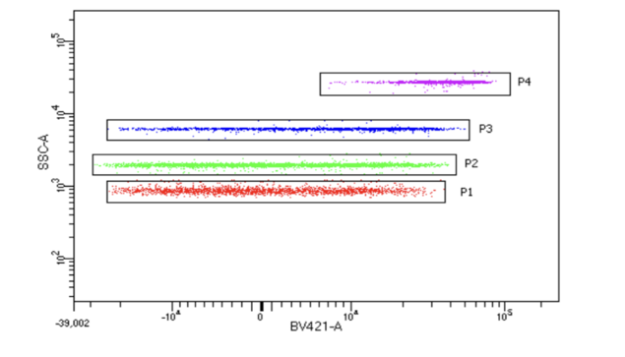

Figure 4. P4 (yellow) refers to 1230nm beads, P3 (blue) to 790nm beads, P2 (pink) refers to 580nm, and P1(red) refers to 290nm beads.

3.3 Determination of antibodies used to characterize EV
Once the isolation protocol was established, it was necessary to standardize all steps required for flow cytometry, as this technique is widely used to analyze EV. Therefore, the selection of appropriate markers is crucial for the accurate detection and characterization of the particles of interest. The tetraspanins CD9, CD63, and CD81 are the most recommended and reliable markers for EV detection by flow cytometry, and they are often associated with cell type-specific markers²⁷⁻³⁰. So, these markers were tested. In addition to the selected markers, appropriate controls were included for concomitant analysis with the target markers. These controls were incorporated following the MISEV recommendations^{2,31}. The buffer-only control (PBS only) was used to quantify the contribution of background noise, and any particles present in the dilution buffer, and to compare these values with the total particle counts in the EV samples. This control also contributed to verification of cytometer cleanliness. The buffer with reagents control (PBS + target makers antibody) was included to assess the contribution of unbound reagents to background noise and the interference in the analysis, as the samples were acquired without prior washing steps. The unstained control (blank samples – PBS + samples) was used to evaluate fluorescence levels of EV relative to background fluorescence, since the small size of EV often results in overlapping signal intensities. Each control tube was prepared under the same conditions as the EV samples and was acquired until the entire volume of the tube had been acquired.
As shown in Figure 5, the buffer-only control (5A and 5B) did not interfere with the analysis, as it did not present false-positive events in the fluorochromes used for sample evaluation. When the unstained sample (5C and 5D) was analyzed, an interference was observed in the V450 channel, which was attributed to the intrinsic fluorescence of the sample itself. Another important observation from this figure is that PBS with antibodies (5E and 5F) did not interfere with the gating strategy of the analysis.Since the sample exhibited autofluorescence in the V450 channel, a second CD9 marker conjugated to another fluorochrome was included to increase sensitivity and to better distinguish true events from background noise and sample autofluorescence, thereby reducing false-positive results. Consequently, the sample was stained with CD9 conjugated to V450 and APC-H7. As shown in Figure 6, a double-positive EV CD9⁺ population could be clearly identified. When this population was treated with surfactant, a total reduction in positive events was observed, confirming the presence of EVs in the analyzed sample. In addition, a PBS control containing antibodies and surfactant was also included (5G and 5H), demonstrating that there was no interference and that the results obtained were reliable.

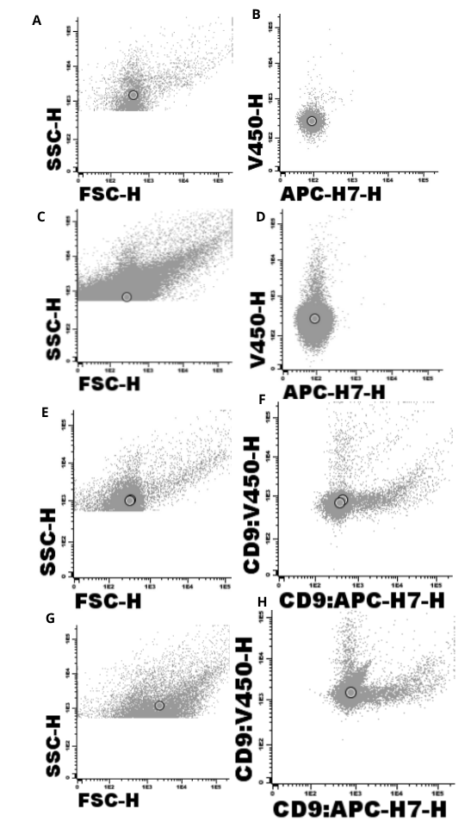

Figure 5. Dotplot of controls. Buffer-only (A and B). Unstained sample (C and D). Buffer with anti-CD9/V450 and anti-CD9/APCH7 (E and F). Buffer with anti-CD9/V450 and anti-CD9/APCH7 and Triton X-100 (G and H). Data represent from five independent samples (N = 5)

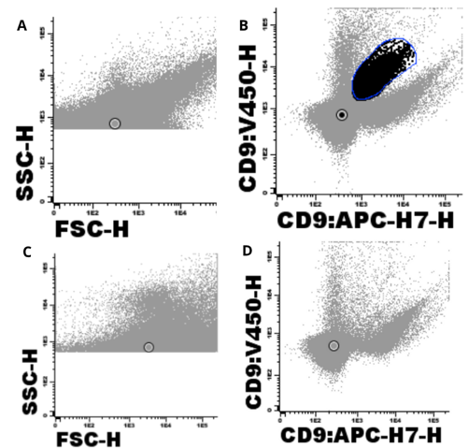
Figure 6. Stained sample (A and B). Stained sample with Triton X-100 (C and D). Data represent from five independent samples (N = 5)

Regarding CD63 (Figure 7), a reduction in the number of positive events for this marker was observed after treatment with the surfactant. However, a background noise was detected, making it impossible to clearly distinguish the extracellular vesicles. In addition, this marker was not available conjugated to another fluorochrome to assess whether the issue was related to sensitivity. Therefore, CD63 was not selected to be maintained as a marker in the subsequent analyses.

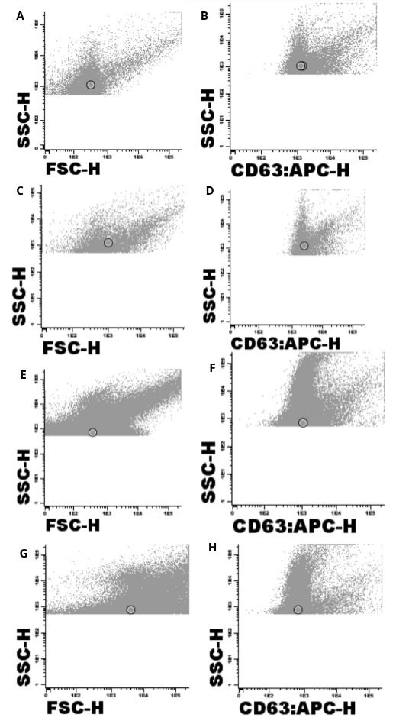
Figure 7. Dotplot of controls. Buffer with anti-CD63 (A and B). Buffer with anti-CD63 and Triton X-100 (C and D). Stained sample (E and F). Stained sample with Triton X-100 (G and H). Data represent from five independent samples (N = 5)

Another marker tested was CD81. It was observed that when only one fluorochrome was used, it was not possible to clearly distinguish CD81⁺ EVs from background noise and sample autofluorescence (Figure 8). However, by applying the same strategy used for CD9, an additional CD81 antibody conjugated to a different fluorochrome was included (Figure 9), which allowed the identification of CD81⁺ EVs, as the positive events disappeared after treatment with surfactant. Moreover, it was observed that the number of CD9⁺ EVs was higher than that of CD81⁺ EVs, which is consistent with previous studies showing that plasma samples contain a greater proportion of CD9⁺ EVs compared to CD81⁺ EV^{32,33}.

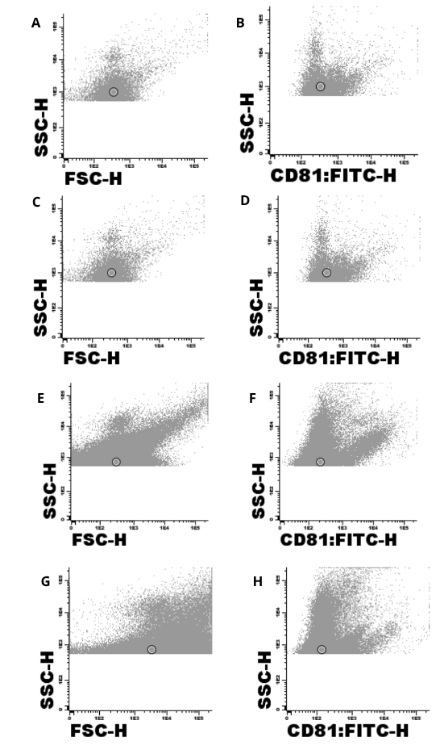

Figure 8. Dotplot of controls. Buffer with anti-CD81 (A and B). Buffer with anti-CD81 and Triton X-100 (C and D). Stained sample (E and F). Stained sample with Triton X-100 (G and H). Data represent from five independent samples (N = 5)

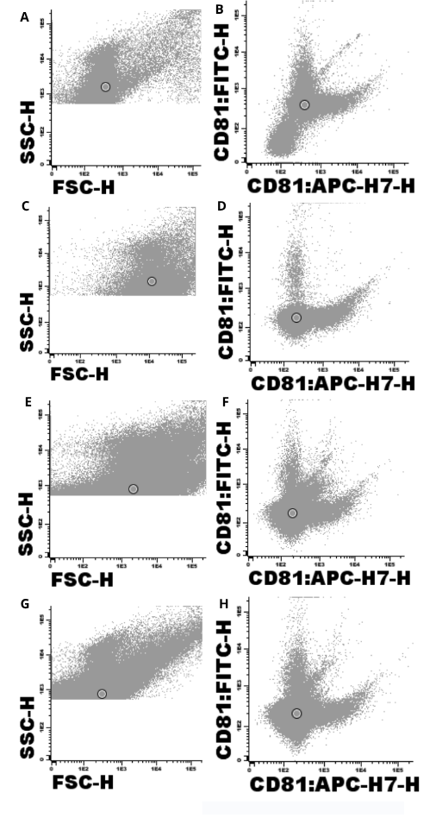

Figure 9. Dotplot of controls. Buffer with CD81/FITC and CD81/APCH7 (A and B). Buffer with anti-CD81/FITC and anti-CD81/APCH7 and Triton X-100 (B and C). Stained sample (E and F). Stained sample with Triton X-100 (G and H).

The results demonstrate that it is possible to analyze CD9⁺ and CD81⁺ EVs using the FACSCanto II; however, it is necessary to use these markers conjugated to two distinct fluorochromes within the same tube to increase sensitivity, improve analytical accuracy, reduce false-positive events, and correctly distinguish true EVs from background noise derived from both the instrument and the sample itself. Data represent from five independent samples (N = 5)

3.4 Determination of EV dilutions and antibody titration
After establishing the markers to be used, it was also necessary to determine the minimum sample dilution suitable for acquisition by flow cytometry. Sample dilutions are essential to avoid the phenomenon known as swarm detection, which occurs when multiple particles simultaneously pass through the cytometer laser and are detected as a single event³⁴. The purpose of the serial dilution controls was to identify the lowest dilution, thus the highest event rate without triggering swarm detection. This phenomenon is considered absent at dilutions where the concentration varies linearly with the dilution factor and where the mean fluorescence intensity and light scatter remain independent of the dilution³⁴.
Additionally, dilutions were selected based on technical feasibility (cytometer acquisition time and events per second). As shown in Figure 6, at the 1:8 dilution, the number of CD9⁺ events increased linearly with dilution. Furthermore, this dilution provided a good number of CD9⁺ events with an optimal acquisition time (approximately 15 minutes per tube) at low velocity. In contrast, higher dilutions (1:16, 1:32, and 1:64) required more than 30 minutes per tube. So, the 1:8 dilution was selected as the minimum dilution for the samples.
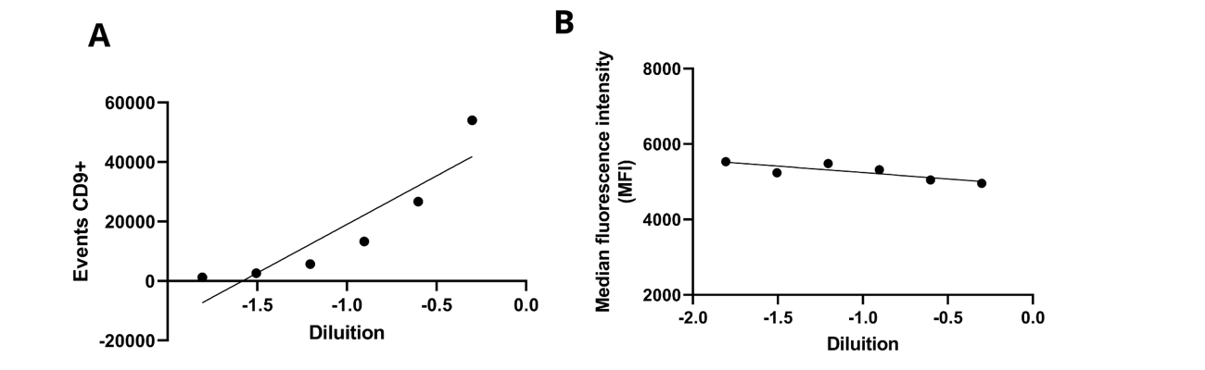
Figure 10. In (A) the number of CD9-positive events is plotted against the dilution factor. In (B) the mean fluorescence intensity is plotted against the dilution factor. Data represent mean from three independent samples (N = 3).

The titration curve for the CD9 antibody was performed (Figure 11) to determine the optimal concentration for staining. Achieving high data resolution in flow cytometry relies on several factors, including the amount of reagent used during staining. Therefore, reagent validation and titration represent essential preliminary steps in assay optimization. The titration process aims to identify the antibody concentration that best distinguishes positive signals from background noise while ensuring saturation of all binding sites and avoiding antibody excess. To accomplish this, serial dilutions of the antibody were tested using samples expressing the CD9 antigen, allowing for the determination of the concentration that provided the clearest separation between specific and nonspecific signals.

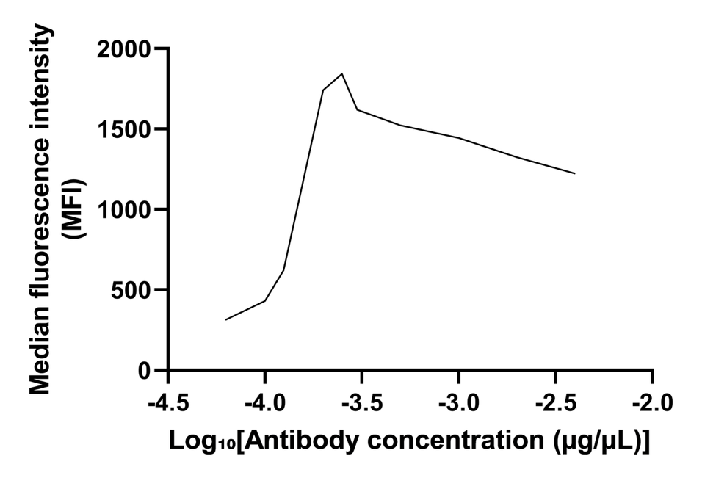
Figure 11. Antibody titration curve. Mean fluorescence intensity (MFI) plotted as a function of antibody concentration. The optimal concentration corresponds to the lowest antibody dilution within the plateau region of the curve. Data represent from 2 independent samples (N = 2)
The titration curve shows at the highest concentrations, the MFI values are lower, increasing progressively as the antibody is diluted, until reaching a peak at 0.00025 µg/µL (0.5 µL). Beyond this point, the MFI decreases again at lower concentrations.This pattern is characteristic of the prozone effect, which occurs when an excess of antibody impairs optimal antigen–antibody complex formation, resulting in reduced fluorescence due to signal saturation and elevated background³⁵. The optimal antibody concentration was determined to be 0.00025 µg/µL (0.5 µL), as it provided the highest MFI, remained within the saturation range, and minimized antibody interference. The optimal concentration (0.00025 µg/µL - 0.5 µL) was selected for subsequent experiments.

3.5 Choosing surfactant as a positive control
It was also necessary to choose a surfactant to be used as a positive control, since biological samples may contain particles of similar size to EV, potentially generating false-positive results and leading to undesired event counts. To address this, the ISEV recommends the use of surfactant-based controls³⁶. The purpose of this control is to distinguish membrane-bound particles such as cells and EV, which are sensitive to surfactants from detergent-resistant particles, such as lipoproteins and immune complexes³⁶. For this purpose, the surfactants Tween 20 and Triton X-100 were tested. Figure 12 shows CD9⁺ events, which are likely EV. To confirm this, Tween 20 and Triton X-100 were added at a final concentration of 1%, to avoid clogging the fluidic system of the flow cytometer. Upon treatment with Triton X-100, all previously detected CD9⁺ events disappeared, confirming the presence of EV. In contrast, treatment with Tween 20 did not completely eliminate the CD9⁺ events. A study by Osteikoetxea et al³⁷ also observed that Triton X-100 was more effective than Tween 20 in lysing EV. Although Tween 20 may also be effective at higher concentrations³⁸,increasing its concentration would result in a more viscous solution, which could interfere with the fluidics system of the equipment and potentially lead to clogging. So, Triton X-100 was selected as the surfactant of choice.

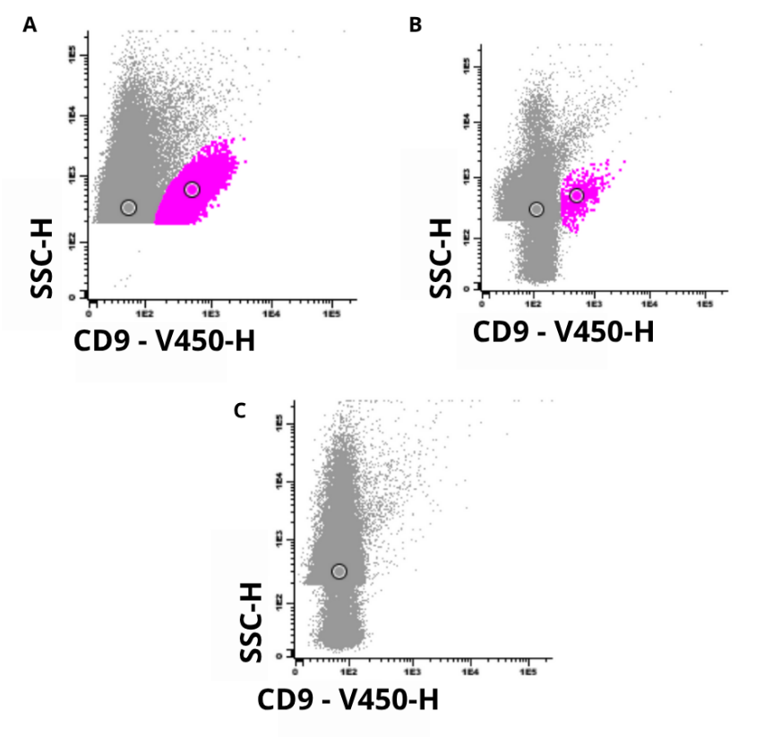

Figure 12. In (A) we have the representation of CD9+ extracellular vesicles, in (B) the use of the surfactant Tween-20 and in (C) the use of the surfactant Triton X-100. Data represent from five independent samples (N = 5)

3.6 Stability of EV samples
After isolation, the samples were stored in a freezer at -80°C, and their stability was tested at different time points (day of isolation (T0), one month after isolation (T1), two months after isolation (T2), and three months after isolation (T3)) (Figure 8). No significant difference was observed at any of the time points analyzed (p>0,05), indicating that these samples were stable at the time points evaluated.

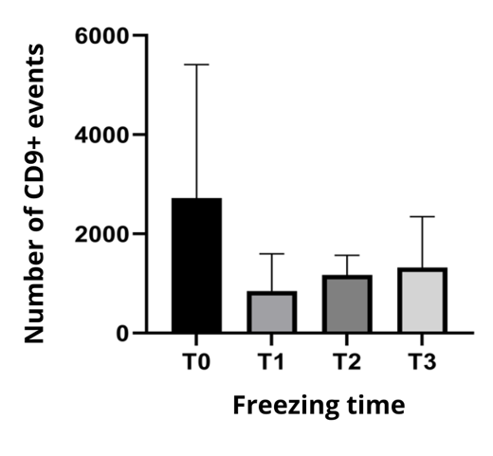
Figure 13. Effect of storage time on the number of CD9+ events. Dara are expressed as mean ± SD. N= 5 independent samples. The data show that there was no significant difference between the number of CD9+ events at the different time points analyzed. The variables were analyzed by ANOVA. *p≤0.05 was considered significant. T0: day of isolation; T1: one month after isolation; T2: two months after isolation; T3: three months after isolation

5. Conclusion

This study demonstrated the feasibility of isolating EV without the need for ultracentrifugation techniques, as well as their analysis using conventional flow cytometers, such as the FACSCanto II. This approach broadens the accessibility of EV research to laboratories with limited infrastructure, thereby facilitating the expansion of studies aimed at understanding these particles, including their potential as disease biomarkers in liquid biopsies, monitoring treatment response and prognostic assessment.

Limitations

This study has some limitations. First, the sensitivity to particles smaller than 200nm and the majority of EV in plasma are smaller than 200nm. Second, for EV analysis in FACSCanto II requires the use of two fluorochromes conjugated to antibodies against the same surface marker (e.g., CD9 and CD81) to ensure accurate identification and discrimination of true EV events from background signals. Therefore, further studies are needed to standardize additional EV markers and improve the detection of a broader range of vesicles.

Conflicts of interest

The authors declare that they have no known competing financial interests or personal relationships that could have appeared to influence the work reported in this paper

Data availability

The authors declare that the data supporting the findings of this study are available within the paper. Should any data files be needed in any other format, they are available from the corresponding author upon reasonable request.

References

- Théry C, et al. Minimal information for studies of extracellular vesicles 2018 (MISEV2018): a position statement of the International Society for Extracellular Vesicles and update of the MISEV2014 guidelines. J Extracell Vesicles. 2018;7(1):1535750.
- Welsh, J. A., Goberdhan, D. C. I., O'Driscoll, L., Buzas, E. I., Blenkiron, C., Bussolati, B., Cai, H., Di Vizio, D., Driedonks, T. A. P., Erdbrügger, U., Falcon-Perez, J. M., Fu, Q. L., Hill, A. F., Lenassi, M., Lim, S. K., Mahoney, M. G., Mohanty, S., Möller, A., Nieuwland, R., Ochiya, T., … Witwer, K. W. (2024). Minimal information for studies of extracellular vesicles (MISEV2023): From basic to advanced approaches. Journal of extracellular vesicles, 13(2), e12404. https://doi.org/10.1002/jev2.12404 Liu, YJ., Wang, C. A review of the regulatory mechanisms of extracellular vesicles-mediated intercellular communication. Cell Commun Signal 21, 77 (2023). https://doi.org/10.1186/s12964-023-01103-6
- Wessler, S., Meisner-Kober, N. On the road: extracellular vesicles in intercellular communication. Cell Commun Signal 23, 95 (2025). https://doi.org/10.1186/s12964-024-01999-8
- Alberro, A., Iparraguirre, L., Fernandes, A., & Otaegui, D. (2021). Extracellular Vesicles in Blood: Sources, Effects, and Applications. International Journal of Molecular Sciences, 22(15), 8163. https://doi.org/10.3390/ijms22158163
- Iraci, N., Leonardi, T., Gessler, F., Vega, B., & Pluchino, S. (2016). Focus on Extracellular Vesicles: Physiological Role and Signalling Properties of Extracellular Membrane Vesicles. International Journal of Molecular Sciences, 17(2), 171. https://doi.org/10.3390/ijms17020171
- Sherman, C. D., Lodha, S., & Sahoo, S. (2021). EV Cargo Sorting in Therapeutic Development for Cardiovascular Disease. Cells, 10(6), 1500. https://doi.org/10.3390/cells10061500
- Ruan, J., Miao, X., Schlüter, D., Lin, L., & Wang, X. (2021). Extracellular vesicles in neuroinflammation: Pathogenesis, diagnosis, and therapy. Molecular therapy : the journal of the American Society of Gene Therapy, 29(6), 1946–1957. https://doi.org/10.1016/j.ymthe.2021.04.020
- Yizhuo Wang et al.Nutrient availability regulates the secretion and function of immune cell–derived extracellular vesicles through metabolic rewiring.Sci. Adv.10,eadj1290(2024).DOI:10.1126/sciadv.adj1290
- Wang, L., Wang, D., Ye, Z., & Xu, J. (2023). Engineering Extracellular Vesicles as Delivery Systems in Therapeutic Applications. Advanced science (Weinheim, Baden-Wurttemberg, Germany), 10(17), e2300552. https://doi.org/10.1002/advs.202300552
- Hendrix, A., Lippens, L., Pinheiro, C. et al. Extracellular vesicle analysis. Nat Rev Methods Primers 3, 56 (2023). https://doi.org/10.1038/s43586-023-00240-z
- Ciferri, M. C., Quarto, R., & Tasso, R. (2021). Extracellular Vesicles as Biomarkers and Therapeutic Tools: From Pre-Clinical to Clinical Applications. Biology, 10(5), 359. https://doi.org/10.3390/biology10050359
- Yu, D., Li, Y., Wang, M. et al. Exosomes as a new frontier of cancer liquid biopsy. Mol Cancer 21, 56 (2022). https://doi.org/10.1186/s12943-022-01509-9
- Welsh, J. A., Arkesteijn, G. J. A., Bremer, M., Cimorelli, M., Dignat-George, F., Giebel, B., Görgens, A., Hendrix, A., Kuiper, M., Lacroix, R., Lannigan, J., van Leeuwen, T. G., Lozano-Andrés, E., Rao, S., Robert, S., de Rond, L., Tang, V. A., Tertel, T., Yan, X., Wauben, M. H. M., … van der Pol, E. (2023). A compendium of single extracellular vesicle flow cytometry. Journal of extracellular vesicles, 12(2), e12299. https://doi.org/10.1002/jev2.12299
- SMITH, Stephanie F.; BREWER, Daniel S.; HURST, Rachel; COOPER, Colin S.. Applications of Urinary Extracellular Vesicles in the Diagnosis and Active Surveillance of Prostate Cancer. Cancers, [S.L.], v. 16, n. 9, p. 1717, 28 abr. 2024.
- MATUSZCZAK, Milena; SCHALKEN, Jack A.; SALAGIERSKI, Maciej. Prostate Cancer Liquid Biopsy Biomarkers’ Clinical Utility in Diagnosis and Prognosis. Cancers, [S.L.], v. 13, n. 13, p. 3373, 5 jul. 2021.
- Lucien, F., Gustafson, D., Lenassi, M., Li, B., Teske, J. J., Boilard, E., von Hohenberg, K. C., Falcón-Perez, J. M., Gualerzi, A., Reale, A., Jones, J. C., Lässer, C., Lawson, C., Nazarenko, I., O'Driscoll, L., Pink, R., Siljander, P. R., Soekmadji, C., Hendrix, A., Welsh, J. A., … Nieuwland, R. (2023). MIBlood-EV: Minimal information to enhance the quality and reproducibility of blood extracellular vesicle research. Journal of extracellular vesicles, 12(12), e12385. https://doi.org/10.1002/jev2.12385
- LAURENZANA, Ilaria; TRINO, Stefania; LAMORTE, Daniela; GIRASOLE, Marco; DINARELLI, Simone; STRADIS, Angelo de; GRIECO, Vitina; MAIETTI, Maddalena; TRAFICANTE, Antonio; STATUTO, Teodora. Analysis of Amount, Size, Protein Phenotype and Molecular Content of Circulating Extracellular Vesicles Identifies New Biomarkers in Multiple Myeloma. International Journal Of Nanomedicine, [S.L.], v. 16, p. 3141-3160, maio 2021.
- KUMAR, Mudasir A.; BABA, Sadaf K.; SADIDA, Hana Q.; MARZOOQI, Sara Al.; JEROBIN, Jayakumar; ALTEMANI, Faisal H.; ALGEHAINY, Naseh; ALANAZI, Mohammad A.; ABOU-SAMRA, Abdul-Badi; KUMAR, Rakesh. Extracellular vesicles as tools and targets in therapy for diseases. Signal Transduction And Targeted Therapy, [S.L.], v. 9, n. 1, p. 1-41, 5 fev. 2024.
- PAPAREDDY, Praveen; TAPKEN, Ines; KROH, Keshia; BHONGIR, Ravi Kiran Varma; RAHMAN, Milladur; BAUMGARTEN, Maria; CIM, Eda Irem; GYÖRFFY, Lilla; SMEDS, Emanuel; NEUMANN, Ariane. The role of extracellular vesicle fusion with target cells in triggering systemic inflammation. Nature Communications, [S.L.], v. 15, n. 1, p. 1-17, 7 fev. 2024.
- SANWLANI, Rahul; GANGODA, Lahiru. Role of Extracellular Vesicles in Cell Death and Inflammation. Cells, [S.L.], v. 10, n. 10, p. 2663, 5 out. 2021.

- GÓMEZ-DE-MARISCAL, Estibaliz; MAŁKA, Martin; KOTRBOVÁ, Anna; POSPÍCHALOVÁ, Vendula; MATULA, Pavel; MUÑOZ-BARRUTIA, Arrate. Deep-Learning-Based Segmentation of Small Extracellular Vesicles in Transmission Electron Microscopy Images. Scientific Reports, [S.L.], v. 9, n. 1, p. 1-10, 13 set. 2019.

- KAPOOR, Kshipra S.; KONG, Seoyun; SUGIMOTO, Hikaru; GUO, Wenhua; BOOMINATHAN, Vivek; CHEN, Yi-Lin; BISWAL, Sibani Lisa; TERLIER, Tanguy; MCANDREWS, Kathleen M.; KALLURI, Raghu. Single Extracellular Vesicle Imaging and Computational Analysis Identifies Inherent Architectural Heterogeneity. Acs Nano, [S.L.], v. 18, n. 18, p. 11717-11731, 23 abr. 2024.

- NIKISHIN, Igor; DULIMOV, Ruslan; SKRYABIN, Gleb; GALETSKY, Sergey; TCHEVKINA, Elena; BAGROV, Dmitry. ScanEV – A neural network-based tool for the automated detection of extracellular vesicles in TEM images. Micron, [S.L.], v. 145, p. 103044, jun. 2021.

- LI, Ruiyu; WILDENBERG, Gregg; BOERGENS, Kevin; YANG, Yingjie; WEBER, Kassandra; RIEGER, Janek; ARCIDIACONO, Ashley; KLIE, Robert; KASTHURI, Narayanan; KING, Sarah B.. OsO2 as the Contrast‐Generating Chemical Species of Osmium‐Stained Biological Tissues in Electron Microscopy. Chembiochem, [S.L.], p. 1-7, 12 set. 2024.

- BELLO, Valentina; MATTEI, Giovanni; MAZZOLDI, Paolo; VIVENZA, Nicoletta; GASCO, Paolo; IDEE, Jean Marc; ROBIC, Caroline; BORSELLA, Elisabetta. Transmission Electron Microscopy of Lipid Vesicles for Drug Delivery: comparison between positive and negative staining. Microscopy And Microanalysis, [S.L.], v. 16, n. 4, p. 456-461, 22 jun. 2010.

- Barreto-Vieira, D., & Barth, O. (2015). Negative and Positive Staining in Transmission Electron Microscopy for Virus Diagnosis. . https://doi.org/10.5772/60511.

- CAMPOS-SILVA, Carmen; SUÁREZ, Henar; JARA-ACEVEDO, Ricardo; LINARES-ESPINÓS, Estefanía; MARTINEZ-PIÑEIRO, Luis; YÁÑEZ-MÓ, María; VALÉS-GÓMEZ, Mar. High sensitivity detection of extracellular vesicles immune-captured from urine by conventional flow cytometry. Scientific Reports, [S.L.], v. 9, n. 1, p. 1-12, 14 fev. 2019.

- GÖRGENS, André; BREMER, Michel; FERRER‐TUR, Rita; MURKE, Florian; TERTEL, Tobias; HORN, Peter A.; THALMANN, Sebastian; WELSH, Joshua A.; PROBST, Christine; GUERIN, Coralié. Optimisation of imaging flow cytometry for the analysis of single extracellular vesicles by using fluorescence‐tagged vesicles as biological reference material. Journal Of Extracellular Vesicles, [S.L.], v. 8, n. 1, p. 1-25, 21 mar. 2019.

- JOHNSON, Suzanne M; BANYARD, Antonia; SMITH, Christopher; MIRONOV, Aleksandr; MCCABE, Martin G.. Large Extracellular Vesicles Can be Characterised by Multiplex Labelling Using Imaging Flow Cytometry. International Journal Of Molecular Sciences, [S.L.], v. 21, n. 22, p. 8723, 18 nov. 2020.

- RAMOS, Teresa L.; SÁNCHEZ-ABARCA, Luis Ignacio; MUNTIÓN, Sandra; PRECIADO, Silvia; PUIG, Noemí; LÓPEZ-RUANO, Guillermo; HERNÁNDEZ-HERNÁNDEZ, Ángel; REDONDO, Alba; ORTEGA, Rebeca; RODRÍGUEZ, Concepción. MSC surface markers (CD44, CD73, and CD90) can identify human MSC-derived extracellular vesicles by conventional flow cytometry. Cell Communication And Signaling, [S.L.], v. 14, n. 1, p. 1-14, 12 jan. 2016.

- WELSH, Joshua A.; TANG, Vera A.; POL, Edwin van Der; GÖRGENS, André. MIFlowCyt‐EV: the next chapter in the reporting and reliability of single extracellular vesicle flow cytometry experiments. Cytometry Part A, [S.L.], v. 99, n. 4, p. 365-368, 26 nov. 2020.

- TORDOFF, Emma; ALLEN, Jillian; ELGART, Katya; ELSHERBINI, Ahmed; KALIA, Vrinda; WU, Haotian; EREN, Erden; KAPOGIANNIS, Dimitrios; GOLOLOBOVA, Olesia; WITWER, Kenneth. A novel multiplexed immunoassay for surface‐exposed proteins in plasma extracellular vesicles. Journal Of Extracellular Vesicles, [S.L.], v. 13, n. 11, nov. 2024.

- RYDLAND, Anne; HEINICKE, Fatima; FLÅM, Siri T.; MJAAVATTEN, Maria D.; LIE, Benedicte A.. Small extracellular vesicles have distinct CD81 and CD9 tetraspanin expression profiles in plasma from rheumatoid arthritis patients. Clinical And Experimental Medicine, [S.L.], v. 23, n. 6, p. 2867-2875, 24 fev. 2023.

- LIBREGTS, S.F.W.M.; ARKESTEIJN, G.J.A.; NÉMETH, A.; HOEN, E.N.M. Nolte‐’T; WAUBEN, M.H.M.. Flow cytometric analysis of extracellular vesicle subsets in plasma: impact of swarm by particles of non⠰interest. Journal Of Thrombosis And Haemostasis, [S.L.], v. 16, n. 7, p. 1423-1436, jul. 2018.

- BONILLA, Diana L.; PAUL, Alberta; GIL-PULIDO, Jesus; PARK, Lily M.; JAIMES, Maria C.. The Power of Reagent Titration in Flow Cytometry. Cells, [S.L.], v. 13, n. 20, p. 1677, 11 out. 2024.

- WELSH, Joshua A.; ARKESTEIJN, Ger J. A.; BREMER, Michel; CIMORELLI, Michael; DIGNAT‐GEORGE, Françoise; GIEBEL, Bernd; GÖRGENS, André; HENDRIX, An; KUIPER, Martine; LACROIX, Romaric. A compendium of single extracellular vesicle flow cytometry. Journal Of Extracellular Vesicles, [S.L.], v. 12, n. 2, p. 1-77, fev. 2023.

- OSTEIKOETXEA, Xabier; SÓDAR, Barbara; NÉMETH, Andrea; SZABÓ-TAYLOR, Katalin; PÁLÓCZI, Krisztina; VUKMAN, Krisztina V.; TAMÁSI, Viola; BALOGH, Andrea; KITTEL, Ágnes; PÁLLINGER, Éva. Differential detergent sensitivity of extracellular vesicle subpopulations. Organic & Biomolecular Chemistry, [S.L.], v. 13, n. 38, p. 9775-9782, 2015.

- SCHULTZ, David; MÜNTER, Rasmus D.; CANTÍN, Alex M.; KEMPEN, Paul J.; JAHNKE, Nadin; ANDRESEN, Thomas L.; SIMONSEN, Jens B.; URQUHART, Andrew J.. Enhancing RNA encapsulation quantification in lipid nanoparticles: sustainable alternatives to triton x-100 in the ribogreen assay. European Journal Of Pharmaceutics And Biopharmaceutics, [S.L.], v. 205, p. 114571, dez. 2024.

