Original Research Article
ANTIMICROBIAL AND ANTIOXIDANT ACTIVITIES OF THE MARINE ENDOPHYTIC FUNGUS PENICILLIUM JAVANICUM UL1 ISOLATED FROM ULVA LACTUCA

ABSTRACT
Marine seaweeds are known to host diverse microbial communities, including endophytic fungi that are important sources of bioactive secondary metabolites with significant pharmacological potential. The present study investigated the antimicrobial and antioxidant activities of an endophytic fungal isolate obtained from the green seaweed Ulva lactuca. The isolate was cultured on Potato Dextrose Agar (PDA) and identified through morphological and molecular characterization as Penicillium javanicum isolate UL1 (GenBank Accession No. MN559951). The fungal isolate was cultivated in Potato Dextrose Broth (PDB) for 2–3 weeks, and crude metabolites were extracted from the mycelium and culture broth separately using ethyl acetate. The antimicrobial potential of the extracts was evaluated against six human pathogens and four fish pathogens. The culture broth extract exhibited inhibitory activity against all tested human pathogens except Enterococcus faecalis. The highest antibacterial activity was observed against Pseudomonas aeruginosa (17 ± 2 mm), while the lowest inhibition was recorded against Staphylococcus aureus (13.6 ± 1.52 mm). Among fish pathogens, the strongest inhibition was detected against Edwardsiella tarda (18 ± 2.64 mm), whereas the lowest activity was observed against Vibrio vulnificus (15 ± 1.73 mm). In comparison, the mycelial extract showed limited activity, inhibiting three human pathogens (S. aureus, E. faecalis, and P. aeruginosa) and one fish pathogen, Aeromonas hydrophila, with a zone of inhibition of 11.3 ± 1.24 mm. Antioxidant activity was determined through DPPH and nitric oxide radical scavenging assays. The extract demonstrated a maximum DPPH radical scavenging activity (64.12 ± 0.009 %) and nitric oxide scavenging activity (62.26 ± 0.011 %) at a concentration of 500µg. The lowest activity was observed at 100µg in both the assays. Additionally, the total antioxidant activity and total phenolic content were found to be 55.38 ± 1.00 µg/ml and 40.38 ± 2.00 µg/ml, respectively. These results suggest that the endophytic fungus Penicillium javanicum associated with U. lactuca represents a promising source of antimicrobial and antioxidant compounds with potential biomedical and aquaculture applications.
Keywords: Seaweed; Endophytic fungi; Pencillium javanicum; Antimicrobial activity; Antioxidant activity

1. INTRODUCTION
Marine ecosystems harbor an immense diversity of microorganisms that represent an underexplored reservoir of bioactive compounds with pharmaceutical and industrial relevance. (Ameen et al., 2020). Among these, marine-derived fungi have gained increasing attention due to their ability to produce structurally unique secondary metabolites with antimicrobial, antioxidant, anticancer, and other therapeutic properties (Barzkar et al., 2024). These endophytes enhance host defenses against herbivory by synthesizing secondary metabolites (Clay and Schardt, 2002) and improving nutrient acquisition (Malinowski et al., 2000). Furthermore, they play a critical role in host adaptation to heat (Redman et al., 2002) and salinity (Rodriguez et al., 2004), while influencing broader evolutionary trajectories (Brundrett, 2006) and maintaining plant biodiversity (Krings et al., 2007; Arnold et al., 2007). These adaptation of fungi to extreme marine environments, including high salinity, pressure, and competition for resources, often drives the synthesis of novel metabolites not commonly found in their terrestrial counterparts (Kamat et al., 2023). The genera Aspergillus, Cladosporium and Penicillium exhibit specialized adaptions to marine environments, leading to endophytic colonization on various seaweed species (Zuccaro et al., 2008; Suryanarayanan et al., 2010).
Penicillium species are well-documented producers of antibiotics, mycotoxins, and a wide array of secondary metabolites with a huge potential in pharmaceutical applications. The previous studies show that Penicillium from marine habitats can produce antimicrobial agents effective against drug-resistant bacteria and antioxidant compounds that neutralize reactive oxygen species (ROS), helping to reduce oxidative stress linked to aging and degenerative diseases (Lv and Zeng., 2024). The present study investigates the antimicrobial and antioxidant properties of Penicillium javanicum isolate UL1, an endophytic fungus isolated from the marine alga Ulva lactuca. The findings provide insights into its potential as a source of pharmacologically relevant metabolites and contribute to the growing knowledge of marine-derived endophytic fungi as reservoirs of novel bioactive compounds.
2. MATERIALS AND METHODS
2.1 Collection of Ulva lactuca and isolation of endophytes
Specimens of healthy Ulva lactuca (Figure 1A), were harvested from Someshwara Beach, Mangaluru (12.78°N, 74.85°E) (Figure 1B), and transferred to the laboratory in chilled containers within a 12-hour window. To isolate true endophytes, surface sterilization was conducted according to the protocol by Kjer et al. (2010). The thalli (Figure 2) were initially washed thrice with sterile seawater to clear external debris, followed by a 60–120 second immersion in 70% (v/v) ethanol to deactivate epiphytic microbes. After a final rinse in sterile seawater, the seaweed was meticulously dried using sterile cotton to prepare for downstream analysis.

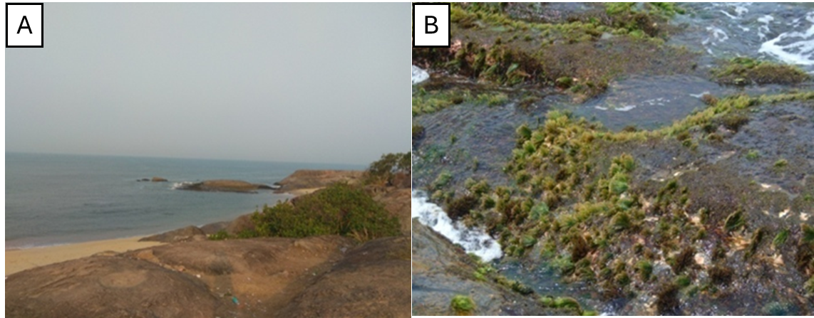
Fig. 1. Photographs of the sampling site and associated macroalgae. (A) Someshwara Beach, Mangalore (12.78°N, 74.85°E). (B) Macroalgae growing on the rocky substrata at Someshwara Beach, Mangalore.
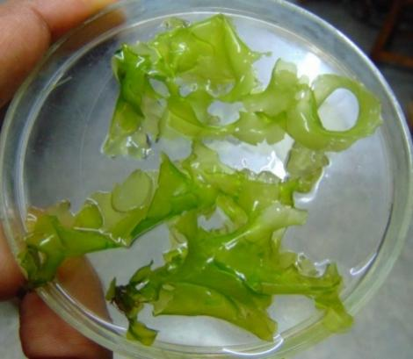
Fig. 2. Green seaweed Ulva lactuca utilized in the present study.
The sterilized U. lactuca thalli were aseptically partitioned into small segments and inoculated onto Potato Dextrose Agar (PDA) supplemented with chloramphenicol (150 mg/L) to suppress bacterial growth. To ensure the efficacy of the surface sterilization, a control was established by plating the final rinse water. All plates were sealed and maintained at 25 °C for 14 days, following the protocols of Suryanarayanan et al. (2010). Emerging hyphae from the tissue margins were systematically subcultured onto fresh media to achieve axenic cultures. Long-term storage of the pure isolates was managed in Potato Dextrose Broth (PDB) enriched with 30% glycerol at -80 °C.
2.2 Morphological identification of fungi
Hyphae and conidia from purified fungal colonies were mounted on glass slides, stained with lactophenol cotton blue, and examined under an optical microscope at 1000X magnification to observe morphological features (Gilman,1998 and Nagamani et al.,2006).
2.3 Scanning electron microscopy (SEM)
To visualize the micromorphological features of the isolates, mycelial plugs (approx. 0.5 cm²) were excised from actively growing cultures and immediately submerged in modified Karnovsky’s fixative. This solution comprising 2.5% glutaraldehyde and 2.5% paraformaldehyde in a 0.05 M cacodylate buffer with 0.001 M calcium chloride was utilized to chemically stabilize the fungal structures during a 24-hour incubation at 4 °C. Following fixation, the samples underwent a triple rinse with 0.05 M cacodylate buffer, were post-fixed in 1% osmium tetroxide, and subsequently washed with distilled water. A graded acetone series (25%–100%) was employed for dehydration, followed by CO₂-based critical point drying. After gold–palladium sputter coating, imaging was conducted at Mangalore University (Qiu, 2010). Final taxonomic identification was achieved by comparing morphological traits against established keys, including Barnett and Hunter (1971) and Ellis et al. (2007).
2.4 Molecular identification of endophytic fungi
2.4.1 Genomic DNA extraction and PCR amplification
Genomic DNA from fungal isolate was extracted using a conventional method with digestion buffer (10 mM Tris-HCl, pH 8.0; 0.1 M EDTA, pH 8.0; 0.5% Triton X-100; 6 M guanidine hydrochloride; 0.1 M sodium acetate). The internal transcribed spacer (ITS) region of the rDNA was amplified using universal primers ITS1 (5′-TCCGTAGGTGAACCTGCGG-3′) and ITS4 (5′-TCCTCCGCTTATTGATATGC-3′) (White et al., 1990). PCR amplification was carried out under the following conditions: Initial denaturation at 95 °C for 5 min; 35 cycles of denaturation at 94 °C for 1 min, annealing at 55 °C for 30 s, and extension at 72 °C for 1 min; followed by a final extension at 72 °C for 5 min. PCR products were resolved on a 1.2% agarose gel, and bands were visualized under a UV transilluminator (Bio-Rad, USA).
2.4.2 Sequencing and phylogenetic analysis
Purified PCR products were sequenced bi-directionally at Eurofins Genomics (Bangalore, India). The resulting ITS sequences were compared with existing sequences in the NCBI GenBank database using the BLASTN algorithm to determine taxonomic identity based on the highest sequence similarity. The sequences obtained in this study were deposited in GenBank. Multiple sequence alignments were performed using ClustalW (Thompson et al., 1994), and phylogenetic analysis was conducted in MEGA X version 5.2 (Tamura at al., 2011). A Neighbor-Joining tree was constructed using the Kimura 2-parameter model, and branch support was assessed by bootstrap analysis with 1000 replicates.
2.5 Production and recovery of fungal crude extracts
Pure fungal isolate was aseptically inoculated into 1000 ml Erlenmeyer flasks containing 300 ml of potato dextrose broth (PDB) and incubated at room temperature under static conditions for 3–4 weeks. Following fermentation, the culture broth and mycelium were separated by filtration through a double-layered muslin cloth. The mycelial biomass (retentate) was subjected to ultrasonic disruption for 10 min in 300 ml of PDB. Both the sonicated mycelial suspension and culture filtrate were extracted separately using ethyl acetate in a separation funnel. The aqueous phase was re-extracted twice with 300 ml ethyl acetate. Organic phases from each extraction were pooled and evaporated to dryness, and the resulting crude extracts (from both mycelium and broth) were stored at −20 °C until further analysis. (Doaa et al.,2020)
2.6 Evaluation of antimicrobial activity against human and fish pathogens
Dried crude extract (0.1 g each from mycelium and broth) was dissolved in 10 ml of ethyl acetate and used for antimicrobial assays. Antimicrobial activity was evaluated by the well diffusion method on Mueller–Hinton agar (MHA), with each well loaded with 30 μl of extract (Taye et al., 2011). Test organisms included six human pathogens: Staphylococcus aureus, Listeria monocytogenes, Enterococcus faecalis, Pseudomonas aeruginosa, Escherichia coli, and Candida albicans, and four fish pathogens: Aeromonas hydrophila, Edwardsiella tarda, Vibrio harveyi, and Vibrio vulnificus. Tetracycline (30μg) served as the positive control, while ethyl acetate was used as the negative control. All experiments were performed in triplicate, and zones of inhibition (ZOI) were measured using an Antibiotic Zone Scale (Hi-Media).
2.7 Determination of DPPH activity
The free radical-scavenging activity was determined using the DPPH (2,2-diphenyl-1-picrylhydrazyl) method described by Brand-Williams et al. (1995), with slight modifications. The ethyl acetate extract (100 - 500 μg/ml) were taken different tubes and the volume was adjusted to 1 ml using methanol. Standard ascorbic acid (100 - 500 μg/ml) used as positive control. Then, 3 ml of 0.1 M DPPH solution (Sigma, USA) was added to each tube and mixed thoroughly using a vortex mixer (REMI, India). The reaction mixtures were incubated in the dark at room temperature for 30 minutes. Absorbance was measured at 517 nm using a UV-visible spectrophotometer. The test was performed in triplicate and the results were presented as mean ± SD. The percentage of DPPH radical scavenging activity was calculated using the following equation:
$$Inhibition \% =\frac{Absorbance of DPPH solution -Absorbance of sample }{Absorbance of DPPH solution }×100$$
2.8 Determination of nitric oxide radical scavenging assay (NORSA)
The nitric oxide–scavenging activity of the extracts was determined by Griess-ilosvay reaction, as outlined by Danagoudar et al. (2017). A 3 ml reaction mixture containing 2 ml of 10 mM sodium nitroprusside, 0.5 ml phosphate-buffered saline (PBS), and 0.5 ml of either standard ascorbic acid or ethyl acetate extract (100–500 μg/ml) was prepared. The mixture was incubated at 25 °C for 150 min under light to induce nitric oxide generation. Subsequently, 0.5 ml of the reaction mixture was transferred to a fresh test tube and mixed with 1 ml of sulfanilic acid reagent (0.33% in 20% glacial acetic acid). After 5 min of diazotization, 1 ml of naphthylethylenediamine dihydrochloride (NED) solution was added, mixed gently, and incubated for 30 min at room temperature for color development. Absorbance of the resulting pink chromophore was measured at 546 nm using a UV–visible spectrophotometer. Phosphate buffer served as the blank, and ascorbic acid was used as the positive control. The percentage inhibition of nitric oxide was calculated using the equation:
$$Inhibition \% =\frac{Absorbance of control-Absorbance of sample /standard}{A control }×100$$
2.9 Determination of total antioxidant capacity (TAC) assay
The total antioxidant capacity of the extracts was determined using the phosphomolybdenum method described by Kanner et al. (1994) with slight modifications. Ethyl acetate extract (1mg/ml) was mixed with 3 ml of phosphomolybdate reagent (0.6 M H₂SO₄, 4 mM ammonium molybdate, and 28 mM sodium phosphate) in a test tube and incubated at 95 °C for 90 min. After cooling to room temperature, absorbance was measured at 695 nm using a UV–visible spectrophotometer (Shimadzu, USA). Total antioxidant content was expressed as ascorbic acid equivalents (AAE). All assays were performed in triplicate, and results were presented as mean ± SD.
2.10 Determination of total phenolic content (TPC)
The total phenolic content of the extracts was determined using the Folin–Ciocalteu method described by Yadav et al. (2014). Ethyl acetate extract (1 mg/ml) and standard tannic acid (0.1 mg/ml) were used for the assay. To each tube, 0.5 ml of Folin–Ciocalteu reagent (1:1 dilution) and 2.5 ml of 20% sodium carbonate solution were added, and the final volume was adjusted to 10 ml with distilled water. After incubation, absorbance was measured at 760 nm using a UV–visible spectrophotometer (Shimadzu, USA). Gallic acid was used as the standard, and TPC was expressed as milligrams of gallic acid equivalents (GAE). All measurements were performed in triplicate, and results were expressed as mean ± standard deviation (SD).
3. RESULTS AND DISCUSSION
3.1 Isolation of endophytic fungi
In the present study, five distinct endophytic fungal isolates were obtained from the green seaweed Ulva lactuca collected from the coastal region. Isolation was performed on potato dextrose agar (PDA) supplemented with chloramphenicol to suppress bacterial growth. All isolates exhibited characteristic fungal colony morphology and were subsequently purified for morphological and molecular characterization. Among the five isolates, the three (Penicillium javanicum isolate UL1, Talaromyces sp. Isolate UL2, Chaetomium sp isolate UL37) exhibited the antimicrobial activity in preliminary screening were selected for morphological and molecular identification. Penicillium javanicum isolate UL1 (Figure 3) was one among the three selected isolates. Penicillium species have been frequently reported as endophytes from various seaweeds, including Ulva fasciata (Gamal et al., 2009; Suryanarayanan et al., 2010) and Ulva lactuca (Suryanarayanan et al., 2010; Andrew et al., 2013). The successful isolation of endophytic fungi from seaweed tissues depends largely on the use of stringent sterile techniques, optimized culture conditions, and the intrinsic capacity of fungal strains to grow under in vitro conditions (Guo et al., 2000; Hyde and Soytong, 2008).
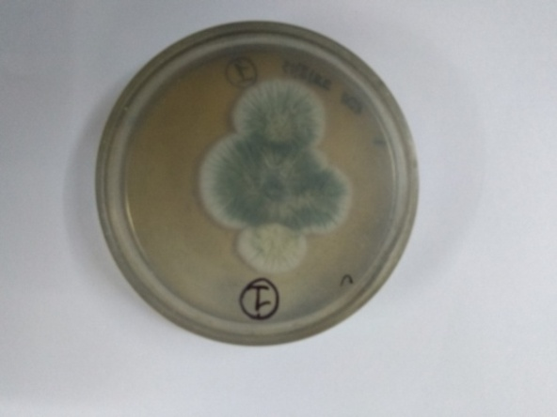
Fig. 3. Colony morphology of Penicillium javanicum isolate UL1 on potato dextrose agar (PDA).
3.2 Identification of endophytic fungi
Optical and scanning electron microscopy revealed septate hyphae with bottle-shaped, unbranched chains of nearly spherical conidia (Figure 4 & 5). The overall morphology displayed the characteristic penicillus or “brush-like” arrangement typical of Penicillium species. The characteristic penicillus arrangement is in agreement with earlier descriptions of Penicillium sp. reported from marine and terrestrial sources. According to Pitt (1979) and Samson et al. (2010), Penicillium species are distinguished by the presence of septate hyphae and brush-like conidiophores bearing unbranched or symmetrically branched chains of conidia. Similar morphological features were also reported in marine-derived Penicillium isolates from Ulva lactuca (Andrew et al., 2013) and Ulva fasciata (Gamal et al., 2009).
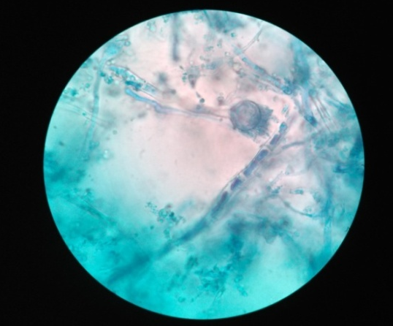
Fig. 4: Optical micrograph of Penicillium javanicum at 100X magnification

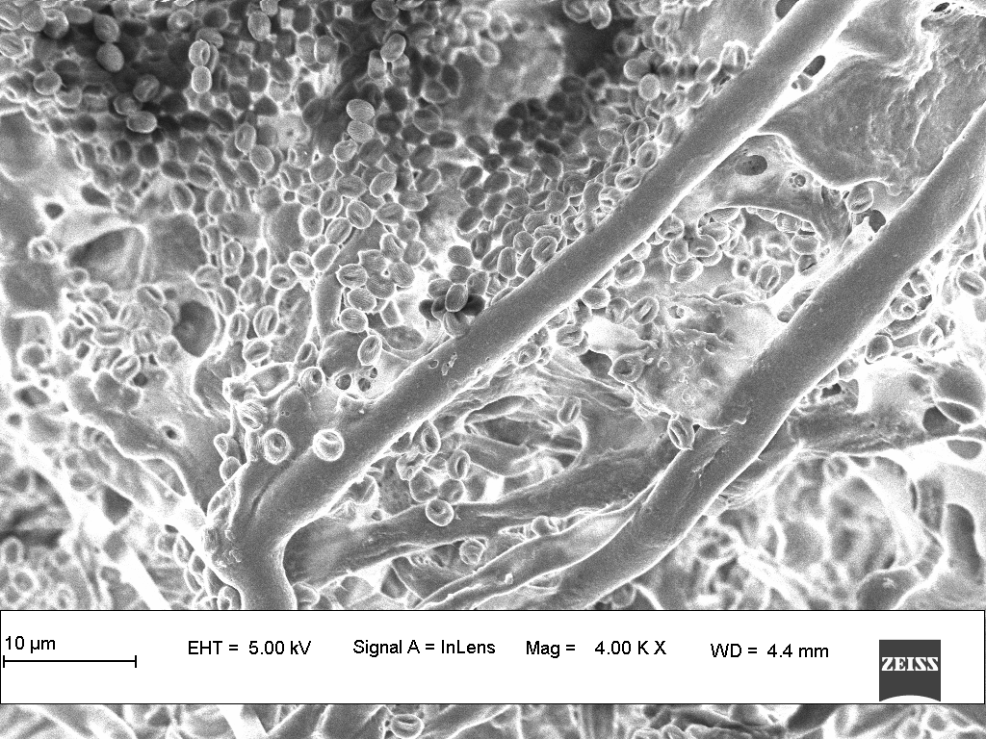
Fig. 5: Scanning electron microscope (SEM) images of Penicillium javanicum isolate UL1 conidiophore stalks and numerous small conidia spore(500x)
PCR amplified ITS sequence showed 100% similarity with Pencillium isolates of the NCBI database. The sequence of the present study was submitted to NCBI GenBank with the Accession No. MN559951. The phylogenetic tree analysis of the ITS sequence of the endophytic fungus and its closest relatives from NCBI showed maximum homology with Pencillium sp. strain FGB7-1 (MK399691.1) (Figure 6). Schoch et al. (2012) identified ITS as the official fungal barcode based on its discriminatory power and availability in public databases like GenBank/NCBI. The initial identification of isolates via the BLAST algorithm is consistent with the methods employed by Arnold et al. (2007) and Gazis and Chaverri, (2015), who also used BLAST to compare endophytic fungal sequences against the NCBI database to determine taxonomic affiliations.

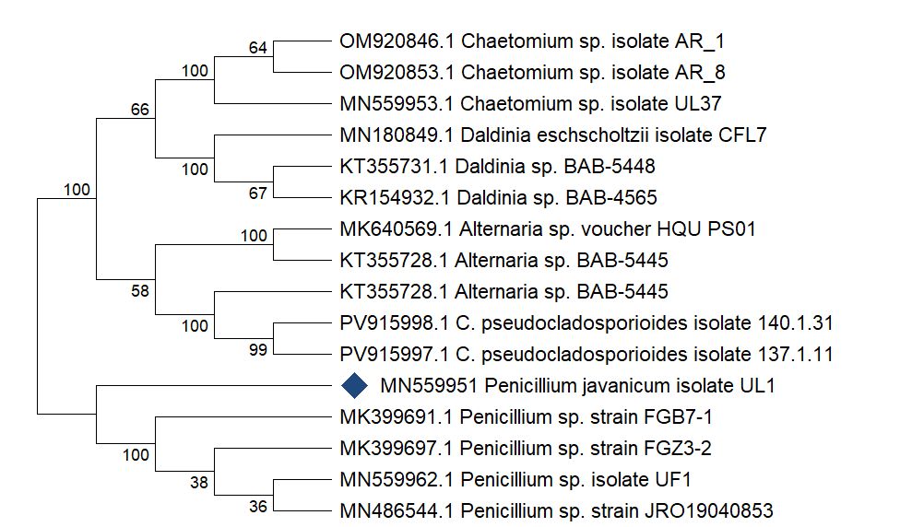
Fig. 6: Neighbor –joining tree for Penicillium javanicum isolate UL1. Tree generated using Mega 5.2 software
3.3 Antimicrobial activity against human and fish pathogens
The broth extract of Penicillium javanicum isolate UL1 (MN559951) inhibited all tested human pathogens except Enterococcus faecalis. The highest inhibition zone was observed against Pseudomonas aeruginosa (17 ± 2 mm), while the smallest was against Staphylococcus aureus (13.6 ± 1.52 mm). Inhibition zones for the remaining pathogens, in ascending order, were Listeria monocytogenes (14 ± 1 mm), Candida albicans (14 ± 2 mm), and Escherichia coli (15 ± 2 mm). The crude mycelial extract inhibited S. aureus, E. faecalis, and P. aeruginosa, with the lowest activity against E. faecalis (8.5 ± 1.63 mm) and the highest against P. aeruginosa (13.6 ± 1.24 mm). Moderate inhibition was recorded for S. aureus (12 ± 0.81 mm) (Table 1, Figure 7).
Table:1 Antimicrobial activity against human pathogens (Diameter of the zone of inhibition in ‘mm’)
Test Organisms | Broth | Mycelium | Tetracycline
Staphylococcus aureus | 13.6±1.52 | 12±0.81 | 17±0.24
Listeria monocytogenes | 14±1 | - | 16±0.47
Enterococcus faecalis | - | 8.5±1.62 | 10±0.81
Pseudomonas aeruginosa | 17±2 | 13.6±1.24 | 12±0.58
Escherichia coli | 15±2 | - | 11±0.81
Candida albicans | 14±2.08 | - | 16±0.94

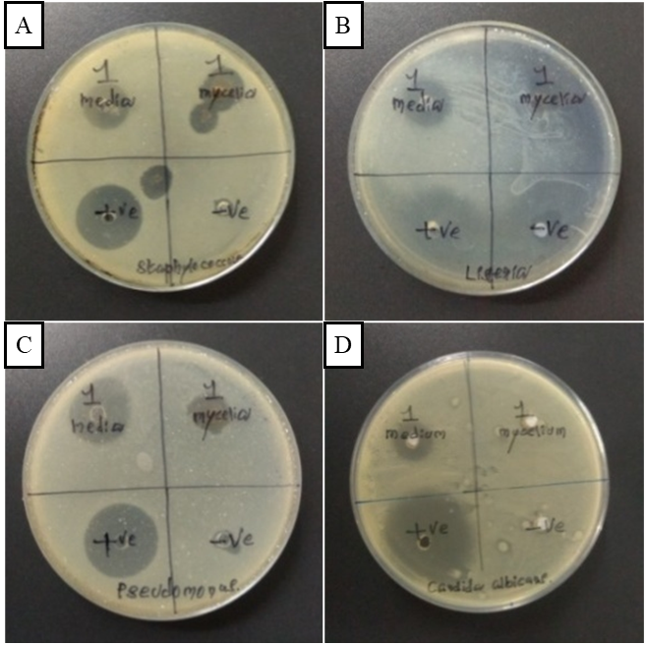
Fig. 7: Antimicrobial activity of test samples against selected human pathogens. Zones of inhibition are shown for: A. Staphylococcus aureus, B. Listeria monocytogenes, C. Pseudomonas aeruginosa, D. Candida albicans.
Against fish pathogens, the broth extract exhibited the strongest inhibitory activity against Edwardsiella tarda (18 ± 2.64 mm), followed by Aeromonas hydrophila (17±1) and Vibrio harveyi (15.6±1.52), whereas its effect was least pronounced against Vibrio vulnificus (15 ± 1.73 mm). In contrast, the crude mycelial extract demonstrated activity solely against Aeromonas hydrophila, producing an inhibition zone of 11.3 ± 1.24 mm (Table 2, Figure 8). Culture filtrates commonly show higher activity than mycelial extracts because many active metabolites are excreted into the medium; similar patterns have been described in previous studies (Wang et al., 2024) of marine endophytic and mangrove-derived Penicillium isolates. Variability in susceptibility across target species (e.g., low activity against E. faecalis) likely reflects the different intrinsic resistance mechanisms of the pathogens and the specific metabolite profile of the extract (Narumon Tangthirasunun et al., 2024).
Table 2: Antimicrobial activity against fish pathogens (Diameter of the zone of inhibition in ‘mm’)
Test Organisms | Broth | Mycelium | Tetracycline
Aeromonas hydrophila | 17±1 | 11.3±1.24 | 12±0.81
Edwardsiella trada | 18±2.64 | - | 8±0.47
Vibrio harveyi | 15.6±1.52 | - | 9.5±1.24
Vibrio vulnificus | 15±1.73 | - | 16±0.94

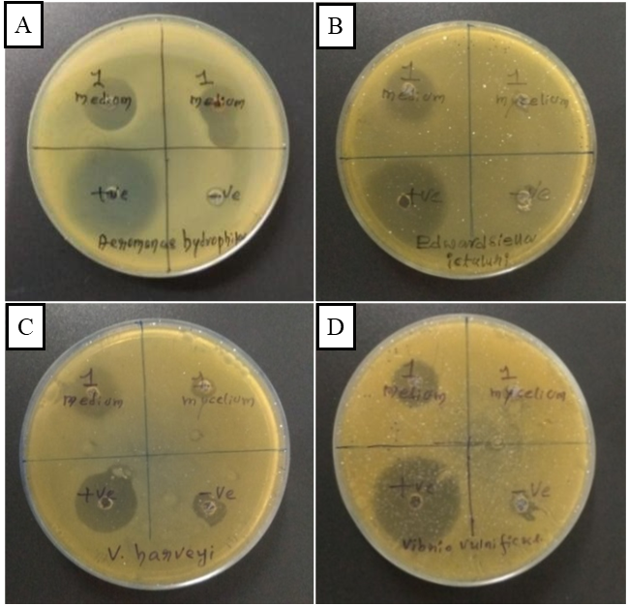
Fig. 8: Antimicrobial activity of test samples against selected fish pathogens. Zones of inhibition are shown for: A. Aeromonas hydrophila, B. Edwardsiella ictaluri, C. Vibrio harveyi, D. Vibrio vulnificus.
3.4 Antioxidant activates
The ethyl acetate extract of Penicillium javanicum isolate UL1 (MN559951) exhibited the highest DPPH radical scavenging activity at 500 µg, with an inhibition of 64.12 ± 0.009%. At 100, 200, 300, and 400 µg, the inhibition values were 23.45 ± 0.032%, 31.53 ± 0.015%, 41.74 ± 0.008%, and 53.73 ± 0.015%, respectively (Table 3; Figure 9). Nitric oxide scavenging activity peaked at 500 µg (62.26 ± 0.011%) and was lowest at 100 µg (45.61 ± 0.015%). Activities at 200, 300, and 400 µg were 50.32 ± 0.015%, 55.68 ± 0.003%, and 59.78 ± 0.010%, respectively (Table 4; Figure 10). The ethyl acetate extract of Penicillium javanicum UL1 showed dose-dependent DPPH and nitric oxide (NO) radical scavenging, reaching 64.1% and 62.3% inhibition at 500µg, respectively. A similar concentration-dependent DPPH trend has been reported for P. javanicum ethyl acetate extracts, where scavenging increased with dose and approached ~70% at 300 µg/ml, supporting the present pattern and magnitude of activity (Begum et al.,2025). Comparable activity has been observed among marine endophytic fungi including Penicillium sp.-isolated from Ulva spp. seaweeds. In a multi-isolate comparison, crude extracts of Ulva-derived endophytes displayed measurable DPPH scavenging indicating that endophyte extracts of Penicillium sp. show meaningful antioxidant capacity consistent with our findings (Noor et al., 2024). Nitric oxide scavenging profile (46–62% across 100–500µg) is also consistent with prior reports for Penicillium sp. (Priyanka and Daljit, 2012). In the present study, total antioxidant and total phenolic contents were recorded as 55.38 ± 1.00 µg/mg, and 40.38 ± 2.00 µg/mg respectively. Total antioxidant indicates a moderate level of antioxidant potential suggests that P. javanicum UL1 possesses meaningful reducing capacity. The relatively high phenolic content observed in the fungal extract may therefore contribute significantly to the antioxidant activity detected in this study. Evernia prunastri hexane extract achieved high phenolic content (~73µgGAE/mg), and demonstrated strong antioxidant activity (Shcherbakova et al., 2021). According to Bajaj (1998), variations in antioxidant and phenolic contents can arise due to several factors, including plant species, extraction solvent, environmental conditions, and methodological differences.

Table 3: DPPH activity of sample and positive control (% of scavenging)
Conc. µg/ml | Penicillium javanicum isolate UL1 | Ascorbic acid
100 | 23.45±0.032 | 80.12±0.008
200 | 31.53±0.015 | 86.54±0.006
300 | 41.74±0.008 | 90.12±0.008
400 | 53.73±0.015 | 97.1±0.004
500 | 64.12±0.009 | 96.85± 0.002

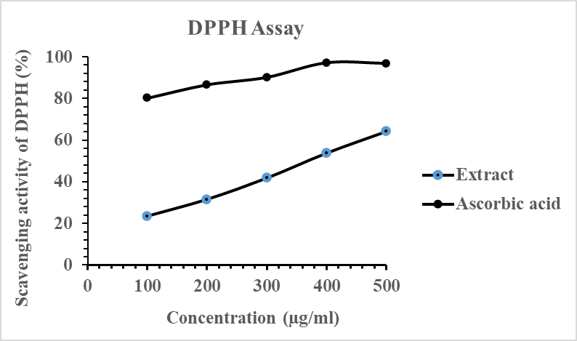
Fig. 9: Graphical representation of percentage scavenging activity of DPPH free radicals against varied concentrations of extract in comparison with ascorbic acid as a standard.

Table 4: Nitric oxide radical scavenging assay (NORSA) (% of scavenging)
Conc. µg/ml | Penicillium javanicum isolate UL1 | Ascorbic acid
100 | 45.61±0.015 | 68±0.008
200 | 50.32±0.015 | 75±0.012
300 | 55.68±0.003 | 76±0.014
400 | 59.78±0.010 | 85±0.008
500 | 62.26±0.011 | 90±0.012

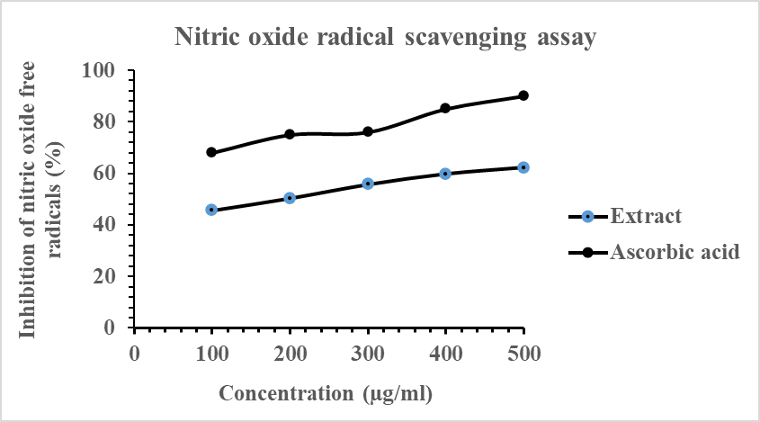
Fig. 10: Graphical representation of percentage scavenging activity of Nitric oxide radical against varied concentrations of extract in comparison with ascorbic acid as a standard.
4. CONCLUSION
In the present study, the endophytic fungus Penicillium javanicum isolate UL1 (MN559951) was successfully obtained from the green seaweed Ulva lactuca. The crude broth extracts demonstrated notable antimicrobial activity, effectively inhibiting both human and fish pathogens, whereas the mycelial extracts showed comparatively weaker effects. The broth extracts exhibited the substantial antioxidant property in scavenging the free radical of DPPH Nitric oxide, and Phenolic content. The fungi relatively showed good antimicrobial and antioxidant activities when compared to other fungi i.e Talaromyces sp. Isolate UL2, Chaetomium sp isolate UL37) of the present study.
CONSENT
Not applicable
ETHICAL APPROVAL
Not applicable
REFERENCES
Ameena, F., AlNadharib, S., & Al-Homaidana, A. A. (2020). Marine microorganisms as an untapped source of bioactive compounds. Saudi Journal of Biological Sciences, 28, 224–231.
Andrew, J. F., Katelyn, T. E., Joseph, S., Erica, F., John, A. J., & Christopher, A. G. (2013). Macroalgal endophytes from the Atlantic Coast of Canada: A potential source of antibiotic natural products. Microorganisms, 1, 175–187.
Arnold, A. E., Luis, C. M., Damond, K., Enith, I. R., Zuleyka, M., Nancy, R., & Edward, A. H. (2007). Fungal endophytes limit pathogen damage in a tropical tree. Proceedings of the National Academy of Sciences, 100(26), 15649–15654. https://doi.org/10.1073/pnas.2533483100 (doi.org in Bing)
Barnett, H. L., & Hunter, B. B. (1971). Illustrated genera of fungi (4th ed.). Burgess Publishing Company.
Barzkar, N., Sukhikh, S., & Babich, O. (2024). Study of marine microorganism metabolites: New resources for bioactive natural products. Frontiers in Microbiology, 14, 1285902. https://doi.org/10.3389/fmicb.2023.1285902 (doi.org in Bing)
Bajaj, Y. P. S. (1998). Biotechnology for the improvement of medicinal plants. Acta Horticulturae, 457, 37–46.
Begum, S. N., Sankareddy, P. D., & Syamprasad, G. (2025). GCMS analysis of anti-diabetic and antioxidant metabolites from Penicillium javanicum NZ JNTU. Biosciences Biotechnology Research Asia, 22(2), 733–745.
Brand-Williams, W., Cuvelier, M., & Berset, C. (1995). Use of a free radical method to evaluate antioxidant activity. Lebenson Wiss Technol, 28, 25–30.
Brundrett, M. C. (2006). Understanding the roles of multifunctional mycorrhizal and endophytic fungi. In Microbial root endophytes. Springer-Verlag.
Clay, K., & Schardl, C. (2002). Evolutionary origins and ecological consequences of endophyte symbiosis with grasses. The American Naturalist, 160(4), 99–127.
Danagoudar, A., Joshi, C. G., Sunilkumar, R., Poyya, J., Nivya, T., Hulikere, M. M., & Appaiah, K. A. (2017). Molecular profiling and antioxidant as well as antibacterial potential of polyphenol-producing endophytic fungus Aspergillus austroafricanus CGJ-B3. Mycology, 8(1), 28–38.
Doaa, M. A. K., Soad, A. E., & Magdi, A. E. (2020). Phytochemical screening and antioxidant potential of endophytic fungi isolated from Hibiscus sabdariffa. Applied Biotechnology Reports, 7(2), 116–124.
Ellis, D., Davis, S., Alexiou, H., Handke, R., & Bartley, R. (2007). Descriptions of medical fungi (2nd ed.). Underdale, South Australia.
Gamal-Eldeen, A. M., Abdel-Lateff, A., & Okino, T. (2009). Modulation of carcinogen metabolizing enzymes by chromanone: A new chromone derivative from algicolous marine fungus Penicillium sp. Environmental Toxicology and Pharmacology, 28, 317–322.
Gazis, R., & Chaverri, P. (2015). Wild trees in the Amazon basin harbor a great diversity of beneficial endosymbiotic fungi: Is this evidence of protective mutualism? Fungal Ecology, 17, 18–29.
Gilman, J. C. (1998). A manual of soil fungi. Biotech Books.
Guo, L. D., Hyde, K. D., & Liew, E. C. Y. (2000). Identification of endophytic fungi from Livistona chinensis (Palmae) using morphological and molecular techniques. New Phytologist, 147, 617–630.
Hyde, K. D., & Soytong, K. (2008). The fungal endophyte dilemma. Fungal Diversity, 33, 163–173.
Kamat, S., Sahana, K., Sarah, P., & Madhuree, K. (2023). Secondary metabolites from marine fungi: Current status and application. Microbial Biomolecules, 181–209.
Kanner, J., Frankel, E., Granit, R., German, B., & Kinsella, J. E. (1994). Natural antioxidants in grapes and wines. Journal of Agricultural and Food Chemistry, 42, 64–69.
Kjer, J., Debbab, A., Aly, A., & Proksch, P. (2010). Methods for isolation of marine-derived endophytic fungi and their bioactive secondary products. Nature Protocols, 5(3), 479–490.
Krings, M., Taylor, T. N., Hass, H., Kerp, H., & Dotzler, N. (2007). Fungal endophytes in a 400-million-yr-old land plant: Infection pathways, spatial distribution, and host responses. New Phytologist, 174, 648–657.
Lv, F., & Zeng, Y. (2024). Novel bioactive natural products from marine-derived Penicillium fungi: A review (2021–2023). Marine Drugs, 22, 191. https://doi.org/10.3390/md22050191
Malinowski, D. P., Alloush, G. A., & Belesky, D. P. (2000). Leaf endophyte Neotyphodium coenophialum modifies mineral uptake in tall fescue. Plant and Soil, 227, 115–126.
Nagamani, A., Kunwar, I. K., & Manoharachary, C. (2006). Handbook of soil fungi. I K International Publishing House Pvt. Ltd.
Tangthirasunun, N., Darbhe, J. B., & Supattra, P. (2024). Antibacterial and lignocellulose-degrading enzyme activities of coprophilous fungi obtained from cow dung in Thailand. Asian Journal of Agriculture and Biology, 4, 1–17. https://doi.org/10.35495/ajab.2023.323 (doi.org in Bing)
Noor, S., Begum, N., Satyajit, R. R., Mohammad, Z. U., Sohrab, M. H., & Abdul, M. M. (2024). Bioactivity and chemical screening of endophytic fungi associated with the seaweed Ulva sp. of the Bay of Bengal, Bangladesh. Botanica Marina, 67(2), 115–129.
Pitt, J. I. (1979). The genus Penicillium and its teleomorphic states Eupenicillium and Talaromyces. Academic Press.
Priyanka, C., & Daljit, S. A. (2012). Optimization of antioxidant potential of Penicillium granulatum Bainier by statistical approaches. ISRN Microbiology, 10. https://doi.org/10.5402/2012/452024 (doi.org in Bing)
Qiu, M., Xie, R., Shi, Y., Zhang, H., & Chen, H. (2010). Isolation and identification of two flavonoid-producing endophytic fungi from Ginkgo biloba L. Annals of Microbiology, 60, 143–150.
Redman, R. S., Sheehan, K. B., Stout, R. G., Rodriguez, R. J., & Henson, J. M. (2002). Thermotolerance generated by plant/fungal symbiosis. Science, 298(5598), 1581–1581.
Rodriguez, R. J., Redman, R. S., & Henson, J. M. (2004). The role of fungal symbioses in the adaptation of plants to high stress environments. Mitigation and Adaptation Strategies for Global Change, 9, 261–272.
Samson, R. A., Houbraken, J., & Thrane, U. (2010). Food and indoor fungi. CBS Laboratory Manual Series 2. CBS-KNAW Fungal Biodiversity Centre.
Schoch, C. L., Seifert, K. A., Huhndorf, S., Robert, V., Spouge, J. L., Levesque, C. A., & Chen, W. (2012). Nuclear ribosomal internal transcribed spacer (ITS) region as a universal DNA barcode marker for fungi. Proceedings of the National Academy of Sciences, 109(16), 6241–6246.
Shcherbakova, A., Strömstedt, A. A., Göransson, U., Gnezdilov, O., Turanov, A., Boldbaatar, D., Kochkin, D., Ulrich-Merzenich, G., & Koptina, A. (2021). Antimicrobial and antioxidant activity of Evernia prunastri extracts and their isolates. World Journal of Microbiology and Biotechnology, 37, 129. https://doi.org/10.1007/s11274-021-03099-y
Suryanarayanan, T. S., Venkatachalam, A., Thirunavukkarasu, N., Ravishankar, J. P., Doble, M., & Geetha, V. (2010). Internal mycobiota of marine macroalgae from the Tamil Nadu coast: Distribution, diversity and biotechnological potential. Botanica Marina, 53, 457–468.
Taye, B., Giday, G., Animus, A., & Seid, J. (2011). Antibacterial activities of selected medicinal plants in traditional treatment of human wounds in Ethiopia. Asian Pacific Journal of Tropical Biomedicine, 2, 370–375.
Wang, B., Cai, J., Huang, L., Chen, Y., Wang, R., Luo, M., Yang, M., Zhang, M., Nasihat, Chen, G., Huang, G., & Zheng, C. (2024). Significance of research on natural products from marine-derived Aspergillus species as a source against pathogenic bacteria. Frontiers in Microbiology, 15, 1464135. https://doi.org/10.3389/fmicb.2024.1464135 (doi.org in Bing)
Yadav, M., Yadav, A., & Yadav, J. P. (2014). In vitro antioxidant activity and total phenolic content of endophytic fungi isolated from Eugenia jambolana Lam. Asian Pacific Journal of Tropical Medicine, 7, 256–261.
Zuccaro, A., Schoch, C. L., Spatafora, J. W., Kohlmeyer, J., Draeger, S., & Mitchell, J. I. (2008). Detection and identification of fungi intimately associated with the brown seaweed Fucus serratus. Applied and Environmental Microbiology, 74(4), 931–941.

