ORIGINAL RESEARCH ARTICLE
Comparative evaluation of selected medicinal plant extracts against multidrug resistant Pseudomonas fluorescens: Evidence for phototherapeutic potential in Kalahandi district, Odisha

Abstract
Background:
The rapid emergence of multidrug-resistant (MDR) bacteria has become a serious global health concern. This has increased the need to explore alternative antimicrobial agents, particularly from medicinal plants known for their rich phytochemical composition.
Methods:
In the present study, ten medicinal plant species were collected from different locations of Kalahandi, Odisha. Ethanolic extracts were prepared using a standard solvent extraction method. Phytochemical screening was carried out to identify major secondary metabolites. The antibacterial activity of the extracts against MDR Pseudomonas fluorescens was evaluated using the well diffusion method at different concentrations (20, 30, 40, and 50 µl). Minimum inhibitory concentration (MIC) was also determined for the most effective extracts.
Results:
Phytochemical analysis revealed the presence of alkaloids, flavonoids, tannins, terpenes, glycosides, and phenolics in most of the plant extracts. Nine out of ten plant species showed antibacterial activity against MDR P. fluorescens. Eucalyptus globulus exhibited the highest activity with zones of inhibition ranging from 1.2 to 1.6 cm, followed by Boswellia serrata (0.4–1.3 cm). Paederia foetida showed minimal activity and was effective only at the highest concentration. A clear dose-dependent increase in antibacterial activity was observed. Some plant extracts showed activity comparable to the standard antibiotic (azithromycin).
Conclusion:
The study reveals strong antibacterial activity of selected medicinal plants against multidrug-resistant Pseudomonas fluorescens. Eucalyptus globulus and Boswellia serrata showed activity comparable to azithromycin. Their dose-dependent effects and rich phytochemical content indicate potential as sustainable, natural sources of novel antimicrobial agents to combat increasing antimicrobial resistance.
Keywords: Medicinal plants; MDR Pseudomonas fluorescens; Antibacterial activity; Phytochemicals; MIC.

1. INTRODUCTION
The emergence and rapid spread of multidrug-resistant (MDR) bacteria have become a serious global public health concern. These bacteria reduce the effectiveness of existing antibiotics and make the treatment of infectious diseases more difficult (Alara & Alara, 2024). Among them, species of the genus Pseudomonas are particularly important due to their intrinsic resistance mechanisms, metabolic adaptability, and ability to acquire and transfer resistance genes (Laborda et al., 2022).
Pseudomonas fluorescens, once considered a non-pathogenic environmental and plant-associated bacterium, is now increasingly recognized as an opportunistic pathogen. It also serves as a reservoir of antimicrobial resistance genes in clinical, agricultural, and environmental settings (Silverio et al., 2022; Behzadi et al., 2022). This bacterium can form biofilms and produce efflux pumps and resistance enzymes, which together contribute to its multidrug resistance. MDR strains of P. fluorescens have been reported from soil, water, food systems, and clinical sources, highlighting their wide distribution and potential risk to human and animal health (Hanim et al., 2025).
Due to the limitations of conventional antibiotics, there is a growing interest in alternative approaches such as ethnopharmacology. Medicinal plants have been used for centuries as primary healthcare resources, especially in rural and indigenous communities. These plants produce various bioactive compounds, including alkaloids, flavonoids, phenolics, tannins, saponins, and terpenoids, which show strong antimicrobial activity (Karunamoothi et al., 2013). Unlike synthetic antibiotics, plant-based compounds often act on multiple targets, reducing the chances of resistance development (Rafeeq et al., 2025).
India is rich in medicinal plant diversity and traditional healthcare systems such as Ayurveda and folk medicine. The state of Odisha, particularly the Kalahandi district, has diverse flora and a strong tradition of ethnomedicinal practices (Afreen et al., 2021). Tribal communities in this region use local plants to treat infections, wounds, and other diseases. However, scientific validation of these plants against MDR pathogens is still limited (Sahoo, 2011).
Therefore, the scientific study of ethnomedicinal plants from regions like Kalahandi is important. It helps validate traditional knowledge and identify new bioactive compounds with potential pharmaceutical use. Evaluating plant extracts against MDR bacteria can provide insights into their effectiveness and support the development of alternative or complementary therapies.
In this context, the present study aims to perform a comparative evaluation of selected ten medicinal plants such as Mimosa pudica, Tamarindus indica, Paederia foetida, Ficus auriculata, Andrographis paniculata, Eucalyptus globulus, Parthenium spp., Boswellia serrata, Phyllanthus emblica, and Dolichandrone falcata, which are traditionally used in the Kalahandi district of Odisha. Plant extracts were tested against MDR P. fluorescens. The study further compares the antibacterial activity of these plant extracts with standard antibiotics to assess their relative effectiveness. The objective is to generate experimental evidence supporting their phototherapeutic potential. The findings of this study are expected to validate traditional knowledge and contribute to the development of plant-based antimicrobial agents for the management of MDR bacterial infections.
2. MATERIALS AND METHODS
2.1. Plant extraction by Soxhlet method
Plant materials of ten selected species were collected from different locations in Kalahandi, Odisha, as shown in Fig. 1.
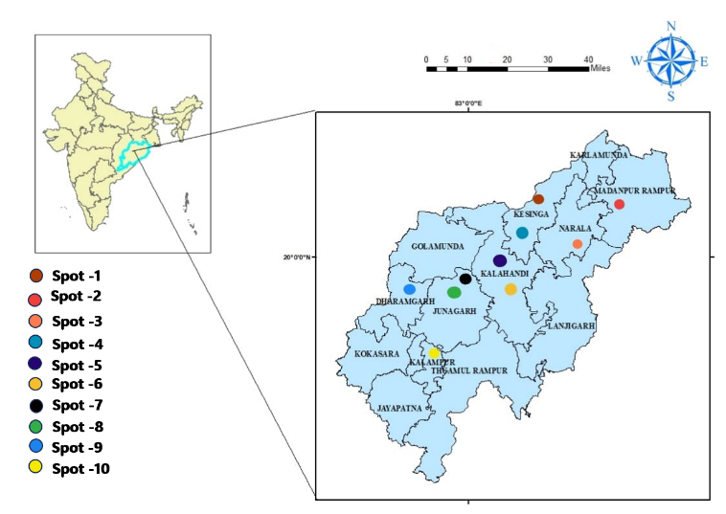
Fig. 1. Map showing the sampling locations in Kalahandi, Odisha: Spot 1 – Kesinga; Spot 2 – Madanpur Rampur; Spot 3 – Narla; Spot 4 – Utkela; Spot 5 – Dadpur; Spot 6 – Bhawanipatna; Spot 7 – Nandul; Spot 8 – Junagarh; Spot 9 – Dharamagarh; Spot 10 – Kalampur.

The extraction process followed the method described by Jhample et al. (2015) with slight modifications. Healthy plants were selected, and leaves were carefully plucked and cleaned. The leaves were washed 3–4 times with tap water and then shade-dried for 7–8 days. The dried leaves were ground into a fine powder using a mortar and pestle. About 10 g of leaf and stem powder from each plant was mixed with 100 ml of ethanol in a 250 ml conical flask and dissolved separately. The mixture was then filtered through eight layers of muslin cloth (Pimsin et al., 2025) to obtain the extract. The filtered extract was poured into medium-sized Petri plates and placed in a water bath at 80°C until it dried into powder form. The dried extract was then gently scraped from the plates using a sterile spatula to obtain the final powder, as shown in Fig. 2.
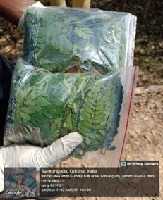 | 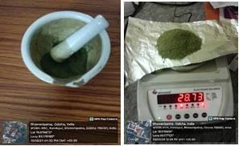 |  | 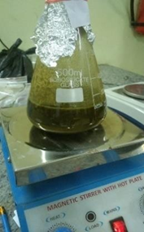
(a) | (b) | (c) | (d)
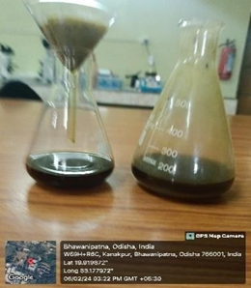 | 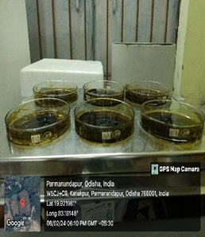 | 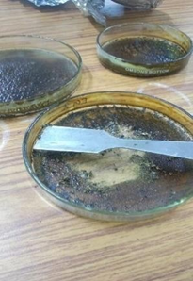
(e) | (f) | (g)

Fig 2. (a) Collected plant sample (b) Shade-dried and crushed powder (c) weighing of crushed powder (d) Powder shocked in distilled water (e) Filtering powder with a muslin cloth (f) Boiling in water bath (g) Scratching of boiled extract powder form

2.2. Secondary metabolites test on different plants
Table 1: Different secondary metabolites test
Tannin test | Few drops of 5% FeCl₃ was added to 2 ml diluted extract.
Terpenoid test | 2 ml of CHCl₃ was added to 5 ml of extract then 3 ml of H₂SO₄ was added to it.
Glycosidic test | Few drops of 10 % FeCl₃ was added to 1ml of extract.  Then 1ml of conc. H₂SO₄(98%) was added to it.
Flavonoid test | 1 ml of 1% NaOH was added to 1ml of extract.
Alkaloid test | 1 ml of Mayer’s reagent was added to 2 ml of extract.

2.3. Antibacterial activity of the plant extracts
2.3.1. Bacterial strains.
The antibacterial potency of each plant extract was evaluated using Multi drug resistance bacterial strains P. florescence causing food poisoning diseases. The bacterial strains were provided from the culture collection of Botany Dept. Maa Manikeshwari University, Kalahandi, Odisha.
2.3.2. Inoculum Preparation
Each bacterial strain was subcultured overnight at 35°C on Mueller–Hinton agar slants. The bacterial growth was collected using 5 ml of sterile saline solution. The absorbance was adjusted at 580 nm using a spectrophotometer. The suspension was then diluted to obtain a final concentration of 10⁷ CFU/ml.
2.3.3. Antibacterial Activity of Plant Extracts
The antibacterial activity of each plant extract was evaluated using the well diffusion method, as described by Nayak et al. (2020). The plant extract residue (50 mg) was re-dissolved in 2.5 ml of ethanol and sterilized using a Millipore filter. Sterile Petri dishes were prepared by pouring 10 ml of Mueller–Hinton agar as the basal layer. This was followed by adding 15 ml of seeded medium inoculated with bacterial suspension (1 ml of 10⁷ CFU/ml in 100 ml medium) to achieve a final concentration of 10⁵ CFU/ml. Wells were made in the agar plates, and 10 mg/ml of sterile plant extract was added to each well. Gentamycin was used as a positive control. The plates were kept at 5°C for 2 hours to allow diffusion of the extracts. They were then incubated at 35°C for 24 hours. The zones of inhibition were measured and recorded as an indication of antibacterial activity.
2.3.4. Determination of Minimum Inhibitory Concentration (MIC)
The MIC is defined as the lowest concentration of an antimicrobial agent that inhibits visible microbial growth after 24 hours of incubation. Plant extracts that showed strong antibacterial activity at 10 mg/ml were selected for MIC determination. Different concentrations of the plant extracts (20 µl, 30 µl, 40 µl, and 50 µl per well) were tested. For comparison, 30 µl of Gentamycin was used as a positive control, and 30 µl of distilled water was used as a negative control. Mueller–Hinton agar plates were prepared and inoculated with bacterial suspensions of pathogenic strains. Wells were filled with different concentrations of the selected plant extracts. The plates were kept at 5°C for 2 hours to allow diffusion and then incubated at 35°C for 24 hours. The zones of inhibition were measured and recorded for each concentration to determine the MIC of the plant extracts.
3. RESULTS
3.1 Plant Extraction Yield
Phytocompounds from selected medicinal plants were extracted using a conventional solvent extraction method with slight modifications. Fresh plant materials were washed thoroughly with tap water followed by sterile distilled water and then shade-dried at room temperature. The dried materials were ground into a fine powder using a sterile mortar and pestle. A known quantity of the powder was soaked in solvent (ethanol/methanol/distilled water) at a ratio of 1:10 (w/v) and kept for 24–72 hours with occasional shaking. The extract was filtered using muslin cloth and Whatman No. 1 filter paper, and the filtrate was concentrated by evaporation to obtain the crude extract. The dried extract was stored at 4°C for further analysis.
3.2. Secondary Metabolite Analysis
Ethanolic extracts of ten plant species were screened for secondary metabolites. The results showed the presence of alkaloids, tannins, terpenoids, and flavonoids in most of the plants (Fig. 2). Mimosa pudica, Andrographis paniculata, Tamarindus indica, Dolichandrone falcata, Ficus auriculata, and Boswellia serrata contained all the tested metabolites. Paederia foetida and Eucalyptus globulus lacked terpenoids and tannins, while Emblica officinalis did not show the presence of flavonoids.
3.3. Antibacterial activity of plants extract
The antimicrobial properties of medicinal plants have been widely reported by researchers over the past three decades. Several studies, including those based on traditional Chinese and Asian medicine, have documented their effectiveness (Palombo and Semple, 2001). In the present study, the selected ten plant species were found to contain various bioactive compounds such as terpenes, tannins, flavonoids, alkaloids, glycosides, and phenolics. The ethanolic extracts of these plants showed inhibitory activity against multidrug-resistant Pseudomonas fluorescens. Out of the ten plant species, nine-Mimosa pudica, Tamarindus indica, Ficus auriculata, Andrographis paniculata, Eucalyptus globulus, Parthenium spp., Boswellia serrata, Phyllanthus emblica, and Dolichandrone falcata exhibited significant antimicrobial activity against MDR P. fluorescens, as presented in Table 2.
Table 2. Qualitative screening of secondary metabolites (terpenes, tannins, flavonoids, alkaloids, glycosides, and phenolics) in ethanolic extracts of selected medicinal plants. Presence (+ve) and absence (−ve) of phytochemicals are indicated.
Sl.no | Plant name | Secondary metabolites/ phytochemicals
Sl.no | Plant name | Terpene  s | Tannins | Flavo  noids | Alkalo  ids | Glyco  sides | Phenoli  cs
1 | Mimosa  pudica | +ve | +ve | +ve | +ve | +ve | +ve
2 | Andrographis  paniculata | +ve | +ve | +ve | +ve | +ve | +ve
3 | Paederia  foetida | -ve | -ve | +ve | +ve | +ve | +ve
4 | Tamarindus  indica | +ve | +ve | +ve | +ve | +ve | +ve
5 | Eucalyptus  globulus | -ve | -ve | +ve | +ve | +ve | +ve
6 | Parthenium sp | +ve | +ve | -ve | +ve | +ve | +ve
7 | Dolichandrone  falcata | +ve | +ve | ++ve | +ve | +ve | +ve
8 | Ficus  auriculata | +ve | +ve | ++ve | +ve | +ve | +ve
9 | Emblica officinalis | +ve | +ve | -ve | +ve | +ve | +ve
10 | Boswellia  serrata | +ve | +ve | +ve | +ve | +ve | +ve

The results of the antimicrobial activity of the plant extracts suggest that multidrug-resistant P. fluorescens can resist several phytocompounds present in the extracts. Therefore, further experiments were conducted to determine the minimum inhibitory concentration (MIC) of the effective plant extracts against MDR P. fluorescens.
3.4 Minimum inhibitory concentrations (MIC’s) of the effective plants extract
Most of the tested plant species showed inhibitory activity at one or more concentrations (20, 30, 40, and 50 µl). However, Paederia foetida did not show any inhibition at 20, 30, and 40 µl, and exhibited only a small inhibition zone (0.2 cm) at 50 µl. Among all the plant species, Eucalyptus globulus showed the highest antibacterial activity. It produced zones of inhibition measuring 1.2, 1.3, 1.5, and 1.6 cm at 20, 30, 40, and 50 µl, respectively. The standard antibiotic azithromycin showed a zone of inhibition of 2.0 cm. The maximum inhibition by Eucalyptus globulus (1.6 cm at 50 µl) was only 0.4 cm lower than the antibiotic, indicating comparable antibacterial potential. Boswellia serrata also showed strong and concentration-dependent activity, with inhibition zones of 0.4, 0.8, 1.1, and 1.3 cm at 20, 30, 40, and 50 µl, respectively. Although its maximum inhibition was lower than the antibiotic control, it showed consistent activity at all concentrations. Overall, the results indicate a clear dose-dependent antibacterial effect of the plant extracts. Eucalyptus globulus and Boswellia serrata were the most effective, showing activity close to that of the standard antibiotic. The detailed results are presented in table 3 and illustrated in Fig. 3.
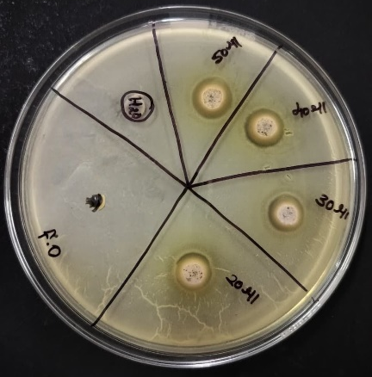 | 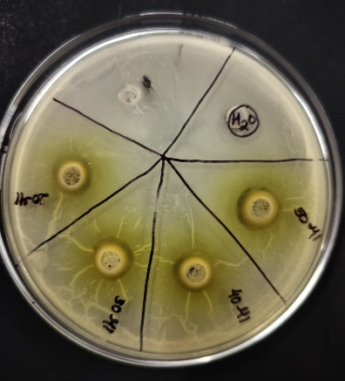 | 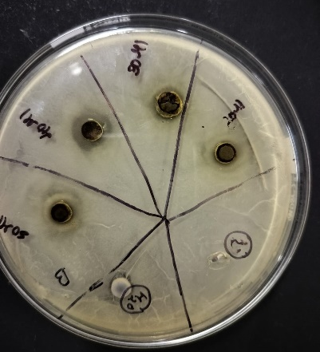
(a) | (b) | (c)
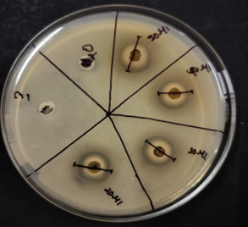 | 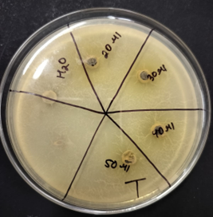
(d) | (e)

Fig 3. Zone of inhibition of different plant extract (a) Mimosa pudica (b) Ficus auriculata (c) Boswellia serrat (d) Eucalyptus globulus (e) Tamarindus indica

Table 3. Comparative study of effect of plant extract and antibiotic against Pseudomonas based on zone of inhibition formation.
Sl. No | Plant name | Water | Antibiotics | 20 µl | 30 µl | 40 µl | 50 µl | Result
1 | Mimosa pudica | 0 | 2 | 0.1 | 0.5 | 0.53 | 0.6 | +ve
2 | Tamarindus indica | 0 | 2 | 0.1 | 0.2 | 0.2 | 0.4 | +ve
3 | Ficus auriculata | 0 | 2 | 0.3 | 0.4 | 0.5 | 0.6 | +ve
4 | Andrographis paniculata | 0 | 2 | 0.2 | 0.4 | 0.4 | 0.3 | +ve
5 | Eucalyptus globulus | 0 | 2 | 1.2 | 1.3 | 1.5 | 1.6 | +ve
6 | Parthenium sps. | 0 | 2 | 0.3 | 0.4 | 0.5 | 0.6 | +ve
7 | Boswellia serrata | 0 | 2 | 0.4 | 0.8 | 1.1 | 1.3 | +ve
8 | Paederia foetida | 0 | 2 | 0 | 0 | 0 | 0.2 | -ve
9 | Phyllamthus emblica | 0 | 2 | 0.2 | 0.3 | 0.3 | 0.4 | +ve
10 | Dolichandrone falcata | 0 | 2 | 0.2 | 0.3 | 0.5 | 0.6 | +ve

4. DISCUSSION
The present study provides a comprehensive evaluation of the antibacterial potential of selected medicinal plant extracts against multidrug-resistant Pseudomonas fluorescens. The increasing prevalence of antimicrobial resistance among pathogenic microorganisms has become a major global concern, reducing the effectiveness of conventional antibiotics and necessitating the search for alternative therapeutic agents (Elshobary et al., 2025). In this context, medicinal plants have gained considerable attention due to their rich content of bioactive phytochemicals and their long history of use in traditional medicine systems. The findings of the present study support this approach and highlight the relevance of plant-based compounds in combating resistant bacterial strains. Phytochemical screening of the selected ten plant species revealed the presence of several important secondary metabolites, including alkaloids, flavonoids, tannins, terpenes, glycosides, and phenolic compounds. These bioactive constituents are well known for their antimicrobial properties and are often responsible for the therapeutic potential of medicinal plants (Shrinet et al., 2021). The presence of these compounds in most of the tested plants indicates their ability to interfere with microbial growth through various mechanisms, such as disruption of cell membranes, inhibition of enzyme activity, and interference with nucleic acid synthesis (Awuchi, 2020). The variation in phytochemical composition among the plants may explain the differences observed in their antibacterial activity.
The antibacterial activity of the ethanolic extracts was evaluated using the well diffusion method. The results demonstrated that most of the plant species exhibited inhibitory effects against multidrug-resistant P. fluorescens. A clear concentration-dependent increase in antibacterial activity was observed, as the zones of inhibition increased with higher extract concentrations (20, 30, 40, and 50 µl). This dose-dependent response suggests that the active compounds present in the extracts become more effective at higher concentrations, which is consistent with previous reports on plant-derived antimicrobials. Among all the tested plant species, Eucalyptus globulus exhibited the highest antibacterial activity. It produced the largest zones of inhibition at all tested concentrations. At the highest concentration (50 µl), it showed a zone of inhibition of 1.6 cm, which was only slightly lower than that of the standard antibiotic azithromycin (2.0 cm). This finding indicates that Eucalyptus globulus possesses strong antibacterial potential and could serve as an effective natural alternative to conventional antibiotics. It was also reported that inhibition of quorum sensing-regulated virulence factors and biofilm formation by Eucalyptus globulus occurs against multidrug-resistant Pseudomonas aeruginosa (Sagar et al., 2022). Several studies have also demonstrated its antimicrobial efficacy against P. aeruginosa with promising results (Pereira et al., 2024; Quatrin et al., 2017). The present study is the first report of its activity against P. fluorescens. This species was isolated for the first time from medical waste in Kalahandi, Odisha, and showed antibiotic susceptibility (Behera et al., 2025). The high efficacy of this plant may be attributed to the presence of essential oils and bioactive compounds such as eucalyptol, which are known for their strong antimicrobial properties. Molecular docking investigations further support its potential for future therapeutic applications (Sharma et al., 2024). Boswellia serrata was the second most effective plant in this study, showing a consistent and concentration-dependent increase in antibacterial activity. Boswellia serrata (Salai/Salai guggul) (Family: Burseraceae; Genus: Boswellia) is a moderate to large-sized branching tree that grows in dry mountainous regions of India, Northern Africa, and the Middle East (Siddiqui, 2011). The resin of Boswellia species has been used as incense in religious and cultural ceremonies and in traditional medicine since time immemorial in Kalahandi, Odisha. Although its maximum inhibition zone (1.3 cm) was lower than that of the antibiotic control, it still demonstrated significant inhibitory effects across all concentrations. This suggests that Boswellia serrata contains potent antimicrobial compounds capable of inhibiting resistant bacterial growth. Recent studies also report its antibacterial activity and molecular characteristics, along with its role in wound healing (Vakayil et al., 2022). Similarly, other plants such as Ficus auriculata, Dolichandrone falcata, Parthenium spp., and Mimosa pudica exhibited moderate antibacterial activity, indicating their potential as supplementary sources of antimicrobial agents. In contrast, Paederia foetida showed very weak antibacterial activity. No inhibition was observed at lower concentrations, and only a minimal zone of inhibition was recorded at the highest concentration. This reduced activity may be due to the absence or low concentration of key phytochemicals such as terpenes and tannins, as observed during phytochemical screening. However, Paederia foetida has been reported to exhibit antimicrobial activity against several microorganisms, including multidrug-resistant Acinetobacter baumannii (Santajit et al., 2025) and Escherichia coli (De et al., 2025). In contrast, Morshed et al. (2012) reported that methanolic extracts of the whole plant showed no antibacterial or antifungal activity. However, n-hexane, chloroform, and ethyl acetate fractions exhibited moderate to low antibacterial activity against certain strains, along with weak antifungal effects. Overall, the findings of the present study suggest that medicinal plants, particularly Eucalyptus globulus and Boswellia serrata, possess strong potential as alternative antimicrobial agents against multidrug-resistant bacteria. Further studies involving isolation and characterization of active compounds, toxicity assessment, and in vivo validation are required to support their development into effective therapeutic agents.
The comparison of plant extracts with the standard antibiotic showed that, although most extracts had lower activity, some plants produced comparable effects at higher concentrations. This finding is important because it indicates that plant-derived compounds can act as potential alternatives or supplements to existing antibiotics, especially against multidrug-resistant bacteria. Plant extracts may also reduce side effects and slow the development of resistance due to the presence of multiple bioactive compounds acting synergistically. The results are consistent with earlier studies reporting strong antimicrobial activity of medicinal plants. Traditional systems such as Ayurveda and Chinese medicine have long used plant-based remedies to treat infections, and the present findings support their scientific relevance in modern healthcare. In addition to antibacterial activity, the phytochemicals identified in this study may also possess antioxidant, anti-inflammatory, and immunomodulatory properties, which can enhance overall therapeutic effects. Thus, these plants may provide multiple health benefits beyond antimicrobial action. However, this study was conducted under in vitro conditions, and further research is needed to confirm efficacy and safety in vivo. Detailed studies on isolation, purification, and characterization of active compounds are required to understand their mechanisms. Toxicity evaluation and clinical trials are also necessary before therapeutic use.
5. CONCLUSION
In conclusion, the study highlights the strong antibacterial potential of selected medicinal plants against multidrug-resistant Pseudomonas fluorescens. Eucalyptus globulus and Boswellia serrata showed particularly high activity, comparable to standard antibiotics (Azithromycin). The dose-dependent response and rich phytochemical content support their role as promising sources of new antimicrobial agents. These findings emphasize the importance of medicinal plants as sustainable and effective options to combat antimicrobial resistance.

6. REFERENCES

- Afreen, S., Syed, W., & Banerjee, S. (2021). Herbal based drug discovery for skin and surgical infectious diseases. Biopharmacological activities of medicinal plants and bioactive compounds, 101.
- Alara, J. A., & Alara, O. R. (2024). An overview of the global alarming increase of multiple drug resistant: a major challenge in clinical diagnosis. Infectious Disorders-Drug TargetsDisorders), 24(3), 26-42.
- Awuchi, C. G. (2020). The biochemistry, toxicology, and Uses of the acologically active phytochemicals: Alkaloids, terpenes, polyphenols, and glycosides. Merit Research Journals, 5(1), 6-21.
- Behera, G., Nayak, N. R., Sahu, A., Dash, R., Sahu, S. R., Meher, S., Khura, P. M., Bhoi, P., & Panigrahi, S. K. (2025). Antibiotic susceptibility and molecular characterization of Pseudomonas fluorescens from hospital biomedical waste in Kalahandi, India. Journal of Advances in Microbiology, 25(4), 65–76. https://doi.org/10.9734/jamb/2025/v25i4918
- Behzadi, P., Ambrosi, C., Scribano, D., Zanetti, S., Sarshar, M., Gajdács, M., & Donadu, M. G. (2022). Current perspectives on Pseudomonas aeruginosa: epidemiology, virulence and contemporary strategies to combat multidrug-resistant (MDR) pathogens. Frontiers in Microbiology, 13, 975616.
- De, D., Karar, I., Paul, B., Chakraborty, N., & Samanta, S. (2025). Influence of extraction solvents on the antibacterial properties of Paederia foetida leaf extracts against E. coli. Carpathian Journal of Food Science & Technology, 17(4).
- Elmaidomy, A. H., Shady, N. H., Abdeljawad, K. M., Elzamkan, M. B., Helmy, H. H., Tarshan, E. A., ... & Abdelmohsen, U. R. (2022). Antimicrobial potentials of natural products against multidrug resistance pathogens: A comprehensive review. RSC advances, 12(45), 29078-29102.
- Elshobary, M. E., Badawy, N. K., Ashraf, Y., Zatioun, A. A., Masriya, H. H., Ammar, M. M., ... & Assy, A. M. (2025). Combating antibiotic resistance: mechanisms, multidrug-resistant pathogens, and novel therapeutic approaches: an updated review. Pharmaceuticals, 18(3), 402.
- Hanim, M. S., Ishamri, L., Nurhayati, Y., Abd Ghani, A., & Tang, J. Y. H. (2025). Pseudomonas fluorescens and P. aeruginosa contaminations of poultry and poultry products: A review on food safety and quality. International Food Research Journal, 32(3), 621-640.
- Hol, W. G., Bezemer, T. M., & Biere, A. (2013). Getting the ecology into interactions between plants and the plant growth-promoting bacterium Pseudomonas fluorescens. Frontiers in plant science, 4, 81.
- Jhample, S. B., Gajdhane, S. B., Kasabe, P. J., Bhagwat, P. K., & Dandge, P. B. (2015). Phytochemical screening and in vitro antimicrobial activity of Tridax procumbens L. Research Journal of Life sciences, Bioinformatics, Pharmaceutical, and Chemical Sciences, 1(1), 42-51.
- Karunamoorthi, K., Jegajeevanram, K., Vijayalakshmi, J., & Mengistie, E. (2013). Traditional medicinal plants: a source of phytotherapeutic modality in resource-constrained health care settings. Journal of Evidence-Based Complementary & Alternative Medicine, 18(1), 67-74.
- Laborda, P., Hernando-Amado, S., Martínez, J. L., & Sanz-García, F. (2022). Antibiotic resistance in Pseudomonas. In Pseudomonas aeruginosa: Biology, Pathogenesis and Control Strategies (pp. 117-143). Cham: Springer International Publishing.
- Morshed, H., Islam, M. S., Parvin, S., Ahmed, M. U., Islam, M. S., Mostofa, A. G. M., & Sayeed, M. S. B. (2012). Antimicrobial and cytotoxic activity of the methanol extract of Paederia foetida Linn.(Rubiaceae). Journal of Applied Pharmaceutical Science, (Issue), 77-80.
- Murugaiyan, J., Kumar, P. A., Rao, G. S., Iskandar, K., Hawser, S., Hays, J. P., ... & van Dongen, M. B. (2022). Progress in alternative strategies to combat antimicrobial resistance: focus on antibiotics. Antibiotics, 11(2), 200.
- Nayak, N. R., Pattnayak, A., & Sahu, A. R. (2020). Screening for Phytochemicals, antimicrobial and anticoagulant activity of aqueous extract of Tridax procumbence. Research and Reviews in Plant Science Volume II, 13(12), 115.
- Palombo, E. A., & Semple, S. J. (2001). Antibacterial activity of traditional Australian medicinal plants. Journal of ethnopharmacology, 77(2-3), 151-157.
- Pereira, V., Dias, C., Vasconcelos, M. C., Rosa, E., & Saavedra, M. J. (2014). Antibacterial activity and synergistic effects between Eucalyptus globulus leaf residues (essential oils and extracts) and antibiotics against several isolates of respiratory tract infections (Pseudomonas aeruginosa). Industrial Crops and Products, 52, 1-7.
- Pimsin, N., Janshongsawang, J., Chanthai, S., Thongsom, M., Nuengmatcha, P., & Porrawatkul, P. (2025). In-Situ Synthesis of AgNPs using Boesenbergia Rotunda L. Extract as Reducing Agent Development of Antibacterial and UV Protective Muslin Fabrics. Trends in Sciences, 22(4), 9476-9476.
- Quatrin, P. M., Verdi, C. M., de Souza, M. E., de Godoi, S. N., Klein, B., Gundel, A., ... & Santos, R. C. V. (2017). Antimicrobial and antibiofilm activities of nanoemulsions containing Eucalyptus globulus oil against Pseudomonas aeruginosa and Candida spp. Microbial pathogenesis, 112, 230-242.
- Rafeeq, A., Arshad, S., Abid, M. A., Sajjad, M. A., Shahzad, M., Qadir, M. L., ... & Majid, B. (2025). Potential of Plant-Derived Phytochemicals in Combating Antimicrobial Resistance: A Comprehensive Review. Journal of Health, Wellness and Community Research, e762-e762.
- Sagar, P. K., Sharma, P., & Singh, R. (2022). Inhibition of quorum sensing regulated virulence factors and biofilm formation by Eucalyptus globulus against multidrug-resistant Pseudomonas aeruginosa. Journal of Pharmacopuncture, 25(1), 37.
- Sahoo, A. K. (2011). Ethnomedicinal Plants Resource of Orissa (Vol. 1). New India Publishing Agency.
- Santajit, S., Thavorasak, T., Horpet, D., Kong-Ngoen, T., Permpoon, U., Kim, C. Y., ... & Indrawattana, N. (2025). Phytochemical inhibition of quorum sensing and biofilm formation by Paederia foetida Linn. against multidrug-resistant Acinetobacter baumannii: An integrated in vitro and in silico investigation. Veterinary World, 18(8), 2181.
- Sharma, D., Bose, D., Yadav, R., Mehta, J., & Jaiswal, A. (2024). Exploring Eucalyptus globulus phytochemicals: Analytical, antibacterial, and molecular docking investigations. The Microbe, 3, 100084.
- Shrinet, K., Singh, R. K., Chaurasia, A. K., Tripathi, A., & Kumar, A. (2021). Bioactive compounds and their future therapeutic applications. In Natural bioactive compounds (pp. 337-362). Academic Press.
- Siddiqui, M. Z. (2011). Boswellia serrata, a potential antiinflammatory agent: an overview. Indian journal of pharmaceutical sciences, 73(3), 255.
- Silverio, M. P., Kraychete, G. B., Rosado, A. S., & Bonelli, R. R. (2022). Pseudomonas fluorescens complex and its intrinsic, adaptive, and acquired antimicrobial resistance mechanisms in pristine and human-impacted sites. Antibiotics, 11(8), 985.
- Tan, E. W., Low, L. H., Atanasov, A. G., & Goh, B. H. (2025). Bridging traditions and technology: the role of ethnopharmacology in shaping next‐generation multidisciplinary researchers. Pharmacology Research & Perspectives, 13(1), e70074.
- Vakayil, R., Kabeerdass, N., Murugesan, K., Shanmugam, G., Ramasamy, S., & Mathanmohun, M. (2022). Antibacterial activity and molecular characteristics of Indian Olibanum (Boswellia serrata) phytochemicals: an in silico approach. Applied Ecology & Environmental Research, 20(2).

