Original Research Article
Integrative Evaluation of MIC, LD₅₀, and Anti-virulence Properties of Herbal Extracts Targeting Aeromonas hydrophila
Abstract
Aeromonas hydrophila is a major bacterial pathogen that causes significant economic losses in freshwater aquaculture, highlighting the need for alternatives to conventional antibiotics. This study evaluated the antibacterial activity of neem (Azadirachta indica), tulsi (Ocimum sanctum), and their combined formulations against A. hydrophila using agar well diffusion and resazurin-based broth microdilution assays with aqueous and ethanolic extracts, as well as an in vivo assessment of pathogen virulence in common carp (Cyprinus carpio). All herbal preparations exhibited inhibitory activity, with the combined 5% neem + 5% tulsi aqueous extract producing the largest inhibition zone (14.3 ± 0.3 mm), while the corresponding ethanolic formulation showed significantly greater activity (20.6 ± 0.3 mm), although remaining less potent than oxytetracycline. Minimum inhibitory concentration analysis revealed substantially lower MIC values for ethanolic extracts (0.0391% for neem, 0.0195% for tulsi, and 0.0391% for the combined formulation) compared with aqueous extracts (0.625% for individual herbs and 0.0391% for the aqueous combination), indicating enhanced efficacy of ethanol-extracted phytoconstituents and synergistic effects in combined treatments. Pathogenicity trials demonstrated a dose-dependent mortality response in common carp, with mortality reaching ~60% at 1.0 × 10⁸ cfu/ml and declining sharply at lower doses. The LD₅₀ was estimated to be between 1.0 × 10⁷ and 1.0 × 10⁸ cfu/ml, confirming high pathogen virulence. Overall, neem–tulsi formulations, particularly ethanolic extracts, show promise as phytotherapeutic agents for sustainable aquaculture disease management.
Introduction
The growing demand for sustainable aquaculture has intensified efforts to substitute synthetic antibiotics and chemical feed additives with safer and more environmentally sustainable alternatives. Medicinal plants have emerged as prominent candidates, with increasing evidence supporting their ability to promote fish growth, enhance immune function, and improve disease resistance, thereby reducing dependence on conventional antimicrobials.
Plant-derived therapeutics have been integral to human and veterinary health since ancient times, forming the foundation of traditional medicine and numerous modern pharmaceuticals used to treat infectious diseases in humans and livestock. Unlike synthetic pesticides and antibiotics, which are frequently associated with non-target effects, environmental persistence, residues, and the development of resistance, phytochemicals present environmentally sustainable alternatives for disease control. Over the past two decades, agricultural and botanical research has increasingly concentrated on plant-origin compounds with documented antibacterial and antifungal properties to address these limitations (Egamberdieva et al., 2017). Medicinal plants, utilized for centuries against bacterial infections, are rich in structurally diverse secondary metabolites—tannins, terpenoids, alkaloids, flavonoids, steroids, and phenolics—that demonstrate potent in vitro antibacterial activity (Chahal et al., 2016). Within aquaculture, these phytochemicals are gaining recognition as promising alternatives to conventional chemotherapeutics for enhancing fish health and immunity and supporting more sustainable disease management (Pandey et al., 2025). Concerns regarding antibiotic residues, side effects, and antimicrobial resistance have intensified the search for safe immunostimulatory agents, and multiple studies have identified plant extracts as effective fish immunostimulants (Elumalai et al., 2020). Several botanicals, including Allium sativum, Curcuma longa, Zingiber officinale, Azadirachta indica, Ocimum sanctum, and Moringa oleifera, have been shown to improve disease resistance, stimulate digestive enzyme activity, and enhance growth performance through improved nutrient utilization and feed conversion, while simultaneously exhibiting notable antibacterial activity against significant fish pathogens (Sumana et al., 2025).
The necessity for alternative solutions is emphasized by the impact of Aeromonas hydrophila, a gram-negative, facultative anaerobic opportunistic pathogen, which is prevalent in freshwater environments and serves as a primary etiological agent of motile Aeromonas septicemia, hemorrhagic septicemia, and ulcerative conditions in aquaculture. Infections caused by A. hydrophila are facilitated by a range of virulence factors, including hemolysins, proteases, lipases, and enterotoxins, which collectively result in severe tissue damage, systemic disease, and high mortality rates, thereby causing significant economic losses in the aquaculture industry (Baloch et al., 2021; Semwal et al., 2023; Mahmood et al., 2024; Shrivastava et al., 2025). These challenges underscore the urgent need for the development of plant-based interventions that can offer both direct antimicrobial effects and host immunomodulation against Aeromonas infections.
Among the candidate species, Azadirachta indica (neem) has been utilized for over 2000 years in Indian traditional medicine and demonstrates a wide range of biological activities, including anti-inflammatory, antibacterial, antiviral, antioxidant, hepatoprotective, antimutagenic, and anticarcinogenic effects in its leaves, seeds, bark, roots, and other tissues (Madesh et al., 2024). Comprehensive pharmacological evaluations suggest that all parts of the neem tree contribute to resistance against bacterial, fungal, and viral agents while enhancing antioxidant capacity, thereby positioning A. indica as a promising phytobiotic candidate in fish health management (Raihan et al., 2021). Similarly, Ocimum sanctum (tulsi, “holy basil”), long esteemed in Asian medicinal systems as the “queen of plants” and “mother medicine of nature,” exhibits a broad pharmacological profile that includes anti-asthmatic, anti-inflammatory, hypoglycemic, antipyretic, endocrine, antimicrobial, anti-stress, anti-tubercular, antioxidant, and immunomodulatory activities (Pushpam et al., 2017; Jothie Richard et al., 2016; Jayapal et al., 2021; Parveen et al., 2023). Collectively, this expanding body of evidence supports the strategic exploration of neem and tulsi, alongside other medicinal plants, as multifaceted phytobiotic agents capable of providing antimicrobial, immunostimulatory, and performance-enhancing benefits in aquaculture, particularly against A. hydrophila-associated diseases.
In this study, we assessed the in vitro bactericidal efficacy of methanolic and aqueous leaf extracts of A. indica and O. sanctum, and determined their minimum inhibitory concentrations against the fish bacterial pathogen A. hydrophila.
Materials and Methods
Preparation Herbal Extracts
Fresh leaves of Azadirachta indica (neem) and Ocimum sanctum (tulsi) were procured from mature plants maintained in the Medicinal, Aromatic, and Potential Crops Section (GPB) at CCSHAU, Hisar, India. The leaves underwent thorough rinsing with cold tap water, followed by surface disinfection using a 1 ppm potassium permanganate solution, and were subsequently dried in a hot-air oven at 60°C for 24 hours. The dried material was then ground into a fine powder using an electric mixer-grinder and stored in airtight containers until extraction. For the preparation of extracts, 5 g of neem leaf powder, 5 g of tulsi leaf powder, and 5 g of a 1:1 (w/w) neem–tulsi leaf powder mixture were each combined with 100 ml of distilled water (for aqueous extracts) or 100 ml of ethanol (for ethanolic extracts). Extractions were conducted using a Soxhlet apparatus at 60°C for 5–6 hours, after which the solvent phases were filtered through Whatman filter paper to obtain clear crude extracts for subsequent bioassays.
Bacterial Strain
A pure culture of Aeromonas hydrophila (MTCC 1739) was procured from the Microbial Type Culture Collection and Gene Bank (MTCC) at the CSIR–Institute of Microbial Technology, Chandigarh, India. The isolate was inoculated into nutrient broth (HiMedia, India) and incubated at a temperature range of 28–30°C for 24 hours under aerobic conditions. Post-incubation, the culture was subjected to centrifugation at 5,000 rpm for 5 minutes, and the resulting pellet was washed three times with phosphate-buffered saline (PBS; pH 7.4) to eliminate residual media. Subsequently, the bacterial suspension was adjusted spectrophotometrically to an optical density of 0.7 at 600 nm, which corresponds to approximately 4x10⁶ CFU/mL, as verified by serial dilution and viable plate count (Harikrishnan et al., 2010).
Lethal Dose (LD₅₀) Assessment of Aeromonas hydrophila in Common Carp
Common carp (Cyprinus carpio) were randomly distributed into 12 aquariums (10 fish per aquarium) with three replicates per dose to determine the median lethal dose (LD₅₀) of Aeromonas hydrophila for disease incidence. Each group received intramuscular injections of 0.1–0.2 mL bacterial suspensions at concentrations of 1×10⁵ cfu/mL, 1×10⁶ cfu/mL, 1×10⁷ cfu/mL, and 1×10⁸ cfu/mL. Mortality was recorded daily for 14 days.
In vitro Antibacterial Activity
Mueller–Hinton (MH) agar plates were used to assess the antibacterial activity of the plant extracts against A. hydrophila. Briefly, 100 µL of the standardized bacterial suspension was spread uniformly over the surface of each MH agar plate using a sterile spreader to obtain a confluent lawn. Wells with diameters of 8 mm were aseptically punched into the agar using sterile micropipette tips, and 100 µL of each test solution (methanolic and aqueous extracts) was dispensed into the respective wells. Oxytetracycline antibiotic discs served as positive controls, and appropriate solvent controls were included. The plates were incubated at 35 ± 2°C for 24 h, and the diameter of the inhibition zones around each well or disc was measured in millimeters. All treatments were tested in triplicate using independent plates.
Minimum Inhibitory Concentrations
The minimum inhibitory concentrations (MICs) of 5% Azadirachta indica (neem), 5% Ocimum sanctum (tulsi), and 5% combined neem–tulsi leaf extracts (aqueous and ethanolic) against Aeromonas hydrophila were determined using a 96‑well broth microdilution assay, as described by Sarker et al. (2007). Crude extracts were prepared at 5% (w/v) and subjected to two‑fold serial dilution in sterile cation‑adjusted Mueller–Hinton broth across the microplate to generate a concentration series suitable for MIC determination, while additional wells containing broth only served as sterility controls. Each well was inoculated with a standardized A. hydrophila suspension and incubated at 35 ± 2 °C for 24 h. To verify viability and increase the sensitivity of detection, resazurin dye was then added to each well and plates were incubated for a further 1–2 h; wells that showed no color change were considered growth‑inhibited, whereas wells that developed color were interpreted as containing metabolically active, surviving bacteria.
Results

Fig.1 Lethal Dose (LD₅₀) Assessment of Aeromonas hydrophila in Common Carp
The lethal dose (LD50) assessment of Aeromonas hydrophila in common carp demonstrated a clear dose-dependent increase in mortality (Figure 1). At the highest bacterial concentration of 1.0 × 10⁸ cfu/ml, mortality reached approximately 60%, indicating severe pathogenicity at elevated exposure levels. A reduction in bacterial concentration to 1.0 × 10⁷ cfu/ml resulted in a marked decrease in mortality to approximately 30%. Further dilution to 1.0 × 10⁶ cfu/ml caused only 10% mortality, while no mortality was observed at the lowest tested concentration of 1.0 × 10⁵ cfu/ml. These findings indicate a strong inverse relationship between bacterial concentration and survival of common carp, with the LD₅₀ estimated to fall between 1.0 × 10⁷ and 1.0 × 10⁸ cfu/ml.
Table 1. Zones inhibition of different plant extracts against Aeromonas hydrophila
S.N. | Extract | Antimicrobial inhibition zones (mm)
S.N. | Extract | Aqueous extract | Ethanolic extract
1. | 5% Neem extract | 12.3± 0.3 | 17.6± 0.3
2. | 5% Tulsi extract | 10.3± 0.3 | 12.0± 0.5
3. | 5% Neem+ Tulsi extract | 14.3± 0.3 | 20.6± 0.3
4. | Oxytetracycline | 25.3± 0.3 | 26.0± 0.5

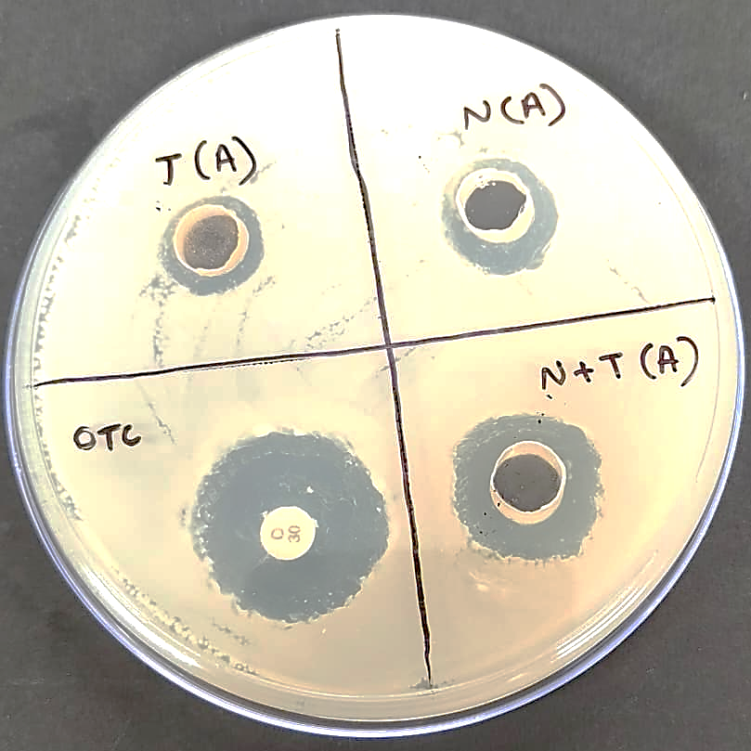 | 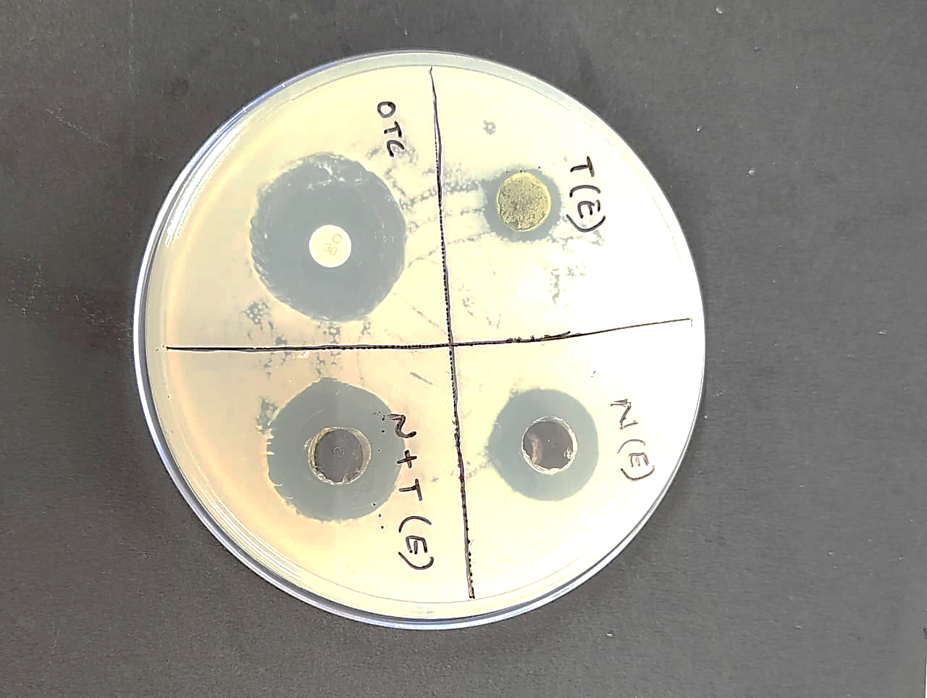
Fig.2. Zones of inhibition produced by aqueous herbal extracts against Aeromonas hydrophila. | Fig.3. Zones of inhibition produced by ethanolic herbal extracts against Aeromonas hydrophila.

The agar well diffusion assay demonstrated that both ethanolic and aqueous preparations of neem, tulsi, and their combination produced clear zones of inhibition against Aeromonas hydrophila, confirming the pathogen's susceptibility to these botanical extracts. Among the aqueous extracts (Fig.2), the combined 5% neem + 5% tulsi formulation generated the largest mean inhibition zone (14.3 ± 0.3 mm), followed by 5% neem (12.3 ± 0.3 mm) and 5% tulsi (10.3 ± 0.3 mm), suggesting a modest synergistic or additive interaction between the two plants, although all were substantially less active than the positive control oxytetracycline (25.3 ± 0.3 mm). Larger zones were observed for the ethanolic extracts (Fig.3), with the 5% neem + 5% tulsi ethanol preparation (20.6 ± 0.3 mm) outperforming the single-plant ethanolic extracts of neem (17.6 ± 0.3 mm) and tulsi (12.0 ± 0.5 mm), yet still not matching the inhibition produced by oxytetracycline (26.0 ± 0.5 mm), consistent with the recognized ability of ethanol to solubilize a broader spectrum of antimicrobial phytochemicals than water. Overall, these diffusion data highlight the superior antibacterial efficacy of ethanolic over aqueous herbal preparations and the consistently enhanced activity of the neem–tulsi combination relative to individual plant extracts, while situating their performance below that of the conventional antibiotic control.
Minimum Inhibitory Concentration
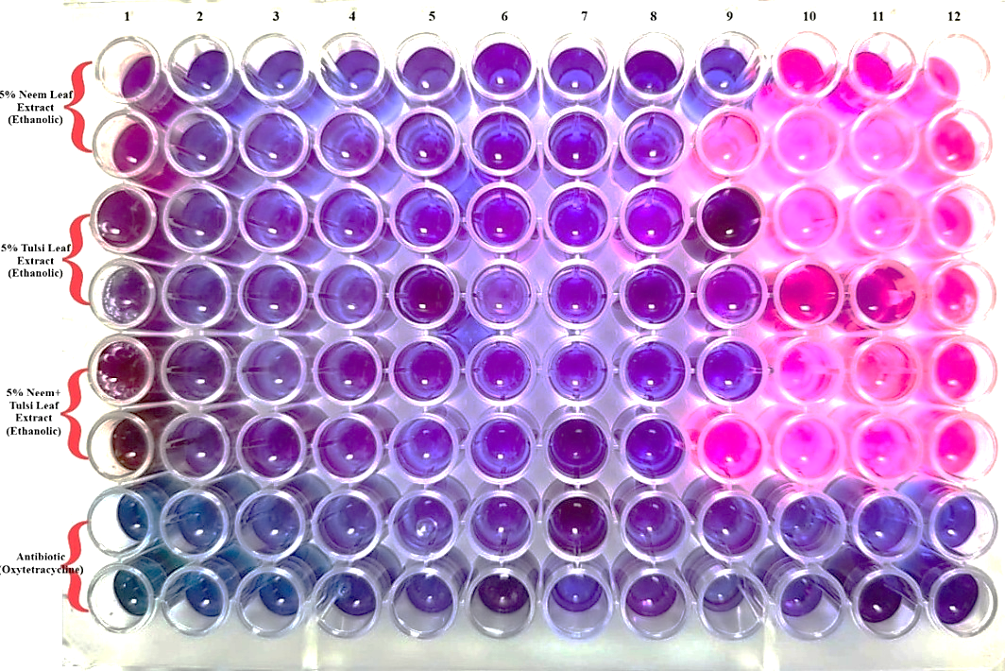
Fig. 4 Minimum inhibitory concentrations of ethanolic herbal extracts against Aeromonas hydrophila determined by a 96-well microdilution assay.
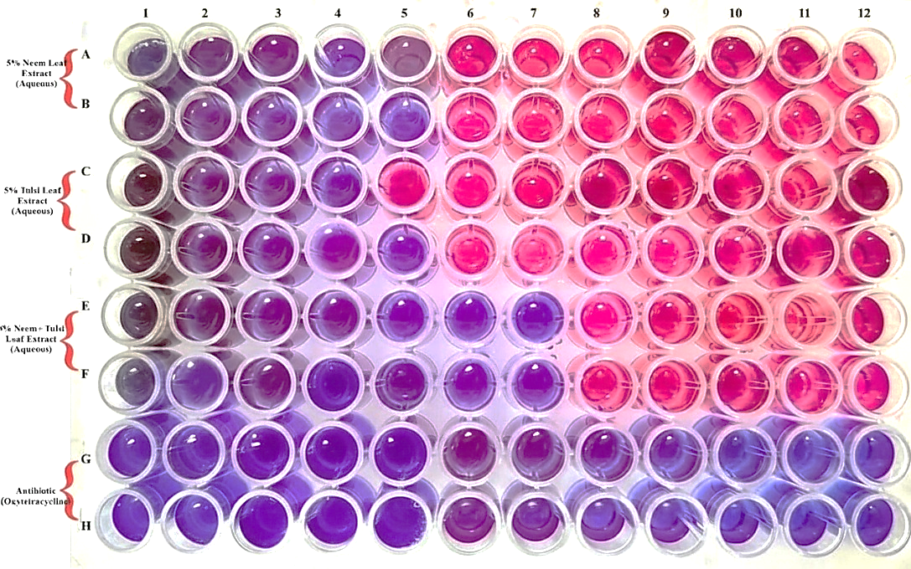
Fig. 5 Minimum inhibitory concentrations of aqueous herbal extracts against Aeromonas hydrophila determined by a 96-well microdilution assay.

Visual inspection of the resazurin-based broth microdilution plates revealed a distinct color change from purple (indicating no growth) to pink (indicating bacterial growth), facilitating precise MIC determination for both ethanolic and aqueous herbal extracts against A. hydrophila. In the ethanolic series, exceptionally low MICs were recorded, with 5% neem, 5% tulsi, and a combined 5% neem + tulsi extracts inhibiting A. hydrophila at concentrations of 0.0391%, 0.0195%, and 0.0391%, respectively (wells 8–9), demonstrating the high antibacterial potency of the ethanol-extracted phytoconstituents. Conversely, the aqueous preparations showed higher MICs: both 5% neem and 5% tulsi leaf extracts inhibited visible growth only up to 0.625%, whereas the aqueous 5% neem + 5% tulsi combination achieved a lower MIC of 0.0391%, indicating a synergistic interaction even in water-based extracts. Overall, the significantly lower MIC range for the ethanolic formulations (0.0195–0.0391%) compared to most aqueous counterparts (0.0391–0.625%) highlights the superior antibacterial efficacy of ethanol-derived neem and tulsi extracts against A. hydrophila, while also emphasizing the enhanced activity of the combined preparations in both solvent systems.
Discussion
The present findings substantiate the increasing body of evidence suggesting that plant-derived extracts serve as a viable alternative or complement to conventional antibiotics for managing A. hydrophila in aquaculture systems. In this study, ethanolic extracts of Ocimum sanctum, Azadirachta indica, and their combination exhibited distinct inhibition zones and low minimum inhibitory concentration (MIC) values against the gram-negative pathogen A. hydrophila, corroborating the widely reported superior antimicrobial efficacy of ethanolic over aqueous herbal preparations. These results are consistent with the work of Harikrishnan and Balasundaram (2005), who demonstrated the effective inhibition of A. hydrophila by aqueous and ethanolic decoctions of Curcuma longa, O. sanctum, and A. indica, with neem and tri-herbal (1:1:1) formulations showing particularly strong activity. Subsequent studies have further documented the broad-spectrum antibacterial potential of organic solvent neem extracts against a range of fish and non-fish pathogens, including Bacillus subtilis, Streptococcus iniae, Pseudomonas aeruginosa, Escherichia coli, P. stutzeri, Aeromonas junii, and A. veronii (El Mahmood et al., 2010; Abalaka et al., 2012; Kavitha et al., 2017). Additional support is provided by Wattanuruk and Detraksa (2023), who reported the inhibitory effects of crude ethanolic herbal extracts against A. hydrophila, Streptococcus agalactiae, and Edwardsiella ictaluri, as well as by Olusola et al. (2017), who demonstrated MIC-defined antibacterial activity of neem leaf and turmeric rhizome extracts against fish pathogenic bacteria. Similar broad-spectrum efficacy has also been reported for commercial ethanolic extracts of multiple medicinal plants against key aquaculture pathogens, such as Listonella anguillarum, Yersinia ruckeri, Photobacterium damselae subsp. piscicida, and Lactococcus garvieae (Bulfon et al., 2014). Concurrently, the present pathogenicity assessment confirmed the high virulence of A. hydrophila in common carp, with the LD50 estimated to fall between 1.0 × 10⁷ and 1.0 × 10⁸ cfu/mL, a range consistent with previously reported LD50-96h values of 4.1 × 10⁸ CFU/mL (Samayanpaulraj et al., 2019) and 0.3 × 10⁸ CFU/mL (Alsaphar, 2012). Minor inter-study variations in LD₅₀ are likely attributable to differences in bacterial strain virulence, host size and susceptibility, exposure routes, and environmental conditions. Collectively, these convergent data underscore the substantial antimicrobial potential of ethanol-extracted phytochemicals from neem, tulsi, and other medicinal plants and support the strategic integration of standardized herbal formulations as antibiotic-sparing tools within sustainable aquaculture health management frameworks.
Conclusion
The study indicates that Ocimum sanctum and Azadirachta indica are promising sources of natural antimicrobial compounds for controlling fish diseases in aquaculture, with the combined ethanolic extract of both herbs showing the strongest antibacterial activity and lowest MIC values among the tested formulations. These results support the potential use of standardized neem–tulsi phytopreparations as antibiotics-sparing- interventions and underscore the need for further in vivo experiments to evaluate the efficacy, safety, and metabolite effects of these extracts against a broader range of fish-pathogenic bacteria in relevant fish models.
Referances
- Abalaka, M., Oyewole, O. A., & Kolawole, A. R. (2012). Antibacterial activities of Azadirachta indica against some bacterial pathogens. Advances in life Sciences, 2(2), 5-8.
- Alsaphar, S. A. (2012). Detection and study of the experimental infection of Aeromonas strain in the common carp (Cyprinus carpio L.). Sundus AA Alsaphar and Jamal KH Al-Faragi. The Iraqi Journal of Veterinary Medicine, 36(2), 222-230.
- Baloch, A. A., Abdelsalam, E. E., Piačková, V. (2021). Cytokines studied in carp (Cyprinus carpio L.) in response to important diseases. Fishes, 7(1), 3.
- Bulfon, C., Volpatti, D., & Galeotti, M. (2014). In vitro antibacterial activity of plant ethanolic extracts against fish pathogens. Journal of the world aquaculture society, 45(5), 545-557.
- Chahal, K. K., Monika, M., Dalvir Kataria, D. K., & Ravinder Singh, R. S. (2016). Antifungal potential of dill seed essential oil and its constituents.
- Egamberdieva, D., Wirth, S., Behrendt, U., Ahmad, P., & Berg, G. (2017). Antimicrobial activity of medicinal plants correlates with the proportion of antagonistic endophytes. Frontiers in microbiology, 8, 199.
- El-Mahmood, A. M., Ogbonna, O. B., & Raji, M. (2010). The antibacterial activity of Azadarichta indica (neem) seeds extracts against bacterial pathogens associated with eye and ear infections. J. Med. Plants Res, 4(14), 1414-1421.
- Elumalai, P., Kurian, A., Lakshmi, S., Faggio, C., Esteban, M. A., & Ringø, E. (2020). Herbal immunomodulators in aquaculture. Reviews in Fisheries Science & Aquaculture, 29(1), 33-57.
- Harikrishnan, R., & Balasundaram, C. (2005). Antimicrobial activity of medicinal herbs in vitro against fish pathogen, Aeromonas hydrophila. Fish Pathology, 40(4), 187-189.
- Jayapal, V., Raj, C. V., Muthaiah, M., Chadha, V. K., Brammacharry, U., Selvaraj, S., & Easow, J. M. (2021). In-vitro anti-Mycobacterium tuberculosis effect of essential oil of Ocimum sanctum L. (Tulsi/Basil) leaves. Indian Journal of Tuberculosis, 68(4), 470-473.
- Jothie Richard, E., Illuri, R., Bethapudi, B., Anandhakumar, S., Bhaskar, A., Chinampudur Velusami, C., ... & Agarwal, A. (2016). Anti‐stress Activity of Ocimum sanctum: Possible Effects on Hypothalamic–Pituitary–Adrenal Axis. Phytotherapy Research, 30(5), 805-814.
- Kavitha, M., Raja, M., Kamaraj, C., Karthik, R. R., Balasubramaniam, V., Balasubramani, G., & Perumal, P. (2017). In vitro antimicrobial activity of Azadirachta indica (leaves) against fish pathogenic bacteria isolated from naturally infected Dawkinsia filamentosa (Blackspot barb). Med Aromat Plants (Los Angels), 6(294), 2167-0412.
- Madesh, S., Sudhakaran, G., Sreekutty, A. R., Kesavan, D., Almutairi, B. O., Arokiyaraj, S., ... & Arockiaraj, J. (2024). Exploring neem aqueous extracts as an eco-friendly strategy to enhance shrimp health and combat EHP in aquaculture. Aquaculture International, 32(3), 3357-3377.
- Mahmood, S., Rasool, F., Hafeez-ur-Rehman, M., & Anjum, K. M. (2024). Molecular characterization of Aeromonas hydrophila detected in Channa marulius and Sperata sarwari sampled from rivers of Punjab in Pakistan. Plos one, 19(3), e0297979.
- Olusola, S. E., Fakoya, S., & Omage, I. B. (2017). Antimicrobial activity of leaf extracts of Neem (Azadrichta indica) and Tumeric (Curcuma longa) rhizome against some pathogens isolated from Clarias gariepinus. Journal of Advanced Microbiology, 3(5-6), 238-245.
- Pandey, S., Singh, G., Verma, S., Dahiya, T., Singh, A., Shahi, S., & Tiwari, P. K. (2025). Phytotherapy as a natural alternative to antibiotics in aquaculture. Indian J Anim Health, 64(1), 55-65.
- Parveen, A., Perveen, S., Ahmad, M., Naz, F., & Riaz, M. (2023). Essentials of medicinal and aromatic crops.
- Pushpam, M., Durairajan, P., Arumugam, P., & Patric Joshua, P. (2017). Comparison of antipyretic effectiveness between standard drugs with different doses of Ocimum sanctum Linn (tulsi). World Journal of Pharmaceutical Sciences, 162-167.
- Raihan, T., Azad, A. K., Ahmed, J., Shepon, M. R., Dey, P., Chowdhury, N., ... & Suhani, S. (2021). Extracellular metabolites of endophytic fungi from Azadirachta indica inhibit multidrug-resistant bacteria and phytopathogens. Future Microbiology, 16(8), 557-576.
- Samayanpaulraj, V., Velu, V., & Uthandakalaipandiyan, R. (2019). Determination of lethal dose of Aeromonas hydrophila Ah17 strain in snake head fish Channa striata. Microbial pathogenesis, 127, 7-11.
- Sarker, S. D., Nahar, L., & Kumarasamy, Y. (2007). Microtitre plate-based antibacterial assay incorporating resazurin as an indicator of cell growth, and its application in the in vitro antibacterial screening of phytochemicals. Methods, 42(4), 321-324.
- Shrivastava, Y., Nayak, S. K., & Mogalekar, H. S. (2025). Aquatic Animal Health Management. In Management of Fish Diseases (pp. 189-211). Singapore: Springer Nature Singapore.
- Sumana, S. L., Xue, T., Hu, H., Abdullateef, M. M., Shui, Y., Ayana, G. U., ... & Xiaojun, J. (2025). Medicinal Plants as Ecological Solutions for Fish Growth and Immunostimulatory Effects in Aquaculture. Aquaculture Research, 2025(1), 9778623.
- Wattanuruk, D., & Detraksa, J. (2023). Effect of herbal plant extracts on inhibition of pathogenic bacteria in Nile tilapia (Orechromis niloticus). Journal of Food Health and Bioenvironmental Science, 16(1), 46-53.

