Original Research Article
Green Synthesis and Characterization of AgNPs of Martynia annua Fruit Extract: Evaluation for Their Antioxidant and Antibacterial Activities

Abstract
Sustainable synthesis of metallic nanoparticles using plant derived biomolecules has emerged as an effective strategy to minimize the environmental and biological hazards associated with conventional chemical routes. In the present study, silver nanoparticles (AgNPs) were synthesized using the fruit extract of Martynia annua L., a medicinal plant recognized for its rich phytochemical profile. The fruit extract is abundant in phenolics, flavonoids, tannins and other bioactive phytochemicals that play a crucial role in the reduction and stabilization of AgNPs. The green synthesis approach employed in this study represents an eco-friendly, cost-effective and non-toxic alternative to conventional chemical methods. The formation of silver nanoparticles of M. annua fruit extract (MAF-AgNPs) was confirmed by UV–Visible spectroscopy, which showed a characteristic absorption peak at 432 nm, indicating the successful synthesis of silver nanoparticles. Scanning electron microscopy revealed that the synthesized MAF-AgNPs were predominantly spherical and oval in shape. Fourier transform infrared spectroscopy confirmed the presence of phytochemical functional groups on the nanoparticle surface indicating effective capping by plant biomolecules while X-ray diffraction analysis demonstrated the crystalline nature of the MAF-AgNPs. The antioxidant potential of the green-synthesized MAF-AgNPs were evaluated using in-vitro assays including DPPH, ABTS and FRAP. The results revealed significant free radical scavenging activity highlighting the strong antioxidant potential of silver nanoparticles of M. annua fruit extract. Furthermore, the synthesized MAF-AgNPs exhibited pronounced antibacterial activity against both Gram-negative bacteria (Escherichia coli and Pseudomonas aeruginosa) and Gram-positive (Bacillus subtilis) with comparatively higher inhibitory activity against E. coli suggesting enhanced nanoparticle interaction with the bacterial cell envelope. Overall, this study highlights the dual advantage of using M. annua fruit extract for the green synthesis of silver nanoparticles and for enhancing their antioxidant and antibacterial properties supporting the potential application of these MAF-AgNPs in biomedical and pharmaceutical fields.

Keywords: Antioxidant assays (DPPH, ABTS & FRAP), Kirby–Bauer antibacterial assay, green synthesis, Martynia annua L., Silver nanoparticles (AgNPs)

1. Introduction:
The advancement of nanotechnology especially in the biomedical and pharmaceutical sectors has led to the development of metal-based nanoparticles such as silver nanoparticles (AgNPs) with remarkable applications owing to their antimicrobial, antioxidant, anti-inflammatory and catalytic properties (Ahmed et al., 2016; Iravani et al., 2022). Traditionally AgNPs have been synthesized using physical and chemical methods which are often costly, energy-intensive and environmentally hazardous. In contrast green synthesis techniques particularly those utilizing plant extracts offer an eco-friendly, biocompatible and cost-effective alternative that aligns with sustainable development goals (Salem &Fouda, 2020).
Plant based green synthesis utilizes phytochemicals such as flavonoids, phenolics, terpenoids, tannins and alkaloids that serve dual roles as reducing and capping agents during nanoparticle synthesis (Eker et al., 2025). Numerous medicinal plants have been explored for their nanoparticle synthesis potential including Aloe vera (Chandran et al., 2006), Ocimum sanctum (Rao et al., 2013), Moringa oleifera (Hameed et al.,2021), Azadirachta indica (Kumari et al., 2022) Acalypha indica (Sakaray et al., 2024), Nothaphodyte foetida (Dharavath et al., 2025), Trema Orientalis (Jha et al., 2025) and Convolvulus arvensis (Al-Audah et al., 2026). These biosynthesized nanoparticles exhibit enhanced biological activity and are gaining importance in drug delivery, wound healing and antioxidant therapies (Simon et al., 2022). Among these medicinal plants, Martynia annua L., commonly known as Devil’s Claw or Tiger’s Claw is a plant of significant ethnomedicinal importance. Various parts of the plant including leaves, fruits and roots have been traditionally used for the treatment of skin disorders, wounds, inflammation, infections, epilepsy and alopecia indicating its broad therapeutic relevance (Sharma et al., 2024). Pharmacological studies have further demonstrated biological activities of M. annua, such as hair growth-promoting effects in testosterone-induced alopecia models, supporting its medicinal potential (Itankar et al., 2013). Phytochemical investigations of M. annua have revealed the presence of diverse bioactive constituents including alkaloids, flavonoids, phenolics, tannins, saponins and glycosides and these are known to contribute to antioxidant, antimicrobial and therapeutic activities (Dhingra et al., 2013). Recent studies have reported qualitative phytochemical screening and in-vitro antioxidant evaluation of M. annua leaves collected from Rajasthan, confirming significant free-radical scavenging activity (Sharma et al., 2025a).
In recent years researchers have investigated the use of M. annua extracts for the green synthesis of various nanomaterials. Studies by Thangapushbam et al. (2022) reported the synthesis of AgNPs using aqueous root extract of M. annua with significant antioxidant and antidiabetic activities. Similarly, Duraisamy et al. (2022) synthesized chitosan nanoparticles using the leaf extract demonstrating potent antibacterial effects. Thangapushbam et al., 2024 developed MnO₂ nanoparticles using M. annua extract have also shown promising antioxidant and anti-inflammatory potential. developed silver nanoparticles from root extract (MAR-AgNPs) and carbon dots (MA-CDs) from leaf extract both exhibiting antioxidant, antidiabetic and neuroprotective effects. Moreover, M. annua derived carbon dots (Abbigeri et al. 2025 a) and silver nanoparticles from root extract (Abbigeri et al. 2025 b) both exhibiting antioxidant, antidiabetic and neuroprotective effects. Despite the growing body of research, the use of M. annua fruit extract specifically for nanoparticle synthesis remains largely unexplored. Fruits are known to contain a distinct phytochemical composition compared to roots and leaves often characterized by varying concentrations and profiles of phenolics, flavonoids and other bioactive metabolites (Arshad et al., 2017). The recent evaluation of fruit extracts demonstrated significantly higher antioxidant potential compared to flower and leaf extracts, indicating organ-specific variation in secondary metabolite richness (Sharma et al.,2025b). Such phytochemical variability across plant organs can substantially influence the reducing efficiency, stabilization potential and surface functionalization of biosynthesized silver nanoparticles. Exploring the fruit extract for AgNPs synthesis can thus provide insights into its untapped pharmacological potential.
The present study focuses on the green synthesis of silver nanoparticles using the fruit extract of M. annua followed by characterization using UV–visible spectroscopy, Fourier-transform infrared spectroscopy (FTIR), X-ray diffraction (XRD) and scanning electron microscopy (SEM). The synthesized silver nanoparticles of M. annua fruit extract (MAF-AgNPs) were evaluated for their in-vitro antioxidant activity using DPPH, ABTS and FRAP assays as well as for antimicrobial activity against Gram-negative (Escherichia coli and Pseudomonas aeruginosa) and Gram-positive (Bacillus subtilis) bacteria using the Kirby Bauer disc diffusion method. This study contributes to the field of green nanobiotechnology by highlighting a novel part of M. annua for nanoparticle synthesis and establishing its relevance in multifunctional potential in antioxidant, antimicrobial and biomedical applications (Figure 1).
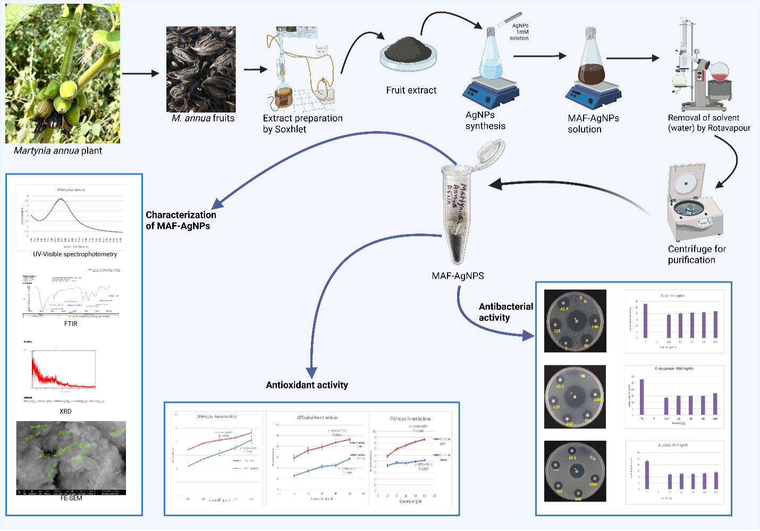
Figure1: Overview of the study including synthesis, characterization, in-vitro antioxidant activity and antibacterial activity of MAF-AgNPs. Created with https://BioRender.com

2. Materials and methods:
2.1. Chemicals and Reagents:
All chemicals and reagents used in the present study were of analytical grade and were procured from HiMedia Laboratories (India) and Merck (India). Silver nitrate (AgNO₃, ≥99% purity), dimethyl sulfoxide (DMSO), ciprofloxacin, DPPH (2,2-diphenyl-1-picrylhydrazyl), FRAP (ferric ion reducing antioxidant power), ABTS (2,2-azino-bis-3-ethylbenzothiazoline-6-sulphonic acid) and methanol were used without further purification. All solutions were freshly prepared using double-distilled water and stored in the dark to prevent photochemical degradation. Glassware employed in the experiments was thoroughly washed with acetone, rinsed with double-distilled water and dried prior to use.

2.2. Plant material:
Fresh fruits of M. annua L. were collected from in and around Jaipur city (Latitude: 27.019447° N, Longitude: 75.878333° E) during the fruiting season (Figure 2A). The plant material was taxonomically authenticated by the Herbarium, Department of Botany, University of Rajasthan, Jaipur, India and a voucher specimen was deposited under accession number RUBL No. 211763. The collected fruits (Figure 2B) were thoroughly washed with tap water followed by double-distilled water to remove adhering soil and debris before further experimental use.
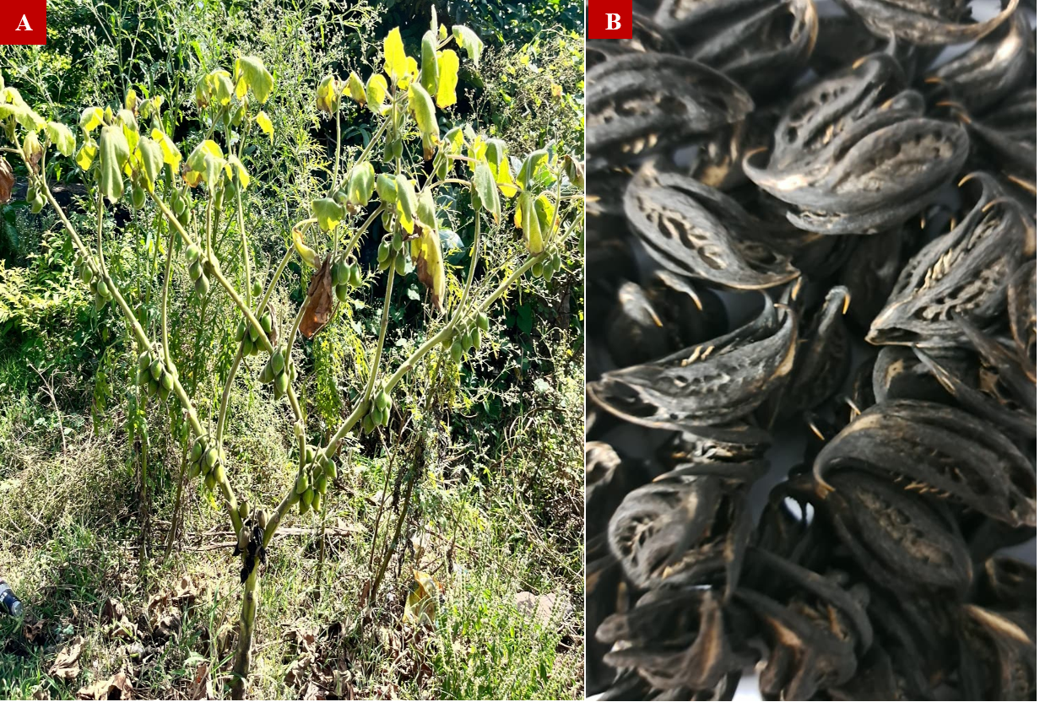
Figure 2: (A) M. annua L. plant showing its natural growth habit with erect stem, broad lobed leaves and clusters of fruits at different developmental stages under field conditions (Plant accession number RUBL No. 211763). (B) Dried mature fruits of M. annua L. exhibiting characteristic curved, horn-like morphology.
2.3 Preparation of Fruit Extract:
The collected fruits were thoroughly washed with distilled water shade dried at room temperature for 10–12 days and subsequently ground into a fine powder. Extract of the fruits was prepared using Soxhlet extraction with a 3:1 methanol-to-water solvent system under at 40-45◦C for 48 hrs. (according to CG-04 protocol, WHO, 1983). The solvent was evaporated to concentrate the M. annua fruit extract (MAF), which was then dried and stored in an airtight container at room temperature for further analysis.

2.4. Green Synthesis of Silver Nano particles (AgNPs):
To synthesize the silver nanoparticles 0.1ml of 1mg/ml solution of MAF was added to 10 ml of 1 mM AgNO₃ solution and mix solutions with the help of magnetic stirrer at 50ºC and 500 revolutions per minute (RPM) for 3 hours. This reaction mixture was incubated in the dark to avoid photo reduction. Following completion of the reaction the reaction mixture was concentrated using a rota vapour under reduced pressure to remove excess solvent. The concentrated suspension was then subjected to centrifugation at 6000 rpm for 15 minutes to pellet the synthesized MAF-AgNPs. The resulting pellet was washed repeatedly with ethanol to remove unreacted silver ions and residual phytochemicals. After washing, the purified MAF-AgNPs were dried in a hot air oven at 30-35°C until a constant weight was achieved. The dried MAF-AgNPs powder was carefully collected and stored in airtight containers at room temperature in the dark for further physicochemical characterization and biological assays (Iravani, 2011).

2.5. Characterization of Synthesized MAF-AgNPs:
2.5.1 UV–Visible Spectroscopy:
The formation of MAF-AgNPs was initially confirmed by UV–Visible spectrophotometry (Thermo Scientific Multiskan GO spectrophotometer). The fruit extract of M. annua served as a reducing and stabilizing agent. Distilled water was used as a blank reference. The absorbance spectrum was recorded in the range of 300–700 nm using a spectrophotometer to detect the characteristic surface plasmon resonance (SPR) band of MAF-AgNPs (Chaudhuri et al., 2016).

2.5.2 Fourier-Transform Infrared Spectroscopy (FTIR):
FTIR spectroscopy was performed to identify the functional biomolecules of M. annua fruit extract responsible for the reduction, capping and stabilization of MAF-AgNPs. The biosynthesized MAF-AgNPs were dried at 37 °C using a hot air oven and mixed with KBr to form pellets by compression under a hydraulic press. FTIR spectrometer (Perkin Elmer Spectrum version 10.4.00) in the range of 4000–400 cm⁻¹ with a resolution of 4 cm⁻¹. The spectra were recorded in KBr pellet mode over the wavenumber range of 4000–450 cm⁻¹.

2.5.3 X-ray Diffraction (XRD):
To investigate the distribution of molecules within the crystalline structure the XRD technique was used. The dried samples were carefully prepared for structural characterization of MAF-AgNPs following the protocol used by Ahmed et al., (2016). The crystalline nature of the synthesized MAF-AgNPs were examined using a PANalytical X’pert PRO X-ray diffractometer system. The measurements were performed with a Cu-Kα radiation source (λ = 1.5406 Å) at an operating voltage of 40 kV and current of 40 mA. Diffraction patterns were recorded in the 2θ range of 20° to 80° with a scanning step size of 0.02° and a counting time of 1 s per step ensuring high resolution phase identification and lattice structure determination. The obtained XRD patterns were analyzed to confirm the crystalline phases and calculate the average crystallite size by the Debye Scherrer equation with the diffraction peaks compared against standard reference data from the Joint Committee on Powder Diffraction Standards (JCPDS) database.
2.4.4 Field Emission Scanning Electron Microscopy (FE-SEM):
The surface morphology and particle size of the synthesized MAF-AgNPs were analyzed using FE-SEM (JEOL JSM-7610F Plus). A thin layer of the dried sample was mounted on an aluminum stub and coated with a 5 nm gold layer by sputter coating to enhance conductivity. The instrument was operated at an accelerating voltage of 5 kV. Images were captured at different magnifications to evaluate the shape, size and surface characteristics of MAF-AgNPs.

2.5. In-vitro Antioxidant Activity:
2.5.1 DPPH Radical Scavenging Assay:
The antioxidant activity of synthesized MAF-AgNPs were evaluated using the DPPH assay as described by Braca et al. (2001) with minor modifications. 1 mL of 0.1 mM DPPH solution in methanol was mixed with 1 mL of MAF-AgNPs solution at various concentrations (25–200 µg/mL). The mixture was incubated in the dark at room temperature for 30 minutes and absorbance was measured at 517 nm using a UV–Visible spectrophotometer (Thermo Scientific Multiscan Go, Finland). Ascorbic acid was used as a positive control. Percentage scavenging activity was calculated using the formula:
Percentage scavenging activity (%) =$(A_{\text{control}}-A_{\text{sample}})/A_{\text{control}}×100$
Where $A_{\text{control}}$is the absorbance of the Ascorbic acid and $A_{\text{standard}}$is the absorbance of MAF-AgNPs solution.

2.5.2 ABTS Radical Cation Decolorization Assay:
The antioxidant activity of synthesized MAF-AgNPs were further evaluated using the ABTS assay as described by Re et al. (1999) with minor modifications. The ABTS•⁺ (ABTS radical cation) working solution was prepared by mixing equal volumes of 7.0 mM ABTS stock solution and 2.45 mM potassium persulfate followed by incubation in the dark at room temperature for 12–16 hr to generate the radical cation. Prior the use ABTS•⁺ solution was diluted with 0.1 M phosphate buffer (pH 7.4) to obtain an absorbance of 0.700 ± 0.020 at 734 nm. For the assay, 3.0 mL of ABTS•⁺ working solution was mixed with 30–60 µL of MAF-AgNPs solution at various concentrations (25–200 µg/mL) and incubated in the dark at room temperature for 6 min. The absorbance was recorded at 734 nm using a UV–Visible spectrophotometer (Thermo Scientific Multiscan Go, Finland). Ascorbic acid was used as the standard antioxidant. Percentage scavenging activity was calculated using the formula:
Percentage scavenging activity (%) =$(A_{\text{control}}-A_{\text{sample}})/A_{\text{control}}×100$
Where $A_{\text{control}}$is the absorbance of the Ascorbic acid and $A_{\text{standard}}$is the absorbance of MAF-AgNPs solution.

2.5.3 Ferric Reducing Antioxidant Power (FRAP) Assay:
The ferric reducing antioxidant power (FRAP) assay was performed according to the modified method described by Pulido et al. (2000). The FRAP reagent was freshly prepared by mixing 300 mM acetate buffer (pH 3.6), 10 mM TPTZ solution, and 20 mM FeCl₃·6H₂O in a 10:1:1 ratio. 100 µL of MAF-AgNPs sample was added to 3 mL of FRAP reagent and incubated at 37 °C for 30 minutes. Absorbance was measured at 593 nm using a UV–Visible spectrophotometer (Thermo Scientific Multiscan Go, Finland). Higher absorbance indicates higher reducing power. Trolox was used as the standard antioxidant and a reagent blank containing FRAP reagent with methanol was used for baseline correction. FRAP activity was expressed as percentage reducing power using the following formula:
Percentage scavenging activity (%) =$(A_{\text{control}}-A_{\text{sample}})/A_{\text{control}}×100$
Where $A_{\text{control}}$is the absorbance of the Trolox and $A_{\text{standard}}$is the absorbance of MAF-AgNPs solution.

2.6. In-vitro Antibacterial Activity:
Antibacterial activity of the synthesized MAF-AgNPs were evaluated using the agar disc diffusion method (Kirby–Bauer method) was carried out as per Christenson et al., (2018). Mueller–Hinton agar (MHA) plates were prepared and uniformly inoculated by spreading 100 µL of freshly grown bacterial suspension over the agar surface. The bacterial strains used in this study included Escherichia coli, Pseudomonas aeruginosa (Gram-negative) and Bacillus subtilis (Gram-positive). The inoculum for each strain was standardized to 0.5 McFarland turbidity, corresponding to an approximate cell density of 1.5 × 10⁸ CFU/mL, prepared from Mueller–Hinton broth. Sterile paper discs were impregnated with 5 µL of MAF-AgNPs suspension at different concentrations (0–200 mg/mL) and placed aseptically on the inoculated agar plates. Discs loaded with solvent alone served as the vehicle control, while a ciprofloxacin disc (4 µg) was used as the positive control. All plates were incubated at 37 °C for 24 h under aerobic conditions. After incubation, the zones of inhibition formed around the discs were measured in millimetres and recorded as an indicator of antibacterial activity.

3. Results:
3.1. Yield of MAF Extract and Synthesized MAF-AgNPs:
The yield of MAF obtained after Soxhlet extraction using a methanol: water (3:1, v/v) solvent system was observed to be 6.21 ± 0.28 gm and that indicates efficient extraction of phytoconstituents from the plant material. The yield of MAF-AgNPs were determined following purification by centrifugation, repeated washing and drying. From a 10 mL reaction mixture containing 1 mM AgNO₃, the dried nanoparticles yielded 2.9 ± 0.2 mg, suggesting efficient bio reduction of silver ions. The consistency in nanoparticle yield reflects good reproducibility of the synthesis process.
The yield of MAF-AgNPs were determined after purification by centrifugation, washing, and drying. From a 10 mL reaction mixture containing 1 mM AgNO₃, the dried MAF-AgNPs yielded 2.9 ± 0.2 mg, indicating good reproducibility and efficient bio reduction of silver ions mediated by phytochemicals present in the fruit extract.

3.2. UV–Visible Spectral Analysis
During the synthesis process a distinct colour change of the reaction mixture was observed, shifting from milky white to light brown and gradually intensifying to a darker brown with time. This progressive colour change reflects the reduction of Ag⁺ ions to metallic Ag⁰ nanoparticles. UV–Visible spectrophotometric analysis performed in the wavelength range of 350–700 nm revealed a characteristic surface plasmon resonance (SPR) band between 410 and 450 nm with a prominent absorption peak (λ_{max}) at 432 nm further supporting the formation of MAF-AgNPs (Figure 3).
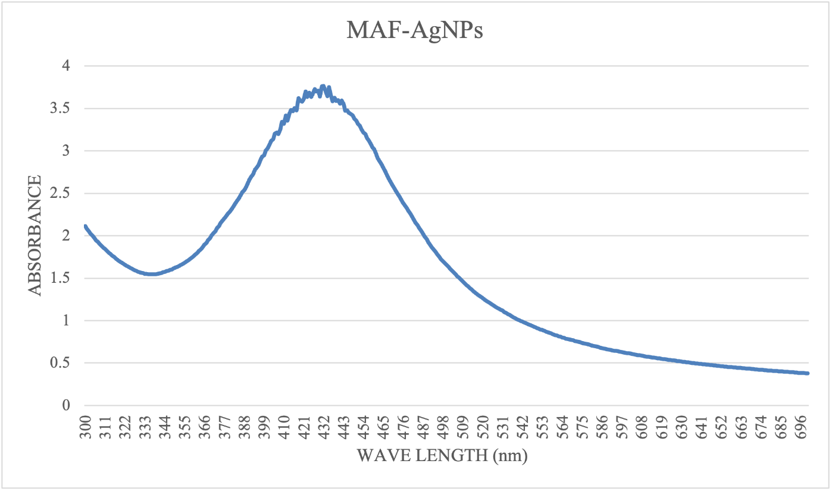
Figure 3: UV–visible absorption spectrum of synthesized MAF-AgNPs showing a characteristic surface plasmon resonance peak around 431–432 nm indicates the formation of nanoparticles.

3.3 Fourier Transform Infrared (FTIR) Analysis

The FTIR spectroscopy was performed to identify the functional groups and chemical interactions involved in the synthesis of MAF-AgNPs. The biomolecules present in the extract were responsible for the reduction of Ag⁺ ions to form stable MAF-AgNPs. The FTIR spectra of both the MAF and the synthesized MAF-AgNPs showed several prominent absorption bands at different wavelengths, corresponding to the presence of functional groups such as hydroxyl (-OH), carbonyl (C=O), alkane (C–H), alkene (C=C) and halo compounds. The shifts in peak positions between the MAF and MAF-AgNPs confirmed the active participation of phytochemicals in the reduction, stabilization, and capping of MAF-AgNPs. Various bands are prominently visible in FTIR spectra of M. annua fruit extract (Figure 5A) at which corresponds to different vibrations of alcoholic O–H stretching, alkane C–H stretching, aromatic compound C-H bending , amine N-H bending, nitro compound N-O stretching, alkene C=C stretching, aldehyde C-H bending, amine C-N stretching, alcohol O-H bending, fluoro compound C-F stretching, alkene C=C bending and halo compound C-X stretching indicating the presence of bioactive phytochemicals responsible for reduction and stabilization (Figure 4A).

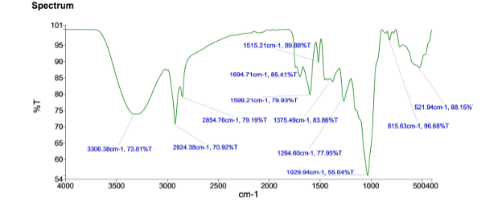
Figure 4(A): FTIR spectrum of synthesized M. annua fruit extract showing characteristic functional groups of bioactive phytochemicals involved in MAF-AgNPs synthesis.
In the spectra of MAF-AgNPs (Figure 4B), a noticeable shift and intensity variation in characteristic peaks were recorded, confirming nanoparticle formation. A broad O–H stretching band was observed at 3426.82 cm⁻¹, signifying the involvement of hydroxyl groups in capping along with a medium conjugated Alkane C-H stretching band at 2923.66 cm⁻¹, alkane C-H stretching band at C-H stretching, Alkene C=C stretching band at 1632.07cm⁻¹, Aldehyde C-H bending band at 1382.69 cm⁻¹, Amine C-N stretching band at 1069.58 cm⁻¹, Alkene C=C bending band at 829.06 cm⁻¹. Additionally, a prominent alkene C=C stretching band was detected at 695.63 cm⁻¹ (Figure 4B).
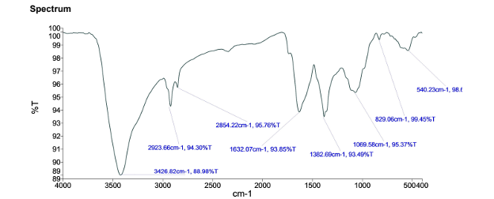
Figure 4(B): FTIR spectrum of synthesized MAF-AgNPs showing characteristic functional groups of bioactive phytochemicals involved in MAF-AgNPs synthesis.
3.4. X-Ray Diffraction (XRD) Analysis
The crystalline structure of synthesized MAF-AgNPs were confirmed by XRD analysis. The diffractogram showed a prominent diffraction peak at 2θ = 32.54°, corresponding to a d-spacing of 2.749 Å, which indicates the formation of crystalline silver nanoparticles. The high-intensity peak suggests a well-defined crystalline nature of the MAF-AgNPs. These results are consistent with the face-centered cubic (FCC) structure of metallic silver, which agrees with previously reported standard JCPDS data (Card No. 04-0783). The sharp and intense peaks further confirm the successful bio reduction of silver ions into stable nanoparticles by phytochemicals present in the fruit extract. The narrow Full Width at Half Maximum (FWHM = 1.152°) indicates the formation of small monodispersed nanoparticles. Using the Debye–Scherrer equation D=0.9λ/βCosθ Where D is the crystallite size, λ= 1.5406 Å is the wavelength of X-ray, β is the full width half maximums (FWHM) of the peak in radians, and θ is the Bragg angle, the crystallite size of the synthesized MAF-AgNPs were approximately 7.2 nm observed (Figure 5).
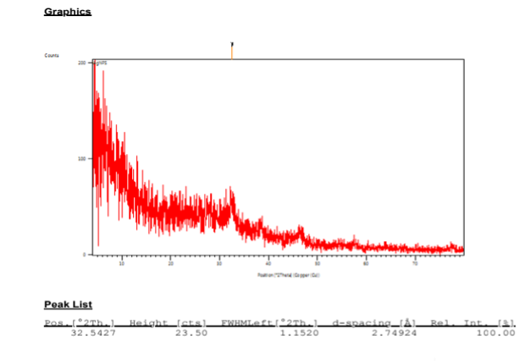
Figure 5: XRD pattern of synthesized MAF-AgNPs showing characteristic diffraction peaks indicative of their crystalline nature.

3.5. Field Emission Scanning Electron Microscopy (FE-SEM) Analysis
FE-SEM was performed to investigate the morphology and surface characteristics of the synthesized MAF-AgNPs (Figure 5). The micrographs revealed that the MAF-AgNPs were predominantly spherical with a uniform size distribution and minimal aggregation suggesting effective stabilization by phytochemical capping agents present in the extract.
The slight aggregation observed indicates the presence of residual surface charges, which is commonly reported in green-synthesized nanoparticles. Furthermore, the FE-SEM images confirmed a crystalline morphology, consistent with the structural properties typically associated with biologically synthesized MAF-AgNPs. The measured particle size ranged between 15.0 nm and 51.91 nm, with the majority of particles below 100 nm (Figure 6).
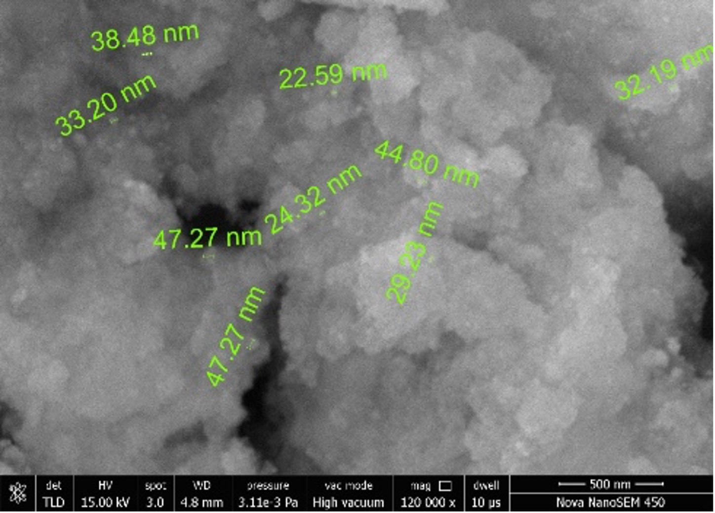
Figure 6: FE-SEM micrograph of synthesized MAF-AgNPs showing predominantly spherical nanoparticles with sizes in the range of approximately 15–50 nm.
3.6. DPPH Radical Scavenging Activity
The in-vitro antioxidant activity of MAF-AgNPs were as calculated by the DPPH free radical scavenging assay with ascorbic acid employed as the standard. The MAF-AgNPs demonstrated a clear concentration-dependent increase in radical scavenging activity across the tested concentration range (Figure 7). The percentage inhibition increased from 43.18 ± 6.29% at 200 µg/ml to 82.91 ± 5.18% at 1000 µg/ml that was indicating strong dose dependent antioxidant potential. In comparison the standard antioxidant exhibited consistently higher scavenging activity at all corresponding concentrations with inhibition values increasing from 67.64 ± 2.12% at 200 µg/ml to 93.40 ± 4.071% at 1000 µg/ml. Although the scavenging efficiency of MAF-AgNPs were lower than that of the standard the nanoparticles indicated moderate antioxidant potential compared to the standard ascorbic acid.

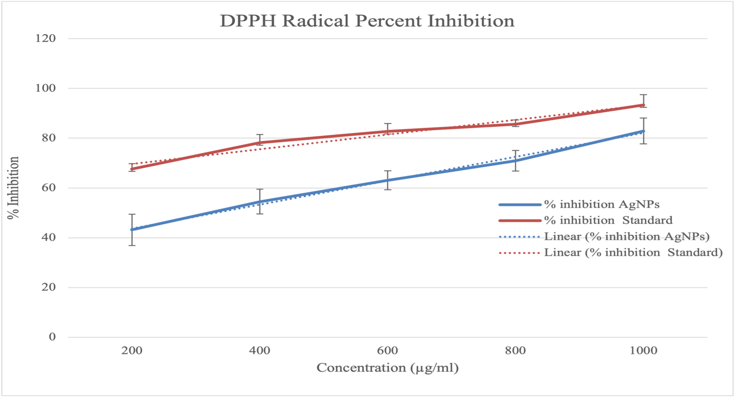
Figure 7: DPPH Radical scavenging activity expressed as % inhibition by MAF-AgNPs at 1 mg/ml concentration compared with ascorbic acid.

3.7. ABTS Radical Scavenging Activity
The ABTS radical cation scavenging assay further confirmed the antioxidant potential of MAF-AgNPs. The nanoparticles exhibited a gradual, concentration-dependent increase in ABTS radical scavenging activity over the tested concentration range (Figure 8). The percentage inhibition increased from 25.42± 3.80 % at 20 µg/ml to 57.23± 1.68 % at 100 µg/ml, indicating a moderate but consistent enhancement in radical scavenging capacity with increasing concentration. In comparison the standard ascorbic acid showed markedly higher ABTS scavenging activity at all corresponding concentrations with percent inhibition values rising from 57.47± 2.39% at 20 µg/ml to 92.69± 1.67 % at 100 µg/ml. Although the scavenging efficiency of MAF-AgNPs were lower than that of the standard antioxidant the observed activity confirms the ability of the biosynthesized nanoparticles to effectively neutralize ABTS radicals in a concentration dependent manner.

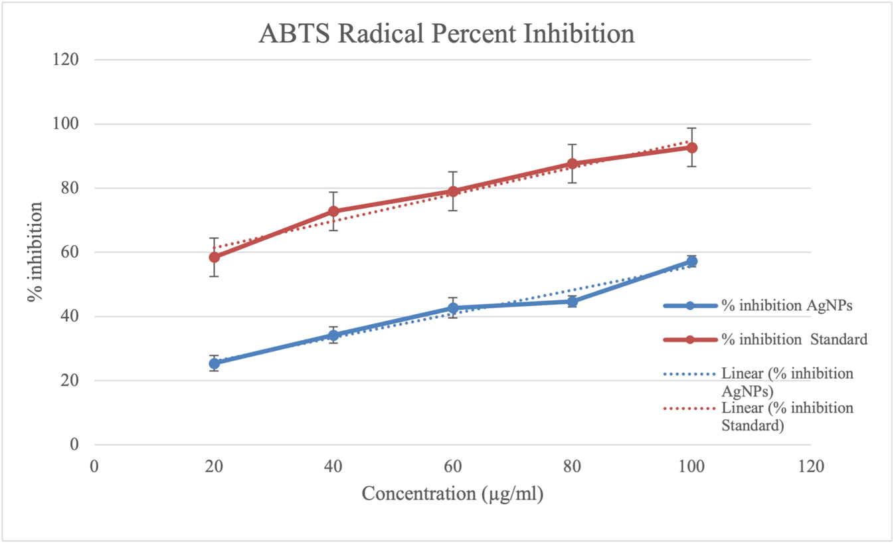
Figure 8: FRAP Radical scavenging activity expressed as % inhibition by MAF-AgNPs at 1 mg/ml concentration compared with ascorbic acid.

3.9. In vitro antibacterial test:
Green-synthesized MAF-AgNPs exhibited broad-spectrum antibacterial activity against both Gram negative (Escherichia coli and Pseudomonas aeruginosa) and Gram positive (Bacillus subtilis) bacteria as assessed by the Kirby Bauer disc diffusion assay. At an effective dose of 20.0 mm, 13.33 mm and 12.0 mm against E. coli, P. aeruginosa and B. subtilis respectively while ciprofloxacin (3–4 µg) showed larger inhibition zones (23–28 mm), validating the assay (Figure9 &11). No inhibitory effect was observed with the solvent control. Overall, Gram negative bacteria were more susceptible to MAF-AgNPs than Gram positive bacteria indicating enhanced nanoparticle cell wall interactions. These findings confirm the potent dose dependent antibacterial efficacy of synthesized MAF-AgNPs and highlight their potential as eco-friendly antimicrobial agents.
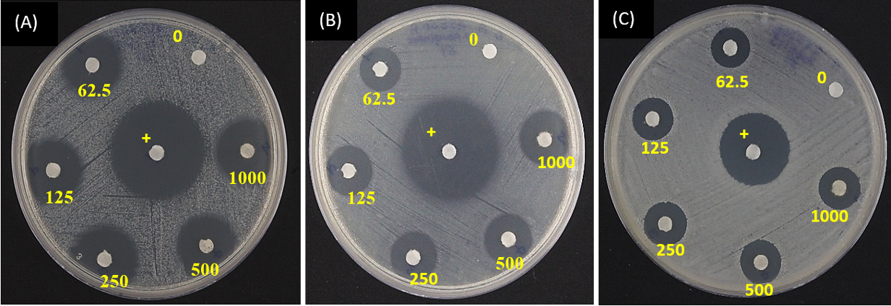
Figure 9: Image of clear inhibition zone produced by MAF-AgNPs against Gram negative (E. coli and P. aeruginosa) and Gram positive (B. subtilis) bacteria (A) E. coli, (B) P. aeruginosa, (C) B. subtilis. Ciprofloxacin (3–4 µg/disc) served as the positive control represented by (+), while the solvent control showed no inhibitory effect.
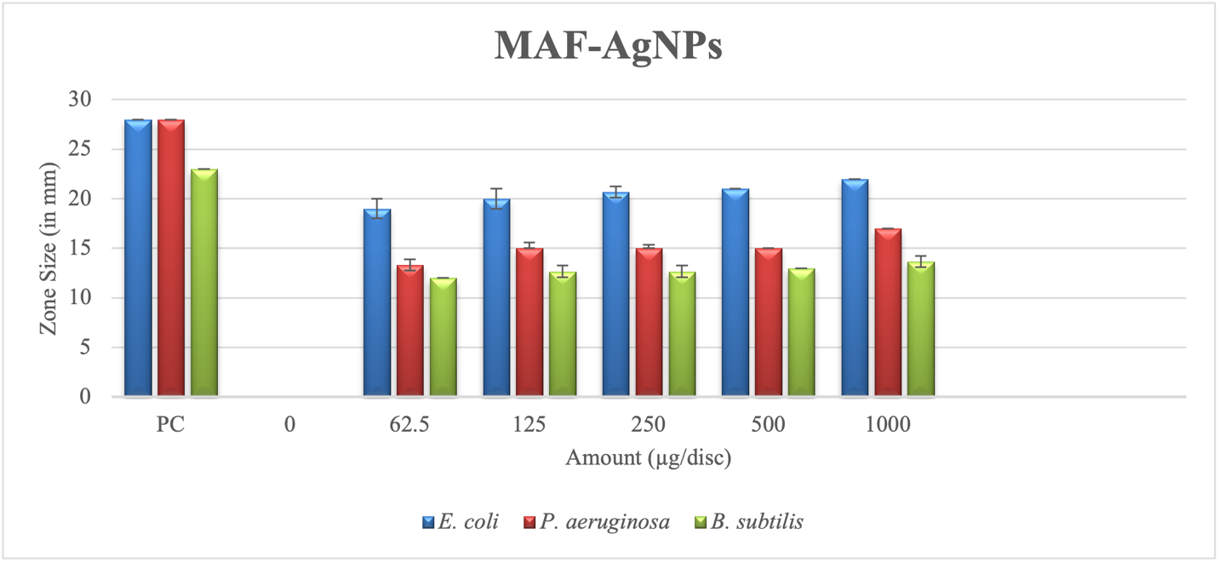
Figure 10: Dose-dependent antibacterial activity of MAF-AgNPs against E. coli, P. aeruginosa and B. subtilis. Ciprofloxacin (3–4 µg/disc) served as the positive control (PC), while the solvent control showed no inhibitory effect.

4. Discussion:
The present study demonstrates the successful green synthesis of silver nanoparticles using M. annua fruit extract (MAF-AgNPs) as confirmed by visible colour change and a characteristic surface plasmon resonance peak around 431–432 nm. Such optical features are well-recognized indicators of Ag⁺ ion reduction to metallic Ag⁰ nanoparticles in plant-mediated synthesis systems (Ahmed et al., 2016). The effectiveness of M. annua fruit extract (MAF) as a reducing and stabilizing agent can be attributed to its rich phytochemical composition particularly phenolics and flavonoids which are capable of donating electrons and stabilizing nanoparticle surfaces (Gupta & Deogadde, 2018; Sharma et al., 2025). FTIR comparative analysis of MAF and MAF-AgNPs suggested the presence of hydroxyl, carbonyl and amine functional groups indicating the involvement of fruit derived biomolecules in nanoparticle reduction and capping. Shifts in peak positions after MAF-AgNPs formation suggest strong interactions between silver ions and phytochemicals, contributing to nanoparticle stability. XRD analysis confirmed the crystalline nature of the synthesized MAF-AgNPs with diffraction patterns corresponding to the face-centred cubic (FCC) structure of silver consistent with earlier reports on biosynthesized MAF-AgNPs. FE-SEM observations showed predominantly spherical nanoparticles with sizes ranging from approximately 15 to 52 nm. Nanoparticles within this size range are known to exhibit enhanced biological activity due to increased surface area and effective cellular interactions (Albanese et al., 2012). The limited aggregation observed further supports effective phytochemical capping, as plant-derived biomolecules act as natural stabilizing agents that prevent nanoparticle agglomeration (Eker et al., 2025). The antioxidant activity of MAF-AgNPs were evident across DPPH, ABTS and FRAP assays showing a clear concentration dependent inhibition. Higher activity in the DPPH assay suggests efficient hydrogen or electron donation while ABTS and FRAP results reflect overall redox and reducing capacity. Although lower than standard antioxidants the observed activity indicates that phytochemicals retained their functional properties after nanoparticle formation, consistent with synergistic nano silver phytochemical interactions reported earlier (Khan et al., 2025). The synthesized MAF-AgNPs exhibited broad-spectrum in-vitro antibacterial activity against both Gram-negative (Escherichia coli and Pseudomonas aeruginosa) and Gram-positive (Bacillus subtilis) bacteria with higher susceptibility observed in Gram-negative strains. This difference may be attributed to variations in cell wall architecture that facilitate nanoparticle penetration and membrane disruption (Zhou et al., 2012). The antibacterial efficacy observed aligns with established mechanisms involving oxidative stress induction, enzyme inhibition and DNA interaction (Christenson et al., 2018). The use of M. annua fruit extract thus expands the scope of plant-based nanomaterial synthesis beyond leaves and roots offering an alternative phytochemical matrix for biologically active nanoparticle development.
5. Conclusion:
The study concludes the green synthesis of MAF-AgNPs an underexplored plant resource for nanoparticles synthesis. Comprehensive physicochemical characterization confirmed the formation of stable, crystalline and predominantly spherical silver nanoparticles effectively capped by fruit derived phytochemicals. The biosynthesized MAF-AgNPs exhibited concentration dependent in-vitro antioxidant activity in DPPH, ABTS and FRAP assays indicating their ability to scavenge free radicals and exert reducing power. In addition, the MAF-AgNPs showed pronounced broad spectrum antibacterial activity against both Gram-negative and Gram-positive bacteria with greater efficacy observed against Gram-negative strains. These results provide the potential of MAF-AgNPs as eco-friendly, multifunctional nanoparticles and underscore their relevance for future applications in antioxidant therapy, antimicrobial formulations and biomedical research.

References:
Abbigeri, M. B., Khan, M., Thokchom, B., Singh, S. R., Bhavi, S. M., Kulkarni, S. R., ... & Babu, Y. R. (2025). Therapeutic evaluation of Martynia annua derived carbon dots in epileptic Drosophila model. Scientific Reports, 15(1), 21572.
Abbigeri, M. B., Thokchom, B., Singh, S. R., Bhavi, S. M., Harini, B. P., & Yarajarla, R. B. (2025). Antioxidant and anti-diabetic potential of the green synthesized silver nanoparticles using Martynia annua L. root extract. Nano Trans Med, 4, 100070.
Ahmed, S., Saifullah, Ahmad, M., Swami, B. L., &Ikram, S. (2016). Green synthesis of silver nanoparticles using Azadirachta indica aqueous leaf extract. Journal of Radiation Research and Applied Sciences, 9(1), 1–7.
Al-Audah, S. A., Alghamdi, A. I., Alsanie, S. I., Alabdalla, N. M., Alawdah, A., Alenezi, N., AlShammari, A., Taha, I., Albarrag, A., Aldakeel, S., & Aldayel, M. (2026). Green synthesis of silver nanoparticles with antibacterial, anti-inflammatory and antioxidant activity using Convolvulus arvensis. International Journal of Molecular Sciences, 27(3), 1210.
Albanese, A., Tang, P. S., & Chan, W. C. (2012). The effect of nanoparticle size, shape, and surface chemistry on biological systems. Annual review of biomedical engineering, 14(1), 1-16.
Arshad, Z., Saied, S., & Naz, S. (2017). Antioxidant Activities and Phytochemical Screening of Martynia annua Fruit Extract. Biosciences biotechnology research Asia, 14(4), 1363-1369.
Braca, A., De Tommasi, N., Di Bari, L., Pizza, C., Politi, M., & Morelli, I. (2001). Antioxidant principles from Bauhinia tarapotensis. Journal of natural products, 64(7), 892–895.
Brand-Williams, W., Cuvelier, M. E., & Berset, C. L. W. T. (1995). Use of a free radical method to evaluate antioxidant activity. LWT - Food Science and Technology, 28(1), 25–30.
Chandran, S. P., Chaudhary, M., Pasricha, R., Ahmad, A., & Sastry, M. (2006). Synthesis of gold nanotriangles and silver nanoparticles using Aloe vera plant extract. Biotechnology progress, 22(2), 577–583.
Chaudhuri, S. K., Chandela, S., & Malodia, L. (2016). Plant Mediated Green Synthesis of Silver Nanoparticles Using Tecomella undulata Leaf Extract and Their Characterization. Nano Biomedicine & Engineering, 8(1).
Christenson, J. C., Korgenski, E. K., & Relich, R. F. (2018). Laboratory diagnosis of infection due to bacteria, fungi, parasites, and rickettsiae. In S. S. Long, C. G. Prober, & M. Fischer (Eds.), Principles and practice of pediatric infectious diseases (5th ed., pp. 1422–1434.e3). Elsevier.
Dharavath, Sunitha Bai & Maduru, Narsimhulu & Porika, Mahendar & Pavani, Chirumamilla & Veera, Spoorthi & Ponnam, Nirosha & Shasthree, Taduri. (2025). Green synthesis of silver nanoparticles using Nothapodytes foetida leaf extract: Optical, antibacterial and anticancer activities. Next Nanotechnology. 7. 100162.
Dhingra, A. K., Chopra, B., & Mittal, S. K. (2013). Martynia annua L.: A review on its ethnobotany, phytochemical and pharmacological profile. Journal of Pharmacognosy and Phytochemistry, 1(6), 135–140.
Duraisamy, N., Dhayalan, S., Shaik, M. R., Shaik, A. H., Shaik, J. P., & Shaik, B. (2022). Green Synthesis of Chitosan Nanoparticles Using of Martynia annua L. Ethanol Leaf Extract and Their Antibacterial Activity. Crystals, 12(11), 1550.
Eker, F., Akdaşçi, E., Duman, H., Bechelany, M., & Karav, S. (2025). Green synthesis of silver nanoparticles using plant extracts: A comprehensive review of physicochemical properties and multifunctional applications. International Journal of Molecular Sciences, 26(13), 6222.
Hameed, Tuqa & Kareem Hameed, Tuqa. (2021). Green Synthesis of Sliver Nanoparticles from Moringa oleifera as a Promising Agent Against Breast Cancer Cell Line. AIP Conference Proceedings. 2372, 030006. 030006.
Iravani, S. (2011). Green synthesis of metal nanoparticles using plants. Green Chemistry, 13(10), 2638–26.
Iravani, S., Varma, R. S., & Barani, M. (2022). Plant-based green synthesis of metallic nanoparticles: Biological applications and perspectives. Green Chemistry, 24(5), 1646–1683.
Itankar, Prakash & Thakre, P.T. & Murkute, A.V. & Tauqeer, Mohammad. (2013). Effect of medicated oil of Martynia annua leaves and fruits on testosterone induced alopecia in Mice. Asian Journal of Pharmaceutical and Clinical Research. 6. 49-52.
Jha, S., Yadav, P., Gahlawat, D., & Singh, S. (n.d.). Green microwave-assisted Ag/Zn nanoparticle production: Mechanistic assessment of antibacterial and antioxidant properties and structural analysis. Preparative Biochemistry & Biotechnology, 1–22.
Khan, A., Anas, M., Bibi, F., Ali, M., Khalil, A. T., Munawar, K. S., ... & Shinwari, Z. K. (2025). Phytochemical-mediated green synthesis of silver, copper, and Ag–Cu bimetallic nanoparticles using Peganum harmala demonstrating advanced catalytic, antioxidant, and biomedical applications. Applied Biochemistry and Biotechnology, 197(6), 3630-3667.
Kumari, S. A., Patlolla, A. K., & Madhusudhanachary, P. (2022). Biosynthesis of silver nanoparticles using Azadirachta indica and their antioxidant and anticancer effects in cell lines. Micromachines, 13(9), 1416.
Mittal, A. K., Chisti, Y., & Banerjee, U. C. (2013). Synthesis of metallic nanoparticles using plant extracts. Biotechnology advances, 31(2), 346–356.
Pulido, R., Bravo, L., & Saura-Calixto, F. (2000). Antioxidant activity of dietary polyphenols as determined by a modified ferric reducing/antioxidant power assay. Journal of agricultural and food chemistry, 48(8), 3396–3402.
Re, R., Pellegrini, N., Proteggente, A., Pannala, A., Yang, M., & Rice-Evans, C. (1999).
Antioxidant activity applying an improved ABTS radical cation decolorization assay.
Free Radical Biology and Medicine, 26(9–10), 1231–1237.
Sakaray, V., Rao, Y. S., & Naidu, N. V. (2024). Green Synthesis of Silver Nanoparticles by Acalypha indica Plant Extract and Their Approach towards Multifunctional Applications. Nano Biomedicine & Engineering, 16(4).
Salem, S. S., &Fouda, A. (2020). Green synthesis of metallic nanoparticles and their prospective biotechnological applications: An overview. Biological Trace Element Research, 199(1), 344–370.
Sharma, K. K., Jeengar, M. K., Meghwal, G. P., Patel, D. D., & Meena, P. (2025 a). Qualitative phytochemical screening and in vitro antioxidant evaluation of Martynia annua leaves collected from Alwar District, Rajasthan, India. International Journal for Multidisciplinary Research, 7(6), 1–9.
Sharma, K. K., Jeengar, M. K., Patel, D. D., & Meena, P. (2024). Baghnakh (Martynia annua): Prehistory to contemporary medicinal value. Journal of Pharmacognosy and Phytochemistry, 13(6), 409-415.
Sharma, K. K., Jeengar, M. K., Patel, D. D., & Meena, P. (2025 b). Evaluation of antioxidant and antibacterial properties of fruit and flower extracts of Martynia annua from Alwar District, Rajasthan, India. International Journal of Innovative Research in Science, Engineering and Technology, 14(9), 19669–19678.
Simon, S., Sibuyi, N. R. S., Fadaka, A. O., Meyer, S., Josephs, J., Onani, M. O., ... & Madiehe, A. M. (2022). Biomedical applications of plant extract-synthesized silver nanoparticles. Biomedicines, 10(11), 2792.
Subba Rao, Y., Kotakadi, V. S., Prasad, T. N., Reddy, A. V., & Sai Gopal, D. V. (2013). Green synthesis and spectral characterization of silver nanoparticles from Lakshmi tulasi (Ocimum sanctum) leaf extract. Spectrochimica acta. Part A, Molecular and biomolecular spectroscopy, 103, 156–159.
Thangapushbam, V. & Karuppiah, Muthu. (2022). Biosynthesis of silver nanoparticles using Martynia annua and its antimicrobial and cytotoxic activities. Materials Technology. 37. 1-10.
Thangapushbam, V., Rama, P., Sivakami, S., Jothika, M., Muthu, K., Almansour, A. I., ... & Perumal, K. (2024). Potential in-vitro antioxidant and anti-inflammatory activity of Martynia annua extract mediated Phytosynthesis of MnO2 nanoparticles. Heliyon, 10(8).
Zhou, Y., Kong, Y., Kundu, S., Cirillo, J. D., & Liang, H. (2012). Antibacterial activities of gold and silver nanoparticles against Escherichia coli and bacillus Calmette-Guérin. Journal of nanobiotechnology, 10, 19.

