Antibacterial Activity of Elytraria acaulis Leaf extracts Aagainst multi-drug Resistant Uropathogens

ABSTRACT
Urinary tract infections (UTIs) represent a global health challenge, with multidrug resistant uropathogens posing a significant threat to effective treatment. This study investigates the potential of Elytraria acaulis leaf extracts as a novel antimicrobial agent against multidrug resistant uropathogens. Extracts of methanol, ethanol, and hexane were subjected to in-vitro antibacterial assays against a panel of clinically isolated multidrug resistant uropathogens viz., Escherichia coli, Klebsiella variicola, Providencia stuartii, Enterobacter bugandensis and Enterococcus faecalis using Zone of Inhibition (ZOI) with the help of agar well diffusion method. Ethanol extracts exhibited ZOI ranging from 7.5±0.5 mm (Low) to 12.4±0.3 mm (High). Methanol extracts displayed ZOI spanning from 8±0.1 mm (Low) to 14±0.4 mm (High). Hexane extracts showed ZOI ranging from 7.2±0.4 mm (Low) to 11.3±0.2 mm (High). Methanol extracts consistently demonstrated higher inhibitory effects compared to ethanol and hexane extracts. Moreover, the combination of Elytraria acaulis extracts with various antibiotics commonly used to treat UTIs showed synergistic interactions, potentially offering a strategy to combat antibiotic-resistant uropathogens more effectively. In conclusion, this study underscores the significant in vitro antibacterial potential of Elytraria acaulis extracts against multidrug resistant uropathogens, suggesting their utility as a promising source of alternative therapeutic agents for the management of UTIs in the era of increasing antibiotic resistance.
KEYWORDS: UTI, Elytraria acaulis, Multidrug Resistant Bacteria, Chronic Kidney Disease, Antibiotic Resistance
INTRODUCTION
The pursuit of innovative antimicrobial agents has become critically important due to the increasing global menace of antibiotic-resistant bacteria.^{[1]} Within the diverse realm of medicinal plants, Elytraria acaulis has emerged as a compelling candidate due to its potential antibacterial properties. This herbaceous perennial plant, colloquially known as the "Purple False Eranthemum," belongs to the Acanthaceae family and is native to various regions, including parts of Asia and Africa.
Over time, traditional healers and local communities have harnessed the healing qualities of Elytraria acaulis. These traditional uses have spurred scientific curiosity in investigating the pharmacological potential of this plant, with a specific emphasis on its antibacterial attributes.^{[2,3]} The rise and dissemination of antibiotic-resistant uropathogenic bacteria have generated a pressing demand for alternative strategies to combat urinary tract infections (UTIs). UTIs are among the most prevalent bacterial infections affecting humans, primarily caused by uropathogens such as Escherichia coli, Enterobacter sp., Klebsiella pneumoniae, and Enterococcus faecalis. These bacteria have developed resistance to multiple antibiotics, diminishing the effectiveness of conventional treatment options.^{[4]}
The plant species Elytraria acaulis, a traditional medicinal plant, exhibits a range of valuable medicinal properties, including antimicrobial, anti-inflammatory, antioxidant, and antidiabetic activities. It has garnered significant recognition in various traditional medicinal systems like Ayurveda, Unani, Siddha, and traditional Chinese medicine, as well as being utilized by traditional healers in Central and South America. In traditional medicine, Elytraria acaulis is employed for treating conditions such as diarrhoea, rickets, leucorrhoea, and throat complaints.^{[5]} Furthermore, this plant possesses several other properties, including anthelmintic, antifertility, anti-hyperglycemic, antimicrobial, analgesic, antioxidant, larvicidal, and hepatoprotective activities.^{[5]} These diverse properties make it a promising candidate for developing new formulations with enhanced therapeutic benefits. Despite the common use of Elytraria acaulis roots in traditional medicine, there is a notable absence of studies examining the antibacterial effectiveness of its leaf extracts.^{[6]}
The present study aims to shed light on the untapped potential of this plant species, emphasizing its rich medicinal properties and the need for further exploration, particularly in the context of antibacterial efficacy using its leaf extracts.

In this context, the exploration of Elytraria acaulis's antibacterial capabilities has gained significance. The plant's extracts, replete with bioactive compounds, have exhibited potential in restraining the proliferation of diverse bacterial strains, including those resistant to multiple drugs among uropathogens.^{[7]} A deeper understanding of Elytraria acaulis's antibacterial potential could pave the way for the development of innovative therapeutic agents for the management of UTIs, presenting an alternative or complementary approach to the presently available antibiotic therapies.
MATERIALS AND METHODS
Materials
Glucose, peptone, yeast extract, beef extract, sodium chloride, protease peptone (meat and casein), lactose monohydrate, bile salts, indole, and methyl red, The following ingredients are used buffered peptone, dipotassium phosphate, alpha-naphthol, 5%, absolute ethanol, pancreatic digest of gelatin, dibasic potassium phosphate, lactose along with ampicillin (2 mcg), ceftriaxone (30 mcg), norfloxacin (10 mcg), levofloxacin (5 mcg), tazobactam (10 mcg), gentamycin (10 mcg), meropenem (10 mcg), imipenem (10 mcg), co-trimoxazole (25 mcg), tobramycin (30 mcg), methicillin (10 mcg) and Gram’s staining kit from HiMedia Labs in Mumbai
Methods
Collection of Elytraria acaulis Plant Specimens
Elytraria acaulis, a member of the Acanthaceae family, was sourced from the vicinity of Warangal district and subjected to morphological and taxonomical identification. The collected specimens were subsequently submitted to the Department of Botany at Annamalai University, located in Annamalai Nagar, Tamil Nadu, India.
Bacteria under Testing
The assessment of the antimicrobial efficacy of the plant extract was carried out against pathogens responsible for urinary tract infections. In our study, we utilized bacterial strains that included Providencia stuartii, Enterococcus faecalis, Enterobacter bugandensis, Escherichia coli, Klebsiella variicola, and Escherichia coli. To maintain sterility, distinct sterile nutrient agar slants were prepared, and each bacterial strain was individually introduced into these slants using aseptic techniques. Subsequently, they were incubated at 37ºC for 24 hours under sterile conditions. Following incubation, colonies from each slant were separately harvested and inoculated into sterile nutrient broths, placed in individual test tubes, and stored under refrigerated conditions. ^{[8]}
Preparation of Samples
Fresh leaves and stems of Elytraria acaulis were sourced from local gardens in Hyderabad, India. Upon acquisition, the plant material underwent a rigorous purification process using distilled water before being subjected to freeze-drying. Following freeze-drying, the desiccated samples were finely ground into a powder and stored at a temperature of -20°C until they were required for further use.
To increase the polarity of the plant extracts, we employed a sequential fractionation method, which involved the use of n-hexane, ethyl acetate, methanol, and distilled water. This fractionation procedure was carried out with a mass-to-volume ratio of 1:10 and was conducted at an approximate temperature of 25°C over a period of three days. After this fractionation process, the plant specimens were sequentially extracted using hexane (H), ethyl acetate (EA), methanol (M), and ethanol (E). Each solvent within the extracted samples was subsequently removed by utilizing a rotary evaporator, with temperature settings adjusted according to the boiling point of each solvent. Subsequent to the evaporation process, the resulting solvent-free extracts were dissolved in dimethyl sulfoxide (DMSO) and then assessed for their effectiveness against the chosen multidrug-resistant bacterial strains. ^{[9]}

Antimicrobial activity of the plant extract
The extracts were reconstituted in a solution containing 5% dimethyl sulfoxide (DMSO) and then impregnated into sterile, empty discs with a diameter of 6 mm. Mueller Hinton agar plates were prepared, and bacterial cultures isolated from post-operative incision (POI) wounds were inoculated onto these plates. Subsequently, the discs containing plant extracts, along with positive controls, were positioned onto the Mueller Hinton agar medium. The plates were then incubated for 24 hours at a temperature of 37ºC. After the 24 hours incubation period, the zone of inhibition produced by the bacterial species was measured using a graduated zone measuring scale and expressed in millimetres (mm) in diameter. It's important to note that the data represent three separate replicates for each microorganism.
Antibacterial activity against multidrug resistant uropathogens
Solutions of the extracts were prepared in dimethyl sulfoxide (DMSO) at varying concentrations, specifically 40, 80, 150, and 250 mg/mL. Nutrient agar plates were prepared, autoclaved, and then cooled to room temperature. The cooled agar was evenly distributed into Petri dishes and refrigerated to solidify. Each plate was subsequently inoculated separately with the test bacterial strains using a spread plate technique and a sterilized spreader. Sterile steel borers with a diameter of 6 mm were used to create wells on the Petri dish, into which 100μl of the prepared plant extract solutions at concentrations of 50 and 100 mg per well were dispensed. A standard drug viz., Fosfomycin, Tetracycline, Methicillin, Ampicillin and Norfloxacin at a concentration of 100μg per well was also placed as a control.^{[6]}
The prepared plates were left undisturbed to allow the samples placed in the wells to diffuse into the agar. Subsequently, the Petri plates were incubated for a period of 24 hours at 37±2°C. After this incubation period, the plates were examined to determine the antibacterial activity of the extracts by measuring the zones of inhibition. The entire experiment was conducted in triplicate, and the results were presented as the mean ± standard deviation (SD).
RESULTS
The table-1, 2 and 3 summarizing the results of the zone of inhibition (in millimeters) for three different extracts of Elytraria acaulis when tested against multiple drug-resistant (MDR) bacterial isolates. The three types of extracts tested are Ethanol Extract (EE), Methanol Extract (ME), and Hexane Extract (HE). Each extract is tested at three different concentrations: Low (50µg/ml), High (100µg/ml), and a Standard concentration (10µg/ml). The standards used were Fosfomycin, Tetracycline, Methicillin, Ampicillin and Norfloxacin.
The ethanol extract (EE) exhibited varying degrees of zone of inhibition, contingent upon the bacterial isolate and the concentration of the extract used (Table-1 and Fig. 1). When tested against Enterococcus faecalis, the zone of inhibition ranged from 7.5±0.5 mm (at the Low concentration) to 12.4±0.3 mm (at the High concentration), and expanded further to 13.2±0.2 mm (at the Standard concentration). In the case of Providencia stuartii, the zone of inhibition ranged from 9.8±0.1 mm to 13.8±0.2 mm, eventually reaching 16.3±0.1 mm at the Standard concentration. Klebsiella variicola displayed a zone of inhibition of 8.2±0.3 mm, 14.1±0.1 mm, and 22.2±0.5 mm at the respective concentrations. Similarly, Enterobacter bugandensis exhibited zone of inhibition values of 9.2±0.4 mm, 14.9±0.1 mm, and 22.8±0.3 mm at the Low, High, and Standard concentrations, respectively. In the case of Escherichia coli, the zone of inhibition varied from 9.9±0.2 mm to 15.4±0.2 mm and notably increased to 23.2±0.6 mm at the Standard concentration.
Date represented in Table-2 and Fig. 2 shows that the methanol extract (ME), it's worth noting that the zone of inhibition exhibits variations among different bacterial isolates and across distinct extract concentrations. In the case of Enterococcus faecalis, the zone of inhibition spans from 8±0.1 mm (at the Low concentration) to 14±0.4 mm (at the High concentration) before stabilizing at 13±0.6 mm when the Standard concentration is applied. Providencia stuartii showcases a range of zone of inhibition values, shifting from 10.7±0.2 mm to 15.4±0.1 mm and extending further to 20.3±0.2 mm at the Standard concentration. Klebsiella variicola displays zone of inhibition measurements of 8.2±0.1 mm, 14.1±0.2 mm, and 22.2±0.3 mm at the Low, High, and Standard concentrations, respectively. Correspondingly, Enterobacter bugandensis manifests zone of inhibition values of 9.6±0.3 mm, 13.7±0.3 mm, and 21.5±0.1 mm at the respective concentrations. As for Escherichia coli, the zone of inhibition fluctuates between 10.2±0.2 mm and 14.7±0.5 mm and demonstrates a marked increase, reaching 22.9±0.4 mm at the Standard concentration. It has been reported that the methanolic extract of the plant Elytraria acaulis has secondary metabolites such as tannins, flavonoids, glycosides, protein, carbohydrates and phenols. ^{[10]}
In the context of the hexane extract (HE), it's notable that the zone of inhibition exhibits variability across different bacterial isolates and concentrations of the extract (Table-3 and Fig. 3). Specifically, when tested against Enterococcus faecalis, the zone of inhibition spans from 7.2±0.4 mm (at the Low concentration) to 11.3±0.2 mm (at the high concentration), eventually stabilizing at 12.7±0.3 mm with the application of the Standard concentration. In the case of Providencia stuartii, the zone of inhibition showcases a range, fluctuating from 7.9±0.2 mm to 12.5±0.6 mm, and further extending to 13.6±0.1 mm at the Standard concentration. Klebsiella variicola demonstrates zone of inhibition measurements of 8.1±0.1 mm, 13.9±0.1 mm, and 15.8±0.2 mm at the Low, High, and Standard concentrations, respectively. Similarly, Enterobacter bugandensis manifests zone of inhibition values of 9.4±0.3 mm, 14.7±0.3 mm, and 17.1±0.5 mm at the respective concentrations. As for Escherichia coli, the zone of inhibition varies between 9.7±0.1 mm and 15.2±0.1 mm, displaying a notable increase to 20.6±0.2 mm at the standard concentration.
Ethanol extracts exhibited ZOI ranging from 7.5±0.5 mm (Low) to 12.4±0.3 mm (High) while, Methanol extracts displayed ZOI spanning from 8±0.1 mm (Low) to 14±0.4 mm (High). Hexane extracts showed ZOI ranging from 7.2±0.4 mm (Low) to 11.3±0.2 mm (High). Methanol extracts consistently demonstrated higher inhibitory effects compared to ethanol and hexane extracts. The study suggests that the three extracts of Elytraria acaulis exhibit different degrees of inhibitory activity against the MDR bacterial isolates, and the effectiveness varies with the concentration of the extracts.^{[11]} Further investigations are required to identify and characterize the active compounds responsible for the observed antimicrobial effects, which may lead to the development of potential therapeutic agents against MDR infections.
DISCUSSION
Antibiotic resistance has emerged as a pressing global concern, with a growing number of bacterial pathogens developing or gradually acquiring resistance to most available antibiotics. To address this critical issue, there is a heightened focus on exploring new sources of antibacterial agents, with a particular emphasis on plant-based drugs and antibacterial compounds. Phytochemicals, which are naturally occurring compounds found in medicinal plants, leaves, vegetables, and roots, function as a natural defence mechanism, providing protection against various diseases.
In the current investigation, various extracts obtained from the roots of Elytraria acaulis (EAR) were examined, revealing the presence of numerous bioactive substances, including carbohydrates, alkaloids, phenols, saponins, tannins, flavonoids, glycosides, and phytosterols. The results of this research suggest that methanol and ether extracts displayed significant inhibitory effects on all tested bacterial pathogens, while the aqueous extract exhibited comparatively lower inhibitory effects. This variation in antibacterial activity may be attributed to the existence of compounds like tannins, flavonoids, alkaloids, and glycosides.
Flavonoids, which are hydroxylated phenolic compounds, are renowned for their antimicrobial properties, effectively targeting a wide range of microorganisms. Their antimicrobial attributes are believed to stem from their ability to interact with extracellular and soluble proteins and form complexes with bacterial cell walls.^{[1]} Alkaloids exert their inhibitory effects by suppressing nucleic acid production, interfering with cell division, disrupting the Z-ring, and compromising the integrity of external layers and cytoplasm.^{[12]} Glycosides may exert their antibacterial action by inhibiting the synthesis of RNA nucleic acids.^{[13]}

Previous investigations involving different extracts of Elytraria acaulis have demonstrated notable antimicrobial effects against various pathogenic bacteria.^{[13]} Furthermore, Elytraria acaulis has exhibited potent antibacterial activity against drug-resistant bacteria such as Pseudomonas aeruginosa, E. coli, and methicillin-resistant Staphylococcus aureus, isolated from burn wound sepsis, surpassing the effectiveness of both honey and antibiotics.^{[14]} Methanolic extracts of Elytraria acaulis have consistently exhibited strong antimicrobial properties against a variety of selected microorganisms.^{[15,16]} To summarize, based on both previous research and the current study, it can be concluded that different parts of the Elytraria acaulis plant, including its roots, leaves, and flowers, possess varying levels of antibacterial potential. The effectiveness of these components relies on the presence of specific phyto constituents with antibacterial properties.
CONCLUSIONS
In conclusion, our research highlights the potent antimicrobial properties of Elytraria acaulis leaves against multidrug-resistant uropathogens. The presence of bioactive compounds, including flavonoids, alkaloids and glycosides, contributes to their impressive antibacterial activity. This study suggests that Elytraria acaulis leaves hold significant promise as a natural remedy for combating challenging urinary tract infections caused by multidrug-resistant pathogens. Further investigations and clinical studies are warranted to harness the full potential of Elytraria acaulis leaves as a valuable resource in addressing the growing concern of antibiotic resistance in urology. Elytraria acaulis leaves offer a promising avenue for innovative approaches to combat multidrug-resistant uropathogens.
REFERENCES
- Cowan MM. Plant products as antimicrobial agents. Clinical microbiology reviews. 1999; 1;12(4):564-582.

- Houghton PJ. The role of plants in traditional medicine and current therapy. The Journal of Alternative and Complementary Medicine. 1995; 1;1(2):131-143.

- Kähkönen MP, Hopia AI, Vuorela HJ, Rauha JP, Pihlaja K, Kujala TS, Heinonen M. Antioxidant activity of plant extracts containing phenolic compounds. Journal of agricultural and food chemistry. 1999; 18;47(10):3954-3962.

- Kalemba DA, Kunicka A. Antibacterial and antifungal properties of essential oils. Current medicinal chemistry. 2003; 1;10(10):813-829.

- Babu PS, Babu KA, Chitra K, Chamundeeshwari D. A review on phytochemical and pharmacological profile of Elytraria acaulis Lindau. International Journal of Pharmaceutical Sciences and Research. 2015; 1;6(9):3671.

- Singh S, Nigam R, Sharma A, Kumar A, Laxmi V. In-vitro antibacterial activity of Elytraria acaulis roots against some gram-positive and gram-negative bacterial strains. Journal of Pharmacognosy and Phytochemistry. 2020; 9(5):2218-2225.

- Karthikumar S, Vigneswari K, Jegatheesan K. Screening of antibacterial and antioxidant activities of leaves of Eclipta prostrata (L). Sci. Res. Essays. 2007; 1;2(4):101-104.

- Bhalodia NR, Shukla VJ. Antibacterial and antifungal activities from leaf extracts of Cassia fistula l.: An ethnomedicinal plant. Journal of advanced pharmaceutical technology & research. 2011; 2(2):104.

- Othman M, San Loh H, Wiart C, Khoo TJ, Lim KH, Ting KN. Optimal methods for evaluating antimicrobial activities from plant extracts. Journal of Microbiological Methods. 2011 Feb 1;84(2):161-166.

- Jagadeesan K, George T, Kamalanathan MN. Ilayaraja. T (2014). Studies on the Anthelmintic and Antioxidant Activity of Root Extracts of Elytraria Acaulis. Adv. Anim. Vet. Sci. 2014; 2(8):457-463.

- Singh S, Nigam R, Sharma A, Kumar A, Laxmi V. In-vitro antibacterial activity of Elytraria acaulis roots against some gram-positive and gram-negative bacterial strains. Journal of Pharmacognosy and Phytochemistry. 2020; 9(5):2218-2225.

- Cushnie TT, Cushnie B, Lamb AJ. Alkaloids: An overview of their antibacterial, antibiotic-enhancing and antivirulence activities. International journal of antimicrobial agents. 2014; 1;44(5):377-386.

- Soulef K, Abdelouahab Y, Dalal B. Effect of glycosides extract of the medicinal plant Glycyrrhiza glabra L. from the region of Mlilli (southeast of Algeria) on the growth of some human pathogenic bacteria. Journal of Scientific & Innovative Research. 2014; 3(1):28-34.

- Kowsalya V. Antibacterial activity of honey and Elytraria acaulis against bacteria isolated from burnt wound sepsis. J Pharm Biol Sci. 2012;1(5):1-20.
- Singh S, Nigam R, Sharma A, Kumar A, Laxmi V. In-vitro antibacterial activity of Elytraria acaulis roots against some gram-positive and gram-negative bacterial strains. Journal of Pharmacognosy and Phytochemistry. 2020; 9(5):2218-2225.

- Sundar S, Joseph LH, Raj TL. Preliminary phytochemical and antimicrobial investigations of Elytraria acaulis (LF) Lindau. Eur J Mol Biol Biochem. 2015; 2(2):71-74.

Name of the organism |  | Zone of inhibition (mm)
 |  | Low (50µg/ml) |  | High (100µg/ml) | Standard (10µg/ml)
Enterococcus faecalis |  | 7.5±0.5 |  | 12.4±0.3 | 13.2±0.2
Providencia stuartii |  | 9.8±0.1 |  | 13.8±0.2 | 16.3±0.1
Klebsiella variicola |  | 8.2±0.3 |  | 14.1±0.1 | 22.2±0.5
Enterobacter bugandensis |  | 9.2±0.4 |  | 14.9±0.1 | 22.8±0.3
Escherichia coli |  | 9.9±0.2 |  | 15.4±0.2 | 23.2±0.6
Table 1: Zone of inhibition (mm) of ethanol extracts (EE) of Elytraria acaulis against MDR isolates

Table 2: Zone of inhibition (mm) of methanol extracts (ME) of Elytraria acaulis against MDR isolates

Name of the organism | Zone of inhibition (mm)
Name of the organism | Low (50µg/ml) | High (100µg/ml) | Standard (10µg/ml)
Enterococcus faecalis | 8±0.1 | 14±0.4 | 13±0.6
Providencia stuartii | 10.7±0.2 | 15.4±0.1 | 20.3±0.2
Klebsiella variicola | 8.2±0.1 | 14.1±0.2 | 22.2±0.3
Enterobacter bugandensis | 9.6±0.3 | 13.7±0.3 | 21.5±0.1
Escherichia coli | 10.2±0.2 | 14.7±0.5 | 22.9±0.4

Table 3: Zone of inhibition (mm) of hexane extracts (HE) of Elytraria acaulis against MDR isolates

Name of the organism | Zone of inhibition (mm)
Name of the organism | Low (50µg/ml) | High (100µg/ml) | Standard (10µg/ml)
Enterococcus faecalis | 7.2±0.4 | 11.3±0.2 | 12.7±0.3
Providencia stuartii | 7.9±0.2 | 12.5±0.6 | 13.6±0.1
Klebsiella variicola | 8.1±0.1 | 13.9±0.1 | 15.8±0.2
Enterobacter bugandensis | 9.4±0.3 | 14.7±0.3 | 17.1±0.5
Escherichia coli | 9.7±0.1 | 15.2±0.1 | 20.6±0.2

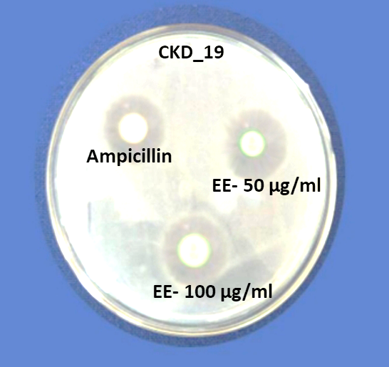
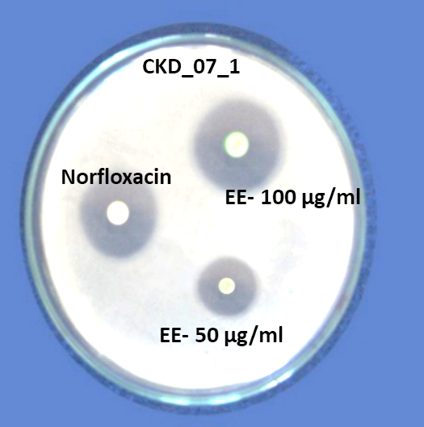

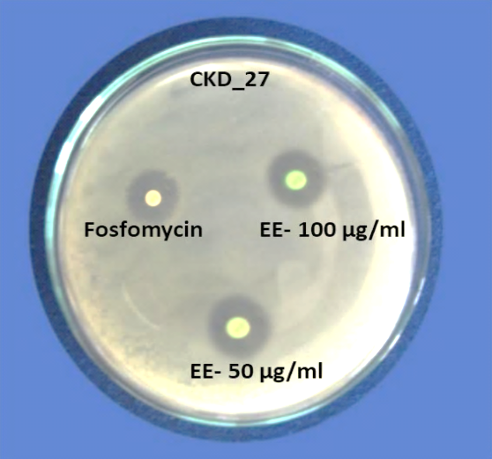
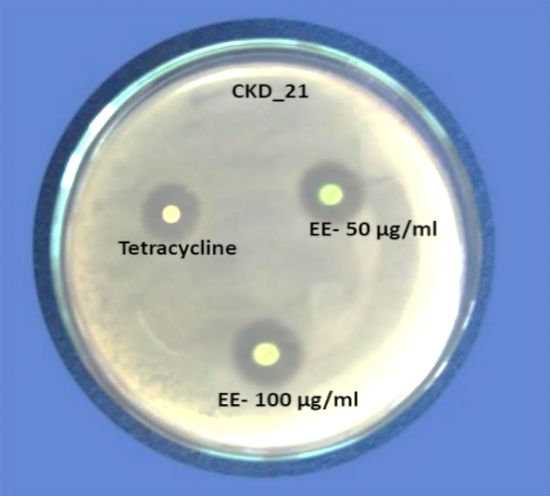
Enterococcus faecalis Providenci stuartii

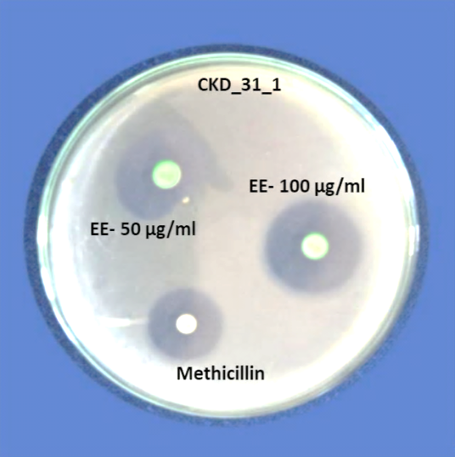
Klebsiella variicola Enterobacter bugandensis

Escherichia coli
Fig. 1: Zone of inhibition (mm) of Ethanol Extracts (EE)
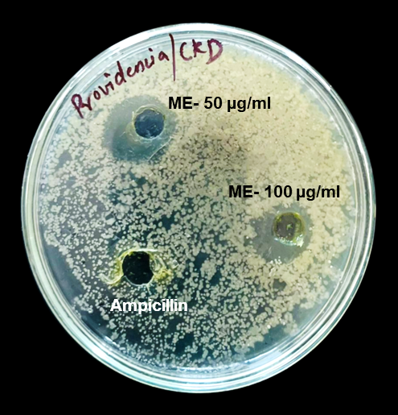
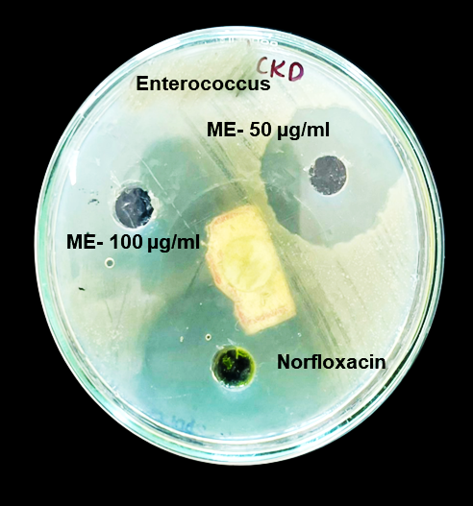
Enterococcus faecalis Providenci stuartii
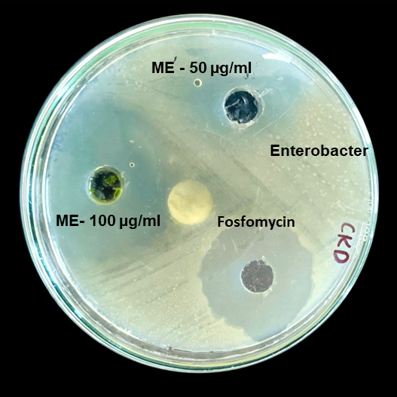
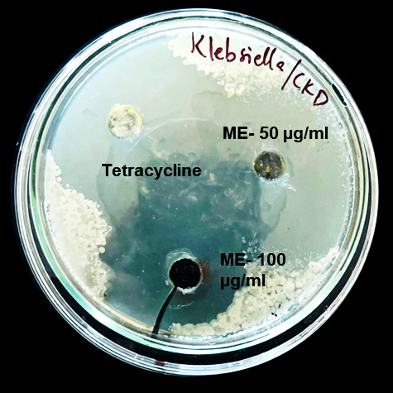
Klebsiella variicola Enterobacter bugandensis
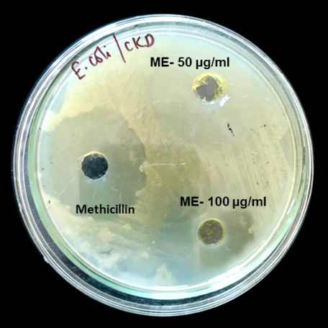

Escherichia coli
Fig. 2: Zone of inhibition (mm) of methanol extracts (ME)
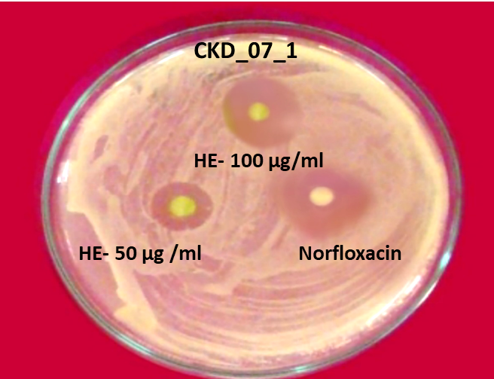
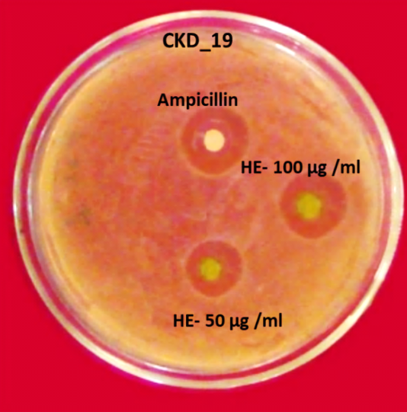

Enterococcus faecalis Providenci stuartii
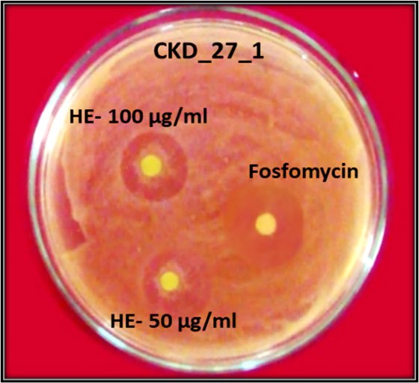
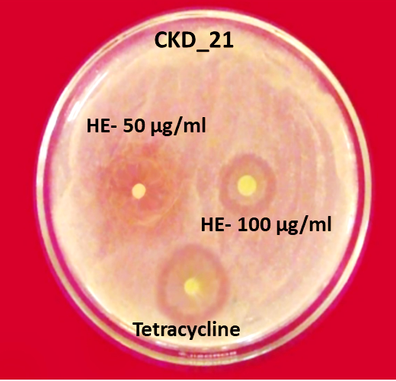

Klebsiella variicola Enterobacter bugandensis

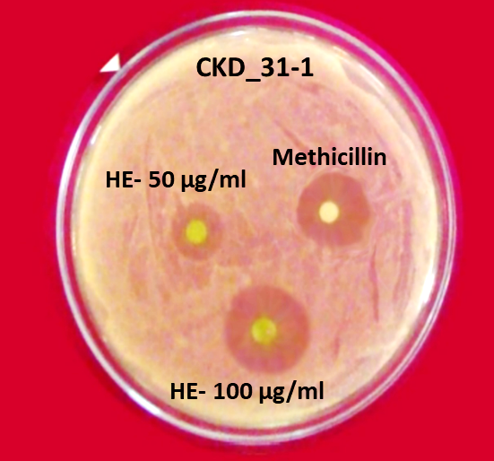

Escherichia coli
Fig. 3: Zone of inhibition (mm) of hexane extracts (HE)

