Review Article
Smart Fertilizers for Sustainable Agriculture: A Review

Abstract
About 40% to 50% of the Earth's land surface is covered by agricultural land systems {managed grassland, cropland, permanent crops, including bioenergy crops and agroforestry (Smith et al 2007)} that are necessary for human food production. The demand for food and the need for feedstock will rise as the world's population rises quickly. In order to abolish hunger and severe poverty by 2030, as well as to protect the environment and the global climate, the UN approved 17 sustainable development goals in 2015. This suggests innovative agricultural intensification on currently used land through cooperation across several industries (Chabbi et al 2017). The development of plant fertilization techniques may be the best way to increase agricultural productivity. These include the creation and use of smart fertilizers with slow/controlled mechanisms for nutrient release.
Key words: Conventional fertilizers, climate, sustainable, smart fertilizers, controlled release and slow release
1. Introduction
The population of earth is projected to increase continuously, and by 2050, there will be roughly 9.5 billion people (Azeem et al 2014). Additionally, as the population of the world has continued to increase exponentially, so have the world's food needs. To feed the anticipated population of 2050, there must be 70% rise in food production as per the FAO (United Nations Food and Agriculture Organization) estimation. (Dos Santos et al 2015). Ammonia volatilization, mineralization, emission of oxides of nitrogen, Leaching, denitrification and soil erosion processes all contribute to the loss of 40-70% of the nitrogen content. In terms of phosphorous, mineralization (formation of Fe and Al-based oxides and fixation of P) and surface run-off account for 80-90% of the loss, whereas leaching related with surface run-off and water movement in the soil accounts for 50-70% of the loss (Rop et al 2018). This high amount of nutrient loss causes environmental issues in addition to economic losses. Nitrates from nitrogen fertilizer sources can pollute groundwater through accumulation and leaching from agricultural activities, causing substantial and immediate consequences on human health due to the deterioration of drinking water quality. N volatilization also pollutes the air, causing detrimental atmospheric impacts and toxic emissions, as well as cutaneous irritation and breathing issues. Phosphorus overflow causes eutrophication in estuaries and freshwater which promotes the formation of algal blooms and contributes to a variety of water-related issues such as disagreeable tastes in drinking water, foul odors and summer fish kills. Excess fertiliser use can harm soil quality by heavy metal accumulation, persistent organic pollutants and by causing acidification (Khan et al 2017). In this context, a new class of fertiliser known as smart fertilizers is being developed to match nitrogen delivery to plant needs and increase nutrient use efficiency.
2. Smart Fertilizers
  - Nano fertilizers
Nano fertilizers are made from traditional fertilizers, bulky fertilizer ingredients, or plant parts or other plants by covering them with nanoparticles for control and a delayed release of nutrients for the development of soil fertility, productivity, and agricultural product quality (Zulfiqar et al 2019). The combined nutrients can be released in a Nano sized form in a controlled manner to improve the efficiency of crop plants along with the minimum impact on the environment. The use of Nano fertilizers in a correct way can feed plants slowly in such a manner that increases the nutrient use efficiency, prevents leaching, minimizes volatilization and diminishes overall environmental risks (Linquist et al 2013). Nano fertilizers improve the bioavailability of nutrients owing to nano size, high specific surface area and more reactivity (Solanki et al 2015).
Mode of Action and Chemistry of Nano fertilizers
Excessive use of mineral fertilizer has a significant influence on soil and groundwater. Excess minerals leach down the soil or pollute the air, threatening sustainability and crop production (Chandini et al 2019). Ecofriendly Nano fertilizers are one of the alternatives to mineral fertilizers, capable of enhancing soil fertility, yield, reducing pollution, and promoting microbial activity {(Ahmed et al 2012) (Fig.1)}.
Nanotechnology can be considered as a powerful solution in the agriculture sector to increase the efficiency of fertilizers and pesticides, reduce pollution and is also used in food processing technology (Baruah and Dutta, 2009). Nano-fertilizers provide control release of agrochemicals, reduce toxicity in soil and plant, site targeted delivery as well as maximize nutrient efficiencies of the utilized fertilizer (Cui et al 2010). High solubility due to small size, high surface area to volume ratio, specific targeting, high mobility and low toxicity are the innovative characters that provide advantages of nano- fertilizers (Sasson et al 2007).
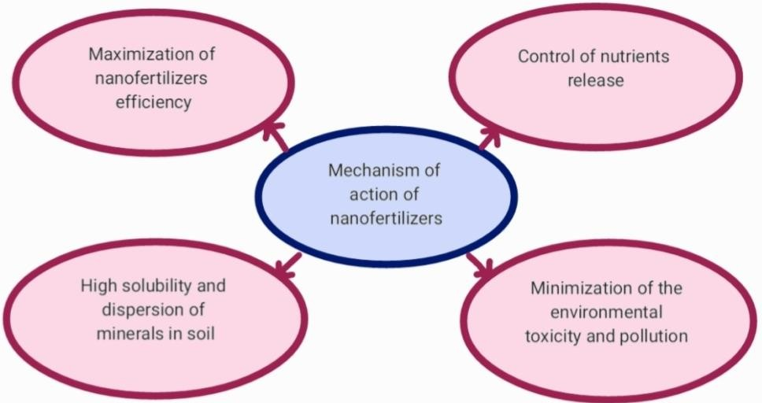
Figure 1. Mechanism of action of Nano fertilizers.
Maximization of Nano fertilizers Efficiency
The nutrient use efficiency in agriculture is 20-50%, 10-25% and 30-40% for N, Pand K fertilizers respectively. It indicates the need for food production to be much more efficient (Tarafdar et al 2013). Fertilizers that are typified in nano-particles have increased accessibility and uptake of nutrients. The utilization of nano-fertilizers has a positive effect on the effectiveness of fertilizers and supplements uptake by plants from soil (Liscano et al 2000).
Navarro et al., (2008) accredited the high proficiency of the Nano fertilizers to
- Reactivity of nano-materials with other compounds is more than those of ordinary ones. It is because of smaller size and high surface area that provides more sites for reaction.
- Enhancement of nutrients penetration and plant uptake, due to the small size of nano- particles, specific surface area and particle number per unit is increased that causes increase in the contact surface between nano-fertilizers and plants (Lin and Xing, 2007). The critical factor to determine the entry of nano-particle through cell-wall is the diameter of plant cell wall pores which range between 5-20 nm (Fleischer et al 1999). The penetration of Nano fertilizer is easier because of their small size i.e., less than 100 nm. Plant cell walls pores are larger than the nano-particle aggregates which makes it easier for nano-particles to enter the plant through the cell wall and reach the plant cell membrane (Moore, 2006).
- To enhance uptake, active nano-particles can cause increase in size of pores and induce new pores in the plant cell wall (Juarez-Maldonado et al 2019). Nair et al in 2010 in their studies emphasized that nano-particle uptake by plant cells occurs through the binding of nano particles with the carrier protein, via aquaporin, endocytosis or ion channels.
Control of Nutrients Release
Doses of traditional fertilizer applied are not used totally for the crop. Only a few parts reach the targeted plant parts. The remaining fates to evaporation, runoff, leaching, hydrolysis by soil moisture and degradation by soil flora (Preetha and Balakrishnan, 2017). About 40-70%, 80-90%, and 50-90% of nitrogen, phosphorus and potassium fertilizers respectively are lost within the soil and not able to reach the plant (Saigusa and Ombódi, 2000). Higher quantities of fertilizers and pesticides are applied to the soil to recompense for the fertilizer lost. It adversely affects the balance of nutrients. Nano-fertilizers are one of the ways to overcome the problem of excessive use of fertilizers.
Slowly-released Nano fertilizer s can be considered a great alternative to traditional fertilizers. They provide a moderate rate of discharge of supplements during the development of crops. Plants can absorb most of the nutrients without much loss (Huiyuan et al 2018). Nano-particles strongly bond the nutrients when fertilizer is coated on the surface of nanomaterials because of their higher surface tension than that of conventional fertilizers. This coating improves fertiliser efficiency by limiting the discharge of these fertilizers. (Brady and Weil, 1999).
Nitrogen fertilizer is an important fertilizer but causes severe damage to the plants and surroundings as it is its highly soluble in nature. Leggo, (2000), in his study, highlighted that there was a considerable increase in nitrogen uptake with efficient controlled release when nanoporous zeolite was used with urea. Urea modified hydroxyapatite (HA) nanoparticles were synthesized for controlled release of nitrogen through the crop growth period and it was found to have a slower release of nitrogen reaching 60 days of plant growth when compared to traditional fertilizers which reach upto 30 days only (Kottegoda et al 2011).
Soluble fertilizers are enveloped inside nano-materials in controlled-release Nano fertilizers. It prevents the exposure of water-soluble materials from the surroundings. The soluble part is released into soil mainly through diffusion (Huiyuan et al 2018). Nano fertilizers release nitrogen 50 days slower when compared to conventional mineral fertilizers (Subramanian and Rahale, 2009). To encourage the slow release from fertilizers, a nono-membrane can be used to coat fertilizer particles (Tarafdar et al 2012). Nanocomposite containing macronutrients like nitrogen, phosphorus and potassium are widely in use as they increase the uptake and utilization of nutrients by the crop plants.
Excessive use of fertilizer and pesticides had harmed flora and fauna by creating an imbalance of nutrients in the soil and causing environmental pollution. Continuous and large-scale application of fertilizer reduces the fixation of nitrogen, increases the bioaccumulation of pesticides, increases pest and pathogen resistance, and destroys the natural habitat of organisms. This creates a huge environmental imbalance which causes economic and sustainable losses (Tilman et al 2002).
Nano fertilizers reduce the rate at which fertilizers are lost in the soil. It decreases the use of conventional mineral fertilizers, which causes contamination of soil. Encapsulated Nano fertilizers like nano-clays and zeolites increase the efficiency of using fertilizers, which in turn enhance plant health and soil fertility and also reduce environmental as well as agro- ecological degradation (Manjunatha et al 2016). It is important to check the use of mineral fertilizers, provide nutrients in optimum amount and decrease the damages of the environmental contamination. These objects can be accomplished by using Nano fertilizers.
High mineral solubility and dispersion in soil
Nano-mineral micronutrients increase the solubility of insoluble nutrients and dispersion in soil. It will decrease the absorption and fixation of nutrients in the soil. All these together lead to an increase in the bioavailability of nutrients and will also increase nutrient uptake efficiency (Guru et al 2015). The use of nano-sized rock phosphate increases the availability of phosphorus to the plants. It reduces the fixation of phosphorus in soil. There is no phosphorus obsession due to iron, silica acid, or calcium in the soil, thus it leads to increased phosphorus accessibility within the soil. ZnO in form of nano-particles have a higher dissolution rate than the bulk ones. This character of ZnO nano-particles of high solubility can improve their efficiency as novel fertilizer.
2.2 Slow release and controlled release fertilizers
Slow release fertilizers (SRFs) are fertilizers that release or change into a form that is available to plants more slowly than a suitable reference soluble product. Regarding CRFs, they are designed to deliver nutrients throughout time at a consistent rate under particular circumstances.
Classification of slow release fertilizers
According to and Xie et al (2012) and Azeem et al (2014) controlled release fertilisers and slow release fertilizers can be roughly divided into three categories:
- Organic substances:
Low-solubility, natural, and organic-N compounds are the types of organic substances. The former can be separated between chemically decomposing compounds like urea acetaldehyde/cyclo diurea or isobutyledene-diurea (IBDU) and biologically decomposing compounds that are typically based on urea-aldehyde condensation products, e.g., urea-formaldehyde (UF) (CDU). Manure, crop leftovers, composts, slurry, sewage sludge, and organic-mineral fertilizers are included in the latter (e.g., horn and hoof meal, bone and meat meal, treated leather meal, rapeseed meal, etc.).
- Inorganic compounds having low-solubility:
Fertilizers like metal ammonium phosphates (like MgNH4PO4) (PAPR) and partially acidulated phosphate rocks.
iii) Water-soluble fertilizers with physical barriers:
These barriers can be created by adding nutrients to matrices that limit the fertilizer's ability to dissolve, coating granules or cores with sulphur or polymer compounds, or both. Fertilizers that have been coated can be further categorized into three types: those coated with organic polymers that are either resin or thermoplastic, those coated with inorganic substances like coatings made of sulphur or minerals, and those coated with a combination of sulphur and organic polymers. Hydrophobic substances like rubber, polyolefins etc., and gel-forming polymers can create the matrices (hydrogels).
3. History and scientometric investigation of controlled release fertilizers/slow release fertilizers
Although the term "slow release fertilizers" (SRFs) was first used in the 1920s, Oertli and Lunt did not identify it and did not explain it until the 1960s (Oertli and Lunt, 1962; O'skarsson et al 2006). However, the 1980s and 1990s saw the majority of the advancements. The first commercial slow release fertilizer product was created in the USA in 1955 and was based on compounds made from condensation of urea and formaldehyde (UF). In the early 1960s, it was substantially enhanced by mixing it with polymers (urea-formaldehyde-polymer, URP). One of the most popular kinds of coated fertilizers is sulfur-coated urea (SCU), which is a SRF created by coating urea with sulphur and wax. In the 1960s, SCU was created in the USA. Because of SCU's rather low performance, a polymer-coated SCU (PSCU) was introduced to the market. This hybrid coating, which was created in 1969, provided greater nutrient element release. While polymer-coated NPK was first produced commercially in California commencing in 1967 under the trade name "Osmocote," sulfur-coated NPK fertilizers were first developed in Japan in 1975. Dicyclopentadiene and glycerol ester form a copolymer in the resin that serves as the coating's basis ingredient. Late in 1976, Chisso-Asahi Fertilizer Company created the first controlled-release fertiliser in history. The process required encapsulating NPK fertilizers under a polyolefin shell, and the resulting product is known as "Nutricote." Under the brand name "Plantacote," the German company SAG produced polyurethane-coated NPK in 1982. Polyon, developed by Pursell Industries in 1988, is a comparable product that uses an ultra-thin polyurethane membrane coating. In order to create controlled-release of urea, the first use of biopolymers organic coating fertilizers was developed by (Otey et al 1984) and was based on starch as a coating material (starch-urea). Teixeira et al. reported on the coating of fertilizers with chitosan and alginate in 1990. For urea fertilizers, Garcia et al. created lignin-based controlled-release coatings in 1996.
According to the IHS Markit Chemical Economics Handbook (Markit, 2018), global demand for slow release/controlled release fertilizers reached more than 1.5 million metric tonnes in 2018 and is expected to rise by roughly 6% in 2022. Controlled- and Slow-Release Fertilizers Report. China is the largest consumer of slow- and controlled-release fertilizers having a consumption rate of 46%, US ranks at number two, followed by Western Europe, and Japan [Garca, et al 1996 (Fig. 2)].
Since 2000, 795 indexed research articles have been published using the keywords "polymer coated fertilizers," "controlled release fertilizers," and "slow release fertilizers," according to the Web of Science database. The keyword "Controlled release fertilizers" came in first, accounting for 48.2% of all global publications in this field, according to the data gathered and it was followed by "Slow release fertilizers" with 379 (47.7%), followed by the keyword "Polymer coated fertilizers" with 33 (4.1%). According to this data, there were 14 publications in the field in 2000; there were 98 publications in 2018; and the number of publications is still growing rapidly. This is a blatant sign that there is more research now looking into this subject.
4. Advantages of Slow Release Fertilizers and Controlled Release Fertilizers
The latest generation of fertilizers is referred to as “Slow Release Fertilizers” and “Controlled Release Fertilizers”, although these titles have various connotations. The release of a fertilizer, in our opinion, is mostly dependent on the coating features (such as thickness, composition, porosity, and solubility of the core materials and coating materials, etc.), as well as the characteristics of the soil (temperature, soil type, moisture, soil pH, microbial activities, etc.). To distinguish between these two groups, CRFs are typically associated with fertilizers that have an inorganic or organic matter coating or encapsulation. CRFs include fertilizer with polymer coating. SRFs include compost, animal manures, and plant manures, all of which must first undergo microbial breakdown in order for the nutrients to be released.
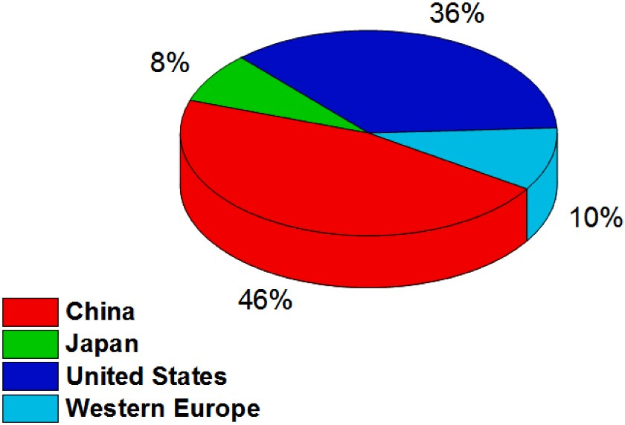
Fig. 2: Total consumption of Slow/Controlled Release Fertilizers in 2018 (García, et al 1996)
Additionally, they comprise Crotonilidine Diurea (CDU), Isobutylidine Diurea (IBDU), and Urea Formaldehyde (UF) (Liu, et al 2017). CRFs also enable a much more regulated nutrient release duration and rate using semi-permeable coverings. While the efficacy of microbial organisms prevents the time of release in a slow release fertiliser from being controlled. CRFs have the ability to decrease any negative impacts and the risk of environmental pollution, as well as the nutrient losses (Schmidt, 2013).
Agronomic effect:
Agronomic benefits of CRFs include enhanced environment for plant growth. These fertilizers with increased efficiency slowly release the nutrients to fit the nutrient requirements of the plants and to ensure synchronisation with crop needs. The absence of osmotic stress or the burning of leaves and roots brought on by the high concentration of soluble salts in conventional fertilizers means that plants benefit from the fertilizer as well. CRFs may also increase germination rates and soil quality while decreasing disease infestation and stalk
Economic impacts:
Controlled release fertilizers can produce savings in terms of fertilizer supply by minimizing nutrient loss. When CRFs are employed, it is possible to reduce the recommended rate of application of a conventional fertilizer by 20 to 30% while keeping the yield same (Trenkel, 2010). Additional cost savings can be made in the form of labour, energy and time. In fact, a single application of CRFs can provide crops with all the nutrients they need for a whole season, avoiding the need for repeated applications and saving on spreading expenses (Trenkel, 2010).
Conclusion
To accomplish sustainable development goals, agriculture must produce more while lowering pollution and greenhouse gas emissions linked with farming operations. Advances in the application of nanotechnology and biotechnology may facilitate improved nutrient management and utilization efficiency in agroecosystems. Smart fertilizers, like Nano fertilizers and slow/controlled release fertilizers, have been demonstrated to improve soil productivity, crop yields, and reduce nutrient losses when compared to conventional fertilizers.
References
Ahmed, S., Niger F., Kabir, MH., Chakrabarti, G., Nur, H.P., & Imamul Huq. S.M. (2012). Development of Slow Release Nano Fertilizer.pp. 45. Proceedings of the on Nanotechnology, September 21-23, 2012-Dhaka, Bangladesh.
Azeem, B., Kushaari, K., Man, ZB., B1asit, A., & Thanh, TH. (2014). Review on materials & methods to produce controlled release coated urea fertilizer. The Journal of Controlled Release 181, 11–21.
Baruah, S., & Dutta, J. (2009). Nanotechnology applications in sensing and pollution degradation in agriculture. Environmental Chemistry Letters, 7, 191-204.
Brady, N.C., and Weil, R.R. (1999). The Nature and Properties of Soils, 12th Edition, Prentice Hall Publishers, London. 1-9, 453-536.
Chabbi, A., Lehmann, J., Ciais, P., Loescher, H.W., Cotrufo, M.F., Don, A., San Clements, M., Schipper, L., Six, J., Smith, P., & Rumpel, C. (2017). Aligning agricul-ture and climate policy. Nature Climate Change, 7,307–309.
Chandini, K.R., Kumar, R. & Prakash, O. (2019). The Impact of chemical fertilizers on our environment and ecosystem. Research Trends in Environmental Sciences, 2, 69-86.
Cordell, D., White, S. (2014). Life’s bottleneck: sustaining the world’s phosphorus for a food secure future. Annual Review of Environment and Resources, 39, 161-88.
Cui, HX., Sun, C.J., Liu, Q., Jiang, J. & Gu, W. (2010). Applications of nanotechnology in agrochemical formulation, perspectives, challenges and strategies. Pp. 28-33. In: International conference on Nanoagri, Sao Pedro, Brazil.
Dos, Santos, B.R., Bacalhau, F.B., Pereira, T.D.S., Souza, C.F., & Faez, R. (2015). Chitosan- montmorillonite microspheres: a sustainable fertilizer delivery system. Carbohydrate Polymers, 127, 340–346.
Erisman, J.W., & Schaap, M. (2004). The need for ammonia abatement with respect to secondary PM reductions in Europe. Environmental Pollution, 129, 159-63.
Fleischer, A., O’Neill, M.A., & Ehwald, R. (1999). The pore size of non-graminaceous plantcell walls is rapidly decreased by borate ester cross-linking of the pectic polysaccharide rhamnogalacturonan II. Plant Physiology, 121, 829-838.
García, M., Díez, J.A., Vallejo, A., García, L. & Artagena, M.C. (1996). Use of kraft pine lignin in controlled-release fertilizer. Industrial & Engineering Chemistry Research, 35, 245–249.
Guru, T., Veronica, N., Thatikunta, R. & Reddy, S.N. (2015). Crop Nutrition Management with Nano fertilizers. International Journal of Environmental Science and Technology, 1(1), 4-6.
Huiyuan, G., Jason, C.W., Zhenyu, W. & Baoshan, X. (2018). Nano-enabled fertilizers tocontrol the release and use efficiency of nutrients. Current Opinion in Environmental Science and Health, 6, 77-83.
Juárez-Maldonado, A., Hortensia, O., América, B.M., Susana, G., Álvaro, M.M., Cabrera-Dela Fuente, M., Sandoval-Rangel, A., Cadenas, P. G. & Benavides-Mendoza, A. (2019). Nanoparticles and Nanomaterials as Plant Biostimulants. International Journal of Molecular Sciences, 20(1), 162.
Khan, M.N., Mobin, M., Abbas, Z.K., Alamri, S.A. (2017). Fertilizers and their contaminants in soils, surface and groundwater. Encyclopedia of Anthropology, pp. 225–240.
Kottegoda, N., Munaweera, I., Nadeesh, M.A. & Karunaratne, V. (2011). A green slow- release fertilizer composition based on urea-modified hydroxyapatite nanoparticles encapsulated wood. Current Science, 101(1), 73-78.
Leggo, P.J. (2000). An investigation of plant growth in an organo-zeolitic substrate and its ecological significance. Plant and Soil, 219, 135-146.
Lin, D. & Xing, B. (2007). Phytotoxicity of Nanoparticles: Inhibition of Seed Germination and Root Growth. Environmental Pollution, 50, 243-250.
Linquist, B.A., Liu, L., van Kessel, C., & van Groenigen, K. J. (2013). Enhanced efficiency nitrogen fertilizers for rice systems: Meta-analysis of yield and nitrogen uptake. Field Crops Research, 154, 246-254.
Liscano, J.F., Wilson, C.E., Norman, R.J. & Slaton, N.A. (2000). Zinc availability to rice from seven granular fertilizers. AAES Research Bulletin, 963, 1-31.
Liu, G., Zotarelli, L., Li, Y., Dinkins, D., Wang, Q. & Ozores-Hampton, M. (2017). Controlled- Release and Slow-Release Fertilizers as Nutrient Management Tools. pp. 1–6. University of Florida, Institute of Food and Agricultural Sciences.
Manjunatha, S.B., Biradar, D.P., & Aladakatti, Y.R. (2016). Nanotechnology and its applications in agriculture: A review. Journal of Farm Sciences, 29(1), 1-3.
Markit, H.I.S. (2018). Chemical Economics Handbook.
Moore, M. (2006). Do nanoparticles present ecotoxicological risks for the health of the aquatic environment? Environment International, 32, 967-976.
Nair, R., Varghese, S.H., Nair, B.G., Maekawa, T., Yoshida, Y., & Kumar, D.S. (2010). Nanoparticulate material delivery to plants. Plant Science, 179, 154-168.
Navarro, E., Baun, A., Behra, R., Hartmann, N.B., Filser, J., Miao, A.J., Quigg, A., Santschi, P.H., & Sigg, L. (2008). Environmental behavior and ecotoxicity of engineered nanoparticles to algae, plants, and fungi. Ecotoxicology, 17, 372-386.
O´skarsson, H., Sigurgeirsson, A., & Raulund-Rasmussen, K. (2006). Survival, growth, and nutrition of tree seedlings fertilized at planting on Andisol soils in Iceland: six- year results. Forest Ecology and Management, 229, 88–97.
Oertli, J.J. & Lunt, O.R. (1962). Controlled release of fertilizer minerals by incapsulating membranes: I. Factors influencing the rate of release. Soil Science Society of America Journal, 26, 579–583.
Otey, F.H., Trimnell, D., Westhoff, R.P., & Shasha, B.S. (1984). Starch matrix for controlled release of urea fertilizer Felix. Journal of Agricultural and Food Chemistry, 32, 1095–1098.
Pahl-Wostl, C. (2009). A conceptual framework for analysing adaptive capacity and multi-level learning processes in resource governance regimes. Global Environmental Change, 19, 354-65.
Preetha, S., & Balakrishnan, N. (2017). A review of nano fertilizers and their use and functions in soil. International Journal of Current Microbiology and Applied Science, 6(12), 3117-3133.
Remya, V.R., George, S.J., & Sabu, T. 2021. Polymer formulations for controlled release of fertilizers. Academic Press, Ppp. 183–194.
Rop, K., Karuku, GN., Mbui, D., Michira, I. & Njomo, N. (2018). Formulation of slow release NPK fertilizer (cellulose-graft-poly(acrylamide)/nano-hydroxyapatite/soluble fertilizer) composite and evaluating its N mineralization potential. Annals of Agricultural Sciences, 63, 163–172.
Saigusa, M. & Ombódi, A. (2000). Broadcast application versus band application of polyolefin‐coated fertilizer on green peppers grown on andisol. Journal of Plant Nutrition, 23, 1485-1493.
Sasson, Y., Levy-Ruso, G., Toledano, O., & Ishaaya, I. (2007). Nanosuspensions: emergingnovel agrochemical formulations, pp. 1-39. In: Ishaaya, I.; Horowitz, A.R. and Nauen R. (eds.). Insecticides design using advanced technologies, Springer, Berlin.
Schmidt, M.A., Kreinberg, A.J., Gonzalez, J.M., Halvorson, J.J., French, E., Bollmann, A., & Hagerman, A.E. (2013). Soil microbial communities respond differently to three chemically defined polyphenols, Plant Physiol. Biochemical, 72, 190–197.
Smith, P.D., Cai, M.Z., Gwary, D., Janzen, H., Kumar., McCarl, B., Ogle, S., O’Mara, F., Rice, C., Scholes, B. & Sirotenko, O. (2007). Agriculture. In: Metz B, Davidson OR, Bosch PR, Dave R, Meyer LA (Eds.), Climate Change 2007: Mitigation. Cambridge University Press, Cambridge, UK/New York, pp. 497–540. Contribution of Working Group III to the 4th AR of IPCC.
Solanki, P., Bhargava, A., Chhipa, H., Jain, N. & Panwar, J. (2015). Nano-fertilizers and their smart delivery system. In: Nanotechnologies in Food and Agriculture, pp 81-101, Springer, Cham.
Subramanian, K.S. & Rahale, S. (2009). Synthesis of nanofertiliser formulations for balanced nutrition. Proceedings of the Indian society of soil science-platinum Jubilee celebration. IARI Campus, New Delhi. 85.
Tarafdar, J.C., Raliya, R. & Rathore, I. (2012). Microbial synthesis of phosphorous nanoparticle from tri- calcium phosphate using Aspergillus tubingensis TFR-5.” Journal of Bionanoscience 6: 84-89.
Tarafdar, J.C., Sharma, S., & Raliya, R. (2013). Review nanotechnology: interdisciplinary science of applications. African Journal of Biotechnology, 12(3), 219-226.
Teixeira, M.A., Paterson, W.J., Dunn, E.J., Li, Q., Hunter, B.K., Goosen, M.F.A., & Hunter, B. K. (1990). Assessment of chitosan gels for the controlled release of agrochemicals. Industrial & Engineering Chemistry Research, 29, 1205–1209.
Tilman, D., Knops, J., Wedin, D., & Reich, P. (2002). Plant diversity and composition: effects on productivity and nutrient dynamics of experimental grasslands, pp 21-35. In: Loreau M, Naeem Inchausti PS (eds.). Biodiversity and ecosystem functioning. Oxford University Press, Oxford.
Trenkel, M.E. (2010). Slow and controlled-release and stabilized fertilizers, International Fertilizer Association, pp.1–163.
Xie, L., Liu, M., Ni, B., & Wang, Y. (2012). New environment-friendly use of wheat straw in slow-release fertilizer formulations with the function of superabsorbent. Industrial & Engineering Chemistry Research, 51, 3855–3862.
Zulfiqar, F., Navarro, M., Ashraf, M., Akram, N.A., & Munne-Bosch, S. (2019). Nanofertilizer use for sustainable agriculture: advantages and Limitations. Plant Science 289: 110270.

