Original Research Article
AFLP Analyses of Divergence in Indian Potato Varieties

.
ABSTRACT
Twenty commercial Indian potato varieties on semi-automated AFLP analysis revealed moderately wide genetic base (similarity index range 0.54-0.74). Three AFLP primer pairs analyzed (MseI CAG x EcoRI ACT-FAM, MseI CAG x EcoRI AAC-NED, MseI CAG x EcoRI ACG-JOE) amplified a total of 346 alleles of which 96 were highly informative, 19 unique and 6 were monomorphic alleles. On an average there were 163 alleles per genotype, ranging from lowest of 136 in Gulabia to a highest of 215 alleles in Kufri Chipsona2. Dendrogram analysis revealed four clusters with three microclusters with single variety each (Kufri Sindhuri, Kufri Chipsona2 and Kufri Dewa), and a megacluster comprising of rest all cultivars studied. Within this megacluster, a separate sub-clusterwas represented byvarieties released during 1958-1971, from Solanum demissum R-gene derived late blight resistance programme. In 2D PCO scatter plot analysis four varieties (Kufri Sindhuri; Kufri Chipsona2; Kufri Dewa and Kufri Safed) were very distinct from rest defined by first component. Kufri Safed derived from landrace Phulwa (S. tuberosum ssp. andigena), was distinct along both components of scatter plot analysis. In addition, neotubersum cultivars, Kufri Chipsona1, Kufri Kanchan, Kufri Anand, Kufri Swarna and landrace Gulalbia also exhibited significant divergence. Overall, the late blight resistance programme varieties showed narrow genetic base, while most of the recent neotubersum cultivars and those of ssp. andigena landraces showed higher diversity. This study also justifies the application of AFLP markers in large scale potato genetic mapping and molecular breeding work.

1. INTRODUCTION

The commonly cultivated potato is a tetraploid and belongs to the species Solanum tuberosum, which includes two subspecies viz. ssp. tuberosum adapted to long days and ssp. andigena adapted to short days. Since most of the present-day potato (Solanum tuberosum L.) varieties are derived from crossing and selection of few lines of Solanum tuberosum subspecies andigena introduced into temperate world around 300 years back, it is known to have narrow genetic base (Bhardwaj et al. 2023., Spanoghe et al. 2022). Potato was introduced into India barely 40 years after its first introduction into Europe (Singh & Dutt 2024). Some European cultivars belonging to ssp. tuberosum were also introduced in the temperate hills of the country. All these cultivars have now been largely replaced by 35 improved varieties released by Central Potato Research Institute, Shimla. With an annual production of about 24 million tons from 1.3 million ha, India ranks 4th in area and 3rd in potato production in the world. However, only fragmented information is available on genetic divergence of Indian potato varieties.
The present-day Indian potato varieties have a narrow genetic base for most of the economically important characters. The genetic base of all Indian potato varieties developed over past 50 years can be traced back to around 70 parents. Most of these parents represent tetraploid potato cultivars with negligible representation of S. tuberosum ssp. andigena and wild/cultivated species (Chaudhary et al. 2024). There is need for better utilization of S. tuberosum ssp. andigena, which is adapted to short days and is suitable for sub-tropical plains. Comparative transcriptome profiling of Andigenum varieties revealed rapid up-regulation of ABA-related genes in tolerant lines, providing a molecular basis for developing drought-resistant crops for water-stressed subtropical regions (Ponce et al., 2022). The under exploitation of wild and primitive cultivated species in variety improvement is primarily due to long time required in developing desirable parental lines. In nutshell, a core collection and focused approach hold the key to utilization of potato genetic resources in future.
Potato breeding is a difficult task due to inherent biological factors, cytoplasmic nuclear sterilities, tetrasomic inheritance and inbreeding depression. The conventional potato breeding depends mainly on identification of promising parental lines for making desired crosses, creation of variability through hybridization and subsequent selection of desirable recombinants for further evaluation and vegetative propagation. Therefore, Information on genetic divergence is essential for sustained genetic improvement of a crop.
Molecular markers have contributed extensively in understanding basic aspects of genome organization, genetic divergence and function during last two decades being simple, quick and informative. Molecular markers are being extensively used for divergence studies. AFLP has become the main tool in molecular marker technology due to its capacity to reveal a high number of polymorphic alleles in a single reaction. In addition, AFLP involves use of a set of generic primers without any prior knowledge of the origin and complexity of the genome sequence. It is primarily dominant (co-dominant if band intensity is compared) with good reproducibility which are distributed throughout the genome. AFLP markers have successfully been used for analyzing genetic diversity in many crop plant species; with these studies indicating that the AFLP technique is highly applicable for molecular discrimination at the species level. In Indian potato, few reports have been published on the analysis of the diversity viz., RAPD (Chakrabarti et al., 2001; Chimote et al., 2007), microsatellite (Chimote et al., 2004; Chimote et al., 2007, Bhardwaj et al., 2023), organelle genome specific (Chimote et al., 2008) and morphological characters (Gaur et al., 1978; Chimote et al., 2007). But no work has been reported using AFLP molecular techniques for evaluating genetic diversity in Indian potato. Further they are limited in their informativeness. Best estimation of genetic diversity available within the commercial potato cultivars is a pre-requisite for sustained potato breeding programme, since many of the released varieties are often used as breeding material. The objective of this study was to evaluate the genetic diversity in Indian potato cultivars by using the AFLP marker technology.
2. material and methods

2.1 Plant DNA material: CTAB method (Doyle & Doyle; 1987) was used to isolate genomic DNA from 2 grams of fresh leaves of each of 20 Indian potato varieties grown from disease-free tubers in glasshouse under long summer days of Shimla (Latitude: 31.60-N, Longitude: 77.13-E, Altitude: 2202 msl). The amount of DNA was quantified by spectrophotometry and quality was checked by absorbance ratio at A260/280 and also by gel-electrophoresis. The varieties consisted of 1 local landrace; 1 exotic and 18 Indian potato varieties (Table 1).
Table 1. Potato varieties used in the study and their parentage.
SN | Variety | Female Parent | Male Parent | Year of release
Clonal selections
 | Kufri Safed | Clonal selection of Phulwa |  | 1958
Half sibs involving different common parents
 | Kufri Kundan | Ekishirazu | Katahdin | 1958
 | Kufri Dewa | Craig’s Defiance | Phulwa | 1973
 | Kufri Sindhuri | Kufri Red | Kufri Kundan | 1967
 | Kufri Muthu (SLB/Z785) | 3046 (1) | M109-3 | 1971
 | Kufri Swarna | Kufri Jyoti | (VTn)² 62.33.3 S.verneipedigree | 1985
 | Kufri Lauvkar | Serkov | Adina | 1972
 | Kufri Sherpa | Ultimus | Adina | 1983
 | Kufri Badshah | Kufri Jyoti | Kufri Alankar | 1979
 | Kufri Sutlej | Kufri Bahar | Kufri Alankar | 1996
Grand Half sibs (2182EF (7) and M 109-3 derived)
 | Kufri Jyoti (SLB/Z389) | 3069d (4) (2182EF (7) x M109-3) | 2814a (1) | 1968
Varieties with distinct parents
 | Kufri Chandramukhi | Sd. 4485 | Kufri Kuber | 1968
 | Kufri Megha | SLB/K-37 | SLB/Z-73 | 1989
 | Kufri Chipsona 1 | MEX.750826 | MS/78-79 (Kufri Jyoti x EM/H-1601) | 1998
 | Kufri Chipsona 2 | F-6 (C 2346) | QB/B 92-4 (Kufri Red x Navajo) | 1998
 | Kufri Anand | Kufri Ashoka | PH/F-1430 | 1999
 | Kufri Kanchan | SLB/Z-405(a) | Pimpernel | 2000

2.2 AFLP analysis: The AFLP reactions (Vos et al; 1995) were carried out following the instructions supplied with the ABI AFLP kit system (PE Applied Biosystems). Simultaneous restriction-ligation reactions were performed overnight at 25°C by double digesting genomic DNA (250 ng) with MseI and EcoRI restriction enzymes (1.0 unit each); EcoRI and MseI adapters were ligated to the digested DNA samples by T4 DNA ligase (0.25 unit) to generate template DNA for amplification. A fraction of the digested DNA was checked on a 1.5% (w/v) agarose gel to ensure check for complete DNA digestion. The restricted-ligated samples were incubated at 75ºC for 15 min to inactivate the restriction endonucleases.
Pre-selective amplification was carried out with adapters +1- primers each carrying one selective nucleotide (EcoRI adapter+A and MseRI adapter+C) in a thermocycler for 20 cycles set at 94ºC denaturation (30 sec), 56ºC annealing (30 sec), and 72ºC extension (30 sec). The initial denaturation was done at 94ºC for 30 sec and the final extension at 72ºC for 8 min. The pre-amplification products were diluted 20-fold in TE buffer and stored at -20ºC; and a fraction of each sample was checked on a 1.5% (w/v) agarose gel to check for pre-selective amplification.
Selective AFLP amplification was carried out with 5’ fluorescently labeled EcoRI adapters + 3 primers (6-FAM- EcoRI ACT; NED-EcoRI AAC and JOE-EcoRI ACG)and unlabeled MseI adapters +3 primer (MseI CAG) and 5 µL of the diluted PCR products from the pre-amplification. Three AFLP primer pairs (MseI CAG x EcoRI ACT; MseI CAG x EcoRI AAC and MseI CAG x EcoRI ACG) were selected from ABI AFLP Selective amplification kits (Applied Biosystems) on the basis of their informativeness reported previously in solanaceous crops. The PCR amplifications were carried out as follows: 13 cycles of touchdown PCR in which the annealing temperature was decreased by 0.7ºC every cycle until a touchdown annealing temperature of 56ºC was reached; i.e. 94ºC for 30 sec, 65ºC for 30 sec with a decrease of -0.7ºC per cycle, and 72ºC for 1 min. Once annealing temperature of 56ºC was reached, another 20 cycles were conducted as described above for pre-amplification.
After selective amplification, JOE-labelled reactions were diluted 100-fold, FAM-labelled reactions by 5-fold, and NED-labelled reactions were not diluted. For multiplexing and semi-automated analysis, 12 µl of deionised formamide, 0.4 µl of Genescan 500 ROX size standard (Applied Biosystem) and 1 µl of each diluted sample was mixed together in a PCR tube. Electrophoresis was performed on the ABI Prism 310 Genetic analyzer (Applied Biosystems) as described earlier (Chimote et al; 2004).
2.3 Diversity analysis of AFLP data: The AFLP fragments scored after Diversity Database analysis and the peak positions of AFLP alleles identified using Genotyper ® 2.5 were recorded as 1 (band/peak present) and 0 (band/peak absent). The binary data were analyzed under the SIMQUAL module of NTSYSpc (Rohlf; 1998) using Dice coefficient (Nei & Li; 1979). SAHN module based on UPGMA clustering method (Sneith & Sokal; 1973) was used to generate a tree (dendrogram).

3. results and discussion

AFLP analysis the genomic DNA of twenty potato cultivars, with three AFLP markers produced a total of 346 peaks/ alleles ranging in size from 50 to 400 bp. The mean number of alleles per variety was 163, ranging from a least of 136 alleles in oldest landrace Gulabia to the maximum of 215 alleles in processing variety Kufri Chipsona-2. The number of alleles detected by individual AFLP marker varied from- 134with MseI CAG x EcoRI AAC-NED, 116 alleles with MseI CAG x EcoRI ACG-JOE and 96 alleles with MseI CAG x EcoRI ACT-FAM. Out of them 96 alleles (27.7%) were highly polymorphic (present in 40-60% samples) and 187 alleles were moderately polymorphic (present/absent in 10-40% samples). Out of the 83 (18.2%) less polymorphic alleles (Present/absent in <10% samples), 6 (1.73%) were monomorphic and 19 (5.49 %) were unique in their profile.
All AFLP markers were the highly informative, capable of distinguishing all varieties studied. All twenty varieties could be clearly grouped into 1 major and three minor clusters on the dendrogram (Figure I) with similarity value ranging from 0.54-0.74. Kufri Chipsona2 (202 alleles), Kufri Sindhuri (144 alleles), and Kufri Dewa (171 alleles), were the most distinct potato cultivars with each forming single mono-genotype clusters. These cultivars have andigena pedigree (Glendinning; 1975). In the large mega cluster (SI =0.67-0.74) had closely grouped cultivars released in between 1958 to 1971 (except Kufri Sherpa released in 1983) with British pedigree. All these varieties (except Kufri Safed and Kufri Kundan) have Solanum demissum derived R gene from Scottish Crop Research Institute, UK (SLB series). Rest of varieties formed divergent minor clusters and are of neotuberosum type (except landrace Gulabia) released in between 1985-2000.
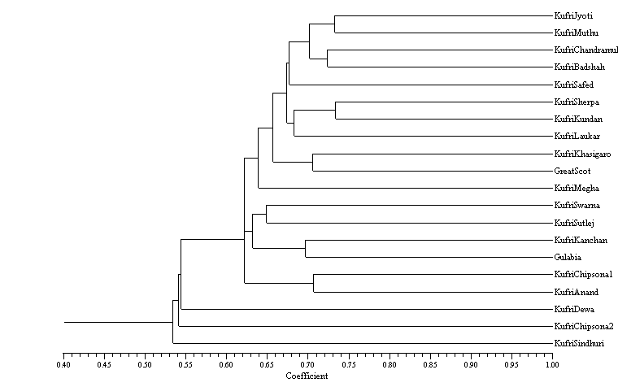Fig. I. AFLP analysis derived dendrogram of 20 Indian potato varieties.

This report matches with our previous report (Chimote et al.; 2007) which showed that Indian varieties were distinguished into three separate groups. Solanum demissum derived late blight resistant varieties formed a closely placed group and andigena type varieties released prior to late blight programme formed a diverse group. Third group composed of either traditional tuberosum varieties or recently released neotuberosum showed overlapping pattern. Most of the oldandigena type varieties (except Kufri Kuber) have local cultivars in descent (Kufri Red, Kufri Safed, Kufri Lalima, Kufri Sindhuri, Kufri Bahar, Kufri Dewa, Kufri Sheetman and Kufri Chamatkar).
Many varieties introduced since late 1960's have Solanum demissum derived late blight resistance and are basically derived from small pool of germplasm from SCRI, UK. These varieties are either of SLB series (Kufri Jyoti and Kufri Muthu), or derived (Kufri Swarna, Kufri Badshah, Kufri Megha and Kufri Kanchan) or with Kennebec pedigree (Kufri Badshah and Kufri Sutlej).
These studies have increased the understanding of the relatedness of potato cultivars. Cultivated potato has high level of heterozygosity thereby allows the distinction of the most cultivars by using almost any molecular marker technique. As expected from earlier reports, limited kinship/ parent–progeny relationship was observed in potato may be due complex genetic nature of potato.
Clear tuberosum varieties were placed in the same quarter of 2D-Scatter plot (positive half of both axis) forming two subgroups with first group comprising Kufri Badshah, Kufri Jyoti, Kufri Chandramukhi and KufriMuthu; while second subgroup comprised of Kufri Sherpa, Great Scot, Kufri Megha, Kufri Laukar, Kufri Kundan and partially to some extent Kufri Khasi Garo and Kufri Sutlej (Figure II).
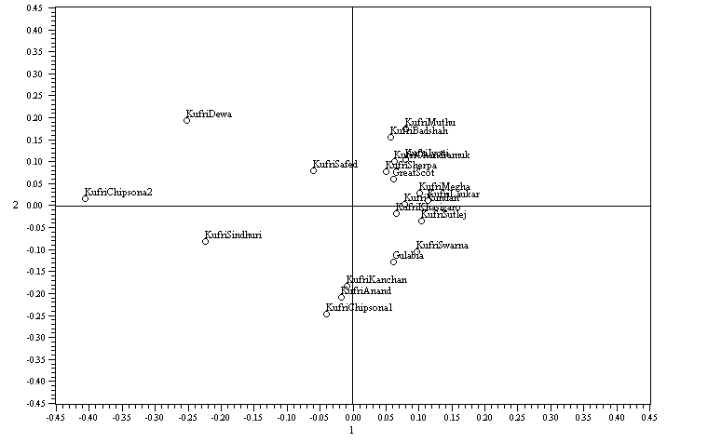 Fig. II. AFLP analysis derived 2D Scatter plot of 20 Indian potato varieties
There was a fringe group comprising Kufri Swarna (with S. vernei in paternal pedigree); Gulabia (Local red tuber landrace); with neo-tuberosum type Kufri Anand, Kufri Kanchan and Kufri Chipsona1 placed in 2D scatter plot quarter exactly opposite to clear tuberosum quarter. All these varieties of recent andigena type are likely to be Neo-tuberosum clones selected from andigena through hybridization with tuberosum followed by selection (Singh and Dutt, 2024, Simmonds et al., 1966).They show many morphological characters that were earlier present only in Indian tuberosum type varieties, e.g. late blight resistance, early tuberization, fleet eyes. Morphologically similar genotypes might not be genotypically similar as different gene pool on selection and breeding can create similar phenotypes. Lack of close association between morphological and genotypic studies indicate that gene pool of recently released varieties is not restricted.
Processing varieties studied i.e. Kufri Chipsona1 and Kufri Chipsona2, were most far placed along X and Y axis respectively. In our previous studies (Chimote et al., 2004) both were found to have andigena maternal parents; while later one has the same also from paternal side pedigree QB/B 92-4 (Kufri Red x Navajo).
Clear segregation of andigena and tuberosum cultures from India into different clusters was reported in earlier morphology-based studies (Gaur et al., 1978; Chimote et al., 2007) as well as molecular studies (Chimote et al., 2007).They observed greater genetic divergence in tuberosum x andigena hybrids than in tuberosum derived exotic/Indian varieties/hybrids confirming that andigena introgression into tuberosum increases the level of their gene pool. In SSR studies it was reported that Indian varieties cluster with Chilean landraces whereas Andean andigena types form a separate cluster with broader genetic diversity (Chimote et al., 2004).
Better resolution of AFLP markers in our studies shows that AFLP primers are extremely powerful tools in diversity analysis as they yield polymorphic multiple alleles. Automation also helps in realizing full potential of the technique during molecular breeding (Figure III).
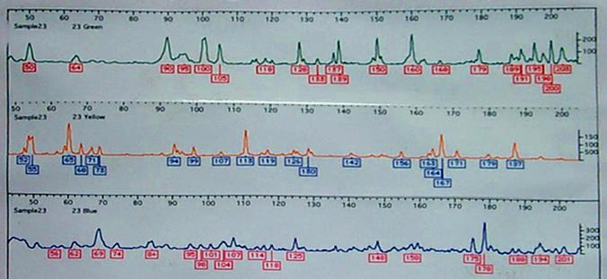
Fig. III. Representative AFLP (Amplified Fragment Length Polymorphism) electropherogram showing the molecular "fingerprinting" to identify genetic variation.

In this experiment attempted to assess the genetic diversity and study inter-relationship in Indian potato varieties by AFLP approach. It suggests that diverse germplasm sources (other than S. demissum) should be used as parental lines for developing late blight resistant varieties. This characterization and documentation of diversity status of Indian varieties is likely to help in sustained potato improvement programme.

4. Conclusion
AFLP-based analysis revealed a moderately wide genetic diversity among Indian potato cultivars, with distinct clustering patterns reflecting their pedigree and breeding history. Varieties derived from solanum demissum exhibited a narrow genetic base, whereas neotuberosum cultivars and andigena landraces showed greater divergence and variability. The study confirms that AFLP markers are highly effective tools for genetic characterization and emphasizes the need for broadening germplasm sources in future potato breeding programs.

References
Bhardwaj, V., Kumar, A., Sharma, S., Singh, B., Poonam, Sood, S., Dipta, B., Singh, R., Siddappa, S., Thakur, A.K. & Dalamu, D. (2023). Analysis of genetic diversity, population structure and association mapping for late blight resistance in potato (Solanum tuberosum L.) accessions using SSR markers. Agronomy, 13(2), p.294.
Chakrabarti, S. K., Pattanayak, D., & Naik, P. S. (2001) Fingerprinting Indian potato cultivars by random amplified polymorphic DNA (RAPD) markers." Potato research 44(4), p.375-387.
Chaudhary, B., Gupta, V., Luthra, S. and Kumar, M. (2024). Morphological characterization of indigenous potato (Solanum tuberosum) genotypes. https://agris.fao.org/search/en/providers/122648/records/667195bc75507fed3402ca1e
Chimote, V. P., Chakrabarti, S. K., Pattanayak, D., & Naik, P. S. (2004). Semi-automated simple sequence repeat analysis reveals narrow genetic base in Indian potato cultivars. Biologia plantarum, 48(4), 517-522.
Chimote, V. P., Chakrabarti, S. K., Pattanayak, D., Pandey, S. K., & Naik, P. S. (2008). Molecular analysis of cytoplasm type in Indian potato varieties. Euphytica, 162(1), 69-80.
Chimote, V. P., Pattanayak, D., & Naik, P. S. (2007). Molecular and morphological divergence studies in Indian potato varieties. Indian Journal of Biotechnology, 6(2), 216.
Doyle, J. J., & Doyle, J. L. (1987). A rapid DNA isolation procedure for small quantities of fresh leaf tissue. Phytochemical bulletin, 19(1), p.11-15.
Gaur, P. C., Gupta, P. K., & Kishore, H. (1978). Studies on genetic divergence in potato. Euphytica, 27(2), 361-368.
Nei, M., & Li, W. H. (1979). Mathematical model for studying genetic variation in terms of restriction endonucleases. Proceedings of the National Academy of Sciences, 76(10), 5269-5273.
Ponce, O. P., Torres, Y., Prashar, A., Buell, R., Lozano, R., Orjeda, G. & Compton, L. (2022) Transcriptome profiling shows a rapid variety-specific response in two Andigenum potato varieties under drought stress. Front. Plant Sci. 13: 1003907.doi: 10.3389/fpls.2022.1003907
Rohlf, F. J. (1998). NTSYSpc numerical taxonomy and multivariate analysis system version 2.0 user guide. New York
Simmonds, N. W. (1966). Studies of the tetraploid potatoes. III. Progress in the experimental re-creation of the Tuberosum Group. Botanical Journal of the Linnean Society, 59(379), 279-288.
Singh, B. & Dutt, S. (2024). Seventy-five years of potato in India. Indian Farming; Vol. 74 No. 5 (2024): World Potato Day; 03-08, 0019-4786
Sneath, P. H. A., & Sokal, R. R. (1973). Numerical Taxonomy Freeman. The Principles and Practice of Numerical Classification. 1-573.
Spanoghe, M., Marique, T., Nirsha, A., Esnault, F. & Lanterbecq, D. (2022). Genetic diversity trends in the cultivated potato: a spatiotemporal overview. Biology, 11(4), p.604.
Vos, P., Hogers, R., Bleeker, M., Reijans, M., Lee, T. V. D., Hornes, M., ... & Zabeau, M. (1995). AFLP: a new technique for DNA fingerprinting. Nucleic acids research, 23(21), 4407-4414.

