Bioefficacy of Different Herbicides Against Cyperus spp. in Direct-Seeded Rice and Their Effect on Rice Growth Parameters

Abstract
Direct-seeded rice (DSR) is becoming more popular due to lower labour and water requirements. However, severe weed infestation, particularly by Cyperus rotundus and the associated sedges, remains a major impact on crop production. A field experiment was conducted at faculty of agriculture wadura, to evaluate the bioefficacy of different herbicides against Cyperus spp. in Direct-Seeded Rice and their effect on rice growth parameters. The soil of the experimental field was slighty acid in reaction pH (5.9), medium in available Nitrogen (327 kgha⁻¹), Phosphorous (17.3kgha⁻¹) and Potassium (248kgha⁻¹) with high organic carbon content (0.98%). A randomized block design was used to evaluate various pre and post-emergence herbicide treatments to weedy and weed-free controls. viz, Halosulfuron (75 WG) @ 35 g ha⁻¹ , Bensulfuronmethyl (60 DF), @ 60 g ha⁻¹,Cyhalofopbutyl (10 EC) @ 100 g ha⁻¹ , Bispyribacsodium (10 SC) @ 30 ha⁻¹, Ethoxysulfuron (15 WDG) @ 45 g ha⁻¹, Pretilachlor @ 700 g ha⁻¹ Pendimethalin (30 EC) fb 2,4-D (58 SL) (0.75kg ha⁻¹ +1.0kg⁻¹ ), along with Weedy check and Weed free within three replications. Among the herbicides application of Bispyribacsodium @ 30gha⁻¹ provides excellent control of weed spices (grasses, cyperus weed spp. and broad leaf weeds) which resulted in significant increase in growth parameters like plant height, LAI and dry matter accumulation. The highest benefit: cost ratio of 1.49 was recorded with application of bispyribacsodium @ 30gha⁻¹, Therefore, The study illustrates that, in direct-seeded rice, proper herbicide selection and timing can greatly improve management of Cyperus spp., boosting crop growth and supporting sustainable rice production in labor- and water-constrained environments.
Keywords: Direct-seeded rice, Cyperus spp., crop growth, herbicide efficacy, sedge control

1. Introduction

Rice (Oryza sativa) is a significant grain crop and the staple food for more than half of the world's population. Over the last decade, India has produced 150 million tons of rice from 43 million hectares, with an average productivity of 3.2-3.7 t/ha (Singh and Ranguwal, 2024). Puddled transplanted rice (PTR) is a popular conventional production system, however it is highly unsustainable in the long run since it consumes a large amount of water, labor, and energy, as well as destroys soil health due to puddling and frequent tillage operations (Ojha and Kwatra, 2014). In recent years, traditional transplanted rice has been replaced by direct seeded rice. It has several benefits, including labor savings, reduced water and drudgery requirements, early crop maturity, low production costs, improved soil physical conditions for subsequent crops, reduced methane emissions, and better options to be the best fit in various cropping systems (Kaur and Singh, 2017). In many cases, most farmers are small or marginal landholders and are unable to bear the high costs associated with these operations. Moreover, prolonged turnaround time and erratic monsoon rainfall often delay the sowing of the succeeding crop (Singh and Singh, 2010). Depending on the amount of water available in the region, direct seeding of rice can be either wet or dry. In addition to other management techniques, weed concerns, especially grassy weeds, plague the use of sprouted rice seed or wet-seeded rice in puddled soil, despite its growing importance as a crop establishment technique under lowland rice. However, due to high weed infestation and the lack of an effective post-emergence herbicide molecule for weed flora management this method became redundant (Jat et al., 2010). Weed growth in DSR is severe, and it is one of the major limiting factors in meeting DSR's yield potential (Rao et al., 2007). Due to water scarcity and labor scarcity, farmers are once again turning to direct-seeded rice systems that are mechanized for the sustainability of rice production in irrigated ecosystems (Sandhu et al., 2021). DSR success relies heavily on good weed management methods. The expansion of direct-seeded rice (DSR) cultivation has remained limited primarily because of severe weed infestation and inadequate weed management practices (Mohammad et al., 2018). Weeds are considered one of the most serious constraints in DSR, causing yield reductions ranging from 50 to 90%, and under severe infestation, complete crop failure may occur (Kaur et al., 2024). The magnitude of yield reduction in direct-seeded rice largely depends on both the severity and duration of crop–weed competition during crop growth (Sardana et al., 2017). In direct-seeded rice, the critical period during which weeds cause maximum damage generally extends from 2 to 12 weeks after sowing, which is considerably longer than in puddled transplanted rice (Singh et al., 2014). Traditionally, weed management in many Asian rice-growing regions relies heavily on manual weeding. However, this practice has become increasingly difficult because of labour scarcity and rising wage rates, making manual weed control highly expensive and labour demanding, often costing several times more than chemical methods (Rao et al., 2007). In contrast, herbicide application has emerged as a more practical and economical option, as it provides effective and selective weed control, requires less labour, and can be applied more conveniently under large-scale field conditions. Consequently, the adoption of herbicides among direct-seeded rice farmers has increased substantially in recent years (Chauhan, 2012). Several pre-emergence and post-emergence herbicides have shown promise in efficiently managing a variety of weed species in direct-seeded rice (Bana et al., 2020). Among the herbicides commonly recommended for weed management in direct-seeded rice, pendimethalin is widely used as a pre-emergence herbicide because of its effectiveness against early germinating weeds. Applied to the soil soon after sowing, it is absorbed mainly through roots and coleoptiles, where it suppresses cell division and restricts seedling elongation, thereby preventing weed establishment (Pathak et al., 2011). Ethoxysulfuron is generally applied at the early post-emergence stage and is particularly effective against sedges and broad-leaved weeds. It is absorbed through both roots and foliage and subsequently translocated within the plant to inhibit weed growth (Pathak et al., 2011). Bispyribac-sodium has gained importance as a post-emergence herbicide for controlling a wide range of grasses, broad-leaved weeds, and sedges in rice ecosystems. It acts by inhibiting the enzyme acetolactate synthase (ALS), which blocks the biosynthesis of branched-chain amino acids essential for plant growth, ultimately leading to weed death (Vencill, 2002). Because of its broad-spectrum activity, bispyribac-sodium is frequently used either alone or in combination with other herbicides to improve weed control efficiency under diverse field conditions (O’Barr et al., 2003). Halosulfuron is a comparatively newer herbicide that has shown strong effectiveness against Cyperus rotundus and other Cyperus spp., while also providing control of several broad-leaved weed species. Its usefulness becomes particularly important in direct-seeded rice where diverse terrestrial and aquatic weed flora often occur simultaneously, requiring broad-spectrum weed management strategies (Gianessi et al., 2002). In addition, sequential herbicide application has been found effective under Indian conditions, where cyhalofop-butyl followed by 2,4-D provided satisfactory control of mixed weed populations in rice fields (Angiras and Attri, 2002).Keeping in view above facts the experiment was taken up, to study the Bioefficacy of Different Herbicides Against Cyperus spp. in Direct-Seeded Rice and Their Effect on Rice Growth Parameters.
2. Materials and Methods
A field experiment was conducted at Faculty of Agriculture, SKUAST Kashmir, Wadura during Kharif 2019. The experiment was conducted in the temperate agro-climatic conditions of the union territory located at 34°34′ N latitude and 74°40′ E longitude, at an elevation of 1584 m above mean sea level. The site falls under the mid-altitude temperate zone, which is characterized by warm summers and severe winters. The region receives an average annual precipitation of 812 mm, based on long-term records of the previous 20 years, with the major share of precipitation occurring between December and April in the form of rainfall and snowfall. Meteorological observations recorded during the cropping season at the Meteorological Observatory, Kupwara are presented in Figure 1. The weather data indicated that the mean maximum and minimum temperatures during the crop growth period were 33.34°C and 5.34°C, respectively. Total precipitation received during the cropping period was 355.2 mm. In addition, the mean maximum relative humidity was 87.29%, while the mean minimum relative humidity remained 44% during crop growth.
The soil of the experimental field was slightly acidic in reaction pH (5.9), medium in available Nitrogen (327kgha⁻¹), Phosphorus (17.3kgha⁻¹) and Potassium (248kgha⁻¹) with high organic carbon content (0.98%). The experiment was laid out in Randomized block design (RBD) comprised of nine treatments including seven herbicidal treatments viz, Halosulfuron (75 WG) @ 35 g ha-1 , Bensulfuronmethyl (60 DF), @ 60 g ha⁻¹ , Cyhalofopbutyl (10 EC) @ 100 g ha⁻¹ , Bispyribacsodium (10 SC) @ 30 ha⁻¹ , Ethoxysulfuron (15 WDG) @ 45 g ha⁻¹, Pretilachlor @ 700 g ha⁻¹ Pendimethalin (30 EC) fb 2,4-D (58 SL) (0.75kg ha⁻¹ +1.0kg⁻¹ ), along with Weedy check and Weed free within three replications. Weed control in the experimental field was done as per the treatments including weedy check and weed free. Pre-germinated rice seeds were manually planted in puddled soil by spot seeding at a spacing of 15 × 15 cm during the ist week of may 2019. Fertilizers were supplied according to the recommended nutrient schedule at the rate of 80 kg nitrogen, 40 kg phosphorus (P₂O₅), and 40 kg potassium (K₂O) per hectare, using Urea, Diammonium phosphate, and Muriate of potash as nutrient sources, respectively. Irrigation water was applied at 7-day intervals to maintain a standing water depth of 3–5 mm, depending on rainfall conditions, up to the grain-filling stage of the crop. Weed management treatments were carried out according to the prescribed experimental treatment schedule.T he herbicide pendimethalin fb 2,4-D (0.75kg ha⁻¹+1.0kg ha⁻¹ ) were applied as pre-emergent at 3 DAS, while as cyhalofopbutyl (100g a.i ha⁻¹) bispyribacsodium (30 g a.i ha⁻¹) ethoxysulfuron (45 g a.i ha⁻¹) and halosulfuron (35 g a.i ha⁻¹) as post emergent were applied at 25 DAS. The herbicides were sprayed on moist soil on the plots with a knapsack sprayer equipped with a flat fan nozzle using 500 liters of water per hectare.
Economic analysis of the different treatments was carried out using grain and straw yield on a per hectare basis. The cost of cultivation and gross returns were calculated according to the prevailing market prices of inputs and produce. Net returns were obtained after subtracting the total cost of cultivation from gross returns. The benefit–cost ratio was computed as the ratio of net returns to the total cost of cultivation, representing the return obtained per unit of investment. Benefit–cost ratio = Net returns / Total cost of cultivation
The observation was recorded at 20 days intervals. The data obtained in respect of various observations were statistically analyzed by method described by Cochran and Cox (1963). The significance of ‘F’and ‘t’ was tested at 5 percent level of significance. The critical difference value was determined when ‘F’ test was significant. Analysis of the data was done by using OP Stat software programme.
3. Results and Discussion
Different weed management treatments exerted a significant influence on rice plant height at various growth stages of the crop. However, treatment effects were not significant at 20 days after sowing (DAS). At crop maturity, the weed-free treatment produced the tallest plants, indicating the beneficial effect of complete weed suppression on crop growth. Among the herbicidal treatments, application of bispyribac-sodium at 30 g a.i. ha⁻¹ resulted in significantly greater plant height at maturity compared with the other weed control treatments, followed by bensulfuron-methyl at 60 g a.i. ha⁻¹. In contrast, the weedy check recorded the lowest plant height, which may be attributed to severe weed competition for nutrients, moisture, light, and space throughout the crop growth period. The superior performance of bispyribac-sodium may be associated with its effective weed suppression, which enhanced nutrient availability and uptake by the crop, thereby promoting better vegetative growth, as also reported by (Kumar and Rana ,2013). Table 1, Figure 2
Leaf area index (LAI) was not significantly influenced by weed management treatments at 20 DAS; however, significant differences among treatments were observed at later growth stages (40, 60, 80, 100, and 120 DAS). The LAI increased progressively from 20 DAS to 80 DAS, reached its maximum at 80 DAS, and declined thereafter until harvest. This trend reflects active leaf expansion during vegetative growth followed by senescence of older leaves at later stages. The highest LAI at 80 DAS was recorded under the weed-free treatment, indicating the beneficial effect of complete weed suppression on canopy development. Among herbicidal treatments, bispyribac-sodium @ 30 g a.i. ha⁻¹ produced significantly higher LAI compared with pendimethalin followed by 2,4-D (0.75 + 1.0 kg ha⁻¹) and halosulfuron @ 35 g a.i. ha⁻¹. In contrast, the weedy check consistently recorded the lowest LAI throughout the crop growth period due to severe crop–weed competition. Since LAI is directly related to leaf area, its increase up to 80 DAS may be attributed to vigorous leaf development, while the subsequent decline was associated with senescence and drying of lower leaves, as described by (Gomez,1972). The superior LAI observed under bispyribac-sodium treatment may be due to effective weed control, which reduced shading and competition, thereby improving the availability of light, water, and nutrients for crop growth. Similar findings have also been reported by Dangol et al. (2020); Sangra et al. (2018). and Bhurer et al. ( 2012). Table 2, Figure 3
Dry matter accumulation of rice was significantly affected by different weed management treatments at all growth stages except 20 DAS. The weed-free treatment recorded the highest dry matter accumulation throughout the crop growth period and at maturity, whereas the weedy check produced the lowest dry matter yield, with a value of 96.34 q ha⁻¹ at maturity. Among herbicidal treatments, bispyribac-sodium @ 30 g a.i. ha⁻¹ resulted in significantly greater dry matter accumulation at different growth stages and at maturity compared with pendimethalin followed by 2,4-D (0.75 + 1.0 kg ha⁻¹) and halosulfuron @ 35 g a.i. ha⁻¹. The higher dry matter production under bispyribac-sodium may be attributed to effective weed suppression, which reduced crop–weed competition during the critical growth period and improved the availability of light, nutrients, and moisture to the crop. Dry matter production largely depends on photosynthetic efficiency and the partitioning of assimilates among plant organs, which ultimately determines economic yield, as described by Arnon. (1972). Similar observations have also been reported by Sangra et al. (2018). and Bhurer et al.(2012). Table 3, Figure 4
Economic evaluation of weed management treatments indicated clear differences in profitability among treatments. The weed-free treatment produced the highest gross returns (₹132,978 ha⁻¹) and net returns (₹71,913 ha⁻¹), but recorded a comparatively lower benefit:cost ratio (1.17) due to the high labour cost involved in repeated manual weedings throughout the crop season. Among herbicidal treatments, bispyribac-sodium @ 30 g a.i. ha⁻¹ generated gross returns of ₹123,901 ha⁻¹, net returns of ₹74,261 ha⁻¹, and the highest benefit:cost ratio (1.49), indicating superior economic efficiency. This may be attributed to effective weed suppression during the critical crop growth stages, which improved crop productivity with lower cultivation cost. In contrast, the weedy check recorded the lowest economic returns and benefit:cost ratio because of severe yield reduction caused by weed competition. Similar findings have been reported by Mahajan et al. (2009); Hussain et al. (2008); Subramanium et al. (2006) and Yadav et al. (2009). Table 4
4. Conclusion
Based on the present investigation, it can be concluded that among the evaluated weed management practices, bispyribac-sodium @ 30 g ha⁻¹, apart from the weed-free treatment, proved to be the most effective in suppressing a broad spectrum of weeds, including Cyperus spp., under direct-seeded rice conditions. Post-emergence application of bispyribac-sodium at 25 DAS resulted in improved crop growth, as reflected by greater plant height, higher leaf area index, and enhanced dry matter accumulation. In addition, this treatment produced superior economic returns, indicating its effectiveness as a practical and economically viable weed management option in direct-seeded rice cultivation.

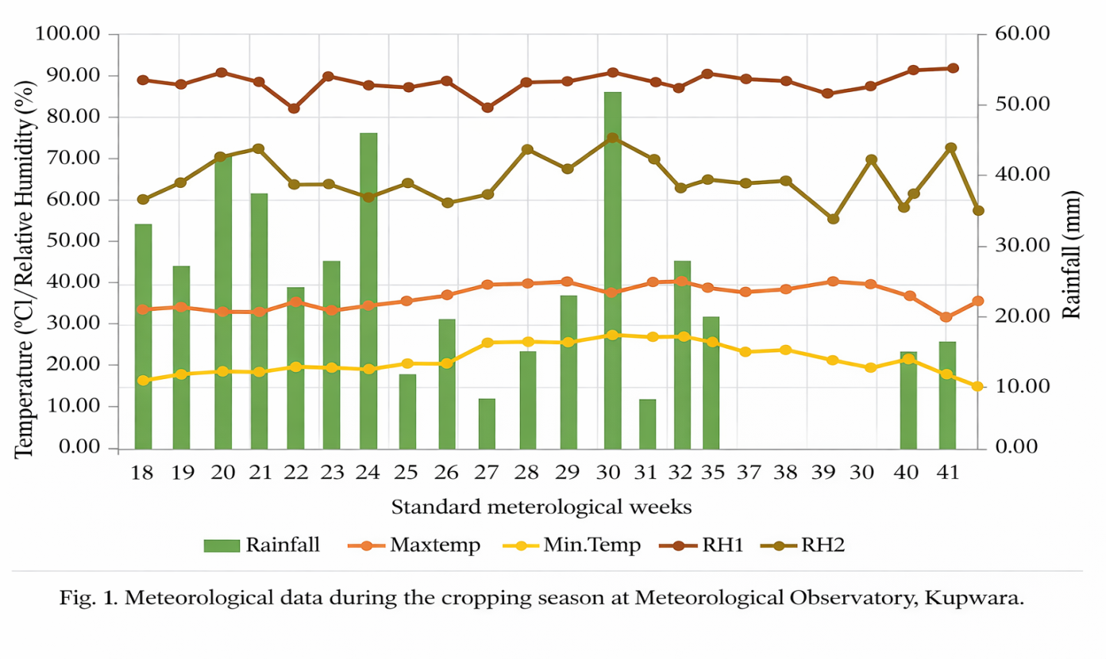

Table 1. Effect of different weed control treatments on plant height (cm) in direct seeded rice (DSR) at different intervals after sowing

Treatments | 20 DAS | 40 DAS | 60 DAS | 80 DAS | 100 DAS | 120 DAS | At Maturity
Halosulfuron (35 g a.i ha⁻¹ ) | 16.22 | 22.01 | 51.95 | 90.95 | 108.63 | 113.50 | 115.54
Bensulfuronmethyl (60 g a.i ha⁻¹) | 16.20 | 21.52 | 51.80 | 88.25 | 105.16 | 111.25 | 113.96
Cyhalofopbutyl (100 g a.i ha⁻¹) | 16.20 | 21.00 | 51.46 | 87.68 | 104.88 | 109.63 | 111.73
Bispyribacsodium (30 g a.i ha⁻¹) | 16.25 | 23.76 | 54.46 | 95.14 | 111.69 | 116.10 | 118.66
Ethoxysulfuron (45 g a.i ha⁻¹) | 16.10 | 20.58 | 50.99 | 85.32 | 104.70 | 108.25 | 110.82
Pretilachlor (700 g a.i ha⁻¹) | 16.00 | 20.03 | 50.54 | 82.62 | 102.08 | 106.30 | 108.40
Pendimethalin fb 2,4-D (0.75 kg ha-1+1.0 kg ha⁻¹ | 16.07 | 22.51 | 52.58 | 92.52 | 109.80 | 114.69 | 116.77
Weedy check | 15.67 | 19.23 | 39.87 | 72.34 | 100.66 | 95.43 | 98.21
Weed free | 17.27 | 24.25 | 56.02 | 97.87 | 113.11 | 118.15 | 121.70
SE(m)± | 0.55 | 0.97 | 0.70 | 1.17 | 2.05 | 1.97 | 1.11
CD(p≤0.05) | NS | 2.93 | 2.12 | 3.55 | 6.22 | 5.96 | 3.38

Table 2. Effect of different weed control treatments on Leaf area index (LAI) in direct seeded rice (DSR) at different intervals after sowing

Treatments | 20 DAS | 40 DAS | 60 DAS | 80 DAS | 100 DAS | 120 DAS
Halosulfuron (35 g a.i ha-1 ) | 0.24 | 1.84 | 2.87 | 4.66 | 3.77 | 3.35
Bensulfuronmethyl (60 g a.i ha-1 ) | 0.22 | 1.82 | 2.37 | 4.47 | 3.61 | 3.21
Cyhalofopbutyl (100 g a.i ha-1 ) | 0.20 | 1.80 | 2.14 | 4.32 | 3.46 | 3.15
Bispyribacsodium (30 g a.i ha-1 ) | 0.27 | 2.18 | 3.24 | 4.96 | 4.18 | 3.49
Ethoxysulfuron (45 g a.i ha-1 | 0.17 | 1.75 | 2.03 | 4.26 | 3.36 | 3.04
Pretilachlor (700 g a.i ha-1 | 0.15 | 1.36 | 1.98 | 4.15 | 3.26 | 2.72
Pendimethalin fb 2,4-D (0.75 kg ha-1+1.0 kg ha⁻¹ | 0.26 | 1.86 | 3.00 | 4.76 | 3.90 | 3.44
Weedy check | 0.12 | 1.10 | 1.86 | 3.82 | 3.10 | 2.45
Weed free | 0.28 | 2.49 | 3.58 | 5.22 | 4.34 | 3.54
SE(m)± | 0.05 | 0.19 | 0.32 | 0.21 | 0.03 | 0.04
CD(p≤0.05) | N.S | 0.58 | 0.96 | 0.63 | 0.11 | 0.13

Table 3. Effect of different weed control treatments on dry matter accumulation (qha⁻¹) in direct seeded rice (DSR) at different intervals after sowing
Treatments | 20 DAS | 40 DAS | 60 DAS | 80 DAS | 100 DAS | 120 DAS | At Maturity
Halosulfuron (35 g a.i ha-1 ) | 1.17 | 5.25 | 34.37 | 94.87 | 115.76 | 131.84 | 136.58
Bensulfuronmethyl (60 g a.i ha-1 ) | 1.14 | 4.75 | 31.26 | 91.77 | 110.52 | 126.13 | 131.85
Cyhalofopbutyl (100 g a.i ha-1 ) | 1.09 | 4.25 | 26.40 | 88.85 | 107.280 | 122.61 | 127.99
Bispyribacsodium (30 g a.i ha-1 ) | 1.21 | 6.42 | 40.54 | 100.69 | 124.83 | 142.58 | 147.03
Ethoxysulfuron (45 g a.i ha-1 | 1.07 | 4.00 | 23.32 | 85.03 | 105.98 | 118.95 | 123.67
Pretilachlor (700 g a.i ha-1 | 1.00 | 3.92 | 21.71 | 82.03 | 103.87 | 114.74 | 116.95
Pendimethalin fb 2,4-D (0.75 kg ha-1+1.0 kg ha⁻¹ | 1.21 | 5.74 | 37.70 | 97.81 | 120.55 | 136.26 | 141.97
Weedy check | 0.94 | 3.08 | 17.52 | 56.21 | 76.21 | 93.13 | 96.34
Weed free | 1.22 | 6.92 | 43.15 | 103.32 | 131.14 | 150.10 | 155.16
SE(m)± | 0.07 | 0.36 | 1.17 | 1.81 | 1.54 | 1.75 | 2.15
CD(p≤0.05) | N. S | 1.09 | 3.54 | 5.48 | 4.66 | 5.31 | 6.52

Table 4. Effect of different Treatment control on Relative economics ₹ (ha⁻¹) in direct seeded rice (DSR) at different intervals after sowing.
Treatments | Total cost of cultivation (Rs.) | Gross returns from grain yield (Rs. | Gross returns from straw yield (Rs.) | Total returns (Rs.) | Net returns (Rs.) | B:C ratio
Halosulfuron (35 g a.i ha-1 ) | 48608 | 75660 | 25350 | 101010 | 52402 | 1.07
Bensulfuronmethyl (60 g a.i ha-1 ) | 49475 | 72995 | 24789 | 97784 | 48309 | 0.97
Cyhalofopbutyl (100 g a.i ha-1 ) | 49395 | 65000 | 24729 | 89729 | 40334 | 0.81
Bispyribacsodium (30 g a.i ha-1 ) | 49640 | 96382 | 27519 | 123901 | 74261 | 1.49
Ethoxysulfuron (45 g a.i ha-1 | 49365 | 63050 | 24300 | 87350 | 37985 | 0.76
Pretilachlor (700 g a.i ha-1 | 47742 | 59540 | 24150 | 83690 | 35948 | 0.75
Pendimethalin fb 2,4-D (0.75 kg ha-1+1.0 kg ha-1 | 49190 | 84630 | 26100 | 110730 | 61540 | 1.25
Weedy check | 45065 | 41626 | 20568 | 62194 | 17129 | 0.38
Weed free | 61065 | 104130 | 28848 | 132978 | 71913 | 1.17
Labour @ Rs.400/day; Seed @ Rs.25/kg;Urea @ Rs.5.50/kg; DAP @ Rs.26.00/kg; MOP @ Rs.19/kg; ZnSo4 @ Rs.72/kg;
Halosulfuron@Rs1943/kg;Bensulfuronmethyl@Rs.2810/kg;Cyhalofopbutyl@Rs.2730/kg; Bispyribacsodium@Rs2975
/kg.Ethoxysulfuron@Rs2700/kgPretilachlor@Rs1077/LPendimethalin@Rs1620/L;.2,4-D@Rs905/L.CostofManual weeding (4
times), 1 labour/2 kanal @ Rs. 400/labour. Rice @ 1300/q; Straw @ Rs 27/bundle (9 kg).

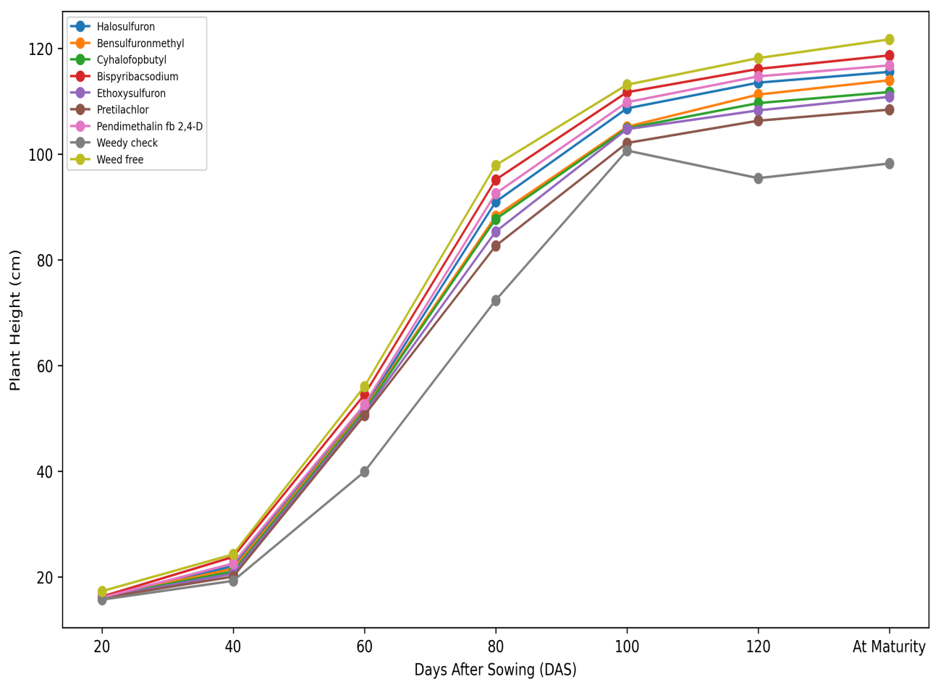
Fig 2. Effect of different weed control treatment on Plant height at different growth intervals
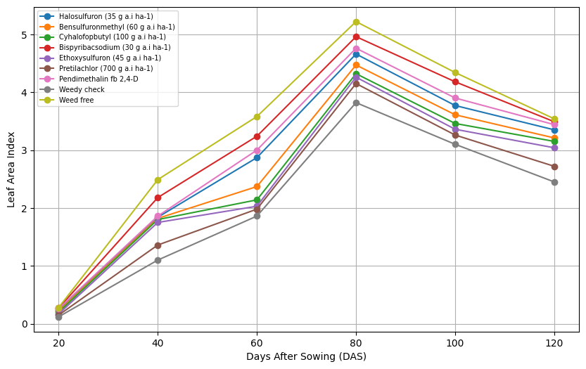

Fig 3. Effect of different weed control treatment on Leaf area index at different growth intervals

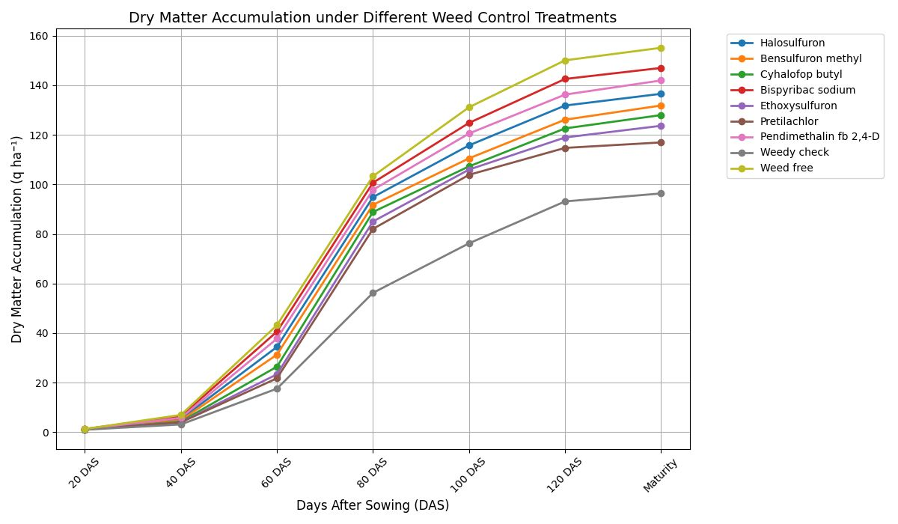

Fig 4. Effect of different weed control treatment Dry matter accumulation (qha⁻¹) at different growth intervals

References
Angiras, N. N., & Attri, S. P. (2002). Efficacy of herbicide mixture to control mixed weed flora in direct seeded puddled rice. Indian Journal of Weed Science, 34, 42–45.

Arnon. (1972). Crop production in dry regions. Leonard Hill Books.

Bana, R. S., Singh, D., Nain, M. S., Kumar, H., Kumar, V., & Sepat, S. (2020). Weed control and rice yield stability studies across diverse tillage and crop establishment systems under on-farm environments. Soil and Tillage Research, 204, 104729. https://doi.org/10.1016/j.still.2020.104729

Bhurer, K. P., Yadav, D. N., Ladha, J. K., Thapa, R. B., & Pandey, K. (2012). Efficacy of various herbicides to control weeds in dry direct-seeded rice (Oryza sativa L.). Global Journal of Research and Education, 2(4), 205–212.

Chauhan, B. S. (2012). Weed ecology and weed management strategies for dry-seeded rice in Asia. Weed Technology, 26(1), 1–13. https://doi.org/10.1614/WT-D-11-00105.1

Dangol, R., Pandey, S. R., Shrestha, B., Thapa Magar, D. B., & Bhattarai, N. (2020). Effects of different weed management practices on growth and yield of direct-seeded spring rice in Jhapa, Nepal. Cogent Food & Agriculture, 6(1), 1825040. https://doi.org/10.1080/23311932.2020.1825040

Gianessi, L. P., Silvers, C. S., Sankula, S., & Carpenter, J. E. (2002). Plant biotechnology: Current and potential impact for improving pest management in U.S. agriculture—An analysis of 40 case studies (Herbicide tolerant rice). National Center for Food and Agriculture Policy.

Hussain, S., Ramzan, M., Akhter, M., & Aslam, M. (2008). Weed management in direct seeded rice. Journal of Animal and Plant Sciences, 18(2–3), 86–88.

Jat, M. L., Singh, R. G., Sidhu, H. S., Singh, U., Malik, R., Kamboj, B. R., & Gupta, R. K. (2010). Resource conserving technologies in South Asia: Frequently asked questions. CIMMYT.

Kaur, J., & Singh, A. (2017). Direct seeded rice: Prospects, problems/constraints and researchable issues in India. Current Agriculture Research Journal, 5(1), 13–32. https://doi.org/10.12944/CARJ.5.1.03

Kaur, S., Ahmed, S., Awan, T. H., Ali, H. H., Singh, R., Mahajan, G., & Chauhan, B. S. (2024). Adoption pattern of direct-seeded rice systems in three South Asian countries during COVID-19 and thereafter. Crops, 4(3), 324–332. https://doi.org/10.3390/crops4030021

Kumar, S., & Rana, S. S. (2013). Bioefficacy of bispyribac-sodium for weed control in direct seeded rice. Pesticide Research Journal, 25(2), 123–127.

Mahajan, G., Chauhan, B. S., & Johnson, D. E. (2009). Weed management in aerobic rice in north-western Indo-Gangetic Plains. Journal of Crop Improvement, 23(4), 366–382. https://doi.org/10.1080/15427520902969958

Mohammad, A., Sudhishri, S., Das, T. K., Singh, M., Bhattacharyya, R., Dass, A., & Kumar, M. (2018). Water balance in direct-seeded rice under conservation agriculture in north-western Indo-Gangetic Plains of India. Irrigation Science, 36(6), 381–393. https://doi.org/10.1007/s00271-018-0592-9

Ojha, P., & Kwatra, S. (2014). Analysis of different paddy transplanting methods in northern India: Ergo-economical study. Journal of Applied and Natural Science, 6(2), 654–658.

O’Barr, J. H., Chandler, J. M., & McCauley, G. N. (2003). Pre- vs. post-flood applications of Regiment in rice. Proceedings of the Southern Weed Science Society, 56, 52.

Pathak, H., Tewari, A. N., Sankhyan, S., Dubey, D. S., Mina, U., Singh, V. K., Jain, N., & Bhatia, A. (2011). Direct-seeded rice: Potential, performance and problems. Current Advances in Agricultural Sciences, 3, 77–88.

Rao, A. N., Johnson, D. E., Sivaprasad, B., Ladha, J. K., & Mortimer, A. M. (2007). Weed management in direct-seeded rice. Advances in Agronomy, 93, 153–255. https://doi.org/10.1016/S0065-2113(06)93004-1

Sandhu, N., Sagare, D. B., Singh, V. K., Yadav, S., & Kumar, A. (2021). Environment-friendly direct seeding rice technology to foster sustainable rice production. In Scaling-up solutions for farmers (pp. 279–305). Springer. https://doi.org/10.1007/978-3-030-03822-9_12

Sangra, R., Singh, N., Singh, A. P., Devendra, & Mahajan, R. (2018). Evaluation of different weed management practices on growth and yield attributes of rice under direct-seeded system. Journal of Pharmacognosy and Phytochemistry, Special Issue 1, 454–458.

Sardana, V., Mahajan, G., Jabran, K., & Chauhan, B. S. (2017). Role of competition in managing weeds: An introduction to the special issue. Crop Protection, 95, 1–7. https://doi.org/10.1016/j.cropro.2016.06.011

Singh, G., & Ranguwal, S. (2024). Resource conservation through direct seeded rice: Evidence from Indian Punjab. Agro International Journal, 9(1), 5–15.

Singh, M., Bhullar, M. S., & Chauhan, B. S. (2014). The critical period for weed control in dry-seeded rice. Crop Protection, 66, 80–85. https://doi.org/10.1016/j.cropro.2014.08.012

Singh, R. G., Singh, S., Singh, V., & Gupta, R. K. (2010). Efficacy of azimsulfuron applied alone and tank-mixed with metsulfuron + chlorimuron (almix) in dry direct seeded rice. Indian Journal of Weed Science, 42(3–4), 168–172.

Subramanian, E., Martin, G. J., & Balasubramanian, R. (2006). Effect of integrated weed management practices on growth and yield of wet-seeded rice (Oryza sativa L.) and residual effect on succeeding pulse crop. Indian Journal of Agronomy, 51(2), 93–96.

Vencill, W. K. (Ed.). (2002). Herbicide handbook (8th ed.). Weed Science Society of America.

Yadav, D. B., Yadav, A., & Punia, S. S. (2009). Evaluation of bispyribac-sodium for weed control in transplanted rice. Indian Journal of Weed Science, 41(1–2), 23–27.

