Original Research Article
Phytochemical Screening and Bioactivity Evaluation of Volkameria inermis Flower Essential Oil: Antioxidant, Anti-Inflammatory, and in-Silico ADMET Studies

Abstract
The present study explored the phytochemical composition, antioxidant, anti-inflammatory, and molecular docking potential of the flower essential oil of Volkameria inermis. GC-MS analysis identified 34 volatile constituents, with the oil being rich in linalool (24.52%), followed by 1,6-hentriacontanone (13.48%), n-hexacosane (10.68%), 1-octen-3-ol (8.77%), and n-pentacosane (8.59%), indicating the predominance of oxygenated monoterpenes and long-chain hydrocarbons. The essential oil showed a clear concentration-dependent antioxidant activity, reaching 70.54±0.16% DPPH radical scavenging and 72.22±0.27% hydrogen peroxide scavenging at 100 µL/mL, with IC₅₀ values of 64.93±0.02 and 64.53±0.02 µL/mL, respectively. A significant anti-inflammatory effect was also observed in the protein denaturation assay, where the oil produced 62.70±0.24% inhibition at 100 µL/mL with an IC₅₀ of 73.50±0.29 µL/mL. The molecular docking studies supported these biological findings. In antioxidant docking with superoxide dismutase (SOD), (E)-nerolidol showed the strongest interaction (-6.5 kcal/mol), followed by fokienol (-5.9 kcal/mol), eugenol (-5.5 kcal/mol), α-terpineol (-5.5 kcal/mol), and linalool (-5.1 kcal/mol), showing affinities comparable to the standard antioxidants. In anti-inflammatory docking, (Z)-lanceol acetate showed the highest binding with COX-1 (-8.4 kcal/mol), while α-copaene displayed the strongest COX-2 interaction (-7.7 kcal/mol), supporting the observed inhibition of protein denaturation. Overall, the combined GC-MS, antioxidant, anti-inflammatory, and docking results suggest that the flower essential oil of V. inermis is a promising natural source of bioactive antioxidant and anti-inflammatory compounds, with linalool-rich terpenoids and sesquiterpenes playing major roles in the observed activity.

1. Introduction
Medicinal plants remain central to contemporary natural product-based drug discovery because of their ability to biosynthesize structurally diverse metabolites with high pharmacological relevance (Shrivastava & Patel, 2007; Chan et al. 2023). Volkameria inermis (L.) (syn. Clerodendrum inerme), a coastal medicinal shrub belonging to the family Lamiaceae, has emerged as a scientifically significant species due to its broad ethnopharmacological use, rich phytochemical diversity, and expanding evidence base of pharmacological efficacy (Yuan et al. 2010; Chan et al. 2023). The species is widely distributed throughout tropical and subtropical coastal ecosystems of South and Southeast Asia, Africa, Australia, and Pacific islands, where it thrives in saline habitats, mangrove margins, sandy shores, and littoral scrublands (Chan et al. 2023; Kulshreshtha et al. 2026). Traditionally, the leaves and aerial parts have been used in Indian, Thai, and Vietnamese folk medicine for the treatment of fever, skin disorders, inflammation, cough, rheumatism, neuralgia, boils, wounds, hepatic disorders, and microbial infections, thereby establishing a strong ethnomedicinal basis for phytopharmacological investigation (Shrivastava & Patel, 2007; Chan et al. 2023).
V. inermis is recognized as a chemically prolific medicinal taxon, with investigations on aerial parts, leaves, stems, roots, and flowers revealing a broad spectrum of flavonoids, diterpenoids, triterpenoids, sterols, iridoid glycosides, phenolic glycosides, phenylethanoid glycosides, phenylpropanoid glycosides, chalcones, and sesquiterpenes (Chen et al. 2012). Major reported constituents include acacetin, hispidulin, apigenin, scutellarein, eucalyptin, acteoside, crolerodendrums A and B, cleroinermin, inerme A, and inerme B (Chan et al. 2023; Chen et al. 2012). Flower-specific chalcones, including 3-hydroxy-3′,4′-dimethoxychalcone and 3,2′-dihydroxy-3′,4′-dimethoxychalcone, further highlight the importance of the underexplored floral metabolome. These metabolite classes are biologically important because flavonoids and chalcones contribute to radical scavenging, anti-inflammatory signaling, membrane stabilization, and antiproliferative effects, whereas phenylethanoid glycosides such as acteoside are strongly associated with cytoprotective, hepatoprotective, and neuroprotective responses (Chen et al. 2012). Likewise, diterpenoid and triterpenoid scaffolds are frequently linked to antimicrobial, cytotoxic, and enzyme inhibitory mechanisms, supporting their value as lead structures in natural product research (Shrivastava & Patel, 2007).
Pharmacological investigations on extracts and isolated compounds of V. inermis have demonstrated anticancer, anti-inflammatory, antioxidant, hepatoprotective, analgesic, antibacterial, antifungal, anti-tyrosinase, neuroprotective, wound-healing, antipyretic, larvicidal, hypotensive, and hypoglycemic activities (Chen et al. 2012; Shrivastava & Patel, 2007). Particularly notable is the reported neuropharmacological activity and prepulse inhibition deficits, which provides a distinctive therapeutic dimension to this species These activities are mechanistically linked with suppression of oxidative stress, modulation of inflammatory mediators, amyloid-β inhibition, and glutamatergic neuroprotection (Kulshreshtha et al. 2026).
Despite these advances, most studies on V. inermis have focused on leaves, aerial parts, roots, and conventional solvent extracts, while the flowers of V. inermis remain insufficiently studied. Since biological investigations on flower-derived essential oil chemistry are still limited in this species, the present work specifically emphasizes the extraction and investigation of floral essential oil to explore its unexplored volatile bioactive constituents and associated biological relevance. Therefore, targeted investigation of this underexplored floral bioactive part may support the investigation of novel lead molecules with pharmaceutical relevance.

2. Materials and Methods
2.1 Collection of Plant Material
Fresh V. inermis flowers were collected from Kashipur (29.2104° N, 78.9619° E) situated in the Tarai region of Udham Singh Nagar, Uttarakhand, India. The collection was carried out during the month of September to ensure appropriate physiological maturity of the plant material and were subsequently shade dried at ambient temperature to preserve thermolabile and volatile phytoconstituents. V. inermis flowers and plant specimen thus collected were then identified by Dr. D.S. Rawat (Taxonomist) with voucher specimen number GBPUH-1930, was deposited in the herbarium of Department of Biological Sciences, for future references.

2.2 Isolation/Extraction of Essential oil
The fresh flowers of V. inermis were subjected to hydro-distillation using a Clevenger-type apparatus for 4 h to extract the essential oil. Distillation was performed with distilled water under controlled heating conditions to facilitate efficient recovery of volatile components. The obtained essential oil was separated and dried over anhydrous sodium sulphate (Na₂SO₄) to remove any residual moisture. The dried oil was subsequently transferred into amber-colored glass vials to minimize photo-degradation and stored at 4 °C in a refrigerator until further analysis. The percentage yield of the essential oil was calculated on a dry weight basis and recorded as 0.5% by mass.

2.3 Chemical Composition Analysis of Essential oil
To check the chemical composition of the extracted essential oil GC-MS was performed with Shimadzu QP 2010 Plus using GCMS-QP 2010 Ultra DB-5 and GCMS-QP 2010 Ultra Rtx-5MS columns (30 m × 0.25 mm i.d., 0.25 µm). The following experimental conditions used helium as the carrier gas (flow rate = 1.21 mL/min, split ratio = 10.0). The oven temperature was programmed from at 50-280 °C with a temperature gradient of 3 °C/min up to 210 °C (isotherm for 2 min), then 6 °C/min up to 280 °C. Identification of essential oil components was done by comparing their relative retention index (RI) values with mass spectra NIST (NIST version 2.1) and WILEY (7th edition) libraries, and by matching the fragmentation patterns of the mass spectral data with those reported in the literature (Adams, 2007; Acree & Chickos, 2022).
2.4 In-vitro Phytochemical Bioassays
The in-vitro phytochemical bioassays, the antioxidant and anti-inflammatory activities were examined in the Department of Chemistry at Govind Ballabh Pant University of Agriculture and Technology, Pantnagar, Uttarakhand.
2.4.1 Antioxidant Activity
2.4.1.1 DPPH Radical Scavenging Activity
In this assay, different concentrations of the test sample (25-100 µL/mL) were mixed with 5 mL of freshly prepared 0.004% DPPH solution in ethanol and incubated in the dark for 30 min. All measurements were performed in triplicate, after which the absorbance was recorded at 517 nm using a UV spectrophotometer (Thermo Fisher Scientific, Evolution-201, Waltham, MA, USA) against a blank. BHT, prepared at the same concentration range (25-100 µL/mL) as the tested essential oil, served as the reference standard. The percentage inhibition of DPPH free radicals by the essential oil and the standard was determined using the following equation:
$$\% DPPH Radical Scavenging Activity=\left[{(A}_{0}-A_{t}\right)/A_{0}] ×100$$
Where $A_{0}$ represents the absorbance value of the control sample, and $A_{t}$ represents the absorbance value of test sample. The dose-response curve was plotted with percentage inhibition against concentration. A higher percentage of inhibition value indicates a higher radical scavenging activity (Diniz do Nascimento et al. 2020; Karakoti et al. 2022; Kumari et al. 2026).

2.4.1.2 Hydroxyl Radical Scavenging Activity
Hydrogen peroxide radical scavenging activity is based on the ability of antioxidant molecules to donate electrons to hydrogen peroxide (H₂O₂), thereby reducing it to water and neutralizing its reactivity (Kumari et al. 2026; Karakoti et al. 2022). In this method, 60 mL of 1 mM FeSO₄·7H₂O was mixed with 90 mL of 1 mM aqueous 1,10-phenanthroline solution. To this reaction mixture, 2.4 mL of 0.2 mM phosphate buffer (pH 7.8) was added. Thereafter, 150 mL of 0.17 M hydrogen peroxide and 1 mL of the test sample at varying concentrations (25-100 µL/mL) were introduced. After incubation for 5 min, the absorbance was measured at 560 nm against a blank. L-ascorbic acid, prepared in the same concentration range (25-100 µL/mL), was used as the positive control. The percentage scavenging of H₂O₂ was then determined using the following equation:
$$\% H_{2}O_{2} radical scavenging activity=\left[{(A}_{0}-A_{t}\right)/A_{0}] ×100$$
Where $A_{0}$ represents the absorbance value of the control sample, and $A_{t}$ represents the absorbance value of test sample. The dose-response curve was plotted with percentage inhibition against concentration. A higher percentage of inhibition value indicates a higher H₂O₂ radical scavenging activity (Moller et al. 2021; Karakoti et al. 2022).

2.4.2 Anti-inflammatory Activity
Anti-inflammatory activity, a biological response to harmful stimuli is the capacity of a substance or treatment to alleviate inflammation. This is achieved by anti-inflammatory agents, which can be pharmaceutical or natural that inhibit specific pro-inflammatory molecules in the body (Dharmendra et al. 2019). The egg albumin method was employed to assess anti-inflammatory activity. To 2 mL of test sample at concentrations ranging from (25-100 µL/mL), a mixture of 2.8 mL of 0.002 M phosphate buffer and 0.2 mL of egg albumin was added. The reaction mixture was subjected to a two-step temperature treatment, involving incubation at 37°C for 15 minutes, followed by a 5-minute heat treatment at 70°C, and subsequent cooling to room temperature. Absorbance readings were taken at 660 nm, using a reagent blank as the control and Diclofenac sodium as the reference standard. Subsequent calculations of percentage inhibition were performed using the provided equation:
$$\% Inhibition=\left[{(A}_{0}-A_{t}\right)/A_{0}] ×100$$
Where $A_{0}$ represents the absorbance value of the control sample, and $A_{t}$ represents the absorbance value of test sample. The dose-response curve was plotted with percentage inhibition against concentration.
2.5 In-silico Studies
2.5.1 Protein Models and Molecular Docking
Molecular docking was performed to predict and rationalize the probable molecular mechanisms underlying the antioxidant and anti-inflammatory activity of the major phytoconstituents identified in the essential oil of flowers of V. inermis. Three-dimensional (3D) crystal structures of the target proteins were retrieved from the RCSB Protein Data Bank (PDB) (Dallakyan & Olson, 2015). The target protein was pre-processed using BIOVIA Discovery Studio 2022 to remove water molecules, heteroatoms, cofactors, ligands, and non-essential chains, resulting in a refined structure containing only the protein backbone with polar hydrogen atoms (Hernandez et al. 2024). The phytochemicals selected for docking were based on their higher relative abundance in the essential oil composition of V. inermis, as identified by GC-MS analysis. The ligands included Linalool (CID: 6549), Geraniol (CID:637566), Eugenol (CID: 3314), Nerolidol (CID: 5284507), Phytol (CID: 5280435), Squalene (CID: 638072), Fokienol (CID: 5352449), 16-Hentriacontanone (CID: 94741).
2.5.1.1 Antioxidant Activity
For antioxidant activity, the protein with PDB ID: 2C9V (Superoxide dismutase) was obtained from RCSB PDB. This enzyme is critical for scavenging superoxide radicals, thereby protecting biological systems from oxidative stress. The structure was used to study the binding efficiency of plant-derived antioxidants.
2.5.1.2 Anti-inflammatory Activity
Anti-inflammatory mechanisms were explored through docking with Human Cyclooxygenase-1 (COX-1, PDB ID: 4O1Z) and Human Cyclooxygenase-2 (COX-2, PDB ID: 4M11). Phytochemicals are well recognized for their ability to modulate inflammatory responses, largely by influencing COX-1, COX-2 and reducing the synthesis of prostaglandin E₂ (PGE₂), a key mediator of inflammation (Peana et al. 2002).
Molecular docking analyses were performed using PyRx 0.8 to assess the binding affinities and interaction profiles from V. inermis flower essential oil with selected proteins (Dallakyan and Olson, 2015). The two-dimensional (2D) structures of all selected ligands were retrieved from the PubChem database (https://pubchem.ncbi.nlm.nih.gov) accessed on 06 April 2026 in SDF format. In PyRx, the prepared protein structure was imported as the macromolecule, while the ligands were treated as flexible molecules with defined rotatable bonds. A three-dimensional grid box encompassing the entire protein surface along the X, Y, and Z axes was generated to define the docking search space. Docking was executed using the Vina Wizard module, with exhaustiveness parameters set to ensure reliable sampling of ligand conformations. For each ligand-protein complex, multiple docking poses were generated, and the best-ranked conformations were selected based on the lowest binding energy values (kcal/mol). The top scoring docked complexes were further visualized and analyzed using BIOVIA Discovery Studio-2021 Client to elucidate key intermolecular interactions, including hydrogen bonding, hydrophobic interactions, π–π stacking, van der Waals forces, and alkyl interactions. Strong binding affinities and stable ligand-protein interactions indicate the potential of selected phytochemicals. Thus, to substantiate experimental observations and to elucidate the probable molecular mechanisms governing the biological potential of V. inermis flower essential oil constituents, molecular docking was performed.
2.5.2 In-Silico ADMET Study
The pharmacokinetic and toxicological evaluation of bioactive compounds derived from the essential oil of flowers of Volkameria inermis represents a critical step in assessing their suitability as potential drug candidates. The ADMET (Absorption, Distribution, Metabolism, Excretion, and Toxicity) properties of selected phytochemicals were systematically evaluated using established web-based computational platforms to predict their pharmacological feasibility and safety profiles (Arya et al. 2023).
The chemical structures of the selected compounds were initially drawn using ChemDraw Ultra 8.0, and subsequently converted into SMILES format for computational analysis. The drug-likeness, physicochemical properties, and pharmacokinetic parameters including GI absorption, blood-brain barrier permeability, lipophilicity, solubility, and compliance with Lipinski’s rule of five were predicted using the SwissADME online server (http://www.swissadme.ch/, accessed on 06 April 2026) following the recommended protocol. The SwissADME predictions provided insights into the oral bioavailability and overall drug-likeness of the selected compounds. In parallel, the ProTox-3.0 web server (http://tox.charite.de/protox_II, was accessed on 06 April 2026) utilized to evaluate the toxicity profiles of the selected phytochemicals. It calculates the prediction-based toxicity endpoints based on molecular similarity, fragment-based analysis, and machine-learning models (James et al, 2023; Manojkumar et al, 2024). Parameters assessed included acute oral toxicity (LD₅₀ values), toxicity class, hepatotoxicity, cytotoxicity, mutagenicity, carcinogenicity, and immunotoxicity, thereby providing a comprehensive toxicological risk assessment.
2.6 Statistical Analysis
All the trials were conducted in triplicates and the data were statistically analyzed using RStudio software (Version 2021.09.2, developed by RStudio Team, PBC, Boston) as mean ± standard deviation (SD), calculated from independent experiments. Statistical significance among the groups was determined based on p-value analysis enquiring critical difference and p value <0.05 was considered to indicate a statistically significant difference. IC₅₀ (half-maximal inhibitory concentration) values were obtained through sigmoidal curve fitting of percent inhibition against concentrations using OriginPro Learning Edition 2026 software.

3. Results and Discussion
3.1 Chemical Composition
Phytochemical analysis of the essential oil derived from V. inermis flowers identified a chemically complex mixture comprising 34 bioactive constituents, systematically categorized by molecular formula, retention index, relative abundance, and structural classification. The oil exhibited a predominance of linalool (24.52%), a monoterpene alcohol recognized for its significant influence on the oil’s aromatic profile and potential biological activity. Other major components were 1,Octen-3-ol (8.77%), α-3-Cyclohexene-1-methanol (2.27%), Geraniol (2.89%), Eugenol (2.69%), Nerolidol (1.79%), n-Pentacosane (8.59%), n-Hexacosane (10.68%), 1,6- Hentriacontanone (13.93%), Phenol 2,4 bis(1,1 dimethylethyl)-phosphite(3.38%). The phytochemical spectrum further encompassed substantial levels of fatty alcohols (such as 1-octanol and (Z)-3-nonen-1-ol), aromatic aldehydes (notably phenylacetaldehyde), sesquiterpenes ((E)-nerolidol, fokienol), diterpenoids (kolavenol, squalene), and minor cyclic or polycyclic hydrocarbons, collectively contributing to the oil’s diverse biochemical landscape and suggesting a multifaceted potential for pharmacological applications. The total chemical composition is given in Table 1.

Table 1: Chemical composition of Essential Oil of V. inermis flowers
S.No | Pubchem CID | Compound Name | Molecular Formula | R.I. | % Composition | Chemical Class
1 | 18827 | 1-Octen-3-ol | C₈H₁₆O | 969 | 8.77 | Secondary alcohol
2 | 998 | Phenylacetaldehyde | C₈H₈O | 1045 | 1.20 | Aromatic aldehyde
3 | 140213 | 3-Ethyl-3-methyl heptane | C₁₀H₂₂ | 931 | 1.84 | Branched alkane
4 | 957 | 1-Octanol | C₈H₁₈O | 1059 | 1.56 | Fatty alcohol
5 | 28468 | 3,7-Dimethyl decane | C₁₂H₂₆ | 1086 | 0.78 | Branched alkane
6 | 6549 | Linalool | C₁₀H₁₈O | 1082 | 24.52 | Monoterpene
7 | 5364631 | (Z)- 3-Nonen-1-ol | C₉H₁₈O | 1167 | 0.30 | Fatty alcohol
8 | 519158 | 3-Hydroxy decane | C₁₀H₂₀O | 1184 | 0.38 | Aliphatic alcohol
9 | 17100 | α-Terpineol | C₁₀H₁₈O | 1175 | 2.27 | Terpene
10 | 643820 | (Z)-3,7-Dimethyl, 2,6-octadien-1-ol | C₁₀H₁₈O | 1228 | 0.91 | Monoterpene alcohol
11 | 637566 | Geraniol | C₁₀H₁₈O | 1255 | 2.89 | Monoterpenoid
12 | 11635 | Octadecane | C₁₈H₃₈ | 1800 | 0.43 | Alkane
13 | 12398 | n- Heptadecane | C₁₇H₃₆ | 1700 | 1.18 | Alkane
14 | 3314 | Eugenol | C₁₀H₁₂O₂ | 1357 | 2.69 | Terpenoid
15 | 19774 | 2,6,10-Trimethyl tridecane | C₁₆H₃₄ | 1425 | 0.43 | Sesquiterpenoid
16 | 94334 | Cis-1,1,4A,7-tetramethyl- 2,3,4,4A,5,6,7,8-octahydro-1H-benzocyclohepten-7-ol | C₁₅H₂₆O | 1490 | 0.90 | Polycyclic aromatic alcohol
17 | 565721 | (2-Ethyl-1-methylbutylidene)- cyclohexane | C₁₃H₂₄ | 1313 | 0.65 | Substituted cycloalkane
18 | 5284507 | (E)-Nerolidol | C₁₅H₂₆O | 1561 | 1.79 | Sesquiterpene
19 | 5352449 | Fokienol | C₁₅H₂₄O | 1596 | 1.20 | Sesquiterpenoid
20 | 117301 | α- Bisabolol oxide B | C₁₅H₂₆O₂ | 1655 | 0.37 | Sesquiterpene derivative
21 | 31291 | Tetradecanal | C₁₄H₂₈O | 1524 | 3.31 | Fatty aldehyde
22 | 10408 | 6,10,14-Trimethyl, 2-pentadecanone | C₁₈H₃₆O | 1838 | 1.54 | Sesquiterpenoid
23 | 5365667 | (Z)- 9,17- Octadecadienal | C₁₈H₃₂O | 1997 | 0.70 | Fatty aldehyde
24 | 5367436 | 3-(1-Methyl-2-propenyl)- 1,5-cyclooctadiene | C₁₂H₁₈ | 1209 | 0.24 | Cyclic hydrocarbon
25 | 5364643 | Hexadec-(9Z)-enal | C₁₆H₃₀O | 1796 | 0.33 | Fatty aldehyde
26 | 86869 | 7-Isopropyl-1,1,4A -trimethyl-1,2,3,4,4A,9,10,10A-octahydro-phenanthrene | C₂₀H₃₀ | 2043 | 0.28 | Diterpenoid
27 | 5280435 | [R-[R*,R* -(E) ]]- 3,7,11,15-Tetramethyl, 2-hexadecen-1-ol | C₂₀H₄₀O | 2103 | 0.73 | Diterpenoid
28 | 6442554 | Kolavenol | C₂₀H₃₄O | 2220 | 0.83 | Diterpenoid
29 | 12406 | n- Pentacosane | C₂₅H₅₂ | 2500 | 8.59 | Alkane
30 | 12410 | n- Hentriacontane | C₃₁H₆₄ | 3100 | 0.45 | Alkane
31 | 12407 | n-Hexacosane | C₂₆H₅₄ | 2600 | 10.68 | Alkane
32 | 638072 | Squalene | C₃₀H₅₀ | 2914 | 0.40 | Triterpenoid
33 | 94741 | Palmitone | C₃₁H₆₂O | 3280 | 13.48 | Dialkyl ketone
34 | 91601 | Phenol,2,4-bis(1,1-dimethylethyl)- phosphite | C₄₂H₆₃O₃ P | 3420 | 3.38 | Phosphite ester

3.2 Antioxidant Activity

The essential oil obtained from the flowers of Volkameria inermis demonstrated significant antioxidant potential, evidenced by its concentration-dependent scavenging ability in both DPPH (2,2-diphenyl-1-picrylhydrazyl) scavenging and Hydroxyl (H₂O₂) scavenging assays. The oil showed strong, dose-dependent radical neutralization comparable to standard antioxidants BHT and Ascorbic acid. The dose-dependent increase in antioxidant activity observed in both assays reflects the cumulative and synergistic effects of the identified constituents. The biological response observed indicates that the antioxidant capacity is due to the synergistic effect of its major and minor phytoconstituents. The synergistic interactions among monoterpenes within essential oils are well established and can substantially amplify their biological activities, often surpassing the effects exerted by the individual constituents alone (Bakkali et al. 2008; Mohanty et al. 2023).
3.2.1 DPPH Radical Scavenging Activity
The essential oil of V. inermis flowers demonstrated a clear dose-dependent DPPH radical scavenging activity, indicating appreciable antioxidant potential. As presented in Table 2, the essential oil showed a progressive increase in percentage radical scavenging activity (%RSA) with increasing concentration, in comparison with the standard antioxidant BHT. At 25 μL/mL, VIEO exhibited 26.43±0.12% RSA, which increased to 35.14±0.36% at 50 μL/mL, suggesting moderate antioxidant activity at lower concentrations. A further substantial rise in radical scavenging was observed at 75 μL/mL, where the essential oil produced 51.58±0.39% RSA, indicating effective neutralization of DPPH free radicals. At the highest tested concentration (100 μL/mL), the oil achieved 70.54±0.16% RSA, demonstrating strong antioxidant efficiency. In comparison, the reference antioxidant BHT exhibited 44.17±0.38%, 63.21±0.21%, 86.82±0.10%, and 99.21±0.10% RSA at 25, 50, 75, and 100 μL/mL, respectively. Table 2 represents the dose-dependent DPPH radical scavenging activity of the EO.
Table 2: DPPH Radical Scavenging activity of Essential Oil of V. inermis flowers
Sample | Replication | Concentration (µL/mL) |  |  |  | CD at 5%
Sample | Replication | 25 | 50 | 75 | 100 | CD at 5%
VIEO | R1 | 26.31 | 35.45 | 51.19 | 70.67 | 0.58
VIEO | R2 | 26.43 | 35.22 | 51.97 | 70.59 | 0.58
VIEO | R3 | 26.55 | 34.75 | 51.97 | 70.36 | 0.58
VIEO | Mean ± SD | 26.43±0.117 | 35.14±0.357 | 51.58±0.391 | 70.54±0.162 | 0.58
BHT | R1 | 43.73 | 63.41 | 86.95 | 99.10 | 0.43
BHT | R2 | 44.43 | 63.25 | 86.76 | 99.25 | 0.43
BHT | R3 | 44.35 | 62.98 | 86.76 | 99.29 | 0.43
BHT | Mean ± SD | 44.17±0.38 | 63.21±0.21 | 86.82±0.10 | 99.21±0.10 | 0.43
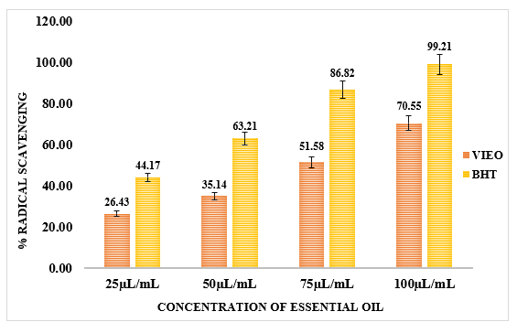
Figure 1: DPPH Radical Scavenging activity of Essential Oil of V. inermis flowers
Figure 1 explains that although the activity of VIEO remained lower than BHT, the observed concentration-responsive increase confirms the substantial radical scavenging capacity of the floral volatile fraction. The oil was dominated by linalool (24.52%), an oxygenated monoterpene alcohol well recognized for its hydrogen atom transfer (HAT)-based radical scavenging ability due to the presence of an allylic hydroxyl group. The presence of geraniol (2.89%), another oxygenated monoterpenoid alcohol, may further enhance the scavenging potential through proton donation and stabilization of the resulting radical intermediates. Additionally, eugenol (2.69%), a phenolic terpenoid, is a particularly potent antioxidant because its phenolic hydroxyl group readily donates hydrogen atoms and forms resonance-stabilized phenoxyl radicals, thereby efficiently quenching DPPH radicals (Ruberto and Baratta, 2000). The contributions of (E)-nerolidol (1.79%), fokienol (1.20%), and α-bisabolol oxide B, all belonging to oxygenated sesquiterpene classes, may further strengthen antioxidant activity.
Table 3: IC values of DPPH Radical Scavenging activity of Essential Oil of V. inermis flowers
Sample | Replication | Inhibitory Concentrations (IC)
Sample | Replication | IC10 | IC50 | IC90
VIEO | R1 | 13.25 | 64.92 | 318.06
VIEO | R2 | 13.26 | 64.95 | 317.82
VIEO | R3 | 13.26 | 64.93 | 317.65
VIEO | Mean±SD | 13.26±0.01 | 64.93±0.02 | 317.84±0.21
BHT | R1 | 9.75 | 30.44 | 95.01
BHT | R2 | 9.68 | 30.39 | 95.75
BHT | R3 | 9.65 | 30.41 | 96.01
BHT | Mean±SD | 9.69±0.05 | 30.41±0.03 | 95.59±0.52
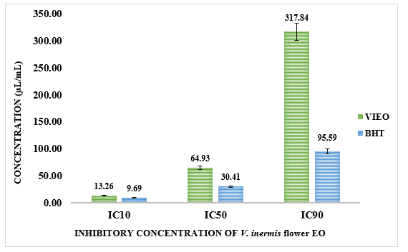
Figure 2: IC values of DPPH Radical Scavenging activity of Essential Oil of V. inermis flowers
The inhibitory concentration values derived from the dose-response curve further substantiated these findings. As shown in Table 3, the essential oil exhibited IC₁₀ and IC₅₀ values of 13.26±0.01, 64.93±0.02 μL/mL, respectively, while higher inhibition of IC₉₀ level of 317.84±0.21 μL/mL is noted. In comparison, BHT displayed lower inhibitory concentrations (IC₁₀ = 9.69±0.05 μL/mL, IC₅₀ = 30.41±0.03 μL/mL, and IC₉₀ = 95.59±0.52 μL/mL), reflecting its established strong antioxidant efficacy (Fig. 2). Nevertheless, figure 2 and table 3, exhibits the moderate IC₅₀ value of 64.93 μL/mL indicating a considerable ability of the essential oil to scavenge free radicals and supports its potential as a natural antioxidant source.
Mechanistically, the antioxidant effect can be mainly attributed to HAT and SET-PT pathways, primarily contributed by linalool, geraniol, and eugenol, while unsaturated sesquiterpenes such as nerolidol may additionally participate via RAF mechanisms (Ruberto & Baratta, 2000). The presence of minor amounts of squalene, a triterpenoid hydrocarbon known for singlet oxygen quenching and oxidative stabilization, may also contribute to the overall reducing potential. Although long-chain alkanes and dialkyl ketones such as n-hexacosane (10.68%), n-pentacosane (8.59%), and 16-hentriacontanone (13.48%) possess relatively weak intrinsic antioxidant activity, they do not diminish the strong contribution of the dominant oxygenated bioactive constituents.
3.2.2 Hydrogen Peroxide (H₂O₂) Radical Scavenging Activity
The flower essential oil of V. inermis exhibited a pronounced concentration-dependent hydrogen peroxide radical scavenging activity, indicating its capability to neutralize reactive oxygen species and reduce oxidative stress. As presented in Table 4, the percentage radical scavenging activity (%RSA) increased progressively with concentration in comparison with the reference standard ascorbic acid. At 25 μL/mL, the essential oil showed 29.44±0.10% RSA, which increased to 36.70±0.20% at 50 μL/mL, reflecting moderate peroxide scavenging at lower concentrations. A more pronounced increase was observed at 75 μL/mL, where the oil demonstrated 47.30±0.11% RSA, while the maximum activity of 72.22 ± 0.27% RSA was recorded at 100 μL/mL, indicating strong H₂O₂ neutralization potential at higher concentrations. In comparison, ascorbic acid exhibited 48.78±0.11%, 72.20±0.15%, 87.28±0.01%, and 98.63±0.10% RSA at 25, 50, 75, and 100 μL/mL, respectively. Although the scavenging efficiency of VIEO was lower than the standard as can be seen in figure 3, the observed concentration-responsive increase confirms a substantial peroxide quenching potential of the floral volatile constituents.
Table 4: Percent Hydrogen peroxide (H₂O₂) Radical Scavenging activity of Essential Oil of V. inermis flowers
Sample | Replication | Concentration (µL/mL) |  |  |  | CD at 5%
Sample | Replication | 25 | 50 | 75 | 100 | CD at 5%
VIEO | R1 | 29.61 | 36.85 | 47.38 | 72.53 | 0.34
VIEO | R2 | 29.44 | 36.77 | 47.34 | 72.11 | 0.34
VIEO | R3 | 29.44 | 36.47 | 47.17 | 72.03 | 0.34
VIEO | Mean±SD | 29.44±0.097 | 36.70±0.199 | 47.30±0.111 | 72.22±0.271 | 0.34
Ascorbic acid | R1 | 48.69 | 72.49 | 87.32 | 98.69 | 0.41
Ascorbic acid | R2 | 48.77 | 72.40 | 87.27 | 98.69 | 0.41
Ascorbic acid | R3 | 48.90 | 71.73 | 87.27 | 98.52 | 0.41
Ascorbic acid | Mean±SD | 48.78±0.105 | 72.20±0.415 | 87.28±0.028 | 98.63±0.098 | 0.41

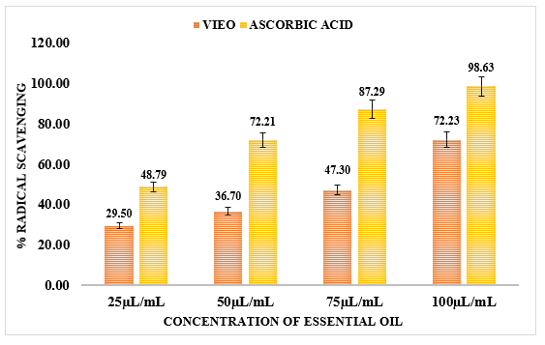
Figure 3: Percent Hydrogen peroxide (H₂O₂) Radical Scavenging activity of Essential Oil of V. inermis flowers
Table 5: IC values of H₂O₂ Radical Scavenging activity of Essential Oil of V. inermis flowers
Sample | Replication | Inhibitory Concentrations (IC)
Sample | Replication | IC10 | IC50 | IC90
VIEO | R1 | 10.86 | 64.53 | 383.19
VIEO | R2 | 10.83 | 64.51 | 384.57
VIEO | R3 | 10.84 | 64.55 | 384.11
VIEO | Mean±SD | 10.84±0.01 | 64.53±0.02 | 383.96±0.57
Ascorbic Acid | R1 | 8.35 | 26.56 | 84.52
Ascorbic Acid | R2 | 8.32 | 26.56 | 84.75
Ascorbic Acid | R3 | 8.20 | 26.51 | 86.02
Ascorbic Acid | Mean±SD | 8.29±0.06 | 26.54±0.02 | 85.10±0.66
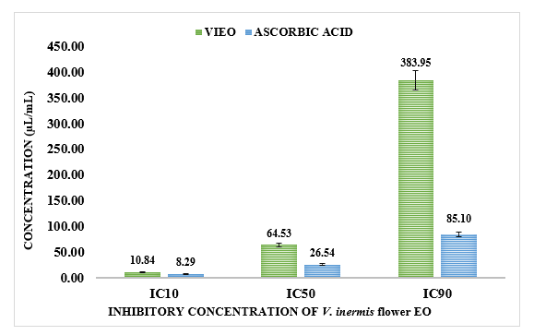
Figure 4: IC values of H₂O₂ Radical Scavenging Antioxidant activity of Essential Oil of V. inermis flowers
The inhibitory concentration values derived from the concentration-response curve further support these findings. As shown in Table 5 and figure 4, the essential oil demonstrated IC₁₀ and IC₅₀ values of 10.84±0.01, and 64.53±0.02 μL/mL, respectively, while higher inhibition levels at IC₉₀ of 383.96±0.57 μL/mL is noted. In contrast, ascorbic acid showed lower inhibitory concentrations (IC₁₀ = 8.29 ± 0.06 μL/mL, IC₅₀ = 26.54±0.02 μL/mL, and IC₉₀ = 85.10±0.06 μL/mL), confirming its stronger peroxide scavenging efficiency. Nevertheless, the IC₅₀ value of 64.53 μL/mL indicates a considerable ability to neutralize H₂O₂ radicals and supports its potential as a natural antioxidant source. The peroxide scavenging activity can be mainly attributed to the electron-donating oxygenated terpenoids, where hydroxyl-containing compounds convert hydrogen peroxide into harmless water molecules before it generates highly reactive hydroxyl radicals. The contribution of squalene, a triterpenoid hydrocarbon known for oxidative quenching and lipid membrane protection, may further enhance the antioxidant efficiency of the oil.

3.3 Anti-inflammatory Activity
The anti-inflammatory potential of the essential oil obtained from V. inermis was evaluated using a protein denaturation inhibition assay, and the results are presented in Table 6 and figure 5. The flower essential oil of V. inermis exhibited a marked concentration-dependent anti-inflammatory activity, demonstrating its ability to inhibit protein denaturation in comparison with the standard drug diclofenac sodium. The percentage inhibition increased progressively with increasing concentration. At 25 μL/mL, the essential oil showed 21.65±0.25% inhibition, which increased to 39.52±0.26% at 50 μL/mL, indicating moderate anti-inflammatory activity at lower concentrations. A substantial increase was observed at 75 μL/mL, where the oil exhibited 45.70±0.35% inhibition, followed by a pronounced rise to 62.70±0.24% inhibition at 100 μL/mL, confirming strong concentration-responsive anti-inflammatory potential. In comparison, the standard diclofenac sodium demonstrated significantly higher inhibition values of 37.55±0.03%, 61.76±0.21%, 79.26±0.48%, and 88.36±0.18% at 25, 50, 75, and 100 μL/mL, respectively. Although the activity of VIEO remained lower than the reference standard, the essential oil displayed a substantial capacity to prevent heat-induced protein denaturation, which is a recognized in vitro indicator of anti-inflammatory efficacy. The observed inhibition suggests that the floral volatile constituents may stabilize protein conformation and reduce denaturation-associated inflammatory responses.
The observed anti-inflammatory response can be directly correlated with the GC-MS identified phytoconstituents, particularly the abundance of linalool (24.52%), eugenol (2.69%), geraniol (2.89%), and (E)-nerolidol (1.79%). Linalool, a dominant oxygenated monoterpene alcohol, is widely reported for its anti-inflammatory activity through suppression of pro-inflammatory mediators such as TNF-α, IL-6, and nitric oxide, along with inhibition of NF-κB signaling pathways. Eugenol, a phenolic terpenoid, is especially relevant due to its established ability to inhibit cyclooxygenase (COX)-mediated prostaglandin synthesis and reduce protein denaturation through hydrogen bonding interactions with amino acid residues, thereby stabilizing protein tertiary structure (Gülçin and Alwasel, 2023). Similarly, geraniol contributes through membrane stabilization and downregulation of oxidative-inflammatory pathways, while nerolidol and α-bisabolol oxide B are known to reduce inflammatory signaling and oxidative tissue damage through lipophilic interaction with cellular membranes.
Table 6 : Anti-inflammatory activity of Essential Oil of V. inermis flowers
Sample | Replication | Concentration (µL/mL) |  |  |  | CD at 5%
Sample | Replication | 25 | 50 | 75 | 100 | CD at 5%
VIEO | R1 | 21.84 | 39.52 | 45.20 | 62.93 | 0.52
VIEO | R2 | 21.74 | 39.78 | 45.72 | 62.72 | 0.52
VIEO | R3 | 21.37 | 39.25 | 45.88 | 62.46 | 0.52
VIEO | Mean±SD | 21.65±0.246 | 39.52±0.260 | 62.70±0.354 | 62.70±0.235 | 0.52
Diclofenac sodium | R1 | 37.59 | 61.73 | 79.82 | 88.26 | 0.56
Diclofenac sodium | R2 | 37.53 | 61.99 | 78.98 | 88.58 | 0.56
Diclofenac sodium | R3 | 37.53 | 61.57 | 78.98 | 88.26 | 0.56
Diclofenac sodium | Mean±SD | 37.55±0.034 | 61.76±0.211 | 79.26±0.484 | 88.36±0.184 | 0.56

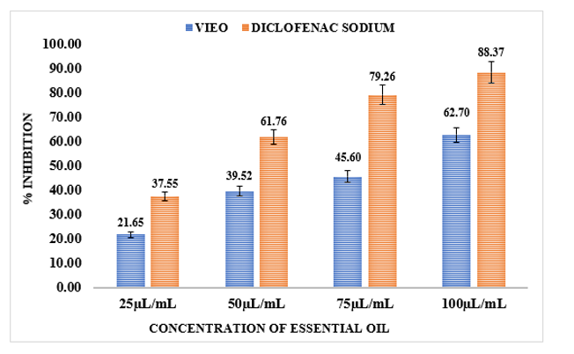
Figure 5: Anti-inflammatory activity of Essential Oil of V. inermis flowers
Table 7: IC values of Anti-inflammatory activity of Essential Oil of V. inermis flowers
Sample | Replication | Inhibitory Concentrations (IC)
Sample | Replication | IC10 | IC50 | IC90
VIEO | R1 | 12.22 | 73.71 | 444.59
VIEO | R2 | 12.14 | 73.77 | 447.24
VIEO | R3 | 12.52 | 73.11 | 433.83
VIEO | Mean±SD | 12.29±0.16 | 73.50±0.29 | 441.89±5.80
Diclofenac Sodium | R1 | 9.78 | 34.91 | 124.56
Diclofenac Sodium | R2 | 9.72 | 34.95 | 125.35
Diclofenac Sodium | R3 | 9.60 | 34.95 | 126.85
Diclofenac Sodium | Mean±SD | 9.70±0.07 | 34.94±0.02 | 125.59±0.95
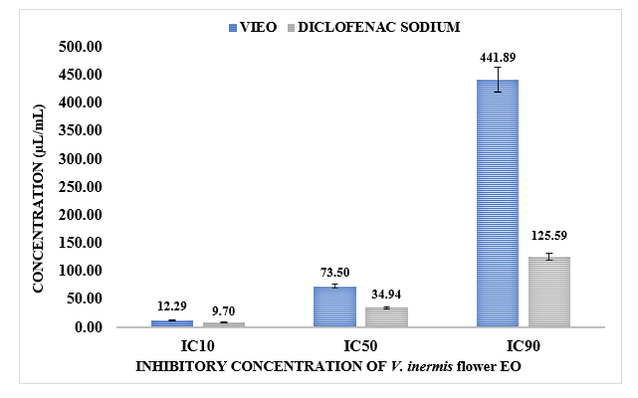
Figure 6: IC values of Anti-inflammatory activity of Essential Oil of V. inermis flowers
The inhibitory concentration values further support these findings. As shown in the IC data table 7 and figure 6, the essential oil exhibited IC₁₀ and IC₅₀ values of 12.29±0.16 and 73.50±0.29 μL/mL respectively, while higher inhibition levels of IC₉₀ of 441.89±5.80 μL/mL is noted. In comparison, diclofenac sodium displayed lower inhibitory concentrations (IC₁₀ = 9.70±0.07 μL/mL, IC₅₀ = 34.94±0.02 μL/mL and IC₉₀ = 125.59±0.95 μL/mL), reflecting its strong pharmaceutical anti-inflammatory efficiency. Nevertheless, the IC₅₀ value of 73.50 μL/mL for VIEO indicates a significant ability of the essential oil to inhibit protein denaturation and supports its therapeutic promise as a natural anti-inflammatory agent.
3.3.1 Mechanistic Overview of the Anti-inflammatory activity
The proposed pathway in Figure 7 explains the possible molecular basis of the anti-inflammatory activity of the flower essential oil of V. inermis. Inflammatory stimuli activate TLR4-mediated IKK phosphorylation, leading to degradation of IκBα and nuclear translocation of NF-κB, which enhances the expression of TNF-α, IL-6, and iNOS, thereby promoting inflammatory signaling. Mechanistically, the anti-inflammatory activity of VIEO may be attributed mainly to the protein-stabilizing and mediator-suppressing effects of oxygenated monoterpenes and phenolic terpenoids. Compounds such as linalool and geraniol can interact with hydrophobic regions of proteins, thereby reducing conformational unfolding during thermal stress and suppressing NF-κB-associated inflammatory pathways, while eugenol may further contribute through hydrogen atom donation, membrane stabilization, and COX pathway modulation, resulting in decreased prostaglandin synthesis. In addition, nerolidol, due to its lipophilic sesquiterpene structure, may stabilize cellular membranes and reduce ROS-mediated oxidative stress, while the presence of squalene and oxygenated diterpenoids such as kolavenol may further support membrane-protective and anti-inflammatory actions by reducing lipid peroxidation and oxidative inflammatory cascades. Therefore, the observed anti-inflammatory activity of VIEO can be primarily linked to the synergistic effects of linalool, eugenol, geraniol, nerolidol, squalene, and other oxygenated terpenoids, which collectively stabilize proteins, suppress inflammatory mediator generation, reduce oxidative stress, and enhance membrane integrity.

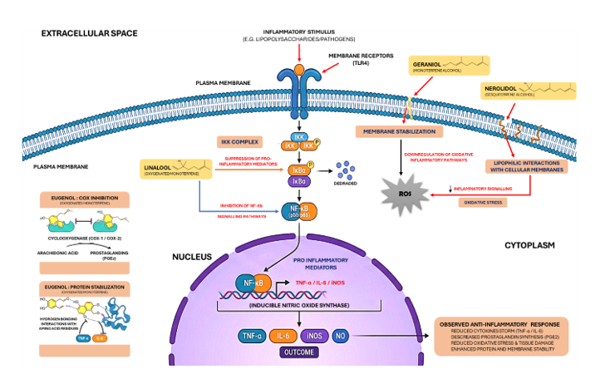
Figure 7: Proposed mechanistic overview of the anti-inflammatory activity by major phytoconstituents of V. inermis flower EO
3.4 In-silico Molecular Docking Analysis
3.4.1 Antioxidant Activity
Molecular docking studies were performed to evaluate the binding affinity and interaction profiles of the major phytoconstituents identified in the flower essential oil of V. inermis against Superoxide dismutase (SOD) (PDB ID: 2C9V) is presented in table 8 and figure 8. A key antioxidant defense enzyme involved in the catalytic dismutation of superoxide radicals into hydrogen peroxide and molecular oxygen, thereby protecting biological systems from oxidative stress mediated cellular damage. The docking analysis revealed distinct interaction patterns among the investigated phytochemicals, with several compounds exhibiting binding energies comparable to the standard antioxidants BHT and ascorbic acid.
Among the tested ligands, (E)-nerolidol exhibited the highest binding affinity (-6.5 kcal/mol), indicating the strongest interaction with the active region of the SOD protein. The ligand interacted predominantly with residues VAL5, CYS6, VAL7, LEU8, LYS9, GLY10, ASP11, GLY51, ASP52, ASN53, GLY156, and ILE149, forming extensive van der Waals and hydrophobic interactions that suggest stable accommodation within the catalytic binding pocket. Eugenol interacted with key residues including VAL5, CYS6, VAL7, LEU8, LYS9, GLY10, GLY51, VAL148, and GLY150, while α-terpineol showed a similar hydrophobic interaction profile involving CYS6, ASN53, CYS146, GLY147, VAL148, and ILE149. These interactions indicate that phenolic terpenoids and monoterpene alcohols may effectively associate with catalytically significant hydrophobic regions of SOD. Similarly, geraniol showed a favorable binding energy of -5.4 kcal/mol, with interactions involving CYS6, VAL7, LEU8, LYS9, GLY151, ASP52, ASN53, and ILE149, suggesting stable ligand accommodation within the enzyme pocket. Linalool, the dominant phytoconstituent of the EO, exhibited a binding energy of -5.1 kcal/mol, forming interactions with residues such as VAL5, CYS6, VAL7, LEU8, LYS9, GLY151, ASP52, and ILE149. Fokienol exhibited a binding affinity of -5.9 kcal/mol, indicating strong stabilization within the SOD active region through hydrophobic interactions involving LEU8, LYS9, GLY10, GLY51, ASP52, ASN53, GLY156, CYS146, GLY147, VAL148, and GLY150. Phenylacetaldehyde and 1-octen-3-ol displayed moderate binding energies of -4.9 and -4.5 kcal/mol, respectively, while still maintaining favorable van der Waals contacts with catalytically relevant residues.
For comparison, the standard antioxidant compounds BHT and ascorbic acid demonstrated binding energies of -5.6 and -5.8 kcal/mol, respectively. Interestingly, several phytochemicals, particularly nerolidol, fokienol, eugenol, α-terpineol, geraniol, and linalool, exhibited comparable or closely related interaction strengths, suggesting their potential contribution to the antioxidant activity observed experimentally through enzyme stabilization and ROS-regulating interactions. Figure 9 explains the receptor- ligand interaction diagrams of docked compounds at active site of selected protein (PDB ID:2C9V).

Figure 8: Docking Scores of compounds (L1-L10) docked in the binding cavity of PDB ID: 2C9V (Superoxide dismutase)

Table 8: Docked conformations of compounds in the binding cavity of Superoxide dismutase (PDB ID: 2C9V)
Target Protein | Compound Name | Binding Energy (kcal/mol) | Amino acid residues
29CV  (Superoxide dismutase) | Linalool | -5.1 | Chain A: ASP52 ASN53 CYS146 GLY147 VAL148 ILE149 Chain F: VAL5 CYS6 VAL7 LEU8 LYS9 GLY51 ASP52 ASN53
29CV  (Superoxide dismutase) | Geraniol | -5.4 | Chain A: CYS6 VAL7 LEU8 LYS9 GLY10 GLY51 ASP52 ASN53 Chain F: VAL5 CYS6 CYS57 CYS146 GLY147 VAL148 ILE149 GLY150
29CV  (Superoxide dismutase) | Eugenol | -5.5 | Chain A: LYS9 GLY10 GLY51 ASP52 ASN53 CYS146 GLY147 VAL148 GLY150 Chain F: GLY51 ASP52 ASN53 CYS146 GLY147 VAL148 ILE149 GLY150
29CV  (Superoxide dismutase) | Nerolidol | -6.5 | Chain A: CYS6 VAL7 LEU8 GLY147 VAL148 ILE149 Chain F: VAL5 CYS6 VAL7 LEU8 LYS9 GLY10 GLY51 ASN53 CYS146
29CV  (Superoxide dismutase) | Alpha-Terpineol | -5.5 | Chain A: LYS9 GLY10 ASN53 CYS146 GLY147 VAL148 ILE149 Chain F: CYS6 VAL7 LEU8 LYS9 GLY51 ASN53
29CV  (Superoxide dismutase) | Fokienol | -5.9 | Chain A: GLY51 ASP52 ASN53 GLY56 CYS146 GLY147 VAL148 ILE149 GLY150 Chain F: VAL5 CYS6 VAL7 LEU8 LYS9 VAL148 ILE149
29CV  (Superoxide dismutase) | Phenylacetaldehyde | -4.9 | Chain A: GLY51 ASP52 ASN53 CYS146 GLY147 VAL148 Chain F: VAL5 CYS6 VAL7 LEU8 LYS9 GLY51 ASP52
29CV  (Superoxide dismutase) | 1-Octen-3-ol | -4.5 | Chain A: VAL5 CYS6 VAL7 LEU8 LYS9 ASN53 Chain F: VAL5 CYS6 VAL7 LEU8 LYS9 GLY51 ASP52 ASN53
29CV  (Superoxide dismutase) | BHT  (Standard) | -5.6 | Chain A: GLU49 PRO66 LEU106 GLY108 ASP109 Chain F: THR2 LYS3 GLY108 CYS111 ILE113 ILE151 ALA152
 | Ascorbic Acid  (Standard) | -5.8 | Chain A: VAL5 CYS6 VAL7 LEU8 ILE149 GLY150 Chain F: CYS6 VAL7 LEU8 LYS9 GLY51 ASP52
Figure 9: Receptor- Ligand Interaction diagrams of docked compounds at active site of selected protein (PDB ID:2C9V)
L1 | 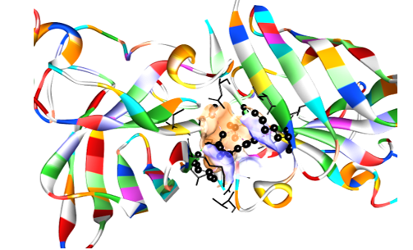 | 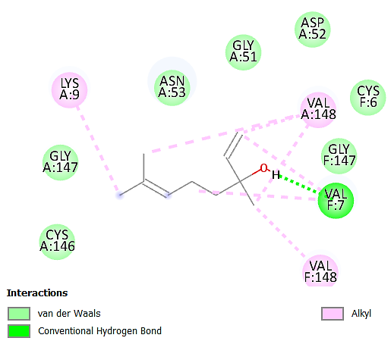
L2 | 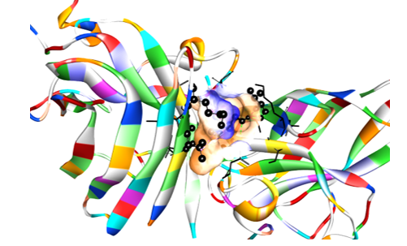 | 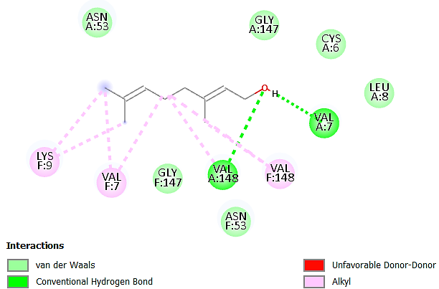
L3 | 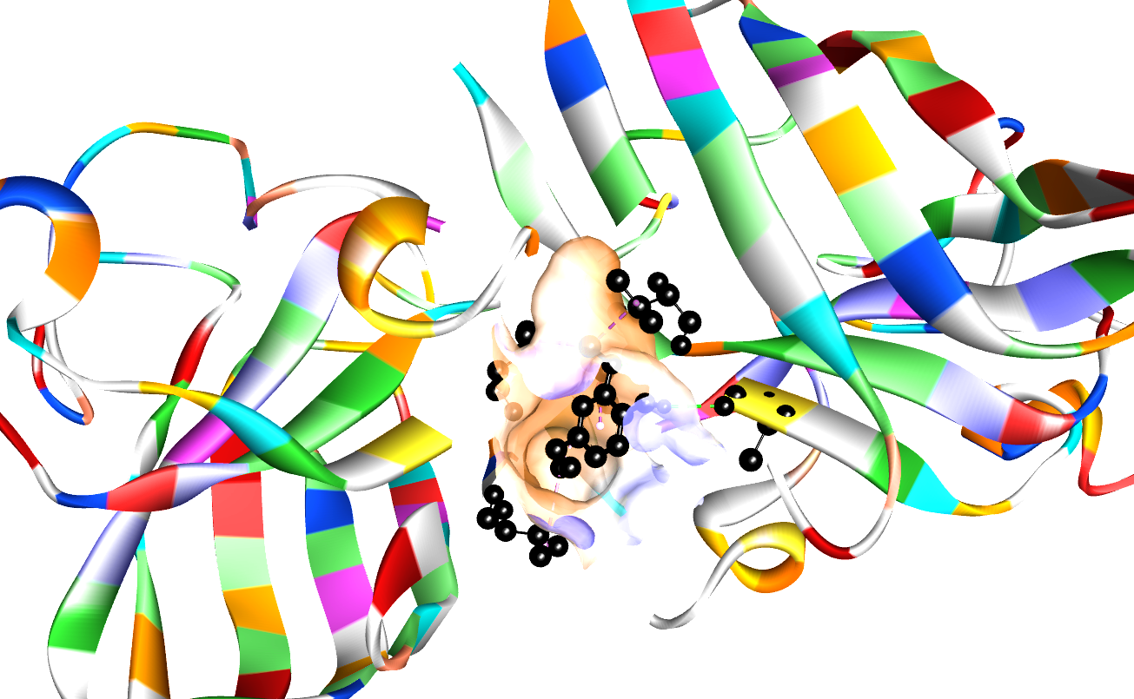 | 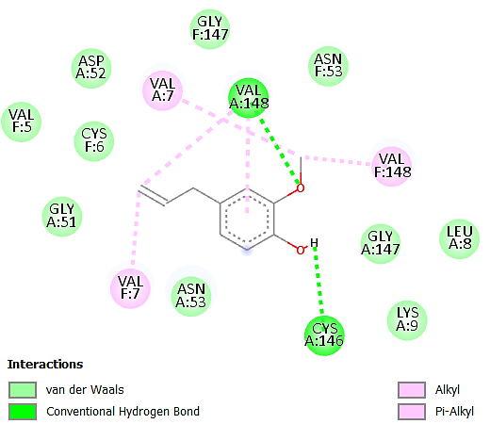
L4 | 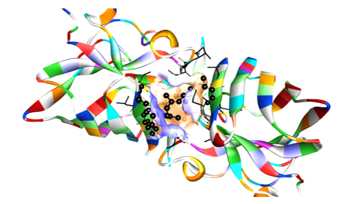 | 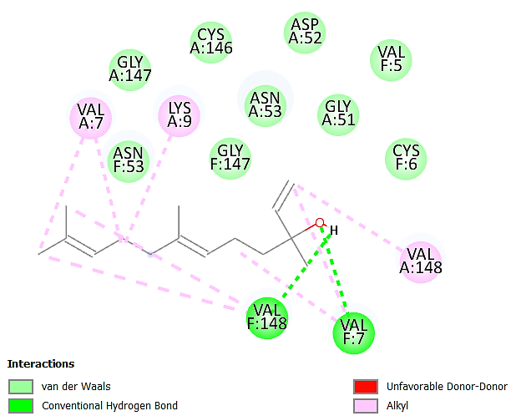
L5 | 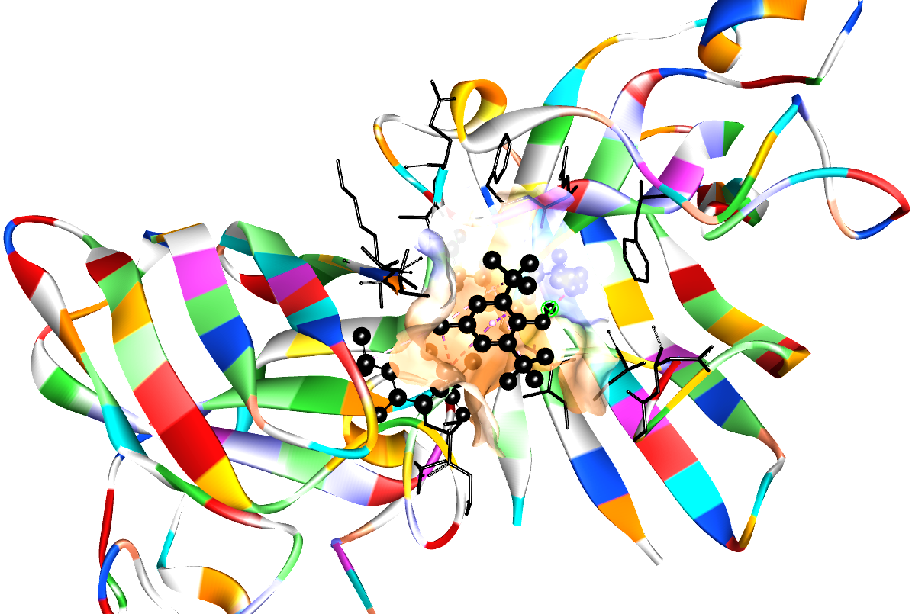 | 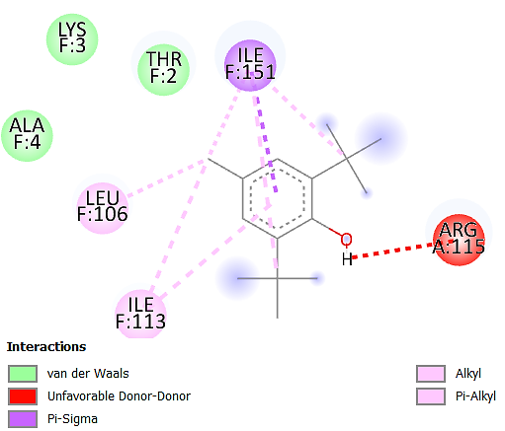
L6 | 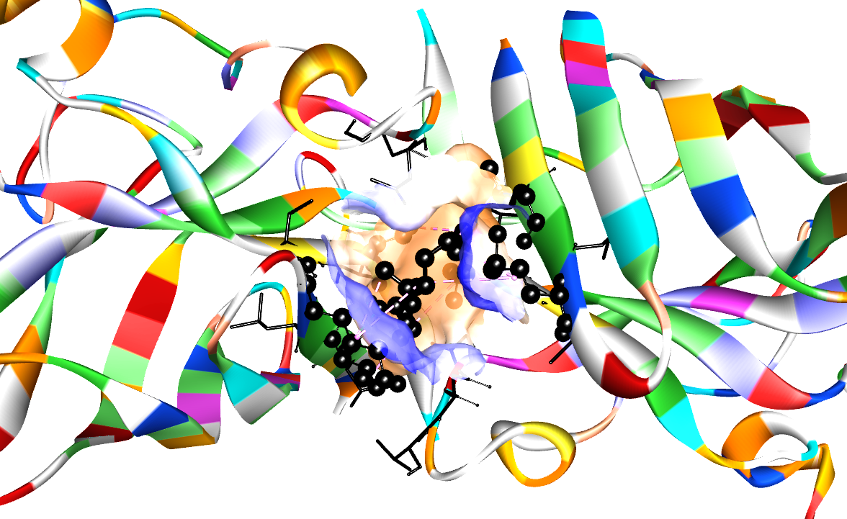 | 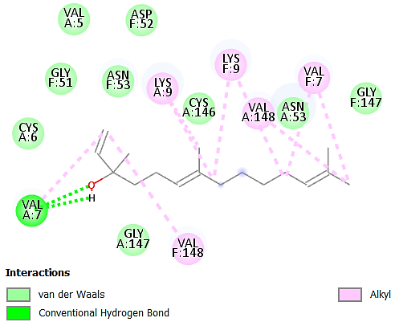
L7 | 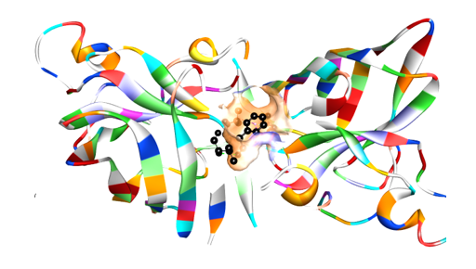 | 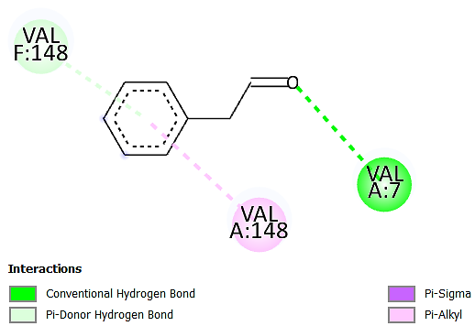
L8 | 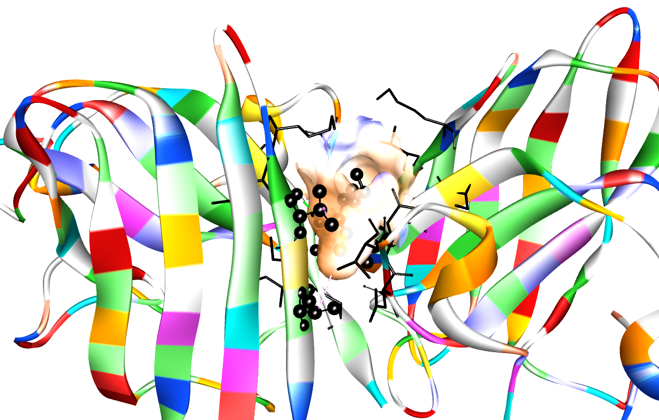 | 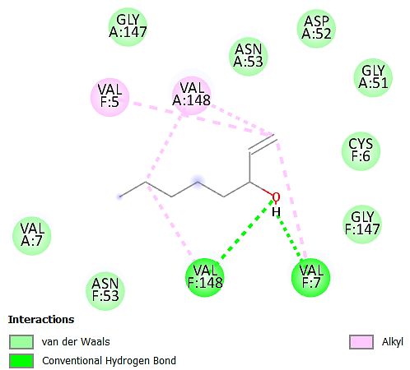
L9 | 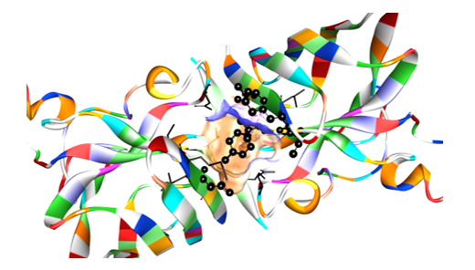 | 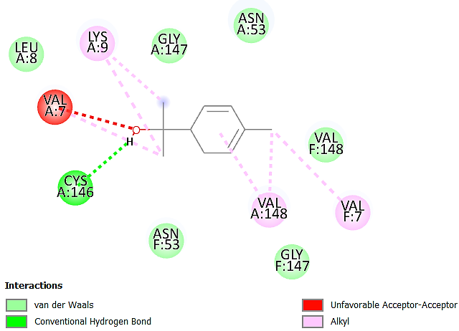
L10 | 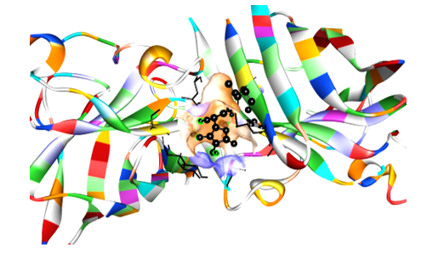 | 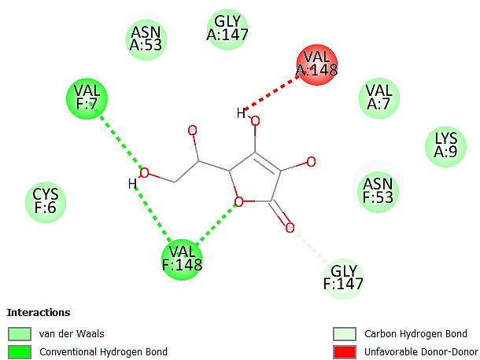

3.4.2 Anti-inflammatory Activity
Molecular docking studies were performed to evaluate the binding affinity and interaction profiles of the major phytochemicals identified in the flower essential oil of V. inermis with Human cyclooxygenase-1 (COX-1; PDB ID: 4O1Z) and Human cyclooxygenase-2 (COX-2; PDB ID: 4M11), two key enzymes involved in the conversion of arachidonic acid into prostaglandin intermediates that mediate inflammation, pain, and swelling. Since inhibition of COX enzymes is a well-established mechanism of non-steroidal anti-inflammatory drugs, the docking analysis was undertaken to provide a molecular basis for the strong protein denaturation inhibitory activity observed experimentally.
Table 9 represents the evaluated phytochemicals among which Fokienol exhibited the strongest binding affinity toward both COX-1 and COX-2, with docking scores of -7.4 kcal/mol against each target, interacting with a predominantly hydrophobic pocket comprising residues ARG83, PRO84, SER85, PRO86, PHE88, ILE89, LEU92, and MET113. A similar interaction profile was observed in COX-2, where the ligand formed strong contacts with residues including LYS83, PRO84, ILE92, LEU93, TRP100, ILE112, MET113, TYR115, supporting strong anti-inflammatory potential through effective COX inhibition. Similarly, (E)-nerolidol showed highly favorable binding energies of -7.1 kcal/mol with COX-1 and -7.2 kcal/mol with COX-2, making it one of the most promising anti-inflammatory constituents in the EO. In COX-1, nerolidol strongly interacted with residues in the catalytic region indicating strong accommodation within the enzyme’s substrate-recognition site. Among the oxygenated monoterpenoids, α-terpineol demonstrated notable binding affinities of -6.3 kcal/mol against both COX-1 and COX-2, while eugenol showed -6.0 and -6.1 kcal/mol, respectively. Likewise, geraniol displayed -6.0 kcal/mol with both targets, and linalool exhibited -5.9 kcal/mol for COX-1 and -5.8 kcal/mol for COX-2. These compounds consistently interacted with hydrophobic residues such as VAL349, LEU352, TRP387, PHE518, MET522, GLY526, ALA527, and SER530, which are known to contribute to ligand stabilization near the cyclooxygenase catalytic tunnel. Moderate binding affinities were observed for 1-octen-3-ol (-5.4 kcal/mol for COX-1 and -5.6 kcal/mol for COX-2) and phenylacetaldehyde (-4.7 and -5.1 kcal/mol, respectively), which still formed stabilizing hydrophobic and van der Waals interactions with catalytically relevant amino acids. Although these compounds showed weaker binding than the major terpenoids, they may still contribute synergistically to the total anti-inflammatory effect of the essential oil. The binding scores of docked compounds are given in figure 10.
For comparison, the reference anti-inflammatory drug diclofenac sodium demonstrated strong binding energies of -7.8 kcal/mol with COX-1 and -8.5 kcal/mol with COX-2, while aspirin showed -6.5 and -6.4 kcal/mol, respectively. Interestingly, Fokienol and Nerolidol exhibited docking affinities approaching those of the standard drugs, particularly against COX-2, suggesting that these oxygenated sesquiterpenes may serve as important lead molecules responsible for the observed anti-inflammatory activity. Figure 11 represents the receptor- ligand interaction diagrams of docked compounds at active site of COX-1 (PDB ID: 4O1Z) and COX-2 (PDB ID: 4M11)
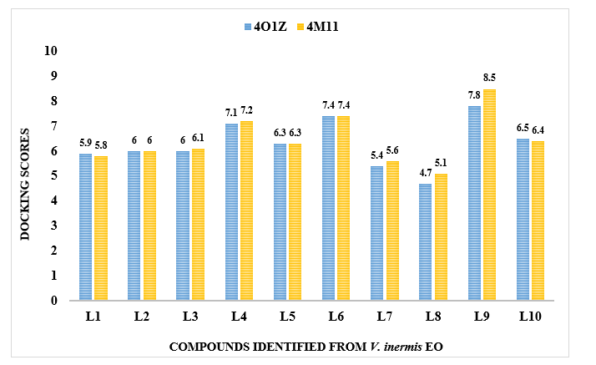
Figure 10: Docking Scores of compounds (L1-L10) docked in the binding cavity of Human Cyclooxygenase-1 (PDB ID: 4O1Z) and Human Cyclooxygenase-2 (PDB ID: 4M11)

Table 9: Docked conformations of compounds in the binding cavity of Human cyclooxygenase-1 (PDB ID: 4O1Z) and Human Cyclooxygenase-2 (PDB ID: 4M11)

Compound Name | Target Protein | Binding Energy (kcal/mol) | Amino acid residues
Linalool | 4O1Z | -5.1 | Chain A: ARG83 ILE89 LEU92 LEU93 VAL119 ARG120 ILE345 TYR348 LEU357 LEU359
Linalool | 4M11 | -5.8 | Chain A: PHE381 LEU384 TYR385 TRP387 GLN461 GLU465 LYS468 PRO538 Chain B: GLN543
Geraniol | 4O1Z | -6.0 | Chain A: LYS360 MET522 ILE523 GLU524 GLY526 ALA527 PRO528 SER530 LEU531 LEU534 LEU535
Geraniol | 4M11 | -6.0 | Chain D: PHE518 MET522 VAL523 GLU524 GLY526 ALA527 SER530 LEU531 LEU534 MET535
Eugenol | 4O1Z | -6.0 | Chain B: TRP387 PHE518 MET522 ILE523 GLU524 GLY526 ALA527 SER530 LEU531 LEU534 LEU535
Eugenol | 4M11 | -6.1 | Chain D: VAL89 ILE92 LEU93 TRP100 ILE112 MET113 TYR115 VAL116 LEU117 SER119
Nerolidol | 4O1Z | -7.1 | Chain A: GLU543 LYS546 Chain B: SER154 PRO156 GLN461 ASN464 GLU465 TYR466 LYS468 ARG469
Nerolidol | 4M11 | -7.2 | Chain D: VAL349 LEU352 SER353 TYR355 PHE357 LEU359 PHE381 LEU384 TYR385 TRP387
Alpha-Terpineol | 4O1Z | -6.3 | Chain A: VAL119 ARG120 ILE345 VAL349 LEU352 SER353 TYR355 LEU357 LEU359 LYS360 ILE523
Alpha-Terpineol | 4M11 | -6.3 | Chain A: LEU359 LYS360 LYS468 SER471 GLU524 GLY526 ALA527 PRO528 SER530 LEU531 LYS532
Fokienol | 4O1Z | -7.4 | Chain B: ILE523 GLU524 MET525 GLY526 ALA527 PRO528 SER530 LEU531 LEU534 LEU535
Fokienol | 4M11 | -7.4 | Chain D: TYR115 VAL116 LEU117 SER119 ARG120 TYR122 ILE345 TYR348 VAL349
1-Octen-3-ol | 4O1Z | -5.4 | Chain B: ARG120 PRO191 GLN192 ILE345 VAL349 LEU352 SER353 GLY354 TYR355 LEU357
1-Octen-3-ol | 4M11 | -5.6 | Chain D: PHE381 LEU384 TYR385 TRP387 PHE518 MET522 VAL523 GLY526 ALA527 SER530 LEU531
Phenylacetaldehyde | 4O1Z | -4.7 | Chain B: GLY45 ILE46 CYS47 TYR130 ASP135 LEU152 PRO153 GLN461 ASN464 GLU465 TYR466 LYS468
Phenylacetaldehyde | 4M11 | -5.1 | Chain A: GLY526 ALA527 PRO528 SER530 LEU531 LYS532 LEU534 MET535
Diclofenac Sodium (Standard) | 4O1Z | -7.8 | Chain A: THR322 TRP323 GLN327 SER548 THR549 Chain B: ASN34 CYS36 TYR39 PRO40 CYS41 GLN42 HIS43 GLN44 GLY45 ILE46 CYS47 VAL48 ARG49
Diclofenac Sodium (Standard) | 4M11 | -8.5 | Chain A: ARG44 GLY45 GLU46 CYS47 MET48 Chain B: TRP323 GLN327 PHE371 TYR373 GLN374
Aspirin (Standard) | 4O1Z | -6.5 | Chain B: ARG83 PRO86 ILE89 LEU93 LEU115 VAL116 LEU117 VAL119 ARG120 TYR348 VAL349 LEU352 SER353 TYR355 LEU359 PHE381 LEU384 TYR385
Aspirin (Standard) | 4M11 | -6.4 | Chain D: VAL89 LEU93 MET113 TYR115 VAL116 LEU117 SER119 ARG120 VAL344 ILE345 VAL349

Figure 11: Receptor- Ligand Interaction diagrams of docked compounds at active site of COX-1 (PDB ID: 4O1Z) and COX-2 (PDB ID: 4M11)

L1 | 4O1Z | 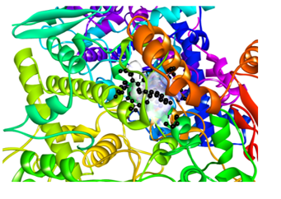 | 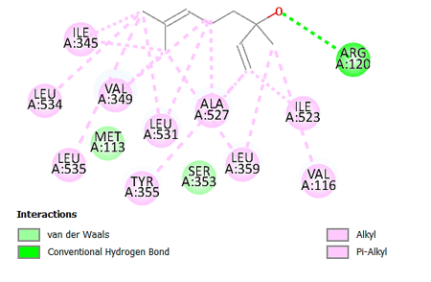
L1 | 4M11 | 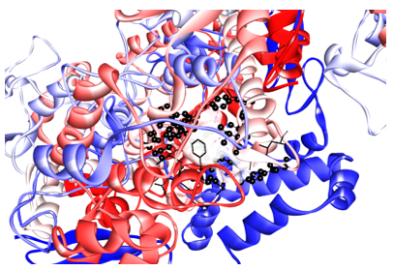 | 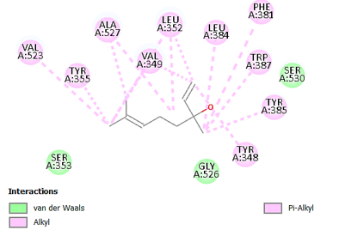
L2 | 4O1Z | 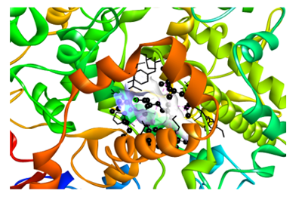 | 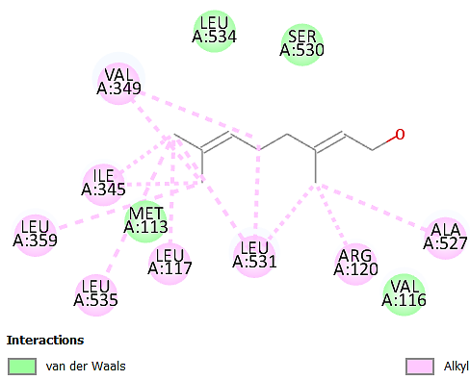
L2 | 4M11 | 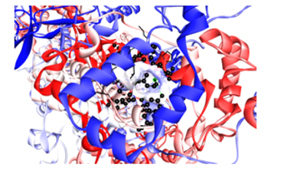 | 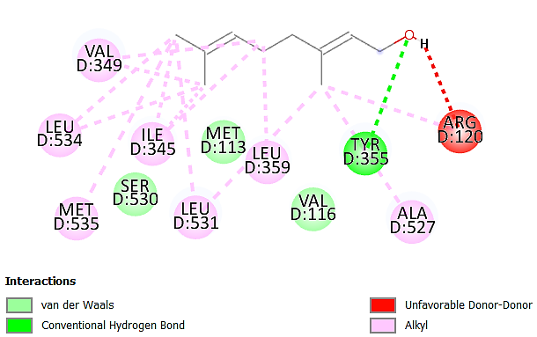
L3 | 4O1Z | 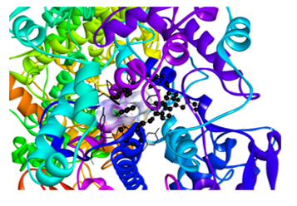 | 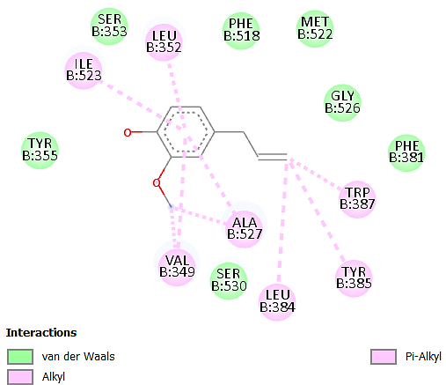
L3 | 4M11 | 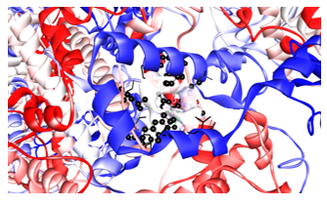 | 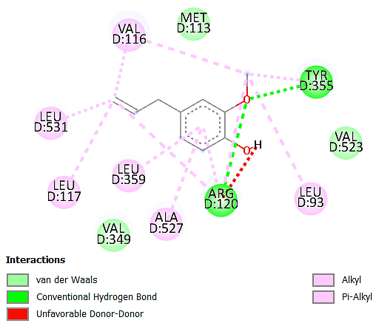
L4 | 4O1Z | 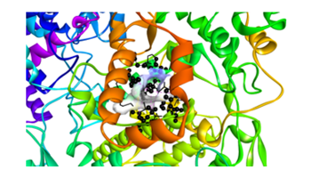 | 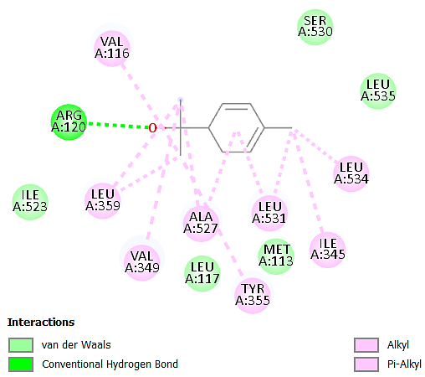
L4 | 4M11 | 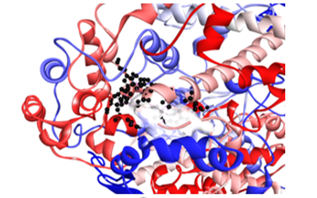 | 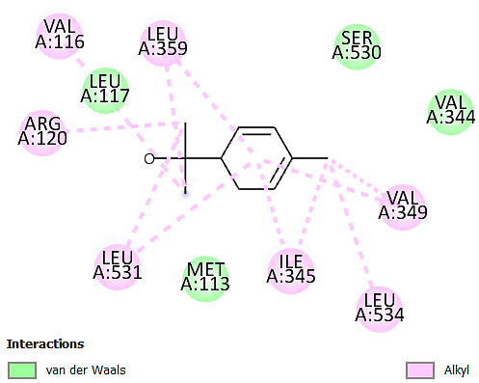
L5 | 4O1Z | 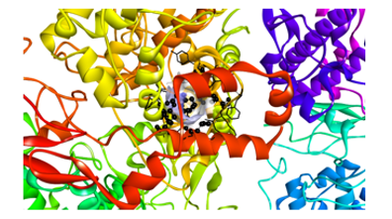 | 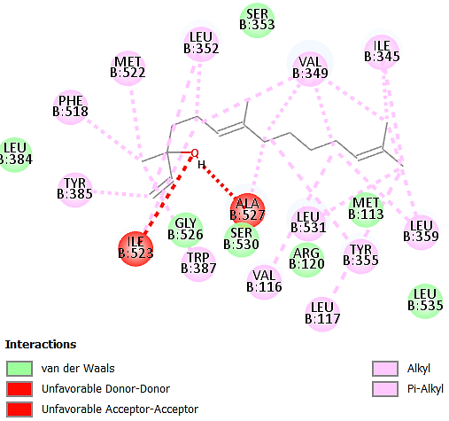
L5 | 4M11 | 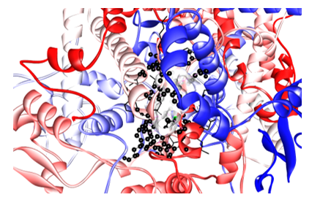
L6 | 4O1Z | 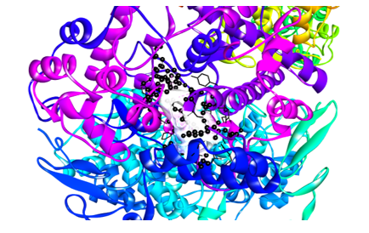 | 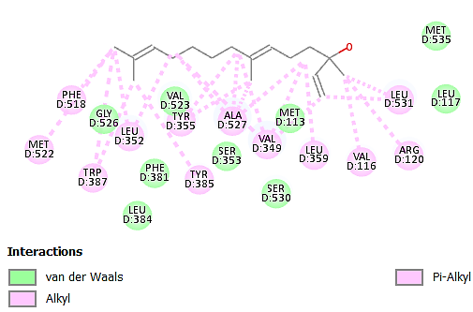
L6 | 4M11 | 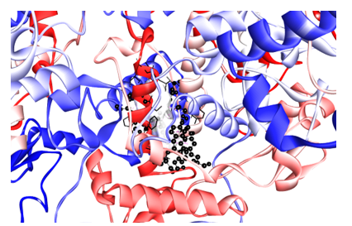 | 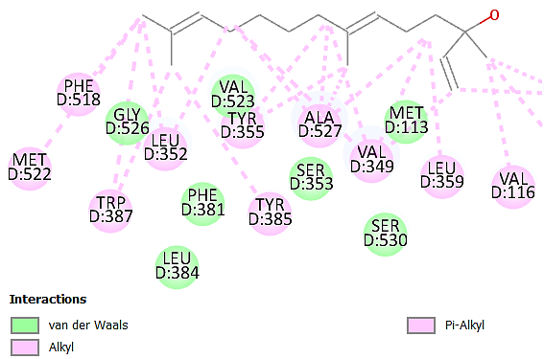
L7 | 4O1Z | 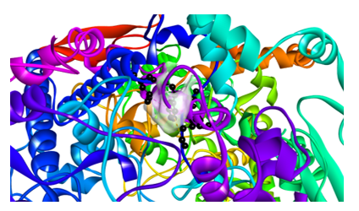 | 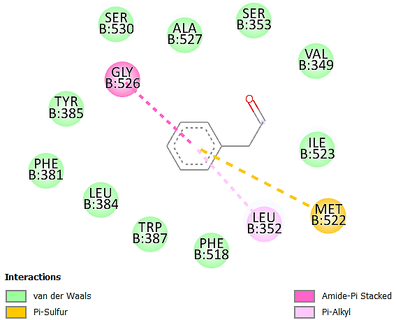
L7 | 4M11 | 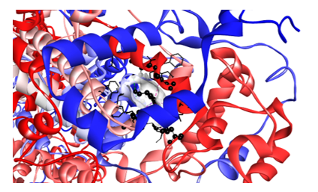 | 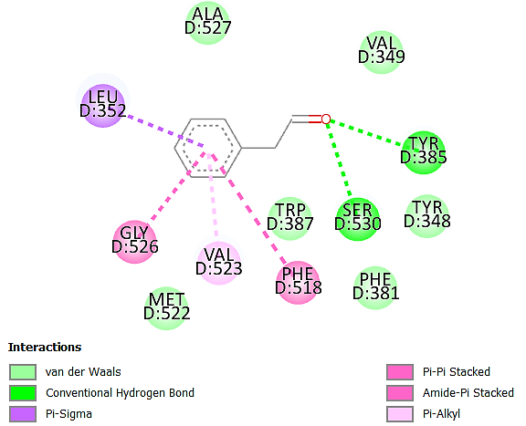
L8 | 4O1Z | 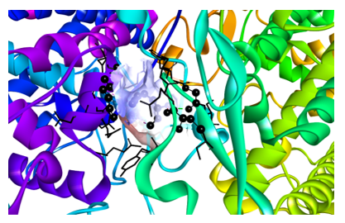 | 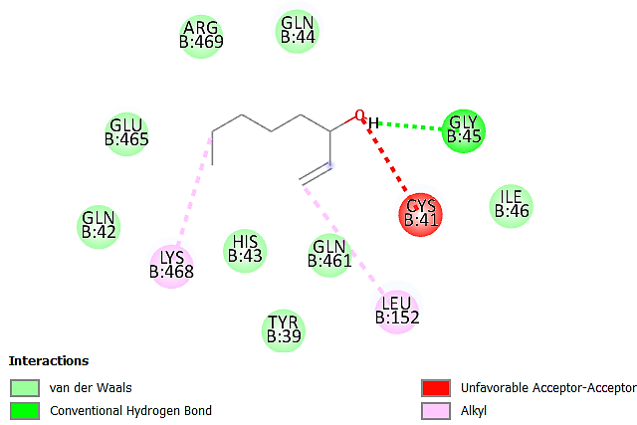
L8 | 4M11 | 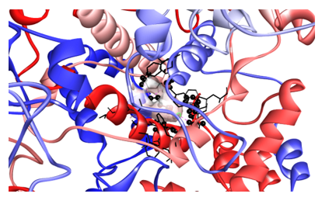 | 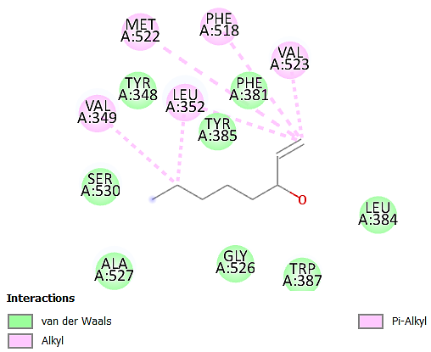
L9 | 4O1Z | 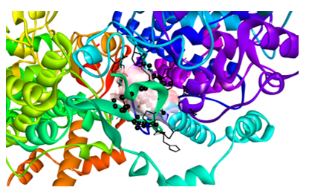 | 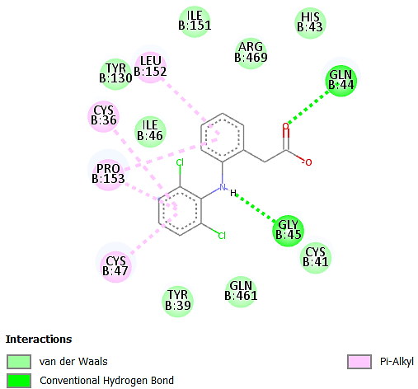
L9 | 4M11 | 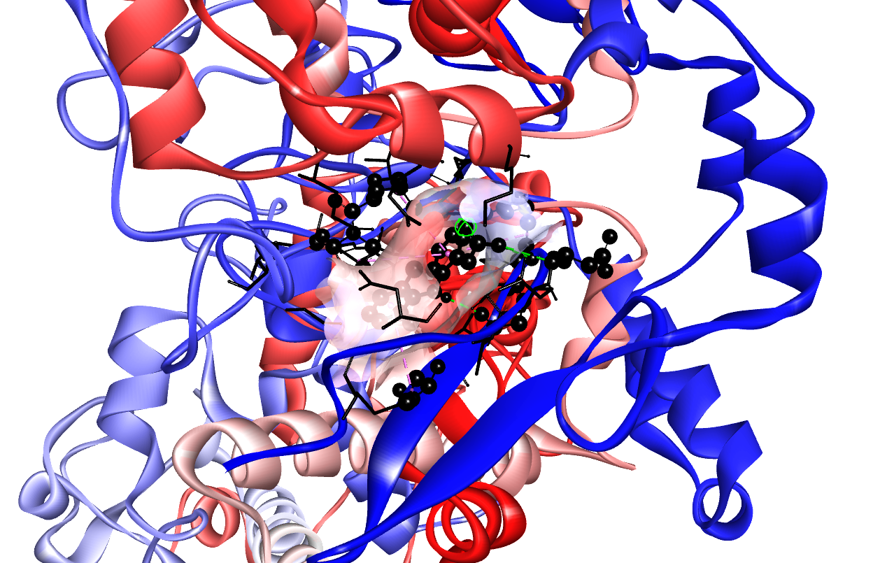 | 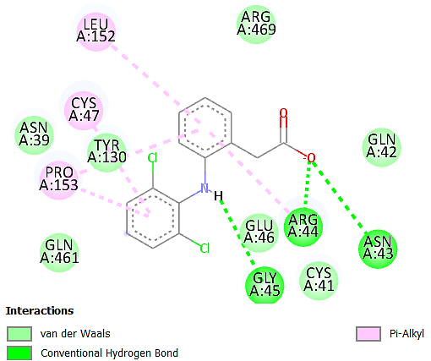
L10 | 4O1Z | 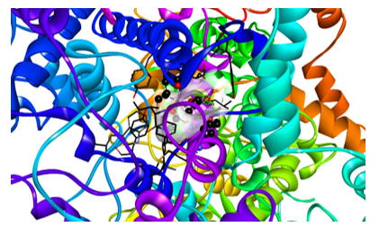 | 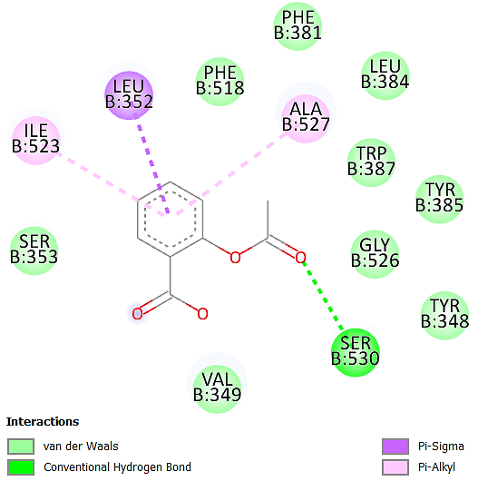
L10 | 4M11 | 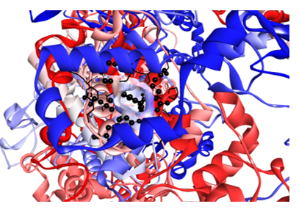 | 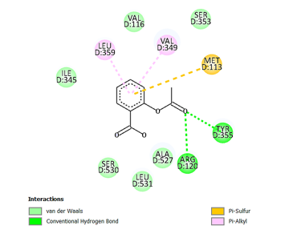
3.5 In-silico ADMET Study
A comprehensive in silico ADMET, toxicity, and BOILED-Egg analysis was performed for the major phytoconstituents identified in the flower essential oil of V. inermis to evaluate their drug-likeness, pharmacokinetic suitability, metabolic stability, and predicted safety profiles, as summarized in Table 10. The selected compounds, namely linalool, geraniol, eugenol, nerolidol, α-terpineol, fokienol, phenylacetaldehyde, and 1-octen-3-ol, generally exhibited favourable physicochemical properties, with molecular weights ranging from 122.21 to 248.40 g/mol, TPSA values between 17.07 and 29.46 Å², and consensus LogP values of 2.74-4.19, indicating an optimal balance between lipophilicity and polarity for passive membrane diffusion. The WLOGP values (1.43-4.95) further supported adequate lipophilic character required for efficient cellular permeation and target engagement.
All compounds complied with Lipinski’s rule of five without any violations, with a uniform bioavailability score of 0.55, supporting their favourable oral drug-likeness. Most phytoconstituents were predicted to be soluble to moderately soluble in water, which is advantageous for formulation feasibility and systemic distribution. Importantly, all compounds demonstrated high gastrointestinal absorption, consistent with their moderate lipophilicity and low molecular mass, suggesting efficient intestinal uptake after oral administration. None of the compounds were predicted to act as P-glycoprotein substrates, indicating a low risk of efflux-mediated reduction in bioavailability and supporting improved intracellular retention.
The predicted blood-brain barrier (BBB) permeability was positive for all compounds except phenylacetaldehyde, suggesting that the majority of these volatile terpenoids possess the structural features necessary for central nervous system penetration. This observation is consistent with their low TPSA and favourable WLOGP values. Metabolic liability assessment against major cytochrome P450 isoforms (CYP1A2, CYP2C19, CYP2C9, CYP2D6, and CYP3A4) revealed an overall low risk of CYP-mediated drug-drug interactions. Most compounds were predicted to be non-inhibitors of CYP isoforms; however, eugenol, nerolidol, α-terpineol, and fokienol showed selective CYP inhibition tendencies, particularly toward CYP1A2 and CYP2D6, which may reflect their aromatic and oxygenated terpenoid scaffolds and warrants further microsomal validation.
The toxicity prediction profile further supported the pharmacological suitability of the selected phytoconstituents. Most compounds were classified as inactive for hepatotoxicity, cytotoxicity, immunotoxicity, mutagenicity, and carcinogenicity, indicating a generally safe toxicological profile. Predicted oral LD₅₀ values ranged from 340 to 3600 mg/kg, placing the compounds predominantly within toxicity classes III-V, which reflects low to moderate acute toxicity and acceptable therapeutic margins. Notably, 1-octen-3-ol exhibited the lowest LD₅₀ value (340 mg/kg; class IV), suggesting relatively higher acute toxicity among the studied molecules, while geraniol showed the highest safety margin (3600 mg/kg; class V). Mild ecotoxicity probabilities were predicted for linalool, nerolidol, phenylacetaldehyde, and 1-octen-3-ol, whereas eugenol and geraniol were predicted as ecotoxicologically inactive, indicating comparatively safer environmental behavior. In addition, the drug-likeness and gastrointestinal absorption/blood–brain barrier permeability potential of the major floral essential-oil phytoconstituents were further assessed through in silico ADMET analysis, and the BOILED-Egg model prediction is presented in Figure 12.

Table 10: ADMET profiles of phytoconstituent compounds of EO of V. inermis flowers
 |  | Compounds
 | Parameters | Linalool | Geraniol | Eugenol | Nerolidol | Alpha-Terpineol | Fokienol | Phenylacetaldehyde | 1-Octen-3-ol
Physicochemical Properties | TPSA $\left({\dot{A}}^{2}\right)$ | 20.23 | 21.25 | 29.46 | 20.23 | 20.23 | 20.23 | 17.07 | 20.23
Physicochemical Properties | Consensus log P_{o/w} | 2.66 | 2.74 | 2.25 | 4.19 | 2.58 | 4.72 | 1.73 | 2.21
Physicochemical Properties | Mol wt (g/mol) | 154.25 | 154.25 | 164.20 | 222.37 | 154.25 | 248.40 | 120.15 | 128.21
Physicochemical Properties | nRB | 4 | 4 | 3 | 7 | 1 | 9 | 2 | 5
Physicochemical Properties | nHA | 1 | 1 | 2 | 1 | 1 | 1 | 1 | 1
Physicochemical Properties | nHD | 1 | 1 | 1 | 1 | 1 | 1 | 0 | 1
Physicochemical Properties | WLOGP | 2.67 | 2.32 | 2.13 | 4.40 | 2.50 | 4.95 | 1.43 | 2.11
Physicochemical Properties | Water solubility | Soluble | Soluble | Soluble | Moderately Soluble | Soluble | Moderately Soluble | Soluble | Soluble
Physicochemical Properties | Molar Refractivity | 50.44 | 50.40 | 49.06 | 74.00 | 48.80 | 83.14 | 36.42 | 41.26
Pharmacokinetics | GI absorption | High | High | High | High | High | High | High | High
Pharmacokinetics | BBB Permeant | Yes | Yes | Yes | Yes | Yes | Yes | Yes | Yes
Pharmacokinetics | P-gp substrate | No | No | No | No | No | No | No | No
Pharmacokinetics | CYP1A2 inhibitor | No | No | Yes | Yes | No | Yes | Yes | No
Pharmacokinetics | CYP2C19 inhibitor | No | No | No | No | No | No | No | No
Pharmacokinetics | CYP2C9 inhibitor | No | No | No | Yes | No | Yes | No | No
Pharmacokinetics | CYP2D6 inhibitor | No | No | No | No | No | No | No | No
Pharmacokinetics | CYP3A4 inhibitor | No | No | No | No | No | No | No | No
Pharmacokinetics | Log K_{p} (cm/s) Skin permeation | -5.13 | -4.71 | -5.69 | -4.23 | -4.83 | -3.88 | -5.77 | -5.27
Drug Likeliness | Lipinski | Yes | Yes | Yes | Yes | Yes | Yes | Yes | Yes
Drug Likeliness | Lipinski violation | 0 | 0 | 0 | 0 | 0 | 1 | 0 | 0
Drug Likeliness | Bioavailability score | 0.55 | 0.55 | 0.55 | 0.55 | 0.55 | 0.55 | 0.55 | 0.55
Toxicological Properties | Hepatotoxicity | Inactive | Inactive | Inactive | Inactive | Inactive | Inactive | Active (Pb=0.57) | Inactive
Toxicological Properties | Carcinogenicity | Inactive | Inactive | Inactive | Inactive | Inactive | Inactive | Inactive | Inactive
Toxicological Properties | Cytotoxicity | Inactive | Inactive | Inactive | Inactive | Inactive | Inactive | Inactive | Inactive
Toxicological Properties | Immunotoxicity | Inactive | Inactive | Inactive | Inactive | Inactive | Inactive | Inactive | Active (Pb=0.55)
Toxicological Properties | Mutagenicity | Inactive | Inactive | Inactive | Inactive | Inactive | Inactive | Inactive | Inactive
Toxicological Properties | Respiratory | Inactive | Inactive | Inactive | Inactive | Inactive | Inactive | Inactive | Inactive
Toxicological Properties | Ecotoxicity | Active (Pb= 0.56) | Inactive | Inactive | Active (Pb=0.43) | Inactive | Inactive | Active (Pb=0.73) | Active (Pb=0.65)
Toxicological Properties | BBB Barrier | Active (Pb= 0.92) | Inactive | Inactive | Inactive | Inactive | Inactive | Inactive | Inactive
Toxicological Properties | Predicted LD₅₀ (mg/kg) | 2200 | 3600 | 2000 | 2610 | 2830 | 2147 | 1550 | 340
Toxicological Properties | Toxicity Class | V | V | IV | V | V | V | IV | IV
TPSA: topological polar surface area, nRB: no. of rotatable bonds, nHA: no. of H-bond acceptor, nHD: no. of H-bond donor, WLOGP: water partition coefficient, GI absorption: gastrointestinal absorption, BBB: blood-brain barrier, P-gp: permeability glycoprotein, CYP: cytochrome P450, Toxicity class: [class I: fatal if swallowed (LD50≤5), class II: fatal if swallowed (5<LD50≤50), class III: toxic if swallowed (50<LD50≤300), class IV: harmful if swallowed (300<LD50≤2000), class V: may be harmful if swallowed (2000<LD50≤5000), class VI: non-toxic (LD50>5000)].

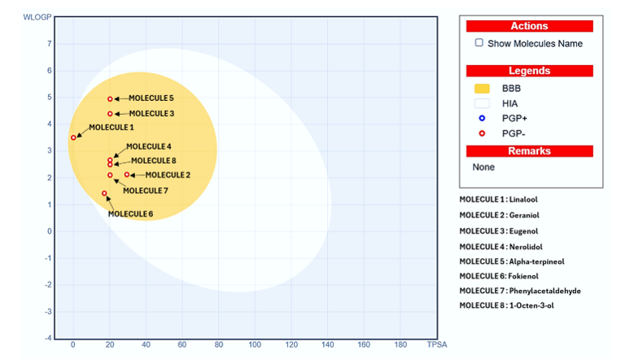
Figure 12: Boil egg prediction graph of the phytocompounds from Volkameria inermis flower essential oil
The BOILED-Egg model further corroborated the pharmacokinetic suitability of the investigated phytoconstituents. The model demonstrated that all selected compounds were positioned within the white region, indicating a high probability of passive gastrointestinal absorption, which strongly supports the SwissADME predictions of excellent oral uptake. Notably, several compounds, particularly linalool, geraniol, eugenol, nerolidol, α-terpineol, and fokienol, were clustered toward the yolk region, suggesting a strong likelihood of blood–brain barrier permeation, which is consistent with their low polar surface area and moderate lipophilicity. Importantly, all plotted molecules were represented as red dots, indicating non-substrate behavior for P-glycoprotein (P-gp) and therefore reduced efflux susceptibility. The BOILED-Egg analysis therefore confirms that the major volatile phytoconstituents possess excellent intestinal absorption characteristics, substantial CNS accessibility, and minimal P-gp mediated transport liability, collectively strengthening their pharmacokinetic promise as bioactive lead molecules.
4. Conclusion
The present study demonstrates that the flower essential oil of Volkameria inermis is a chemically diverse and biologically active phytochemical fraction enriched in oxygenated monoterpenes and phenolic terpenoids, with linalool as the predominant constituent. The essential oil exhibited significant antioxidant and anti-inflammatory activities, which were further substantiated by molecular docking against the antioxidant target protein (PDB: 2C9V) and inflammatory enzymes COX-1 (PDB: 4O1Z) and COX-2 (PDB: 4M11), indicating potential modulation of oxidative stress and prostaglandin-mediated inflammatory pathways. In addition, ADMET and BOILED-Egg analyses confirmed favorable drug-likeness, gastrointestinal absorption, blood-brain barrier permeability, and acceptable toxicity profiles for the major volatile phytoconstituents. Collectively, these findings establish V. inermis flower essential oil as a promising source of multifunctional bioactive terpenoids with potential pharmaceutical relevance against oxidative stress and inflammation-associated disorders.
Disclaimer
Author(s) hereby declare that NO generative AI technologies such as Large Language Models (ChatGPT, COPILOT, etc) and text-to-image generators have been used during writing or editing of this manuscript.
Conflict of Interest
The authers declare that they have no competing interests.
Ethical approval
Not applicable
Availability of Data and Materials
The Datasets used and analysed during this study are available from the corresponding auther on request.

References
Acree, W.J.& Chickos, J.S. (2022). Phase Transition Enthalpy Measurements of Organic and Organometallic Compounds. In NIST Chemistry WebBook, NIST Standard Reference database Number 69., Gaithersburg, MD, USA.
Adams, R.P. (2007). Identification of Essential oil Components by Gas Chromatography/Mass Spectrometry. Allured Publishing Corporation: Carol Stream. pp- 544-545.
Arya, S., Sonu Kumar Mahawer, Himani Karakoti, Kumar, R., Prakash, O., Kumar, S., Mamta Latwal, Panday, G., Ravi Mohan Srivastava, Santana, & Dharmendra Singh Rawat. (2023). Study of the Variability of the Chemical Profile, and Biological Activity Approaches of Hedychium coronarium J. Koenig Essential Oil from Different Habitats of Uttarakhand, India. Journal of Food Quality, 2023, 1-19.
Bakkali F, Averbeck S, Averbeck D, Idaomar M. Biological effects of essential oils-a review. Food Chem Toxicol. 2008. 46(2): 446-75.
Chan, E. W. C., Wong, S. K., & Chan, H. T. (2023). Volkameria inermis: An overview of its chemical constituents and pharmacological properties, notably the amelioration of motortics. Journal of Herbmed Pharmacology, 12(2): 176-186.
Chen, H., Lee, H., Huang, W., Chou, J., Fan, P., Du, J., Ku, Y., & Chiou, L. (2012). Clerodendrum inerme Leaf extract alleviates animal behaviors, hyperlocomotion, and prepulse inhibition disruptions, mimicking Tourette syndrome and schizophrenia. Evidence-based Complementary and Alternative Medicine, 2012, 1-8.
Dallakyan, S. & Olson, A.J. (2015). Small Molecule Library Screening by Docking with PyRx. Chemical Biology; Human Press: New York, NY, USA : 243-250.
Dharmendra, S., Ghaedi, M., Naghiha, R., Saheli, A. & Jannesar, R. (2019). Antibacterial, Antifungal and E. Coli DNA Cleavage of Euphorbia Prostrata and Pelargonium Graveolens Extract and their Combination with novel Nanoparticles. Brazilian Journal of Pharmaceutical Science. Vol- 54.
Diniz do Nascimento, L. Moraes, A.A.B.D; Costa, K.S.D. Pereira Galúcio, J.M. Taube, P.S. Costa, C.M.L. & Faria, L.J.G.D. 2020. Bioactive natural compounds and antioxidant activity of essential oils from spice plants: New findings and potential applications. Biomolecules 2020, 10: 988.
Gülçin, İ., & Alwasel, S. (2023). DPPH radical scavenging assay. Processes, 11(8): 2248-2248.
Hernandez, R.D., Genio, F.A.F., Casanova, J.R., Conato, M.T., & Paderes, M.C. (2024). Antiproliferative Activities and SwissADME Predictions of Physicochemical Properties of Carbonyl Group-Modified Rotenone Analogues. Chemistry Open. 13(1): e202300087.
James, J. P., Puneeth Deepak Ail, Lenisha Crasta, Kamath, R., Shura, M. H., & Sindhu T.J. (2023). In Silico ADMET and Molecular Interaction Profiles of Phytochemicals from Medicinal Plants in Dakshina Kannada. Journal of Health and Allied Sciences NU.
Kakar, R., Kalra, J., Mantha, S.V. & Prashad, K. (1995). Lipid Peroxidation and Activity of antioxidant Enzymes in diabetic rats. Molecular cell Biochemistry. 151: 113-119.
Karakoti, H., Mahawer, S. K., Tewari, M., Kumar, R., Prakash, O., de Oliveira, M. S., & Rawat, D. S. (2022). Phytochemical Profile, In Vitro Bioactivity Evaluation, In Silico Molecular Docking and ADMET Study of Essential Oils of Three Vitex Species Grown in Tarai Region of Uttarakhand. Antioxidants, 11(10):1911.
Kulshreshtha, S., Jangra, B., Tandalekar, Y. B., Goyal, A., & Jachak, S. M. (2026). Volkameria (L.): A comprehensive review of its traditional medicine uses, phytochemistry and pharmacology. Medicinal Chemistry Research, 35(3): 506-547.
Kumari, B., Dhami, D. S., Sagar, A. K., Kumari, R., & Kumar, L. S. (2026). Integrated Phytochemical Profiling, Biological Activities and in-silico Mechanistic Insights of Plumeria obtusa Pod Essential Oil. Journal of Advances in Biology & Biotechnology, 29(1), 1033-1057.
Manojkumar, S., Thandeeswaran, M., Thangavel, S.K., Arjunan, A., Muthuselvam, M., Kalaiarasi, G. and Gnanajothi, K. (2024). Phytochemical Screening, In Silico Molecular Docking, ADME Properties, and In Vitro Antioxidant, Anticancer, and Antidiabetic Activity of Marine Halophyte Suaeda maritima (L.) Dumort. ACS Omega.
Mohanty, S., Mohanta, O., Panda, S. S., Das, P. K., Jena, S., Ray, A., Sahoo, A., Nayak, S., & Panda, P. C. (2023). Chemical Composition and Antioxidant Activity of the Leaf Essential Oil of Volkameria aculeata. Chemistry of Natural Compounds, 59(6), 1206–1208.
Moller, A.C.; Parpa, C.; Said, B.; Werner, E.; Flores, S.; Villena, J.; Madrid, A. Antioxidant and anti-proliferative activity of essential oil and main components from leaves of Aloysia polystachya harvested in Central Chile. Molecules 2021, 26, 131.
Ruberto, G., & Baratta, M. T. (2000) Antioxidant Activity of Selected Essential Oil Components in Two Lipid Model Systems. Food Chemistry, 69, 167-174.
Shrivastava, N. and Patel, T. (2007) Clerodendrum and Healthcare An Overview. Medicinal and Aromatic Plant Science and Biotechnology, 1, 142-150.
Yuan, Y., Mabberley, D. J., Steane, D. A., & Olmstead, R. G. (2010). Further disintegration and redefinition of Clerodendrum (Lamiaceae): Implications for the understanding of the evolution of an intriguing breeding strategy. Taxon, 59(1), 125-133.

