Original Research Article
Studies on Graft Compatibility Between Wild Rootstocks and Brinjal Cultivars in Terai Zone of West Bengal

ABSTRACT
Brinjal grafting has proven to mitigate some soil-borne diseases and abiotic stresses as well as improve plant growth, yield and fruit quality. The present study was conducted at UBKV, West Bengal during rainy season (2024) and (2025). The aimed was to investigate the compatibility between brinjal cultivars viz, VNR-212, Mukta Keshi and Bhangar as scions with the wild brinjal rootstocks (Solanum torvum) and the cultivated rootstock (Surya) from KAU, Thrissur, Kerala. The experiment was laid out in factorial completely randomized design (FCRD) with five replications. The two years result showed that among the different combinations, the longest duration for graft union was observed in the combination of T₂ (S. torvum+Bhangar), requiring 8.30 days and T₄ (Surya + VNR-212), requiring less days (5.10 days) for successful union of the grafts. Maximum days taken to attain transplanting in the combination of T₂ (S. torvum+Bhangar) and minimum days taken to attain transplanting in the combination of T₄ (Surya+VNR-212). The grafting combination of T₆ (Surya+Muktakeshi) exhibited higher graft survival rates (94.47%) and the grafting combination of T₃ (S. torvum+Muktakeshi) exhibited minimal survival percentage (85.08%). The compatibility of the rootstock is crucial for successful graft union and subsequent performance of the grafted plants.
Keywords: Brinjal, Grafting, Rootstock, Scion and Compatibility.
- INTRODUCTION
Brinjal (Solanum melongena L.) is an important vegetable crop belonging to the Solanaceae family and is widely cultivated throughout the year under suitable agro-climatic conditions (Kumar and Peter, 2020). In India, brinjal is extensively cultivated in several states such as West Bengal, Odisha, Bihar, Karnataka, Andhra Pradesh, Maharashtra and Uttar Pradesh. Among these, West Bengal ranks first in production with about 3029.02 Mt, contributing nearly 23.72% of the total national production (Anon., 2023). However, the productivity of brinjal is often reduced due to various biotic and abiotic stresses (Venema et al., 2008). Grafting has emerged as an effective strategy to overcome these limitations in vegetable production. This technique involves joining a rootstock and scion through tissue regeneration so that they develop into a single plant (Zeist et al., 2017). Successful grafting depends on a series of coordinated biochemical and structural events. The initial stage involves the adhesion of parenchymatous cells, which is essential for establishing contact between the stock and scion. This is followed by the development of vascular tissues and their subsequent differentiation into xylem and phloem. The establishment of a functional vascular connection during the wound-healing process is critical, as it enables efficient water absorption and the transport of nutrients across the graft junction. Furthermore, the re-establishment of vascular continuity allows the movement of macromolecules between the graft union (Harada, 2010).
The use of resistant or tolerant rootstocks helps plants withstand several environmental and biological stresses. Initially, grafting was mainly practiced to manage soil-borne diseases (King et al., 2010), but it is now widely used to enhance nutrient uptake, improve water-use efficiency, increase yield and fruit quality and tool to induce tolerance to abiotic stresses (Davis et al., 2008; Turhan et al., 2011; Petran, 2013). Successful grafting largely depends on compatibility between the rootstock and scion. Factors such as proper selection of scion and rootstock materials, grafting technique, healing ability and similar stem diameter between rootstock and scion, the environmental factor influence graft success (Black et al., 2003; Bletsos and Olympios, 2008; Lee et al., 2010). Incompatibility may lead to abnormal growth, restricted transport of water and nutrients and eventual plant failure. Therefore, identifying compatible combination of high yield cultivars as scion and tolerant rootstocks is the prerequisite to address the low productivity of brinjal in the region.
- MATERIALS AND METHODS
The field experiment was conducted to evaluate the graft compatibility between the popular brinjal cultivars and wild/tolerant brinjal rootstocks during the period from May to October of years 2024 and 2025. The experiment was carried out in a polyhouse at Uttar Banga Krishi Viswavidyalaya, Pundibari, Cooch Behar, West Bengal (26°19′ N latitude and 89°23′ E longitude, at an altitude of 43 m above mean sea level). The region experiences a sub-tropical climate characterized by high humidity and substantial rainfall, which is favourable for brinjal cultivation. The weather conditions during the two experimental seasons were largely similar; however, relatively higher rainfall was recorded during the second year of the study. During the experimental period, the maximum temperature reached about 35°C, while the minimum temperature was around 20°C, with an average relative humidity ranging between 80-95%. The experimental material consisted of three brinjal cultivars namely, VNR-212, Mukta Keshi and Bhangar as scions with the wild brinjal rootstocks (Solanum torvum) and the cultivated rootstock (Surya) from KAU, Thrissur, Kerala. The experiment was laid out in factorial completely randomized design (FCRD) with five replications. Seeds of the rootstock were sown in protrays containing a potting mixture of cocopeat and vermicompost. The scion seeds were sown in protrays 20-22 days after the sowing of rootstock seeds to synchronize the seedling stage suitable for grafting. After germination, a recommended dose of N:P:K (19:19:19) @ 1-2 g per litre of water was applied at 10 day intervals to promote stem girth development of the seedlings. Ten randomly selected healthy seedlings were used to record observations on days to germination, germination percentage and days required to reach the grafting stage. Seedlings approximately 8-10 cm in height or 45-60 days old, having a stem diameter of about 2-2.5 mm, were selected as rootstocks for grafting. Grafting was performed using the splice grafting method. In this method, one cotyledon and the emerging true leaf of the rootstock were removed using a razor blade by making a 45° slanting cut. A similar slanting cut was made on the hypocotyl of the scion seedling. The cut surfaces of the scion and rootstock were then joined carefully and secured using 2 mm grafting clips. Immediately after grafting, the seedlings were transferred to a healing chamber where the temperature and relative humidity were maintained at 25-30°C and 90-95%, respectively. After completion of the healing process, observations related to graft compatibility were recorded. These included graft survival percentage, number of days taken for graft union formation and days required to reach the transplanting stage. The pooled data obtained from the two years of experimentation were analyzed statistically following the methods outlined by Panse and Sukhatme (2000). Mean values obtained from randomly selected plants in each replication across all treatments were used to determine the significance of treatment effects at the 5% level of significance.

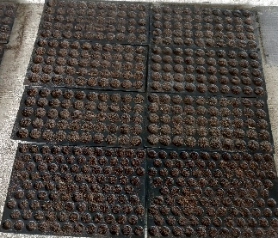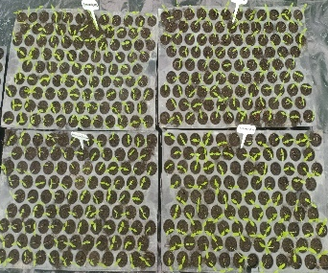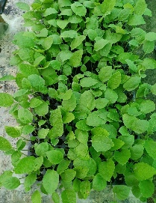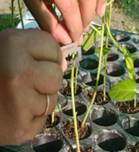
D
A

B
C
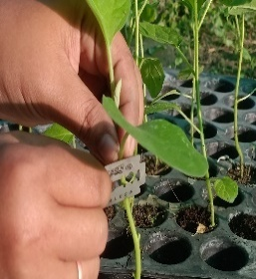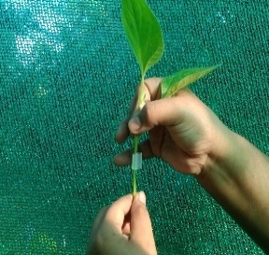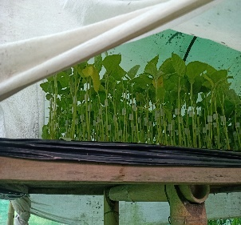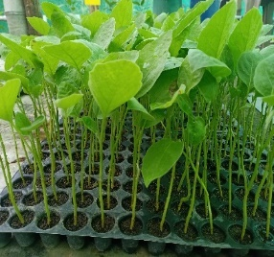
H
G
F
E
Fig.1. Procedure of splice grafting. (A) Seeds sown in pro-trays. (B) Germination of seeds. (C) Seedlings ready for grafting. (D) Using blade the rootstocks were cut. (E) Using blade the scions were cut. (F) Joining of rootstock and scion at cut portion. (G) Grafted plant inside healing chamber. (H) Grafted plant ready for transplanting.
- RESULTS AND DISCUSSION
Significant variation was observed in (Table 1) the average number of days required for germination across the years, 2024 and 2025. Among the rootstocks evaluated, S. torvum required the highest number of days for germination (17.00 days), whereas the rootstock Surya recorded the shortest germination period (5.30 days). In the case of scions, VNR 212 exhibited the earliest germination (4.30 days), while Mukta Keshi required the longest duration (6.50 days) for germination. These findings are in agreement with earlier reports by Gisbert et al. (2011) and Kumar et al. (2015). According to Gisbert et al. (2011), the delayed germination observed in S. torvum can be attributed to its hard seed coat, which induces prolonged dormancy and results in slower and irregular germination. The germination performance of the rootstocks revealed that Surya recorded the highest germination percentage (91.42%), followed by S. torvum (83.82%). In the case of scions, VNR 212 exhibited the maximum germination (95.94%), followed by Mukta Keshi (92.48%), whereas the lowest seed germination percentage was observed in Bhangar (84.59%). These observations are in agreement with earlier reports by Shipepe and Msogoya (2018) and Hossain et al. (2019). Among the different rootstock treatments, Surya exhibited the shortest duration (44.80 days) from germination to reaching the grafting stage. In contrast, S. torvum required a significantly longer period (66.20 days) to attain the same stage. With respect to scion varieties, VNR 212 reached grafting stage in the least time (35.70 days), whereas Mukta Keshi required a comparatively longer duration (37.40 days). The prolonged time taken by S. torvum to reach the grafting stage may be attributed to its slower germination and growth rate. These observations are in agreement with earlier reports by Bahadur et al. (2015), Hossain et al. (2019), and Sharma et al. (2019).
The interaction between rootstock and scion showed significant variation for days taken to attain transplanting and survival rate per cent where as non-significant variation was observed for days taken for union formation (Table 2). Among the different rootstock and scion combinations, VNR 212 grafted onto Surya exhibited the shortest duration for graft union formation (5.10 days) and required the least time to attain transplanting stage (18.90 days) compared to other combinations. After successful graft union formation, the grafted seedlings were gradually removed from the healing chamber and exposed to natural sunlight for acclimatization. This hardening process is essential to prepare the plants for field conditions and to minimize transplanting shock. Similar observations have been reported by earlier researchers, including Mohamed et al. (2012), Kumar et al. (2015) and Palanikumar et al. (2020). Among the treatments, Mukta Keshi grafted onto Surya recorded the highest survival rate (94.47%). In contrast, Mukta Keshi grafted onto Solanum torvum showed a comparatively lower survival rate (85.08%), indicating reduced graft success. This variation may be attributed to differences in vigour and compatibility, regardless of the genetic relatedness between scion and rootstock (Gisbert et al., 2011). According to Kawaguchi et al. (2008), reduced compatibility between scion and rootstock genotypes is often associated with poor vascular connectivity. Furthermore, differences in morpho-physiological traits between rootstock and scion can limit successful graft union formation. In some cases, incompatibility between species prevents the proper establishment of vascular connections, which are crucial for the healing process (Zeist et al., 2017). Inadequate vascular integration restricts water transport and nutrient uptake, leading to reduced stomatal conductance and suppressed growth of the scion (Atkinson and Else, 2001).

Table 1. Assessment of germination behaviour and growth characteristics of rootstock and scion (pooled data of 2024 and 2025)

Treatments | Days taken for germination | Germination per cent (%) | Days taken to reach grafting stage
Rootstock
Solanum torvum | 17.00 | 83.82 | 66.20
Surya | 5.30 | 91.42 | 44.80
Scion
VNR-212 | 4.30 | 95.94 | 35.70
Bhangar | 5.10 | 84.59 | 36.70
Mukta Keshi | 6.50 | 92.48 | 37.40
S.Em (±) | 0.24 | 0.58 | 0.41
CD at 5% | 0.68 | 1.65 | 1.17

Table 2. Growth performance and survival rate of grafted plants as influenced by different rootstock–scion combinations (pooled data of 2024 and 2025)

Treatment | Number of days taken for graft union | Days taken to attain transplanting | Survival of grafted plants per cent (%)
Rootstock
R1 | 7.40 | 24.00 | 89.53
R2 | 5.40 | 22.40 | 91.32
S.Em (±) | 0.16 | 0.18 | 0.36
CD at 5% | 0.45 | 0.51 | 1.01
Scion
S1 | 5.85 | 21.35 | 93.25
S2 | 6.40 | 24.00 | 89.78
S3 | 6.95 | 24.25 | 88.26
S.Em (±) | 0.19 | 0.22 | 0.44
CD at 5% | 0.55 | 0.63 | 1.24
Interaction (R x S)
R1S1 | 6.60 | 23.80 | 93.51
R1S2 | 7.30 | 23.70 | 85.08
R1S3 | 8.30 | 24.50 | 90.02
R2S1 | 5.10 | 18.90 | 92.99
R2S2 | 5.50 | 24.30 | 94.47
R2S3 | 5.60 | 24.00 | 86.49
S.Em (±) | 0.27 | 0.31 | 0.62
CD at 5% | N.S. | 0.89 | 1.75
R1= Solanum torvum, R2= Surya, S1= VNR-212, S2= Mukta Keshi, S3= Bhangar
CONCLUSION
These results highlight the crucial importance of rootstocks compatibility for the successful cultivation of grafted plants. As grafting practices continue to advance and improve, a deeper understanding of rootstock traits becomes essential. Overall, the rootstock Surya is the most suitable rootstock, followed by Solanum torvum, based on graft success and survival percentage. But both rootstocks can be effectively utilized for grafting due to their tolerance to major biotic stresses such as nematodes and bacterial wilt.

REFERENCE
Anonymous, (2023). Area, production and productivity of brinjal in different states of India. www. indiastat. com.
Atkinson, C. J., & Else, M. A. (2001). Understanding how rootstock dwarf fruit trees. Compact Fruit Tree, 34, 46-49.
Bahadur, A., Rai, N., Kumar, R., Tiwari, S. K., Singh, A. K., Rai, A. K., & Singh, B. (2015). Grafting tomato on eggplant as a potential tool to improve water logging tolerance in hybrid tomato. Vegetable Science, 42, 82-87.
Black, L., Wu, D., Wang, J., Kalb, T., Abbass, D., & Chen, J. (2003). Grafting tomatoes for production in the hot-wet season. Asian Vegetable Research & Development Center. AVRDC Publication, (03-551): 6.
Bletsos, F. A. and Olympios, C. M. (2008). Rootstocks and grafting of tomatoes, peppers and eggplants for soil borne disease resistance, improved yield and quality. The European Journal of Plant Science and Biotechnology, 2(1), 63-73.
Davis, A. R., Perkins-Veazie, P., Hassell, R., Levi, A., King, S. R., & Zhang, X. (2008). Grafting effects on vegetable quality. Hort Science, 43(6), 1670-1672.
Gisbert, C., Prohens, J., & Nuez, F. (2011). Eggplant relatives as sources of variation for developing new rootstocks: Effects of grafting on eggplant yield and fruit apparent quality and composition. Scientia Horticulturae, 128, 14-22.
Harada, T. (2010). Grafting and RNA transport via phloem tissue in horticultural plants. Scientia Horticulturae, 125, 545-550.
Hossain, M. G., Ali, M. A., Ripa, R. A., Ayrin, S., & Mahmood, S. (2019). Influence of rootstocks on yield and quality of summer tomato cv ‘BARI Tomato-4’. Earth Systems and Environment, 3, 289-300.
Kawaguchi, M., Taji, A., Backhouse, D., & Oda, M. (2008). Anatomy and physiology of graft in compatibility in solanaceous plants. The Journal of Horticultural Science and Biotechnology, 83, 581-588.
King, S. R., Davis, A. R., Zhang, X., & Crosby, K. (2010). Genetics, breeding and selection of rootstocks for Solanaceae and Cucurbitaceae. Scientia Horticulturae, 127(2), 106-111.
Kumar, P., & Peter, V. K. (2020). Genetics and Breeding of Vegetable Crops. Indian Council of Agricultural Research Publication, New Delhi. pp. 408-423.
Kumar, P., Rana, S., Sharma, P., & Negi, V. (2015). Vegetable grafting: a boon to vegetable growers to combat biotic and abiotic stresses. Himachal Journal of Agricultural Research, 41, 1-5.
Lee Kubota, C., Tsao, S. J., Bie, Z., Hoyos Echevarria, P., Morra, L., & Oda, M., (2010). Current status of vegetable grafting: Diffusion, grafting techniques, automation. Scientia Horticulturae, 127, 93-105.
Mohamed, F. M., Wasfy, M., Elwan, M., El Sayed, K., El-Hamed, A., & Hussien, M. A. N. (2012). Comparative growth, yield and fruit quality of grafted and non-grafted cherry tomato plants under protected cultivation. Agriculture & Food Security, 12, 21-29.
Palanikumar, M., Thiripurasundhari, S., Vinothini, R., & Ajitha, V. (2020). Grafting compatibility of tomato (Solanum lycopersicum), Brinjal (Solanum melongena) and chilli (Capsicum annum) through cleft graft method. International Journal of Current Research, 12, 15061-65.
Panse, V. G., & Sukhatme, P. V., (2000). Statistical methods for agricultural workers. ICAR, New Delhi, 359p.
Petran, A. J. (2013). Interspecific grafting of tomato (Solanum lycopersicum) onto wild rootstocks on tomato fruit yield and quality. Horticultural Science, 38, 142-149.
Sharma, V., Kumar, P., Sharma, P., Negi, N. D., Singh, A., Sharma, P. K., Dhillon, N., & Vats, B. (2019). Rootstock and scion compatibility studies in tomato under protected conditions. International Journal of Current Microbiology and Applied Sciences, 8, 1188-97.
Shipepe, B. T., & Msogoya, T. J. (2018). Graft compatibility between eggplant rootstocks and hybrid tomato (Solanum lycopersicum Mill.) cultivars. Tanzania. The Journal of Agricultural Science, 17, 31-38.
Turhan, A., Ozmen, N., Serbeci, M. S., & Seniz, V. (2011). Effects of grafting on different rootstocks on tomato fruit yield and quality. Horticultural Science, 38,142-149.
Venema, J. H., Dijk, B. E., Bax, J. M., Van Hasselt, P. R., & Elzenga, J. T. M. (2008). Grafting tomato (Solanum lycopersicum) onto the rootstock of a high-altitude accession of Solanum habrochaites improves suboptimal-temperature tolerance. Environmental and Experimental Botany, 63, 359-3.
Yildirim, A. N., Polat, M., Dolgun, O., Askin, M. A., Gokbayrak, Z., & San, B. (2010). Graft formation in some spur and vigorous apple varieties grafted on Ottawa 3 rootstock: a histological investigation. Journal of Food, Agriculture and Environment, 8, 512-514.
Zeist, A. R., De Resende, J. T., Giacobbo, C. L., Rios Faria, C. M., & Munhoz Dias, D. (2017). Graft takes of tomato on other solanaceous plants. Caatinga, Mossoro., 30, 513 520.

