Original Research Article
Potential of Fermented Fruit Peels for the Production of Industrially Important Enzymes

ABSTRACT
Background: Fruit peel waste constitutes a significant proportion in organic waste generated daily in our communities. Processing this waste into value-added products hold the potential to mitigate the environmental waste challenge.
Objective: This study aimed to evaluate the potential of fermenting fruit peels for the production of industrial enzymes, focusing specifically on amylase, cellulase, pectinase, protease, and lipase.
Methods: The fruit peels used include banana, papaya, and mango individually and in combination. The peels were subjected to a 90-days natural fermentation in a mixture with brown sugar and water. The fermented solutions were characterized on the basis of color appearance, aroma, pH, and biocatalytic attributes.
Results: The color of the fermented solutions was ranges from yellowish-brown to dark brown after 90 days fermentation. The smell was fresh/sour and fresh, and all samples exhibited acidic pH between 2.7–3.4. biocatalytic assays indicated that all the solutions possessed amylase, cellulase, pectinase, protease, and lipase activities.
Conclusion: The results revealed that fruit peels fermentation is a valuable process for repurposing organic waste such as fruit peels in to value added products. Through this, a vast amount of multi-enzyme can be obtained within a short period of time. This holds a promising potential as cost effective, environmentally friendly, and sustainable process in various industries including food, animal feed supplements, juice/pulp clarity, textiles, detergents, paper, and leather among others.
Keywords: Fruit peels; Fermentation; Industrial enzymes; Biocatalytic; Fermented solutions.

Introduction
Fruit peels constitute a substantial portion of food processing waste, often discarded despite being valuable sources of phytochemicals such as phenolics, flavonoids, carotenoids and organic acids [1]. Inappropriate disposal of these residues not only leads to resource mismanagement but also contributes to greenhouse gas emissions and landfill accumulation, which remain pressing global concerns. Converting such waste streams into value-added products aligns with the principles of the circular economy, where agricultural byproducts are reintegrated into productive use through sustainable biotechnological processes. Among the available strategies, fermentation has emerged as an efficient and eco-friendly method for valorizing fruit peel waste. Fermentation of peels produces solutions usually regarded as eco-enzymes or garbage enzymes, which are naturally enriched with organic acids, phenolics and other metabolites [2]. These products are low-cost, scalable and environmentally compatible, making them promising for both industrial and household applications. The multifunctionality of fermented fruit peels solutions makes them suitable biotechnological solutions.
Primarily, microorganisms, animals, and plants are the major sources of enzymes, with microbial being the source that is widely preferred largely due to their economic viability and easier downstream processing. Microbial enzymes are critical tools across many industries due to their specificity, ability to work under mild conditions and lower environmental impact than chemical catalysts [3]. Microbial enzymes such as amylases feature in starch liquefaction, brewing and food processing; cellulases degrade cellulose to simpler sugars useful for bioethanol and biorefinery; pectinases are used in fruit juice clarification, textile processing and waste treatment; proteases and lipases appear in detergents, pharmaceuticals, leather processing and organic waste bioconversion [4]. Various industrial sectors require more than a single enzyme, for example; detergent industry, production of biofuel through lignocellulosic hydrolysis, and animal feed improvement [5–7]. Considering the economic benefit for such applications, a source that can produce multiple enzymes would be of much interest. In addition, simple, easily available, and accessible substrates are important requirement for the production of cheaper industrial products. A recently released Enzymes Market Size review estimated the enzyme market at a value of USD 60.48 billion during 2023 and this was anticipated to grow further annually from 2024 to 2030 at growth rate of 6.5% [8]. Although, advanced technologies were suggested as a major driving force in this market estimate [9].
The indiscriminate waste disposal especially the agro-industrial, fruits, and vegetable wastes is a major concern for our environment. Considering this challenge, the focus is now on re-purposing these organic wastes because of the abundant bio-constituents present in them [10]. Production of compounds such as secondary metabolites, organic acids, and proteins/enzymes can be achieved by utilizing such substances as substrates for microbial fermentation [11]. Remarkably, various bioprocesses can apply microbial enzymes as tools or end products. Therefore, organic waste especially fruit peels can serve as good substrates for microbial fermentation capable of producing multiple enzymes. This study evaluated the potential of fermenting fruit peels for the production of industrially important enzymes by fermenting banana, papaya, and mango fruit peels.

Materials and Methods

Materials
The materials for fermentation included fresh banana, papaya, and mango peels, in addition to brown sugar and distilled water. Fresh banana (musa acuminate), papaya (carica papaya) and mango (mangifera indica) peels were sourced directly from fruit vendors at the central market in Birnin Kebbi. The selection of these specific fruit peels was based on their availability, organic nature and potential to yield beneficial enzymes during the fermentation process.

Methods

Production of Fermented Solutions
The collected fresh fruit peels were cut into smaller pieces using a sterile stainless-steel knife. Each of the fruit peel was separately put in an airtight plastic container followed by addition of brown sugar and water in a ratio of 1:3:10. The mixture was then mixed thoroughly. Additionally, a mixture containing all three (3) fruit peels was prepared using the same ratio. Fermentation was conducted for three (3) months under sun-protected conditions at room temperature. To prevent rupture due to gas buildup, the containers were opened periodically to release accumulated gases. After 90 days of fermentation, the solutions were filtered using a muslin cloth. The filtered solutions were stored in sterile plastic bottles at 4°C until further analysis. An illustration of this process is presented in figure 1.

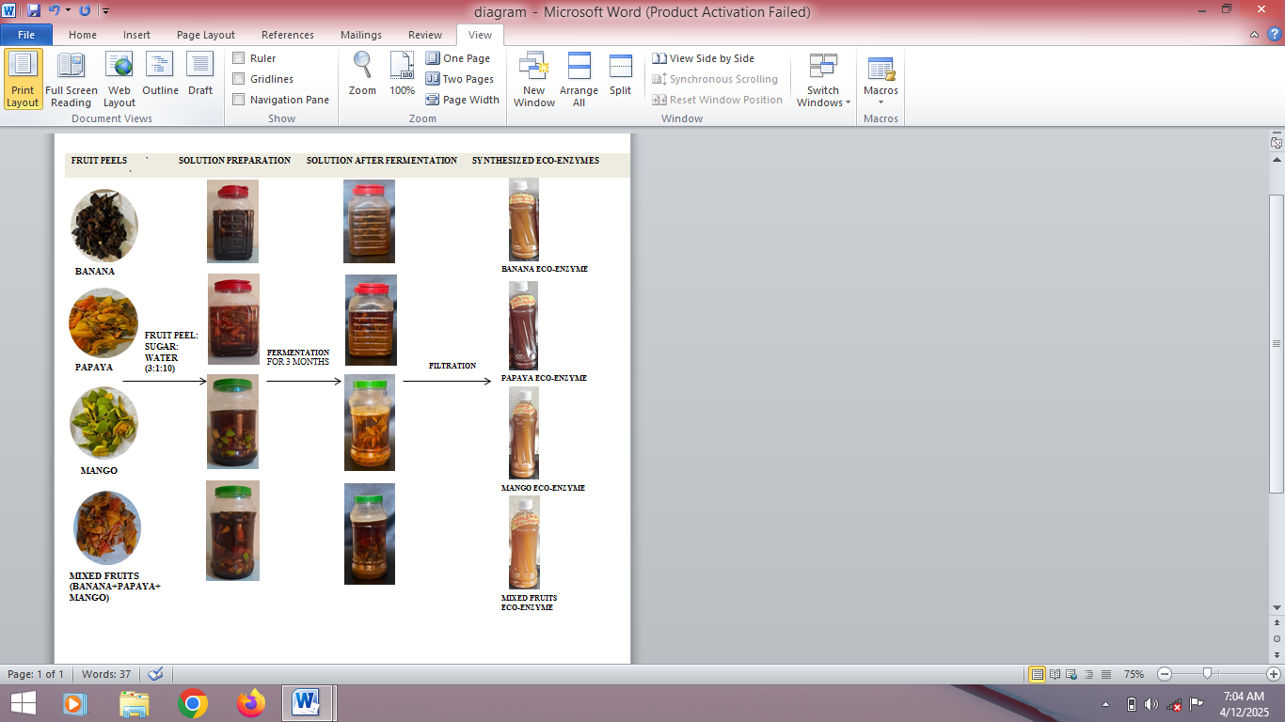
Figure 1. Schematic illustration of the fermentation process using banana, mango and papaya fruit peels.

pH Measurement
The pH values of solutions were measured before and after the 90-day fermentation period using a calibrated pH meter.

Determination of Amylase Activity
Amylase activity was assessed using cassava starch as a substrate adopting a method described previously [12]. A 0.5 mL aliquot of the fermented solution was mixed with solubilized cassava starch of varying concentrations (0.2%, 0.4%, 0.6%, 0.8% and 1% w/v) in 0.1 M phosphate buffer (pH 7). The mixture was incubated at 50°C for 30 minutes. The release of reducing sugars was determined using the 3,5-dinitrosalicylic acid (DNS) method. The reaction mixture, including 3 mL of DNS reagent, was heated for 10 minutes, followed by the addition of 10 mL of distilled water. Absorbance was measured at 540 nm using a spectrophotometer. Enzyme blanks were prepared using heat-denatured samples to account for non-enzymatic sugar release. One unit (U) of amylase activity was defined as the amount of enzyme required to release 1 µmol of glucose per minute under assay conditions.

Determination of Cellulase Activity
Cellulase activity was determined using carboxymethyl cellulose (CMC) as a substrate [13]. A 0.5 mL aliquot of fermented solution was mixed with solubilized CMC of varying concentrations (0.2%, 0.4%, 0.6%, 0.8% and 1% w/v) in 0.1 M phosphate buffer (pH 7). The mixture was incubated at 50°C for 30 minutes and the released reducing sugars were quantified using the DNS method. Absorbance was recorded at 540 nm. Enzyme blanks were included to correct for non-enzymatic sugar release. One unit (U) of cellulase activity was defined as the amount of enzyme needed to release 1 µmol of glucose per minute.

Determination of Pectinase Activity
Pectinase activity was determined using powdered orange peel as a substrate [14]. The amount of reducing sugars released was measured at 540 nm. One unit (U) of pectinase activity was defined as the quantity of enzyme releasing 1 µmol of galacturonic acid per minute.

Determination of Protease Activity
Protease activity was determined using casein as a substrate [15]. A 0.5 mL aliquot of fermented solution was mixed with casein solutions of varying concentrations (0.2%, 0.4%, 0.6%, 0.8% and 1% w/v) in 0.1 M phosphate buffer (pH 7) and incubated at 50°C for 30 minutes. The reaction was stopped by adding 0.5 mL of 20% trichloroacetic acid (TCA). After centrifugation at 13,000 rpm for 15 minutes at 4°C, absorbance was measured at 280 nm. The blank contained heat-denatured enzyme and casein. One unit (U) of protease activity was defined as the enzyme required to release 1 µg of tyrosine per mL per minute.

Determination of Lipase Activity
Lipase activity was determined by titrimetric assay of lipids using olive oil as a substrate [16]. A blank and test flask were prepared with 2.5 mL of water, 1 mL of HCl buffer, 3 mL of olive oil and 1 mL of fermented solution (added only to the test flask). After 15 minutes of incubation at 37°C, 3 mL of 95% ethanol and thymolphthalein were added. The mixture was titrated with NaOH until a light blue color appeared. One unit (U) of lipase activity was defined as the enzyme liberating 1 µmol of fatty acid per minute.

Results

pH of Fermented Solutions
On both day 0 and day 90 of fermentation, all the fermented solutions exhibited acidic pH, however, a decrease in pH was observed at day 90 compared to day 0 of fermentation. The pH values of all the fermented solutions are presented in table 1.
Table 1: pH of Fermented Solutions
Solutions | pH (day 0) | pH (day 90)
BPS | 3.4 | 2.8
PPS | 2.9 | 2.5
MPS | 3.0 | 2.2
MFPS | 2.7 | 1.9

Determination of Enzymatic Activity
Analysis of the enzymatic activities indicated that all the target enzymes including amylase, cellulase, pectinase, protease, and lipase were present in all of the fermented solutions. In this study, the highest enzyme activity shown at the highest substrate concentration were considered for each enzyme. Mango peels solution showed the highest amylase activity of 5.30 U/mL and papaya peels solution has the lowest activity of amylase which was 2.10 U/mL as shown in Fig. 2a. For cellulase, the highest activity was observed in the mixed fruits peels solution at 5.75 U/mL, while papaya peels solution recorded the lowest cellulase activity of 3.60 U/mL (Fig. 2b). Banana peels solution exhibited the highest pectinase activity of 3.35 U/mL and papaya peels solution with the lowest pectinase activity of 1.85 U/mL (Fig. 2c). Protease activity was found to be greatest in mango peels solution at 7.17 U/mL and the lowest protease activity was recorded in the mixed fruit peels solution which had 4.70 U/mL (Fig. 2d). For lipase, the mango peels solution showed the highest activity of 6.67 U/mL, while banana peels solution recorded the lowest at 1.67 U/mL, this result is displayed in table 2. In all cases, a consistent increase in the enzyme activity was observed as the concentration of substrate was increased.

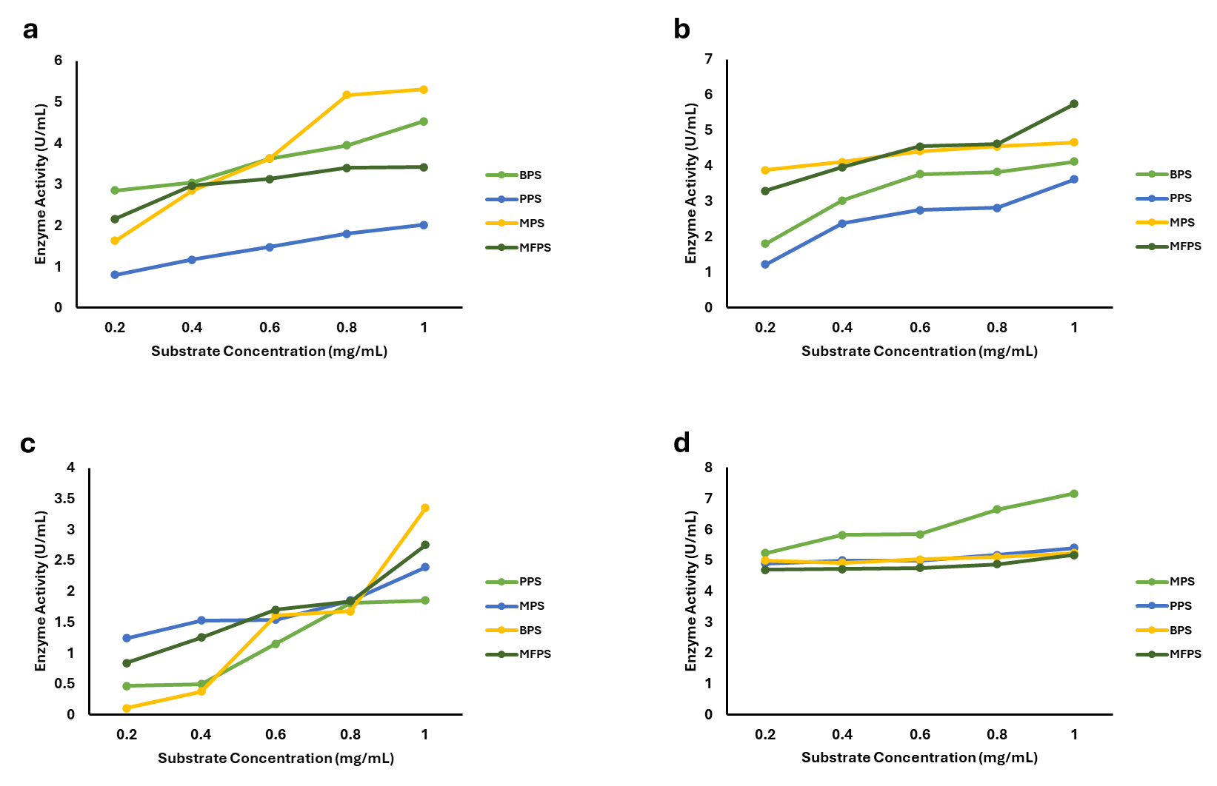
Figure 2: Activities of enzymes from different fermented solutions. (a) Amylase, (b) Cellulase, (c) Pectinase, and (d) Protease.
Table 2: Lipase activity
Solutions | Lipase Activity (U/mL)
PPS | 4.00
MPS | 6.67
BPS | 1.67
MFPS | 5.67

Discussion
In recent years, the utilization of fruit waste for production of value adding products has gained more attention. This highlights the recognition of fruit waste as a valuable resource for sustainable industrial applications. The paradigm of circular economy and advances in bioprocessing technologies have contributed further to this expansion reinforces the potential of fruit wastes in various sectors of industry. Considering these, the present study investigated the potential of fermented fruit peels for the production of industrially important enzymes. The solutions were produced after fermentation of fruit peels from banana, mango, and papaya peels. The common characteristic feature of a fermented solution from fruit peels is determined by pH, as seen in table 1, the pH of all the fermented solutions was acidic and this because organic acids and other metabolites are produced due to the breakdown of larger organic substances by the microbes during fermentation [17]. As the smaller components from the breakdown of larger molecules accumulate, they can change the pH of the solution and this could be the reason why a change in pH was observed between the start and the end of fermentation in our study. These results aligned well with various literatures on the acidic nature of solutions produced from fruit peels [18–22].
Various industries require multitude of enzymes for their processes, some of these enzymes include amylase, pectinase, cellulase, protease, and lipase. Although the specific activities of different enzymes found in fermented fruit peels solutions varied widely, amylase, cellulase, pectinase, protease, and lipase are the more frequently reported [22–24]. This shows that our results followed the similar trend with the current literature on how diverse fermented fruit waste are in exhibiting biocatalytic potentials. An interesting aspect of our result is that, the production of multiple enzymes from the fermentation of banana, mango, and papaya peels have been highlighted. Only a few literatures have reported the production of multiple enzymes from the fermentation of these fruit peels. Out study also underscore the potential in the production of multienzymes through the fermentation of fruit peels which can serve as a very important aspect of industrial processes because biocatalysts are advantageous compared to chemical catalysts. Additionally, the use of inexpensive materials is vital for industrial commercialization because it can lead to production of cheaper products. Considering this, our study suggest that banana, mango, and papaya fruit peel wastes are viable materials for natural fermentation that could be used for the cost-effective simultaneous production of various enzymes.
Conclusion
This study, investigated the potential of fermenting fruit peels for industrially important enzymes production. Fermented solutions of banana, mango, and papaya peels are enriched with multiple active enzymes, including amylase, cellulase, pectinase, lipase and protease, indicating their potentials for the ecofriendly, cost-effective, and sustainable alternative technology for the production of enzymes of industrial applications.

References
1. Ramírez-Sucre MO, Avilés-Betanzos KA, López-Martínez A, Rodríguez-Buenfil IM. Evaluation of Polyphenol Profile from Citrus Peel Obtained by Natural Deep Eutectic Solvent/Ultrasound Extraction. Processes. 2024;12: 2072. doi:10.3390/pr12102072
2. Ismail AY, Nainggolan MF, Aminudin S, Siahaan RY, Dzulfannazhir F, Sofyan HN. Characterization of chemical composition of eco-enzyme derived from banana, orange, and pineapple pineapple peels. Braz J Biol. 2024;84: e286961. doi:https://doi.org/10.1590/1519-6984.286961
3. Singh B, Soni SK, Mathur P, Garg N. Microbial Multienzyme Viz., Pectinase, Cellulase and Amylase Production Using Fruit and Vegetable Waste as Substrate—A Review. Applied Microbiology. 2024;4: 1232–1246. doi:10.3390/applmicrobiol4030084
4. Cristofoli NL, Lima AR, Tchonkouang RDN, Quintino AC, Vieira MC. Advances in the Food Packaging Production from Agri-Food Waste and By-Products: Market Trends for a Sustainable Development. Sustainability. 2023;15: 6153. doi:10.3390/su15076153
5. Naganthran A, Masomian M, Rahman RNZRA, Ali MSM, Nooh HM. Improving the Efficiency of New Automatic Dishwashing Detergent Formulation by Addition of Thermostable Lipase, Protease and Amylase. Molecules. 2017;22: 1577. doi:10.3390/molecules22091577
6. Binod P, Gnansounou E, Sindhu R, Pandey A. Enzymes for second generation biofuels: Recent developments and future perspectives. Bioresource Technology Reports. 2019;5: 317–325. doi:10.1016/j.biteb.2018.06.005
7. Alsersy H, Salem AZM, Borhami BE, Olivares J, Gado HM, Mariezcurrena MD, et al. Effect of Mediterranean saltbush (Atriplex halimus) ensilaging with two developed enzyme cocktails on feed intake, nutrient digestibility and ruminal fermentation in sheep. Anim Sci J. 2015;86: 51–58. doi:10.1111/asj.12247
8. Industrial Enzymes Market Size, Share | Industry Report, 2033. [cited 19 Jan 2026]. Available: https://www.grandviewresearch.com/industry-analysis/industrial-enzymes-market
9. Maghraby YR, El-Shabasy RM, Ibrahim AH, Azzazy HME-S. Enzyme Immobilization Technologies and Industrial Applications. ACS Omega. 2023;8: 5184–5196. doi:10.1021/acsomega.2c07560
10. Lucarini M, Durazzo A, Bernini R, Campo M, Vita C, Souto EB, et al. Fruit Wastes as a Valuable Source of Value-Added Compounds: A Collaborative Perspective. Molecules. 2021;26: 6338. doi:10.3390/molecules26216338
11. Sanchez S, Demain AL. Metabolic regulation and overproduction of primary metabolites. Microb Biotechnol. 2008;1: 283–319. doi:10.1111/j.1751-7915.2007.00015.x
12. Rathore DS, Singh SP. Kinetics of growth and co-production of amylase and protease in novel marine actinomycete, Streptomyces lopnurensis KaM5. Folia Microbiol. 2021;66: 303–316. doi:10.1007/s12223-020-00843-z
13. Demissie MS, Legesse NH, Tesema AA. Isolation and characterization of cellulase producing bacteria from forest, cow dung, Dashen brewery and agro-industrial waste. PLOS ONE. 2024;19: e0301607. doi:10.1371/journal.pone.0301607
14. Shrestha S, Khatiwada JR, Zhang X, Chio C, Kognou ALM, Chen F, et al. Screening and Molecular Identification of Novel Pectinolytic Bacteria from Forest Soil. Fermentation. 2021;7: 40. doi:10.3390/fermentation7010040
15. Ben Hmad I, Gargouri A. Stable and effective eco-enzyme cocktails in powder and liquid form of Stachybotrys microspora used as detergent additives. Heliyon. 2024;10: e25610. doi:10.1016/j.heliyon.2024.e25610
16. Kattatheyil H, Sajeela V, Kabeer SS, Ezhuthanikkunnel AP, Padinchati KK, Ammanamveetil MH. Screening, optimization, and molecular characterization of cold-active lipase producing Bacillus cereus I13 from Arctic sediments. Biologia. 2024;79: 1041–1055. doi:10.1007/s11756-024-01610-y
17. Haile M, Kang WH. The Role of Microbes in Coffee Fermentation and Their Impact on Coffee Quality. Journal of Food Quality. 2019;2019: 4836709. doi:10.1155/2019/4836709
18. Bulai IS, Adamu H, Umar YA, Sabo A. Biocatalytic remediation of used motor oil-contaminated soil by fruit garbage enzymes. Journal of Environmental Chemical Engineering. 2021;9: 105465. doi:10.1016/j.jece.2021.105465
19. Khang DT, Tien LTT, Men TT, Thuy NP. Potential of Fermented Fruit Peel Liquid in Cosmetics as a Skin Care Agent. Cosmetics. 2021;8: 33. doi:10.3390/cosmetics8020033
20. Tallei TE, Fatimawali, Niode NJ, Alsaihati WM, Salaki CL, Alissa M, et al. Antibacterial and Antioxidant Activity of Ecoenzyme Solution Prepared from Papaya, Pineapple, and Kasturi Orange Fruits: Experimental and Molecular Docking Studies. Journal of Food Processing and Preservation. 2023;2023: 5826420. doi:10.1155/2023/5826420
21. Punniamoorthy R, Lee WS, Loh QP, Goh Y, Tay KX, Wong KH, et al. Biochemical Content, Antimicrobial, and Larvicidal Activities of Jiaosu Derived from Different Combinations of Fruit Wastes. Waste Biomass Valor. 2024;15: 6927–6939. doi:10.1007/s12649-024-02631-z
22. Das SC, Khan O, Khadem AH, Rahman MA, Bedoura S, Uddin MA, et al. Evaluating the biocatalytic potential of fruit peel-derived eco-enzymes for sustainable textile wastewater treatment. Results in Engineering. 2024;21: 101898. doi:10.1016/j.rineng.2024.101898
23. Rasit N, Hwe Fern L, Ab Karim Ghani WAW. Production and Characterization of Eco Enzyme Produced from Tomato and Orange Wastes and Its Influence on the Aquaculture Sludge. Rochester, NY: Social Science Research Network; 2019. Available: https://papers.ssrn.com/abstract=3456453
24. Benny N, Shams R, Dash KK, Pandey VK, Bashir O. Recent trends in utilization of citrus fruits in production of eco-enzyme. Journal of Agriculture and Food Research. 2023;13: 100657. doi:10.1016/j.jafr.2023.100657

