Original Research Article
Plate–Rod Fixation Using Locking Compression Plates with an Open-But-Do-Not-Touch Approach for Femoral Fractures in Dogs: A Clinical Study

ABSTRACT
Aims:
To evaluate the clinical and radiographic outcomes of femoral fracture repair in dogs using a plate–rod construct with locking compression plates (LCP) combined with an intramedullary rod occupying approximately 40% of the medullary cavity, employing an open-but-do-not-touch (OBDNT) biological approach
Study Design:
A prospective clinical case series.
Place and Duration of Study:
The study was conducted at the Department of Veterinary Surgery and Radiology, College of Veterinary and Animal Sciences, Pookode, Wayanad, over a period of one year.
Methodology:
Six dogs with femoral fractures of varying configurations (simple, wedge, and comminuted) were included irrespective of age, breed, and sex. Fractures were classified according to Unger’s classification system. All animals underwent surgical stabilisation using a plate–rod construct with an intramedullary rod occupying approximately 40% of the medullary cavity, combined with appropriately sized locking compression plates. A standard craniolateral approach was used, adhering to the OBDNT principle to preserve the biological environment. Postoperative evaluation included clinical assessment of posture, gait, lameness, and functional outcome, along with serial radiographic evaluation at 14, 30, 60, and 90 days.
Results:
All fractures healed successfully through callus formation and secondary bone healing. Early weight bearing was observed in most animals within 2–4 weeks postoperatively. Radiographic evaluation demonstrated progressive callus formation, with complete fracture union achieved in all cases by 90 days. No major complications such as implant failure, malalignment, or infection were observed. Functional outcomes were graded as excellent in all animals, with complete resolution of lameness.
Conclusion:
The plate–rod construct using a 40% intramedullary rod in combination with locking compression plates, applied using an OBDNT approach, provides effective stabilisation and promotes favourable biological healing in canine femoral fractures. This technique is a reliable option for managing fractures of varying configurations with excellent functional outcomes.
Key words: Plate rod, LCP, Open but do not touch,

Introduction
Long bone fractures are prevalent in young dogs, with a higher incidence in the hind limbs (64.29%) compared to the forelimbs (35.71%). Within hind limb fractures, the femur is predominantly affected, accounting for 81.81% of cases (Henea et al., 2020). Specifically, fractures of the femur and tibia constitute 45% and 26% of cases, respectively (Ali, 2013). The primary etiologies include road accidents, falls, and other forms of trauma. A comprehensive understanding of bone biomechanics is essential for the appropriate selection of implants and fixation systems. Available options encompass bone plates and screws, intramedullary pins and cerclages, pin-plate combinations, locked intramedullary nails, and external fixators. Beale (2004) demonstrated that the combination of an intramedullary pin with a bone plate is optimal for biological fracture management, as it enhances construct stiffness and resistance to fatigue failure. Reems et al. (2003) observed that the inclusion of an intramedullary pin significantly extends the fatigue life of the implant by reducing plate strain. An intramedullary pin occupying 35-40% of the medullary cavity effectively protects the plate while allowing sufficient space for screws (Stiffler, 2004). The reduced plate-bone contact of the Locking Compression Plate (LCP) preserves the blood supply, thereby facilitating bone healing (Miller and Goswami, 2007). This study documents the successful application of plate-rod combinations with LCP for femur fracture repair in dogs.
Materials and methods
The present study was performed to evaluate the efficacy of the plate-rod technique and an “Open but do not touch” approach for the management of various types of traumatic femur fractures in dogs. Six cases of femoral fractures in dogs presented to the Department of Veterinary Surgery and Radiology, College of Veterinary and Animal Sciences, Pookode, Wayanad was recorded irrespective of age, breed, and sex. Dogs that presented with complaints of hindlimb lameness were further examined, and radiographic examination was performed to confirm the type of fracture. The fractures were classified based on Unger’s system of fracture classification (Unger et al. 1990). Blood samples were collected to perform haematological analysis and to determine serum calcium, phosphorus, and alkaline phosphatase concentrations. All fractures were surgically managed with a plate rod system with an intramedullary rod occupying 40 percent of the isthmus of the femur. The locking plate (LCP) size required for the respective body weights was chosen with screws placed bicortically in the fracture fragments. All femurs were approached through a standard craniolateral approach under general anaesthesia. A Steinman pin was initially inserted normograde to reestablish the axial realignment and length of the femur. Ancillary technique of cerclage wiring was used whenever required. Every effort was made to preserve the periosteal blood supply and muscle attachments to facilitate a good biological environment. Fracture fragments with soft tissue attachments were retained without compromising muscle attachments, thus ensuring an “open but do not touch” approach (Griffon. 2005). A minimum of two bicortical screws were placed in each fracture fragment.
Postoperatively, all the animals were treated with amoxicillin clavulanate at the dose rate of 20 mg/kg body weight BID for 5 days along with carprofen at the rate of 3 mg/kg body weight BID for 7 days and gabapentin at the rate of 20 mg/kg for 2 weeks. Multivitamin supplements were prescribed. All owners were advised to provide strict cage rest for four weeks, followed by leash walking for the next four weeks. Skin sutures were removed on the tenth postoperative day. The limbs were not bandaged. All the fracture repairs were evaluated for apposition, alignment, apparatus and activity. Radiographic evaluation was conducted at 14, 30, 60, and 90 postoperative days. Postoperative grading was performed for lameness, weight bearing while running, and functional outcome during the review periods.
Result and discussion
The clinical and radiographic progression of femoral fracture repair in dogs A1 to A6 is shown in Fig. 1-6.
  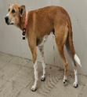 |   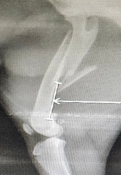 |   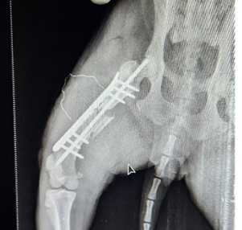 |   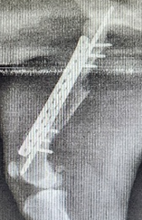 |   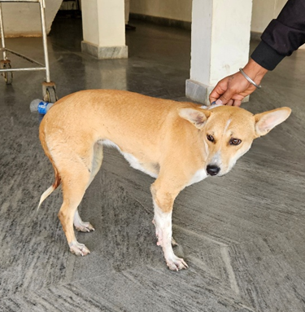
Fig. 1 (a-e): Photographs and radiographs of Dog A1. (a) Preoperative photograph showing non-weight bearing lameness (b) Preoperative radiograph (c) Immediate postoperative radiograph (d) Postoperative radiograph after 3 months (e) Photograph showing complete weight bearing- 3 months postoperative

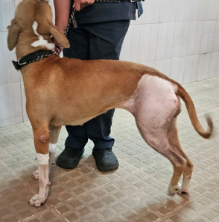 | 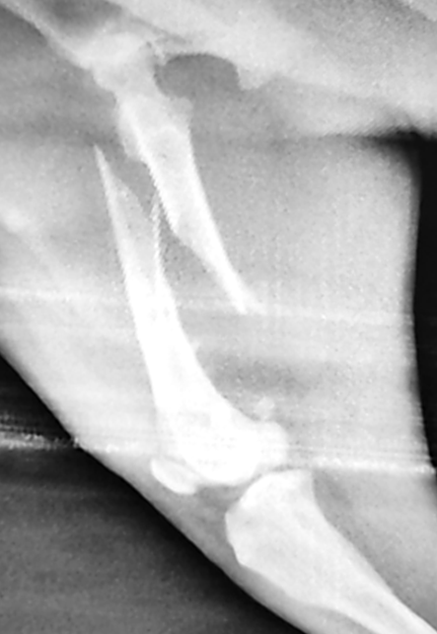 |   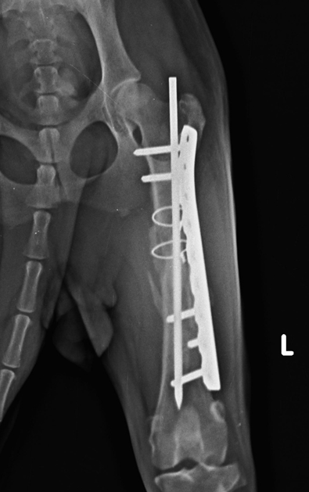 | 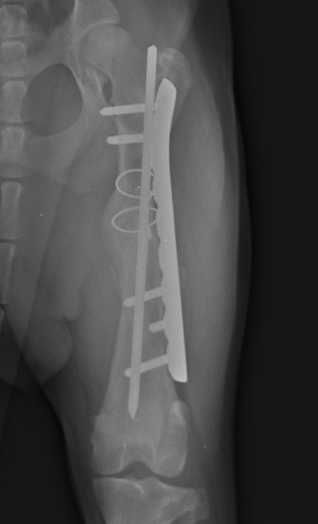 | 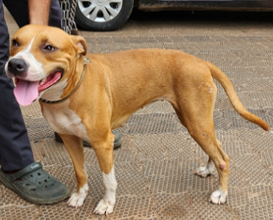
Fig. 2 (a-e): Photographs and radiographs of Dog A2. (a) Preoperative photograph showing non-weight bearing lameness (b) Preoperative radiograph (c) Immediate postoperative radiograph (d) Postoperative radiograph after 3 months (e) Photograph showing complete weight bearing- 3 months postoperative

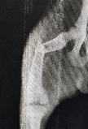 | 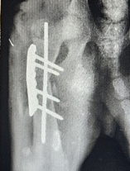 | 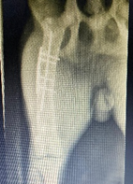 | 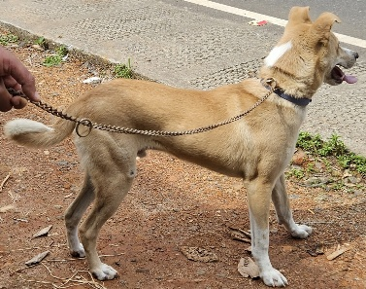
Fig. 3 (a-d): Photographs and radiographs of Dog A3. (a) Preoperative radiograph (b)Immediate postoperative radiograph (c) Postoperative radiograph after 3 months (d)Photograph showing complete weight bearing- 3 months postoperative

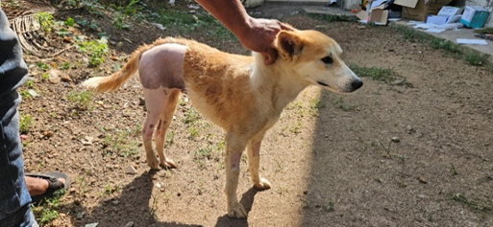 | 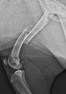 | 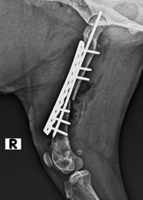 | 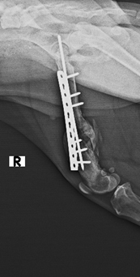 |   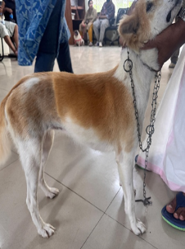
Fig. 4 (a-e): Photographs and radiographs of Dog A4. (a) Preoperative photograph showing non-weight bearing lameness (b) Preoperative radiograph (c) Immediate postoperative radiograph (d) Postoperative radiograph after 3 months (e) Photograph showing complete weight bearing- 3 months postoperative

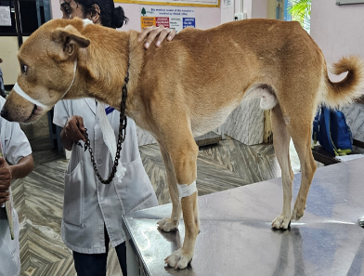 | 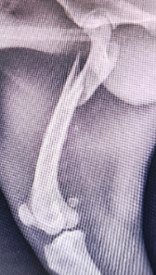 | 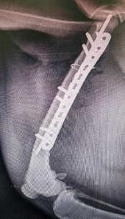 | 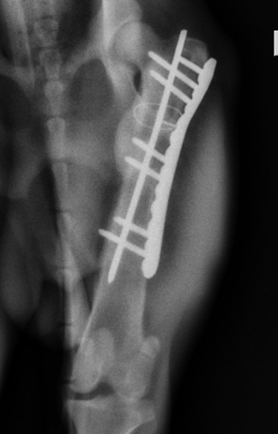 | 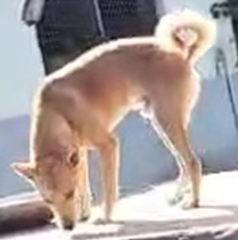
Fig. 5 (a-e): Photographs and radiographs of Dog A5. (a) Preoperative photograph showing non-weight bearing lameness (b) Preoperative radiograph (c) Immediate postoperative radiograph (d) Postoperative radiograph after 3 months (e) Photograph showing complete weight bearing- 3 months postoperative

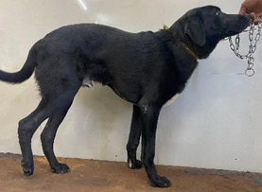 | 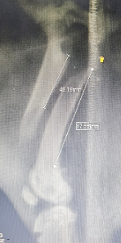 | 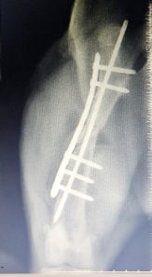 | 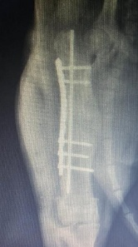 | 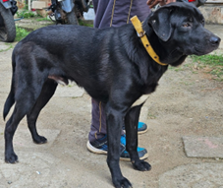
Fig. 6 (a-e): Photographs and radiographs of Dog A6. (a) Preoperative photograph showing non-weight bearing lameness (b) Preoperative radiograph (c) Immediate postoperative radiograph (d) Postoperative radiograph after 3 months (e) Photograph showing complete weight bearing- 3 months postoperative

Table 1. Details of dogs with femur fracture repaired using plate rod technique
Dog | Age | Breed | Sex (M/F) | Body weight (Kg) | Etiology | Time lapsed till repair (days)
A1 | 9 m | ND | Male | 12.8 | RTA | 5
A2 | 1.5 yr | ND | Male | 20 | Fall from height | 5
A3 | 8m | ND | Male | 8 | RTA | 6
A4 | 9m | ND | Female | 10 | RTA | 10
A5 | 3yr | ND | Male | 14.5 | RTA | 28
A6 | 7m | ND | Male | 24.2 | RTA | 12

Table 2. Configuration of femur fractures of dogs in the study group
Dog | Nature | Severity | Diaphysis involved | Orientation/complexity | Unger’s class | Number of fragments | Intrame-dullary diameter (mm)
A1 | Closed | Wedge | Mid | Several reducible wedge | 32B2 | 4 | 8.1
A2 | Closed | Wedge | Mid | Non  reducible wedges | 32B3 | 4 | 9
A3 | Closed | Wedge | Mid | Reducible wedge | 32B1 | 3 | 7
A4 | Closed | Wedge | Mid | Non reducible wedge | 32B3 | 5 | 6.5
A5 | Closed | Simple | Proximal | Oblique | 32A2 | 2 | 7.8
A6 | Closed | Simple | Mid | Oblique | 32A2 | 2 | 8

Table 3. Dimension and configuration of implants used
Dog | Dimension of LCP plate used | Intramedullary rod (mm) | Number of bicortical locking screws |  | Total screws | Ancillary implants used
Dog | Dimension of LCP plate used | Intramedullary rod (mm) | Proximal | Distal | Total screws | Ancillary implants used
A1 | 12 hole 2.7 | 3 | 3 | 3 | 6 | nil
A2 | 9 hole 3.5 | 3.5 | 2 | 3 | 5 | cerclage
A3 | 7 hole 2.7 | 2.5 | 2 | 2 | 4 | nil
A4 | 10 hole 2.7 | 2.5 | 3 | 3 | 6 | nil
A5 | 12 hole 2.7 | 2.5 | 3 | 4 | 7 | cerclage
A6 | 9 hole 3.5 | 3.5 | 2 | 3 | 5 | nil

All animals were non-descript dog breeds. Among the six dogs, five were male and one was female. The mean body weight (mean ± SE) of the animals was 14.92 ± 2.51 kg (range–8-24.2 kg). The age of animals ranged from 7 to 36 months, with a mean age of (mean ± SE) 14.5 ± 4.59 months. The common etiology behind the fracture was road traffic accident which accounted for five animals while one dog sustained fracture due to a fall from height. Earlier research by Aithal et al. (1999), Beale (2004), Libardoni et al. (2016), Vallefuoco et al. (2016) and Kallianpur et al. (2018) has documented similar results. The mean time to repair was 11 ± 3.60 days, and the time interval between injury and surgical intervention ranged from 5 to 28 days. Animal A5 had the longest time delay with a time period of 28 days and showed quadriceps contracture. The current study found that the interval between the fracture occurrence and its fixation was longer than the five day period reported by Wangchuk et al. (2021) and Gopinathan et al. (2023). The details of dogs with femur fracture repaired using plate rod technique are given in table 1.
The general body condition of the animals was good on the day of presentation. All dogs, irrespective of the group, showed severe pain, crepitus, oedema, and non-weight-bearing lameness of the affected limbs.
Wedge fractures were the most frequently encountered type, accounting for four out of six cases, whereas the remaining two fractures were classified as simple. Similar types of fracture configurations of femur were reported by Reems et al. (2003) and Sarangom et al. (2018). All fractures in the group were closed fractures. Regarding the anatomical location, five were mid-diaphyseal and one was proximal. The mean number of fractured fragments (Mean ± SE), including the main proximal and distal fragments in the group was 3.33 ± 0.49 (ranged from two to five). The mean diameter of the medullary cavity in the group was 7.73 ± 0.36 (ranged from 6.5 to 9 mm). Based on the orientation /complexity, two were non reducible wedge, one was several reducible wedge, one was reducible wedge and two fractures were oblique in configuration. The Configuration of femur fractures of dogs in the study group is summarised in table 2.
All animals in the group demonstrated progressive improvement in the posture score from the day of surgery until the twelfth postoperative week. On the day of surgery, all dogs exhibited non-weight-bearing lameness, carrying the affected limb off the ground. By the second postoperative week, three of the six animals (A1, A3, and A6) had begun placing their paw on the ground, whereas the remaining dogs initiated toe-touching. The recovery progressed steadily in all cases, and by the twelfth postoperative week, all animals were bearing weight normally on the operated limbs. The mean posture score (mean ± SE) in the group increased from 1.00 ± 0.00 at week 0 to 2.50 ± 0.22, 2.67 ± 0.21, 3.00 ± 0.00, and 3.00 ± 0.00 at weeks 2, 4, 8, and 12 respectively
The gait scores in the group showed progressive improvement throughout the observation period. Two animals (A1 and A3) began placing their paws on the ground with every step from the second postoperative week onwards. The remaining animals also demonstrated steady and consistent improvement in their gait, achieving optimal gait scores by the eighth postoperative week, characterised by consistent paw placement with each step. By the 12th week, all animals had perfect gait scores with complete weight bearing during running and walking. The mean gait score (mean ± SE) in the group improved from 1.00 ± 0.00 at week 0 to 3.17 ± 0.60, 4.17 ± 0.40, 5.00 ± 0.00, and 5.00 ± 0.00 at weeks 2, 4, 8, and 12, respectively.
All animals in the group exhibited severe lameness at presentation, characterised by an inability to place the toe or foot on the ground during standing and ambulation. Consistent and progressive improvements in lameness scores were observed throughout the postoperative period. By the second postoperative week, animal A3 had regained a sound gait, whereas animal A2 continued to exhibit severe lameness. The remaining animals demonstrated mild-to-moderate lameness at this stage. Subsequently, lameness scores improved steadily in all cases, and by the twelfth postoperative week, all animals in the group had achieved a sound gait. The mean lameness score (mean ± SE) in the group decreased from 10.00 ± 0.00 at week 0 to 5.67 ± 1.50, 3.50 ± 1.20, 1.67 ± 0.76, and 0.00 ± 0.00 at weeks 2, 4, 8, and 12, respectively.
The implant configuration used for fracture stabilisation in the group is summarised in Table 3. Locking compression plates (LCP) of varying lengths and sizes were selected according to the fracture location and bone dimensions of each animal. The plates used included 12-hole and 7-hole 2.7 mm LCPs and 9-hole 3.5 mm LCPs. Intramedullary rods of 2.5 mm, 3 mm, and 3.5 mm Steinmann pins were used in combination with the plates to provide additional axial stability. The number of bicortical locking screws placed in the proximal and distal fragments varied depending on the plate length and fracture configuration, with two to three screws proximally and two to four screws distally, resulting in a total of four to seven screws per construct. Ancillary fixation was required in two cases (A2 and A5), where cerclage wires were applied to achieve improved fragment apposition and stability. Ancillary techniques like lag screws (Haaland et al. 2009) and cerclage wires (Basha et al.2023) are commonly used in fracture management to improve fragment apposition and provide supplementary stabilisation. In the remaining animals, satisfactory fracture stabilisation was achieved using the plate–rod construct alone without the need for additional implants. The mean plate screw density of the group was 0.56 ± 0.01(ranged from 0.5 to 0.6) (mean ± SE), indicating that approximately 56% of the available plate holes were occupied by screws in the plate–rod constructs used for fracture stabilisation. This falls within the acceptable range recommended by Gautier and Sommer (2003) for locking plate constructs (0.3–0.6). Similar observation was made by Gopinathan et al. (2023). The screw density used in the present study provided adequate construct stability while maintaining sufficient plate working length for biological fracture fixation. Maintaining a moderate screw density helped distribute mechanical load along the plate while avoiding excessive construct rigidity, thereby promoting favourable conditions for secondary bone healing.
Fracture apposition was well maintained throughout the observation period. No alterations in alignment or angulation were detected when compared with immediate postoperative radiographs. The implants remained in their original positions, with no radiographic evidence of loosening, bending, or breakage. The intramedullary rods retained their position without any signs of migration, indicating sustained stability of the fracture fixation throughout the healing period. The sustained mechanical integrity of the fixation construct provided a stable biological environment conducive to fracture healing, which was reflected in the favourable radiographic fracture healing progression and functional recovery observed in this group. The overall status and positioning of the implants were excellent.
Radiographic healing during the postoperative period was evaluated using the modified Radiographic Union Score for Tibial fractures (mRUST), as described by Litrenta et al. (2015). Animal A3 demonstrated comparatively advanced radiographic healing as early as the second postoperative week, characterised by the presence of well-formed bridging callus. The remaining animals exhibited early signs of fracture healing at this stage, with mild callus formation evident on the radiographs. By the eighth postoperative week, all animals showed a steady progression of healing. Radiographic scores exceeded 14 in animals A3 and A6, while the remaining animals recorded scores of 12, indicating advanced stages of fracture healing. By the 12th postoperative week, mRUST scores ranged between 14 and 16 in all animals, confirming radiographic union. A score of 4-6 indicates no radiographic evidence of healing, 7-10 indicates early fracture healing with callus formation, 11-13 indicates progressive /advanced fracture union while 14-16 indicates radiographic fracture union.
The functional outcome in the animals was graded as excellent, with complete resolution of lameness observed in all cases. These findings reflect the stability of the fixation construct and the favourable biological environment established at the fracture site, which facilitated early callus formation and progressive fracture healing. The combination of mechanical stability and biological support ultimately contributed to the consistently superior clinical outcomes observed in this study.
Conclusion
The overall results concluded that the use of plate-rod constructs with intramedullary rods occupying 40 percent of the medullary cavity, appropriate plate size for body weight, and an ‘open but do not touch’ approach is highly efficient for the repair of various grades of femur fractures in dogs. This technique provides relative stability and a conducive biological environment for promoting secondary fracture healing in dogs.
Reference
Henea, M. E., Grecu, M., Grădinaru, A. C., and Solcan, G. (2020). Incidence, genetic predisposition, and recovery by physiotherapy of orthopedic disorders in dogs and cats. Human and Veterinary Medicine, 12(4), 1–7.
Ali, L.M.B. (2013). Incidence, occurrence, classification & outcome of small animal fractures: a retrospective study (2005-2010). World Academy of Science, Engineering & Technology International Journal of Animal and Veterinary Sciences, 7(3), 191-196.
Beale, B. (2004). Orthopedic clinical techniques femur fracture repair. Clinical Techniques in Small Animal Practice, 19(3), 134-150.
Reems, M. R., Beale, B. S., and Hulse, D. A. (2003a). Use of a plate-rod construct and principles of biological osteosynthesis for repair of diaphyseal fractures in dogs and cats: 47 cases (1994-2001). Journal of the American Veterinary Medical Association, 223(3), 330–335
Stiffler, K. S. (2004). Internal fracture fixation. Clinical Techniques in Small Animal Practice, 19(3), 105-113
Miller, D. L., & Goswami, T. (2007). A review of locking compression plate biomechanics and their advantages as internal fixators in fracture healing. Clinical biomechanics, 22(10), 1049-1062
Unger M, Montavon P M and Heim U F. (1990). Classification of fractures of long bones in the dog and cat: Introduction and clinical application. Veterinary and Comparative Orthopaedics and Traumatology 3: 41–5
Griffon, D. J. (2005). Fracture healing. In: AO principles of fracture management in the dog and cat (Johnson, A. L., Houlton, J. E., & Vannini, R.Eds), AO publishing,pp.73-97
Aithal, H. P., Singh, G. R., & Bisht, G. S. (1999). Fractures in dogs: A survey of 402 cases. Indian Journal of Veterinary Surgery, 20(1), 15-21.
Libardoni, R. D., da Costa, D., Menezes, F. B., Cavalli, L. G., Pedrotti, L. F., Kohlrausch, P. R., Minto, B. W., and Silva, M. A. M. (2018). Classification, fixation techniques, complications and outcomes of femur fractures in dogs and cats: 61 cases (2015–2016). Ciência Rural, 48(6), e20170028.
Vallefuoco, R., Le Pommellet, H., Savin, A., Decambron, A., Manassero, M., Viateau, V., and Fayolle, P. (2016). Complications of appendicular fracture repair in cats and small dogs using locking compression plates. Veterinary and Comparative Orthopaedics and Traumatology, 29(01), 46-52.
Kallianpur, N., Singh, K., Gopinathan, A., Sarangom, S. B., John, C., Sowbharenya, C., and Sharma, P. (2018). Investigation on relation between factors affecting occurrence and outcome of repair of long bone fractures in 216 dogs. International Journal of Livestock Research, 8(2), 225-234.
Wangchuk, T., Khosa, J. S., Singh, T., Mohindroo, J., Sangwan, V., & Singh, O. (2021). Evaluation of pin plate combination for surgical management of comminuted diaphyseal femur fracture in dogs. The Pharma Innovation Journal, 10(8), 156-160.
Gopinathan, A., Singh, K., Arya, M., SN, C., Shrama, P., Alifsha, B., Sowbharenya, C. and Kumar, A., 2023. Plate-rod technique for femur fracture repair in dogs: A report of 31 cases. Acta Scientific Veterinary Sciences (ISSN: 2582-3183), 5(5).
Sarangom, S. B., Singh, K., Gopinathan, A., Basha, K. M. A., Surendra, D. S., Sowbharenya, C., and John, C. (2018). Plate-rod technique for the repair of comminuted diaphyseal femoral fractures in young dogs. International journal of advanced biological research, 8(4), 451-453
Haaland, P. J., Sjöström, L., Devor, M., and Haug, A. (2009). Appendicular fracture repair in dogs using the locking compression plate system: 47 cases. Veterinary & Comparative Orthopaedics & Traumatology, 22(04), 309-315.
Basha, K. M. A., Singh, K., Gopinathan, A., Sarangom, S. B., Surendra, D. S., Kumar, A., ... & Jabeen, U. (2023). A randomised clinical study to evaluate the plate rod fixation for diaphyseal femoral fracture in dogs. Indian Journal of Animal Sciences, 93(04). Indian Journal of Animal Sciences 93 (4): 342–348.
Gautier, E., and Sommer, C. (2003). Guidelines for the clinical application of the LCP. Injury, 34, 63-76.
Litrenta, J., Tornetta III, P., Mehta, S., Jones, C., O'Toole, R. V., Bhandari, M., and Horwitz, D. (2015). Determination of radiographic healing: an assessment of consistency using RUST and modified RUST in metadiaphyseal fractures. Journal of orthopaedic trauma, 29(11), 516-520.

