Original Research Article

Assessment of Mean Performance for Yield Traits in Garden Pea (Pisum sativum L.) Genotypes Across Differential Thermal Environments

.
ABSTRACT

The present study was undertaken to examine the mean performance of garden pea (Pisum
sativum L.) genotypes for yield and its associated traits under varying thermal conditions, with the objective of identifying stable and heat-tolerant lines. The Field experiment laid out in an Augmented Block Design at the Vegetable Research Centre, Govind Ballabh Pant University of Agriculture and Technology, Pantnagar, Uttarakhand, India, during the rabi season of 2024–2025. A total of 72 diverse genotypes along with two standard check varieties (PM-128 and PSM-3) were evaluated under three different thermal regimes, namely pre-flowering heat stress (Environment 1), optimum conditions (Environment 2), and terminal heat stress (Environment 3). Observations were recorded on important phenological and yield-related traits. Considerable variability was observed among the genotypes across the three environments. Pre-flowering heat stress (Environment 1) led to accelerated flowering and reduced vegetative growth, with comparatively moderate effects on yield traits relative to terminal heat stress. The crop performed best under optimal conditions (Environment 2), whereas a marked decline in yield attributes was evident under terminal heat stress (Environment 3), particularly for pod number, seed set, and overall pod yield. Among the entries, PSM-151, PM-128, PSM-3, PSM-166 and PSM-221 consistently exhibited better performance and stability across environments, indicating their relative tolerance to heat stress. On the other hand, genotypes such as PSM-152 and PSM-202 were found to be more susceptible, especially under late-season heat stress.

The findings indicate that heat stress imposed during the reproductive phase has a pronounced adverse effect on yield in garden pea. Genotypes demonstrating stable performance across environments, such as PSM-3, PM-128 and PSM-151 may serve as promising material for breeding programmes aimed at developing heat-resilient cultivars. However, further evaluation across locations and seasons would be necessary to confirm their wider adaptability.

Keywords: Garden Pea; Heat Stress; Genotypic Performance; Early flowering
1. INTRODUCTION
Garden pea (Pisum sativum L., 2n = 2x = 14) is among the earliest domesticated grain legumes, with a cultivation history extending thousands of years. It is an important cool-season crop widely grown in temperate regions, contributing over 35 million tonnes to global production. In addition to its economic significance, pea serves as a valuable nutritional source due to its high protein content (21–33%) and richness in essential amino acids like lysine, making it an effective complement to cereal-based diets (FAOSTAT, 2019). In India, pea is cultivated on approximately 567 thousand hectares, yielding an annual production of around 5,846 thousand metric tons (Rawat et al., 2024) though its productivity remains variable, largely due to its narrow optimal temperature range of 10–18°C, which makes it sensitive to environmental fluctuations (Kumar and Choudhary, 2014). Prominent early varieties in Uttarakhand's Tarai region include Arkel, introduced from England, Pant Sabji Matar-3 from Pantnagar, and VL-7 from VPKAS, which is commonly grown in the hilly areas (Singh et al., 2012).
The crop is particularly vulnerable to heat stress during the reproductive phase, where temperatures above 25°C can severely reduce yield. While elevated temperatures during vegetative growth affect biomass accumulation and physiological functions, stress during flowering and pod initiation has more pronounced effects, often leading to poor pollination and flower drop (Sita et al., 2017). Temperatures approaching 30°C are considered critical for reproductive failure in pea, and exposure to such conditions during the terminal stage accelerates development, shortens the grain-filling period, and results in reduced seed size and poorly developed pods (Guilioni et al., 2003; Jiang et al., 2019).
With the anticipated rise in global temperatures by 2–4°C, terminal heat stress is expected to intensify, especially in the North Indian plains where flowering coincides with increasing temperatures during March–April (IPCC, 2014). Even a slight increase of 1°C during flowering has been shown to significantly reduce yield by 0.7–0.8 t/ha, highlighting the crop’s sensitivity to thermal stress (Lamichaney et al., 2021). This underscores the urgent need to identify heat-tolerant genotypes capable of sustaining yield under elevated temperatures (Parihar et al., 2022; Wang et al., 2022).
Given the complexity of genotype × environment interactions, selection of stable and high-yielding cultivars requires evaluation across diverse conditions. Heat tolerance in pea is governed by multiple traits and influenced by complex physiological mechanisms, making its improvement challenging. Therefore, systematic screening under both stress and non-stress environments is essential to distinguish true tolerance from environmental effects. In this context, the present study evaluates 72 diverse genotypes under three thermal regimes—pre-flowering stress, optimal conditions, and terminal heat stress—to identify promising lines for developing climate-resilient pea cultivars (Yan et al., 2007; Kumar et al., 2020).
2. material and methods

2.1 Experimental Design and Field Management
A field experiment was carried out at the Vegetable Research Centre, G. B. Pant University of Agriculture and Technology, Pantnagar (Uttarakhand), during the rabi season of 2024–2025 with the aim of assessing the response of seventy two genotypes of garden pea (Pisum sativum L.) to different thermal regimes. The details of the genotypes are present in Table 1. Pantnagar is located at 29°0′ N latitude and 79°3′ E longitude, at an altitude of 243.8 m above mean sea level. To represent contrasting temperature conditions prevalent in the region, three staggered sowing dates were adopted. The first sowing (Environment I) was undertaken on October 24, 2024, to expose the crop to relatively higher temperatures (up to 35°C) during the early vegetative and pre-flowering stages. The second sowing (Environment II), carried out on November 15, 2024, corresponded to the normal growing season and served as the control. The third sowing (Environment III) on February 5, 2025, was planned to subject the crop to elevated temperatures during the reproductive and pod-filling stages.
The trial followed an Augmented Block Design (ABD) consisting of four blocks. A total of 70 test genotypes, along with two standard check varieties (PM-128 and PSM-3), were included in the study. A spacing of 30 cm between rows and 10 cm between plants was maintained during sowing. All recommended agronomic practices were applied uniformly throughout the growing period to ensure proper crop establishment and to reduce the influence of extraneous variability.
Table 1: Garden Pea (Pisum sativum L.) Genotypes Used for Evaluation in the current
investigation

Test Genotypes*
PSM-151 | PSM-152 | PSM-153 | PSM-154 | PSM-155 | PSM-156 | PSM-157 | PSM-158
PSM-159 | PSM-160 | PSM-161 | PSM-162 | PSM-163 | PSM-164 | PSM-165 | PSM-166
PSM-167 | PSM-168 | PSM-169 | PSM-170 | PSM-171 | PSM-172 | PSM-173 | PSM-174
PSM-175 | PSM-176 | PSM-177 | PSM-178 | PSM-179 | PSM-180 | PSM-181 | PSM-182
PSM-183 | PSM-184 | PSM-185 | PSM-186 | PSM-187 | PSM-188 | PSM-189 | PSM-190
PSM-191 | PSM-192 | PSM-193 | PSM-194 | PSM-195 | PSM-196 | PSM-197 | PSM-198
PSM-199 | PSM-200 | PSM-201 | PSM-202 | PSM-203 | PSM-204 | PSM-205 | PSM-206
PSM-207 | PSM-208 | PSM-209 | PSM-210 | PSM-211 | PSM-212 | PSM-213 | PSM-214
PSM-215 | PSM-216 | PSM-217 | PSM-218 | PSM-219 | PSM-220 | PSM-221 | PSM-222
Check Cultivars
PSM-3 |  |  |  | PM-128
*All test genotypes were sourced from GBPUA&T, Pantnagar, Uttarakhand, India.

2.2 Environmental Conditions and Thermal Screening
The crop season at the experimental site was characterized by pronounced temperature fluctuations, which facilitated the creation of distinct thermal regimes for stress evaluation. During the initial phase of the season (October), relatively high temperatures prevailed, with maximum values reaching up to 35°C and an average of around 33°C, thereby exposing the crop to heat stress during early vegetative growth. As the season advanced into the main growing period (November–January), a gradual decline in temperature was observed. The months of December and January marked the coldest phase, with mean minimum temperatures of 7.6°C and 7.2°C, respectively, and occasional drops to as low as 4–5°C.
A noticeable rise in temperature occurred during the later stages of crop development. February remained relatively moderate, with a mean temperature of 16.7°C; however, a rapid increase in temperature was recorded from the third week of March onwards. By April, temperatures reached their seasonal peak, nearing 40°C, thereby subjecting the crop to significant heat stress during the reproductive and grain-filling phases. Temperature prevailing throughout the crop trial are presented in Fig. 1. These sequential changes in temperature effectively resulted in three distinct environmental conditions for screening the genotypes:
- Environment I: High-temperature exposure during the early vegetative and pre-flowering stages.
- Environment II: Optimal cool-season conditions during critical growth stages.
- Environment III: Terminal heat stress (post-flowering) during pod development and seed maturation.
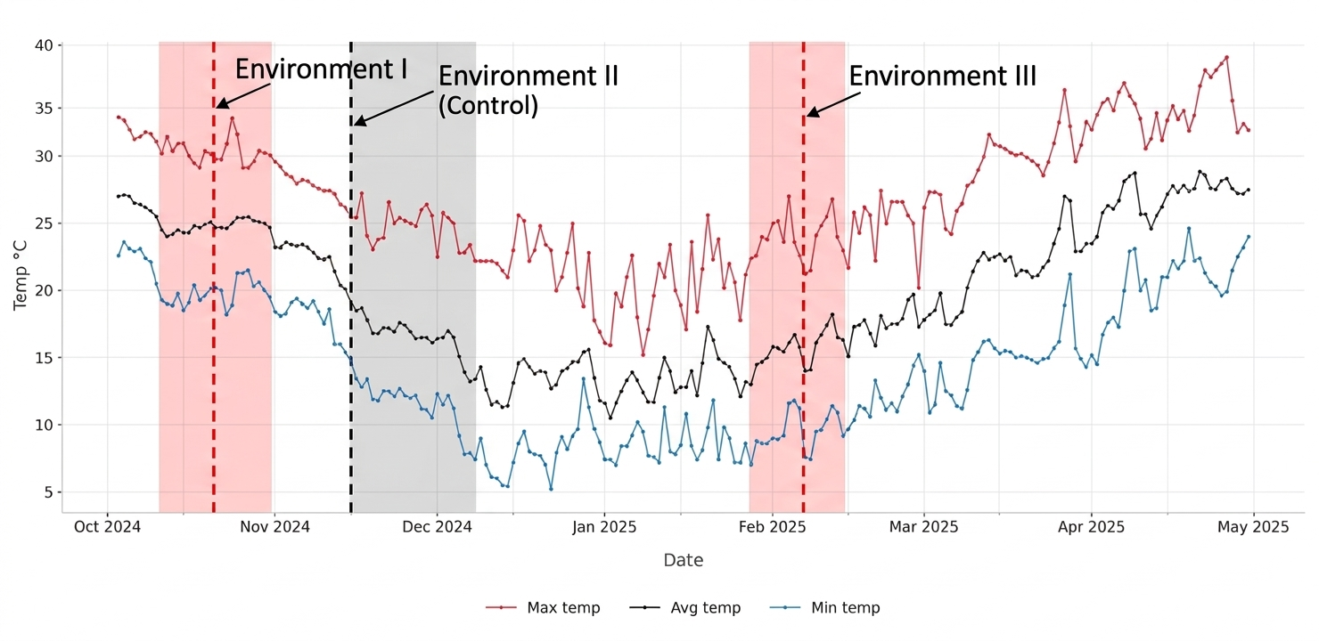Fig. 1: Weather data prevailed during Environment - I, II, III garden pea production in the year 2024-25.
2.2 Statistical Analysis

An independent Analysis of Variance (ANOVA) was performed for yield traits across each of the three thermal environments (I, II, and III) following the Augmented Block Design (ABD) proposed by Federer (1955). To ensure a valid comparison among the unreplicated test genotypes, adjusted means were calculated by utilizing the performance of the repeated check varieties to account for intra-block environmental heterogeneity. Differences between treatment means were tested for significance using the Critical Difference at a 5% level of probability (P = .05).

3. results and discussion

3.1 Survival and Phenological Progress of Genotypes Under Different Sowing Conditions

The experimental trials were conducted across three distinct sowing windows to evaluate the differential impact of heat stress on garden pea phenology and reproductive success. In Environment I (Stress up to flowering), 41 genotypes successfully reached the 50% flowering stage, with 39 progressing to seed formation as average weekly temperatures declined from 25.2°C to 13.0°C by the twelfth week. The details of the genotypes are present in Table 2. In contrast, Environment II (Normal/Control) provided an optimal thermal regime (15.7–17.8°C), enabling all 74 genotypes to complete their life cycle with uniform flowering and pod set by the eighth week. Environment III (Terminal heat stress) was characterized by a progressive rise in temperature, exceeding 35°C during the later stages of growth; while all genotypes germinated, only 38 reached 50% flowering, and reproductive success was further restricted to just 22 genotypes due to post-flowering thermal injury.

Table 2. List of garden pea genotypes reaching seed set stage under Environment I

PSM-3* | PM-128* | PSM-151 | PSM-152 | PSM-153 | PSM-154 | PSM-157
PSM-159 | PSM-160 | PSM-162 | PSM-164 | PSM-165 | PSM-166 | PSM-167
PSM-168 | PSM-169 | PSM-170 | PSM-176 | PSM-182 | PSM-183 | PSM-194
PSM-197 | PSM-198 | PSM-199 | PSM-201 | PSM-202 | PSM-203 | PSM-210
PSM-212 | PSM-213 | PSM-214 | PSM-215 | PSM-216 | PSM-217 | PSM-218
PSM-219 | PSM-220 | PSM-221 | PSM-222
*PM-128 and PSM-3 are standard check cultivars.
To ensure a robust and unbiased statistical comparison of genetic parameters and mean performance in contrasting environments, only genotypes that consistently reached full reproductive maturity and seed filling across all three viable environments (I, II and III) were selected. This resulted in a common germplasm set of 20 test genotypes and two check cultivars (Table 3) for all subsequent stability and yield-related analyses. Mean performance and variability of yield and its component traits under heat stress and normal conditions are provided in Table 4.

Table 3. List of 22 common garden pea genotypes that successfully completed the reproductive cycle across all three thermal environments

PSM-151 | PSM-152 | PSM-153 | PSM-154 | PSM-160 | PSM-164 | PSM-165
PSM-166 | PSM-167 | PSM-169 | PSM-170 | PSM-197 | PSM-198 | PSM-199
PSM-201 | PSM-202 | PSM-212 | PSM-214 | PSM-215 | PSM-221 | PM-128*
PSM-3*
*PM-128 and PSM-3 are standard check cultivars.

3.2 Days to 50% Flowering
The timing for 50% flowering was clearly influenced by the specific environmental conditions, with significant variability observed among the 22 genotypes. In the pre-flowering heat stress environment (E1), the crop reached this phenological stage relatively quickly, as evidenced by a grand mean of 43.62 days. Within this group, PSM-214 (34.64 days) and PSM-152 (57.12 days) defined the range extremes, with 12 genotypes performing above the environmental average. This trend shifted significantly in the control season (E2), where the absence of thermal stress allowed for a more prolonged vegetative phase. Here, the grand mean climbed to 56.51 days, and the distribution narrowed slightly. PSM-151 was the earliest to reach the 50% threshold at 48.42 days, while PSM-152 was again the latest at 68.30 days.
In contrast, Environment III (E3), which introduced heat stress after the flowering stage, showed an intermediate response. The average time to 50% flowering settled at 47.92 days, a mid-point between the early stress of E1 and the favourable conditions of E2. The range in this third environment was the most compact of the three, spanning from 38.57 days (PSM-151) to 55.06 days (PSM-198), with 11 genotypes exceeding the mean. The comparative response of genotypic stature to different heat stress timings is depicted in Fig. 2. Similar acceleration in flowering and shortening of crop duration under heat stress in pea have been reported by Susmita et al., (2020), Tafesse et al., (2019), Jiang et al., (2019), and Guilioni et al., (1997).

Table 4: Mean performance and variability of yield and its component traits across all three thermal environments
 | APW |  |  | DFF |  |  | NPP |  |  | NSP
 | E1 | E2 | E3 | E1 | E2 | E3 | E1 | E2 | E3 | E1 | E2 | E3
Mean ± SE | 8.52 ±0.14 | 9.93 ±0.15 | 3.39 ±0.14 | 44.41 ±0.84 | 56.68 ±1.07 | 48.18 ±0.96 | 14.27 ±0.27 | 17.11 ±0.37 | 3.66 ±0.21 | 8.56 ±0.16 | 10.39 ±0.14 | 4.77 ±0.15
CD (5%) | 1.03 | 0.53 | 0.42 | 4.49 | 3.5 | 4.66 | 1.19 | 0.5 | 0.4 | 1.05 | 0.64 | 0.39
CV (%) | 2.7 | 1.19 | 2.53 | 2.35 | 1.44 | 2.18 | 1.89 | 0.66 | 2.2 | 2.77 | 1.41 | 1.79

 | PD |  |  | PH |  |  | PL |  |  | PWP
 | E1 | E2 | E3 | E1 | E2 | E3 | E1 | E2 | E3 | E1 | E2 | E3
Mean ± SE | 6.16 ±0.09 | 7.20 ±0.13 | 3.95 ±0.09 | 72.79 ±1.34 | 106.98 ±2.84 | 59.87 ±1.68 | 9.83 ±0.12 | 11.11 ±0.15 | 6.51 ±0.09 | 61.78 ±0.67 | 68.88 ±0.66 | 7.20 ±0.33
CD (5%) | 0.66 | 0.5 | 0.22 | 4.13 | 5.1 | 4.85 | 0.39 | 0.5 | 0.51 | 2.54 | 2.57 | 1
CV (%) | 2.44 | 1.58 | 1.17 | 1.3 | 1.1 | 1.8 | 0.92 | 1.05 | 1.73 | 0.93 | 0.84 | 2.83

APW: Average Pod Weight; DFF: Days to 50% Flowering; NPP: Number of Pods per Plant; NSP: Number of Seeds per Pod; PD: Pod Diameter; PH: Plant Height; PL: Pod Length; PWP: Pod Weight per Plant; E1 (Environment I); E2 (Environment II); E3 (Environment III)

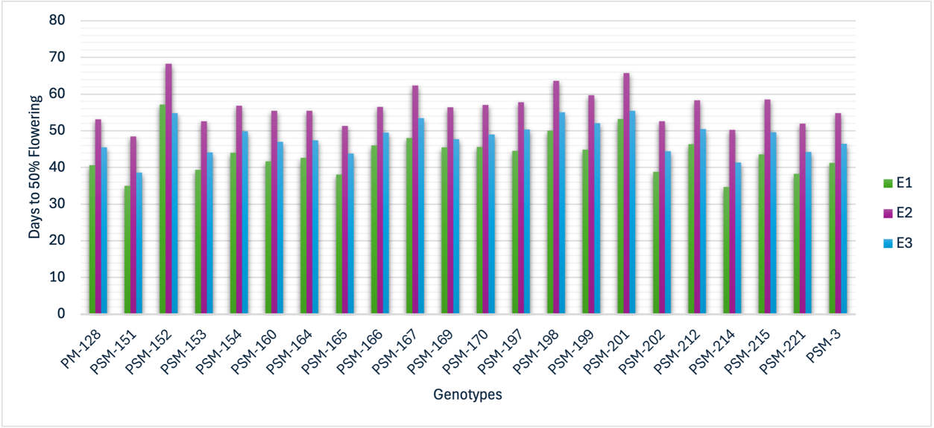

Fig. 2: Adjusted mean performance of 22 garden pea genotypes for Days to 50%
flowering across Environment I (E1), Environment II (E2), and Environment III (E3)

3.3 Plant Height (cm)
The 22 genotypes demonstrated considerable structural plasticity, with plant height significantly influenced by the timing of heat stress. In Environment I (E1), where heat stress was applied prior to flowering, the grand mean for plant height was 71.54 cm. Under these conditions, the population stature fluctuated between 41.46 cm (PSM-221) and 93.10 cm (PSM-198), with 10 genotypes recording heights above the environmental average.
As expected, the control season (E2) facilitated the most vigorous growth, resulting in a substantially higher grand mean of 107.43 cm. In this favourable environment, plant height reached its maximum of 149.72 cm in PSM-198, while the minimum was 66.56 cm in PSM-221. A total of 10 genotypes surpassed the mean value in this environment. Conversely, Environment III (E3), characterized by post-flowering heat stress, appeared to be the most restrictive for vertical growth, with the grand mean dropping to 59.87 cm. The plant height in E3 ranged between 39.22 cm (PSM-221) and 84.86 cm (PSM-198), with 13 genotypes performing above the mean. The comparative response of genotypic stature to different heat stress timings is depicted in Fig. 3.
A cross-environmental comparison highlights a consistent performance hierarchy within the population. Notably, PSM-198 and PSM-221 acted as stable extremes for this trait across all three regimes; PSM-198 consistently maintained the tallest stature, while PSM-221 remained the most dwarfed genotype regardless of the stress application or timing. Reductions in plant height under elevated temperature stress in pea have been documented by Tafesse et al., (2019), Vijaylaxmi (2013), and Sadras et al., (2013) as well.
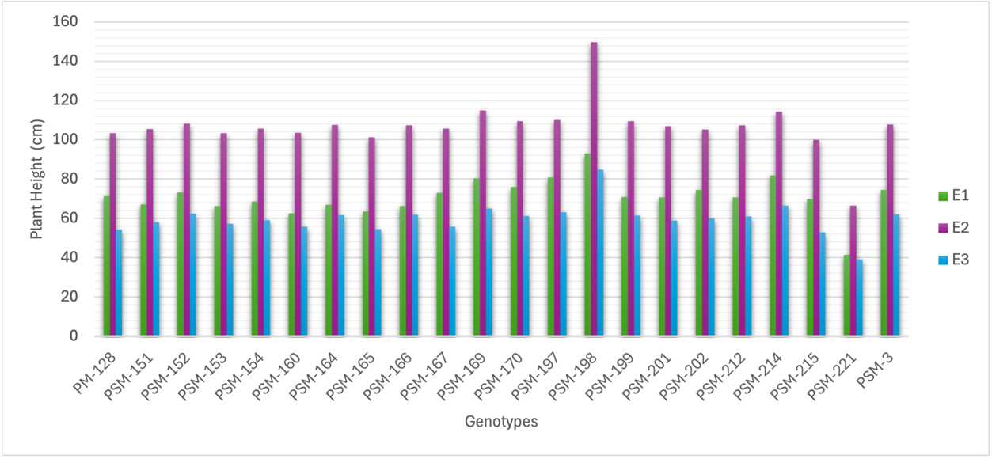
Fig. 3: Adjusted mean performance of 22 garden pea genotypes for Plant Height across Environment I (E1), Environment II (E2), and Environment III (E3)

3.4 Number of Pods per Plant
Productivity in terms of pod count per plant was markedly impacted by environmental variations, with the most severe yield reduction occurring under terminal heat stress. In Environment I (E1), where stress was restricted to the pre-flowering stage, the grand mean for pod production was 14.18. The number of pods in this environment ranged from a minimum of 9.41 (PSM-215) to a maximum of 16.04 (PSM-3), with a majority of the genotypes (15 out of 22) achieving a pod count higher than the group average.
The control season (E2) allowed the genotypes to reach their full reproductive potential, as indicated by the highest grand mean of 17.16 pods per plant. Within this favourable environment, PSM-3 once again exhibited the highest productivity (18.75 pods), while PSM-215 recorded the lowest (10.25 pods). However, the introduction of heat stress after flowering in Environment III (E3) led to a drastic decline in pod setting across all genotypes. The grand mean plummeted to 3.67 pods per plant, with values spanning a narrow range from 1.94 (PSM-199) to 5.38 (PM-128). The comparative response of genotypic stature to different heat stress timings is depicted in Fig. 4.
While all genotypes suffered in E3, PM-128 and PSM-3 showed a degree of relative resilience by maintaining the highest pod counts under post-flowering stress. This suggests that while terminal heat stress is a major limiting factor for pod development, specific genotypes like PSM-3 demonstrate a consistent advantage in reproductive efficiency across diverse environments. Declines in the number of pods per plant due to heat-induced reproductive limitations have been reported by Mohapatra et al., (2020), Tafesse et al., (2019), Guilioni et al., (1997), and Sadras et al., (2013).

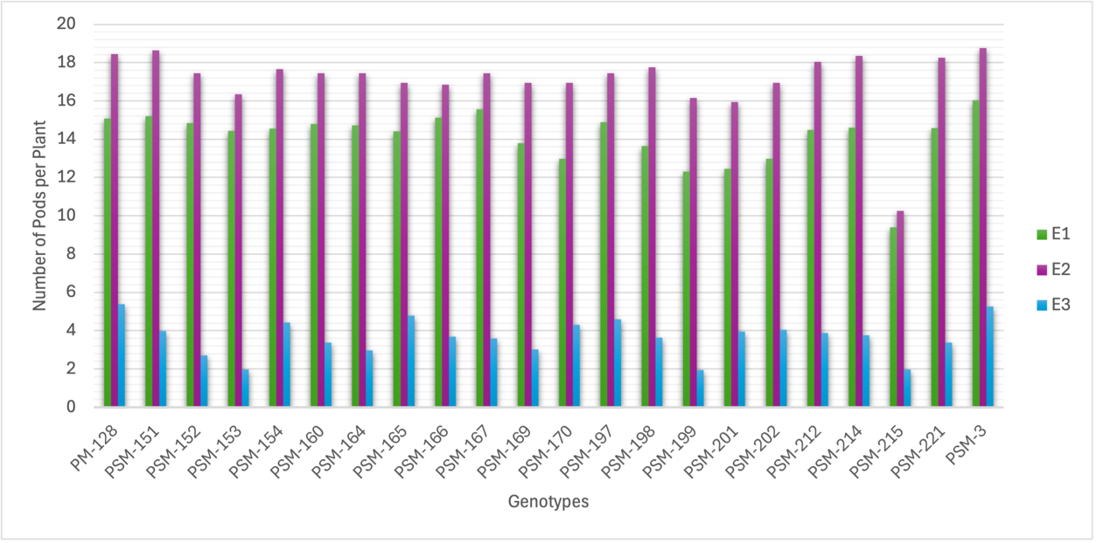

Fig. 4: Adjusted mean performance of 22 garden pea genotypes for Number of pods per plant across Environment I (E1), Environment II (E2), and Environment III (E3)

3.5 Number of Seeds per Pod
The seed count per pod, a vital component of total grain yield, exhibited a clear response to varying thermal conditions across the three environments. In the pre-flowering heat stress regime (E1), the genotypes produced a grand mean of 9.01 seeds per pod. Data within this environment ranged from 7.94 (PSM-153) to a high of 13.01 (PSM-151), with 10 genotypes exceeding the environmental average.
Under the optimal conditions of the control season (E2), seed set improved across the population, resulting in a grand mean of 10.39. During this favourable period, PSM-151 remained the superior genotype with 13.03 seeds per pod, while PSM-202 recorded the minimum value of 9.78. Conversely, the introduction of heat stress after flowering (E3) caused a substantial decline in seed development, with the grand mean dropping to 4.77. The impact of terminal heat was particularly evident in the narrowed range, which spanned from 2.71 (PSM-202) to 6.90 (PSM-151). In this restrictive environment, 11 genotypes maintained a seed count above the mean. The comparative response of genotypic stature to different heat stress timings is depicted in Fig. 5.
A cross-environmental review highlights PSM-151 as a standout line for this trait; it produced the maximum number of seeds per pod consistently across the three environments, demonstrating resilience to both early and late-season heat stress. In contrast, PSM-202 showed significant sensitivity to terminal heat, where its seed production was most severely hampered compared to its performance in the control and pre-flowering stress environments. Similar reductions in seeds per pod under heat stress conditions have been observed by Jeuffroy et al., (1990), Guilioni et al., (2003), and Jiang et al., (2019) as well.

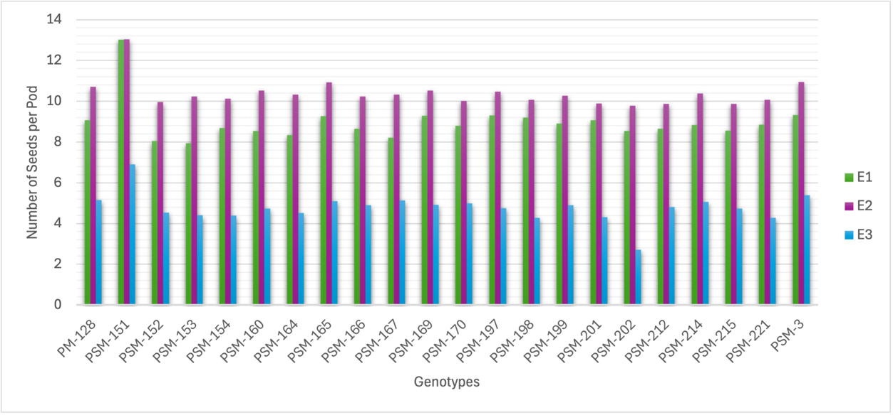

Fig. 5: Adjusted mean performance of 22 garden pea genotypes for Number of seeds per pod across Environment I (E1), Environment II (E2), and Environment III (E3)

3.6 Pod Diameter (mm)
The transverse development of pods showed distinct variations depending on the environmental regime. In Environment I (E1), where heat stress was encountered prior to flowering, the grand mean for pod diameter was 6.06 mm. The population measurements for this trait ranged from 4.47 mm (PSM-170) to 6.68 mm (PM-128), with 14 of the 22 genotypes performing above the environmental average. Under the optimal conditions of the Control Season (E2), the pods reached their maximum expansion, resulting in an increased grand mean of 7.14 mm. In this environment, PSM-151 and PSM-166 shared the maximum recorded diameter of 7.78 mm, while PSM-170 again occupied the lower extreme at 4.87 mm. The comparative response of genotypic stature to different heat stress timings is depicted in Fig. 6.

Conversely, Environment III (E3), characterized by post-flowering heat stress, appeared to be the most detrimental to pod filling and expansion. The grand mean for this environment dropped to 3.98 mm, with values spanning a narrow range between 2.75 mm (PSM-170) and 4.74 mm (PM-128).
A comparative analysis suggests that while terminal heat stress (E3) significantly curtails pod diameter across all genotypes, certain lines like PM-128 and PSM-151 maintain a relatively superior pod girth even under stress. Furthermore, PSM-170 demonstrated a consistent phenotype for the smallest pod diameter across all three regimes, indicating that its slender pod characteristic is likely a stable genetic trait rather than a purely environmental response. Comparable constraints on pod development and reduced pod filling under heat stress have been documented by Lamichaney et al., (2021).
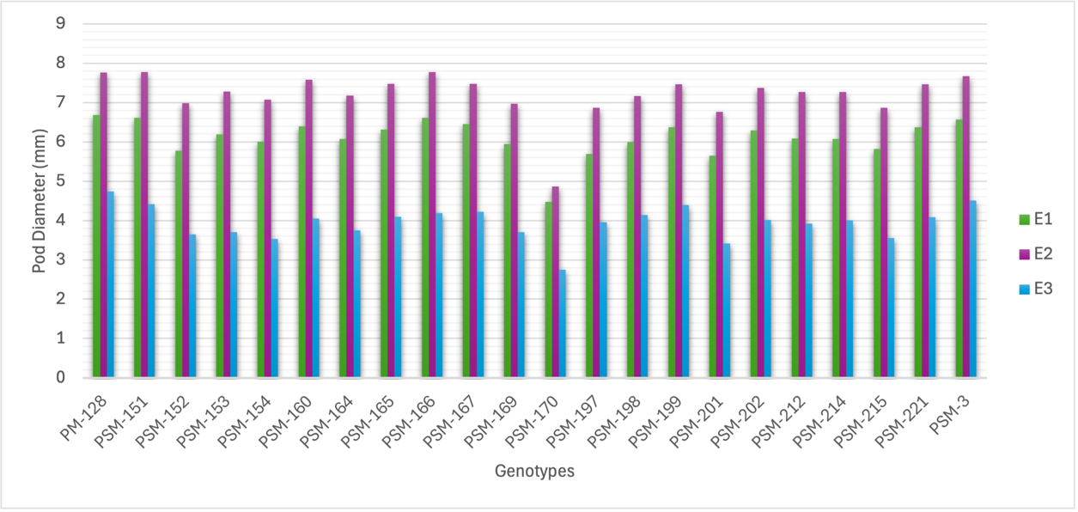
Fig. 6: Adjusted mean performance of 22 garden pea genotypes for Pod Diameter across Environment I (E1), Environment II (E2), and Environment III (E3)

3.7 Pod Length (cm)
The linear development of pods exhibited a clear response to varying thermal regimes across the 22 genotypes. In Environment I (E1), where heat stress occurred prior to flowering, the grand mean for pod length was 10.10 cm. Within this environment, the population extremes were represented by PSM-151 (13.08 cm) and PSM-201 (9.48 cm), with 7 genotypes recording lengths that surpassed the environmental average.
The Control Season (E2) provided the most favourable conditions for pod development, resulting in a higher grand mean of 11.18 cm. In this environment, the length reached its maximum potential of 14.05 cm in PSM-151, while PSM-201 again recorded the minimum value of 10.45 cm. A total of 7 genotypes exceeded the mean performance under these non-stress conditions. In contrast, Environment III (E3), characterized by post-flowering heat stress, appeared to be the most restrictive for pod elongation. The grand mean dropped significantly to 6.51 cm, and the range was markedly compressed, spanning from 5.61 cm (PSM-201) to 7.42 cm (PSM-151). In this restrictive regime, 11 genotypes maintained a pod length above the mean. The comparative response of genotypic stature to different heat stress timings is depicted in Fig. 7.
A cross-environmental comparison highlights PSM-151 as a consistently superior genotype, maintaining the longest pods regardless of the timing of heat application. Conversely, PSM-201 demonstrated a stable phenotype for shorter pod length across all three environments. The drastic decline in pod length observed in E3 suggests that heat stress during the pod development stage (post-flowering) is more detrimental to the linear growth of the pod than stress encountered during the early vegetative or pre-flowering phases. Similar decreases in pod length under high temperature stress in pea have been reported by Bueckert et al., (2015), Jiang et al., (2015), Jiang et al., (2017), and Jiang et al., (2020).

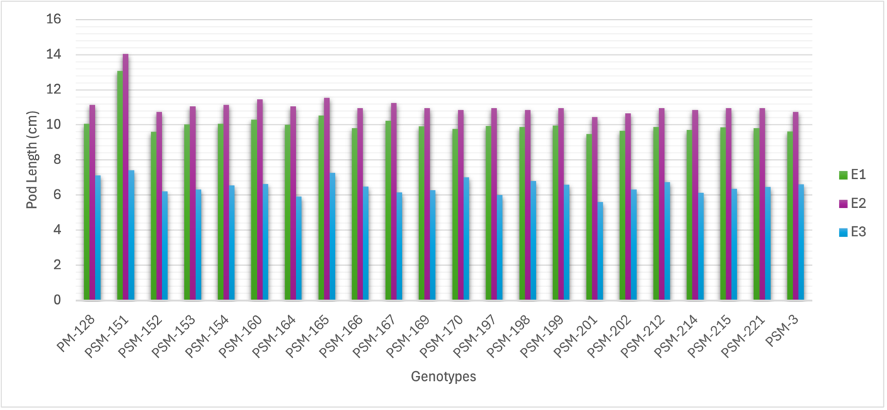

Fig. 7: Adjusted mean performance of 22 garden pea genotypes for Pod Length across Environment I (E1), Environment II (E2), and Environment III (E3)

3.8 Average Pod Weight (g)
The phenotypic expression of pod weight varied significantly across the three environmental regimes. In Environment I (E1), where heat stress was limited to the pre-flowering stage, the grand mean for pod weight was 8.82 g. Under these conditions, values ranged from 7.89 g (PSM-170) to 11.39 g (PSM-3), with 9 genotypes exceeding the environmental average.
As expected, the Control Season (E2) facilitated the highest dry matter accumulation, resulting in a grand mean of 9.98 g. In this favourable environment, PSM-3 remained the superior genotype with a maximum pod weight of 12.38 g, while PSM-152 recorded the minimum at 8.99 g. A total of 8 genotypes performed above the mean in the control environment. Conversely, Environment III (E3), characterized by post-flowering heat stress, proved to be the most restrictive for pod development. The grand mean plummeted to 3.44 g, and the range was markedly compressed, spanning from 1.70 g (PSM-152) to 4.91 g (PM-128). In this highly stressed regime, 13 genotypes managed to maintain a weight above the mean. The comparative response of genotypic stature to different heat stress timings is depicted in Fig. 8.
The data indicates that while all genotypes suffered weight loss under terminal heat (E3), PSM-3 and PM-128 exhibited relatively better resilience by maintaining higher pod weights compared to the population average. Notably, PSM-152 appeared particularly vulnerable to post-flowering stress, experiencing the most drastic decline in pod weight compared to its performance in both the control and pre-flowering stress environments. Reductions in average pod weight due to heat stress conditions have been reported by Sadras et al., (2013).
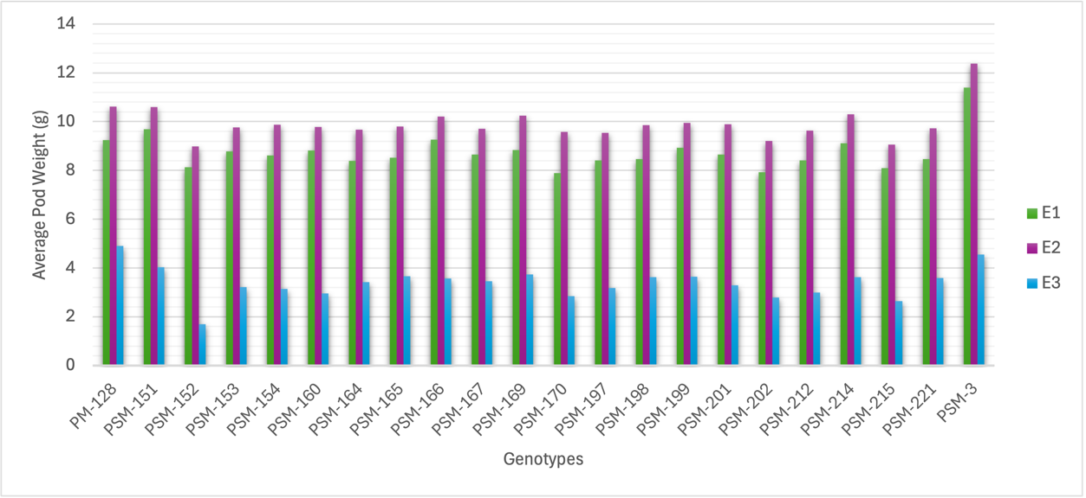
Fig. 8: Adjusted mean performance of 22 garden pea genotypes for Average Pod Weight across Environment I (E1), Environment II (E2), and Environment III (E3)

3.9 Pod Weight per Plant (g)
The overall productivity, measured as pod weight per plant, varied significantly under the influence of the three environmental regimes. In Environment I (E1), where heat stress was confined to the pre-flowering phase, the grand mean reached 63.36 g. The genotypes in this environment displayed a range of 57.83 g (PSM-154) to 72.52 g (PM-128), with 9 genotypes exceeding the environmental average.
The Control Season (E2) provided the most favourable conditions for biomass partitioning to the pods, resulting in an increased grand mean of 69.11 g. Under these non-stress conditions, PM-128 remained the highest-yielding genotype (78.87 g), while PSM-154 recorded the lowest productivity (63.95 g). However, the imposition of heat stress after flowering in Environment III (E3) led to a severe reduction in total pod weight. The grand mean declined sharply to 7.19 g, with the observed range extending from PSM-198 (5.96 g) to PM-128 (10.40 g). Despite this overall reduction, 10 genotypes performed above the mean under these highly restrictive conditions. The comparative response of genotypic performance under different heat stress regimes is illustrated in Fig. 9.

A cross-environmental synthesis highlights PM-128 as a genotype of significant interest for breeding programs, as it consistently ranked as the top performer for pod weight per plant across all three environments. Conversely, the severe yield depression observed in E3 compared to E1 and E2 suggests that the post-flowering stage is the most critical period for heat-induced yield loss in the assessed genotypes, as the ability to maintain pod weight per plant was nearly ten times lower than under control conditions. Significant reductions in pod yield under heat stress in pea have been widely reported by Bueckert et al., (2015), Sadras et al., (2013), Lamichaney et al., (2021), and Devi et al., (2022).
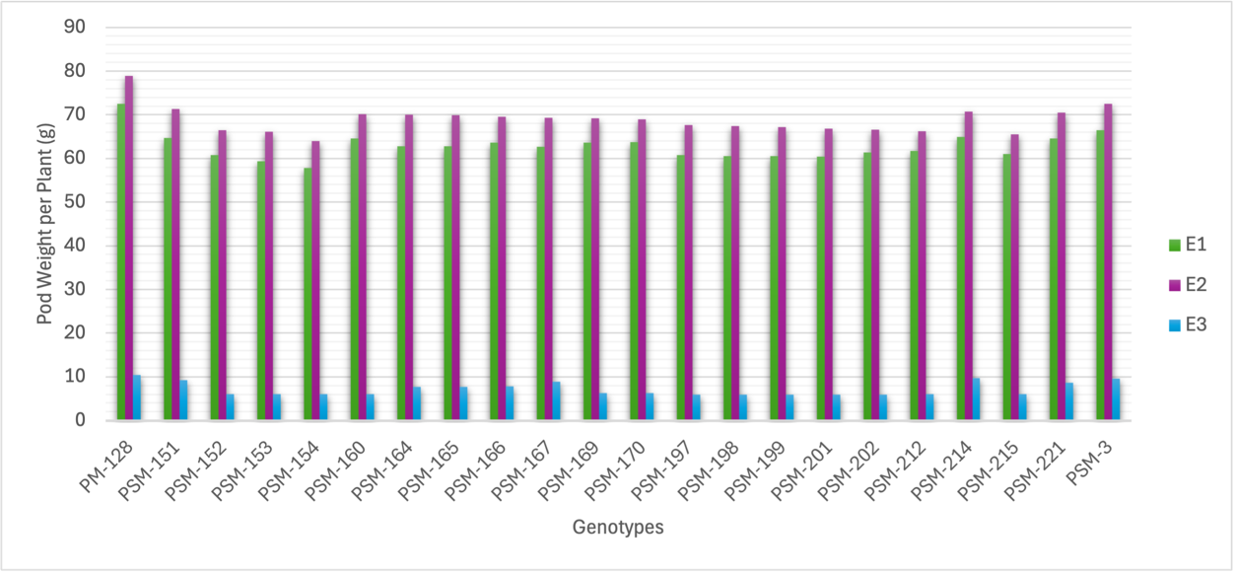
Fig. 9: Adjusted mean performance of 22 garden pea genotypes for Pod weight per plant across Environment I (E1), Environment II (E2), and Environment III (E3)

4. CONCLUSIONS

The present study underscores the differential impact of heat stress timing on the phenological and yield-related traits of garden pea. Our findings demonstrate that while heat stress prior to flowering (Environment I) primarily triggers an escape response through accelerated floral initiation and reduced vegetative height, terminal heat stress (Environment III) serves as a much more severe constraint on reproductive efficiency. The drastic reduction in pod weight per plant and seed set observed in Environment III suggests that the post-flowering stage is the most vulnerable period, where high temperatures likely interfere with successful pollination and subsequent sink-source partitioning.
Among all entries, PSM-3 emerged as the most superior genotype, consistently recording higher values for number of pods per plant, seeds per pod, average pod weight, and pod weight per plant across environments, along with better tolerance to heat stress conditions. PM-128 was identified as the next best genotype, exhibiting excellent stability and maintaining higher pod weight per plant and pod number, particularly under stress environments. PSM-151 also showed promising performance, especially for reproductive traits such as seeds per pod and pod length, indicating its usefulness for improving yield components. In addition, PSM-166 demonstrated a stable and balanced performance across most of the traits, making it a reliable genotype under varying environmental conditions. PSM-221 also performed well, particularly in maintaining higher pod weight under stress conditions, indicating its adaptability to heat stress, especially during the post-flowering stage. Conversely, genotypes like PSM-152 and PSM-202 proved highly sensitive to late-season thermal fluctuations, marking them as unsuitable for heat-prone regions.
In summary, selecting for genotypes that maintain a robust pod-filling duration and early flowering such as the elite lines identified here offers a viable strategy for improving heat tolerance in garden pea. Future research should focus on the physiological mechanisms underlying the resilience of PSM-3, PM-128, PSM-151, PSM-166 and PSM-221 to further refine the development of climate-resilient cultivars.

References

Bueckert, R. A., Wagenhoffer, S., Hnatowich, G., and Warkentin, T. D. (2015). Effect of heat and precipitation on pea yield and reproductive performance in the field. Canadian Journal of Plant Science, 95(4), 629–639.
Devi, M. J., Sinclair, T. R., and Jain, M. (2022). Heat stress effects on pea (Pisum sativum L.) and its mitigation strategies: A review. Frontiers in Plant Science, 13, 1108276. https://doi.org/10.3389/fpls.2022.1108276

FAOSTAT (2019). 2018 Food and Agriculture Data. Retrieved from http://www.fao.org/faostat/en/#home
Federer, W. T. (1955). Experimental Design: Theory and Application. Macmillan.
Guilioni, L., Wery, J., and Tardieu, F. (1997). Heat stress-induced abortion of buds and flowers in pea: Is sensitivity linked to organ age or to relations between reproductive organs? Annals of Botany, 80(2), 159–168.
Guilioni, L., Wery, J., and Lecoeur, J. (2003). High temperature and water deficit may reduce seed number in field pea purely by decreasing plant growth rate. Functional Plant Biology, 30(11), 1151–1164.
IPCC (2014). Climate Change 2014: Synthesis Report. Intergovernmental Panel on Climate Change.
Jeuffroy, M. H., Duthion, C., and Meynard, J. M. (1990). Effect of a short period of high day temperatures during flowering on the seed number per pod of pea (Pisum sativum L.). Agronomie, 10, 139–145.
Jiang, Y., Lahlali, R., Karunakaran, C., Kumar, S., Davis, A. R., and Bueckert, R. A. (2015). Seed set, pollen morphology and pollen surface composition response to heat stress in field pea. Plant, Cell and Environment, 38, 2387–2397. https://doi.org/10.1111/pce.12589
Jiang, Y., Bueckert, R., Warkentin, T., and Davis, A. (2017). High temperature effects on in vitro pollen germination and seed set in field pea. Canadian Journal of Plant Science, 98, 71–80. https://doi.org/10.1139/CJPS-2017-0073
Jiang, Y. F., Davis, A. R., Vujanovic, V., and Bueckert, R. A. (2019). Reproductive development response to high daytime temperature in field pea. Journal of Agronomy and Crop Science, 205(4), 324–333.
Jiang, Y., Lindsay, D. L., Davis, A. R., Wang, Z., MacLean, D. E., and Warkentin, T. D. (2020). Impact of heat stress on pod-based yield components in field pea (Pisum sativum L.). Journal of Agronomy and Crop Science, 206, 76–89. https://doi.org/10.1111/jac.12365
Kumar, A. and Choudhary, A. (2014) Scientific cultivation of vegetable pea. In: Scientific Cultivation of Vegetable Pea, pp. 45–51. ISBN: 978-93-83168-17-0.
Kumar, J., Sen Gupta, D., and Djalovic, I. (2020). Breeding, genetics, and genomics for tolerance against terminal heat in lentil: Current status and future directions. Legume Science, 2(3), 38.
Lamichaney, A., Parihar, A. K., Hazra, K. K., Dixit, G. P., Katiyar, P. K., Singh, D., et al. (2021). Untangling the influence of heat stress on crop phenology, seed set, seed weight, and germination in field pea (Pisum sativum L.). Frontiers in Plant Science, 12, 635868.
Mohapatra, C., Chand, R., Tiwari, J. K., and Singh, A. K. (2020). Effect of heat stress during flowering and pod formation in pea (Pisum sativum L.). Physiology and Molecular Biology of Plants, 26, 1119–1125. https://doi.org/10.1007/s12298-020-00803-4
Parihar, A. K., Kumar, J., Gupta, D. S., Lamichaney, A., Naik, S. J. S., Singh, A. K., et al. (2022). Genomics enabled breeding strategies for major biotic stresses in pea (Pisum sativum L.). Frontiers in Plant Science, 13, 861191.
Rawat, N., Raghav, M., Singh, D., Verma, A., Pareek, N., Kuriyal, H., and Shah, I. (2024). Effect of integrated weed management practices on growth parameters in vegetable pea (Pisum sativum L.). Journal name to be confirmed, 22.
Sadras, V. O., Lake, L., Leonforte, A., McMurray, L. S., and Paull, J. G. (2013). Screening field pea for adaptation to water and heat stress: Associations between yield, crop growth rate and seed abortion. Field Crops Research, 150, 63–73.
Singh, J. P., Singh, D., and Tewari, A. (2012). A comparative study on yield and contributing traits of vegetable pea varieties under Tarai region of Uttarakhand. Pantnagar Journal of Research, 10(2), 259–260.
Sita, K., Sehgal, A., Hanumantha Rao, B., Nair, R. M., Vara Prasad, P. V., Kumar, S., et al. (2017). Food legumes and rising temperatures: Effects, adaptive functional mechanisms specific to reproductive growth stage and strategies to improve heat tolerance. Frontiers in Plant Science, 8, 1658.
Susmita, C., Aghora, T. S., and Mohanty, N. B. R. (2020). Breeding for improvement of high temperature tolerance in garden pea (Pisum sativum L.) for off-season cultivation. Journal of Horticultural Science, 15, 62–66. https://doi.org/10.24154/JHS.2020.v15i01.008
Tafesse, E. G., Warkentin, T. D., and Bueckert, R. A. (2019). Canopy architecture and leaf type as traits of heat resistance in pea. Field Crops Research, 241, 107561. https://doi.org/10.1016/j.fcr.2019.107561
Vijaylaxmi (2013). Effect of high temperature on growth, biomass and yield of field pea. Legume Research, 36(3), 250–254.
Wang, D., Yang, T., Liu, R., Li, N., Ahmad, N., Li, G., et al. (2022). Large-scale heat-tolerance screening and genetic diversity of pea (Pisum sativum L.) germplasms. Plants, 11(19), 2473.
Yan, W., Kang, M. S., Ma, B., Woods, S., and Cornelius, P. L. (2007). GGE biplot vs. AMMI analysis of genotype-by-environment data. Crop Science, 47(3), 641–653.

