Feeding and Reproductive Performance of Coccinella undecimpunctata L. on
two Different Apple Aphids for Sustainable Pest Management.

ABASTRACT
A key element of integrated pest management (IPM), biological control provides a sustainable substitute for chemical pesticides. Ladybird beetles (Coleoptera: Coccinellidae) have been shown to be effective natural enemies of aphids and other soft-bodied pests among predator insects. Ladybird beetles (Coleoptera: Coccinellidae) are a species-rich, ecologically diversified group with substantial agricultural and horticultural importance, living in many sorts of terrestrial biomes. The eleven-spotted ladybird, Coccinella undecimpunctata L., is widely distributed and exhibits high reproductive potential, voracious feeding habits, and strong synchrony with prey populations, making it a promising candidate for pest suppression in apple orchards. During observation it was seen that feeding pattern of C. undecimpunctata during development followed the order Aphis pomi ˃ Aphis spiraecola .After careful examination it was seen that Coccinella undecimpunctata adult laid maximum eggs (634 ±67.4) when reared on Aphis pomi in comparison to ( 402 ±45.25). The 1st ,2nd, 3rd and 4th larval durations averaged 4.5 ± 0.70, 3.4± 0.69, 4.9± 0.87 and 3.9± 0.87 days on when the larvae of the predator were fed on Aphis pomi, respectively, where it was 2.9± 0.73, 2.7± 0.67, 4.9 ±0.87 and 3.9± 0.87 days on Aphis spiraecola. The total larval duration lasted an average of 16.7 ± 1.05 and 12.2 ±1.31 days, Aphis pomi and Aphis spiraecola respectively. Adult female longevity was longer than that of males, with mean values of 48.8 ± 2.97 and 39.5 ± 2.27 days on the respective hosts. These results support the inclusion of C. undecimpunctata in sustainable pest management strategies by highlighting its potential as a promising biological control agent against apple aphids.

Keywords: Aphis pomi, Biological control, Coccinellidae , Mangement , Pest, Strategies .

INTRODUCTION
Biological control is a crucial part of integrated pest management. Natural enemies control pest populations. (Solangi et al., 2007). Utilizing live creatures to decrease pests, diseases, and invasive species, biological management is a potent and environmentally sustainable approach. It effectively and resiliently disturbs pest populations by using natural enemies like parasitoids, predators, and microbiological agents. In contrast to chemical control, it reduces harmful residues, maintains biodiversity, and improves ecological stability. This dynamic strategy improves long-term productivity and environmental integrity by integrating smoothly into agro ecosystems. A key component of contemporary sustainable agriculture, biological control combats biotic hazards while protecting human health and natural resources by incorporating creativity, equilibrium, and ecological intelligence. Aphid ranks among the most noxious insects attacking on apple orchards all over the world. By their piercing sucking mouth parts, aphid extracts large amounts of phloem sap resulting in greater than 50% yield reductions (Salman et al., 2014). Ladybirds beetles (Coleoptera: Coccinellidae) are among the most important insect predators that attack aphid pests world wide (Obrycki and Kring, 1998).Coccinellids are considered among the most important predaceous insects attacking aphids , bugs , spider mites, thrips, jassids , whitefly and scale insects Gautarm, 1989; Obrycki and Kring, 1998 ; Bahy El- Din, 2006) Ladybird beetles (Coccinellidae: Coleoptera) are dominant predators in natural and agricultural habitats (Hodek and Honek, 1996).Coccinellidae form an important group of predators .Over 4,500 predatory species of the Coccinellidae family have been described. (Sathe TV; Bhosale YA, 2001) The biodiversity of Indian coccinellids is estimated to be over 300 species, with 261 recognized prey species spanning 57 genera that prey on various insects and acarines. (Omkar and Pervez A. 2000). Ladybird beetles are well-known worldwide as insect predators. There is opposition in a number of Asian countries, including India. (Singh J. Brar, KS. 2004).They are the most commonly recognized of all beneficial insects. They are extremely economically important because they prey on a wide range of major crop pests, including aphids, coccids, and other soft body insects. (Hippa H et al.,1978).
There are large number of bio- agents viz. Parasites, predators, parasitoids and microbial agents that keep the pest population at below economic injury level .Among different predators, Coccinella undecimpunctata (Coccinellide: Coleoptera) commonly referred to as ladybugs or ladybeetle with eleven black spots found on its red/ orange elytra are important predators in Agri- Horti ecosystem and prey upon many economically important pests. It is fact that the pesticides minimize the pest population increase the crop yield however, the indiscriminate use of insecticides leads to severe problems like pest resurgence, pest resistance, secondary pest outbreak due to elimination of natural enemies, increased cost of production and various hazards to human health and livestock. The best alternative for the pest control is organic farming which mainly emphasizes de-avoidance of chemical fertilizers and pesticides in the integrated pest management programme. Among the different components of IPM, biological control is the important one. It is relatively permanent, economical and eco- friendly. Coccinellids are well-known beneficial predators of insect pests like aphids (Aleyrodidae: Homoptera), thrips (Thripidae: Thysanoptera), mealybugs (Pseudococcidae: Homoptera), whiteflies (Aleyrodidae: Homoptera), jassids (Cicadellidae: Homoptera), and psyllids (Psyllidae: Homoptera) (Ullah et al., 2012). Coccinellids have the potential to be proficiently used in integrated pest management programs due to their seasonal synchrony with specific preys, tremendous foraging performance, and high reproductive efficiency. Generalist predators, such as ladybeetles, have recently been concede for their role in conservation biological control through conservation and enhancement strategies (Obryckl et al., 2009). They also prey on minute larvae, insect eggs, and phytophagous mites, which are deleterious to agricultural and forest plantations (Gordon.R.D.1985). Ladybirds are widely regarded as salutary insects and one of the most valuable counterpart of farmers and gardeners since many species feed on aphids or scale insects, which are pests in gardens, agricultural fields, orchards, and other similar settings. They are natural pest controllers that outperform toxic venom (Sarwar and Saqib, 2010).
Aim of the present work is to evaluate the role of as an important Coccinella undecimpunctata biological control agent in suppressing aphids, and (Fig 1) by Aphis pomi, Aphis spirecola studying its biological aspects and predation efficacy under laboratory condition
Materials and Methods
2.1 Cultural maintenance
Studies on the biology of Coccinella undecimpunctata on green apple aphid and speria aphid were conducted at laboratory of Division of Entomology, SKUAST-K, Shalimar, Srinagar during 2021-2023. Large number of eggs from High density apple orchard ecosystem SKUAST- K Shalimar Srinager. Ladybeetle cultures were started by collecting newly emerging overwintering adults of the relevant coccinellid species. Adults of Coccinella undecimpunctata species were kept in plastic jars (Height 20cm, Diameter 15 cm) with a ample supply of food from the aphid colonies until oviposition. The raising jars were outfitted with crumpled paper to cater as oviposition sites. The eggs were collected every 24 hours , and those eggs transfer into the Petri dishes (Fig 2), for hatching. All cultures were kept in a laboratory. Newly hatched grubs of Coccinella undecimpunctata were removed from the stock cultures and feed with a plenty of aphids (Aphis pomi and Aphis spirecola). Adults from this stock were desexed and acclimatized under laboratory conditions by rearing of new generation. Photographs of each larval stage was taken through EM-310M digital microscope, eye piece camera with USB2.0 output 3.2M Resolution 2048X 1536, 110mm (H) X 55mm D0 and 23mm adapter.
Aphid colonies were reared in laboratory cages (18 × 18 x 18 cm) on fresh apple twigs (Aphis pomi and Aphis spiraecola) to feed Coccinellid predators. The aphid colonies were obtained from pesticide-free apple orchards on the SKUAST-K Shalimar campus. To keep aphid-teeming apple leaves from drying out, honey-soaked cotton was wrapped around their leaf stems. Ladybird beetle egg culture is gathered from the field and kept in cages. Newly emerging adults are kept in separate petri dishes.
2.2 Biology of Coccinella undecimpunctata
One pair of adults from a lab culture were released into a cage measuring 18x18x18 and covered with muslin material. Ten such leans(pairs) were extended. After three to four days, eggs produced by the female Coccinella undecimpunctata on the cage's leaves on periphery were gently brushed with a soft camel hair brush and stored in Petridish to reduce cannibalism among developing grubs. For feeding aphids were given to the predatory grubs daily in each individual petri dish until they pupated. Adults emerged from pupae were collected singly and placed in a glass cage for mating. The total number of instars, duration of each instar, total grub period, pre-pupal period, and pupal period were all observed. Adults were collected after emergence and examined under a microscope to determine sex (Fig .4). The total number of eggs spread (fecundity) by each female over her lifetime, the longevity of male and female adults, and their sex ratio were also documented.
Statistical analysis
All biological parameters of Coccinella undecimpunctata reared on two host species (Aphis pomi and Aphis spiraecola ) were expressed as mean ± standard error (SE). Differences between the two host treatments were evaluated using a two- tailed Students t- test for independent samples. The test was applied to compare pre- ovipostion period, oviposition period, fecundity, egg incubation period , adult longevity, larval duration, pre- pupal period, pupal period and mean adult emergence. Prior to analysis, data were assessed for normality and homogeneity of variance to ensure compliance with parametric test assumptions. Statistical significance was determined at a threshold of (P< 0.001) . All analyses were performed using standard statistical software .
Results and discussion
The systematic position of Coccinella undecimpunctata is as under :
Kingdom : Animalia
Phylum : Arthropda
Subphylum : Haxapoda
Class : Insecta
Order : Coleoptera
Suborder : Polyphaga
Family : Coccinellidae
Super family : Cucujoidea
Genus : Coccinella
Species : Coccinella undecimpunctata
Morphology of Coccinella undecimpunctata :
Diagnostic characters
Coccinella undecimpunctata is also called 11- spotted ladybird beetle with a yellowish body . Adult body length is 5.2mm and width is 4.8 mm. Both elytra are yellowish or light orange and carry 10 black spots .Each elytron has three bigger black spots in the central, middle corner and upper corner. One big black spot occurs on both elytra in the upper position behind the pronotum and is funnel shaped called the “scutellary spot”.
Life history of Coccinella undecimpunctata:
Female of eleven spotted ladybird beetle, Coccinella undecimpunctata L. laid clusters of yellowish eggs that turned into dark yellow before hatching shape of egg is oval as shown in( Fig 3 )Each cluster had an average of 10-18 eggs. The size of a single egg was 0.5× 0.25 mm. For 1st larval stage body is black in colour. The head and legs are black in hue. The body is dark grey. Thorax consists of two white spots encircled by two black dots. Four longitudinal rows of hair are seen on the abdomen. The size of 1st instar larval stage (1.6 × 0.5 mm) 2nd larval stage body is black in colour and elongated Two black dots are present . Four longitudinal rows of hair are present and size of 2nd larval stage was (2.4 × 0.77 mm ) The body of 3rd larval stage is black in colour and larger than 2nd larval stage but Morphological characters are similar and size of 3rd larval stage ( 2.7 × 1.0 mm ) . In fourth larval stage the body is also black in colour and larger in size and size of fourth larval stage is (5.4 × 2.7mm) . .The pupae is dark brown in color, initially pure yellow, then orange-brown, and finally reddish brown Size of pupae is (4.5 × 2.2 mm) . Adult male body is light orange in colour containing eleven black spots on each elytron and is smaller in size. Size of adult male is (0.3× 0.3mm) . Adult female is dark orange in colour containing eleven black spots on elytron adult female is larger in size . Size of adult female is (0.6 × 0.27 mm) respectively.
Male genitalia (phalobase): Trab's basal section is long and triangular. Paramers are cylindrical in shape with apical hairs. The median lobe is large and thick at the base, then dilates medially and gradually thins out to form a little lobe-like structure at the distal end
Siphon : Siphonal capsule is normal more or less thicker than Siphonal tube , Siphonal tube forms loop like structure upto maximum of its length , sub apical portion narrow at apex
. Biological Attributes of Coccinella undecimpunctata L., on two different hosts
  - Pre-oviposition period (D):-
Data in (Table 1 & Fig 1) indicated that the pre- oviposition period varied from 7.6 ± 1.17 and 5.8 ± 1.03 days , when feeds on Aphis pomi and Aphis spiraecola respectively. . It is clear from the results obtained that the pre-oviposition of the Coccinella undecimpunctata fed on two above mentioned species of differed significantly from each other and followed the order Aphis pomi < Aphis Spiraecola. These findings are close conformity with the results of Sipio et al., (2017) observed the pre- oviposition period of 6.00, 7.00 and 9.00 days when fed on Lipaphis erysimii, Aphis nerii and Brevicoryne brassicae , respectively. Mohamed et al. (2020) reported that the pre- oviposition period of Coccinella undecimpunctata on Rhopalosiphum padi (L.) and Schizaphis graminum (Rond.) were 5.57 and 5.14 days. Mari et al., (2016) who reported pre-oviposition period of 4.20, 3.51 and 3.91 days when Coccinella undecimpunctata was reared on Maize aphid and alfalfa aphid and Mustard aphid.
1.2 Oviposition
Data present in (Table 1) showed that the oviposition period of Coccinella undecimpunctata was after feeding on Aphis pomi and Aphis spiraecola was 31.7 ± 2.26 and 23.3 ± 2.40 days, respectively. The results revealed that the oviposition period of Coccinella undecimpunctata reared on Aphis pomi and Aphis spiraecola differed significantly. These results are close conformity with results of Sipio et al. (2017) who reported oviposition period of Coccinella undecimpunctata was 59.0, 62.0 and 72.0 days respectively, when reared on Lipaphis erysimii, Aphis nerii and Brevicoryne brassicae. Mohamed et al., 2020 who documented the oviposition period of Coccinella undecimpunctata was 66.29 days on Rhopalosiphum padi (L.) and 72.82 days on Schizaphis graminum (Rond).

  - Fecundity
The average fecundity of Coccinella undecimpunctata observed in the present investigation recorded was higher on Aphis pomi (634 ± 6.75 eggs/ female) as compared to that on Aphis spiraecola (402 ± 4.54 eggs / female). Respectively It is evident from the data that the fecundity of Coccinella undecimpunctata fed on two above mentioned aphid species differ non-significantly among each other and was in the order of Aphis pomi > Aphis Spiraecola. The results are in accordance with Mohamed et al. 2020 who recorded highest mean number of eggs laid per female of Coccinella undecimpunctata was 521.42 eggs on Schizaphis graminum (Rond), however, the lowest value of 480.25 eggs was recorded on Rhopalosiphum padi (L.).Sipio et al., 2017 reported that the average fecundity of Coccinella undecimpunctata (L.) when reared on Lipaphis erysimii, Aphis pomi and Brevicoryne brassicae was 1241.24, 819.01and 1025.26 eggs, respectively. Mari et al. 2016 followed same results as 621, 616 and 601 eggs when Coccinella undecimpunctata reared on Maize aphid, alfalfa aphid and Mustard aphid, respectively.

  - Incubation period
The freshly laid eggs of Coccinella undecimpunctata were light yellow in colour and finally darken before hatching. The mean incubation period was 3.6 ± 0.69 and 4.3 ± 0.67 on two different hosts, respectively and differed significantly. Sipio et al., 2017 who observed that the incubation period of Coccinella undecimpunctata was 3.0, 9.0 and 7.0 days when reared on Lipaphis erysimii, Aphis pomi and Brevicoryne brassicae Mari et al., 2016 recorded the incubation period of Coccinella undecimpunctata was 6.50, 8.20 and 7.00 days when reared on Maize aphid, alfalfa aphid and Mustard aphid respectively. Mohamed et al ., 2020 stated that the mean incubation period of Coccinella undecimpunctata were 5.75 ± 0.75 and 6.00 ± 1,09 days , when feeds on R. padi and S .graminum, respectively .Solangi et al. 2007 who reported that the incubation period in Coccinella undecimpunctata was 3.7 days on lipaphis erysimi Kalt
1.5 Mean Adult longevity
On an average, the adult male longevity of Coccinella undecimpunctata on Aphis pomi and Aphis spiraecola obtained from the present studies was 38.1 ±1.85 and 32.3 ± 2.00 days respectively, exhibit non- significant difference from each other .In general the longevity of males was observed to be shorter as compared to that of females and adult female longevity was 48.8 ± 2.97 and 39.5 ± 2.27 days, respectively. It is evident from the data obtained that adult female longevity of Coccinella undecimpunctata fed on above mentioned species differed significantly. The present results get support from the findings of Solangi et al. (2007) who reported the adult male and female longevity of Coccinella undecimpunctata was 36.5 and 46.0 days on Lippaphis erysimi Kalt. Mohamed et al., (2020) recorded that the adult longevity of Coccinella undecimpunctata was 24.86, 63.84 and 31.29, 82.14 days when raised on R. padi and S. graminum respectively. Mari et al., (2016) also recorded the male and female longevity of Coccinella undecimpunctata as 42.0, 32.0; 35.0, 50.0 and 40.90 days, when feed on Maize Aphid , Alfalfa aphid and Mustard aphid, Sarwar M. and Saqib, M.S. 2010. Under laboratory conditions, the predatory seven-spotted ladybird beetle Coccinella septempunctata L. (Coleoptera: Coccinellidae) was reared on natural and artificial diets respectively.
1.6 Mean Adult emergence
The results present in Table 1 revealed that out of 15 pupae taken into observation in 10 batches each, the mean adult male emergence of Coccinella undecimpunctata fed on Aphis pomi and Aphis spiraecola was 9.1 ± 2.79 (60.66%) and 7.5 ± 0.97(50.00%), respectively and in order of Aphis pomi > Aphis spiraecola. The mean adult female emergence of Coccinella undecimpunctata fed on Aphis pomi and Aphis spiraecola was 9.5 ±0.94 (63.33%) and 8.2 ±1.93 (54.6%) respectively and was in the order of Aphis pomi > Aphis spiraecola. The present results get support from the findings of Solangi et al. (2007) who reported that the male adult emergence of Coccinella undecimpunctata was 7.4 (38.50%) and female emergence was 8.9 (43.48) when feeds on Lippaphis erysimi Kalt. respectively. Sarwar M. and Saqib, M.S. 2010. Under laboratory conditions, the predatory seven-spotted ladybird beetle Coccinella septempunctata L. (Coleoptera: Coccinellidae) was reared on natural and artificial diets.

2.Developmental attributes of Coccinella undecimpunctata L., on two different hosts
2.1 Larval duration
The larvae of C. undecimpunctata passed through four larval stages by moulting (instars) and each instar is occupying different durations (Table 2) All the four instars could easily be distinguished on the basis of body size and width of larva. The average duration of Ist, 2nd , 3rd and fourth instar larvae of Coccinella undecimpuncata fed on Aphis pomi and Aphis spiraecola was 4.5 ± 0.70, 3.4± 0.69, 4.9± 0.87 and 3.9± 0.87 days on Aphis pomi and 2.9± 0.73, 2.7± 0.67, 4.9 ±0.87 and 3.9± 0.87 days on Aphis spiraecola, respectively .These results are in harmony with the findings Solangi et al. 2007,Who reported larval duration of four instars as 3.9, 3.1, 3.5 and 3.3 days on Lipaphis erysimi Kalt, respectively. Sipio et al., 2017 also reported larval duration of Ist ,2nd, 3rd and 4thinstars of Coccinella septempunctata were 2.67, 3.45, 4.61 and 3.82 days ,when reared on Lipaphis erysimii and 3.33, 4.21, 5.21 and 4.92 days , when reared on Brevicoryne brassicae respectively .
Pandi et al.,2012 reported that larval duration of four instars of Coccinella Cheilomenes sexmaculata were 1.7,1.6, 2.2, 2.5 ; 2.1, 1.8, 2.5, 2.9; 2.2,2.0,2.7,3.3; 2.5, 2.3, 3.2, 3.8 days when fed with Aphis craccivora, Aphis gossypii,, R. maidis and L.erysimi, respectively. These results also agree with Mari et al.,2016 who revealed that the i^{st} , 2nd 3rd and 4th instars of Coccinella undecimpunctata complete their development in 6.50, 5.52, 5.23, 5.60; 6.0, 5.66, 7.90,6.10; 5.91, 8.01,7.80 and 8.50 days on Maize aphid, Alfalfa aphid, and Mustard aphid respectively .
2.2 Total larval period
The average larval period of Coccinella undecimpunctata on Aphis pomi and Aphis spiraecola was 16.7 ± 1.05 and 12.2 ±1.31 days, respectively. These results are in disagreement with those of Solangi et al., 2007. Who reported that the total larval duration of Coccinella undecimpunctata was 12.9 days when reared on Lipaphis erysimi Kalt. Sipio et al., 2017 also reported that the total larvae duration of Coccinella septempunctata was 14.55, 17.67, 19.63 when reared on Lipaphis erysimii, Aphis nerii and Brevicoryne brassicae based on similar lines .Kumari et al .,2020 reported that the total larval duration of Coccinella septempunctata was 13.34 reared on Aphis gossypii.
2.3 Pre- pupal
The average pre- pupal period of Coccinella undecimpunctata put down by current investigation was 2.3 ± 0.48 and 2.2 ± 0.78 on Aphis pomi and Aphis spiraecola, respectively. These results are in close conformity to the results of Sipio et al., 2017 who reported a pre-pupal period of 2.67, 2.33, 2.33 days when Coccinella septempunctata was reared on Lipaphis erysimii, Aphis nerii and Brevicoryne brassicae, repectively .Similarly Kumari Deeksha et al.2020 reported the pre- pupal period of Coccinella septempunctata was 1.90 days when reared on Aphis gossypii. Similar results were obtained by Pandi et al ., 2012 in Coccinella Cheilomenes sexmaculata in which the pre-pupal period ranged from 2.5 to 3.8 days when fed on four different hosts respectively.
2.4 Pupal period
The Pupal period recorded was 8.0 ± 0.81 and 10 ± 1.49 days from the present studies. The pupal period observations resemble the findings of Mohamed et al. 2020, who reported that the pupal period of coccinella undecimpunctata was 6.0 and 5.17days when raised on Rhopalosiphum padi (L.) and Schizaphis graminum. Pandi et al.2012 reported that the pupal period of Coccinella Cheilomenes sexmaculata was 2.5, 2.9, 3.3, 3.8 days when fed on Aphis craccivora, Aphis gossypii, R. maidis and L.erysimi, respectively. Similar observations were recorded by Kumari Deeksha et al. 2020 i.e., the pupal period of Coccinella septempunctata as 3.90 days when reared on Aphis gossypii. Sipio et al. 2017 reported that pupal period ranges from 2.33 to 3.81 days when reared on three different preys. Similar results were followed by Solangi et al. 2007 who reported pupal period of 5.6 days when Coccinella undecimpunctata was fed with Lipaphis erysimi Kalt.

Conclusion :
Coccinella undecimpunctata is the most common species of predatory coccinellid in Kashmir's horticultural ecosystems. In this Both Aphis pomi and Aphis spirecola are suitable prey for Coccinella undecimpunctata Highest fecundity was observed on Aphis pomi (634.3 ±67.4) followed by Aphis spiraecola (402.1± 45.24) .Because Aphis pomi was found to be a better prey/ host for Coccinella undecimpunctata The effectiveness of this Coccinellid predator against green apple aphid implies that they have a lot of potential for managing this problem. These natural predators successfully control aphid numbers and should be reared to be available throughout the year. It is fortunate because, in addition to protecting the apple plant, the use of insecticides for controlling aphid pests would be reduced. It was concluded that Coccinella undecimpunctata both grubs and adults were voracious feeders on both the aphid species. But Aphis pomi was more preferred as compared to Aphis spirecola. This beetle has great potential and can be used against these two aphid species to get significant results. So, inclusion of this predator as a biocontrol tool in IPM program will be helpful in augmentative releases in horticultural ecosystem for suppression of the studied aphid pests.

Table 1: Biological Attributes of Coccinella undecimpunctata L., on two different hosts
Biological Attributes |  | Host Species
 |  | Aphis pomi | Aphis spiraecola | t- stat | p- value
Pre-oviposition period (D) |  | 5.8 ±1.032 | 7.6 ± 1.17 | 3.64 | 0.000935
Oviposition period (D) |  | 31.7 ± 2.26 | 23.3 ± 2.406 | 8.041 | 1.14000
Fecundity (Eggs) |  | 634.3 ± 67.4 | 402 ± 45.24 | 9.018 | 2.14000
Egg Incubation period |  | 3.6 ± 0.699 | 4.3 ± 0.674 | 2.277 | 0.017558
Adult longevity (days) | Male | 38.1 ± 1.85 | 32.3 ± 2.00 | 6.722 | 1.3300
Adult longevity (days) | Female | 48.8 ± 2.97 | 39.5 ± 2.27 | 7.856 | 1.58700
Mean adult emergence (D) | Male | 9.1 ± 2.79 (60.66%) | 7.5 ± 0.97 (50.00%) | 1.023 | 0.159821
Mean adult emergence (D) | Female | 9.5 ± 0.94 (63.33) | 8.2 ± 1.93 (54.67%) | 0.045 | 0.482095
Mean adult emergence (D) | Sex ratio M/F | 0.81± 0.15 | 0.90 ±0.22 | 1.034 | 0.157307
*Mean± S.E of 10 replications
P- value< 0.05…...
*= non- significant....

Table 2:Developmental attributes of Coccinella undecimpunctata L., on two different hosts
Developmental attributes |  | Aphis pomi | Aphis spiraecola | t- stat | p- value
Larval duration | I instar | 4.5 ± 0.70 | 2.9 ± 0.73 | 4.950 | 5.16100
Larval duration | II instar | 3.4 ± 0.69 | 2.7 ± 0.67 | 1.554 | 0.068626
Larval duration | III instar | 4.9 ± 0.87 | 3.5 ± 0.70 | 3.093 | 0.000487
Larval duration | IV instar | 3.9 ± 0.87 | 3.1 ± 0.56 | 2.424 | 0.013043
Larval duration | Total larval period | 16.7 ± 1.05 | 12.2 ± 1.31 | 8.421 | 5.86000
Pre-pupal period |  | 2.3 ± 0.48 | 2.2 ± 0.78 | 3.076 | 0.00032
Pupal period |  | 8.0 ± 0.81 | 10 ± 1.49 | 3.721 | 0.000782
*Mean ± S.D of 10 replications.
P- value< 0.05…..
*= slightly significant…..
**= Highly significant

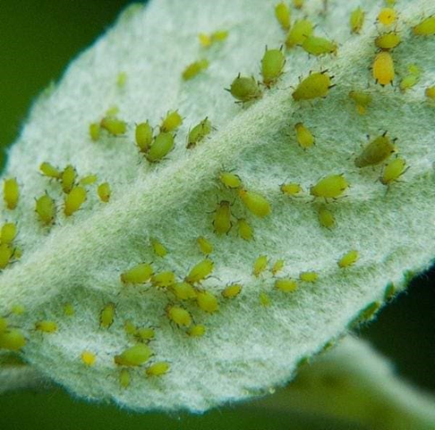
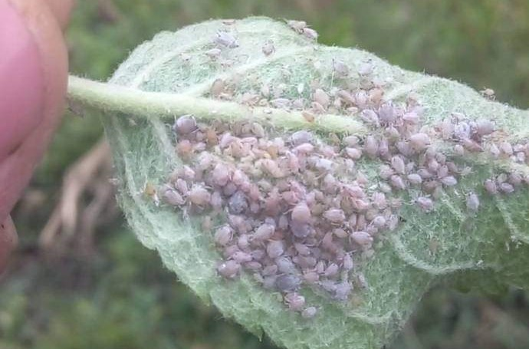

Fig1:Host species under study Aphis pomi and Aphis spiraecola

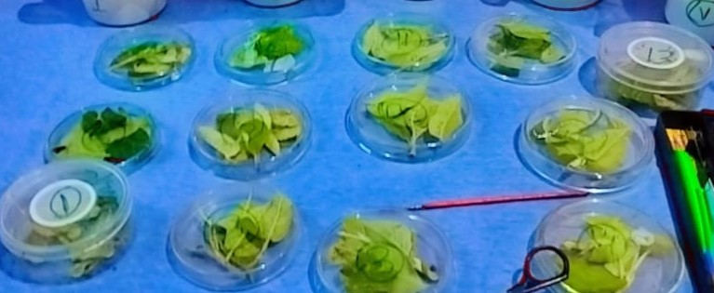
Fig 2 : Rearing of Coccinella undecimpunctata in petri- dishes

Fig 3 Diagrammatic representation showing life cycle of Coccinella undecimpunctata L.,

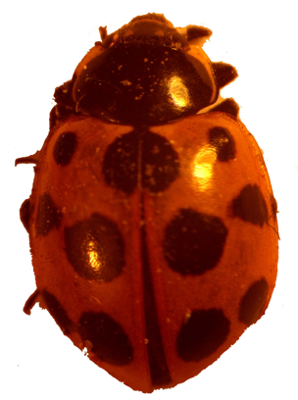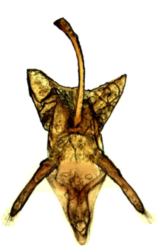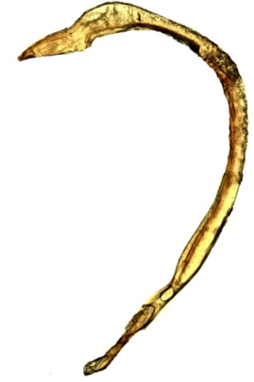
FIG: 4: A)Coccinella undecimpunctata B)Male genitalia ( Phalobase) and siphon.

Graph 1: Biological attributes when feeding on Aphis pomi (Red)and Aphis Sphericola (Green)

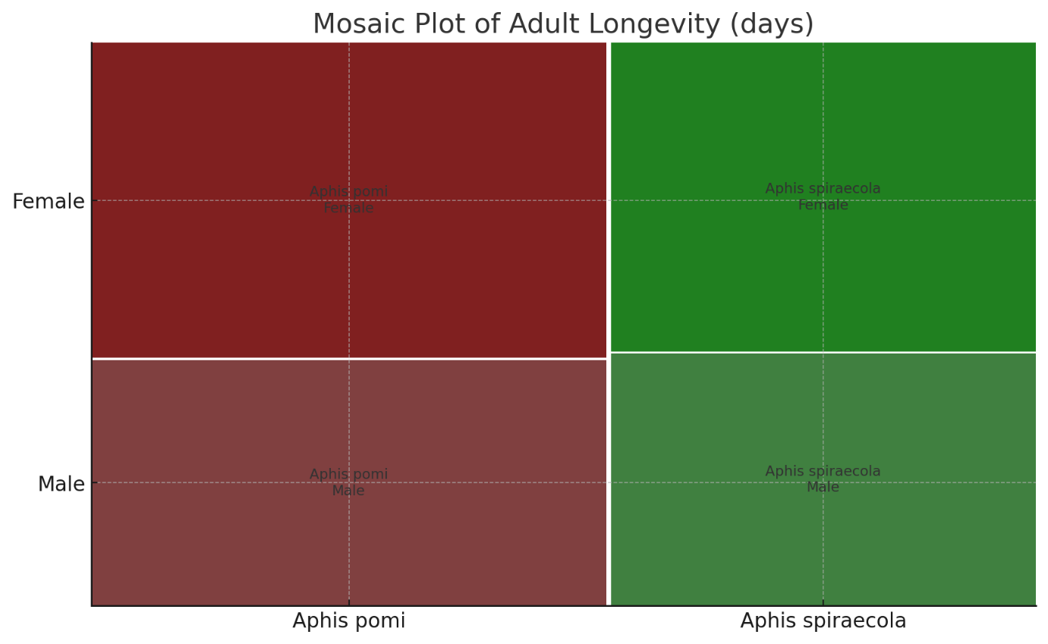
Graph 2: 2nd part : Mosaic plot Adult longevity by Mosaic plot

References :
Bahy El-Din, I.A.E. 2006. Studies on the biology and feeding capacity
of some coccinellid species. M.Sc. Thesis, Faculty of Agriculture,
Moshtohor Benha University, Egypt, 212.
Ullah, R., Haq, F., Ahmad, H., Inayatullah, M., Saeed, K. and Khan, S. 2012. Morphological characteristics of ladybird beetles collected from District Dir Lower, Pakistan. African Journal of biotechnology 11(37): 9149-9155.
Obrycki, J.J. and T.J. Kring 1998. Evaluation of different diets for mass
rearing of Coccinella undecimpunctata L. (Coleoptera:
Coccinellidae). Annual Review of Entomology 43: 215- 321.
Obrycki, 2009. Aphidophagy of Coccinellids ;application of biological control in agro ecosystem. Biological control 51: 244-254.
Gautam, R.D., 1989. Influence of different hosts on the adults of
Menochilus sexmaculatus (Fab.) Journal of Boilogical 3:90-92.
Gordon, R. D. 1985 The Coccinellidae (Coleoptera) of American north of Maxico. Journal of the york. Entomological Society 93: 654-678.
Hodek, I. and Honek, A. 1996. Ecology of Coccinellidae. Kluwer Academic Publishers,
Dordrecht Boston London, 464.
Hippa, H., Kepeken, S. D. & Laine, T. (1978). On the feeding biology of Coccinella
hieroglyphica L. (Coleoptera: Coccinellidae). Reports from the Kevo Subarctic Research
Station, 14, 18–20.
Kumari, D., Verma, S. C. and Sharma, P. L. 2020. Biology, feeding potential and functional response of Coccinella septempunctata L. against Aphis gossypii Glover infesting cucumber. Journal of Entomology and Zoological Studies 8: 631-636.
Lanzoni, A. 2004. Biological traits and life table of the exotic Harmonia axyridis Compared with Hippodamia Variegata and Adalia bipunctata (Col.: Coccinellidae). Journal of Apllied Entomology 128: 298 -306.

Mohamed H. Bayoumy; Ahmed M; Abou- Elnaga; Abdel- Badie A.; Ghanim; and Ghassan A.;
Mashhoot.2020 Functional and numerical responses of Coccinella undecimpunctata
(Coleoptera: Coccinellidae ). An analytical approach for predators gender in a two-
aphid feeding system. Egyption Journal of Biological Pest Control
Mari, J. M., Bugti, G. A., Bin, W. and Na, C., 2016. Biological parameters and preferential
feeding response of Coccinella undecimpunctata L. on three aphid species. Journal of
Entomology and Zoology Studies 4(4):1306-1310.
Pervez, A. and Omkar, S. 2004. Prey-dependent life attributes of an aphidophagous ladybird beetle, Propylea dissecta (Coleoptera: Coccinellidae). Biocontrol Science and Technology 14: 385-396.
Pandi, G., Paul, B., Vivek, S. and Shankarganesh, K. 2012. Feeding potential and biology of Coccinellid predator Cheilomenes sexmaculata (Fabricius) (Coleoptera) on aphid hosts. Indian journal of Entomology 74(4): 388-393.
Sarwar M. and Saqib, M. S. 2010. Rearing of Predatory Seven Spotted Ladybird beetle Coccinella septempunctata L. (Coleoptera: Coccinellidae) on Natural and Artificial Diets under Laboratory Conditions. Pakistan Journal of Zoology 42(1): 47-51
Sathe TV, Bhosale YA. 2001 Insect pest predators, Daya publishing House, Delhi, 1-195.
Singh, J, Brar KS. 2004. Mass production and biological control potential of Coccinellidae in india. In Sahayaraj K. ed. Indian insect predators in biological control. Daya Publishing House , Delhi , India , 204- 260.
Solangi, B.K., A.G. Lanjaar and M.K. Lohar 2007. Predatory potential and life history
characteristics of eleven spotted beetle, Coccinella undecimpunctata L. reared on cotton
mealybug, Phenacoccus solenopsis Tinsley. Journal of Applied Science 7: 3086-3090.
Salman, A.M.A., M.A. El-Harery and E.A. El-Solimany 2014. Effects of population Densities of
Aphis craccivora Koch. On predators Efficiency of Coccinella septempunctata L.,
Coccinella undecimpunctata L. and Chrysoperla carnea Stephens. Larvae under
laboratory condition. Fac. of Agric. Sohag Univ., Egypt. Journal of Agriculture
Research, 3(1): 116-122.
Sipio, F. A., Bukero, A., Khanzada, K. K., Ali, I., Kumbhar, A. A. S., Jat, M. I. and Hussain, R. 2017. Biology of seven spotted beetle, Coccinella septempuntata (Linn.) on different aphid species. Journal of Entomology and Zoology Studies 5(6) :2014-2017

