OPTIMIZATION OF SECONDARY HARDENING TECHNIQUES FOR EMBRYO RESCUED INTERSPECIFIC CROSSES IN CHILLI (Capsicum annuum L.)

Abstract
The laboratory experiment on " Optimization of Secondary Hardening Techniques for Embryo Rescued Interspecific Crosses in Chilli (Capsicum annuum L.)" was conducted at the Horticulture lab in the Department of Horticulture, College of Agriculture, University of Agriculture Science, Raichur, during November 2023-24. The experiments were designed in a Completely Randomized Design (CRD). The first experiment aimed to identify the best secondary hardening media for embryo-rescued interspecific plantlets, testing seven treatments: T₁: Cocopeat, T₂: Vermiculite, T₃: Vermicompost, T₄: Cocopeat: Vermiculite (1:1), T₅: Cocopeat: Vermicompost (1:1), T₆: Vermiculite: Vermicompost (1:1), and T₇: Cocopeat: Vermiculite: Vermicompost (1:1:1). The parents UARChH 42 belongs to Capsicum annuum and PBC 80 belongs to Capsicum baccatum were crossed and the fruit obtained was embryo rescued and raised in the Tissue culture laboratory for 30 days and they were transferred to different soilless medias for secondary hardening. Results showed that T₁: Cocopeat provided the best growth metrics, including the shoot length, per cent increase in shoot length, root length, per cent increase in root length, chlorophyll content, number of leaves, per cent of new leaves formation, seedling biomass, per cent increase in plantlet biomass, Survivability percentage was observed. Conversely, plantlets in T₃: Vermicompost exhibited no growth and all the plants died after transplanting.
Key Words: Secondary hardening, embryo rescued interspecific plantlets, soilless media
1.Introduction
Chilli (Capsicum annuum L.), commonly known as hot pepper, belongs to the nightshade family Solanaceae, which includes vegetables like potato, tomato, and eggplant (Knapp, 2002). The genus Capsicum comprises 27 species, with five domesticated and 22 semi-domesticated and wild ones (Costa et al., 2006). Capsicum annuum, with a genome size of 3.48 GB, is grown on 1.5 million hectares worldwide, producing 7 million tonnes annually. Rich in vitamins and minerals, dried red chillies are particularly high in vitamin A and β-carotene (Pundir et al., 2016). Integrating resistant genes from wild species into cultivated varieties can reduce pesticide use, lower cultivation costs, and minimize health and environmental hazards. However, interspecific crosses in chilli face challenges due to cross incompatibility (Pickersgill, 1997).
Embryo rescue is crucial for overcoming hybridization barriers, enabling the development of viable interspecific hybrids with desirable traits such as disease resistance and heat tolerance. The delicate nature of rescued embryos necessitates refining hardening processes to ensure robust growth and field establishment. Secondary hardening, which acclimatizes in vitro cultured plantlets to external conditions, is critical for bridging laboratory and field environments. This research aims to optimize secondary hardening conditions by evaluating factors like substrate composition, humidity control, and light intensity, ultimately developing a standardized protocol to minimize plantlet mortality and promote healthy growth. These efforts could significantly enhance chilli breeding programs, leading to the development of resilient varieties that meet global agricultural demands.
2. Material and Methods:
The method of embryo rescue for interspecific hybridization was used as per the method given by Yoon et al. (2006). The other references (Bhattarai et al., 2009 and Walter et al., 2018) were utilized for further optimize the protocol. Interspecific cross between F₁ hybrid belongs to Capsicum annuum UARChH 42 and PBC 80 genotype belongs to Capsicum bacccatum were made. All the required plant protection measures were taken from time to time to maintain the healthy and optimum plant growth conditions were utilized for crossing and further rescuing embryo and placed in MS media containing glass jars and they were raised in Tissue-Culture Laboratory. The experiment was conducted under well-defined conditions of the culture room maintained at 25°-26°C. Uniform light (cal 1000 lux) provided by fluorescent tubes (7200°K) over a light/dark cycles of 16/8 hour.
Seven treatments and three replications by using different soilless medias like cocopeat, vermicompost and vermiculite and different compositions were taken i.e., T₁: Cocopeat, T₂: Vermiculite, T₃: Vermicompost, T₄: Cocopeat: Vermiculite (1:1), T₅: Cocopeat: Vermicompost (1:1), T₆: Vermiculite: Vermicompost (1 :1), T₇: Cocopeat: Vermiculite: Vermicompost (1:1:1). All the mentioned medias are represented in plate 2 (a).
The embryo rescued interspecific plantlets were hardened in above mentioned medias for 30 days. After transplanting, observations like shoot length, root length, per cent increase in root length, chlorophyll content, number of leaves, per cent of new leaves formation, seedling biomass, per cent increase in plantlet biomass, Survivability percentage was recorded at every 10th, 20th and 30th days after transplanting.
3. Result and Discussion
3.1 Shoot length (cm)
On the tenth day, vermiculite (T₄) and cocopeat (T₁) showed similar shoot lengths (7.95 cm and 7.39 cm, respectively), with cocopeat (T₁) displaying the longest shoot (9.15 cm). Among the plantlets that survived, cocopeat: vermiculite: vermicompost (T₆) had the shortest shoot length (1.23 cm). On the twentieth day, cocopeat (T₁) once more displayed the longest shoot length (10.82 cm), with T₄ and T₂ coming in second and third, respectively, with 9.02 and 8.18 cm. The lowest T₆ was still 1.53 cm. After 30 days, T₁ (cocopeat) continued to have the longest shoots at 11.42 cm, followed by T₄ (9.65 cm) and T₆ (1.83 cm).
Cocopeat provides a well-aerated, moisture-retaining environment conducive to root development, enhancing nutrient uptake and hydration. Vermiculite's structure supports water retention and aeration, promoting optimal root growth and nutrient absorption. The balanced physical properties of the cocopeat and vermiculite mix likely foster healthy shoot development, resulting in robust growth. These findings align with research on chilli by Uttekar et al. (2021), and studies on other crops by Nazki (2014) and Gowtam (2023).
3.2 Per cent increase in shoot length (%)
As demonstrated in Table 1 the plantlets placed at different hardening media was found significant difference in per cent increase in shoot length. The plantlets placed in cocopeat (T₁) showed highest percentage increase in shoot length (47.15 %) and it was on par with the cocopeat: vermiculite (T₄) and vermiculite (T₂) with the percentages of (40.51 %) and (38.86 %). There was no increase in shoot length percentage in vermicompost (T₃). The lowest percentage increase in shoot length was observed in cocopeat: vermiculite: vermicompost (T₆). With the increase in percentage of (0.29 %).
This can be attributed to the varying physical and chemical properties of the media and their effects on plant growth. Cocopeat, cocopeat: vermiculite, and vermiculite likely provided favourable conditions for shoot elongation due to their ability to retain moisture, aerate the root zone, and promote nutrient availability. These media may have facilitated optimal root development, leading to enhanced water and nutrient uptake, which in turn promoted shoot growth. These findings are in line with studies on chilli by Uttekar et al. (2021) and in other crops by Nazki (2014) and Gowtam (2023).
Table 1. Effect of different hardening media on shoot length and per cent increase in shoot length for embryo rescued interspecific F1 hybrid of chilli plantlets
Treatment | Shoot length (cm) |  |  | Per cent increase in shoot length
Treatment | Day 10 | Day 20 | Day 30 | Per cent increase in shoot length
T₁ | 9.15 | 10.82 | 11.41 | 47.15
T₂ | 7.39 | 8.18 | 8.69 | 38.86
T₃ | 0.00 | 0.00 | 0.00 | 0.00
T₄ | 7.95 | 9.02 | 9.65 | 40.51
T₅ | 3.11 | 1.95 | 2.02 | 1.41
T₆ | 1.23 | 1.53 | 1.83 | 0.29
T₇ | 3.23 | 3.25 | 4.55 | 18.55
Mean | 4.58 | 4.96 | 5.57 | 20.97
S.Em ± | 0.52 | 0.59 | 0.66 | 2.63
CD (0.01) | 2.07 | 2.36 | 2.03 | 10.56

T₁: Cocopeat
T₂: Vermiculite
T₃: Vermicompost
T₄: Cocopeat: Vermiculite (1:1)
T₅: Cocopeat: Vermicompost (1:1)
T₆: Vermiculite: Vermicompost (1:1)
T₇: Cocopeat: Vermiculite: Vermicompost (1:1:1)

3.3 Chlorophyll content (SPAD)
On 10th day, when compared to all other treatments, cocopeat (T₁) showed highest chlorophyll content (35.70) which was on par with cocopeat: vermiculite (T₄) and vermiculite (T₂) which showed chlorophyll content of 32.22 and 30.90, respectively. However, among the treatments in which plantlets survived lowest chlorophyll content (16.60) was observed in cocopeat: vermiculite: vermicompost (T₆).
On 20th day, when compared to all other treatments, cocopeat (T₁) showed highest chlorophyll content (38.40) which was on par with cocopeat: vermiculite (T₄) which showed chlorophyll content reading of 34.81. However, among the treatments in which plantlets survived lowest chlorophyll content (7.49) was observed in cocopeat: vermiculite: vermicompost (T₆).
On 30th day, when compared to all other treatments, cocopeat (T₁) showed highest chlorophyll content (41.80) which was on par with cocopeat: vermiculite (T₄) which showed chlorophyll content of 37.97. However, among the treatments in which plantlets survived lowest chlorophyll content (8.30) was observed in cocopeat: vermiculite: vermicompost (T₆).
The differences in chlorophyll content among treatments are likely due to variations in nutrient availability and soil conditions provided by different growth media. Cocopeat and cocopeat: vermiculite likely offered better nutrient retention and availability, promoting chlorophyll synthesis and photosynthetic activity, resulting in higher chlorophyll content. Therefore, selecting appropriate growth media is crucial for ensuring optimal nutrient availability and supporting healthy plant growth. These findings are in line with studies on chilli by Uttekar et al. (2021) and in other crops by Nazki (2014) and Gowtam (2023).
3.4 Root length (cm)
Root length is critical for plant life, and superior root growth makes the plant to acclimatise easily in field conditions and absorbs the water and nutrients easily. There was a significant difference in root length between the plantlets under different media, as evidenced by data in Table 2. Among different treatments, cocopeat (T₁) exhibited the highest root length (13.18 cm), which was on par with cocopeat: vermiculite (T₄) and vermiculite (T₂) with a root length of 11.83 cm and 11.07 cm, respectively. However, no survivability was observed in vermicompost (T₃). The lowest root length (2.26 cm) among the treatments in which root length was observed in cocopeat: vermiculite: vermicompost (T₆).
Cocopeat ensures effective nutrient uptake and hydration by providing an environment that is well-aerated and moisture-retaining for root development. Because of its special composition, vermiculite retains more water and allows for better aeration, which supports healthy root development and nutrient absorption. Furthermore, the balanced physical characteristics of the combination media probably encourage strong growth and elongation as well as healthy shoot development. Vermiculite and cocopeat work together to generate a perfect growing environment that encourages rapid branch growth in chili plantlets. These findings are consistent with studies by Uttekar et al. (2021) on chili, and Nazki (2014) and Gowtam (2023) on a variety of other crops.
3.5 Per cent increase in root length (%)
As demonstrated in Table 2 the plantlets placed at different hardening media was found significant difference in per cent increase in root length. The plantlets placed in cocopeat (T₁) showed highest percentage increase in root length (68.64 %) and it was on par with the cocopeat: vermiculite (T₄) with percentage increase in root length of (61.96 %) and it was followed by vermiculite (T₂) with percentage increase in root length of 48.81%. There was no increase in root length percentage in vermicompost (T₃). The lowest percentage increase in root length was observed in cocopeat: vermiculite: vermicompost (T₆) with the increase in percentage of (8.07 %).
Plantlets in various hardening media exhibit varying per cent increases in root length, which can be attributed to variances in their physical and chemical qualities. Cocopeat and cocopeat: vermiculite provides the right amount of moisture, oxygen, and nutrients to allow for root elongation, leading to significant percentage gains. These findings are in line with studies on chilli by Uttekar et al. (2021) and in other crops by Nazki (2014) and Gowtam (2023).

Table 2. Effect of different hardening media on chlorophyll content, root length and per cent increase in root length for embryo rescued interspecific F1 hybrid of chilli plantlets
Treatment | Chlorophyll content (SPAD) |  |  | Root length  (cm) | Per cent increase in root length
Treatment | Day 10 | Day 20 | Day 30 | Root length  (cm) | Per cent increase in root length
T₁ | 35.70 | 38.40 | 41.80 | 13.18 | 68.64
T₂ | 30.90 | 26.48 | 28.20 | 11.07 | 48.81
T₃ | 0.00 | 0.00 | 0.00 | 0.00 | 0.00
T₄ | 32.22 | 34.81 | 37.97 | 11.83 | 61.96
T₅ | 7.04 | 8.11 | 8.81 | 2.28 | 14.73
T₆ | 6.60 | 7.49 | 8.30 | 2.26 | 8.07
T₇ | 15.81 | 16.83 | 18.39 | 6.37 | 21.57
Mean | 18.33 | 18.87 | 20.49 | 6.71 | 31.96
S.Em ± | 2.06 | 2.14 | 2.33 | 0.76 | 3.79
CD (0.01) | 8.27 | 8.61 | 9.35 | 3.04 | 15.18

T₁: Cocopeat
T₂: Vermiculite
T₃: Vermicompost
T₄: Cocopeat: Vermiculite (1:1)
T₅: Cocopeat: Vermicompost (1:1)
T₆: Vermiculite: Vermicompost (1:1)
T₇: Cocopeat: Vermiculite: Vermicompost (1:1:1)
3.6 Number of leaves
10th day: Cocopeat (T₁) had the highest number of leaves (7.00), followed by cocopeat: vermiculite (T₄) at 6.28 and vermiculite (T₂) at 5.58. The lowest was in cocopeat: vermiculite: vermicompost (T₆) with 0.70 leaves.
20th day: Cocopeat (T₁) again had the highest number of leaves (9.50), followed by cocopeat: vermiculite (T₄) at 8.60 and vermiculite (T₂) at 6.05. The lowest was in cocopeat: vermiculite: vermicompost (T₆) with 0.93 leaves.
30th day: Cocopeat (T₁) had the highest number of leaves (13.25), followed by cocopeat: vermiculite (T₄) at 11.63 and vermiculite (T₂) at 10.46. The lowest was in cocopeat: vermiculite: vermicompost (T₆) with 0.93 leaves.
These differences in leaf production can be attributed to the substrates' ability to provide optimal conditions for root development, nutrient uptake, and overall plant vigour. Cocopeat and cocopeat-vermiculite mixtures generally supported the highest leaf production compared to vermicompost-containing substrates. These findings align with research on chili peppers by Uttekar et al. (2021) and other crops by Nazki (2014) and Gowtam (2023).
3.7 New leaf formation (%)
Table 3 shows significant differences in new leaf formation among plantlets in different hardening media. Plantlets in cocopeat (T₁) had the highest increase in leaf number (95.54%), followed by cocopeat: vermiculite (T₄) at 84.03% and vermiculite (T₂) at 81.24%. No increase was observed in vermicompost (T₃), and the lowest increase (8.07%) was in cocopeat: vermiculite: vermicompost (T₆).
Cocopeat retains moisture, while vermiculite ensures proper drainage and aeration, creating optimal conditions for root development and leaf formation. This combination likely led to the better results in new leaf formation. These findings align with studies on chili by Uttekar et al. (2021) and other crops by Nazki (2014) and Gowtam (2023).
3.8 Seedling biomass (g)
Table 3 shows significant differences in seedling biomass across various hardening media. Plantlets in cocopeat (T₁) had the highest biomass (2.50 g), followed by cocopeat: vermiculite (T₄) at 2.29 g and vermiculite (T₂) at 1.91 g. The lowest biomass was in cocopeat: vermiculite: vermicompost (T₆) at 0.46 g.
These differences are due to the varying physical and chemical properties of the media. Cocopeat's excellent water retention and aeration support robust root development and nutrient absorption, resulting in the highest biomass. Vermiculite and cocopeat: vermiculite mixtures also provide favourable conditions for seedling growth. These findings highlight the importance of selecting the right hardening media for healthy seedling growth, consistent with studies by Uttekar et al. (2021), Nazki (2014), and Gowtam (2023).
3.9 Per cent increase in plantlet biomass (%)
Table 3 shows significant differences in plantlet biomass increase across different hardening media. Plantlets in cocopeat (T₁) had the highest biomass increase (87.50%), followed by cocopeat: vermiculite (T₄) at 76.42% and vermiculite (T₂) at 74.60%. The lowest increase (12.62%) was in cocopeat: vermiculite: vermicompost (T₆).
The physical and chemical properties of the media explain these differences. Cocopeat's water retention and aeration promote strong root development and nutrient absorption, resulting in high biomass. Similar results were observed with vermiculite and cocopeat: vermiculite mixtures. These findings underscore the importance of selecting the appropriate hardening medium for healthy seedling growth, aligning with studies by Uttekar et al. (2021), Nazki (2014), and Gowtam (2023).
3.10 Survivability percentage (%)
The survivability percentages varied significantly, as shown in Table 3. Among all treatments, cocopeat (T₁) exhibited the highest survivability percentage (93.75%), comparable to cocopeat: vermiculite (T₄) at 81.25%. Vermiculite (T₂) followed with 62.50% survivability. No survivability was observed in vermicompost (T₃). The lowest survivability (12.50%) among surviving plantlets was in cocopeat: vermiculite: vermicompost (T₆).
Cocopeat and vermiculite likely showed high survivability due to their water retention and aeration properties, respectively, which create an optimal environment for plant growth. Additionally, both mediums retain nutrients, maintain pH balance, and prevent diseases, supporting plant survival. The lack of survivability in vermicompost alone may be due to nutrient imbalances, pH issues, presence of pathogens or toxins, poor drainage, or root damage. These factors made vermicompost unsuitable, resulting in the death of all plantlets. These findings align with studies on chilli by Uttekar et al. (2021) and other crops by Nazki (2014) and Gowtam (2023).
Table 3. Effect of different hardening media on number of leaves, biomass and per cent increase in number of leaves, biomass and survivability percentage for embryo rescued interspecific F1 hybrid of chilli plantlets
Treatment | Number of leaves |  |  | Per cent increase in number of leaves | Seedling biomass  (g) | Per cent increase in plantlet biomass | Survivability percentage (%)
Treatment | Day 10 | Day 20 | Day 30
T₁ | 7.00 | 9.50 | 13.25 | 95.54 | 2.50 | 87.50 | 93.75
T₂ | 5.58 | 6.05 | 10.46 | 81.24 | 1.91 | 74.60 | 62.50
T₃ | 0.00 | 0.00 | 0.00 | 0.00 | 0.00 | 0.00 | 0.00
T₄ | 6.28 | 8.60 | 11.63 | 84.03 | 2.29 | 76.42 | 81.25
T₅ | 1.86 | 1.40 | 1.86 | 7.75 | 0.48 | 23.94 | 43.75
T₆ | 0.70 | 0.70 | 0.93 | 7.75 | 0.46 | 12.62 | 12.50
T₇ | 3.02 | 3.95 | 5.12 | 9.30 | 1.29 | 62.21 | 56.25
Mean | 3.49 | 4.31 | 6.17 | 40.81 | 1.27 | 48.18 | 50.00
S.Em ± | 0.39 | 0.52 | 0.74 | 5.31 | 0.14 | 5.23 | 6.09
CD (0.01) | 1.59 | 2.08 | 2.96 | 21.23 | 0.57 | 20.95 | 24.42

T₁: Cocopeat
T₂: Vermiculite
T₃: Vermicompost
T₄: Cocopeat: Vermiculite (1:1)
T₅: Cocopeat: Vermicompost (1:1)
T₆: Vermiculite: Vermicompost (1:1)
T₇: Cocopeat: Vermiculite: Vermicompost (1:1:1)
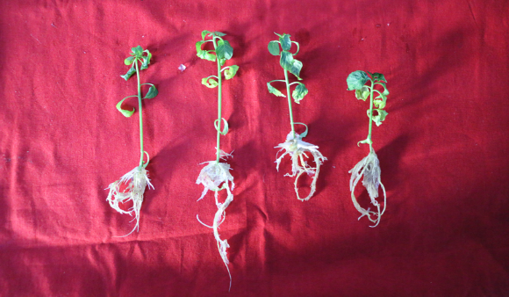
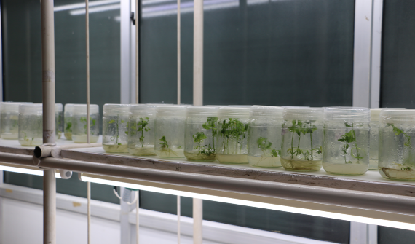

Embryo rescued tissue culture plants 30 days old plantlet
Plate 1: Embryo rescued interspecific plantlets before transplanting into different
hardening media

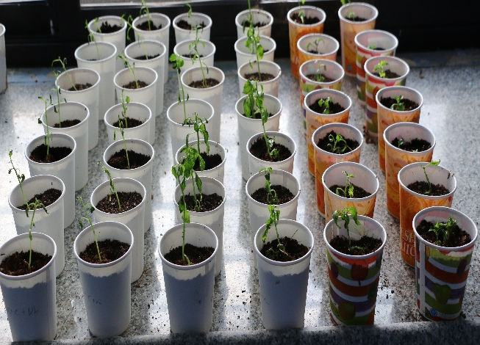
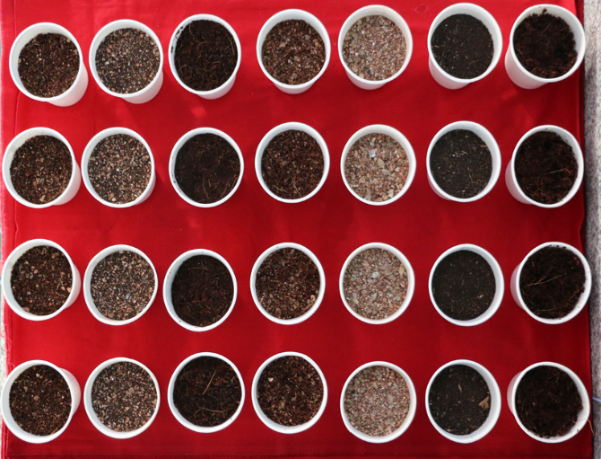

a. Different soilless media for hardening b. Transplanted interspecific plants to different hardening media

Plate 2: General view of Experiment 1 (a & b)

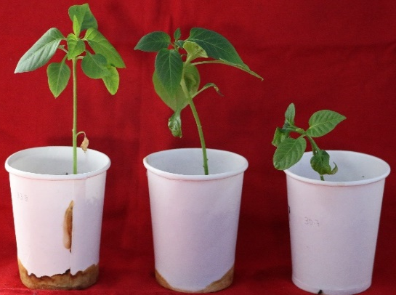
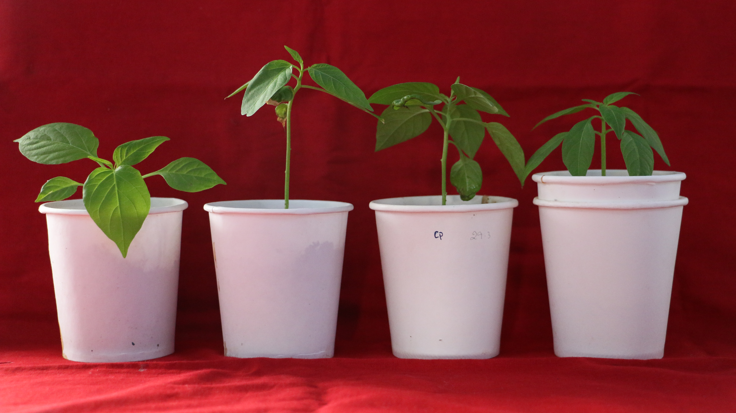
Cocopeat: Vermiculite
Cocopeat
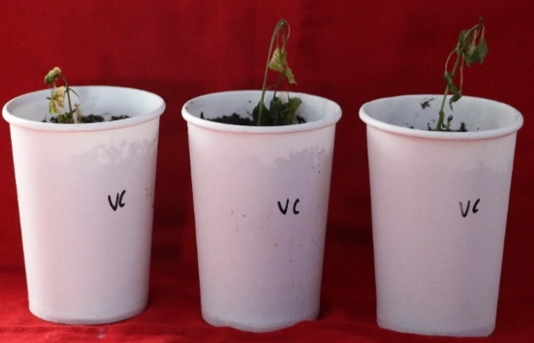
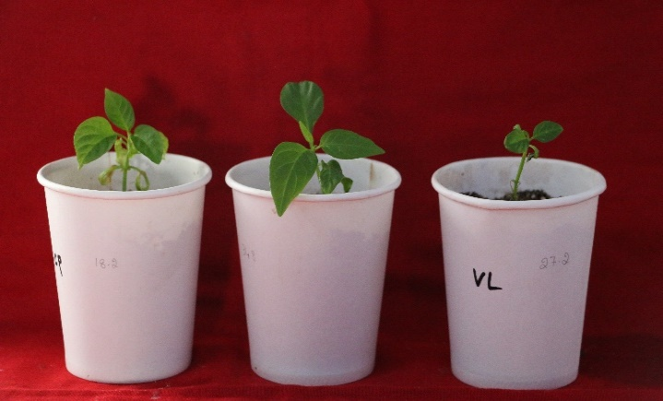
Vermiculite
Vermicompost

Plate3: Performance of different hardening media for embryo rescued interspecific hybrid in chilli
References:
Bhattarai, A. 2009. Genetic Diversity and Agronomic performance of chili pepper (Capsicum spp.) varieties in Nepal. J. Agric. Sci. Technol., 12(3): 45-58.
Costa, F. R., Pereira, T. N. S., Vitoria, A. P., Campos, K. P., Rodrigues, R., Silvia, D. H. and Pereira, M. G. 2006. Genetic diversity among Capsicum accessions using RAPD markers. Crop Breeding and Applied Biotechnology., 6: 18-23.
Gautam, B., Sharma, P. and Gupta, Y.C., 2019. Studies on rooting and hardening of in vitro plantlets of carnation (Dianthus caryophyllus L.). IJCS., 7(5):3179-3182.
Knapp, S., Bohs, L., Nee M. and Spooner, D. M. (2004). Solanaceae-a model for linking genomics with biodiversity. Comparative and Functional Genomics., 5: 285-291.
Nazki, T., Siddique, M.A.A., Rather, Z.A., Mir, M.A. and Bhat, M.A., 2014, An improvised low-cost hardening protocol for in vitro raised plantlets of Gerbera jamesonii. Indian J. Agric. Sci., 5(1): 43-46.
Pickersgill, B., 1997, Genetic resources and breeding of Capsicum spp. Euphytica., 96(1): 129-133.
Pundir, R., Rani, R., Tyagi, S. and Pundir, P., 2016, Advance review on nutritional phytochemical, pharmacological and antimicrobial properties of chilli. Int. J. Ayurveda Pharma Res.,4(4): 53-59.
Uttekar, V. S., Gabhale, L. K., Parulekar, Y. R., Kadam, J. J. and Sanap, P. B., 2021, Effect of various potting media on growth and development of Chilli (Capsicum annuum L.) seedlings for grafting. Pharma Innov. J., 10(11): 800-803.
Walter, A. 2018. Genetic variation and environmental influence on yield and quality traits of chili pepper (Capsicum spp.). J. Agric. Sci., 45(2): 112-125.
Yoon, J. B., Yang, D. C., Do, J. W. and Park, H. G., 2006, Overcoming two post-fertilization genetic barriers in interspecific hybridization between C. annuum and C. baccatum for introgression of anthracnose resistance. Breed. Sci., 56(1): 31-38.

