Original Research Article
Spatiotemporal Modulation of Cell Wall, Sugar and Reactive Oxygen Species Metabolism Genes in Banana During Fruit Development and Ripening

ABSTRACT
Understanding the spatiotemporal regulation of gene expression during fruit development and ripening is crucial for improving postharvest quality and shelf-life in climacteric fruits like banana. This study focused on differential expression of key metabolic genes involved in cell wall modification, reactive oxygen species (ROS), and sugar synthesis across different developmental and ripening stages in banana (cv. Grand Naine). Quantification of starch and total soluble sugars revealed dynamic changes in starch degradation and soluble sugar accumulation during early to late ripening stages. In addition, sucrose, glucose and maltose emerging as the predominant sugar at late ripening stages. The RT-qPCR based gene expression demonstrated distinct spatiotemporal patterns, where xyloglucan endotransglucosylase/hydrolase (XTHs) gene family such as XTH3, XTH4, and XTH8 were highly expressed during early developmental stages, supporting cell expansion. Whereas, XTH5, XTH6, and PEL1 exhibited strong induction during ripening, indicating involvement of these genes in cell wall disassembly and softening. Superoxide dismutase (SOD) exhibited increased expression during late ripening in pulp, suggesting ROS scavenging role during degradation of cell wall components. Sucrose synthase gene (SUS) expression reduced from developmental to ripening phase indicating carbon partitioning during fruit development. Collectively, the coordinated action of XTH (-3, -4, -5, -6, -8), pectate lyase (PEL1), SOD, peroxidase (POD), and SUS genes underscores their role in the carbon partitioning and sugar metabolism, cell wall modification, and ROS homeostasis during fruit development and ripening. This study provides a novel molecular insight governing banana fruit development and ripening. Information on modulation of genes provide foundation and open up the window for further validation, to assign their individual functional role in fruit development and ripening through genome editing tools.
Keywords: Spatiotemporal gene expression; cell wall modification; XTH; ROS metabolism; sucrose synthase

- INTRODUCTION
Banana is among the most significant fruit crops globally, contributing substantially to food security and serving as a vital source of income for millions of people. India stands as the leading producer, accounting for nearly 38% of the total banana output globally (FAO. 2024). Bananas are a valuable source of carbohydrates such as starch and dietary fiber, and are also abundant in vitamin- A, B, and C, along with phenolic compounds and essential minerals like manganese and potassium (Kumari et al., 2023). Being a climacteric fruit, the banana is harvested at its physiological maturity stage and subsequently undergoes ripening after detachment from the plant (Dwivany et al., 2016). However, once ripening begins, the process cannot be reversed or delayed, which poses challenges in post-harvest management, including storage and transportation (Al-Dairi et al., 2023). Post-harvest losses result primarily from physiological deterioration, tissue softening, microbial spoilage, and improper handling (Wasala et al., 2014; Sugianti et al., 2022; Al-Dairi et al., 2023). Strategies such as controlled-atmosphere storage, low-temperature storage, ethylene inhibitors, and surface coatings can reduce losses, but their application is limited by high costs, chilling injury, and uneven ripening (Deng et al., 2017; Ali et al., 2022; Satekge and Magwaza, 2022). Therefore, gaining a deeper understanding of the physiological and biochemical mechanisms underlying banana ripening is crucial for developing effective strategies to enhance post-harvest quality and extended shelf life.

During the pre-climacteric stage, banana fruits are characterized by exceptionally high starch content, typically comprising 70-80% of the dry fruit weight. As ripening progresses, starch undergoes extensive enzymatic degradation, resulting in almost complete conversion to soluble sugars. By the end of the climacteric phase, the starch content declines to less than 1% (Pereira et al., 2018). This dramatic shift is crucial for the development of the banana’s sweet flavor and soft texture. Enzymatic activities such as amylases and starch phosphorylases are primarily responsible for catalyzing this conversion during ripening (Li et al., 2025).
Previous studies of Gidado et al. (2018) revealed that during banana ripening, sucrose, glucose, and fructose are the predominant soluble sugars, with sucrose often exceeding 10% on fresh weight basis in early ripening and increased moderately at late ripening (Gidado et al., 2018). Further, the absence of detectable maltose throughout ripening stage was noticed and it could be due to the rapid turnover during starch catabolism, highlighting the dynamic regulation of starch-derived sugar metabolism in banana fruit (Phillips et al., 2021).
Starch accumulated during the fruit development, after which net starch degradation coincided with increased sucrose accumulation, marking the transition toward fruit ripening (Duran-Soria et al., 2020; Campos et al., 2022). Studies on different fruits such as blueberries and tamarillos, further demonstrate that glucose and fructose accumulation parallels key metabolic and physiological transitions during ripening, reinforcing their central role in fruit development and quality (Hu et al., 2023; Acharya et al., 2024).
Interestingly, spatial and temporal variations in starch content known to be hydrolyzed during ripening and have long served as a traditional indicator of fruit maturity (Nicolai et al., 2023). In bananas, ripening is characterized by pronounced modifications in the structure and composition of the cell wall (Li et al., 2023). Previous studies on bananas have identified several gene families involved in cell wall degradation, highlighting the complex molecular processes that occur during fruit softening (Asif et al., 2014; Song et al., 2023).

In addition to genes associated with fruit softening, several transcriptome studies on banana have identified numerous genes that are linked to ethylene biosynthesis, signal transduction, and transcriptional regulation. The ripening process in banana is likely governed by the coordinated up- and down-regulation of numerous genes, that remain uncharacterized (Peng et al., 2022; Li et al., 2025).
At biochemical level fruit softening is a significant transformation that takes place during ripening, which involves extensive restructuring of the cell wall (Wang et al., 2023; Li et al., 2025). The plant cell wall is a complex structure consisting of polysaccharides and proteins that undergoes dynamic alterations in composition and structure throughout the fruit ripening (Brummell, 2006; Wang et al., 2022). Structural changes in cell wall fractions are coordinated by various class of enzymes, such as cellulase, polygalacturonase (PG), β-galactosidase (β-gal), pectate lyase (PL) and XTH (Ma et al., 2020; Su et al., 2022; Shi et al., 2023; Al-Hinai et al., 2024; Lika et al., 2026).
XTH genes play critical roles in cell wall remodelling during fruit development and ripening processes that determine fruit growth, softening, and textural changes (Aguilar-Velazquez et al., 2021; Wang et al., 2023; Sahoo et al., 2026). So far, the functions of XTH, which are encoded by a broad gene family, have been extensively studied in several fruits such as apple (Li et al., 2023; Liu et al., 2024), tomato (Yuan et al., 2024), kiwifruit (Fu et al., 2024), strawberry (Witasari et al., 2019) and persimmon (Han et al., 2016). XTH is thought to be responsible for apple softening and texture formation and the preservation of this structural function is essential for maintaining the integrity of the cell wall (Li et al., 2023).
In addition, XTH regulate plant growth and fruit ripening by modifying xyloglucan molecules, in the cell wall, enabling remodelling in response to phytohormones and developmental process (Cosgrove, 2022; Huang et al., 2023). Along with XTH, PEL1 has a wide range of potential role in plant growth and development. Pectin-degrading enzymes (pectinases) are vital regulators of plant growth and development, orchestrating processes such as fruit ripening, seed release, organ abscission, and dehiscence (Anderson and Pelloux, 2025). Among these, PELs hold particular importance for both reproductive and vegetative functions, influencing leaf expansion, senescence, and xylem differentiation (Anderson and Pelloux, 2025).
In fruits, PODs play a pivotal role in regulating redox balance during development and ripening, processes that are tightly associated with changes in texture, flavor, and overall quality (Wang et al., 2015; Zhu et al., 2021). Beyond their regulatory roles in ripening physiology, POD activity has been widely used as a biochemical indicator of fruit quality and postharvest deterioration, as elevated POD levels are often associated with the development of undesirable flavours (Vella et al., 2021; Punia et al., 2022).
SODs act as the first defense against oxidative stress by catalyzing the conversion of O₂⁻ into H₂O₂ and molecular oxygen (O₂). SODs constitute a vital class of antioxidant enzymes that protect plants from ROS generated during metabolism, development, and stress responses (Sudhakar et al., 2001; Liu et al., 2021; Zhang et al., 2024; Rao et al., 2025). Comparative genomic analysis within the Rosaceae family identified 25 SOD genes, including 11 in pear, emphasizing their roles in lignin biosynthesis and structural development (Li et al., 2025).

In Pyrus bretschneideri, PbPOD genes have been shown to respond actively to stress stimuli while contributing to fruit development, highlighting their potential utility in molecular breeding programs aimed at improving fruit quality Li et al., 2024). Moreover, class III PODs play pivotal roles in fruit physiology, as demonstrated in sweet pepper (Capsicum annuum), where 75 CaPOD genes were identified, of which only 10 were expressed in fruit tissues (González-Gordo et al., 2023). Expression profiling revealed two CaPOD genes upregulated and seven downregulated during ripening, suggesting a finely tuned regulatory mechanism governing fruit maturation and oxidative balance (González-Gordo et al., 2023). New insights suggest that the expression and activity of sucrose phosphate synthase (SPS) are tightly coordinated with the activities of other enzymes like sucrose synthase (SUS) and invertases, forming a complex network governing the balance between starch breakdown and sugar accumulation (Gujjar et al., 2024).

Despite extensive research on banana ripening, most of the existing studies have primarily focused on global transcriptome-level analyses or on a limited number of stages (Rahman et al., 2024; Ma et al., 2025; Pradhan et al., 2025) often neglecting tissue-specific (peel and pulp) and spatiotemporal variations in gene expression (Asif et al., 2014; Yang et al., 2025). Moreover, the integration of cell wall modification (CWM), ROS, and sugar metabolism pathways as a unified regulatory network remains largely unexplored. Previous reports have characterized either a single stage, specific tissue type of or specific metabolic pathways. However, there is still limited understanding of how different metabolic pathway genes operates spatiotemporally to regulate texture, ripening, and fruit quality aspects (Asif et al., 2014; Campos et al., 2022; Li et al., 2024). The current study addresses this gap by performing a comprehensive spatiotemporal expression analysis across multiple developmental, 40, 60, 90 days after flowering (DAF) and ripening, 6 and 12 days after ripening (DAR) stages and tissue type. Tissue specific and spatiotemporal investigation in the current study provides novel insight into the transcriptional reprogramming underlying fruit softening, sugar accumulation, and oxidative homeostasis, that are key physiological processes determining postharvest fruit quality.
Objectives of the study were (i). to quantify biometric, biochemical changes (in starch and total sugar and glucose, sucrose, and maltose) contents) during fruit development and ripening, and correlate them with gene expression. (ii). to study spatiotemporal expression of sugar metabolism (SUS), cell wall modification (XTHs, PEL1) and ROS (SOD, POD) metabolism genes across developmental and ripening stages in peel and pulp tissues.

- MATERIALS AND METHODS
2.1 Plant material collection
The banana fruit (cv. Grand Naine) samples were collected from Horticultural Research Station, OUAT, Bhubaneswar at different developmental stages i.e., 40, 60 and 90 DAF. Fully developed banana fruit i.e. 90-DAF was allowed to ripen at ambient temperature for 2, 4, 6, 8, 10 and 12-days, and three biological replicates were collected for each stage. The peel and pulp tissues were separated from the fruits from different developmental and ripening stages, and stored at -80°C for further use. Frozen tissues of peel and pulp from different developmental and ripening stages were ground to a fine powder in liquid nitrogen using a mortar and pestle.
2.2 Biometric studies
2.2.1 Measurement of fresh weight (FW)
Fresh weight of the banana fruit (whole fruit) and tissues (peel and pulp) from different developmental and ripening stages were separated, and fresh weights in triplicate for each of the stage were recorded (g kg⁻¹) and plotted the graph.

2.3 Biochemical studies
2.3.1 Starch estimation
The starch content in banana peel and pulp tissues during the developmental and ripening stages was estimated according to Shafiee et al. (2005).

2.3.2 Total sugar content
The total sugar content was analysed by following Franscistt et al. (1971).
2.3.3 Quantification of D-glucose, maltose and sucrose content during fruit development and ripening
2.3.3.1 Sample preparation
Fruit tissue samples i.e., peel and pulp were considered for sample preparation to estimate D-glucose, maltose and sucrose from different developmental and ripening stages. 100 mg of pulp and peel tissue was taken and homogenized with motor and pestle. Then 5mL of 80% ethanol was added to each sample and mixed properly by vertexing. Each tube was centrifuged at 3000 rpm for 10 min (with 3-time repetition). Then the supernatant was collected into a 50mL tube by adjusting the final volume to 25 mL with 80% ethanol. All the tubes were placed in a boiling water bath for 3 min at 80°C to evaporate the additional ethanol. Then 5 mL of Carrez I solution, 5 mL of Carrez II solution and 10 mL 100 mM of NaOH solution was added and mixed properly after each addition. Then the volumetric flask was filled to 50mL with distilled water, mixed properly and filtered with Whatman® paper no1. From the filtrate sample solution 0.1mL (100µl) of liquid sample was taken for sugar estimation.

2.3.3.2 Estimation of free sugars
Free D-glucose, maltose and sucrose contents of the banana peel and pulp samples of different developmental and ripening stages were estimated as per the prescribed method of Megazyme K-MASUG assay kit (Megazyme International Ireland Ltd, Wicklow, Ireland).

2.4 RNA extraction and cDNA synthesis
Total RNA from peel and pulp tissues of different developmental and ripening stages of banana was extracted using modified Meisel et al. (2005) method. First-strand cDNA was synthesized using total RNA by using Superscript II reverse transcriptase first strand cDNA synthesis kit (Invitrogen, USA) according to the prescribed protocol. The cDNA quality was checked by agarose gel-electrophoresis for RT-qPCR analysis.

2.5 Gene expression analysis by Real-Time Quantitative PCR (RT-qPCR)
The RTq-PCR study was implemented with Invitrogen Quantstudio-5 (Applied Biosystems, USA) under the following condition: step (1) 50˚C 2 min, step (2) 95˚C 2 min, step (3) (95˚C 0.15 min, 50-60˚C 0.15 min, 70 ˚C 1min) × 40 cycles, followed by the thermal dissociation curve (Chen et al., 2011). The relative expression level was analyzed using the 2^{-ΔΔCt} method and normalized with reference housekeeping gene cyclophilin (CYP) (Schmittgen and Livak, 2008).

Table 1. Primers utilized for gene expression study by RTq-PCR.

Gene with ID | Primer name | Sequence (5’→3’) | Functional categorised | References
Sucrose synthase SUS1  chr10:25291305.25295732 | SUS-F | AACTACAAGGGCATGTCGATG | Sugar metabolism | Xia et al., 2020
Sucrose synthase SUS1  chr10:25291305.25295732 | SUS-R | GGTGTCAGATGCGATACTCAATAG | Sugar metabolism | Xia et al., 2020
Pectate lyases MaPEL1 (PEL; EC 4.2. 2.2) | PEL1-F | TGCTCATTTCTCTTCTTTCACG | Cell wall modification | Mbe-guie et al., 2009
Pectate lyases MaPEL1 (PEL; EC 4.2. 2.2) | PEL1-F | TCCCAAGTCAAGTAGTATCAACACA | Cell wall modification | Mbe-guie et al., 2009
Xyloglucan endotransglucosylase/hydrolase (XTHs) (Ma XTH3) (FJ264506) | XTH3-F | GACAGGATGAGGTGGGTGCAGAAGA | Cell wall modification | Mbe-guie et al., 2009
 | XTH3-R | TGCTAATCCGGTAGACGCAGAACAGA | Cell wall modification | Mbe-guie et al., 2009
Xyloglucan endotransglucosylase/hydrolase (XTHs) (Ma XTH5) (FJ264508) | XTH5-F | CACATTCCCGGACTGCGATTACGTC | Cell wall modification | Mbe-guie et al., 2009
 | XTH5-R | CTTCGAACACCAATCCCCGATGCTC | Cell wall modification | Mbe-guie et al., 2009
Xyloglucan endotransglucosylase/hydrolase (XTHs) (Ma XTH6) (FJ264509) | XTH6-F | TGCTACGACCAGCATCGATATGGCA | Cell wall modification | Mbe-guie et al., 2009
 | XTH6-R | GATGGTTGATCGTCGACGGCACTTG | Cell wall modification | Mbe-guie et al., 2009
Xyloglucan endotransglucosylase/hydrolase (XTHs) (Ma XTH4) (FJ264507) | XTH4-F | CGACTGATGGCTGCTGGAT | Cell wall modification | Mbe-guie et al., 2009
 | XTH4-R | TCCATCTTTTACATACAAAACGGAACT | Cell wall modification | Mbe-guie et al., 2009
Xyloglucan endotransglucosylase/hydrolase (XTHs) (Ma XTH8) (FJ264511) | XTH8-F | TACAACTACTGCAACGACGCCAAGC | Cell wall modification | Mbe-guie et al., 2009
 | XTH8-R | CCTGAGAACATGGTTTGCGCAGGTT | Cell wall modification | Mbe-guie et al., 2009
Superoxide dismutase Ma SOD (AF510071.1) | SOD-F | TTCAATGGTGGAGGTCAT | ROS (Reactive Oxygen Species) | Wu et al., 2014
Superoxide dismutase Ma SOD (AF510071.1) | SOD-R | CAGAGTTTCTTACTTCCCTTAT | ROS (Reactive Oxygen Species) | Wu et al., 2014
Peroxidase Ma POD (EU104681.1) | SOD-F | CGATGACCTCAAACCCTC | ROS (Reactive Oxygen Species) | Wu et al., 2014
Peroxidase Ma POD (EU104681.1) | SOD-R | GGCTTCACTTCCACGACT | ROS (Reactive Oxygen Species) | Wu et al., 2014
Cyclophilin (CYP) (HQ853241) | CYP-F | ATAGCGGGTCCACCAAGAAG | Housekeeping gene | Chen et al., 2011
Cyclophilin (CYP) (HQ853241) | CYP-R | GGCTCCTGCTGACGATAATG | Housekeeping gene | Chen et al., 2011

- RESULTS AND DISCUSSION
3.1 Visual appearance of banana at different developmental and ripening stages
The visual appearance of banana fruit was evaluated at various developmental and ripening stages by means of size, shape, and colour. Forty -DAF (days after flowering) fruits were larger; blossom ends remained with small ridges; fruit hue was green and twisted in shape. In the case of 60-DAF, the pedicel part was similar to 40-DAF but without a blossom end. Fruits were usually larger in size than 40 and 60-DAF. When compared to other developmental stages, the 90-DAF fruit was found to be larger in size, with small ridges and a green colour with traces of yellow. There were no longer any ridges, and the fruit texture was mushy with a few brown spots visible in 6-DAR. The pedicle portion's colour began to change to black. Regarding 12-DAR, the fruit's colour was brown and its texture was observed to be softer with black spots (Fig. 1). In the current study, the weight loss of banana fruits increased as they ripened, with the largest weight loss occurring after 6-DAR. The loss of weight in banana fruit tissues could be attributed to respiration, transpiration, and other biochemical changes that occur during the ripening.
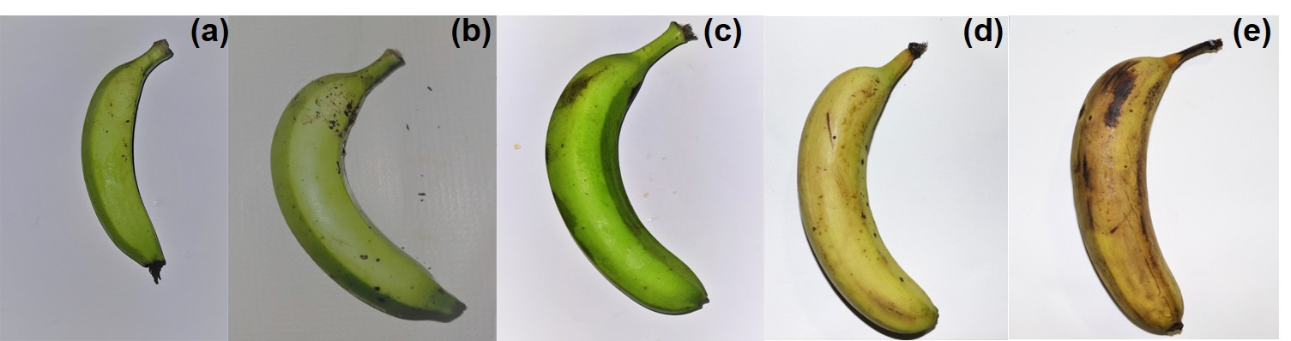

Fig. 1. Visual appearance of banana cv. Grand Naine at different developmental and ripening stages. Fruit sampling was done at 40-DAF (a), 60-DAF (b), 90 DAF (c), 6-DAR (d), 12-DAR (e) and considered for the biometric, biochemical and gene expression.
3.2 Biometric and biochemical analysis
3.2.1 Fresh weight and firmness
Fruit fresh weight exhibited a pronounced increase (10-fold) during the developmental phase, followed by a slight decline during ripening. Upon transition to the ripening phase (6-12 DAR), the whole fruit displayed a modest decline of approximately 25% in the fresh weight at later ripening stages, stabilizing around 150g by day 12, indicative of water loss and tissue softening during ripening. The peel showed a decrease in fresh weight, by nearly 40%, in contrast the fruit firmness in pulp reduced during ripening stage and maintained relatively stable weight. The slight decline in the whole-fruit fresh weight during ripening observed in this study is in agreement with the previous reports attributing late-stage weight loss, due to the transpiration-driven water loss and tissue softening, rather than dry matter degradation (Rana, 2006; Alferez et al., 2010).
The disproportionate reduction in peel fresh weight, along with the relative stability of pulp mass, suggests tissue-specific regulation of water balance, likely mediated by differences in cuticle properties, peel permeability, and aquaporin activity during ripening (Burdon et al., 1994; Zhang et al., 2021). Our results are in consistent with the previous results, where peel-dominated water loss during ripening has been documented in several climacteric and non-climacteric fruits, reinforcing the role of peel as the primary site of post-developmental water loss (Cronje et al., 2017; Sachan and Kumar, 2022). Overall, the data indicate that fruit mass accumulation primarily occurs during development due to pulp expansion, while the ripening period is characterized by differential weight loss between tissues, most notably in the peel suggesting tissue-specific regulation of water balance and turgor during maturation (Fig. 2 a, b).

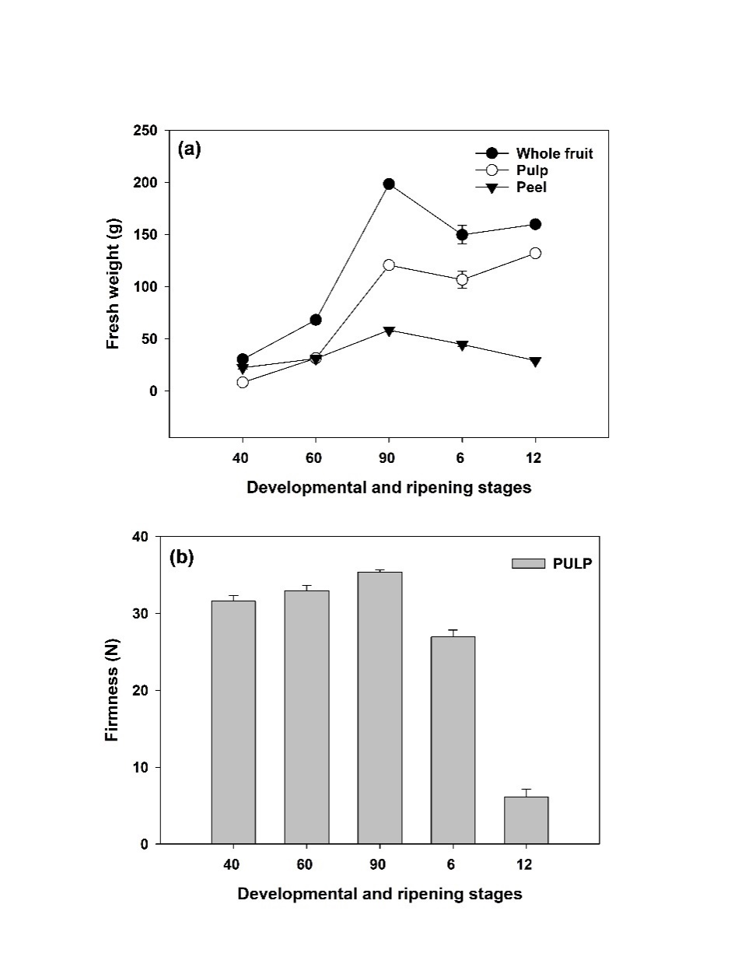

Fig. 2.a, b. Representing biometric changes of banana fruit (a) fresh weight and (b) pulp firmness during developmental and ripening stages of banana. Each value shows the average of three biological replications of three fruits and vertical error bars represent the standard deviation (±SD).

3.2.2 Estimation of starch, total sugar, sucrose, glucose and maltose content
In the present study the starch content was reduced from developmental to ripening stages in both peel and pulp tissues. Further, slightly higher starch content was recorded for the peel compared to pulp tissue during developmental and ripening stages. Higher starch levels in the peel compared to the pulp during developmental stages are in consistent with the previous reports, revealing peel tissues can act as transient storage sites, partly due to their photosynthetic capacity and delayed mobilization of reserves (Grierson, 2001; Schmitz et al., 2022). Upon transition to the ripening stage, a pronounced decline of starch content was evident at 12 DAR in both peel (20%) pulp (50%) tissues, compared to 90DAF, indicating a rapid starch degradation and conversion into soluble sugars, that contribute to sweetness and texture softening (Do et al., 2006; Silva et al., 2008). In contrast, the slower reduction of starch in the peel supports the idea of tissue-specific regulation of carbohydrate metabolism, likely linked to lower amylolytic enzyme activity or delayed induction of starch-degrading pathways in peel tissues (Purgatto et al., 2001; Xiao et al., 2018). Such spatiotemporal differences in starch turnover between peel and pulp have been reported in several climacteric fruits during ripening (Gao et al., 2016; Xiao et al., 2018; Nicolai et al., 2023) (Fig. 3a).
During the fruit development, sugar accumulation showed a steady increase in both peel (2.75-fold increase, ≈175%) and pulp (2.5-fold rise ≈150%) tissues. Following the onset of ripening, a marked increase in sugar concentration was observed in both tissues at 12DAR compared to 6DAR, and the observed trend is inconsistent with the starch breakdown (Fig. 3b).

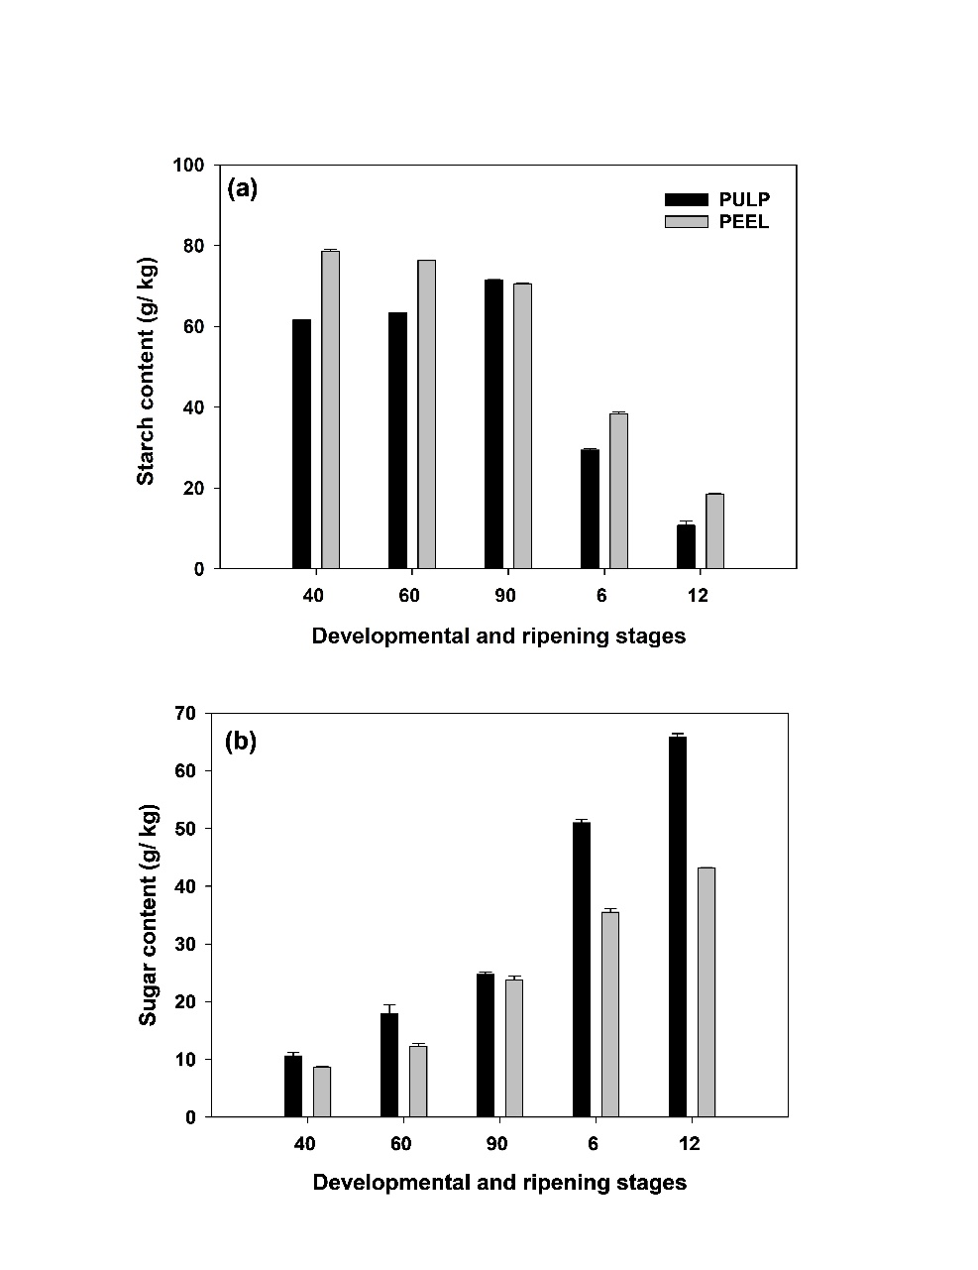

Fig. 3.a, b. Representing the biochemical changes of banana fruit (a) starch content (g/ kg) and (b) sugar content (g/kg) during different developmental and ripening stages. Each value represents the mean of three biological replications of three fruits analyzed at each ripening stage and vertical error bars represent the standard deviation (±SD).

The concentration of total soluble sugars, including sucrose, glucose, and maltose, exhibited a marked increase from the developmental to ripening stage, indicating active starch hydrolysis and sugar accumulation during fruit ripening. Among the sugars, sucrose (Fig. 4b) was the predominant component, showing a substantial elevation in both tissues. Glucose also showed a notable rise across ripening stages, with the peel increasing from approximately 200 to 550 mg g⁻¹ FW (~2.75-fold or 175% increase) and the pulp from 150 to about 350 mg g⁻¹ FW (~2.3-fold or 133% increase) (Fig. 4a). In consistence with our results, previous studies on melons revealed the glucose levels initially exceeded sucrose during early development, but higher sucrose content recorded in ripening stage, while the glucose content declined (Chayut et al., 2015).
In contrast, maltose displayed the most dramatic increase at 12 DAR in the pulp tissue. The peel exhibited a rise in maltose content at 12 DAR compared to 6DAR (Figure 4c). In this study, among the sugars analysed, sucrose consistently exhibited higher concentrations than both D-glucose and maltose throughout the fruit maturation, and similar results were observed in different fruit crops previously (Ersoy et al., 2007; Phillips et al., 2021). In our study, all three sugars in pulp tissue consistently exhibited higher concentrations than the peel, particularly during early development and ripening, and our results are in consistence with the earlier reports (Pereira et al., 2018). This marked acceleration in sugar accumulation from early to late ripening, indicating intensified sugar metabolism and possibly enhanced sucrose hydrolysis and hexose accumulation associated with ripening processes. Which supports the hypothesis that banana fruit ripening is a redox-mediated developmental reprogramming process, where oxidative bursts and carbohydrate dynamics fine-tune cell wall disassembly (Pereira et al., 2018; Phillips et al., 2021; Li et a., 2021; Rodrigues et al., 2023).
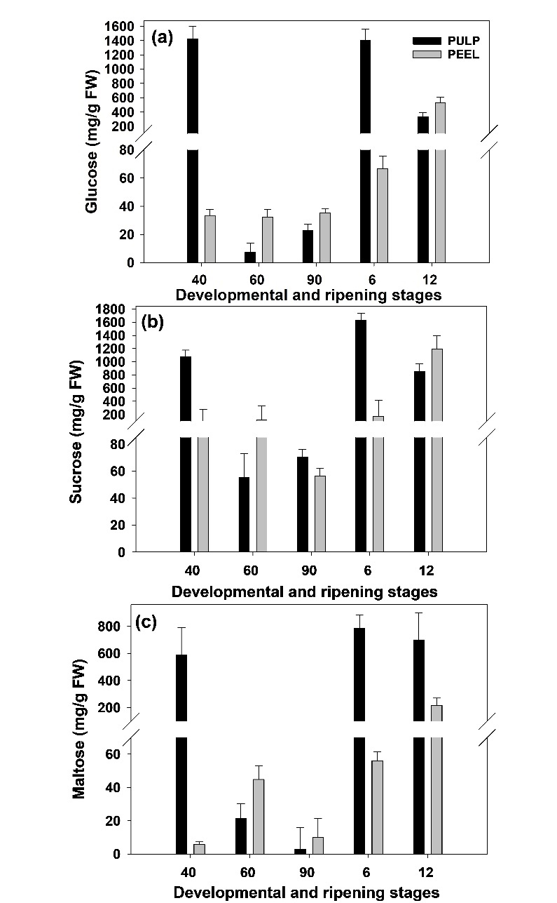

Fig. 4.a-c. Representing the total soluble sugar content of banana fruit (a) glucose (mg/g FW) (b) sucrose (mg/g FW) (c) maltose (mg/g FW). Each value represents the mean of three biological replications of three fruits analyzed at each ripening stage and vertical error bars represent the standard deviation (±SD).

3.3 Spatiotemporal gene expression studies through RTqPCR banana fruit during development and ripening and in different tissues

Based on the proteome analysis (Mohanty et al., 2025) data, highly interacting proteins corresponding genes from different metabolic pathways considered for gene expression by RTq-PCR. Total nine genes were considered based on their potential role in starch and sugar metabolism, cell wall modification and ROS scavenging activity.

3.3.1 Differential expression dynamics of SUS metabolism gene
During the ripening phase, SUS expression remained relatively low in both tissues at 6 and12 DAR, indicating minimal transcriptional activity during the ripening transition. Overall, SUS expression was predominantly higher in pulp tissues during early developmental stages and showed reduced expression during ripening in the present study (Fig. 7c). However, earlier reports revealed SUS gene exhibited a dual expression pattern with elevated levels at early and late ripening stage, in both peel and pulp tissue (Pereira et al., 2018; Phillips et al., 2021).
3.3.2 Differential expression dynamics of cell wall metabolism genes

The expression pattern of cell wall modifying genes i.e., XTH and PEL1 during developmental to ripening shift indicates a dual phase regulation, early- acting XTHs mediate extensibility, while late-acting XTHs and PEL1 drive softening and pectin solubilization in different fruits (Wang et al., 2023; Rodrigues et al., 2023; Srivastava et al., 2026). In this study, XTH-3, -4, and -8 showed strong expression in the pulp during early fruit developmental stage which is coinciding with the previous reports (Zhai et al., 2022; Rodrigues et al., 2023), but the overall peel expression profile was reduced from developmental to late ripening stages. XTH-5, -6, and PEL1 shows higher expression level at ripening stages and our results are in consistent with the previous study carried out on persimmon fruit and Fragaria vesca, on secondary wall disassembly and softening (Ghosh et al., 2015; Han et al., 2016; Zhang et al., 2020). The expression of PEL1 gene in this study, decreased in both the tissues from developmental to ripening stages, which is in consistence with the earlier reports, where peel and pulp softening occurred in a coordinated manner to promote necessary softening of the climacteric fruit (Wang et al., 2023; Rodrigues et al., 2023; Li et al., 2023 Srivastava et al., 2026).

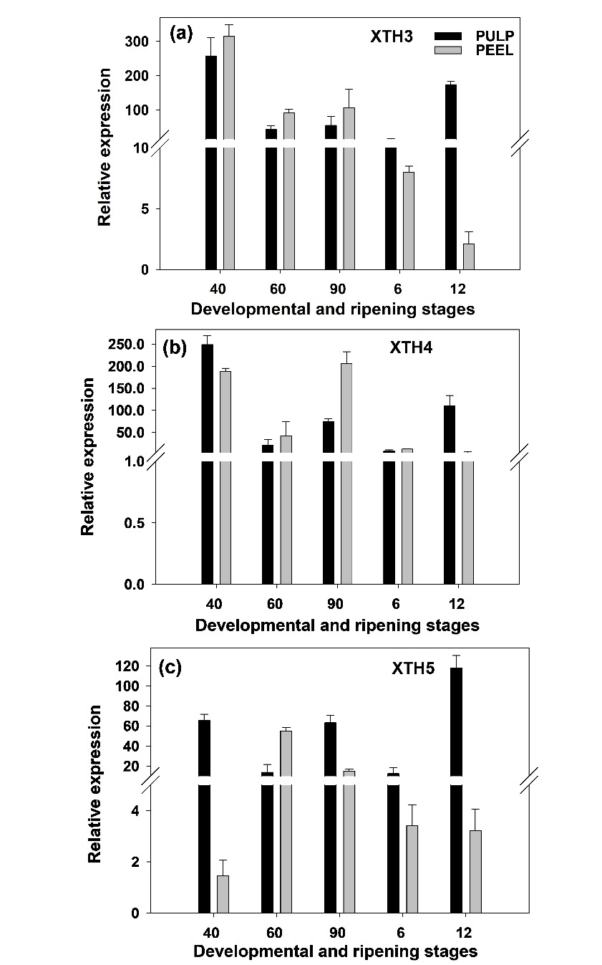

Fig. 5.a-c. Real time quantitative polymerase chain reaction (RT-qPCR) analysis representing the gene expression profiles of (a) XTH3 (b) XTH4 and (c) XTH5, and CYP as reference gene. Each vertical bar represents the relative expression of gene at different developmental and ripening stages and vertical bars represent standard deviation from three replicated assays.

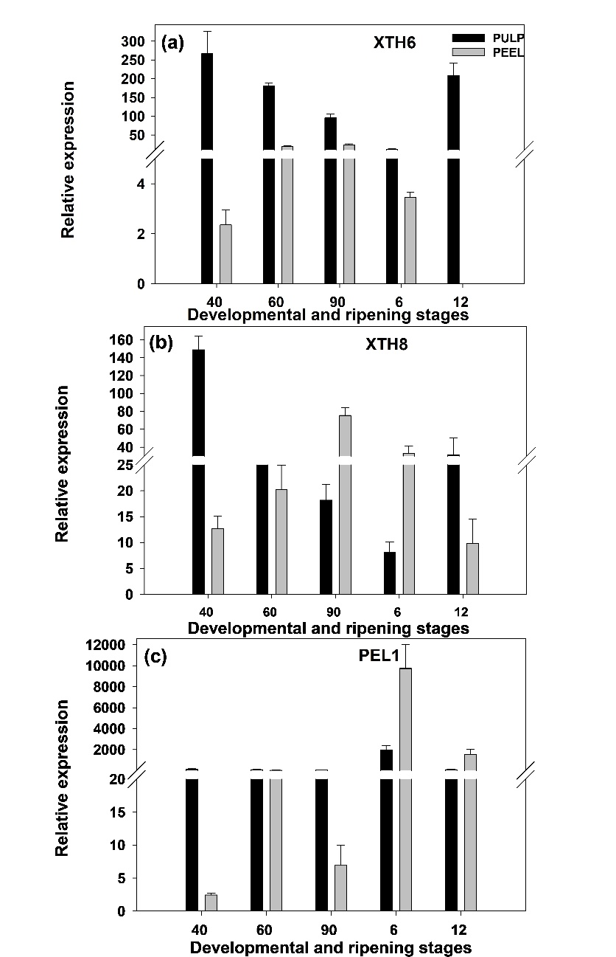

Fig. 6.a-c. Real time quantitative polymerase chain reaction (RT-qPCR) analysis representing the gene expression profiles of (a) XTH6 (b) XTH8 and (c) PEL1, and CYP as reference gene. Each vertical bar represents the relative expression of gene at different developmental and ripening stages and vertical bars represent standard deviation from three replicated assays.

3.3.3 Differential expression dynamics of ROS metabolism genes
The SOD activity increased from early to late ripening stage in pulp, whereas decreased trend was recorded in peel from developmental to ripening stage. In peel tissue, ROS generation is active due to the water loss, and tissue experience stress, which suggests that SOD could be having role in ROS scavenging in peel at ripening. This was confirmed by the earlier reports, that SOD exhibited a dramatic induction at the late ripening stage in pulp (Zhang et al., 2020; Li et al., 2023).
POD expression was reduced from early to late ripening in both peel and pulp tissues, respectively, reflecting its active role in early ripening, by facilitating softening of the tissue (Fig. 7a, b). This pattern suggests a functional transition in ROS scavenging mechanism of POD predominantly involves in fruit development, while SOD plays a major role in ROS scavenging in the pulp during the later stages of ripening (Sudhakar et al., 2001; Zhang et al., 2020; Li et al., 2021; Li et al., 2023).

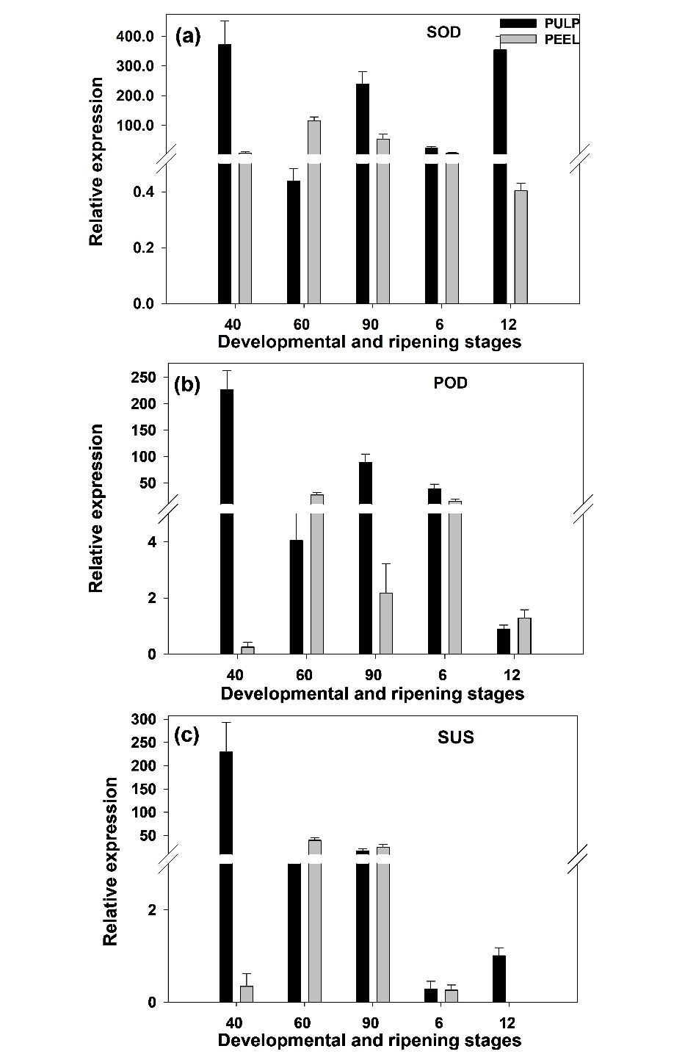

Fig. 7.a-c. Real time quantitative polymerase chain reaction (RT-qPCR) analysis representing the gene expression profiles of (a) SOD (b) POD and (c) SUS, and CYP as reference gene. Each vertical bar represents the relative expression of gene at different developmental and ripening stages and vertical bars represent standard deviation from three replicated assays.

- CONCLUSION
In this study, we have conducted gene expression studies through RTq-PCR for a major class of cell wall modification genes i.e. SUS, XTH (XTH-3, -4, -5, -6 and -8), PEL1, POD, and SOD by considering CYP as housekeeping gene. Majority of the studied XTH genes, i.e. XTH-3, -4, -5, -8 and -6 exhibited increased gene expression during ripening stages of banana, confirming its role in fruit ripening. However, studied XTH genes expression was not explored previously to the best of our knowledge in banana during fruit ripening, hence it becomes the first report which is dealing with the spatiotemporal expression of XTH genes.
In line with XTH gene expression, another important cell wall modifying gene i.e., PEL1 expression was also increased during the ripening stage, confirming its role in degrading the cell wall pectins, thereby softening of the fruit. During early development, high pulp SUS expression correlates with active carbon partitioning toward expanding tissues, sugar accumulation, and cell wall depolymerization. SOD showed a dramatic induction at the late ripening stage, particularly in pulp tissue. This strong upregulation of SOD implies an active detoxification response against oxidative bursts accompanying cell wall degradation and ethylene signalling. In contrast, POD expression was relatively stable across development but reduced during ripening stages, indicating its role in scavenging hydrogen peroxide generated by metabolic activity.
Hence the current study discloses coordinated activities of XTHs, PEL, ROS and SUS metabolism genes in cell wall modification during banana fruit development and ripening. Identified genes can be further validated using genome editing tool to assign individual functional role for these genes in fruit ripening and shelf-life.

Disclaimer (Artificial Intelligence)
Author(s) hereby declare that NO generative AI technologies such as Large Language Models (ChatGPT, COPILOT, etc.) and text-to-image generators have been used during the writing or editing of this manuscript.
References
Acharya, T. P., Malladi, A., & Nambeesan, S. U. (2024). Sustained carbon import supports sugar accumulation and anthocyanin biosynthesis during fruit development and ripening in blueberry (Vaccinium ashei). Scientific Reports, 14(1), 24964. https://doi.org/10.1038/s41598-024-74929-w
Aguilar-Velazquez, B., Rosas-Quijano, R., Vazquez-Ovando, A., Salvador-Figueroa, M., Adriano-Anaya, L., & Galvez-Lopez, D. (2021). CpXTH2 and CpXTH5 genes are expressed during fruit development and ripening in Carica papaya L. Fruits, 76(1), 3-10. https://doi.org/10.17660/th2021/76.1.1
Al-Dairi, M., Pathare, P. B., Al-Yahyai, R., Jayasuriya, H., & Al-Attabi, Z. (2023). Postharvest quality, technologies, and strategies to reduce losses along the supply chain of banana: A review. Trends in Food Science & Technology, 134, 177-191. https://doi.org/10.1016/j.tifs.2023.03.003
Alferez, F., Alquezar, B., Burns, J. K., & Zacarias, L. (2010). Variation in water, osmotic and turgor potential in peel of ‘Marsh’grapefruit during development of postharvest peel pitting. Postharvest Biology and Technology, 56(1), 44-49. https://doi.org/10.1016/j.postharvbio.2009.12.007
Al-Hinai, T. Z., Mackay, C. L., & Fry, S. C. (2024). Fruit softening: evidence for rhamnogalacturonan lyase action in vivo in ripe fruit cell walls. Annals of botany, 133(4), 547-558. https://doi.org/10.1093/aob/mcad197
Ali, S., Ullah, M.A., Nawaz, A., Naz, S., Shah, A.A., Gohari, G., Razavi, F., Khaliq, G., & Razzaq, K. (2022). Carboxymethyl cellulose coating regulates cell wall polysaccharides disassembly and delays ripening of harvested banana fruit. Postharvest Biology and Technology, 191, 111978.https://doi.org/10.1016/j.postharvbio.2022.111978
Anderson, C. T., & Pelloux, J. (2025). The dynamics, degradation, and afterlives of pectins: influences on cell wall assembly and structure, plant development and physiology, agronomy, and biotechnology. Annual Review of Plant Biology, 76(1), 85-113. https://doi.org/10.1146/annurev-arplant-083023-034055
Asif, M. H., Lakhwani, D., Pathak, S., Gupta, P., Bag, S. K., Nath, P., & Trivedi, P. K. (2014). Transcriptome analysis of ripe and unripe fruit tissue of banana identifies major metabolic networks involved in fruit ripening process. BMC plant biology, 14(1), 316. https://doi.org/10.1186/s12870-014-0316-1
Brummell, D. A. (2006). Cell wall disassembly in ripening fruit. Functional Plant Biology, 33(2), 103-119. https://doi.org/10.1071/FP05234
Burdon, J. N., Dori, S., Lomaniec, E., Marinansky, R., & Pesis, E. (1994). The post-harvest ripening of water stressed banana fruits. Journal of Horticultural Science, 69(5), 799-804. https://doi.org/10.1080/14620316.1994.11516515
Campos, N.A., Colombié, S., Moing, A., Cassan, C., Amah, D., Swennen, R., Gibon, Y., & Carpentier, S. C. (2022). From fruit growth to ripening in plantain: a careful balance between carbohydrate synthesis and breakdown. Journal of Experimental Botany, 73(14), 4832-4849. https://doi.org/10.1093/jxb/erac187
Chayut, N., Yuan, H., Ohali, S., Meir, A., Yeselson, Y., Portnoy, V., Zheng, Y., Fei, Z., Lewinsohn, E., Katzir, N., & Tadmor, Y. (2015). A bulk segregant transcriptome analysis reveals metabolic and cellular processes associated with Orange allelic variation and fruit β-carotene accumulation in melon fruit. BMC plant biology, 15(1), 274. https://doi.org/10.1186/s12870-015-0661-8
Chen, L., Zhong, H. Y., Kuang, J. F., Li, J. G., Lu, W. J., & Chen, J. Y. (2011). Validation of reference genes for RT-qPCR studies of gene expression in banana fruit under different experimental conditions. Planta, 234(2), 377-390. https://doi.org/10.1007/s00425-011-1410-3
Cosgrove, D. J. (2022). Building an extensible cell wall. Plant Physiology, 189(3), 1246-1277. https://doi.org/10.1093/plphys/kiac184
Cronjé, P. J., Zacarías, L., & Alférez, F. (2017). Susceptibility to postharvest peel pitting in Citrus fruits as related to albedo thickness, water loss and phospholipase activity. Postharvest Biology and Technology, 123, 77-82. https://doi.org/10.1016/j.postharvbio.2016.08.012
Deng, Z., Jung, J., Simonsen, J., & Zhao, Y. (2017). Cellulose nanomaterials emulsion coatings for controlling physiological activity, modifying surface morphology, and enhancing storability of postharvest bananas (Musa acuminate). Food Chemistry, 232, 359-368. https://doi.org/10.1016/j.foodchem.2017.04.028
Do Nascimento, J. R. O., Júnior, A. V., Bassinello, P. Z., Cordenunsi, B. R., Mainardi, J. A., Purgatto, E., & Lajolo, F. M. (2006). Beta-amylase expression and starch degradation during banana ripening. Postharvest Biology and Technology, 40(1), 41-47. https://doi.org/10.1016/j.postharvbio.2005.11.008
Durán-Soria, S., Pott, D. M., Osorio, S., & Vallarino, J. G. (2020). Sugar signaling during fruit ripening. Frontiers in Plant Science, 11, 564917. https://doi.org/10.3389/fpls.2020.564917
Dwivany, F. M., Esyanti, R. R., & Zaskia, H. (2016). Expression study of banana pathogenic resistance genes. HAYATI Journal of Biosciences, 23(4), 196-199. https://doi.org/10.1016/j.hjb.2016.06.007
Ersoy, N., Gozlekçki, S., & Kaynak, L. (2007). Changes in sugar contents of fig fruit (Ficus carica l. Cv. Bursa Siyahi) during development.https://dergipark.org.tr/en/download/article-file/308834
FAO, 2024. Banana Market Review 2022-23. FAO, Rome.https://www.fao.org/markets-and-trade/commodities/bananas/en
Franscistt, W., David, F. B., & Robert, M. D. (1971). The estimation of the total soluble carbohydrate in cauliflower tissue. Experiment in plant phyisiology. Exp Plant Phyisiol Van Nostrand New York, 16.
Fu, C., Han, C., Wei, Y., Liu, D., & Han, Y. (2024). Two NAC transcription factors regulated fruit softening through activating xyloglucan endotransglucosylase/hydrolase genes during kiwifruit ripening. International Journal of Biological Macromolecules, 263, 130678. https://doi.org/10.1016/j.ijbiomac.2024.130678
Gao, H., Huang, S., Dong, T., Yang, Q., & Yi, G. (2016). Analysis of resistant starch degradation in postharvest ripening of two banana cultivars: Focus on starch structure and amylases. Postharvest Biology and Technology, 119, 1-8. https://doi.org/10.1016/j.postharvbio.2016.03.022
Ghosh, S., Meli, V. S., Kumar, A., Thakur, A., Chakraborty, N., Chakraborty, S., & Datta, A. (2011). The N-glycan processing enzymes α-mannosidase and β-D-N-acetylhexosaminidase are involved in ripening-associated softening in the non-climacteric fruits of capsicum. Journal of Experimental Botany, 62(2), 571-582. https://doi.org/10.1093/jxb/erq289
Gidado, A., Daja, A., Kassim, Z. M., Idris, A., & Audu, M. (2018). Free Sugars and Fructan Contents of Commonly Consumed Fruits of Maiduguri Metropolis North East Nigeria. J Food Process Technol, 10(770), 2. http://dx.doi.org/10.4172/2157-7110.1000770
González-Gordo, S., Muñoz-Vargas, M. A., Palma, J. M., & Corpas, F. J. (2023). Class III peroxidases (POD) in pepper (Capsicum annuum L.): Genome-wide identification and regulation during nitric oxide (NO)-influenced fruit ripening. Antioxidants, 12(5), 1013. https://doi.org/10.3390/antiox12051013
Grierson, W. (2001). Fruit development, maturation, and ripening. In Handbook of plant and crop physiology,(pp. 165-182). CRC Press. https://doi.org/10.1201/9780203908426-10/fruit-development-maturation-ripening-william-grierson
Gujjar, R. S., Kumar, R., Goswami, S. K., Srivastava, S., & Upadhyay, A. K. (2024). Colletotrichum falcatum influences sucrose accumulation in sugarcane stalks by modulating the expression of SPS, SPP, SuSy, and invertases. Physiological and Molecular Plant Pathology, 130, 102237. https://doi.org/10.1016/j.pmpp.2024.102237
Han, Y. E., Ban, Q., Li, H., Hou, Y., Jin, M., Han, S., & Rao, J. (2016). DkXTH8, a novel xyloglucan endotransglucosylase/hydrolase in persimmon, alters cell wall structure and promotes leaf senescence and fruit postharvest softening. Scientific reports, 6(1), 39155. https://doi.org/10.1038/srep39155
Hu, C., Gao, X., Dou, K., Zhu, C., Zhou, Y., & Hu, Z. (2023). Physiological and metabolic changes in tamarillo (Solanum betaceum) during fruit ripening. Molecules, 28(4), 1800. https://doi.org/10.3390/molecules28041800
Huang, X., Sun, G., Wu, Z., Jiang, Y., Li, Q., Yi, Y., & Yan, H. (2023). Genome-wide identification and expression analyses of the pectate lyase (PL) gene family in Fragaria vesca. BMC genomics, 24(1), 435. https://doi.org/10.1186/s12864-023-09533-9
Kaur, A., Sharma, S., & Singh, N. P. (2021). Biochemical changes in pear fruits during storage at ambient conditions. Advances in Horticultural Science, 35(3), 293-304.https://www.torrossa.com/en/resources/an/5176340#page=89
Kumari, P., Gaur, S. S., & Tiwari, R. K. (2023). Banana and its by‐products: A comprehensive review on its nutritional composition and pharmacological benefits. EFood, 4(5), e110. https://doi.org/10.1002/efd2.110
Li, G., Hu, F., Zhang, Y., Zhao, Y., Wang, H., Chen, T., Cheng, X., & Cai, Y. (2021). Comparative genomic analysis of superoxide dismutase (SOD) genes in three Rosaceae species and expression analysis in Pyrus bretschneideri. Physiology and Molecular Biology of Plants, 27(1), 39-52. https://doi.org/10.1007/s12298-021-00926-2
Li, G., Manzoor, M.A., Wang, G., Huang, S., Ding, X., Abdullah, M., Zhang, M., & Song, C. (2024). Comparative analysis of POD genes and their expression under multiple hormones in Pyrus bretschenedri. BMC Genomic Data, 25(1), 41. https://doi.org/10.1186/s12863-024-01229-7
Li, N., Zhai, K., Yin, Q., Gu, Q., Zhang, X., Melencion, M. G., & Chen, Z. (2023). Crosstalk between melatonin and reactive oxygen species in fruits and vegetables post-harvest preservation: An update. Frontiers in Nutrition, 10, 1143511. https://doi.org/10.3389/fnut.2023.1143511
Li, X., Rahman, F.U., Zhao, Y., Lei, Q., Chen, W., Li, X., Hu, H., & Zhu, X. (2025). 1-MCP and MAP treatments reduce the finger drop of banana during the shelf-life after high temperatures storage by regulating cell-wall metabolism. Postharvest Biology and Technology, 229, 113692. https://doi.org/10.1016/j.postharvbio.2025.113692
Li, X., Su, Q., Feng, Y., Gao, X., Wang, B., Tahir, M.M., Yang, H., & Zhao, Z. (2023). Identification and analysis of the xyloglucan endotransferase/hydrolase (XTH) family genes in apple. Scientia Horticulturae, 315, 111990. https://doi.org/10.1016/j.scienta.2023.111990
Li, X., Xiong, T., Zhu, Q., Zhou, Y., Lei, Q., Lu, H., Chen, W., Li, X., & Zhu, X. (2023). Combination of 1-MCP and modified atmosphere packaging (MAP) maintains banana fruit quality under high temperature storage by improving antioxidant system and cell wall structure. Postharvest Biology and Technology, 198, 112265. https://doi.org/10.1016/j.postharvbio.2023.112265
Li, Y., Huang, W., Gao, H., Yi, G., & Yan, S. (2025). Regulation of starch metabolism in banana fruit: Mechanisms shaping the nutritional quality. Current Opinion in Plant Biology, 84, 102698. https://doi.org/10.1016/j.pbi.2025.102698
Lika, R., Socheata, C., & Sokra, I. (2026). Regulatory role of cell wall–modifying enzymes in fruit softening and texture development: A comprehensive review. Journal of Agriculture and Technology, 2(1), 72-78. https://doi.org/10.5281/zenodo.17958590
Liu, B., Jing, D., Liu, F., Ma, H., Liu, X., & Peng, L. (2021). Serendipita indica alleviates drought stress responses in walnut (Juglans regia L.) seedlings by stimulating osmotic adjustment and antioxidant defense system. Applied Microbiology and Biotechnology, 105(23), 8951-8968. https://doi.org/10.1007/s00253-021-11653-9
Liu, L., Feng, Y., Han, Z., Song, Y., Guo, J., Yu, J., Wang, Z., Wang, H., Gao, H., Yang, Y. & Wang, Y., (2024). Functional analysis of xyloglucan endotransglycosylase/hydrolase gene MdXTH2 in apple fruit firmness formation. Journal of Integrative Agriculture. https://doi.org/10.1016/j.jia.2024.12.034
Ma, H., Hu, L., Zhao, J., He, J., Wen, A., Lv, D., Xu, Z., Lan, W. & Pan, L. (2025). Comparative analysis of chilling injury in banana fruit during storage: Physicochemical and microstructural changes, and early optical-based nondestructive identification. Foods, 14(8), 1319. https://doi.org/10.3390/foods14081319
Ma, X., Yuan, Y., Wu, Q., Wang, J., Li, J., & Zhao, M. (2020). LcEIL2/3 are involved in fruitlet abscission via activating genes related to ethylene biosynthesis and cell wall remodeling in litchi. The Plant Journal, 103(4), 1338-1350. https://doi.org/10.1111/tpj.14804
Mbéguié-A-Mbéguié, D., Hubert, O., Baurens, F. C., Matsumoto, T., Chillet, M., Fils-Lycaon, B., & Sidibé-Bocs, S. (2009). Expression patterns of cell wall-modifying genes from banana during fruit ripening and in relationship with finger drop. Journal of Experimental Botany, 60(7), 2021-2034. https://doi.org/10.1093/jxb/erp079
Meisel, L., Fonseca, B., González, S., Baeza-Yates, R., Cambiazo, V., Campos, R., Gonzalez, M., Orellana, A., Retamales, J. & Silva, H. (2005). A rapid and efficient method for purifying high quality total RNA from peaches (Prunus persica) for functional genomics analyses. Biological research, 38(1), 83-88. http://dx.doi.org/10.4067/S0716-97602005000100010
Mohanty, S., Suravajhala, P., & Surabhi, G. K. (2025). Spatiotemporal proteome expression during banana fruit development and ripening: Elucidation of molecular insights. Journal of Applied Biology & Biotechnology, 13(2), 122-135. http://dx.doi.org/10.7324/JABB.2025.199158
Nicolaï, B. M., Xiao, H., Han, Q., Tran, D. T., Crouch, E., Hertog, M. L., & Verboven, P. (2023). Spatio-temporal dynamics of the metabolome of climacteric fruit during ripening and post-harvest storage. Journal of Experimental Botany, 74(20), 6321-6330. https://doi.org/10.1093/jxb/erad230
Peng, Z., Liu, G., Li, H., Wang, Y., Gao, H., Jemrić, T., & Fu, D. (2022). Molecular and genetic events determining the softening of fleshy fruits: a comprehensive review. International journal of molecular sciences, 23(20), 12482. https://doi.org/10.3390/ijms232012482
Pereira, G. A., Arruda, H. S., Molina, G., & Pastore, G. M. (2018). Extraction optimization and profile analysis of oligosaccharides in banana pulp and peel. Journal of Food Processing and Preservation, 42(1), e13408. https://doi.org/10.1111/jfpp.13408
Phillips, K. M., McGinty, R. C., Couture, G., Pehrsson, P. R., McKillop, K., & Fukagawa, N. K. (2021). Dietary fiber, starch, and sugars in bananas at different stages of ripeness in the retail market. PLoS One, 16(7), e0253366. https://doi.org/10.1371/journal.pone.0253366
Pradhan, D., Pradhan, N., & Surabhi, G. K. (2025). Omics Approach for the Identification and Validation of Genes, Proteins and Regulators in Relevance to Fruit Development, Ripening and Shelf Life: Current Status and Future Prospectives. Journal of Advances in Biology & Biotechnology, 28(11), 1714-1744. https://doi.org/10.9734/jabb/2025/v28i113356
Punia Bangar, S., Trif, M., Ozogul, F., Kumar, M., Chaudhary, V., Vukic, M., Tomar, M., & Changan, S. (2022). Recent developments in cold plasma‐based enzyme activity (browning, cell wall degradation, and antioxidant) in fruits and vegetables. Comprehensive Reviews in Food Science and Food Safety, 21(2), 1958-1978. https://doi.org/10.1111/1541-4337.12895
Purgatto, E., Lajolo, F. M., Oliveira do Nascimento, J. R., & Cordenunsi, B. R. (2001). Inhibition of β-amylase activity, starch degradation and sucrose formation by indole-3-acetic acid during banana ripening. Planta, 212(5), 823-828. https://doi.org/10.1007/s004250000441
Rahman, F.U., Yao, Y., Xie, X., Chen, J., Ma, K., Chen, W., Li, X., & Zhu, X. (2024). Transcriptomics and metabolomics analysis reveal the key regulator in BTH-induced fruit resistance of banana. Plant Stress, 14, 100682. https://doi.org/10.1016/j.stress.2024.100682
Rana, M. K. (2006). Ripening changes in fruits and vegetables-a review. 35, 271-279. https://www.cabidigitallibrary.org/doi/full/10.5555/20083173609
Rao, M.J., Duan, M., Zhou, C., Jiao, J., Cheng, P., Yang, L., Wei, W., Shen, Q., Ji, P., Yang, Y., & Zheng, B. (2025). Antioxidant defense system in plants: reactive oxygen species production, signaling, and scavenging during abiotic stress-induced oxidative damage. Horticulturae, 11(5), 477. https://doi.org/10.3390/horticulturae11050477
Rodrigues, M.A., Ferreira, C.F., Amorim, E.P., Santos, R.M.F., Martins, F.M., Ledo, C.A.D.S., Soares, T.L., & Santana, J. R. F. D. (2023). Morpho-anatomical characterization, gene expression and protein cell wall modifications associated with natural finger drop in bananas. Acta Scientiarum. Agronomy, 45, e58336. https://doi.org/10.4025/actasciagron.v45i1.58336
Sachan, N., & Kumar, V. (2022). A critical review on physiological changes during growth maturation and ripening of citrus fruits. European Journal of Nutrition & Food Safety, 14(11), 146-159. https://doi.org/10.9734/ejnfs/2022/v14i111272
Sahoo, S., Jena, A., Pradhan, D., & Surabhi, G. K. (2026). A comprehensive review on tandem mass tag based proteomics deciphering molecular insights of fruit development and ripening. Discover Plants, 3(1), 41. https://doi.org/10.1007/s44372-026-00510-6
Satekge, T. K., & Magwaza, L. S. (2022). Delayed 1-Methylcyclopropene application improves ripening recovery in banana fruit after cold storage. Horticulture, Environment, and Biotechnology, 63(2), 207-215. https://doi.org/10.1007/s13580-021-00388-1Schmittgen, T. D., & Livak, K. J. (2008). Analyzing real-time PCR data by the comparative CT method. Nature protocols, 3(6), 1101-1108.https://doi.org/10.1038/nprot.2008.73.
Schmitz, G. J. H., Freschi, L., Ferrari, R. C., Peroni-Okita, F. H. G., & Cordenunsi-Lysenko, B. R. (2022). Exploring the significance of photosynthetic activity and carbohydrate metabolism in peel tissues during banana fruit ripening. Scientia Horticulturae, 295, 110811. https://doi.org/10.1016/j.scienta.2021.110811
Shafiee, R., Nahvi, I., & Emtiazi, G. (2005). Bioconversion of raw starch to SCP by co-culture of Cryptococcus aerius and Saccharomyces cerevisiae. Journal of Biological Sciences, 5(6), 717-723. https://www.academia.edu/download/3450396/717-723.pdf
Shi, Y., Li, B. J., Grierson, D., & Chen, K. S. (2023). Insights into cell wall changes during fruit softening from transgenic and naturally occurring mutants. Plant physiology, 192(3), 1671-1683. https://doi.org/10.1093/plphys/kiad128
Silva, A. P. F. B., Nascimento, J. R. O. D., Lajolo, F. M., & Cordenunsi, B. R. (2008). Starch mobilization and sucrose accumulation in the pulp of Keitt mangoes during postharvest ripening. Journal of food biochemistry, 32(3), 384-395. https://doi.org/10.1111/j.1745-4514.2008.00175.x
Song, Z., Zhu, X., Lai, X., Chen, H., Wang, L., Yao, Y., Chen, W., & Li, X. (2023). MaBEL1 regulates banana fruit ripening by activating cell wall and starch degradation‐related genes. Journal of Integrative Plant Biology, 65(9), 2036-2055. https://doi.org/10.1111/jipb.13506
Srivastava, A., Jain, G., Singh, M., & Verma, P. C. (2026). Targeted disruption of a cell wall-modifying gene α-Mannosidase using CRISPR-Cas9 enhances post-harvest shelf life in tomato through ABA accumulation. Plant Physiology and Biochemistry, 111017. https://doi.org/10.1016/j.plaphy.2026.111017
Su, Q., Li, X., Wang, L., Wang, B., Feng, Y., Yang, H., & Zhao, Z. (2022). Variation in cell wall metabolism and flesh firmness of four apple cultivars during fruit development. Foods, 11(21), 3518. https://doi.org/10.3390/foods11213518
Sudhakar, C., Lakshmi, A., & Surabhi, G. K. (2001). Changes in the antioxidant enzyme efficacy in two high yielding genotypes of mulberry (Morus alba L.) under NaCl salinity. Plant science, 161(3), 613-619. https://doi.org/10.1016/S0168-9452(01)00450-2
Sugianti, C., Imaizumi, T., Thammawong, M., & Nakano, K. (2022). Recent postharvest technologies in the banana supply chain. Reviews in Agricultural Science, 10, 123-137. https://doi.org/10.7831/ras.10.0_123
Vella, F. M., Calandrelli, R., & Laratta, B. (2021). Influence of ripening on polyphenolic content, degradative, and browning enzymes in Cantaloupe varieties (C. melo, L.). Horticulturae, 7(11), 421. https://doi.org/10.3390/horticulturae7110421
Wang, C. J., Chan, Y. L., Shien, C. H., & Yeh, K. W. (2015). Molecular characterization of fruit-specific class III peroxidase genes in tomato (Solanum lycopersicum). Journal of plant physiology, 177, 83-92. https://doi.org/10.1016/j.jplph.2015.01.011
Wang, L., Chen, S., Shao, J., Zhang, C., Mei, L., Wang, K., Jin, P., & Zheng, Y. (2022). Hydrogen sulfide alleviates chilling injury in peach fruit by maintaining cell structure integrity via regulating endogenous H2S, antioxidant and cell wall metabolisms. Food Chemistry, 391, 133283. https://doi.org/10.1016/j.foodchem.2022.133283
Wang, W., Wang, Y., Chen, T., Qin, G., & Tian, S. (2023). Current insights into posttranscriptional regulation of fleshy fruit ripening. Plant Physiology, 192(3), 1785-1798. https://doi.org/10.1093/plphys/kiac483
Wasala, W. M. C. B., Dissanayake, C. A. K., Dharmasena, D. A. N., Gunawardane, C. R., & Dissanayake, T. M. R. (2014). Postharvest losses, current issues and demand for postharvest technologies for loss management in the main banana supply chains in Sri Lanka. Journal of Postharvest Technology, 2(1), 80-87.
Witasari, L. D., Huang, F. C., Hoffmann, T., Rozhon, W., Fry, S. C., & Schwab, W. (2019). Higher expression of the strawberry xyloglucan endotransglucosylase/hydrolase genes Fv XTH 9 and Fv XTH 6 accelerates fruit ripening. The Plant Journal, 100(6), 1237-1253. https://doi.org/10.1111/tpj.14512
Wu, B., Guo, Q., Li, Q., Ha, Y., Li, X., & Chen, W. (2014). Impact of postharvest nitric oxide treatment on antioxidant enzymes and related genes in banana fruit in response to chilling tolerance. Postharvest Biology and Technology, 92, 157-163. https://doi.org/10.1016/j.postharvbio.2014.01.017
Xia, Y., Chiu, C. H., Do, Y. Y., & Huang, P. L. (2020). Expression fluctuations of genes involved in carbohydrate metabolism affected by alterations of ethylene biosynthesis associated with ripening in banana fruit. Plants, 9(9), 1120. https://doi.org/10.3390/plants9091120
Xiao, Y. Y., Kuang, J. F., Qi, X. N., Ye, Y. J., Wu, Z. X., Chen, J. Y., & Lu, W. J. (2018). A comprehensive investigation of starch degradation process and identification of a transcriptional activator Mab HLH 6 during banana fruit ripening. Plant biotechnology journal, 16(1), 151-164. https://doi.org/10.1111/pbi.12756
Yang, F., Wan, K., Kang, X., Zhong, W., Lv, J., Lin, Y., Wang, J., Lai, Z., Liao, B., & Lin, Y. (2025). Transcriptomics and Gene Family Identification of Cell Wall-Related Differentially Expressed Genes Reveal MaXTH32. 5 Involved in Fruit Firmness During Banana Ripening. Plants, 14(24), 3810. https://doi.org/10.3390/plants14243810
Yuan, S., Gou, X., Hu, J., Xiao, C., & Du, J. (2024). Mutation of tomato xyloglucan transglucosylase/hydrolase5 increases fruit firmness and contributes to prolonged shelf life. Journal of Plant Physiology, 303, 154350. https://doi.org/10.1016/j.jplph.2024.154350
Zhai, Z., Feng, C., Wang, Y., Sun, Y., Peng, X., Xiao, Y., Zhang, X., Zhou, X., Jiao, J., Wang, W., & Li, T. (2021). Genome-wide identification of the xyloglucan endotransglucosylase/hydrolase (XTH) and polygalacturonase (PG) genes and characterization of their role in fruit softening of sweet cherry. International Journal of Molecular Sciences, 22(22), 12331. https://doi.org/10.3390/ijms222212331
Zhang, M., Yang, H., Zhu, F., Xu, R., & Cheng, Y. (2021). Transcript profiles analysis of citrus aquaporins in response to fruit water loss during storage. Plant Biology, 23(5), 819-830. https://doi.org/10.1111/plb.13269
Zhang, W. W., Zhao, S. Q., Zhang, L. C., Xing, Y., & Jia, W. S. (2020). Changes in the cell wall during fruit development and ripening in Fragaria vesca. Plant Physiology and Biochemistry, 154, 54-65. https://doi.org/10.1016/j.plaphy.2020.05.028
Zhang, Y., Chen, Y., Gao, W., Tian, S., Lin, B., Gu, X., Lin, Y., Li, M., Wang, Y., He, W., & Tang, H. (2024). Characterization of superoxide dismutase (SOD) gene family and their responses to salinity stress and fruit development in octoploid strawberry. Agronomy, 14(11), 2514. https://doi.org/10.3390/agronomy14112514
Zhu, X., Jiang, L., Cai, Y., & Cao, Y. (2021). Functional analysis of four Class III peroxidases from Chinese pear fruit: a critical role in lignin polymerization. Physiology and Molecular Biology of Plants, 27(3), 515-522. https://doi.org/10.1007/s12298-021-00949-9

