Original Research Article
Host Range Expansion of Helopeltis theivora Waterhouse (Hemiptera: Miridae): First Record on Cowpea (Vigna unguiculata) in India

.
ABSTRACT

Aims: To document the occurrence of the tea mosquito bug, Helopeltis theivora on cowpea and to characterise its feeding damage in a newly recorded host.
Study design: Field-based observational study with laboratory confirmation.
Place and Duration of Study: Vegetable fields of Kerala Agricultural University, India; conducted during routine field surveillance from December 2025 to January 2026
Methodology: Field observations were carried out in cowpea-growing plots to record the incidence of H. theivora. Infested plants were examined for the presence of nymphs and adults, and feeding symptoms were documented. Specimens were collected and subjected to morphological and taxonomic identification under laboratory conditions for species confirmation. The extent of infestation was assessed based on the proportion of affected plants, and characteristic feeding damage symptoms were recorded and described.
Results: Both nymphs and adults of H. theivora were observed feeding on tender cowpea foliage. A high infestation level of 82% was recorded in the study area. Initial feeding symptoms appeared as small whitish spots, which progressively developed into brown, angular necrotic lesions, leading to a reduction in photosynthetic area. This study constitutes the first recorded incidence of H. theivora on cowpea.
Conclusion: The host expansion of H. theivora to cowpea indicates a potential emerging threat to pulse-based cropping systems. Such adaptation may lead to significant yield losses if left unmanaged. This warrants intensive pest monitoring, surveillance, along with the formulation of effective pest management strategies.

Keywords: Helopeltis theivora, cowpea, host expansion, Kerala, India

1. INTRODUCTION

The tea mosquito bugs of the genus Helopeltis exhibit a wide geographical distribution, ranging from West Africa to New Guinea and northern Australia, and include 40 species (Stonedahl, 1991). In India, among the Helopeltis complex, dominant species include Helopeltis theivora, H. antonii, and H. bradyi, which cause substantial damage. Within the species complex, the predominant species was H. antonii, due to its high population density, wide distribution, and economic importance, especially in cashew ecosystems. Studies reveal that H. antonii has a host range of approximately 30 plant species across 18 families (Prabhavathi et al., 2025). Reports on H. bradyi were restricted to peninsular India, though they were also recorded in the high-altitude region of Meghalaya. Helopeltis theivora was first reported infesting tea in Java in 1847 (Rao, 1970). In India, its occurrence on tea was subsequently documented in the Cachar region of Assam in 1865 (Watt and Mann, 1903). H. theivora is a highly polyphagous pest, which is reflected in its wide host range, including tea, cashew, cocoa, guava and coffee. In addition to food and cash crops, several weed species, such as Mikania micrantha, serve as alternate hosts for H. theivora in completing their lifecycle. The ability of these mirid bugs to infect a wide range of hosts helps them persist in different agroecosystems (Bharathi et al., 2024; Yao et al., 2025).
Reports suggest that the host range of H. theivora has been expanding continuously in recent years (Roy et al., 2015; Srikumar et al., 2015; Saroj et al., 2016), emphasising its capacity for host adaptation and colonisation, leading to the exploitation of new agroecosystems, including vegetables such as amaranth and eggplant. In this context, cow pea (Vigna unguiculata), an economically important legume crop infested with H. theivora, is of significant relevance. To the best of our knowledge, such an association has not been previously documented. Therefore, the present study reports the first record of H. theivora infesting cowpea ecosystems, thereby further extending its documented host range and showing its potential as an emerging threat to pulse-based agroecosystems of India.

2. material and methods

2.1 Field observation
A regular field visit was conducted in the vegetable fields of Kerala Agricultural University (10°32'48.0"N 76°16'54.7"E) to document the pests and diseases prevalent in the ecosystem during December 2025 to January 2026. Symptoms of damage were documented, and pests were collected in vials containing 70% ethanol for preservation and further identification in the laboratory.
2.2 Insect identification
The pest specimens collected were observed under a stereomicroscope for morphological characters such as antenna, body colour, wing venation and scutellar process. The species' identity was further validated by comparison with taxonomic keys and descriptions of Stonedahl (1991).

3. results and discussion

Investigations conducted in the cowpea field at the Kerala Agricultural University, Thrissur, Kerala, revealed blighted foliage on cowpea plants, indicating localised feeding damage associated with bug infestation. The collected specimens, upon microscopic examination and taxonomic comparison, were identified as Helopeltis theivora Waterhouse (Hemiptera: Miridae).
Species of adult H. theivora can be easily differentiated from others by a bicoloured pronotal collar, i.e., the pronotum typically exhibits a dark yellowish-orange colouration on the anterior half of the collar and along the anterolateral margins of the disc; in some cases, the coloured region extends further, leaving only the posterior margin of the disc infuscated. The base of antennal segment I is narrowly pale. In males, the distal third of antennal segment II and a substantial portion of segment III bear long, erect setae. The abdominal sternum (I–V) is uniformly pale along the lateral margins. The head typically displays a broad pale lateral stripe. The later instar nymphs also exhibit a greenish coloured body

Both nymphs and adults of H. theivora were found infesting the foliage of cowpea plants. (Fig. 1) The nymphs and adults suck sap from the leaf tissue, resulting in necrotic lesions on the leaf surface. Singular and coalesced lesions were observed due to extensive pest feeding. Initially, a white spot-like symptom developed in the feeding area around the stylet insertion region, which later progressed to pale necrotic lesions (Fig 2.). The stylet extracts the cellular contents of the individual plant cells, leaving the cell walls intact and structurally uncollapsed (Miles, 1987). Consequently, the spots progressively darken, and the inner area gradually develops a light brown colour that extends from the margin towards the centre due to the host plant's hypersensitive response (Yao et al., 2025). Similar symptoms were observed in Arabica coffee, with white spots with brown margins appearing within 3 minutes of feeding (Jakkoksung et al., 2023). Around 82% of the cowpea plants were infested with H. theivora. Adults and nymphs tend to prefer young leaves over older leaves, as the majority of the feeding symptoms were recorded on newly emerged and tender foliage. Such preference may be influenced by variations in plant metabolites, including flavonoids, phenolic acids, terpenoids, and soluble sugars, which are known to affect feeding and reproductive behaviour in Helopeltis theivora. Differences in the qualitative and quantitative composition of these metabolites can either promote or deter feeding, as observed in certain hosts, such as Senna tora (Fabaceae), which has been categorised as a low-preference host (Borthakur and Bora, 2023).
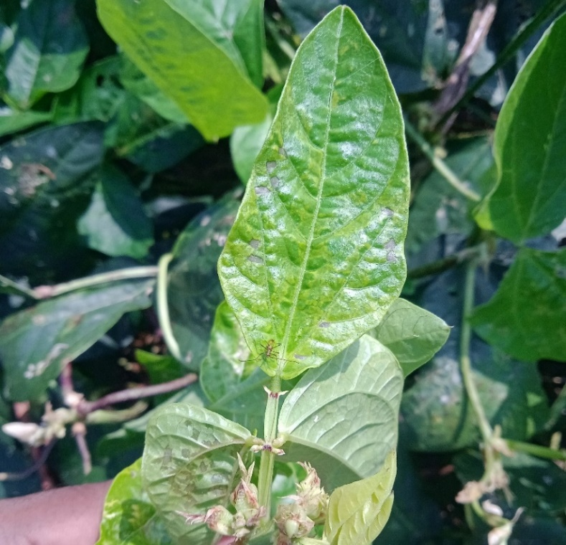
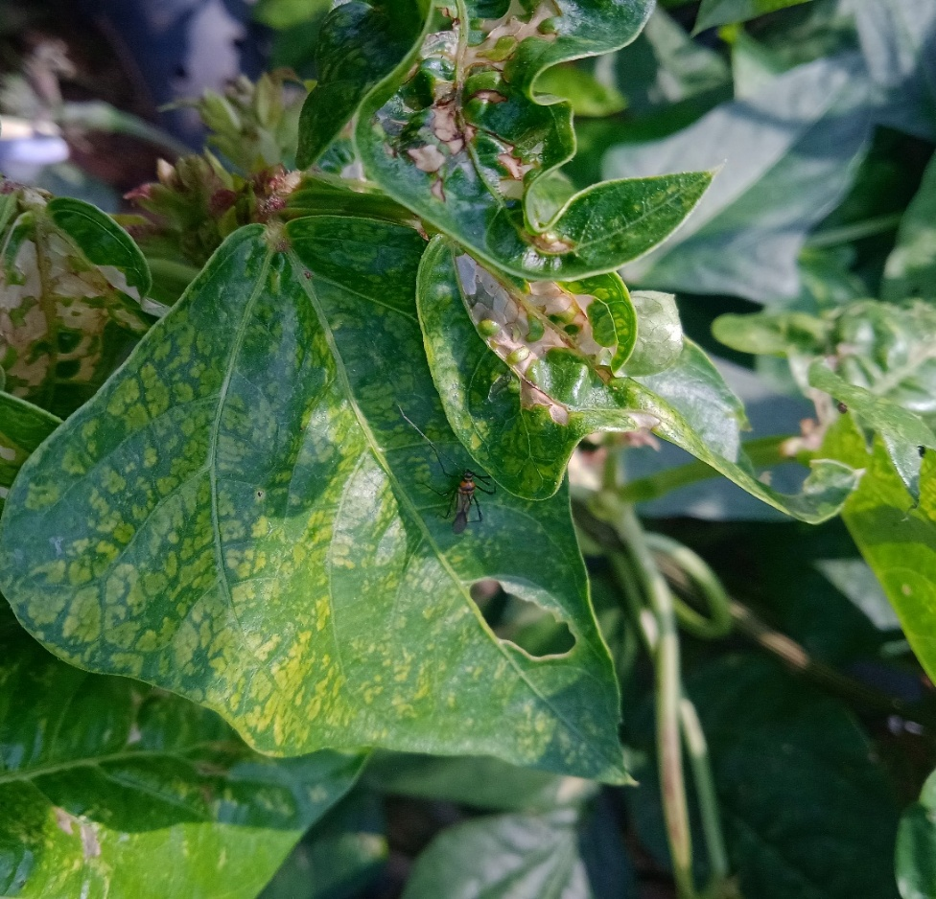
Such variation in metabolite composition not only influences feeding behaviour but also determines host suitability and utilisation by Helopeltis theivora. Accordingly, owing to its polyphagous nature, a wide range of crops serve as host plants for H. theivora, which mostly includes plantation and fruit crops. However, recent studies conducted in the Kollam district of Kerala reported that H. theivora was recorded on vegetable crops such as eggplant and green amaranth, with a high infestation rate (98%) (Sivakumar and Yeshwanth, 2019). This adaptability to metabolically diverse hosts may be facilitated by detoxifying enzymes, such as cytochrome P450 monoxygenases, which facilitate the utilisation of secondary metabolites from certain plants (Terriere, 1984; Li et al., 2007). In addition, H. theivora exhibited genetic variability linked to host association, with six haplotypes identified across 14 variable sites that clustered by host plant (Chamdrashekara et al., 2015), suggesting host-specific diversification. Such trends may result from initial host colonisation via ecological fitting, in which inherent traits enable the utilisation of new hosts without requiring prior evolutionary adaptation (Araujo et al., 2015). The present record of H. theivora on cowpea further substantiates its expanding host range and emerging importance in diverse cropping systems.
(a)
Fig. 1 Infestation of H. theivora in cowpea: (a) Nymph; (b) Adult
(b)

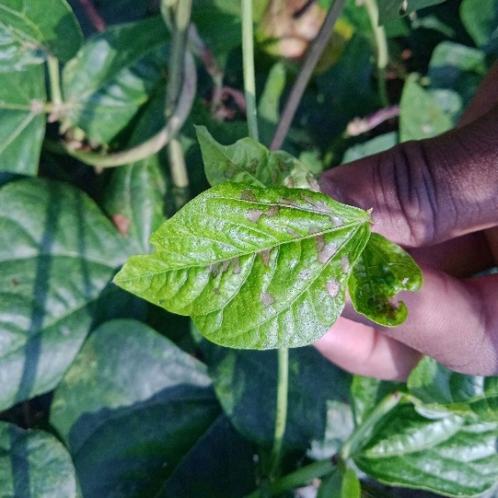
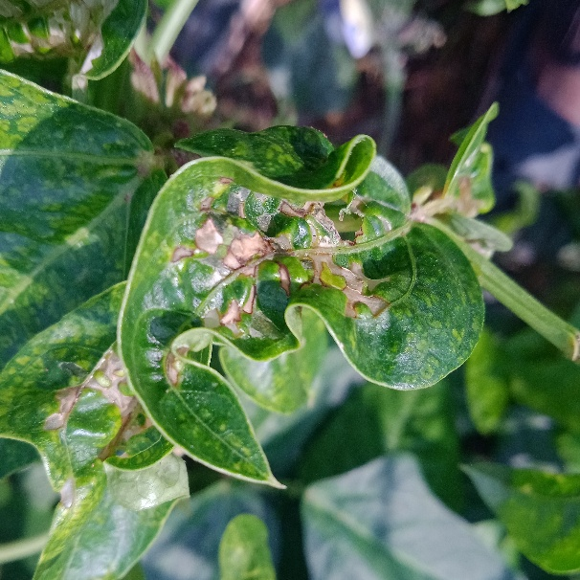
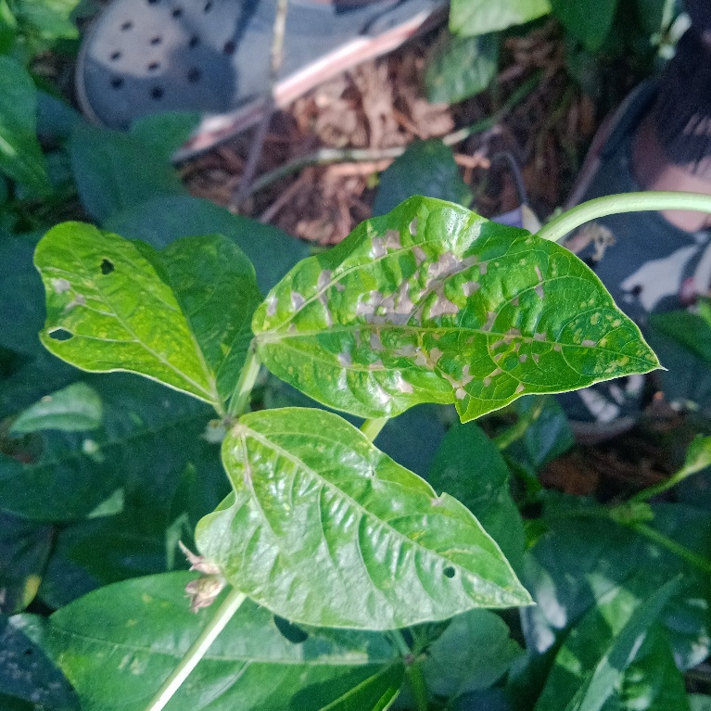

(a)
(c)
(b)

Fig. 2 Development of feeding lesions on cowpea caused by H. theivora: (a) Multiple discrete whitish lesions (early stage); (b) Coalesced whitish lesions (early stage); (c) Brown necrotic lesions (later stage).

4. Conclusion

The occurrence of Helopeltis theivora on cowpea in India is reported for the first time in this study, extending its known host range. The observed infestation confirms cowpea as a suitable host and highlights the pest's potential to expand into new cropping systems. Continuous monitoring and timely management are therefore essential to mitigate potential economic losses.

Competing interests

No potential conflict of interest was reported by author(s)

DECLARATION

Author(s) hereby declare that no generative AI technologies such as Large Language Models (ChatGPT, COPILOT, etc.) and text-to-image generators have been used during the writing or editing of this manuscript.

References

Araujo, S., Braga, M., Brooks, D., Agosta, S., Hoberg, E., Von Hartenthal, F., & Boeger, W. (2015). Understanding host-switching by ecological fitting. PLoS ONE, 10, e0139225. doi: 10.1371/journal.pone.0139225
Bharathi, N. S., Rabesh, T., & Sujatha, K. (2024). Courtship behavior and ecology of mating in tea mosquito bug Helopeltis theivora (Hemiptera: Miridae). Mysore Journal of Agricultural Sciences, 58(3), 316–324. doi: 10.55446/IJE.2023.821
Borthakur, S., & Bora, D. (2023). Identification of chemical cues of Camellia sinensis and alternate host plants for preference by tea mosquito bug Helopeltis theivora. International Journal of Scientific Research Archives, 8, 710–719. doi: 10.30574/ijsra.2023.8.1.0123
Chandrashekara, K. N., Raj Kumar, R., Kumar, V., Banerjee, D., Kundu, S., Ghosh, B., & Tyagi, K. (2015). DNA barcoding reveals host associated genetic diversity of tea mosquito bug Helopeltis theivora (Miridae: Heteroptera) from India. Journal of Asia-Pacific Entomology, 18(3), 541–545. doi: 10.1016/j.aspen.2015.07.004
Jakkoksung, A., Attasopa, K., Chiu, C., & Chanbang, Y. (2023). Life cycle and damage patterns of tea mosquito bug Helopeltis theivora, a newly recorded pest on arabica coffee in northern Thailand. Chiang Mai Journal of Science, 50(5), e2023047. doi: 10.12982/CMJS.2023.047
Li, X., Schuler, M. A., & Berenbaum, M. R. (2007). Molecular mechanisms of metabolic resistance to synthetic and natural xenobiotics. Annual Review of Entomology, 52, 231–253. doi: 10.1146/annurev.ento.51.110104.151104
Miles, P. W. (1987). Plant-sucking bugs can remove the contents of cells without mechanical damage. Experientia, 43, 937–939. doi: 10.1007/BF01951678
Prabhavathi, S. J., Kavimugilan, S., Kalyanasundaram, A., Gowsalya, R., Nanthini, B., Natarajan, S. K., Elankavi, S., & Venkatachalam, S. R. (2025). Tea mosquito bug, Helopeltis spp. (Miridae; Hemiptera) an emerging phytotoxic pest: A comprehensive review of its biology and management. Plant Science Today, 12(2), 1–12. doi: 10.14719/pst.7327
Rao, G. N. (1970). Helopeltis: A breakthrough in its control. UPASI Tea Scientific Department Bulletin, 28, 21–24.
Roy, S., Muraleedharan, N., Mukhapadhyay, A., & Handique, G. (2015). The tea mosquito bug Helopeltis theivora: status, biology, ecology and management in tea plantations. International Journal of Pest Management, 61(3), 179–197. doi: 10.1080/09670874.2015.1030002
Saroj, P. L., Bhat, P. S., & Srikumar, K. K. (2016). Tea mosquito bug (Helopeltis spp.) – a devastating pest of cashew in India: a review. Indian Journal of Agricultural Sciences, 86(2), 151–162. doi: 10.56093/ijas.v86i2.55868
Sivakumar, T., & Yeshwanth, H. M. (2019). New hosts of tea mosquito bug Helopeltis theivora on eggplant and amaranth from India. Phytoparasitica, 47, 499–503. doi:10.1007/s12600-019-00750-1
Srikumar, K. K., Bhat, P. S., Raviprasad, T. N., Vanitha, K., Krishnakumar, N. K., Rebijith, K. B., & Asokan, R. (2015). Distribution of major sucking pest Helopeltis spp. of cashew in India. Proceedings of the Zoological Society, 68(1), 30–35. doi: 10.1007/s12595-013-0091-2
Stonedahl, G. M. (1991). The Oriental species of Helopeltis (Heteroptera: Miridae): a review of economic literature and guide to identification. Bulletin of Entomological Research, 81, 465–490. doi: 10.1017/S0007485300032041
Terriere, L. C. (1984). Induction of detoxification enzymes in insects. Annual Review of Entomology, 29, 71–88. doi: 10.1146/annurev.en.29.010184.000443
Watt, A., & Mann, H. H. (1903). The pests and blights of the tea plant. Govt. Printing Press, Calcutta, pp. 429.
Yao, Q., Lin, Y. Z., Qin, S., Lin, Z. F., & Ji, X. C. (2025). Characterization of feeding damage by tea mosquito bug Helopeltis theivora on Hainan Dayezhong tea cultivar. Frontiers in Plant Science, 15, 1529535. doi: 0.3389/fpls.2024.1529535

