Original Research Article
Prevalence, antimicrobial resistance and phenotypic detection of virulence factors of non-fermenting Gram-negative bacilli isolated from canine clinical infections.

ABSTRACT
Non-fermenting gram-negative bacteria (NFGNB) are increasingly implicated in persistent and multidrug-resistant infections in companion animals, prompting the present investigation to assess their prevalence, identification, antimicrobial resistance, virulence attributes, and genomic characteristics in canine clinical infections, with particular emphasis on Pseudomonas and Acinetobacter species. A total of 402 clinical samples collected from dogs with diverse clinical conditions were processed for bacteriological examination, of which 332 samples (82.6%) yielded bacterial growth, and 73 isolates (21.7%) were identified as NFGNB. Among these, Pseudomonas spp. Constituted 19.0% (63/332), Acinetobacter spp. 2.7% (9/332) and Sphingomonas spp. 0.3% (1/332) with otitis and wound infections representing the major sources. Cultural and biochemical characterization showed that all NFGNB produced non-lactose-fermenting colonies on Macconkey agar; in the oxidative–fermentative (of) test, both Pseudomonas and Acinetobacter isolates demonstrated oxidative utilization of glucose without fermentation, supporting their classification as non-fermenters. Phenotypically, all pseudomonas isolates were motile and oxidase- and catalase-positive, whereas Acinetobacter isolates were non-motile and oxidase-negative; hemolytic activity was observed in 93.7% (59/63) of Pseudomonas isolates, while none of the Acinetobacter isolates exhibited hemolysis and biofilm formation was detected in 63.5% of Pseudomonas and 33.3% of Acinetobacter isolates. Antimicrobial susceptibility testing demonstrated a high burden of multidrug resistance, with pseudomonas spp. Showing resistance to cephalothin (57.14%), cefotaxime (53.97%), ceftazidime (52.38%), imipenem (34.92%), meropenem (19.05%), and colistin (30.16%), while acinetobacter spp. Exhibited marked resistance to oxacillin (88.89%), co-trimoxazole (77.78%), cefotaxime (66.67%), ceftazidime (66.67%), imipenem (44.44%), and meropenem (33.33%).
Key words: Non-fermenting Gram-negative bacteria, Pseudomonas, Acinetobacter, oxidative–fermentative test.

1. INTRODUCTION
Non-fermenting Gram-negative bacilli (NFGNB) are a heterogeneous group of aerobic, non-spore-forming bacteria that utilize oxidative rather than fermentative metabolism (Rezaei, 2022). Important genera include Pseudomonas, Acinetobacter, Alcaligenes, Sphingomonas and others. Once considered environmental contaminants, NFGNB are now recognized as significant opportunistic pathogens in both human and veterinary medicine (Praveetha et al., 2024). The SCOPE study reported that approximately 25% of Gram-negative bacteremia cases are caused by non-fermenters (Wisplinghoff et al., 2004). Their persistence in hospital environments and remarkable ability to withstand antimicrobial pressure has contributed to their rising clinical importance (Sushitha et al., 2025).
Among them, Pseudomonas aeruginosa and Acinetobacter baumannii are major healthcare-associated pathogens and members of the ESKAPE group (Magiorakos et al., 2012; De Oliveira et al., 2020). Both have been listed as urgent or critical threats by global health agencies, including the World Health Organization (WHO, 2017). In dogs, P. aeruginosa is frequently implicated in otitis externa, pyoderma, urinary tract infections, and wound infections (Degi et al., 2021). Otitis externa affects 7.5–16.5% of canine clinical cases (Miller, 2013) and P. aeruginosa accounts for 20–60% of reported infections, particularly in chronic or recurrent cases (Nocera et al., 2021).
The pathogenic success of P. aeruginosa is attributed to intrinsic resistance mechanisms such as low outer membrane permeability, efflux pump systems, and AmpC β-lactamase production, as well as acquired mechanisms including porin loss and β-lactamase gene acquisition (Yoshimura and Nikaido, 1982; Li et al., 2012). The emergence of carbapenem-resistant strains, including VIM-producing isolates, poses a serious therapeutic challenge (Gentilini et al., 2018). Additionally, virulence factors such as haemolysis, motility and biofilm formation enhance persistence and antimicrobial tolerance (Fernandes et al., 2018; Thöming and Häussler, 2022).
Reports of multidrug-resistant Acinetobacter infections in veterinary hospitals underscore their emerging nosocomial significance (Kuzi et al., 2016). Limited but growing evidence from India highlights the presence of resistant Pseudomonas and Acinetobacter isolates in companion animals (Anekar, 2018; Sharma, 2022).
From a One Health perspective, the close association between humans and companion animals facilitates bidirectional transmission of antimicrobial-resistant bacteria (Asokan et al., 2019; Elfadadny et al., 2023). Therefore, comprehensive surveillance of NFGNB in canine infections is essential to understand their prevalence, resistance patterns and virulence attributes to mitigate potential public health risks.

2. MATERIALS AND METHODS

2.1 STUDY LOCATION AND SAMPLE COLLECTION
The present study was carried out in the Department of Veterinary Microbiology, College of Veterinary Science and Animal Husbandry, DUVASU, Mathura, Uttar Pradesh, India. A total of 402 clinical samples were collected aseptically from dogs presented to the Teaching Veterinary Clinical Complex between February 2024 and June 2025.
Samples included ear swabs (n = 120), wound swabs (n = 110), eye swabs (n = 32), pus/abscess samples (n = 20), midstream urine samples (n = 28), uterine pus (n = 22), skin swabs (n = 60), and cyst aspirates (n = 10). All samples were transported promptly to the laboratory and processed under standard microbiological procedures.

2.2 ISOLATION AND IDENTIFICATION OF NON-FERMENTING GRAM-NEGATIVE BACILLI
Samples were inoculated into nutrient broth and incubated at 37°C for 18–24 h. Enriched cultures were streaked onto nutrient agar and MacConkey agar and incubated aerobically. Non-lactose fermenting colonies were further subcultured on selective media including cetrimide agar for presumptive Pseudomonas spp. and HiChrome Acinetobacter agar for presumptive Acinetobacter spp.
Preliminary identification was based on colony morphology, pigmentation, Gram staining, and biochemical tests including catalase, oxidase, citrate utilization, methyl red, Voges–Proskauer, nitrate reduction, indole, triple sugar iron (TSI), and oxidative–fermentative (OF) tests following standard protocols.
Species-level confirmation was performed using 16s rDNA gene and VITEK 2 Compact system (bioMérieux, France). PCR targeting a species-specific region of the 16S rDNA gene of Pseudomonas aeruginosa was carried out using PA-SS primers (Spilker et al. 2004). The forward primer sequence was 5′-GGGGGATCTTCGGACCTCA-3′ and the reverse primer sequence was 5′-TCCTTAGAGTGCCCACCCG-3′, which amplify a 956 bp fragment. PCR amplification was performed in a thermal cycler under the following conditions: initial denaturation at 95 °C for 2 min, followed by 25 cycles of denaturation at 94 °C for 20 s, annealing at 58°C for 20 s, and extension at 72 °C for 20 s, with a final extension at 72 °C for 1 min. The amplified PCR products were analyzed by agarose gel electrophoresis. A 1.5% agarose gel prepared in 1× TAE buffer containing ethidium bromide was used for separation of the amplified products. An aliquot of the PCR product mixed with loading dye was loaded into the wells along with a 100 bp DNA ladder as a molecular size marker. Electrophoresis was carried out at 80–100 V for approximately 45–60 min. The DNA bands were visualized under a UV transilluminator and documented using a gel documentation system.

2.3 PHENOTYPIC DETECTION OF VIRULENCE FACTORS
Isolates were screened for hemolytic activity on 5% sheep blood agar. Motility was assessed using motility agar plates after 24 h incubation. Biofilm formation was evaluated using the Congo red agar method where black, dry crystalline colonies were considered biofilm producers.

2.4 ANTIMICROBIAL SUSCEPTIBILITY TESTING
Antimicrobial susceptibility testing was performed by the Kirby–Bauer disc diffusion method on Mueller–Hinton agar in accordance with CLSI (2022) guidelines. Twenty-one antimicrobial agents representing 11 classes were tested. Results were interpreted as susceptible, intermediate, or resistant. Isolates showing resistance to three or more antimicrobial classes were classified as multidrug-resistant (MDR).

3. RESULTS AND DISCUSSION

3.1 PREVALENCE OF NON-FERMENTING GRAM-NEGATIVE BACILLI
Out of 402 canine clinical samples processed, 332 (82.6%) yielded bacterial growth. Among these, non-fermenting Gram-negative bacilli (NFGNB) accounted for 21.7% (73/332) of total isolates. Pseudomonas spp. were the predominant NFGNB, comprising 19.0% (63/332) of isolates, followed by Acinetobacter spp. at 2.7% (9/332). One isolate (0.3%) was identified as Sphingomonas spp. Overall, Escherichia coli (48.8%) and Staphylococcus spp. (24.1%) were the most common bacterial isolates recovered. Among NFGNB, otitis (17.5%) and wound infections (15.4%) were the principal sources of Pseudomonas spp., while Acinetobacter spp. were mainly isolated from otitis and wound cases. 16S rDNA species-level identification confirmed that 51 of the 63 Pseudomonas isolates were Pseudomonas aeruginosa (Fig.1). The Acinetobacter isolates included A.calcoaceticus–baumannii complex (n = 5), A. lwoffii (n = 3) and A. radioresistens/Moraxella/A. lwoffii (n = 1) were confirmed by VITEK 2 compact. The predominance of Pseudomonas in this study is in agreement with earlier findings, where Colombini et al. (2000) reported 23.2% prevalence in canine otitis, Türkyilmaz (2008) observed 17%, Hillier et al. (2007) recognized it as a leading pathogen in canine skin infections, and Singh et al. (2017) and Rosales et al. (2024) documented 22.22% and 18.3%, respectively.
The relatively low prevalence of Acinetobacter spp. (2.71%) observed in the present study is comparable to earlier veterinary reports. Black et al. (2009) identified A. baumannii in approximately 7% of canine clinical samples, indicating a modest but notable occurrence. Mitchell et al. (2018) reported colonization in 25% (10/40) of clinically healthy dogs, with 13 isolates recovered from 160 skin swabs (8.1%).
3.2 BIOCHEMICAL AND VIRULENCE ACTIVITY:
All Pseudomonas isolates were oxidase positive, motile, strictly aerobic, and non-fermentative, with most producing pigment. Similar observations were reported by Anekar (2018) and Narayan (2023) in canine isolates, and by Malini et al. (2009) in human samples. Conversely, Acinetobacter isolates were oxidase negative, non-motile, and strictly aerobic, aligning with findings of Gupta et al. (2015), Nakbubpa et al. (2021), and Kolk et al. (2019). Comparable conventional biochemical identification of NFGNB has also been documented in both veterinary and human studies (Mathewson and Simpson, 1982; Mahajan et al., 2016).
Phenotypic assessment showed that 93.6% (59/63) of Pseudomonas isolates exhibited hemolytic activity. All Pseudomonas isolates were motile, whereas Acinetobacter isolates were non-motile. Biofilm formation was observed in 63.5% of Pseudomonas and 33.3% of Acinetobacter isolates. Similar hemolytic patterns have been reported by Khalil et al. (2015) and Mohammed et al. (2024), while biofilm prevalence, although lower than that documented by Karatuna and Yagci (2010) and Inat et al. (2021), was comparable to Abdelraheem et al. (2020). In contrast, only 33.3% of Acinetobacter isolates formed biofilm, lower than the universal biofilm production described by Lysitsas et al. (2024), suggesting strain or geographic variation.

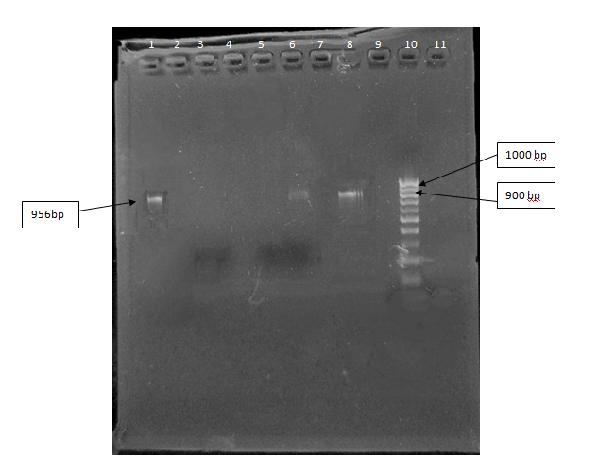
Figure 1: Amplification of 16S rDNA species specific geneof Pseudomonas aeruginosa
Lane 1, 6: 956 bp amplicon in Pseudomonas aeruginosa isolates
Lane 8 : Positive control (Pseudomonas aeruginosa (AT 27853))
Lane 9 : Negative control
Lane 10: Gene ruler 100bp ladder (Thermo Scientific)

3.3 Antimicrobial Resistance Profiles
Antimicrobial susceptibility testing of Pseudomonas spp. revealed high resistance to cephalosporins (52–60%), doxycycline (47.6%), amikacin (47.6%), oxacillin (42.8%), erythromycin (42.8%), and chloramphenicol (42.8%). Carbapenem resistance was observed for imipenem (34.9%) and meropenem (19.0%). Fluoroquinolones demonstrated comparatively better efficacy, particularly levofloxacin (71.4% susceptible). Piperacillin–tazobactam (60.3% susceptible) and colistin (66.7% susceptible) retained moderate activity (Fig. 2). . Resistance to fluoroquinolones and aminoglycosides exceeded levels reported by Yukawa et al. (2017), indicating declining efficacy in canine practice.
Similarly, Acinetobacter spp. showed marked resistance to oxacillin (88.9%), co-trimoxazole (77.8%), cefotaxime and ceftazidime (66.7%), and doxycycline (66.7%). Carbapenem resistance was detected in 44.4% of isolates for imipenem and 33.3% for meropenem. Colistin (77.8% susceptible) and enrofloxacin (77.8% susceptible) exhibited comparatively better effectiveness (Fig. 3). Overall, a substantial proportion of NFGNB isolates exhibited multidrug-resistant (MDR) phenotypes, particularly against β-lactams, cephalosporins, macrolides, and sulfonamides. Parallel findings were reported by Kuzi et al. (2016) and Gupta et al. (2015), while carbapenem resistance, though lower than ICU reports (Kipsang et al., 2023), remains concerning.

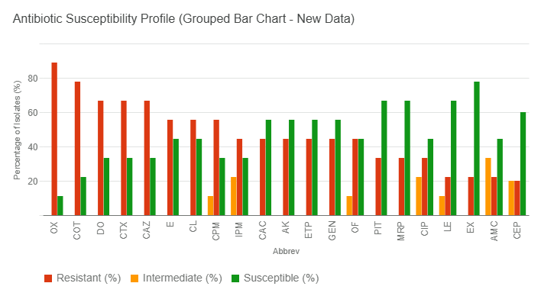

Figure 2: Graphical representation of antimicrobial susceptibility profile of Pseudomonas spp. isolates.
Imipenem (IPM), Meropenem (MRP), Chloramphenicol (CL), Enrofloxacin (EX), Amikacin (AK), Ertapenem (ETP), Gentamicin (GEN), Co-trimoxazole (COT), Ciprofloxacin (CIP), Ofloxacin (OF), Piperacillin–Tazobactam (PIT), Cephalosporin (CPM), Cefotaxime (CTX), Ceftazidime (CAZ), Erythromycin (E), Oxacillin (OX), Levofloxacin (LE), Doxycycline (DO), Ceftazidime/Clavulanic acid (CAC), Amoxicillin–Clavulanic acid (AMC), and Cephalothin (CEP).
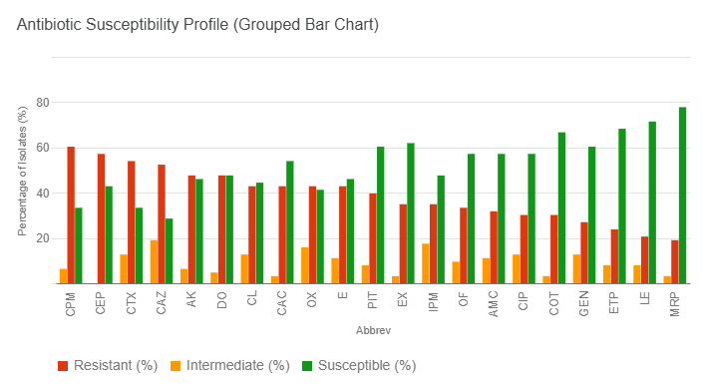

Figure 3: Graphical representation of antimicrobial susceptibility profile of Acinetobacter spp. isolates.
Imipenem (IPM), Meropenem (MRP), Chloramphenicol (CL), Enrofloxacin (EX), Amikacin (AK), Ertapenem (ETP), Gentamicin (GEN), Co-trimoxazole (COT), Ciprofloxacin (CIP), Ofloxacin (OF), Piperacillin–Tazobactam (PIT), Cephalosporin (CPM), Cefotaxime (CTX), Ceftazidime (CAZ), Erythromycin (E), Oxacillin (OX), Levofloxacin (LE), Doxycycline (DO), Ceftazidime/Clavulanic acid (CAC), Amoxicillin–Clavulanic acid (AMC) and Cephalothin (CEP).

4. CONCLUSION
The present study highlights a considerable prevalence of non-fermenting Gram-negative bacilli (NFGNB) in canine clinical infections, with Pseudomonas aeruginosa emerging as the predominant species, followed by diverse Acinetobacter spp. A substantial proportion of isolates exhibited multidrug resistance, including reduced susceptibility to critically important antimicrobials such as carbapenems and colistin, alongside widespread distribution of β-lactamase genes. The high frequency of hemolytic activity, biofilm formation, and motility further underscores their pathogenic potential and persistence in clinical settings. Collectively, these findings emphasize the growing therapeutic challenge posed by NFGNB in veterinary practice and reinforce the need for continuous surveillance, rational antimicrobial use, and integrated One Health strategies to limit their spread.
COMPETING INTERESTS
Authors have declared that no competing interests exist.
References
Rezaei N. (2022). Encyclopedia of infection and immunity. Elsevier, Amsterdam.
Wisplinghoff H, Bischoff T, Tallent SM, Seifert H, Wenzel RP, Edmond MB. (2004). Nosocomial bloodstream infections in US hospitals: Analysis of 24,179 cases. Clin Infect Dis, 39(3), 309–317.
Sushitha TS, Pulikottil SK, Beena VG. (2025). Bacteriological profile of NFGNB causing infections in immunocompromised patients. Int J Acad Med Pharm, 7(1), 149–154.
Magiorakos AP, Srinivasan A, Carey RB, Carmeli Y, Falagas ME, Giske CG, et al. (2012). Multidrug-resistant bacteria definitions. Clin Microbiol Infect, 18, 268–281.
De Oliveira DMP, Forde BM, Kidd TJ, Harris PNA, Schembri MA, Batson SA, et al. (2020). Antimicrobial resistance in ESKAPE pathogens. Clin Microbiol Rev, 33, e00181-19.
World Health Organization (WHO). (2017). Global priority pathogens list.
Dégi J, Moțco OA, Dégi DM, Suici T, Mareș M, Imre K, et al. (2021). Antibiotic susceptibility of Pseudomonas aeruginosa in dogs. Antibiotics, 10, 846.
Miller WH, Griffin CE, Campbell KL, Muller GH. (2013). Muller and Kirk’s small animal dermatology (7th ed.). Elsevier.
Nocera FP, Attili AR, Martino LD. (2021). Acinetobacter baumannii clinical significance. Pathogens, 10(2), 127.
Yoshimura F, Nikaido H. (1982). Outer membrane permeability of Pseudomonas aeruginosa. J Bacteriol, 152(2), 636–642.
Li M, Du X, Villaruz AE, Diep BA, Wang D, Song Y. (2012). MRSA epidemic and virulence determinants. Nat Med, 18, 816–819.
Gentilini F, Turba ME, Pasquali F, Mion D, Romagnoli N, Zambon E, et al. (2018). Carbapenem resistance in hospitalized pets. Front Microbiol, 9, 2872.
Fernandes MR, Sellera FP, Moura Q, Carvalho MPN, Rosato PN, Cerdeira L, et al. (2018). Transmission of drug-resistant Pseudomonas aeruginosa. Emerg Infect Dis, 24(6), 1160–1162.
Thöming JG, Häussler S. (2022). Biofilm tolerance in Pseudomonas aeruginosa. Front Cell Infect Microbiol, 12, 851784.
Kuzi S, Blum SE, Kahane N, Adler A, Hussein O, Segev G, et al. (2016). MDR Acinetobacter calcoaceticus–baumannii outbreak in pets. J Small Anim Pract, 57, 617–625.
Anekar SV. (2018). Isolation and molecular characterization of Pseudomonas aeruginosa from canine otitis. MVSc Thesis.
Sharma S. (2022). Prevalence of Acinetobacter spp. in pet animals. MVSc Thesis.
Asokan GV, Ramadhan T, Ahmed E, Sanad H. (2019). WHO priority pathogens analysis. Oman Med J, 34, 184.
Elfadadny A, Ragab RF, Hamada R, Al Jaouni SK, Fu J, Mousa SA, et al. (2023). Bioactive compounds and antimicrobial implications. Toxicol Appl Pharmacol, 461, 116405.
Colombini S, Merchant SR, Hosgood G. (2000). Microbial flora in canine otitis. Vet Dermatol, 11, 235–239.
Türkyilmaz S. (2008). Antibiotic susceptibility of Pseudomonas aeruginosa in dogs. Turk J Vet Anim Sci, 32, 65–70.
Hillier A, Alcorn JR, Cole LK, Kowalski JJ. (2007). Pseudomonas pyoderma in dogs. Vet Dermatol, 17, 432–439.
Singh VK, Kumar A, Jayshree, Yadav SK. (2017). Prevalence of Pseudomonas aeruginosa in animals. Indian J Comp Microbiol Immunol Infect Dis, 38(1), 37–42.
Rosales RS, Ramírez AS, Moya-Gil E, de la Fuente SN, Suárez-Pérez A, Poveda JB. (2024). Canine otitis antimicrobial patterns. Animals, 14, 742.
Black DM, Rankin SC, King LG. (2009). ICU infections in dogs. J Vet Emerg Crit Care, 19, 489–495.
Mitchell KE, Turton JF, Lloyd DH. (2018). Acinetobacter in canine skin. Vet Dermatol, 29, 240.
Gupta N, Gandham N, Jadhav S, Mishra R. (2015). Acinetobacter resistance patterns. J Nat Sci Biol Med, 6, 159–162.
Nakbubpa K, Janchawna R, Thumchop W, Panboonthong A, Pornsukarom S. (2021). Acinetobacter prevalence. Korean J Vet Res, 61, e26.
Mahajan R, Neeraj, Sarika, Mahajan B. (2016). NFGNB identification. Sch J Appl Med Sci, 4, 872–876.
Malini A, Deepa EK, Gokul BN, Prasad SR. (2009). NFGNB infections. J Lab Physicians, 1, 45–49.
Mathewson JJ, Simpson RB. (1982). Non-fermenting bacteria in veterinary samples. J Clin Microbiol, 15, 1016–1018.
Khalil MA, Sonbol FI, Mohamed AF, Ali SS. (2015). Virulence in Pseudomonas aeruginosa. Turk J Med Sci, 45, 60–69.
Mohammed BQ, Abdullah AH, Rayshan AR. (2024). Pseudomonas in canine otitis. Int J Agric Biosci, 13, 59–64.
Karatuna O, Yagci A. (2010). Quorum sensing in Pseudomonas. Clin Microbiol Infect, 16, 1770–1775.
Inat G, Siriken B, Baskan C, Erol I, Yildirim T, Ciftci A. (2021). Virulence factors in Pseudomonas. Sci Rep, 11, 15639.
Abdelraheem WM, Abdelkader AE, Mohamed ES, Mohammed MS. (2020). Biofilm formation in Pseudomonas. Meta Gene, 23, 100646.
Lysitsas M, Triantafillou E, Chatzipanagiotidou I, Antoniou K, Spyrou V, Billinis C, et al. (2024). Biofilm genes in Acinetobacter. Trop Med Infect Dis, 9, 109.
Yukawa S, Tsuyuki Y, Sato T, Fukuda A, Usui M, Tamura Y. (2017). Antimicrobial resistance in pets. Jpn J Infect Dis, 70, 461–463.
Kipsang F, Munyiva J, Menza N, Musyoki A. (2023). Carbapenem-resistant Acinetobacter. Int J Infect Dis, 9, 111–116.

