Exploring the plant growth promoting potential of phosphate solubilizing Aspergillus niger PSMH-2 and Acinetobacter pitti PSMM-8 isolated from the green gram (Vigna radiata L.) rhizosphere in three distinct agro-climatic zones of Karnataka

ABSTRACT
Phosphate solubilizing microorganisms (PSMs) play a crucial role in enhancing phosphorus availability to plants, thereby promoting agricultural productivity. This study aimed to isolate, characterize, and evaluate the efficacy of phosphate solubilizing microorganisms from the rhizosphere soil of green gram (Vigna radiata) cultivated in different agro-climatic zones of Karnataka, India. A total of 30 PSM isolates were obtained from soil samples collected from Mandya, Hassan, and Bengaluru districts. These isolates were identified as either bacterial or fungal and were screened for their phosphate solubilization efficiency using Pikovskaya’s agar medium. The solubilization index (SI) of the isolates was calculated, with seven fungal and four bacterial isolates demonstrating high phosphate solubilization efficiency. The biochemical characterization of selected bacterial isolates was conducted using HiMedia biochemical test kits. The isolates displayed varied biochemical profiles, indicating the presence of diverse enzyme systems. Additionally, the selected isolates were further assessed for their plant growth-promoting attributes, including phosphatase activity, organic acid production, siderophore production, and phytohormone (IAA, GA3, ABA, and SA) synthesis. Notably, the fungal isolate PSMH-2 and the bacterial isolate PSMM-8 showed superior performance in phosphate solubilization and plant growth-promoting traits compared to other isolates and the reference strains. The study highlights the potential of these efficient phosphate solubilizing isolates as bio-inoculants for sustainable agriculture, particularly in enhancing phosphorus availability and promoting the growth of green gram. The findings suggest that these isolates could be utilized to develop biofertilizers aimed at improving crop yield while reducing the dependency on chemical fertilizers.

Keywords: Phosphate solubilization, Green gram, Phytohormone, Organic acid, Siderophore, Aspergillus niger, Acinetobacter pitti .

- INTRODUCTION
Phosphorus is a major nutrient that plays a fundamental role in various physiological process and metabolic activities within the plants. It is an essential part of nucleic acids, which provide the basis of genetic information. It is also a key component of ATP, the universal energy carrier and phospholipids, which are important for the construction and integrity of cell membrane (Hasan et al., 2016). Phosphorus supports plant development, nutrient intake, and general metabolic processes by facilitating photosynthesis, respiration and the synthesis of enzymes and proteins (Alori et al., 2017). Plants experiencing phosphorus deficiency exhibit stunted growth, delayed maturity, reduced flowering and fruiting, leading to decreased crop yield (Hasan et al., 2016).
The global soil phosphorus content is approximately 0.05% (w/ w). However, only 0.10% of this phosphorus is readily accessible for plant use (Zhu et al., 2011). Phosphate ions, primarily H₂PO₄⁻ , HPO₄²⁻ and PO₄³⁻ are the phosphorus forms that the plant absorbs from the soil. Depending on the soil pH, level of organic matter, and type of microorganisms, roughly 70 to 90 per cent of the phosphatic fertilizers added to the soil become unavailable or change into fixed form due to chemical fixation with Ca²⁺, Al³⁺ and Fe³⁺ (Kalayu et al., 2019).
The use of phosphorus as a chemical fertilizer can enhance crop production. However, excessive utilization leads to eutrophication and low phosphorus use efficiency, resulting in severe environmental consequences (Sharma et al., 2013). Phosphate solubilizing microorganisms (PSMs) play a crucial role in solubilizing phosphate in the soil, thereby making it readily available for plant uptake. They achieve this through processes such as acidification, chelation, exchange reactions and the production of organic acids (Sharma et al., 2013).
Green gram (Vigna radiata L.) is traditionally grown in India from ancient times. The nitrogenous and potassium fertilizers are readily available to the crop, phosphatic fertilizers, when applied, typically provide only around 30 per cent or even less of their content to the plant, limiting their overall availability for uptake. Various soil microorganisms play an essential role in the solubilization of phosphorus. Thus, the present study was aimed to isolate and evaluate efficient phosphate solubilizing microorganisms from rhizosphere soils of green gram and to evaluate their potential to influence the growth and yield of green gram (Vigna radiata L.).
2. MATERIAL AND METHODS
2.1. Collection of soil samples and isolation of phosphate solubilizing microorganisms
Green gram rhizosphere soil samples were collected from three different agro-climatic zones viz., Hassan (Arsikere- 13.0033°N, 76.1004°E), Mandya (Helligere- 12.5218°N, 76.8951°E) and Bangalore (GKVK- 13.0767°N, 77.5776°E) districts of Karnataka. The phosphate solubilizing microorganisms were isolated from all soil samples by standard plate count technique on Pikovskaya’s agar medium (Pikovskaya, 1948). The plates were incubated at 28±2ºC for two to seven days and colonies with clear zones around were counted. The representative colonies of each type of bacteria and fungi with a clear halo around were purified, sub-cultured and maintained on the slants of Nutrient Agar (NA) and Potato Dextrose Agar (PDA) media respectively for further studies.
2.2. Estimation of phosphate solubilization and selection of efficient isolates
Preliminary screening for phosphate solubilization was done by a plate assay method using Pikovskaya’s agar medium supplemented with tri calcium phosphate. The bacterial and fungal colonies forming large zone of solubilization were kept for further study. On the basis of diameter of clearing halo zones, solubilization index was calculated using the formula as given below (Nguyen et al., 1992).
Solubilization index (S.I) = Colony diameter +Halozone diameter

Colony diameter

2.3. Biochemical characterization of selected phosphate solubilizing isolates
Best effective PSB isolates showing superior phosphate solubilization were further subjected to various biochemical tests by using commercially available kits KB002 Hi AssortedTM Biochemical Test Kit and KB004 Hi StaphTM Identification Kit (HiMedia Laboratories Pvt Ltd., Mumbai). Preparation of bacterial inoculum of each effective isolates was done by inoculating individual colonies in sterilized five mL of Luria Broth test tubes and incubated at 37±1 °C for six hours. The kits were opened aseptically in laminar flow and each well in the kits was surface inoculated with 50 µl of inoculum and then incubated at 37±1 °C for 24 hrs. Following the incubation period, a series of reagents were added in pre-designated wells according to manufacturer’s instruction to conduct various biochemical tests.
2.4. Screening of isolates for phosphate solubilization and plant growth promoting determinants
The seven fungal isolates viz., PSMM-3, PSMM-4, PSMM-5, PSMM-6, PSMM-7, PSMH-2 ,PSMG-2 and four bacterial isolates viz., PSMM-8, PSMH-6, PSMG-3 and PSMG-5 which showed higher solubilization index were further screened for their ability to release phosphorus in broth, to produce acid and alkaline phosphatase enzyme, siderophore and phytohormone under in-vitro conditions with Aspergillus awamori and Bacillus megaterium as fungal and bacterial reference strain respectively.
2.5.1. Phosphate solubilization
The selected isolates were further screened for their ability to solubilize inorganic phosphate by growing them in both Pikovskaya’s agar and broth containing tricalcium phosphate Isolates (100 µL of the overnight in case of bacteria and three days old homogenized culture in case of fungi) were inoculated to 100 mL of Pikovskaya’s broth in 150 mL flasks. The available phosphorus was determined by using colorimetrically at 880 nm with standard KH2PO4 (Murphy and Riley, 1962). The Solubilization Efficiency (S.E) is calculated using the formula as given below (Nguyen et al., 1992).
Solubilization Efficiency (S.E) = Halozone diameter - Colony diameter X 100

Colony diameter

2.5.2. Phosphatase activity
Tabatabai and Bremner (1969) method was used for determining the phosphatase activity of the selected phosphate solubilizing isolates. Three mL aliquot of two days old culture of bacteria and five days old culture of fungi, one mL modified universal buffer and one mL 0.115 M p-NPP were pipetted into a 20 mL reagent vial. The mixture was incubated at 37±1 °C for 1 hr. The Phosphatase reaction was stopped by the addition of 20 mL of 0.5N sodium hydroxide. The mixture was later transferred to a 50 mL volumetric flask and absorbance was recorded with a spectrophotometer at 410 nm along with standards.

2.5.3. Organic acid production
Selected isolates were screened for organic acid production as per the procedure described by Naureen et al. (2015). The sterilized Pikovskaya’s medium amended with 0.2 per cent bromophenol blue was poured into the sterilized petri plates. After solidification of the media, spot inoculation of all the isolates was done in the center of the agar plates with the help of a flame sterilized loop under aseptic conditions. The plates were incubated at room temperatures for 24 to 72 hrs. The colour change to orange yellow in the plate was indicated as positive for organic acid production. The pH drop in the broth at specific interval (second, fourth and sixth day after inoculation) was checked by inoculating the isolates in Pikovskaya’s broth.
2.5.4. Siderophore production
Chrome azurol‘s agar used to estimate the production of siderophore. One single colony of culture was spot inoculated on the CAS agar plates and incubated at 30 °C for 3-4 days. Nutrient agar and potato dextrose agar were prepared and autoclaved it separately and the 20 mL of CAS dye (Chromoazural) was prepared. Formation of yellow halo zone around the colony is indicated as positive for siderophore production (Schwyn and Neilands, 1987).
2.5.5. Phytohormone production
The selected seven fungal and four bacterial isolates were evaluated for IAA, GA3, ABA and SA production. A 25 mL of each nutrient broth and potato dextrose broth were prepared and sterilized. The 2 mL of inoculated broth culture was added to each broth. The cultures were incubated in the medium for 7 days. After the incubation the broth cultures were centrifuged at 6000 rpm to remove the bacterial and fungal culture. The pH of the supernatant was adjusted to 2.8 with 0.1N HCl. 25 mL acidified supernatant was taken in a 100 mL conical flask and equal volume of diethyl ether was added to the supernatant and incubated in dark for 4 h. The mixture of diethyl ether and the supernatant was incubated for overnight at 4°C in a separating funnel. The organic phase was discarded and the solvent phase was collected. The solvent phase was poured in a sterile plate and allowed to evaporate. To the dried material 2 mL of methanol was added and the IAA, GA3, ABA and SA were quantified by a high performance liquid chromatography (Shimadzu, Japan) by the conditions described below:
List 1 : High-performance liquid chromatography findings
Properties | IAA | GA₃ | ABA | SA
Stationary phase | C18 column | C18 column | C18 column | C18 column
Flow rate | 1 mL/ min | 0.8 mL/ min | 0.8 mL/ min | 1 mL/min
Mobile phase | Methanol: Water (80:20) | Methanol: Water (70:30) | Acetonitrile:acetic acid 0.5% (80:20) | Acetonitrile:acetic acid 0.5% (90:10)
Wavelength | 270 nm | 208 nm | 254 nm | 302 nm
Column Temperature | 30⁰C | 30⁰C | 30⁰C | 30⁰C

2.6. Molecular characterization of efficient phosphate solubilizing microorganisms
The efficient fungal isolate (PSMH-2) and bacterial isolate (PSMM-8) obtained after in-vitro screening were further carried for molecular characterization and identification. The genomic DNA of the selected isolates were isolated and amplification of the 18srRNA gene for fungus and 16srRNA gene for bacterium and sequencing was carried out using Sanger sequencing method and blasting of consensus sequence. The Molecular Evolutionary Genetics Analysis Tool (MEGA 10.1) was used to align the obtained nucleotide sequences. The Jukes cantor model is used for the construction of a phylogenetic tree of aligned sequences. Dissimilarity analysis and representation for windows (DARwin 6) software with a bootstrap value of 1000 was used for the construction. All the sequence of the isolates and identity were submitted to the NCBI-GenBank, online repository/ library of sequences.
2.7. Greenhouse experiment
An experiment was conducted for the evaluation of efficient phosphate solubilizers on the growth and yield of green gram. The initial soil physico- chemical properties were analysed prior to the experiment (pH-6.78, Available Nitrogen- 251.12 Kg ha⁻¹, Available Phosphorus- 21.48 Kg ha⁻¹, Available Potassium 176.39 Kg ha⁻¹). The experiment was laid in completely randomized design (CRD) with 16 treatments and three replications.
2.7.1. Preparation of inoculum
The efficient fungal and bacterial isolates were selected based on their phosphate solubilization traits and plant growth promoting activity under in vitro experiments and they were used in the pot culture studies. A loopful of bacterial isolate and mycelial plug of fungal isolate were inoculated into nutrient broth and potato dextrose broth respectively and incubated for 48 h at 30 ºC. Carrier based formulation of potential isolates was prepared and each culture was well mixed with one kg of talc powder.
2.7.2. Preparation of potting mixture
Five kg capacity plastic bags were filled with a mixture of soil and farm yard manure (FYM) in the ratio of 2:1. The green gram (variety: KKM3) seeds were treated with inoculum prepared as mentioned earlier. These seeds were sown to bags containing soil and farm yard manure. The recommended dose of urea and MOP were applied (in grams) in 5 kg of soil per bag (Urea: 1.2 g/ 5Kg, MOP: 0.9 g/ 5Kg). The entire dose of MOP and 50% of urea were applied as basal dose at the time of sowing and remaining 50% of urea was applied in the standing crop plants in two equal doses, first at flowering stage and second at pod initiation stage.
2.7.3. Observations recorded
The growth and yield parameters viz., plant height, number of leaves per plant, shoot and root biomass, root length, number of nodules per plant, weight of nodule, number of pods per plant, grain yield per plant were recorded. The nutrients uptake by plant were also recorded. Plant samples taken from each treatment were separately dried and powdered. The powdered samples were kept in airtight containers for further chemical analysis. These samples were used for analysis of N (modified Micro-Kjeldhal‘s method as outlined by Jackson (1973)), P (Vanadomolybdate phosphoric yellow color method outlined by Jackson (1973)), K (flame photometer outlined by Jackson (1973)). A chemical analysis was conducted to test the nutrient status of soil. Representative soil samples from the experimental pots were drawn from the top 0- 15 cm depth after the harvest of crop. Soil samples collected were air dried in shade, powdered with wooden mallet and passed through 2 mm sieve and analysed for available nitrogen (Subbiah and Asija, 1956), phosphorus (Jackson, 1973) and potassium (Jackson, 1973).
2.8. Statistical Analysis
The data obtained from laboratory and green house experiments were statistically analyzed using completely randomized design (CRD). The statistical analysis was done by using WASP: 2.0 (Web Agri Stat Package 2) statistical tool (www.icargoa.res.in/wasp2/index.php) and means were separated by Duncan Multiple Range Test (DMRT).
3. RESULTS AND DISCUSSION
3.1. Collection of soil samples and isolation of phosphate solubilizing microorganisms
The rhizosphere soil samples from green gram growing areas of three different agro-climatic zones namely Mandya, Hassan and Bengaluru districts of Karnataka were collected for the isolation of phosphate solubilizing microorganisms. Totally 30 phosphate solubilizing isolates were isolated and assigned with respective code numbers based on the area of sample collected (Table 1). These isolates were purified and preserved on agar slants at 4°C for further study.
Table 1. Phosphate solubilizing cultures isolated from green gram rhizosphere soil
Location | Cultures isolated
Location | Fungal cultures | Bacterial cultures
Mandya  (Hallegere) | PSMM-1, PSMM-2, PSMM-3, PSMM-4, PSMM-5, PSMM-6, PSMM-7 | PSMM-8, PSMM-9, PSMM-10, PSMM-11, PSMM-12, PSMM-13, PSMM-14, PSMM-15, PSMM-16
Hassan  (Arsikere) | PSMH-1, PSMH-2 | PSMH-3, PSMH-4, PSMH-5, PSMH-6, PSMH-7, PSMH-8
Bengaluru  (GKVK) | PSMG-1, PSMG-2 | PSMG-3, PSMG-4, PSMG-5, PSMG-6
Note : PSMM- Phosphate Solubilizing Microorganism Mandya, PSMH- Phosphate Solubilizing Microorganism Hassan, PSMG- Phosphate Solubilizing Microorganism GKVK.
3.2. Estimation of phosphate solubilization and selection of efficient isolates
The obtained isolates were able to solubilize phosphate. After 7 days of plating, the zone of solubilization was measured using a scale, and their solubilization index (SI) was calculated (Table 2 (a) and (b)). Among fungal isolates, seven isolates were found to exhibit a solubilization index greater than 1 (SI >1.0). Maximum SI was observed by PSMH-2 (4.11). Among bacterial isolates, four isolates were found to exhibit a solubilization index greater than 2 (SI >2.0). The bacterial isolate PSMM-8 showed maximum SI of 2.91. A similar method of screening was adopted by Rfaki et al. (2019) where they used Pikovskaya’s agar medium with tricalcium phosphate for the selection of phosphate solubilizing isolates.
Table 2(a). Solubilization index of phosphate solubilizing fungal isolates isolated from different rhizosphere soil
Isolates | Solubilization index
Control | 0.00^{h}
PSMM-1 | 0.92^{fg}
PSMM-2 | 0.84^{fg}
PSMM-3 | 2.21de
PSMM-4 | 1.35^{f}
PSMM-5 | 3.24^{b}
PSMM-6 | 1.94e
PSMM-7 | 2.50^{cd}
PSMH-1 | 0.57^{g}
PSMH-2 | 4.11ª
PSMG-1 | 0.43^{g}
PSMG-2 | 2.92^{bc}
Note : Numerical values are mean of three replicates. Treatments with the different superscripts in the same column represent a significant difference as determined by DMRT (p ≤ 0.05)
Table 2 (b). Solubilization index of phosphate solubilizing bacterial isolates isolated from different rhizosphere soil
Isolates | Solubilization index | Isolates | Solubilization index
Control | 0.00^{i} | PSMH-3 | 1.78^{d}
PSMM-8 | 2.91ª | PSMH-4 | 1.36e
PSMM-9 | 1.53e | PSMH-5 | 0.53^{g}
PSMM-10 | 1.49e | PSMH-6 | 2.24^{c}
PSMM-11 | 0.92^{f} | PSMH-7 | 1.31e
PSMM-12 | 0.65^{g} | PSMH-8 | 0.57^{g}
PSMM-13 | 1.43e | PSMG-3 | 2.41^{b}
PSMM-14 | 0.21^{h} | PSMG-4 | 1.39e
PSMM-15 | 1.38e | PSMG-5 | 2.11^{c}
PSMM-16 | 0.85^{f} | PSMG-6 | 0.87^{f}
Note : Numerical values are mean of three replicates. Treatments with the different superscripts in the same column represent a significant difference as determined by DMRT (p ≤ 0.05).
3.4. Biochemical characterization of phosphate solubilizing bacterial isolates
Various microorganisms can produce distinct metabolites using the same substrate or different substrates, depending on their enzyme systems. In order to identify various microorganisms, numerous biochemical reaction assays were utilized (Sandle, 2016; Janda and Abbott, 2002).
The four selected bacterial isolates under consideration in the present study were evaluated to study their biochemical profile by HiMedia biochemical test kit and the experimental findings are presented in Table 3. Biochemical results exhibited that all four isolates were positive for citrate, lysine and ornithine utilization. The isolate PSMM-8 and PSMG-3 exhibited positive for urease test and Voges Proskauer’s test unlike PSMH-6 and PSMG-5 which showed negative reactions to both tests. whereas all the selected four isolates showed positive tests for Ornithine, Arginine utilization and Hydrogen sulphide production. All the isolates except PSMG-3 showed negative for phenylalanine deamination test and all the isolates except PSMM-8 showed positive for nitrate reduction test. PSMH-6 and PSMG-3 tested positive for hydrogen sulphide production unlike PSMM-8 and PSMG-5 which showed negative to the same test. All the isolate except PSMG-3 exhibited negative reaction for ONPG test. PSMH-6 and PSMG-5 showed positive result for arginine utilization and PSMM-8 and PSMG-3 showed negative result for the same test.
The selected bacterial isolates used different types of carbohydrates compounds as carbon source. Among sugar fermentation test, sucrose and maltose were fermented by all the selected isolates. Sorbitol and trehalose are fermented by all the isolates except PSMM-8. The isolate PSMG-3 showed positive reaction regarding the fermentation of adonitol, lactose and arabinose unlike other three isolates which showed negative reaction to the same tests. Glucose and Mannose were fermented by only PSMM-8 and PSMG-5. The isolate PSMG-3 and PSMG-5 exhibited positive for raffinose utilization whereas other two isolates were negative for the same test (Fig. 1a and 1b).
Gupta et al. (2012) isolated four phosphate solubilizing bacteria (namely A1, A6, A51, A20) and performed various biochemical tests and observed that all isolates showed positive reaction for citrate utilization. Isolate A1 and A6 were negative for voges-proskauer whereas isolate A20 and A51 were positive for voges-proskauer. Similar findings were also observed in the present studies.

1
2
3
4
5
6
7
8
9
10
11
12
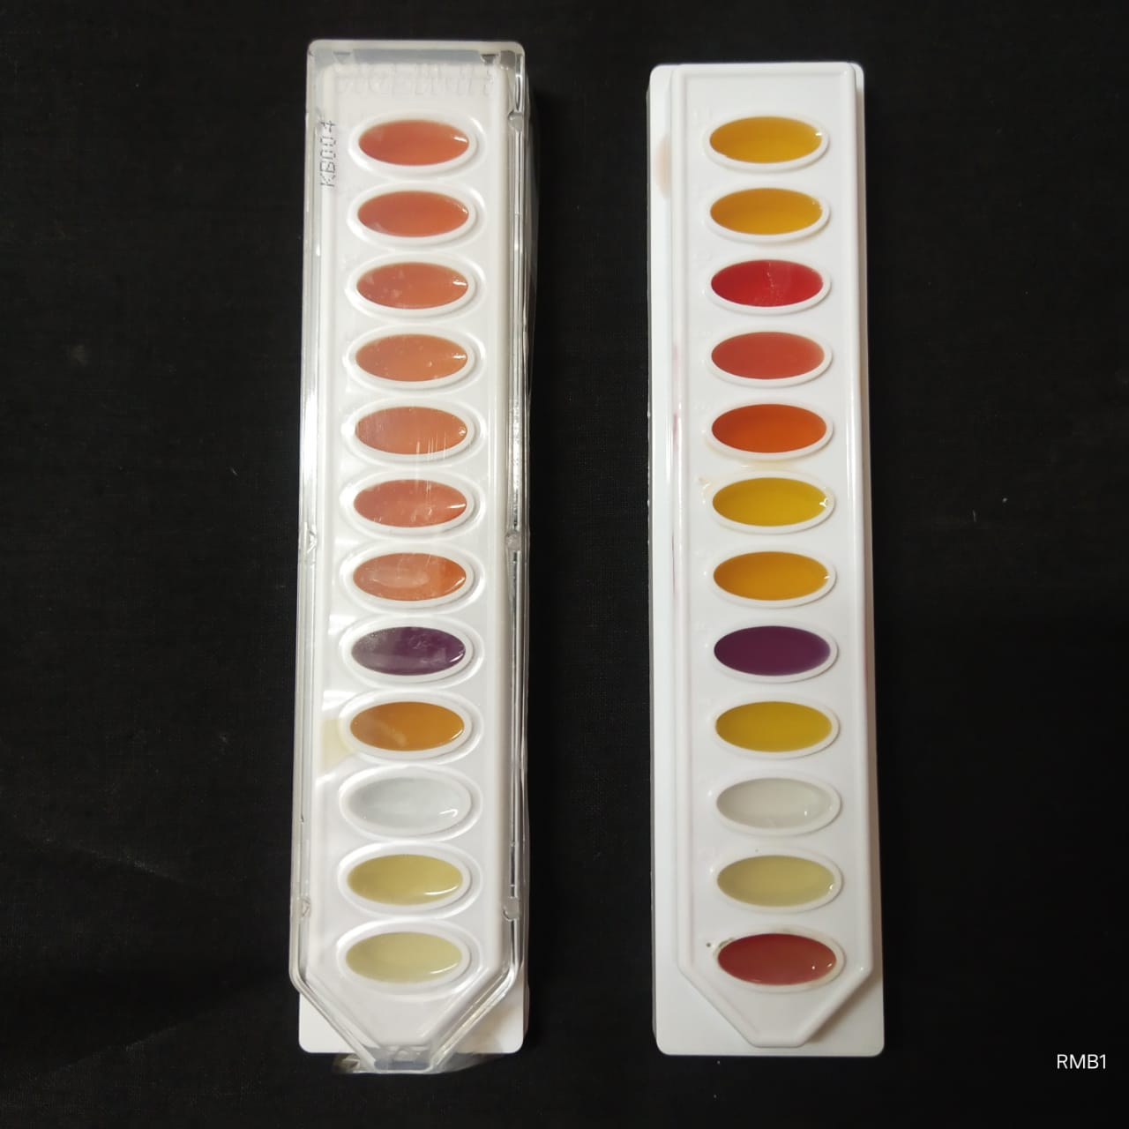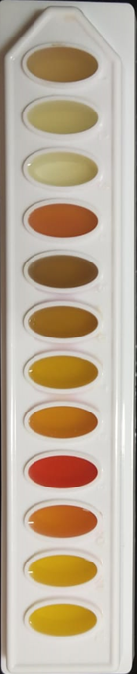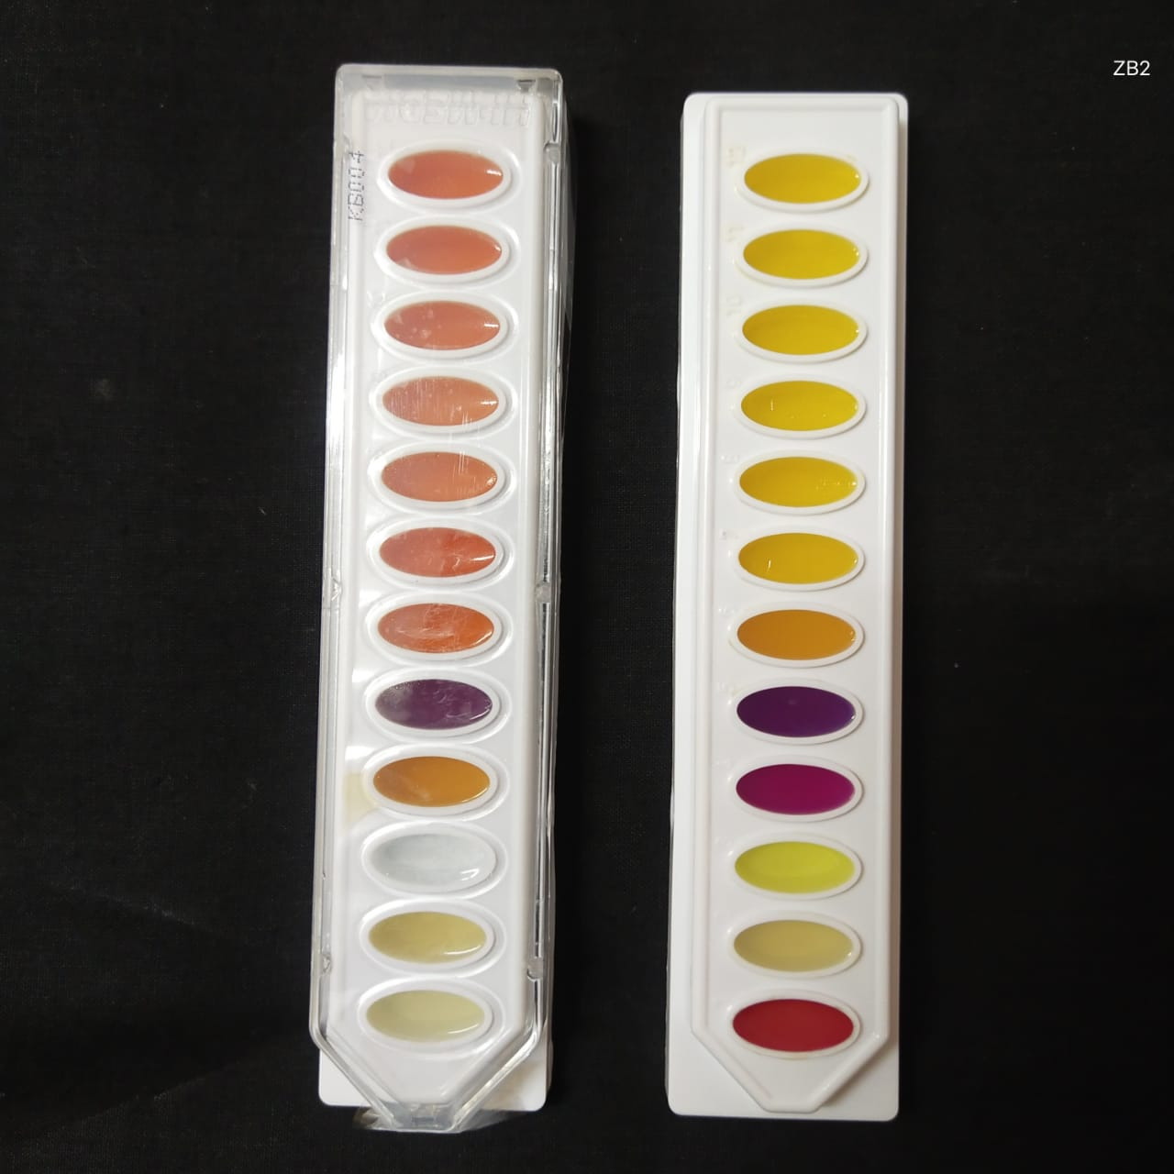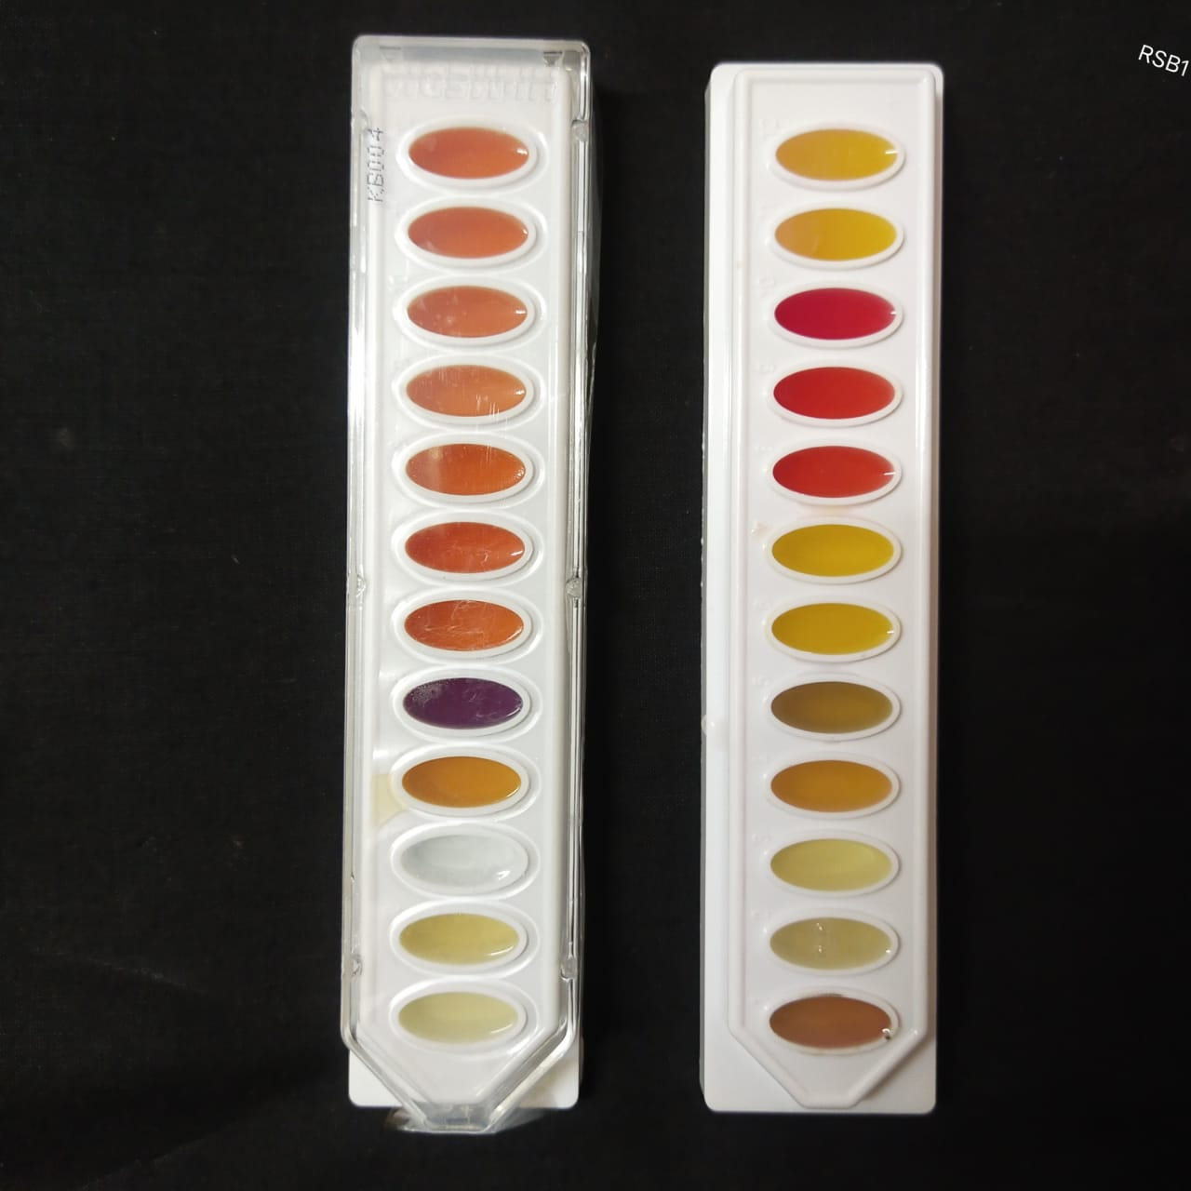
(Uninoculated)
Control PSMM-8 PSMH-6 PSMG-3 PSMG-5

No. | Test | Original colour of the medium | Positive  reaction | Negative reaction
1. | Voges Proskauer’s | Colourless | Pinkish red | Colourless/Slight copper
2. | Alkaline phosphatase | Cream | Pink | Cream
3. | ONPG | Colourless | Yellow | Colourless
4. | Urease | Orangish yellow | Pink | Orangish yellow
5. | Arginine utilization | Olive green | Purple | Yellow
6. | Mannitol | Red | Yellow | Red/ Pink
7. | Sucrose | Red | Yellow | Red/ Pink
8. | Lactose | Red | Yellow | Red/ Pink
9. | Arabinose | Red | Yellow | Red/ Pink
10. | Raffinose | Red | Yellow | Red/ Pink
11. | Trehalose | Red | Yellow | Red/ Pink
12. | Maltose | Red | Yellow | Red/ Pink
Note: Result interpretation chart
Fig. 1a. KB004 Hi AssortedTM Biochemical test of bacterial isolates
1
2
3
4
5
6
7
8
8
9
10
11
12
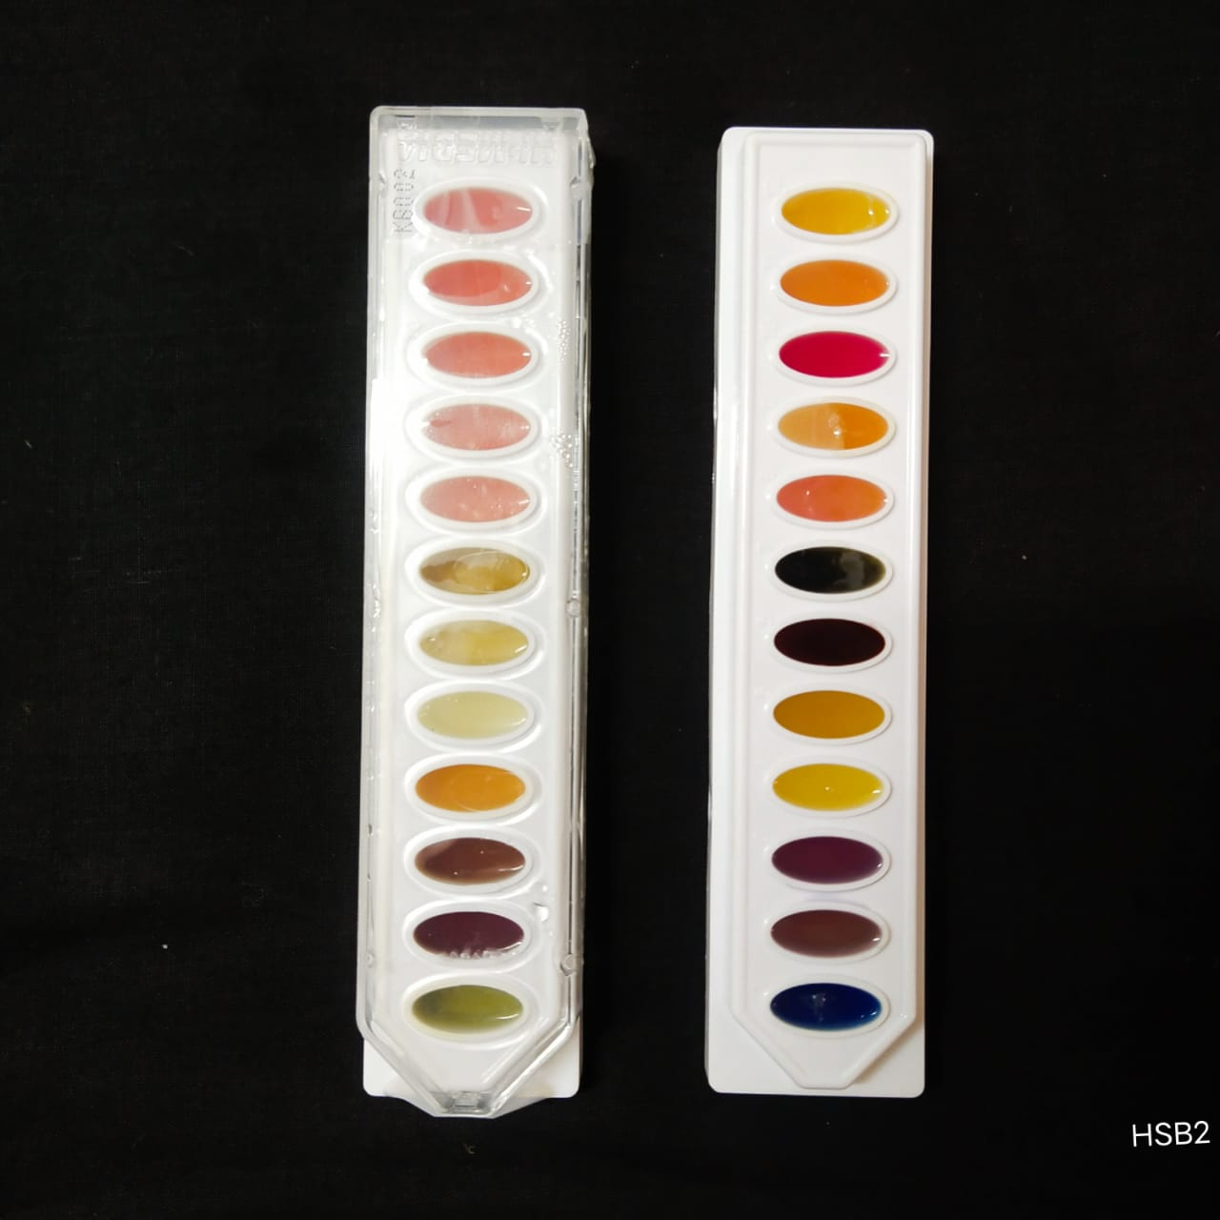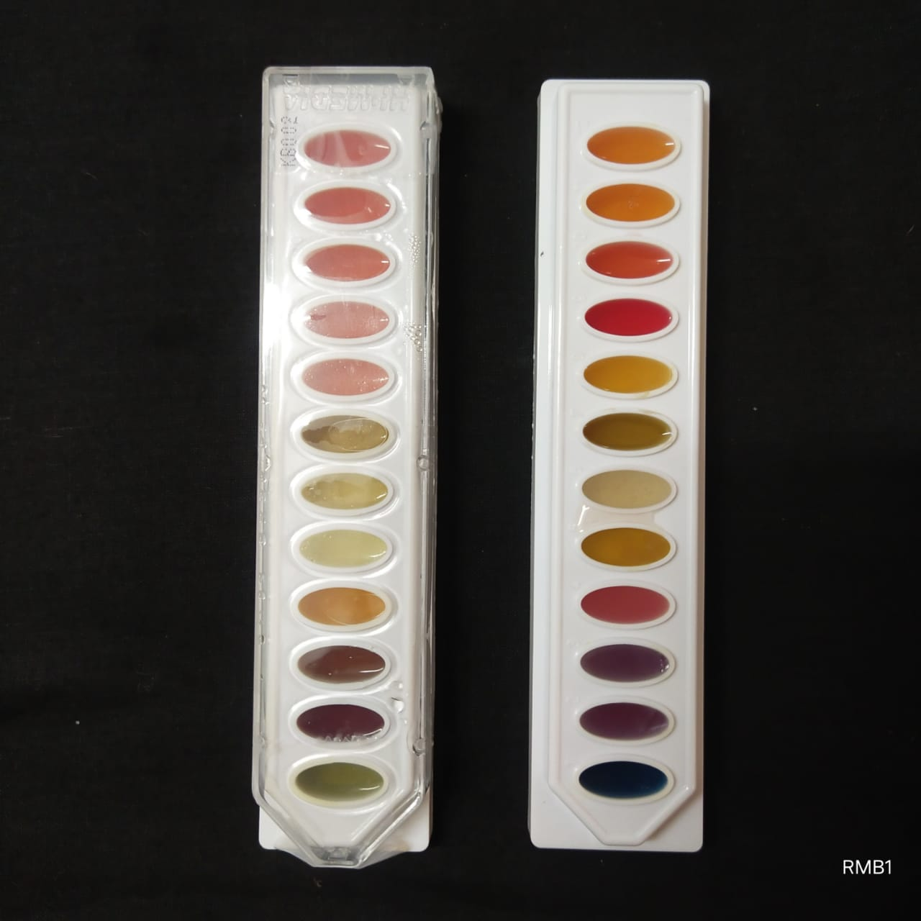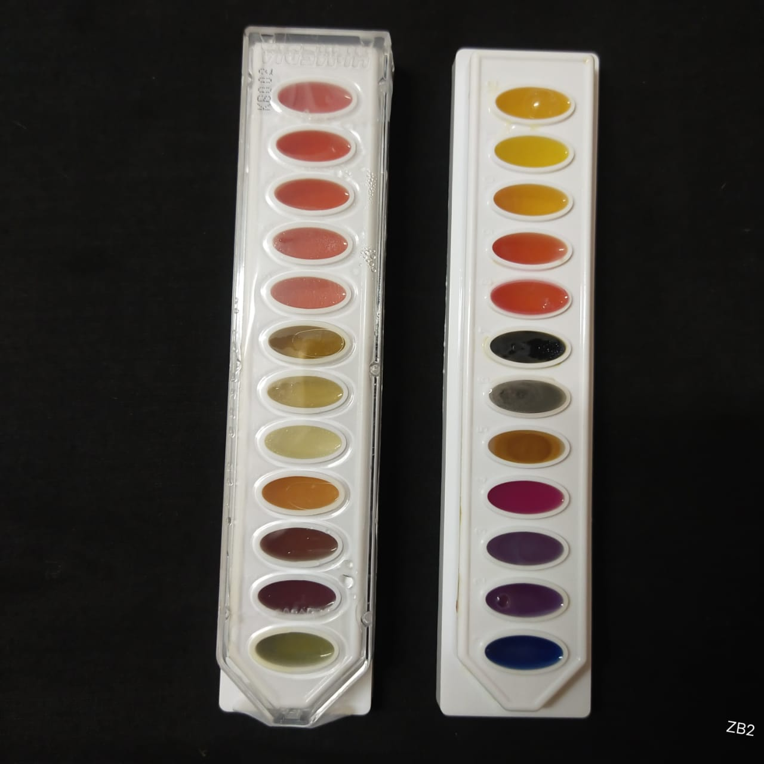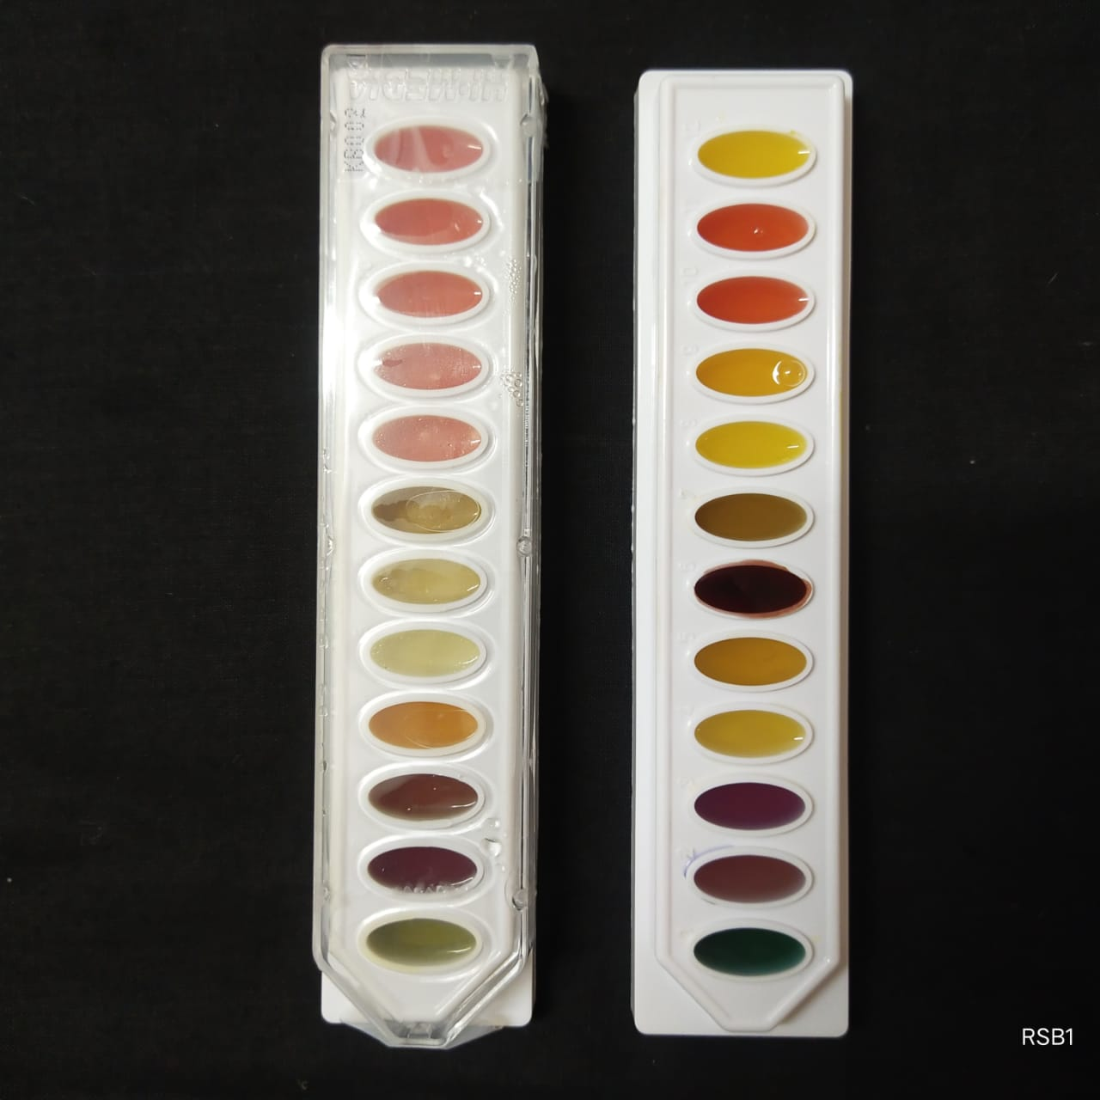
(Uninoculated)
Control PSMM-8 PSMH-6 PSMG-3 PSMG-5

No. | Test | Original colour of the medium | Positive  reaction | Negative reaction
1. | Citrate utilization | Green | Blue | Green
2. | Lysine utilization | Olive green to light purple | Purple/ Dark purple | Yellow
3. | Ornithine utilization | Olive green to light purple | Purple/ Dark purple | Yellow
4. | Urease | Orangish yellow | Pink | Orangish yellow
5. | Phenylalanine deamination | Colourless | Green | Colourless
6. | Nitrate reduction | Colourless | Pinkish red | Colourless
7. | H₂S production | Orangish yellow | Black | Orangish yellow
8. | Glucose | Pinkish red | Yellow | Pinkish red
9. | Adonitol | Pinkish red | Yellow | Pinkish red
10. | Lactose | Pinkish red | Yellow | Pinkish red
11. | Arabinose | Pinkish red | Yellow | Pinkish red
12. | Sorbitol | Pinkish red | Yellow | Pinkish red
Note: Result interpretation chart
Fig. 1b. KB002 Hi AssortedTM Biochemical test of bacterial isolates
Table 3. Biochemical tests of the phosphate solubilizing bacterial isolates
Sl.No. | Biochemical test | PSMM-8 | PSMH-6 | PSMG-3 | PSMG-5
1. | Citrate utilization | + | + | + | +
2. | Lysine utilization | + | + | + | +
3. | Ornithin utilization | + | + | + | +
4. | Urease | + | - | + | -
5. | Phenylalanine deamination | - | - | + | -
6. | Nitrate reduction | - | + | + | +
7. | Hydrogen sulphide | - | + | + | -
8. | Voges Proskauer’s | + | - | + | -
9. | ONPG | - | - | + | -
10. | Arginine utilization | - | + | - | +
11. | Glucose | + | - | - | +
12. | Adonitol | - | - | + | -
13. | Lactose | - | - | + | -
14. | Arabinose | - | - | + | -
15. | Sorbitol | - | + | + | +
16. | Mannitol | + | - | - | +
17. | Sucrose | + | + | + | +
18. | Raffinose | - | - | + | +
19. | Trehalose | - | + | + | +
20. | Maltose | + | + | + | +
Note : (+)-Positive, (-)-Negative

3.5. Screening of isolates for phosphate solubilization and plant growth promoting determinants
The seven fungal isolates viz., PSMM-3, PSMM-4, PSMM-5, PSMM-6, PSMM-7, PSMH-2 ,PSMG-2 and four bacterial isolates namely PSMM-8, PSMH-6, PSMG-3 and PSMG-5 which showed higher solubilization index were further screening.
3.5.1. Phosphate solubilization
The selected isolates were further screened for their ability to solubilize inorganic phosphate by growing them in both Pikovskaya’s agar and broth containing tricalcium phosphate The data pertaining to this is represented in Table 4 (a) and 4(b). The fungal isolate PSMH-2 showed a significantly higher S.E of 152.17% over the reference strain (132.21%). Among the bacterial isolates, PSMM-8 showed a higher S.E of 115.42% over the reference strain (98.25%) (Fig. 2(a) and 2 (b)). The results are in accordance with Kanimozhi and Panneerselvam (2010), who isolated and screened phosphate solubilizing microorganisms and showed that, the solubilization efficiency of the phosphate solubilizing fungus Aspergillus niger was 166.66 %.

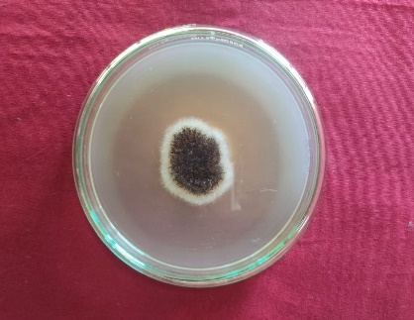
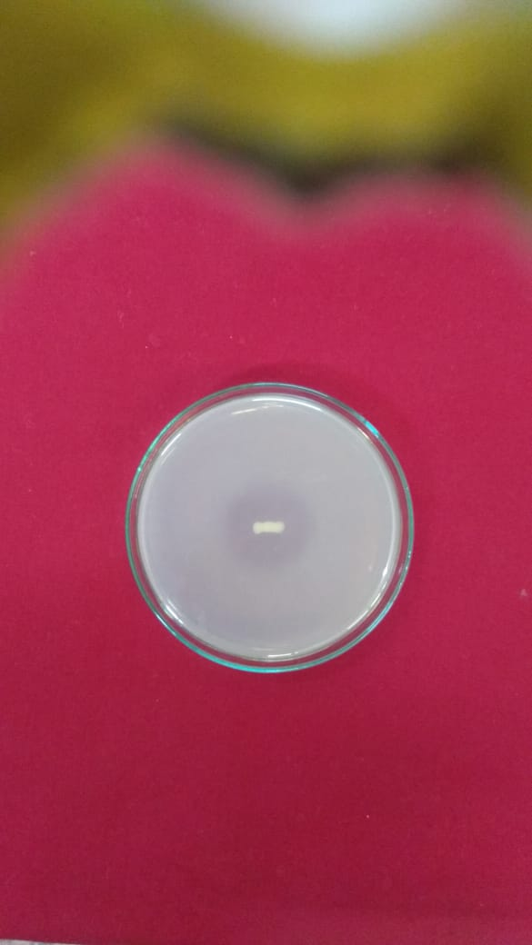
b
a

Fig. 2 (a). Halozone formation by PSMH-2, (b). Halozone formation by PSMM-8
The inorganic phosphorus (Pi) released by the fungal isolates at six days after inoculation ranged from 55.48 to 146.77 mg L⁻¹. The fungal isolate PSMH-2 recorded significantly higher release of Pi (144.77 mg L⁻¹ ) than the reference strain.
The Pi released by the bacterial isolates at six days after inoculation ranged from 63.50 to 113.42 mg L⁻¹. The bacterial isolate PSMM-8 recorded significantly higher release of Pi (113.42 mg L⁻¹ ) than the reference strain. Recently, Chen et al. (2021) isolated and purified seven strains of phosphate- solubilizing bacteria from Chinese fir seedlings and studied in vitro phosphate solubilization by the strains, ranging from 44.29 to 195.61 μg/ml. These results are in accordance with our findings.
Table 4 (a). Phosphate solubilization efficiency (S.E) and Available phosphorus (mg L⁻¹) released in broth by selected fungal isolates
Isolates | S.E (%) | Available phosphorus (mg L⁻¹ )
PSMM - 3 | 68.45e | 68.33^{f}
PSMM - 4 | 61.87e | 55.48^{g}
PSMM - 5 | 112.34^{c} | 91.40^{c}
PSMM - 6 | 65.37e | 66.40^{f}
PSMM -7 | 89.45^{d} | 77.28e
PSMH -2 | 152.17ª | 146.77ª
PSMG -2 | 92.75^{d} | 86.44^{d}
Reference strain | 132.21^{b} | 120.48^{b}
Note : Numerical values are mean of three replicates. Treatments with the different superscripts in the same column represent a significant difference as determined by DMRT (p ≤ 0.05) Reference strain- Aspergillus awamori
Table 4 (b). Phosphate solubilization efficiency (S.E) of selected bacterial isolates
Isolates | S. E(%) | Available phosphorus (mg L⁻¹)
PSMM - 8 | 115.34ª | 113.42ª
PSMH - 6 | 59.20^{d} | 65.52^{d}
PSMG - 3 | 61.58^{c} | 74.49^{c}
PSMG - 5 | 55.55e | 63.50^{d}
Reference strain | 98.25^{b} | 93.61^{b}
Note : Numerical values are mean of three replicates. Treatments with the different superscripts in the same column represent a significant difference as determined by DMRT (p ≤ 0.05) Reference strain- Bacillus megaterium

3.5.2. Phosphatase activity
The phosphatases play a key role in transforming organic forms of phosphorus into plant available inorganic forms and are found to be active in microorganisms, plants and roots. A significant correlation had been noticed between the depletion of organic P and phosphatase activity in the rhizosphere soil of wheat (Tarafdar and Jungk, 1987). The selected fungal and bacterial isolates were further screened for the phosphatase enzyme activity (Acid and Alkaline) in liquid broth by quantitative methods and results obtained are presented in Tables 5 (a) and 5 (b).
The amount of acid and alkaline phosphatase activity by fungal isolates ranged from 3.38 to 10.60 µmol mL⁻¹ min⁻¹ and 2.38 to 8.67 µmol mL⁻¹ min⁻¹ (Fig.3 (a)) respectively. The maximum acid and alkaline phosphatase activity were recorded by the isolate PSMH-2 (10.60 µmol mL⁻¹ min⁻¹ and 8.67 µmol mL⁻¹ min⁻¹, respectively) which were significantly superior over all other isolates as well as the reference strain (7.94 and 6.17 µmol mL⁻¹ min⁻¹, respectively). Varsha et al. (2010) reported that the fungal isolate F1 produced the enzymes alkaline and acid phosphatase in the range 1.86 and 1.90 mU respectively.
The amount of acid and alkaline phosphatase activity by bacterial isolates ranged from 0.34 to 5.36 µmol mL-1 min-1 and 0.21 to 4.48 µmol mL-1 min-1 (Fig. 3b) respectively. The maximum acid and alkaline phosphatase activity were recorded by the isolate PSMM-8 (5.36 µmol mL-1 min-1 and 4.48 µmol mL-1 min-1, respectively) which were significantly superior over all other isolates as well as the reference strain (4.01 and 3.50 µmol mL-1 min-1, respectively). Chawngthu et al. (2020), isolated 15 phosphate solubilizing bacteria belong to the genera Bacillus, Burkholderia, Paenibacillus sp. and were found to be produce acid phosphatase enzyme.
Fig. 3a. Acid and alkaline phosphatase production by selected fungal isolates
Fig. 3b. Acid and alkaline phosphatase production by selected bacterial isolate
3.5.3. Organic acid production
The production of organic acids is widely recognized as one of the key mechanisms through which phosphate solubilizing microorganisms enhance the availability of insoluble phosphate in the soil. Organic acids, such as citric acid, gluconic acid, and oxalic acid, are excreted by these microorganisms as metabolic byproducts. These organic acids have the ability to chelate and solubilize bound phosphate compounds, thereby making them more accessible to plant roots (Kishore et al., 2015).
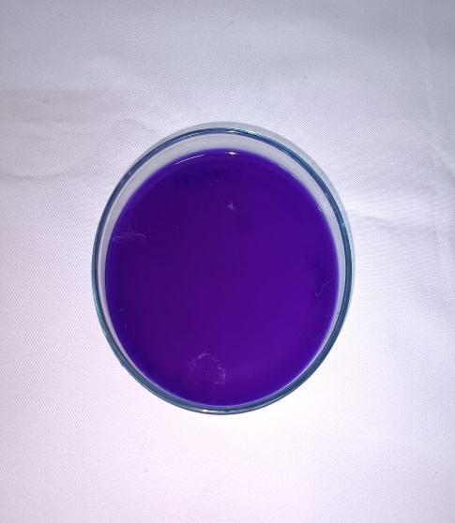
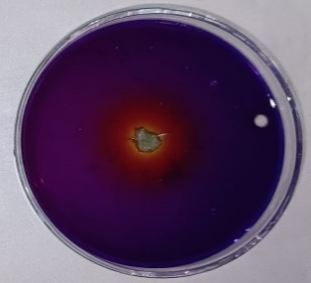
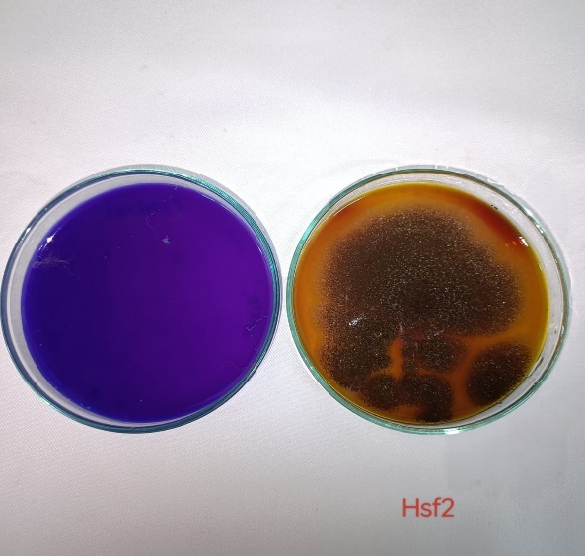
The selected isolates were tested for organic acid production qualitatively in Pikovskaya’s agar containing Bromophenol blue as indicator and the results are recorded. The colour change from blue to orange yellow indicate the production of organic acids by the isolates. All the isolates were tested positive for organic acid production and the isolates PSMH-2 and PSMM-8 have showed more zone of colour change in the petriplate over the others (Fig. 4).
c
b
a

Fig. 4. Organic acid production a) control, b) PSMH-2, c) PSMM-8
3.5.3.1. pH drop in the medium
The observed decrease in pH of the growth medium during the incubation period further supports the notion of organic acid production by the phosphate solubilizing microorganisms. The secretion of organic acids into the growth medium creates a localized acidic environment, which aids in the dissolution of phosphate minerals (Khan et al., 2006). The selected efficient seven fungal and four bacterial isolates were tested for change in pH of the broth during solubilization at different incubation periods and presented in Fig. 5 (a) and 7 (b).
The change in pH of the medium (initial pH of broth 7.00) was found to decrease with an increase in incubation period and lowest pH was observed at sixth day after inoculation (3.12 for PSMH-2 and 2.61 for PSMM-8). The pH decrease serves as a valuable indicator of the microbial activity associated with organic acid production. The correlation between organic acid secretion, pH reduction, and phosphate solubilization provides a strong basis for understanding the role of organic acids in the process. Drop in pH by PSM isolates (73MB, 109MB and A. clavatus) ranging from 4.00 to 3.20) at the end of incubation period has been reported by Alam et al. (2002). Similar results were observed by Bar Yosuf et al. (1999) and Khalil and Sultan (2000).

Fig. 5 (a). Effect of selected fungal isolates on pH of Pikovskaya’s broth

Fig. 5 (b). Effect of selected bacterial isolates on pH of Pikovskaya’s broth
3.5.4. Siderophore production
Siderophores are high affinity iron chelating compounds secreted by microorganisms which help to chelate few elements essential for plants. The siderophore production by phosphate solubilizing microorganisms is one of the mechanisms involved in the phosphate solubilization. The fungal isolates PSMH-2 and the bacterial isolates PSMM-8 tested positive for siderophore production (Fig. 6).
. Rfaki et al., (2019) reported that the phosphate solubilizing bacterial isolates A17, B26, and B107 belong to Pantoea, Pseudomonas, Serratia genera showed the ability to produce siderophores ranging from 79.3 to 20.8% siderophore units. Similarly, Franken et al. (2014) reported siderophore production in fungus Aspergillus niger.

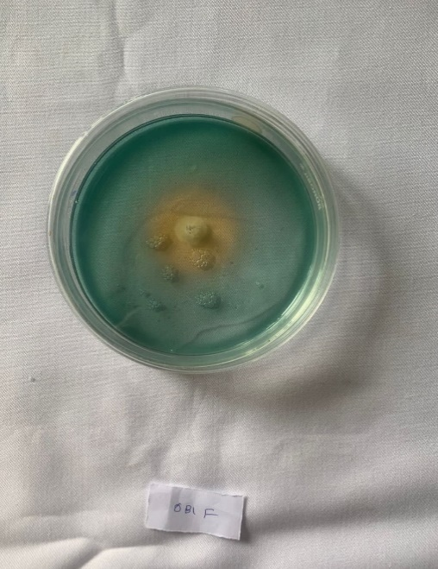
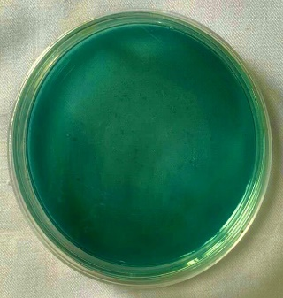
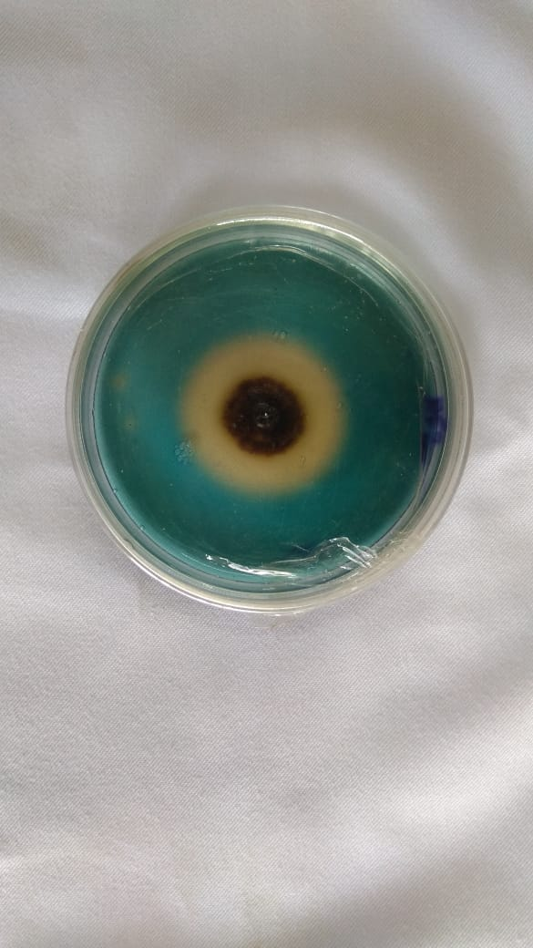
Fig. 6. Siderophore production a) control, b) PSMH-2, c) PSMM-8

3.5.5. Phytohormone production
The selected fungal and bacterial isolates were examined to produce IAA, GA₃, ABA and SA. All the fungal and bacterial isolates were able to produce IAA, GA₃, ABA and SA. Among fungal isolates, the maximum IAA production was recorded by the isolate PSMH-2 (14.87 mg L ⁻¹) which was significantly superior to the reference strain (11.26 mg L ⁻¹) and also significantly superior over all other isolates (Table 5 (a)). Among bacterial isolates, the maximum IAA production was recorded by the isolate PSMM-8 (28.93 mg L ⁻¹) which was significantly superior to the reference strain (23.47 mg L ⁻¹) and also significantly superior over all other isolates (Table 5 (b)). Recently, Batool and Iqbal (2019) tested plant growth promoting attributes in 30 phosphate solubilizing rhizobacteria and observed that all the strains had ability to produce IAA. The highest IAA produced by WumS-3 (120 mg/ml) and lowest by WumS-25 (25 mg/ml). Thus, the PSMs isolates used in the study could provide additional plant growth promotional activity apart from releasing Pi.
Table 5 (a). Phytohormone production by selected fungal isolates
Isolates | IAA  (mg L⁻¹) | GA₃  (mg L⁻¹) | ABA  (mg L⁻¹) | SA  (mg L⁻¹)
PSMM - 3 | 5.93de | 44.28^{ef} | 1.25^{efg} | 1.53^{cd}
PSMM - 4 | 5.39e | 38.95^{g} | 1.01^{g} | 1.14e
PSMM - 5 | 8.73^{c} | 60.49^{c} | 1.84^{cd} | 1.83^{bc}
PSMM - 6 | 5.74de | 40.27^{fg} | 1.13^{fg} | 1.36de
PSMM -7 | 6.23^{d} | 47.38e | 1.49^{def} | 1.62^{cd}
PSMH -2 | 14.87ª | 84.56ª | 2.95^{b} | 2.90ª
PSMG -2 | 6.48^{d} | 52.48^{d} | 1.62de | 1.67^{bcd}
Reference strain | 11.26^{b} | 71.58^{b} | 2.18^{c} | 1.96^{b}
Note : Numerical values are mean of three replicates. Treatments with the different superscripts in the same column represent a significant difference as determined by DMRT (p ≤ 0.05) Reference strain- Aspergillus awamori
Table 5 (b). Phytohormone production by selected bacterial isolates
Isolates | IAA  (mg L⁻¹) | GA₃  (mg L⁻¹) | ABA  (mg L⁻¹) | SA  (mg L⁻¹)
PSMM - 8 | 28.93ª | 113.87ª | 3.75ª | 3.55ª
PSMH - 6 | 15.42^{d} | 76.58^{d} | 2.16^{cd} | 1.53^{d}
PSMG - 3 | 19.37^{c} | 95.29^{c} | 2.32^{c} | 1.98^{c}
PSMG - 5 | 18.29^{c} | 47.21e | 2.01^{d} | 1.29^{d}
Reference strain | 23.47^{b} | 101.54^{b} | 2.98^{b} | 2.33^{b}
Note : Numerical values are mean of three replicates. Treatments with the different superscripts in the same column represent a significant difference as determined by DMRT (p ≤ 0.05) Reference strain- Bacillus megaterium
3.6. Molecular characterization of efficient phosphate solubilizing microorganisms
The in-vitro screening results of all isolates for phosphate solubilization and plant growth promotion potential revealed that the isolates PSMH-2 and PSMM-8 are best fungal and bacterial isolates respectively. These isolates were further carried for molecular characterization and identification. Phylogenetic analysis of the sequence is shown in Fig. 7 (a) and 7 (b).
Based on the percent identity, the isolate PSMH-2 and PSMM-8 were identified as Aspergillus niger and Acinetobacter pitti respectively. All the sequence of the isolates and identity were submitted to the NCBI-GenBank, online repository/ library of sequences, and were designated as Aspergillus niger strain PSMH-2 and Acinetobacter pitti strain PSMM-8 with the accession number OR523461 and OR527816 respectively.
Similar results were reported by Mazrou et al. (2020) who isolated 16 phosphate solubilizing fungi from the rhizosphere of healthy plants in Abha city, Saudi Arabia and were identified by 5.8S-ITS region sequencing and characterized by 11 ISSRPCR markers. All isolates showed 96–100% similarity to Aspergillus niger strains available at GenBank database. The results were also in accordance with the findings of Josephine and Thomas (2022) who isolated phosphate solubilizing bacterium from maize rhizosphere. The strain was identified as Acinetobacter pittii through 16S rRNA sequencing and was designated as Acinetobacter pittii strain F2 5 with the accession number KM677194.

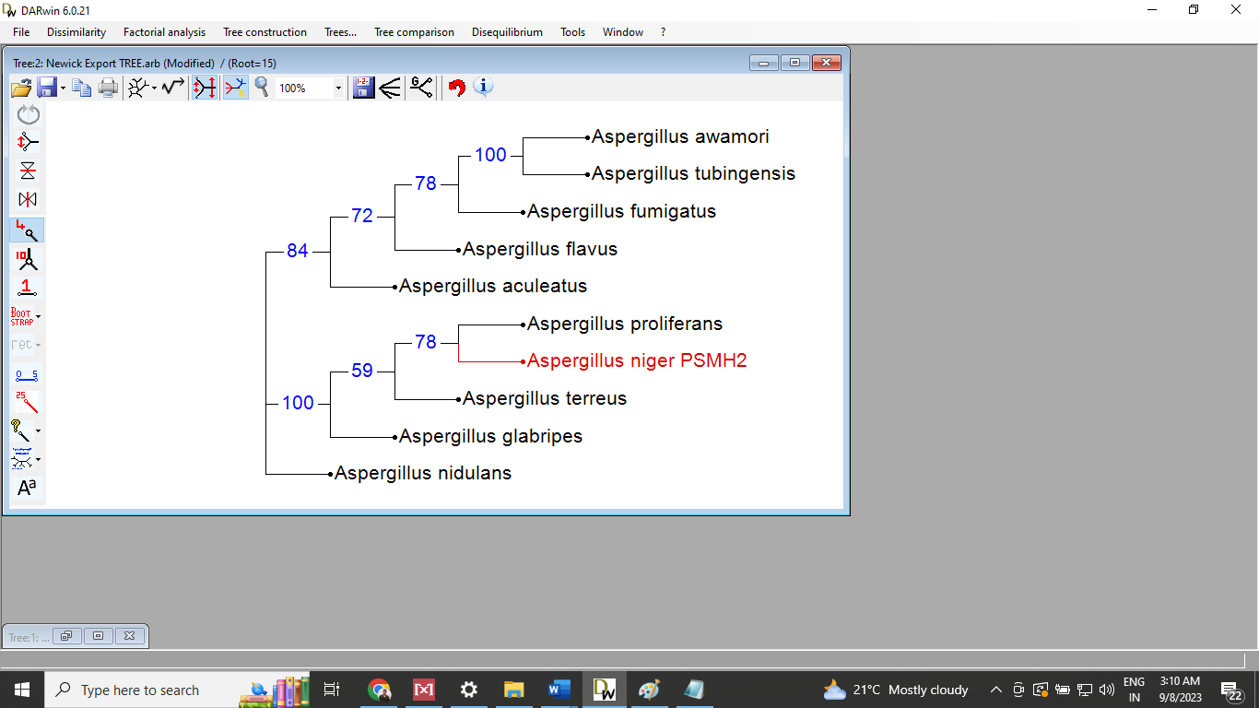
Fig. 7(a) . Phylogenetic tree of efficient fungal isolates constructed by DARwin 6 software
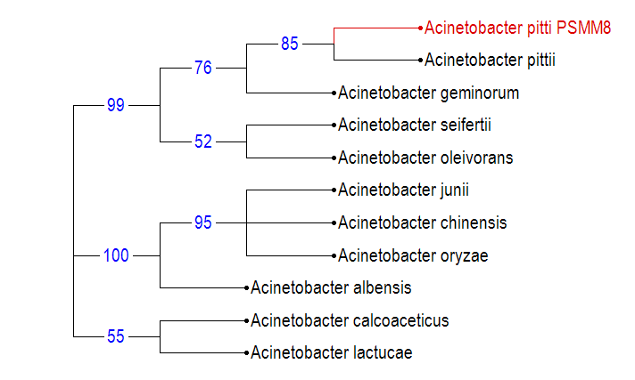
Fig. 7 (b). Phylogenetic tree of efficient bacterial isolates constructed by DARwin 6 software
3.7. Greenhouse experiment
3.7.1. Evaluation of efficient phosphate solubilizing isolates on growth and yield of green gram
The plant growth promoting activity of efficient isolates, PSMH-2 and PSMM-8 (selected from in-vitro screening for phosphate solubilization, plant growth promotion potential), in green gram were studied in greenhouse conditions. A remarkable increase in shoot length, root length, number of leaves, nodulation and yield were observed in green gram plants inoculated with efficient isolates compared with absolute control, reference strain and treatments with only SSP (Table 6 and 7) (Fig. 8 (a), 8 (b), 8 (c) and 8 (d)).
The maximum plant height (34.95 cm), number of leaves (14.58), root length (13.55 cm), number of nodule (28.05), nodule weight (216.08 mg/ plant), shoot weight (fresh weight: 35.86 g/ plant; dry weight: 5.87 g/ plant), root weight (fresh weight: 3.58 g/ plant; dry weight: 1.25 g/ plant), number of pods (34.68) and grain weight (15.89 g/ plant) were recorded for the plant inoculated with PSMM-8 along with 100 % SSP. The plant inoculated with PSMH-2 along with 100 % SSP also resulted in increased plant height (34.89 cm), root length (12.83 cm), number of leaves (14.53), number of nodule (26.77), nodule weight (198.11 mg/ plant), shoot weight (fresh weight: 34.57 g/ plant; dry weight: 5.13 g/ plant), root weight (fresh weight: 3.09 g/ plant; dry weight: 0.99g/ plant), number of pods (32.21) and grain weight (14.99 g/ plant) over the absolute control, reference strain and plant treated with only SSP.
Increased growth and phosphorous uptake of several crop plants due to inoculation of PSM have also been reported in a number of studies conducted both under growth chamber and green house conditions (Vikram and Hamzehzarghani, 2008; Hariprasad and Niranjana, 2009; Yu et al., 2011). The increases in shoot length, root length, shoot dry weight, and root dry weight of green gram plants inoculated with PSM strains could be attributed to a greater absorption of nutrients, especially phosphorous. However, phosphate solubilization is not the only way PSM promote plant growth, because they facilitate the growth of plants by stimulating the efficiency of producing plant hormones such as auxins, cytokinins, gibberellins as well as some volatile compounds (Podile and Kishor, 2006).
3.7.2. Evaluation of efficient phosphate solubilizing isolates on soil available nutrients and plant nutrient uptake
The soil available nitrogen recorded significantly higher value for the treatment T₈ (299.83 Kg ha⁻¹) and T₁₄ (301.45 Kg ha⁻¹) over absolute control and reference strain. The treatments T₈ and T₁₄ also exhibited significantly higher values for soil available phosphorus (35.42 Kg ha⁻¹ and 36.57 Kg ha⁻¹ respectively) and potassium (195.23 Kg ha⁻¹ and 194.42 Kg ha⁻¹) (Table 9). These treatments (T₈ and T₁₄) exhibited significantly higher nitrogen, phosphorus and potassium uptake compared to both treatments relying solely on SSP the reference strain (Table 8).
The results are in accordance with the findings of Singh et al. (2018) who reported that application of phosphorus accelerated the uptake of nutrients (N,P and K) significantly Kuan et al. (2016) also revealed that the microbially induced plant growth regulators like auxin stimulate lateral and adventitious root establishment, which boosts general plant nutrient uptake. Similar results was also reported by Afzal and Bano 2008.
Table 6 : Plant height (cm), Number of leaves, Root length (cm), Number of nodules and Weight of nodule (mg/ plant) measurement of the treatments

Treatments | Plant height (cm) |  |  | Number of leaves |  |  | Root length (cm) | Number of nodules | Weight of nodule (mg/ plant)
Treatments | 20 DAS | 40 DAS | At harvest | 20 DAS | 40 DAS | At harvest | Root length (cm) | Number of nodules | Weight of nodule (mg/ plant)
T₁ : Absolute control | 7.60e | 7.81^{g} | 8.52^{d} | 2.96^{d} | 2.57e | 3.04^{f} | 5.50^{h} | 4.05^{i} | 60.05^{g}
T₂ : 100% SSP | 11.78^{cd} | 18.86^{d} | 28.75^{bc} | 3.97^{c} | 4.56^{d} | 8.58^{d} | 8.61^{f} | 8.03^{g} | 106.13e
T₃ : 75% SSP | 9.45^{d} | 15.37e | 26.43^{bc} | 3.93^{c} | 4.54^{d} | 5.57e | 7.55^{g} | 6.17^{h} | 84.23^{f}
T₄ : 50% SSP | 8.38^{d} | 13.34^{f} | 23.57^{c} | 3.90^{c} | 4.53^{d} | 5.54e | 6.90^{g} | 5.36^{hi} | 80.74^{f}
T₅ : 100% SSP + Fungal reference strain | 13.69^{b} | 21.49^{abc} | 30.64^{b} | 4.94^{b} | 6.58^{c} | 12.59^{c} | 10.92^{bc} | 15.11e | 148.02^{cd}
T₆ : 75% SSP + Fungal reference strain | 11.24^{bc} | 19.16^{c} | 29.28^{b} | 4.84^{b} | 6.53^{c} | 12.54^{c} | 9.61de | 13.95^{f} | 140.13^{cd}
T₇ : 50% SSP + Fungal reference strain | 10.16^{bc} | 18.20^{c} | 28.14^{b} | 4.80^{b} | 6.52^{c} | 12.53^{c} | 9.20^{ef} | 12.23^{f} | 136.64^{d}
T₈ : 100% SSP + Efficient fungal isolate | 15.92ª | 23.74^{abc} | 34.89ª | 6.07ª | 8.54^{ab} | 14.53^{ab} | 12.83ª | 26.77^{b} | 198.11^{b}
T₉ : 75% SSP + Efficient fungal isolate | 13.75ª | 21.65^{abc} | 33.72ª | 5.99ª | 8.50^{ab} | 13.57^{bc} | 11.78^{b} | 26.34^{b} | 197.96^{b}
T₁₀ : 50% SSP + Efficient fungal isolate | 12.61ª | 21.53^{abc} | 32.58ª | 5.93ª | 7.59^{bc} | 13.55^{bc} | 10.69^{bc} | 25.99^{b} | 196.86^{b}
T₁₁ : 100% SSP + Bacterial reference strain | 13.84^{b} | 20.62^{abc} | 30.83^{b} | 4.96^{b} | 8.58^{ab} | 14.58^{ab} | 11.41^{b} | 18.42^{c} | 154.82^{c}
T₁₂ : 75% SSP + Bacterial reference strain | 11.35^{bc} | 19.57^{abc} | 29.35^{b} | 4.93^{b} | 8.57^{ab} | 14.61^{ab} | 10.22^{cd} | 16.99^{cd} | 148.01^{cd}
T₁₃ : 50% SSP + Bacterial reference strain | 10.17^{bc} | 19.35^{bc} | 29.13^{b} | 4.87^{b} | 8.55^{ab} | 14.60^{ab} | 10.17^{cde} | 16.13de | 146.39^{cd}
T₁₄ : 100% SSP + Efficient bacterial isolate | 16.82ª | 23.58ª | 34.95ª | 6.13ª | 9.57ª | 15.62ª | 13.55ª | 28.05ª | 216.08ª
T₁₅ : 75% SSP + Efficient bacterial isolate | 14.65ª | 22.49ª | 33.64ª | 5.99ª | 9.53ª | 15.61ª | 12.49ª | 28.01ª | 215.27ª
T₁₆ : 50% SSP + Efficient bacterial isolate | 13.58ª | 21.36^{ab} | 32.27ª | 5.93ª | 9.53ª | 15.61ª | 11.43^{b} | 27.99ª | 214.55ª
Note : Numerical values are mean of three replicates. Treatments with the different superscripts in the same column represent a significant difference as determined by DMRT (p ≤ 0.05). SSP- Single super phosphate. DAS- Days after sowing. Fungal reference strain-Aspergillus awamori. Bacterial reference strain-Bacillus megaterium.
Table 7 : Shoot weight (g/ plant), Root weight (g/ plant), Number of pods/plant, Grain weight
(g/ plant) measurement of the treatments

Treatments | Shoot weight (g/ plant) |  | Root weight (g/ plant) |  | Number of pods/ plant | Grain weight  (g/ plant)
Treatments | Fresh | Dry | Fresh | Dry | Number of pods/ plant | Grain weight  (g/ plant)
T₁ : Absolute control | 9.32e | 1.10^{g} | 0.62e | 0.02e | 2.40^{g} | 2.56^{d}
T₂ : 100% SSP | 18.55^{d} | 3.21e | 1.98^{c} | 0.28^{d} | 22.58^{d} | 11.87^{bc}
T₃ : 75% SSP | 17.28^{d} | 2.67^{f} | 1.56^{c} | 0.25^{d} | 17.61e | 10.45^{c}
T₄ : 50% SSP | 16.25^{d} | 1.40^{g} | 1.12^{d} | 0.21^{d} | 13.55^{f} | 9.89^{c}
T₅ : 100% SSP + Fungal reference strain | 29.47^{bc} | 4.23^{c} | 2.98^{b} | 0.86^{c} | 28.87^{b} | 13.56^{ab}
T₆ : 75% SSP + Fungal reference strain | 27.22^{c} | 3.96^{c} | 1.97^{c} | 0.79^{c} | 25.29^{c} | 12.42^{ab}
T₇ : 50% SSP + Fungal reference strain | 26.98^{c} | 3.60^{d} | 1.96^{c} | 0.78^{c} | 24.96^{c} | 11.12^{bc}
T₈ : 100% SSP + Efficient fungal isolate | 34.57ª | 5.13^{b} | 3.09ª | 0.99^{b} | 32.21ª | 14.99ª
T₉ : 75% SSP + Efficient fungal isolate | 33.64ª | 4.12^{c} | 2.99^{b} | 0.98^{b} | 32.19ª | 13.87^{ab}
T₁₀ : 50% SSP + Efficient fungal isolate | 33.42ª | 4.03^{c} | 2.87^{b} | 0.97^{b} | 31.63ª | 13.79^{ab}
T₁₁ : 100% SSP + Bacterial reference strain | 30.81^{b} | 4.31^{c} | 2.88^{b} | 0.88^{c} | 29.83^{b} | 13.98^{ab}
T₁₂ : 75% SSP + Bacterial reference strain | 29.42^{bc} | 3.98^{c} | 1.74^{c} | 0.85^{c} | 27.59^{b} | 12.87^{ab}
T₁₃ : 50% SSP + Bacterial reference strain | 28.39^{bc} | 3.74^{c} | 1.68^{c} | 0.83^{c} | 26.91^{bc} | 11.68^{bc}
T₁₄ : 100% SSP + Efficient bacterial isolate | 35.86ª | 5.87ª | 3.58ª | 1.25ª | 34.68ª | 15.89ª
T₁₅ : 75% SSP + Efficient bacterial isolate | 34.26ª | 4.86^{c} | 2.56^{b} | 1.19ª | 33.96ª | 14.54ª
T₁₆ : 50% SSP + Efficient bacterial isolate | 33.69ª | 4.70^{c} | 2.55^{b} | 1.09ª | 33.61ª | 13.12^{ab}
Note : Numerical values are mean of three replicates. Treatments with the different superscripts in the same column represent a significant difference as determined by DMRT (p ≤ 0.05). SSP- Single super phosphate. DAS- Days after sowing. Fungal reference strain-Aspergillus awamori. Bacterial reference strain-Bacillus megaterium.
Table 8 : Soil available nutrients (Kg ha⁻¹) and Nutrient uptake (%) measurement of the treatments

Treatments | Soil available nutrients (Kg ha⁻¹) |  |  | Nutrient uptake (%)
Treatments | Nitrogen | Phosphorus | Potassium | Nitrogen | Phosphorus | Potassium
T₁ : Absolute control | 251.36^{f} | 11.87^{f} | 176.16^{i} | 0.98e | 0.06e | 0.41^{c}
T₂ : 100% SSP | 265.37^{cde} | 19.43^{d} | 190.34^{f} | 1.89^{cd} | 0.13^{d} | 0.63^{b}
T₃ : 75% SSP | 262.85de | 15.28de | 189.32^{g} | 1.61^{d} | 0.12^{d} | 0.62^{b}
T₄ : 50% SSP | 259.72^{ef} | 12.67e | 188.41^{h} | 1.43de | 0.09de | 0.61^{b}
T₅ : 100% SSP + Fungal reference strain | 278.15^{b} | 29.78^{b} | 193.21^{c} | 2.87^{ab} | 0.26^{bc} | 0.76ª
T₆ : 75% SSP + Fungal reference strain | 273.83^{bcd} | 28.71^{bc} | 192.28^{d} | 2.28^{b} | 0.25^{bc} | 0.74ª
T₇ : 50% SSP + Fungal reference strain | 270.11^{bcde} | 27.98^{bc} | 191.17e | 2.27^{bc} | 0.22^{c} | 0.68^{b}
T₈ : 100% SSP + Efficient fungal isolate | 299.83ª | 35.42ª | 194.42^{b} | 3.31ª | 0.38ª | 0.77ª
T₉ : 75% SSP + Efficient fungal isolate | 297.98ª | 34.12ª | 193.29^{c} | 2.62^{b} | 0.37ª | 0.75ª
T₁₀ : 50% SSP + Efficient fungal isolate | 296.54ª | 33.98ª | 192.38^{d} | 2.44^{b} | 0.36ª | 0.71ª
T₁₁ : 100% SSP + Bacterial reference strain | 280.17^{b} | 30.21^{b} | 193.25^{c} | 2.98^{ab} | 0.28^{b} | 0.69^{b}
T₁₂ : 75% SSP + Bacterial reference strain | 276.33^{bc} | 29.87^{bc} | 192.39^{d} | 2.88^{ab} | 0.25^{bc} | 0.66^{b}
T₁₃ : 50% SSP + Bacterial reference strain | 274.19^{bcd} | 28.99^{bc} | 191.17e | 1.63^{d} | 0.21^{c} | 0.62^{b}
T₁₄ : 100% SSP + Efficient bacterial isolate | 301.45ª | 36.57ª | 195.23ª | 3.33ª | 0.39ª | 0.78ª
T₁₅ : 75% SSP + Efficient bacterial isolate | 298.74ª | 34.83ª | 194.42^{b} | 2.32^{b} | 0.37ª | 0.76ª
T₁₆ : 50% SSP + Efficient bacterial isolate | 297.26ª | 33.12ª | 193.69^{bc} | 2.29^{b} | 0.35ª | 0.74ª
Note : Numerical values are mean of three replicates. Treatments with the different superscripts in the same column represent a significant difference as determined by DMRT (p ≤ 0.05). SSP- Single super phosphate. DAS- Days after sowing. Fungal reference strain-Aspergillus awamori. Bacterial reference strain-Bacillus megaterium.

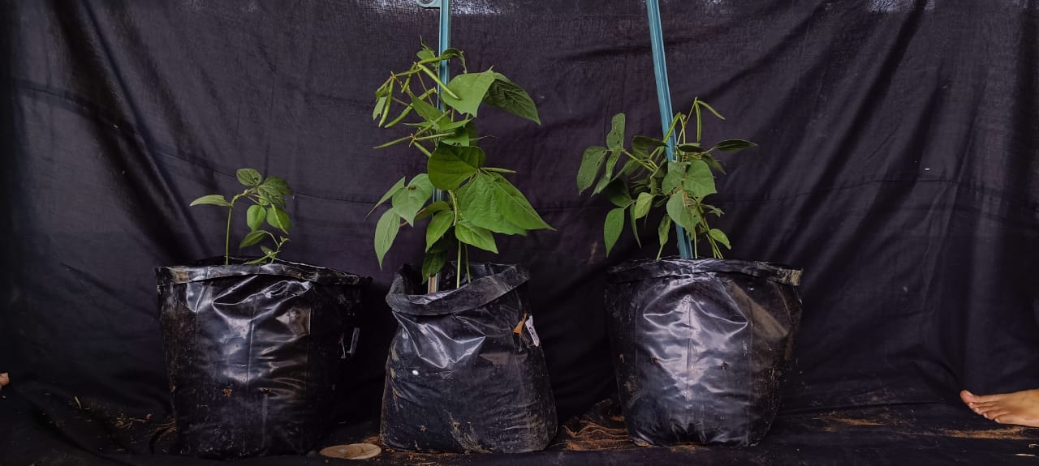
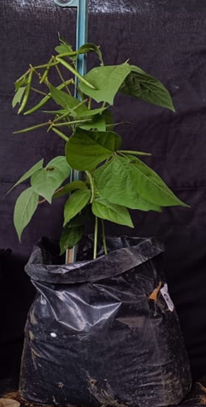
T₈
T₅
T₁
Fig. 8 (a). Effect of inoculation of efficient fungal isolate on growth of green gram plants under green house condition

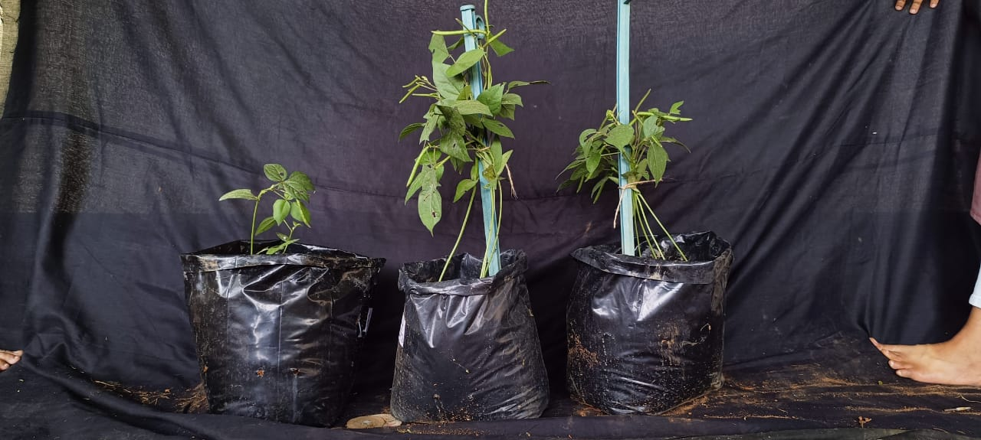
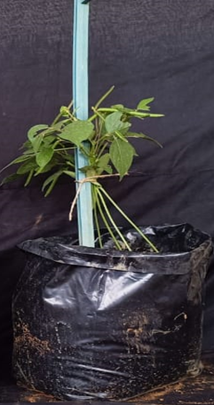
T₁₄
T₁₁
T₁
Fig. 8 (b). Effect of inoculation of efficient bacterial isolate on growth of green gram plants
under greenhouse condition

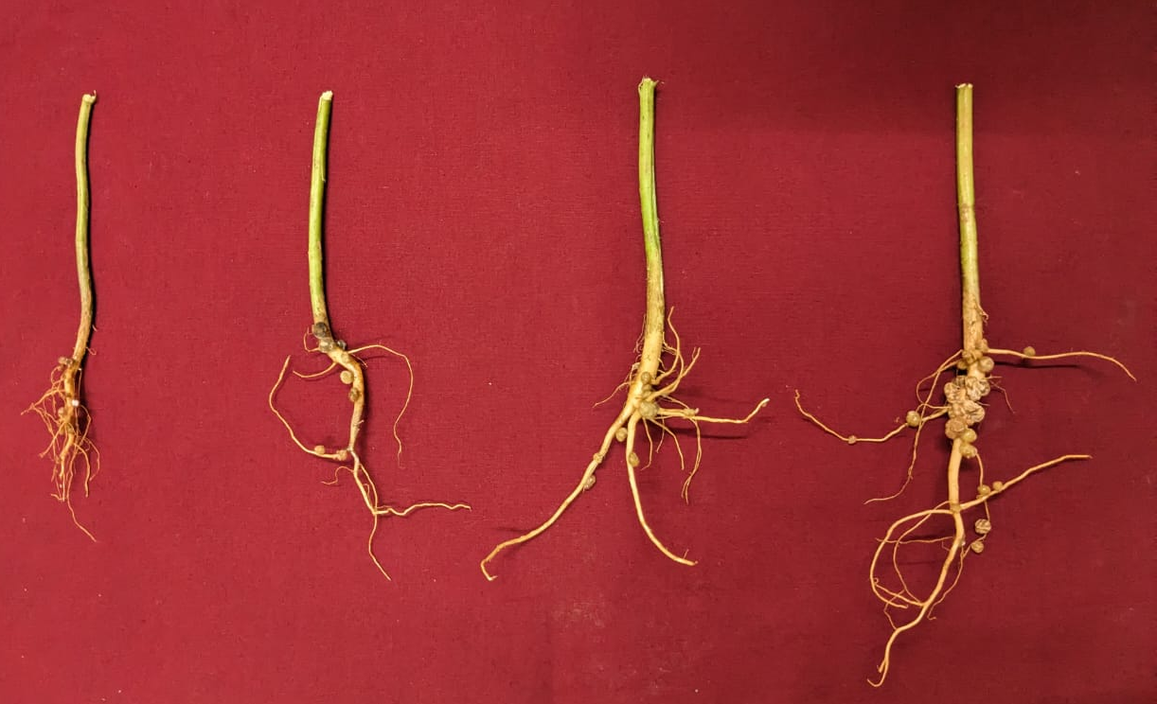

T₈
T₅
T₂
T₁
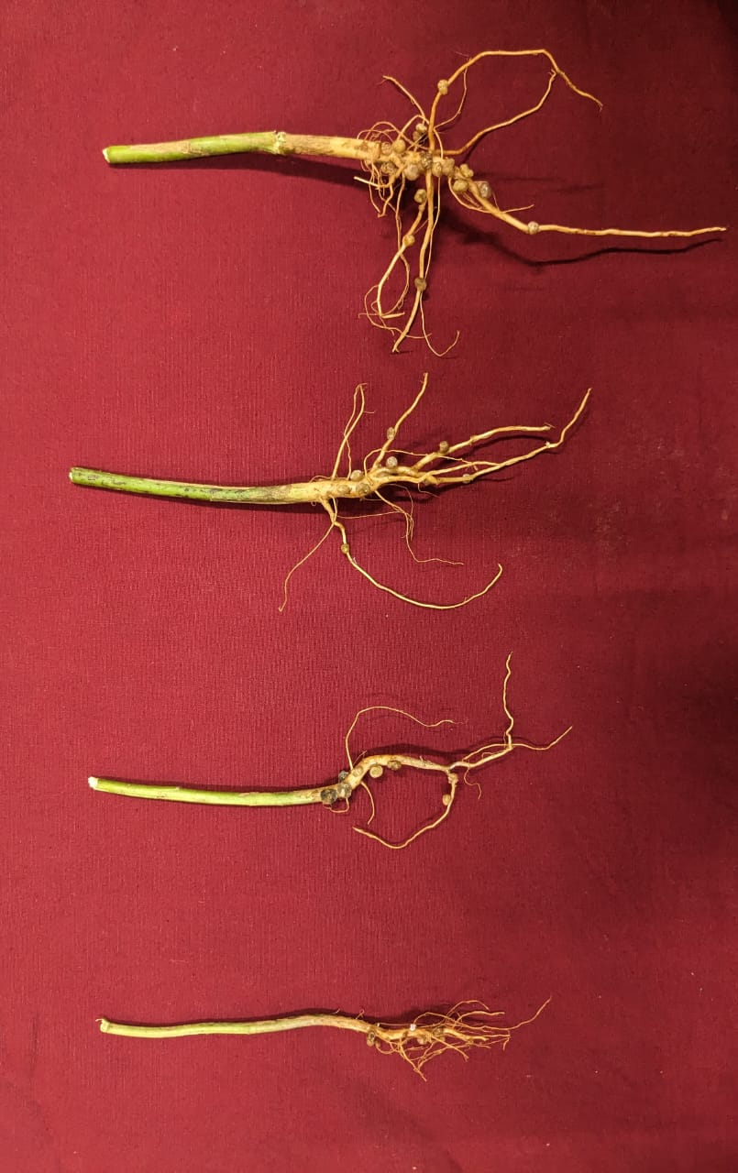
Fig. 8 (c) . Effect of inoculation of efficient fungal isolate on nodulation of green gram plants under greenhouse condition

T₁₄
T₁
T₂
T₁₁

Fig. 8 (d). Effect of inoculation of efficient bacterial isolate on nodulation of green gram plants under greenhouse condition

4. CONCLUSIONS
Phosphorus is a vital element for plant growth and the development of healthy root systems. In many soils, phosphorus is often unavailable to plants due to fixation. This unavailability can severely limit plant growth and productivity. The phosphate solubilizing microorganisms possess the ability to release phosphorus from its bound forms in the soil, making it accessible to plants. This microbial driven solubilization not only enhances phosphorus uptake but also promotes overall plant health and vigor, ultimately contributing to increased agricultural yields and improved ecosystem sustainability. Considering all these factors, efforts were undertaken in the current work to identify and characterize efficient isolates that solubilize insoluble phosphate. Some bacterial and fungal isolates were isolated and evaluated for their ability to raise the phosphorus content and plant growth in green gram grown in a glasshouse.
A total of 30 PSM strains were isolated from the rhizospheric soil samples of green gram plant collected from different regions of Karnataka. Efficient 11 strains producing a prominent halo zone around them were selected for detailed studies. Biochemical characterization of all the bacterial isolates was performed and result showed that the carbohydrate utilization and biochemical reactions were different from strain to strain. The phosphate solubilizing potential of the potent PSM isolates was determined by both qualitative as well as quantitative estimation. Based on qualitative and quantitative analysis, PSMH-2 and PSMM-8 were selected as efficient phosphate solubilizers among fungal and bacterial isolates, respectively for further studies. Upon subjecting PSMH-2 and PSMM-8 to molecular characterization, they were identified as Aspergillus niger PSMH-2 and Acinetobacter pitti PSMM-8 respectively.
The plant growth promoting activity of efficient isolates (PSMH-2 and PSMM-8) in green gram were studied in greenhouse conditions. In the experiment, efficient isolates were used in combination with recommended doses of phosphorus fertilizer. Sixteen treatments were designed with combination of SSP and isolates. A remarkable increase in shoot length, root length, leaf number, nodulation and yield were observed in green gram plants inoculated with efficient isolates compared with absolute control and treatments with only SSP. The maximum plant height (34.95 cm), root length (13.55 cm), number of nodule (28.05), number of pods (34.68) and grain wight (15.89 g/ plant) were recorded for the plant inoculated with PSMM-8 along with 100 % SSP. The plant inoculated with PSMH-2 along with 100 % SSP also resulted in increased plant height (34.89 cm), root length (12.83 cm), number of nodule (26.77), number of pods (32.21) and grain wight (14.99 g/ plant) over the absolute control and plant treated with only SSP.
The phosphorus and nitrogen uptake by the plant inoculated with PSMH-2 and PSMM-8 along with 100 % SSP were significantly higher when compared to the treatments contain only SSP. The soil nutrient analysis revealed that the highest soil nitrogen and phosphorus content was recorded in plant treated with PSMH-2 and PSMM-8 along with 100 % SSP over the treatments contain only SSP.
This study has provided evidence that isolates Aspergillus niger and Acinetobacter pitti have significant effects on both phosphorus solubilization and plant growth enhancement.
Based on the results, the isolates Aspergillus niger and Acinetobacter pitti have been identified as efficient phosphate solubilizers. These isolates when inoculated to plant with SSP were resulted in maximum growth and yield of green gram plant when compared to the plants which treated with only SSP. However, further studies should be carried out under field conditions, in confirmation of the present results, to demonstrate these strains’ high potential for use as soil inoculants to enhance soil fertility and plant growth.

5. REFERENCES
Afzal, A., Bano, A., 2008. Rhizobium and phosphate solubilizing bacteria improve the yield and phosphorus uptake in wheat (Triticum aestivum). Int. J. Agric. Biol., 10(1): 85-88.
Alori, E. T., Bernard, R., Glick, Olubukola, O., 2017. Babalola microbial phosphorus solubilization and its potential for use in sustainable agriculture. Front. Microbiol. Plant Microbe Interact., 8: 971.
Barthalomew, J. W., Mittewar, T., 1950. A simplified bacterial stain. Stain Technol., 25: 153.
Bar-yosuf, B., Rogers, R. D., Wolform, J. H. Richman, E., 1999. Pseudomanas cepacia mediated rock phosphate solubilization in Kaolinite and montmorillonite suspensions. Soil Sci. Society Amer. J., 63:1703-1708.
Chawngthu, L., Hnamte, R. Lalfakzuala, R., 2020. Isolation and characterization of rhizospheric phosphate solubilizing bacteria from wetland paddy field of Mizoram, India. Geomicrobiol. J., 37(4): 366-375.
Chen, J., Zhao, G., Wei, Y., Dong, Y., Hou, L. Jiao, R. 2021. Isolation and screening of multifunctional phosphate solubilizing bacteria and its growth-promoting effect on Chinese fir seedlings. Scientifc Reports. 11: 9081
Franken, A.C., Lechner, B.E., Werner, E.R., Haas, H., Lokman, B.C., Ram, A.F., Van den hondel, C.A., De Weert, S., Punt, p.j., 2014. Genome mining and functional genomics for siderophore production in Aspergillus niger. Briefings function. Genom., 13(6): 482-492.
Gilman, J. C., 1957. A manual of soil fungi. 2nd Edn, Oxford and IBH pub. Co., Calcutta, Bombay, New Delhi.
Gupta, M., Kiranc, S., Gulati, A., Singh. B., Tewari, R. 2012. Isolation and identification of phosphate solubilizing bacteria able to enhance the growth and aloin-A biosynthesis of Aloe barbadensis Miller. Microbiolol. Res., 167:358-363.
Hariprasad, P., Niranjana, S. R., 2009, Isolation and characterization of phosphate solubilizing rhizobacteria to improve plant health of tomato. Plant and Soil. 316:13-24
Hasan, M. M., Hasan, M. M., Jaime, A., Silva, T. D. Xuexian, L., 2016. Regulation of phosphorus uptake and utilization: transitioning from current knowledge to practical strategies. Cell. Mol. Biol. Lett., 21:7.
Isenberg, H.D., 1995. Essential Procedures for Clinical Microbiology, American Society for Microbiology, Washington D.C.
Jackson, M. L., 1973. Soil chemical analysis. Prentice Hall of India, New Delhi, 1- 485.
Janda, J., Abbott, S. 2002. Bacterial identification for publication: when is enough enough? J. of Clinical Microbio., 40(6): 1887-1891.
Josephine, C.M., Thomas, J., 2022. Plant growth ameliorating and rhizosphere competent native Acinetobacter pittii strain F2 5 from the rhizosphere of Zea mays L. Indian J. of Agric. Res., 56(2), 152-156.
Kalayu, G., 2019. Phosphate solubilizing microorganisms: promising approach as biofertilizers. Int. J. Agron., 15: 1-7.
Kanimozhi, G., Panneerselvam, A., 2010. Isolation and screening of phosphate solubilising fungi from Mangrove soils of Muthupettai, Thiruvarur Ditrict, India. Asian J. Micribiol. Biotech. Env. Sci., 12 (2): 359-361.
Khalil, S., Sultan, T., 2000. Phosphorus solubilizing microorganisms potential improve P availability from unavailable sources. 8th Int. Soil Sci. Cong. Islamabad.
Khan, M.M.K., Bhuiyan, M., Kabir, S.M., Oki, Y., Adachi, T., 2006. Effect of selected treatments on the production of rice (Oryza sativa) in acid sulfate soils in a stimulation study. Japanese Soc. Trop. Agric., 50: 109-115.
Khan, M.S., Zaidi, A., Ahemad, M., Oves, M., Wani, P.A. 2010. Plant growth promotion by phosphate solubilizing fungi–current perspective. Archi. Agron. Soil Sci.,56: 73-98.
Kishore, N., Pindi, P. K. Reddy, S. R. 2015. Phosphate solubilizing microorganisms: a critical review. Springer, 307- 333.
Kuan, K.B., Othman, R., Abdul rahim, K., Shamsuddin, Z.H., 2016. Plant growth promoting rhizobacteria inoculation to enhance vegetative growth, nitrogen fixation and nitrogen remobilization of maize under greenhouse conditions. PLOS ONE 11(3):152478
Mazrou, V.S., Makhlouf, A.H., Elbealy, E.R., Salem, M.A, Farid, M.A., Awad, M.F., Hassan, M.M., Ismail, M., 2020. Molecular characterization of phosphate solubilizing fungi Aspergillus niger and its correlation to sustainable agriculture. J. Environ. Biol., 41(3),592-599.
Murphy, J. A. M. E. S., Riley, J., 1962. A modified single solution method for the determination of phosphate in natural waters. Anal. Chim. Acta., 27: 31- 36.
Naureen, Z., Aqeel, M., Hassan, M. N., Gilani, S. A., Bouqellah, N. A., Mabood, F., Hussain, J., Hafeez, F. Y., 2015. Isolation and screening of silicate bacteria from various habitats for biological control of phytopathogenic fungi. Am. J. Plant Sci., 6: 2850-2859.
Nguyen, C., Yan, W., Le tacon, F. Lapeyrie, F., 1992. Genetic variability of phosphate solubilizing activity by monokaryotic and dikaryotic mycelia of the ectomycorrhizal fungus Laccaria bicolor (Maire) P. D Orton. Plant Soil, 143(2): 193- 199.
Pikovskaya, R. L., 1948. Mobilization of phosphorus in soil in connection with vital activity of some microbial species. Microbiologia, 17:362-370.
Podile, A.R., Kishor, G.K., 2006. Plant growth promoting rhizobacteria. Plant associated bacteria. springer, Dordrecht :195-230.
Rfaki, A., Zennouhi, O., Aliyat, F. Z., Nassiri, L. Ibijbijen, J., 2020. Isolation, selection and characterization of root-associated rock phosphate solubilizing bacteria in moroccan wheat (Triticum aestivum L.). Geomicrobiol. J., 37(3): 230-241.
Sandle, T., 2016. Microbial identification. Pharmaceutical Microbiology, Science direct. 103-113.
Schwyn, B. Neilands, J. B., 1987. Universal chemical assay for the detection and determination of siderophores. Anal. biochem., 160(1): 47-56.
Sharma, S. B., Sayyed, R. Z., Trivedi, M. H. Gobi, T. A., 2013. Phosphate solubilizing microbes: sustainable approach for managing phosphorus deficiency in agricultural soils. Springerplus, 2: 587.
Singh, R., Singh, P., Singh, V., Vadav, R.A., 2018. Effect of phosphorus and PSB on yield attributes, quality and economics of summer green gram (Vigna radiata L.). Journal of pharmacognosy and phytochemistry, 7(2) :404-408.
Subbaiah, B. V., Asija, G. L., 1956. A rapid procedure for the estimation of available nitrogen in soils. Curr. Sci., 25: 259-260.
Tabatabi, M. A., Bremner, J. M., 1969. Soil Biol. Biochem., 1: 301– 307.
Tarafdar, J., Jungk, A., 1987. Phosphatase activity in the rhizosphere and its relation to the depletion of soil organic phosphorus. J. Biol. Fert. Soil., 3: 199-204.
Varsha, N., Pratima, D., Tithi, S., Shalini, R., 2010. Isolation and characterization of a fungal isolate for phosphate solubilisation and plant growth promoting activity. J. Yeast Fung. Res., 1(1): 9-14.
Vikram, A., Hamzehzarghani H., 2008. Effect of phosphate solubilizing bacteria on nodulation and growth parameters of green gram (Vigna radiata L. Wilchek). Res. J. Microbiol., 3:62-72
Yu, X., Liu, X., Zhu, T, H., Liu, G, H., Mao C., 2011. Isolation and characterization of phosphate solubilizing bacteria from walnut and their effect on growth and phosphorus mobilization. Biol. Fertility Soils. 47:437-446.
Zhu, F., Qu, L., Hong, X., Sun, X., 2011. Isolation and characterization of a phosphate solubilizing halophilic bacterium Kushneria sp. YCWA18 from Daqiao Saltern on the coast of yellow sea of China. Evid. Based Complementary Altern. Med., 9: 615032.

