Isolation, Identification and Antibiogram Study of E. coli isolated from Bovine Mastitis Milk

ABSTRACT
Bovine mastitis is the most common disease in dairy animals. It is the inflammation of the udder, usually caused by various bacterial pathogens, continues to pose a significant challenge to animal health and productivity. Mastitis is considered as a serious problem of dairy animals affecting animal welfare as well as economically leads to huge losses to the dairy industry. The present study was conducted to isolate, identify and to determine antimicrobial resistance profile of E. coli from bovine mastitis milk in and around Jabalpur. A total of 210 bovines were screened for mastitis through California Mastitis Test (CMT) and positive samples were inoculated in Brain Heart Infusion broth followed by Nutrient Agar and MacConkey lactose Agar. These samples were further inoculated on to specific culture media for isolation of E. coli and further identified by gram staining, biochemical tests/ BD Phoenix M50 automated machine. The antimicrobial sensitivity of isolates was tested by Kirby Bauer disc diffusion method. A total of 34/210 (16.19%) samples were reported positive for clinical mastitis. Out of this six isolates (17.64%) were confirmed as E. coli. They were showing pink colonies on MLA and green metallic sheen on EMB Agar. On Gram’s staining they appear as short rods. Genotypic identification using 16S rRNA revealed that 100% phenotypically confirmed isolates of E. coli were found positive. The antibiogram revealed that the isolates of E. coli showed resistance against Ampicillin (83.33%) and Cefoxitin (66.66%), while shows sensitivity towards Amikacin (83.33%), Gentamicin (83.33%) and Tetracycline (83.33%). These result highlights the significant concern of antimicrobial resistance in E. coli isolates from mastitic milk and emphasizes the critical need for prudent antimicrobial use and on-going surveillance to effectively manage mastitis and mitigate the impact of resistance in dairy farming.
Keywords: E. coli, Bovine Mastitis, Antimicrobial resistance.

INTRODUCTION
Bovine mastitis is the most common disease in dairy animals and characterized by inflammation of the udder which usually caused by bacterial infection. India besides being first in the world in terms of milk production still faces mastitis as a serious problem of dairy animals which affects animal welfare economically and leads to huge losses to the dairy industry by means of decreased production performance and increased culling rates. In cattle and buffalo, mastitis is an important economic problem worldwide including India (Das et al., 2018). Mastitis is a multi-etiological disease which commonly associated with faulty milking habits of milkers and defective machine milking techniques that also favour the pathogens to infect the udder to propagate and leads to mastitis.
The disease is primarily caused by bacterial pathogens such as Streptococcus spp, S. aureus, E. coli and Klebsiella spp. Although E. coli was reported as the most frequent cause of mastitis in cows followed by Klebsiella pneumoniae which tend to cause clinical mastitis with severe inflammation and necrosis in mammary glands (Zhao and Lacasse, 2008). These bacteria can form protective layers called biofilms because of which it could develop resistance many antibiotics, which may complicate the treatment. Although mastitis cannot be treated only with antibiotics, as the misuse and overuse of antibiotics can lead to another serious issue i.e., the antimicrobial resistance (AMR) which means the bacteria evolve enough to resist the antibiotics. It is the most costly disease in the dairy industry because of the excessive use of antibiotics (Erskine et al., 2002). The common etiological agents of AMR in bovine mastitis are Staphylococcus spp (36.04%), Enterococcus spp (19.52%), E. coli (9.26%) and Streptococcus spp (4.39%) (Patel et al., 2019). The consequences of AMR in mastitis are harmful to animals and humans due to the causative pathogens resistant to antibiotic treatment, leading to high mortality rates among animals and increased cost of treatment which is responsible for economic losses for farmers. Thus, mastitis is not only economically important to the farmers but also has public health significance associated with potential zoonotic risk and dissemination of livestock acquired multi-drug resistant organisms. This highlights the importance of continuous surveillance and monitoring for antimicrobial resistance in veterinary and public health.

MATERIAL AND METHODS
Location and place of work
The proposed work was conducted in the Department of Veterinary Microbiology, College of Veterinary Science and Animal Husbandry, Jabalpur. Nanaji Deshmukh Veterinary Science University, Jabalpur.
Sample Collection
A total of 210 bovines were screened for clinical mastitis from various organized and unorganized dairy farms in and around Jabalpur. Milk samples from all the four teats were screened aseptically by washing the teats, drying and cleaning with cotton soaked in 70% ethyl alcohol (Hogan et al., 2009). First few streams of milk was discarded and subsequently equal amount of milk from the teats was directly taken into California mastitis test (CMT) paddle and tested for mastitis. In this series CMT positive mastitic milk samples were collected, kept in ice box and immediately brought to the Bacteriology Laboratory of the Department for further analysis.

Sample Processing and Isolation of Escherichia coli from milk sample
The Escherichia coli from the mastitic milk was isolated by conventional method following methodology of (Markey et al., 2013) with some modifications.
Initially the milk samples were centrifuged and sediment was inoculated in Brain Heart Infusion broth (BHIB) and incubated for 24hrs at 37°C for pre-enrichment. Next day the broth culture was inoculated on Nutrient agar plates and incubated for 24hrs at 37°C. Then on the basis of colony characteristics and Gram’s staining colonies were further streaked selectively on various culture media like MacConkey agar, EMB agar and was further incubated at 37ºC for 24hrs.

Phenotypic Identification of Escherichia coli
Presumptive bacterial isolates were subjected to Gram staining for differentiation into Gram-positive and Gram-negative organisms. Further identification was carried out using standard biochemical tests, including Catalase, Oxidase, Motility, Indole, Methyl Red, Voges–Proskauer, Citrate utilization, Urease and Nitrate reduction test as per (Markey et al., 2013).

Molecular detection of E. coli isolates by PCR
DNA extraction procedure for Gram negative isolates (E. coli)
Extraction of genomic DNA of Gram-negative isolates was performed using GSure® Bacterial DNA Isolation Kit by the procedure specified by the manufacturer. The extracted DNA was then tested for the presence of 16S rRNA gene by PCR using primers and reaction conditions as explained by (Shrivastav, 2016) and produces an amplicon size of 1472bp. PCR- amplified products had been analysed by agarose gel electrophoresis by employing 1 percent (w/v) agarose gel in 1X Tris Acetate EDTA buffer, Gel documentation unit had been employed to visualize PCR products (Alpha Innotech).
Table 01: Sequences of the primers for E. coli used in the study
Primer | Primer sequence | Product size | Reference
E. coli  16S rRNA | F-TGGGAACGGCGAGTCGGAATAC | 1476bp | (Shrivastav, 2016)
E. coli  16S rRNA | R-GGCGCAGGGGATGAAACTCAAC | 1476bp | (Shrivastav, 2016)

Antibiotic sensitivity testing of E. coli isolates
Antimicrobial susceptibility testing of isolates was performed against different antibiotics by Kirby-Bauer disk diffusion method (Bauer et al., 1969) and interpretation of antibiotic susceptibility pattern was done as per CLSI (2024). The isolates were tested against antibiotics- Amikacin(30 µg), Ampicillin(10 µg), Amoxyclav(30 µg), Cefoxitin(30 µg), Cefpodoxime(10 µg), Chloramphenicol(30 µg), Ciprofloxacin(5 µg), Cotrimoxazole (25 µg), Gentamicin ((10 µg), Imipenem(10 µg), Levofloxacin(5 µg), Tetracycline(30 µg).

RESULTS AND DISCUSSION
Out of 210 bovines screened from dairy farms for clinical mastitis by California mastitis test (CMT) and observing clinical symptoms, total 34/210 (16.19%) samples were reported positive for clinical mastitis (Table 02).
Table 02: Details of the milk samples collected
S. No. | Dairy farms | No. of animals screened | Mastitis positive samples
1. | LSF | 85 | 14
2. | JDF | 51 | 4
3. | MDF | 34 | 5
4. | ODF | 12 | 2
5. | Unorganized | 28 | 9
 | Total | 210 | 34 (16.19%)

This finding aligns with earlier reports from India and neighbouring regions. As, Maddela et al. (2024) reported a slightly lower prevalence of 12.5% in bovines in India, while Ali et al. (2021) documented a comparable prevalence of 17% in north-west Pakistan. Out of 34 mastitic milk samples, 06 isolates were suspected as E. coli based on their growth on MacConkey Lactose Agar (Plate 01), Gram’s staining and catalase and oxidase test and they were further confirmed by the characteristic metallic green sheen on EMB agar (Plate 02). Based on cultural characteristics, morphological features and biochemical profiling, which confirmed all six isolates (100%) as E. coli and accounted for a prevalence of 06 (17.64%) among the 34 mastitic milk samples analyzed. All the suspected isolates of E. coli were confirmed by biochemical tests. These isolates were oxidase-negative and catalase-positive, motile, positive for indole and methyl red tests, while negative for Voges-Proskauer, citrate, urease tests and reduced nitrate. This study confirmed prevalence of 17.64% E. coli among mastitic milk samples. This finding is supported by earlier reports from India by Singh et al. (2016) and Manoj et al. (2024), who reported prevalence rates of 16.66% and 17%, respectively.
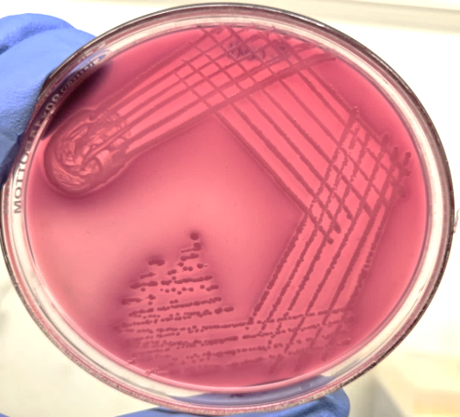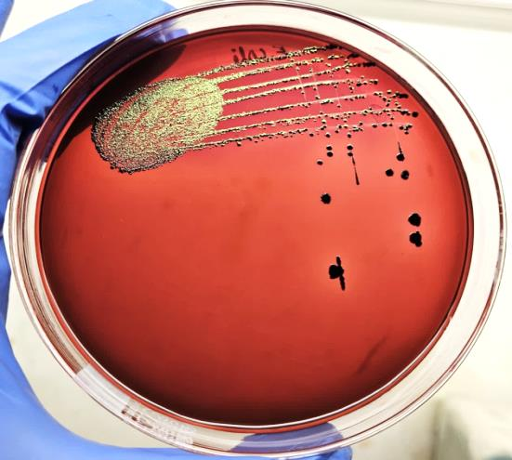
Plate 02: Growth of Escherichia coli on Eosin Methylene Blue Agar
Plate 01: Growth of Escherichia coli on MacConkey Lactose Agar

After phenotypic identification the E. coli isolates were further subjected to genotypic identification via polymerase chain reaction (PCR). In the present study, all six Gram-negative isolates conventionally identified as Escherichia coli were confirmed by PCR targeting the 16S rRNA which is highly conserved gene, with all isolates (100%) producing the expected amplicon size of 1476 bp (Plate 03).
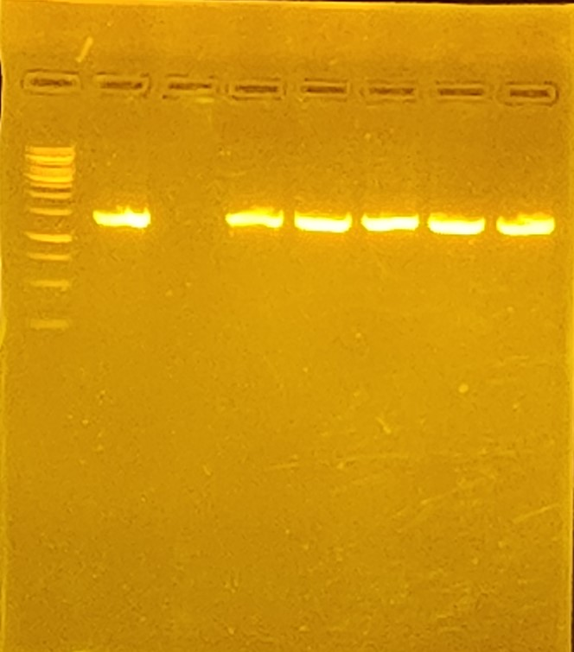

1500bp

1000bp

750bp
500bp
250bp
1476bp
Plate 03: Agarose gel electrophoresis showing 1476bp amplified product of 16S rRNA gene of Escherichia coli
Lane L = 1kb ladder
Lane P = Positive control
Lane N = Negative control
Lane 1-5 shows 16SrRNA gene in E. coli isolates

Antibiotic sensitivity test revealed that the isolates of E. coli were resistant to Ampicillin (83.33%); Cefoxitin (66.66%), Cefpodoxime and Ciprofloxacin (50%); Amoxyclav, Cotrimoxazole and levofloxacin (33.33%) while sensitive to Amikacin, Chloramphenicol and Gentamicin (83.33%) (Plate 04 and Figure 01). Out of 06 isolates, 03 isolates of E. coli (50%) were detected as Multi drug resistant bacteria (MDR). The results of this study agreed with the work performed by Bag et al. (2021) who observed high resistance to amoxicillin (94.5%), ampicillin (89.5%). Priyantha et al. (2021) recorded high resistance with 100% resistance to ampicillin, amoxicillin, sulfamethoxazole and trimethoprim. Resistance to commonly used β-lactams and fluoroquinolones may be attributed to prolonged and indiscriminate use of antibiotics in dairy practice.
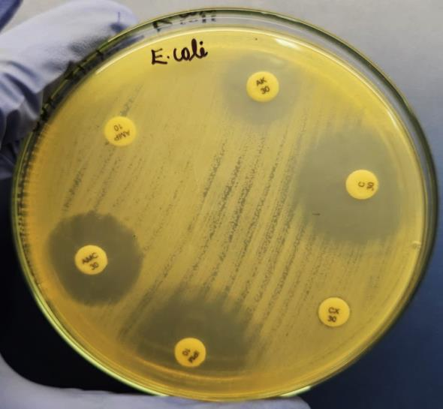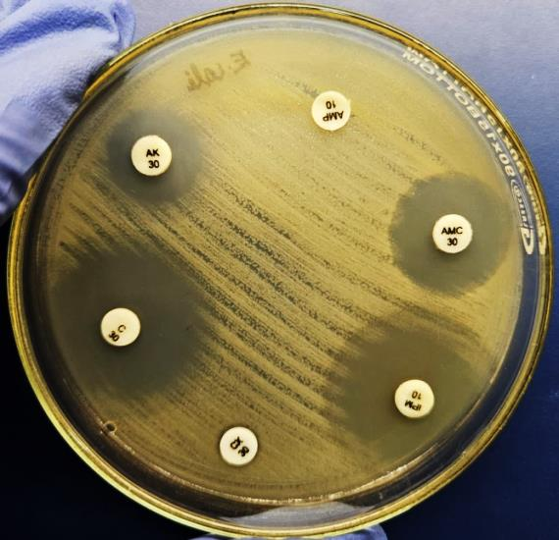
(B)
(A)
Plate 04: (A and B): Antibiotic Sensitivity test of E. coli by Kirby bauer disc diffusion assay

Figure 01: Antimicrobial Drug Resistance profile of E. coli

CONCLUSION
This investigation emphasizes the prevalence of antibiotic resistance among E. coli isolated from bovine mastitic milk. The screening of Cattles and Buffaloes for mastitis and detection of multi-drug resistant bacteria is important not only for effective treatment but also to prevent the transfer of the multi-drug resistant bacteria to humans. The findings underline the important role that resistant genes play in antibiotic resistance and point to geographical differences in resistance patterns that are probably impacted by microbial ecosystems, environmental variables and antibiotic use. This study emphasizes how crucial it is to use antibiotics sparingly and monitor antimicrobial resistance frequently in order to effectively treat bovine mastitis. In order to reduce antibiotic resistance in bovines, more study is required to investigate new resistance genes and their mechanisms.
DISCLAIMER (ARTIFICIAL INTELLIGENCE)
Author(s) hereby declares that no generative AI technologies such as Large Language Models (ChatGPT, COPILOT, etc) and text-to-image generators have been used during writing or editing of this manuscript.
COMPETING INTERESTS
Authors have declared that no competing interests exist.
References
Ali, T., Kamran, N., Raziq, A., Wazir, I., Ullah, R., Shah, P., Ali, M.I., Han, B. and Liu, G. (2021). Prevalence of mastitis pathogens and antimicrobial susceptibility of isolates from cattle and buffaloes in Northwest of Pakistan. Frontiers in Veterinary Science, 8: 746-755.
Bag, M.A.S., Khan, M.S.R., Sami, M.D.H., Begum, F., Islam, M.S., Rahman, M.M., Rahman, M.T. and Hassan, J. (2021). Virulence determinants and antimicrobial resistance of E. coli isolated from bovine clinical mastitis in some selected dairy farms of Bangladesh. Saudi Journal of Biological Sciences, 28(11): 6317-6323.
Bauer, A.W., Kirby, L.M.M., Sherris, J.C. and Tureck, M. (1996). Antibiotic susceptibility testing by a standardized single disc method. American Journal of Clinical Pathology, 45: 493-494.
CLSI (2024). Performance standards for antimicrobial disk and dilution susceptibility tests for bacteria isolated from animals. 7th Edn. CLSI supplement. Clinical and Laboratory Standards Institute, 44(2): 42-91.
Das, D., Panda, S.K, Jena, B. and Sahoo, A.K. (2018). Economic impact of subclinical and clinical mastitis in Odisha, India. International Journal of Current Microbiology and Applied Sciences, 7(03):3651–3654.
Erskine, R. J., Bartlett, P. C., VanLente, J. L. and Phipps, C. R. (2002). Efficacy of systemic ceftiofur as a therapy for severe clinical mastitis in dairy cattle. Journal of dairy science, 85(10): 2571-2575.
Hogan, J.S., Gonzales, R.N. and Harmon, R.J. (2009). Laboratory Handbook on Bovine Mastitis. National Mastitis Council, Madison, Wisconsin, USA.
Maddela, P., Makwana, P. M., Parmar, S. M., Kalyani, I. H., Patel, D. R. and Parasana, D. K. (2024). Cultural and Biochemical Characterization of Staphylococcus aureus Isolates from Bovine Clinical and Subclinical Mastitis. Indian Journal of Veterinary Sciences & Biotechnology, 20(3): 149-157.
Manoj, J., Chhabra, R., Singh, M. and Singh, M. K. (2024). A temporal study on incidence of bovine mastitis in Haryana, India. Microbiology Research Journal International, 34(4): 1-12.
Markey, B., Leonard, F., Archambault, M., Cullinane, A. and Manguire, D. (2013). Clinical Veterinary Microbiology. 2nd Edn., Elsevier, London, 443 p.
Patel, R., Kunjadia, P., Koringa, P., Joshi, C. and Kunjadiya, A. (2019). Microbiological profiles in clinical and subclinical cases of mastitis in milking Jafarabadi buffalo. Research in Veterinary Science, 125: 94–99.
Priyantha, M. A. R., Fernando, P. S. and De Alwis, P. S. (2021). Emerging antimicrobial resistance in coagulase-positive Staphylococci and E. coli isolated from bovine clinical mastitis in Sri Lanka. Asian Journal of Research in Animal and Veterinary Sciences, 7(4): 29-35.
Shrivastava, A. (2016). Studies on prevalence, characterization and inhibitory potential of herbs on extended spectrum beta lactamase E. coli in broilers. Ph.D thesis.
Singh, N., Singh, P. and Patel, R. K. (2016). Isolation and identification of bacterial organisms from mastitis milk. Journal of Livestock Science, 7: 46-48.
Zhao, X. and Lacasse, P. (2008). Mammary tissue damage during bovine mastitis: causes and control. Journal of animal science, 86(13): 57-65.

