Assessment of SSR markers for verification of poplar (Populus deltoides) clones

Abstract
The present study entitled “Assessment of SSR markers for verification of poplar (Populus deltoides) clones” was undertaken in the Department of Tree Improvement and Genetic Resources, Dr. Y.S. P. U. H. F., Nauni- Solan 173230 (H.P.). In this study, fifteen Poplar clones were collected from various research institutes across India. Molecular markers play an important role in breeding programs because they help in identifying and evaluating genetic differences within plant populations and germplasm collections. The modern trend in forest genetics focuses on developing reliable molecular marker systems that can help study genetic diversity, differentiation, and gene flow, especially in fragmented forest populations. Such genetic information is valuable for designing effective conservation and management plans. In this work, Simple Sequence Repeat (SSR) markers, also known as microsatellite markers, were used for genotyping through Polymerase Chain Reaction (PCR). The molecular results confirmed the identity of most clones as originally recorded. However, some minor genetic differences were observed within certain clones. Considering the ecological and commercial importance of Populus species in the Northern Hemisphere, the SSR marker set optimized in this study will be highly useful for breeding and selection programs, ecological landscape studies, and for ensuring the long-term conservation and sustainable management of Populus genetic resources.
Key words: Poplar, SSR, Molecular, Cluster, Dendrogram

Introduction
‘Poplar’ belongs to the genus Populus and family Salicaceae order Salicales and group Amentiferae, with 35 identified species (Dickmann and Stuart, 1984) occurs throughout warm temperate to cool temperate regions of world. Vegetative propagation is one of the distinctive characteristics of this genus (Dickmann, 2001). Genetically improved clones of Populus deltoides were introduced in India in 1950 for short rotation plantation designed to maximize wood production (Chaturvedi and Rawat, 1994). Smulders et al. (2001) cloned microsatellite repeats from black poplar (Populus nigra L.) and developed primers for microsatellite marker analysis. Ten primer pairs, mainly targeting trinucleotide repeats, successfully produced variable (polymorphic) DNA fragments in Populus nigra. Some of these primers also worked in other Poplar species such as P. deltoides, P. tricocarpa, P. tremula, P. tremuloides, P. candicans, and P. lasiocarpa. From these, the six most informative loci were selected and tested on 23 P. nigra genotypes collected from different regions across Europe. Molecular markers are especially useful for studying genetic variation in tree species because trees have very long life cycles. Traditional methods like common garden experiments are time-consuming and difficult to manage. In contrast, molecular markers allow researchers to assess genetic diversity more quickly and efficiently by using DNA directly, without waiting for plants to grow and mature.
A wide range of molecular markers are normally like AFLPs, RFLP, nuclear and cytoplasmic SSRs and SNPs are normally employed to study genetic variation (Krutovsky and Neale, 2006); microsatellites or SSRs and SNPs are currently regarded as the most useful ones, as they are widespread in the nuclear genome and co-dominant. In Populus, a database that includes thousands of SSR loci has been developed by the International Populus Genome Consortium. Expressed Sequence Taq (EST) collections were of first and foremost importance to the success of establishing Populus as a model system in the field of forest genomics. Large-scale Populus EST collections have been a rich resource for qualitative and quantitative assessment of gene expression, offspring snap shots of tissue-or developmental– specific gene expression (Sterky et al., 2004; Kohler et al., 2003).

Method and Materials
The present investigations was carried out in the Department of Tree Improvement and Genetic Resources, Dr. Y.S. Parmar University of Horticulture and Forestry, Nauni, Solan (H.P.). 15 clones were planted with three replications in randomized blocks design. Cuttings of 15 different clones were collected from various research institutes. To evaluate these clones, Simple Sequence Repeat (SSR) markers were used. Fresh young leaves were taken from the field and used for DNA extraction. The nuclear DNA was isolated following the Doyle and Doyle (1987) method, with minor modifications. For SSR analysis, DNA amplification was performed using eighteen SSR primers that were procured from Bangalore Genei, India. Before running the final PCR reactions, optimization tests were carried out to determine the most suitable amplification conditions, particularly the annealing temperature. The annealing temperature for each primer pair was adjusted based on their calculated melting temperatures (Tm) to ensure proper amplification.
The scored bands were analyzed in the form of binary system to pattern to prepare the similarity index. The data matrices so prepared was analyzed by SIMQUAL programme of NTSYS-PC (Version 2.2) and similarities between genotypes were estimated using Jaccard similarity coefficient, calculated as J = A/ (N-D), where A is the number of positive matches (i. e. presence of band in both samples), D is the number of negative matches (i. e. absence of band in both samples) and N is the total sample size including both the number of matches and unmatched.

Result and Discussion

The clones were evaluated using SSR (Simple Sequence Repeat) markers. A total of eighteen SSR primers were used to verify the identity of the clones based on their banding patterns. After PCR amplification, the resulting SSR bands were analyzed to determine how genetically similar the clones were to each other. Each band was scored as ‘1’ if present and ‘0’ if absent for every clone, and this data was organized into a matrix. The matrix was then analyzed using the NTSYS-2.2 software to calculate the Jaccard’s similarity coefficient among the clones (Figure 1).

The clones studied for morphological characterization were tested using SSR markers. Among 18 SSR markers, fourteen markers PMGC-571, PMGC-2163, PMGC-333, ORPM- 028, ORPM-190, ORPM-114, ORPM-092, ORPM-137, ORPM-149, ORPM-166, ORPM- 029, ORPM-186, PTR-1, ORPM-177 and WPMS-07 showed polymorphic pattern while WPMS-05, WPMS-03, ORPM-026 and ORPM-114 showed monomorphic pattern. So, 14 polymorphic SSR’s were used for further analysis. A close appraisal of the SSR banding pattern obtained after the amplification of genomic DNA of the clones revealed that, all the clones were true to type. SSR markers associated with each clones were assessed on 3.5 % agarose. The amplification products were consisting of one or combination of the two bands for all the samples of P. deltoides.

Dendrogram (Figure 2) showing different clusters were based on NTSYS-PC ver. 2.02. Similarity coefficient obtained by Jacquard coefficient was for UPGMA analysis of NTSYS. In the dendrogram (Figure 2) the 15 clones separated into two main clusters, ‘I’ and cluster ‘II’ at 64 % similarity. This revealed less similarity between cluster I and the member of cluster II. Cluster I was further subdivided into two clusters i.e. I1 and I2 at similarity value of 72.4 %. Also cluster I1 further dived into I1a and I1b with 77.8 % similarity. Cluster I1a was further divided to I1a1 and I1a2 which were 81.8% similar consisting of clone L-6105. However, I1a1 consist two clones L-30/06 and L-621/84 at 88% similarity. I1b was further divided into I1b1 and I1b2 at 82% similarity. Similarly, I1b1 again divided into I1b12’ and I1b22’ at 85.4 % similarity consisting clones G-48 and PL-3 respectively. I2 further divided into I2a and I2b at 85.4 % similarity with consisting clones PL-6 and PL-7.

Cluster II was further subdivided divided into two i.e. II1 and II2 at similarity of 70.5 %. II1 is further divided into II1a and II1b at 72.4 % similarity. II1a further divided into II1a1’ consist one clone i.e. S7C15 77.8 % similar and II1a2 consist of two clones namely WSL-22 and WSL-39 with 88% similarity. Also, II1b also divided into II21b1 and II21b1 with 81.8 % similarity. II21b1 consists of two clones namely 6503 and 5503 at 88% of similarity and II21b2 consist only one clone 1007 with 81.8 % similarity. II2 consist only one clone L-200/86. L-200/86 was less similar than other clones and having unique morphological characteristics with downward waviness. Molecular characterization of clones was obtained at very basic level due to small number of primers. Further investigation needed with larger number of trait specific primers to correlate morphological and molecular characterization of clones.

Khasa et al. (2003) reported that 17 microsatellites of simple sequence repeats markers in the genus Populus were optimized for seven species (P. balsamifera, P. tremuloides, P. davidiana, P. alba, P. tremula and P.nigra) in which they found that the 14 out of 17 primer pairs amplified SSR loci exhibiting variable amounts of polymorphism across the species studied. Similar results reported by Rahman and Rajora (2002) allowed reliable amplification of Populus species belonging to three sections of genus (Aigeiros, Tachamahaca and Populus). Our results were in the line of Grewal et al. (2013) who studied 32 simple sequence repeats (SSR) markers in Populus deltoides in which only 22 marker showed polymorphic pattern and amplified a total of 102 alleles. Singh et al. (2013) studied 16 RAPD and 14 SSR primers in willow clones and total of 363 markers were generated and out of which 351 were showing high (96.7%) ray of polymorphism. 18 out of 30 primers showed 100% polymorphism. Dobhal (2016) studied 18 primers in poplar 15 out of 18 gave monomorphism while 3 gave polymorphism.

Conclusion
Molecular markers are particular DNA sequences that show variation between individuals, allowing us to distinguish one organism from another. These variations arise due to changes in the nucleotide sequence of DNA, which may result in the creation or loss of restriction sites, random mutations, or alterations in simple repeat regions and their surrounding areas. Because these markers are highly abundant, show good levels of variation, and provide reliable results, they are widely preferred over other types of DNA markers. In this study, sixteen DNA markers that were previously identified and described in aspen (Populus tremuloides) and other poplar species (Populus spp.) were initially examined for their usefulness.

References
Dickmann D I and Stuart K W. 1984. The culture of poplars in Eastern North America. Michigan State Univiversity, 168p.
Dickman D I. 2001. An overview of genus Populus. In: Dickman D I, Isebrands J G, Eckenwalder J E, Richardson J (eds) Poplar culture in North America. Part A. NRC Research Press, Ottwa, Canada. 1-45.
Dobhal S. 2016. Line x tester analysis in Populus deltoides Bartr. Ph.D. Thesis. Department of Tree improvement and Genetic resources, Dr. Y. S. Parmar University of Horticulture and Forestry, Nauni, Solan. 121p.
Doyle J J and Doyle J J. 1987. A rapid DNA isolation procedure from small quantities of fresh leaf tissues. Phytochemistry Bulletin 19 : 11-15.
Smulders M J, Vander J S, Arens P and Vosman B. 2001. Tri-nucleotide repeat microsatellite markers for black poplar (Populus nigra L.). Molecular Ecology Notes 1 : 188-190.
Krutovsky K V and Neale D B. 2006. Forest genomics and new molecular genetic approaches to measuring and conserving adaptive genetic diversity in forest trees. In: Geburek T, Turok J (eds). Conservation and Management of Forest Genetic Resources in Europe. Arboreta Publishers, Zvolen, Slovakia. 369-390.
Kohler A, Delaruelle C, Martin D, Encelot N and Martin F. 2003. The poplar root transcriptome : Analysis of 7000 express sequence tags. FEBS Letters 542 : 37-41.
Sterky F, Bhalerao R R, Unneberg P, Segerman B, Nillson P, Brunner A M, Campa C L, Lindvall J J, Tandre K, Strauss S H, Gustaffson P, Uhlen M, Bhalerao R P, Nilsson O, Sandberg G, Karlsson J, Lundberg J and Jasson S.2004. A Populus EST resource for plant functional genomics. Proc. Natl. Acad. Sci. USA. 101 : 13951-13956.
Khasa D P, Nadeem S, Thomas B, Robertson A and Bousquet J. 2003. Application of SSR markers for parentage analysis of Populus clones. Forest Genetics 10 : 273-281.
Rahman M H and Rajora O P. 2002. Microsatellite DNA fingerprinting, differentiation and genetic relationships of clones, cultivars and varieties of six poplar species from three sections of the genus Populus. Genome 45 : 1083-94.
Grewal G K, Gill R I S, Dhillon G P S and Vikal. 2013. Molecular characterization and genetic diversity analysis of Populus deltoides Bartr. ex Marsh. clones using SSR markers. Indian Journal of Biotechnology 13 : 388-397.
Singh N B, Choudhary P and Joshi S. 2013. Molecular diversity in willow clones selected for commercial plantation. Indian Journal of Plant Genetic Resources 26 : 138-145

Figure 1: verification of clones using SSR primers

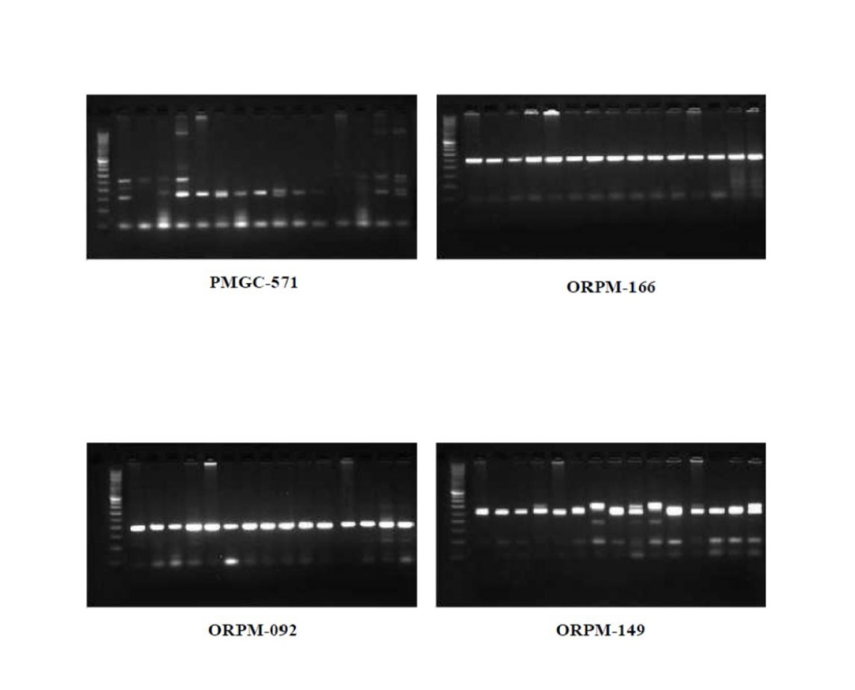

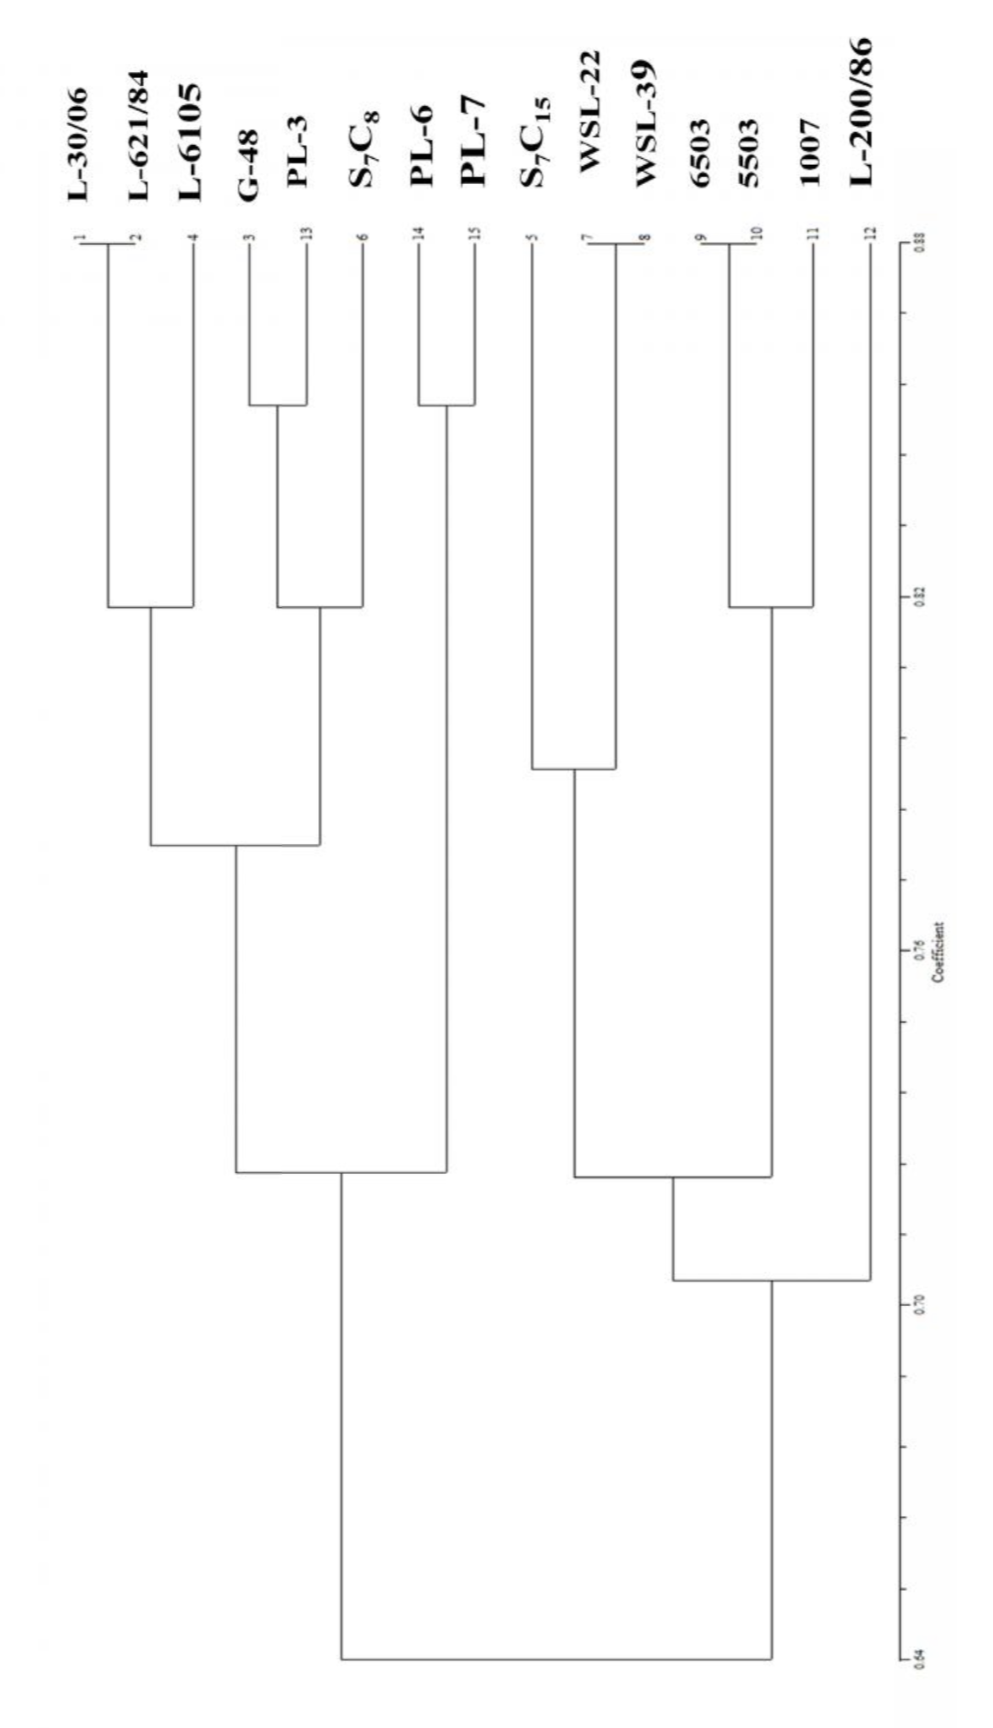
Figure 2: Dendrogram of 18 SSR primer for 15 poplar clones

