Optimising disease-free sweet potato [Ipomoea batatas (L.) Lam.] planting material via in vitro culture : Insights from Togo.

ABSTRACT
Aims : Sweet potato [Ipomoea batatas (L.) Lam.] is an important food crop in Togo, yet its large-scale propagation is constrained by limited availability of quality planting material. This study assessed the regeneration capacity of five local varieties, with the aim of identifying genotypes best adapted to in vitro conditions.
Study design: The experiment was conducted using a completely randomised block design with three replications.
Place and Duration of study : The study was carried out at the tissue culture laboratory of the Togolese Agricultural Research Institute (ITRA) during a four- week period from August to September 2025.
Methodology: Five cultivated varieties were assessed for their micropropagation performance using Murashige and Skoog (MS) medium supplemented with 4 g/L MS salts, 5 g/L 6-Benzylaminopurine (BAP), 8 g/L agar, and 24 g/L sucrose. Parameters recorded included bud break rate, shoot number, leaf number, root number, and plantlet height. Data were subjected to analysis of variance (ANOVA), and mean separation was performed using Tukey’s HSD test.
Results : Significant differences were observed among varieties. Irène exhibited the highest shoot regeneration potential, highlighting its suitability for in vitro multiplication. Gnigbé 2 produced more leaves and attained greater plantlet height, indicating enhanced vigour under the tested conditions. While the medium effectively induced callus formation and shoot development, rooting remained suboptimal.
Conclusion : These findings underscore the decisive role of genotype in regeneration success and provide a preliminary framework for optimising micropropagation protocols of sweet potato in Togo. Further refinement of hormone concentrations and medium composition is recommended to improve rooting efficiency and ensure robust plantlet establishment.

Keywords: Micropropagation, In vitro regeneration, Murashige and Skoog medium, Sweet potato, Togo

Introduction
Sweet potato is among the most widely cultivated root crops worldwide, contributing significantly to food security, nutrition, and income generation (Mohammed et al., 2023). Its adaptability to diverse agro-ecological zones has enabled its cultivation in more than 150 countries, where it serves as a staple food and a source of industrial raw material (Bilali et al., 2025). Beyond its caloric value, sweet potato is rich in vitamins, minerals, and antioxidants, making it an important crop for addressing malnutrition and promoting dietary diversification (Bibi et al., 2025).
Despite its global importance, sweet potato production in sub-Saharan Africa, and particularly in Togo, faces persistent challenges (Glato et al., 2017). Farmers often rely on informal seed systems, which provide planting material of variable quality. The lack of disease-free vines, coupled with the susceptibility of local cultivars to viral infections, fungal pathogens, and insect pests, undermines productivity and limits the potential of the crop to contribute fully to food security (Tighankoumi et al., 2024). These constraints highlight the urgent need for reliable methods of producing healthy planting material.
In vitro culture techniques, especially micropropagation, offer a promising solution to these challenges (Cioloca et al., 2020). By enabling the rapid multiplication of pathogen-free plantlets under controlled conditions, tissue culture can ensure the availability of high-quality planting material for farmers (Xu et al., 2024). As such, in vitro culture constitutes a cornerstone of contemporary sweet potato seed systems, providing a reliable pathway toward improved yields and sustainable production (Villalba et al., 2024).
Previous studies have demonstrated the effectiveness of Murashige and Skoog (MS) medium supplemented with growth regulators in promoting shoot induction and plantlet development in sweet potato (An et al., 2016 ; Alula et al., 2018). However, varietal differences in response to culture conditions highlight the need for localized investigations to establish optimized protocols. In Togo, research has confirmed the feasibility of in vitro culture for local cultivars, revealing significant genotype-dependent variation in morphogenetic responses (Glato et al., 2014). Early work showed that varieties such as Damadoami, Tombolo, and Nagohé displayed variable shoot induction and rooting capacities under MS medium supplemented with auxins, underscoring the importance of cultivar-specific optimization (Kodjo et al., 2013). Subsequent studies demonstrated that direct organogenesis and micropropagation are achievable, though efficiency remains strongly influenced by growth regulator composition and varietal characteristics (Hadj et al., 2025). Collectively, these findings provide a foundation for developing protocols tailored to togolese germplasm, while also emphasizing the need for broader evaluations across additional varieties and media formulations.
This study was therefore undertaken to evaluate the in vitro performance of five newly released sweet potato varieties in Togo. The objective was to establish a protocol for the production of disease-free planting material and to identify varietal responses that could inform future optimization of culture media and hormonal concentrations. By addressing the constraints of planting material quality, this work contributes to strengthening sweet potato production systems and enhancing food security in Togo.

MATERIAL AND METHODS

Study area
The experiment was carried out at the tissue culture laboratory of the Togolese Agricultural Research Institute (ITRA) (N 6°13’12", E 1°12’00") (Figure 1) during a four- week period from August to September 2025. The laboratory is equipped with standard equipments, enabling the rapid propagation of healthy plantlets across diverse crops, including sweet potato.

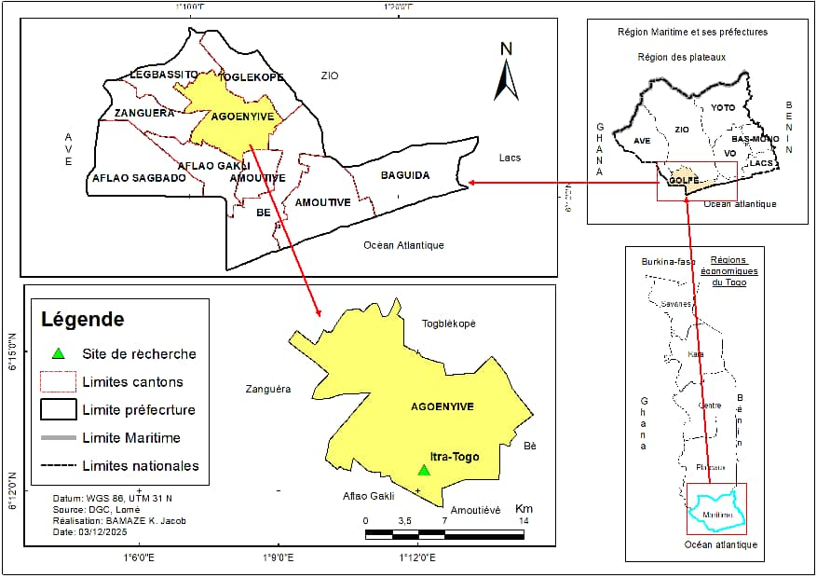

Figure 1: Map of Togo indicating the study site

Plant material
The plant material consisted of in vitro plantlets from five sweet potato varieties, sourced from the togolese gene bank and maintained under slow-growth conditions at the tissue culture laboratory of ITRA. The varieties included Bella (V1), Irène (V2), Djété Gbazé Djin Jaune (V3), Gnigbé 2 (V4), and the local cultivar 8 (V5) (Figure 2). These varieties were selected based on their availability at the laboratory, their agronomic and phytosanitary performance, as well as their nutritional value and local significance. The specific characteristics of each variety (Tighankoumi et al., 2024) are presented in Table 1.
Table 1. Agronomic features of evaluated sweet potato varieties

Code | Variety Name | Flesh Color | Growth Cycle (months) | Average Yield (t/ha) | Nutritional Value (β-carotene) | Disease Resistance
V1 | Bella | Orange | 3-4 | 35-45 | High | Good
V2 | Irène | White | 4 | 30-40 | Low | Moderate
V3 | Djété Gbazé Djin Jaune | Yellow | 3 | 25-35 | Medium | Good
V4 | Gnigbé 2 | White | 4–5 | 20-30 | Low | Low
V5 | Local Cultivar 8 | White | 4 | 15-25 | Variable | Moderate

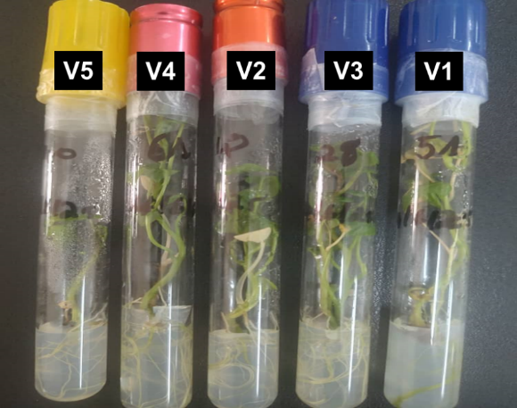
Figure 2: In vitro plantlets of evaluated sweet potato varieties. V1 = Bella, V2 = Irène, V3 = Djété Gbazé Djin Jaune, V4 = Gnigbé 2, and V5 = Local Cultivar 8.

Laboratory materials and infrastructures
The laboratory materials comprised small equipment, major apparatus, and specific infrastructures. The small equipment included forceps, scalpels, beakers, tubes, racks, pipettes, aluminum foil, magnetic stir bars, parafilm, weighing spatulas, graduated test tubes, and crucibles (Figure 3). These tools were essential for fine manipulations and for the preparation of culture media. The major laboratory apparatus (Figure 4) consisted of a magnetic stirrer with a heating plate, used to homogenize and heat culture media; a precision electronic balance (± 0.001g) for accurate reagent measurement; an electric autoclave for moist-heat sterilization of tools and media at 121 °C for 8 minutes; a laminar flow hood equipped with an ultraviolet lamp for sterilization and maintenance of aseptic conditions; a bead sterilizer for rapid disinfection of instruments such as forceps and scalpels during operations; and a pH meter for monitoring culture medium acidity.
The laboratory infrastructures included a preparation room for media formulation, a sterile manipulation room equipped with a laminar flow hood, and a conservation room for maintaining in vitro plantlets in culture vessels (Ahmad et al., 2012).

Composition of the culture medium
The culture medium consisted of 4.4 g/L MS (Murashige and Skoog, 1962), supplemented with 24 g/L sucrose (carbon source), 5 g/L BAP (6-Benzylaminopurine), and 8 g/L agar (gelling agent) (Figure 5). The pH of the medium was adjusted to 5.7 ± 1 using NaOH as a base and HCl as an acid (Glato et al., 2014).

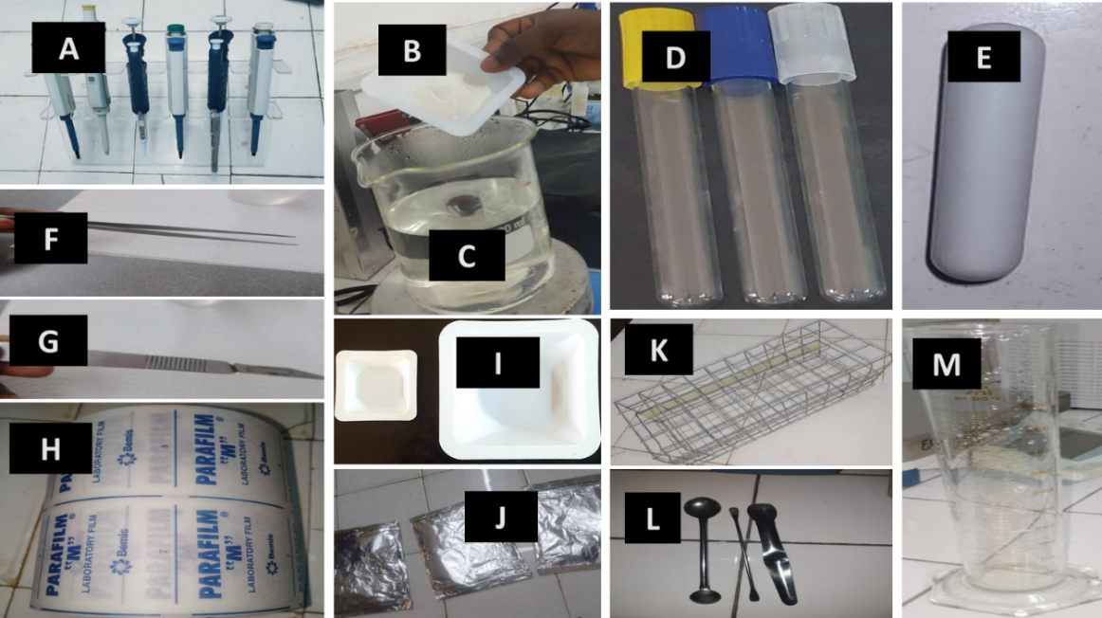
Figure 3: Small equipment utilized in the experiment. A = micropipettes; B = crucible; C = beaker; D = tubes; E = magnetic stir bar; F = forceps; G = scalpel; H = parafilm; I = crucible; J = aluminium foil; K = rack; L = spatulas; M = graduated test tube.
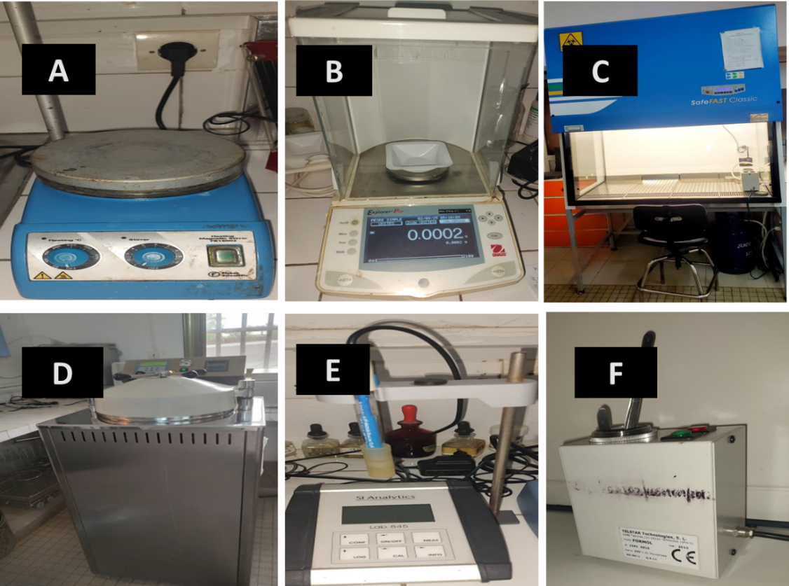
Figure 4: Major laboratory equipment used in the experiment. A = magnetic stirrer with heating plate; B = electronic balance; C = laminar flow hood prepared for manipulation; D = autoclave.

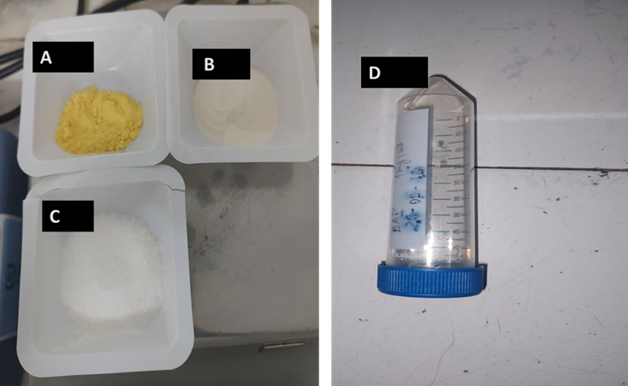
Figure 5: Culture medium constituents. A = Murashige and Skoog; B = Agar; C = sugar; D = 6-Benzylaminopurine.

Preparation and sterilisation of the culture medium
The culture medium was prepared in a 1 litre beaker, with a total volume of 800 ml. Initially, 600 ml of distilled water was poured into the beaker and pre-heated on a hot plate. Subsequently, the following components were added in sequence: MS salts, sucrose, BAP, and agar. The mixture was then supplemented with an additional 200 ml of distilled water and continuously stirred using a magnetic bar placed in the beaker to ensure thorough homogenisation. The solution was brought to boiling (300 °C) on a hot plate for 30 minutes, until complete dissolution of the agar particles was achieved (Kodjo et al., 2013). Finally, the prepared medium was dispensed into tubes, each containing 5 ml, which were hermetically sealed with their caps and aluminium foil (Abubakar et al., 2018) (Figure 6).
The medium thus prepared was autoclaved at 121 °C for 8 minutes under a pressure of 1 bar (Hadj et al., 2025). This in vitro culture technique requires such conditions to ensure the destruction of bacteria and fungal spores. Following autoclaving, the tubes containing the medium were placed under a laminar flow hood for 24 hours to confirm sterility before proceeding with subculturing (Hadj et al., 2025).

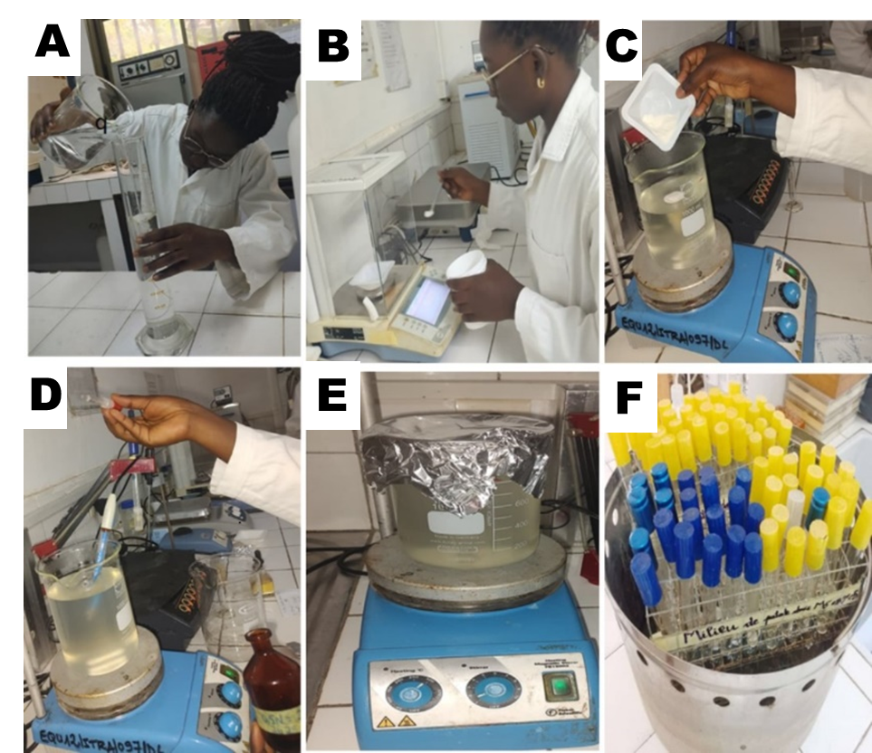

Figure 6: Preparation of the MS medium. A = Measurement of the volume of water to be used; B = Weighing of reagents; C = Addition of reagents; D = Adjustment of pH; E = Medium brought to boiling; F = Medium ready for autoclaving.

Experimental protocol
- Aseptic conditions for in vitro culture
The success of in vitro culture relies on strict adherence to aseptic conditions (Xu et al., 2024). All manipulations were therefore carried out under a sterile laminar airflow hood, following a set of precautions. The hood and the UV lamp were switched on at least twenty minutes prior to each manipulation (Tatah et al., 2019). The work surface, the interior of the hood, and its immediate surroundings were cleaned with 70% ethanol (Alula et al., 2018), as were all instruments used, throughout the manipulations. Finally, the bead steriliser, intended for the sterilisation of scalpels and forceps, was switched on fifteen minutes before each manipulation and kept in operation throughout the subculturing period (Xu et al., 2024).

- Experimental design
The experiment was conducted using a completely randomised block design with three replications (Figure 7). For each variety, thirty tubes were inoculated, with ten micro-cuttings per replication. In total, fifty tubes were inoculated and incubated per replication. The plantlets were arranged uniformly under controlled environmental conditions (photoperiod, temperature, humidity, and light intensity).
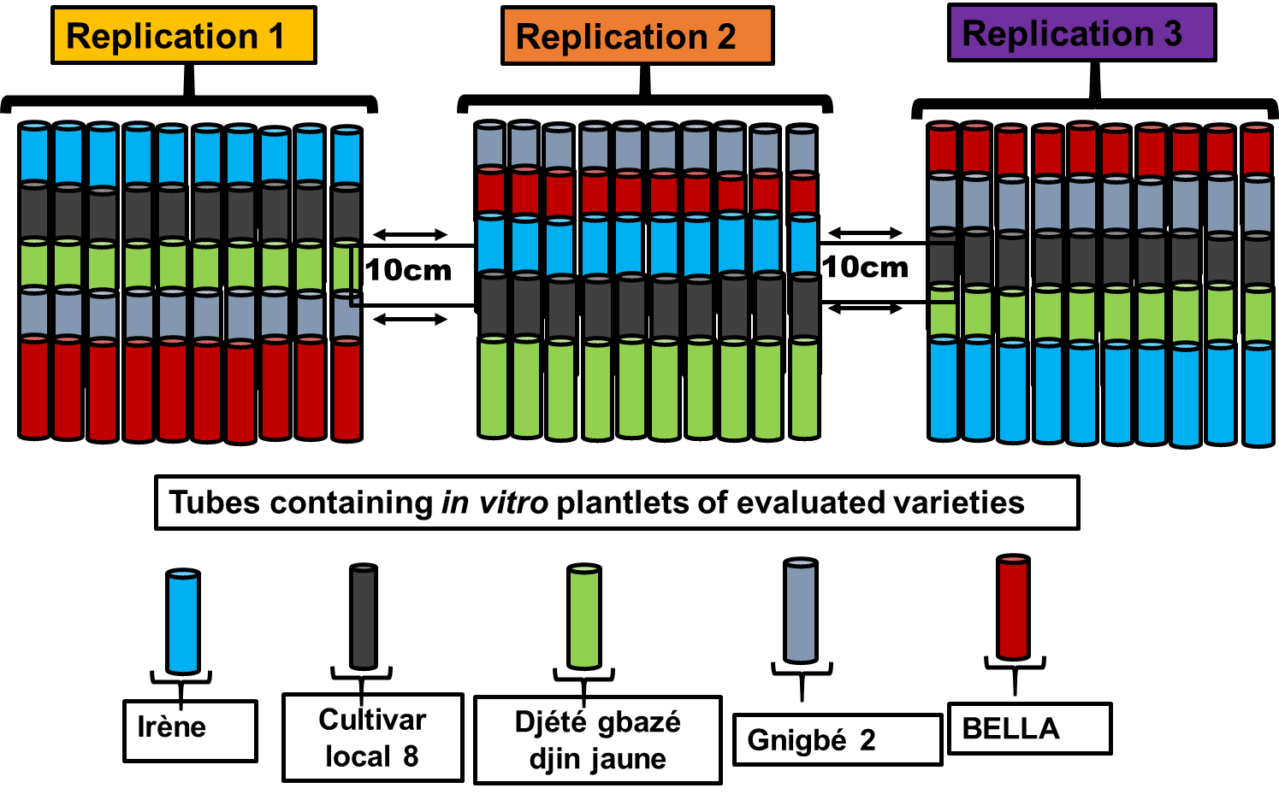
Figure 7: Diagram of the experimental design
- Subculturing of in vitro plantlets
The in vitro plantlets of each variety used as mother plants were removed from the tubes with sterile forceps and sectioned into single-node segments using a sterile scalpel. The resulting micro-cuttings were subcultured onto the culture medium with sterilised forceps. The explants were planted in such a way that the bud was not completely embedded in the medium and remained upright. The inoculated tubes were then sealed with their caps and sterilised parafilm, before being placed in the conservation room (Dudina et al., 2023).

- Conservation room conditions for in vitro plantlets
The subcultured plantlets were maintained under controlled environmental conditions to ensure consistency and reliability of observations. The photoperiod was strictly regulated to 12 hours of light and 12 hours of darkness, thereby promoting plant growth (Wilms et al., 2020). Ambient temperature was kept constant at 25 °C ± 2, while relative humidity was stabilised at 60%. Light intensity was measured and adjusted to an average value of 1672.33 Lux ± 179.21 (Abubakar et al., 2018). These parameters were monitored and controlled throughout the experiment to guarantee uniform growth conditions.

Data collection
Data collection was carried out systematically to ensure the reliability and reproducibility of the results (Mohammed et al., 2023). Observations focused on the morphological parameters of plantlets cultivated on culture medium, namely plant height, number of leaves, roots, and shoots, as well as a recovery parameter (bud-break rate). Measurements were taken at regular intervals (every 7 days) throughout the duration of the experiment using calibrated instruments (Kodjo et al., 2013), thereby ensuring the accuracy of the data collected. This periodicity allowed monitoring of bud-break dynamics and comparison among varieties (Sharma et al., 2025).
The bud-break rate was assessed to determine the capacity of explants to initiate bud growth on the culture medium. An explant was considered to have undergone bud break when an apical or axillary bud exhibited visible emergence, characterised by stem elongation or the appearance of new leaves (Glato et al., 2014). Only well-differentiated buds were taken into account. Culture tubes were observed under a laminar flow hood to maintain sterile conditions. Each explant was visually examined and classified into two categories: bud-broken or non-bud-broken. The total number of bud-broken explants per variety and per replicate was recorded on monitoring sheets. The bud-break rate was expressed as a percentage according to the formula:

$$Bud-breah rate(\%)=\frac{(Number of bud- broken explants)}{Total number of subcultured explants }×100$$

Plantlet height was measured using a sterilised graduated ruler, from the base of the plant (collar region) to the apical extremity. The number of leaves and shoots was determined by direct visual counting under the laminar flow hood, considering only well-differentiated organs. The number of roots was assessed by visual observation, counting the main roots emerging from the plant base. Each culture tube or vessel was opened under sterile conditions to minimise contamination risks. Plantlets were handled carefully to avoid mechanical damage.

Statistical analysis
Data were recorded by variety and replication, and organized in Microsoft Excel (2018). Normality of distributions was assessed using the Shapiro–Wilk test (Mkhonta et al., 2025). When assumptions were violated, square-root transformation was applied to count data and angular transformation to percentage data (Kamath et al., 2025). Descriptive statistics (mean, standard deviation, minimum, maximum, and coefficient of variation) were calculated to summarize varietal performance. A one-way ANOVA was performed with “variety” as the fixed factor at a 5% significance level (p < 0.05). Significant effects were further examined using Tukey’s Honest Significant Difference (HSD) test to separate means and identify the most suitable variety (Iwuagwu & Nwosu, 2018). Data validation was conducted in XLSTAT (2025), while statistical analyses were performed in R 4.5.1 using the agricolae package for ANOVA and Tukey’s HSD, and ggplot2 for visualization.

RESULTS

Performance of sweet potato varieties on MS medium after four weeks
The performance of the sweet potato varieties on MS medium is summarized in Table 2. Overall, the varieties exhibited distinct responses in terms of vegetative recovery. The bud‑break rate of explants ranged from 20% to 100%, with a mean of 74.70 ± 22.3, demonstrating the capacity of the tested varieties to initiate growth. The number of shoots per plantlet averaged 5.84 ± 3.64, varying from 1 in varieties with low in vitro multiplication potential to 17 in those with high multiplication potential. Leaf production per plantlet ranged from 0.00 to 5.00, with a mean of 0.32 ± 0.86, indicating variability among varieties in their ability to form leaves. Root development was limited, with a mean of 0.33 ± 0.24 roots per plantlet, ranging from 0.00 in poorly performing varieties to 2.00 in those with stronger root formation. Plant height varied between 0.30 cm (varieties with low growth potential) and 2.80 cm (varieties with high growth potential), with an average of 0.99 ± 0.48 cm (Table 2).
Analysis of variance (ANOVA) revealed significant differences among the varieties for the number of shoots (p < 0.001), number of leaves (p < 0.05), and plantlet height (p < 0.001) (Table 3). These findings highlight substantial variability in leaf formation and multiplication potential in vitro. In contrast, no significant differences were observed for bud‑break rate (p > 0.05) and number of roots (p > 0.05) (Table 3).

Table 2. Growth parameters of five sweet potato varieties on MS medium after four weeks

Parameter | Minimum | Maximum | Mean | Standard Deviation
BudBrRa (%) | 20.00 | 100.00 | 74.70 | 22.30
ShootNo | 1.00 | 17.00 | 5.84 | 3.64
LeafNo | 0.00 | 5.00 | 0.32 | 0.86
RootNo | 0.00 | 2.00 | 0.03 | 0.24
HeiPlt (cm) | 0.30 | 2.80 | 0.99 | 0.48

BudBrRa = Bud-break rate (%), ShootNo = Number of shoots per plantlet, LeafNo = Number of leaves per plantlet, RootNo = Number of roots per plantlet, HeiPlt = height of a plantlet (cm)

Table 3. Analysis of variance (ANOVA) of growth parameters in five sweet potato varieties cultured on MS medium for four weeks

Parameter | Sum of squares |  |  | Mean squares |  |  | F | Probability (P)
Parameter | Variety  (df = 4) | Error  (df= 10) |  | Variety  (df = 4) | Error  (df = 10) |  | F | Probability (P)
BudBrRa (%) | 0,07 | 0,62 |  | 0,02 | 0,06 |  | 0,28 | 0,883
ShootNo | 576,90 | 1405,30 |  | 144,22 | 9,69 |  | 14,88*** | <0,0001
LeafNo | 10,44 | 100,20 |  | 2,61 | 0,69 |  | 3,78** | 0,006
RootNo | 0,13 | 8,70 |  | 0,03 | 0,06 |  | 0,56 | 0,69
HeiPlt (cm) | 6,38 | 28,19 |  | 1,59 | 0,19 |  | 8,20*** | <0,0001

BudBrRa = Bud-break rate (%), ShootNo = Number of shoots per plantlet, LeafNo = Number of leaves per plantlet, RootNo = Number of roots = roots per plantlet, HeiPlt = height of a plantlet (cm), * = Significant; ** = Highly significant; *** = Very highly significant; F = Fisher’s statistic testing the effect of varieties; P = probability.

Screening of sweet potato varieties for adaptation to MS culture medium
The Tukey HSD test was used to compare mean values of the varieties for each parameter and to group them into homogeneous clusters (Table 4, Figure 8). Although V2 (Irène) exhibited a higher bud‑break rate than V1 (Bella), V5 (Local cultivar 8), V3 (Djété gbazédjin jaune), and V4 (Gnigbé 2) (Figure 8), the test revealed no significant differences among the five varieties.
For shoot production, V2 (Irène) produced significantly more shoots than V4 (Gnigbé 2), while V1 (Bella) and V3 (Djété gbazédjin jaune) occupied an intermediate cluster (Figure 9B). V5 (Local cultivar 8) recorded the lowest shoot number.
Regarding leaf formation, V4 (Gnigbé 2) displayed a significantly higher number of leaves compared with V1 (Bella) and V2 (Irène), whereas V3 (Djété gbazédjin jaune) and V5 (Local cultivar 8) were intermediate.
Root development showed that V1 (Bella) and V2 (Irène) had higher root numbers than V3 (Djété gbazédjin jaune) and V5 (Local cultivar 8). However, statistical analysis indicated no significant differences among the five varieties. Rhizogenesis was more pronounced in Irène and Bella, while Djété gbazédjin jaune and Local cultivar 8 exhibited the lowest root numbers.
In terms of plantlet height, V4 (Gnigbé 2) was significantly taller than V1 (Bella) and V5 (Local cultivar 8), but did not differ significantly from V2 (Irène) and V3 (Djété gbazédjin jaune).

Table 4. Mean performance of five sweet potato varieties cultured on MS medium after four weeks.

Variety code | Variety name | TauxDeb (%) | NbrePou | NbreFeu | NbreRa | HPlt (cm)
V1 | Bella | 43,30ª | 4,33^{bc} | 0,20^{ab} | 0,06ª | 0,84^{bc}
V2 | Irène | 93,70ª | 9,37ª | 0,56^{ab} | 0,06ª | 1,02^{ab}
V3 | Djété gbazédjin jaune | 55,30ª | 5,53^{bc} | 0,07^{b} | 0,00ª | 1,15^{ab}
V4 | Gnigbé 2 | 62,00ª | 6,20^{b} | 0,70ª | 0,04ª | 1,26ª
V5 | Cultivar local 8 | 20,77ª | 3,77^{c} | 0,06^{b} | 0,00ª | 0,69^{c}
Mean |  | 74,70 | 5,84 | 0,32 | 0,03 | 0,99
CV (%) |  | 5,32 | 22,50 | 26,93 | 7,30 | 18,50
F |  | 0,28 | 14,88*** | 3,78** | 0,56 | 8,20***
BudBrRa = Bud-break rate (%), ShootNo = Number of shoots per plantlet, LeafNo = Number of leaves per plantlet, RootNo = Number of roots = roots per plantlet, HeiPlt = height of a plantlet (cm), * = significant; ** = highly significant; *** = very highly significant. F = Fisher’s statistic for varietal effect; P = probability. Values in the same column followed by the same letter are not significantly different at the 5% level.

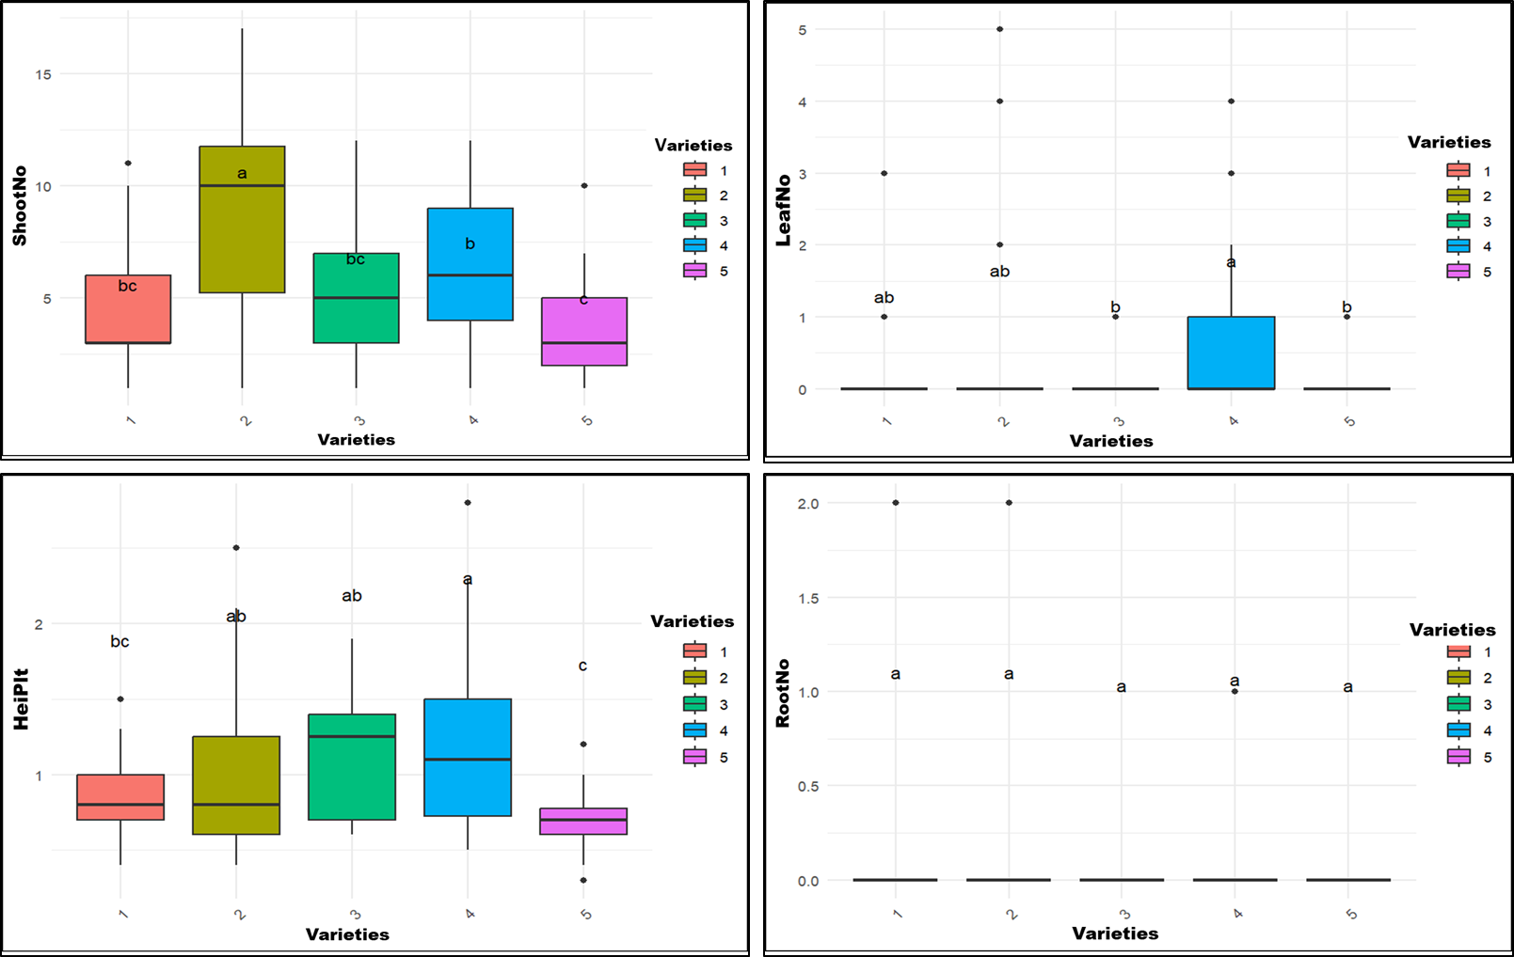
Figure 8. Clustering of five sweet potato varieties cultured on MS medium after four weeks, based on shoot number (ShootNo), leaf number (LeafNo), root number (RootNo), and plantlet height (HeiPlt). Varieties sharing the same letter are not significantly different for the parameter considered.

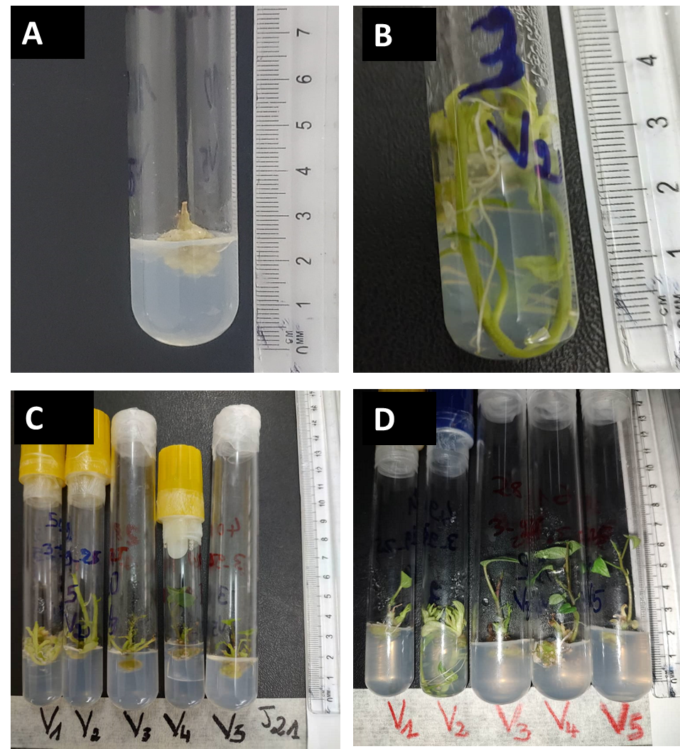
Figure 9. In vitro sweet potato plantlets from the experiment: (A) callus formation seven days after subculturing; (B) response of variety Irène (V2) after 28 days; (C) response of evaluated varieties after 21 days after subculturing ; (D) response of evaluated varieties after 28 days subculturing.

DISCUSSION

Response of sweet potato varieties on MS medium after four weeks
The results obtained highlight a notable variability among the different parameters studied. The bud-break-rate, with a mean of 74.70% and a range from 20.00% to 100.00%, reveals considerable heterogeneity among the evaluated varieties, reflecting differences in their capacity for shoot initiation. The number of shoots showed a mean of 5.84 with relatively high dispersion (standard deviation of 3.64), indicating that this trait varies substantially from one plantlet to another and constitutes a discriminating criterion between varieties.
The number of leaves, with a mean of 0.32, remained low with a range between 0 and 5, suggesting limited but nonetheless significant variability in leaf production. The number of roots, with a mean of 0.33 and a range from 0 to 2, appeared to be the least variable trait, which may be linked to genetic or environmental constraints. Finally, plantlet height presented a mean of 0.99 cm with a range of 0.30 to 2.80 cm, indicating moderate variability in height growth among the vitroplants of the different varieties tested.
Overall, these results show that certain parameters, such as bud-break rate and number of shoots, exhibit strong variability and can be used as varietal differentiation criteria. Others, such as number of roots and leaves, appear more limited but remain relevant for complementing morphological evaluation. These observations confirm the importance of combining several traits for a comprehensive analysis of varietal performance on culture medium.
The differences observed between varieties demonstrate that height growth is strongly influenced by genetic factors, despite identical culture conditions. Variety V4 (Gnigbé 2) distinguished itself by significantly greater height, reflecting better aptitude for cell elongation and apical growth. Conversely, V5 (Local cultivar 8) presented lower values, suggesting reduced sensitivity to growth regulators present in the culture medium. These results confirm that morphological response varies according to variety, even under homogeneous conditions.
Leaf number is an indicator of the future photosynthetic capacity of vitroplants. Variety V4 (Gnigbé 2) showed a higher number of leaves, reflecting better leaf differentiation and increased vigour. Variety V1 (Bella), by contrast, produced fewer leaves, which could limit its performance during acclimatisation. These differences highlight the importance of genetic background in the foliar morphogenesis of sweet potato varieties.
Root development is essential for nutrient absorption and survival ex vitro. For root number, analyses showed no significant differences among the five varieties. The results indicate that varieties V1 (Bella) and V2 (Irène) produced the highest number of roots, conferring an advantage for acclimatisation. Variety V3 (Djété gbazédjin jaune) and V5 (Local cultivar 8) showed lower values, reflecting reduced rooting ability. These observations suggest that these varieties possess better root induction capacity, probably linked to their genotypes. The only hormone present in the culture medium tested in our study was BAP, which induces neoformation of shoots. Gezahegn & Markos (2017) also showed that media containing 4 mg/L and 5 mg/L BAP promoted strong shoot formation. Furthermore, the use of auxins in the tested medium would likely have improved rhizogenesis across all varieties, as reported by Glato et al.(2014), who emphasised the decisive role of auxin in the establishment and maintenance of the root meristem.
Vegetative multiplication through lateral shoots is a key parameter for sweet potato micropropagation. Variety V2 (Irène) produced the highest number of shoots, confirming its potential for rapid multiplication. V3 (Djété gbazédjin jaune) and V1 (Bella) occupied an intermediate position, while V5 (Local cultivar 8) remained the least productive. These results show that varietal identity directly influences proliferation capacity, which is critical for large-scale production of clean plant material.
Bud-break rate reflects the ability of explants to initiate growth. Only variety V2 (Irène) displayed a bud-break rate above 80%, indicating excellent aptitude to exit dormancy and engage in development. V1 (Bella) and V5 (Local cultivar 8) showed lower rates, limiting their multiplication in vitro. These differences confirm that the success of the protocol depends not only on the medium but also on the variety used. Similar results were reported by Glato et al. (2014).
The present study was conducted to evaluate the effect of MS medium (MS + BAP + agar + sucrose) on the in vitro shoot regeneration potential of five sweet potato varieties. During the experiment, normal growth of explants was observed with substantial emergence of new shoots. The parameters studied demonstrated significant differences among varieties. The highest regeneration potential was observed in Irène, followed by Gnigbé 2. This difference may be genetic in origin. According to An et al. (2016) and Glato et al. (2014), the induction of organogenesis (neoformed buds) from cuttings depends on the variety, the nature, and the concentration of phytohormones. These results are consistent with those of Gezahegn & Markos (2017), who showed that organogenesis is strongly influenced by the intrinsic characteristics of explants across species in culture. Regarding the effect of the culture medium independently of variety, only callogenesis was significantly influenced. However, variety-medium interactions had a highly significant effect on bud-break rate, number of shoots, number of leaves, and plantlet height.

Screening of sweet potato varieties for adaptation to MS culture medium
Overall, when considering all the parameters studied, except for plantlet height and number of leaves, the variety Irène displayed higher values than the other four. Among these four, it is noteworthy that Gnigbé 2 and Bella responded better than Djété gbazédjin jaune and Local cultivar 8. This leads us to conclude that the tested culture medium is more suitable for Irène. This finding suggests that in vitro regeneration capacity depends more on genotype than on the culture medium. Similar results were reported by Glato et al. (2014) with the sweet potato cultivars Tombolo, Damadoami, and Nagohé. Nevertheless, when considering the response of each variety on MS medium, a higher bud-break rate and callus formation were observed compared with rooting.
The differences observed among sweet potato varieties may also be attributed to the influence of in vitro environmental conditions. Light intensity, fixed at 1672.33 Lux under a photoperiod of 12 hours light and 12 hours darkness, plays an essential role in photosynthesis, morphogenesis of cultured cuttings, and rapid shoot regeneration (Kumar et al., 2022). For optimal growth of sweet potato plants, at least 6 to 8 hours of light per day are required. Kumar et al. (2022) demonstrated this in their protocol for accelerating in vitro propagation of tuberous plants. Moderate light favours shoot elongation and chlorophyll production, whereas excessively low or high intensity may respectively limit photosynthesis or induce photo-oxidative stress (Genene et al., 2018). Dessoky et al.(2016) showed a strong dependence of regeneration on genotype and environmental conditions. The differences observed between Irène and Gnigbé 2 may therefore reflect distinct physiological responses to this light intensity, particularly in terms of photosynthetic efficiency.
Furthermore, the constant temperature of 25 °C and humidity maintained at 60% may have contributed to the stability of culture conditions, allowing clearer expression of varietal differences. However, even under identical conditions, the five sweet potato varieties produced different responses, confirming that environmental conditions are effectively controlled in the laboratory setting. These results are consistent with those reported by (Bandyopadhyay et al., 2025).
Finally, the study demonstrated that this medium could induce callus formation and shoot development in several sweet potato varieties. This is of considerable interest for in vitro micropropagation of sweet potato, as it would enable the production of numerous micro-cuttings for further multiplication, even from callus tissue (Gautam et al., 2021).

CONCLUSION
This study evaluated the regeneration potential of five sweet potato varieties cultivated in Togo using MS medium and identified genotypes best suited for in vitro culture. Significant varietal differences were observed, underscoring the importance of genotype in determining regeneration outcomes. Among the tested varieties, Irène exhibited the highest shoot regeneration capacity, positioning it as a promising candidate for large-scale in vitro multiplication. Gnigbé 2 demonstrated superior leaf production and plantlet height, reflecting enhanced vigour under the experimental conditions. The MS medium supplemented with BAP, agar, and sucrose proved effective in promoting callus induction and shoot development, though its efficiency for rooting was limited. These findings provide a valuable foundation for the optimisation of sweet potato micropropagation protocols in Togo. Future work should focus on refining hormone concentrations and medium composition to improve rooting efficiency and ensure robust plantlet establishment.

References

Abubakar, A. S., Yahaya, S. U., Shaibu, A. S., Ibrahim, H., Ibrahim, A. K., Lawan, Z. M., & Isa, A. M. (2018). In vitro propagation of sweet potato (Ipomoea batatas ( L .) Lam.) cultivars. Agricultural Science Digest, 38(1), 17–21. https://doi.org/10.18805/ag.D-128.
Ahmad, M. Z., Hussain, I., Roomi, S., Zia, M. A., Zaman, M. S., Abbas, Z., & Shah, S. H. (2012). In vitro Response of Cytokinin and Auxin to Multiple Shoot Regeneration in Solanum tuberosum L . American-Eurasian J. Agric. & Envion.Sci., 12(11), 1522–1526. https://doi.org/10.5829/idosi.aejaes.2012.12.11.1856.
Alula, K., Zeleke, H., & Manikandan, M. (2018). In Vitro propagation of sweet potato (Ipomoea batatas ( L.) Lam ) through apical meristem culture. Journal of Pharmacognosy and Phytochemistry, 7(1), 2386–2392.
Anh, D. Vu Thi Thuy Hang, Ha Thi Anh Thu, & Vu Dinh Hoa (2016). Developing an efficient regeneration protocol for sweetpotato using nodal explants. Vietnam J. Agri. Sci.,14(10), 1491–1501.
Bandyopadhyay, S., Subrahmanyeswari, T., Mallick, J., Dey, S., & Kinetin, K. (2025). A mono ‑ phasic protocol for micropropagation of potato cv . Cooch Behar local , its acclimatization , on ‑ field evaluation , and fidelity analysis Inter simple sequence repeats. 3 Biotech, 15(2), 1–11. https://doi.org/10.1007/s13205-025-04207-7.
Bibi, A., Maqsood, S., & Ikram, A. (2025). Unveiling the Role of Sweet Potato Root in Skin Health : A New Approach to Collagen Synthesis and Rejuvenation. Food Science & Nutrition, 13:e70281 https://doi.org/10.1002/fsn3.70281.
Bilali, H. El, Nanema, R. K., Rokka, V., Guimbo, I. D., Kiebre, Z., Siciliano, R. A., Reine, S., Tietiambou, F., Dambo, L., Nanema, J., Grazioli, F., & Acasto, F. (2025). Research on Sweet Potato ( Ipomoea batatas) in West Africa : State, Features and Gaps. Agronomy, 15(4),766. https://doi.org/10.3390/agronomy15040766.
Cioloca, M., Tican, A., Popa, M., & Bărăscu, N. (2020). Optimization of sweet potato In vitro cultivation by using the contaminated cultures for obtaining new shoots in greenhouse conditions. Lucrări Ştiinţifice, 63(2), 125–130.
Dessoky, E. D. S., Attia, A. O., Ismail, I. A., & El-hallous, E. I. (2016). In vitro Propagation of Potato under Different Hormonal Combinations. International Journal of Advanced Research, 4(1), 684–689.
Dudina, Y. A., Temirbekova, S. K., Khuat, Q. V, Trukhachev, V. I., & Sumin, A. V. (2023). Influence of Mineral Treatment , Plant Growth Regulators and Artificial Light on the Growth of Jewel Sweet Potato In Vitro. Life, 13(1), 1–11. https://doi.org/10.3390/life13010052.
Gautam, S., Solis-gracia, N., Teale, M. K., & Mandadi, K. (2021). Development of an in vitro Microtuberization and Temporary Immersion Bioreactor System to Evaluate Heat Stress Tolerance in Potatoes. 12, 1–11. https://doi.org/10.3389/fpls.2021.700328.
Genene, G., Mekonin, W., Meseret, C., Manikandan, M., & Tigist, M. (2018). Protocol optimization for in vitro propagation of two Irish potato (Solanum tuberosum L.) varieties through lateral bud culture. African Journal of Plant Science,12, 180–187. https://doi.org/10.5897/AJPS2018.1661.
Gezahegn, G., & Markos, T. (2017). Protocol Optimization and Mass Propagation of Virus Free Sweet Potato [Ipomoea Batatas L. (Lam) to Enhance production in Southern, Ethiopia. Journal of Biology, Agriculture and Healthcare; 7(24), 6–10.
Glato, K., Aidam, A., Kane, N. A., Bassirou, D., Couderc, M., Zekraoui, L., Scarcelli, N., Barnaud, A., & Vigouroux, Y. (2017). Structure of sweet potato diversity in West Africa covaries with a climatic gradient. PLoS ONE, 12(5): e0177697, 1–17. https://doi.org/10.1371/journal.pone.0177697.
Glato Kodjo, Djidjolé, E. K., Dzifa, K. A., & Aziadekey, M. (2014). Régénération in vitro par partir de boutures de trois cultivars originaire du Togo. European Scientific Journal, 10(27), 276–291.
Hadj, E., Tapily, H., Kouassi, K. M., Kouassi, M. K., Seka, J. S. S., & Pita, J. S. (2025). Enhancing In Vitro Regeneration in Three Sweet Potato Genotypes : Interplay Between Disinfectant , Explant Age , and Genotype. BioTech, 14(3), 63. https://doi.org/10.3390/biotech14030063.
Iwuagwu, M. O., & Nwosu, N. N. (2018). Performance of In Vitro Cassava (Manihot esculenta Crantz ) Plantlets Weaned with Locally Sourced Substrates. International Journal of Environment, Agriculture and Biotechnology, 3(2), 663–669. http://dx.doi.org/10.22161/ijeab/3.2.47.
Kamath, A., Poojari, S., & Varsha, K. (2025). Assessing the robustness of normality tests under varying skewness and kurtosis : a practical checklist for public health researchers. BMC Med Res Methodol., 25(1):206. http://dx.doi.org/10.1186/s12874-025-02641-y.
Kodjo, G., Djidjolé, E. K., Mensah, S., Koffi, T., & Atsou, A. (2013). Comparison of in vitro morphogenetic capacities of different clones of three local cultivars of sweet potato from Togo. African Journal of Biotechnology, 12(29), 4648–4655. https://doi.org/10.5897/AJB2013.12083.
Kumar, M., Sirohi, U., Malik, S., Kumar, S., & Ahirwar, G. K. (2022). Methods and Factors Influencing In Vitro Propagation Efficiency of Ornamental Tuberose ( Polianthes Species ): A Systematic Review of Recent Developments and Future Prospects. Horticulturae, 8(11), 998. https://doi.org/10.3390/horticulturae8110998.
Mkhonta, K. A. K., Shimelis, H., Abady, S., & Ngidi, A. (2025). Agronomic Performance of Newly Developed Elite Cowpea Mutant Lines in Eswatini. Agriculture,15(15), 16-31. https://doi.org/10.3390/agriculture15151631.
Mohammed, S., Adu-gyamfi, R., & Ted, E. C. (2023). Evaluation of Four Varieties of Sweetpotato ( Ipomeoa Batatas ( L.) Lam)under Different Sources of Planting Material for Field Performance and Viral Load. Agricultural Sciences, 14, 1007–1021. https://doi.org/10.4236/as.2023.148067.
Sharma, A., Tripathi, M. K., Pandey, A., Payasi, D. K., Sharma, M., & Mishra, R. (2025). Standardization of In vitro Propagation Protocol for Asparagus racemosus Employing Nodal Segments. Plant Cell Biotechnology and Molecular Biology, 26(9), 73–90. https://doi.org/10.56557/pcbmb/2025/v26i9-109693.
Tatah, E. L., Chi, C. T., Roland, B. A., & Nsaidzeka, N. D. (2019). Investigating the Response to Meristem Culture of Four Regional Sweetpotato Varieties in the Western Highlands of Cameroon. Sustainable Agriculture Research, 8(4), 1–12. https://doi.org/10.5539/sar.v8n4p1.
Tighankoumi, G., Atti, T., Napoli, P., Kebalo Bamaze, J., Some, K., Ernest Traore, R., Hamed Ouedraogo, M., & Romaric Nanema, K. (2024). Phenotypic Diversity of Sweet Potato (Ipomoea Batatas[L.]Lam.) Germplasmusing Quantitative Traits: a Pre- Breeding Study in Togo. International Journal of Advanced Research, 12(10), 439–453. https://doi.org/10.21474/ijar01/19659.
Villalba, A., Mart, E., & Morard, M. (2024). Optimizing sweet potato production : insights into the interplay of plant sanitation , virus influence , and cooking techniques for enhanced crop quality and food security. Front. Plant Sci., 15, 1–16. https://doi.org/10.3389/fpls.2024.1357611.
Wilms, H., Sleziak, N. F., Auweraer, M. Van Der, & Brands, M. (2020). Development of a fast and user ‑ friendly cryopreservation protocol for sweet potato genetic resources. Scientific Reports, 10(1):14674. https://doi.org/10.1038/s41598-020-70869-3.
Xu, Y., Wang, L., Chen, C., Ma, S., Zhou, R., & Xiong, A. (2024). Virus-Free Sweet Potato Industry : Development Status and Production Suggestions. Horticulturae 10 (9), 979. https://doi.org/10.3390/horticulturae10090979.

