Original Research Article
Volumetric and Viscometric Investigations of Binary Mixtures of Ethyl Acetate with Isobutanol and n-Hexane at Different Temperatures

ABSTRACT
Densities and viscosities of binary liquid mixtures of ethyl acetate + isobutanol and ethyl acetate + n-hexane were measured over the entire range of composition at 303.15, 308.15, 313.15 and 318.15 K. The experimental density and viscosity data have been used to evaluate the excess molar volume $V_{m}^{E}$, excess viscosity, (η^{E}), excess Gibb’s free energy of activation for viscous flow ($∆G_{m}^{*E}$) and Grunberg-Nissan interaction parameter (d₁₂). The calculated values of excess functions, $V_{m}^{E}$, η^{E} and $∆G_{m}^{*E}$were fitted to the Redlich-Kister polynomial equation to obtain fitting coefficient (A_{i}) and standard deviation ($σ$). The observed values of excess parameters for both the liquid mixtures have been interpreted in terms of molecular interactions in the mixtures. The observed excess molar volumes,$V_{m}^{E}$are positive and excess viscosity, η^{E} have been found to be negative over the whole composition range at all investigated temperatures for both the systems. In addition, the values of $∆G_{m}^{*E}$and d₁₂ are negative for both the binary mixtures. These findings indicate that chemical or specific interactions between the unlike component molecules are absent for both the mixtures, and dispersion type of forces are predominant.
Keywords: Ethyl acetate, binary liquid mixtures, interaction parameter, dispersion forces

INTRODUCTION
In industrial and chemical processes, liquid mixtures are extensively used more than individual pure liquids as the mixtures provide important characteristics with variable physical properties. The extraordinary behavior of binary mixtures, compared to their constituents, arise from the nature molecular interactions between the component molecules in the mixtures. The nature of intermolecular interactions occurring between component molecules in a binary liquid mixture can be understood by studying the volumetric and viscometric properties of liquid mixtures [1-5]. The density and viscosity are the two most fundamental physicochemical properties of liquids. The excess thermodynamic functions of liquid system such as excess molar volume, $V_{m}^{E}$, excess viscosity, η^{E} and excess free energy of activation for viscous flow, $∆G_{m}^{*E}$can be estimated from the experimentally measured values of density and viscosity data. These excess thermodynamic functions can provide information about the nature of molecular interactions between the two components in a binary mixture. The changes of these functions with composition and temperature and their degree of deviations from ideality can thus be used to explain the nature of molecular interactions between the component molecules of liquid mixtures.
This investigation deals with the measurements of densities and viscosities of binary mixtures of ethyl acetate with isobutanol and n-hexane at different compositions and temperature. Ethyl acetate is primarily used as an extraction solvent in the production of pharmaceuticals and as a carrier solvent for herbicides. It is also used in paints, confectionery, perfumes, and foods. The mixture of alcohol and ester is of prime interest from theoretical aspects because in the mixing process, the breaking of hydrogen-bonded structure of the alcohol is likely to occur, and the formation of new H-bonded molecular species may occur between the alcohol and the ester [6]. Isobutanol is widely used as a solvent because many organic materials are soluble in it. It is used as raw materials for coating resins and as paint thinners. Isobutanol is also used as a component of some biofuels to improve fuel quality
In industries, hexane is used as an ingredient in glues for manufacturing shoes and bags as well as to extract vegetable oils from crops such as soybeans. Considering the importance of these liquids and to understand the nature of molecular interactions of ethyl acetate with isobutanol and n-hexane, the binary mixtures of ethylacetate with isobutanol and n-hexane have been investigated through volumetric and viscometric studies at different temperatures. We report here the excess volume, $V_{m}^{E}$, excess viscosity, η^{E}, Grunberg-Nissan interaction parameter, d₁₂ and excess Gibbs free energy of activation for viscous flow,$∆G_{m}^{*E }$for the investigated liquid mixtures over the whole range of composition at 303.15, 308.15, 313.15 and 318.15 K. The excess thermodynamic functions${ V}_{m}^{E}$, η^{E} and$∆G_{m}^{*E}$have been fitted to Redlich-Kister (RK) polynomial to find fitting coefficients and standard deviation.
EXPERIMENTAL
Solvents used in this work were of AR grade and obtained from BDH Limited with quoted purity, ethyl acetate (EtOAc) 99.5%, isobutanol (i-BuOH) 99.5%, and n-hexane, 99.8%. All these solvents were used without any further treatment. The purity of solvents was ascertained by comparing the experimental values of densities and viscosities of pure solvents with the literature values [6-15],which shows reasonable agreement (Table 1). The binary mixtures of liquids of different compositions were prepared by mass using an analytical balance (METTLER PM 200) with an accuracy of ± 0.0001g. Precautions were taken to minimize the evaporation losses, and the error in the mole fraction was estimated to be ± 0.0001.

Table1: Experimental and literature values of densities and viscosities of pure liquids at different temperatures
Liquids | T/K | Density, gcm⁻³ |  | Viscosity, η cP
 |  | Experimental | Literature | Experimental | Literature
Ethyl Acetate | 303,15 | 0.8883 | 0.8885[6] | 0.3936 | 0.403[6]
Ethyl Acetate | 308.15 | 0.8825 | 0.8826[7] | 0.3733 | 0.383[7]
Ethyl Acetate | 313.15 | 0.8760 | 0.8760[7] | 0.3533 | 0.362[7]
Ethyl Acetate | 318.15 | 0.8698 | 0.8699[8] | 0.3345 | 0.346[9]
Isobutanol | 303,15 | 0.7967 | 0.7941[10] | 2.5541 | 2.648[10]
Isobutanol | 308.15 | 0.7929 | 0.7901[10] | 2.1959 | 2.279[10]
Isobutanol | 313.15 | 0.7888 | 0.7861[10] | 1.9000 | 1.965[10]
Isobutanol | 318.15 | 0.7845 | 0.7821[10] | 1.6533 | 1.692[10]
n-Hexane | 303.15 | 0.6503 | 0.6509[11]  0.6502[12] | 0.2815 | 0.2776[13]  0.2830[12]
n-Hexane | 308.15 | 0.6466 | 0.6460[14] | 0.2652 | 0.2680[15]
n-Hexane | 313.15 | 0.6420 | 0.6417[11] | 0.2542 | 0.2550[15]
n-Hexane | 318.15 | 0.6375 | 0.6421[15] | 0.2405 | 0.2450[15]

Densities of the pure components and their mixtures were measured by using a 25 mL specific gravity bottle. The specific gravity bottle was calibrated with redistilled water. An Ostwald viscometer with a sufficiently long efflux time was used in viscosity measurements. The viscometer was calibrated with double distilled water using density and viscosity values from the literature [16]. An electronic digital stopwatch accurate up to ±0.01 s was used for the measurement of flow time. The same analytical balance (METTLER PM 200) was used in the density measurements. A thermostatic water bath of accuracy ±0.05 ⁰C was used to control the temperature for every measurement. All the measurements were conducted in triplicate and averaged for calculations. The overall uncertainty in density and viscosity measurements was found to be ±0.0001 g cm⁻³ and ±0.003 cP, respectively.
The experimental data on densities ($ρ$) have been used to estimate the excess molar volume$({ V}_{m}^{E})$for the mixtures of different mole fractions using the following equation [17],
$V_{m}^{E}=(x_{1}M_{1}+x_{2}M_{2})/ρ -( x_{1}M_{1}/ρ_{1}+ x_{2}M_{2}/ρ_{2})$ (1)
where $ρ$is the density of the mixture; x₁, x₂, M₁, M₂, $ρ$₁, and$ρ$₂ are mole fractions, molecular weights, and densities of the pure components 1 and 2, respectively.
The excess viscosity, η^{E} of the binary liquid mixture was calculated from the experimental viscosity of the mixtures and that of their pure componentsusing the following relation [18],
$η^{E}=η-(x_{1}η_{1}+x_{2}η_{2})$ (2)
where η is the measured viscosity of binary mixture, η₁ andη₂ are the viscosities of pure components 1 and 2 having mole fractions x₁ and x_{2,} respectively.
The viscosity data has been analyzed based on Grunberg-Nissan treatment. Grunberg and Nissan[19] have put forward the following relation between the viscosity of the binary liquid mixtures and pure components,
$lnη=x_{1}lnη_{1}+x_{2}lnη_{2}+x_{1}x_{2}d_{12}$ (3)
where η is the observed viscosity of the mixture and d₁₂ is an interaction parameter.
The excess Gibb’s free energy of activation, $∆G_{m}^{*E}$for the binary liquid mixture was computed from Eyring equation [20],
$ΔG^{*E}=RT[\ln\left(ηV\right)-x_{1}lnη_{1}V_{1}-x_{2}lnη_{2}V_{2}]$ (4)
where V is the molar volume of binary liquid mixture, V₁ is the molar volume of the pure component 1, and V₂ is the molar volume of the pure component 2 present in the mixture having mole fractions x₁ and x_{2,} respectively. The molar volumes,V of the binary liquid mixture were calculated from the measured density ($ρ)$ of the mixture using the following equation,
$V=(x_{1}M_{1}+x_{2}M_{2})/ρ$ (5)
All the excess functions $V_{m}^{E}$, η^{E} and$∆G_{m}^{*E}$were fitted to the Redlich-Kister(RK) polynomial equation [21],
$Y^{E}=x_{1}x_{2}\sum_{i}^{n}{A_{i}{(x_{2}-x_{1})}^{i}}$ (6)

where Y^{E} refers to excess parameters $V_{m}^{E}$or, η^{E} or$∆G_{m}^{*E}$and x₁and x₂ are the mole fractions of the components in the mixture, n is the degree of the polynomial, A_{i} is the fitting coefficients of the polynomial equation. The values of coefficient A_{i} were determined by a multiple regression analysis based on the least-square method along with the standard deviation. The corresponding standard deviation ($σ$ ) have been calculated using the following relation,
$σ{\left(Y^{E}\right)=\left[\sum{{\left(Y_{obs}^{E}-Y_{cal}^{E}\right)}^{2}/(n-m)}\right]}^{1/2}$(7)
where n is the total number of experimental points, m is the number of coefficients, Y_{obs} and Y_{cal} are the experimental and calculated parameters, respectively.

RESULTS AND DISCUSSION

Densities ($ρ$), viscosities (η), and the calculated values of excess molar volume ($V_{m}^{E}$), excess viscosity (η^{E}), excess free energy of activation for viscous flow ($∆G_{m}^{*E}$), and Grunberg-Nissan interaction parameter (d₁₂) for the binary EtOAc + i-BuOH and EtOAc + n-hexane liquid mixtures at 303.15, 308.15, 313.15 and 318.15 K as a function of composition of binary mixtures are shown in Table 2 and 3 respectively

Table 2: Densities, $ρ$ (gm cm³), viscosities, η (cP), excess molar volume, $V_{m}^{E}$ (cm³mol⁻¹), excess viscosities, η^{E} (cP), excess free energy of activation,$∆G_{m}^{*E}$(kJ mol⁻¹) and Grunberg-Nissan interaction parameter, d₁₂ for the binary mixtures of ethyl acetate (x₁) + isobutanol (x₂) at different temperatures
x₂ | $$ρ$$ | η | $$V_{m}^{E}$$ | η^{E} | $$∆G_{m}^{*E}$$ | d₁₂
 | 303.15K
0.0000 | 0.8883 | 0.3936 | 0.0000 | 0.0000 | 0.0000 | 0.0000
0.1056 | 0.8775 | 0.4406 | 0.1872 | -0.1811 | -0.2082 | -0.8972
0.2099 | 0.8671 | 0.4739 | 0.3306 | -0.3732 | -0.5121 | -1.2479
0.3130 | 0.8575 | 0.5593 | 0.3828 | -0.5105 | -0.5787 | -1.0884
0.4147 | 0.8480 | 0.6211 | 0.4254 | -0.6677 | -0.7927 | -1.3160
0.5153 | 0.8388 | 0.7366 | 0.4310 | -0.7703 | -0.8367 | -1.3489
0.6145 | 0.8299 | 0.8371 | 0.4176 | -0.8841 | -0.9826 | -1.6656
0.7127 | 0.8211 | 1.0303 | 0.3620 | -0.9031 | -0.9739 | -1.8097
0.8096 | 0.8131 | 1.3334 | 0.2474 | -0.8093 | -0.7340 | -1.9074
0.9054 | 0.8052 | 1.8513 | 0.0792 | -0.4956 | -0.3624 | -1.6929
1.0000 | 0.7967 | 2.5541 | 0.0000 | 0.0000 | 0.0000 | 0.0000
 | 308.15K
0.0000 | 0.8825 | 0.3733 | 0.0000 | 0.0000 | 0.0000 | 0.0000
0.1056 | 0.8715 | 0.4032 | 0.2368 | -0.1622 | -0.2753 | -1.1653
0.2099 | 0.8613 | 0.4350 | 0.3833 | -0.3209 | -0.5501 | -1.3203
0.3130 | 0.8520 | 0.5122 | 0.4257 | -0.4316 | -0.5983 | -1.1081
0.4147 | 0.8427 | 0.5779 | 0.4504 | -0.5512 | -0.6807 | -1.2272
0.5153 | 0.8338 | 0.7002 | 0.4636 | -0.6123 | -0.7143 | -1.1374
0.6145 | 0.8251 | 0.7952 | 0.4358 | -0.6981 | -0.8394 | -1.4044
0.7127 | 0.8164 | 0.9349 | 0.4048 | -0.7374 | -0.8716 | -1.3066
0.8096 | 0.8083 | 1.1915 | 0.3031 | -0.6574 | -0.6931 | -1.7781
0.9054 | 0.8010 | 1.6168 | 0.1051 | -0.4067 | -0.3517 | -1.6192
1.0000 | 0.7929 | 2.1959 | 0.0000 | 0.0000 | 0.0000 | 0.0000
 | 313.15K
0.0000 | 0.8760 | 0.3533 | 0.0000 | 0.0000 | 0.0000 | 0.0000
0.1056 | 0.8651 | 0.3824 | 0.2583 | -0.1342 | -0.2491 | -1.0445
0.2099 | 0.8551 | 0.4115 | 0.4130 | -0.2665 | -0.5104 | -1.2100
0.3130 | 0.8461 | 0.4788 | 0.4499 | -0.3586 | -0.5662 | -1.0358
0.4147 | 0.8372 | 0.5397 | 0.4755 | -0.4550 | -0.6992 | -1.1290
0.5153 | 0.8284 | 0.6463 | 0.4867 | -0.5040 | -0.6575 | -1.0528
0.6145 | 0.8199 | 0.7367 | 0.4628 | -0.5670 | -0.7644 | -1.2621
0.7127 | 0.8114 | 0.8459 | 0.4354 | -0.6066 | -0.8352 | -1.5918
0.8096 | 0.8034 | 1.0654 | 0.3481 | -0.5401 | -0.6617 | -1.6762
0.9054 | 0.7963 | 1.4272 | 0.1513 | -0.3265 | -0.3259 | -1.4848
1.0000 | 0.7888 | 1.9000 | 0.0000 | 0.0000 | 0.0000 | 0.0000
 | 318.15K
0.0000 | 0.8698 | 0.3345 | 0.0000 | 0.0000 | 0.0000 | 0.0000
0.1056 | 0.8587 | 0.3592 | 0.3090 | -0.1146 | -0.2494 | -1.0328
0.2099 | 0.8492 | 0.3881 | 0.4306 | -0.2224 | -0.4816 | -1.1267
0.3130 | 0.8404 | 0.4418 | 0.4674 | -0.3055 | -0.5733 | -1.0321
0.4147 | 0.8317 | 0.5066 | 0.4925 | -0.3748 | -0.6402 | -1.0200
0.5153 | 0.8231 | 0.5981 | 0.5026 | -0.4160 | -0.6258 | -0.9700
0.6145 | 0.8147 | 0.6814 | 0.4889 | -0.4635 | -0.7004 | -1.1415
0.7127 | 0.8064 | 0.7753 | 0.4595 | -0.4991 | -0.7749 | -1.4562
0.8096 | 0.7986 | 0.9625 | 0.3690 | -0.4397 | -0.6151 | -1.5364
0.9054 | 0.7917 | 1.2666 | 0.1674 | -0.2619 | -0.2998 | -1.3470
1.0000 | 0.7845 | 1.6533 | 0.0000 | 0.0000 | 0.0000 | 0.0000

Table 3: Densities, $ρ$ (gm cm⁻³), viscosities, η (cP), excess molar volume, $V_{m}^{E}$ (cm³mol⁻¹), excess viscosities, η^{E} (cP), excess Gibb’s free energy of activation,$∆G_{m}^{*E}$ (kJ mol⁻¹) and Grunberg-Nissan interaction parameter, d₁₂ for the binary mixtures of ethyl acetate (x₁) + n-hexane (x₂) at different temperatures
x₂ | $$ρ$$ | η | $$V_{m}^{E}$$ | η^{E} | $$∆G_{m}^{*E}$$ | d₁₂
 | 303.15 K
0.0000 | 0.8883 | 0.3936 | 0.0000 | 0.0000 | 0.0000 | 0.0000
0.1167 | 0.8509 | 0.3557 | 0.2050 | -0.0248 | -0.1525 | -0.6033
0.1997 | 0.8260 | 0.3338 | 0.3578 | -0.0374 | -0.2319 | -0.6126
0.3040 | 0.7966 | 0.3175 | 0.5481 | -0.0420 | -0.2588 | -0.5336
0.4025 | 0.7704 | 0.3047 | 0.7544 | -0.0438 | -0.2717 | -0.5031
0.5073 | 0.7442 | 0.2927 | 0.9801 | -0.0440 | -0.2769 | -0.5050
0.6187 | 0.7185 | 0.2807 | 1.1553 | -0.0435 | -0.2861 | -0.5536
0.7056 | 0.7003 | 0.2730 | 1.1630 | -0.0415 | -0.2853 | -0.6230
0.8092 | 0.6800 | 0.2661 | 1.1135 | -0.0368 | -0.2682 | -0.7791
0.9182 | 0.6609 | 0.2668 | 0.8401 | -0.0239 | -0.1817 | -1.0799
1.0000 | 0.6503 | 0.2815 | 0.0000 | 0.0000 | 0.0000 | 0.000
 | 308.15 K
0.0000 | 0.8825 | 0.3733 | 0.0000 | 0.0000 | 0.0000 | 0.0000
0.1167 | 0.8447 | 0.3372 | 0.2987 | -0.0235 | -0.1391 | -0.5994
0.1997 | 0.8197 | 0.3178 | 0.5010 | -0.0339 | -0.2074 | -0.5798
0.3040 | 0.7905 | 0.3028 | 0.7233 | -0.0376 | -0.2275 | -0.4958
0.4025 | 0.7645 | 0.2895 | 0.9346 | -0.0403 | -0.2521 | -0.4848
0.5073 | 0.7383 | 0.2769 | 1.2099 | -0.0416 | -0.2680 | -0.5014
0.6187 | 0.7134 | 0.2669 | 1.2980 | -0.0394 | -0.2647 | -0.5236
0.7056 | 0.6952 | 0.2603 | 1.3447 | -0.0368 | -0.2567 | -0.5744
0.8092 | 0.6751 | 0.2526 | 1.2993 | -0.0332 | -0.2503 | -0.7370
0.9182 | 0.6559 | 0.2553 | 1.0863 | -0.0187 | -0.1407 | -0.8788
1.0000 | 0.6466 | 0.2652 | 0.0000 | 0.0000 | 0.0000 | 0.0000
 | 313.15 K
0.0000 | 0.8760 | 0.3533 | 0.0000 | 0.0000 | 0.0000 | 0.0000
0.1167 | 0.8378 | 0.3202 | 0.3898 | -0.0215 | -0.1343 | -0.5820
0.1997 | 0.8127 | 0.3034 | 0.6392 | -0.0301 | -0.1914 | -0.5419
0.3040 | 0.7834 | 0.2881 | 0.9092 | -0.0351 | -0.2255 | -0.4910
0.4025 | 0.7580 | 0.2761 | 1.0771 | -0.0373 | -0.2445 | -0.4744
0.5073 | 0.7322 | 0.2646 | 1.3436 | -0.0384 | -0.2614 | -0.4886
0.6187 | 0.7074 | 0.2555 | 1.4624 | -0.0365 | -0.2572 | -0.5104
0.7056 | 0.6893 | 0.2494 | 1.5208 | -0.0340 | -0.2486 | -0.5585
0.8092 | 0.6693 | 0.2417 | 1.4960 | -0.0314 | -0.2486 | -0.7338
0.9182 | 0.6507 | 0.2435 | 1.2008 | -0.0188 | -0.1510 | -0.9308
1.0000 | 0.6420 | 0.2542 | 0.0000 | 0.0000 | 0.0000 | 0.0000
 | 318.15 K
0.0000 | 0.8698 | 0.3345 | 0.0000 | 0.0000 | 0.0000 | 0.0000
0.1167 | 0.8314 | 0.3034 | 0.3898 | -0.0201 | -0.1328 | -0.5732
0.1997 | 0.8059 | 0.2882 | 0.6392 | -0.0275 | -0.1820 | -0.5200
0.3040 | 0.7769 | 0.2748 | 0.9092 | -0.0311 | -0.2059 | -0.4551
0.4025 | 0.7517 | 0.2630 | 1.0771 | -0.0337 | -0.2296 | -0.4478
0.5073 | 0.7264 | 0.2512 | 1.3436 | -0.0356 | -0.2550 | -0.4762
0.6187 | 0.7017 | 0.2430 | 1.4624 | -0.0333 | -0.2457 | -0.4875
0.7056 | 0.6838 | 0.2364 | 1.5208 | -0.0318 | -0.2457 | -0.5503
0.8092 | 0.6640 | 0.2309 | 1.4960 | -0.0275 | -0.2251 | -0.6716
0.9182 | 0.6453 | 0.2334 | 1.2008 | -0.0148 | -0.1161 | -0.7590
1.0000 | 0.6375 | 0.2405 | 0.0000 | 0.0000 | 0.0000 | 0.0000

Excess molar volume
The variation of excess molar volume, $V_{m}^{E}$of binary EtOAc + i-BuOH and EtOAc + n-hexane liquid systems as a function of mole fraction of i-BuOH and n-hexane at different temperatures are shown in Figures 1 and 2, respectively. Figure 1 shows that the$V_{m }^{E } for the binary mixtures of EtOAc + i-BuOH$increases with the increase in the mole fraction of isobutanol and then decreases with further increase in x₂ with a maximum at x₂$≈$0.5 .

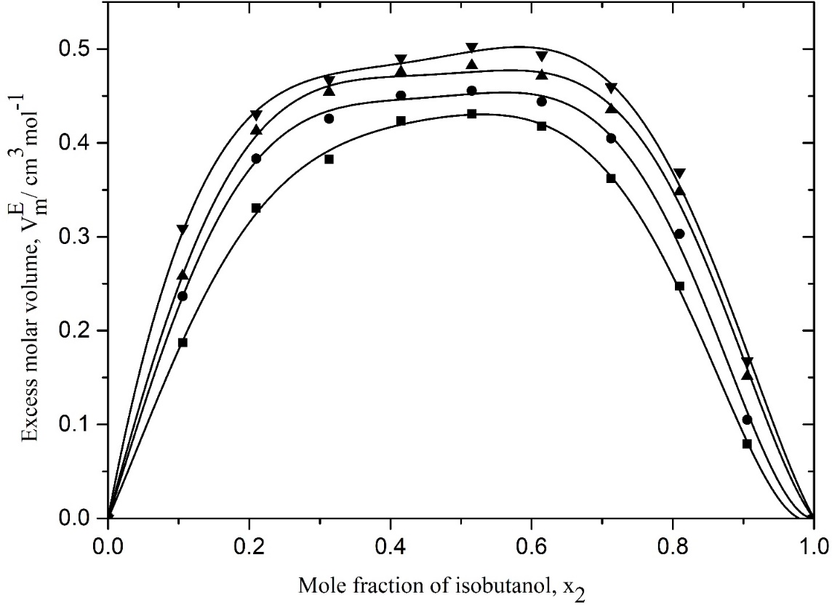
Figure 1: Excess volume, $V_{m}^{E}$ of binary mixture of ethyl acetate + isobutanol as a function of mole fraction of isobutanol, x₂ at T: (■, 303.15; ●, 308.15; ▲, 313.15; and ▼, 318.15) K. The solid lines represent fitting of the corresponding functions to RK equation.
For the EtOAc + n-hexane system, the values of $V_{m }^{E} also$increase with an increase in the mole fraction of hexane passes through a maximum at about x₂ = 0.7 and then decreases with an increase in the mole fraction of hexane (Fig. 2). For both the binary mixtures, the values of $V_{m}^{E}$become more positive with an increase in temperature,i.e., d$V_{m}^{E}$/dT is positive over the entire range of concentration for the systems.
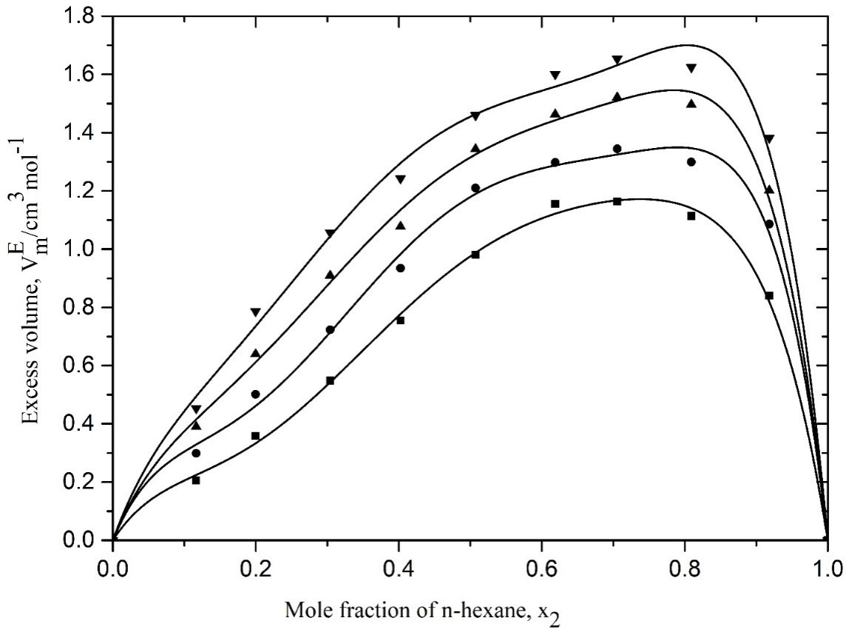
Figure 2: Excess volume, $V_{m}^{E}$of binary mixture of ethyl acetate + n-hexane as a function of mole fraction of n-hexane, x₂ at T: (■, 303.15; ●, 308.15; ▲, 313.15; and ▼, 318.15) K. The solid lines represent fitting of the corresponding functions to RK equation.
The sign and magnitude of $V_{m}^{E}$ of a binary mixture depends on the contribution of several opposing effects such as chemical, physical, and structural [22]. Chemical or specific interactions leads to volume contraction giving negative values of $V_{m}^{E}$ which indicates the formation of bonds between component molecules. On the other hand, physical interactions or nonspecific interactions are weak and involve predominantly the dispersion forces that make a positive contribution to $V_{m}^{E}$. Structural contributions are mostly negative and arise from geometrical fitting of one component into the other because of the difference in the molar volume of component molecules and free volume between them. Alcohols are strongly associated liquid through hydrogen bonding and tend to dissociate from aggregates in the presence of another organic molecule or form hydrogen bond with it in the mixtures. In the present work, for EtOAc +i-BuOH binary system, the positive values of $V_{m}^{E }$indicate a weak interaction between the component molecules. This implies that dispersion forces are predominant in the system giving positive contribution to volume. This contribution to the expansion of volume may also be attributed to the dissociation of associated alcohol in the presence of ethyl acetate in the solution system. Steric hindrance of isobutanol due to its branching is another important factor that contributes significantly towards volume expansion.
Like EtOAc +i-BuOH binary mixtures, the excess molar volume $V_{m }^{E}$is also positive for EtOAc + n-hexane system over the whole range of compositions at all investigated temperatures, but the values of $V_{m}^{E}$for EtOAc + hexane are much higher than that of EtOAc +i-BuOH system. Ethyl acetate is slightly polar due to the presence of polar C=O and C-O bonds. Its dipole moment is 1.18D and interacts through dipole-dipole interactions. On the other hand,n-hexane with its two methyl groups is nonpolar because of its symmetrical geometrical structure and its dipole moment is zero. It is likely that ethyl acetate and n-hexane are chemically nonreactive; thus, the possibility of formation of hydrogen bond or the formation charge-transfer complex is not possible.The positive values of $V_{m}^{E}$ indicate the absence of any chemical or specific interactions in the binary mixtures of ethyl acetate + n-hexane and predominance of dispersion type of forces at all investigated temperatures. The possible steric hindrance exhibited by the methyl groups of n-hexane to ethyl acetate is expected to contribute to positive values of excess molar volume, $V_{m}^{E}$of this binary system. A similar type of volumetric study of binary mixture of 1,4-dioxane with n-hexane was carried out by Nayeem et. al [15], and they observed the positive values of $V_{m}^{E }$for this system at 308.15, 313.15, and 318.15 K over the entire composition range. The observed increase in $V_{m}^{E }$with the increase of temperature for both the binary mixtures is attributed to the rupture of hydrogen bonds in self-associated alcohol and the reduction of dipolar interaction between the molecules of polar ethyl acetate.

Excess viscosity
The variation of excess viscosities, η^{E} of the binary mixtures of EtOAc + i-BuOH and EtOAc + n-hexane with mole fraction (x₂) of isobutanol and n-hexane at 303.15, 308.15, 313.15 and 318.15 K are shown in Figures 3 and 4 respectively.
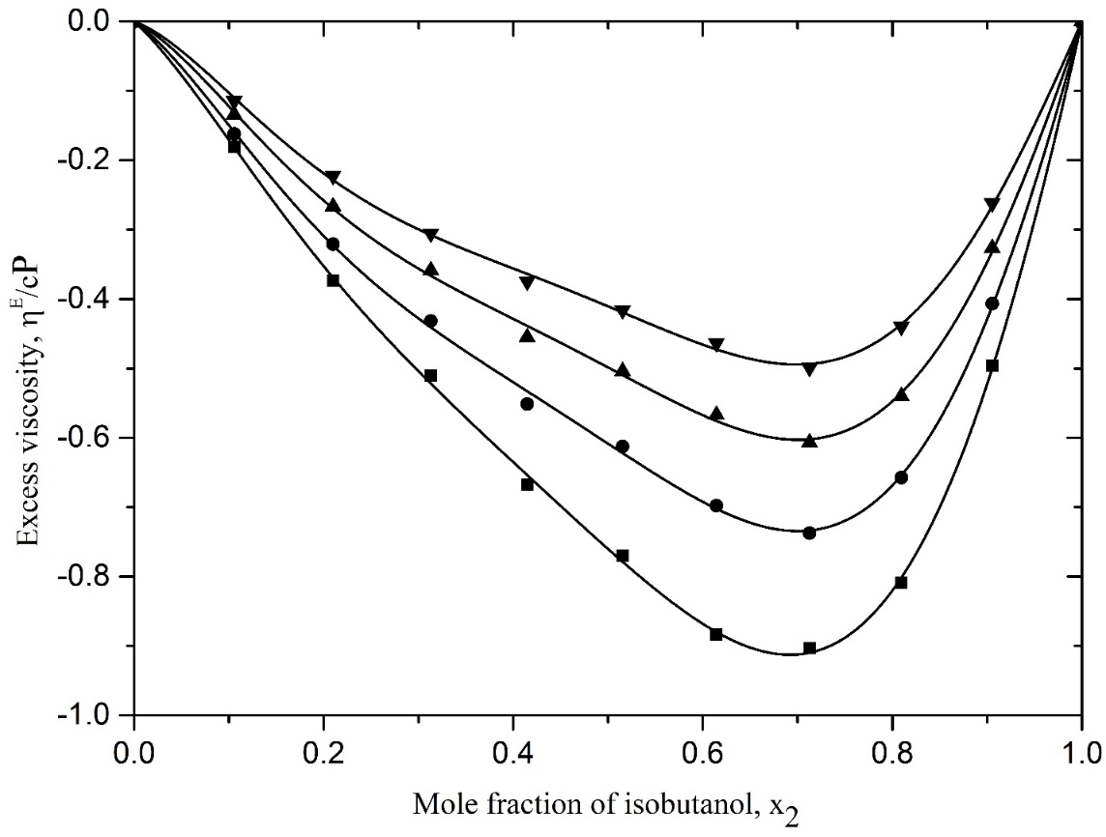
Figure3: Excess viscosity, η^{E} of the binary mixture of ethyl acetate + isobutanol as a function of mole fraction of isobutanol, x₂ at T: (■, 303.15; ●, 308.15; ▲, 313.15; and ▼, 318.15) K. The solid lines represent fitting of the corresponding functions to RK equation.

For both the systems, the values of η^{E} are found to be negative over the entire range of composition. Excess viscosity, η^{E} becomes more negative with the increase in the mole fraction of both isobutanol and n-hexane, and a minimum for ethyl acetate + i-BuOH system is observed at x₂ $≈$ 0.7 (Fig. 3) while for ethyl acetate +n-hexane this minimum is found at x₂$≈$ 0.5 (Fig. 4). Excess viscosities, η^{E} for the system EtOAc +i-BuOH is more negative in values than that of EtOAc + n-hexane system, and the η^{E}values become less negative for both the systems with the increase of temperature.
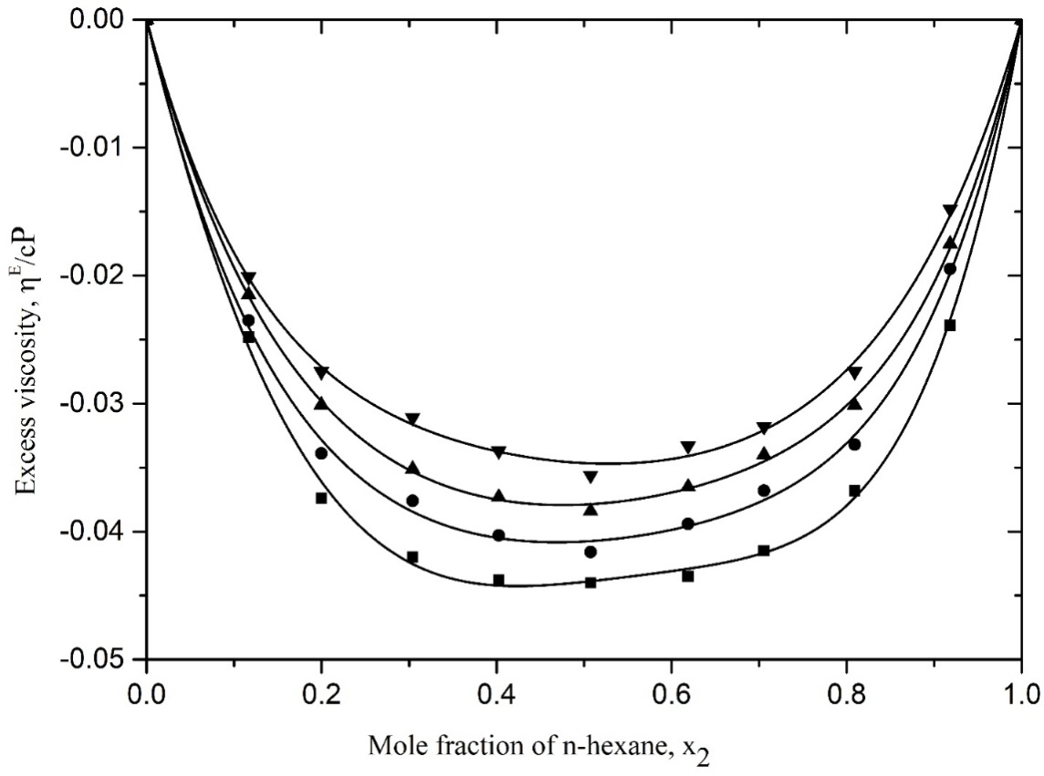
Figure 4: Excess viscosity, η^{E} of the binary mixture of ethyl acetate + n-hexane as a function of mole fraction of n-hexane, x₂ at T: (■, 303.15; ●, 308.15; ▲, 313.15; and ▼, 318.15) K. The solid lines represent fitting of the corresponding functions to RK equation.
The negative values of η^{E} for the binary mixtures of EtOAc +i-BuOH indicate no specific interaction or weak interaction between the components of liquid mixture, and some physical forces of attraction such as dispersion forces are dominant in the mixtures. It appears that the values of η^{E} for EtOAc + i-BuOH system are quite large i.e more negative than the reported values of η^{E} for the binary mixtures of ethyl acetate with n-propanol and n-butanol [7]. It suggests that the branched chain alcohol causes a greater reduction in viscosity than ideal values showing larger negative η^{E} than the straight chain alkanol. Similar studies of some alkanolwith cumene have been reported by Saleh et.al.[23]. They observed that the system having branched chain alcohol (2-propanol, tert-butanol) have larger negative η^{E} than the straight chain isomers (1-propanol and 1-butanol). The observed decrease in the negative values of η^{E} for EtOAc + i-BuOH system with the rise of temperature implies that as the temperature increases, viscosity offered by the fluid decreases. In fact, the increase of temperature disturb the self-association of the alcohol in the system which increase the fluidity of the mixture and thus the mixtures tend towards ideal behavior with the rise of temperature. The relatively small negative η^{E} values observed for ethyl acetate + n-hexane system indicates the dominance of dispersive forces in the mixture compared to dipole-dipole interactions in the system containing an associated component. Like EtOAc + i-BuOH system, values of η^{E} for EtOAC + n-hexane mixture becomes less negative with the rise of temperature.The increase of temperature is expected to reduce the dipole-dipole interactions in ethyl acetate. As a result, the frictional resistance is reduced, and consequently, η^{E} decreases resulting an increase in the fluidity of the mixture.
Excess Gibb’s free energy
The values of $∆G_{m}^{*E }$for the binary mixtures of EtOAc + i-BuOH and EtOAc + n-hexane have been plotted as a function of mole fraction, x₂ of isobutanol and n-hexane at 303.15, 308.15, 313.15 and 318.15 K as shown in Figures 5 and 6 respectively. It is observed that $∆G_{m}^{*E}$values are negative for both systems for whole range of composition at all investigated temperatures. The curve for EtOAc + i-BuOH show a minimum ar around x₂= 0.7 and for the system EtOAc + n-hexane the minimum is observed at x₂$≈$ 0.6.
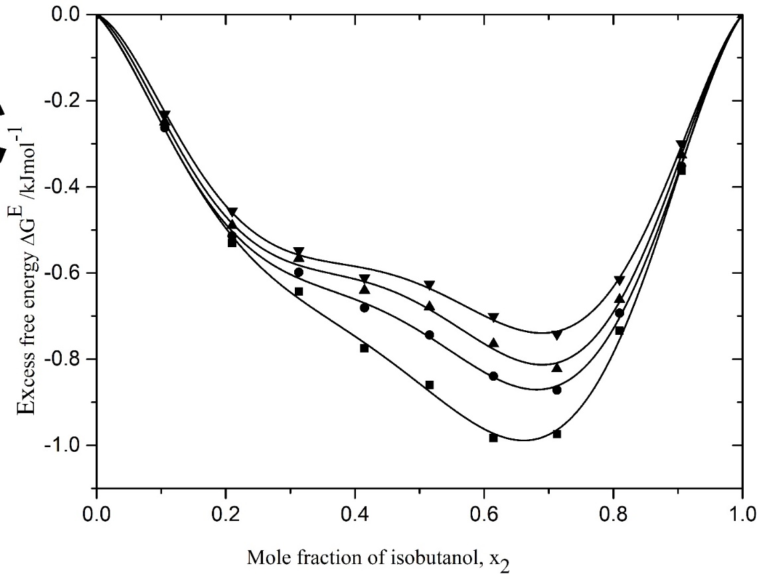
Figure 5: Excess molar free energy, $∆G_{m}^{*E}$of activation for viscous flow of binary mixture of ethyl acetate + isobutanol as a function of mole fraction of isobutanol, x₂ at T: (■, 303.15; ●, 308.15; ▲, 313.15; and ▼, 318.15) K. The solid lines represent fitting of the corresponding functions to RK equation.
Furthermore, the values of $∆G_{m}^{*E }$for the EtOAc + i-BuOH system is more negative than that of EtOAc + n-hexane system.Excess Gibb’s free energy of activation for viscous flow, $∆G_{m}^{*E }$is considered a reliable measure to infer the presence of molecular interactions between the component molecules. According to Reid and Taylor [24] the positive values of $∆G_{m}^{*E }$may be attributed to molecular interactions or structural compactness due to geometrical fitting of one component into the other’s structurein the mixture, and negative $∆G_{m}^{*E }$may be ascribed to the dominance of dispersion forces allowing easier fluid flow.
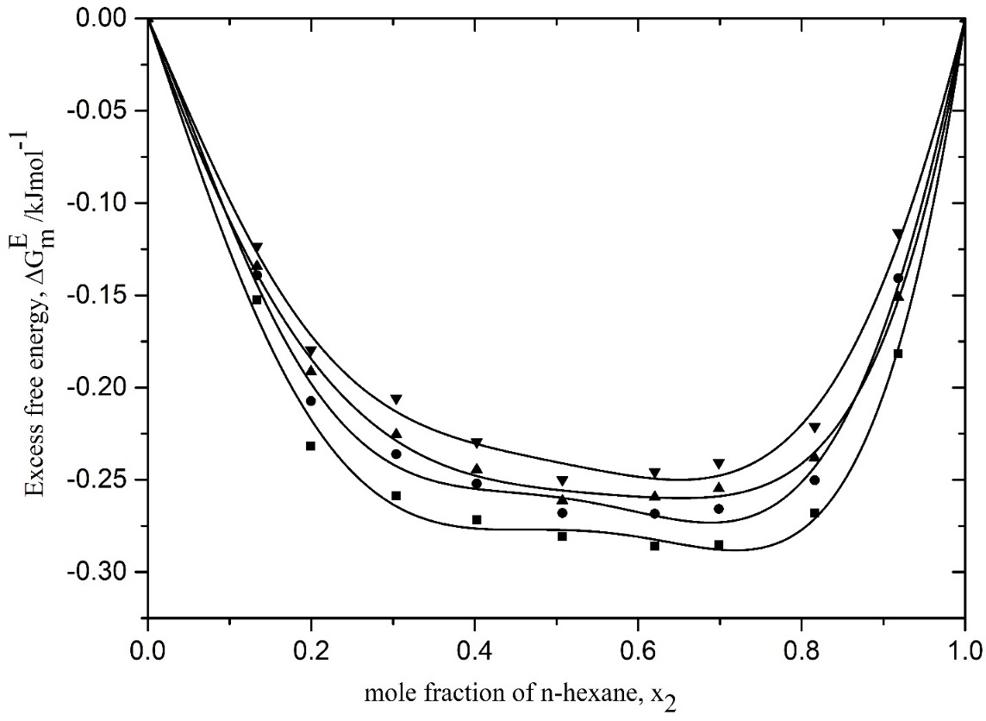
Figure 6: Excess molar free energy, $∆G_{m}^{*E}$of activation for viscous flow of binary mixture of ethyl acetate + n-hexane as a function of mole fraction of n-hexane, x₂ at T: (■, 303.15; ●, 308.15; ▲, 313.15; and ▼, 318.15) K. The solid lines represent fitting of the corresponding functions to RK equation.
In the present work, for both the EtOAc + i-BuOH and EtOAc + n-hexane systems, the observed negative values of excess Gibb’s free energy of activation for viscous flow indicate the presence of weak interactions among unlike molecules and strong interactions among the like molecules. The larger negative values of $∆G_{m}^{*E }$for EtOAc + i-BuOH than that of EtOAc + n-hexane indicate that the mixture EtOAc + i-BuOH overcome the smaller energy barrier than the expected from ideal behavior. It appears that the values of $∆G_{m}^{*E}$ tend to be less negative for both systems with the increase of temperature, i. e. the$∆G_{m}^{*E}$value tends toward zero. This suggests that the system approaches ideal behavior with the rise of temperature.
All the values of${ V}_{m}^{E}$, η^{E} and$∆G_{m}^{*E}$have been fitted to Redlich-Kister type polynomial equation. The values of coefficient A_{i} of the equation and the corresponding standard deviation ( $σ$) were obtained using the least square regression method. The calculated values of A for $V_{m}^{E}$, η^{E} and$∆G_{m}^{*E}$along with standarddeviation ( $σ$) are shown in Tables 4 and 5.

Table 4: Redlich-Kister coefficient of excess molar volume, $V_{m}^{E}$, excess viscosity, η^{E}, free energy of activation for viscous flow, $∆G_{m}^{*E}$ and standard deviation, $σ$ for ethyl acetate + isobutanol system at 303.15, 308.15, 313.15, and 318.15 K
Properties | T/K | A₀ | A₁ | A₂ | A₃ | A₄ | $$σ$$
$V_{m}^{E}$,  (cm³mol⁻¹) | 303.15 | 1.7176 | 0.1172 | 0.9026 | -1.1531 | -1.9415 | 0.0069
$V_{m}^{E}$,  (cm³mol⁻¹) | 308.15 | 1.8050 | 0.1212 | 1.6976 | -1.2947 | -2.3258 | 0.0130
$V_{m}^{E}$,  (cm³mol⁻¹) | 313.15 | 1.8990 | 0.1017 | 1.9129 | -1.0002 | -1.9554 | 0.0133
$V_{m}^{E}$,  (cm³mol⁻¹) | 318.15 | 1.9814 | 0.2551 | 1.7883 | -1.5506 | -1.1039 | 0.122
η^{E},  (cP) | 303.15 | -3.0410 | -2.4266 | -2.3352 | -0.0238 | 1.6693 | 0.0117
η^{E},  (cP) | 308.15 | -2.4334 | 1.7871 | -2.3781 | -0.2393 | 1.8077 | 0.0121
η^{E},  (cP) | 313.15 | -1.9938 | -1.4367 | -2.0902 | -0.1930 | 1.7687 | 0.0115
η^{E},  (cP) | 318.15 | -1.6418 | -1.1377 | -1.8189 | -0.1314 | 1.6719 | 0.0092
$$∆G_{m}^{*E}$$  (kJ mol⁻¹) | 303.15 | -3.3966 | -2.4640 | -3.3037 | 2.0392 | 5.5206 | 0.0459
$$∆G_{m}^{*E}$$  (kJ mol⁻¹) | 308.15 | -2.8670 | -1.7632 | -5.2345 | 1.6845 | 6.5778 | 0.0240
$$∆G_{m}^{*E}$$  (kJ mol⁻¹) | 313.15 | -2.7204 | -1.4214 | -5.1060 | 0.9208 | 6.7534 | 0.0434
$$∆G_{m}^{*E}$$  (kJ mol⁻¹) | 318.15 | -2.5394 | -1.1382 | -5.0354 | 0.7052 | 6.6345 | 0.0273

TABLE 5: Redlich-Kister coefficient of excess molar volume, $V_{m}^{E}$, excess viscosity, η^{E}, free energy of activation for viscous flow, $∆G_{m}^{*E}$and standard deviation, $σ$ for ethyl acetate + n-hexane system at 303.15, 308.15, 313.15, and 318.15 K
Properties | T (K) | A₀ | A₁ | A₂ | A₃ | A₄ | $$σ$$
$V_{m}^{E}$,  (cm³mol⁻¹) | 303.15 | 3.9022 | 3.1815 | -0.0057 | 2.4053 | 5.6599 | 0.0314
$V_{m}^{E}$,  (cm³mol⁻¹) | 308.15 | 4.7164 | 2.9366 | -0.8735 | 4.6756 | 9.6904 | 0.0478
$V_{m}^{E}$,  (cm³mol⁻¹) | 313.15 | 5.2598 | 2.8771 | 1.1318 | 5.4842 | 7.7290 | 0.0474
$V_{m}^{E}$,  (cm³mol⁻¹) | 318.15 | 5.8197 | 2.3457 | 1.7748 | 7.4256 | 8.9104 | 0.0667
η^{E},  (cP) | 303.15 | -0.1757 | 0.0143 | -0.1535 | -0.0664 | -0.0041 | 0.0009
η^{E},  (cP) | 308.15 | -0.1628 | 0.0058 | -0.1131 | -0.0162 | -0.0171 | 0.0011
η^{E},  (cP) | 313.15 | -0.1512 | 0.0083 | -0.0906 | -0.0409 | -0.0499 | 0.0007
η^{E},  (cP) | 318.15 | -0.1385 | -0.0069 | -0.0781 | 0.0159 | 0.0277 | 0.0008
$$∆G_{m}^{*E}$$  (kJ mol⁻¹) | 303.15 | -1.1051 | -0.0487 | -1.2527 | -0.6087 | -0.0034 | 0.0064
$$∆G_{m}^{*E}$$  (kJ mol⁻¹) | 308.15 | -1.0390 | -0.1487 | -0.9827 | -0.2211 | 0.0664 | 0.0107
$$∆G_{m}^{*E}$$  (kJ mol⁻¹) | 313.15 | -1.0177 | -0.1092 | -0.8058 | -0.4495 | -0.2966 | 0.0082
$$∆G_{m}^{*E}$$  (kJ mol⁻¹) | 318.15 | -0.9739 | -0.2616 | 0.7959 | 0.1503 | 0.0799 | 0.0097

Interaction parameter
The viscosity data of the binary mixtures of EtOAc + i-BuOH and EtOAc + n-hexane are analyzed based on Grunberg-Nissan treatment whose parameter, d₁₂ gives the qualitative information about molecular interactions in the mixtures. The calculated values of interaction parameter, d₁₂ at different investigated temperatures show that d₁₂ are negative for both the EtOAc + i-BuOH and EtOAc + n-hexane systems at all studied temperatures (Table 2 and 3). It appears that the values of d₁₂ are quite large in magnitude at all composition of the mixture and tends to be less negative withthe rise of temperature. According to Fort and Moore [18], for any binary liquid mixture, a positive value of d₁₂ indicates the presence of specific interaction, and a negative value of d₁₂ indicates the presence of weak interaction between the unlike molecules in the mixture. For the present binary mixtures of EtOAc + i-BuOH and EtOAc + n-hexane, the large negative values of d₁₂ indicate the presence of weak interactions between the component molecules and dominance of dispersion forces in the mixture. The decrease in the magnitude of d₁₂ with the increase of temperature for both systems implies that the nonspecific interactions between the component molecules become favorable with the increase of temperature, i.e.,dispersive forces operative between the components in the mixture increase with the increase of temperature.
CONCLUSION
This work reports the experimental data on densities and viscosities of ethyl acetate + isobutanol and ethyl acetate + n-hexane binarymixtures over the entire range of mole fraction at 303.15, 308.15, 313.15, and 318.15 K. The values of excess molar volume ($V_{m}^{E}$), excess viscosity (η^{E}), excess Gibb’s free energy of activation for viscous flow ($∆G_{m}^{*E}$) and Grunberg-Nissan interaction parameter (d₁₂) are estimated from experimental density and viscosity data. It is found that for both the EtOAc + i-BuOH and EtOAc + n-hexane systems, excess molar volume, $V_{m }^{E}$is positive while the excess viscosity, η^{E} values are negative. The positive values of${ V}_{m}^{E}$ and negative values of η^{E} for both systems over the entire range of composition indicate the absence of any specific interactions or weak interaction between unlike molecules in the mixture and predominance of dispersion type of forces. In addition, the observed negative values of excess Gibb’s free energy of activation for viscous flow, $∆G_{m}^{*E}$and Grunberg-Nissan interaction parameter, d₁₂ indicate the presence of weak interaction between the unlike component molecules and domination of dispersion forces in the binary mixtures.For both the systems, the parameters${ V}_{m}^{E}$, η^{E},$∆G_{m}^{*E}$and d₁₂ support each other over the entire composition range and at all investigated temperatures.It appears that both the mixtures tend to approach ideal behavior with rise of temperature.

REFERENCES
[1] Rani, S., Dubey, G.P., Chauhan, S and Kaur, P (2025), Volumetric, acoustic, viscometric and spectroscopic studies of binary liquid mixtures containing triethylamine with 1-propanol, 1-butanol and 1-pentanol. J. Chem. Thermodynamics, 210, 107532.
https://doi.org/10.1016/j.jct.2025, 107532

[2] Alauddin, J., Pande, S., Alauddin, S., Uddin, M. H. and Al-Reza, S. M (2025), Volumetric and viscometric studies of binary mixtures of ethylacetate with n-propanol and 2-propanol at T= ( 303.15, 308.15, 313.15 and 318.15) K under atmospheric pressure. J. Sci. Res. 17 (3), 937-949.
https:// dx.doi.org/10.3329/jsr. v17i3.79608.

[3] Kumar, D. and Mishra, R. K (2024), Molecular interaction studies in binary liquid mixtures containing ethylacetate with n-octanol at different temperatures. W. J. Adv. Res. Rev. 21 (02), 587-598.
https:// doi.org/10.30574/wjarr.2024.21.2.0427.
[4] Rahman, M. M., Islam, M. A., Chowdhury, F. I., Khan, M. A. R. and Akhtar, S (2023), Volumetric properties of binary mixtures of 2-ethoxyethanol and 2-butoxyethanol with 1,4-dioxane. J. Appld. Sci. Process . Engr,10(1), 1-20.
https:// doi.org/10.33736/jaspe.4904.2023

[5] Ekezie, C. M., Cookey, G. A.. and Maduclosi, J. N (2023), Volumetric and viscometric studies of binary mixtures of methanol and some alkyl acetates at varying temperatures. S. Afr. J. Chem. 77 (1), 133-137.
https:// doi.org/10.17159/0379-4350/2023/v77a16
[6] Oswal, S. L. and .Putta, S. S. R (2001), Excess molar volumes of alkanols with ethyl acetate from 298.15 to 323.15 K. Thermochimica Acta, 373(2), 141-152.
DOI: 10.1016/s0040-6031(00)00778-4.
[7] Majstorovic, D. M., Mirkovic, M. R., Kijevcanin, M. Lj. and Zivkovic, E. M (2020), Analysis of thermophysical properties of binary systems containing ethyl acetate and 1-propanol or 1-butanol.Hemijska Industrija. 74 (3), 163-185.
DOI: 102298/HEMIND 191203017M.
[8] Sharma, S. J., Bhalodia, J. J. and Ramani, J (2012), Volumetric, viscometric and ultrasonic studies on binary mixtures of oleic acid with alkyl esters at 303.15, 308.15 and 313.15 K. Int. J. Phys. Sci. 7(8), 1205-1214.
DOI: 10.5897/IJPS11.989.
[9] Pires, R. M., Costa, H. F., Ferreira, A. G. M. and Fonseca, M. A (2007), Viscosity and density of water + ethyl acetate + ethanol mixtures at 298.15 and 318.15 K and atmospheric pressure. J. Chem. Eng. Data. 52(4), 1240-1245.
https://doi.org/10.1021/je600565m.
[10] Bravo-Sanchez, M. G., Iglesias-Silva, G. A. and Estrada-Baltazar, A (2010), Densities and viscosities of binary mixtures of n-butanol with 2-butanol, isobutanol and tert-butanol from (303.15 to 343.15) K. J. Chem. Eng. Data.55, 2310-2315.
DOI: 10.1021/je900722m.
[11] Adhikhari, A. B., Rahman, I. M. M., Ashraf Uddin, M., Hasegawa, H. and M. Majid, M. A (2009), Volumetric behavior of the binary mixtures of methyl ethyl ketone with n-hexane, cyclohexane and benzene at T= (303.15 , 313.15and 323.15 ) K. J. Chem Eng. Data. 54, 1138-1141.
https:// doi.org/10.1021/JE800883B.
[12] Sastry, N. V. and Raj, M. M (1996), Densities, speeds of sound, viscosities, dielectric constant and refractive indices for 1-heptanol + hexane and + heptanes at 303.15 and 313.15 K. J. Chem. Eng. Data. 41(3), 612-618.
https://doi.org/10.1021/je950172p.
[13] Oswal, S., Dave, J. P. and Patel, I. N (1999), Viscosity of binary mixtures of ethyl acetates with hexane, tetrachloromethane and trichloromethane. Int. J. Thermophysics. 20(5), 1449-1465.
Doi:10.1023/A:1021441122016
[14] Ali, A., Abida, Hyder, S. and A. Nain , A. K (2002), Ultrasonic, volumetric and viscometric study of molecular interactions in binary mixtures of 2,2,4-trimethyl pentane with n-hexane and cyclohexane at 308.15K. Indian J. Phys. 76B(5), 661-667.
[15] Nayeem, Sk. M., Kondaiah, M., Sreenath, K., Reddy, M. S. and Rao, D. K (2016), Thermoacoustic, volumetric and viscometric investigations in the binary mixtures of 1,4-dioxane with n-hexane or n-heptane or n-octane. J. Therm. Anal. Calorim. 123, 2241-2255.
doi: 10.1007/s10973-015-4994-1.
[16] Lide, D. R (2004), CRC Handbook of Chemistry and Physics, CRC Press, 85, 990.
[17] Habibullah, M., Rahman, I. M. M., Uddin, M. A., Iwakabe, K., Azam, A. and Hasegawa, H (2011), Densities and viscosities of the binary mixtures of phenylmethanol with 2-butanone. J. Chem. Eng. Data. 56(8), 3323-3327.
https://doi.org/10.1021/je200150r.
[18] Fort, R. J. and Moore, W. R (1966), Viscosities of binary liquid mixtures. Trans. Faraday Society. 62, 1112-1119.
https://doi.org/10.1039.TF9666201112.
[19] Grunberg, L and Nissan, A. H (1949), Mixture law for viscosity. Nature.164(4175), 799-800.
DOI: 10.1038/164799bo.
[20] Glasstone, S., Laidler, K. J and Eyring, H (1941), The theory of rate processes; The kinetics of chemical reaction, viscosity, diffusion and electrochemical phenomena. McGeaw-Hill Book Company, New York.
[21] Kister, A.T and Redlich, O (1948), Algebric Representation of Thermodynamic Properties and the Classification, Ind. Eng. Chem. 40(2), 345-348.
https://doi.org/10.1021/ie50458a036.
[22] Sankar, M. G., Ponneri, V., Kumar, K. S. and Sakamuri, S (2014), Molecular interactions between amines and cyclic ketones at different temperature. J. Therm. Anal. Calorim.115(2), 1821-1827.
DOI: 10.1007/s10973-013-3312-z.
[23] Saleh, M. A., Habibullah, M., Ahmed, M. S., Uddin, M. A., Uddin, S. M. H., Uddin, M. A. and Khan, F. M (2006), Excess molar volume and viscosities of some alkanols with cumene. Phys. Chem. Liq. 44, 31-43.
https://doi.org/10.1080/00319100500287853.
[24] Reid, T. M. and Taylor, T. E (1959), Viscosities of liquid mixtures. J. Phys. Chem. 63(1), 58-67.
https://doi.org/10.1021/j150571a016

