Review Article
Digital Pathology and Artificial Intelligence in Resource-Limited Laboratories: A New Frontier for Cancer Diagnosis

Abstract
Cancer remains a major global health challenge, with a disproportionate burden in low- and middle-income countries (LMICs), where limited diagnostic capacity contributes to delayed detection and poor clinical outcomes. Histopathology is the gold standard for cancer diagnosis; however, its effectiveness in resource-limited settings is constrained by shortages of trained personnel, inadequate infrastructure, and prolonged turnaround times. Digital pathology, particularly whole-slide imaging, has emerged as a transformative approach that enables remote analysis, improved workflow efficiency, and enhanced access to specialist expertise. The integration of artificial intelligence, especially deep learning, has further expanded the capabilities of digital pathology by enabling automated tumour detection, grading, and biomarker prediction with high diagnostic accuracy. This review critically examines the current state of digital pathology and artificial intelligence in cancer diagnostics, with a focus on their application in resource-limited settings. Key clinical applications, including tumour detection, proliferation index assessment, and prognostic modelling, are discussed alongside major implementation challenges such as data scarcity, algorithmic bias, regulatory complexity, and infrastructural limitations.Emerging strategies, including federated learning, low-cost computational models, and integration with telepathology systems, offer promising pathways for scalable adoption. However, widespread clinical implementation will require rigorous validation, standardized workflows, and sustained investment in digital infrastructure.Overall, artificial intelligence-driven digital pathology holds significant potential to improve diagnostic accuracy, enhance efficiency, and expand access to cancer care globally. Its successful deployment in LMICs will depend on context-specific solutions, multidisciplinary collaboration, and careful consideration of ethical and operational challenges.
Keywords: Digital pathology, Artificial intelligence, Whole-slide imaging, Cancer diagnosis, Low- and middle-income countries, Deep learning, Telepathology, Computational pathology
Introduction
Cancer remains a leading cause of morbidity and mortality worldwide, with a disproportionately high burden in low- and middle-income countries (LMICs)(1). Current estimates indicate that nearly 70% of cancer-related deaths occur in LMICs, where healthcare systems are often constrained by limited infrastructure, insufficient workforce capacity, and restricted access to specialized diagnostic services. A major contributor to poor clinical outcomes in these settings is delayed or inaccurate diagnosis, which frequently results in patients presenting at advanced stages of disease when treatment options are less effective and survival rates are significantly reduce (2)
Histopathology is widely regarded as the gold standard for cancer diagnosis, relying on the microscopic evaluation of stained tissue sections. However, in resource-limited settings, the effectiveness of this approach is undermined by several systemic challenges(3). Chief among these is the severe shortage of trained pathologists, leading to increased workloads, prolonged turnaround times, and potential diagnostic variability. In addition, infrastructural deficiencies, including inadequate laboratory equipment, inconsistent supply of reagents, unreliable electricity, and limited quality assurance systems, further compromise diagnostic accuracy and efficiency (4).
Digital pathology has emerged as a promising solution to these challenges. Through whole-slide imaging, conventional glass slides can be digitized into high-resolution images that can be stored, shared, and analyzed remotely(5). This enables telepathology and facilitates access to expert consultation across geographically distant locations. Furthermore, the integration of artificial intelligence, particularly deep learning techniques, has introduced new capabilities in automated image analysis, including tumour detection, grading, and biomarker prediction(6).
This review critically evaluates the role of digital pathology and artificial intelligence in improving cancer diagnostics in resource-limited settings. It examines current technological advancements, clinical applications, implementation challenges, and future directions, with the aim of identifying scalable and context-appropriate solutions for LMICs.

2 Digital Pathology: Current State
Digital pathology represents a major advancement in diagnostic medicine, enabling the conversion of conventional glass slides into high-resolution digital images for analysis, storage, and sharing. Central to this transformation is whole-slide imaging, which allows complete histological slides to be digitized and examined using electronic platforms(7). This technology supports remote diagnosis, consultation, and education, thereby improving workflow efficiency and expanding access to specialist pathology services(8).
Multiple validation studies have demonstrated high concordance between diagnoses made using whole-slide images and those obtained through traditional light microscopy, supporting the reliability of digital pathology for routine clinical use(9). In response to increasing adoption, professional bodies such as the College of American Pathologists have developed guidelines to standardize validation procedures and ensure safe clinical implementation(10).
Beyond digitization, digital pathology enables the extraction of quantitative image data that can be leveraged for computational analysis. When integrated with machine learning techniques, these data facilitate the identification of complex morphological patterns that may not be readily apparent through manual review(11). As a result, digital pathology serves as a foundational platform for the development and deployment of artificial intelligence tools in diagnostic workflows(12).

2.1. Whole-Slide Imaging

Whole-slide imaging is a core component of digital pathology and involves several sequential processes, including image acquisition, storage, processing, and visualization. The process begins with standard histological preparation, which includes tissue fixation in formalin, paraffin embedding, sectioning into thin slices, and staining using appropriate histochemical or immunohistochemical techniques(13). These steps are critical to ensuring adequate preservation of tissue morphology and diagnostic features.

The sequential steps involved in whole-slide imaging and downstream analysis are illustrated in Figure 1.

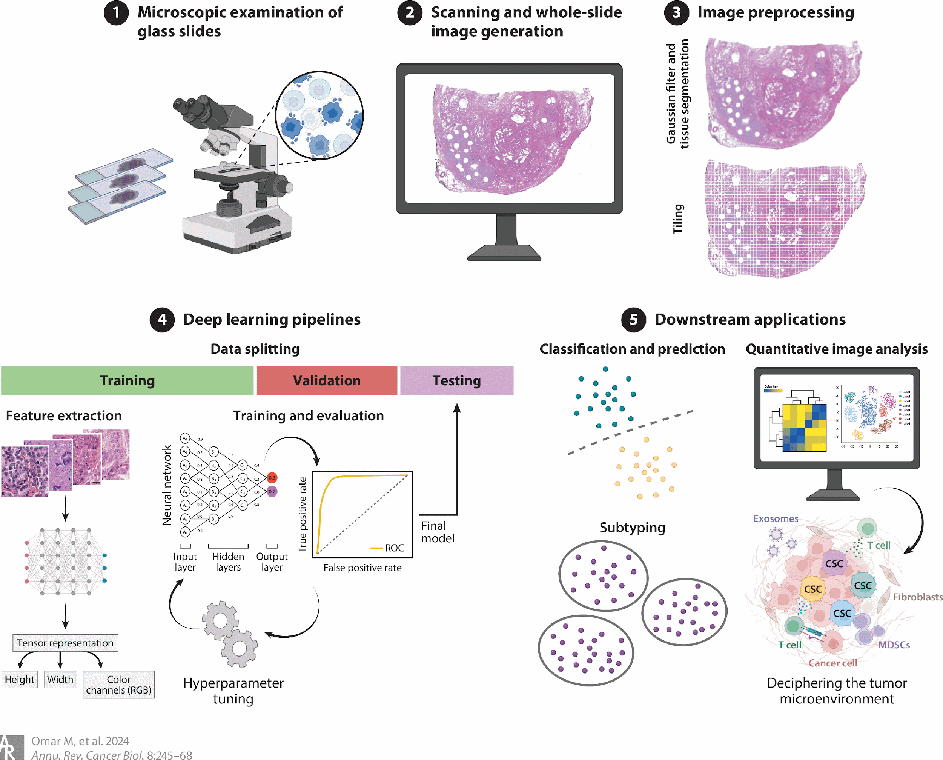

Figure 1. Workflow of whole-slide imaging in digital pathology, including tissue preparation, image acquisition, processing, and integration with artificial intelligence for diagnostic analysis(14)

.

Following preparation, slides are digitized using high-resolution scanners equipped with automated stage systems and advanced optical components. These scanners capture multiple adjacent fields of view at varying magnifications, which are subsequently stitched together using specialized software to generate a complete high-resolution digital image(15). The choice of magnification and scanning parameters depends on the clinical application, with higher magnifications providing greater detail for cellular analysis(16).

Once acquired, whole-slide images undergo processing and are stored in digital repositories that allow efficient retrieval and sharing. Visualization is performed using specialized software platforms that enable pathologists to navigate, zoom, and annotate images in a manner comparable to traditional microscopy(17). Different imaging modalities are available, including bright-field, fluorescence, and multispectral imaging. Bright-field imaging is most commonly used in routine histopathology, while fluorescence and multispectral techniques are particularly valuable in molecular and research applications where multiple biomarkers are assessed simultaneously(18).

2.2 Adoption of digital pathology in High-Income Countries

The adoption of digital pathology has been most advanced in high-income countries, where healthcare systems are supported by robust infrastructure, sufficient funding, and established regulatory frameworks. In these settings, whole-slide imaging has been successfully integrated into routine clinical workflows, supported by high-speed internet connectivity, secure data storage systems, and access to high-performance computing resources(19).

Digital pathology has proven particularly valuable in subspecialty practice, where expert pathologists are often concentrated in specialized centers(20). The ability to share digital slides enables remote consultation and collaboration, improving diagnostic accuracy and reducing delays in clinical decision-making. In addition, digital workflows reduce the risk of slide loss or damage and enhance case tracking and laboratory efficiency(21).

The increasing integration of artificial intelligence has further accelerated the adoption of digital pathology in these regions. AI tools are being incorporated into diagnostic workflows to assist with tasks such as tumour detection, grading, and biomarker quantification(22). These tools improve reproducibility and can reduce inter-observer variability, particularly in complex or high-volume cases. However, their implementation is typically supported by strong institutional capacity, which remains a limiting factor in lower-resource settings(23).
3. Artificial Intelligence in Pathology
Artificial intelligence is increasingly transforming the field of pathology by enabling automated, data-driven analysis of histopathological images. These technologies have the potential to improve diagnostic accuracy, enhance efficiency, and reduce variability in interpretation. Broadly, artificial intelligence approaches in pathology can be categorized into traditional machine learning and deep learning methods(24).
Machine learning methods rely on the extraction of predefined features from images, such as cell morphology, texture, and staining intensity. These features are then used to train algorithms, including support vector machines and decision trees, to perform classification or prediction tasks(25). While effective in certain applications, these approaches are limited by their dependence on manual feature engineering and their reduced ability to capture complex patterns in high-dimensional data(26)
In contrast, deep learning methods, particularly convolutional neural networks, learn features directly from raw image data without the need for manual feature selection. These models are capable of analyzing large and complex datasets, including whole-slide images, and can identify subtle morphological patterns associated with disease(26). As a result, deep learning has demonstrated superior performance in a wide range of pathology applications, including tumour detection, classification, and prognostic prediction(26)
Despite these advantages, the clinical implementation of artificial intelligence remains challenging. Deep learning models require large, well-annotated datasets and substantial computational resources, which may not be readily available in resource-limited settings(27).

3.1 Applications of Artificial Intelligence in Pathology
Artificial intelligence has demonstrated substantial potential across multiple domains in pathology, including tumour detection, grading, and biomarker prediction. These applications aim to improve diagnostic accuracy, reduce workload, and enhance reproducibility in clinical practice(28).
Tumour Detection
Deep learning models have shown high sensitivity and specificity in identifying malignant regions within histopathological images(29). By rapidly analyzing large volumes of data, these systems can assist pathologists in screening slides, highlighting suspicious regions, and prioritizing cases for review. This is particularly valuable in high-volume laboratories and resource-constrained settings where specialist availability is limited(30).
However, many reported results are derived from curated datasets developed in controlled environments. As a result, model performance may decline when applied to real-world data characterized by variability in staining, tissue preparation, and scanner types(31). This limitation underscores the importance of external validation across diverse clinical settings before widespread implementation(32). An example of an artificial intelligence workflow for tumour detection and tissue classification is shown in Figure 2.

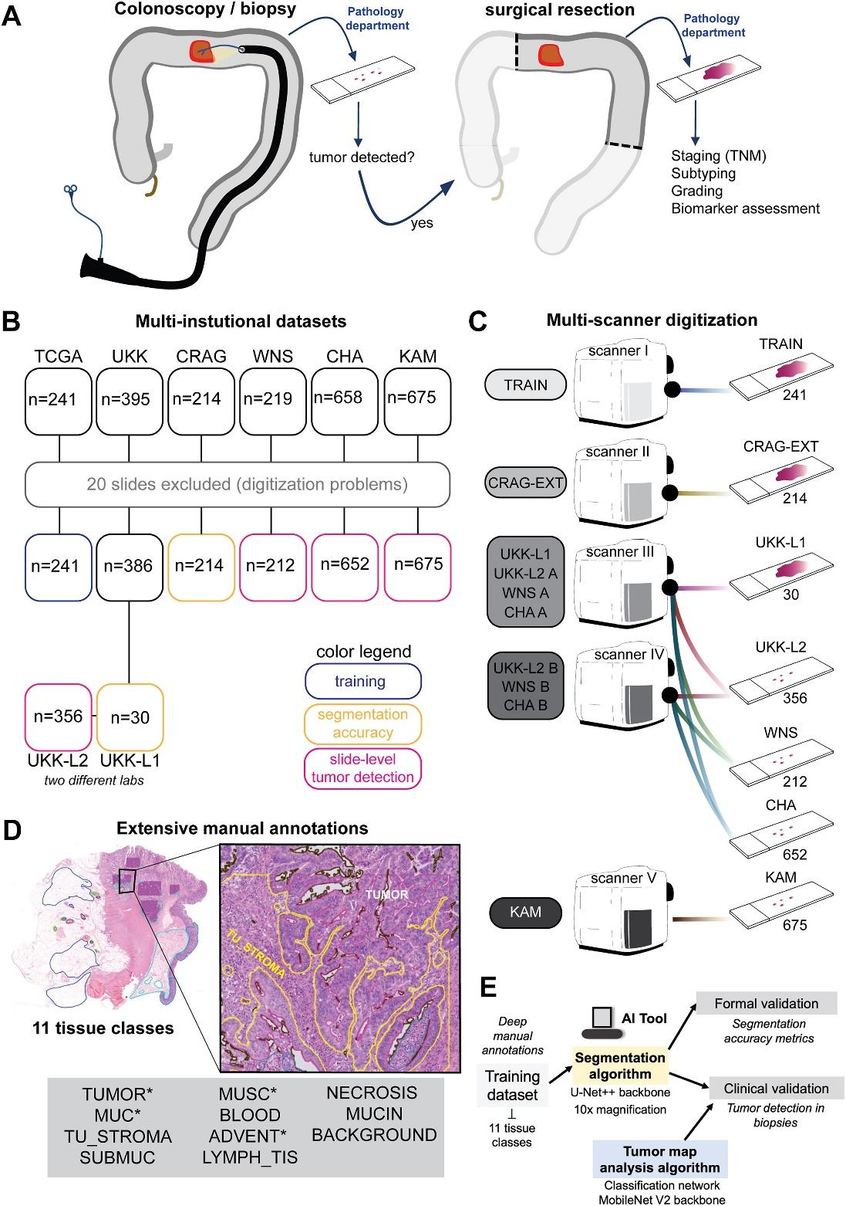
Figure 2. Workflow of an artificial intelligence model for tumour detection and tissue classification in histopathological images, including data acquisition, annotation, model training, and validation(33).
Tumour Grading and Proliferation Index Assessment
Artificial intelligence has been increasingly applied to tumour grading, including the automated evaluation of proliferation markers such as the Ki-67 index in neuroendocrine tumours(34). These systems typically involve image pre-processing, nuclei segmentation, and classification of cells into positive and negative categories based on staining characteristics.
Automated quantification improves reproducibility and reduces inter-observer variability, which is a well-recognized limitation of manual assessment(35). In addition, AI-based systems can process images rapidly, supporting more efficient diagnostic workflows. Despite these advantages, variability in staining protocols and image quality can significantly affect performance, highlighting the need for standardized laboratory practices and robust validation(36). The computational pipeline for automated Ki-67 assessment and spatial analysis is illustrated in Figure 3.

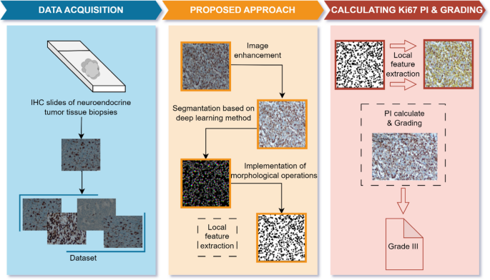
Figure 3. Computational pipeline for automated Ki-67 analysis, including nuclei detection, classification, heatmap generation, and spatial heterogeneity assessment(37).
Biomarker Prediction and Prognostic Modelling
Recent advances in artificial intelligence have enabled the prediction of clinically relevant biomarkers and patient outcomes directly from routine histopathology images. Deep learning models can extract complex, high-dimensional features that correlate with disease progression, recurrence risk, and overall survival(38).
These approaches provide a non-invasive and potentially cost-effective alternative to molecular testing, with applications in risk stratification and personalized treatment planning(39). However, most models have been developed using retrospective datasets and require further validation in large, multi-center studies to establish their clinical utility. In addition, issues related to interpretability and integration into clinical workflows remain important challenges(40).
4. Limitations
Despite the significant promise of artificial intelligence in pathology, several critical limitations must be addressed before widespread clinical implementation can be achieved, particularly in resource-limited settings(41).
One of the primary challenges is the scarcity of large, high-quality annotated datasets. Deep learning models require extensive, accurately labeled data to achieve reliable performance(42). However, in many healthcare systems, especially in low- and middle-income countries, digital pathology data are limited or unavailable. Even when datasets exist, annotation quality may vary due to inter-observer variability among pathologists(43). This inconsistency can negatively affect model training and reduce diagnostic accuracy. In addition, the process of generating detailed annotations is time-consuming and resource-intensive, further constraining dataset availability(44).
Algorithmic bias and limited generalizability represent another major concern. Many artificial intelligence models are developed using datasets derived from high-resource settings, which may not reflect the diversity of global patient populations or laboratory practices(45). Variations in tissue preparation, staining protocols, scanner types, and image resolution can lead to significant performance degradation when models are applied in different environments. This raises important concerns regarding equity, as biased models may produce less accurate results in underrepresented populations(46).
Regulatory and ethical challenges also complicate the integration of artificial intelligence into clinical workflows. The adaptive nature of many AI systems presents difficulties for regulatory approval, as models may evolve over time. In addition, questions regarding accountability in cases of diagnostic error remain unresolved(47). It is often unclear whether responsibility lies with developers, clinicians, or healthcare institutions. Data privacy is another critical issue, particularly when cloud-based systems are used for image storage and analysis, requiring strict compliance with data protection regulations(48).
Financial and infrastructural barriers further limit adoption. The implementation of digital pathology and artificial intelligence requires substantial investment in slide scanners, computing infrastructure, data storage systems, and software(49). Ongoing costs related to maintenance, system upgrades, and cybersecurity must also be considered. These financial requirements are often beyond the capacity of resource-limited healthcare systems(50).
Finally, unreliable power supply and limited digital infrastructure pose significant operational challenges in many settings. Frequent power outages can disrupt workflows, damage equipment, and result in data loss(51). In addition, limited internet connectivity can hinder the transfer of large image files and restrict access to cloud-based tools. These constraints must be addressed to enable the effective and sustainable deployment of artificial intelligence in pathology(52).

5. Discussion

The integration of artificial intelligence into digital pathology represents a significant shift in the landscape of cancer diagnostics, with the potential to address longstanding disparities in access to quality pathology services(53). This is particularly relevant in low- and middle-income countries, where shortages of trained pathologists and limited infrastructure continue to hinder timely and accurate diagnosis(54).

While numerous studies have reported high diagnostic performance of artificial intelligence models in tasks such as tumour detection, grading, and biomarker prediction, these findings must be interpreted with caution(55). Many models are developed and validated using curated datasets obtained from high-resource settings. As a result, their performance may not be directly transferable to diverse clinical environments characterized by variability in staining protocols, slide preparation techniques, and imaging equipment. This limitation highlights the need for robust external validation across heterogeneous datasets before widespread clinical implementation(56).

Despite these challenges, artificial intelligence offers a unique opportunity for resource-limited settings to expand diagnostic capacity without fully replicating traditional infrastructure-intensive models(57). A leapfrogging approach, in which emerging technologies are adopted directly, may enable more rapid improvements in access to diagnostic services(58). However, this approach is contingent upon addressing fundamental barriers, including unreliable electricity, limited internet connectivity, high implementation costs, and insufficient technical expertise(59).

Importantly, artificial intelligence should not be viewed as a replacement for pathologists, but rather as a complementary tool that enhances diagnostic accuracy and efficiency(60). Hybrid diagnostic models, in which artificial intelligence systems perform preliminary screening or highlight regions of interest for human review, may provide a more practical and clinically acceptable pathway for integration, particularly in settings with limited specialist availability(61).

From a policy perspective, the successful implementation of artificial intelligence in pathology will require coordinated efforts across multiple stakeholders. Governments must invest in digital infrastructure, establish clear regulatory frameworks, and ensure equitable access to emerging technologies(62). At the same time, researchers and developers should prioritize the design of cost-effective, generalizable, and ethically robust systems that are tailored to diverse clinical contexts(63).

Ultimately, while artificial intelligence-driven digital pathology holds considerable promise, its impact will depend on thoughtful implementation, rigorous validation, and sustained investment in health systems(64). Without these considerations, there is a risk that technological advancements may inadvertently widen existing disparities rather than reduce them(65).

6. Future Directions
Future research should focus on the development of cost-effective and scalable artificial intelligence solutions tailored to resource-limited settings(66). Current digital pathology systems often require expensive hardware, high-performance computing, and proprietary software, which limit their accessibility. The development of lightweight algorithms capable of operating on lower-cost hardware or local servers may significantly reduce barriers to adoption and facilitate wider implementation(67)

Emerging approaches such as federated learning offer promising solutions for collaborative model development while preserving data privacy(68). In this framework, models are trained across multiple institutions without the need to transfer raw patient data, thereby addressing regulatory and ethical concerns related to data sharing. This approach has the potential to improve model generalizability by incorporating diverse datasets from different geographic and clinical contexts(69).
The integration of artificial intelligence with telepathology systems represents another important direction(70). In such models, digital slides can be transmitted to remote specialists, while artificial intelligence tools perform preliminary screening and highlight areas of concern. This combined approach may significantly improve access to diagnostic services in underserved regions where specialist expertise is limited(71).
Advances in real-time image analysis also present opportunities for improving clinical workflows(72). Future systems may provide rapid or near real-time diagnostic support during slide scanning, which could be particularly valuable in time-sensitive settings such as intraoperative consultations and cancer screening programs(73).
Despite these advances, large-scale clinical validation remains essential. Many artificial intelligence systems demonstrate strong performance in controlled research environments but require further evaluation in real-world clinical settings(74). Multi-center studies involving diverse populations, laboratory conditions, and imaging systems are necessary to ensure reliability, safety, and generalizability(75).
7 Conclusion
Artificial intelligence has the potential to significantly transform the field of pathology by improving diagnostic accuracy, efficiency, and accessibility(76). When integrated with digital pathology, these technologies can enhance the consistency of interpretation, reduce diagnostic delays, and support clinical decision-making. This is particularly important in resource-limited settings, where shortages of trained pathologists and infrastructural constraints continue to limit access to timely and accurate cancer diagnosis(77).
However, the successful implementation of artificial intelligence in pathology requires more than technological advancement. Key challenges, including data scarcity, algorithmic bias, regulatory complexity, and infrastructural limitations, must be addressed to ensure safe and equitable adoption(78). Without careful consideration of these factors, there is a risk that the benefits of artificial intelligence may not be realized uniformly across different healthcare settings(79).
Artificial intelligence should be viewed as a complementary tool that augments, rather than replaces, human expertise(80). Collaborative models that combine automated analysis with expert oversight are likely to offer the most effective and clinically acceptable approach, particularly in environments with limited specialist capacity(81).
Moving forward, coordinated efforts among policymakers, researchers, and industry stakeholders will be essential. Investment in digital infrastructure, development of context-appropriate technologies, and implementation of clear regulatory frameworks will play a critical role in enabling sustainable integration(82). With thoughtful deployment and rigorous validation, artificial intelligence has the potential to improve cancer diagnostics globally and contribute to reducing disparities in healthcare access and outcomes(83)
References
1. Elbarazi I, Ahmed LA. Alleviating the Global Burden of Cancer Through Prevention and Early Detection. Cancer Control J Moffitt Cancer Cent. 2025 Sep 12;32:10732748251378666. doi:10.1177/10732748251378666 PubMed PMID: 40939582; PubMed Central PMCID: PMC12432317.
2. Sobri FB, Bachtiar A, Panigoro SS, Ayuningtyas D, Gustada H, Yuswar PW, et al. Factors Affecting Delayed Presentation and Diagnosis of Breast Cancer in Asian Developing Countries Women: A Systematic Review. Asian Pac J Cancer Prev APJCP. 2021 Oct;22(10):3081–92. doi:10.31557/APJCP.2021.22.10.3081 PubMed PMID: 34710982; PubMed Central PMCID: PMC8858264.
3. Tseng LJ, Matsuyama A, MacDonald-Dickinson V. Histology: The gold standard for diagnosis? Can Vet J. 64(4):389–91. PubMed PMID: 37008634; PubMed Central PMCID: PMC10031787.
4. Carbone FG. The shrinking workforce of pathologists: implications for healthcare and possible solutions. Pathologica. 2025 Oct 31;117(4):449–51. doi:10.32074/1591-951X-N1156 PubMed PMID: 41243517; PubMed Central PMCID: PMC12620947.
5. Fatima G, Alhmadi H, Ali Mahdi A, Hadi N, Fedacko J, Magomedova A, et al. Transforming Diagnostics: A Comprehensive Review of Advances in Digital Pathology. Cureus. 16(10):e71890. doi:10.7759/cureus.71890 PubMed PMID: 39564069; PubMed Central PMCID: PMC11573928.
6. Battazza A, Brasileiro FC da S, Tasaka AC, Bulla C, Ximenes PP, Hosomi JE, et al. Integrating telepathology and digital pathology with artificial intelligence: An inevitable future. Vet World. 2024 Aug;17(8):1667–71. doi:10.14202/vetworld.2024.1667-1671 PubMed PMID: 39328444; PubMed Central PMCID: PMC11422627.
7. Kiran N, Sapna F, Kiran F, Kumar D, Raja F, Shiwlani S, et al. Digital Pathology: Transforming Diagnosis in the Digital Age. Cureus. 15(9):e44620. doi:10.7759/cureus.44620 PubMed PMID: 37799211; PubMed Central PMCID: PMC10547926.
8. Ezeamii VC, Okobi OE, Wambai-Sani H, Perera GS, Zaynieva S, Okonkwo CC, et al. Revolutionizing Healthcare: How Telemedicine Is Improving Patient Outcomes and Expanding Access to Care. Cureus. 16(7):e63881. doi:10.7759/cureus.63881 PubMed PMID: 39099901; PubMed Central PMCID: PMC11298029.
9. Guidelines for the adoption of digital pathology in clinical pathology units recommended by the polish society of pathologists | Diagnostic Pathology | Springer Nature Link [Internet]. [cited 2026 Apr 15]. Available from: https://link.springer.com/article/10.1186/s13000-026-01762-2
10. Snead DR, Azam AS, Thirlwall J, Kimani P, Hiller L, Bickers A, et al. Variation within and between digital pathology and light microscopy for the diagnosis of histopathology slides: blinded crossover comparison study. Health Technol Assess. 2025 Jul;29(30):1–75. doi:10.3310/SPLK4325 PubMed PMID: 40654002; PubMed Central PMCID: PMC12278374.
11. Snead DR, Azam AS, Thirlwall J, Kimani P, Hiller L, Bickers A, et al. Variation within and between digital pathology and light microscopy for the diagnosis of histopathology slides: blinded crossover comparison study. Health Technol Assess. 2025 Jul;29(30):1–75. doi:10.3310/SPLK4325 PubMed PMID: 40654002; PubMed Central PMCID: PMC12278374.
12. Sebastian M, Batra H, Saini ML, Kearney S, Sherry L, Alexanian S, et al. Applications and challenges of utilizing digital pathology and AI-enabled workflows in clinical trials. J Pathol Inform. 2026 Jan 2;20:100542. doi:10.1016/j.jpi.2025.100542 PubMed PMID: 41631127; PubMed Central PMCID: PMC12861029.
13. Sebastian M, Batra H, Saini ML, Kearney S, Sherry L, Alexanian S, et al. Applications and challenges of utilizing digital pathology and AI-enabled workflows in clinical trials. J Pathol Inform. 2026 Jan 2;20:100542. doi:10.1016/j.jpi.2025.100542 PubMed PMID: 41631127; PubMed Central PMCID: PMC12861029.
14. Griem J, Eich ML, Schallenberg S, Pryalukhin A, Bychkov A, Fukuoka J, et al. Artificial Intelligence-Based Tool for Tumor Detection and Quantitative Tissue Analysis in Colorectal Specimens. Mod Pathol Off J U S Can Acad Pathol Inc. 2023 Dec;36(12):100327. doi:10.1016/j.modpat.2023.100327 PubMed PMID: 37683932.
15. Liu Y, Levenson RM, Jenkins MW. Slide Over. Am J Pathol. 2022 Feb;192(2):180–94. doi:10.1016/j.ajpath.2021.10.010 PubMed PMID: 34774514; PubMed Central PMCID: PMC8883436.
16. Kock F, Pontones M, Ghete T, Metzler M, Höfener H. Selecting A Digitization Device for Bone Marrow Aspirate Smears. Lab Invest. 2025 May 1;105(5):104114. doi:10.1016/j.labinv.2025.104114
17. Basak K, Ozyoruk KB, Demir D. Whole Slide Images in Artificial Intelligence Applications in Digital Pathology: Challenges and Pitfalls. Turk J Pathol. 39(2):101–8. doi:10.5146/tjpath.2023.01601 PubMed PMID: 36951221; PubMed Central PMCID: PMC10518202.
18. particularly valuable in molecular and research applications where multiple biomarkers are - Manema ta Google [Internet]. [cited 2026 Apr 15]. Available from: https://www.google.com/search?q=particularly+valuable+in+molecular+and+research+applications+where+multiple+biomarkers+are&oq=particularly+valuable+in+molecular+and+research+applications+where+multiple+biomarkers+are&gs_lcrp=EgZjaHJvbWUyBggAEEUYOdIBCDIwMTdqMGo0qAIAsAIB&sourceid=chrome&ie=UTF-8
19. Masjoodi S, Anbardar MH, Shokripour M, Omidifar N. Whole Slide Imaging (WSI) in Pathology: Emerging Trends and Future Applications in Clinical Diagnostics, Medical Education, and Pathology. Iran J Pathol. 2025;20(3):257–65. doi:10.30699/ijp.2025.2044210.3367 PubMed PMID: 40746923; PubMed Central PMCID: PMC12308189.
20. Hanna MG, Ardon O. Digital pathology systems enabling quality patient care. Genes Chromosomes Cancer. 2023 Nov;62(11):685–97. doi:10.1002/gcc.23192 PubMed PMID: 37458325; PubMed Central PMCID: PMC11265285.
21. Matias-Guiu X, Temprana-Salvador J, Garcia Lopez P, Kammerer-Jacquet SF, Rioux-Leclercq N, Clark D, et al. Implementing digital pathology: qualitative and financial insights from eight leading European laboratories. Virchows Arch. 2025;487(4):815–26. doi:10.1007/s00428-025-04064-y PubMed PMID: 40056197; PubMed Central PMCID: PMC12546502.
22. El-Khoury R, Zaatari G. The Rise of AI-Assisted Diagnosis: Will Pathologists Be Partners or Bystanders? Diagnostics. 2025 Sep 11;15(18):2308. doi:10.3390/diagnostics15182308 PubMed PMID: 41008680; PubMed Central PMCID: PMC12468387.
23. Doktorova V, Goranov G, Nikolov P. Applications of Artificial Intelligence in Chronic Total Occlusion Revascularization: From Present to Future—A Narrative Review. Medicina (Mex). 2025 Dec 17;61(12):2229. doi:10.3390/medicina61122229 PubMed PMID: 41470230; PubMed Central PMCID: PMC12734937.
24. Ahuja S, Zaheer S. Advancements in pathology: Digital transformation, precision medicine, and beyond. J Pathol Inform. 2025 Jan 1;16:100408. doi:10.1016/j.jpi.2024.100408
25. Al-Thelaya K, Gilal NU, Alzubaidi M, Majeed F, Agus M, Schneider J, et al. Applications of discriminative and deep learning feature extraction methods for whole slide image analysis: A survey. J Pathol Inform. 2023 Jan 1;14:100335. doi:10.1016/j.jpi.2023.100335
26. (PDF) Comparative Study of Feature Engineering Techniques for Predictive Data Analytics [Internet]. [cited 2026 Apr 15]. Available from: https://www.researchgate.net/publication/389415779_Comparative_Study_of_Feature_Engineering_Techniques_for_Predictive_Data_Analytics
27. Alowais SA, Alghamdi SS, Alsuhebany N, Alqahtani T, Alshaya AI, Almohareb SN, et al. Revolutionizing healthcare: the role of artificial intelligence in clinical practice. BMC Med Educ. 2023 Sep 22;23:689. doi:10.1186/s12909-023-04698-z PubMed PMID: 37740191; PubMed Central PMCID: PMC10517477.
28. Cheng CH, Shi S sheng. Artificial intelligence in cancer: applications, challenges, and future perspectives. Mol Cancer. 2025 Oct 30;24:274. doi:10.1186/s12943-025-02450-3 PubMed PMID: 41168799; PubMed Central PMCID: PMC12574039.
29. Li L, Wang P, Geng C, Wang J, Cao L, Gao Y, et al. Histopathology Images‐Based Deep Learning Prediction of Histological Types in Endometrial Cancer. Cancer Med. 2025 Dec 30;15(1):e71509. doi:10.1002/cam4.71509 PubMed PMID: 41469815; PubMed Central PMCID: PMC12753328.
30. Fatima G, Alhmadi H, Ali Mahdi A, Hadi N, Fedacko J, Magomedova A, et al. Transforming Diagnostics: A Comprehensive Review of Advances in Digital Pathology. Cureus. 16(10):e71890. doi:10.7759/cureus.71890 PubMed PMID: 39564069; PubMed Central PMCID: PMC11573928.
31. Chai B, Chen J, Cool P, Oumlil F, Tollitt A, Steiner DF, et al. Impact of tissue staining and scanner variation on the performance of pathology foundation models: a study of sarcomas and their mimics. J Pathol Clin Res. 2026 Feb 24;12(2):e70080. doi:10.1002/2056-4538.70080 PubMed PMID: 41735241; PubMed Central PMCID: PMC12932120.
32. Transforming sepsis management: AI-driven innovations in early detection and tailored therapies - PMC [Internet]. [cited 2026 Apr 15]. Available from: https://pmc.ncbi.nlm.nih.gov/articles/PMC12366378/
33. Wagner SJ, Reisenbüchler D, West NP, Niehues JM, Zhu J, Foersch S, et al. Transformer-based biomarker prediction from colorectal cancer histology: A large-scale multicentric study. Cancer Cell. 2023 Sep 11;41(9):1650-1661.e4. doi:10.1016/j.ccell.2023.08.002
34. Yücel Z, Akal F, Oltulu P. Automated AI-based grading of neuroendocrine tumors using Ki-67 proliferation index: comparative evaluation and performance analysis. Med Biol Eng Comput. 2024 Jun;62(6):1899–909. doi:10.1007/s11517-024-03045-8 PubMed PMID: 38409645.
35. Backhaus SJ, Schuster A, Lange T, Stehning C, Billing M, Lotz J, et al. Impact of fully automated assessment on interstudy reproducibility of biventricular volumes and function in cardiac magnetic resonance imaging. Sci Rep. 2021 Jun 2;11:11648. doi:10.1038/s41598-021-90702-9 PubMed PMID: 34078942; PubMed Central PMCID: PMC8172876.
36. Wang J, Wang T, Han R, Shi D, Chen B. Artificial intelligence in cancer pathology: Applications, challenges, and future directions. CytoJournal. 2025 Apr 19;22:45. doi:10.25259/Cytojournal_272_2024 PubMed PMID: 40469709; PubMed Central PMCID: PMC12134795.
37. Automated AI-based grading of neuroendocrine tumors using Ki-67 proliferation index: comparative evaluation and performance analysis | Medical & Biological Engineering & Computing | Springer Nature Link [Internet]. [cited 2026 Apr 15]. Available from: https://link.springer.com/article/10.1007/s11517-024-03045-8
38. Bera K, Schalper KA, Rimm DL, Velcheti V, Madabhushi A. Artificial intelligence in digital pathology — new tools for diagnosis and precision oncology. Nat Rev Clin Oncol. 2019 Nov;16(11):703–15. doi:10.1038/s41571-019-0252-y PubMed PMID: 31399699; PubMed Central PMCID: PMC6880861.
39. Jamalinia M, Weiskirchen R. Advances in personalized medicine: translating genomic insights into targeted therapies for cancer treatment. Ann Transl Med. 2025 Apr 30;13(2):18. doi:10.21037/atm-25-34 PubMed PMID: 40438512; PubMed Central PMCID: PMC12106117.
40. Ahn JS, Shin S, Yang SA, Park EK, Kim KH, Cho SI, et al. Artificial Intelligence in Breast Cancer Diagnosis and Personalized Medicine. J Breast Cancer. 2023 Oct 17;26(5):405–35. doi:10.4048/jbc.2023.26.e45 PubMed PMID: 37926067; PubMed Central PMCID: PMC10625863.
41. Ogut E. Artificial Intelligence in Clinical Medicine: Challenges Across Diagnostic Imaging, Clinical Decision Support, Surgery, Pathology, and Drug Discovery. Clin Pract. 2025 Sep 16;15(9):169. doi:10.3390/clinpract15090169 PubMed PMID: 41002784; PubMed Central PMCID: PMC12468291.
42. Koptelov A, Beketova H, Belnoue JPH, Hallett SR, Tretiak I. Addressing data scarcity in deep learning: Leveraging real and artificial datasets to predict compaction of composites. Mater Des. 2025 Sep 1;257:114536. doi:10.1016/j.matdes.2025.114536
43. Bani MA. Smart Lies and Sharp Eyes: Pragmatic Artificial Intelligence for Cancer Pathology: Promise, Pitfalls, and Access Pathways. Cancers. 2026 Jan 28;18(3):421. doi:10.3390/cancers18030421 PubMed PMID: 41681893; PubMed Central PMCID: PMC12897117.
44. Li M, Jiang Y, Zhang Y, Zhu H. Medical image analysis using deep learning algorithms. Front Public Health. 2023 Nov 7;11:1273253. doi:10.3389/fpubh.2023.1273253 PubMed PMID: 38026291; PubMed Central PMCID: PMC10662291.
45. Joseph J. Algorithmic bias in public health AI: a silent threat to equity in low-resource settings. Front Public Health. 2025 Jul 23;13:1643180. doi:10.3389/fpubh.2025.1643180 PubMed PMID: 40771228; PubMed Central PMCID: PMC12325396.
46. Chai B, Chen J, Cool P, Oumlil F, Tollitt A, Steiner DF, et al. Impact of tissue staining and scanner variation on the performance of pathology foundation models: a study of sarcomas and their mimics. J Pathol Clin Res. 2026 Feb 24;12(2):e70080. doi:10.1002/2056-4538.70080 PubMed PMID: 41735241; PubMed Central PMCID: PMC12932120.
47. Mennella C, Maniscalco U, De Pietro G, Esposito M. Ethical and regulatory challenges of AI technologies in healthcare: A narrative review. Heliyon. 2024 Feb 15;10(4):e26297. doi:10.1016/j.heliyon.2024.e26297 PubMed PMID: 38384518; PubMed Central PMCID: PMC10879008.
48. Mennella C, Maniscalco U, De Pietro G, Esposito M. Ethical and regulatory challenges of AI technologies in healthcare: A narrative review. Heliyon. 2024 Feb 15;10(4):e26297. doi:10.1016/j.heliyon.2024.e26297 PubMed PMID: 38384518; PubMed Central PMCID: PMC10879008.
49. Digital pathology: Barriers to transitioning to the digital age - PMC [Internet]. [cited 2026 Apr 15]. Available from: https://pmc.ncbi.nlm.nih.gov/articles/PMC12901937/
50. Burke W, Stranieri A, Oseni T, Gondal I. The need for cybersecurity self-evaluation in healthcare. BMC Med Inform Decis Mak. 2024 May 23;24:133. doi:10.1186/s12911-024-02551-x PubMed PMID: 38783250; PubMed Central PMCID: PMC11118990.
51. Lebepe P, Mathaba TND. Impact assessment of electricity shortage on enterprises: A systematic literature review. Energy Sustain Dev. 2024 Aug 1;81:101468. doi:10.1016/j.esd.2024.101468
52. Galaz V, Centeno MA, Callahan PW, Causevic A, Patterson T, Brass I, et al. Artificial intelligence, systemic risks, and sustainability. Technol Soc. 2021 Nov 1;67:101741. doi:10.1016/j.techsoc.2021.101741
53. Wang J, Wang T, Han R, Shi D, Chen B. Artificial intelligence in cancer pathology: Applications, challenges, and future directions. CytoJournal. 2025 Apr 19;22:45. doi:10.25259/Cytojournal_272_2024 PubMed PMID: 40469709; PubMed Central PMCID: PMC12134795.
54. Nkengasong JN, Yao K, Onyebujoh P. Laboratory medicine in low-income and middle-income countries: progress and challenges. Lancet Lond Engl. 2018 May 12;391(10133):1873–5. doi:10.1016/S0140-6736(18)30308-8 PubMed PMID: 29550031; PubMed Central PMCID: PMC5962422.
55. Najar Najafi N, Hajihassani H, Azimzadeh Irani M. The Impact of Artificial Intelligence on Cancer Diagnosis and Treatment: A Review. Cancer Inform. 2025 Sep 19;24:11769351251371273. doi:10.1177/11769351251371273 PubMed PMID: 40979169; PubMed Central PMCID: PMC12449654.
56. Tasji L, Alghamdi HS, Almalaise Al-Ghamdi AS. Toward AI-Assisted Sickle Cell Screening: A Controlled Comparison of CNN, Transformer, and Hybrid Architectures Using Public Blood-Smear Images. Diagnostics. 2026 Jan 29;16(3):414. doi:10.3390/diagnostics16030414 PubMed PMID: 41681732; PubMed Central PMCID: PMC12897022.
57. Zuhair V, Babar A, Ali R, Oduoye MO, Noor Z, Chris K, et al. Exploring the Impact of Artificial Intelligence on Global Health and Enhancing Healthcare in Developing Nations. J Prim Care Community Health. 2024 Apr 12;15:21501319241245847. doi:10.1177/21501319241245847 PubMed PMID: 38605668; PubMed Central PMCID: PMC11010755.
58. Gemelgo B, Pereira LF, Dias ÁL, Carvalho JC. Unpacking disruptive innovation: Key insights and strategies for competitive advantage. J Open Innov Technol Mark Complex. 2025 Dec 1;11(4):100641. doi:10.1016/j.joitmc.2025.100641
59. Nnaji IL, Ayanwale MA, Ukeje IO, Ekwunife RA, Igwe CM, Okwor EO, et al. Enhancing governance and performance in Nigerian higher education through AI-driven digital transformation: Insights from stakeholder perspectives. Soc Sci Humanit Open. 2026 Jun 1;13:102348. doi:10.1016/j.ssaho.2025.102348
60. The Rise of AI-Assisted Diagnosis: Will Pathologists Be Partners or Bystanders? - PMC [Internet]. [cited 2026 Apr 15]. Available from: https://pmc.ncbi.nlm.nih.gov/articles/PMC12468387/
61. Chong PL, Vaigeshwari V, Mohammed Reyasudin BK, Noor Hidayah binti RA, Tatchanaamoorti P, Yeow JA, et al. Integrating artificial intelligence in healthcare: applications, challenges, and future directions. Future Sci OA. 11(1):2527505. doi:10.1080/20565623.2025.2527505 PubMed PMID: 40616302; PubMed Central PMCID: PMC12233828.
62. Oduoye MO, Fatima E, Muzammil MA, Dave T, Irfan H, Fariha FNU, et al. Impacts of the advancement in artificial intelligence on laboratory medicine in low‐ and middle‐income countries: Challenges and recommendations—A literature review. Health Sci Rep. 2024 Jan 4;7(1):e1794. doi:10.1002/hsr2.1794 PubMed PMID: 38186931; PubMed Central PMCID: PMC10766873.
63. El Arab RA, Abu-Mahfouz MS, Abuadas FH, Alzghoul H, Almari M, Ghannam A, et al. Bridging the Gap: From AI Success in Clinical Trials to Real-World Healthcare Implementation—A Narrative Review. Healthcare. 2025 Mar 22;13(7):701. doi:10.3390/healthcare13070701 PubMed PMID: 40217999; PubMed Central PMCID: PMC11988730.
64. Zarella MD, McClintock DS, Batra H, Gullapalli RR, Valante M, Tan VO, et al. Artificial intelligence and digital pathology: clinical promise and deployment considerations. J Med Imaging. 2023 Sep;10(5):051802. doi:10.1117/1.JMI.10.5.051802 PubMed PMID: 37528811; PubMed Central PMCID: PMC10389766.
65. Husain L, Kitchens K, Raja S, Memon M. Bridging Implementation Gaps in Digital Health: A Translational Research Imperative for Equitable Healthcare Innovation. Clin Transl Sci. 2025 Oct 3;18(10):e70375. doi:10.1111/cts.70375 PubMed PMID: 41044865; PubMed Central PMCID: PMC12494540.
66. Peretz-Andersson E, Tabares S, Mikalef P, Parida V. Artificial intelligence implementation in manufacturing SMEs: A resource orchestration approach. Int J Inf Manag. 2024 Aug 1;77:102781. doi:10.1016/j.ijinfomgt.2024.102781
67. Bessen JL, Alexander M, Foroughi O, Brathwaite R, Baser E, Lee LC, et al. Perspectives on Reducing Barriers to the Adoption of Digital and Computational Pathology Technology by Clinical Labs. Diagnostics. 2025 Mar 21;15(7):794. doi:10.3390/diagnostics15070794 PubMed PMID: 40218144; PubMed Central PMCID: PMC11988507.
68. Horst A, Loustalot P, Yoganathan S, Li T, Xu J, Tong W, et al. Federated learning: a privacy-preserving approach to data-centric regulatory cooperation. Front Drug Saf Regul. 2025 May 26;5:1579922. doi:10.3389/fdsfr.2025.1579922 PubMed PMID: 40978510; PubMed Central PMCID: PMC12443094.
69. Horst A, Loustalot P, Yoganathan S, Li T, Xu J, Tong W, et al. Federated learning: a privacy-preserving approach to data-centric regulatory cooperation. Front Drug Saf Regul. 2025 May 26;5:1579922. doi:10.3389/fdsfr.2025.1579922 PubMed PMID: 40978510; PubMed Central PMCID: PMC12443094.
70. Battazza A, Brasileiro FC da S, Tasaka AC, Bulla C, Ximenes PP, Hosomi JE, et al. Integrating telepathology and digital pathology with artificial intelligence: An inevitable future. Vet World. 2024 Aug;17(8):1667–71. doi:10.14202/vetworld.2024.1667-1671 PubMed PMID: 39328444; PubMed Central PMCID: PMC11422627.
71. von Bahr J, Suutala A, Diwan V, Mårtensson A, Lundin J, Linder N. AI-Supported Digital Microscopy Diagnostics in Primary Health Care Laboratories: Scoping Review. J Med Internet Res. 2026 Jan 5;28:e78500. doi:10.2196/78500 PubMed PMID: 41490467; PubMed Central PMCID: PMC12768395.
72. Matsuzaka Y, Iyoda M. Applications, image analysis, and interpretation of computer vision in medical imaging. Front Radiol. 5:1733003. doi:10.3389/fradi.2025.1733003 PubMed PMID: 41585084; PubMed Central PMCID: PMC12827770.
73. El-Khoury R, Zaatari G. The Rise of AI-Assisted Diagnosis: Will Pathologists Be Partners or Bystanders? Diagnostics. 2025 Sep 11;15(18):2308. doi:10.3390/diagnostics15182308 PubMed PMID: 41008680; PubMed Central PMCID: PMC12468387.
74. Abdelwanis M, Simsekler MCE, Gabor AF, Sleptchenko A, Omar M. Artificial intelligence adoption challenges from healthcare providers’ perspectives: A comprehensive review and future directions. Saf Sci. 2026 Jan 1;193:107028. doi:10.1016/j.ssci.2025.107028
75. Suleman MU, Mursaleen M, Khalil U, Saboor A, Bilal M, Khan SA, et al. Assessing the generalizability of artificial intelligence in radiology: a systematic review of performance across different clinical settings. Ann Med Surg. 2025 Oct 22;87(12):8803–11. doi:10.1097/MS9.0000000000004166 PubMed PMID: 41377327; PubMed Central PMCID: PMC12689012.
76. Gaffney H, Mirza KM. Pathology in the artificial intelligence era: Guiding innovation and implementation to preserve human insight. Acad Pathol. 2025 Feb 28;12(1):100166. doi:10.1016/j.acpath.2025.100166 PubMed PMID: 40104157; PubMed Central PMCID: PMC11919318.
77. Leveraging digital pathology and AI to transform clinical diagnosis in developing countries - PMC [Internet]. [cited 2026 Apr 15]. Available from: https://pmc.ncbi.nlm.nih.gov/articles/PMC12507838/
78. Gaffney H, Mirza KM. Pathology in the artificial intelligence era: Guiding innovation and implementation to preserve human insight. Acad Pathol. 2025 Feb 28;12(1):100166. doi:10.1016/j.acpath.2025.100166 PubMed PMID: 40104157; PubMed Central PMCID: PMC11919318.
79. Harishbhai Tilala M, Kumar Chenchala P, Choppadandi A, Kaur J, Naguri S, Saoji R, et al. Ethical Considerations in the Use of Artificial Intelligence and Machine Learning in Health Care: A Comprehensive Review. Cureus. 16(6):e62443. doi:10.7759/cureus.62443 PubMed PMID: 39011215; PubMed Central PMCID: PMC11249277.
80. Sezgin E. Artificial intelligence in healthcare: Complementing, not replacing, doctors and healthcare providers. Digit Health. 2023 Jul 2;9:20552076231186520. doi:10.1177/20552076231186520 PubMed PMID: 37426593; PubMed Central PMCID: PMC10328041.
81. Göndöcs D, Horváth S, Dörfler V. Uncovering the dynamics of human-AI hybrid performance: A qualitative meta-analysis of empirical studies. Int J Hum-Comput Stud. 2025 Nov 1;205:103622. doi:10.1016/j.ijhcs.2025.103622
82. Towards robust digital infrastructure for sustainable digital economy development of Nepal | Digital Economy and Sustainable Development | Springer Nature Link [Internet]. [cited 2026 Apr 15]. Available from: https://link.springer.com/article/10.1007/s44265-026-00077-w
83. Huang Y, Lu S, Dai H, Wang W, Liu B, Abudoumijiti M, et al. Artificial intelligence-driven multi-cancer screening: Achievements, challenges, and future prospects. Intell Med. 2026 Mar 3. doi:10.1016/j.imed.2026.02.001

