THE EXPERIMENTAL STUDY ON CERVICAL CANCER IN WOMEN AGED 20-60 FROM ASSAM USING LIQUID BASED CYTOLOGY

Abstract
Introduction: Cervical cancer is the leading cause of cancer death and the third most common cancer in women worldwide. The second most common cancer in India. Around 90% of cases of cervical cancer are found in low- and middle-income nations and death of cervical cancer in high-income nations have more than halved. Objective: Prevalence of cervical cancer in women aged 20-60 years in Assam using Liquid Based Cytology (LBC) as a diagnostic tools. Methodology: This study was carried out in Dept of Pathology, Pratiksha Hospital, Guwahati, ASSAM, INDIA from 01.04.2023 to 15.09.2023. Around 150 pap smears were taken from women between ages of 20-60 years using Liquid Based Method (LBC). Results: All samples (n=150) received in the pathology department were processed for cytological investigation through LBC. It was observed 62 patients had normal smear or NILM. 66 had inflamatory smears. 11 had ASCUS. 6 had LSIL. 4 had HSIL. 1 SCC were diagnosed. Conclusion: Pap smear testing is a very useful, simple, and safe tool for detecting precancerous cervical epithelial lesions.LBC can be a better alternative to conventional smear because of lower rate of unsatisfactory smears. Every woman above the age of 30 years should undergo routine cervical cancer screening. Keywords: Cervical Cancer, LBC, ASCUS, HSIL, LSIL, SCC

INTRODUCTION
Cervical cancer is the leading cause of cancer death in women world wide ^{[1]}and the third most common cancer in women worldwide. The second most common cancer in India^{[2]}. The gap in incidence between developing and developed countries has dramatically narrowed in recent years. Cervical cancer is still a major problem in underdeveloped nations like INDIA ^{[3]}.Around 90% of cases of cervical cancer are foundin low- and middle-income nations where there are no organised screening or HPV immunization programmes. Since the implementation of formal screening programmes 30 years ago, the incidence and death of cervical cancer in high-income nations have more than halved ^{[4]}. The death rate from cervical cancer is 18 times higher in low-income and middle-income countries than it is in wealthy nations, and over 85% of cervical cancer deaths globally take place in underdeveloped or developing nations ^{[5]}. Human papillomavirus (HPV) infection is believed to be an important cause of cervical cancer, Cervical cancer is caused by sexually transmitted human papillomaviruses (HPV), according to various studies, having several sexual partners, having poor personal and sexual hygiene, smoking, low socioeconomic position, and early sexual engagement are some of the risk factors for cervical cancer^{[6,7]}. LBC is a type of cervical cancer screeningtest that usesa liquid medium to preserveand examinecervical cells forsigns ofprecancerousand cancer. It frequently serves as a cervical cancer screening tool. This is the first technical advance in cervical cytology in over 50 years.^{[8]}

METERIAL AND METHOD
From the period of six months, a observational research was study for a total number of 150 pap smears were taken from women between ages of 20-60 years using Liquid Based Method (LBC) from Dept of Pathology, Pratiksha Hospital, Guwahati, ASSAM, INDIA from 01.04.2023 to 15.09.2023

Methodology:
Trained staff collected Pap cervical smear samples in accordance with the manufacturer's instructions for using the Liquid Based Cytology (LBC) direct to slide method. The LBC approach improves visibility, evaluation, and cellular preservation by successfully capturing entire cellular samples within a consistent, limited area. Within 24 hours of receipt, the samples were processed and stained, and the pathologist reported the slides using the most recent Bethesda methodology. The pre-filled pro forma was used to obtain information on the patient's age, marital status, religion, transitional area, reproductive history, present gynecological symptoms (if any), date of Pap smear, and results. All screened women received their results after the screening process, and those with abnormal cytology were sent to the Department of Obstetrics and Gynecology for further necessary examinations and treatment.

RESULTS & STATISTICAL ANALYSIS

1: According to PAP Smear the distribution of patients.
All samples (n=150) received in the pathology department were processed for cytological investigation through Liquid Based Cytology (LBC). Out of 150 cervical PAP smears which were received from 1 april 2023 to 15 september 2023. It was observed 62 patients had NILM. 66 had inflammatory smears.11 had ASCUS. 6 had LSIL. 4 had HSIL. 1 SCC were diagnosed Show in (table no 1). The overall percentage of normal smear is 41.3%, Inflammatory smear is 44%, ASCUS 7.3%, LSIL 4%, HSIL 2.7%, and SCC 0.7%.

RESULTS | NO. OF PATIENTS | PERCENTAGE
Normal smear | 62 | 41.3%
Inflammatory smears | 66 | 44%
ASCUS | 11 | 7.3%
LSIL | 6 | 4%
HSIL | 4 | 2.7%
SCC | 1 | 0.7%
Total | 150 | 100%

Table 1: Distribution of patient according to PAP smear finding.

2:According to age group and PAP smear finding the distribution of patients.
In a study, the total of 150 patients were examined across various age group. Among the patients aged 20- 29, 6 patient had negative, and 5 patient had inflammatory smear. In the 30-39 age group, 3 patients tested LSIL, 25 patients had negative and 21 tested inflammatory smear, while 2,1,2 patients tested ASCUS, LSIL, HSIL inthe 40-49 age groups 21 and 29 patient tested negative and inflammatory smear, in 50-60 age groups, the patient had tested 9 ASCUS, 2 LSIL, 2 HSIL, 1 SCC, 10 negative, and 11inflammatory smear.A P-value 0.005 < 0.05 corresponding to a chi-square test indicates that there is significant association between age of patients and result of the diagnosis.

Age | NILM | Inflammatory smear | ASCUS | LSIL | HSIL | SCC | Percentage (%) | PValue
20-29 | 6 | 5 | 0 | 0 | 0 | 0 | 7.33%
30-39 | 25 | 21 | 0 | 3 | 0 | 0 | 32.66% | 18.534
40-49 | 21 | 29 | 2 | 1 | 2 | 0 | 36.66% | (0.005)
50-60 | 10 | 11 | 9 | 2 | 2 | 1 | 23.33
Total | 62 | 66 | 11 | 6 | 4 | 1 | 100%

Table2: Distribution of patients according to age group and PAP smear findings.

3: According to presents the distribution of patients by their religious.
In the study of total number of positive cases, among Christian patients, 7 tested positive ( 4.66%) , while 15 Hindu patients tested positive ( 10% ). Among total number of negative, In the Christian group, 15 patients tested negative (10%). Among Hindus, 44 patients tested negative (29.33%), and there were 3 negative cases among Islamic patients( 2%). Total number of Inflammatory Smears, Christian patients had 8 cases of inflammatory smears(5.33%), while hindu patients had the highest number of such cases at 51(34%). In the Islamic group, there were 7 cases of inflammatory smears(4.66%). There were a total of 22 positive cases, 62 negative cases, and 66 cases with inflammatory smears among all the patients, accounting for100% of the study population. A P-value 0.103> 0.05 corresponding to a chi-square test indicates that there is no significant association between religion of patients and result of the diagnosis.

Religion | Total. No of positive | Total. No of negative | Total. No of  Inflammatory smear | Percentage of  Attendant different religious | P Value
Christian | 7 | 15 | 08 | 20%
Hindu | 15 | 44 | 51 | 73.33% | 7.710
Islam | 00 | 03 | 07 | 6.66% | (0.103)
Total | 22 | 62 | 66 | 100%

Table3:This tables how the distribution of Patients by religion.

4 : According to the distribution of patients by their marital status and their corresponding test results.
In the study, Patients are classified into two main groups: "Married" and "Unmarried."In total No. of Positive Cases, Among married patients, 22 tested positive for a particular condition, while there were no positive cases among unmarried patients. In total No. of Negative Cases, in the married group, 51patients tested negative(34%), while 11 unmarried patients tested negative(7.33%). Total No. of Inflammatory Smears, Among married patients, 53 cases(35.33%) of inflammatory smears were observed, while among unmarried patients, there were 13 such cases(8.66%). The overall percentage of married patients is 84% and un-married patients is 16%, accounting for 100% of the study population. A P-value 0.041<0.05 corresponding to achi-square test indicates that there is significant association between marital status of patients and result of the diagnosis.

Marital status | Total. no of  positive | Total. no of  negative | Total. no of  Inflammatory smear | Percentage(%) P Value
Married | 22 | 51 | 53 | 84% 5.62
Un-married | 0 | 11 | 13 | 16% (0.041)
Total | 22 | 62 | 66 | 100%

Table 4: Distribution of patients by material status.

5: According to the distribution of patients based on their transitional area (either rural or urban) and their corresponding test results.
In the study, Patients are divided into two categories "Rural Area" and "Urban Area," representing their place of residence. Total No. of Positive Cases, among patients living in rural areas, 9 tested positive(40.90%) for a particular condition, while 13 urban residents tested positive (59.09%). The overall percentage of positive cases is 14.66%. The total row at the bottom summarizes the combined figures for each transitional area category. There were a total of 22 positive cases among all the patients, accounting for 100% of the study population.

Transitional area | Total. no of positive | Percentage (%)
Rural area | 9 | 40.90 %
Urban area | 13 | 59..09%
Total | 22 | 14.66%

Table5:Distributionofpatientsbytransitionalarea.

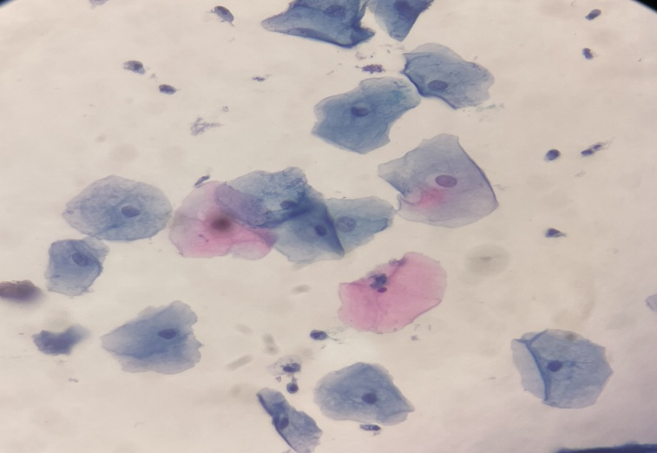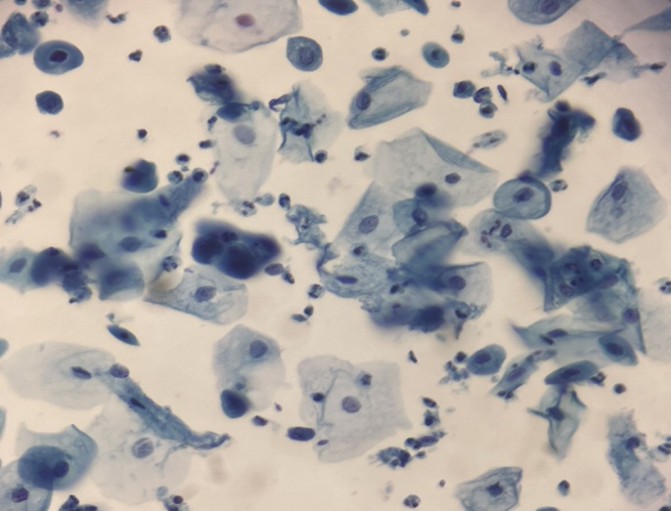
Fig 1 : Negative Fig 2 : ASCUS
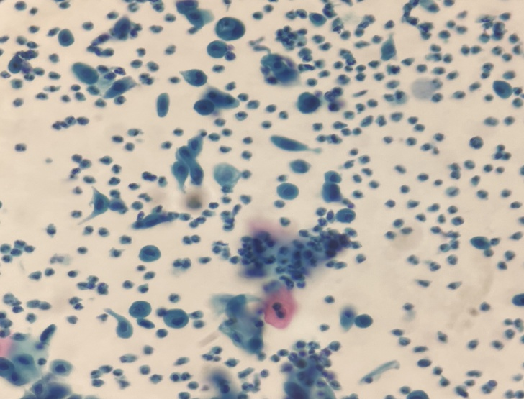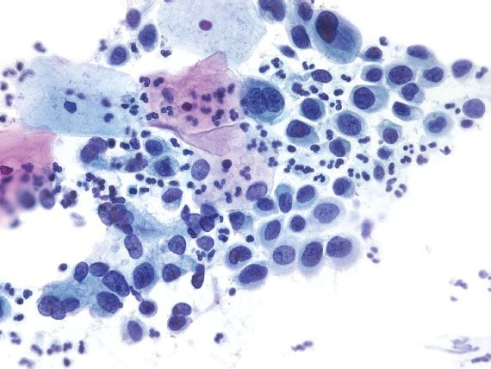
Fig 3: LSIL Fig 4: HSIL

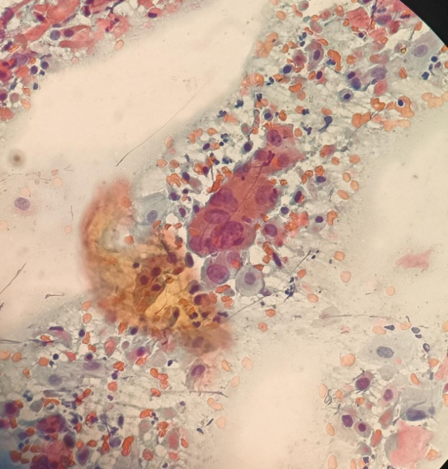
Fig 5: SCC

DISCUSSION
Cervical cancer is a major public health problem worldwide and Assam, India is no exception to its impact on women's health. With changing lifestyles and population profiles in developing countries, non- communicable diseases are emerging as a major health problem that requires a proper control program before they become epidemics. Cancer was a major cause of morbidity and mortality. According to National Cancer Registry program of India , cervical and breast cancer are the most common malignancies among women in India. For a certain age group, there should be and effective mass screening program to detect precancerous lesions before they develop into invasive cancer. The aim of this study was to investigate the prevalence of cervical cancer in women aged 20-60 years of Assam using liquid-based cytology (LBC) as a screening tool. Our results provide valuable information about the burden of cervical cancer in this region and the effectiveness of LBC as a diagnostic method. In our study ,we collected 150 cervical screening samples ,of which we have 11 patients aged 20-29,49 patients aged 30-39, 55 patients aged 40-49 and 35 patients aged 50-60, which revealed an alarming prevalence of cervical cancer among women aged 20 to 60 in Assam. The high incidence of cervical cancer in this region is consistent with global trends, where cervical cancer remains the leading cause of cancer mortality in women.
Our study showed that there were 41% patients were negative for intraepithelial lesion or malignancy (normal smear). 44% had an inflammatory smear. 14.66% had positive while 7.33% had atypical squamous cells of undetermined origin (ASCUS). 2.66% had low-grade squamous intraepithelial lesions (LSIL). 4% had high-grade squamous cell injury (HSIL). 0.66% are Squamous cell carcinoma (SCC)was diagnosed. ASCUS progresses to LSIL, HSIL & SCC. ASCUS was highest in the age group of 50- 60 years. LSIL and HSIL was scatteredly distributed amongst 40-60 years. Sania S. Ullah et.aldid a similar study in Pathology Department OF Silchar Medical College and Hospital, ASSAM, INDIA and had following finding. They reported 808 patients had anormal smear. 636had Inflammatorysmears.22 had Atypical Squamous Cell of Undetermined Significance(ASCUS). 80 had LSIL. 12 had HSIL. 3 had bacterial vaginosis .3 SCC were.^{[3]}

CONCLUSION
In this study underscores the significant prevalence of cervical cancer among womenaged 20-60, as revealed through liquid-based cytology screening. Using liquid-based cytology, the incidence of cervical cancer in women aged 20 to 60 is as follows: 9% of women in their 20s and 29s, 31% of women in their 30- 39s, 42% of women in their 40-49s, and 18% of women in their 50s and 60s. In this group of 20–60- year-olds, LBC detects cervical abnormalities and provides a promising option for early intervention and prevention. Pap smear testing is a very useful, simple, economical, and safe tool for detecting precancerous cervical epithelial lesions .It should be established as a routine screening procedure to reduce the treatment burden, morbidity, and mortality. LBC improve sample quality by collecting cervical cell sample in a liquid medium, reducing sample degradation, and increasing the likelihood of obtaining high quality specimens for analysis. LBC minimizes the rate of inadequate sample and enhances the detection of abnormal cells by debris, improving the visibility of cellular morphology. The study was consisted of a sample size of 150 participants. Everywoman above the age of 30 years should undergo routine cervical cancer screening, even into the postmenopausal period. The Pap test has been regarded as the gold standard of cervical screening programs

REFERENCE
- LiuZ, ShiH. Prognostic Role of Squamous Cell Carcinoma Antigenin Cervical Cancer : AMeta-analysis. Dis Markers. 2019;2019:6710352. Published 2019 Jun 2. doi:10.1155/2019/6710352
- Saranath, D., & Khanna, A. (2014). Current status of cancer burden: global and Indian scenario. Biomed Res J, 1(1),1-5.
- Ullah, S. S., Ahmed, S. A., Deka, M. K., & Sheikh, S. A. A Study On Cervical Cancer Screening Using PAP Smear Test And Its Clinical Correlation In A Tertiary Health Care Centre Of Southern Assam
- Cohen, Paul A. Anjua Jhingran, Ana Oaknin ,and LynetteDenny."Cervicalcancer."TheLancet393,no.10167 (2019): 169-182.
- 262SmallJr,W.,Bacon,M.A.,Bajaj,A.,Chuang,L.T.,Fisher,B.J.,Harkenrider,M.M.,...&Gaffney,D.K. (2017). Cervical cancer: a global health crisis. Cancer, 123(13), 2404-2412.
- JainMA, Limaiem F. Cervical Squamous Cell Carcinoma. In: StatPearls. Treasure Island (FL): Stat Pearls Publishing; November 15, 2022.
- Balasubramaniam SD, Balakrishnan V, OonCE, Kaur G. Key Molecular Events in Cervical Cancer Development.
Medicina.2019;55(7):384
- Banerjee,D.,Mittal,S.,Mandal,R.,&Basu,P.(2022).Screening technologies for cervical cancer :Overview.
Cytojournal,19

