Review Article
Helicobacter pylori Infection in Nigeria: Epidemiology, Risk Factors, Diagnostic Challenges, and Public Health Implications

.
ABSTRACT

Background: Helicobacter pylori infection remains a major global public health concern, with disproportionately high prevalence in developing countries such as Nigeria.
Aims: This study presents a narrative review of the epidemiology, transmission dynamics, risk factors, diagnostic approaches, and public health implications of Helicobacter pylori infection in Nigeria.
Study design: This study is a narrative review with elements of systematic literature search.
Place and Duration of Study: The study was conducted as a desk-based literature review using electronic databases, with the review process carried out between 2010 and 2025.
Methodology: A narrative review with a structured literature search was performed using PubMed and Google Scholar, where relevant studies were screened and analyzed based on predefined inclusion criteria.
Results: Findings indicate that the prevalence of Helicobacter pylori infection in Nigeria varies widely, ranging from 5.5% among university students to as high as 96% among symptomatic patients, with an overall national estimate between 30% and 87.7%. Higher prevalence rates were consistently reported in Northern Nigeria compared to Southern regions. Infection is commonly acquired during childhood and is strongly associated with low socioeconomic status, poor sanitation, overcrowding, unsafe drinking water, alcohol consumption, and smoking. Diagnostic practices rely on both invasive and non-invasive methods; however, access to reliable diagnostic tools such as urea breath tests and molecular techniques remains limited in many settings. Additionally, increasing antimicrobial resistance, particularly to commonly used antibiotics, poses a significant challenge to effective treatment.
Conclusion: Helicobacter pylori infection remains highly endemic in Nigeria, with marked regional and demographic disparities. Strengthening healthcare infrastructure, improving sanitation, promoting health education, and implementing antimicrobial stewardship programmes are essential strategies for reducing infection burden and preventing long-term complications.

Keywords: Helicobacter pylori; Nigeria; prevalence; risk factors; gastric diseases; public health

1. INTRODUCTION

Helicobacter pylori is a Gram‑negative, spiral‑shaped bacterium that colonizes the human gastric mucosa and plays a major role in the development of gastrointestinal diseases (Albehiry et al., 2024). It thrives in the acidic gastric environment by producing urease to neutralize the stomach acid (Öztekin et al., 2021). It colonizes the gastric mucosa, causing chronic inflammation (gastritis), peptic ulcers, and increasing the risk of gastric cancer and MALT lymphoma. Its persistence is linked to host immune evasion and genetic factors (Singh et al., 2025). Eradication via antibiotic regimens improves outcomes, though rising antibiotic resistance complicates treatment. Since its discovery by Barry Marshall and Robin Warren in 1982, the organism has been recognized as a primary cause of chronic gastritis, peptic ulcer disease, and gastric malignancies (Samarasekera, 2024). The discovery of H pylori revolutionized gastroenterology, shifting the understanding of peptic ulcers from stress and diet to bacterial infection. The bacterium survives in the acidic environment of the stomach through several adaptive mechanisms including the production of urease, which neutralizes gastric acid. H pylori's ability to survive in the acidic stomach environment leads to chronic inflammation, causing gastritis, ulcers, and increasing the risk of gastric cancer. Eradication therapy with antibiotics and proton pump inhibitors is now standard treatment, significantly reducing complications (Zaman et al., 2024). Their work earned them the 2005 Nobel Prize in Physiology or Medicine, underscoring its impact on medical science (Marshall & Adams, 2008).
In Figure 1 below, the pathogenesis of Helicobacter pylori illustrates the sequential mechanisms by which the bacterium establishes infection and induces gastric disease. Following colonization of the gastric mucosa, H. pylori produces urease, which neutralizes gastric acid and enables its survival in the acidic environment of the stomach. The organism then adheres to the gastric epithelium through adhesion molecules such as BabA (Blood group antigen-binding adhesin) and SabA (Sialic acid-binding adhesin), facilitating persistent colonization. Subsequent release of virulence factors, particularly CagA (Cytotoxin-associated gene A) and VacA (Vacuolating cytotoxin A), disrupts host cellular processes and promotes inflammation. These combined effects lead to progressive mucosal damage, ultimately resulting in clinical manifestations like chronic gastritis, peptic ulcer disease, and, in severe cases, gastric cancer, linking molecular mechanisms to observable disease outcomes.
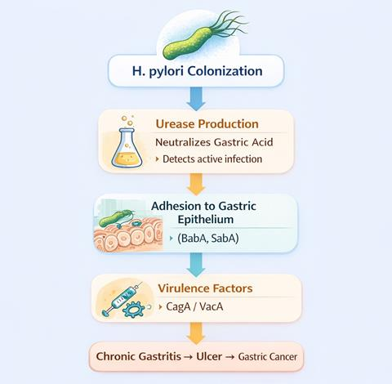
Figure 1: the pathogenesis of Helicobacter pylori (created with Biorender)
As shown in figure 2, the transmission routes of Helicobacter pylori highlight the primary pathways through which the bacterium spreads within human populations. As humans serve as the main reservoir, transmission occurs predominantly via oral-oral contact through saliva, faecal-oral routes involving contaminated food and water, and gastro-oral exposure through vomitus. The figure further emphasizes the role of household transmission, where factors such as poor hygiene practices, overcrowding, and limited access to clean water significantly facilitate the spread of infection. These interconnected pathways underscore the importance of environmental and behavioural factors in sustaining H. pylori transmission, particularly in resource-limited settings.
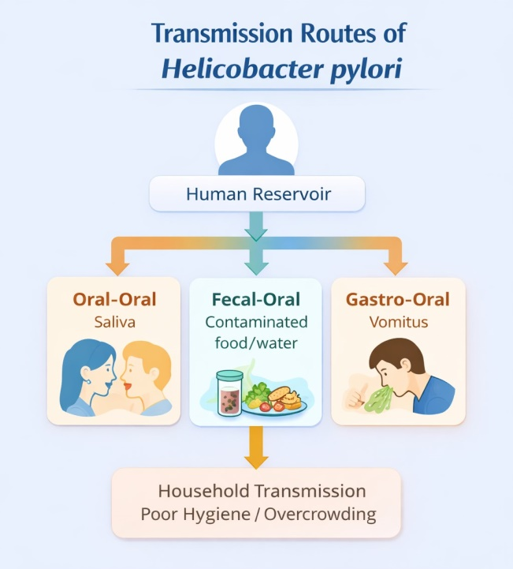
Figure 2: Transmission routes of Helicobacter pylori (created with Biorender)

Figure 3 illustrates the major diagnostic methods for Helicobacter pylori, categorized into non-invasive and invasive approaches based on the type of sample required and procedure involved. Non-invasive methods, including the urea breath test, stool antigen test, and serology, are highlighted for their ease of use and suitability for initial diagnosis and follow-up, although serology is limited in distinguishing active from past infections. In contrast, invasive methods such as the rapid urease test, histology, and polymerase chain reaction (PCR) require gastric biopsy samples obtained during endoscopy and generally provide higher diagnostic accuracy, with histology regarded as the gold standard. The figure emphasizes the trade-offs between accessibility and diagnostic precision, underscoring the importance of selecting appropriate methods based on clinical context and available resources.
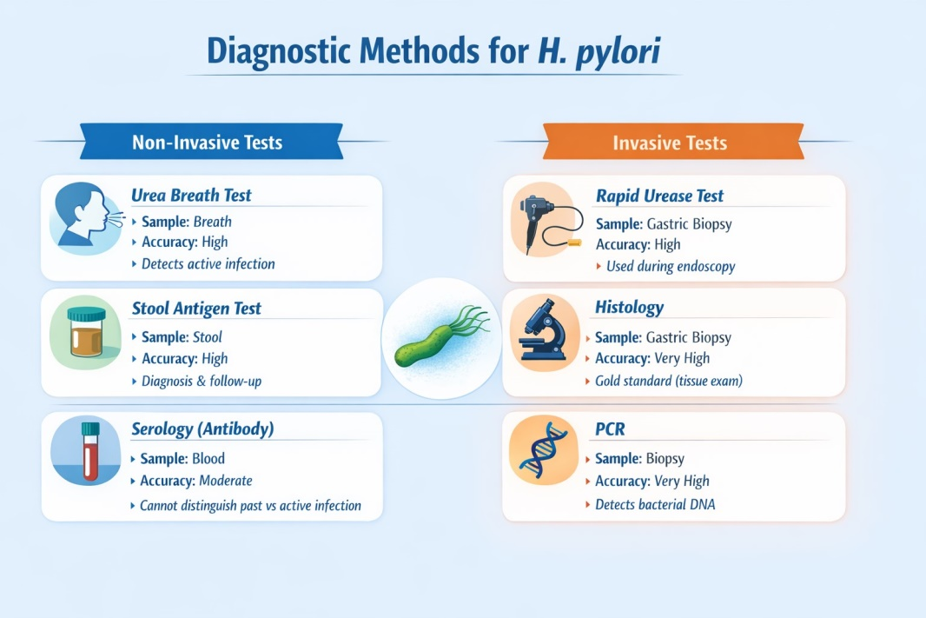
Fig 3: Major diagnostic methods for Helicobacter pylori (created with Biorender)
As shown below in figure 4, the diagnostic workflow for Helicobacter pylori infection outlines a stepwise clinical approach for patients presenting with dyspepsia. Initial evaluation typically involves non-invasive tests, such as the urea breath test or stool antigen test, which are effective for detecting active infection. Patients with positive results are managed with appropriate eradication therapy. However, the presence of alarm symptoms, such as gastrointestinal bleeding, weight loss, or persistent vomiting, warrants prompt endoscopic evaluation. During endoscopy, gastric biopsy samples are obtained for confirmatory testing using invasive methods, including the rapid urease test (RUT), histology, and polymerase chain reaction (PCR). This approach balances diagnostic accuracy with clinical practicality, ensuring timely treatment while identifying patients who require more detailed investigation.
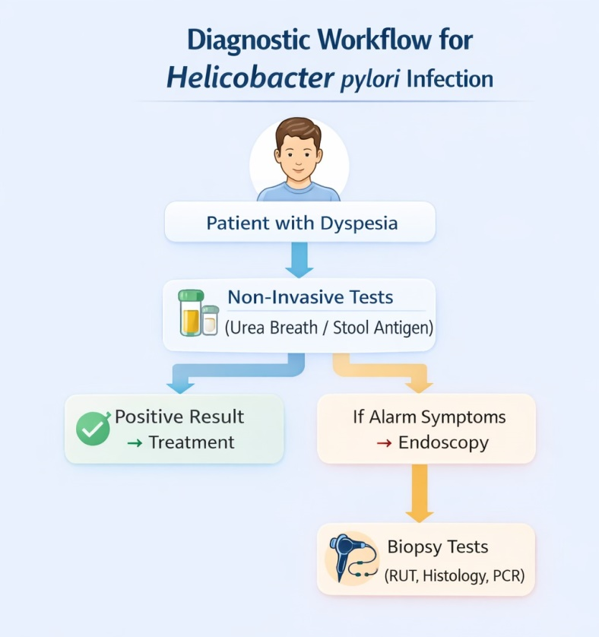
Fig. 4: The diagnostic workflow for Helicobacter pylori infection (created with Biorender)
Globally, approximately half of the world’s population is estimated to be infected with H pylori, although many individuals remain asymptomatic (Shirani et al., 2023). The numbers are steadily decreasing in high-income countries, or countries with high levels of universal health coverage (Li et al., 2023). According to Hooi et al., (2017) Africa had the highest pooled prevalence of H pylori infection (70.1%; 95% CI, 62.6-77.7), whereas Oceania had the lowest prevalence (24.4%; 95% CI, 18.5-30.4). Infection rates are significantly higher in developing countries due to socioeconomic and environmental factors such as overcrowding, poor sanitation, and limited access to safe water (Malfertheiner et al., 2023).
Nigeria exhibits a high burden of Helicobacter pylori infection, with prevalence rates varying widely, between 30% and over 80%, due to differences in study populations, geographic regions, and diagnostic techniques (Palamides et al., 2020). Factors such as poor sanitation, overcrowded living conditions, and limited access to clean water contribute to the high transmission rates. The infection is strongly linked to gastritis, peptic ulcers, and gastric cancer, making it a significant public health concern. Despite this, screening and treatment remain underutilized in many areas, highlighting the need for improved awareness, diagnostic access, and targeted interventions in primary healthcare settings.

2. material and methods
2.1 Search Strategy and study selection
This study adopted a narrative literature review approach examining published research on H. pylori infection in Nigeria and globally. Relevant peer‑reviewed journal articles, systematic reviews, and epidemiological reports were consulted.
A comprehensive literature search was conducted using PubMed and Google Scholar databases covering publications from 2010 to 2025. Search terms included “Helicobacter pylori,” “H. pylori prevalence Nigeria,” and “risk factors of H. pylori in Nigeria.” A total of 135 records were identified, of which 110 remained after removal of duplicates. Following title and abstract screening, 40 full-text articles were assessed for eligibility, and 25 studies were included in the final analysis. The study selection process is summarized using a PRISMA flow diagram.
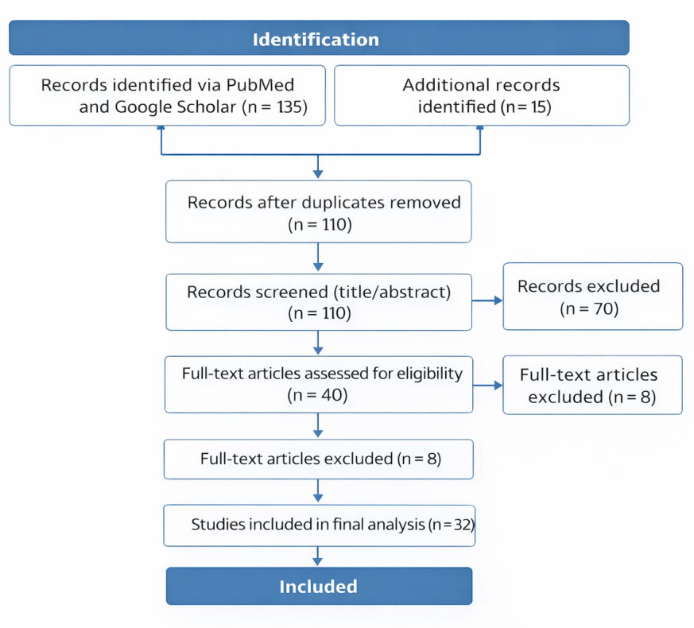
Fig 5: PRISMA Flow diagram of the H. pylori study selection

3. results and discussion

Table 1 presents a regional overview of H. pylori infection across Nigeria, highlighting wide variations in prevalence depending on geographic location and study population. Overall, prevalence ranges from very low levels among university students (as low as 5.5% in North-Central Nigeria) to extremely high rates in clinical populations, particularly in the North-West and South-West, where values reach up to 96% and 80%, respectively. Moderate prevalence is commonly observed across most regions, especially among symptomatic and dyspeptic patients. The table also shows that infection rates tend to be higher in older age groups and among individuals with gastrointestinal conditions such as ulcers, while children exhibit moderate to high prevalence influenced largely by environmental factors. Key associated factors identified across regions include age, gender, socioeconomic status, hygiene practices, overcrowding, alcohol consumption, and access to clean water, reflecting the strong role of both behavioural and environmental determinants in the transmission of the infection.

Table 1: Regional Prevalence, Clinical Features, Diagnostic Approaches, and Management of H. pylori in Nigeria
Region | Study Population | Prevalence (%) | Clinical Manifestations | Diagnostic Methods Used | Associated Factors | Treatment/Notes
North-Central | Patients (Keffi) | 56.3 (Ishaleku & Ihiabe, 2010; Oti et al., 2017) | Dyspepsia, gastritis | Serology, RUT | Age, gender, alcohol | Standard triple therapy
 | University students | 5.5 (Kolawole et al., 2021) | Mostly asymptomatic | Serology | None significant | Low treatment need
North-West | Patients (Kano) | 96 (Kumurya, 2015) | Peptic ulcer, severe dyspepsia | Serology | Age (40–50) | High disease burden
 | Students (Sokoto) | 78.9 (Jidda et al., 2018) | Dyspepsia | Serology | Female, marital status | Empirical therapy common
 | Adults (Sokoto) | 56.8 (Saidu et al., 2015) | Abdominal pain, ulcers | Serology, RUT | Ulcer-related symptoms | Requires targeted therapy
North-East | Dyspeptic patients | 51.96 (Gide et al., 2019) | Dyspepsia, gastritis | Serology | Male, age (50–59) | Standard therapy
South-South | Asymptomatic patients | 52 (Omosor et al., 2017) | No symptoms / mild gastritis | Serology | None | Often undiagnosed
 | Port Harcourt patients | 19.6 (Ayodele et al., 2018) | Mild dyspepsia | Not specified | Not specified | Limited data
 | IDPs (Uyo) | 29.7 (Owowo et al., 2019) | Dyspepsia | Serology | Occupation, smoking, alcohol | Poor access to care
 | Dyspeptic (Calabar) | 42.1 (Kooffreh-Ada et al., 2019) | Gastritis, ulcer | RUT, Histology | Age (40–60) | Requires confirmatory diagnosis
South-West | University students | 23.5 (Enitan et al., 2018) | Mostly asymptomatic | Serology, Stool antigen | Age, gender | Low-risk group
 | Ulcer patients (Lagos) | 80 (Ajayi et al., 2021) | Peptic ulcer disease | PCR, Histology | Disease condition | Requires aggressive therapy
South-East | Ulcer patients | 51.4 (Chukwuma et al., 2020) | Peptic ulcer, gastritis | RUT, Histology | Age, female predominance | Standard therapy
 | Patients (Aba) | 60.63 / 39.37 (Ibebuike et al., 2017) | Bleeding ulcers | RUT | Poor hygiene, low SES | Complicated cases
Children (All Regions) | Paediatric populations | 30.9–68.7 (Etukudo et al., 2012; Olufemi et al., 2015) | Abdominal pain, gastritis | Stool antigen, Serology | Hygiene, overcrowding, water | Early-life infection; public health concern

4. discussion

This review highlights the substantial burden and heterogeneous distribution of Helicobacter pylori infection across Nigeria, with prevalence rates varying widely depending on geographic region, population characteristics, and diagnostic approaches. The observed prevalence range, from as low as 5.5% among university students in North-Central Nigeria to as high as 96% among patients in North-Western regions, underscores the strong influence of socioeconomic, environmental, and clinical factors on infection dynamics. Higher prevalence rates among symptomatic and clinical populations, particularly those with dyspepsia or peptic ulcer disease, are consistent with the well-established role of H. pylori in gastrointestinal pathology.
Regional disparities observed in this study may be attributed to differences in hygiene practices, access to clean water, living conditions, and healthcare infrastructure. Northern regions, particularly the North-West, tend to report higher prevalence rates, which may reflect higher levels of overcrowding and limited sanitation facilities. In contrast, lower prevalence rates observed among university students and certain urban populations suggest that improved living standards, better hygiene, and increased health awareness play a protective role. These findings reinforce the importance of socioeconomic determinants in the transmission and persistence of H. pylori infection.
The analysis of associated factors reveals that age, gender, and lifestyle behaviours such as alcohol consumption and smoking contribute variably to infection risk across regions. In several studies, infection prevalence increased with age, likely reflecting cumulative exposure over time (Taylor et al., 2024). This supports the theory that exposure accumulates over time, particularly in environments with poor sanitation or crowded living conditions. While many infections are acquired in childhood, the lifelong persistence of the bacterium, often asymptomatic, leads to higher detection rates in older adults. However, inconsistent associations with gender suggest that transmission is more closely linked to environmental exposure than biological differences. Among paediatric populations, factors such as parental education, overcrowding, and poor sanitation were consistently associated with infection, indicating that early-life exposure remains a critical driver of disease burden.
Diagnostic approaches also play a significant role in the reported variability of prevalence (Urrutia Iturritza et al., 2024). Non-invasive methods such as the urea breath test and stool antigen test offer practical and reliable options for detecting active infection, particularly in resource-limited settings (Charach et al., 2024). However, invasive methods, including histology, rapid urease test, and PCR, provide higher diagnostic accuracy and are essential for confirming infection in complex cases (Wang et al., 2015). The diagnostic workflow emphasizes a balanced approach, where non-invasive testing is prioritized for initial assessment, while endoscopy with biopsy is reserved for patients presenting with alarm symptoms (Urrutia Iturritza et al., 2024). Despite these options, limited access to advanced diagnostic tools in many parts of Nigeria remains a significant challenge.
The pathogenesis of H. pylori, as illustrated in this review, demonstrates a complex interplay between bacterial virulence factors and host responses. The organism’s ability to survive in the acidic gastric environment through urease production, adhere to epithelial cells via adhesins such as BabA and SabA, and induce cellular damage through virulence factors like CagA and VacA underpins its role in chronic gastritis, peptic ulcer disease, and gastric cancer. These mechanisms highlight the importance of early detection and eradication to prevent long-term complications.
Transmission of H. pylori occurs predominantly through oral-oral, faecal-oral, and gastro-oral routes, with household transmission playing a central role. Poor hygiene, contaminated water sources, and overcrowded living conditions significantly facilitate the spread of infection. These findings align with the higher prevalence rates observed in low-resource settings and emphasize the need for public health interventions targeting sanitation, water quality, and community education.
Despite the insights provided, this study has some limitations. The reliance on previously published studies introduces variability in study design, sample size, and diagnostic methods, which may affect comparability. Additionally, the lack of standardized diagnostic criteria across studies may contribute to inconsistencies in reported prevalence. Nevertheless, the synthesis of available data provides a comprehensive overview of the epidemiology and determinants of H. pylori infection in Nigeria.

5. conclusion

Helicobacter pylori infection remains highly endemic in Nigeria, with marked regional, demographic, and clinical variations in prevalence. The findings of this review demonstrate that infection rates are influenced predominantly by socioeconomic and environmental factors, including poor sanitation, overcrowding, and limited access to clean water, with higher prevalence observed among symptomatic individuals and populations in resource-limited settings. While non-invasive diagnostic methods provide practical tools for initial detection, limited access to advanced and confirmatory techniques continues to hinder effective diagnosis and management in many areas.
The progression of H. pylori infection from colonization to chronic gastritis, peptic ulcer disease, and gastric cancer underscores the importance of early detection and timely intervention. However, treatment efforts are increasingly challenged by rising antimicrobial resistance and the widespread use of empirical therapy without prior susceptibility testing. These issues highlight critical gaps in both diagnostic capacity and treatment strategies within the Nigerian healthcare system.
Addressing the burden of H. pylori infection in Nigeria requires a multifaceted approach, including strengthening healthcare infrastructure, improving access to reliable diagnostic tools, promoting antimicrobial stewardship, and implementing public health interventions aimed at improving hygiene and living conditions. Enhanced awareness, early screening, and evidence-based treatment protocols will be essential in reducing transmission, preventing complications, and ultimately improving gastrointestinal health outcomes in the population.

Consent (where ever applicable)

Not applicable.

Ethical approval (where ever applicable)

Not applicable.

References

Ajayi, A., Jolaiya, T., & Smith, S. I. (2021). Direct detection of Helicobacter pylori from biopsies of patients in Lagos, Nigeria using real-time PCR: A pilot study. BMC Research Notes, 14, 90. https://doi.org/10.1186/s13104-021-05673-4
Albehiry, A., Abalkhail, A., Anajirih, N., Alkhamisi, F., Aldamegh, M., Alramzi, A., AlShaqi, R., Alotaibi, N., Aljuaid, A., Alzahrani, H., Alzaben, F., Rawway, M., Ibrahem, M., Abdelsalam, M. H., Rizk, N. I., Mostafa, M. E., Alfaqir, M. R., Edrees, H. M., & Alqahtani, M. (2024). Helicobacter pylori: Routes of infection, antimicrobial resistance, and alternative therapies as a means to develop infection control. Diseases, 12(12), 311. https://doi.org/10.3390/diseases12120311
Ayodele, M. O., Aaron, U., Oluwatayo, G., & Wariso, K. (2018). Prevalence of Helicobacter pylori infection in Port Harcourt using antibody diagnostic technique. International Journal of Innovative Healthcare Research, 6(2), 24-28.
Biorender. Retrieved from www.Biorender.com
Charach, L., Perets, T. T., Gingold-Belfer, R., Huta, Y., Ashorov, O., Levi, Z., Dickman, R., & Boltin, D. (2024). Comparison of four tests for the diagnosis of Helicobacter pylori infection. Healthcare, 12(15), 1479. https://doi.org/10.3390/healthcare12151479
Chukwuma, O. M., Chukwuma, G. O., Manafa, P. O., Akulue, J. C., & Jeremiah, Z. A. (2020). Prevalence and possible risk factors for Helicobacter pylori seropositivity among peptic ulcerative individuals in Nnewi Nigeria. Biomedical Research Journal, 4(2), 166-172.
Enitan, S. S., Ochei, J. O., Akele, Y. R., Faloye, T. G., & Adeniyi, L.. O. (2018). Screening for Helicobacter pylori infection among undergraduate students of a tertiary institution using serum antibody and stool antigen detection methods. Biomedical Journal of Scientific & Technical Research, 3(2), 3180–3189.
Etukudo, O. M., Ikpeme, E. E., & Ekanem, E. E. (2012). Seroepidemiology of Helicobacter pylori infection among children seen in a tertiary hospital in Uyo, Southern Nigeria. Pan African Medical Journal, 12, 39.
Gide, S., Ibrahim, Y., Anas, G., & Alegbe, S. D. (2019). Prevalence of Helicobacter pylori infection in patients with dyspeptic symptoms in Damaturu metropolitan. Journal of Advances in Medicine and Biology, 18(1), 1–8.
Hooi, J. K. Y., Lai, W.. Y., Ng, W.. K., Suen, M.. M., Underwood, F.. E., Tanyingoh, D., Malfertheiner, P., Graham, D.. Y., Wong, V.. W. S., Wu, J.. C., Chan, F.. K., Sung, J.. J., Kaplan, G.., & Ng, S. (2017). Global prevalence of Helicobacter pylori infection: Systematic review and meta-analysis. Gastroenterology, 153(2), 420–429. https://doi.org/10.1053/j.gastro.2017.04.022
Ibebuike, C., Awomukwu, D., & Ejike, E. (2017). Prevalence of Helicobacter pylori in bleeding and non-bleeding ulcer patients in Aba North L.G.A. European Journal of Research in Medical Sciences, 5(3), 8-12.
Ishaleku, D., & Ihiabe, H.. A. (2010). Seroprevalence of Helicobacter pylori infection among students of a Nigerian university. Asian Pacific Journal of Tropical Medicine, 3, 584–585.
Jidda, M.. L., Aiki, G., Ibrahim, K., Ngaski, A., Abubakar, I., Umar, A., & Nwachukwu, C. (2018). Prevalence of Helicobacter pylori in students with stomach ulcer attending school of health technology Gwadabawa, Sokoto. International Journal of Tropical Disease and Health, 29(4), 1–7.
Kolawole, A.. J. O., Sylvia, A.. K., & Seye, B. (2021). Seroprevalence of Helicobacter pylori infection among students of Bingham University, Karu in North-Central Nigeria. International Journal of Pathogen Research, 7(2), 38–47.
Kooffreh-Ada, M., Okonkwo, U., Ugbong, E., Essien, A., Chukwudike, E., Edogiawerie, D. (2019). Prevalence of Helicobacter pylori infection among dyspepsia patients in Calabar. Global Journal of Pure and Applied Sciences, 25(1), 45-51.
Kumurya, A.. S. (2015). Serological detection of Helicobacter pylori antibodies in patients suffering from gastric symptoms in Kano, Nigeria. American Journal of Health Research, 3(6), 352–355.
Li, Y., Choi, H., Leung, K., Jiang, F., Graham, D.. Y., & Leung, W.. K. (2023). Global prevalence of Helicobacter pylori infection between 1980 and 2022: A systematic review and meta-analysis. The Lancet Gastroenterology & Hepatology, 8(6), 553–564. https://doi.org/10.1016/S2468-1253(23)00070-5
Malfertheiner, P., Camargo, M.. C., El-Omar, E., Liou, J.. M., Peek, R., Schulz, C., Smith, S.. I., & Suerbaum, S. (2023). Helicobacter pylori infection. Nature Reviews Disease Primers, 9(1), 19. https://doi.org/10.1038/s41572-023-00431-8
Marshall, B., & Adams, P.. C. (2008). Helicobacter pylori: A Nobel pursuit?. Canadian Journal of Gastroenterology, 22(11), 895–896. https://doi.org/10.1155/2008/459810
Olufemi, F.. O., Quadri, R.. P., Akinduti, A., & Bamiro, S.. A. (2015). Potential risk factors and prevalence of infection of Helicobacter pylori in Nigeria. Journal of Scientific Research and Reports, 7(1), 42–48.
Omosor, K.. I., Omosor, O.. H., Ibeh, I.. N., Adejumo, B.. I. G., Abdulkadir, U.. I., & Dimkpa, U. (2017). Seroprevalence of Helicobacter pylori infection and risk factors among asymptomatic subjects in Delta State, Nigeria. Microbiology, 7(8), 641–652.
Oti, V.. B., Pennap, G.. R., Dennis, O., Ajegena, A.. S., & Adoga, M.. P. (2017). Prevalence and predictors of Helicobacter pylori infection among patients attending a healthcare facility in North-Central Nigeria. Asian Pacific Journal of Tropical Disease, 7(6), 352–355.
Owowo, E.. E., Christopher, M.. A., Okon, I.. E., Antia, U.. E., & Umoh, V. (2019). Prevalence of Helicobacter pylori infection among internally displaced persons from Bakassi Peninsular and Etim Ekpo in South Southern, Nigeria. Journal of Biosciences and Medicine, 7(11), 28–37.
Öztekin, M., Yılmaz, B., Ağagündüz, D., & Capasso, R. (2021). Overview of Helicobacter pylori Infection: Clinical Features, Treatment, and Nutritional Aspects. Diseases (Basel, Switzerland), 9(4), 66. https://doi.org/10.3390/diseases9040066
Palamides, P., Jolaiya, T., Idowu, A., Loell, E., Onyekwere, C., Ugiagbe, R., Agbo, I., Lesi, O., Ndububa, D., Adekanle, O., Carranza, M., Ally, R., Njom, H., Adeleye, I.. A., Harrison, U., Clarke, A., Fischer, W., Smith, S., & Haas, R. (2020). Helicobacter pylori patient isolates from South Africa and Nigeria differ in virulence factor pathogenicity profile and associated gastric disease outcome. Scientific Reports, 10, 11409. https://doi.org/10.1038/s41598-020-66128-0
Saidu, A.. Y., Munir, G., Salihu, Y., Sani, N.. M., Muhammad, Y., & Dodo, A.. M. (2015). Seroprevalence of Helicobacter pylori among adults in Sokoto metropolis. IOSR Journal of Nursing and Health Science, 4(5), 64–69.
Samarasekera, U. (2024). 40 years of Helicobacter pylori. The Lancet Infectious Diseases, 24(8), e486. https://doi.org/10.1016/s1473-3099(24)00425-0
Shirani, M., Pakzad, R., Haddadi, M. H., Akrami, S., Asadi, A., Kazemian, H., Moradi, M., Kaviar, V. H., Zomorodi, A. R., Khoshnood, S., Shafieian, M., Tavasolian, R., Heidary, M., & Saki, M. (2023). The global prevalence of gastric cancer in Helicobacter pylori-infected individuals: a systematic review and meta-analysis. BMC Infectious Diseases, 23(1). https://doi.org/10.1186/s12879-023-08504-5
Singh, D., Upadhyay, V., Singh, S.. B., Rimal, D., Rawal, O.. K., & Lamichhane, R. (2025). Evaluating Helicobacter pylori infection as a risk factor for iron deficiency anemia: A case-control approach. Cureus, 17(5), e84340. https://doi.org/10.7759/cureus.84340
Taylor, C.. S., McMahon, M.. V., Ward, Z.. J., Alarid-Escudero, F., Camargo, M.. C., Laszkowska, M., Roa, J., & Yeh, J.. M. (2024). Birth cohort and age-specific trends in global Helicobacter pylori seroprevalence: A scoping review. Lancet Regional Health - Americas, 41, 100877. https://doi.org/10.1016/j.lana.2024.100877
Urrutia Iturritza, M., Mlotshwa, P., Gantelius, J., Alfvén, T., Loh, E., Karlsson, J., Hadjineophytou, C., Langer, K., Mitsakakis, K., Russom, A., Jönsson, H. N., & Gaudenzi, G. (2024). An Automated Versatile Diagnostic Workflow for Infectious Disease Detection in Low-Resource Settings. Micromachines, 15(6), 708. https://doi.org/10.3390/mi15060708
Wang, Y.. K., Kuo, F.. C., Liu, C.. J., Wu, M.. C., Shih, H.. Y., Wang, S.. S., Wu, J.. Y., Kuo, C.. H., Huang Y.. K., & Wu, D.. C. (2015). Diagnosis of Helicobacter pylori infection: Current options and developments. World Journal of Gastroenterology, 21(40), 11221–11235. https://doi.org/10.3748/wjg.v21.i40.11221
Zaman, T., Haq, A., Ahmad, R., Sinha, S., Chowdhury, K., Parvin, S., Imran, M., Humayra, Z. U., Kumar, S., & Haque, M. (2024). The role of probiotics in the eradication of Helicobacter pylori and overall impact on management of peptic ulcer: A study involving patients undergoing triple therapy in Bangladesh. Cureus, 16(3), e56283. https://doi.org/10.7759/cureus.56283

Definitions, Acronyms, Abbreviations
Helicobacter pylori (H. pylori) – A Gram-negative, spiral-shaped bacterium that colonizes the gastric mucosa and is associated with gastrointestinal diseases such as gastritis, peptic ulcer disease, and gastric cancer.
Mucosa-Associated Lymphoid Tissue (MALT) – A component of the immune system associated with mucosal surfaces; H. pylori infection is linked to MALT lymphoma.
Polymerase Chain Reaction (PCR) – A molecular diagnostic technique used to amplify and detect specific DNA sequences of H. pylori.
Rapid Urease Test (RUT) – An invasive diagnostic test that detects urease enzyme activity of H. pylori in gastric biopsy samples.
Socioeconomic Status (SES) – A measure of an individual’s or group’s economic and social position, often based on income, education, and occupation.
Internally Displaced Persons (IDPs) – Individuals who have been forced to flee their homes due to conflict or disasters but remain within their country.
Gastrointestinal (GI) – Relating to the stomach and intestines.
World Health Organization (WHO) – A specialized agency of the United Nations responsible for international public health.

