Original Research Article

Lymphatic Filariasis in Southwest, Nigeria: A Cross-sectional Study on Prevalence, Morbidities and Socio-economic Impact in four endemic areas of Ondo State

.
ABSTRACT

Background: Lymphatic Filariasis (LF), commonly called Elephantiasis, is a painful and infectious disease with extreme disabilities, social and economic burden, majorly caused by Wuchereria bancrofti and transmitted by blood-sucking Culex, Aedes and Anopheles mosquitoes in rural and semi-urban areas. In Akoko and Ondo State, Nigeria, there are no data on the endemicity of Lymphatic filariasis. Therefore, this study assessed the prevalence, associated morbidities and socio-economic impact of Lymphatic filariasis.
Methodology: A cross-sectional study design in four endemic areas of Akoko south-west Local Government Areas of Ondo state, Nigeria. Questionnaire data was used to evaluate specifics of LF impact on quality of life, financial burden, access to education, psychological and social involvement (LFSQQ). Nocturnal intravenous blood was collected from subjects across villages and settlements including children, between 11pm and 1am due to parasite's circadian clock and analyzed. Physical morbidities on limbs, breast and scrotum were examined and documented as lymphoedema, limb elephantiasis and hydrocoele.
Results: Overall prevalence of Lymphatic filariasis was 22.1%, with associated morbidities of 42.4%. Hydrocoele of scrotum (66.7%), lymphoedema and limb elephantiasis were endemic in the study area. LF affected population with economic burden (P=0.01; P<0.05) was 84.8%; involving school-aged children, youth, men and women. The socioeconomic impact of LF was expressed as 16.1% as measured using LFSQQ. Hydrocoele impacted higher burden (P=0.001 P<0.05) on the affected, including children of ages 3-14years. Significant statistical relationship existed between infection and study communities (P=0.007, P<0.05), as Ugbegun and Supare were highly infected. Moreover, infection was predominant across all age-groups, although higher among males and elderly of ages 55 and above.
Conclusion: The social, economic and public health impact of Lymphatic filariasis is enormous, preventing smooth education of school-aged children, deprive victims of livelihood, relationships and comfort. Hence, prompt diagnosis and immediate management of associated morbidities and disabilities through health intervention initiatives such as hydrocelectomy is advocated, with properly monitored and timely administration of preventive chemotherapy (MAM) especially in rural and endemic communities.

Keywords: [Elephantiasis; Impact; NTDs; Wuchereria bancrofti; Endemicity; Parasitic-infection; Akoko-S/W-Ondo-State}

1. INTRODUCTION
Lymphatic Filariasis (LF), is a disorder that manly affects human. It is caused by microscopic threadlike worms of the phylum Nematoda and transmitted by mosquito vector of the family Culicidae (CDC, 2023). This infection specifically causes damage to the lymphatic system when the adult parasite occupies the lymphatic tubes and disrupts their function to getting rid of waste and toxins; this congestion of fluid leads to irregular bulging. The parasitic worms, Wuchereria bancrofti, Brugia malayi and Brugia timori that causes Lymphatic filariasis are transmitted through bites from different blood-sucking mosquito species; Culex, Aedes and Anopheles (WHO, 2024) with Culex and Anopheles being most widely spread in rural and semi-urban areas in Sub- Saharan Africa (Mzilahowa et al., 2016)
When infected mosquito bites human, the already developed infective larvae (L3) penetrate the skin into the body, to the lymphatic tubes and mature to adult worms in 8 to 14 months (Farrar et al., 2013). The adult worm can exist for as long as 5years, though some have been found to live up to 8/10years, which mate several times to produce millions of microfilariae that circulate human blood (WHO, 2024). When disease advances to a chronic form, it causes elephantiasis (irregular skin thickening) that drastically reduce the quality of individual life (Melrose, 2002); swelling of the scrotum mostly in males, and of the tissues which occurs at the acute stage of the infection involving the lymph glands. A number of the various kinds of manifestation come as a consequence of the sensitive responsiveness of the human immune system in defiance to the parasite which in turn brings about a weakened lymphatic drainage and a buildup of interstitial fluid in the tissue called oedema (Nurlaila et al., 2022). Lymphoedema disfigures the skin with signs of swelling, roughness and tissue thickening in affected regions (Komoreng et al., 2017). Blood analysis with the aid of a microscope to look for the microfilariae is a typical way to diagnose the illness. At night, microfilariae are mostly active in the blood stream therefore; blood sample should be collected from the individual at midnight to accord with the presence of the active microfilariae.
According to World Health Organization, elimination of Lf is by preventive chemotherapy (PC) and morbidity management (Gyapong et al., 2018). PC involves the meddling of different dosages of anti-helminthic drugs; ivermectin, albendazole and diethylcarbamazine (DEC) to disease-prone individuals. From year 2000 to 2023, 9.7 billion cumulative treatments were delivered to more than 943 million people in at least 71 countries considerably reducing transmission in any places (WHO, 2024). These drugs are very effective in countering the microfilariae activities in the blood but has minor influence on the mature worm (Melrose, 2002; katiyar and Singh, 2011; Ballesteros et al., 2016; WHO, 2024). This strategy was successful in reducing a high rate of the global infection from 120million individuals in 1997 to 56million individuals in 2017 (WHO, 2020).
Nigeria is the most Lymphatic filariasis – endemic African country with estimated 134 million individuals at risk (Hotez et al., 2012; Amanyi-Enegela et al., 2022). In Nigeria, bites from Culex and Anopheles mosquito are the channel of transmission (Manyi et al., 2014). In some localities, 5% of women can have swollen limbs and about 50% of men have hydrocoele (FMOH, 2013). Lymphatic filariasis remains a worrying plague in societies as it imposes social strain and distress on its victims. It is most predominant in rural villages where poverty rate is to a high percentage (Upadhyayula et al.,2012).
With the few findings from different populations across Nigeria, there are endemic communities in southwestern Nigeria, and currently, no data on the endemicity and economic burden of Lymphatic filariasis in Akoko, Ondo State. Disease monitoring in endemic areas is key to effective management and control, to provide updates and information on disease prevalence, social, economic and public health impacts. This research therefore assessed the prevalence, associated morbidities and socio-economic impact of Lymphatic filariasis in Akoko-southwest local government area of Ondo state

2. methoDOLOGY
2.1. Study Area
The study was conducted in four areas: Ugbegun (7°26’34.7" N 5°35’43.8" E), Supare (7°26’55.1" N 5°41’9.9"E), Oba (7°22’16.7" N 5°43’25.4"E) and Agba Oke-Oka (7°28’14.1" N 5°48’14"E) of Akoko South West Local Government Area (LGA), Ondo state, Nigeria (Fig.1). Akoko Southwest is a tropical rain forest biome whose coordinates lies between Latitude 7°22’50.38" N and Longitude 5°40’ 0.59" E with elevation ranging between 322m and 570m. The major occupation of inhabitants includes farming, artisanship and trading.

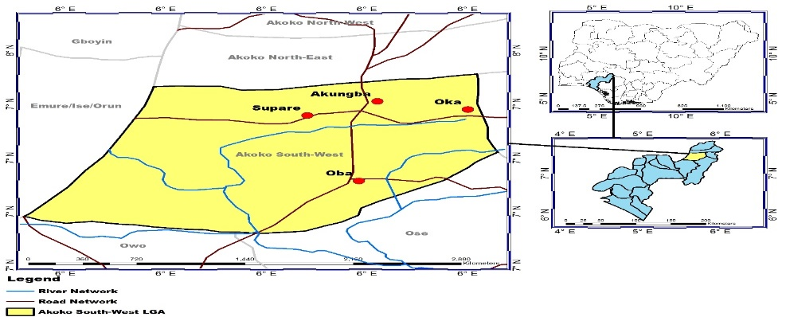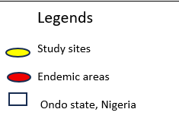

Fig.1: Map of study area in Akoko Southwest LGA of Ondo State Nigeria. The map was created using primary data collected by authors during sampling with GPS GARMI ETREX 10 and developed with ARC GISv10

2.2. Study Design and Sampling
This study was a cross-sectional survey. Random sampling was employed in recruiting participants in the study area. Participants were recruited in each community with the assistance of each community leader and the primary health care development agency. The former called community meetings and the latter moderated the sampling. Structured questionnaire was administered to obtain participants demographic information using local dialect for proper understanding by the respondents; and specific interview to evaluate impact of LF on quality of life (LFSQQ) which covers financial burden, mobility, self-care, dependent on others, access to education, pain/discomfort, psychological and social involvement. Children less than 3 years of age and persons who were not resident and had not spent at least 3 years in the communities were excluded from the study. After sensitization, a total of One hundred and forty-nine (males = 71; females = 78) participants consented formally to participate and were recruited for the study.

2.3. Consent to participate
Formal Consent Forms (FCFs) were completed by study participants who agreed to participate after detailed sensitization, focal group discussion in their local language, during which the participants were made aware of the nature, scope and purpose of the research; using the aid of Information, Education and Communication (IEC) materials. Participants were also assured of confidentiality and their right to withdraw from participation at any time.

2.4. Ethical Approval
Prior to the survey, ethical approval with reference number FUTA/CRD/EC/23/103 was sought from the Research Ethics review board of the Federal University of Technology, Akure; Ministry of Health and Ondo state Primary Health Care Development Agency (OSPHCDA). Verbal consent was also obtained from Community leaders and informed consent forms completed by participants who agreed to participate after detailed sensitization, focal group discussion in their local language, during which the participants were made aware about the nature, scope and purpose of the research. Participants were also assured of confidentiality and their right to withdraw from participation at any time.

2.5. Collection of Blood Samples and Analysis
Blood samples were collected for parasitological examination of microfilariae. About 2ml of blood was collected by venipuncture into an EDTA bottle. A sterile pipette was used to place a drop of the blood on a sterile microscope slide using thick-smear technique. The blood sample was collected from each participant at night between 11p.m and 2 a.m. This was allowed to air-dry and then fixed with Ethanol. The smear was flooded with 10% Giemsa for 45minutes and washed under running tap water. The slide was allowed to drain and air-dry afterwards. Slides were viewed under ×100 oil immersion objective lens of microscope to observe and detect the presence of microfilariae (CDC, 2020).

2.6. ABO Blood grouping
The ABO blood group of each participant was determined using cell grouping Antisera (A, B, and D). Three (3) drops of each participant blood sample is placed on separate points on a sterile white tile divided into four (4) cells. A drop of antisera A, B and D were placed beside the blood and thoroughly mixed to obtain a homogenous mixture with the aid of a sterile rod and the tile was rocked gently to ensure uniform mixing. The mixtures were carefully observed to determine blood group by the presence of agglutination or not. Antiserum D was used to determine the Rhesus factor. Finally, the blood samples of respondents were grouped based on these observation and confirmation into blood group A+, A-, B+, B-, AB+, AB-, O+ and O- (Itansanmi-Ogundayomi and Elemu A, 2023).

2.7. Data Analysis
Data obtained were analyzed using the Statistical Package for Social Sciences (SPSS) version 22. Prevalence was calculated and descriptive statistics including frequencies and percentages was used. Associations between variables such as age-group, blood group and gender were ascertained using Pearson chi-square with confidence interval set at p ≤ 0.05.

3. Results & Discussion
By demographics, 71 (47.6%) of the participants were males and 78 (52.3%) were females. An overall prevalence of 22.1% was recorded for Lymphatic filariasis in the studied communities. Prevalence by age groups (Fig.4) showed that infection was more predominant in ages above 55 years (42%), followed by 3 to 14years and 15 -24 years, both age groups having same prevalence of 15%. Moreover, prevalence of Lymphatic filariasis was high in Blood Group O (20.5%) and Rhesus positive (Rh+) individuals (Fig.5) but Rh- individuals were less susceptible (9.1%); although no significant relationship exists between infection and blood group (p>0.05). By settlement (Fig.8), Significant statistical relationship exists between infection and study communities (p<0.05), as Ugbegun and Supare communities had higher prevalence among the sampled populations.

Fig. 2: Prevalence of Lymphatic filariasis in study areas (P<0.05) ꭕ2 =46.235, P= 0.001
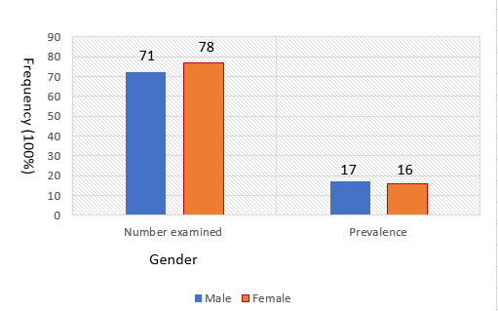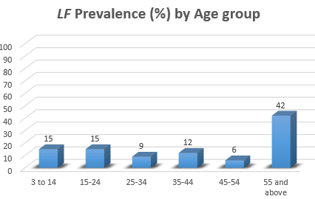
Fig. 3: Prevalence of Lymphatic filariasis among gender in study area (P>0.05) ꭕ2 =0.254, P= 0.379
Fig. 4: Prevalence of Lymphatic filariasis by age-group in study area (P>0.05) ꭕ2=2.686, P= 0.748

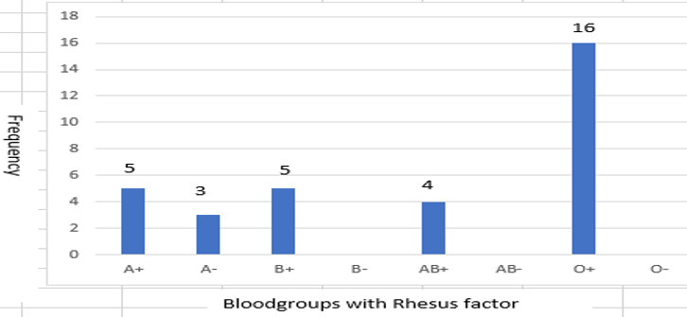
Fig. 5: ABO Blood group and Rhesus factor distribution in relation to Lymphatic filariasis infection among study participants (P>0.05), ꭕ2 =1.788, P= 0.618
(P>0.05) ꭕ2 =1.788, P= 0.618

3.1. Physical Examination for Morbidity
Each participant was examined for signs of Elephantiasis of the limbs, arms, breast and hydrocoele of scrotum (Fig.7)
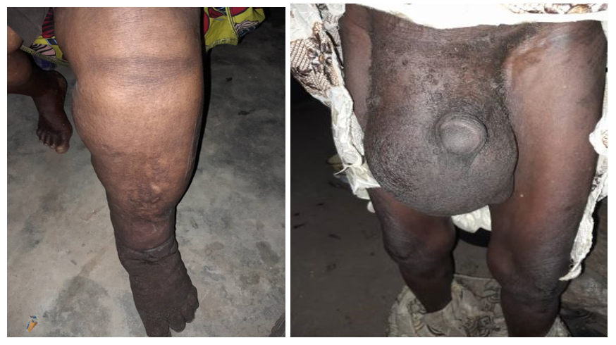
Fig.6: Morbidities seen in examined participants
- Elephantiasis of limbs b. Hydrocoele (affected scrotum)

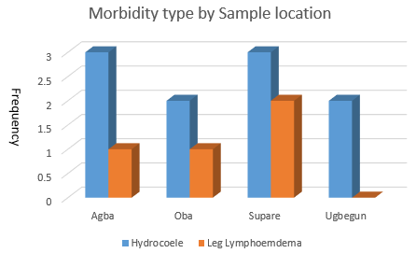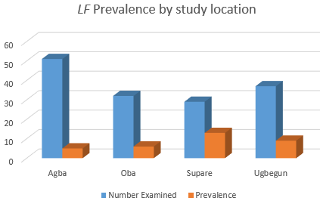
Fig. 8 Prevalence by study location

Fig. 7: Morbidity distribution in study areas

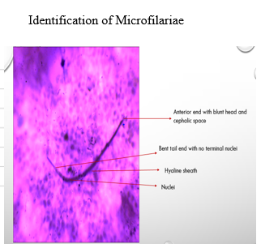
3.2.
Fig. 9: Photomicrograph of Wuchereria bancrofti microfilariae ×1000

More males (60%) were infected in Ugbegun and Oba- Akoko communities than females (40%). However, In Agba and Supare community a reverse prevalence was recorded with 55.6% females infected in both communities. Although, no significant relationship exists between infection and gender (P>0.05).

3.3. Socio-economic impact on study population
Overall Socio-economic impact of LF infection in study population and effect on livelihood

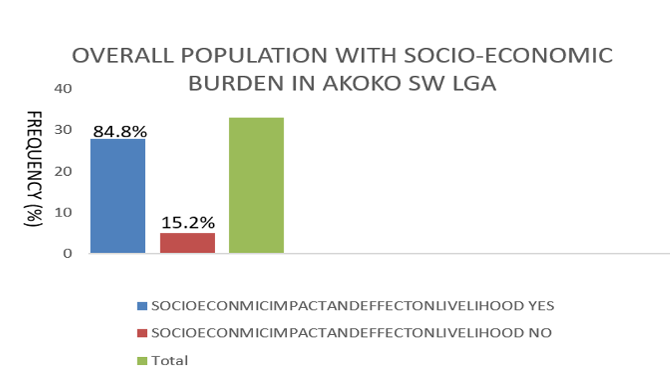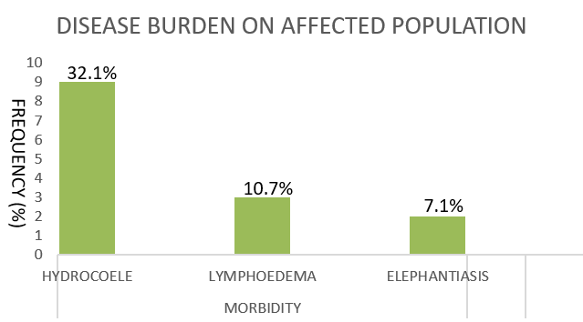
Fig. 10: LF affected population with Socio-economic burden ꭕ2=141.262, P=0.00 (P<0.05)

Fig. 11: Morbidity burden of LF on affected population ꭕ2=73.556, P=0.001 (P<0.05)

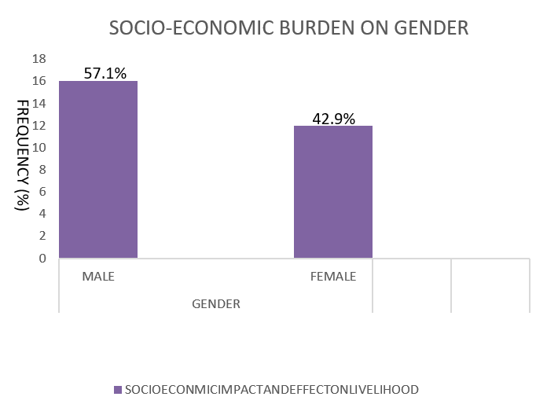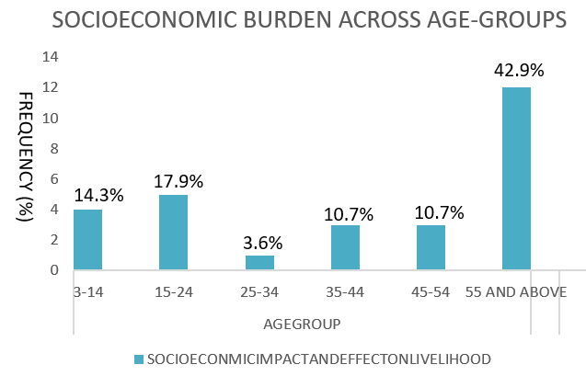
Fig. 12: Burden of Lymphatic filariasis on Gender ꭕ2=2.343, P=0.149 (P>0.05)

Fig. 13: Burden of Lymphatic filariasis on Age-groups ꭕ2=2.015, P=0.497 (P>0.05)

The current study reported a 22.1% Lymphatic filariasis prevalence in Akoko SW LGA of Ondo State, Nigeria. Prevalence recorded in this survey is a public health concern and requires urgent intervention especially by public enlightenment, proper disease management and vector control (Waje et al., 2024). The 22.1% prevalence reported is due to impoverished living conditions of the inhabitants, as some of them still lived in mud houses and cracked walls which can be a breeding site for the vectors. Several vector breeding sites could arise due to poor environmental sanitation; contributing to the recorded prevalence. This is in accordance to the report of (Christiana et al. (2013); Badaki et al. (2013) and Obadiah et al. (2018).
Lymphatic filariasis infection progresses across all age groups, Children between 3 to14years and 15-24 years are susceptible due to poor awareness in the community. From this study, the dangers of teenagers and adults being infected has a great effect which can negatively impact the economic development of Ondo State and Nigeria as a whole; especially in the Agricultural sector (Ogba, 2014). The potential consequences Lymphatic filariasis could inflict on the youth and economy is very worrisome. Dogara et al (2012) also reported increase in prevalence as age advanced. These would have been due to changes in behavioural patterns of community members, exposure due to outdoor activities and length of stay in such endemic communities.
Moreover, majority of these individuals are farmers, artisans and traders; they enjoy staying outdoor overnight without applying proper vector control measures. In addition, high prevalence could be accredited to a number of factors among the teenagers and adults, as people in this age groups (3-14years and 15-24years) are majorly in the productive stage likely to work or play for longer periods on the farm or outdoors with exposed body parts as corroborated by Awiya et al (2020).
Furthermore, the study observed a prevalence of 42.4% associated morbidities with hydrocoele of the scrotum, limb Lymphoedema and Elephantiasis in both gender; predominantly in the elderly people. This is higher than the report of Eyo et al. (2015) who recorded a 22.39% prevalence of circulating filarial antigen (CFA) among six (6) communities in Southwestern Ebonyi State. Meanwhile, Adekunle and Asimea (2018) also reported a 29% prevalence in three rural communities of Ondo State. This implies that Lymphatic filariasis infection progresses in infected individual without proper diagnosis and treatment, resulting in various disabilities as people age due to neglect. There is a serious call for concern which requires immediate health intervention, as these resulting morbidities and disabilities will negatively impact the quality of life and productivity of its hosts. Therefore, proper disease awareness and management will birth decreased exposures to infection and decline in filarial worm load.
The high prevalence in male participants compared to the females could be due to their lifestyle; moving in opened places with bare body to take local alcohol, sleeping patterns and more engagement in outdoor activities in the community as reported by Ebenezer et al. (2011), Brandao et al. (2015) and Muawiyya et al. (2019).
Prevalence rate varied across sampled communities; thus occupation, environment and lifestyle of individual are determining factor to exposure and vulnerability to Lymphatic filariasis infection. This could be attributed to factors like presence of containers holding water, littering of refuse in the environment and overall human attitude and practices; which can support breeding of the parasite (Bal et al., 2009). Another predisposing factor could be the ABO blood group and rhesus factor of individuals. It was observed that rhesus negative individuals were less susceptible to the infection and O+ individuals were more predominant. However, this calls for further research as statistical relationship was not significant.
The percentage population living with social and economic burden of Lymphatic filariasis was 84.8%, encompassing school-aged children, youth, men and women. This affects income, source of livelihood, access to education, psychological and social involvement. Out of all associated morbidities due to Lymphatic filariasis, hydrocoele (32.1%) significantly contributed to socio-economic burden by morbidity on the affected including children of ages 3-14years old. The social, economic and public health impact of the disease is enormous, preventing school aged children from proper access to education, causing absenteeism from school with poor academic performance; deprive victims of livelihood, relationships and comfort. Majority of affected population belong to economically productive age which are forced to quit or reduce working hours (Agrawal, 2021). The cost of treating acute attacks and lost work time contributes to low economic status (Tyrell, 2013; Rani and Shameem, 2024).
Increasing prevalence among young people in the community may lead to incapacitation and inability to work which results in declining development of the economy. Reduction in productivity in a community that are predominantly farmers can give rise to economic stress with impacts on food production, income sustainability and financial balance. Moreover, chronic disabilities caused by Lymphatic filariasis could likely occur across generations because the majority of deformity caused by the infection may be almost irreversible (WHO, 2013).

5.0. Conclusion
Lymphatic filariasis generally affects the mental, physical, social and economic wellbeing. The epidemiology of Lymphatic filariasis and disease prevalence is largely due to lifestyle and continuous exposure to vector bites without proper vector control measures. Public health sensitization, advocacy, effective monitoring and administration of preventive chemotherapy (MAM), will improve disease management and control. The vectors of transmission-mosquitoes, are endemic in the study area and widely spread across Nigeria, this makes Lymphatic filariasis of serious public health concern. Urgent attention should be directed to curb transmission and related burdens of neglected tropical diseases (NTDs). Associated morbidities and disabilities should be managed with health intervention initiatives such as hydrocelectomy, early diagnosis and mass administration of medicines especially in rural areas of the state and Nigeria as a whole. Conscious effort should also be directed towards uninterrupted control programmes, annual evaluation and monitoring of Lymphatic filariasis prevalence in endemic and non-endemic communities; and provide information on vector diversity in various communities.

ETHICS APPROVAL AND CONSENT TO PARTICIPATE
Prior to the survey, ethical approval with reference number FUTA/CRD/EC/23/103 was sought from the Research Ethics review board of the Federal University of Technology, Akure; Ministry of Health and Ondo state Primary Health Care Development Agency (OSPHCDA). Verbal consent was also obtained from Community leaders before commencement of the research. Formal Consent Forms (FCFs) were administered to and completed by study participants who agreed to participate after detailed sensitization, focal group discussion in their local language, during which the participants were made aware of the nature, scope and purpose of the research; using the aid of Information, Education and Communication (IEC) materials. Participants were also assured of confidentiality and their right to withdraw from participation at any time.

All authors hereby declare that all experiments have been examined and approved by the appropriate ethics committee and have therefore been performed in accordance with the ethical standards laid down in the 1964 Declaration of Helsinki

COMPETING INTERESTS DISCLAIMER:
Authors have declared that they have no known competing financial interests OR non-financial interests OR personal relationships that could have appeared to influence the work reported in this paper.

References

Adekunle, N.O and Asimea, A.O. (2018) Prevalence of Lymphatic Filariasis and associated clinical morbidities among adolescents in three rural commnunities in Ondo Sate Southwest Nigeria. J Trop Med Health JTMH-120. DOI: 10.29011/JTMH-120.000120

Agrawal, S.K. (2021) Socio-economic impact of Lymphatic filariasis in semi-urban community of Ratanpur, Chhattisgarh State, India. Uttar Pradesh journal of zoology; 42(24):1089-1094, ISSN:0256-971X(P)

Amanyi-Enegela J.A., Kumbur, J., Burn N., Sankar G, Qureshi B., and et al. (2022) Assessment of progress towards elimination of Lymphatic filariasis in the Federal Capital territory-Abuja, Nigeria. Front Trop. Dis. Neglected tropiocal diseases volume 3(22) doi:10.3389/fitd.2022.1033802

Awiya BH., Amawulu E., Nduka F., Chinwe E. (2020) Prevalence, Knowledge and Perception of Lymphatic Filariasis in Yenagoa Local Government Area, Bayelsa State, Nigeria Journal of Tropical Disease. Vol. 11 Issn 03 No: 1000387

Badaki, J.A., Akogun, O.B., Molta N.B., and Imandeh, G. (2013) Bancroftiasis among the mumuye of Northeastern Nigeria: Parasitological and clinical studies in Northern Taraba state Health, 5: 138-142

Bal M.S., Beuria, M.K., Mandal, N.N., Das, M.K. (2009) Antigenemia in young children living in Wuchereria bancrofti-endemic areas of Orissa, India. Transactions of the Royal Society of Tropical Medicine and Hygiene 103: 262-265.

Ballesteros, C., Tritten, L., O'Neill, M., Burkman, E., Zaky, W.I, Xia, J., Moorhead, A., Williams, S.A., and Geary, T.G. (2016) The effects of ivermectin on Brugia malayi females in vitro: a transcriptomic approach. PLoS Neglected Tropical Diseases 10, 1–19.
Batsa, L.D., Mohammed, A., Osei-Mensah, J., Mubarik, Y., Agbenyega, O., Ayisi-Boateng, N.K. (2020) Morbidity management and surveillance of lymphatic filariasis disease and acute dermatolymphangioadenitis attacks using a mobile phone-based tool by community health volunteers in Ghana. PLOS Neglected Tropical Disease 14(11):e0008839. doi: 10.1371/journal.pntd.0008839

Brandão, E., Bonfim, C., Alves, A., Oliveira, C., Montenegro, C.E. (2015) Lymphatic filariasis among children and adolescents: spatial identification via socio-environmental indicators to define priority areas for elimination. International Health. 7: 324-331

CDC. (2020). Parasites - Lymphatic filariasis. Retrieved 12 11, 2023, from https://www.cdc.gov/parasites/lymphaticfilariasis/health_professionals/dxtx.html#

CDC. 2023 Laboratory identification of parasites of Public Health Concern. Lymphatic Filariasis. Retrieved from https://www.cdc.gov/parasites/lymphaticfilariasis/healthprofessionals/dxtx.html#

Christiana, O., Olajumoke, M., and Oyetunde, S. (2013) Lymphatic filariasis and associate morbidities in rural communities of Ogun State, south-western Nigeria. Travel Medicine and Infectious Diseases, 13: 17-30

Dogara, M.M., Nock, H.I., Agbede, R.I.S., Ndams, S.I., Joseph, K.K. (2012) Prevalence of Lymphatic Filariasis in Three Villages in Kano State, Nigeria. The Inter Journal of Tropical Medicine 8: 1 - 11.

Ebenezer, A., Amadi, E.C., Agi, P.I. (2011) Studies of the microfilaria, antigeneamia and clinical signs of bancroftian filariasis in Epie creek communities, Niger Delta, Nigeria. Int Res Journal of Microbiol. 2(9):370-374

Eyo, J.E., Ezeabikwa, B.O., Ivoke, O.N., Ekeh, F.N., Ezenwayi, N.E., and et al. (2015) Wuchereria bancrofti infection in rural tropical guinea-savannah communities: Rapid Epidemiological Assessment using Immunochromatographic Card Test and Prevalence of Hydrocoele. Tropical Biomedicine 32: 365 - 375.

Farrar, J., Hotez, P.J., Junghanss, T., Kang, G., Lalloo, D., and White, N.J. (2013) Manson’s tropical diseases. Elsevier 2013.

Federal Ministry of Health (2013) Guidelines for Malaria and Lymphatic Filariasis Co-implementation in Nigeria, p. 1.

Gyapong J.O., Owusu, I.O., Dascosta-Vroom, F.B., Mensah, E.O., and Gyapong, M. (2018) Elimination of Lymphatic filariasis: current perspectives on mass drug administration. Research and report in Tropiocal Medicine 6(9:25-33) doi:10.2147/RRTM.SI25204

Hotez, P.J., Asojo, O. A., and Adesina, A.A. (2012) Nigeria: “Ground Zero” for the High Prevalence Neglected Tropical Diseases. PLoS Neglected Tropical Diseases 6: e1600.doi:10.1371/journal.pntd.0001600

Itansanmi-Ogundayomi A.I., and Elemu, A. (2023) Distribution and Co-infection of Malaria and Syphilis in relation with ABO and rhesus among students of Federal University of Technology, Akure Ondo State, Nigeria. World News of Natural Sciences 49 (2023) 111-121

Katiyar, D., and Singh, L.K. (2011) Filariasis: current status, treatment and recent advances in drug development. Current Medicinal Chemistry 18, 2174–2185

Komoreng L., Thekisoe, O., Lehasa, S., Tiwani, T., Mzizi, N., Mokoena, N. (2017) An ethnobotanical survey of traditional medicinal plants used against lymphatic filariasis in south Africa. South African J Bot 111:12–6. doi: 10.1016/j.sajb.2017.03.005

Manyi, M.M., Imandeh, G.N., and Azua, E.T. (2014) Vectorial potential of Anopheles and Culex species in the transmission of bancroftian filariasis in the localities of Makurdi, north- central Nigeria. Journal of Entomology and Zoology Studies, 2 (5): 171-177.

Melrose, W.D. (2002) Lymphatic filariasis: new insights into an old disease. International Journal for Parasitology 32, 947–960.

Muawiyya, U.L., Tukur, A., Aminu, Y.B., Muhtari, J.L. (2019) Sero-Prevalence of lymphatic Filariasis in six Communities of Talata mafara Local Government Area, Zamfara State, Nigeria. J Parasitol Res.

Mzilahowa, T., Madalitso, L., Veronica, U., Don, P.M., Carl, H.C., Mavuto, M., and John, E.G. (2016) Risk factors for Anopheles mosquitoes in rural and urban areas of Blantyre district, southern Malawi. Malawi medical journal 28(4): 154-158 doi:10.4314/mmj.v2814.2

Nurlaila, I., Roh, K., Yeom, C. (2022) Acquired lymphedema: molecular contributors and future directions for developing intervention strategies. Front Pharmacol 13. doi: 10.3389/fphar.2022.873650.

Obadiah, E.S., Sambo, E.D., Alhaji, M.A., A.D. Elisha, K., Santaya, A., Greg., and Adamu, S. (2018) Rapid epidemiological assessment of lymphatic filariasis in Northern Taraba Focus, Nigeria. Int. Journal of Infectious Disease 3: 6-12.

Ogba, E.I. (2014) Challenges and Prospect of Technical Vocational education and training for youth empowerment in vocational Agricultural Education. International Journal of Engineering and management sciences 5: 169 – 172

Rani, S.T., Shameem, U. (2024) Impact of filariasis on health and socio-economic status: A study in Visakhapatnam and East Godavari districts. Afr. J. Biomed. Res Vol 27(September, 2024); 1171-1180.

Tyrell, E. (2013) Socio-economic burden of Lymphatic filariasis in Georgetown Guyana. Tropical medicine and international health: 2013:18(52-158).

Upadhyayula, M.S., Srinivasa, R.M., Madhusudhan, R.K., Balakrishna, N. (2012) A cohort study of lymphatic filariasis on socio economic conditions in Andhra Pradesh, India. PloS one 7 (3), e33779, 2012.

Waje, T., Iliyasu, C.,Yaki, L,M., and Auta, I.K. (2024) A Review of Epidemiology of Lymphatic Filariasis in Nigeria. Pan African Mediacal Journal 2024 (ISSN: 1937-8688)

World Health Organization (2013) Morbidity management and disability prevention in lymphatic filariasis. WHO Regional Office for South-East Asia, 2013

World Health Organization. (2020) Ending the Neglect to Attain the Sustainable Development Goals—A road Map for Neglected Tropical Diseases 2021–2030. Vol. 202. World Health Organization; Geneva, Switzerland: p. 55.

World Health Organization. (2024) Lymphatic filariasis: Mosquito transmitted infection; Causes and Transmission—2021–2030. World Health Organization (WHO); Geneva, Switzerland

World Health Organization. (2024) Lymphatic filariasis: Fact sheets—2021–2030. World Health Organization (WHO); Geneva, Switzerland

