Original research article
Prevalence of Developmental Disturbances Affecting Maxilla and Mandible: A Cross-Section Epidemiological Study

ABSTRACT

Aim:
To assess the prevalence and distribution of developmental disturbances affecting the maxilla and mandible, including micrognathia, macrognathia, dental arch abnormalities, and cleft palate, and to evaluate their association with age and gender.
Study design:Cross-sectional study.
Place and Duration of Study:The study was conducted among individuals aged 12–40 years at a clinical setting (RVS Dental College And Hospital) over a defined study period.
Methodology:A total of 400 individuals (age range 12–40 years) were included in the study. Clinical examination was performed to identify developmental disturbances of the jaws and palate. Data were collected using a structured format. Conditions assessed included micrognathia, macrognathia, dental arch abnormalities, and cleft palate. Malocclusion was classified into Class II Division 1, Class II Division 2, and Class III. Statistical analysis was carried out to determine the association of anomalies with age and gender.
Results:Out of 400 individuals, Class II Division 1 malocclusion was most prevalent (15%), followed by Class III (10%) and Class II Division 2 (8%). Micrognathia and macrognathia were observed in 5% and 4% of individuals, respectively, while cleft palate was the least common anomaly (1.5%). A higher prevalence of developmental disturbances was observed among males and younger individuals; however, the association between gender and anomalies was not statistically significant (p = 0.16). Similarly, the association between age and occurrence of anomalies was also not statistically significant (p = 0.24).
Conclusion:Developmental disturbances of the maxilla and mandible are relatively common. Early diagnosis and timely intervention are essential to improve functional outcomes and facilitate effective multidisciplinary treatment planning.

Keywords: Developmental disturbances, Malocclusion, Micrognathia, Cleft palate, Prevalence, Epidemiology
INTRODUCTION
The growth and development of the craniofacial complex are crucial for normal facial appearance, bite, chewing, and speech. Developmental issues may affect the jaws, palate, and teeth due to genetic, environmental, or systemic factors during craniofacial development and tooth formation. These issues can lead to conditions such as hypodontia, talon cusp, dens evaginatus, micrognathia, macrognathia, and cleft palate. These conditions can impact both oral function and appearance [1,2]. The occurrence of developmental dental anomalies differs among populations due to variations in genetic backgrounds and environmental factors [3,4]. Hypodontia and other permanent teeth malformations are among the most frequent anomalies and may cause bite and appearance problems if not identified early [5,6]. Jaw development abnormalities can also lead to skeletal discrepancies and misaligned bites, which may require orthodontic or surgical treatment [7,8]. Craniofacial anomalies like cleft palate and other developmental issues can greatly affect oral health and quality of life. This highlights the need for early diagnosis and proper treatment planning [9,10].
METHODOLOGY
STUDY DESIGN
The present study is designed as a cross-section observational study to assess the prevalence of developmental disturbances affecting the maxilla and mandible.
STUDY POPULATION
A total of 400 individuals were included in the study.Participants were selected through random sampling from individuals visiting the dental clinic and dental camps
AGE GROUP
Participants included individuals aged between 12 and 40 years.
INCLUSION CRITERIA AND EXCLUSION CRITERIA
Individuals aged between 12 and 40 years who were willing to participate and provided written informed consent were included, while individuals below 12 years or above 40 years, patients undergoing orthodontic treatment with appliances, and children without parental consent were excluded.
DATA COLLECTION
Data were collected using a structured clinical examination form, recording details such as name, age, sex, socioeconomic status, family history, and habit history including thumb sucking and mouth breathing.
CLINICAL EXAMINATION
Clinical examination was carried out using a mouth mirror and dental probe under adequate lighting conditions to assess developmental disturbances such as micrognathia, macrognathia, dental arch relationships including Class II Division 1, Class II Division 2, and Class III malocclusion, as well as the presence of cleft palate (partial or complete), and all findings were recorded systematically in the data collection sheet.
STATISTICAL ANALYSIS
Data collected were entered into Microsoft Excel and analyzed using descriptive statistical methods. Frequency and percentage distributions were calculated for various developmental disturbances including micrognathia, macrognathia, Class II Division 1, Class II Division 2, Class III malocclusion, and cleft palate. Gender-wise and age-group-wise distributions were also analyzed. The study population was categorized into three age groups: 12–20 years, 21–30 years, and 31–40 years.
Inferential statistical analysis was performed using the Chi-square test to assess the association between demographic variables (age and gender) and the occurrence of developmental disturbances. A higher prevalence of developmental disturbances was noted among males and younger individuals; however, the association with gender was not statistically significant (p = 0.16), suggesting that gender may not be a strong independent factor. Similarly, although a higher prevalence was observed in younger age groups, the association between age and the occurrence of anomalies was not statistically significant (p = 0.24). These findings are consistent with previous studies, indicating that genetic and environmental factors may play a more significant role
RESULTS
A total of 400 individuals aged between 12 and 40 years were included in the present study to evaluate the prevalence of developmental disturbances affecting the jaws and palate. Among the study population, Class II Division 1 malocclusion was the most commonly observed condition, affecting 60 individuals (15%), followed by Class III malocclusion in 40 individuals (10%) and Class II Division 2 malocclusion in 32 individuals (8%). Skeletal jaw discrepancies such as micrognathia and macrognathia were observed in 20 individuals (5%) and 16 individuals (4%), respectively, while cleft palate was the least prevalent condition, identified in 6 individuals (1.5%).
Gender-wise distribution showed a higher prevalence of most developmental disturbances among males compared to females. Micrognathia was observed in 12 males and 8 females, macrognathia in 9 males and 7 females, Class II Division 1 malocclusion in 35 males and 25 females, Class II Division 2 in 18 males and 14 females, and Class III malocclusion in 24 males and 16 females. Cleft palate was also more common in males (4 cases) than females (2 cases).
Age-wise distribution revealed that the majority of developmental disturbances were observed in the 12–20 years age group, with decreasing prevalence noted in older age groups. Micrognathia was recorded in 10 individuals aged 12–20 years, 6 individuals aged 21–30 years, and 4 individuals aged 31–40 years. Similarly, macrognathia was observed in 8, 5, and 3 individuals across the respective age groups. Class II Division 1 malocclusion showed a distribution of 30, 20, and 10 cases, while Class II Division 2 showed 15, 10, and 7 cases across the three age groups. Class III malocclusion was observed in 18, 14, and 8 individuals, and cleft palate in 3, 2, and 1 individuals across the age groups, respectively.
The graphical representation using a bar chart demonstrated that Class II Division 1 malocclusion had the highest prevalence, while the pie chart depicting gender-wise distribution of cleft palate indicated a higher proportion in males (66.7%) compared to females (33.3%).
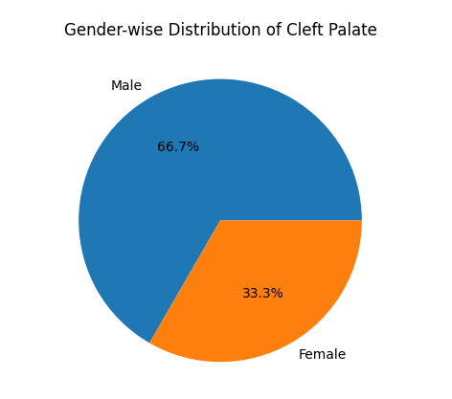

Figure 1:Pie chart showing gender-wise distribution of cleft palate
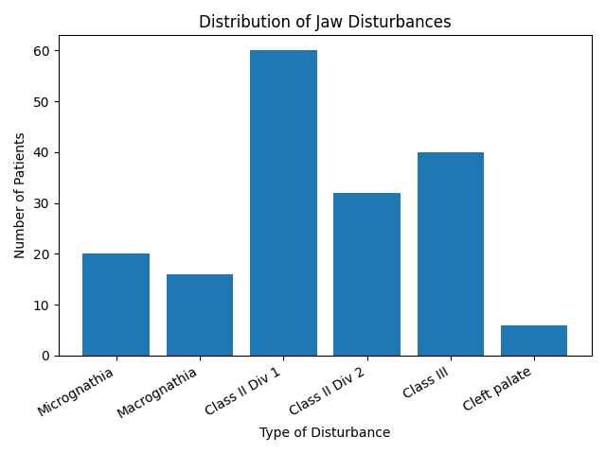

Figure2: Bar chart showing distribution of developmental disturbances affecting jaws and palate

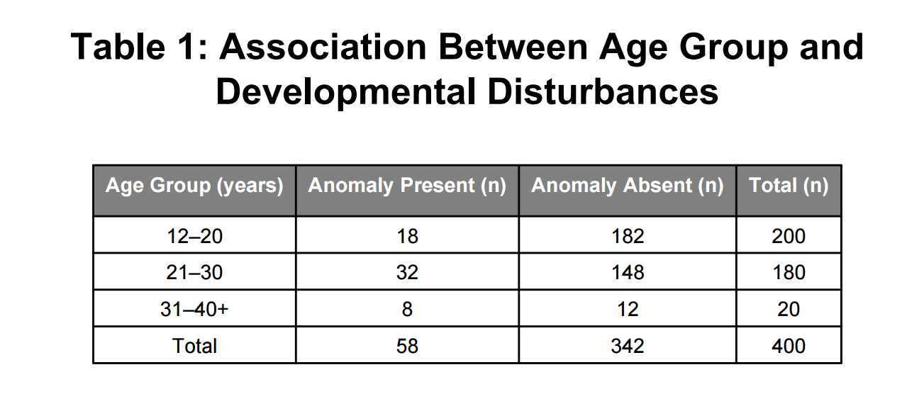
Table 1:Table shows the association between age and developmental disturbances.

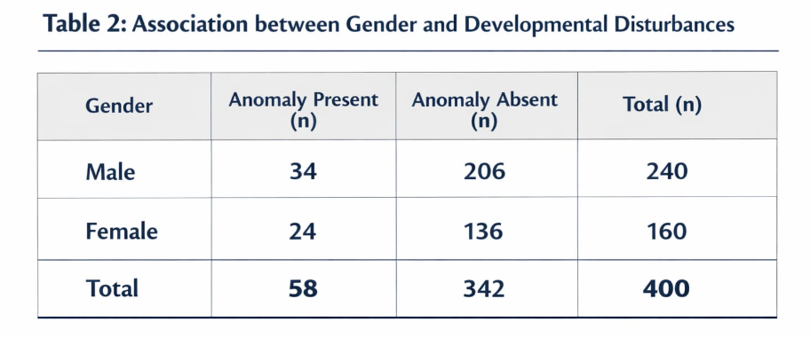
Table 2:Table shows the association between gender and developmental disturbances
DISCUSSION
The present study evaluated the prevalence and distribution of developmental disturbances affecting the jaws and palate among 400 individuals. The findings revealed that Class II Division 1 malocclusion was the most prevalent condition (15%), followed by Class III malocclusion (10%) and Class II Division 2 (8%). These findings are consistent with previous epidemiological studies conducted in Indian populations. Sundaram et al. [1] and Gupta et al. [2] reported a higher prevalence of malocclusions, particularly Class II patterns, in their respective study populations, indicating that malocclusion remains one of the most common developmental disturbances.
The prevalence of dental and craniofacial anomalies observed in this study is also comparable with the findings of Guttal et al. [3], who reported a significant frequency of developmental dental anomalies in the Indian population. Similarly, Bandaru et al. [15] observed notable occurrences of dental anomalies among school children in South India, supporting the current study’s observation of higher prevalence in younger age groups.
Micrognathia (5%) and macrognathia (4%) were observed at lower frequencies in the present study. These findings are in agreement with Tsegga et al. [22], who reported that skeletal jaw discrepancies are less common compared to dental malocclusions. Additionally, studies by Ardakani et al. [8] have also highlighted that severe skeletal anomalies are relatively less prevalent but clinically significant.
The prevalence of cleft palate in the present study was 1.5%, which is consistent with previously reported data in similar populations. Shah et al. [9] and Nahai et al. [23] have reported comparable prevalence rates, emphasizing that although cleft palate occurs less frequently, it has a substantial impact on function, speech, and overall quality of life.
Gender-wise analysis in the present study showed a higher prevalence of most anomalies among males. This finding is supported by studies such as Gupta et al. [2] and Yassin et al. [14], which also reported a male predilection for certain developmental anomalies. The possible reasons include genetic predisposition and environmental influences affecting craniofacial growth. Although males showed a higher frequency of developmental disturbances, the difference was not statistically significant (p > 0.05). This suggests that gender may not be a strong independent factor influencing the occurrence of these anomalies. Similarlyalthough a higher prevalence was observed in younger age groups, the association between age and the occurrence of anomalies was not statistically significant (p = 0.24)Similar findings have been reported in previous studies, indicating that other factors such as genetics and environmental influences may play a more important role.
Age-wise distribution indicated that the majority of anomalies were observed in the 12–20 years age group. This is in accordance with findings by Thongudomporn et al. [6], who suggested that developmental anomalies are more frequently diagnosed during adolescence due to increased awareness and orthodontic consultations during this period.
Environmental and genetic factors play a crucial role in the development of these anomalies. Riga et al. [24] highlighted the influence of environmental factors on dental morphology, while Wadhwa et al. [19] emphasized the role of developmental origins in craniofacial abnormalities. These factors may explain the variation in prevalence observed across different populations.
Overall, the findings of the present study are in agreement with previous Indian and international studies, confirming that malocclusion is the most prevalent developmental disturbance, while skeletal anomalies and cleft conditions are less common but clinically important. The results emphasize the importance of early diagnosis and intervention to reduce long-term complications and improve functional and aesthetic outcomes.
CONCLUSION
This cross-sectional study assessed developmental disturbances of the maxilla and mandible in individuals aged 12–40 years. Dental malocclusions were the most common findings, with Class II Division 1 being the most prevalent, followed by Class III and Class II Division 2. Skeletal anomalies like micrognathia and macrognathia were less common, while cleft palate was the least frequent.A higher prevalence was observed in males, and most cases occurred in the 12–20 years age group, indicating adolescence as a key period for detection and management. Although less common, cleft palate has significant functional and aesthetic impacts, requiring multidisciplinary care. Higher prevalence of developmental disturbances among males and younger individuals; however, the associations with both gender (p = 0.16) and age (p = 0.24) were not statistically significant. These findings suggest that demographic factors may not be strong independent predictors, and that genetic and environmental influences likely play a more significant role.Overall, the study highlights the importance of early diagnosis, timely intervention, and preventive strategies, while providing baseline data for improved clinical planning and future research.
ETHICAL APPROVAL
Ethical approval for this study was obtained from the Institutional Ethical Committee of RVS Dental College and Hospital (Approval No: IRB25I/146). The study was conducted in accordance with ethical guidelines.
COMPETING INTEREST
Authors have declared that no competing interests exist.
Disclaimer (Artificial Intelligence)
Author(s) hereby declare that generative AI technologies such as Large Language Models, etc have been used during writing or editing of this manuscript. This explanation will include the name, version, model, and source of the generative AI technology and as well as all input prompts provided to the generative AI technology.
Details of the AI usage are given:GPT-5 Mini
REFERENCES
- Sundaram L, Rathnavelu V, Venugopal DC, Narasimhan M, Sabesan M, Swetha S. Prevalence of common clinically manifested developmental anomalies of the oral cavity among adults: an epidemiological study in a South Indian population. Cureus. 2020;12(8):e9961.
- Gupta SK, Saxena P, Jain S, Jain D. Prevalence and distribution of selected developmental dental anomalies in an Indian population. J Oral Sci. 2011;53(2):231–238.
- Guttal KS, Naikmasur VG, Bhargava P, Bathi RJ. Frequency of developmental dental anomalies in the Indian population. Eur J Dent. 2010;4(3):263–269.
- Ooshima T, Ishida R, Mishima K, Sobue S. The prevalence of developmental anomalies of teeth in the primary and permanent dentitions of Japanese children. Int J Paediatr Dent. 1996;6(2):87–94.
- Hamasha AA, Safadi RA. Prevalence of talon cusps in Jordanian permanent teeth. BMC Oral Health. 2010;10:6.
- Thongudomporn U, Freer TJ. Prevalence of dental anomalies in orthodontic patients. Aust Dent J. 1998;43(6):395–398.
- Al-Emran S. Prevalence of hypodontia and developmental malformation of permanent teeth in Saudi Arabian schoolchildren. Br J Orthod. 1990;17(2):115–118.
- Ardakani FE, Sheikhha MH, Ahmadi H. Prevalence of dental developmental anomalies: a radiographic study. Community Dent Health. 2007;24(3):140–144.
- Shah RM, Boyd MA, Vakil TF. Studies of permanent tooth anomalies in Canadian individuals. J Can Dent Assoc. 1978;44:262–264.
- Proffit WR, Fields HW, Sarver DM. Contemporary orthodontics. 5th ed. St. Louis: Mosby Elsevier; 2013.
- White SC, Pharoah MJ. Oral radiology: principles and interpretation. 7th ed. St. Louis: Mosby Elsevier; 2014.
- Shafer WG, Hine MK, Levy BM. Shafer’s textbook of oral pathology. 8th ed. New Delhi: Elsevier; 2016.
- Masood F, Benavides E. Alterations in tooth structure and associated systemic conditions. Radiol Clin North Am. 2018;56(1):125–140.
- Yassin SM. Prevalence and distribution of selected dental anomalies among Saudi children in Abha. J Clin Exp Dent. 2016;8(5):e485–e490.
- Bandaru BK, Thankappan P, Kumar Nandan SR, Amudala R, Annem SK, Rajendra Santosh AB. The prevalence of developmental dental anomalies among school children in southern districts of Andhra Pradesh, India. J Clin Diagn Res. 2016;10(12):ZC90–ZC93.
- Mohanty R, Singh V, Dey AK, Behera S. A rare nonsyndromic case of adenomatoid odontogenic tumor associated with multiple impacted supernumerary teeth. Natl J Maxillofac Surg. 2019;10(1):114–117.
- Sharma G, Nagpal A. Talon cusp: a prevalence study of its types in permanent dentition and report of a rare case. J Oral Dis. 2014;2014:595189.
- Tredwin CJ, Scully C, Bagan-Sebastian JV. Drug-induced disorders of teeth. J Dent Res. 2005;84(7):596–602.
- Wadhwa PD, Buss C, Entringer S, Swanson JM. Developmental origins of health and disease. Semin Reprod Med. 2009;27(5):358–368.
- Chaste P, Leboyer M. Autism risk factors: genes, environment and gene–environment interactions. Dialogues Clin Neurosci. 2012;14(3):281–292.
- Dankner E, Harari D, Rotstein I. Dens evaginatus of anterior teeth: literature review and radiographic survey. Oral Surg Oral Med Oral Pathol Oral Radiol Endod. 1996;81(4):472–475.
- Tsegga MT, Christensen CJ. Jaw and dental abnormalities. Dent Clin North Am. 2020;64(2):275–290.
- Nahai F, Williams J, Burstein F, Martin J, Thomas J. The management of cleft lip and palate: pathways of treatment and longitudinal assessment. Semin Plast Surg. 2005;19(4):275–285.
- Riga A, Belcastro MG, Moggi-Cecchi J. Environmental influences on dental morphology and development. Arch Oral Biol. 2014;59(8):847–852.
- Patil S, Maheshwari S, Khandelwal S. Prevalence of dental anomalies in various populations: a systematic review. Am J Orthod Dentofacial Orthop. 2017;152(3):319–329.

