Original Research Article

Comparative In vitro Analysis of Microbial Load Reduction on Dental Burs and Endodontic Files Following Different Decontamination Methods

.
ABSTRACT

Background: Dental instruments when reused poses significant risks of cross-infection. Autoclaving is the gold standard for sterilization, but repeated cycles can degrade the cutting efficiency of burs and files
Aims: This study aims to evaluate the sterilization efficacy of a chemically enhanced glutaraldehyde solution using a 4-hour immersion protocol, compared to standard moist heat sterilization and 70% alcohol.
Study design: In vitro Comparative study
Place and Duration of Study: Department of Pediatric and Preventive Dentistry, in collaboration with the Department of Microbiology, at Mar Baselios Dental College, between July 2025 and December 2025.
Methodology: A total of 120 clinically contaminated instruments (diamond burs, hand K-files, and rotary NiTi files) were divided into four groups (n=30): Group A (70% Isopropyl Alcohol), Group B (4-hr Glutaraldehyde solution), Group C (Autoclave) and Group D (Control). Post-treatment, samples were incubated in Brain Heart Infusion Broth and plated on Brain Heart Infusion (BHI) agar to quantify Colony Forming Units (CFU/mL)
Results: Both the Autoclave and 4-hour glutaraldehyde solution groups achieved complete elimination of viable microorganisms. Statistical analysis revealed no significant difference in efficacy between the two methods (p > .05).
Conclusion: The 4-hour glutaraldehyde protocol achieves sterility comparable to that of autoclaving. This offers a time-efficient and non-corrosive alternative for maintaining the longevity of heat-sensitive dental instruments.

Keywords: Sterilization, Glutaraldehyde, Autoclave, Dental Burs, Endodontic Files, Microbial Load, Infection Control
1. INTRODUCTION

Decontamination is defined as the disinfection or sterilization of toxin or agent-contaminated articles to make them safe for use or disposal (Hawley and Kozlovac, 2005). In modern dental practice, the strict sterilization of instruments that enter sterile tissues or the vascular system is non-negotiable for the prevention of cross-contamination. Endodontic files and dental burs, often heavily contaminated with necrotic pulp tissue, blood, and saliva, pose a unique challenge due to their complex geometry and flutes, which can harbor pathogens such as Enterococcus faecalis and Candida albicans (Yenni et al.,2017; Pooja et al.,2022). While liquid chemical sterilization, often referred to as cold sterilization, is a common alternative to heat-based methods, its protocols remain inconsistent. Previous literature indicates that standard 2% glutaraldehyde requires a full 12-hour immersion to achieve complete sterilization, whereas shorter durations, such as 30 minutes, have been proven unreliable for eliminating resistant microbial loads. (Yenni et al.,2017; Kumar et al 2015). This significant variability necessitates a standardized, time-efficient protocol that bridges the gap between efficacy and clinical practicality. To address this, enhanced aldehyde formulations have been developed that combine glutaraldehyde with synergists like 1,6-dihydroxy-2,5-dioxahexane. These chemically advanced solutions are designed to achieve sporicidal activity in just 4 hours while incorporating corrosion inhibitors to protect delicate instruments. Despite moist heat sterilization method, autoclaving remaining the gold standard for infection control, has notable demerits regarding instrument longevity. Repeated exposure to high temperatures upto 121°C and pressure often leads to the corrosion of carbon steel and the dulling of cutting edges on NiTi files, significantly reducing their clinical lifespan and efficiency (Zhao et al., 2016). Consequently, there is a pressing need for a sterilization method that balances high-level disinfection with instrument preservation. Therefore, the rationale of this study was to identify a reliable alternative that mitigates thermal damage without compromising patient safety. The aim of this in vitro comparative study was to evaluate whether the alcohol and 4-hour glutaraldehyde solution can match the sterilization efficacy of the standard autoclave on contaminated dental burs and endodontic files.

2. Materials and methods

This in vitro study was conducted at the Department of Pediatric and Preventive Dentistry in collaboration with the Department of Microbiology at Mar Baselios Dental College, Kothamangalam, Ernakulam. The research was carried out over six months from July 2025 to December 2025, following ethical approval from the Institutional Review Board with Project number IEC/MBDC/022025/31). A total sample size of 120 instruments, was selected from dental procedures performed in 30 individuals, comprising of 40 Dental Diamond Burs (Mani, Inc., Tochigi, Japan), 40 Stainless Steel Hand K-files (Size 20, 21 mm; Mani, Inc., Tochigi, Japan) and 40 Rotary NiTi Files (ProTaper Gold; Dentsply Sirona, Ballaigues, Switzerland). All instruments were subjected to a standard pre-sterilization cycle before clinical use. The study samples were retrieved immediately following routine dental procedures, specifically cavity preparation using dental burs and biomechanical root canal preparation using endodontic files. Following the collection, instruments were rinsed with sterile Phosphate-Buffered Saline (PBS) to eliminate gross organic debris. Each type of instruments (n=40) was randomly divided into four groups consisting of 10 instruments per group, representing 10 samples from different individuals. Group A included instruments decontaminated with alcohol. Instruments were fully immersed in a sterile glass container containing 70% Isopropyl Alcohol for 15 minutes. After immersion, instruments were retrieved aseptically, rinsed in distilled water and allowed to air-dry. Group B (Korsolex Rapid), instruments were immersed in a 5% solution of Korsolex Rapid (Bode Chemie/Raman & Weil) for 4 hours as per the manufacturer's guidelines. Following immersion, the instruments were retrieved using aseptic technique and rinsed with sterile distilled water. Group C (Autoclave) instruments were packaged and sterilized in an autoclave (Tanda, 23 L; Woson Medical Instrument Co., Ltd., China) at 121°C and 15 psi for 30 minutes. Contaminated instruments of Group D (Control) received no decontamination treatment to serve as a baseline for microbial load.

2.1 Microbiological Analysis

Under sterile conditions, each instrument was transferred to a test tube containing 4mL Brain Heart Infusion (BHI) Broth and incubated at 37 °C for 24 hours. Following incubation, a 100 μL aliquot from each tube was lawn cultured onto Brain Heart Infusion agar and incubated for 24 hours at 37 °C. Colonies were quantified using a digital colony counter and CFU/mL were calculated.

2.2 Statistical Analysis

Data were recorded in Microsoft Excel and analysed using SPSS. The comparison of mean microbial growth (CFU/mL) across the four sterilization groups (Autoclave, Korsolex, Alcohol, and Control) for burs, hand files and rotary files was performed using One-Way Analysis of Variance (ANOVA). A p-value of less than 0.05 (p<0.05) was considered statistically significant.

3. results and discussion

Microbial load was quantitatively evaluated for hand files, rotary files and dental burs across the three decontamination and control groups. Results are presented as mean microbial growth (CFU/mL), and was compared and evaluated across the study groups.

Assessment of Microbial Load Reduction

Hand Files
In the Hand Files group, the control specimens exhibited a mean microbial count of 1.18 × 10³ CFU/mL. The Alcohol group showed a reduction in microbial load, with a mean of 1.01 × 10² CFU/mL. In contrast, both the Glutaraldehyde and Autoclave groups achieved complete sterilization, demonstrating no microbial growth.

Rotary Files
For Rotary files, the control group showed a mean microbial growth of 1.14× 10³ CFU/mL. The Alcohol disinfection resulted in a mean count of 2.25× 10¹ CFU/mL. Consistent with the hand files, both the Glutaraldehyde and Autoclave groups showed complete elimination of microorganisms.

Dental Burs
The control samples showed a mean growth of 1.14× 10³ CFU/mL. The Alcohol group had a mean load of 2.59× 10¹ CFU/mL. However, the Glutaraldehyde and Autoclave groups both demonstrated superior efficacy with no microbial growth.

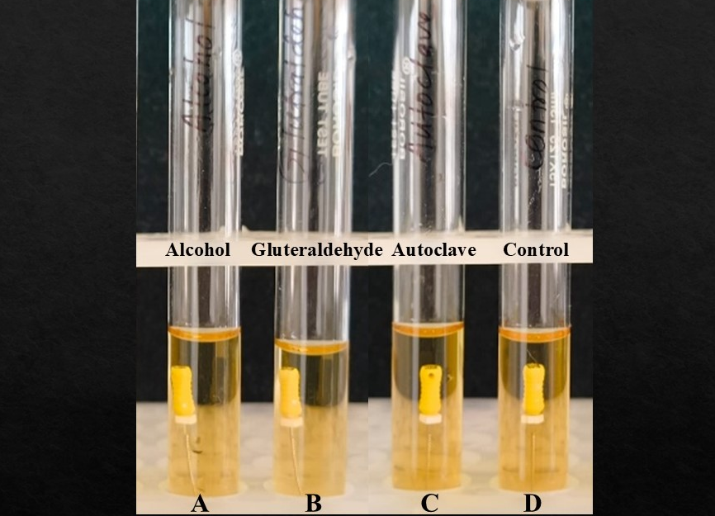
Fig 1: Post-incubation BHI broth containing endodontic hand files following decontamination protocols, along with control group, prior to CFU analysis
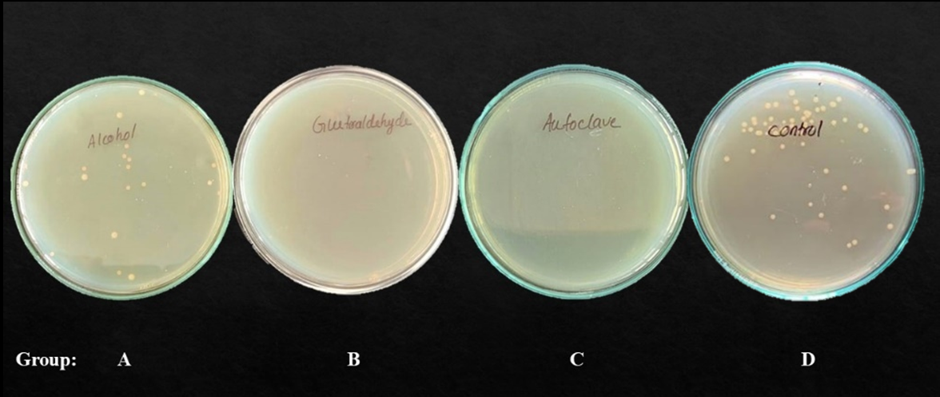

Fig 2: BHI agar plates showing microbial growth after different decontamination protocols
Bacterial growth in Hand files
 | Number | Mean | S. D | S. E
Alcohol | 10 | 1.01×10¹ | 1.14×10¹ | 0.36×10¹
Glutaraldehyde | 10 | 0 | 0 | 0
Autoclave | 10 | 0 | 0 | 0
Control | 10 | 1.18x10³ | 0.11×10³ | 0.035×10³
Bacterial growth in Rotary files
 | Number | Mean | S. D | S. E
Alcohol | 10 | 2.25 × 10¹ | 2.72 × 10¹ | 0.86× 10¹
Glutaraldehyde | 10 | 0 | 0 | 0
Autoclave | 10 | 0 | 0 | 0
Control | 10 | 1.14 ×10² | 0.72× 10² | 0.22× 10²
Bacterial growth in Burs
 | Number | Mean | S. D | S. E
Alcohol | 10 | 2.59× 10¹ | 2.51× 10¹ | 0.79× 10¹
Glutaraldehyde | 10 | 0 | 0 | 0
Autoclave | 10 | 0 | 0 | 0
Control | 10 | 1.14 × 10³ | 0.58× 10² | 0.18× 10²
Table 1: Microbial load (CFU/mL) following various decontamination protocols across endodontic hand files, rotary files and dental burs.

3.1 Statistical inference

One-way ANOVA indicated significant differences in microbial reduction across all three instrument categories: Hand files (F = 7.814, P= 0.002), Rotary files (F = 6.806, p =0.004), and Dental burs (F = 10.642, p< 0.001). The analysis revealed that both the Autoclave and Glutaraldehyde groups achieved identical performance, with complete elimination of microbial growth. The absence of any statistically significant difference between these two methods confirms their equivalent efficacy, regardless of the instrument’s surface geometry. Alcohol was significantly better than control and consistently demonstrated residual contamination, with mean values ranging from 1.01 × 10² to 2.59× 10¹ CFU/mL. These findings statistically confirm that alcohol disinfection is significantly inferior to both autoclaving and glutaraldehyde immersion, rendering it inadequate for the decontamination of complex dental instruments.

4. DISCUSSION

The primary objective of this study was to identify a sterilization protocol that ensures patient safety while preserving the longevity of delicate dental instruments. Our results confirm that Korsolex Rapid (Raman and Weil Pvt, India), when used for 4 hours, achieves complete elimination of viable microbes from naturally contaminated dental instruments, with the same efficacy as the gold standard, autoclave. A key strength of this study lies in its use of naturally contaminated instruments rather than those inoculated with a single laboratory strain. Different bacterial strains were obtained from dental instruments during the study, consistent with the complex oral microflora and pathogenic species. The control plates revealed heterogeneous microbial growth, including Streptococcus spp., Micrococcus spp., Staphylococcus spp., Enterococcus faecalis and Candida albicans. By challenging the sterilization protocols with the realistic, polymicrobial bioburden, the broad-spectrum activity of the 4-hour Korsolex protocol against varied pathogens found in daily practice was validated. Standard glutaraldehyde functions by alkylating the amino and sulfhydryl groups of proteins, a process that kills vegetative bacteria rapidly but requires up to 12 hours for spores (McDonnell & Russell, 2001). The superior performance of Korsolex Rapid over conventional glutaraldehyde regimens aligns with its synergistic chemistry, upon the addition of 1,6-Dihydroxy 2,5-Dioxahexane. This synergistic combination facilitates faster penetration of the chemical into the microbial cell wall, effectively reducing the required sporicidal time to 4 hours. Goel et al. (2025) reported that 2.45% glutaraldehyde, when used for 4 hours, achieved 100% disinfection against E. faecalis, comparable to autoclaving and peracetic acid. While Goel et al. used generic glutaraldehyde, our study confirms that the specific dual-aldehyde formulation of Korsolex Rapid reliably achieves this result, offering a standardised commercial solution for clinicians. The sterilization failure reported by Yenni et al. (2017) can be attributed to their short 30-minute cycle, insufficient for reliable sporicidal activity. Conversely, Venkatasubramanian et al. (2010) demonstrated that even extending the immersion time to 12 hours achieved only 80% efficacy, mirrored by Raju et al. (2013). The poor performance of 70% isopropyl alcohol (Group A) corroborates the findings of Pooja et al., (2022) and Sajjanshetty et al., (2014) that alcohol acts primarily as a surface disinfectant, inadequate for complex critical instruments. It evaporates too rapidly to penetrate the debris-laden flutes of burs and files, making it unsuitable for critical instrument sterilization.

Clinically, the 4-hour Korsolex Rapid protocol offers a pragmatic “middle ground” for high-volume practices, matching the efficacy of autoclave, without thermal damage, minimizing corrosion risk and by reducing the turnaround time compared with overnight glutaraldehyde immersion. This is particularly advantageous for instrument longevity, directly impacting procedural efficiency and cost. However, proper pre-cleaning remains indispensable, as organic debris can shield microorganisms and reduce disinfectant penetration. Limitations of this study include the reliance on aerobic culture protocol, failing to recover obligate anaerobes. Furthermore, conventional CFU enumeration inherently misses viable but non-culturable (VBNC) bacteria that remain metabolically active and potentially pathogenic, underscoring the need for complementary molecular viability assays and anaerobic culture conditions in future studies.

5. CONCLUSION

In conclusion, Korsolex Rapid (4-hour immersion) represents a clinically viable sterilization method for dental burs and endodontic files, comparable in efficacy to the gold standard autoclave while offering superior instrument preservation through reduced corrosion risk and the avoidance of thermal damage. This enhanced dual-aldehyde formulation also provides a markedly shorter turnover time compared with traditional overnight glutaraldehyde protocols, whereas 70% isopropyl alcohol is insufficient for reliable decontamination of complex dental instruments and should not be used as a primary sterilization method.

CONSENT

Not applicable

ETHICAL APPROVAL

Applicable. IEC/MBDC/022025/31

COMPETING INTERESTS DISCLAIMER:
Authors have declared that they have no known competing financial interests OR non-financial interests OR personal relationships that could have appeared to influence the work reported in this paper.

REFERENCES

Hawley, R.J., Kozlovac, J.P. (2005). Decontamination. In: Lindler, L.E., Lebeda, F.J., Korch, G.W. (eds) Biological Weapons Defense. Infectious Disease. Humana Press. https://doi.org/10.1385/1-59259-764-5:333

Yenni, M., Bandi, S., Avula, S. S., Margana, P. G., Kakarla, P., & Amrutavalli, A. (2017). Comparative evaluation of four different sterilization methods on contaminated endodontic files. CHRISMED Journal of Health and Research, 4(3), 194–197.

Pooja, H. R., Nagar, P., Mascarenhas, A. N., & Shree, C. C. (2022). Care or neglect of burs: A comparative study of different sterilization methods. SRM Journal of Research in Dental Sciences, 13(2), 54–57.

Kumar, K. V., Kumar, K. K., Supreetha, S., Raghu, K. N., Veerabhadrappa, A. C., & Deepthi, S. (2015). Pathological evaluation for sterilization of routinely used prosthodontic and endodontic instruments. Journal of International Society of Preventive and Community Dentistry, 5(3), 232–236.

Zhao, D., Shen, Y., Peng, B., & Haapasalo, M. (2016). Effect of autoclave sterilization on the cyclic fatigue resistance of thermally treated nickel–titanium instruments. International Endodontic Journal, 49(10), 990–995.

Raman & Weil. Korsolex Rapid® - Environment & surface disinfectant. rwscience. https://ramanweil.com/products/korsolex-rapid

McDonnell, G., & Russell, A. D. (2001). Antiseptics and disinfectants: Activity, action, and resistance. Clinical Microbiology Reviews, 14(1), 227.

Goel, S., Mistry, L. N., Jawdekar, A. M., Deshpande, S., & Bhattacharjee, M. (2025). A comparison of disinfecting ability of peracetic acid, glutaraldehyde and autoclaving on endodontic K-files tested against Enterococcus faecalis: An in-vitro study. Cureus, 17(4).
Venkatasubramanian, R., Das, U. M., & Bhatnagar, S. (2010). Comparison of the effectiveness of sterilizing endodontic files by 4 different methods: An in vitro study. Journal of Indian Society of Pedodontics and Preventive Dentistry, 28(1), 2–5.

Raju, T. B., Garapati, S., Agrawal, R., Reddy, S., Razdan, A., & Kumar, S. K. (2013). Sterilizing endodontic files by four different sterilization methods to prevent cross-infection: An in-vitro study. Journal of International Oral Health, 5(6), 108.

Sajjanshetty, S., Hugar, D., Hugar, S., Ranjan, S., & Kadani, M. (2014). Decontamination methods used for dental burs: A comparative study. Journal of Clinical and Diagnostic Research, 8(6), ZC39.

