A Review on functional Considerations in Removable Partial Denture Design

Abstract
Esthetics has become a critical determinant of success in removable partial denture (RPD) therapy, strongly influencing patient acceptance, comfort, and oral health–related quality of life. While RPDs have traditionally focused on restoring function and biomechanics, contemporary prosthodontic practice increasingly emphasizes natural appearance, particularly in esthetically sensitive regions. This review summarizes current concepts and evidence related to esthetic considerations in RPD design, encompassing patient-related and oral determinants, framework design principles, clasp selection and modification, precision and semi-precision attachments, and denture base and artificial tooth selection. Special attention is given to anterior edentulous situations, high smile line patients, and geriatric cases where implants may be contraindicated. Recent advances in biomaterials, CAD–CAM fabrication, and digital smile analysis are also discussed for their role in improving esthetic predictability and clinical outcomes. Overall, the literature supports a balanced, individualized, and patient-centered approach that integrates esthetics with functional efficiency, ensuring long-term satisfaction and clinical success of RPDs in modern prosthodontic practice.
Keywords: Removable partial denture; Esthetics; Clasp design; Precision attachments; Digital prosthodontics

Introduction
Functional considerations in removable partial denture (RPD) design have progressively gained prominence as prosthodontics has evolved from a discipline primarily focused on restoring basic oral function to one that equally values natural appearance and patient-centered outcomes.¹ Historically, early prosthodontic appliances of the eighteenth century relied on materials such as ivory and metal bars, offering limited esthetic appeal, while the nineteenth century marked a transition toward porcelain teeth that improved realism and durability. In the modern era, the introduction of flexible thermoplastic materials, particularly nylon-based systems such as Valplast in the mid-twentieth century, significantly reduced metal display and improved comfort, thereby reshaping patient expectations toward lifelike tooth shades, anatomical contours, and harmonious gingival integration.²
Although implant-supported and fixed prostheses are often regarded as the gold standard due to their superior stability and minimal tissue coverage, RPDs continue to play a crucial role in clinical practice, especially in patients with financial constraints, extensive partial edentulism, geriatric populations, or anatomically compromised sites where implants are contraindicated, accounting for a substantial proportion of prosthodontic rehabilitations.³ In this context, contemporary esthetic RPD designs, including flexible dentures and tooth-colored clasp systems, attempt to approximate the visual outcomes of fixed restorations. Esthetics has been shown to be a decisive factor in patient acceptance, with visible metal components particularly anterior clasps negatively affecting self-confidence, social interactions, and oral health–related quality of life, whereas improved tooth arrangement and gingival shade matching are associated with significantly higher patient satisfaction.⁴
Despite these advances, conventional RPDs present inherent esthetic challenges, such as the visibility of cobalt–chromium clasps within the smile line, increased framework bulk affecting lip support and phonetics, limited material translucency for shade matching, and the potential for long-term gingival irritation, all of which necessitate careful design and precise surveying.⁵

Review of Literature
The design of removable partial dentures (RPDs) has increasingly emphasized esthetics as a determinant of patient acceptance, alongside the fundamental requirements of function and comfort.⁶
Earlier literature highlighted that while esthetic considerations are important, they should not compromise the biomechanical efficiency, comfort, or functional performance of the prosthesis, especially in the dynamic oral environment where mastication, speech, and tissue health must be preserved (Seltzer, 2007)⁷
With growing patient awareness and expectations, RPDs are now compared aesthetically with fixed prostheses, making visual appeal a key component of treatment success (Shah & Aras, 2015).⁸ Subsequent studies have demonstrated that improved esthetics positively influence patients’ self-esteem, confidence, and social interactions, thereby reinforcing the need for prosthodontists to integrate esthetic principles into RPD design (Turagam et al., 2019).⁹
In response to these demands, contemporary literature has focused on modifying traditional design elements, particularly clasp assemblies, as visible metallic clasps are often perceived as unaesthetic; alternative approaches such as gingivally approaching clasps, precision attachments, flexible denture materials like Valplast, and tooth-colored clasp systems have therefore been advocated .¹⁰
Advances in material science have further expanded esthetic possibilities, with materials such as polyether ether ketone (PEEK) and zirconia offering favorable esthetic outcomes while maintaining adequate strength, although highly esthetic options such as transparent dentures may present limitations in retention and stability (Grover, 2023).¹¹ Collectively, the literature underscores that optimal RPD design requires vbn bvgn bg a balanced approach in which esthetic enhancements are thoughtfully integrated without undermining functional efficiency and patient comfort, ensuring both visual satisfaction and long-term clinical success (Yu, n.d.).¹²
Removable of partial denture
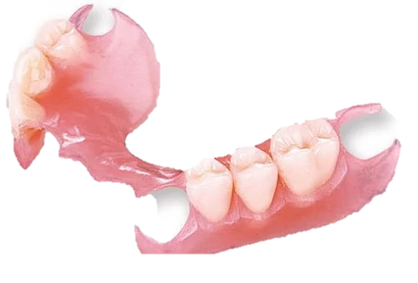

Figure 1: Removable of partial denture

It is defined as any prosthesis that replace some teeth in a partially dentate arch. It can be removed from mouth and replaced at will also called as partial removable dental peosthesis [GPT-9]

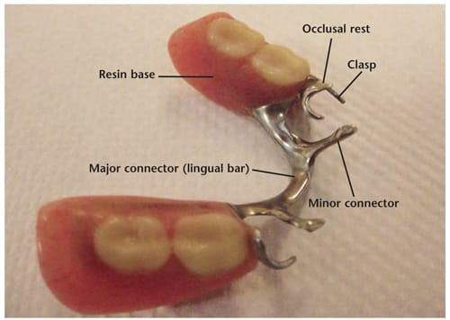

Figure 2:Parts of removable partial denture

2.Major connectors
Major connector: The part of partial removable dental peosthesis that joins the components on one side of arch to those on to opposite side [GTP-8]
Maxillary Major Connectors :
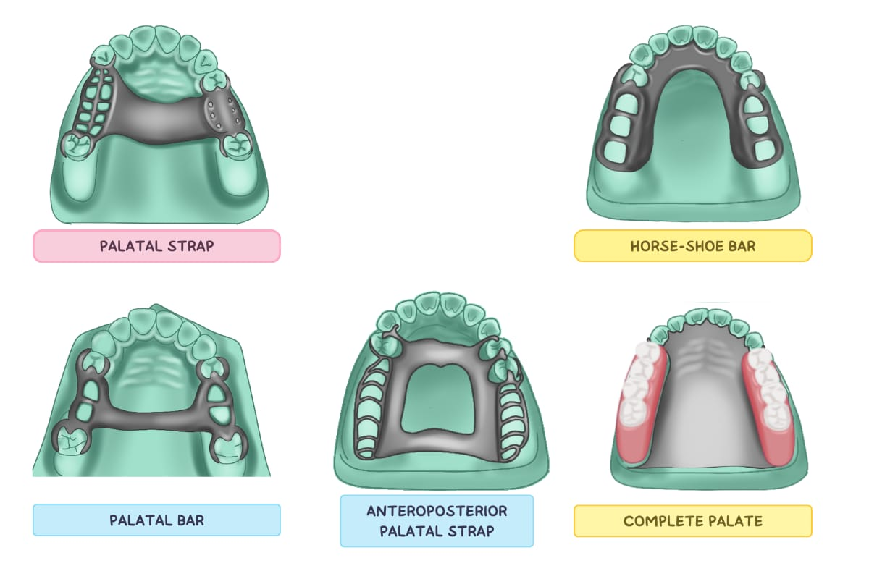
1.Palatal bar
2.Palatal strap
3.Double palatal bar
4.U-shaped connector
5.Anterior posterior palatal strap
6.Complete palate

Figure 3: Maxillary Major Connectors

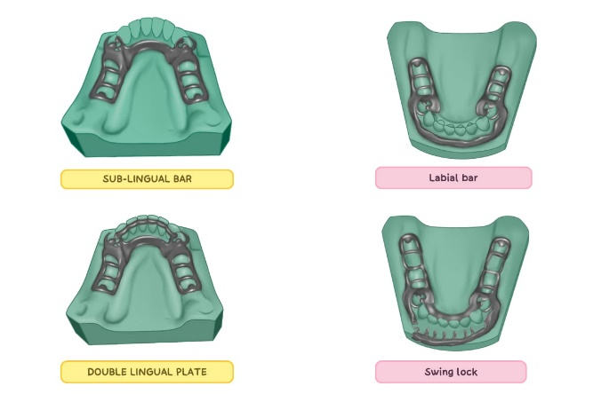
Mandibular Major connectors:
1.Lingual bar
2.Lingual plate
3.Sublingual bar
4.Labial bar
5.Double lingual bar

Figure 4: Mandibular Major connectors

3.Minor connectors:

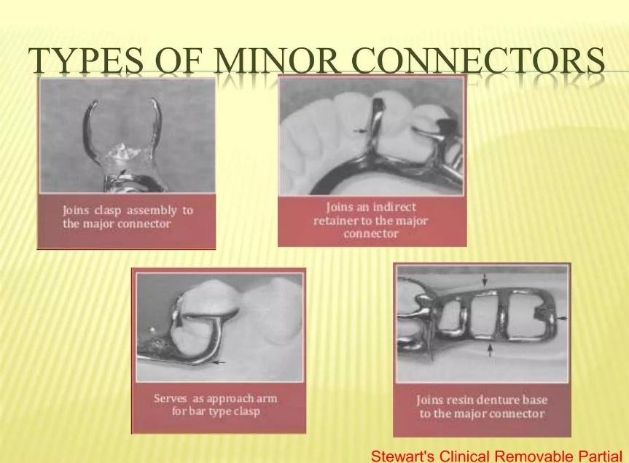

Figure 5: Types of Minor connectors
The connecting link between the major connectors or base of partial removable dental prosthesis such as clasp assembly, indirect retainer occlusal rest or cingulum rests[GPT-8]

Types of minor connectors
Major connectors in removable partial dentures serve several important functions. They connect the clasp assembly to the rest of the prosthesis, ensuring overall unity and stability. They also join indirect retainers and auxiliary rests to the major connectors, allowing for effective distribution of forces. In addition, they connect the denture base to the major connector, providing support for the artificial teeth. Furthermore, major connectors can serve as an approach arm for vertical projection or bar-type clasps, facilitating proper clasp design and function.

4.Direct retainer
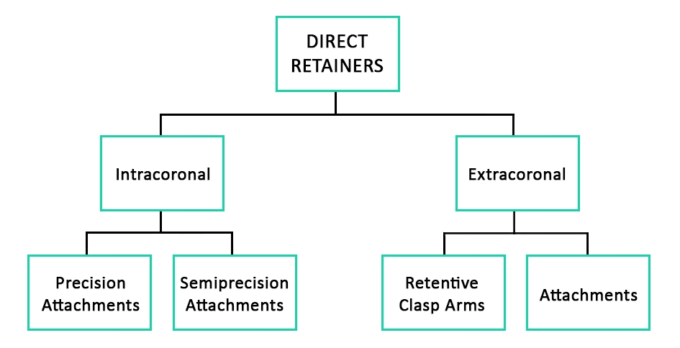

Figure 6: Direct retainer
A component of a removable partial denture that engages an abutment tooth in such a manner as to resist displacement of the prosthesis away from the basal seat tissues; it usually consists of a clasp assembly or a precision attachment.
5.Indirect retainer:
The component of a removable partial denture that assists the direct retainers in preventing displacement of a distal-extension denture base by functioning through lever action on the opposite side of the fulcrum line when the denture base moves away from the tissues in pure rotation around the fulcrum line.

Types of indirect retainer:
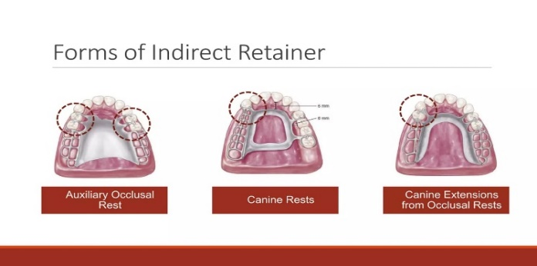

Figure 7: Forms of indirect retainer

Indirect retention in removable partial dentures is achieved through various components that help resist rotational displacement of the prosthesis. These include auxiliary occlusal rests, canine rests, and canine extensions from occlusal rests, which provide additional support and stability. Continuous bar retainers, such as cingulum bars and linguoplates, also contribute to indirect retention by distributing forces effectively. Modification areas may include occlusal rests on secondary abutments to enhance support, while the palatal rugae area can provide additional resistance through rugae support. In some cases, elements of direct retainers can function indirectly, contributing to what is known as direct-indirect retention. Furthermore, major connectors themselves can aid in indirect retention by providing rigidity and helping to stabilize the prosthesis against rotational forces.
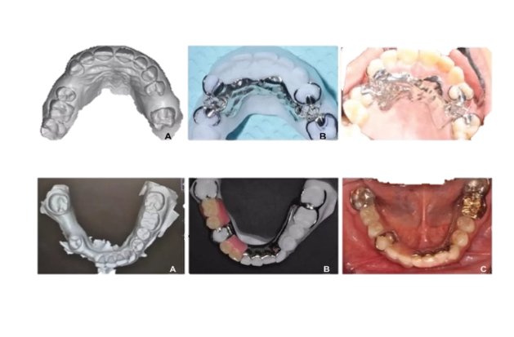
6.Recent advances in CAD/CAM in rpd:

Figure 8: Recent advances in cad\cam in rpd

Table 1. Applications of CAD/CAM
TYPES | USES
1.Intraoral Scanners (IOS) | AI-assisted scanning for margin detection and error correction  Faster, powder-free scanner with high accuracy  Improved scanning for edentulous arches and RPD frameworks  Colour, caries and occlusal analysis integration
2. Advanced CAD Software | AI-based tooth morphology libraries  Automatic design of  Crowns and bridges  Implant abutments  RPD frameworks  Virtual articulation and occlusal simulation  Smile design integration (DSD + CAD)

3. CAM: Improved Milling Technology | 5-axis milling machines → higher precision and complex geometries  Dry and wet milling options  Faster spindle speeds with reduced tool wear  Chairside milling with same-day restorations
4. 3D Printing (Additive Manufacturing) | Major recent breakthrough in CAD–CAM:  Applications:  Temporary crowns & bridges  Denture bases and teeth  Surgical guides  RPD frameworks (metal printing)  Advances:  High-strength printable resins  Multi-material and color printing  Improved accuracy and surface finish
5.New CAD–CAM Materials | High-translucency zirconia (multilayer, gradient)  Zirconia for full-arch prostheses  Hybrid ceramics (PICN – polymer infiltrated ceramic network)  Improved lithium disilicate blocks  Printable ceramic-filled resins
6. CAD–CAM in RPDs | Digital surveying and clasp design  3D-printed resin patterns for casting  Direct metal laser sintering (DMLS) frameworks  Better fit and reduced chairside adjustments

7. CAD–CAM in Implant Prosthodontics | Digital implant planning  CAD–CAM custom abutments  Screw-retained prostheses with improved precision  Full-arch implant prostheses using digital workflows
8. Artificial Intelligence & Automation | Automated margin detection  Occlusal adjustment prediction  Error reduction in design and milling  AI-guided treatment planning
9. Chairside CAD–CAM Systems | Single-visit dentistry  Reduced laboratory dependency  Improved patient comfort  High predictability and consistency
10. Future Trends | Fully automated digital dentistry  Smart materials  Integration with CBCT and facial scanners  Increased use of AI + cloud-based design

7.Functional Considerations in Removable Partial Denture (RPD)
Functional Considerations in Removable Partial Denture (RPD) refer to factors that ensure the prosthesis functions properly during mastication, speech, swallowing, and comfort while protecting oral tissues.

Biomechanical Principles of RPD
The RPD acts as a mechanical device that transmits occlusal forces to supporting structures.

Basic biomechanical principles include:
- Support
- Stability
- Retention
- Stress control
- Occlusal harmony
These principles ensure that forces generated during mastication are distributed evenly between teeth and supporting tissues.

8.Support
Support prevents vertical movement of the denture toward tissues during function. It is derived from teeth through rests, from tissues through the residual ridge, or a combination of both.

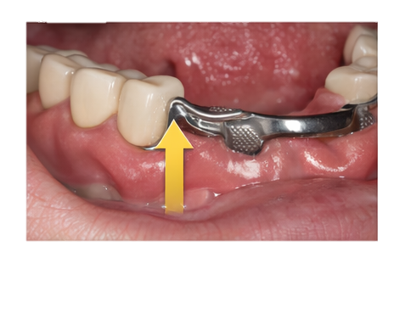
Figure 9: Support in functional consideration in rpd
Support prevents the denture from moving toward the tissues during chewing. Sources of support in removable partial dentures include tooth support, tissue support, and combination support. Tooth support is achieved through rests such as occlusal, cingulum, and incisal rests, which help in directing forces along the long axis of the teeth. Tissue support is provided by the denture base that rests over the residual ridge, allowing the load to be distributed to the underlying mucosa. Combination support involves both teeth and mucosa and is commonly seen in distal extension removable partial dentures, where both structures share the functional load. The main components that provide support in a removable partial denture include rests, major connectors, the denture base, and the residual ridge.

9.Stability
Stability refers to resistance against horizontal forces. It is achieved through proper guide planes, rigid connectors, and accurate denture base adaptation.
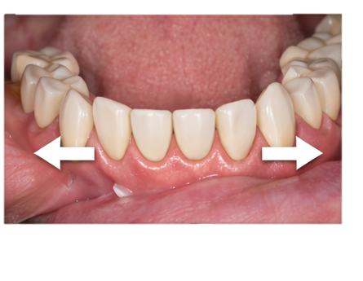

Figure 10: Stability in functional consideration in rpd

Stability in removable partial dentures refers to the resistance against horizontal or lateral forces that may cause displacement of the prosthesis. It is influenced by several factors such as proper guide planes, rigid major connectors, accurate adaptation of the denture base to the supporting tissues, and correct clasp design. These factors work together to ensure that the prosthesis remains stable during function, thereby preventing any rocking or movement of the denture during chewing and improving overall efficiency and patient comfort.

10.Retention
Retention prevents displacement of the prosthesis away from tissues. It is provided by clasps, indirect retainers, adhesion, and neuromuscular control.

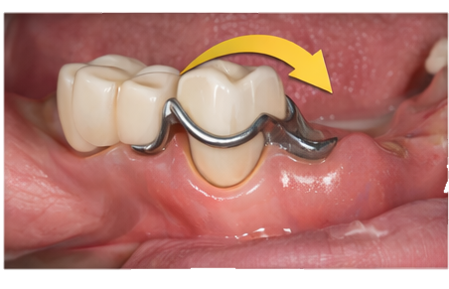
Figure 11: Retention in functional consideration in rpd

Retention refers to the resistance against dislodgement of the prosthesis away from the supporting tissues. It is achieved through various retentive components, including direct retainers such as clasps, indirect retainers, adhesion and cohesion forces, and neuromuscular control. Among these, the design of clasp arms and their flexibility play a crucial role in determining the effectiveness of retention, as they help the prosthesis remain securely in position during function.

11.Occlusal Considerations
Proper occlusion ensures harmonious contact with natural teeth. Balanced occlusion is particularly important in distal extension cases to prevent instability and tissue trauma

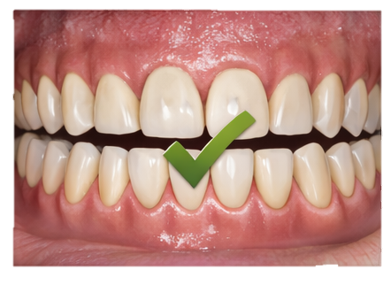
Figure 12: Occulusal consideration in functional consideration

Occlusion is one of the most important functional aspects of a removable partial denture (RPD). It involves several occlusal factors, including harmonious occlusion with the natural teeth, balanced occlusion in distal extension cases, a proper cusp–fossa relationship, and the avoidance of premature contacts. If these factors are not properly maintained, incorrect occlusion can occur, which may lead to instability of the prosthesis and cause trauma to the supporting tissues.

12.Stress Distribution
Even distribution of occlusal forces between abutment teeth and residual ridge is essential. This can be achieved through proper clasp design, broad denture base coverage, and use of indirect retainers.

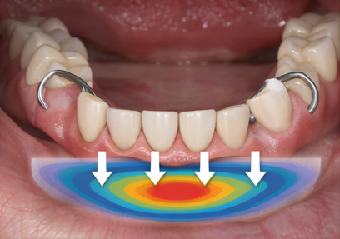
Figure 13: Stress distribution in functional consideration in rpd

Occlusal forces in a removable partial denture must be evenly distributed between the abutment teeth and the residual ridge to ensure stability and prevent damage. Several design principles help improve stress distribution, including broad denture base coverage, proper clasp design, the use of stress-releasing clasps, and the incorporation of indirect retainers. In particular, distal extension RPDs require special consideration, as they are more prone to leverage forces, and careful design is essential to minimize their impact and protect the supporting structures.

13.Functional Impression
Functional impression techniques record tissues under load, improving adaptation and stability, especially in distal extension cases.

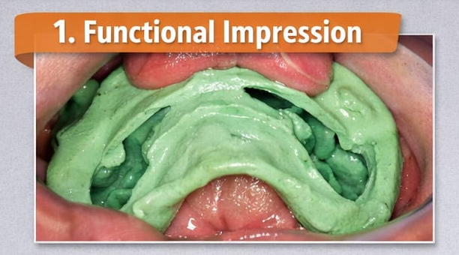
Figure 14: Functional impression

Functional impression techniques are particularly important in distal extension removable partial dentures (RPDs). Their main purpose is to record the tissues under functional load, which helps in achieving better adaptation of the denture base. This, in turn, enhances both support and stability of the prosthesis during function. One of the most commonly used methods for this purpose is the altered cast technique.

14.Patient-Related Functional Factors
Patient-related factors such as oral musculature, saliva, ridge morphology, and neuromuscular control influence the success of RPDs. Proper patient education and follow-up are essential.
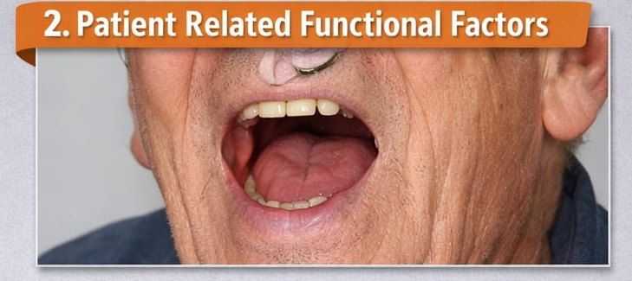
Figure 15: Patient related functional factors
The functional success of a removable partial denture (RPD) also depends on several patient-related factors, including oral musculature, tongue position, saliva, ridge morphology, and the patient’s ability to adapt to the prosthesis. These factors influence how well the denture functions during speech and mastication. Therefore, patient education and regular follow-up are essential to ensure proper use, maintenance, and long-term success of the prosthesis.

15.Denture Base Considerations

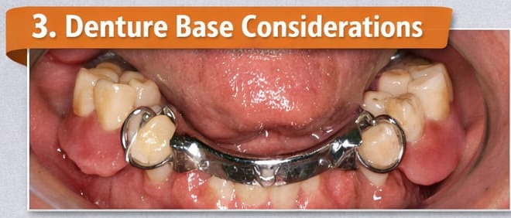

Figure 16: Denture base consideration

The denture base plays a vital role in supporting the artificial teeth and in transferring occlusal forces to the residual ridge. To fulfill its functional requirements, it should provide maximum coverage of the ridge, ensure proper adaptation to the underlying tissues, and have adequate thickness for sufficient strength. A well-designed denture base is essential to distribute forces effectively and must be constructed in a way that minimizes tissue trauma.

16.Influence of Oral Musculature

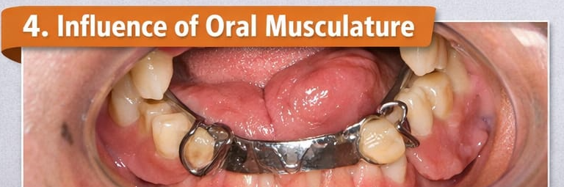
Figure 17: Influence of oral musculature

Oral muscles play an important role in the retention and stability of removable partial dentures (RPDs). Key muscles involved include the buccinator, orbicularis oris, and the tongue muscles, all of which influence the position and movement of the denture during function. Proper denture contouring is essential to ensure harmonious interaction with these muscles, allowing the prosthesis to remain stable and function effectively without interference

17.Influence of Saliva on RPD Function

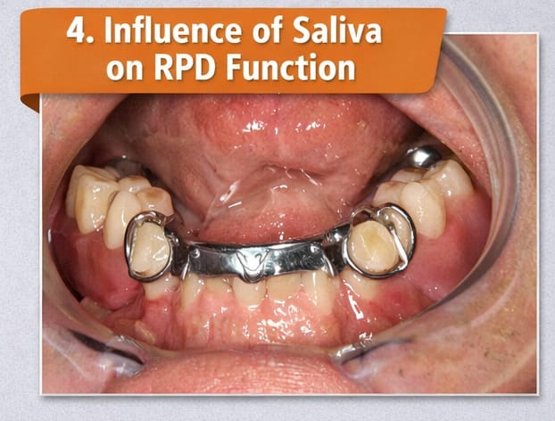
Figure 18: Influence of saliva
Saliva plays a significant role in denture retention and overall comfort by contributing to adhesion and cohesion between the denture and oral tissues, providing lubrication during mastication, and offering protection to the underlying tissues. However, patients with xerostomia may experience reduced denture retention due to the lack of adequate saliva. In addition, successful function of a removable partial denture (RPD) depends greatly on patient adaptation and neuromuscular control. Factors influencing adaptation include tongue control, coordination of cheek muscles, patient motivation, and the learning curve associated with mastication. Therefore, patient education and regular follow-up visits are essential to support proper adaptation, ensure comfort, and maintain the functional longevity of the prosthesis.

Esthetic Determinants in Removable Partial Denture Design
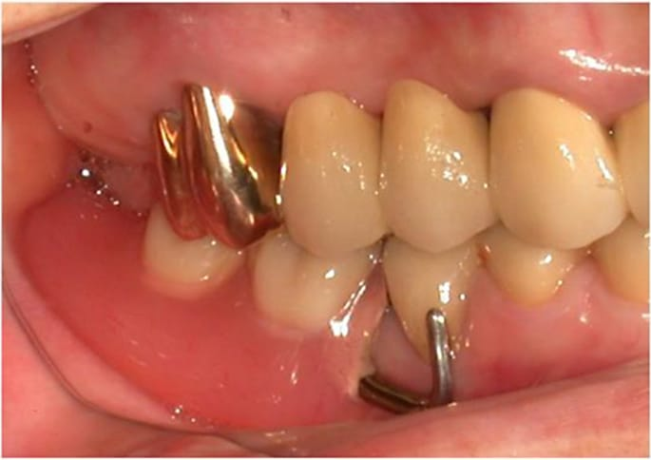

Figure 19: Esthetic Determinants in Removable Partial Denture Design

Esthetic determinants in removable partial denture (RPD) design arise from a complex interplay between patient-specific characteristics and existing oral and dental conditions, both of which are essential for achieving a natural appearance without compromising functional efficiency and biomechanical stability.¹³ Patient-related factors play a pivotal role, as the smile line and lip dynamics largely determine the visibility of clasp assemblies; individuals with a low lip line may tolerate limited metal display, whereas those with a high smile line often require gingivally approaching clasps, precision attachments, or non-metallic alternatives to maintain esthetic harmony.¹⁴
Age-related considerations further influence design decisions, with geriatric patients often requiring enhanced lip support and compensation for residual ridge resorption, while younger patients and particularly females tend to place greater emphasis on facial esthetics and gender-specific arch forms, such as tapered or square contours, to ensure natural integration with facial features. Equally important are patient expectations and psychosocial factors, including self-perception and social confidence, as unmet esthetic expectations frequently result in dissatisfaction and reduced prosthesis acceptance or use.
Oral and dental factors are equally influential, with the location of edentulous spaces being critical; anterior edentulous areas, particularly Kennedy Class III and IV situations, pose significant esthetic challenges due to the increased risk of clasp visibility, in contrast to posterior or distal extension cases where esthetic concerns are less pronounced. The morphology and alignment of abutment teeth dictate the availability and location of retentive undercuts, with well-contoured convex crowns favoring infrabulge clasp designs, while malaligned or tilted teeth may necessitate enamel recontouring, restorative modification, or adjunctive orthodontic intervention^{.15}
Periodontal health and the extent of gingival display further affect esthetic outcomes, as healthy, well-contoured gingiva allows for optimal denture base adaptation and natural emergence profiles, whereas inflammation, recession, or attachment loss may lead to increased framework exposure and compromised esthetics.

Esthetic Principles in Removable Partial Denture Framework Design

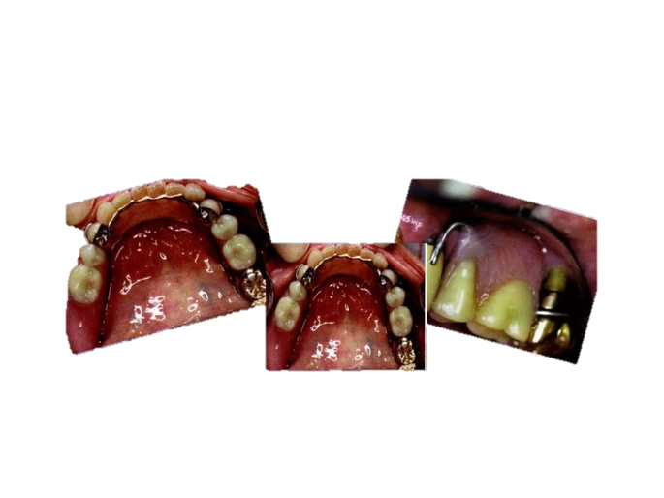

Figure 20:Esthetic Principles in Removable Partial Denture Framework Design

Esthetic principles in removable partial denture (RPD) framework design focus on reducing metal visibility, achieving harmonious integration with oral tissues, and preserving speech and comfort, while simultaneously maintaining adequate strength and biomechanical efficiency.¹⁵ Major connectors, which provide rigidity and unification of the framework, must be carefully selected to remain inconspicuous within the oral cavity; in the maxilla, palatal strap connectors are often preferred for their broad support and minimal visibility due to palatal concealment, making them suitable for shallow vaults, while anterior–posterior palatal straps offer an optimal balance between rigidity and reduced bulk in medium vaults, thereby limiting anterior metal display.
Horseshoe connectors may be indicated in deep palatal vaults or specific clinical situations, but their anterior positioning increases the risk of metal visibility, midline spacing concerns, and potential phonetic disturbances, particularly affecting sibilant sounds. In the mandible, lingual bars are considered the most esthetic option when sufficient functional depth is available, as they provide minimal tissue contact and reduced visibility, whereas lingual plates, although offering enhanced rigidity and indirect retention, introduce greater bulk and may compromise esthetics in patients with shallow lingual sulci or high smile lines.¹⁶
Minor connectors and rests further influence esthetic outcomes and must be designed to blend seamlessly with tooth and gingival contours; placing minor connectors on proximal surfaces away from facial embrasures helps conceal metal components, while smoothly contoured, triangular cross-sectional designs facilitate plaque control and natural gingival flow. Rest seats should be precisely prepared to ensure adequate support without altering occlusion or lip posture, with incisal rests on anterior teeth positioned to avoid labial display and cingulum rests on canines favored for their superior esthetic integration.¹⁷ Careful tissue adaptation, polished surfaces, and alignment with gingival zeniths are essential to prevent irritation, support oral hygiene, and enhance patient comfort, ultimately contributing to improved acceptance of RPDs in esthetically sensitive clinical situations.

Materials used in direct retainer
Cobalt-chromium (Co-Cr) alloy is widely used in removable partial dentures for the fabrication of circumferential clasps and bar clasps due to its high strength, rigidity, and resistance to corrosion. Gold alloys are mainly used in the construction of cast clasps because of their excellent flexibility, adaptability, and high resistance to corrosion. Titanium and its alloys are widely utilized for removable partial denture frameworks as they are lightweight, highly biocompatible, and possess good mechanical strength along with corrosion resistance. Thermoplastic resin materials are commonly used in removable partial dentures, particularly for flexible denture bases, as they provide superior aesthetics, patient comfort, and flexibility. Stainless steel is primarily used for wrought wire clasps due to its adequate strength, flexibility, and ease of manipulation during fabrication

Direct Retainers and Esthetics

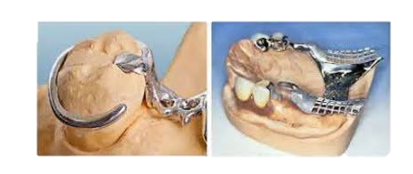

Figure 21: Direct Retainers and Esthetics
Direct retainers play a critical role in removable partial denture (RPD) design by providing adequate retention while simultaneously addressing esthetic demands, particularly in anterior regions where clasp visibility is a major concern.¹⁸ Conventional clasp designs such as circumferential (Akers) clasps are valued for their predictable retention and stability, as they encircle the abutment tooth with a buccal retentive arm positioned above the height of contour and a lingual reciprocal arm; however, their facial metal display often compromises esthetics when used on maxillary canines or premolars within the smile zone. Bar clasp designs, including the I-bar, T-bar, and modified T-bar, approach the undercut from the gingival direction and employ longer, more flexible arms that engage deeper undercuts, thereby reducing metal visibility and improving esthetic outcomes.
Consequently, circumferential clasps are generally preferred in posterior regions or in patients with a low smile line, whereas bar clasps are more suitable for anterior abutments in moderate to high esthetic zones, particularly in distal extension situations. To further enhance esthetics, several modifications have been proposed, such as gingivally approaching or cosmetic clasp designs like the C3PO clasp, which begins above the survey line on the distal surface and engages mesiolingual undercuts, effectively eliminating labial metal display while preserving adequate encirclement.¹⁹
Advanced design concepts, including rotational path RPDs, allow clasp-free retention in anterior regions by using rigid framework components that rotate into place, making them especially advantageous in tooth-borne Kennedy Class III situations, although they demand precise abutment preparation and parallelism. Additional strategies such as clasp relocation through altered surveying, enameloplasty to reposition undercuts, and the use of wrought wire or tooth-colored acetal resin clasps further minimize metal display, emphasizing that the selection of direct retainers must be individualized based on edentulous space location, smile line analysis, and overall esthetic requirements without compromising functional integrity.²⁰

Esthetic Considerations in Denture Base and Artificial Teeth Selection

The selection of denture base materials and artificial teeth in removable partial dentures (RPDs) plays a decisive role in achieving favorable esthetic outcomes by closely simulating the appearance of natural oral tissues and dentition while complementing the underlying framework design.Acrylic resin remains the most widely used denture base material owing to its excellent adaptability, ease of processing, and ability to achieve accurate shade matching through multilayered pigmentation and controlled translucency that replicates natural gingival variations, although its long-term esthetic stability may be compromised by surface porosity and loss of luster over time.²¹
Flexible nylon-based or polyamide denture bases, such as Valplast, provide enhanced translucency and tooth-colored appearance that blends seamlessly with surrounding gingiva, making them particularly suitable for esthetically demanding situations and high smile line cases, especially among geriatric patients, despite their comparatively lower rigidity and limited adjustability. In metal–acrylic frameworks, careful management of the junction between materials is essential, with scalloped finishing lines, highly polished ledges, and the use of opaquers to prevent shadowing and mask alloy show-through at the tissue interface.²² Artificial tooth selection further refines esthetic integration, with shade matching performed relative to adjacent natural teeth under neutral lighting conditions, emphasizing cervical-to-incisal color gradients and subtle surface characterization achieved through intrinsic staining techniques.
Tooth form and arrangement are guided by facial morphology and esthetic principles, with square forms often complementing broader facial types and tapered or ovoid forms harmonizing with narrower profiles, while slight rotations, spacing, and individualized positioning enhance natural appearance and occlusal balance. Gingival characterization through contoured acrylic that reproduces natural scalloping and stippling further enhances realism, and the incorporation of digital preview and planning tools allows precise customization and improved predictability, ultimately ensuring that denture base and tooth selection contribute to a harmonious, lifelike, and patient-acceptable RPD.

Esthetic RPD Design in Specific Clinical Situations and Contemporary Practice
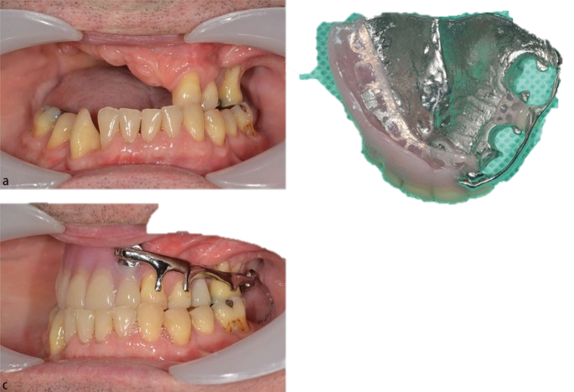

Figure 22:Esthetic RPD Design in Specific Clinical Situations and Contemporary Practice

Esthetic removable partial denture (RPD) design must be tailored to specific clinical situations such as anterior edentulous spaces and patients with high smile lines, where visibility of prosthetic components poses a significant challenge and implant therapy may not always be feasible. In anterior edentulous conditions, particularly Kennedy Class IV cases, excessive labial flange extension can result in unnatural lip support or reveal metal frameworks in areas of soft tissue deficiency; these concerns can be addressed by precise ridge adaptation, reduced or metal-free denture bases, and the use of precision or semi-precision attachments on strategically positioned abutments, such as canines, to achieve clasp-free retention while directing occlusal forces along the long axis of the teeth.²³
Rotational path RPD designs are especially advantageous in such scenarios, as they utilize proximal undercuts and a posterior-to-anterior path of insertion to eliminate the need for visible anterior clasps while conserving abutment tooth structure. In patients with high smile lines, dynamic smile analysis is essential to identify zones of metal exposure,
and esthetic management may involve gingivally approaching I-bar clasps, tooth-colored acetal resin clasps placed below the lip line, back-action clasp designs on lingual surfaces, or complete concealment through the use of semi-precision attachments, with careful phonetic evaluation to prevent speech disturbances such as sibilant distortion.²⁴
The integration of digital technologies has further enhanced esthetic predictability, as CAD–CAM fabricated frameworks provide controlled thickness and precise clasp dimensions using materials such as cobalt–chromium or high-performance polymers like PEEK, resulting in reduced bulk and improved comfort. Three-dimensional printing of trial frameworks and clasp components enables virtual try-ins and significantly reduces chairside adjustments, while digital smile analysis combining intraoral scans with facial photographs allows clinicians to visualize and refine esthetic outcomes before fabrication.
Patient satisfaction is increasingly assessed using both subjective and objective measures, including visual analog scales for perceived naturalness and spectrophotometric analysis to ensure clinically acceptable shade matching, with improvements in esthetics consistently associated with enhanced oral health–related quality of life, particularly among geriatric patients. Common esthetic complaints such as clasp visibility or base overextension can often be resolved through polishing, material substitution, or relining, underscoring the importance of ongoing evaluation and patient feedback in achieving long-term acceptance of esthetic RPDs.²⁵

Conclusion
Esthetic success in removable partial denture design relies on minimizing metal visibility, achieving harmonious integration with oral tissues, and balancing esthetics with biomechanical stability and function. Advances in biomaterials and digital, AI-assisted design workflows have expanded the scope for natural-looking, precise, and predictable esthetic outcomes. From a clinical standpoint, these innovations enhance patient acceptance, comfort, and long-term satisfaction, particularly in esthetically demanding situations. Ultimately, individualized, patient-centered RPD design remains fundamental to delivering prostheses that are both visually pleasing and functionally effective.
References
- Donovan TE, Cho GC. Functional considerations with removable partial dentures. J Calif Dent Assoc. 2003 Jul;31(7):551-7. PMID: 12934629.
- Khalaf FS. Aesthetic criteria in removable partial dentures [BDS project]. Baghdad (Iraq): University of Baghdad; 2023.
- Becker CM, Kaiser DA, Goldfogel MH. Evolution of removable partial denture design. J Prosthodont. 1994 Sep;3(3):158-66. doi: 10.1111/j.1532-849x.1994.tb00147.x. PMID: 7874258.
- Sykora O. Esthetic considerations in the construction of a removable partial denture. Quintessence Int. 1994 Nov;25(11):757-62. PMID: 7568679.
- Ceraulo, S. Aesthetics in Removable Partial Dentures: Modification of the Proximal Plate and Retentive Lamellae in Kennedy Class II Scenarios. Prosthesis 2024, 6, 107-118. https://doi.org/10.3390/prosthesis6010009
- Ganapathi A, Ganapathy D, Jeevitha M. function removable partial denture patients visiting university dental hospital. Int J Psychosoc Rehabil. 2019;23(5):892-895.
- Seltzer, T. (2007). Predictable removable partial dentures using proper design and rest preparations. Dentistry Today, 26(9). https://www.ncbi.nlm.nih.gov/pubmed/179558699
- Shah, R., & Aras, M. (2015). Esthetics in Removable Partial Denture - A Review. Kathmandu University Medical Journal, 11(44), 344–348. https://doi.org/10.3126/KUMJ.V11I4.13482
- Turagam, N., Mudrakola, D. P., Yelamanchi, R. S., Deepthi, M., & Natarajan, M. (2019). Esthetic Clasp Cast Partial Denture. Journal of International Society. of Preventive and Community Dentistry, 9(1), 94–98. https://doi.org/10.4103/JISPCD.JISPCD_220_18
- Budtz-Jørgensen, E., Bochet, G., Grundman, M., & Borgis, S. (2000). Aesthetic considerations for the treatment of partially edentulous patients with removable dentures. Practical Periodontics and Aesthetic Dentistry: PPAD, 12(8), 765–774. https://pubmed.ncbi.nlm.nih.gov/11404872/
- Grover, I. (2023). Aesthetics of Claps in Removable Partial Denture. International Journal of Advanced Dental Sciences and Technology (IJADST), 2(4), 1–4. https://doi.org/10.54105/ijadst.d1009.062422
- YU, H. (n.d.). Design of Esthetic Removable Partial Denture. https://doi.org/10.3969/j.issn.1674-1595.2012.02.002
- Demir A, Bolayir G, Demir H, Soygun K. Esneyebilir bir protez kaide rezin ile hareketli bölümlü protezlerin yapımı: vaka sunumu [Fabrication of removable partial dentures with a flexible denture base resin: a case report]. Cumhuriyet Dent J. 2012;15(4):366-372. doi: 10.7126/cdj.2012.1132.
- Yeung C, Yu OY, Lam WYH, Leung KCM, Wong AWY, Chu CH. Improving Esthetics of Removable Partial Dentures Using Palatal Retentive Arms. Clin Cosmet Investig Dent. 2020 Sep 29;12:391-397. doi: 10.2147/CCIDE.S266145. PMID: 33061651; PMCID: PMC7532890.
- Techapiroontong S, Chuenjitwongsa S, Limpuangthip N. Determinants of removable partial denture success in patients’ perspectives. J Dent. 2025 Dec;163:106145. doi: 10.1016/j.jdent.2025.106145.
- Budtz-Jorgensen E, Bochet G. Alternate framework designs for removable partial dentures. J Prosthet Dent. 1998 Jul;80(1):58-66. doi: 10.1016/s0022-3913(98)70092-7. PMID: 9656179.
- Khan SB, Geerts GA. Aesthetic clasp design for removable partial dentures: a literature review. SADJ. 2005 Jun;60(5):190-4. PMID: 16052751.
- Waskitho A, Widiantoro AY, Ishmah NQ. Wrought wire clasps aesthetic improvement of removable partial denture using modified C clasp design. Proceeding Improve Qual Dent. 2025 May 30;2(1).
- den Haan R, Battistuzzi PG, Witter DJ, de Baat C, Creugers NH. (Semi)precisieverankering bij frameprothesen [(Semi-)precision attachments for cast metal frame removable partial dentures]. Ned Tijdschr Tandheelkd. 2011 Feb;118(2):93-100. Dutch. doi: 10.5177/ntvt.2011.02.10290. PMID: 21438359.
- Arti, Gupta A, Khanna G, Bhatnagar M, Markose GM, Singh S. Precision Attachments in Prosthodontics: A Review. Int J Prev Clin Dent Res 2018;5(2):S34-39.
- Wolfe RE. Symposium on semiprecision attachments in removable partial dentures. Extracoronal attachments. Dent Clin North Am. 1985 Jan;29(1):185-98. PMID: 3882471.
- Alouthah H, Lippert F, Yang CC, Levon JA, Lin WS. Comparison of surface characteristics of denture base resin materials with two surface treatment protocols and simulated brushing. J Prosthodont. 2025 Jan;34(1):58-67. doi: 10.1111/jopr.13794. Epub 2023 Nov 29. PMID: 37950596; PMCID: PMC11730268.
- Suh JS, Billy EJ. Rotational path removable partial denture (RPD): conservative esthetic treatment option for the edentulous mandibular anterior region: a case report. J Esthet Restor Dent. 2008;20(2):98-105; discussion 106-7. doi: 10.1111/j.1708-8240.2008.00158.x. PMID: 18380839.
- Aras MA, Chitre V. Direct retainers: Esthetic solutions in the smile zone. J Indian Prosthodont Soc. 2005 Mar;5(1):11-14.
- Karmakar S, Goel P, Datta S. Aesthetic clasps: masking the artificiality of denture. J West Bengal State Branch Indian Dent Assoc. 2024 Jul;40(2):22-25.
- McCracken’s Removable Partial Prosthodontics Carr AB, Brown DT. McCracken’s Removable Partial Prosthodontics. 13th ed. St. Louis: Elsevier; 2016
- Phoenix RD, Cagna DR, DeFreest CF. Stewart’s Clinical Removable Partial Prosthodontics. 4th ed. Chicago: Quintessence; 2008
- Arnold C, Hey J, Schweyen R, Setz JM. Accuracy of CAD-CAM fabricated removable partial dentures. Clin Oral Investig. 2018;22:321–327.
- Jacobson TE, Krol AJ. A contemporary review of factors involved in retention, stability, and support. J Prosthet Dent. 1983;49(1):5–15.
- Avenport JC, Basker RM, Heath JR, Ralph JP. Principles of removable partial denture design. Br Dent J. 2000;189(8):414–424.

