Study of Biocontrol Efficacy of SiO₂ Nanoparticles Combined with PGPR (Pseudomonas Spp and Bacillus Spp) Against Rhizoctonia Solani in Tomato Plants

Abstract:
In the present study, the effect of silicon dioxide Nanoparticles (SiO₂ -NPs) combined with plant growth promoting rhizobacteria (PGPR) on the seedling (Morphological) characters and stomatal function of Tomato plant Variety (Lycopersicon esculentum Mill. cv. PKM-1) were studied.The experiment was carried out in Green House at Botany Section, School of Sciences, MANUU.Where healthy and uniform sized-seeds were selected for sowing in pots and they were treated with inoculum and PGPR at 4-leaf stage.The treatments were labelled as control (Untreated), PGPR alone, Combined SiO₂ NPs + PGPR with three replications each.The following characters of the plants were studied 60-days after sowing viz; Shoot Length, Root Length, Fresh Shoot Weight, Fresh Root Weight, Dry Shoot Weight and Dry Root Weight.The results indicated that the mean Shoot length (in cm) was observed as 5.10 in control (Untreated) plants, PGPR alone treated plants showed 5.77 and combined SiO₂ NPs + PGPR treated plants showed 6.80.The mean root length (in cm) was observed as 6.00 in control (Untreated) plants, 8.00 in PGPR alone treated plants and 9.67 in SiO₂ NPs + PGPR treated plants.The fresh shoot weight (in g) was seen as 6.00 in control plants, 7.00 in PGPR alone treated plants and 8.67 in SiO₂ NPs + PGPR treated plants.The fresh root weight (in g) was found to be 3.43 in control(Untreated), 4.97 in PGPR alone treated plants and 5.40 in SiO₂ NPs + PGPR treated plants.The average dry shoot dry weight (in g) was found to be 1.65 in control(Untreated), 2.17 by PGPR alone treated plants and 2.73 in SiO₂ NPs + PGPR treated plants.The mean dry root weight (in g) was found to be 1.33 in control(Untreated), 1.87 in PGPR alone treated plants and 3.28 in SiO₂ NPs + PGPR treated plants.The ANOVA results indicated that all the treatments were found to be significant.The functioning of stomata was observed to be advantageous to the tomato plants treated with combined SiO₂ NPs + PGPR when compared with PGPR alone treated plants and control(Untreated) plants.
Keywords: Biocontrol, Rhizoctonia solani, Damping-off, PGPR, SiO2-Nanoparticles, Synergistic effect.

1.Introduction:
R.solani is a major soil-borne tomato (Lycopersicon esculentum Mill.) disease that causes damping-off and root rot worldwide.One of the earliest approaches to disease control is the use of fungicides.(Mogazy et al., 2024a)The disease results in losses from sowing to maturity in both nursery and transplanted fields. The illness is characterized by the emergence of light brown lesions on the primary root just below the soil surface, with root rot being a significant affliction in tomatoes. The frequency of recurrence is locally determined and primarily contingent upon environmental circumstances. The pathogen is particularly challenging to control in field settings because it persists in soil through resistant structures like sclerotia.(Al-Surhanee et al., 2021)Specific bio-inoculants of Bacillus and Pseudomonas spp. Plant defense activation can significantly reduce the occurrence or severity of many illnesses on a variety of hosts.Conventional management strategies largely rely on chemical fungicides; however, their extensive use has raised concerns regarding environmental pollution, pathogen resistance, and negative impacts on non-target organisms (Mogazy et al., 2024b).PGPR (Pseudomonas spp. and Bacillus spp.)inhibit infections by antibiosis, lytic enzymes, siderophore synthesis, competition, and the induction of systemic resistance (ISR).Studies have shown that SiO₂ nanoparticles improve physiological and biochemical parameters in plants, including photosynthetic efficiency, antioxidant activity, and nutrient uptake(Kumari et al., 2024).However, field performance varies depending on environmental conditions and competition with native bacteria. Nanotechnology, specifically silicon dioxide nanoparticles (SiO₂ NPs), can improve biological control by influencing microbial populations and plant immunology.silicon-based compounds have been reported to induce resistance against R. solani by regulating gene expression and strengthening plant defense systems(Feng et al., 2024).
Silica nanoparticles have been found to improve rhizosphere microbial diversity while suppressing pathogenic microorganisms by modifying community composition and increasing beneficial taxonomic abundance, hence aiding disease resistance.Recent investigations revealed that silver nanoparticles showed strong antifungal response against R.solani which lead to decreased disease severity and enhanced plant health.(Islam et al., 2024).SiO₂ NPs improved physiological response and defense response activation(Ahamad & Siddiqui, 2021a).When both PGPR and SiO2 used in combination it reduced oxidative stress and under stress conditions.(Sharma et al., 2025).PGPR and SiO₂ NPs have been shown to have synergistic effects, despite most studies focusing on abiotic stressors like drought(El-Abeid et al., n.d.).Combining PGPR and SiO₂-NPs application boosted antioxidant enzyme activity, phytohormone levels, and wheat growth during drought stress, indicating better stress mitigation than either treatment alone.Because of their special and incredibly small size, nanoparticles (NPs) improve crop growth, yield, and nutritional quality(Ahamad & Siddiqui, 2021b).It is crucial to use sustainable, environmentally friendly agricultural methods that can withstand both biotic and abiotic challenges(Syed Nabi et al., 2021).Future P fertilizer demand will rise due to population growth, shifting dietary preferences toward meat, and expanding need for bioenergy crops(Liu & Lal, 2014).In agriculture, nanotechnology is being applied to enhance plant nutrition while preserving soil texture and protecting it from microbial diseases(Gohar et al., 2024).Although the advantages of silicon and its significance for plants are well known, less research has been done on the benefits of silicon nanoparticles over their bulk form(Rastogi et al., 2019).Manufactured nanoparticles (MNPs) might inadvertently enter several environmental compartments, such as fresh water, air, soil, etc., through their handling or indirect routes, such as landfills, sewage sludge, and wastewater during their synthesis(Tripathi et al., 2017).One of the many types of microorganisms associated with plants that might trigger plant defenses is Plant Growth-Promoting Rhizobacteria (PGPR)(Kloepper et al., 2004).Although nanotechnology has made significant strides in pharmacology and medicine, agricultural applications have garnered relatively less attention(Worrall et al., 2018).Challenges like loss of soil fertility, deficiency of water, loss due to weeds and pests, climate change etc can be faced by the use of Nano-agroparticles for the advancements of agricultural sector(Mridha et al., 2025).A number of bacterial and fungal isolates from tomato plant roots and rhizosphere considerably decreased tomato Fusarium wilt(Larkin & Fravel, 1998).Numerous researchers have investigated the special characteristics of nanoparticles (NPs), namely their size-activity interactions, to increase the effectiveness of microbial agents(Mahawar & Prasanna, 2018).Nanomaterials have become important instruments for improving agricultural capacity(Fetyan et al., 2024).

2.Materials & Methods:
The tomato seeds (Lycopersicon esculentum Mill. cv. PKM-1) were purchased from the local market of hyderabad.The healthy and uniform sized seeds were surface-sterilized for 10 minutes with 1% sodium hypochlorite solution, then washed several times with double distilled water.The experiment is carried out in the Botany laboratory at Maulana Azad National Urdu University, Hyderabad,Telangana. Pseudomonas fluorescens and Bacillus subtilis (PGPR strains) were isolated from soil of MANUU campus using serial dilution method and grown in nutrient agar medium. R. solani isolated from infected tomato roots showing damping-off symptoms and it is grown on potato dextrose agar medium.After 7 days medium shows fungal growth. Rhizoctonia solani virulent isolated and cultured on PDA medium.
SiO₂ Nanoparticles (SiO₂-NPs) obtained from Nano research laboratory, Jharkhand and the particle size is 30-60nm.Requisite concentration (10ppm, 50ppm, 100ppm) of SiO2-Nanoparticles were dissolved in 10 mL of double distilled water in a 100 mL volumetric flask. Prior to the treatment surfactant (Tween-20) was used.Next,0.01% of Tween -20 was used to wash the roots for 1min and then dipped in SiO₂ Nanoparticles.Pseudomonas fluorescens & Bacillus subtilis (PGPR Strains), standard inoculum are at 28°C. Cell density was standardized to 10⁸ CFU/mL before treatment.
2.1:Greenhouse Studies: A completely randomized design (CRD) with the following treatments was used and three replicates are used.The experiment was setup in combination of Control (no pathogen), R. solani + B. subtilis+ Pseudomonas fluorescens and R. solani + B. subtilis+ Pseudomonas fluorescens+ (SiO₂-NPs).The morphological characters like Shoot length, Root length, Fresh Shoot weight, Fresh root weight, Dry Shoot weight, Dry root weight, Shoot and Root biomass were studied.
2.2:Study of Stomata Characteristics:
Treatments:
- C (Control): No treatment
- T1: PGPR (Pseudomonas spp. + Bacillus spp.)
- T2: SiO₂ nanoparticles + PGPR (moderate concentration)
- T3: SiO₂ nanoparticles + PGPR (higher concentration)
Each treatment was applied to an equal number of plants.

2.3:Observation of Stomatal Characteristics:
Sample Collection
- Fully expanded leaves were collected at a specific growth stage (e.g., 30–45 days after sowing).
2.4:Stomatal Analysis Method:
- The method used was nail polish impression:
  - A thin layer of transparent nail polish was applied on the abaxial (lower) leaf surface.
  - After drying, the film was peeled off using transparent tape.
  - The peel was mounted on a glass slide.
- Slides were observed under a light microscope (40× objective).
- The following parameters were recorded: 1)Stomatal type 2)Stomatal density (number/mm²) and 3)Stomatal aperture size (µm).

2.5:Statistical Analysis:
- one-way Analysis of Variance (ANOVA) was performed.
- The treatments were tested for Significance of differences at p ≤ 0.05 and p ≤ 0.01 levels.
- Statistical software such as OPSTAT was used for analysis.
3.Results and Discussion:
The present study evaluated the effect of PGPR (Pseudomonas spp. and Bacillus spp.) alone and in combination with SiO₂ nanoparticles (SiO₂-NPs) on plant growth parameters. The results revealed a consistent enhancement in all measured parameters under treated conditions compared to the control.A gradual increase in shoot length was observed across treatments, with mean values of 5.10 cm (Control), 5.76 cm (PGPR), and 6.80 cm (SiO₂ + PGPR) was observed.Root length showed a significant increase from 6.00 cm in control to 8.00 cm in PGPR and 9.67 cm in SiO₂ + PGPR.The fresh shoot weight showed 6.00 g (control), 7.00 g (PGPR) and 8.67 g (SiO₂ + PGPR).Fresh root weight increased from 3.43 g (control), 4.97 g (PGPR) and 5.40 g (SiO₂ + PGPR). A pronounced increase in dry root weight was recorded, with values of 1.33 g (control), 1.87 g (PGPR), and 3.28 g (SiO₂ + PGPR).Dry shoot weight was showed as 1.65 g (control), 2.17 g (PGPR) and 2.73 g (SiO₂ + PGPR).

Table-1:Showing Mean Values for the Characters of Tomato Plant PKM-1 Variety
Tomato Plant  PKM-1 Variety | Plant Characters
Tomato Plant  PKM-1 Variety | Mean Shoot Length  (in cm) | Mean Root Length  (in cm) | Fresh Shoot Weight  (in g) | Fresh Root Weight  (in g) | Mean Dry Root Weight  (in g) | Mean Dry Shoot weight  (in g)
Control | 5.10 | 6.00 | 6.00 | 3.43 | 1.33 | 1.65
PGPR | 5.77 | 8.00 | 7.00 | 4.97 | 1.87 | 2.17
SiO₂ NPs+ PGPR | 6.80 | 9.67 | 8.67 | 5.40 | 3.28 | 2.73

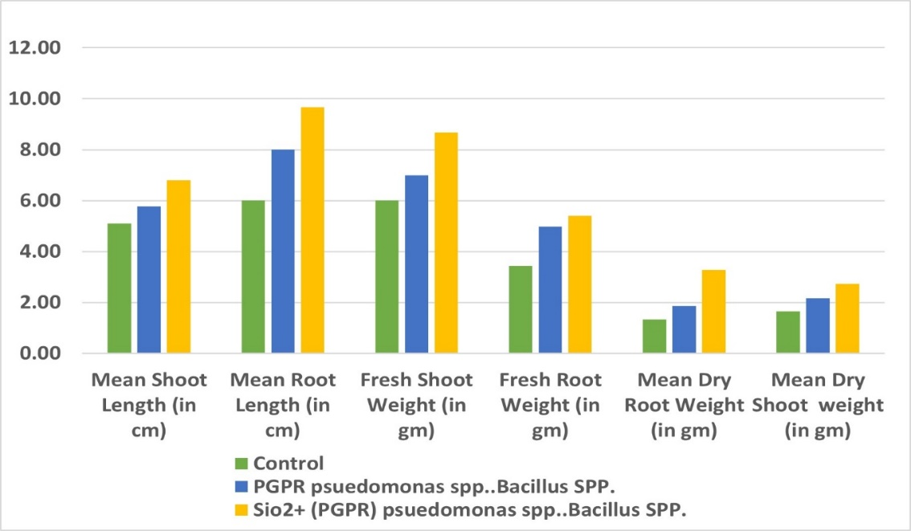
Graph-1: Showing Mean Values of Growth Plant Parameters-Control, PGPR-Treated and SiO₂-NPs PGPR combined Treated

Table-2:Showing One-way ANOVA analysis of Growth Parameters of Tomato Plants PKM-1 Variety.
Parameters | MS (T) | MS (E) | F | Sig. | SE(m) | SE(d) | CD (5%) | CV (%)
Shoot Length | 0.810 | 0.003 | 243.11 | ** | 0.033 | 0.047 | 0.134 | 1.01
Root Length | 3.845 | 0.132 | 29.14 | ** | 0.210 | 0.297 | 0.846 | 16.98
Fresh Shoot Weight | 3.754 | 0.321 | 11.69 | * | 0.327 | 0.463 | 1.319 | 8.19
Fresh Root Weight | 8.770 | 0.088 | 100.23 | ** | 0.171 | 0.242 | 0.689 | 9.86
Dry Root Weight | 6.351 | 0.864 | 7.35 | * | 0.537 | 0.759 | 2.164 | 11.10
Dry Shoot Weight | 5.947 | 0.053 | 112.68 | ** | 0.133 | 0.188 | 0.535 | 6.04
* = Significant at p ≤ 0.05 and ** = Significant at p ≤ 0.01
One-way ANOVA analysis indicated that all the treatments had a highly significant effect.
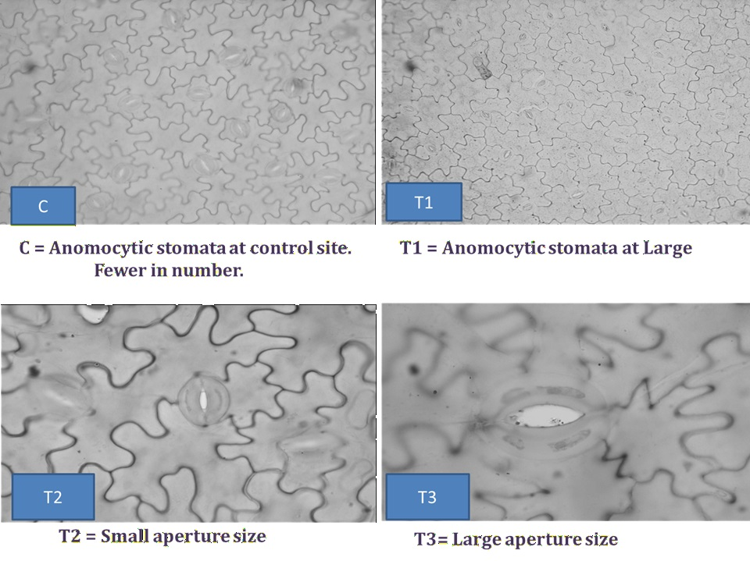Picture -1:Showing Stomatal Characteristics in Control (Untreated), T1(PGPR Alone), T2 (SiO₂ NPs + PGPR moderate concentration) and T3 (SiO₂ NPs + PGPR higher concentration).

Microscopic analysis revealed that all treatments, including control (C), T1 (PGPR), T2 (SiO₂ + PGPR – moderate effect), and T3 (SiO₂ + PGPR – enhanced effect), exhibited anomocytic stomata, indicating that stomatal type remained unaffected by microbial and nanoparticle treatments.
The treatments led to variations in stomatal density and stomatal aperture.The control(Untreated) plants showed little aperture opening and fewer stomata leading to low rate of gas exchange and reduced physiological activity.
PGPR treated plants showed more stomata compared with control(Untreated), improved nutritional uptake and better stomatal function.
Combined treatment (SiO₂ + PGPR) decreased stomatal aperture and lead to partial stomatal closure.Due to this, there will be effective conservation of water by the plant.
The treatment (SiO₂ + PGPR higher efficacy) showed larger stomatal apertures on the leaf of plants with higher CO2 uptake and increased photosynthesis.
These findings are consistent with previous studies reporting that PGPR improve plant physiological traits, while silicon enhances stress tolerance and regulates transpiration dynamics. The combined application appears to create a balance between growth promotion and stress adaptation, as evidenced by variations in stomatal behavior.

4.Conclusion:

The SiO₂-NPs combined with PGPR showed more growth enhancing effect on tomato plants compared to control(Untreated) and PGPR alone treated plants.It supports that NPs facilitate the microbial efficiency which makes them suitable as biocontrol agents.It may involve rhizosphere dynamics, enhanced plant defence responses which leads to decreased disease severity and enhanced plant growth.Field validation and optimizing bioformulations of NPs for disease management of tomato plants are needed for sustainable agriculture.

The ANOVA results revealed that all the treatments are significant.The stomatal study indicates that combined treatment of SiO₂ NPs + PGPR has influenced significantly on the functioning of stomata.

COMPETING INTERESTS DISCLAIMER:
Authors have declared that they have no known competing financial interests OR non-financial interests OR personal relationships that could have appeared to influence the work reported in this paper.
7.References:
Ahamad, L., & Siddiqui, Z. A. (2021a). Effects of silicon dioxide, zinc oxide and titanium dioxide nanoparticles on Meloidogyne incognita, Alternaria dauci and Rhizoctonia solani disease complex of carrot. Experimental Parasitology, 230. https://doi.org/10.1016/j.exppara.2021.108176
Ahamad, L., & Siddiqui, Z. A. (2021b). Effects of silicon dioxide, zinc oxide and titanium dioxide nanoparticles on Meloidogyne incognita, Alternaria dauci and Rhizoctonia solani disease complex of carrot. Experimental Parasitology, 230. https://doi.org/10.1016/j.exppara.2021.108176
Al-Surhanee, A. A., Afzal, M., Bouqellah, N. A., Ouf, S. A., Muhammad, S., Jan, M., Kaleem, S., Hashem, M., Alamri, S., Abdel Latef, A. A. H., Ali, O. M., & Soliman, M. H. (2021). The antifungal activity of ag/chi nps against rhizoctonia solani linked with tomato plant health. Plants, 10(11), 2283. https://doi.org/10.3390/plants10112283
El-Abeid, S. E., Shoala, T., El-Garhy, H. A. S., & Messiha, N. A. S. (n.d.). Open Access BMC Microbiology The efficacy of nanoparticles on soil microbial biodiversity and the prevention of Fusarium wilt disease (Fusarium oxysporum f.sp. lycopersici). https://doi.org/10.1186/s12866-025-04022-3
Feng, Y., Hao, J., Zhang, D., Huo, H., Li, L., Xiu, Z., Yang, C., & Zhang, X. (2024). Transcriptomic Analysis of Sodium-Silicate-Induced Resistance against Rhizoctonia solani AG-3 in Potato. Agronomy 2024, Vol. 14, 14(6). https://doi.org/10.3390/agronomy14061207
Fetyan, N. A. H., Essa, T. A., Salem, T. M., Taha, A. A., Elgobashy, S. F., Tharwat, N. A., & Elsakhawy, T. (2024). Promising Eco-Friendly Nanoparticles for Managing Bottom Rot Disease in Lettuce (Lactuca sativa var. longifolia). Microbiology Research, 15(1), 196–212. https://doi.org/10.3390/microbiolres15010014
Gohar, F., Iqbal, U. Z., Khan, M. B., Rehman, F., Maryam, F. S. U., Azmat, M., Munir, S., Iqbal, H., & Shahid, M. U. (2024). Impact of Nanoparticles on Plant Growth, Development and Physiological Processes: A Comprehensive Review. https://doi.org/10.20944/preprints202410.0780.v1
Islam, A. K. M. S., Bhuiyan, R., Nihad, S. A. I., Akter, R., Khan, M. A. I., Akter, S., Islam, M. R., Khokon, M. A. R., & Latif, M. A. (2024). Green synthesis and characterization of silver nanoparticles and its efficacy against Rhizoctonia solani, a fungus causing sheath blight disease in rice. PloS One, 19(6). https://doi.org/10.1371/journal.pone.0304817
Kloepper, J. W., Ryu, C. M., & Zhang, S. (2004). Induced Systemic Resistance and Promotion of Plant Growth by Bacillus spp. Phytopathology, 94(11), 1259–1266. https://doi.org/10.1094/PHYTO.2004.94.11.1259
Kumari, K., Rani, N., & Hooda, V. (2024). Unravelling the effects of nano SiO2, nano TiO2 and their nanocomposites on Zea mays L. growth and soil health. Scientific Reports 2024 14:1, 14(1), 13996-. https://doi.org/10.1038/s41598-024-61456-x
Larkin, R. P., & Fravel, D. R. (1998). Efficacy of Various Fungal and Bacterial Biocontrol Organisms for Control of Fusarium Wilt of Tomato. Plant Disease, 82(9), 1022–1028. https://doi.org/10.1094/PDIS.1998.82.9.1022
Liu, R., & Lal, R. (2014). Synthetic apatite nanoparticles as a phosphorus fertilizer for soybean (Glycine max). Scientific Reports, 4. https://doi.org/10.1038/srep05686
Mahawar, H., & Prasanna, R. (2018). Prospecting the interactions of nanoparticles with beneficial microorganisms for developing green technologies for agriculture. Environmental Nanotechnology, Monitoring & Management, 10, 477–485. https://doi.org/10.1016/j.enmm.2018.09.004
Mogazy, A. M., Abdallah, W. E., Mohamed, H. I., & Omran, A. A. A. (2024a). The efficacy of chemical inducers and fungicides in controlling tomato root rot disease caused by Rhizoctonia solani. Plant Physiology and Biochemistry, 210, 108669. https://doi.org/10.1016/j.plaphy.2024.108669
Mogazy, A. M., Abdallah, W. E., Mohamed, H. I., & Omran, A. A. A. (2024b). The efficacy of chemical inducers and fungicides in controlling tomato root rot disease caused by Rhizoctonia solani. Plant Physiology and Biochemistry, 210, 108669. https://doi.org/10.1016/j.plaphy.2024.108669
Mridha, D., Lamsal, B., & Antonangelo, J. A. (2025). Nanotechnology in agriculture: Innovations for sustainability and greenhouse gas mitigation-A review. Science of The Total Environment, 995(33), 180065. https://doi.org/10.1016/j.scitotenv.2025.180065
Rastogi, A., Tripathi, D. K., Yadav, S., Chauhan, D. K., Živčák, M., Ghorbanpour, M., El-Sheery, N. I., & Brestic, M. (2019). Application of silicon nanoparticles in agriculture. 3 Biotech, 9(3), 90-. https://doi.org/10.1007/s13205-019-1626-7
Sharma, S., Tripathi, S., Tiwari, K., Mahra, S., & Sharma, S. (2025). Leveraging nano silica and plant growth promoting rhizobacteria (PGPR) isolated from Gangetic riparian zone to Combat Pendimethalin Toxicity in Brassica juncea. Plant Nano Biology, 11(1), 100126. https://doi.org/10.1016/j.plana.2024.100126
Syed Nabi, R. begum, Shahzad, R., Tayade, R., Shahid, M., Hussain, A., Ali, M. W., & Yun, B. W. (2021). Evaluation potential of PGPR to protect tomato against Fusarium wilt and promote plant growth. PeerJ, 9, e11194. https://doi.org/10.7717/peerj.11194
Tripathi, D. K., Shweta, Singh, S., Singh, S., Pandey, R., Singh, V. P., Sharma, N. C., Prasad, S. M., Dubey, N. K., & Chauhan, D. K. (2017). An overview on manufactured nanoparticles in plants: Uptake, translocation, accumulation and phytotoxicity. Plant Physiology and Biochemistry, 110, 2–12. https://doi.org/10.1016/j.plaphy.2016.07.030
Worrall, E. A., Hamid, A., Mody, K. T., Mitter, N., & Pappu, H. R. (2018). Nanotechnology for Plant Disease Management. Agronomy 2018, Vol. 8, Page 285, 8(12), 285. https://doi.org/10.3390/agronomy8120285

