Cassava plantlet survival and growth under Semi-Autotrophic Hydroponics (SAH): Insights from novel varieties in Togo

Abstract
Cassava (Manihot esculenta Crantz), widely cultivated in Africa and ranked as the fourth most produced crop globally, remains constrained by the lack of healthy planting material and its high susceptibility to viral diseases. In a context where access to quality cassava seed remains a major challenge for farmers, the Semi-Autotrophic Hydroponic (SAH) system emerges as an innovative solution to ensure the availability of healthy and vigorous planting material in Togo. This study aimed to evaluate the performance of plantlets from newly introduced IITA varieties obtained through SAH in laboratory conditions, in order to assess their adaptability. The experiment was conducted using a Completely Randomised Design (CRD) with three replications. Two industrial-use varieties (Dixon, Farmer’s Pride) developed by IITA and one local variety (Gbazékouté) were tested. The parameters assessed included contamination rate, establishment rate, collar diameter, plantlet height, leaf number per plantlet, and root number per plantlet. An analysis of variance (ANOVA) was performed, followed by Tukey’s HSD test. The results revealed significant differences among varieties for leaf number, plantlet height, root number, and collar diameter. Farmer’s Pride exhibited superior vigour, with more leaves, greater height, and a better developed root system. Gbazékouté showed a larger collar diameter, indicating robustness, whereas Dixon was generally less performant. These findings suggest that Farmer’s Pride is the variety best adapted to SAH conditions. Overall, these results provide researchers and farmers with concrete bases to improve productivity, secure planting material, and strengthen the resilience of cassava production systems in Togo.
Keywords: Evaluation, Semi-Autotrophic Hydroponic system, Cassava Plantlet, Variety, Togo.

Introduction
Cassava (Manihot esculenta Crantz) is a perennial plant belonging to the family Euphorbiaceae, whose cultivation is of major importance in tropical and subtropical countries of Africa and Latin America (Gmakouba et al., 2024). Its annual tuber production exceeds 200 million tonnes, distributed across Africa (56%), Asia (30%), and Latin America (14%)(Sakadzo et al., 2025). According to (Giles et al., 2018), cassava ranks fourth among global food crop productions, after maize, rice, and wheat. This crop constitutes a staple food for more than 800 million people in tropical and subtropical regions (Ndunguru et al., 2015).
In Togo, cassava is one of the most important staple crops, accounting for more than 50% of the tubers produced nationwide (Tighankoumi et al., 2024). Cultivated in all regions, it plays a crucial role in food security, rural economies, and agro-industrial processing. Despite its strategic importance, the cassava sector faces several challenges, notably low productivity, lack of quality planting material, and vulnerability to diseases and climatic stresses (Gmakouba et al., 2024).
Cassava production in sub-Saharan Africa is largely constrained by pernicious viruses such as cassava mosaic disease, cassava brown streak disease, and several others that damage leaves, thereby reducing photosynthesis and leading to yield losses or even total crop failure. To address these constraints, innovative vegetative propagation techniques have been developed, including the Semi-Autotrophic Hydroponic (SAH) system. Implemented by the International Institute of Tropical Agriculture (IITA), this technique enables the rapid production of healthy, uniform, pathogen-free plantlets, while being more accessible and less costly than in vitro culture (Mamy et al., 2023). The SAH system relies on sterile and nutrient-rich substrates such as peat, vermiculite, or perlite, which ensure adequate aeration and water retention (Mamy et al., 2023). It also promotes effective rooting and controlled growth under laboratory conditions. Unlike conventional stem cuttings, SAH allows rapid multiplication with a high survival rate (>85%), production of pathogen-free plantlets (Iwuagwu & Nwosu, 2018), and reduced costs compared with in vitro culture.
Studies conducted in Democratic Republic of Congo and Nigeria have shown that cassava plantlets obtained through SAH exhibit greater uniformity, more vigorous growth, and enhanced resistance to diseases (Mamy et al., 2023). This technology is particularly suited to African countries to meet the growing demand for quality planting material, while reducing the time required for the dissemination of new varieties.
In response to the increasing demand for healthy and productive planting material, in vitro propagation of cassava plantlets offers a credible alternative. However, the success of their acclimatisation and development under SAH conditions remains poorly documented in Togo. Hence, this study aims to evaluate the laboratory performance of SAH plantlets from new IITA-introduced varieties in Togo, in order to ensure their vegetative vigour and quality prior to large-scale distribution to farmers. This study seeks to contribute to the enhancement of cassava productivity in Togo through an evaluation of the biological performance (survival and growth) of plantlets obtained via the SAH system under controlled conditions. More specifically, it focuses on assessing growth parameters (height, leaf number, collar diameter, and root number) of three newly introduced high-performing varieties under SAH conditions, and identifying the variety best adapted to the system.
1°12'00"
Materials and Methods
Location and description of the SAH laboratory
The experiment was carried out at the SAH laboratory of the Togolese Agricultural Research Institute (ITRA), in Lomé, Cacavéli, Togo (N 6°13’12", E 1°12’00") (Figure 1). The experiment was conducted from August to October 2025.
The laboratory is equipped with standard equipments, enabling the rapid propagation of healthy plantlets across diverse crops, including cassava. The Semi-Autotrophic Hydroponics (SAH) unit is organized into specialized facilities that support each stage of cassava plantlet development. An in vitro culture room houses laminar flow hoods and sterilization equipment, enabling aseptic preparation of explants. Plantlets are then transferred to semi-hydroponic growth chambers with controlled temperature, humidity, and lighting, ensuring uniform growth and vigor. A dedicated multiplication room facilitates regular sectioning every two to three weeks, generating clones and accelerating production. Prior to field transfer, plantlets undergo hardening in an acclimatization room, which prepares them for survival in nurseries or open environments. The system is reinforced by sanitary management and traceability infrastructure, guaranteeing pathogen-free, true-to-type seed material (Makumbu et al., 2024). This integrated approach represents a major innovation for cassava seed systems in Africa.

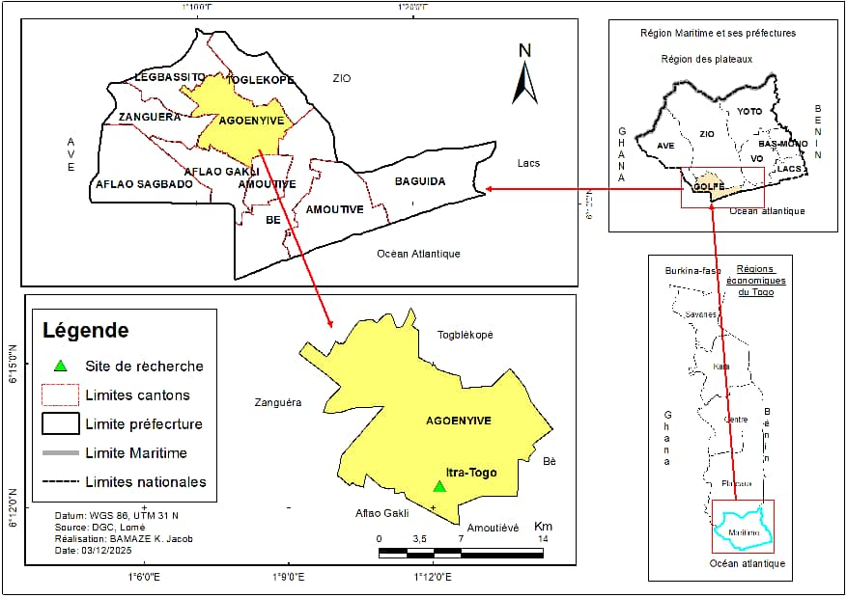
Figure 1. Location of the SAH laboratory of ITRA.

Source and description of the plant material
Plant material was obtained from four-week-old mother plantlets established through tissue culture. The experimental material comprised SAH plantlets of the variety Gbazékouté (TME419), together with two improved varieties, Dixon and Farmer’s Pride, introduced via the cassava breeding program of the International Institute of Tropical Agriculture (IITA), Ibadan. Gbazékouté (TME419), one of the most widely disseminated cassava varieties in West Africa, was developed by IITA to mitigate constraints associated with low productivity and susceptibility to major diseases. It is characterised by high yield potential (25-30 t/ha under favourable conditions), tolerance to cassava mosaic and brown streak diseases (PADES, 2017), adaptability to diverse soils and climates, and starch-rich roots suitable for industrial processing (flour, gari, tapioca). Dixon is distinguished by stable yields under moderate fertility, relative tolerance to major viral diseases, intermediate maturity, and roots suitable for both direct consumption and processing, with the added advantage of good in-soil storage. Farmer’s Pride is recognized for its high yield even under smallholder conditions, combining tolerance to common pests and diseases with high starch content, making it particularly suitable for agro-industrial applications (flour, tapioca, ethanol). Its versatility, combining productivity and processing quality, underpins its growing adoption by farmers.

Technical equipments and Growth Environment
In addition to plant material, a range of technical devices was employed. Small equipment included SAH boxes, which provided a semi-closed environment with substrate for explant transfer; forceps for transplanting and maintenance; and a scalpel with blade for precise sectioning. A wash bottle was used for targeted irrigation with sterile water or nutrient solution, while a hand sprayer ensured surface humidification with water or mineral supplements (Figure 2).
Large equipment comprised an autoclave, which was utilized for substrate sterilisation and to maintain aseptic conditions (Figure 3).
Essential infrastructure was established in a culture room maintained under controlled conditions. The photoperiod was set at 16 hours light and 8 hours dark, with a light intensity of 3170.33 ± 566.02 Lux and a mean temperature of 25.33 ± 0.47 °C, thereby ensuring optimal conditions for plantlet growth.

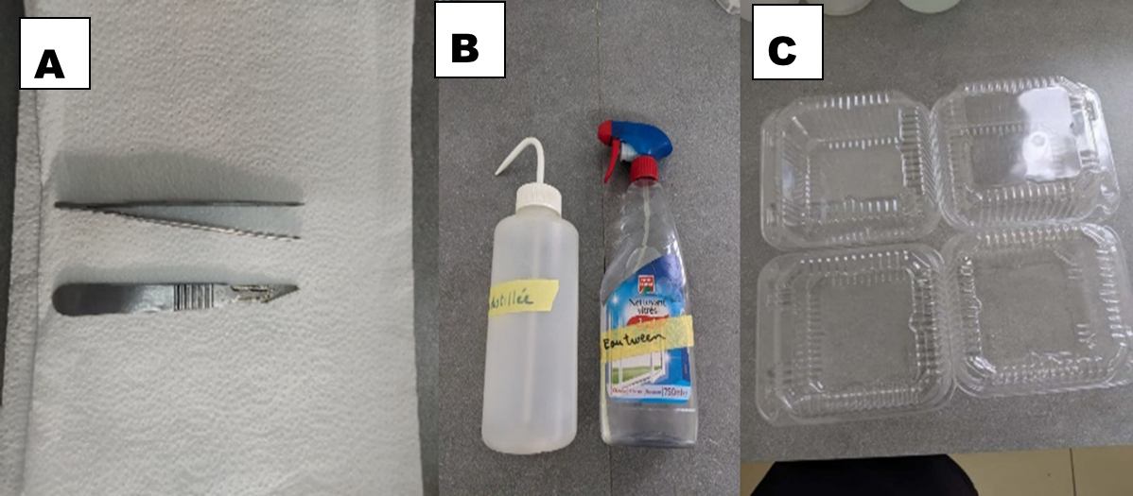

Figure 2. Small equipment used in the experiment: A. Forceps and scalpel; B. Wash bottle and hand sprayer; C. SAH box.
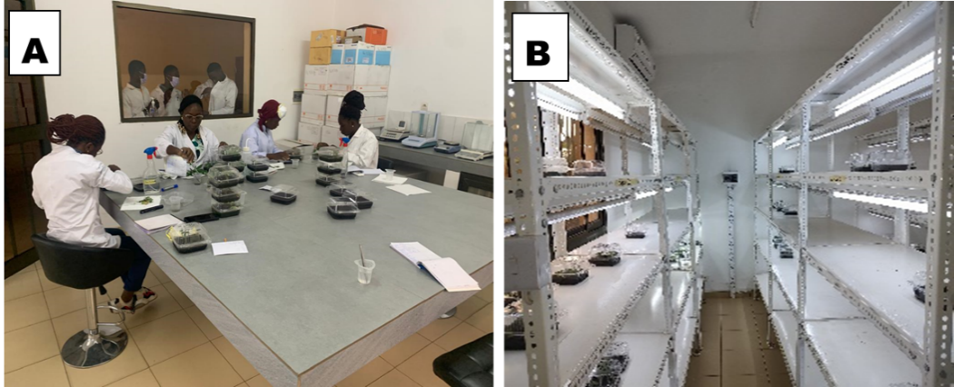

Figure 3. SAH Unit: A. Preparation room; B. Culture (growth) room.
Methods
Experimental design
The experiment was laid out in a completely randomised design with four replicates (Figure 4). Each replication consisted of 12 SAH boxes, with four boxes allocated to each variety. Each box contained 20 plantlets arranged randomly. The SAH boxes were positioned in close proximity, while a spacing of 10 cm was maintained between blocks to ensure experimental isolation and minimize treatment interference.

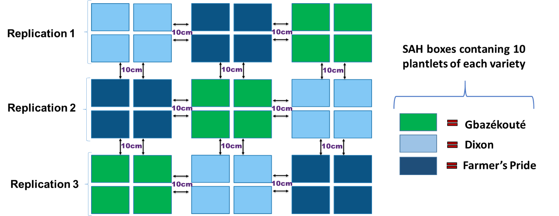
Figure 4. Diagram of the experimental design.
Substrate preparation and planting procedure
The experiment involved cultivating plantlets of each variety in Klasmann TS3 substrate for a single production cycle. KlasmannTS3 consists predominantly of white and black peat, supplemented with organic and mineral components including wood fiber, green compost, and coconut fiber.
The production cycle had a four-week duration. As starting material, four-week-old mother plantlets derived from tissue culture were used for each variety. For planting, 500 ml of KlasmannTS3 substrate was put into a transparent light box of 15 cm × 15 cm × 9 cm ; and irrigated with 75 ml of Miracle-Gro nutrient solution (Figure 5). Twenty cuttings from the mother plants were then inserted at regular intervals of 5 cm × 5 cm (Figure 6). Each cutting measured at least 1 cm in length and contained two nodes and two partially developed leaves. Planting was carried out by inserting 0.5 cm of the cutting into the substrate.

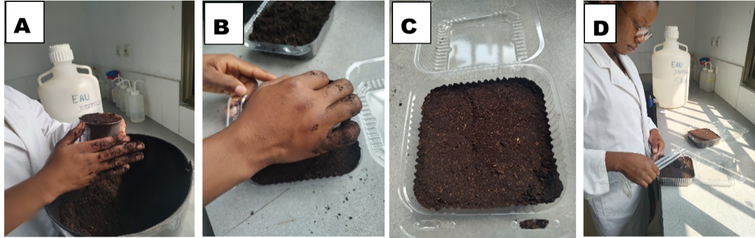
Figure 5: Photo showing the preparation of TS3 substrate: A. Measurement of 500 ml; B. Flattening of the substrate; C. Substrate box; D. Irrigation with Miracle-Gro
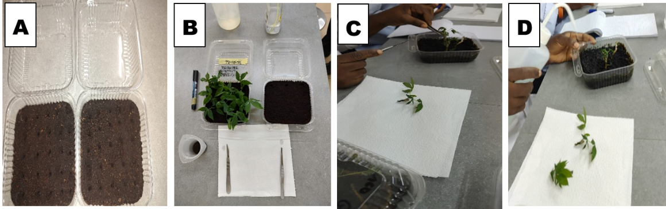
Figure 6. Transplanting of plantlets: A. Hole preparation; B. Transplanting equipment; C. Transplanting; D. Irrigation.

Growth conditions, crop maintenance and nutrient application
The experiment was conducted over a four-week period. Following transplantation, the boxes were maintained in a controlled culture room under a photoperiod of 16 hours of light and 8 hours of darkness per day. Light intensity was maintained at 3170.33 ± 566.02 Lux, and the mean temperature was 25 ± 0.47 °C.
Routine maintenance was carried out throughout the study (Figure 7). The 500 ml of substrate per box was watered with 100 ml of Miracle-Gro All-Purpose Water Solution (2.6 gl/4L) as the nutrient source, at the transplanting time and after that at two-day intervals during the four weeks of the production cycle duration to promote consistent plantlets growth. The SAH boxes lids were kept closed during the growth period to reduce transpiration (Pelemo et al., n.d.)(Makumbu et al., 2024).

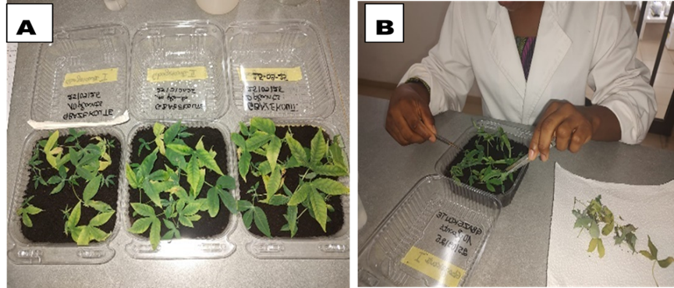
Figure 7 : Maintenance of boxes: A. Plantlets at 7 days after transplanting, B. Weeding within the boxes.
Data collection
Data were collected on plant height, leaf number, collar diameter, and root number together with survival rate and contamination rate. Observations were carried out on ten representative plantlets from each box.
The contamination rate defined as the proportion of plantlets affected by pathogens (bacteria, fungi, viruses) or exhibiting physiological abnormalities during the experiment was determined by counting symptomatic plantlets in each box, with totals per variety and replication recorded on monitoring sheets. The contamination rate was expressed as a percentage according to the formula:

$Contamination rate (\%)=\frac{Number of contaminated plantlets}{Total number of plantlets}$ ×100

Survival rate was calculated as the ratio of plantlets successfully established 14 days after transplanting (DAT) to the total number initially transplanted, expressed as a percentage. Plantlet height was measured with a ruler from the collar base to the apical tip of the main stem. Leaf number was obtained by manual counting of fully developed leaves per plantlet. Collar diameter was measured using a calliper positioned at the stem base at root emergence. Root number was determined after uprooting and manual counting following visual inspection. These measurements were systematically performed on ten plantlets per box at 28 DAT to monitor growth and development.

Data analysis
Values obtained for each parameter were recorded by variety and replication. Raw data were subsequently entered and explored using Microsoft Excel (version 2018). The distribution of variables was assessed using Shapiro-Wilk, Anderson-Darling, Lilliefors, and Jarque-Bera tests to verify normality (Kamath et al., 2025). When variables did not conform to normality, data were transformed to homogenize variances and normalize distributions, thereby meeting assumptions of parametric tests. Square-root transformation was applied to count data, while angular transformation was used for percentage data (Kamath et al., 2025).
Descriptive statistics were computed for each parameter, including mean, standard deviation, minimum, maximum, and coefficient of variation (CV). A one-way ANOVA (factor: variety) was performed at a 5% probability threshold (p < 0.05) to determine significant differences among varieties (Zhang et al., 2025). Post-hoc mean comparisons were conducted using Tukey’s HSD test at the 5% level, enabling both varietal mean comparisons and identification of the variety most suited to SAH system (Pereira et al., 2023). Associations among traits, were examined using Pearson’s correlation test (Karyawati et al., 2021)(Nasir et al., 2023). Data exploration and validation were carried out with XLSTAT (version 2025). Statistical analyses were performed in R (version 4.5.1), employing the agricolae package for ANOVA (Package & Mendiburu, 2025) and Tukey’s HSD, and ggplot2 for graphical visualization of results (Arafat et al., 2013).

Results
Performance of varieties under SAH conditions
Descriptive statistics (Table 1) indicated moderate variation among varieties. Leaf number averaged 5.01 (SD = 0.61), plant height 1.54 cm (SD = 0.36), root number 4.83 (SD = 2.39), and collar diameter 1.99 mm (SD = 0.15). Survival rate was high across all varieties (mean = 95.56%, SD = 7.27%), while contamination rate averaged 27.78% (SD = 13.02).
ANOVA results (Table 2) revealed significant varietal differences for leaf number (p < 0.01), plantlet height (p < 0.001), root number (p < 0.05), and collar diameter (p < 0.05). No significant differences were observed for survival or contamination rates (p > 0.05).
Tukey’s HSD test (Table 3; Figure 8) showed that Farmer’s Pride produced significantly more leaves than Gbazékouté and Dixon, which did not differ from each other. For plantlet height, all three varieties were distinct: Farmer’s Pride was tallest, followed by Dixon, then Gbazékouté. Root number was highest in Farmer’s Pride, lowest in Dixon, with Gbazékouté intermediate. Collar diameter was greater in Gbazékouté than in Dixon, while Farmer’s Pride was intermediate and not significantly different from either. Survival rates were uniformly high, and contamination rates remained comparable across varieties (Figure 8).

Table 1: Descriptive statistics of morphological traits of cassava plantlets under SAH culture at 21 days after transplanting

Traits | Minimum | Maximum | Mean | Standard deviation
NbreLeaPlt | 4.20 | 6.00 | 5.01 | 0.60
HPlt (cm) | 1.05 | 2.15 | 1.54 | 0.36
NbreRoPlt | 1.60 | 8.30 | 4.83 | 2.39
Diam (mm) | 1.85 | 2.33 | 1.99 | 0.15
%Surv | 80.00 | 100.00 | 95.55 | 7. 26
%Conta | 10.00 | 40.00 | 27.77 | 13.01
NbreLeaPlt = Number of leaves per plantlet; HPlt = Height of a plantlet; NbreRoPlt = Number of roots per plantlet; Diam = Collar diameter of a plantlet; %Surv = Survival rate; %Conta = Contamination rate.

Table 2: Analysis of variance (ANOVA) results for growth parameters of cassava varieties under SAH conditions
Parameter | Sum of Squares  (SS) |  |  | Mean Square  (MS) |  |  | Fisher’s F statistic | Probability (P)
Parameter | Variety  (df = 2) | Error  (df = 6) |  | Variety  (df = 2) | Error  (df = 6) |  | Fisher’s F statistic | Probability (P)
%Surv | 155.60 | 266.70 |  | 77.78 | 44.44 |  | 1.75 | 0.252
%Conta | 228.90 | 1066.70 |  | 144.40 | 177.80 |  | 0.813 | 0.487
Diam (mm) | 0.13 | 0.07 |  | 0.07 | 0.01 |  | 6.027* | <0.0367
NbreLeaPlt | 2.63 | 0.34 |  | 1.31 | 0.06 |  | 23.20** | 0.0015
NbreRotPlt | 30.66 | 15.34 |  | 15.33 | 2.55 |  | 5.996* | 0.0371
HPlt (cm) | 0.94 | 0.09 |  | 0.47 | 0.01 |  | 29.46*** | <0.0008
NbreLeaPlt = Number of leaves per plantlet; HPlt = Height of a plantlet; NbreRotPlt = Number of roots per plantlet; Diam = Collar diameter of a plantlet; %Surv = Survival rate; %Conta = Contamination rate. * = Significant; ** = Highly significant; *** = Very highly significant.

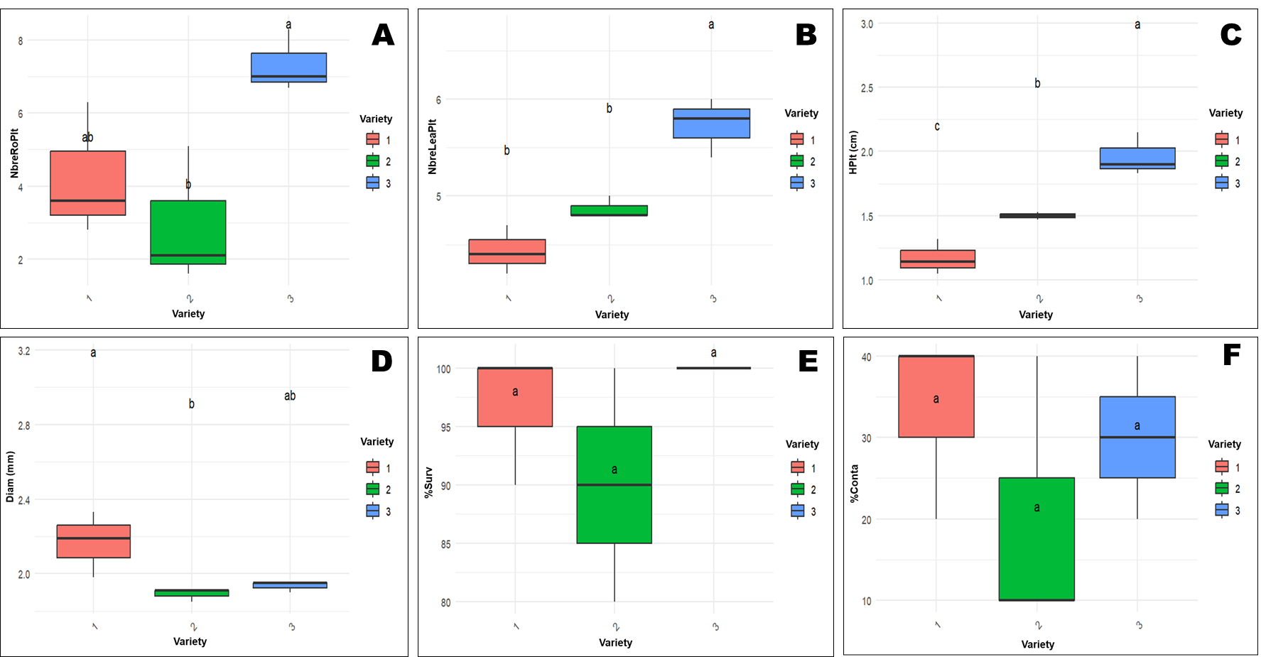
Figure 8: Grouping of three cassava varieties based on agronomic parameters under SAH conditions. A = Number of roots per plantlet; B = Number of leaves per plantlet; C = Plantlet height; D = Collar diameter of a plantlet (cm); E = Survival rate of the varieties (%); F = Contamination rate of the varieties. Varieties for which the boxplots are followed by the same letter are statistically equivalent for the parameter considered and are therefore classified within the same group.

Table 3: Performance of three cassava varieties evaluated under SAH conditions three weeks after planting.
Code | Variety | NbreLeaPlt | HPlt (cm) | NbreRoPlt | Diam | %Surv | %Conta
V1 | Gbazékouté | 4.43^{b} | 1.17^{c} | 4.23^{ab} | 2.17ª | 96.70ª | 33.30 ª
V2 | Dixon | 4.87^{b} | 1.50^{b} | 2.93^{b} | 1.89^{b} | 90.00ª | 20.00 ª
V3 | Farmers’ Pride | 5.73ª | 1.96ª | 7.33ª | 1.93^{ab} | 100.00ª | 30.00 ª
Mean |  | 5.01 | 1.54 | 4.83 | 1.99 | 95.55 | 27.77
Coefficient of variation (%) |  | 12.20 | 23.40 | 49.60 | 7.90 | 7.60 | 4.69
Fisher’s F statistic |  | 23.20** | 29.46*** | 5.99* | 6.02* | 1.75 | 0.81
NbreLeaPlt = Number of leaves per plantlet; HPlt = Height of a plantlet; NbreRoPlt = Number of roots per plantlet; Diam = Collar diameter of a plantlet; %Surv = Survival rate; %Conta = Contamination rate. Values within the same column followed by the same letter are not statistically different at 5% level according to Tukey’s test

Correlations between agronomic and morphological parameters
Significant positive correlations were observed among agronomic and morphological parameters (Table 4). Leaf number was strongly correlated with plantlet height (r = 0.918) and root number (r = 0.687). Plantlet height was positively correlated with root number (r = 0.534). Collar diameter showed a positive correlation with survival rate (r = 0.433). The strongest correlation was between leaf number and plantlet height, indicating a close linkage between these two growth traits.

Table 4. Pearson correlation matrix of agronomic and morphological traits in cassava plantlets under SAH conditions
Parameter | NbreLeaPlt | HPlt | NbreRoPlt | Diam | %Surv | %Conta
NbreLeaPlt | 1 | 0,918* | 0,687* | -0,590 | 0,267 | 0,051
HPlt | 0,918* | 1 | 0,534 | -0,492 | 0,226 | 0,108
NbreRoPlt | 0,687* | 0,534 | 1 | -0,235 | 0,340 | 0,083
Diam | -0,590 | -0,492 | -0,235 | 1 | 0,433 | 0,227
%Surv | 0,267 | 0,226 | 0,340 | 0,433 | 1 | -0,250
%Conta | 0,051 | 0,108 | 0,083 | 0,227 | -0,250 | 1

NbreLeaPlt = Number of leaves per plantlet; HPlt = Height of a plantlet; NbreRoPlt = Number of roots per plantlet; Diam = Collar diameter of a plantlet; %Surv = Survival rate; %Conta = Contamination rate. Values shown in bold are significantly different from zero at 5% level (α = 0.05)

Discussion
Performance of cassava varieties under SAH conditions
Descriptive statistical analyses highlighted clear patterns in the morphological traits of the studied varieties, revealing both stability and differentiation across parameters. Leaf number averaged 5.01 with low dispersion, reflecting relative homogeneity among plantlets and suggesting that foliage production is a relatively stable trait across genotypes. This observation aligns with findings in cowpea, where certain morphological traits exhibited limited variability acrose accessions, indicating trait stability within germplasm collections (Chaudhary et al., 2025).
In contrast, plantlet height displayed moderate dispersion, with a mean of 1.54 m and values ranging from 1.05 to 2.15 m. This variability underscores clear varietal differentiation, pointing to differences in growth vigor and adaptability. Similar patterns of agro-morphological variability have been reported in groundnut accessions, where height and biomass traits were strongly influenced by genetic background and environmental interactions (Amoah et al., 2023). Such differentiation is critical for varietal selection, as height variability often reflects adaptive strategies to resource availability and system-specific constraints.
Root number emerged as the most variable trait, averaging 4.83 but accompanied by a high standard deviation. This pronounced variability confirms strong varietal influence, suggesting that root development is highly genotype-dependent. Root system traits have been widely recognized as key determinants of plant performance under diverse agro-ecological conditions, with intraspecific variability often linked to functional adaptation and resilience (Yang et al., 2025). The strong dispersion observed here reinforces the importance of root traits in varietal evaluation, particularly in systems where below-ground resource acquisition is critical.
Taken together, these findings emphasize the dual importance of stability and variability in varietal performance. While leaf number appears relatively conserved, plant height and root number provide meaningful differentiation that can guide breeding and selection strategies. Integrating descriptive statistics with inferential analyses such as ANOVA and correlation networks offers a multidimensional perspective, enabling identification of varieties that balance trait stability with adaptive potential (de Mendiburu, 2023)
ANOVA and Tukey’s HSD test highlighted significant differences among varieties for growth parameters (leaf number, height, root number, and collar diameter). The variety Farmer’s Pride exhibited superior vigour, making it a strong candidate for multiplication and dissemination. Its enhanced growth reflects better adaptation to SAH conditions (water and nutrient availability), a major advantage for cassava seed systems in Togo. Conversely, Gbazékouté, though less vigorous, displayed a larger collar diameter, indicative of structural robustness, which may be valuable in environments requiring mechanical resistance.
No significant differences were observed among varieties for survival and contamination rates, suggesting that these parameters depend more on cultural conditions than on genetic factors. Previous studies (Makumbu et al., 2024) confirmed that substrate quality, humidity, and hygiene practices strongly influence these variables, underscoring the need for technical innovations rather than varietal selection to improve them.
Controlled experimental conditions (24 °C, light intensity of 3170.33 ± 565.82 Lux for 16 h, and TS3 substrate moistened with Miracle Gro solution) ensured steady growth and high survival rates, consistent with optimal conditions reported by (Makumbu et al., 2024). The contamination observed was fungal, linked to substrate storage conditions. SAH culture, by maintaining balanced water and nutrient availability, promotes photosynthesis, root aeration, and osmotic regulation. Unlike gel- based media, SAH provides better root oxygenation and reduces asphyxia risks, thereby enhancing growth and resilience. This explains the robust root development observed in Farmer’s Pride (7.33 roots on average), reflecting improved nutrient assimilation and metabolic activity.
Varietal differences resulted from complex interactions between genetic potential and environmental conditions. High-performing genotypes such as Farmer’s Pride demonstrated greater phenotypic plasticity, enabling efficient adaptation to semi-hydroponic systems. Differential development of roots and leaves confirms that growth mechanisms rely on balanced interactions between nutrient environment and internal regulation (Makumbu et al., 2024). Root variability (2.6-7.3) indicates that rooting capacity depends on both genetics and substrate oxygen/nutrient availability, consistent with Carvalho et al. (2017), who reported that cassava morphological responses in vitro depend on medium composition and genotype capacity to manage oxidative stress.
Compared with conventional culture methods, SAH offers major advantages: reduced input costs, simplified cultivation, and improved physiological quality of plantlets (Science et al., 2023). It enables the production of healthy, uniform material ready for acclimatisation, supporting rapid multiplication and dissemination of improved varieties (Makumbu et al., 2024).
Agronomically, this approach is particularly relevant for cassava breeding and dissemination programmes in Togo, where demand for vigorous, healthy cuttings is high. Results highlight the need to tailor cultural parameters to each variety to optimise growth and post-acclimatisation survival.
Overall, these findings confirm that morphological traits are essential criteria for varietal selection and productivity improvement, while sanitary parameters should be optimised through adapted cultural practices. They contribute to the valorisation of local varieties and the strengthening of sustainable agricultural systems.
Correlations among evaluated traits
The correlation matrix revealed statistically significant associations among the studied traits, highlighting functional interdependencies that underpin varietal performance. Leaf number was strongly and positively correlated with plantlet height (r=0.918), reflecting a close linkage between foliar development and stem elongation. This relationship supports agronomic observations that enhanced leaf production increases photosynthetic capacity, thereby promoting vertical growth (Reflinur et al., 2026). Similar findings have been reported in cowpea and soybean, where leaf area expansion was directly associated with biomass accumulation and plant stature (Chaudhary et al., 2025).
Leaf number also exhibited a positive correlation with root number (r=0.687), suggesting that genotypes producing more foliage tend to develop denser root systems. This synergy between aerial and underground growth is consistent with reports in groundnut and rice, where vegetative vigor was linked to improved root proliferation and nutrient uptake efficiency (Amoah et al., 2023). Plantlet height was likewise positively correlated with root number (r=0.534), confirming that vigorous varieties integrate above-ground expansion with below-ground anchorage, a trait combination that enhances resilience in low-input systems.
Collar diameter showed a positive correlation with survival rate (r=0.433), underscoring the importance of structural robustness in post-transplant adaptation. This observation aligns with earlier work emphasizing morphological traits as reliable indicators of varietal resilience and establishment success (Souza & Filho, 2024) . Recent studies in cassava further corroborate that thicker stem diameters are associated with improved survival and adaptability under field conditions (Yang et al., 2025).
Overall, these significant correlations highlight functional relationships between morphological and agronomic traits. Vegetative vigor (leaf number, height, root number) and structural robustness (collar diameter) emerge as key criteria for varietal selection and productivity improvement. The strong association between leaf number and plantlet height suggests that aerial vigor can serve as an early indicator of growth potential, facilitating rapid identification of high-performing varieties. Similarly, the positive relationships among leaf number, height, and root number confirm that vigorous genotypes combine enhanced photosynthetic capacity with improved nutrient absorption, a major advantage in resource-limited environments. The correlation between collar diameter and survival rate underscores the role of stem robustness in ensuring successful establishment, highlighting the need to prioritize varieties with larger diameters in breeding and extension programs.
By integrating these relationships into varietal selection frameworks, breeders and extension agents can develop simple, reliable indicators for monitoring crop performance. Such trait-based selection strategies not only enhance the efficiency of varietal improvement programs but also provide farmers with practical tools to identify resilient, high-yielding varieties, thereby contributing to sustainable agricultural productivity.

Conclusion
This study assessed the survival and growth of cassava plantlets from three novel varieties under Semi-Autotrophic Hydroponics (SAH) conditions, with the overarching goal of providing farmers in Togo with reliable, high-quality planting material. The results demonstrate that cassava plantlet performance under SAH is strongly influenced by varietal differences, with vegetative vigor and structural robustness emerging as decisive traits for adaptation and resilience. Descriptive statistics revealed clear patterns of variability, while correlation analyses confirmed functional linkages among leaf number, plantlet height, root number, and collar diameter. These relationships highlight the dual importance of aerial vigor and stem robustness in ensuring successful establishment and resilience under SAH conditions.
Significant varietal differences were observed across key agronomic and morphological parameters, including leaf number, plantlet height, root number, and collar diameter. Among the tested varieties, Farmer’s Pride demonstrated superior vigor, characterized by enhanced leaf production, greater stem elongation, and a more developed root system, making it the most adapted to SAH conditions. Gbazékouté distinguished itself by a larger collar diameter, indicative of structural robustness and resilience, while Dixon was comparatively less performant across most evaluated traits.
The findings not only identify practical selection criteria for breeding programs but also offer farmers simple, reliable indicators to monitor crop performance. Overall, this research underscores the potential of SAH as a scalable propagation system for cassava in Togo. The identification of high-performing varieties based on morphological and survival traits provides actionable insights for extension strategies, contributing to sustainable productivity gains in low-input farming systems. Future research should extend these insights by assessing the agronomic and phytosanitary performance of SAH-derived plantlets after acclimatization and field establishment. Such investigations will be critical to validating the long-term effectiveness of SAH technology and strengthening its role in the sustainable production of high-quality cassava seed, thereby contributing to improved productivity and resilience in smallholder farming systems.

Data availability : The data supporting this study are freely available from the corresponding author upon request.

COMPETING INTERESTS DISCLAIMER:
Authors have declared that they have no known competing financial interests OR non-financial interests OR personal relationships that could have appeared to influence the work reported in this paper.

References

Adu Amoah, R., Nelimor, C., Gymafi, B. A., Boampong, R., Osei, C. Y., Yeboah, A., … Aboagye, L. M. (2023). Analysis of agro-morphological variability and inter-trait relationships in Ghanaian groundnut (Arachis hypogaea L.) accessions. Plant Genetic Resources: Characterization and Utilization, 21(5), 471–479. http://dx.doi.org/10.1017/S1479262123000916.
Arafat, Sayed M, Mohamed A Aboelghar, and Eslam F Ahmed. 2013. Crop Discrimination Using Field Hyper Spectral Remotely Sensed Data. Advances in Remote Sensing, 2, 63–70. http://dx.doi.org/10.4236/ars.2013.22009.
Giles, J. A. D., Rodrigues, W. P., Oliosi, G., Partelli, F. L., Vieira, H. D., & Da Silva Santos, V. (2018). Genetic diversity as tool to identify standard leaf nutrients in cassava genotypes. Genetics and Molecular Research, 17(1). https://doi.org/10.4238/gmr16039862
Gmakouba, T., Dzidzienyo, D. K., Koussao, S., & Tongoona, P. (2024). Identifying cassava production constraints , farmers preferences , and cassava mosaic disease perceptions in Togo : insights for a participatory breeding approach. Agriculture & Food Security, 9. https://doi.org/10.1186/s40066-024-00518-9
Iwuagwu, M. O., & Nwosu, N. N. (2018). Performance of In Vitro Cassava (Manihot esculenta Crantz ) Plantlets Weaned with Locally Sourced Substrates. International Journal of Environment, Agriculture and Biotechnology. 3 (2), 663–669. http://dx.doi.org/10.22161/ijeab/3.2.472.
Kamath, A., Poojari, S., & Varsha, K. (2025). Assessing the robustness of normality tests under varying skewness and kurtosis : a practical checklist for public health researchers. BMC Med Res Methodol 25, 206. https://doi.org/10.1186/s12874-025-02641-y.
Karyawati, A. S., Sinthia, E. N. O., & Puspitaningrum, V. (2021). Correlation and path analysis for agronomic traits contributing to yield in 30 genotypes of soybean. 22(3), 1146–1151. https://doi.org/10.13057/biodiv/d220309.
Makumbu, M., Id, B., Kokou, K., Mouritala, S., Najimu, A., Ibnou, D., Angelique, K., Mignouna, J., & Nyende, A. B. (2024). An alternative Semi-Autotropic Hydroponics ( SAH ) substrate for cassava rapid propagation : A first study case. 1–20. https://doi.org/10.1371/journal.pone.0311437.
Mamy, B.M., Kokou, K., Sikirou, M., Adetoro, N., Angelique, K. & Nyende, A.B. (2023). Performances of plantlets from selected cassava (Manihot esculenta Crantz) genotypes under Semi-Autotrophic Hydroponics (SAH) using different substrates. Journal of Agriculture, Science and Technology, 22(6), 66-89. https://doi.org/10.4314/jagst.v23i6.5

Nasir, B., Razzaq, H., Sadaqat, H. A., Wahid, M. A., & Imtiaz, M. (2023). Correlation and path coefficient analysis in soybean under various levels of water and temperature at maturity stage. 60(1), 107–115. https://doi.org/10.21162/PAKJAS/23.24.
Ndunguru, J., Sseruwagi, P., Tairo, F., Stomeo, F., Maina, S., Djikeng, A., Kehoe, M., & Boykin, L. M. (2015). Correction: Analyses of Twelve New Whole Genome Sequences of Cassava Brown Streak Viruses and Ugandan Cassava Brown Streak Viruses from East Africa: Diversity, Supercomputing and Evidence for Further Speciation. PLOS ONE, 10(10), e0141939. https://doi.org/10.1371/journal.pone.0141939
Package, T., & Mendiburu, A. F. De. (2025). Package ‘ agricolae .’
Pelemo, O., Benjamin, G., Adejumobi, I., Olusola, T., Odom-kolombia, O., Adeosun, T., Edemodu, A., Matsumoto, R., Paterne, A., Adebola, P., & Asfaw, A. (2019). Semi-Autotrophic Hydroponics : A potential seed system technology for reduced breeding cycle and rapid quality seed delivery. URL: https://hdl.handle.net/10568/175089.
Pereira, D., Bastos, W., Oliveira, S. De, & Flores, M. (2023). Analysis of the Effect of the Interaction of Genotype and Environment on the Yield Stability of Maize Varieties ; Genetic Resources for Breeding. Agronomy, 13,1970. https://doi.org/10.3390/agronomy1308197.
Reflinur, R., Heriyan, A., Muflikhati, Z., Aswad, M., Nugroho, K., Ace, M., Tizar, R., Koswanudin, D., Azizah, N., Sari, P., & Hairmansis, A. (2026). Morpho-molecular diversity of improved Indonesia ’ s rice varieties based on grain morphology and three types of DNA-based markers. Journal of Genetic Engineering and Biotechnology, 24(1), 100661. https://doi.org/10.1016/j.jgeb.2026.100661.
Sakadzo, N., Kugedera, A. T., & Ranganai, N. (2025). Cassava : practices and technologies to improve food security in sub-Saharan Africa. Cogent Food & Agriculture, 11(1). https://doi.org/10.1080/23311932.2025.2518758
Mamy, B.M., Kokou, K., Sikirou, M., Adetoro, N., Angelique, K. & Nyende, A.B. (2023). Performances of plantlets from selected cassava (Manihot esculenta Crantz) genotypes under Semi-Autotrophic Hydroponics (SAH) using different substrates. Journal of Agriculture, Science and Technology, 22(6), 66-89. https://doi.org/10.4314/jagst.v23i6.5
Souza, J., & Filho, S. (2024). Stability and genetic parameters for cassava yield attributes in the tropical humid region of Brazil. Euphytica, 220(8), 1–27. https://doi.org/10.1007/s10681-024-03384-5
Tighankoumi, G., Dzidzienyo, D. K., Some, K., Tongoona, P., & Asante, I. (2024). Genetic diversity and unique genotype identification in togo ’ s cassava ( Manihot esculenta Crantz ) germplasm using SNP markers. Cogent Food & Agriculture, 10(1). https://doi.org/10.1080/23311932.2024.2429741
Zhang, F., Hong, H., Liu, X., Wang, X., Zhang, C., Zhao, K., & Yuan, R. (2025). Large-scale evaluation of soybean germplasm reveals geographic patterns in shade tolerance and identifies elite genotypes for intercropping systems. BMC Plant Biol 25, 1092. https://doi.org/10.1186/s12870-025-07121-5.

