Effect of Gamma Radiation on M1 Generation of Two Aromatic Rice Varieties and Determination of Their Lethal Dose

Abstract
Gamma irradiation is a potent tool for inducing genetic variation in aromatic rice. This study evaluated the effects of gamma radiation on the M₁ generation of two aromatic rice varieties, Chinigura (local) and Banglamati (released), and determined their lethal dose (LD₅₀) based on plant survival. One hundred grams of seeds from each variety were irradiated at 0, 100, 200, 250, 300, and 400 Gy at the laboratory of the Bangladesh Institute of Nuclear Agriculture (BINA). The experiment followed a split-plot design with three replications and was conducted at the BINA Sub-station, Sunamganj, Bangladesh. Before irradiation, germination tests were performed under laboratory conditions (27 ± 2°C). Increasing radiation doses caused marked reductions in germination percentage, seedling height, fresh and dry biomass, tiller number, and survival. At 400 Gy, germination declined from 100% in the control to 87.0% in Chinigura and 81.3% in Banglamati. By 21 DAS, seedling height decreased by 16.7% and 19.4%, fresh weight by 51.0% and 45.6%, and dry matter by 48% in both varieties. Tiller number was reduced by nearly 50% at the highest dose. Survival declined linearly with increasing doses, and regression analysis estimated LD₅₀ values of 205.74 Gy for Chinigura and 325.92 Gy for Banglamati, indicating greater radiosensitivity in Chinigura and higher tolerance in Banglamati. These LD₅₀ values provide a key reference for mutation breeding and varietal improvement in aromatic rice.

Keywords: Mutation, Gamma Rays, Aromatic rice, M1 generation, lethal dose (LD₅₀)

1. Introduction
Rice (Oryza sativa L.) is a staple cereal crop that sustains nearly half of the world’s population (Golestan Hashemi et al., 2013; Fukagawa et al., 2019). Global production has steadily increased, currently reaching around 795–820 million metric tons annually (FAO, 2024). Bangladesh ranks third globally in both rice cultivation area and production (BRRI, 2025), with approximately 75% of its cropped area devoted to rice. In 2023–24, the country produced 40.69 million metric tons from 11.66 million hectares (BBS, 2025). Although aromatic rice is highly prized for its superior quality and commands a higher market price (Hasibuzzaman et al., 2025), it occupies only a small fraction of Bangladesh’s rice area, with production reaching just 1.023 million tonnes in 2023–24 (The Daily Star, 2024). Its limited cultivation is attributed to low yield, lodging susceptibility, and longer growth duration compared to non-aromatic released varieties (Imam & Chakraborty, 2018). To enhance yield and shorten cultivation periods, mutation breeding has emerged as an effective approach (Solim & Rahayu, 2021).
Mutation is a sudden, heritable change in genetic material at the gene or chromosome level (Chahal & Gosal, 2002). It generates genetic diversity, enabling breeders to select desirable traits (Mohamad et al., 2005) and improve seedling height, survival, and tiller production (Mohamad et al., 2002a). Mutation breeding can also shorten crop duration by 30–35 days (Azad et al., 2012). Mutations can be induced using physical mutagens such as alpha, beta, gamma, and X-rays, or chemical mutagens like EMS, MMS, 5-bromouracil, and 5-chlorouracil. Among these, gamma rays are one of the most widely used mutagens (Bordoloi et al., 2023).
Gamma rays are electromagnetic radiation capable of interacting with cellular molecules and modifying or damaging cell structures (Minisi et al., 2013). They induce cytological, genetic, biochemical, and physiological changes in plant cells, thereby affecting development and improvement (Ashraf et al., 2003; Akshatha et al., 2013). Determining the lethal dose (LD₅₀) is essential for applying gamma rays in crop improvement, as it helps identify doses that maximize genetic variation (Harding et al., 2012). Several studies have investigated effective gamma doses for inducing desirable traits in rice (Ray et al., 2022; Solim & Rahayu, 2021; Sharma et al., 2020; Gowthami et al., 2016). Therefore, the present study aimed to evaluate the effects of gamma irradiation on two aromatic rice varieties—one local and one released—and to determine the effective gamma doses for generating genetic variation to support varietal improvement programs.
2. Materials and Methods
The experiment was conducted at the Bangladesh Institute of Nuclear Agriculture (BINA), Sub-station, Sunamganj, Bangladesh, from July to October 2020. Two aromatic rice cultivars, Chinigura (local) and Banglamati (released), were used in the study. Chinigura is a photosensitive, tall, long-duration, and low-yielding variety, whereas Banglamati is a photo-insensitive, dwarf, long-duration, and medium-yielding variety.
Prior to irradiation, a germination test was performed to determine the germination percentage and seed viability. Thirty seeds from each genotype were placed in Petri dishes lined with water-soaked filter paper and kept at normal room temperature and in a growth chamber.
One hundred pure, healthy, dry seeds from each cultivar were irradiated with gamma rays at doses of 0, 100, 200, 250, 300, and 400 Gy. After irradiation, the seeds were soaked and placed on moist blotting paper in Petri dishes to assess germination under laboratory conditions (27 ± 2°C). The filter paper was kept moist with distilled water as needed. Germination percentage was recorded after seven days.
The germinated seeds were then transferred to trays containing soil. Plant height was measured at 14 and 21 days after sowing (DAS), and plant survival percentage was recorded at 21 DAS. At 21 DAS, five plants from each radiation dose were carefully uprooted, washed to remove soil, and their fresh weight recorded. The samples were then oven-dried at 90°C for more than 48 hours and weighed again to determine dry weight.
Seedlings that survived after 21 days were transplanted to the field following a randomized complete block design (RCBD) with three replications for each radiation dose. Transplanting was done in rows at a spacing of 15 × 20 cm, with one seedling per hill. At flowering, the total number of tillers per hill was counted for each replication at each dose.Data were analyzed using Microsoft Office Excel 2007. Plant survival percentage was calculated using the following formula:
$$Plant survival \%= \frac{No. of survived seedlings at 21 DAS}{Total number of germinated seeds transferred to tray at 7 DAS} ×100$$
LD50 were calculated at 21 DAS by regression analysis.
Specific regression model used: Y=a+bX
Where:
- Y = plant survival percentage
- X = gamma radiation dose (Gy)
- a = intercept (survival percentage at 0 Gy)
- b = regression coefficient (rate of change in survival percentage per unit increase in dose)
3. Results and discussion

3.1 Germination percentage
Germination was 100% at 0 Gy for both Chinigura and Banglamati, declining progressively with higher gamma doses. In Chinigura, it decreased from 95.67% (100 Gy) to 87.00% (400 Gy), while Banglamati declined from 96.00% to 81.33%, showing sharper reductions. Mean germination was slightly higher in Chinigura (93.00%) than Banglamati (91.94%), with greater variability in Banglamati (SD 6.77 vs 4.52). Similar dose-dependent declines were reported in Kalanamak rice (Mishra et al., 2023) and prior studies (Harding et al., 2012; Taher et al., 2011; Cheema & Atta, 2003).
Table 01. Effect of gamma ray irradiation on germination of Chinigura and Banglamati

Dose (GY) | Chinigura |  | Banglamati
Dose (GY) | Germ. % | % over control | Germ. % | % over control
0 | 100.00 | 100.00 | 100.00 | 100.00
100 | 95.67 | 95.67 | 96.00 | 96.00
200 | 93.33 | 93.33 | 94.33 | 94.33
250 | 92.00 | 92.00 | 93.33 | 93.33
300 | 90.00 | 90.00 | 86.67 | 86.67
400 | 87.00 | 87.00 | 81.33 | 81.33
Mean | 93.00 |  | 91.94
SD | 4.521553 |  | 6.77386
3.2 Seedling height
Higher gamma doses consistently suppressed seedling height in Chinigura and Banglamati at 14 and 21 days after sowing (DAS). At 14 DAS, Chinigura declined from 5.50 cm (0 Gy) to 4.17 cm (400 Gy, 24.12% reduction), while Banglamati dropped from 6.60 cm to 4.25 cm (35.61%), showing less consistency. At 21 DAS, Chinigura decreased from 9.67 cm to 8.06 cm, and Banglamati from 10.17 cm to 8.20 cm. Banglamati seedlings were taller but more variable. Kant et al. (2020) found plant height largely unaffected at low gamma doses but markedly reduced at higher doses. Similarly, Rani et al. (2016), Harding et al. (2012), and Faustino et al. (2024) reported gradual declines in rice seedling height with increasing radiation, reaching the lowest values at 400 Gy.
Table 02. Effect of gamma ray irradiation on seedling height at 14 and 21 days after sowing on Chinigura and Banglamati
Dose (GY) | Chinigura |  | Banglamati |  | Chinigura |  | Banglamati
Dose (GY) | Seedling ht. @14 days (cm) | % over control | Seedling ht. @14 days (cm) | % over control | Seedling ht. @21 days (cm) | % over control | Seedling ht. @21 days (cm) | % over control
0 | 5.50 | 100.00 | 6.60 | 100.00 | 9.67 | 100.00 | 10.17 | 100.00
100 | 5.08 | 92.42 | 6.34 | 96.11 | 9.56 | 98.83 | 9.73 | 95.71
200 | 4.66 | 84.79 | 6.25 | 94.70 | 9.33 | 96.52 | 9.50 | 93.41
250 | 4.50 | 81.82 | 5.03 | 76.26 | 9.17 | 94.79 | 9.23 | 90.79
300 | 4.37 | 79.39 | 5.00 | 75.76 | 9.11 | 94.21 | 9.17 | 90.13
400 | 4.17 | 75.88 | 4.25 | 64.39 | 8.06 | 83.32 | 8.20 | 80.63
Mean | 4.71 |  | 5.58 |  | 9.15 |  | 9.33
SD | 0.493057 |  | 0.946163 |  | 0.576745 |  | 0.663995

3.3 Fresh weight
Fresh weight of Chinigura and Banglamati declined progressively with increasing gamma radiation doses (Table 03). Chinigura exhibited a more pronounced reduction, losing 51.01% of fresh weight at 400 Gy, whereas Banglamati showed a 45.56% decrease compared with the control (0 Gy). The reduction trend was approximately dose-dependent and closely paralleled the decrease observed in seedling height. Across all irradiation levels, Chinigura consistently recorded lower fresh weight than Banglamati, indicating greater sensitivity to gamma exposure. Similarly,Gupta et al. (2021) reported that the shoot fresh weight was highest in Binadhan-17 at 100 Gy and in Galon at 200 Gy; however, it decreased with increasing levels of gamma radiation.
Table 03. Effect of gamma ray irradiation on fresh weight of Chinigura and Banglamati at 21 DAS
Dose (GY) | Chinigura |  | Banglamati
Dose (GY) | Fresh wt. (g) | % over control | Fresh wt. (g) | % over control
0 | 2.81 | 100.00 | 3.00 | 100.00
100 | 2.30 | 81.85 | 2.85 | 95.00
200 | 2.01 | 71.53 | 2.53 | 84.22
250 | 1.50 | 53.26 | 2.10 | 70.00
300 | 1.43 | 51.01 | 1.99 | 66.44
400 | 1.38 | 48.99 | 1.63 | 54.44
Mean | 1.90 |  | 2.35
SD | 0.575224 |  | 0.530477

3.4 Dry matter accumulation
Dry matter accumulation decreased proportionally with increasing gamma radiation doses in both Chinigura and Banglamati (Table 04). At 400 Gy, both varieties exhibited a 48% reduction in dry weight compared to the control. Throughout all treatments, Chinigura consistently recorded lower dry matter values (0.07–0.13 g) than Banglamati (0.08–0.15 g), reflecting similar declines observed in seedling height and fresh weight. The reduction pattern suggests a dose-dependent inhibitory effect of gamma irradiation on biomass production. Lasmana et al. (2025) reported that lower doses, particularly 50 Gy and 100 Gy, induced a hormetic effect by enhancing germination, plant height, and tillering, whereas higher doses (>150 Gy) significantly reduced growth due to physiological and genetic damage.

Table 04. Effect of gamma ray irradiation on Dry matter accumulation of Chinigura and Banglamati at 21 DAS
Dose (GY) | Chinigura |  | Banglamati
Dose (GY) | Dry wt. (g) | % over control | Dry wt. (g) | % over control
0 | 0.13 | 0.13 | 0.15 | 0.15
100 | 0.11 | 82.50 | 0.14 | 94.67
200 | 0.10 | 75.00 | 0.13 | 87.78
250 | 0.08 | 61.25 | 0.11 | 70.67
300 | 0.08 | 60.00 | 0.10 | 66.67
400 | 0.07 | 52.00 | 0.08 | 52.00
Mean | 0.10 |  | 0.12
SD | 0.023571 |  | 0.027766
3.5 Tiller production
Tiller production decreased with increasing gamma doses, showing a non-proportional, zigzag trend (Figure-1). In Chinigura, tillers dropped significantly at 100 Gy and reached about 50% of control at 400 Gy, while in Banglamati, significant reduction occurred at 200 Gy, also declining to 50% at 400 Gy. This aligns with Harding et al. (2012), who reported reduced tillering with higher radiation.
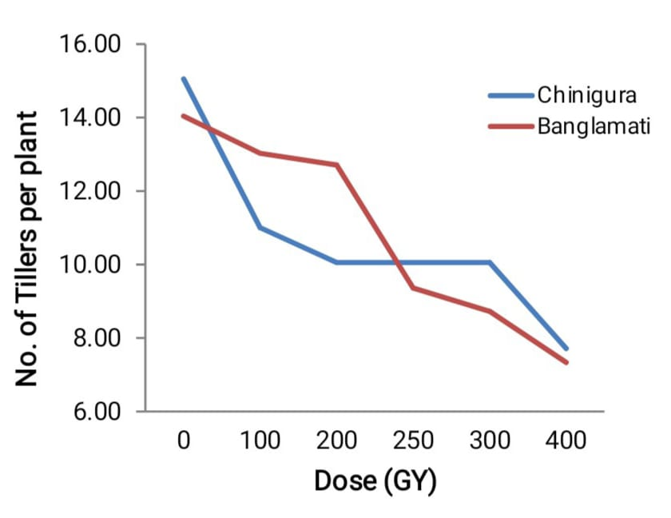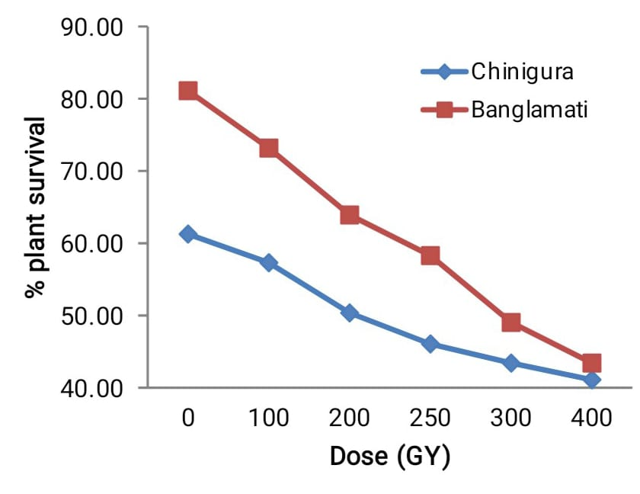
Figure 1. Effect of gamma ray irradiation on tiller production | Figure 2. Effect of gamma ray irradiation on survival percentage
3.6 Survival percentage
Survival percentage of both varities decreases with increasing gamma radiation doses (Figure 2). Banglamati consistently shows higher survival than Chinigura across all doses. At 400 Gy, survival drops to about 43% in Banglamati and 41% in Chinigura, indicating greater tolerance in Banglamati. Increasing gamma radiation reduced survival percentage, a trend observed by Wijesena et al. (2019) and similarly reported in aromatic rice by Harding et al. (2012).

3.7 Determination of lethal dose and relative biological value

The LD₅₀ value, representing the gamma dose at which 50% of the plants fail to survive, was determined based on plant survival percentages (Table 5). Results indicated that Chinigura required a lower gamma dose than Banglamati to reach the same relative biological effect (RBE), demonstrating that Chinigura is more sensitive to gamma irradiation. This heightened sensitivity of the local variety suggests that its physiological and genetic makeup is less tolerant to radiation-induced stress compared to the more robust, released variety Banglamati. The findings are consistent with observations by Rani et al. (2016), who reported that local rice varieties generally exhibit higher susceptibility to gamma radiation, whereas improved or released varieties tend to tolerate higher doses with less impact on survival.

Table 05. Relative biological value (RBE) of the two varieties Chinigura and Banglamati

Variety | Regression Equation | LD50
Chinigura | Y = 61.11-0.054x | 205.74
Banglamati | Y = 81.94-0.098x | 325.92

The optimum gamma doses for Chinigura and Banglamati were 205.74 Gy and 325.92 Gy, respectively. Harding et al. (2012) reported that LD₅₀ doses for rice range from 345 to 423 Gy, while Sharma et al. (2020) suggested an optimal gamma dose range of 280 to 350 Gy. Ramchander et al. (2015) observed that LD₅₀ values varied among rice varieties, with 354.80 Gy for White Ponni and 288.40 Gy for BPT 5204, highlighting varietal differences in sensitivity to gamma irradiation; similarly, Gowthami et al. (2017) reported that for ADT-37 and ADT(R) 45, the LD₅₀ doses were 300.03 Gy and 300.00 Gy, respectively.
4. Conclusion
The study demonstrated that increasing gamma irradiation doses negatively affected the growth and development of both Chinigura and Banglamati rice varieties. The LD₅₀ values, calculated from survival percentage, were 205.74 Gy for Chinigura and 325.92 Gy for Banglamati, confirming higher radiosensitivity in the local variety. Overall, the results highlight a clear dose-dependent suppression of growth parameters, with Chinigura being more sensitive. These findings provide critical information for determining optimal gamma doses for mutation breeding and varietal improvement programs in aromatic.

10. Reference

- Akshatha,Chandrashekar, K. R.; Somashekarappa, H. M.1; Souframanien, J.2. Effect of gamma irradiation on germination, growth, and biochemical parameters of Terminalia arjuna Roxb. Radiation Protection and Environment 36(1);p 38-44, Jan–Mar 2013. | DOI: 10.4103/0972-0464.121826
- Ashraf, M., Cheema, A. A., Rasheed, M., & Qamar, Z. (2003). Effect of gamma rays on M1 generation in Basmati rice. Pakistan Journal of Botany, 35(5), 791–795.
- Azad, M. A. K., Uddin, M. I., & Azam, M. A. (2012). Bioremediation, biodiversity and bioavailability. Bioremediation, Biodiversity and Bioavailability, 6(Special Issue 1), 53–57.
- Bangladesh Bureau of Statistics. (2025). Yearbook of agricultural statistics of Bangladesh, 2024: 36th series (p. 39)
- Bangladesh Rice Research Institute. (2025). Adunik Dhaner Chash (25th ed.). Bangladesh Rice Research Institute., Joydebpur, Gazipur. pp. 5
- Bordoloi, D., Sarma, D., Barua, N. S., & Das, B. K. (2023). Mutation induction in aromatic Joha rice of Assam for improvement of morpho-agronomic traits through M 1 to M 3 generation. International Journal of Radiation Biology, 99(11), 1760–1777. https://doi.org/10.1080/09553002.2023.2214197
- Chahal, G. S., & Gosal, S. S. (2002). Principles and procedures of plant breeding: Biotechnological and conventional approaches. Alpha Science International Ltd / CRC Press.
- Cheema, A. A., & Atta, B. M. (2003). Radiosensitivity studies in Basmati rice. Pakistan Journal of Botany, 35(2), 197–207.
- FAO. 2024. World Food and Agriculture – Statistical Yearbook 2024. Rome. https://doi.org/10.4060/cd2971en
- Faustino, G. P., Habana, E. J. H., Malabanan-Bauan, K. B., Magnaye, A. M. A., Madrid-Savariz, I. J. W., Lopez, P. I. M., Abonitalla, D. B., Borromeo, T. H., & Calayugan, M. I. C. (2024). Identification of median lethal dose (LD50) and shoot and root growth reduction (GR50) dose in four rice varieties irradiated with cobalt-60. Philippine Journal of Science, 153(5), 1899–1910.
- Fukagawa NK, Ziska LH. Rice: Importance for Global Nutrition. J Nutr Sci Vitaminol (Tokyo). 2019;65(Supplement):S2-S3. doi: 10.3177/jnsv.65.S2. PMID: 31619630.
- Golestan Hashemi, F., Rafii, M. Y., Ismail, M. R., Mahmud, T. M. M., Rahim, H. A., Asfaliza, R., & Latif, M. A. (2013). Biochemical, genetic and molecular advances of fragrance characteristics in rice. Critical Reviews in Plant Sciences, 32(6), 445–457. https://doi.org/10.1080/07352689.2013.807716
- Gowthami, R., Vanniarajan, C., Souframanien, J., & Pillai, M. A. (2016). Effect of gamma rays and electron beam on various quantitative traits of rice (Oryza sativa L.) in M1 generation. Advances in Life Sciences, 5(5), 1876–1882.
- Gowthami, R., Vanniarajan, C., Souframanien, J., & Pillai, M. A. (2017). Comparison of radiosensitivity of two rice (Oryza sativa L.) varieties to gamma rays and electron beam in M1 generation. Electronic Journal of Plant Breeding, 8(3), 732–741. https://doi.org/10.5958/0975-928X.2017.00111.9
- Gupta, R., Islam, M. M., Begum, S. N., Akram, W., & Islam, M. S. (2021). Determination of lethal dose of rice (Oryza sativa L.) genotypes by radio sensitivity test. Plant Archives, 21(1), 1912–1916. https://doi.org/10.51470/PLANTARCHIVES.2021.v21.no1.266
- Harding, S. S., Johnson, S. D., Taylor, D. R., Dixon, C. A., & Turay, M. Y. (2012). Effect of gamma rays on seed germination, seedling height, survival percentage and tiller production in some rice varieties cultivated in Sierra Leone. American Journal of Experimental Agriculture, 2(2), 247–255. https://doi.org/10.9734/AJEA/2012/820
- Hasibuzzaman, A. S. M., Perves, M., Chowdhory, M., Hasan, R., & Begum, S. N. (2025). Mutagenesis in aromatic rice: Current progress, challenges and future prospects. Bangladesh Journal of Nuclear Agriculture, 39(1), 13–30. https://doi.org/10.3329/bjnag.v39i1.83308
- Imam, Z., & Chakraborty, N. R. (2018). Effect of gamma rays on non-basmati aromatic rice in M1 generation. International Journal of Current Microbiology and Applied Sciences, 7(08), 4412–4418. https://doi.org/10.20546/ijcmas.2018.708.464
- Kant, A., Chakraborty, N. R., & Das, B. K. (2020). Immediate radiation effects and determination of optimal dose of gamma rays on non-basmati aromatic rice (Oryza sativa L.) of eastern India. Journal of Experimental Biology and Agricultural Sciences, 8(5), 586–604. https://doi.org/10.18006/2020.8(5).586.604
- Lasmana, D., Saragih, S. H. Y., Septyani, I. A. P., & Sepriani, Y. (2025). The effect of gamma ray radiation on the growth of local rice plants (Oryza sativa L.) Silumat variety. Jurnal Agronomi Tanaman Tropika, 7(2), 671–674. https://doi.org/10.36378/juatika.v7i2.4775
- Minisi, F. A., El-mahrouk, M. E., Rida, M. E. F., & Nasr, M. N. (2013). Effects of gamma radiation on germination, growth characteristics and morphological variations of Moluccella laevis L. American-Eurasian Journal of Agriculture & Environmental Sciences, 13(5), 696–704
- Mishra, T., Singh, A., Madhukar, V. K., Verma, A. K., Mishra, S., & Chauhan, R. S. (2023). Assessment of morpho-agronomic and yield attributes in gamma-irradiated mutants of Kalanamak rice (Oryza sativa L.). Journal of Applied Biology & Biotechnology. https://doi.org/10.7324/JABB.2023.110093
- Mohamad, O., Herman, S., Nazir, B. M., Shamsudin, S., & Takim, M. (2005). A dosimetry study using gamma irradiation on two accessions, PHR and PHI, in mutation breeding of roselle (Hibiscus sabdariffa L.). In 7th MSAB Symposium on Applied Biology (pp. 1–10), 3–4 June, Sri Kembangan.
- Mohamad, O., Nazir, B. M., Abdul, R. M., & Herman, S. (2002a). Roselle: A new crop in Malaysia. Bulletin of the Genetics Society of Malaysia, 7(1–2), 12–13.
- Ramchander, S., Ushakumari, R., & Arumugam Pillai, M. (2015). Lethal dose fixation and sensitivity of rice varieties to gamma radiation. Indian Journal of Agricultural Research, 49(1), 24–31. https://doi.org/10.5958/0976-058X.2015.00003.7
- Rani, M. S., Kamruzzaman, M., Ghanim, A. M. A., Azad, M. A. K., & Akter, M. B. (2016). Comparative effect of gamma and X-ray irradiations on some characters of rice seedlings of Ashfal and Binadhan-14. Journal of Bioscience and Agriculture Research, 8(2), 739–745. https://doi.org/10.18801/jbar.080216.88
- Ray, B. P., Nath, U. K., & Azad, M. A. K. (2022). Mutagenesis for the development of submergence tolerance rice genotypes in Indica by gamma irradiation-induced mutation using ⁶⁰Co source isotope with marker assay. International Journal of Agriculture, Environment and Bioresearch, 7(3), 31. https://doi.org/10.35410/IJAEB.2022.5723
- Sharma, D., Sao, R., Sahu, P. K., Vishwakarma, G., Nair, J. P., Petwal, V. C., & Das, B. K. (2020). Comparative study of radio-sensitivity and relative biological effectiveness of gamma rays, X-rays, electron beam and proton beam in short grain aromatic rice. Indian Journal of Genetics and Plant Breeding, 80(4). https://doi.org/10.31742/ijgpb.80.4.3
- Solim, M. H., & Rahayu, S. (2021). Radiosensitivity of rice varieties of Mira-1 and Bestari mutants using gamma rays irradiation. IOP Conference Series: Earth and Environmental Science, 911(1), 012014. https://doi.org/10.1088/1755-1315/911/1/012014
- The Daily Star. (2024, May 30). Aromatic rice production nearly doubles in seven years. The Daily Star. https://www.thedailystar.net/business/news/aromatic-rice-production-nearly-doubles-seven-years-3808151
- Wijesena, K. A. K., Nawarathne, N. M. A., & Basnayake, B. M. M. P. (2019). Effect of gamma irradiation on seed germination and plant growth parameters of three rice varieties cultivated in Sri Lanka. Journal of Agriculture and Value Addition, 2(1), 79–84. https://doi.org/10.4038/java.v2i1.112

