Survey on the Emergence and zoonotic potential of Dipylidium caninum Among School-age children in Daksiri Pella District, Adamawa State, Nigeria

Abstract
Dipylidium caninum is a zoonotic cestode commonly found in dogs and cats but rarely reported in humans. Recently, increasing human-animal interactions and poor environmental sanitation have contributed to the emergence of human infections. This study aimed to investigate the emergence and possible risk factors associated with Dipylidium caninum infection in humans in Adamawa State, Nigeria. A cross-sectional survey was conducted using stool examinations and questionnaires administered to school-aged children across selected communities in Daksiri in Hong Local Government, Adamawa State. Samples were analyzed using concentration techniques. Results revealed that out of a total of one thousand two hundred (1200) participants were recruited for this study. Six hundred and sixty-five (665) males, and five hundred and thirty-five (535) females, 11.9 % were infected with this parasite. Prevalence by sex revealed that males had the highest infection (12.6%) compared to females (11.0%). Age group 6-10 years had the highest occurrence (18.6%), followed by 11–15 (7.9%) and older (1.64%). Evidence of infection associated with risk factors such as poor hygiene, close contact with dogs, and flea infestation. The findings highlight the need for improved public health awareness, regular pet deworming, and better sanitation practices to prevent zoonotic transmission.
Keywords: Dipylidium caninum, zoonosis, tapeworm, dogs, human infection, Adamawa State.

1. Introduction
Dipylidium caninum, commonly known as the dog tapeworm, is a zoonotic parasite that infects dogs, cats, and occasionally humans (Omonijo et al. 2023). Humans become infected through accidental ingestion of infected fleas containing the cysticercoid stage of the parasite. Clinical manifestations in humans include abdominal discomfort, diarrhea, anal itching, and passage of proglottids in stool. (Rousseau et al. 2022). It has many common names, including the “flea tapeworm”, “cucumber tapeworm”, and “double-pored tapeworm. Gravid proglottids are passed intact in the feces or emerge from the perianal region in the host. In the environment, the proglottids disintegrate and release egg packets, which are also occasionally found free in the feces. The intermediate host (most often larval stages of the dog or cat flea Ctenocephalides spp.) ingests egg packets, and the oncosphere within is released into the larval flea’s intestine. The oncosphere penetrates the intestinal wall, invades the insect’s hemocoel (body cavity), and develops into a cysticercoid. The cysticercoid remains in the flea as it matures from a larva into an adult (CDC, 2025). The vertebrate host becomes infected by ingesting the adult flea containing the cysticercoid. In the small intestine of the vertebrate host, the cysticercoid develops into the adult tapeworm after about one month. The adult tapeworms (measuring up to 60 cm in length and 3 mm in width) reside in the small intestine of the host, where they each attach by their scolex. Gravid, double-pored proglottids detach from the strobila (body) and are shed in the feces (CDC,2025).
Dipylidiosis is an underrated disease caused by the cestode Dipylidium caninum. The transmission of this parasite is complex as it involves an intermediate invertebrate host (flea or louse), which subsequently needs to be ingested by the definitive hosts, normally carnivores, but occasionally humans, for the infection to develop (Rousseau et al 2022). In both cases, the infection is asymptomatic, the clinical signs or symptoms are non-specific, and proper diagnosis, treatment, and prevention are challenging (Rousseau et al 2022).
Dipylidium caninum is found worldwide, present on all continents, and detected in both vertebrates, including humans, and insects such as fleas and lice (García-Agudo et al. 2014, Bronstein et al., 2020).
Multiple studies have reported soil contamination with this cestode (ranging from 0.1% to 26.3%) (Maikai et al., 2008; Siyadatpanah et al., 2020; Khademvatan et al., 2014; Sadowska et al., 2019), as well as food contamination at 1.7% (Sadowska et al., 2019). Its broad geographic distribution is expected, given that invertebrate intermediate hosts are also widespread globally, with fleas being the most common ecto parasites of dogs and cats (Debelts et al., 2025).
Although human infections are considered rare, several studies indicate that dogs serve as important reservoirs for the parasite, increasing the risk of transmission to humans (Debelts et al., 2025). Investigations in Nigeria have shown that intestinal helminths are common in dogs, including Dipylidium caninum, which contributes to zoonotic risk where humans live in close contact with pets (Ugbomoiko et al., 2008).
In many Nigerian communities, dogs roam freely and often without veterinary care, creating opportunities for the spread of parasitic infections. Previous surveys across regions of Nigeria have reported the presence of Dipylidium caninum among canine parasites, indicating potential for transmission to humans (Ibidapo, 2005). Despite the public health importance of this parasite, limited information exists regarding its emergence in humans in Adamawa State. Therefore, this study aimed to survey the presence and potential emergence of Dipylidium caninum infection in humans within selected communities in Adamawa State. There are a few reports on cases of Dipylidium caninum in humans in Adamawa state Pukuma and Sale 2007). Most of the available reports of Dipylidium caninum are in Dogs (Elihu et al., 2025).
Humans also acquire infection by ingesting the cysticercoid contaminated flea. Children are most frequently infected, possibly due to close contact with flea-infested pets (CDC,2025).

2. Materials and Methods

2.1 Study Area
This research was carried out in the Pella district of Hong Local Government Area of Adamawa state, Nigeria. The selected communities are characterized by tropical climate conditions and widespread dog ownership for security and hunting purposes.
Hong LGA is located between latitudes 10° 0’ 00’’ N and 10° 35’ 00’’ N and longitudes 12° 35’ 00’’ E and 13° 20’ 00’’ E. It has a total land area of 2,419.11 km2 (Bashir and Raji, 1999). Hong is one of the 21 Local Government Areas of Adamawa State, created in 1987 during the defunct Gongola State. Other districts in Hong include: Dugwaba, Gaya, Hildi, Hong, and Uba. Hong occupies a very fertile land that receives much rainfall, mostly from April to October or early November. There are rivers, ponds, streams, and dams for agricultural activities such as fishing and other domestic purposes, which are mostly carried out throughout the seasons. The primary occupations of the inhabitants of Hong Local Government are mainly farming, fishing, and trading (Joshua, 2017).

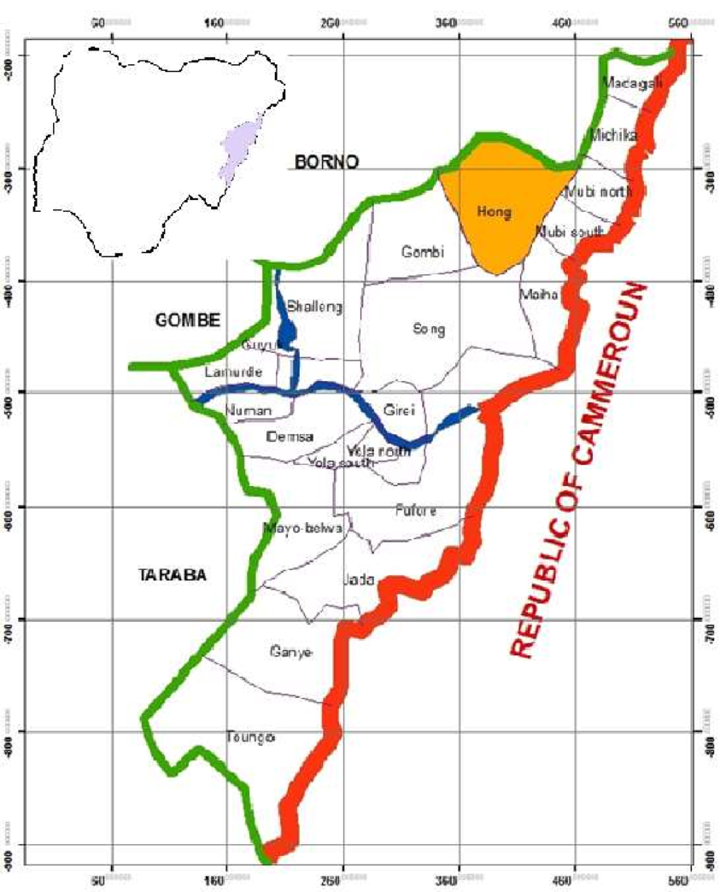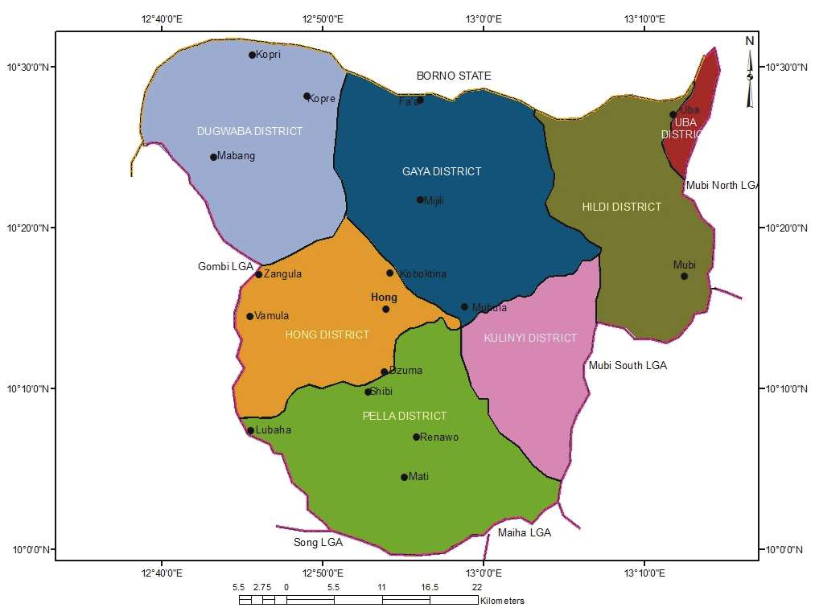
Figure 1:Map of Hong indicating study area

Ethical approval
Ethical clearance and approval were obtained from the Health Department, Hong local government area. Informed consent was sought and obtained from the village head, school authorities, the parents /guardian and the participants, before the commencement of the study.

Sample size determination.
The minimum sample size was calculated according to the method described by Anikwe et al. (2020). The minimum sample size (N) was calculated using the formula:
N=Z²pq
e²
The minimum sample size for this study is 384, approximated to 1400 samples to have a good representation of the study population.

3.3 Sample collection
Stratified random sampling techniques were used to select locations within the study area. Systematic random sampling was also used in selecting the participants. A structured questionnaire was used to collect data such as sex, age, and other demographic information.
The study participants were instructed on how to collect a stool sample into the sample bottle provided. Approximately 1-3 g of faeces were collected. Consequently, 5ml of 10% formaldehyde was added to the stool sample as a preservative (Bala et al., 2012).
The samples collected were well packaged to avoid breakage and transported back to the Parasitology Laboratory, Department of Zoology, Adamawa State University, Mubi, for examination.
Questionnaire
Stool samples were collected from consenting participants across different age groups. Participants were also asked to complete structured questionnaires covering: Age and gender. Pet ownership, Contact with dogs or cats, Hygiene practices and the Presence of fleas in domestic environments.
  - Laboratory Analysis
Stool samples were examined using the Formalin-ether concentration method. Stool sample was mixed with formalin, the mixture was sieved using mesh size of 100 mm by 8 inches siever, di ethyl-ether was added to the mixture after sieving and centrifuge 500 rpm for 5 minutes, a Thermos fisher automatic centrifuge machine with carrying capacity of 76 samples was used. The sediments were viewed under Motic screened binocular microscope(fig.2) at X10, X40 and X100 magnifications. Identification of Dipylidium caninum was based on the presence of characteristic egg packets or proglottids in fecal samples.
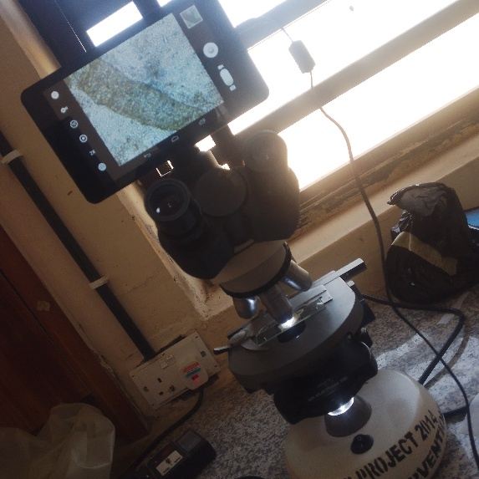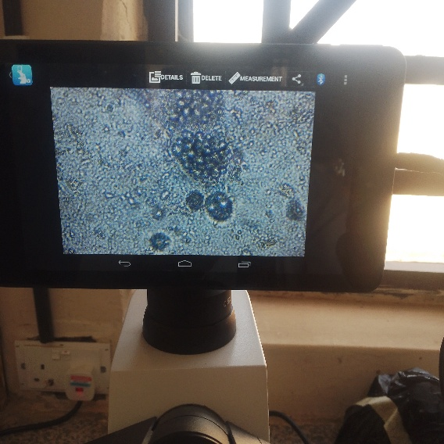

Fig. 2’; Microscope used

2.5 Data Analysis
Data obtained from laboratory analysis and questionnaires were analyzed using descriptive statistics to determine prevalence and associated risk factors.

3. Results
The survey revealed a considerable proportion of participants were infection with Dipylidium caninum (11.9 %). The higher infection rates were recorded among younger children while older children were less infected. A total of one thousand two hundred (1200) participants were recruited for this study (Table 1). Of these participants, six hundred and sixty-five (665) males, and five hundred and thirty-five (535) females were examined (Table 1). Prevalence by sex revealed that males had the highest infection (12.6%) compared to females (11.0%). Age group 6-10 years had the highest occurrence (18.6%), followed by 11–15 (7.9%) and older (1.64%) (Figure 3). Prevalence due to contact activities with pets reveals that 84.2% of those who had regular contacts with pets were more infected while 15.8% of those who had non regular contact with pets were infected (Figure 4). Increased risk in households with dogs not regularly dewormed. Presence of fleas in domestic animals and surrounding environments. Poor sanitation and hygiene practices in affected households. Participants who reported frequent contact with dogs were more likely to be infected. Microscopic Characteristics Egg packets (capsules) are the hallmark Round to oval in Shape ranges 120–200 µm in size and Contain multiple eggs (typically 5–30 per packet). each Individual eggs within packets were Spherical in shape approximately ~35–60, with Thin, colourless shells (Figure 2).

Table 1: Overall prevalence of Dipylidium caninum among Primary Schools Pupils in Daksiri Pella District, Adamawa State, Nigeria
Sex | No. examined |  | No. infected | Prevalence % | Odd ratio | 95% CL.
Male | 665 |  | 84 | 12.6 | 1.17 | 0.8184-1.6624
Female | 535 |  | 59 | 11.0 | 0.86 | 0.6016-1.2218
Total | 1,200 |  | 143 | 11.9

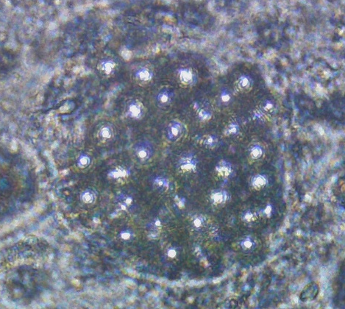 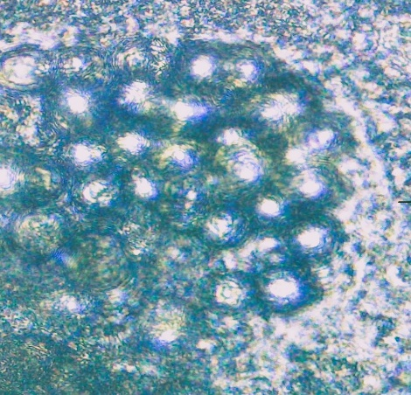 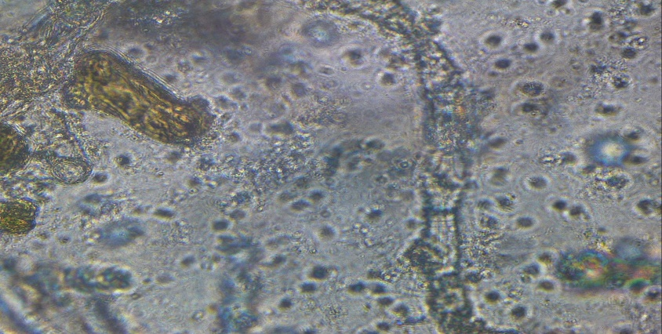Figure 3; A and B. egg of D. caninum recovered from stool sample, C. Adult with visible Proglotid

Figure 4: Prevalence of Dipylidium caninum based on Age Group Among Primary Schools Pupils in Daksiri Pella District, Adamawa State, Nigeria.

Figure 5: Prevalence Dipylidium caninum in relation to presence of pets at household level Among Primary Schools Pupils in Daksiri Pella District, Adamawa State, Nigeria.

4. Discussion
The findings confirm the zoonotic potential of Dipylidium caninum and suggest possible emergence in humans within Adamawa State. Dogs serve as the primary definitive hosts, while fleas act as intermediate hosts responsible for transmission. The observed infection pattern aligns with previous studies showing that dogs harbour multiple intestinal helminths that can infect humans (Sukupayo et al., 2023).
The results of this study found a high prevalence of Dipylidium caninum. Infection among school-aged children in Daksiri ward in Hong local Government area of Adamawa State, Nigeria. This finding supports our hypothesis that Dipylidium caninum is zoonotic and that children are at high risk of infection by this insect-transmitted parasite (Rousseau et al., 2022).
This study reported a higher prevalence of this parasite among young individuals. Children are particularly vulnerable due to their frequent interactions with pets and poor hygiene practices. Gutema et al. (2020) reported 21% in dogs and 0.4% in children. This emphasizes the importance of educating communities about zoonotic diseases and improving pet management. The increased vulnerability of children is likely due to their close contact with animals, including domestic, stray, and unvaccinated animals, as well as their poor hygiene habits, such as infrequent handwashing, playing, and eating on the floor. The high prevalence of D. caninum infection in dogs suggests a significant risk of transmission to humans and should be regarded a public health concern.
Although humans are accidental hosts, children appear to be the most susceptible to infection with D. caninum. Most cases of human infections occur in younger children (Chelkeba et al., 2020) living in dwellings where infected dogs or cats are present. Humans accidentally eat the flea when they kiss or bite the pet, or when the flea falls on their food or sticks to a wet dummy (Bowman, 2014). Once an infected flea is ingested by a dog, cat, or human, the cysticercoid is released by digestion in the small intestine, attaches to the mucosa, and develops into an adult parasite in about 21 days (Beugnet et al., 2014).
Furthermore, the high prevalence of parasites among dogs in Nigeria indicates that lack of veterinary care and uncontrolled stray dog populations contribute to increased zoonotic transmission risk.

The Public Health Importance of Dipylidium caninum infection although often considered a minor zoonosis, D. caninum still has important public health implications Infection passes from pets (dogs and cats) to humans Highlights the importance of the human–animal interface in disease control. Most cases occur in young children (6 months–8 years) Due to Close contact with pets, Poor hand hygiene and Accidental ingestion of fleas (Rousseau et al, 2022).
The Presence of infection suggests an Indication of Poor Environment, Poor flea control, Inadequate pet care and deworming Unsanitary living conditions (Oliveira et al, 2025). Risk Factors of Infection includes Ownership of infected dogs or cats, Pets with heavy flea infestation, Lack of regular deworming Poor sanitation, overcrowded living conditions, Presence of fleas in homes (carpets, bedding), Playing with pets and putting hands in mouth, Poor handwashing habits, Accidental ingestion of fleas during play, Low awareness of zoonotic diseases, Limited access to veterinary care, Rural or peri-urban settings with free-roaming animals (CDC,2025).

5. Conclusion
This survey suggests that Dipylidium caninum may be emerging as a zoonotic infection among humans in Adamawa State. Close contact with infected dogs, flea infestation, and poor hygiene were identified as major risk factors.
To reduce transmission, the following measures are recommended: Regular deworming of domestic dogs and cats, Control of flea infestation in pets, Improved sanitation and hygiene practices, Public health education on zoonotic diseases.

REFERENCE

Bronstein AM, Fedyanina LV, Lukashev AN, Sergeev AR. (2020) Nine cases of human dipylidiasis in Moscow region during 1987 to 2017. Trop Biomed. 37:194–200. [PubMed] [Google Scholar]
Debelts H, Allendorf V, Asala O, Agusi ER, Shittu I, Ogunmolawa O, Bakam J, Inuwa B, Ijomanta J, Oyetunde JS, Chinyere C, Elah A, Omoniwa DO, Dietze K, Adeoye A, Ochu CL, Globig A, Mari-Saez A, Meseko C. (2025) Negotiating cohabitation in a Nigerian abattoir: One Health perspectives of human-animal-ecosystem interactions examined in the light of the SARS-CoV-2 pandemic. One Health Outlook. 2025 Jul 16;7(1):37.
Elihu A, Levi RY, Mathias A, Yusuf T. (2025) Prevalence of Helminth Parasites in Dogs in Song Local Government Area, Adamawa State, Nigeria. Int J Cur Res Sci Eng Tech ; 8(3), 357-360. DOI: doi.org/10.30967/IJCRSET/Elihu-A/191 Received: 07 July, 2025; Accepted: 15 July, 2025; Published: 17 July, 2025
Felsmann MZ, Michalski MM, Felsmann M, Sokół R, Szarek J, Strzyżewska-Worotyńska E. (2017) Invasive forms of canine endoparasites as a potential threat to public health a review and own studies. Ann Agric Environ Med.;24:245–9. doi: 10.5604/12321966.1235019. [DOI] [PubMed] [Google Scholar]
García-Agudo L, García-Martos P, Rodríguez-Iglesias M. (2014) Dipylidium caninum infection in an infant: a rare case report and literature review. Asian Pac J Trop Biomed. ;4:S565–7. doi: 10.12980/APJTB.4.2014APJTB-2014-0034. [DOI] [Google Scholar][Ref list]
Gillespie S., and Bradbury R. S. (2017) A survey of intestinal parasites of domestic dogs in central Queensland. Trop Med Infect Dis.;2:60. doi: 10.3390/tropicalmed2040060. [DOI] [PMC free article] [PubMed] [Google Scholar]

Gutema F.D., Yohannes G.W., Abdi R.D., Abuna F., Ayana D., Waktole H., Amenu K., Hiko A., Agga G.E. (2020) Dipylidium caninum Infection in Dogs and Humans in Bishoftu Town, Ethiopia. Diseases. Dec 22;9(1):1. doi: 10.3390/diseases9010001. PMID: 33374931; PMCID: PMC7839016.
Ibidapo, C. A. (2005). Prevalence of Intestinal Helminth Parasites of Dogs in Lagos, Nigeria. Biological Sciences - PJSIR, 48(4), 279–283. Retrieved from https://v2.pjsir.org/index.php/biological-sciences/article/view/1394
Khademvatan S, Abdizadeh R, Rahim F, Hashemitabar M, Ghasemi M, Tavalla M. (2014) Stray cat’s gastrointestinal parasites and their association with public health in Ahvaz city, South Western of Iran. Jundishapur J Microbiol.;7:e11079. doi: 10.5812/jjm. 18789. [DOI] [PMC free article] [PubMed] [Google Scholar]
Luzio Á, Belmar P, Troncoso I, Luzio P, Jara A, Fernández Í. (2015) Parasites of zoonotic importance in dog feces collected in parks and public squares of the city of Los Angeles, Bío-Bío, Chile. Rev. Chilena Infectol.;32:403–7. doi: 10.4067/S0716-10182015000500006. [DOI] [PubMed] [Google Scholar]
Maikai BV, Umoh JU, Ajanusi OJ, Ajogi I. (2008) Public health implications of soil contaminated with helminth eggs in the metropolis of Kaduna, Nigeria. J Helminthol. ;82:113–8. doi: 10.1017/S0022149X07874220. [DOI] [PubMed] [Google Scholar]
Oliveira C. I., Mattos TADS, Freitas S.M., Hlavac N., Begon M., Costa F., Khalil H., Argibay H.D. (2025) Socioeconomic vulnerability and the management of domestic animal hosts in urban environments: a one health issue. BMC Vet Res. Dec 13;21(1):699. doi: 10.1186/s12917-025-05062-7. PMID: 41390417; PMCID: PMC12702158.
Omonijo A. O., Omonijo A., Akinrinde H.E., Olarinde O. O., Oche M. E., Adesina A. A., Ojo A. E., Awogbami K. C. (2022) prevalence of zoonotic gastrointestinal parasites in stray dogs in oye and ikole local government areas ekiti state, nigeria Journal of Human Kinetics and Health Education Pedagogy 5, :1

Pukuma, S. M., and Sale, M. (2007). Prevalence of gastrointestinal helminth infections among children of Vunoklang Primary School in Moderei Ward of Girei Local Government Area of Adamawa State, Nigeria. Nigerian Journal of Parasitology, 27(1). https://doi.org/10.4314/njpar.v27i1.37842
Rousseau J, Castro A, Novo T, Maia C. (2022) Dipylidium caninum in the twenty-first century: epidemiological studies and reported cases in companion animals and humans. Parasit Vectors. May 10;15(1):131. doi: 10.1186/s13071-022-05243-5. PMID: 35534908; PMCID: PMC9088078.
Sadowska N, Tomza-Marciniak A, Juszczak M. (2019) Soil contamination with geohelminths in children’s play areas in Szczecin, Poland. Ann Parasitol. ;65:65–70. [PubMed] [Google Scholar]
Siyadatpanah A, Pagheh AS, Daryani A, Sarvi S, Hosseini SA, Norouzi R, et al. (2020) Parasitic helminth infections of dogs, wolves, foxes, and golden jackals in Mazandaran Province, North of Iran. Vet World. 13:2643–2648. doi: 10.14202/vetworld.2020.2643-2648. [DOI] [PMC free article] [PubMed] [Google Scholar]
Soriano SV, Pierangeli NB, Roccia I, Bergagna HFJ, Lazzarini LE, Celescinco A,.(2009) A wide diversity of zoonotic intestinal parasites infects urban and rural dogs in Neuquén, Patagonia, Argentina. Vet Parasitol. 2010;167:81–85. doi: 10.1016/j.vetpar..09.048. [DOI] [PubMed] [Google Scholar]
Sowemimo, O. A. (2009). Prevalence and intensity of gastrointestinal parasites of dogs in Ile-Ife, Nigeria.
Sowemimo, O. A., & Asaolu, S. O. (2008). Epidemiology of intestinal helminth parasites of dogs in Ibadan, Nigeria.
Sukupayo PR, Tamang S. (2023) Prevalence of Zoonotic Gastrointestinal Helminth Parasite among Dogs in Suryabinayak, Nepal. Vet Med Int. May 30;2023:3624593. doi: 10.1155/2023/3624593. PMID: 37287959; PMCID: PMC10243950.
Ugbomoiko US, Ariza L, Heukelbach J.(2008) Parasites of importance for human health in Nigerian dogs: high prevalence and limited knowledge of pet owners. BMC Vet Res. Dec 9;4:49. doi: 10.1186/1746-6148-4-49. PMID: 19068110; PMCID: PMC2615757.
Vélez-Hernández L, Reyes-Barrera K, Rojas-Almaráz D, Calderón-Oropeza MA, Cruz-Vázquez JK. Arcos-García JL (2014) Potential hazard of zoonotic parasites present in canine feces in Puerto Escondido, Oaxaca] Salud Publica Mex. 56:625–630. doi: 10.21149/spm.v56i6.7389. [DOI] [PubMed] [Google Scholar]

