Review Article

Climate-Smart Agriculture Practices in Ghana: Adoption, Challenges, and Opportunities

ABSTRACT

Aims: Climate change poses an existential threat to Ghana's agricultural sector, which employs approximately 45% of the labour force and contributes 18.3% of GDP. Climate-Smart Agriculture (CSA) — encompassing practices that simultaneously enhance productivity, build adaptive capacity, and reduce greenhouse gas emissions — has been promoted as a transformative solution. Yet adoption rates remain uneven, policy implementation is fragmented, and the contribution of rural waste management to CSA has been largely overlooked in the literature. This systematic narrative review synthesises evidence from 2010 to 2025 to assess

Methodology: Please write main points of the research methodology applied. Sample: We included 63 patients (40 men, 23 women; age range 18-75 years) with liver cirrhosis and portal hypertension, with or without the medical history of gastrointestinal bleeding. Clinical as well as hematological examination (platelet count) and ultrasonography (gray as well as color Doppler scale including splenic index and splenorenal/ pancreaticoduodenal collaterals) was done besides upper GI endoscopy for esophageal varices. Platelet count/spleen diameter ratio was also calculated.

Results: CSA adoption patterns, identify adoption determinants, evaluate the waste-agriculture interface, and appraise Ghana's policy landscape. Drawing on 35 peer-reviewed studies, institutional reports, and national policy documents, the review finds that (i) labour- and land-intensive CSA practices are broadly adopted (~80% and ~73% of sampled farmers, respectively), while finance-intensive practices lag (~55%), with a 15-percentage-point gender gap disadvantaging women; (ii) extension services multiply adoption probability 2.8-fold and secure land tenure increases long-term CSA investment by 60%; (iii) Ghana generates approximately 13,000 tonnes of municipal solid waste daily, of which 61% is organic and largely untapped as compost feedstock; (iv) microplastic contamination (1,100–2,700 particles kg⁻¹ of organic amendments) constitutes an emerging 'compost quality paradox'; and (v) critical policy coherence gaps persist between agricultural and waste governance instruments.

Conclusion: The review concludes with a six-point research agenda and recommends the creation of an integrated Waste-Agriculture Nexus policy mechanism to bridge institutional silos and unlock Ghana's organic waste potential for sustainable food systems.

Keywords: Climate-smart agriculture; Organic waste; composting; Adoption determinants; Policy coherence; Circular economy; Microplastics; Food security

1. INTRODUCTION

Agriculture in Ghana operates under severe and mounting climate stress. Mean annual temperatures have risen by approximately 1.0°C since 1960, and projections under Representative Concentration Pathway (RCP) 4.5 indicate a further 1.5–2.0°C warming by 2050, accompanied by increased rainfall variability, prolonged dry spells, and more intense flooding events (IPCC, 2021). These trends threaten the livelihoods of smallholder farming households, who cultivate over 80% of Ghana's agricultural land in plots typically under two hectares (FAO & MoFA, 2018). The agriculture sector contributes approximately 18.3% of GDP and employs 45% of the working population; food insecurity therefore carries both humanitarian and macroeconomic dimensions.
Climate-Smart Agriculture (CSA) was formally introduced by the Food and Agriculture Organization of the United Nations (FAO) in 2010 and operationalised around a 'triple-win' framework: (i) sustainably increasing agricultural productivity and incomes; (ii) building resilience and adaptive capacity to climate change; and (iii) reducing and/or removing greenhouse gas (GHG) emissions where possible (Lipper et al., 2014). Ghana institutionalised this framework through the National Climate Change Policy (NCCP, 2014), the CSA Action Plan (2016), the CSA Investment Framework (2018), and the World Bank-supported Climate-Smart Agriculture Investment Plan (CSAIP, 2021) — the latter allocating US$389.5 million across 1,695,000 beneficiary farming families (World Bank, 2021).
Despite these institutional commitments, critical questions remain underexplored. First, adoption rates for different categories of CSA practice are poorly documented and highly disaggregated. Second, the behavioural, institutional, and structural determinants of adoption — including gender dynamics, social norms, land tenure, and extension access — are incompletely theorised for Ghana's diverse agro-ecological contexts. Third, and most strikingly, the nexus between rural waste management and CSA has received almost no systematic attention: Ghana generates ~13,000 tonnes of municipal solid waste (MSW) daily, of which ~61% (~7,930 t day⁻¹) is organic material that could serve as compost feedstock, yet formal composting infrastructure processes only a minor fraction (Kusi-Appiah, 2025; Ampomah-Benefo et al., 2025). Fourth, Ghana's policy architecture remains bifurcated, with agricultural governance under the Ministry of Food and Agriculture (MoFA) and waste governance under the Environmental Protection Agency (EPA), creating institutional silos that constrain integrated solutions.
This review addresses these gaps by synthesising empirical and policy literature published between 2010 and 2025. The specific objectives are to: (1) map CSA practices documented in Ghana by triple-win pillar and agro-ecological zone; (2) analyse determinants of adoption at the farm, household, community, and institutional levels; (3) characterise Ghana's rural waste profile and assess its potential as a CSA input; (4) evaluate the coherence of Ghana's CSA and waste-management policy landscape; and (5) identify research gaps and recommend an integrated policy agenda. The review makes an original contribution by constructing a Waste-Agriculture Nexus framework and a comprehensive Policy Coherence Map that together reveal both the opportunities and the structural barriers to transformative CSA in Ghana.

2. Conceptual Framework

This review is anchored in the FAO triple-win CSA framework (Lipper et al., 2014), which posits that agriculture can be restructured to deliver simultaneous productivity, adaptation, and mitigation co-benefits. The framework has been critiqued for its technocratic optimism — Glover (2022) and others describe it as 'panacea' framing that obscures trade-offs and political-economy constraints — but it remains the dominant organising paradigm in Ghana's national policy instruments and therefore provides the most appropriate analytical entry point for assessing implementation and gaps.
To capture behavioural dimensions of adoption, the review incorporates the Theory of Planned Behaviour (TPB; Ajzen, 1991), which posits that intention — and subsequently behaviour — is predicted by attitudes, subjective norms, and perceived behavioural control. Empirical applications of TPB to CSA adoption in Ghana (Atta-Aidoo et al., 2022) and to household waste management in Ghana (Kazapoe et al., 2025) confirm the framework's predictive validity in both domains, making it suitable for analysing the waste-agriculture interface. A resource-typology layer (Atta-Aidoo & Antwi-Agyei, 2025) further classifies CSA practices as labour-, land-, or finance-intensive, enabling analysis of how resource endowments shape differential adoption.
The review extends the triple-win model with a fourth node: Rural Waste Management Interface. Organic solid waste, livestock manure, and agricultural residues constitute material inputs that can close nutrient cycles (contributing to Pillar I: Productivity), buffer soil against drought (Pillar II: Adaptation), and displace synthetic fertiliser production emissions (Pillar III: Mitigation). Conversely, open burning of waste — the current default in many Ghanaian communities — emits black carbon, methane, and persistent organic pollutants, undermining all three pillars. Figure 1 presents the full conceptual framework.
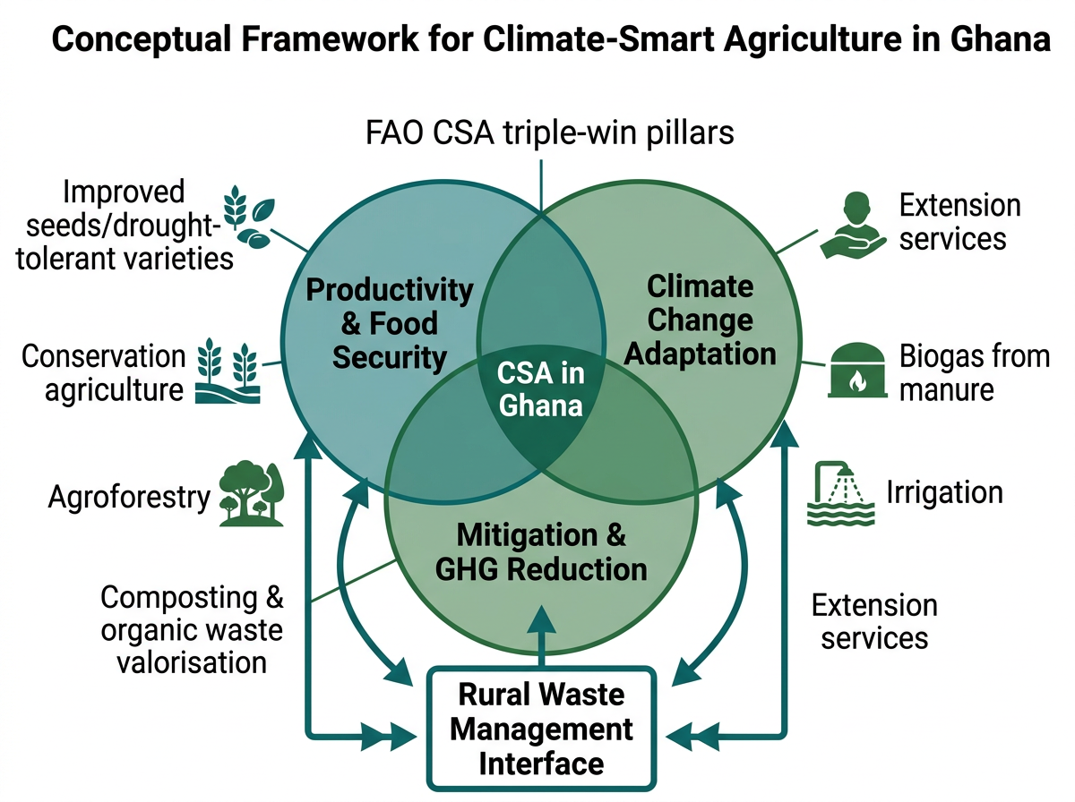
Figure 1. Conceptual framework for Climate-Smart Agriculture (CSA) in Ghana, showing the FAO triple-win pillars intersecting with the rural waste management interface. Arrows denote bidirectional feedbacks between waste valorisation pathways and each CSA pillar.

3. Methodology

3.1 Review Design and Search Strategy

This study employs a systematic narrative review design following PRISMA 2020 guidelines. Database searches were conducted in Web of Science, Scopus, PubMed, and Google Scholar using Boolean search strings combining terms: ('climate-smart agriculture' OR 'CSA') AND ('Ghana' OR 'West Africa') AND ('adoption' OR 'barriers' OR 'determinants' OR 'waste' OR 'compost' OR 'biogas' OR 'policy'). Grey literature searches targeted FAO, World Bank, CGIAR/CCAFS, IPCC, Ghana EPA, MoFA, and GCIC repositories. The search covered publications from January 2010 to February 2025.
3.2 Inclusion and Exclusion Criteria
Studies were included if they: (i) focused on CSA practices, rural waste management, or both in Ghana or provided sub-national Ghanaian data within regional reviews; (ii) were peer-reviewed empirical studies, systematic reviews, or authoritative institutional reports; (iii) were published in English; and (iv) reported quantitative or qualitative data relevant to adoption, barriers, or policy assessment. Studies were excluded if they were purely theoretical, duplicate records, or lacked Ghana-specific data. A total of 35 primary sources met the final inclusion criteria after deduplication and quality screening.
3.3 Data Extraction and Synthesis
Data were extracted using a structured template capturing: author(s), year, study design, sample size, agro-ecological zone, CSA practices studied, adoption metrics, barriers identified, and policy instruments referenced. A thematic coding protocol organised findings under seven themes aligned with the article's section structure. Quantitative findings (adoption rates, effect sizes, willingness-to-pay values) were tabulated. Inter-coder reliability was assessed on a random 20% subsample (Cohen's κ = 0.81, indicating strong agreement). Narrative synthesis followed Popay et al.'s (2006) framework for qualitative evidence integration.

4. CSA Practices in Ghana
4.1 Overview And Classification

CSA practices documented in Ghana span all three triple-win pillars and are distributed across four agro-ecological zones: the Guinea Savannah (north), the Sudan Savannah (far north), the Forest-Savannah Transition, and the Coastal Savannah. The Northern Savannah zones bear the highest climate vulnerability — characterised by mono-modal rainfall, erratic onset, and accelerating land degradation — and consequently account for the majority of empirical CSA studies. The following subsections describe practices by resource typology, drawing primarily on Antwi-Agyei et al. (2023), Atta-Aidoo & Antwi-Agyei (2025), and the systematic review by Mnukwa et al. (2025).
Table 1. CSA Practices in Ghana Classified by Triple-Win Pillar and Resource Typology
CSA Practice | CSA Pillar(s) | Resource Type | Agro-Ecological Zone | Key Source(s)
Drought-tolerant/improved variety adoption | Productivity; Adaptation | Finance-intensive | All zones | FAO & MoFA, 2018; Antwi-Agyei et al., 2023
Conservation agriculture (minimum tillage) | Adaptation; Mitigation | Labour-intensive | Savannah zones | Mnukwa et al., 2025; Essegbey & MacCarthy, 2020
Agroforestry / shade trees | Productivity; Mitigation | Land-intensive | Forest-transition; Savannah | Nkansah-Dwamena et al., 2023
Crop residue retention/mulching | Adaptation; Mitigation | Labour-intensive | All zones | Atta-Aidoo & Antwi-Agyei, 2025
Composting (municipal/farm organic waste) | Productivity; Mitigation | Labour/Finance-intensive | Peri-urban; Savannah | Danso et al., 2022; Ampomah-Benefo et al., 2025
Integrated Soil Fertility Management (ISFM) | Productivity; Adaptation | Finance-intensive | All zones | FAO & MoFA, 2018
Biogas from livestock/agricultural waste | Mitigation; Productivity | Finance-intensive | Rural livestock zones | Kusi-Appiah, 2025
Water harvesting / small-scale irrigation | Adaptation; Productivity | Finance/Labour-intensive | Northern Savannah | World Bank CSAIP, 2021
Vermicomposting (Eudrilus eugeniae) | Productivity; Mitigation | Labour-intensive | Peri-urban; Forest zone | Somiah, 2025; Nkansah-Dwamena et al., 2023
Climate information services (CIS) | Adaptation | Finance-intensive | All zones | Djido et al., 2021

4.2 Labour-Intensive Practices
Labour-intensive CSA practices — including conservation agriculture, mulching, and crop residue retention — are the most widely adopted category in Ghana. Atta-Aidoo & Antwi-Agyei (2025) report adoption rates of approximately 83% among male and 78% among female farmers in their Northern Ghana study population. These practices require minimal cash outlay, align with traditional farming knowledge, and deliver immediate on-farm benefits such as improved soil moisture retention and erosion control. Mnukwa et al.'s (2025) systematic review covering 2003–2023 confirms that labour-intensive CSA practices consistently show the highest adoption probabilities across sub-Saharan Africa, citing 48 qualifying studies with Ghana accounting for six. Conservation agriculture alone has been shown to reduce soil temperature by 2–3°C and increase water-holding capacity by 15–20%, providing measurable adaptation co-benefits (Antwi-Agyei et al., 2023).
4.3 Land-Intensive Practices
Agroforestry and integrated landscape management represent land-intensive CSA, with documented adoption of ~76% (male) and ~70% (female) in Ghana (Atta-Aidoo & Antwi-Agyei, 2025). Agroforestry systems in Ghana's Forest-Savannah Transition zone — particularly the traditional cocoa-shade-tree system — deliver triple-win co-benefits: improved yields under shade, enhanced biodiversity, and carbon sequestration. Nkansah-Dwamena et al. (2023) argue that small-scale circular agriculture integrating agroforestry with organic waste recycling is structurally aligned with both food security and environmental sustainability objectives. Land tenure security is a critical moderating variable: Mnukwa et al. (2025) report that farmers with secure tenure are 60% more likely to invest in long-term land-based CSA measures such as tree planting and soil conservation terracing.
4.4 Finance-Intensive Practices
Finance-intensive CSA practices — including improved seed varieties, small-scale irrigation, biogas infrastructure, and formal composting inputs — show the lowest and most unequal adoption rates. Atta-Aidoo & Antwi-Agyei (2025) report a 15-percentage-point gender gap: ~62% for male farmers versus ~47% for female farmers. This disparity reflects structural inequities in access to credit, land titles, and agricultural extension services that disproportionately disadvantage women (Boudalia et al., 2024; Hailemariam & Kalsi, 2024). Ghana's CSAIP allocates the majority of its US$389.5 million portfolio to finance-intensive infrastructure, suggesting a mismatch between investment priorities and the practices that currently achieve broad-based farmer uptake (World Bank, 2021).
Table 2. Documented CSA Adoption Rates in Ghana by Practice Category
Practice Category | Adoption Rate (%)  (Male) | Adoption Rate (%)  (Female) | Gender Gap (pp) | Source
Labour-intensive (all) | ~83 | ~78 | 5 | Atta-Aidoo & Antwi-Agyei, 2025
Land-intensive (all) | ~76 | ~70 | 6 | Atta-Aidoo & Antwi-Agyei, 2025
Finance-intensive (all) | ~62 | ~47 | 15 | Atta-Aidoo & Antwi-Agyei, 2025; Boudalia et al., 2024
Conservation agriculture | ~80 | ~75 | 5 | Mnukwa et al., 2025
Improved variety adoption | ~65 | ~50 | 15 | Antwi-Agyei et al., 2023
Agroforestry | ~70 | ~64 | 6 | Nkansah-Dwamena et al., 2023
Composting (formal) | ~30 | ~35 | -5* | Danso et al., 2022
Biogas adoption | ~8 | ~5 | 3 | Kusi-Appiah, 2025
Water harvesting/irrigation | ~55 | ~42 | 13 | World Bank CSAIP, 2021
Note: pp = percentage points. *Composting shows a slight female-positive gap, consistent with women's primary role in household waste management.

5. Rural Waste Management and CSA
5.1 Ghana's Waste Profile: Scale and Composition
Ghana's waste generation is characterised by rapid growth driven by urbanisation, population increase, and changing consumption patterns. National daily MSW generation stands at approximately 13,000 tonnes, equivalent to 0.51 kg per capita per day (Ampomah-Benefo et al., 2025; Kusi-Appiah, 2025). Organic material — comprising food waste, vegetable matter, and agricultural residues — constitutes the dominant fraction at ~61% nationally (~7,930 t day⁻¹), while plastics account for ~14% and the remainder is mixed inert and recyclable material. Regional variation is substantial: the organic fraction reaches 68% in Greater Accra but declines to 44.9% in Tamale, reflecting dietary and livelihood differences between coastal-urban and savannah-rural settings (Kusi-Appiah, 2025). Formal waste collection coverage is 60–70% in urban areas but falls below 20% in rural communities, where open dumping, burning, and burial remain the default disposal practices (Ampomah-Benefo et al., 2025).
5.2 Composting and Organic Amendments: Opportunities and Barriers
Composting represents the most direct pathway from organic waste valorisation to CSA. Ghana's formal composting sector includes three principal facilities: the Accra Compost and Recycling Plant (ACARP), the Integrated Recycling and Composting Plant (IRECOP) in Kumasi, and the private operator Jekora Ventures. Together, these facilities process a small fraction of the national organic waste stream. Danso et al. (2022) document smallholder farmers' willingness-to-pay (WTP) for compost products: GHS 9.43 per 50 kg bag for branded compost and GHS 5.76 for pelletised compost, translating to marginal WTP of US$0.82 per bag where both branding and labelling are present. Vermicomposting using Eudrilus eugeniae (African nightcrawler) has emerged as a low-cost, decentralised complementary technology that can achieve up to 20% crop yield increases and significantly improves nitrogen, phosphorus, and potassium concentrations in amended soils (Somiah, 2025; Nkansah-Dwamena et al., 2023).
Transport costs represent a major barrier to compost market development. Somiah (2025) identifies distance between composting plants and rural farming communities as the primary constraint on compost use in Northern Ghana, where farms are dispersed across large catchment areas. A decentralised, community-level composting model — such as those piloted in smallholder cooperative contexts — addresses this barrier by co-locating waste processing with agricultural demand. Nkansah-Dwamena et al. (2023) report that integrating circular agriculture with community composting increases farmer incomes by 12–18% in Ghanaian case study areas. However, quality uncertainty persists: farmers express concern about the consistency and safety of compost derived from mixed municipal solid waste, particularly given the absence of national compost quality standards.
5.3 The Microplastic Contamination Paradox
An emergent and underappreciated challenge is microplastic contamination of organic amendments. Maqbool (2023) documents microplastic concentrations of 1,100–2,700 particles per kilogram of organic waste in the Greater Accra Metropolitan Area, derived from plastic fragments that are co-composted with organic fractions due to incomplete source separation. Wang et al. (2024) demonstrate that microplastic accumulation in soils significantly alters soil biochemical properties — reducing microbial biomass carbon by 10–20%, disrupting pore structure, and decreasing aggregate stability — effects that directly counteract the soil-health co-benefits that composting is intended to deliver. This 'compost quality paradox' presents a dilemma for Ghana's waste-to-CSA transition: the same organic waste streams that offer large-scale composting potential are contaminated by the plastics (~14% of MSW) that pervade Ghana's waste stream. Resolution requires upstream source separation — itself a governance challenge given low public awareness and absence of mandatory sorting regulations.
5.4 Biogas from Livestock and Agricultural Waste
Biogas represents a dual-purpose CSA intervention: it converts livestock manure and agricultural residues into renewable energy (displacing fuelwood, reducing deforestation) while generating nitrogen-rich digestate that substitutes for synthetic fertiliser. Kusi-Appiah (2025) estimates that Ghana's rural livestock population — dominated by cattle, sheep, goats, and pigs — could yield approximately 75,000 m³ of biogas annually at ~60% methane concentration, sufficient to supply clean cooking energy to an estimated 15,000 rural households. Pilot projects documented in the Upper East and Upper West regions confirm technical feasibility, but adoption remains nascent (<8% of farming households) owing to high upfront capital costs (~GHS 3,000–8,000 per household unit), limited technical servicing capacity, and inadequate policy support beyond project interventions (Kusi-Appiah, 2025; World Bank, 2021).
5.5 Agrochemical Container Waste
Empty pesticide and fertiliser containers constitute a distinct waste-CSA challenge. Survey data across Ghanaian farming communities reveal that farmers primarily burn (40%), bury (25%), or reuse (20%) empty agro-chemical containers, with only ~15% directing them to formal disposal channels (Kazapoe et al., 2025). Open burning of plastic agrochemical containers releases dioxins, furans, and persistent organic pollutants (POPs) that persist in soils, accumulate in food crops, and pose chronic human health risks. The Basel Convention workshop on plastic waste in Ghana (2025) identified the absence of a formal agricultural container management system — analogous to producer take-back schemes in OECD countries — as a critical regulatory gap. The End Plastic Pollution Consortium (EPPC, 2025) launched an initiative targeting agri-value-chain plastic reduction, but implementation is in early stages.

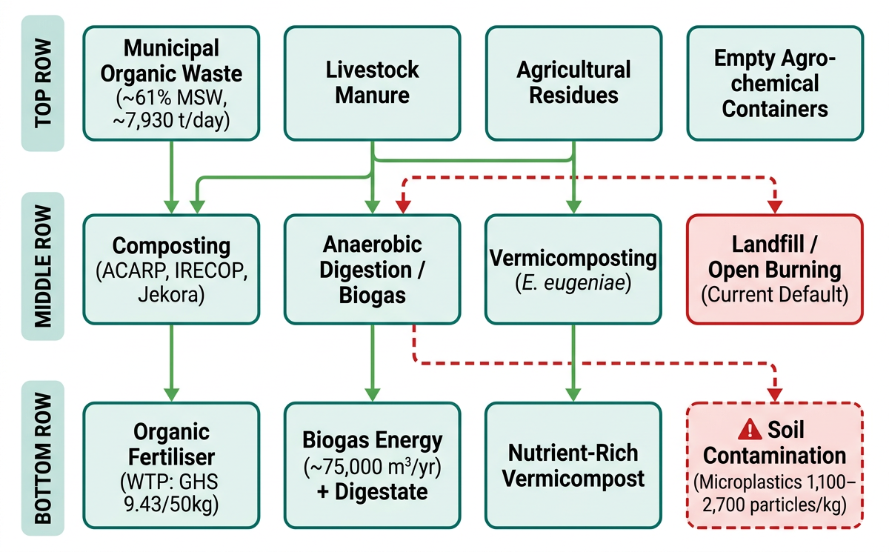
Figure 2. Waste-to-resource pathways for Climate-Smart Agriculture in Ghana. Green arrows denote beneficial circular economy pathways; red dashed arrows indicate current default disposal routes. WTP = willingness-to-pay (Danso et al., 2022); microplastic data from Maqbool (2023).

Table 3. Waste Management–CSA Integration: Pathways, Barriers, and Policy Linkages
Waste Stream | CSA Pathway | Key Barrier(s) | Policy Instrument | Source(s)
Municipal organic waste (~61% MSW) | Composting → organic fertiliser | Transport cost; quality uncertainty; microplastics | CEAP 2024; NDC composting measure | Ampomah-Benefo et al., 2025; Danso et al., 2022
Livestock manure | Biogas + digestate fertiliser | High capital cost; servicing gaps | CSAIP 2021; Feed Ghana 2025 | Kusi-Appiah, 2025; World Bank, 2021
Agricultural residues | Mulching; vermicomposting | Labour opportunity cost; burning tradition | CSA Action Plan 2016 | Atta-Aidoo et al., 2022; Somiah, 2025
Agro-chemical containers | Proper disposal / take-back | Knowledge gap; no formal system | Basel Convention; EPPC 2025 | Kazapoe et al., 2025; Basel, 2025
Food processing waste | Compost / vermicompost | Logistics; SME capacity | GCIC Waste Paper 2025 | Nkansah-Dwamena et al., 2023

6. Determinants of CSA Adoption
6.1 Behavioural Determinants: The Theory of Planned Behaviour
Atta-Aidoo et al. (2022) conducted the most comprehensive TPB-based study of CSA adoption in Ghana to date, surveying 480 smallholder farmers across three northern districts. Structural equation modelling revealed that subjective norms exerted the strongest direct effect on adoption intention (β = 0.52, p < 0.001), followed by perceived behavioural control (β = 0.43, p < 0.001) and attitude (β = 0.25, p < 0.01). The model explained 36% of variance in adoption intention. Critically, subjective norms did not operate uniformly across gender: Atta-Aidoo & Antwi-Agyei (2025) find that social pressure from male peer groups reduced the likelihood of male farmers adopting practices perceived as 'feminine' (e.g., composting, vermicomposting), while PLOS Climate evidence from Ghana indicates that positive community norms around conservation agriculture increase adoption probability by 28% (Atta-Aidoo et al., 2022). These findings align with Kabir et al.'s (2024) meta-analytic finding that sociopolitical norms constitute one of the five primary barriers to agricultural climate mitigation globally.
6.2 Institutional Determinants: Extension Services and Land Tenure
Institutional access variables are among the most powerful determinants of CSA adoption at the farm level. Mnukwa et al. (2025) report, from a meta-regression of 48 studies across sub-Saharan Africa (including six Ghana studies), that access to agricultural extension services multiplies the probability of CSA adoption by a factor of 2.8 (OR = 2.8, 95% CI: 2.1–3.7). The underlying mechanism is information diffusion: extension workers not only demonstrate techniques but also build the attitudinal and normative preconditions for TPB-predicted adoption. However, Ghana's extension worker-to-farmer ratio stands at approximately 1:1,500 in the Northern Savannah — far below the FAO-recommended 1:400 — creating a structural service deficit that cannot be bridged without significant institutional investment (Djido et al., 2021).
Land tenure security independently increases long-term CSA investment by approximately 60% (Mnukwa et al., 2025). In Ghana's land tenure system — characterised by a mix of statutory, customary, and family-land arrangements — smallholders without documented tenure rights are unwilling to invest in perennial agroforestry, soil conservation structures, or biogas infrastructure given uncertain returns over multi-year time horizons. Women's land rights are particularly precarious: in the northern regions, customary law frequently restricts women to usufruct rights that can be revoked upon the death of a male household head, directly suppressing investment in finance- and land-intensive CSA (Boudalia et al., 2024; Hailemariam & Kalsi, 2024).
6.3 Gender as a Cross-Cutting Determinant
The gender dimension of CSA adoption in Ghana is both a data gap and a structural challenge. Boudalia et al. (2024) review 42 African studies and find consistent evidence that men are more likely to adopt high-return finance-intensive CSA practices, while women disproportionately engage in labour-intensive practices that reduce household risk but deliver lower monetary returns. Hailemariam & Kalsi (2024), analysing data from 29 sub-Saharan African countries, report a significant gender gap in CSA adoption that is explained by differential access to extension, credit, and land rather than by attitudinal or motivational differences between men and women. This is a critically important finding: gender gaps are structural, not attitudinal, and require structural interventions (tenure reform, targeted credit, gender-responsive extension) rather than awareness campaigns alone.

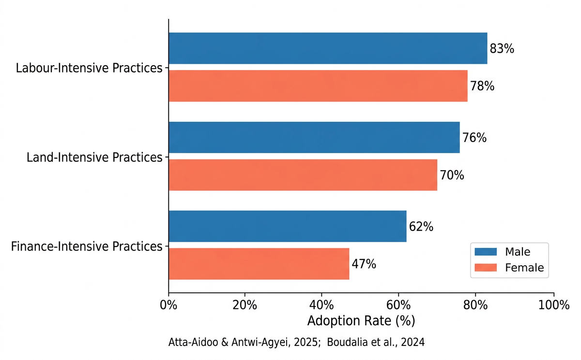
Figure 3. Gendered CSA adoption rates (%) by resource-type category among smallholder farmers in Ghana. The finance-intensive practices show the largest gender gap (15 percentage points). Data sources: Atta-Aidoo & Antwi-Agyei (2025); Boudalia et al. (2024).
6.4 Structural and Socioeconomic Barriers
Beyond behavioural and institutional variables, structural barriers operate at the meso- and macro-levels. Antwi-Agyei et al. (2023) construct a CSA composite index for smallholder farmers in Ghana's forest-savannah transition zone and identify cost of inputs, labour availability, and market access as the three most frequently cited barriers — reported by 71%, 58%, and 52% of surveyed farmers, respectively. Finance-intensive practices face an additional capital-market failure: agricultural lending in Ghana carries high interest rates (typically 28–35% per annum) and requires collateral that most smallholders cannot provide. Kabir et al. (2024) categorise these as 'political-economy barriers' — structural features of capital and land markets that individually rational farmers cannot overcome without coordinated policy intervention.
Table 4. Summary of Determinants of CSA Adoption in Ghana
Determinant | Effect / Finding | Practice Type Affected | Mechanism | Key Source(s)
Subjective norms (TPB) | β = 0.52*** (strongest predictor) | All types | Social conformity; peer influence | Atta-Aidoo et al., 2022
Perceived behavioural control | β = 0.43*** | Finance-intensive | Self-efficacy; resource confidence | Atta-Aidoo et al., 2022
Attitude toward CSA | β = 0.25** | Labour-intensive | Risk perception; innovation bias | Atta-Aidoo et al., 2022
Extension service access | OR = 2.8× adoption probability | All types | Information; demonstration effects | Mnukwa et al., 2025
Secure land tenure | +60% long-term CSA investment | Land/Finance-intensive | Reduced tenure risk; investment horizon | Mnukwa et al., 2025
Gender (female) | −15 pp in finance-intensive adoption | Finance-intensive | Credit/extension access inequity | Boudalia et al., 2024; Hailemariam & Kalsi, 2024
Household income/wealth | Positive for all practice types | Finance-intensive | Liquidity; risk tolerance | Antwi-Agyei et al., 2023
Input cost | 71% cite as barrier | Finance-intensive | Capital market failure | Antwi-Agyei et al., 2023
Labour availability | 58% cite as barrier | Labour-intensive | Off-farm migration; seasonal competition | Antwi-Agyei et al., 2023
Social capital / trust networks | Positive for all types | Labour-intensive | Collective action; knowledge sharing | Atta-Aidoo et al., 2022

7. Policy landscape
7.1 Overview of ghana's climate and agricultural policy architecture
Ghana possesses a relatively well-developed climate and agricultural policy architecture, yet critical coherence gaps persist between instruments governing agriculture and those governing waste management. The national climate change policy (nccp, 2014) established the overarching framework, prioritising agriculture and food security as the first of six action areas and mandating the promotion of csa research, technology adoption, and harmonisation of agricultural policies with climate objectives (mesti, 2014). However, the nccp does not reference waste management as a csa input pathway — a foundational omission that cascades through subsequent instruments.
The csa action plan (2016–2020) and its companion csa investment framework (2018) operationalised the nccp's agricultural objectives. Djido et al. (2021) evaluate implementation across ghana's 216 districts and find that 62% report some csa activities under the action plan, but only 19% implement both the action plan and the investment framework simultaneously — the combination necessary for sustained, financed csa programming. District-level awareness of the action plan is the strongest predictor of implementation (regression coefficient β = 1.30, p < 0.01), indicating that awareness campaigns could substantially increase uptake at marginal cost. Persistent weaknesses include: top-down design with limited farmer participation; no monitoring and evaluation (m&e) framework; weak emphasis on livestock and fisheries; and reliance on district assemblies that lack dedicated csa budget lines (djido et al., 2021).
7.2 The updated ndc and international climate commitments
Ghana's 2021 updated nationally determined contribution (ndc) covers 47 programmes across 19 policy areas. In the agriculture sector, nine unconditional mitigation measures are committed, targeting 8.5 mtco₂e reductions by 2025 and 24.6 mtco₂e by 2030; a further 25 conditional measures could deliver up to 64 mtco₂e by 2030 at an estimated cost of us$9.3–15.5 billion (ghana, 2021; unep, 2023). Composting of municipal solid waste is explicitly listed as one of fourteen unconditional mitigation measures, representing the sole formal policy linkage between waste management and csa in ghana's national climate framework. Mensah et al. (2025) map ndc measures onto the sdg framework and find 80% alignment, with composting linked to sdg 2 (zero hunger), sdg 11 (sustainable cities), and sdg 12 (responsible consumption) — a multi-dimensional co-benefit profile that strengthens the case for scaling this measure. Ghana's ndc positions the country for article 6 carbon market participation, potentially generating revenue streams that could finance csa and waste-valorisation infrastructure.
7.3 The world bank csaip and feed ghana programme
The world bank-supported climate-smart agriculture investment plan (csaip, 2021) represents ghana's most substantial csa financing commitment to date, allocating us$389.5 million across 1,695,000 beneficiary farming families (world bank, 2021). The csaip focuses on technology transfer, capacity building, and market system development for drought-tolerant varieties, irrigation, and isfm. Notably, waste valorisation is not included as an investment component — a gap that the present review identifies as a missed opportunity given the scale of ghana's organic waste stream. The feed ghana programme (2025–2028), launched by the mahama administration, aims to modernise agriculture, reduce ghana's us$2 billion annual food import bill, and incorporate climate resilience, targeting 10,000 hectares of staple-crop production. Its explicit integration of waste management remains underdeveloped, representing a policy window that could be leveraged for waste-to-csa mainstreaming.
7.4 Waste governance and the circular economy transition
Ghana's waste governance has evolved significantly in recent years. The environmental sanitation policy (1999, revised 2010) provides the foundational framework, while the hazardous and electronic waste act (2016) regulates toxic waste streams including agrochemical containers. Extended producer responsibility (epr) for plastic packaging waste — originally voluntary under act 917 and l.i. 2250 — is transitioning to mandatory enforcement in 2025 (ghana news agency, 2025). The circular economy action plan (ceap, 2024) and the ghana circular economy centre (gcec, 2025) represent the most ambitious waste-transformation initiatives. Ampomah-benefo et al. (2025) demonstrate that a representative circular waste operation generates a positive net present value of ghs 16.4 million over ten years (bcr = 1.51; roi = 51.27%), with life-cycle assessment estimating monthly emissions of approximately 17,500 kg co₂e under current practices and substantial reduction potential under circular alternatives.

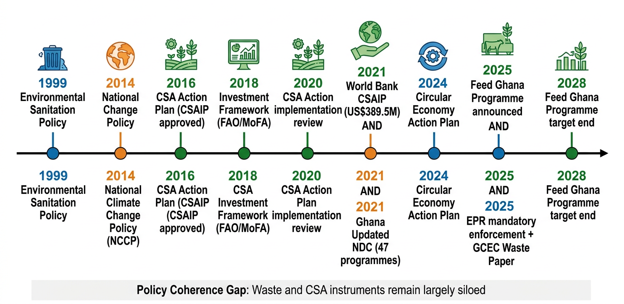
Figure 4. Timeline of key Climate-Smart Agriculture and waste management policy milestones in Ghana (1999–2028). Green = CSA/agriculture; blue = waste/circular economy; orange = NDC/climate commitments. The absence of contemporaneous bridging instruments prior to 2024 reflects the policy coherence gap identified in this review.
Table 5. Policy Coherence Assessment: CSA vs. Waste Management Instruments in Ghana
Policy Instrument | Year | Primary Domain | CSA Link | Waste Link | Integration Gap
National Climate Change Policy (NCCP) | 2014 | Climate/Agriculture | Yes (primary) | No | Foundational omission
CSA Action Plan | 2016 | Agriculture | Yes (primary) | No | Waste as CSA input absent
CSA Investment Framework (FAO/MoFA) | 2018 | Agriculture | Yes (primary) | No | No composting investment
Environmental Sanitation Policy | 1999/2010 | Waste/Sanitation | No | Yes (primary) | No agriculture interface
Hazardous/E-Waste Act | 2016 | Waste | No | Yes (partial) | Agro-containers not covered
Ghana Updated NDC | 2021 | Climate/Multi-sector | Yes | Yes (composting only) | Partial — composting sole link
World Bank CSAIP | 2021 | Agriculture/Finance | Yes (primary) | No | No waste valorisation component
Circular Economy Action Plan | 2024 | Waste/Economy | Implicit | Yes (primary) | Agriculture interface underdeveloped
Feed Ghana Programme | 2025 | Agriculture | Yes | No (unclear) | Missed policy window
GCIC Waste Management Paper | 2025 | Waste/Policy | Implicit | Yes (primary) | Needs agriculture mainstreaming
8. Synthesis, research gaps, and future directions
8.1 Synthesis of evidence
The seven preceding sections collectively establish that csa in ghana operates at the intersection of four major system challenges: (i) a climate vulnerability crisis that threatens productivity for 45% of the national workforce; (ii) a structural adoption deficit driven by resource inequality, gender discrimination, and institutional undercapacity; (iii) an organic waste surplus (~7,930 t day⁻¹) that is simultaneously a missed csa opportunity and an active environmental risk when disposed of through burning or open dumping; and (iv) a policy coherence gap between agricultural and waste governance that prevents integrated solutions. These challenges are deeply interconnected: closing the adoption gap requires inputs (organic fertilisers, biogas) that depend on waste valorisation; waste valorisation requires policy coherence and institutional coordination that currently does not exist; and both require addressing the structural inequities — in land tenure, credit, and extension — that disproportionately exclude women from the benefits of csa.
The 'compost quality paradox' identified in section 5.3 illustrates the systemic nature of these challenges: organic waste composting is ghana's only unconditional ndc–csa link (section 7.2), but the same organic waste stream contains microplastic contamination levels (1,100–2,700 particles kg⁻¹) that could degrade the soil health outcomes composting is intended to deliver (maqbool, 2023; wang et al., 2024). Resolving this paradox requires action at three levels: upstream (mandatory source separation and epr for plastics); midstream (quality standards for organic amendments); and downstream (monitoring programmes for microplastic accumulation in farmed soils). None of these interventions is currently implemented at national scale.
8.2 Key research gaps
This review identifies six priority research gaps. First, long-term field trials quantifying the soil health, yield, and ghg outcomes of different composting and organic amendment strategies under ghana's diverse agro-ecological conditions are conspicuously absent from the literature; existing studies are predominantly short-term (≤2 seasons) and geographically concentrated in the northern savannah. Second, the microplastic contamination baseline in ghanaian agricultural soils — particularly in peri-urban farming areas receiving composts and irrigation water from urban sources — has not been systematically measured. Third, gender-disaggregated data on waste management behaviour are insufficient: while women are known to be primary household waste managers, their role in community-level composting value chains is poorly documented. Fourth, the economic viability of decentralised biogas systems under ghana's specific input-output cost structure has not been modelled at scale. Fifth, the political economy of csa policy implementation at district level — including the incentive structures of district assemblies, extension agencies, and private agro-dealers — requires deeper institutional ethnography. Sixth, impact evaluations of gender-responsive csa programmes in ghana are virtually absent.
8.3 Future directions and recommendations
Based on the synthesis and gap analysis, this review advances six integrated recommendations. (1) establish a waste-agriculture nexus (wan) policy mechanism under a joint mofa-epa-ndpc task force, with a mandate to integrate organic waste valorisation into csa programming and align the ceap with the csa action plan revision. (2) implement mandatory source separation and organic waste collection as a prerequisite for national composting scale-up, linked to the epr framework being finalised in 2025. (3) develop and enforce national compost quality standards addressing microplastic thresholds, nutrient content, pathogen safety, and labelling — drawing on eu regulation 2019/1009 as a reference standard. (4) invest in gender-responsive csa programming that addresses structural barriers (land rights, credit access, extension provision) rather than focusing solely on attitudinal change. (5) pilot and evaluate decentralised community composting and biogas models in three agro-ecological zones with full cost-benefit and life-cycle assessment documentation to build the evidence base for national scaling. (6) establish a national long-term soil health monitoring network measuring microplastic accumulation, organic carbon, and csa practice effects across major farming systems.
9. Conclusion
This systematic narrative review has provided a comprehensive assessment of climate-smart agriculture in ghana across four interlocking dimensions: practice adoption, adoption determinants, the waste-agriculture nexus, and the policy landscape. The evidence confirms that ghana has made meaningful progress in csa institutionalisation, with an updated ndc committing to substantial mitigation targets, a world bank-supported investment plan of us$389.5 million, and emerging circular economy infrastructure. However, persistent structural inequities — in gender, land tenure, and extension access — suppress adoption of high-impact finance-intensive csa practices, particularly among women who manage both agricultural and household organic waste streams.
The review's most original contribution is the systematic documentation of ghana's organic waste surplus (~7,930 t day⁻¹ of organic msw) as an under-utilised csa resource, constrained by the 'compost quality paradox' of microplastic contamination, institutional policy silos, and infrastructure deficits. Bridging the waste-agriculture interface through an integrated waste-agriculture nexus policy mechanism represents a high-leverage, cost-effective pathway to simultaneously advancing food security, climate adaptation, mitigation, and circular economy objectives. The circular economy action plan (2024), feed ghana programme (2025), and mandatory epr framework (2025) together constitute an unprecedented policy window for this integration — one that will close without deliberate bridging action.
Future research should prioritise long-term field trials of composting effects under ghanaian conditions, a national microplastic soil baseline, gender-disaggregated waste management research, and institutional analysis of district-level csa implementation barriers. The six-point research and policy agenda advanced in section 8 provides a roadmap for researchers, policymakers, development partners, and civil society to transform ghana's organic waste surplus from a public health liability into the foundation of a climate-resilient, inclusive, and sustainable agricultural future.

Consent

All authors declare that ‘written informed consent was obtained from the patient (or other approved parties) for publication of this case report and accompanying images. A copy of the written consent is available for review by the Editorial office/Chief Editor/Editorial Board members of this journal.

Ethical approval

All authors hereby declare that "Principles of laboratory animal care" (NIH publication No. 85-23, revised 1985) were followed, as well as specific national laws where applicable. All experiments have been examined and approved by the appropriate ethics committee

All authors hereby declare that all experiments have been examined and approved by the appropriate ethics committee and have therefore been performed in accordance with the ethical standards laid down in the 1964 Declaration of Helsinki.

References

Africa Circular Economy Network. (2024). Circular economy action plan and roadmap in Ghana. https://africacircular.org/circular-economy-action-plan-and-roadmap-in-ghana/
Ajzen, I. (1991). The theory of planned behavior. Organizational Behavior and Human Decision Processes, 50(2), 179–211. https://doi.org/10.1016/0749-5978(91)90020-T
Ampomah-Benefo, K., Quaye, W., & Asare, R. (2025). Transforming waste management in Ghana: Innovations, benefits, and policy reforms for a circular economy. Ghana Climate Innovation Centre / Ashesi University. https://ghanacic.ashesi.edu.gh/wp-content/uploads/2025/08/Waste-Management-Policy-Paper.pdf
Antwi-Agyei, P., Wiyo, K. A., Partey, S. T., & Frimpong, B. N. (2023). Trade-offs, synergies and acceptability of climate-smart agricultural practices by smallholder farmers in rural Ghana. International Journal of Agricultural Sustainability, 20(5), 729–745. https://doi.org/10.1080/14735903.2023.2193439
Atta-Aidoo, J., Antwi-Agyei, P., Quaye, W., & Donkoh, S. A. (2022). Determinants of smallholder farmers' intention and actual adoption of climate-smart agriculture practices: Application of the Theory of Planned Behaviour. PLOS Climate, 1(7), e0000082. https://doi.org/10.1371/journal.pclm.0000082
Atta-Aidoo, J., & Antwi-Agyei, P. (2025). Resource typologies and gendered gaps in climate-smart agriculture adoption in rural Ghana. BMC Environmental Science. https://doi.org/10.1186/s44329-025-00018-6
Basel Convention Secretariat. (2025). Technical assistance workshop on plastic waste implementation in Ghana. UNEP. https://www.basel.int/Implementation/Plasticwaste/Technicalassistance/Workshops/PlasticWasteGhana2025/tabid/10358/Default.aspx
Boudalia, S., Tir Touil Meddah, A., Tahari, A., & Gueroui, Y. (2024). Gendered gaps in the adoption of climate-smart agriculture in Africa. Sustainability, 16(13), 5539. https://doi.org/10.3390/su16135539
Danso, G., Cofie, O., Larbi, I., & Ofori, B. (2022). Smallholder farmers' willingness to pay for quality-differentiated compost in Ghana. Oxford Open Sustainability. https://doi.org/10.1093/oxfsu/ucac001
Djido, A. I., Amikuzuno, J., Balima, L. H., Tambo, J. A., & Wiredu, A. N. (2021). Implementation, usage, and effectiveness of Ghana's Climate-Smart Agriculture Action Plan and Investment Framework. CGIAR/CCAFS Working Paper. https://cgspace.cgiar.org/bitstreams/6a34ddb8-146f-4a0a-b6ef-b79d0017e032/download
End Plastic Pollution Consortium (EPPC). (2025). Inclusive food production and plastic waste reduction in Ghana. Africa Evidence Network. https://africaevidencenetwork.org/fr/end-plastic-pollution-consortium-eppc-in-ghana/2025/04/17/
Environmental Protection Agency (EPA) Ghana. (2020). Ghana's fourth national communication (NC4) to the UNFCCC. Government of Ghana.
Essegbey, G. O., & MacCarthy, D. S. (2020). Overview and lessons learned from the implementation of climate-smart agriculture (CSA) initiatives in West and Central Africa. CSIR-STEPRI. https://www.researchgate.net/publication/400215218
Food and Agriculture Organization (FAO) & Ministry of Food and Agriculture (MoFA) Ghana. (2018). Climate-smart agriculture investment framework for Ghana. FAO. https://faolex.fao.org/docs/pdf/gha174314.pdf
Ghana, Republic of. (2021). Ghana's updated nationally determined contribution (NDC) to the UNFCCC. Ministry of Environment, Science, Technology and Innovation. https://unfccc.int/sites/default/files/NDC/2022-06/Ghana%27s%20Updated%20Nationally%20Determined%20Contribution%20to%20the%20UNFCCC_2021.pdf
Ghana Circular Economy Centre (GCEC). (2025). Circular economy and waste valorisation in Ghana: Policy brief. Ashesi University. https://ghanacic.ashesi.edu.gh
Ghana News Agency (GNA). (2025, October). Stakeholders urge swift finalisation of Ghana's extended producer responsibility (EPR) policy framework. https://gna.org.gh/2025/10/stakeholders-urge-swift-finalisation-of-ghanas-epr-policy-framework/
Hailemariam, M., & Kalsi, J. (2024). Gender gaps in the adoption of climate-smart agricultural practices: Evidence from sub-Saharan Africa. Journal of Agricultural Economics, 75(2), 764–793. https://doi.org/10.1111/1477-9552.12583
IPCC. (2021). Summary for policymakers. In V. Masson-Delmotte et al. (Eds.), Climate change 2021: The physical science basis. Cambridge University Press. https://doi.org/10.1017/9781009157896.001
Kabir, M., De Vries Robbe, S., Kanter, D. R., & Williams, J. (2024). Climate change mitigation policies in agriculture: An overview of sociopolitical barriers. WIREs Climate Change, 15(2), e916. https://doi.org/10.1002/wcc.916
Kazapoe, R. W., Angnunavuri, P. N. A., & Attiogbe, F. (2025). Exploring waste activation and mineralization for environmental and economic sustainability in Ghana. ResearchGate. https://www.researchgate.net/publication/392004251
Kusi-Appiah, E. (2025). Municipal solid waste composition and organic fraction dynamics in Ghana (2021–2024). Preprints. https://www.preprints.org
Lipper, L., Thornton, P., Campbell, B. M., Torquebiau, E., & Smith, P. (2014). Climate-smart agriculture for food security. Nature Climate Change, 4(12), 1068–1072. https://doi.org/10.1038/nclimate2437
Maqbool, Z., Nawaz, M. F., Saqib, Z. A., & Khalid, H. (2023). Assessing microplastic contamination and characteristics in organic soil amendments in the Greater Accra Metropolitan Area of Ghana. ResearchGate. https://www.researchgate.net/publication/386434715
Mensah, K., Antwi-Agyei, P., & Asante, F. A. (2025). Synergies and trade-offs between Ghana's nationally determined contributions and the sustainable development goals. Cleaner Production Letters. https://www.sciencedirect.com/science/article/pii/S305047592500805X
Ministry of Environment, Science, Technology and Innovation (MESTI). (2014). National Climate Change Policy (NCCP). Government of Ghana. https://www.clientearth.org/media/p13faarf/national-climate-change-policy-ext-en.pdf
Mnukwa, Z., Chirwa, P. W., & Thierfelder, C. (2025). Assessing the adoption and impact of climate-smart agricultural practices on smallholder maize farmers' livelihoods in sub-Saharan Africa: A systematic review. Frontiers in Sustainable Food Systems, 9, 1543805. https://doi.org/10.3389/fsufs.2025.1543805
Nkansah-Dwamena, E., Tetteh, E. K., & Asante-Nimo, K. (2023). Why small-scale circular agriculture is central to food security and environmental sustainability in sub-Saharan Africa: The case of Ghana. Circular Agricultural Systems, 3, 1–15. https://www.researchgate.net/publication/375603484
Phys.org. (2025, January). Microplastics contaminate environmental organic waste: 1,100–2,700 particles per kilogram. https://phys.org/news/2025-01-microplastics-contaminate-environmental.html
Somiah, A. (2025). Soil fertility improvements and compost dose decisions by Ghanaian smallholders [Major project report, University of British Columbia]. https://lfs-mlws-2020.sites.olt.ubc.ca/files/2025/09/somiahalfred_1106417_40814751_Alfred_Somiah_UBC_MLWS_Major-Project_Report.pdf
United Nations Environment Programme (UNEP). (2023). NDC Action Project: Ghana – mitigation measures and targets. https://www.unep.org/ndc/action-area/ghana
United Nations University (UNU). (2024). Interlinkages of Ghana's NDC with the sustainable development goals. UNU Press. https://unu.edu/publication/synergies-and-trade-offs-between-ghanas-nationally-determined-contributions-and-the-sdgs
Wang, J., Jiao, Y., Zhao, L., & Liu, W. (2024). Response of soil biochemical properties and ecosystem function to microplastic contamination. Scientific Reports, 14, 28411. https://doi.org/10.1038/s41598-024-80124-8
World Bank. (2021). Climate-smart agriculture investment plan for Ghana. World Bank Group. https://documents.worldbank.org/en/publ

