Original Research Article

Knowledge level and Adoption Pattern of Climate Smart Technologies in NICRA Adopted Village in the Western Agro-climatic Zone of Punjab

ABSTRACT
Aims: The present survey based investigation was carried out with an objective to have an idea about the impact of various promotional activities carried out under NICRA project in terms of knowledge level and adoption pattern of climate smart technologies (CSTs).
Study design: The study was carried out in 2024-25 including a pre-designed interview cum questionnaire schedule based survey of the beneficiaries (70) and non-beneficiaries (40) of NICRA project in the adopted village.
Methodology: The test to check the knowledge level constituted 35 queries which included a list of questions pertaining to CSTs. The answers to the question were quantified by giving 2 score to full knowledge, 1 score for partial knowledge and zero score for no knowledge. The correlation matrix between knowledge level and independent variables was used to identify the deriving factors behind the preference of a given technology by the beneficiaries.
Results: The data showed that beneficiary farmers reported highest percentage of farmers in the category of high knowledge level (44.3%) i.e., 31 followed by medium knowledge level category (32.9%) i.e., 23. On the contrary, non-beneficiary farmers recorded highest percentage in low knowledge level (17) followed by medium category (12). Among beneficiaries recorded 50, 47.1 and 71.4 per cent in high category in terms of technology wise understanding, respectively. Adoption pattern depicted that 32.9 per cent (23) beneficiaries follow alternate wetting and drying in comparison to 22.5 per cent (09) among non-beneficiaries. Understanding about the CSTs depicted highly significant positive correlation with education (0.817), farming experience (0.359) and attending the training programmes (0.519) and significantly positive correlation with age of the respondents (0.262).
Conclusion: Education level, training component, land holding and access to the credit depicted positive relation with the adoption of technologies making these factors as best fitting determinants.
Key Words: NICRA, Adoption pattern, Climate Smart Technologies, Correlation, Knowledge level

- INTRODUCTION
Hike in mean temperature, unpredicted and non-uniform rainfall, occurrence of droughts, floods are some of the indicators of climate change (OECD, 2016). Climate change and/or weather variability create considerable level of concern in the context of agriculture production and farmer livelihoods, mainly for small land holdings (Murray et al., 2016). Weather vagaries not only threaten the food security but also pose challenges in terms of loss in productivity (Jaidka and Brar, 2024). In view of the various challenges posed by climate change, an increased level of concern for having food security along with reacting to the effects of climate change by adoption of a climate smart technologies. (Mango et al., 2018; Murray et al., 2016; Traore et al., 2021; Zerssa et al., 2021). Climate smart agriculture involves region specific analysis to identify feasible agricultural practices to resolve various concerns (FAO, 2013; Belay et al., 2023). In South Asia various soil, water, and nutrient management practices have great potential to alleviate the detrimental effects of climate change (Aryal et al., 2020). The adoption level of climate smart technologies (CSTs) in any region is affected by the age, education, land holding, farmer awareness, farmer experience etc. (Mebratu et al., 2022). In addition to this, social network and farmer perception also affect decision making process in the context of CSTs (Belay & Fekadu, 2021; Chaudhuri et al., 2021; Zeweld et al., 2020). District Moga, situated in the Western Plain region of Punjab, India is prone to multiple risks related to agriculture production system posed by weather variability and climate change. For instance, hike in temperature during grain filling period of wheat crop in the month of March and April in 2021-22 resulted in decrease in grain yield by 8.24 % relative to 2020-21. Keeping in view the vulnerability of the district to the climatic vagaries, NICRA project was sanctioned by ICAR-CRIDA in the year 2021. Under this project, one village was adopted as per the guidelines for the demonstration of climate smart technologies at the farmer field. Climate smart technologies such management of crop residue without burning, foliar spray of potassium nitrate, short duration paddy varieties etc. were demonstrated along with a number of awareness and training programs (Jaidka et al, 2024). Beneficiaries are those farmers which were selected to conduct the demonstration of CSTs while non-beneficiaries include those farmers which did not conduct demonstrations of technologies. Farmers were divided into two groups with an objective to have comparative study among NICRA and non-NICRA farmers mainly related to performance or economic analysis of the technologies. Hence, identification of determinants for implementation of climate smart agriculture practices and investigating the factors affecting their adoption were the objectives of this survey based study.
- MATERIAL AND METHODS
Krishi Vigyan Kendra, Budh Singh Wala district Moga, Punjab works under the aegis of Punjab Agricultural University, Ludhiana. Krishi Vigyan Kendra Moga undertakes a project entitled ‘National Innovations in Climate Resilient Agriculture (NICRA)’ since 2021 by adopting one village where the climate smart technologies (CSTs) are demonstrated at the farmers’ fields. This study includes an interview based survey of farmers in adopted village under NICRA project in 2024-25 by selecting 70 beneficiaries and 40 non-beneficiaries. The number of respondents out of beneficiaries and non-beneficiaries were decided on the basis of parameters given in Table 1.
Table 1: Parameters to decide final sample size of beneficiaries and non-beneficiaries
Parameter | Beneficiaries | Non-beneficiaries
Population size | 175 | 110
Confidence level (%) | 95 | 95
Margin of error (%) | 10 | 10
Expected proportion (%) | 40 | 40
Minimum sample size | 61 | 39
Final sample size | 70 | 40

The required information was collected irrespective of the age, gender and caste of the respondents by using a pre-designed interview cum questionnaire schedule. The climate smart technologies (CSTs) under study were related to resource conservation (happy seeder, smart seeder, foliar spray of potassium nitrate, alternate wetting and drying etc.), crops (short duration paddy varieties, summer moong, and cultivation of oilseeds) and animals (mineral mixture, Urea Molasses Multi-nutrient bricks).
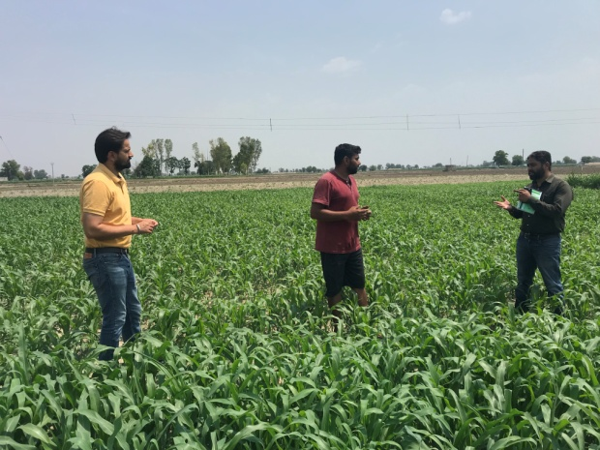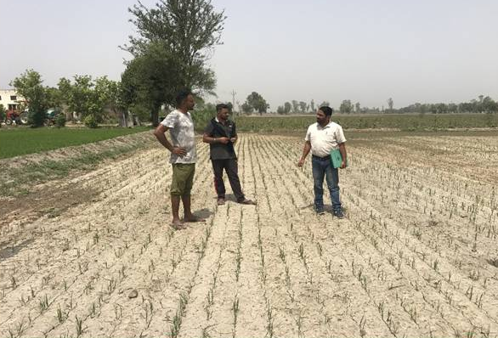
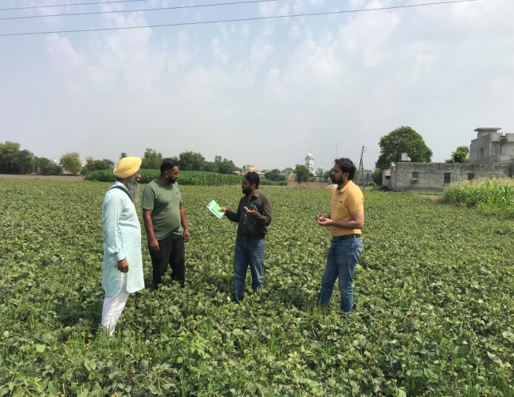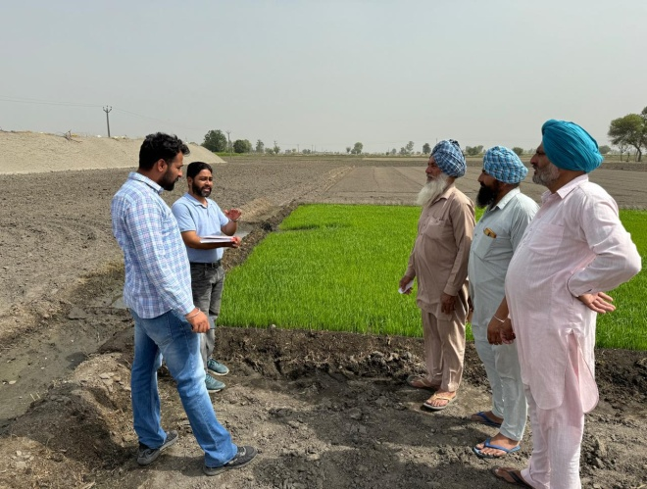
Fig. 1: Glimpses of survey study conducted in the adopted village under NICRA project
The test to check the knowledge level constituted 35 queries which included a list of questions pertaining to CSTs. The answers to the question were quantified by giving 2 score to full knowledge, 1 score for partial knowledge and zero score for no knowledge. The maximum knowledge score obtained by a respondent could be 70 and the minimum 0. The total knowledge of a given respondent about a particular technology was the addition of its scores reported in the test. On the basis of mean (39.50) and S.D (18.35) including beneficiaries and non-beneficiaries, the respondents were segregated into low, medium and high knowledge level as given in table 2.
Table 2: Categorization of Knowledge level of respondents for CSTs
S. No. | Category | Criteria | Score
1. | Low Knowledge | Up to mean–S.D (39.50-18.35) | Up to 21.15
2. | Medium Knowledge | Between mean + S.D (39.50+18.35) | 21.16-57.85
3. | High Knowledge | Mean + S.D (39.50+18.35) and above | 57.86 and above
The adoption of the CSTs was computed by counting number of respondents using the innovations among beneficiaries as well as non-beneficiaries. The technology-wise ranking was done on the basis of number of farmers recorded under each technology. The correlation matrix between knowledge level and independent variables was computed by using OPSTAT software. The correlation between knowledge level and independent variables was used to identify the deriving factors behind the preference of a given technology by the beneficiaries.
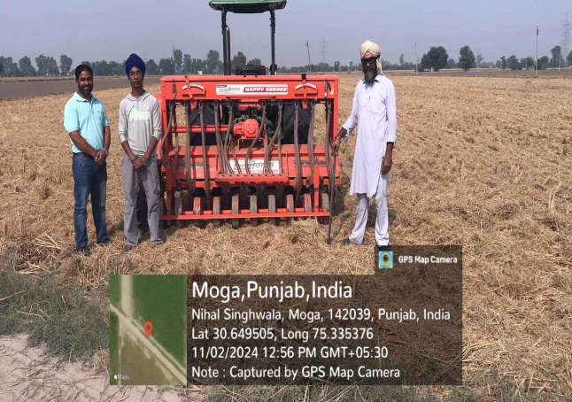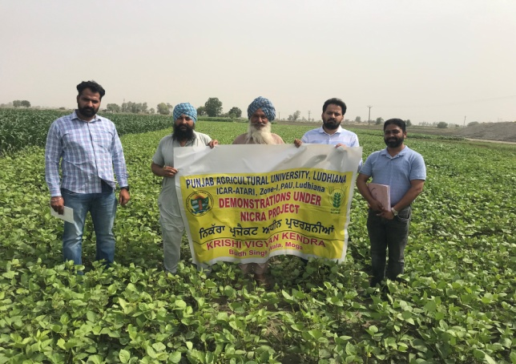
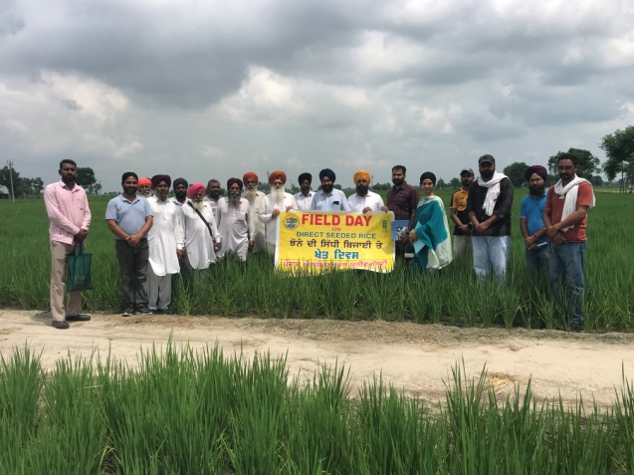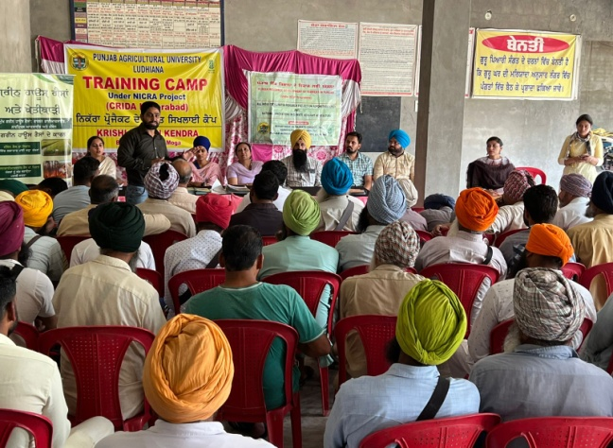
Fig. 2: Glimpses of activities conducted under NICRA project in the adopted village
- RESULTS AND DISCUSSION
3.1 KNOWLEDGE LEVEL OF RESPONDENTS
The data pertaining to segregation of respondents for overall understanding about CSTs (Table 3) shows that beneficiaries reported highest percentage of farmers in the category of high knowledge level (44.3%) i.e., 31 followed by medium knowledge level category (32.9%) i.e., 23. On the contrary, in case of non-beneficiary farmers, highest percentage was recorded in category of low knowledge level (42.5%) i.e., 17 followed by medium category (30.0%) i.e., 12. In high knowledge category only 27.5 per cent farmers were recorded which was 16.8 per cent lower than that of beneficiaries.The data regarding knowledge level of respondents (Table 4) for the climate smart technologies shows better understanding of beneficiaries about the interventions. Irrespective of the type of technology, higher percentage of respondents was reported in high range in beneficiaries relative to non-beneficiaries, which indicates that beneficiaries have better technical know-how. For instance, in case of happy seeder, bed planting of summer moong and foliar spray of potassium nitrate, beneficiaries were recorded to the range of 50, 47.1 and 71.4 per cent in high category as compared to 27.5, 30.0 and 17.5 per cent in case of non-beneficiaries, respectively. Similarly, in case of green manuring, cultivation of oilseeds (mustard), beneficiaries recorded 57.1 and 50.0 percentage in high category than 50.00 and 27.5 percentage of non-beneficiaries, respectively. The better understanding of beneficiaries about climate smart interventions can be attributed to their recurrent use at farmer field. Regular use of technologies by the farmers provides better exposure to technicality like how to use, when to use etc. For example, use of happy seeder technology requires better soil moisture regime and harvesting of preceding paddy crop with combine harvester fitted with straw management system. At the same time, if a farmer wants to sow wheat crop with surface seeding technique after paddy crop, the field needs to levelled, at minimum possible soil moisture content. Farmers can be better acquaint with these kind of technical points as and when they regularly follow these technologies due to learning by doing process. Therefore, regular use of these technologies, time to time interaction with the experts and continuous exposure led to improved knowledge level of beneficiaries regarding climate smart technologies than non-beneficiaries. The technical know-how among the non-beneficiaries about CSTs can be attributed to the process of learning about any new or upcoming techniques by the farmers from nearby farmers, social media and awareness activities, such as trainings, undertaken under the NICRA project. Aziz et al (2024) also reported high understanding of beneficiaries about climate smart technologies in comparison to non-beneficiaries.
Table 3: Overall knowledge level of respondents
Category | Beneficiaries (n=70) |  | Non-beneficiaries (n=40)
Category | Frequency | Percentage | Frequency | Percentage
Low Knowledge (Up to 21.15) | 16 | 22.9 | 17 | 42.5
Medium Knowledge (21.16-57.85) | 23 | 32.9 | 12 | 30.0
High Knowledge (57.86 and above) | 31 | 44.3 | 11 | 27.5
Mean | 42.64 |  | 34
Standard Deviation | 18.33 |  | 17.28

Table 4: Technology wise level of understanding of respondents about climate smart technologies
Technology | Beneficiaries (n=70) |  |  |  | Non-beneficiaries (n=40) |  |  |  | Technology | Beneficiaries (n=70) |  |  |  | Non-beneficiaries (n=40)
 | Low | Medium | High | Low |  | Medium | High |  |  | Low | Medium | High | Low |  | Medium |  | High
Resource Conservation Technologies
Happy seeder | 13  (18.6*) | 22  (31.4) | 35  (50.0) | 13 (32.5) |  | 16 (40.0) | 11 (27.5) | DSR |  | 11 (15.71) | 21 (30.0) | 38 (54.3) | 11 (27.5) |  |  | 18 (45.0) | 11 (27.5)
Super seeder | 06 (8.6) | 21 (30.0) | 43 (61.4) | 12 (30.0) |  | 08 (20.0) | 20 (50.0) | AWD |  | 09 (12.9) | 17 (24.3) | 44 (62.9) | 13 (32.5) |  |  | 18 (45.0) | 09 (22.5)
Smart seeder | 15 (21.4) | 26 (37.1) | 29 (41.4) | 17 (42.5) |  | 15 (37.5) | 08 (20.0) | Laser leveling |  | 02 (2.9) | 09 (12.9) | 59 (84.3) | 05 (12.5) |  |  | 11 (27.5) | 24 (60.0)
MB plough | 08 (11.4) | 11 (15.7) | 51 (72.9) | 11 (27.5) |  | 14 (35.0) | 15 (37.5) | Surface seeding |  | 14 (20.0) | 21 (30.0) | 35 (50.0) | 13 (32.5) |  |  | 18 (45.0) | 09 (22.5)
Mulching | 09 (12.9) | 12 (17.1) | 49 (70.0) | 13 (32.5) |  | 14 (35.0) | 13 (32.5) | Foliar spray of potassium nitrate |  | 09 (12.9) | 11 (15.7) | 50 (71.4) | 12 (30.0) |  |  | 21 (52.5) | 07 (17.5)
Bed planting of summer moong | 14 (20.0) | 23 (32.9) | 33 (47.1) | 19 (47.5) |  | 09 (22.5) | 12 (30.0) | Cultivation of Kharif maize |  | 10 (14.3) | 17 (24.3) | 43 (61.4) | 10 (25.0) |  |  | 22 (55.0) | 08 (20.0)
Crops
Short duration varieties | 05 (7.1) | 07 (10.0) | 58 (82.9) | 04 (10.0) |  | 10 (25.0) | 26 (65.0) | Summer greengram |  | 11 (15.7) | 17 (24.3) | 42 (60.0) | 08 (20.0) |  | 21 (52.5) |  | 11 (27.5)
Green manuring | 11 (15.7) | 19 (27.1) | 40 (57.1) | 09 (22.5) |  | 11 (27.5) | 20 (50.0) | Cultivation of oilseeds |  | 14 (20.0) | 21 (30.0) | 35 (50.0) | 12 (30.0) |  | 17 (42.5) |  | 11 (27.5)
Animal
Mineral mixture | 13 (18.6) | 20 (28.6) | 37 (52.9) | 13 (32.5) |  | 17 (42.5) | 10 (25.0) | UMMB |  | 17 (24.3) | 24 (34.3) | 29 (41.4) | 23 (57.5) |  | 10 (25.0) |  | 07 (17.5)
*values in parenthesis indicate percentage of total respondents

3.2 Correlation Analysis
The data on correlation coefficient between independent variable and knowledge level (Table 5) indicate that understanding about CSTs has highly significant positive correlation with education (0.817), farming experience (0.359) and attending the training programmes (0.519). At the same time, significantly positive correlation was observed between knowledge level and age of the respondents (0.262). The knowledge level of respondents although had positive and negative correlation with land holding and family size of the respondents, respectively, but it could not achieve level of significance. The highly significant positive correlation between knowledge and education and training results clearly shows that education of the respondents makes it the farmers competent to understand the technicality about a given CST and capacity building programmes give more exposure and opportunity to interact with the experts. Positive correlation with farming experience proves the fact of learning by doing. While actually dealing with the technicality of CSTs, the farmers get more exposure and ability to understand the benefits and importance of given CST in context of the environment.
Table 5: Correlation matrix between knowledge level and independent variables
Variable | Age | Education | Farming experience | Land holding | Family size | Training attended | Knowledge level
Age | 1.000 | -0.199^{NS} | 0.871** | -0.101^{NS} | 0.018^{NS} | -0.399** | 0.262*
Education | -0.199^{NS} | 1.000 | -0.282* | 0.065^{NS} | -0.034^{NS} | 0.282* | 0.817**
Farming experience | 0.871** | -0.282* | 1.000 | -0.199^{NS} | -0.079^{NS} | -0.447** | 0.359**
Land holding | -0.101^{NS} | 0.065^{NS} | -0.199^{NS} | 1.000 | 0.323** | 0.065^{NS} | 0.066^{NS}
Family size | 0.018^{NS} | -0.034^{NS} | -0.079^{NS} | 0.323** | 1.000 | 0.087^{NS} | -0.122^{NS}
Training attended | -0.399** | 0.282* | -0.447** | 0.065^{NS} | 0.087^{NS} | 1.000 | 0.519**
Knowledge level | 0.262* | 0.817** | 0.359** | 0.066^{NS} | -0.122^{NS} | 0.519** | 1.000

3.3 ADOPTION OF CLIMATE SMART TECHNOLOGIES (CSTs)
Data regarding adoption of resource conservation technologies (Table 6) shows that among beneficiaries as well as non-beneficiaries, laser levelling is the top scored (I) technology i.e., 100 per cent of farmers use this technology that can be consequent or on alternate basis. On the contrary, a considerable difference among beneficiaries and non-beneficiaries was reported with respect to CSTs such as happy seeder, surface seeding, foliar spray of potassium nitrate etc. For instance, among beneficiaries, 12.9 per cent (09) beneficiaries use happy seeder technique for sowing of wheat crop which is 2.5 per cent (01) among non-beneficiaries. Similarly, 32.9 per cent (23) beneficiaries follow alternate wetting and drying in comparison to 22.5 per cent (09) among non-beneficiaries. Furthermore, 77.1 (54) and 8.6 per cent (06) beneficiaries go for foliar spray of potassium nitrate (score II) and bed planting of summer moong (score V) relative to 35.0 (14.00) (score III) and 2.5 per cent (01) (score VII) non-beneficiaries, respectively. Non-adoption of surface seeding and cultivation of kharif maize was reported among non-beneficiaries as compared to 2.9 and 1.4 per cent among beneficiaries. Adoption of crop related technologies shows that only 5.0 per cent (02) non-beneficiaries go for green manuring relative to 17.1 per cent (12) beneficiaries. Furthermore, adoption of short duration varieties and cultivation of summer moong was reported among 72.9 (51) and 27.1 per cent (19) beneficiaries in comparison to 32.5 (13) and 15.0 per cent (06) non-beneficiaries, respectively. Data on adoption of animal related CSTs depicted high percentage of adoption of mineral mixture by beneficiaries i.e., 34.3 per cent in comparison to 17.5 per cent in case of non-beneficiaries. No adoption of UMMB was observed among non-beneficiaries while 15.7 per cent beneficiaries use UMMB bricks for their farm animals.

Table 6: Adoption pattern of CSTs among the beneficiaries and non-beneficiaries
Technology | Beneficiaries  (n=70) |  | Non-beneficiaries  (n=40) |  | Technology | Beneficiaries  (n=70) |  | Non-beneficiaries  (n=40)
Technology | Adoption | Score | Adoption | Score | Technology | Adoption | Score | Adoption | Score
Resource Conservation Technologies
Happy seeder | 09 (12.9*) | VII | 01 (2.5) | VII | DSR | 05 (7.14) | X | 01 (2.50) | VII
Super seeder | 35  (50.0) | III | 17 (42.5) | II | AWD | 23 (32.86) | IV | 09 (22.50) | IV
Smart seeder | 07 (10.0) | VIII | 01 (2.5) | VII | Laser leveling | 70 (100) | I | 40 (100) | I
MB plough | 21 (30.0) | V | 05 (12.5) | V | Surface seeding | 02 (2.9) | XI | - | -
Mulching | 17 (24.3) | VI | 02 (5.0) | VI | Potassium nitrate spray | 54 (77.1) | II | 14 (35.0) | III
Bed planting | 06 (8.6) | IX | 01 (2.5) | VII | Kharif maize | 01 (1.4) | XII | - | -
Crops
Short duration varieties | 51 (72.9) | I | 13 (32.5) | I | Summer greengram | 19 (27.1) | III | 06 (15.0) | III
Green manuring | 12 (17.1) | IV | 02 (5.0) | IV | Cultivation of oilseeds | 23 (32.9) | II | 10 (25.0) | II
Animal
Mineral mixture | 24 (34.3) | I | 07(17.5) | I | UMMB | 11 (15.7) | II | - | -
*Values in the parenthesis indicate percentage of total number of respondents
3.4 Factors associated with adoption of CSTs
The determinants were computed as correlation coefficient between independent variables (age, education, land holding etc.) and dependent variables i.e., CSTs., which shows effect of a given demographic feature on adoption of technologies. Survey data (Table 7) shows that age of the farmers negatively influenced the chances of adoption of a given technology. It indicates that youth farmers are more motivated in comparison to aged farmers to adopt CSTs such as happy seeder, super seeder. These technologies affect soil fertility directly or indirectly; therefore, these can be termed as practices that improve soil health. The results of effect of age on adoption of CSTs are in accordance with Mebratu et al (2022).The results show that the education level of respondents showed significantly positive effect on the adoption of all the CSTs. It implies that education of the farming community makes the farmers more competent to learn and use the technologies. Even education provides more avenues to understand the importance of particular technologies in the context of ecology which further motivates the farmers to adopt the techniques based on their priority. Furthermore, the land holding of the respondents significantly enhanced the adoption of technologies like super seeder, Reversible MB plough etc. which clearly shows role of land holding to afford high cost techniques to use increased the implementation of agroforestry practices. The findings are in line with those of Samuel et al. (2022), who found that adoption of minimum tillage (a conservation agriculture technique) was substantially and favourably influenced by total land holding, and Tamirat (2022) found that adoption of conservation tillage was significantly and positively influenced by land size. Training component had positive and significant affect on adoption of CSTs which means that educated and sensitized farmers are more likely to use crop residue management techniques like happy seeder, super seeder indicating that climate smart innovation adoption is knowledge intensive (Wordofa et al., 2020). The results showing positive and significant influence of trainings on adoption of CSTs are in line with Teklu et al (2023).The results of the survey depicted that beneficiaries having access to credit are more likely to adopt technologies such as happy seeder, super seeder as it helps resolve the financial deficit of the farmers. The positive and significant influence of credit services in the adoption of techniques can be attributed to requirement of more funds to purchase these machines like super seeder. Although access to credit positively affected adoption of bed planting, short duration varieties but it was non-significant which means that these techniques do not involve much flow of capital. It can be concluded that having access to working capital may aid farmers in filling this gap between need and use of technology.

Table 7: Correlation between adoption of climate smart technologies and various factors
 | Happy seeder | Super seeder | Reversible MB plough | Bed planting of summer moong | Direct seeding of rice | Short duration varieties
Age | -0.145^{NS} | -0.272* | -0.097^{NS} | -0.047^{NS} | -0.164^{NS} | -0.128^{NS}
Education | 0.341** | 0.353** | 0.527** | 0.247* | 0.409** | 0.483**
Farming experience | 0.233^{NS} | 0.296* | 0.145^{NS} | 0.110^{NS} | 0.242* | 0.161^{NS}
Land holding | 0.084^{NS} | 0.268* | 0.265* | 0.246* | 0.013^{NS} | 0.031^{NS}
Family size | -0.058^{NS} | 0.239* | -0.066^{NS} | -0.117^{NS} | 0.024^{NS} | 0.113^{NS}
Training attended | 0.211* | 0.251* | 0.443** | 0.018^{NS} | 0.294* | 0.407**
Access to credit | 0.257* | 0.457** | 0.299* | 0.009^{NS} | 0.063^{NS} | 0.045^{NS}

- CONCLUSION
From the survey study it can be concluded that beneficiary farmers have better understanding about climate smart technologies as compared to non-beneficiaries. Education level and capacity building of farmers is need of the hour to have good grasp about technical know-how of the CSTs. Adoption percentage of CSTs was more in beneficiary farmers which means that regular sensitization, knowledge sharing and availability of CSTs enhance the adoption rate. Educational qualification, land availability, capacity building and access to credit are major factors that influence the adoption of CSTs. Taking care of these factors can help in implementation and use of technologies at field level. Better credit access to small farmers can make them to use the technique just like that large farmers.

References
Aryal, J.P, Rahut, D.B. and Sapkota, T.B. (2020). Climate change mitigation options among farmers in South Asia. Environment, Development and Sustainability, 22, 3267-3289.
Aziz, T., Tabina, Bhat, B.A. and Magray, M.M. (2024). Knowledge level of NICRA beneficiaries about climate resilient technologies. International Journal of Agricultural Extension and Social Development, 7, 411-414.
Belay, A., Mirzabaev, A. and Recha, J.W. (2023). Does climate-smart agriculture improve household income and food security? Evidence from southern Ethiopia. Environment, Development and Sustainability, 9, 1-28.
Belay, D. and Fekadu, G. (2021). Influence of social capital in adopting climate change adaptation strategies: empirical evidence from rural areas of Ambo district in Ethiopia. Climate and Development, 13(2), 1-12.
Chaudhuri, S., Roy, M., McDonald, L.M. and Emendack, Y. (2021). Reflections on farmers’ social networks: a means for sustainable agricultural development? Environment, Development and Sustainability, 23, 2973-3008.
FAO (2013). Climate-smart agriculture sourcebook. Rome: Food and agriculture Organization of the United Nations (FAO). Rome: FAO.
Jaidka, M. and Brar, A.S. (2024). Residue Retention and Potassium Nitrate Improvise the Yield and Economics of Wheat Crop. International Journal of Economic Plants, 11(3), 228-232.
Jaidka, M., Brar, A.S. and Singh, H. (2024). Production efficiency of rice wheat cropping system and path coefficient analysis of wheat under climate smart technologies. International Journal of Research in Agronomy, 7(2), 504-508.
Mango, N., Makate, C., Tamene, L., Mponela, P. and Ndengu, G. (2018). Adoption of small-scale irrigation farming as a climate-smart agriculture practice and its influence on household income in the Chinyanja Triangle. Southern Africa. Land, 7, 1-19.
Mebratu, N., Alemu, T., Hagos, F. and Haileslassie, A. (2022). Determinants of adoption of climate smart agricultural practices among farmers in bale-eco region, Ethiopia. Heliyon, 8(7), e09824
Murray, U., Gebremedhin, Z., Brychkova, G. and Spillane, C. (2016). Smallholder Farmers and Climate Smart Agriculture: Technology and Labor-productivity Constraints amongst Women Smallholders in Malawi. Gender, Technological Development, 20, 117-148.
OECD (2016). Agriculture and climate change: towards sustainable, productive and climate-friendly agricultural systems. Geneva: OECD.
Samuel, D., Tesfaye, A. and Erko, B. (2022). Determinants of adoption of climate-smart agricultural technologies and practices in the coffee-based farming system of Ethiopia. Agriculture and Food Security, 11(1), 1-14.
Tamirat, G. (2022). Is there A synergy in adoption of climate smart agricultural practices? Evidences from Ethiopia. The Turkish Journal of Agriculture –Food Science and Technology, 10, 1611-1619.
Teklu, A., Simane, B., Bezabih, M. (2023). Multiple adoption of climate-smart agriculture innovation for agricultural sustainability: Empirical evidence from the Upper Blue Nile Highlands of Ethiopia. Climate Risk Management, 39, 100477.
Traore, B., Birhanu, B.Z., Sangare, S., Gumma, M.K., Tabo, R. and Whitbread, A.M. (2021). Contribution of climate-smart agriculture technologies to food self-sufficiency of smallholder households in Mali. Sustainability, 13, 1-17.
Wordofa, M.G., Okoyo, E.N. and Erkalo, E. (2020). Factors influencing adoption of improved structural soil and water conservation measures in Eastern Ethiopia. Environmental Systems Research, 9(13), 1-11.
Zerssa, G., Feyssa, D., Kim, D.G. and Eichler-L¨obermann, B. (2021). Challenges of smallholder farming in Ethiopia and opportunities by adopting climate-smart agriculture. Agriculture, 11, 1-26.
Zeweld, W., Van Huylenbroeck, G., Tesfay, G., Azadi, H. and Speelman, S. (2020). Sustainable agricultural practices, environmental risk mitigation and livelihood improvements: Empirical evidence from Northern Ethiopia. Land Use Policy, 95(1), 103799.

