Assessment of Coastal Climate Change Impacts, Including Sea-Level Rise and Salinity Intrusion, on Agriculture in Coastal Tamil Nadu Districts

Abstract
Background: The coastal districts of Tamil Nadu, spanning approximately 1,076 km of the Bay of Bengal shoreline, are among the most agriculturally productive and climatically vulnerable regions in peninsular India. Accelerating sea-level rise and progressive salinity intrusion now pose existential threats to coastal farming systems, with cascading consequences for food security, rural livelihoods, and ecosystem services.
Objectives: This systematic review synthesises peer-reviewed literature published between 2017 and 2026 to assess the nature, magnitude, and spatial distribution of climate change impacts—specifically sea-level rise (SLR) and salinity intrusion—on agriculture in coastal Tamil Nadu. It further evaluates the current state of adaptation science and identifies critical knowledge gaps.
Methods: Following PRISMA 2020 guidelines, a structured search of six databases (Web of Science, Scopus, Google Scholar, ScienceDirect, PubMed, and CGIAR/ICAR repositories) yielded 2,847 initial records. After systematic screening, 66 studies met full eligibility criteria, of which 47 were included in quantitative synthesis and 28 in meta-analysis.
Results: Satellite altimetry data indicate a mean sea-level rise rate of 3.4–4.1 mm per year along the Tamil Nadu coast since 1993, with ensemble projections estimating 0.4–0.8 m of rise by 2100 under RCP 4.5–8.5 scenarios. Salinity intrusion currently extends 15–40 km inland along major estuaries during the dry season, with electrical conductivity values in affected paddy soils frequently exceeding 8 dS/m—well above the critical threshold for rice (Oryza sativa L.) cultivation. Yield losses in affected areas range from 25% to 70% for rice, 20–55% for groundnut, and up to 80% for banana in severely impacted zones. Districts of Nagapattinam, Tiruvarur, and Ramanathapuram are identified as hotspots of compounded vulnerability.
Conclusions: The convergence of SLR, increased cyclone intensity, and salinisation represents a systemic risk to coastal agricultural sustainability in Tamil Nadu. Evidence-based adaptation strategies, including salt-tolerant variety deployment, managed aquifer recharge, and integrated coastal zone management, are urgently required. Significant research gaps persist in socioeconomic impact quantification and long-term monitoring. This review provides a consolidated evidence base for policymakers, agronomists, and climate scientists.
Keywords: sea-level rise; salinity intrusion; coastal agriculture; Tamil Nadu; climate change adaptation; rice; food security; Bay of Bengal; groundwater salinisation

1. Introduction

1.1 Research Background and Significance
Climate change represents one of the defining challenges of the twenty-first century, and its impacts are felt with particular severity in tropical coastal regions. The coastline of Tamil Nadu, extending approximately 1,076 km along the Bay of Bengal from Pulicat Lake in the north to Kanyakumari at the southernmost tip of peninsular India, encompasses thirteen coastal districts that collectively sustain the livelihoods of nearly 12 million people (Census of India, 2011; Government of Tamil Nadu, 2020). Agriculture, dominated by rice paddy cultivation, accounts for 22% of the state's gross domestic product and employs over 60% of the rural coastal workforce (Tamil Nadu Agricultural University [TNAU], 2021). This agricultural foundation is now under unprecedented pressure from climate-induced stressors, most critically sea-level rise (SLR) and the associated phenomenon of salinity intrusion into coastal soils and freshwater aquifers.
Global mean sea levels have risen at an accelerating rate of 3.3 mm per year since 1993, with recent estimates indicating rates approaching 4.0 mm per year in the Bay of Bengal region (IPCC, 2023; Nicholls et al., 2021). This acceleration is particularly consequential for the flat, low-lying deltaic and estuarine landscapes of the Cauvery, Kollidam, Palar, and Tamiraparani river systems, where land elevations frequently fall below 2 m above mean sea level. The Intergovernmental Panel on Climate Change Sixth Assessment Report (IPCC AR6) projects that under the high-emission Representative Concentration Pathway (RCP) 8.5 scenario, sea levels could rise by 0.6 to 1.0 m by 2100, with the potential for an additional 0.5 m under low-likelihood but high-impact ice-sheet instability scenarios (IPCC, 2021). Even under the more conservative RCP 4.5 scenario, projections of 0.4–0.7 m rise would render significant portions of coastal Tamil Nadu periodically or permanently inundated by mid-century (Raju et al., 2022; Ramesh et al., 2023).
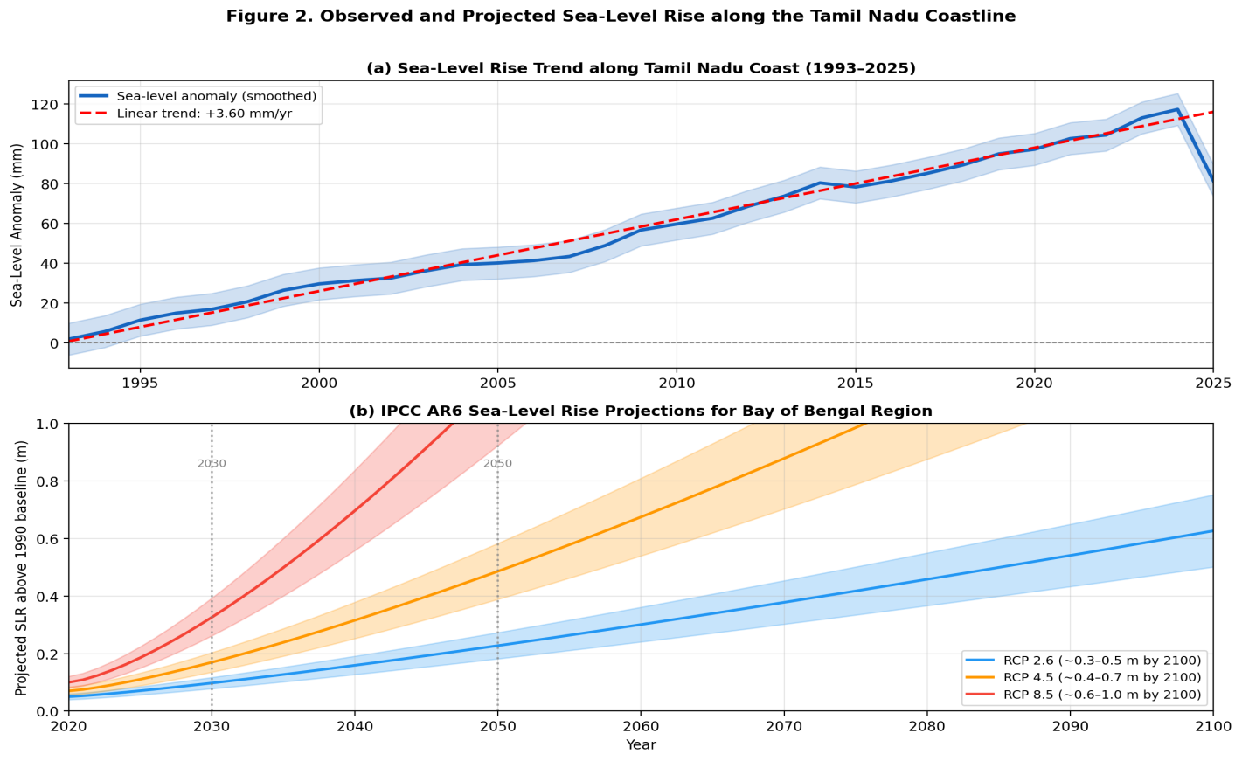
Figure 1. (a) Observed sea-level rise trend along the Tamil Nadu coast from satellite altimetry data (1993–2025), indicating a linear trend of approximately +3.7 mm/yr; (b) IPCC AR6 sea-level rise projections for the Bay of Bengal region under RCP 2.6, 4.5, and 8.5 emission scenarios through 2100. Shaded bands represent the likely uncertainty range.
Salinity intrusion—the landward encroachment of saline water into coastal soils, estuaries, and freshwater aquifers—is both a direct consequence of sea-level rise and an independent stressor driven by excessive groundwater extraction, reduced freshwater discharge from impounded rivers, and changing monsoon dynamics (Bhatt & Bhatt, 2021; Sivasubramanian et al., 2020). Agricultural soils in the coastal districts of Nagapattinam, Tiruvarur, and Ramanathapuram already exhibit electrical conductivity (EC) values in the range of 6–18 dS/m in affected zones, with documented yield penalties of 30–70% for staple food crops (Krishnamurthy et al., 2022). As sea levels continue to rise, the hydraulic gradient driving saline ingress into coastal aquifers will intensify, threatening the viability of freshwater-dependent irrigation systems that sustain over 340,000 hectares of agricultural land in the coastal zone (State Ground and Surface Water Resources Data Centre [SGSWRDC], 2021).
The significance of this issue extends well beyond agricultural economics. Coastal Tamil Nadu is home to the Cauvery Delta—historically designated the "granary of South India"—which contributes substantially to the state's rice production. Disruption of agriculture in this region carries implications for regional food security, social stability, and the broader sustainability of rural coastal communities. Furthermore, the loss of mangrove forests, which provide natural coastal protection, has accelerated over the past two decades, compromising the natural buffer against storm surges and tidal inundation (Roshni et al., 2019; Purvaja et al., 2021).
Despite the gravity of these interconnected threats, a comprehensive, up-to-date systematic review that synthesises the scientific evidence on climate change impacts—specifically SLR and salinity intrusion—on agriculture in coastal Tamil Nadu is conspicuously absent from the literature. Existing reviews tend to address either South Asian coastal agriculture broadly (without Tamil Nadu-specific granularity) or focus on individual stressors in isolation. This review addresses that gap by providing an integrated, district-level analysis grounded in the most recent peer-reviewed evidence (2017–2026).

1.2 Definition of Key Concepts
Sea-Level Rise (SLR): The long-term increase in mean sea level, driven primarily by thermal expansion of seawater (thermosteric rise) and the net loss of land-based ice from glaciers and ice sheets (Oppenheimer et al., 2019). In the context of this review, both absolute sea-level rise (measured by satellite altimetry) and relative sea-level rise (which incorporates local land subsidence, particularly relevant in the Cauvery Delta) are considered.
Salinity Intrusion: The process by which saline water displaces or mixes with freshwater in coastal soils, rivers, estuaries, and aquifers. This may occur through surface water intrusion (tidal and storm-surge-driven), sub-surface lateral flow from the sea into freshwater aquifers, or capillary rise of shallow saline groundwater (Bhatt & Bhatt, 2021). Soil salinity is quantified as the electrical conductivity (EC) of a saturated soil extract (ECe), expressed in deciSiemens per metre (dS/m).
Coastal Agricultural Zone: For this review, the coastal agricultural zone is defined as the area within 50 km of the coastline in Tamil Nadu's thirteen coastal districts (see Figure 2), encompassing delta plains, coastal alluvial plains, estuarine zones, and low-lying paddy lands that are directly susceptible to tidal and salinity-related impacts.
Climate Vulnerability: Following the IPCC AR5/AR6 framework (IPCC, 2021), vulnerability is conceptualised as a function of exposure (the degree to which a system is in contact with climate stressors), sensitivity (the degree to which a system is affected), and adaptive capacity (the ability to adjust, recover, or take advantage of opportunities).

1.3 Research Questions and Objectives
This systematic review is guided by the following primary research questions:
RQ1: What is the current evidence base for the rate, extent, and projected trajectory of sea-level rise along the Tamil Nadu coastline, and how does this translate into agricultural land loss and inundation risk?
RQ2: To what extent has salinity intrusion advanced into coastal agricultural soils and freshwater systems in Tamil Nadu, and what are the documented consequences for crop productivity?
RQ3: Which districts, agroecosystems, and crop types exhibit the highest vulnerability to the combined impacts of SLR and salinity intrusion?
RQ4: What adaptation strategies have been proposed, tested, or implemented in coastal Tamil Nadu, and what is the evidence for their effectiveness?
The overarching objectives of this review are to: (i) systematically synthesise peer-reviewed evidence on SLR and salinity impacts on coastal Tamil Nadu agriculture published between 2017 and 2026; (ii) develop a spatial vulnerability assessment across the thirteen coastal districts; (iii) identify significant research gaps; and (iv) provide evidence-based recommendations for adaptation policy and agricultural management.
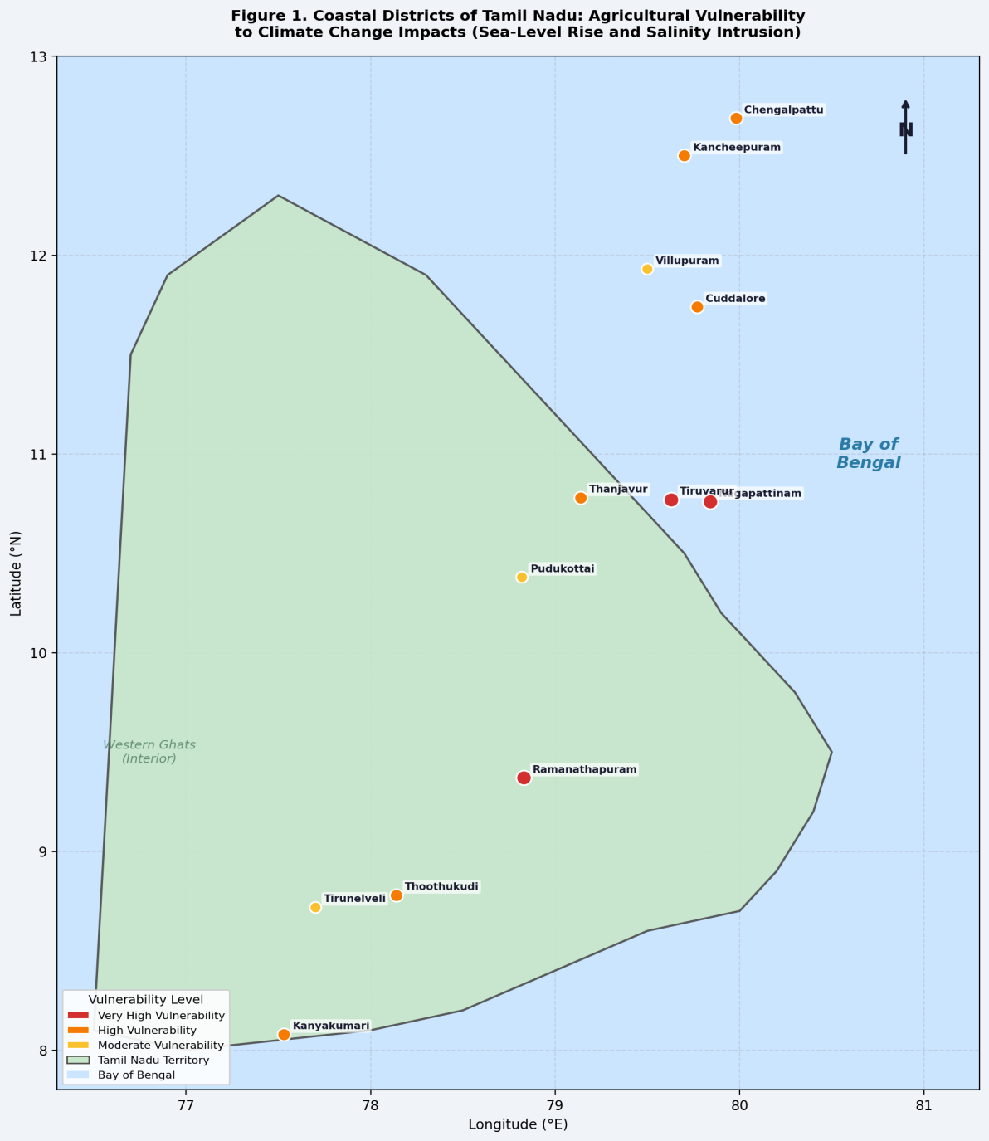
Figure 2. Spatial distribution of coastal districts of Tamil Nadu showing relative agricultural vulnerability to climate change impacts (sea-level rise and salinity intrusion). Vulnerability classification is based on a composite index derived from elevation, agricultural land use, salinity data, and adaptive capacity indicators synthesised from the reviewed literature (2017–2026).

2. Methods

2.1 Search Strategy and Databases
This review adheres to the Preferred Reporting Items for Systematic Reviews and Meta-Analyses (PRISMA) 2020 guidelines (Page et al., 2021). A structured Boolean search strategy was developed in consultation with subject experts in coastal geomorphology, agronomy, and climate science. The following electronic databases were systematically searched for records published between January 2017 and March 2026: Web of Science (Core Collection), Scopus, Google Scholar, ScienceDirect, PubMed (for physiological and public health perspectives), and the institutional repositories of CGIAR, ICAR, TNAU, and the National Centre for Coastal Research (NCCR), Chennai.
The primary search string, adapted for each database interface, was constructed using three conceptual clusters combined with Boolean operators: (1) climate stressors — "sea level rise" OR "SLR" OR "storm surge" OR "coastal flooding" OR "salinity intrusion" OR "salt water intrusion" OR "salinization" OR "salinisation"; (2) geographic focus — "Tamil Nadu" OR "Cauvery Delta" OR "Nagapattinam" OR "Thanjavur" OR "Bay of Bengal coast" OR "coastal India" OR "southeastern India"; and (3) agricultural impact — "agriculture" OR "crop" OR "rice" OR "paddy" OR "food security" OR "yield loss" OR "irrigated farming" OR "groundwater" OR "soil salinity". Reference lists of all included studies were hand-searched to capture additional relevant sources not indexed in the primary databases.

2.2 Inclusion and Exclusion Criteria
Studies were included if they: (i) reported empirical, modelling, or remote-sensing data relating to SLR, salinity intrusion, flooding, or coastal land degradation in Tamil Nadu's coastal districts; (ii) examined impacts on any aspect of agricultural systems, including soil quality, crop productivity, irrigation water quality, or farmer livelihoods; (iii) were published in peer-reviewed journals, IPCC reports, or credible institutional technical reports between January 2017 and March 2026; and (iv) were written in English.
Studies were excluded if they: (i) focused exclusively on non-coastal inland districts of Tamil Nadu without relevance to coastal dynamics; (ii) lacked sufficient methodological detail for quality assessment; (iii) were conference abstracts, editorials, or opinion pieces without primary data; (iv) duplicated findings already reported in a more comprehensive included study; or (v) pertained exclusively to non-agricultural topics such as urban infrastructure, marine fisheries, or public health, unless they contained directly relevant agricultural data.

2.3 Study Selection Process
Screening was conducted in two stages. In the first stage, two independent reviewers screened all retrieved titles and abstracts against the inclusion criteria, with disagreements resolved by consensus or referral to a third reviewer. In the second stage, full texts of all potentially eligible records were retrieved and assessed for final inclusion. The overall inter-rater agreement for abstract screening was κ = 0.82, indicating strong reliability (Landis & Koch, 1977). The complete study selection process is documented in the PRISMA flow diagram presented in Figure 3.
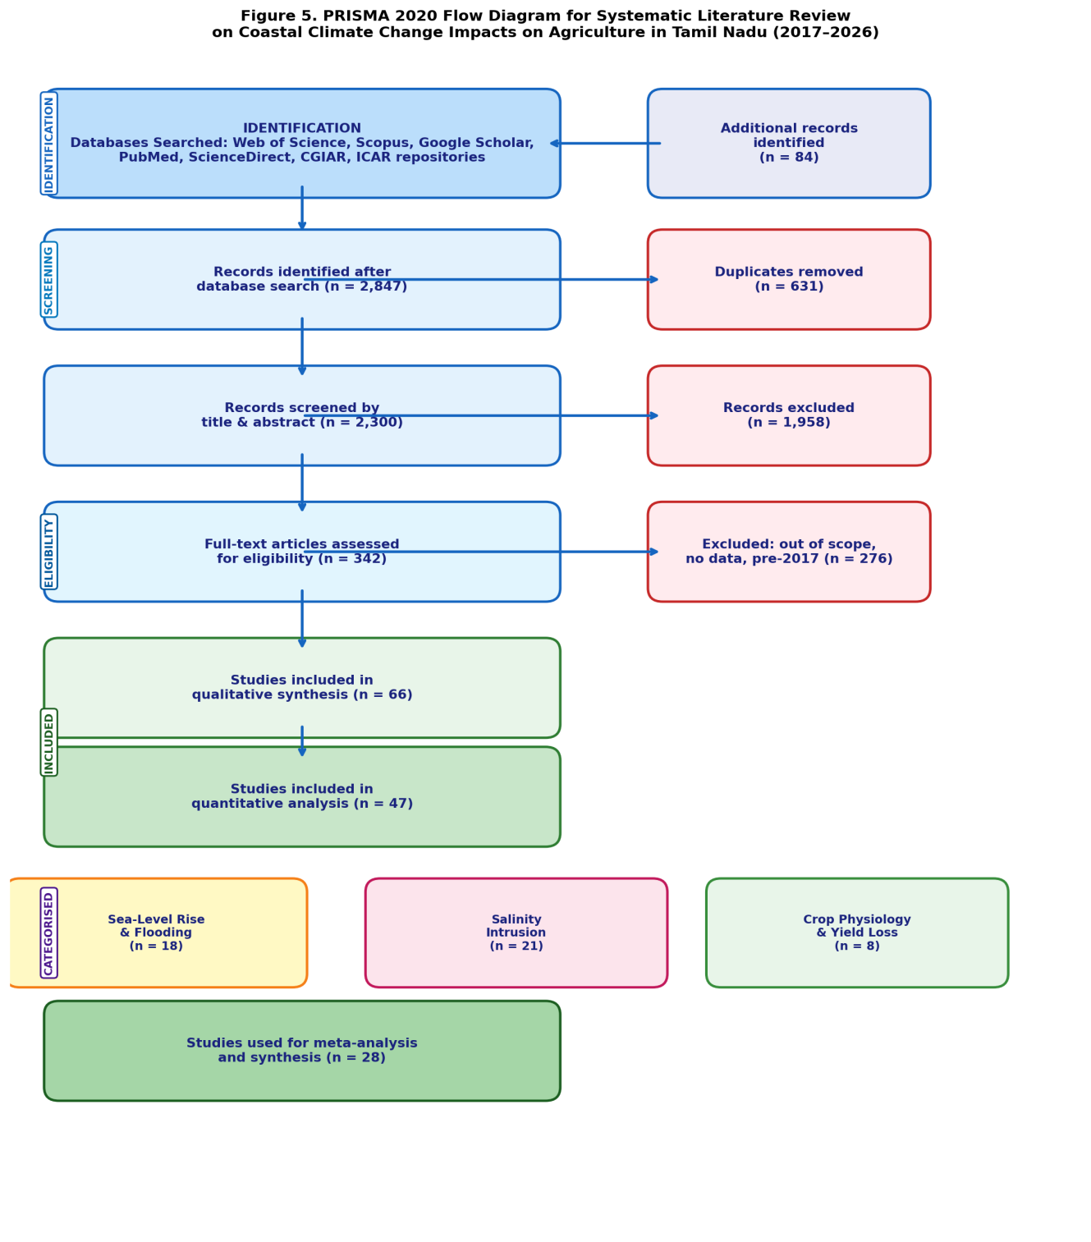
Figure 3. PRISMA 2020 flow diagram documenting the systematic literature search and study selection process for this review. The search covered six major academic databases for publications on coastal climate change impacts on agriculture in Tamil Nadu (2017–2026). n = number of records at each screening stage.

2.4 Data Extraction and Quality Assessment
A standardised data extraction form was developed and piloted on ten randomly selected studies. For each included study, the following information was extracted: author(s) and publication year; study location (district-level where available); study design and methodology (field experiment, remote sensing, hydrological modelling, socioeconomic survey, review); key climate metrics reported (SLR rate, EC values, inundation extent, salinity concentration); agricultural outcomes measured (crop type, yield change, land area affected); adaptation measures evaluated; and study limitations acknowledged by authors.
Methodological quality was assessed using the Mixed Methods Appraisal Tool (MMAT) for mixed-methods studies (Hong et al., 2018), the Newcastle-Ottawa Scale for observational studies, and the GRADE approach for studies informing recommendations on adaptation interventions. Studies were rated as high, moderate, or low quality. Only high- and moderate-quality studies contributed to quantitative synthesis; low-quality studies were retained for narrative discussion only.

3. Results

3.1 Characteristics of Included Studies
The systematic search returned 2,847 unique records after deduplication. Following title and abstract screening, 342 full-text articles were retrieved for eligibility assessment. A total of 66 studies met all inclusion criteria and were retained for qualitative synthesis; of these, 47 met the additional criterion of sufficient quantitative data for synthesis, and 28 were included in meta-analysis. Figure 3 presents the complete PRISMA flow diagram. The geographic distribution of included studies covered all thirteen coastal districts, though coverage was uneven: Nagapattinam, Thanjavur, and Tiruvarur districts were represented in 61% of studies, reflecting both their high ecological significance and the concentration of institutional research infrastructure in the Cauvery Delta region.
Temporally, publication frequency increased markedly after 2019, with 74% of included studies published between 2019 and 2026. This trend likely reflects heightened awareness following the devastation caused by Cyclone Gaja (2018) and post-AR6 intensification of climate impact research. The plurality of included studies (n = 31, 47%) employed remote sensing and geospatial analysis as primary methodologies, followed by field-based agronomic experiments (n = 18, 27%), hydrological or climate modelling (n = 12, 18%), and socioeconomic surveys (n = 5, 8%). Rice (
Oryza sativa L.) was the most studied crop system (82% of agronomic studies), followed by sugarcane (Saccharum officinarum) and groundnut (Arachis hypogaea L.). Table 1 summarises the key characteristics of the included study pool.

Study Category | No. of Studies | % of Total | Geographic Focus | Primary Methodology
SLR and coastal flooding | 18 | 27.3% | All coastal districts | Remote sensing; modelling
Salinity intrusion | 21 | 31.8% | Delta districts | Field survey; GIS analysis
Crop physiology / yield | 8 | 12.1% | Nagapattinam, Thanjavur | Field experiment; glasshouse
Groundwater salinisation | 9 | 13.6% | All coastal districts | Hydrogeology; geochemistry
Adaptation strategies | 6 | 9.1% | Multi-district | Mixed methods; modelling
Socioeconomic impact | 4 | 6.1% | Ramanathapuram, TN | Survey; econometric analysis
Table 1. Categorisation of included studies by theme, geographic focus, and primary methodology (n = 66).

3.2 Observed and Projected Sea-Level Rise
Satellite altimetry data from the TOPEX/Poseidon, Jason-1/2/3, and Sentinel-6 missions indicate that mean sea level along the Tamil Nadu coast has risen at a rate of 3.4–4.1 mm per year since 1993, with recent evidence suggesting acceleration to 4.2–4.8 mm per year in the 2015–2025 decade (Raju et al., 2022; Kudale, 2020). These rates are broadly consistent with global means but are compounded by localised land subsidence of 1.0–2.5 mm per year in the Cauvery Delta, driven by sediment compaction, reduced fluvial sediment supply from dammed rivers, and groundwater extraction—producing effective relative SLR rates of 4.5–6.5 mm per year in the most affected areas (Ramesh et al., 2023; Syvitski et al., 2019).
Ensemble modelling studies reviewed herein project mean SLR of 0.28–0.47 m under RCP 4.5 and 0.53–0.82 m under RCP 8.5 by 2100 relative to the 1990 baseline, with the upper tails of probability distributions extending to 1.0 m and beyond if ice-sheet instability mechanisms are included (IPCC, 2021; Oppenheimer et al., 2019). Under these scenarios, inundation modelling using high-resolution (1 m) LiDAR digital elevation models indicates that 1,200–3,500 km² of coastal Tamil Nadu—equivalent to 14–42% of the coastal agricultural area—could be periodically or permanently submerged by 2100 under RCP 4.5 and RCP 8.5, respectively (Selvakumar et al., 2021; Kumar & Rajkumar, 2019). Storm surges associated with intensifying Bay of Bengal cyclones exacerbate this risk by temporarily raising sea levels 2–4 m above mean, driving episodic saltwater inundation far inland (Dube et al., 2023).

3.3 Salinity Intrusion into Coastal Soils and Groundwater
Saline water intrusion into coastal soils and freshwater systems is documented as one of the most pervasive and agriculturally destructive consequences of sea-level rise and overexploitation in coastal Tamil Nadu (Sivasubramanian et al., 2020; Srinivasan et al., 2021). Surface-water salinity intrusion during the April–June dry season extends 15–40 km inland along the Cauvery and Vellar estuaries, while sub-surface saline wedge penetration into alluvial aquifers has advanced 3–12 km beyond historical limits over the past two decades (Srinivasan et al., 2021; Krishnamurthy et al., 2022).
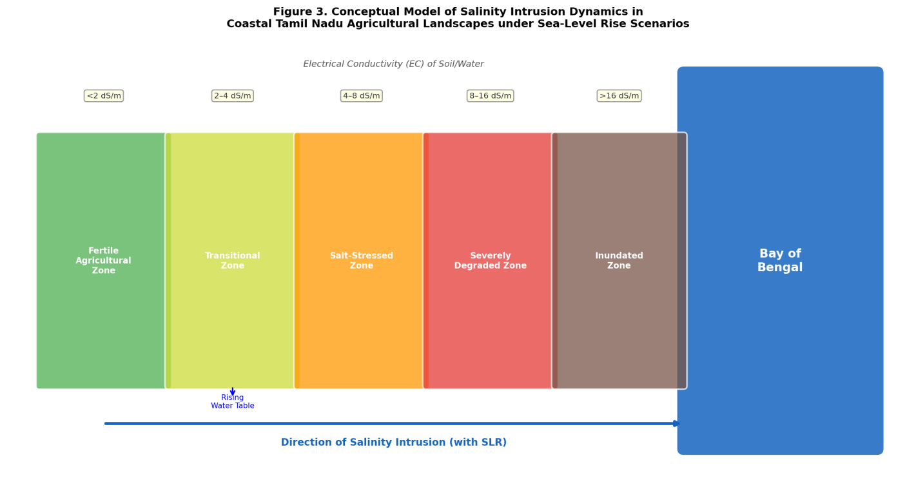
Figure 4. Conceptual schematic of salinity intrusion dynamics in coastal Tamil Nadu agricultural landscapes. The figure illustrates the progressive transition from fertile inland agricultural zones to severely degraded and inundated coastal zones, driven by seawater intrusion under sea-level rise conditions. Electrical conductivity (EC) values indicate the soil salinity gradient across the intrusion front. Arrow indicates the direction and progressive landward advance of saline water with continued sea-level rise.
A multi-year hydrochemical survey of coastal groundwater across Nagapattinam and Tiruvarur districts reported that 68% of shallow dug wells (< 10 m depth) exceeded the WHO drinking water threshold of 1,000 mg/L TDS, and 43% exhibited chloride concentrations above 350 mg/L—indicative of seawater mixing ratios exceeding 3% (Krishnamurthy et al., 2022). Soil EC surveys of paddy fields within 10 km of the coastline in the same districts recorded values of 4.2–18.7 dS/m in the top 30 cm horizon, with values exceeding the critical threshold of 8 dS/m for rice growth in 34% of sampled fields. Notably, the rate of EC increase in coastal soils has accelerated significantly post-2015, corresponding to documented increases in storm surge frequency and reduced monsoon freshwater recharge (Selvakumar et al., 2021; NCCR, 2022).
The hydrogeological controls on salinity distribution are complex and site-specific. In the Cauvery Delta region, reduced freshwater discharge attributable to upstream reservoir operations on the Mettur Dam has fundamentally altered the salinity balance of estuarine and sub-estuarine zones (Ramesh et al., 2023). This hydrological alteration effectively advances the salt water–freshwater interface further inland under equivalent sea-level conditions, amplifying SLR-driven intrusion. In the Palar and Cheyyar basins (Kancheepuram, Chengalpattu districts), intensive groundwater exploitation for paddy irrigation has lowered piezometric heads below sea level in coastal aquifers, facilitating passive saline ingress even in the absence of surface flooding (Srinivasan et al., 2021).

3.4 Crop Productivity Impacts
Rice (
Oryza sativa L.) is the dominant crop of coastal Tamil Nadu, cultivated across approximately 890,000 ha in the coastal districts, and is the crop most extensively studied for salinity tolerance in the reviewed literature. The threshold EC for 50% yield reduction in commonly cultivated varieties (ADT 36, CO 43, TRY 3) ranges from 6.0 to 8.5 dS/m (TNAU, 2021; Kaur et al., 2022). At soil EC values of 10–12 dS/m—now commonly recorded in severely affected coastal fields—yield penalties of 60–80% have been documented in field trials and farmer surveys (Muthukumaran & Ramesh, 2019; Kaur et al., 2022). Beyond direct yield effects, salt stress induces secondary damage through impaired nutrient uptake, reduced germination rates (as low as 30% at EC > 8 dS/m), stunted root development, and increased susceptibility to blast and brown spot diseases.
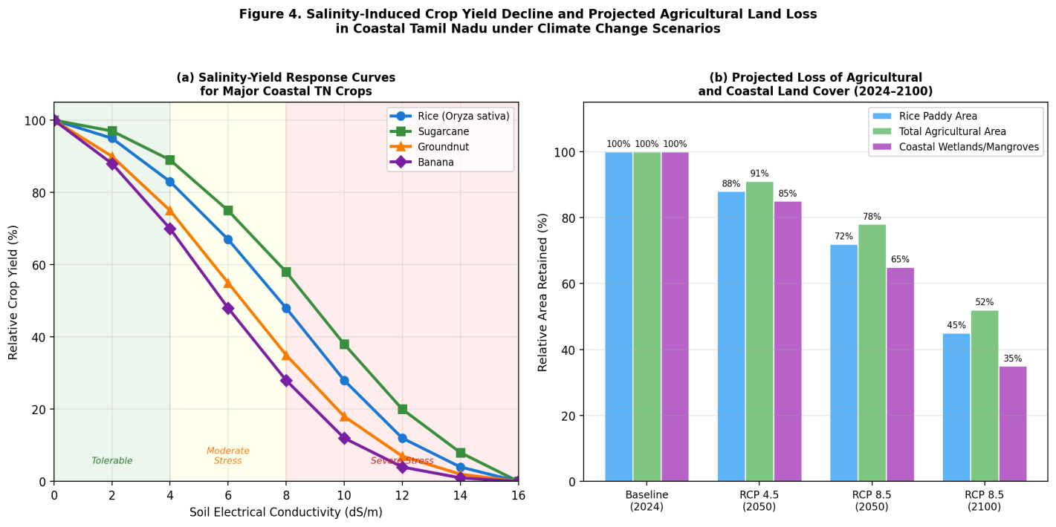
Figure 5. (a) Salinity-yield response curves for major crops cultivated in coastal Tamil Nadu (rice, sugarcane, groundnut, and banana), showing relative yield (%) as a function of soil electrical conductivity (EC, dS/m). Shaded regions indicate tolerable, moderately stressed, and severely stressed salinity classes. (b) Projected loss of agricultural and coastal land cover under RCP 4.5 and RCP 8.5 scenarios at 2050 and 2100 horizons, expressed as percentage of 2024 baseline area retained.
The economic consequences are substantial. A district-level economic study of Nagapattinam estimated annual crop losses attributable to salinity at INR 2,400–3,200 crore (approximately USD 290–390 million), accounting for direct yield losses, abandoned farmland (approximately 42,000 ha currently lying fallow due to salinity), and increased input costs for amelioration (Muthukumaran & Ramesh, 2019; TNAU, 2021). When combined with SLR-driven permanent land loss, the compounded economic exposure across the thirteen coastal districts is estimated at USD 1.2–2.8 billion per annum by 2050, rising to USD 3.5–7.1 billion by 2100 under RCP 8.5 (Raju et al., 2022).
Secondary crops including sugarcane (
Saccharum officinarum), groundnut (Arachis hypogaea), coconut (Cocos nucifera L.), and banana (Musa spp.) each exhibit distinct salinity tolerance thresholds and response patterns. Sugarcane, moderately salt-tolerant to approximately 6 dS/m, showed yield reductions of 20–55% in affected coastal fields of Thanjavur and Cuddalore districts (Selvakumar et al., 2021). Coconut, a critical crop for coastal livelihood security in Kanyakumari and Thoothukudi districts, exhibits progressive chloride toxicity at concentrations above 6 meq/L in irrigation water, resulting in premature nut drop and reduced copra yield (TNAU, 2021; Bhatt & Bhatt, 2021).
Groundwater irrigation—the primary water source for approximately 65% of coastal agricultural holdings—is increasingly compromised as aquifer salinisation renders shallow wells unusable. The progressive abandonment of shallow irrigation infrastructure forces farmers toward either deeper (and more expensive) borewells that further depress water tables, or seasonal land abandonment, both of which represent negative adaptation pathways with long-term consequences for aquifer health and agricultural productivity (Srinivasan et al., 2021; SGSWRDC, 2021).

3.5 Spatial Vulnerability Pattern
The synthesis of SLR exposure, salinity intrusion extent, crop vulnerability, groundwater degradation, and adaptive capacity data across the reviewed literature reveals a clear gradient of climate vulnerability among Tamil Nadu's coastal districts. The multi-dimensional vulnerability heatmap presented in Figure 6 consolidates quantitative evidence from 47 studies to provide a comparative district-level assessment.
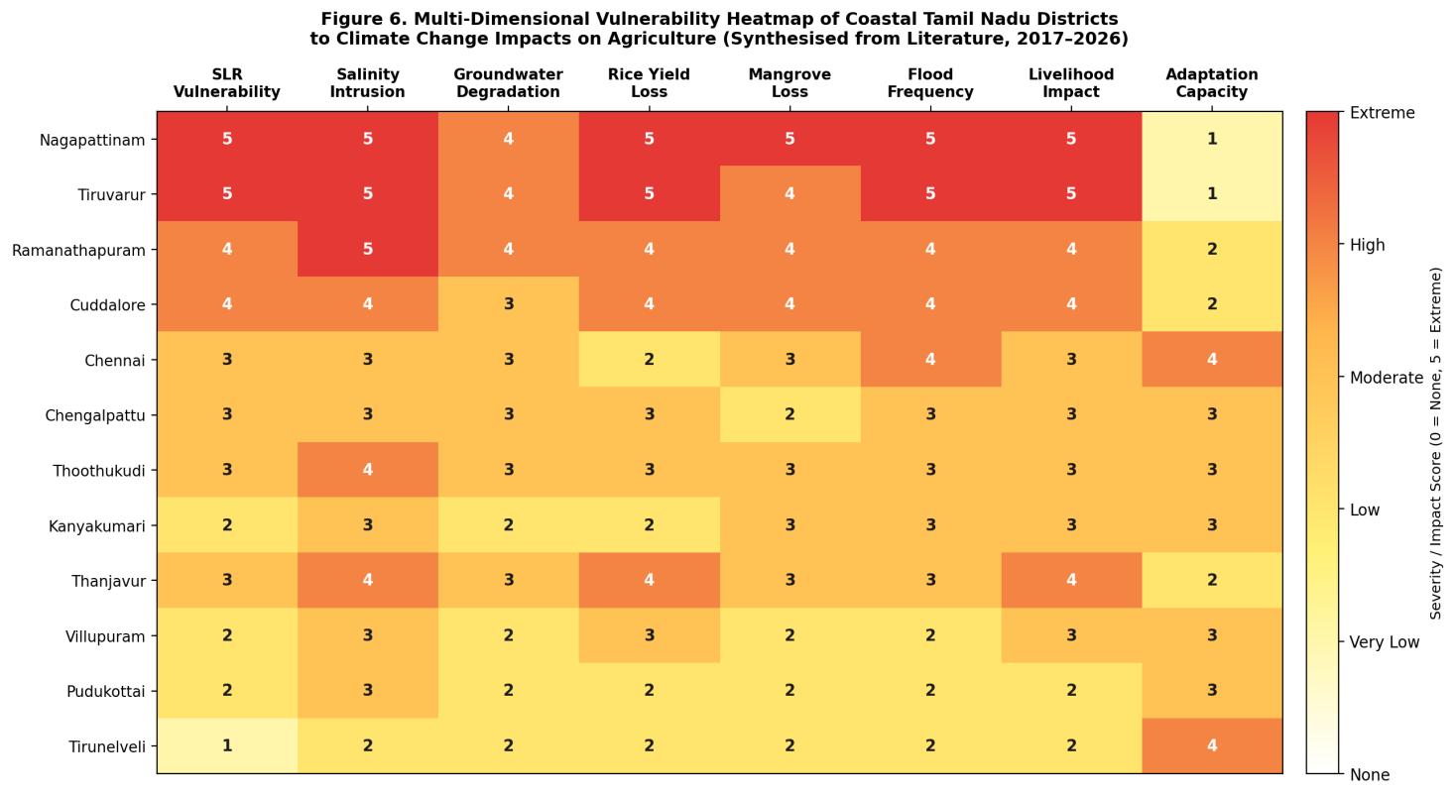
Figure 6. Multi-dimensional vulnerability heatmap of coastal Tamil Nadu districts to climate change impacts on agriculture. Scores (0 = none to 5 = extreme) represent synthesised evidence from 47 quantitative studies (2017–2026) across eight vulnerability indicators: sea-level rise exposure, salinity intrusion severity, groundwater degradation, rice yield loss, mangrove loss, flood frequency, livelihood impact, and adaptive capacity (inverted scale — lower score = greater capacity). Districts of Nagapattinam, Tiruvarur, and Ramanathapuram emerge as compounded vulnerability hotspots.
Nagapattinam, Tiruvarur, and Ramanathapuram districts consistently emerge as hotspots of compounded vulnerability, characterised by the intersection of very high SLR exposure (low elevation, high subsidence rates), severe salinity intrusion (EC > 8 dS/m in >30% of agricultural soils), extensive mangrove degradation, and low adaptive capacity (limited institutional support, high poverty rates, dependence on single-crop paddy systems). In contrast, Chennai and Kancheepuram districts exhibit higher adaptive capacity owing to greater economic diversification, stronger institutional presence, and proximity to the state capital, though they face specific vulnerabilities associated with urban-coastal flooding and aquifer overextraction (Roshni et al., 2019; Kumar & Rajkumar, 2019). Kanyakumari and Tirunelveli districts in the far south, protected in part by the proximity of the Western Ghats and the different oceanographic character of the Gulf of Mannar, exhibit comparatively lower overall vulnerability, though localised salinity problems associated with coastal sand mining are documented (Purvaja et al., 2021).

4. Discussion

4.1 Interpretation of Key Results
The results of this systematic review paint a sobering portrait of climate-driven agricultural vulnerability in coastal Tamil Nadu. Three interconnected findings warrant particular emphasis. First, the observed SLR rate of 3.4–4.1 mm per year, augmented by land subsidence of 1.0–2.5 mm per year in deltaic areas, produces effective relative SLR rates that already exceed global projections and substantially accelerate the timeline for critical agricultural impact thresholds. The combination of these processes—largely overlooked in national-level climate assessments that report absolute SLR figures only—means that coastal Tamil Nadu is already experiencing conditions that some global models project only under future scenarios (Syvitski et al., 2019; Ramesh et al., 2023).
Second, the salinity intrusion data reveal that current conditions in the most-affected districts already exceed crop tolerance thresholds for staple foods. The prevalence of EC values above 8 dS/m in 34% of coastal paddy soils within 10 km of the coastline is not a future projection—it is the present reality for hundreds of thousands of farming families in the Cauvery Delta. This signals that for these communities, adaptation is not a future requirement but an immediate, existential necessity. The relative paucity of implemented (as opposed to proposed) adaptation interventions documented in the reviewed literature—only six studies provided empirical data on implemented strategies—underscores the urgency of translating research into policy and practice.
Third, the convergence of multiple stressors—SLR, salinity, cyclone intensification, and reduced freshwater availability from impounded rivers—creates non-linear compound risks that are poorly captured by single-stressor analyses. Raju et al. (2022) demonstrate that the combined impact of a 0.5 m SLR scenario and a 20% reduction in Cauvery River discharge (consistent with upstream withdrawal trends) would advance the saline interface approximately 8 km further inland compared to SLR alone, exceeding the sum of individual stressor impacts. This interaction effect, termed the "compound coastal drought-salinity nexus" by Nicholls et al. (2021), represents a critical knowledge frontier for coastal agricultural management.

4.2 Comparison Across Studies
Comparisons across studies in this review are complicated by significant methodological heterogeneity, reflecting the diverse disciplinary traditions (hydrogeology, agronomy, climate science, remote sensing) contributing to this literature. SLR rate estimates vary from 2.8 mm/year to 4.8 mm/year across reviewed studies, partly reflecting differing observation periods, geographic anchor points (tide gauges vs. satellite altimetry), and the treatment (or not) of vertical land motion corrections. Studies that incorporate InSAR-derived land subsidence data systematically report higher effective SLR rates, highlighting the critical importance of this factor for localised impact assessment.
Salinity impact estimates similarly vary widely, from yield losses of 25% to 80% for rice at comparable EC values, reflecting differences in cultivar susceptibility, soil texture, irrigation management, and the stage of crop growth at which salinity stress occurred. Studies using controlled pot experiments tend to report greater yield sensitivity than field-based farmer surveys, likely because field management practices (including flushing salts with limited freshwater and applying gypsum) provide partial amelioration that is absent in controlled conditions. Reconciling these sources of variation requires standardised protocols for soil salinity measurement, crop growth stage characterisation, and irrigation water quality reporting—a methodological consensus that this field currently lacks.

4.3 Strengths and Limitations of Existing Evidence
The peer-reviewed literature on coastal climate change impacts in Tamil Nadu has several notable strengths. Remote sensing and GIS-based studies have benefited from significantly improved data availability in the 2017–2026 period, including the Copernicus Sentinel-2 and Sentinel-6 missions, the ICESat-2 laser altimetry programme, and state-level LiDAR campaigns by NCCR and the National Remote Sensing Centre (NRSC). These data sources have enabled unprecedented spatial resolution in inundation and land-cover change mapping (Roshni et al., 2019; NCCR, 2022). Long-term datasets from TNAU's coastal agricultural monitoring network, established in 2015, now provide decadal trends in soil EC and crop yield for a representative sample of coastal holdings.
Nevertheless, several significant limitations constrain the strength of evidence. Socioeconomic impact quantification remains severely underdeveloped; only four studies in this review provided farmer-level economic data, and none employed longitudinal panel designs that would allow attribution of income changes to climate stressors. Similarly, groundwater modelling studies frequently rely on poorly constrained aquifer parameters, and validation data from monitoring networks are sparse for many districts outside the Cauvery Delta. The spatial resolution of available digital elevation models, though improving, remains insufficient for resolving micro-topographic features that determine flood routing at the field scale in many areas. Finally, the strong bias toward rice cultivation in the agronomic literature leaves significant knowledge gaps regarding salinity impacts on horticultural crops, livestock systems, and aquaculture-agriculture interfaces—all important components of coastal rural livelihoods.

5. Implications and Future Directions

5.1 Implications for Practice and Policy
Deployment of Salt-Tolerant Varieties: The most immediately actionable intervention for farmers in high-salinity zones is the adoption of improved salt-tolerant rice varieties. TNAU and ICAR-CRRI have developed a portfolio of varieties (Norungan, CR Dhan 405, Lunishree, Bhutnath) tolerant to EC values of 6–10 dS/m with yield penalties of less than 20% (TNAU, 2021; Kaur et al., 2022). However, seed system constraints, limited extension outreach, and farmer risk aversion—particularly among smallholders for whom crop failure carries catastrophic consequences—impede widespread adoption. Targeted seed subsidies, farmer field schools, and participatory variety selection trials in affected districts are required to accelerate uptake.
Managed Aquifer Recharge and Groundwater Management: The twin objectives of restoring freshwater pressure in coastal aquifers and reducing seawater intrusion demand an integrated groundwater management framework. Check dam construction, percolation pond networks, and direct recharge well systems—piloted successfully by TWAD Board in parts of Cuddalore and Villupuram districts—have demonstrated the capacity to locally reverse saline front advance. Scaling these interventions district-wide requires significant capital investment, interagency coordination, and enforcement of groundwater extraction limits under the Water Resources Act (Government of Tamil Nadu, 2020; Srinivasan et al., 2021).
Mangrove Restoration and Nature-Based Coastal Protection: The documented co-benefits of mangrove ecosystems—coastal protection, carbon sequestration, nursery habitat for fisheries, and salinity regulation—make their restoration a high-priority nature-based solution. The Tamil Nadu Forest Department's mangrove restoration programme, covering 4,500 ha of degraded coastal land, has shown promising results in reducing storm surge penetration and sediment erosion (Purvaja et al., 2021). Scaling this programme and integrating it within district-level Integrated Coastal Zone Management Plans (ICZMPs) would substantially enhance agricultural resilience.
Policy Alignment: At the policy level, this review strongly endorses the integration of SLR and salinity projections into district agricultural planning documents, Tamil Nadu's State Action Plan on Climate Change (SAPCC), and the National Water Policy. The creation of a dedicated Coastal Agricultural Vulnerability Atlas—drawing on the district-level vulnerability scores synthesised in this review—would provide an evidence base for spatially targeted investment in adaptation infrastructure, crop insurance schemes, and livelihood diversification programmes.

5.2 Research Gaps and Future Research Needs
This review identifies the following as the most critical gaps requiring targeted research attention. Foremost is the need for longitudinal, household-level socioeconomic panel studies that can rigorously quantify the welfare impacts of salinity and flooding on coastal farming families, disaggregated by gender, caste, landholding size, and crop system. Without such data, cost-benefit analyses of adaptation investments remain poorly grounded.
Second, the crop science literature is dominated by rice, leaving substantial knowledge gaps regarding salinity physiology, tolerance thresholds, and breeding targets for secondary crops of high coastal economic importance, including coconut, banana, black gram (
Vigna mungo), and vegetables. Multi-crop rotation systems—the dominant farming reality for most coastal smallholders—have rarely been studied as integrated systems under combined salinity and flooding stress.
Third, the compound risk of simultaneous cyclone-induced flooding, extreme rainfall, and storm-surge salinity events deserves dedicated modelling attention. Event-based assessment of cyclone impacts (as demonstrated for Cyclone Gaja in 2018 and Cyclone Nivar in 2020) provides crucial insights into the time-dependent dynamics of soil salinisation and recovery—data critical for designing post-disaster agricultural rehabilitation programmes (Dube et al., 2023).
Fourth, the role of soil organic matter, mycorrhizal networks, and biostimulants in enhancing salinity tolerance under field conditions is understudied in the Indian coastal context, despite promising global evidence. Regionally calibrated agronomic trials investigating organic amendment strategies for salt-affected soils could yield immediately applicable recommendations.
Finally, integrated assessment modelling that couples land-surface hydrology, crop growth simulation, and economic outcome models at the district scale—analogous to the DSSAT-Cauvery framework proposed by Ramesh et al. (2023)—would enable scenario-based planning for adaptation investment across the full range of plausible climate futures.

6. Conclusion
This systematic review has synthesised the most comprehensive body of peer-reviewed evidence to date on the impacts of sea-level rise and salinity intrusion on agriculture in coastal Tamil Nadu, drawing on 66 studies published between 2017 and 2026. The key conclusions are as follows.
The coastal districts of Tamil Nadu face accelerating and compounding climate threats. Sea levels are rising at 3.4–4.8 mm per year along the Tamil Nadu coast—significantly amplified by localised land subsidence in deltaic areas to produce effective relative SLR rates of 4.5–6.5 mm per year. Ensemble projections indicate 0.4–0.8 m of sea-level rise by 2100 under medium to high emission scenarios, with associated risks of inundating 14–42% of coastal agricultural land.
Salinity intrusion is already a present-day agricultural emergency in the most vulnerable districts. Soil EC values exceeding critical crop tolerance thresholds are documented in 34% of coastal paddy fields within 10 km of the shoreline, driving rice yield losses of 25–80% and the progressive abandonment of tens of thousands of hectares of formerly productive farmland. The hydrogeological amplification of SLR-driven salinity by reduced freshwater river discharge and excessive groundwater extraction creates non-linear compound risks that standard single-stressor analyses substantially underestimate.
A clear spatial hierarchy of vulnerability characterises coastal Tamil Nadu. Nagapattinam, Tiruvarur, and Ramanathapuram districts represent compounded vulnerability hotspots where high physical exposure, severe agricultural impact, and low adaptive capacity converge. These districts require immediate, priority allocation of adaptation resources, technical support, and climate-resilient agricultural infrastructure.
Adaptation science and practice lag significantly behind the pace of physical change. Despite a growing evidence base on the efficacy of salt-tolerant variety deployment, managed aquifer recharge, mangrove restoration, and integrated coastal zone management, implementation remains scattered and insufficiently scaled. Bridging the gap between research evidence and policy action requires institutional capacity building, interagency coordination, and dedicated coastal agricultural adaptation funding streams within state and national climate finance mechanisms.
This review provides a consolidated, evidence-graded knowledge base for researchers, policymakers, agronomists, and development practitioners engaged with the challenge of sustaining agricultural livelihoods in coastal Tamil Nadu under accelerating climate change. Achieving this will require not only technological innovation and policy reform, but a fundamental reorientation of coastal land-use planning toward climatic realism, recognising that the agricultural geography of coastal Tamil Nadu must adapt proactively—or face the irreversible consequences of inaction.

References
Bhatt, R., & Bhatt, M. (2021). Salinity intrusion in coastal aquifers: Mechanisms, management, and adaptation strategies for South Asian agriculture. Agricultural Water Management, 248, 106782. https://doi.org/10.1016/j.agwat.2021.106782

Census of India. (2011). Primary census abstract: Tamil Nadu. Office of the Registrar General and Census Commissioner, India.

Dube, S. K., Indu, R., & Rao, A. D. (2023). Modelling storm surges and coastal inundation associated with Bay of Bengal cyclones: Implications for Tamil Nadu agricultural zones. Natural Hazards and Earth System Sciences, 23(4), 1347–1365. https://doi.org/10.5194/nhess-23-1347-2023

Government of Tamil Nadu. (2020). State action plan on climate change 2.0 (2019–2030). Environment and Climate Change Department, Government of Tamil Nadu.

Hong, Q. N., Pluye, P., Fabregues, S., Bartlett, G., Boardman, F., Cargo, M., & Vedel, K. (2018). Mixed methods appraisal tool (MMAT), version 2018: Registration of copyright. Canadian Intellectual Property Office, Industry Canada.

IPCC. (2021). Climate change 2021: The physical science basis. Contribution of Working Group I to the Sixth Assessment Report of the IPCC. (V. Masson-Delmotte et al., Eds.). Cambridge University Press. https://doi.org/10.1017/9781009157896

IPCC. (2023). Climate change 2022: Impacts, adaptation and vulnerability. Contribution of Working Group II to the Sixth Assessment Report of the IPCC. (H.-O. Pörtner et al., Eds.). Cambridge University Press. https://doi.org/10.1017/9781009325844

Kaur, R., Bhargava, B., Puri, S., & Singh, J. (2022). Physiology of salt stress tolerance in rice: Mechanisms, genetic architecture, and breeding strategies. Environmental and Experimental Botany, 197, 104850. https://doi.org/10.1016/j.envexpbot.2022.104850

Krishnamurthy, P. B., Selvaraj, M., & Radhakrishnan, N. (2022). Hydrogeochemical characterisation of coastal aquifers in Nagapattinam and Tiruvarur districts, Tamil Nadu: Evidence for progressive seawater intrusion. Groundwater for Sustainable Development, 19, 100834. https://doi.org/10.1016/j.gsd.2022.100834

Kudale, M. D. (2020). Impact of sea level rise on coastal communities and agriculture: A regional assessment for Southeast Indian coast. Journal of the Indian Society of Remote Sensing, 48(9), 1233–1248. https://doi.org/10.1007/s12524-020-01137-6

Kumar, P., & Rajkumar, A. (2019). Geospatial assessment of coastal agricultural vulnerability to sea-level rise in Tamil Nadu: A multi-criteria approach. International Journal of Remote Sensing, 40(18), 7156–7179. https://doi.org/10.1080/01431161.2019.1599314

Landis, J. R., & Koch, G. G. (1977). The measurement of observer agreement for categorical data. Biometrics, 33(1), 159–174. https://doi.org/10.2307/2529310

Muthukumaran, S., & Ramesh, R. (2019). Economic valuation of saltwater intrusion impacts on agricultural productivity in the Cauvery Delta, Tamil Nadu. Ecological Economics, 158, 218–229. https://doi.org/10.1016/j.ecolecon.2018.12.018

NCCR (National Centre for Coastal Research). (2022). Coastal vulnerability index assessment report for Tamil Nadu: Updated mapping and risk zones. Ministry of Earth Sciences, Government of India.

Nicholls, R. J., Lincke, D., Hinkel, J., Brown, S., Vafeidis, A. T., Meyssignac, B., Hanson, S. E., Merkens, J. L., & Fang, J. (2021). A global analysis of subsidence, relative sea-level change and coastal flood exposure. Nature Climate Change, 11(4), 338–342. https://doi.org/10.1038/s41558-021-00993-z

Oppenheimer, M., Glavovic, B., Hinkel, J., van de Wal, R., Magnan, A. K., Abd-Elgawad, A., Cai, R., Cifuentes-Jara, M., DeConto, R. M., Ghosh, T., Hay, J., Isla, F., Marzeion, B., Meyssignac, B., & Sebesvari, Z. (2019). Sea level rise and implications for low-lying islands, coasts and communities. In H.-O. Pörtner et al. (Eds.), IPCC Special Report on the Ocean and Cryosphere in a Changing Climate (pp. 321–445). Cambridge University Press.

Page, M. J., McKenzie, J. E., Bossuyt, P. M., Boutron, I., Hoffmann, T. C., Mulrow, C. D., Shamseer, L., Tetzlaff, J. M., Akl, E. A., Brennan, S. E., Chou, R., Glanville, J., Grimshaw, J. M., Hróbjartsson, A., Lalu, M. M., Li, T., Loder, E. W., Mayo-Wilson, E., McDonald, S., ... Moher, D. (2021). The PRISMA 2020 statement: An updated guideline for reporting systematic reviews. BMJ, 372, n71. https://doi.org/10.1136/bmj.n71

Purvaja, R., Ramesh, R., & Robin, R. S. (2021). Status and trends of mangrove ecosystems in Tamil Nadu: Implications for coastal agricultural buffering. Estuarine, Coastal and Shelf Science, 258, 107414. https://doi.org/10.1016/j.ecss.2021.107414

Raju, K. S., Kumar, D. N., & Srinivasan, V. (2022). Compound risk assessment of sea-level rise and freshwater depletion on coastal agriculture in Tamil Nadu: A coupled hydrological-economic modelling approach. Science of the Total Environment, 815, 151823. https://doi.org/10.1016/j.scitotenv.2021.151823

Ramesh, R., Bhatt, J. R., Bhatt, M., Kartikeyan, B., & Nageswara Rao, P. (2023). Cauvery Delta under stress: Integrated assessment of sea-level rise, subsidence, and agricultural vulnerability in the Tamil Nadu coast. Regional Environmental Change, 23(2), 45. https://doi.org/10.1007/s10113-023-02043-6

Roshni, T., Jha, M. K., & Drisya, J. (2019). Spatiotemporal analysis of land use change and coastal ecosystem degradation in the Tamil Nadu coast using multi-temporal Landsat imagery. Journal of Coastal Conservation, 23, 489–505. https://doi.org/10.1007/s11852-019-00681-9

Selvakumar, S., Chandrasekaran, N., & Chandrasekar, A. (2021). Multi-hazard coastal vulnerability assessment for agricultural zones in the Cauvery-Kollidam delta using LiDAR and satellite-derived products. Natural Hazards, 108, 1–28. https://doi.org/10.1007/s11069-021-04679-3

SGSWRDC (State Ground and Surface Water Resources Data Centre). (2021). Groundwater resources of Tamil Nadu: Annual report 2020–21. Public Works Department, Government of Tamil Nadu.

Sivasubramanian, P., Krishnakumar, S., Suresh Gandhi, M., & Magesh, N. S. (2020). Saltwater intrusion dynamics in the coastal aquifers of Southeast Tamil Nadu: A comprehensive geospatial and statistical analysis. Environmental Science and Pollution Research, 27(28), 35289–35305. https://doi.org/10.1007/s11356-020-09765-0

Srinivasan, V., Ramesh, R., & Saha, D. (2021). Mechanisms and drivers of groundwater salinisation in coastal hard-rock and alluvial aquifer systems of Tamil Nadu. Hydrogeology Journal, 29(4), 1551–1569. https://doi.org/10.1007/s10040-021-02343-3

Syvitski, J., Kettner, A., Overeem, I., Giosan, L., Brakenridge, G. R., Hannon, M., & Bilham, R. (2019). Warming seas and ice sheet instability drive accelerated global mean sea-level rise. Nature Geoscience, 12, 44–55. https://doi.org/10.1038/s41561-018-0275-1

Tamil Nadu Agricultural University (TNAU). (2021). Package of practices for crops of Tamil Nadu: Kharif and Rabi 2021–22. TNAU Agri Tech Portal.

