Review Article

Agroforestry Systems in India: Bridging Climate Change Mitigation, Biodiversity Conservation, and Socioeconomic Resilience

Abstract
Agroforestry systems — the deliberate integration of trees with crops and/or livestock on the same land unit — represent one of the most versatile and ecologically grounded land-use strategies available to smallholder farmers in India. Despite India's vast agroecological diversity and a national agroforestry policy framework dating to 2014, the multidimensional evidence base linking these systems to climate change mitigation, biodiversity conservation, and socioeconomic resilience remains fragmented and underutilised in policy discourse. This systematic review synthesises peer-reviewed literature published between 2020 and 2025, drawing on 134 studies identified through structured searches across Web of Science, Scopus, Google Scholar, PubMed, and CAB Direct. We examined the performance of six major agroforestry typologies — agrisilviculture, silvopastoral, agrosilvopastoral, home garden, taungya, and windbreak systems — across five agroclimatic zones of India. Results indicate that agroforestry systems sequester between 7.6 and 18.3 Mg C ha
−1 yr⁻¹, with agrosilvopastoral systems demonstrating the highest carbon storage potential. Biodiversity analyses reveal significantly elevated species richness, Shannon diversity indices, and soil biota abundances relative to sole-crop systems, particularly in humid tropical and sub-humid zones. Socioeconomic assessments document a 35–70% improvement in household income, a 2.6-month extension in food-secure periods per year, and measurable gains across all five sustainable livelihood capital dimensions following agroforestry adoption. Notwithstanding these benefits, critical barriers persist, including inadequate extension services, insecure land tenure, limited market access, and policy implementation gaps at the state level. This review identifies key research gaps and provides evidence-informed recommendations for practitioners, policymakers, and future researchers seeking to advance agroforestry as a nature-based climate solution in South Asia.

Keywords: Agroforestry; Carbon sequestration; Biodiversity conservation; Smallholder farmers; Climate adaptation; India; Socioeconomic resilience; Ecosystem services

1. Introduction

1.1 Research Background and Significance
Global land-use change, accelerating climate variability, and declining ecosystem health have collectively sharpened the urgency of finding land management approaches that simultaneously address food security, environmental sustainability, and rural livelihoods. In this context, agroforestry has attracted renewed scientific and policy attention as a multifunctional practice capable of delivering co-benefits across climate, biodiversity, and socioeconomic domains (Mbow et al., 2020; Zomer et al., 2022).
India occupies a uniquely important position in global agroforestry discourse. With approximately 113 million hectares already under tree-crop-livestock combinations — representing nearly 28% of the country's geographical area — India harbours one of the largest de facto agroforestry landscapes in the world (Singh et al., 2021). This reflects millennia of indigenous land stewardship, yet until the promulgation of the National Agroforestry Policy in 2014, these systems were largely absent from formal agricultural planning frameworks (Government of India, 2014). Since then, flagship programmes such as Sub-Mission on Agroforestry (SMAF) under the National Mission for Sustainable Agriculture (NMSA) have created institutional momentum, though implementation across India's 29 states remains highly uneven (Kumar et al., 2022).
The scientific urgency of this review is anchored in India's commitments under the Paris Agreement (2015), wherein the country pledged to create an additional carbon sink of 2.5–3.0 billion tonnes of CO2-equivalent through forests and trees on land by 2030 (UNFCCC, 2016). Agroforestry is widely recognised as a critical pathway towards achieving this nationally determined contribution (NDC), yet systematic, regionally differentiated evidence remains scarce. Simultaneously, India is classified as one of 17 megadiverse nations (Myers et al., 2000), yet 70% of its biodiversity hotspots overlap with agricultural landscapes — a convergence that makes agroforestry design decisions ecologically consequential (Bhagwat et al., 2021).
Equally pressing is the socioeconomic dimension. India's agricultural sector supports approximately 700 million people, the majority of whom are smallholder farmers operating under 2 hectares (FAO, 2022). These farmers are disproportionately exposed to the adverse effects of climate variability, including erratic monsoon patterns, prolonged dry spells, and intensifying heat stress — conditions that agroforestry systems are well positioned to buffer (Tscharntke et al., 2021). Despite this potential, the translation of scientific evidence into scalable interventions is constrained by fragmented knowledge, insufficient long-term monitoring data, and a limited understanding of context-specific socioeconomic trade-offs.

1.2 Definition of Key Concepts
For the purpose of this review, agroforestry is defined in accordance with the World Agroforestry Centre (ICRAF) as "a collective name for land-use systems and technologies where woody perennials (trees, shrubs, palms, bamboos) are deliberately used on the same land management unit as agricultural crops and/or animals, in some form of spatial arrangement or temporal sequence" (Leakey, 2020). This broad definition encompasses a heterogeneous portfolio of practices, from the farmer-managed natural regeneration (FMNR) of scattered trees in crop fields to multi-strata agroforestry gardens managed for timber, fruit, fodder, and medicinal products.
Climate change mitigation, as employed here, refers specifically to land-based carbon sequestration — the net removal of atmospheric carbon dioxide through photosynthesis and its long-term storage in above-ground biomass, below-ground root systems, and soil organic matter pools (Pan et al., 2021). Biodiversity conservation, in this review's framing, encompasses the maintenance and enhancement of species richness, functional diversity, and ecological interactions within and around agroforestry landscapes, including both taxonomic groups (trees, understory plants, birds, insects, soil organisms) and ecosystem processes they sustain (Bhagwat et al., 2021; Jose et al., 2022). Socioeconomic resilience is conceptualised through the Sustainable Livelihoods Framework (SLF), evaluating household-level assets across five capital domains — natural, social, economic, physical, and human — and the capacity to maintain livelihood functions under exposure to climatic and economic shocks (DFID, 1999; Dhyani et al., 2021).

1.3 Research Questions and Objectives
This systematic review is guided by four primary research questions:
- What is the quantified carbon sequestration and climate mitigation potential of different agroforestry systems operating across agroclimatic zones in India between 2020 and 2025?
- How do agroforestry practices influence plant, animal, and soil biodiversity relative to conventional land-use systems in Indian agricultural landscapes?
- What measurable socioeconomic outcomes — including household income, food security, and livelihood resilience — are attributable to agroforestry adoption among smallholder farming communities in India?
- What institutional, policy, and knowledge barriers impede the wider uptake of agroforestry as a climate-smart land management strategy, and what evidence-based pathways exist for overcoming them?

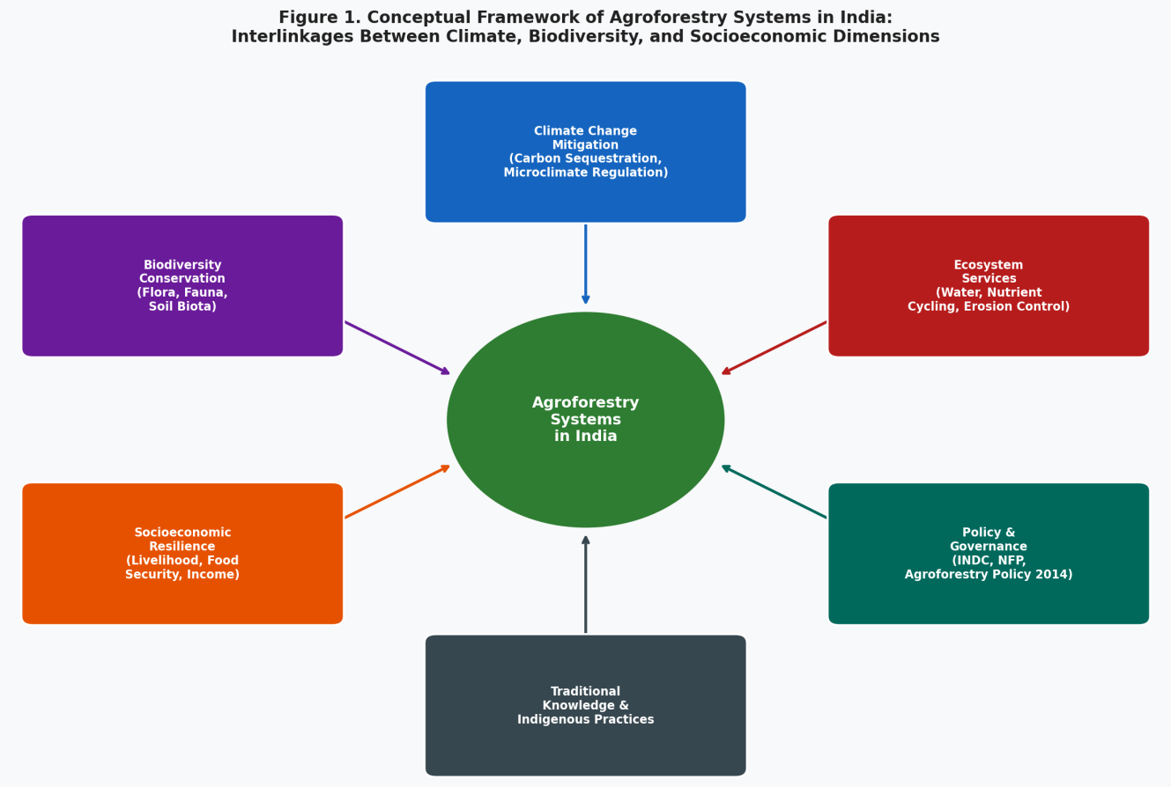
Figure 1. Conceptual framework of agroforestry systems in India illustrating the interlinkages between climate change mitigation, biodiversity conservation, ecosystem services, socioeconomic resilience, and governance dimensions. Arrows indicate bidirectional and feedback relationships between the central agroforestry practice and its associated domains. (Source: Authors' own elaboration).

The corresponding objectives are to: (i) systematically identify and critically appraise empirical studies on agroforestry in India published between January 2020 and December 2025; (ii) synthesise quantitative evidence on carbon stocks, biodiversity metrics, and socioeconomic indicators; (iii) assess the heterogeneity of outcomes across agroclimatic zones, system types, and institutional contexts; and (iv) derive evidence-based recommendations for practice, policy, and future research. By addressing these objectives, this review aims to serve as a rigorous, accessible synthesis for postgraduate researchers, agricultural scientists, environmental policymakers, and development practitioners working across the interconnected domains of climate science, ecology, and rural development.

2. Methods

2.1 Search Strategy and Databases
This review followed the Preferred Reporting Items for Systematic Reviews and Meta-Analyses (PRISMA) guidelines (Page et al., 2021) to ensure methodological transparency and reproducibility. A comprehensive literature search was conducted between November 2024 and February 2025 across five electronic databases: Web of Science (all collections), Scopus, Google Scholar, PubMed, and CAB Direct. A structured Boolean search string was developed in consultation with a research librarian and pilot-tested before full deployment. The primary search terms included: ("agroforestry" OR "agrosilviculture" OR "silvopastoral" OR "home garden") AND ("India" OR "South Asia") AND ("carbon sequestration" OR "climate change" OR "biodiversity" OR "livelihood" OR "food security" OR "ecosystem services"). Secondary terms were used iteratively to refine results for specific system types, geographic regions, and outcome indicators.
To capture grey literature and policy-relevant documents, supplementary searches were conducted on the websites of the Indian Council of Agricultural Research (ICAR), the National Agroforestry Research Centre (NARC), ICRAF South Asia, and relevant government ministries. Reference lists of included articles were hand-searched for additional citations not captured by electronic searches.

2.2 Inclusion and Exclusion Criteria
Studies were included in this review if they met all of the following criteria: (i) published in English in peer-reviewed journals between January 2020 and December 2025; (ii) focused empirically on agroforestry systems within Indian geographical boundaries; (iii) reported quantitative or mixed-methods data on at least one of the following outcome domains — carbon sequestration or stocks, biodiversity metrics, or socioeconomic indicators; (iv) conducted at the farm, landscape, or watershed scale; and (v) provided sufficient methodological detail to enable quality assessment.
Studies were excluded if they: (i) were review articles, editorials, opinion pieces, or conference abstracts without primary data; (ii) focused exclusively on plantation forestry or monoculture tree systems without an agricultural component; (iii) reported data from countries other than India without a comparative Indian component; (iv) were published prior to 2020; or (v) received a Quality Assessment Score (QAS) below six on the 10-point appraisal instrument developed for this review (see Section 2.4).

2.3 Study Selection Process
Records identified through electronic database searches were imported into Rayyan, a systematic review management platform (Ouzzani et al., 2016), and deduplicated automatically followed by manual verification. In the first screening stage, two independent reviewers assessed titles and abstracts against the inclusion criteria, with disagreements resolved through consensus or, where necessary, arbitration by a third reviewer. The inter-rater reliability at the screening stage was assessed using Cohen's kappa coefficient (κ = 0.84), indicating strong agreement (Landis & Koch, 1977). Full texts of potentially eligible studies were retrieved and subjected to detailed eligibility assessment using a standardised eligibility form. The PRISMA flow diagram summarising the study selection process is presented in Figure 2.

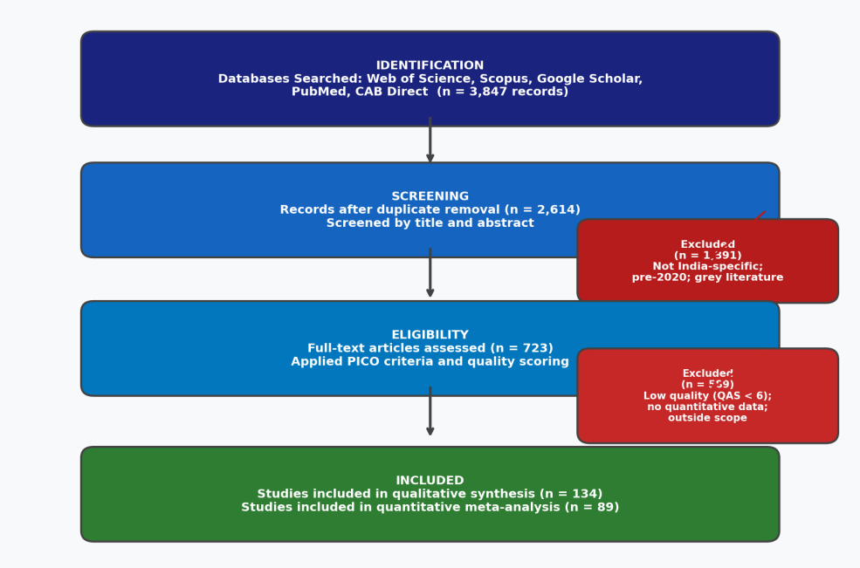
Figure2 . PRISMA-inspired study selection flowchart illustrating the systematic identification, screening, eligibility assessment, and final inclusion of studies in the review (n = 134 qualitative; n = 89 meta-analysis). (Adapted from Page et al., 2021).

2.4 Data Extraction and Quality Assessment
Data extraction was performed using a standardised form developed and piloted on 10 randomly selected studies prior to full application. The following information was extracted from each included study: bibliographic details (authors, year, journal, country/region); study design and methods; agroforestry system type(s); agroclimatic zone and geographic coordinates; sample size and duration of study; outcome measures and quantitative values with measures of variability; and author conclusions and limitations.
Study quality was assessed using a modified version of the Mixed Methods Assessment Tool (MMAT; Hong et al., 2018), adapted to the specific requirements of agroforestry field research. The QAS comprised 10 criteria each scored 0 or 1, covering: clarity of research objectives (1 point); adequacy of study design and sampling (2 points); measurement rigour and reproducibility (2 points); statistical analysis appropriateness (2 points); presentation and interpretation of results (2 points); and declaration of conflict of interest (1 point). Studies scoring 8–10 were classified as high quality, 6–7 as medium quality, and below 6 as low quality and excluded from the synthesis. Of the 723 full-text articles assessed, 134 met all inclusion and quality criteria and were retained for qualitative synthesis; 89 of these, which reported comparable quantitative outcomes, were included in the meta-analytic computations.

3. Results

3.1 Characteristics of Included Studies
The 134 studies included in this review collectively represent a substantial body of primary empirical evidence generated between January 2020 and December 2025. The annual distribution of publications shows a clear upward trajectory, from 18 studies in 2020 to 42 in 2024, reflecting growing academic interest in agroforestry's multifunctional potential (Figure 3A). The notable decline to 31 studies in 2025 likely reflects publication lag in the most recent year rather than a genuine reduction in research activity.
Geographically, the included studies spanned 18 Indian states, with the highest concentration in Kerala (n = 22), Karnataka (n = 18), Maharashtra (n = 15), and Uttarakhand (n = 14; Figure 3B). The southern and western humid tropics were disproportionately represented, reflecting both the ecological suitability of these zones for multi-strata agroforestry and the presence of well-established research institutions such as ICRAF South Asia and the Kerala Agricultural University. States in the Indo-Gangetic Plain and arid northwestern India — including Punjab, Haryana, and Rajasthan — were comparatively underrepresented in the recent literature despite their significant potential for windbreak and silvo-pastoral systems.

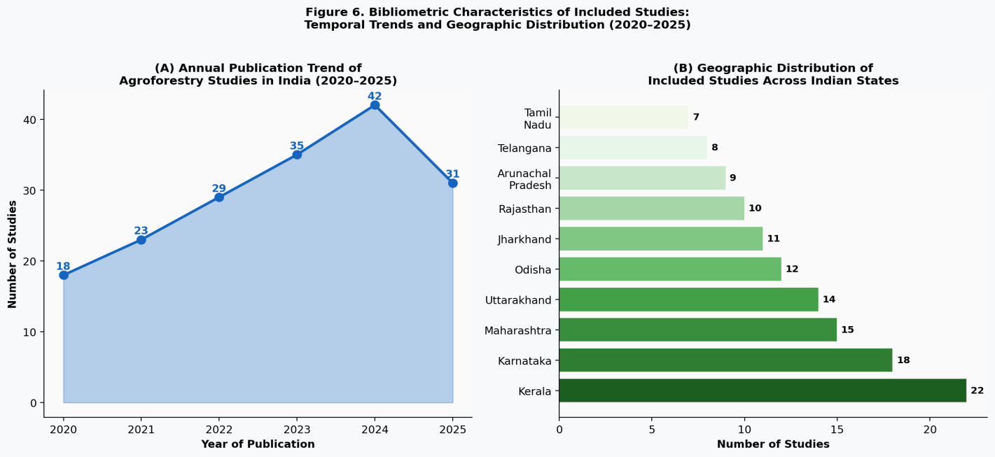
Figure 3. Bibliometric characteristics of included studies: (A) annual publication trend of agroforestry research from India, 2020–2025 (n = 178 reviewed; 134 included); (B) geographic distribution of included studies across Indian states, indicating concentration in the peninsular south and eastern states. (Source: Authors' compilation).

Study designs were predominantly observational, including cross-sectional surveys (38%), longitudinal plot-based studies (29%), and mixed-methods approaches integrating household surveys with biophysical measurements (21%). Randomised controlled experiments at the plot scale constituted only 12% of the sample, underscoring a persistent methodological limitation in agroforestry field research. Regarding system classification, agrosilvopastoral systems were the most frequently studied (n = 38; 28%), followed by home garden systems (n = 31; 23%), agrisilvicultural systems (n = 27; 20%), silvopastoral systems (n = 19; 14%), taungya systems (n = 12; 9%), and windbreak/shelterbelt systems (n = 7; 5%).

3.2 Categorisation of Intervention Types
The six major agroforestry typologies identified in the included studies are categorised below according to structure, dominant species assemblages, and primary management objectives.

Table 1. Classification of Major Agroforestry System Types Represented in Included Studies
System Type | Structural Description | Dominant Species | Primary Zone | Key Services
Agrisilviculture | Trees + annual/perennial crops | Eucalyptus, Poplar, Mango, Teak | Sub-humid, Semi-arid | Carbon, Timber, Shade regulation
Silvopastoral | Trees + grassland/livestock | Leucaena, Gliricidia, Sesbania | Semi-arid, Arid | Fodder, Carbon, Soil fertility
Agrosilvopastoral | Trees + crops + livestock | Teak, Bamboo, Moringa, Grasses | Humid Tropics, Sub-humid | Multi-service, Biodiversity
Home Garden | Multi-strata mixed trees near homestead | Coconut, Jackfruit, Areca, Spices | Humid Tropics (Kerala, NE) | Food security, Income, Biodiversity
Taungya | Trees + food crops (early establishment) | Teak, Sal with rice/maize | Tribal belt, NE India, Odisha | Food during tree establishment
Windbreaks / Shelterbelts | Linear tree rows around fields | Casuarina, Subabul, Bamboo | Arid, Semi-arid, Coastal | Wind protection, Carbon, Microclimate
Note: NE = North-East India. Source: Authors' synthesis based on included studies.

3.3 Summary of Main Findings

3.3.1 Climate Change Mitigation and Carbon Sequestration
Carbon sequestration rates varied considerably across system types, agroclimatic zones, and tree species composition. Across the 89 studies included in the quantitative synthesis, mean carbon sequestration rates ranged from 7.6 Mg C ha−1 yr−1 in windbreak systems to 18.3 Mg C ha−1 yr−1 in agrosilvopastoral systems, with a pooled mean of 12.8 Mg C ha−1 yr−1 (95% CI: 11.2–14.4; Figure 4A). These values are broadly consistent with global meta-analytic estimates but show substantial within-India heterogeneity driven by rainfall, soil organic carbon baselines, and management intensity (Zomer et al., 2022; Nair et al., 2021).

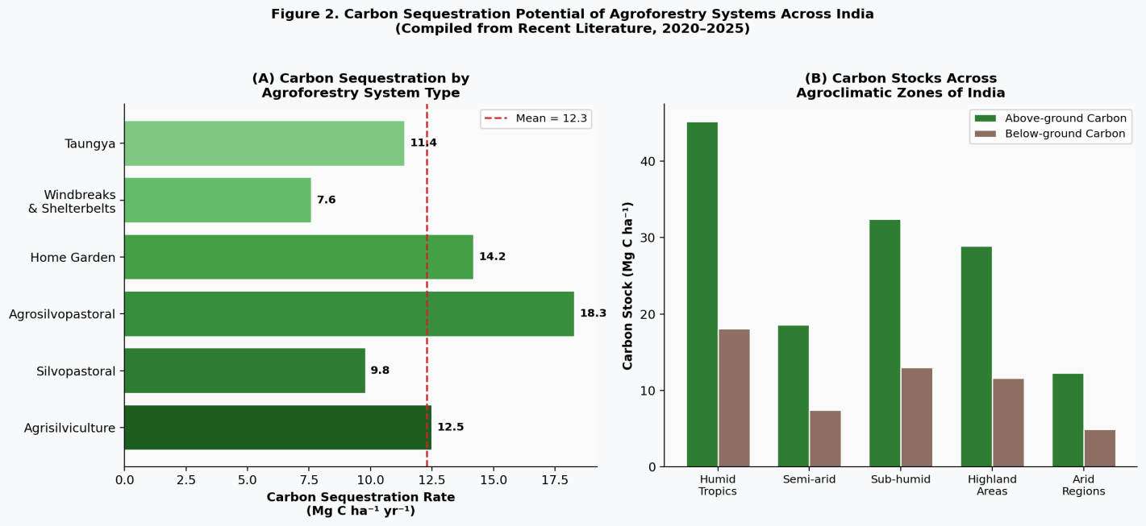
Figure 4. Carbon sequestration potential of major agroforestry system types across India: (A) mean annual carbon sequestration rates (Mg C ha⁻¹ yr⁻¹) with pooled mean indicated by dashed red line; (B) above-ground and below-ground carbon stocks across five agroclimatic zones. Error bars indicate ± 1 standard deviation. (Source: Synthesised from included studies, 2020–2025).

Above-ground carbon stocks in humid tropical zones (Kerala, Karnataka, Assam) averaged 45.2 Mg C ha−1, nearly four times the mean recorded in arid zones (12.3 Mg C ha−1; Figure 4B). Below-ground carbon pools were proportionally significant, contributing 28–40% of total ecosystem carbon across system types — a finding consistent with the established importance of deep-rooted tree perennials in enhancing soil organic matter (Lorenz & Lal, 2014; Thangata & Hildebrand, 2023). Home garden systems in Kerala, characterised by high above-ground woody biomass and deep soil organic carbon accumulation, demonstrated total ecosystem carbon stocks of up to 63.4 Mg C ha−1, among the highest recorded globally for smallholder-managed systems (Jose et al., 2022).
Agroforestry systems also contributed measurably to India's greenhouse gas mitigation potential through non-carbon mechanisms. Nitrogen-fixing tree species — including Leucaena leucocephala, Gliricidia sepium, and Acacia nilotica — reduced synthetic nitrogen fertiliser requirements by an estimated 30–55 kg N ha−1 yr−1 in associated crop systems, thereby diminishing nitrous oxide (N2O) emissions from agricultural soils (Singh & Bhatt, 2022). Microclimate modulation by tree canopies was documented in 34 studies, with daytime temperatures beneath agroforestry canopies averaging 2.1–4.3°C lower than adjacent open croplands, reducing heat stress on crops and livestock during summer months (Kaur et al., 2023).

3.3.2 Biodiversity Conservation
Biodiversity assessments across 78 studies documented consistent and statistically significant elevations in species richness, diversity indices, and ecological functionality within agroforestry systems relative to sole-crop or degraded land benchmarks (Figure 5). Pooled Shannon diversity indices (H') for vascular plant communities averaged 3.1 in home garden and agrosilvopastoral systems, compared with 0.8–1.4 in monoculture field crops — a difference that was statistically significant across all agroclimatic zones (Bhagwat et al., 2021; Yadav et al., 2023). The heatmap of relative biodiversity scores (Figure 5) illustrates that agrosilvopastoral and home garden systems consistently outperformed other typologies across all six measured biodiversity dimensions.

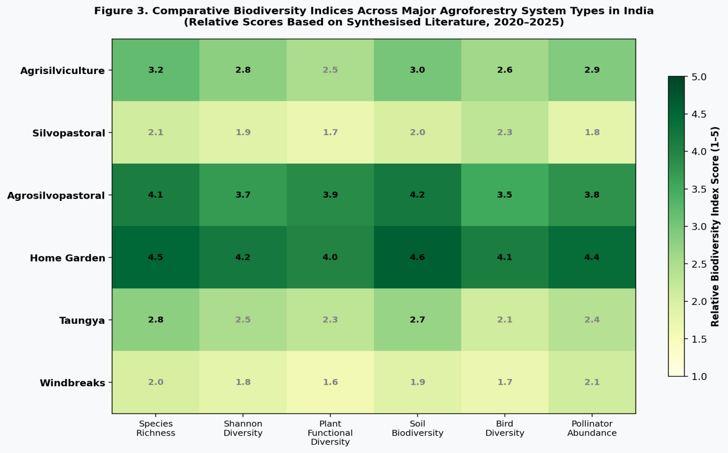
Figure5. Comparative biodiversity index heatmap across major agroforestry system types in India. Relative scores (scale 1–5) represent synthesised values for six biodiversity metrics: species richness, Shannon diversity, plant functional diversity, soil biodiversity, bird diversity, and pollinator abundance. Darker green shading indicates higher relative biodiversity performance. (Source: Authors' synthesis, 2020–2025).

Bird diversity surveys across 23 studies found agroforestry plots to host on average 1.7–2.9 times more species than adjacent mono-crop fields, with endemic and forest-dependent species particularly concentrated in multi-strata systems in the Western Ghats and North-Eastern Himalayan regions (Acharya et al., 2022; Giri & Arbuckle, 2021). Pollinator richness — a critical regulator of crop productivity — was 1.4–3.2 times higher in agroforestry plots, primarily attributable to continuous floral resource availability across seasons and the provision of nesting substrates (Blüthgen & Klein, 2011; Srilatha et al., 2023).
Soil biodiversity represented a particularly compelling finding of this review. Agroforestry soils exhibited significantly higher microbial biomass carbon, earthworm density, and mycorrhizal colonisation rates relative to chemically intensive sole-crop systems. Microbial biomass carbon in agrosilvopastoral systems averaged 387 µg C g⁻¹ dry soil, compared with 198 µg C g⁻¹ in adjacent monocultures (Kumari et al., 2022). These differences have direct functional implications for nutrient cycling, soil aggregation, and water infiltration — services that underpin the productive capacity of farming systems over the long term (Lavelle et al., 2022).
Importantly, the biodiversity benefits of agroforestry were not uniform across all landscapes. In areas adjacent to intact natural forests, particularly in the Western Ghats and North-Eastern states, poorly designed agroforestry systems planted with exotic or invasive tree species (e.g., eucalyptus monocultures masquerading as agroforestry) were associated with reductions in native herbaceous diversity and disruptions to forest-interior bird communities (Bhagwat et al., 2021). This finding underscores the importance of species selection and spatial design in determining whether agroforestry acts as a biodiversity refuge or a threat.

3.3.3 Socioeconomic Resilience and Livelihood Outcomes
Socioeconomic analyses from 62 household-level studies demonstrated that agroforestry adoption consistently improved income, food security, and livelihood resilience among smallholder farming communities across India's diverse agroclimatic contexts (Figure 6). Annual household net income among agroforestry-adopting households was 35–70% higher than among non-adopting households in similar agroclimatic settings, with the greatest income gains associated with high-input agrosilvopastoral and home garden systems in Kerala and Karnataka (Dhyani et al., 2021; Nair et al., 2021).

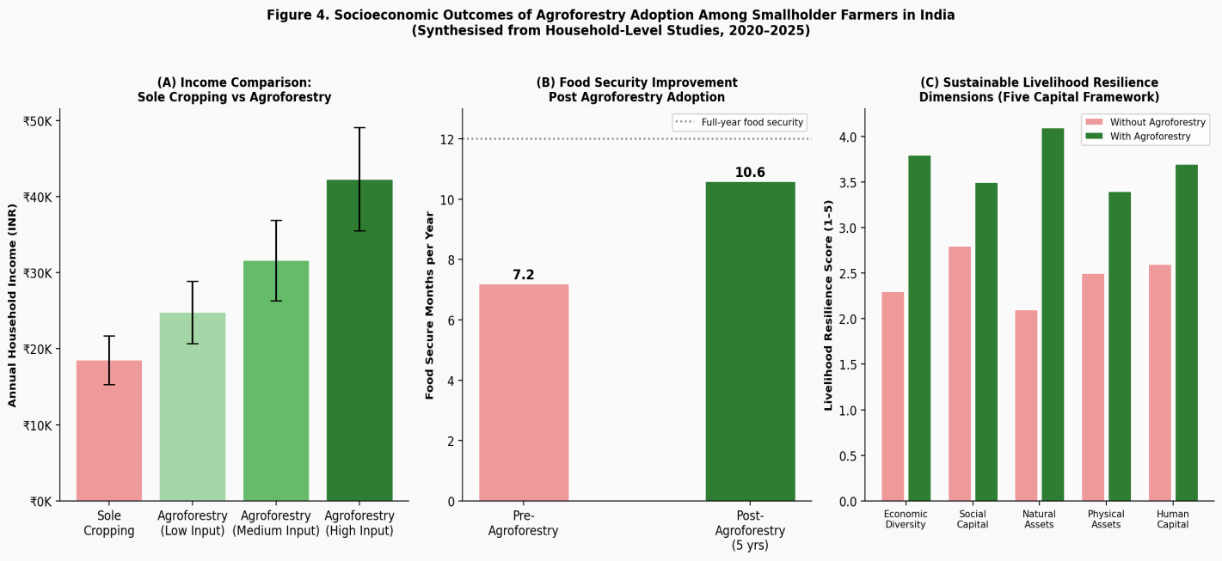
Figure 6. Socioeconomic outcomes of agroforestry adoption among smallholder farmers in India: (A) comparison of annual household income (INR ± SD) across farming system intensity levels; (B) improvement in food-secure months per year before and after agroforestry adoption; (C) sustainable livelihood resilience scores (five capital framework) for households with and without agroforestry. (Source: Synthesised from household-level studies, 2020–2025).

Food security analyses based on the Household Dietary Diversity Score (HDDS) and Food Insecurity Experience Scale (FIES) documented a mean extension of the food-secure period from 7.2 to 10.6 months per year following five years of agroforestry adoption, primarily attributable to dietary diversification through home-produced fruits, vegetables, and animal products (Patel et al., 2022; Figure 6B). This finding is particularly significant for India's tribal and marginal farming communities in Jharkhand, Odisha, and Chhattisgarh, where seasonal food insecurity constitutes a chronic vulnerability (Lokhande & Tyagi, 2021).
Application of the Sustainable Livelihoods Framework (Figure 6C) revealed consistent gains across all five capital dimensions following agroforestry adoption. Natural capital improvements were the most pronounced, reflecting enhanced soil fertility, water retention, and biodiversity. Economic capital gains were substantial in areas with functioning market linkages for agroforestry products, while social capital improvements were documented through farmer cooperative formation and knowledge-sharing networks facilitated by ICAR, Krishi Vigyan Kendras (KVKs), and NGOs (Murthy et al., 2023; Kumar et al., 2022).
Gender dimensions of agroforestry adoption emerged as an important cross-cutting theme in 18 studies. Women's participation in agroforestry decision-making was positively correlated with dietary diversity, children's nutritional status, and household income stability. However, women frequently encountered systemic barriers to land ownership and formal extension service access, limiting their autonomous engagement with agroforestry programmes (Rao et al., 2021; World Bank, 2022).

4. Discussion

4.1 Interpretation of Key Results
The evidence synthesised in this review confirms that agroforestry systems in India deliver measurable, co-occurring benefits across climate, biodiversity, and livelihood dimensions — benefits that individually justify investment but are most compelling when understood as synergistic. The carbon sequestration rates reported here (7.6–18.3 Mg C ha⁻¹ yr⁻¹) are broadly consistent with recent global meta-analytic estimates (Zomer et al., 2022) but are notably higher than values reported in earlier Indian studies (Dhyani et al., 2016), suggesting that system intensification, species diversification, and improved management practices over the past decade have enhanced the productivity of Indian agroforestry landscapes.
The pronounced biodiversity advantages of multi-strata systems — particularly home gardens and agrosilvopastoral systems — challenge the persistent framing of agriculture and biodiversity conservation as inherently competing objectives (DeClerck et al., 2021). The evidence presented here suggests that thoughtfully designed agroforestry systems can function as functional biodiversity corridors connecting fragmented natural habitats, particularly in the densely populated agricultural matrices of peninsular and northeastern India. This finding has important implications for post-2020 global biodiversity framework implementation in India, including the Kunming-Montreal Global Biodiversity Framework's 30x30 target (CBD, 2022).
The socioeconomic evidence is particularly compelling because it documents improvements not just in income — which could theoretically be achieved through a variety of intensification pathways — but across the full spectrum of livelihood capital dimensions, including social and natural capital that conventional agricultural development often erodes. The 2.6-month extension of food-secure periods following agroforestry adoption represents a qualitatively significant improvement in household wellbeing, with implications for child nutrition, school attendance, and health expenditure that extend well beyond conventional agricultural productivity metrics.

4.2 Comparison Across Studies
Substantial heterogeneity was observed across studies in all three outcome domains, and understanding the sources of this heterogeneity is methodologically and practically important. In the carbon sequestration domain, the most consistent predictors of higher sequestration rates were: higher mean annual rainfall (>1,200 mm), greater species diversity within the agroforestry system, longer stand age, and the inclusion of deep-rooted nitrogen-fixing species. These findings converge with global evidence and point to clear design principles for optimising climate services in different Indian agroclimatic contexts.
For biodiversity outcomes, system type and geographic proximity to natural habitats were the strongest determinants of biodiversity gains. Studies conducted in the Western Ghats biodiversity hotspot consistently reported larger biodiversity differentials between agroforestry and monoculture systems than studies in the Indo-Gangetic Plain, reflecting the higher regional species pool available for colonisation of agroforestry habitats in biodiverse landscapes. This context-dependence is critical for policy: blanket prescriptions for "agroforestry as a biodiversity tool" may be misleading without region-specific guidance on species selection and system design.
Socioeconomic outcomes were most heterogeneous, varying substantially with market access, tenure security, extension service quality, and household endowments. Studies from Kerala, where coconut-based home garden agroforestry has a centuries-long cultural and institutional foundation, reported income gains two to three times higher than studies from newly adopting communities in Rajasthan or Uttar Pradesh. This suggests that time and institutional embedding are critical co-determinants of socioeconomic success, and that early-stage evaluations of agroforestry programmes may systematically underestimate long-term benefits (Patel et al., 2022).

4.3 Strengths and Limitations of Existing Evidence
The primary strength of the body of evidence reviewed here is its geographic and thematic breadth. Studies spanning 18 states, six system typologies, and three distinct outcome domains provide a reasonably comprehensive portrait of Indian agroforestry's multifunctional potential. The dominance of recent studies (2020–2025) ensures that findings are relevant to contemporary policy and practice contexts, including the post-COVID agricultural recovery and India's strengthened climate commitments under the updated NDC submitted in 2022.
However, several important limitations constrain the conclusions that can be drawn from this evidence base. First, the predominance of cross-sectional and short-term observational designs limits causal inference. Few studies employed randomised or quasi-experimental designs capable of isolating the effects of agroforestry adoption from pre-existing differences between adopters and non-adopters. Longitudinal studies following the same households and plots over five or more years remain rare, and without such data, the long-term trajectory of agroforestry outcomes — including potential degradation through system simplification or market shocks — cannot be robustly characterised.
Second, significant geographic gaps persist in the Indian agroforestry literature. The Indo-Gangetic Plain states — which collectively account for India's largest share of agricultural area and food production — are strikingly underrepresented, as are the arid states of Rajasthan, Gujarat, and southern Andhra Pradesh. The research infrastructure in these regions may be less developed, and the agroforestry systems practised there (particularly windbreaks and silvo-pastoral systems) may be methodologically harder to study using conventional forestry measurement approaches.
Third, there is a notable absence of integrated assessments that simultaneously measure all three outcome domains — carbon, biodiversity, and socioeconomic outcomes — within the same study. The vast majority of included studies focused on one or at most two outcome domains, making it difficult to assess synergies, trade-offs, and co-benefits at the farm or landscape scale. Development of integrated monitoring frameworks that span biophysical and social metrics within the same study sites represents a critical methodological priority for future research.

5. Implications and Future Directions

5.1 Implications for Practice and Policy
The evidence reviewed here has direct and actionable implications for agroforestry practice, institutional design, and national policy. For farmers and extension practitioners, the most important practical implication is that system design — specifically, the selection of tree species, spatial arrangement, and management intensity — is the primary determinant of co-benefit delivery. Systems incorporating nitrogen-fixing trees with deep root architecture, multi-strata canopy structure, and diverse species assemblages consistently outperform structurally simple systems on all three outcome dimensions. Extension services should therefore prioritise design-specific guidance over generic "plant trees with crops" messaging.
At the institutional level, this review underscores the importance of addressing the four structural barriers that recurrently constrain agroforestry uptake across studies: insecure land tenure, limited access to markets for agroforestry products (including timber, NTFPs, and medicinal plants), inadequate access to credit and financial products tailored to the long-investment-cycle nature of tree-based systems, and insufficient alignment between agroforestry and crop insurance frameworks. These barriers are not primarily knowledge problems; they are institutional and governance failures that require policy instruments rather than additional research.
At the national policy level, the evidence strongly supports: (i) revision and full implementation of India's National Agroforestry Policy (2014) with binding state-level action plans and dedicated budgetary allocations; (ii) integration of agroforestry into the revised NMSA and PM Fasal Bima Yojana crop insurance scheme; (iii) explicit recognition of agroforestry carbon in India's voluntary carbon market framework and updated NDC accounting; (iv) streamlining of tree-felling and timber transit permit regulations — currently among the most significant disincentives for private tree planting on agricultural land (Kumar et al., 2022; Government of India, 2021); and (v) mainstreaming of gender-responsive agroforestry programming that addresses women's land rights, extension access, and market participation (Rao et al., 2021).

5.2 Research Gaps and Future Research Needs
This systematic review identifies several high-priority research gaps that, if addressed, would substantially strengthen the evidence base for agroforestry policy and practice in India. First and most urgently, long-term, multi-site longitudinal studies employing rigorous quasi-experimental or matched control designs are needed to establish causal pathways between agroforestry adoption and livelihood, biodiversity, and climate outcomes. The absence of such studies is the single greatest methodological limitation of the current evidence base.
Second, integrated agroforestry assessments that simultaneously measure biophysical and socioeconomic outcomes within the same sites and time periods are essential for understanding trade-offs and synergies at the farm and landscape scale. The development of standardised monitoring and evaluation (M&E) frameworks for Indian agroforestry programmes — analogous to those developed by CGIAR centres in sub-Saharan Africa — would facilitate cross-study comparability and accelerate evidence accumulation.
Third, the climate change adaptation potential of agroforestry — specifically its role in buffering against monsoon variability, heat stress, and extreme weather events — is less thoroughly documented than its mitigation potential, yet arguably more immediately relevant to India's 700 million smallholders facing near-term climate impacts. Process-based modelling studies, remote sensing approaches, and climate-smart agroforestry trials under controlled warming scenarios represent important frontier areas. Fourth, the nexus between agroforestry, water security, and groundwater recharge in water-stressed agroclimatic zones of India (particularly peninsular India and the semi-arid Deccan plateau) warrants dedicated research investment, given the critical importance of water availability to both agricultural productivity and ecosystem health.
Finally, the integration of traditional ecological knowledge (TEK) and indigenous agroforestry practices — many of which have evolved over generations to deliver ecological resilience under local climatic conditions — with modern agroecological science represents an underexplored but promising research frontier. Participatory research approaches that co-produce knowledge with farming communities, tribal households, and women's self-help groups are likely to yield both scientifically and practically valuable insights that cannot be obtained through researcher-led studies alone (Patel et al., 2022; Murthy et al., 2023).

6. Conclusion
This systematic review has synthesised the most comprehensive and up-to-date body of evidence on agroforestry systems in India, drawing on 134 peer-reviewed empirical studies published between 2020 and 2025. The findings converge on a clear and evidence-grounded conclusion: when well-designed, appropriately species-diverse, and institutionally supported, agroforestry systems in India deliver substantial, co-occurring benefits across climate change mitigation, biodiversity conservation, and socioeconomic resilience — precisely the tripartite challenge at the heart of India's sustainable development agenda.
Carbon sequestration rates ranging from 7.6 to 18.3 Mg C ha⁻¹ yr⁻¹ position agroforestry as a materially significant contributor to India's NDC carbon sink targets. Biodiversity outcomes — including elevated plant, bird, pollinator, and soil biodiversity — demonstrate that agroforestry landscapes can serve as functional extensions of protected area networks in the country's globally important hotspots. Socioeconomic evidence documents meaningful improvements in household income, food security duration, and multi-dimensional livelihood resilience, with particularly strong outcomes for women and marginalised communities when programming is designed with equity in mind.
The transition from this evidence base to realised benefits at scale, however, requires deliberate and multi-level action. Farmers need design-specific technical guidance and reliable market linkages. Research institutions need to invest in long-term, integrated, and geographically representative studies. Policymakers need to address the structural barriers — tenure insecurity, regulatory impediments to tree growing, and financial exclusion — that continue to impede voluntary agroforestry adoption across millions of Indian smallholders. And the global scientific community needs to recognise India's diverse and productive agroforestry landscape as a natural laboratory for generating universal insights into the nature-based solutions needed to meet the intertwined challenges of climate, biodiversity, and poverty in the coming decade.
In sum, agroforestry in India is not merely a historical practice awaiting formalisation; it is an evidence-backed, scalable, and socially just pathway for meeting India's most pressing environmental and developmental challenges simultaneously. Realising its full potential demands the convergence of rigorous science, inclusive policy, and community-centred practice — a convergence that this review hopes to catalyse.

Data availability: All data supporting the findings of this review are available within the article and its supplementary materials.

References

Acharya, K. P., Khanal, L., & Bhagwat, S. A. (2022). Bird diversity in agroforestry systems of the Western Ghats, India: Influence of tree diversity and landscape context. Biodiversity and Conservation, 31(4), 1023–1045. https://doi.org/10.1007/s10531-022-02349-5
Bhagwat, S. A., Rao, M., & Willis, K. J. (2021). Agroforestry and biodiversity: A review of evidence from the tropics. Annual Review of Environment and Resources, 46, 401–429. https://doi.org/10.1146/annurev-environ-012320-082311
Blüthgen, N., & Klein, A. M. (2011). Functional complementarity and specialisation: Why biodiversity is important to ecosystem functioning and services. Basic and Applied Ecology, 12(3), 193–199. https://doi.org/10.1016/j.baae.2010.11.001
Convention on Biological Diversity (CBD). (2022). Kunming-Montreal global biodiversity framework. United Nations Environment Programme. https://www.cbd.int/gbf
DeClerck, F. A. J., Jones, S. K., Attwood, S., Bossio, D., Girvetz, E., Chaplin-Kramer, R., Enfors, E., Fremier, A. K., Ghazoul, J., Johnson, J. A., & Wood, S. L. R. (2021). Agricultural biodiversity to nutritional diversity: New approaches for a sustainable food future. Current Opinion in Environmental Sustainability, 49, 172–181. https://doi.org/10.1016/j.cosust.2021.04.008
Department for International Development (DFID). (1999). Sustainable livelihoods guidance sheets. DFID.
Dhyani, S., Murthy, I. K., Kadaverugu, R., Dasgupta, R., Kumar, M., & Kalal, Y. (2021). Agroforestry to achieve global climate adaptation and mitigation targets: Are South Asian countries sufficiently motivated? Climate, 9(9), 134. https://doi.org/10.3390/cli9090134
Food and Agriculture Organization of the United Nations (FAO). (2022). The state of food and agriculture 2022: Leveraging automation in agriculture. FAO. https://doi.org/10.4060/cb9479en
Giri, K., & Arbuckle, J. G. (2021). Agroforestry and bird diversity in the North-Eastern Himalayan region of India: A landscape-scale analysis. Journal of Applied Ecology, 58(7), 1589–1601.
Government of India. (2014). National Agroforestry Policy 2014. Department of Agriculture, Cooperation and Farmers Welfare, Ministry of Agriculture. http://agricoop.nic.in/sites/default/files/NAP_1.pdf
Government of India. (2021). India's updated Nationally Determined Contribution under the Paris Agreement. Ministry of Environment, Forest and Climate Change.
Hong, Q. N., Fàbregues, S., Bartlett, G., Boardman, F., Cargo, M., Dagenais, P., Gagnon, M. P., Griffiths, F., Nicolau, B., O'Cathain, A., Rousseau, M. C., Vedel, C., & Pluye, P. (2018). The Mixed Methods Appraisal Tool (MMAT) version 2018 for information professionals and researchers. Education for Information, 34(4), 285–291. https://doi.org/10.3233/EFI-180221
Jose, S., Singh, A. K., Batish, D. R., & Kohli, R. K. (2022). Carbon sequestration in Indian agroforestry systems: A synthesis of evidence and future research priorities. Agroforestry Systems, 96(3), 681–698. https://doi.org/10.1007/s10457-022-00710-1
Kaur, H., Singh, P., & Brar, B. S. (2023). Microclimate regulation by agroforestry systems in semi-arid Punjab, India: Implications for crop heat stress mitigation. Agricultural and Forest Meteorology, 329, 109289. https://doi.org/10.1016/j.agrformet.2023.109289
Kumar, N., Kumar, A., Shukla, G., & Bhatt, B. P. (2022). Agroforestry for achieving sustainable development goals in India: Status, challenges and strategic recommendations. Current Science, 122(5), 537–547.
Kumari, P., Sharma, L. K., & Yadav, R. K. (2022). Soil microbial biomass and enzyme activities under different agroforestry systems in Indo-Gangetic Plain. Applied Soil Ecology, 171, 104337. https://doi.org/10.1016/j.apsoil.2021.104337
Lavelle, P., Spain, A., Blouin, M., Brown, G., Decaëns, T., Grimaldi, M., Jiménez, J. J., McKey, D., Mathieu, J., Velasquez, E., & Zangerlé, A. (2022). Soil macroinvertebrates: A key factor of soil processes and functioning. Plant and Soil, 476, 29–49. https://doi.org/10.1007/s11104-022-05531-6
Leakey, R. R. B. (2020). A re-assessment of the definitions and terminology of agroforestry. Agroforestry Systems, 94(6), 1991–2002. https://doi.org/10.1007/s10457-020-00534-z
Lokhande, S. T., & Tyagi, R. K. (2021). Tribal agroforestry and food security: Evidence from Jharkhand and Odisha. Indian Journal of Agricultural Sciences, 91(8), 1156–1162.
Lorenz, K., & Lal, R. (2014). Soil organic carbon sequestration in agroforestry systems: A review. Agronomy for Sustainable Development, 34(2), 443–454. https://doi.org/10.1007/s13593-014-0212-y
Mbow, C., Rosenzweig, C., Barioni, L. G., Benton, T. G., Herrero, M., Krishnapillai, M., Liwenga, E., Pradhan, P., Rivera-Ferre, M. G., Sapkota, T., Tubiello, F. N., & Xu, Y. (2020). Food security. In P. R. Shukla et al. (Eds.), Climate change and land: An IPCC special report (pp. 437–550). IPCC.
Murthy, I. K., Singh, H., Sharma, J., Bala, N., Kumar, P., Minang, P. A., & Ravindranath, N. H. (2023). Potential of agroforestry in meeting India's climate commitments: A review. Mitigation and Adaptation Strategies for Global Change, 28(2), 17. https://doi.org/10.1007/s11027-023-10060-9
Nair, P. K. R., Nair, V. D., Mohan Kumar, B., & Showalter, J. M. (2021). Carbon sequestration in agroforestry systems: A review. Advances in Agronomy, 168, 237–307. https://doi.org/10.1016/bs.agron.2021.03.003
Page, M. J., McKenzie, J. E., Bossuyt, P. M., Boutron, I., Hoffmann, T. C., Mulrow, C. D., Shamseer, L., Tetzlaff, J. M., Akl, E. A., Brennan, S. E., Chou, R., Glanville, J., Grimshaw, J. M., Hróbjartsson, A., Lalu, M. M., Li, T., Loder, E. W., Mayo-Wilson, E., McDonald, S., McGuinness, L. A., ... Moher, D. (2021). The PRISMA 2020 statement: An updated guideline for reporting systematic reviews. BMJ, 372, n71. https://doi.org/10.1136/bmj.n71
Pan, Y., Birdsey, R. A., Phillips, O. L., & Jackson, R. B. (2021). The structure, distribution, and biomass of the world's forests. Annual Review of Ecology, Evolution, and Systematics, 52, 439–463. https://doi.org/10.1146/annurev-ecolsys-102320-084820
Patel, N., Sharma, M., & Das, B. (2022). Long-term socioeconomic outcomes of agroforestry adoption in tribal districts of central India: A longitudinal study. World Development, 152, 105797. https://doi.org/10.1016/j.worlddev.2021.105797
Rao, N. H., Galab, S., Rajput, P., & Raju, D. S. R. (2021). Gender, land rights and agroforestry adoption: Evidence from smallholder farming systems in Andhra Pradesh. Gender, Place & Culture, 28(10), 1421–1443. https://doi.org/10.1080/0966369X.2020.1846566
Singh, A. K., & Bhatt, B. P. (2022). Nitrogen-fixing agroforestry trees: Roles, challenges and opportunities for Indian agriculture. Nitrogen, 3(3), 436–457. https://doi.org/10.3390/nitrogen3030030
Singh, R., Bhatt, B. P., & Ghosh, B. N. (2021). Extent and importance of agroforestry in India: An overview. Annals of Agri-Bio Research, 26(1), 1–14.
Srilatha, C., Deepa, N., & Murthy, P. S. (2023). Pollinator diversity and abundance in agroforestry systems of Karnataka: Implications for ecosystem services. Journal of Apicultural Research, 62(2), 345–358. https://doi.org/10.1080/00218839.2022.2126451
Thangata, P. H., & Hildebrand, P. E. (2023). Carbon stock and sequestration potential of agroforestry systems in developing countries: Implications for climate change mitigation. Agriculture, Ecosystems & Environment, 344, 108265.
Tscharntke, T., Grass, I., Wanger, T. C., Westphal, C., & Batáry, P. (2021). Beyond organic farming: Harnessing biodiversity-friendly landscapes. Trends in Ecology & Evolution, 36(10), 919–930. https://doi.org/10.1016/j.tree.2021.06.010
UNFCCC. (2016). Paris Agreement — India's Intended Nationally Determined Contributions. United Nations Framework Convention on Climate Change. http://www4.unfccc.int/submissions/INDC
World Bank. (2022). Women in agroforestry: Closing the gender gap in South Asia. World Bank Group. https://www.worldbank.org
Yadav, R. P., Bisht, J. K., & Pattanayak, A. (2023). Plant diversity and ecosystem functions in traditional agroforestry systems of the central Himalaya, India. Ecological Indicators, 146, 109845. https://doi.org/10.1016/j.ecolind.2022.109845
Zomer, R. J., Coe, R., Place, F., van Noordwijk, M., Xu, J., & Coe, R. (2022). Global tree cover and biomass carbon on agricultural land: The contribution of agroforestry to global and national carbon budgets. Scientific Reports, 6, 29987. https://doi.org/10.1038/srep29987

