Morphometric Characterization and Hydrological Interpretation of the Shastri Watershed Using Geospatial Techniques
Abstract
The geomorphological attributes of a watershed exert strong control over drainage configuration, runoff dynamics, erosion intensity, and groundwater potential. Therefore, quantitative geomorphometric evaluation is fundamental for interpreting the linkage between landform characteristics and hydrological response. The present study investigates the geomorphometric properties of the Shastri watershed and their hydrological implications using geospatial tools. Remote Sensing (RS) and Geographic Information Systems (GIS) techniques were employed to extract morphometric parameters from a 30 m resolution CARTOSAT-DEM and Survey of India (SOI) topographic maps for watershed and drainage delineation. Computed linear, areal, and relief parameters reveal that elongated basin morphology, reflected by low form factor, elongation ratio, and circularity ratio. Elevated basin relief, moderate relief ratio, and ruggedness number indicate pronounced terrain variability, promoting higher runoff velocity and erosion susceptibility. Additionally, the asymmetry factor suggests uneven slope development, influencing spatial runoff distribution. Overall, the watershed exhibits moderate to high runoff potential, particularly during high-intensity rainfall events. The study highlights the robustness of RS-GIS-based approaches in deriving reliable morphometric insights and underscores their utility in supporting effective watershed management and sustainable resource planning.
Keywords: Geospatial Technique, Morphometric analysis, Stream network, Watershed etc.
- Introduction:
Land and water are the two important resources decreasing day by day due to the growing population pressure. Watersheds serve as fundamental geomorphic and hydrological units, emerging from the intricate interactions among Earth's surface topography, climate, and hydrological processes. The geomorphology examines the physical and chemical processes near or on the Earth's surface that shape topographic features and drive their evolution over time (Clarke, 1966). Morphometry is the systematic description of watershed geometry and its stream channel system, enabling the measurement of linear aspects of the drainage network, areal aspects of the drainage basin, and relief aspects of the channel network (Ingle et al., 2025).
Drainage networks represent key landscape components that are highly sensitive to topography, which in turn governs their structure and fluvial dynamics. These networks, encompassing stream patterns and river systems, vary across space and time under the influence of geomorphology, geology, structural controls, and vegetation (Rekha et al., 2011). Physiographic characteristics such as catchment shape, stream density, and basin gradient play a crucial role in linking hydrological responses within a region (Waikar and Nilawar, 2014). Analysis of these characteristics provides valuable insights into runoff behavior and water flow patterns within a basin, while geomorphological processes directly influence water availability.
Furthermore, basin morphometry significantly controls hydrological processes such as flood peaks, sediment yield, and soil erosion (Shekar and Mathew, 2023; Shekar et al., 2023). It quantitatively describes the size, shape, and configuration of landforms and surface features (Clarke, 1996; Agarwal, 1998; Reddy et al., 2002). Morphometric studies generally encompass linear, areal, and relief aspects, often analyzed using GIS-based approaches (Agarwal, 1998), which provide comprehensive insights into the topographic and hydrological characteristics of a watershed (Pirasteh et al., 2010).
With advancements in geospatial technologies, Remote Sensing (RS) and Geographic Information Systems (GIS) have become effective tools for rapid and precise computation of morphometric parameters with high spatial accuracy (Singh et al., 2013; Gautam et al., 2021). In this context, the present study applies RS and GIS techniques to evaluate the morphometric characteristics of the Shastri watershed, with the objective of understanding its hydrological response and supporting policymakers in the planning and design of suitable water harvesting structures
- Material and Methods
  - Description of Study Area:
In the present study, watershed is situated on Shastri watershed situated on Shastri river basin selected as a study area in the Konkan region. The latitude extent of watershed is between 17˚6.200’ N - 17˚22.800’ N and longitude extent is between 73˚36.000’ E - 73˚42.000’E. The study area is covering 151 sq.km (15100 ha). The basin receives 3,300 mm of average annual rainfall , most of which falls during the southwest monsoon season (June–September). Orographic uplift along the Western Ghats significantly enhances rainfall intensity, leading to rapid runoff generation, saturated soil conditions, and pronounced seasonal discharge within the watershed. The elevation of the study area ranges from 26.05 m to 987 m above Mean Sea Level(MSL).The location map of shastri watershed is shown in Figure 1.
  - Database Used
Data required for the present study was toposheets(1:50000 scale) and Digital Elevation Model(DEM). Toposheet of the study was obtained from the official website of Survey of India(SOI). The 30-m Cartosat-1 DEM (Digital Elevation Model) was used and which downloaded from Bhoonidhi Portal (link: https://earthexplorer.usgs.gov/). The Digital Elevation Map Shown as Figure 4. It is suitable for detailed terrain analysis, watershed delineation, slope and drainage extraction, and geomorphological studies.
  - Software Used
QGIS which is open source software (Version 3.18, released in February 2021) developed by the QGIS.ORG Association was utilized in the present study for geospatial analysis. The software was employed for watershed delineation, preparation of thematic maps, and extraction of drainage networks using Digital Elevation Model (DEM) data. Further, it was used to compute various morphometric parameters, including linear, areal, and relief aspects of the watershed, which are essential for understanding hydrological behavior and geomorphological characteristics.

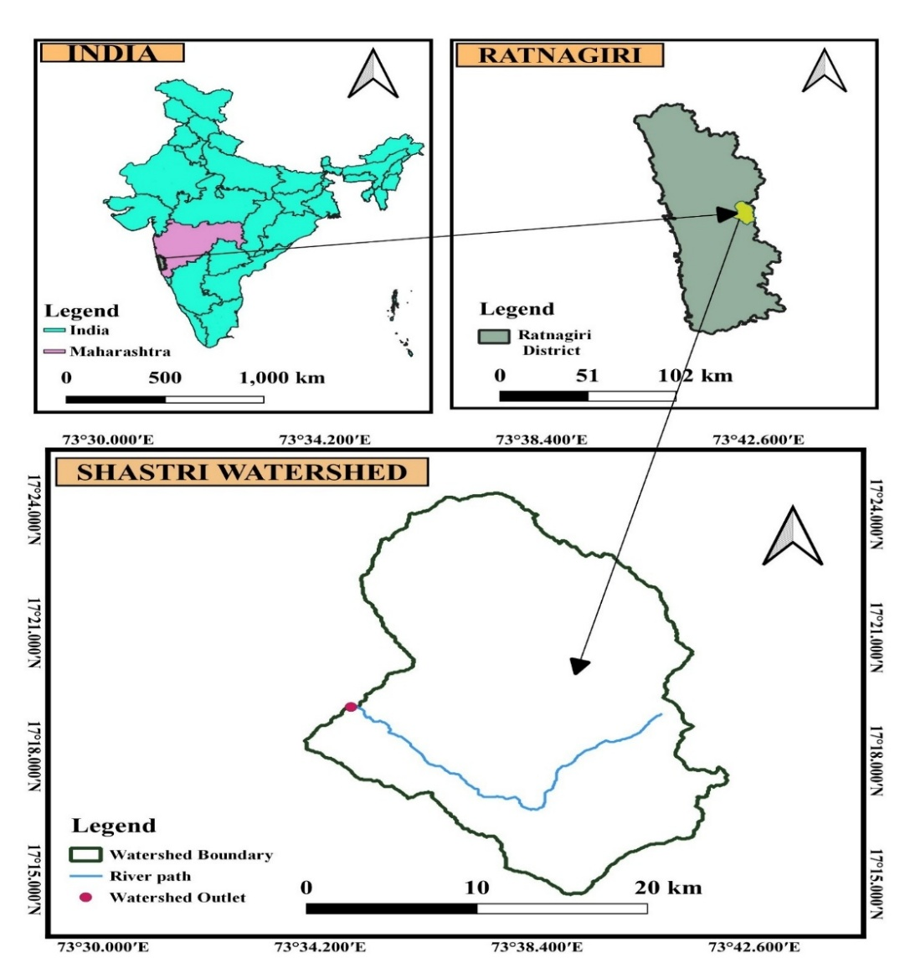

Figure 1. Location Map of Study Area
  - Extraction of watershed boundary and drainage network
The watershed is a topographically defined hydrological entity that collects and transmits runoff from precipitation to a common outlet, like a lake, river, stream, or reservoir, via a network of flow pathways. A flowchart showing steps for extraction of watershed boundary in the Q-GIS 3.18 environment is given in Figure 2.
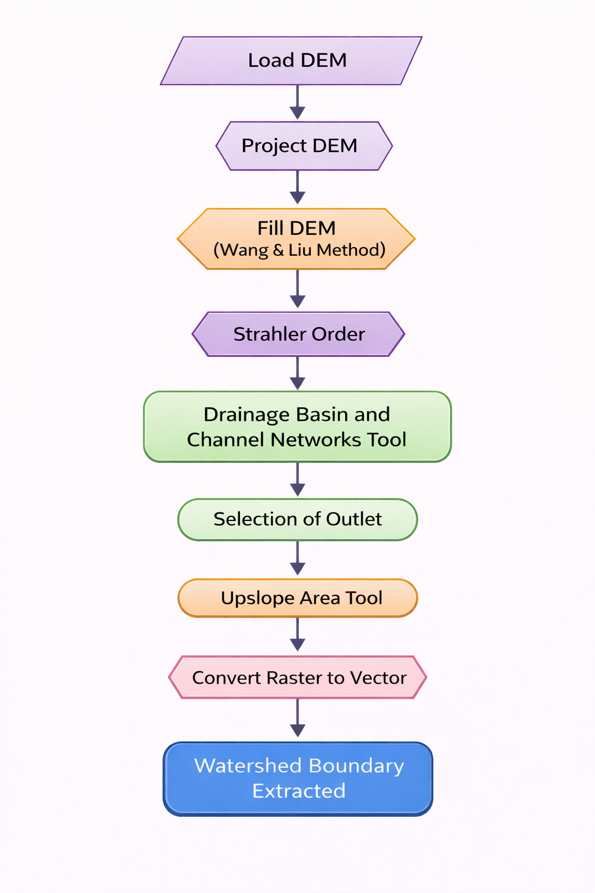
Figure 2. Flowchart showing steps for extracting boundary of watershed
  - Estimation of geomorphometric parameters
The morphometric analysis of a drainage basin is considered as the most satisfactory method; this method enables us to find interrelationship among different aspects of a drainage pattern (Biswas et al. 1999).The geomorphological characteristics of watershed are grouped under stream properties, shape properties, drainage network characteristics and slope characteristics. Three main elements are presented for evaluation:
2.5.1. Linear aspects (One dimension)
2.5.2. Areal aspects (Two dimension)
2.5.3. Relief aspects (Three dimension)
2.5.1. Linear parameters
The linear aspects of a watershed primarily describe the characteristics of the stream system and its drainage network, representing essentially one-dimensional attributes of basin geometry. These parameters include watershed area and perimeter, basin length, stream order, total number of streams, individual and cumulative stream lengths, mean stream length, stream length ratio, bifurcation ratio, and the Rho coefficient. Computation of all linear morphometric parameters was carried out using standard formulae, as detailed given in Table 1.
- Watershed Area (A)
Watershed area (A) is the area enclosed by the ridgeline. It significantly affects directly on streamflow as size of watershed increases.
- Watershed Perimeter (P)
It is defined as the length of the watershed divide that surrounds a basin. It is measured along a ridge line that separate one watershed along from other.
- Length of Watershed ($L_{μ}$)
It is the extended linear dimension of the basin collateral to the principal drainage line which travels the largest quantity of stream flow (Schumm., 1956).
- Stream Order (u)
The stream order represents the degree of stream branching within watershed. Horton (1945) first introduced it. Strahler (1964) defines first order streams as the smallest tributaries with no branching. When two first order streams come together, a second order channel segment is generated. A third order stream appears when two 2nd order streams connect and so on in that manner main channel discharges a large quantity of water indicated as the highest order stream of a drainage basin.
- Stream Number (N_{u})
The number of streams of each order in a given watershed is known as stream number. Horton (1945) stated that the inverse geometric sequence forms between the order-wise number of stream segments with order number.
- Stream Length (L_{u})
Stream length (Lu) for the watershed has been calculated using Horton law. Stream length describes the surface runoff characteristics of a basin. The stream having smaller length is indicative of areas with larger slopes with finer textures whereas longer streams with relatively larger length are characteristics of flatter gradient (Najar and Pandey., 2018).

- Mean Stream length(L_{um})
Mean stream length is a ratio of the Mean stream length of a given order to the mean stream length of next lower order (Horton, 1945). The value of L_{um} increases as the order number increases.
- Stream length ratio(R_{l})
Horton (1945) defined the stream length ratio, R_{l}, as the ratio of mean length, Lu of segments of order u to mean length of segments of the immediate lower order,-
- Bifurcation Ratio(R_{b})
It is the ratio between total numbers of streams in a one order (Nu) to the number of next higher order (N_{u} + 1) (Schumm., 1956). It can be measures surface water potential and hydrographs of a watershed (Jain et al., 2000).
- Rho coefficient($ρ$)
Rho coefficient is calculated by dividing the stream length ratio to the bifurcation ratio. The relation between the drainage density and physiographic development of basin is determined by Rho coefficient (Horton., 1945).
Table 1. Formulas for calculating different Linear parameters
Sr No. | Morphometric  parameters | Estimation method/formula | Unit | Range | References
Linear Aspects
1 | Watershed Area $(A$) | QGIS Software | Sq.km | - | -
2 | Watershed Perimeter $(P$) | QGIS Software | km | - | -
3 | Length of the Watershed${(L}_{μ}$) | QGIS Software | km | - | -
4 | Stream Order (u) | Hierarchical rank | - | - | Strahler (1964)
5 | Stream Number (N_{u}) | QGIS Software | - | - | Horton (1945)
6 | Stream length (L_{u}) | L_{u}= Lu₁+Lu₂+………+Lu_{n} | km | - | Horton (1945)
7 | Mean Stream length (L_{u}) | L_{u} =$\frac{L_{u}}{N_{μ}}$ | km | - | Strahler (1964)
8 | Stream length ratio (R_{l}) | R_{l}=$\frac{L_{u}}{L_{μ-1}}$ | Dimensionless | - | Horton (1945)
9 | Bifurcation Ratio(R_{b}) | R_{b}=$\frac{N_{u}}{N_{u+1}}$ | Dimensionless | Range of 3 to 5 | Schumm (1956), Strahler (1964)
10 | Rho coefficient($ρ)$ | $$ρ=\frac{R_{l}}{R_{b}}$$ | Dimensionless | 0 to 1 | Horton (1945)

2.5.2. Areal parameters
The areal parameters of drainage morphometric analysis encompass quantitative indices that describe the spatial configuration and hydrological behavior of a drainage basin. These include the form factor, Circularity ratio, elongation ratio, shape index drainage density, stream frequency, textural ratio, drainage intensity and asymmetric factor. The areal morphometric parameters were derived using established mathematical formulations, with their detailed computational expressions provided in Table 2.
- Form factor (F_{f})
Form factor is defined as the ratio between area of watershed to the square of basin length (Horton.,1932). The smaller the value of the form factor, the more elongated will be the basin. The basin with high form factor has high peak flow for shorter duration.
- Elongation ratio (R_{e})
Schumm (1956) defined elongation ratio as the ratio of diameter of a circle of the same area as the drainage basin and the maximum length of the basin. Values of R_{e} generally vary from 0.6 to 1.0 over a wide variety of climatic and geologic types.
- Circularity ratio (R_{c})
Circularity ratio is dimensionless property and express as the degree of circularity of the entire basin. Circularity ratio a similar measure as that of the elongation ratio is defined as the ratio of the area of the basin to the area of the circle having the same circumference as the basin perimeter (Miller., 1953).
- Shape index (S_{w})
Shape factor is defined as reciprocal of form factor. It is the proportion of the square of basin length to the basin area (Horton., 1945). The shape factor or index effects on many factors in that significantly affects on-stream flow, sediment yield along flow path (Sangma and Guru., 2020).
- Drainage density (D_{d})
Drainage density is the ratio of total stream length of all the orders per unit basin area (Horton.,1945). D_{d} is a numerical measure of landscape dissection and runoff potential (Chorley., 1969).
- Drainage Intensity (D_{i})
Drainage intensity is the proportion of stream frequency to the drainage density (Faniran., 1968).
- Stream frequency (F_{s})
Stream frequency of a basin is defined as the number of streams per unit area( Horton .,1945). stream frequency indicates high permeable geology and low relief (Soni et al., 2013).
- Texture ratio (R_{t})
Texture ratio (R_{t}) is the ratio of the total tributaries in the first order to the basin perimeter. Textural ratio (R_{t}) is a measure of the roughness or irregularity of the boundary of a watershed.

- Drainage texture (D_{t})
Drainage texture is calculated by dividing the total number of stream segments of all orders to the perimeter of that area (Horton., 1945). Smith (1950) classified drainage density into five different classes of drainage texture, i.e., less than 2 shows very coarse, between 2 and 4 is coarse, between 4 and 6 shows moderate, between 6 and 8 shows fine and greater than 8 falls in very fine drainage texture.
- Compactness coefficient (C_{c})
Strahler (1964) defined compactness coefficient as the ratio of watershed perimeter to perimeter of a circle of a watershed area. It is greater than or equal to unity, in which value 1 indicates that basin has perfectly circular shape and greater value indicate more deviation from the circular shape of basin (Horton.,1945)
- Constant of channel maintenance (C)
Schumm (1956) has used the inverse of the drainage density having the dimension of length as a property termed constant of channel maintenance. It indicates magnitude of drainage basin surface area required to sustain one linear km of length stream segment.
- Length of overland flow (L_{g})
Horton (1945) defined the length of overland flow as the length of flow path projected on horizontal plan of non-channel flow from a point on a drainage divide to the adjacent stream channel. It is one of the most important variables affecting both hydrologic and physiographic development of watershed.
- Infiltration number (I_{f})
It is obtained by the multiplication of drainage density (D_{d}) and stream frequency (S_{f}). It has inverse relationship with infiltration rate and surface runoff (Faniran., 1968).
- Lemniscate ratio (k)
Lemniscate ratio (k) measures watershed shape deviation from a figure-eight lemniscate curve, it is defined as the ratio of the watershed’s length along the mainstream to its area (Chorley., 1957).
- Asymmetry Factor (A_{f})
The asymmetry factor developed to detect tectonic tilting transverse to flow at a drainage basin (Sangma and Balamurugan., 2017). A_{f} index equal to 50% the drainage network formation is under stable condition.
Table 2. Formulas for calculating different Areal parameters
Sr No. | Morphometric  parameters | Estimation method/formula | Unit | Range | References
Areal Aspects
1 | Form factor (F_{f}) | F_{f} = $\frac{A}{{L_{μ}}^{2}}$ | Dimensionless | 0 to 1  0= strongly elongated shape  1= circular shape | Horton (1945)
2 | Elongation ratio (R_{e}) | $R_{e}$=$2×\frac{\sqrt{\frac{A}{π}}}{L_{μ}}$ | Dimensionless | 0 = Highly elongated  1 = circular | Schumm (1956),  Strahler 1964)
3 | Circularity ratio (R_{s}) | R_{s}=4$π×\frac{A}{P^{2}}$ | Dimensionless | 0 = in line  1= circle | Chougale and Jagdish (2017), Miller (1953)
4 | Shape index (S_{w}) | S_{w}=$\frac{L_{b}^{2}}{A}$ | Dimensionless | Greater than 1 | Horton (1945)
5 | Drainage density (D_{d}) | D_{d}=$\frac{L_{μ}}{A}$ | km/km² | 0.55 to 2.09  (Humid region). | Horton (1945), Joji et al.(2013).
6 | Drainage Intensity (D_{i}) | $$Di=\frac{F_{s}}{D_{d}}$$ | Km⁻¹ | - | Faniran (1968)
7 | Stream frequency (F_{s}) | F_{s}=$\frac{N_{μ}}{A}$ | km⁻² | - | Horton (1945)
8 | Texture ratio (R_{t}) | R_{t}=$\frac{N_{1}}{P}$ | Dimensionless | - | Ozdemir and Bird (2009)
9 | Drainage texture (D_{t}) | D_{t}= $\frac{N_{u}}{P}$ | km⁻¹ | > 8 = very fine.  6–8= fine, 4–6= moderate  2–4 =coarse  And  < 2= very coarse | Horton (1945), Smith (1950)
10 | Compactness coefficient (C_{c}) | Cc =$\frac{P_{b}}{2{(πA)}^{0.5}}$ | Dimensionless | 𝐶𝑐 varies with ≥1  1= Circular  >1=Deviation from circular shape | Strahler (1964)
11 | Constant of channel maintenance (C) | $$C=\frac{1}{D_{d}}$$ | km²/km | - | Schumm (1956)
12 | Length of overland flow (L_{g}) | $$Lg=\frac{1}{{2D}_{d}}$$ | km | <0.2 km= Short flow length  0.2 to 0.3 km= moderate condition  >0.3 km= Longer flow path | Chandrashekar et al. (2015),Horton (1945)
13 | Infiltration number (I_{f}) | $$If=D_{d}×F_{s}$$ | Number/km³ | - | Faniran (1968)
14 | Lemniscate ratio (k) | $$k=\frac{L_{μ}^{2}}{4A}$$ | Dimensionless | - | Chorley (1957)
15 | Asymmetry Factor (Af) | $$Af=\frac{{(A}_{r })}{\left(A_{t}\right)}×100$$ | Percentage | AF > 50% tilting left downstream  AF < 50%= titling right Downstream | Gardner et al.(1987), Singh (1992)

2.5.3. Relief parameters
In morphometric analysis, relief parameters quantify terrain variability and topographic energy, and are commonly evaluated through indices such as basin relief, relief ratio, relative relief, and ruggedness number. All relief morphometric parameters were computed using standard geomorphological formulae, the detailed expressions of which are presented in Table 3.
- Basin relief (H)
Basin relief is the elevation difference exist between maximum (H_{max}) and minimum (H_{min}) points in a basin (Hadley and Schumm., 1961).
- Relief Ratio (R_{r})
Relief ratio is a dimensionless ratio of basin relief and basin length and effective measure of gradient aspects of the watershed (Schumm., 1956).
- Relative Relief (R_{hp})
Relative relief is calculated by using the formula given by the Melton (1957). Relative Relief (Rhp) is defined as the ratio of maximum basin relief to basin perimeter, multiplied by 100.
- Ruggedness Number (Rn)
Ruggedness number is a dimensionless product of relief and drainage density. Extremely high value of ruggedness number is possible in hill areas compared to plains. It is a measure of surface unevenness (Selvan et al., 2011).
Table 3. Formulas for calculating different Relief parameters
Sr No. | Morphometric  parameters | Estimation method/formula | Unit | Range | References
Relief Aspects
1 | Basin relief (H) | H=H_{max} - H_{min} | m | < 500 m= low ,  500–850 m= moderate ,  > 850 m= high | Hadley and Schumm (1961), Prabhakaran and Raj.( 2018).
2 | Relief Ratio(Rr) | $$Rr=\frac{H}{L_{μ}}$$ | Dimensionless | - | Schumm (1956)
3 | Relative Relief(Rhp) | $$Rhp=R×\frac{100}{P}$$ | Dimensionless | - | Melton (1957)
4 | Ruggedness Number(Rn) | $R_{n}$= H$×D_{d}$ | Dimensionless | 0 to 1  Near to 0= Smooth surface  Nearer to 1= Rough surface | Strahler (1957)

- Results and Discussion
The hydrological behavior of watershed had been studied based on morphometric characteristics viz., linear, areal and relief. The Table 7 shows complete results of the morphometric parameters obtained from GIS environment and standard formulas and their detailed morphometric metrics were discussed below:
  - Linear morphometric parameters
- Watershed Area: The total drainage area of the basin was estimated to be 151 km².
- Watershed Perimeter: The computed perimeter is 77.74 km, which reflects the overall shape, boundary complexity, and spatial extent of the watershed.
- Watershed Length: The length of the study watershed was measured as 13 km.
- Stream Order: Analysis of the drainage network derived from CARTOSAT DEM revealed that the basin attains a maximum of fifth-order streams, indicating a well-developed and mature drainage system. Figure 5 shows the stream order map.
- Stream Number: The total number of stream segments identified within the watershed is 94, comprising 69 first-order, 17 second-order, 5 third-order, 2 fourth-order, and 1 fifth-order streams. A logarithmic plot of stream number against stream order reveals an inverse geometric relationship, exhibiting a near-linear trend (Figure 3). This pattern indicates relatively homogeneous lithological conditions across the basin. The systematic decrease in stream number with increasing stream order reflects the progressive integration of flow, controlled by runoff concentration, channel network development, and the structural and geomorphological characteristics of the watershed.

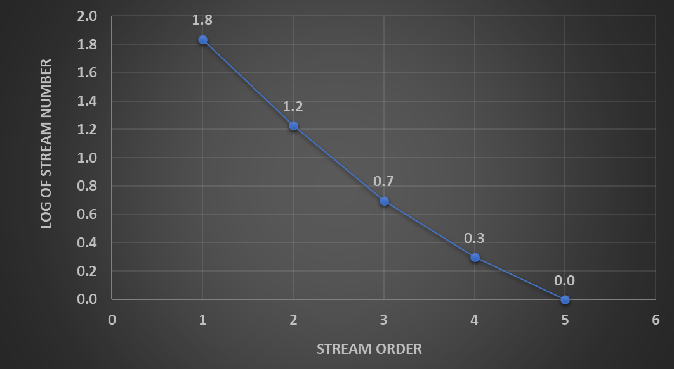

Figure 3. Graphical representation of log₁₀ of stream number V/s stream order
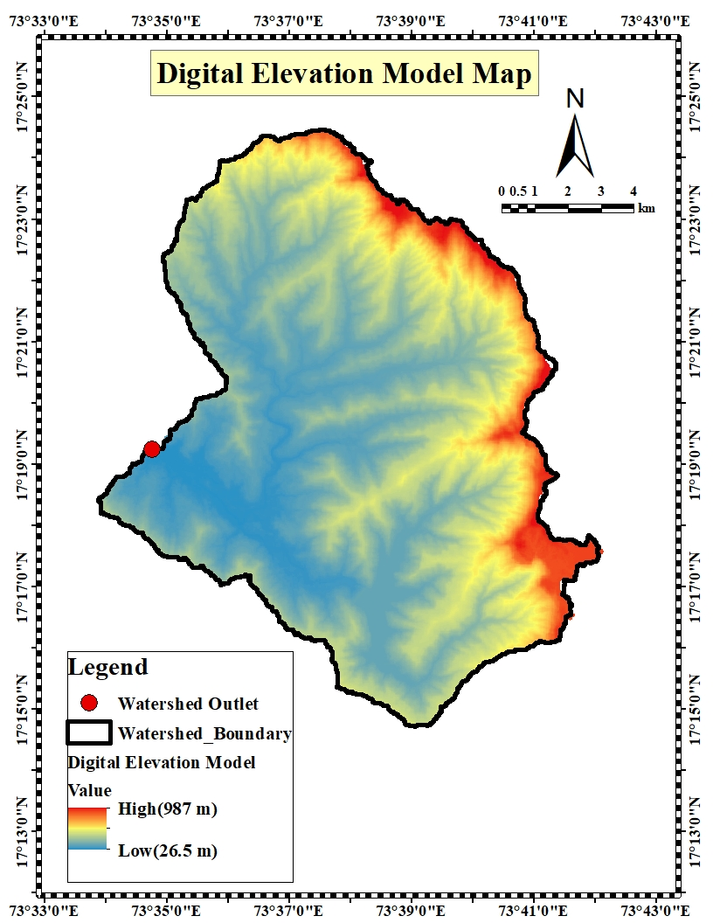
Figure 4. Digital Elevation Model map of Shastri watershed

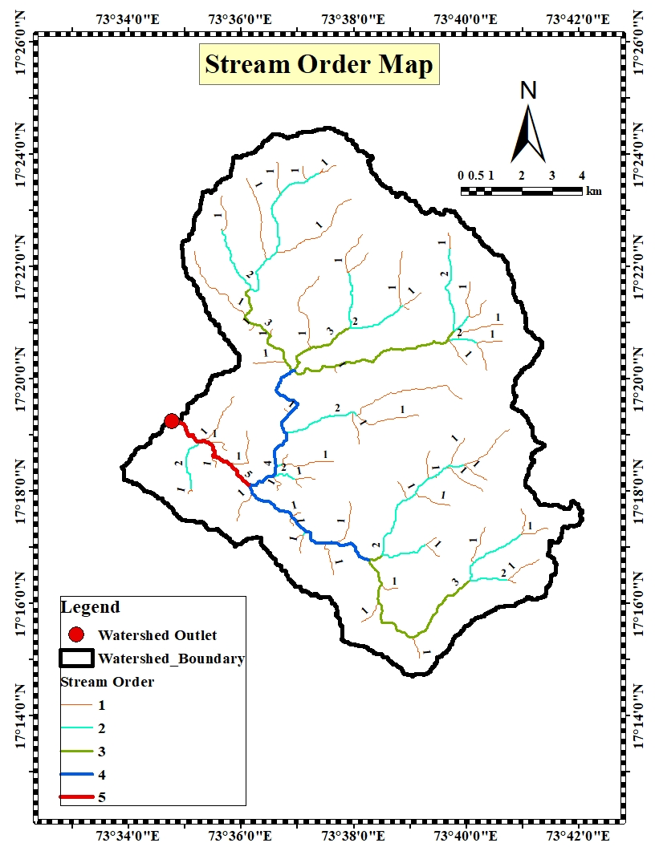
Figure 5. Stream order map of Shastri watershed
- Stream length and Mean stream length: The calculated values of stream length and mean stream length are presented in Table 4.
Table 4. Computed values of Stream Order, Stream Number, and Stream Length
Stream Order(u) | Stream Numbers(Nu) | Stream Length (km) | Mean Stream Length(km)
I | 69 | 70.97 | 1.03
II | 17 | 32.58 | 1.92
III | 5 | 19.68 | 3.94
IV | 2 | 11.07 | 5.54
V | 1 | 3.58 | 3.58
Total | 94 | 137.88
Mean |  | 27.58 | 3.20

- Stream Length ratio : The computed stream length ratios for successive stream orders are 0.46 (II/I), 0.60 (III/II), 0.56 (IV/III), and 0.32 (V/IV). The observed variation in stream length ratios across different orders reflects the influence of changing slope conditions, relief characteristics, and underlying topographic heterogeneity within the watershed. Table 5. shows the obtained values of stream length ratio.
Table 5. Values of stream length ratio for watershed
Stream order | Stream Length Ratio
II/I | 0.46
III/II | 0.60
IV/III | 0.56
V/IV | 0.32
Mean | 0.49

- Bifurcation ratio: In the present study, the bifurcation ratio ranges from 2.00 to 4.06, with a mean bifurcation ratio of 2.99. These values suggest that the watershed possesses moderately to highly dissected, undulating terrain. The details of the values of bifurcation ratio shows in Table 6.
Table 6. Values of Bifurcation ratio for watershed
Stream Order | Bifurcation Ratio(R_{b})
I/II | 4.06
II/III | 3.4
III/IV | 2.5
IV/V | 2
Mean | 2.99

- Rho Coefficient :The value of 0.16 of Rho coefficient indicate less hydrologic storage.

  - Areal morphometric parameters
1. Form factor: The computed form factor 0.29 indicates that the watershed possesses an elongated basin configuration.
2. Elongation ratio: The elongation ratio of 0.35 reflects an elongated basin morphology with moderate slope characteristics.
3. Circularity ratio: The Circularity ratio 0.31 further confirms the elongated nature of the watershed and suggests relatively uniform geological conditions.
4. Shape index: The shape index value of 3.41 indicates a high degree of basin elongation.
5. Drainage density: The drainage density 0.91 km/km² is low, implying the presence of permeable subsurface materials.
6. Drainage Intensity : The drainage intensity value 0.68 km⁻¹ is low, suggesting susceptibility to flash flooding during high-intensity rainfall events.
7. Stream frequency: The stream frequency 0.62 km⁻¹is low, indicating dominance of permeable geological formations within the watershed.
8. Texture ratio: The texture ratio value of 0.89 indicates a fine drainage texture.
9. Drainage Texture: The drainage texture 6.88 km⁻¹classifies the basin under the fine drainage texture category.
10. Compactness coefficient: The value 1.10 indicates low structural disturbance and a mature to old geomorphic stage of basin development.
11. Constant of channel maintenance: The computed value of 1.10 suggests that the basin has experienced relatively low structural disturbance and has reached a mature to old geomorphic stage.
12. Length of overland flow: The estimated value 0.55suggests moderate runoff generation due to appreciable infiltration capacity and longer flow path.
13. Infiltration number: The infiltration number 0.57indicates moderate runoff conditions supported by adequate infiltration.
14. Lemniscate ratio : The calculated value 0.85 reflects a favorable basin geometry with better flood attenuation potential.
15. Asymmetry Factor: The asymmetry factor 17.69% indicates relatively higher slope development on the right side of the basin compared to the left.

3.3.Relief morphometric parameters
1. Basin relief: In the present investigation, the maximum basin relief was estimated to be 960.95 m. This reflects pronounced topographic variation and suggests the presence of significant vertical dissection.
2. Relief Ratio : The relief ratio of the study area was computed as 0.04, which implies a relatively elongated basin configuration with a gentle overall slope, influencing runoff characteristics and drainage efficiency.
3. Relative Relief: The relative relief value was found to be 1.23, indicating moderate to high terrain steepness. This suggests a greater susceptibility to erosion processes and enhanced surface runoff.
4. Ruggedness Number: The ruggedness number was calculated as 0.88, signifying a moderately high degree of terrain roughness. This reflects considerable topographic irregularities and the presence of sharp geomorphic features within the watershed.

Table 7. Computed results of morphometric analysis of Shastri watershed
Sr No. | Morphometric  parameters | Unit | Result
A. Linear Aspects
1 | Watershed Area $(A$) | Sq.km | 151
2 | Watershed Perimeter $(P$) | km | 77.74
3 | Length of the Watershed${(L}_{μ}$) | km | 13
4 | Stream Order (u) | Dimensionless | 1 -5
5 | Stream Number (N_{u}) | Dimensionless | 94
6 | Stream length (L_{u}) | km | As given in Table
7 | Mean Stream length (L_{u}) | km | As given in Table
8 | Stream length ratio (R_{l}) | Dimensionless | As given in Table
9 | Bifurcation Ratio(R_{b}) | Dimensionless | As given in Table
10 | Rho coefficient($ρ)$ | Dimensionless | 0.16
B. Areal Aspects
1 | Form factor (F_{f}) | Dimensionless | 0.89
2 | Elongation ratio (R_{e}) | Dimensionless | 0.60
3 | Circularity ratio (R_{s}) | Dimensionless | 0.31
4 | Shape index (S_{w}) | Dimensionless | 1.12
5 | Drainage density (D_{d}) | km/km² | 0.91
6 | Drainage Intensity (D_{i}) | Km⁻¹ | 0.62
7 | Stream frequency (F_{s}) | km⁻² | 0.89
8 | Texture ratio (R_{t}) | Dimensionless | 6.88
9 | Drainage texture (D_{t}) | km⁻¹ | 0.00
10 | Compactness coefficient (C_{c}) | Dimensionless | 1.79
11 | Constant of channel maintenance (C) | km²/km | 1.10
12 | Length of overland flow (L_{g}) | km | 0.55
13 | Infiltration number (I_{f}) | Number/km³ | 0.57
14 | Lemniscate ratio (k) | Dimensionless | 0.28
15 | Asymmetry Factor (Af) | Percentage | 0.68
C. Relief Aspects
1 | Basin relief (H) | m | 960.95
2 | Relief Ratio(Rr) | Dimensionless | 0.07
3 | Relative Relief(Rhp) | Dimensionless | 1.23
4 | Ruggedness Number(Rn) | Dimensionless | 0.88

4. Conclusion
The qualitative morphometric analysis of the watershed was carried out and it reveals that its hydrological response is strongly governed by basin geometry, drainage characteristics, and relief conditions. The watershed analysis shows an elongated basin (area 151 sq.km, perimeter 77.74 km, length 13 km) with 5th-order streams (N_{u}=94, R_{b} moderate, ρ=0.16). Low form factor (0.89), elongation ratio (0.60), and Circularity ratio (0.31) indicate delayed peak flows. Moderate drainage density (0.91 km/km²), stream frequency (0.89 km⁻²), and infiltration number (0.57) suggest permeable soils with limited runoff under normal rain. High basin relief (960.95 m), relief ratio (0.07), relative relief (1.23), and ruggedness number (0.88) enhance erosion potential during intense storms. Asymmetry factor (0.68%) shows uneven slope development. Overall, the basin exhibits moderate-high runoff potential with rapid flow concentration, requiring soil conservation measures. These findings highlight the need for appropriate watershed management and soil conservation measures to mitigate runoff-induced impacts.
DISCLAIMER (ARTIFICIAL INTELLIGENCE)
Author(s) hereby declare that NO generative AI technologies such as Large Language Models (ChatGPT, COPILOT, etc.) and text-to-image generators have been used during writing or editing of manuscripts.
COMPETING INTERESTS
Authors have declared that no competing interests exist
5.References
Agarwal C.S.1998. Study of drainage pattern through aerial data in Naugarh area of Varanasi district Uttar Pradesh. Journal of the Indian Society of Remote Sensing. 26:169-175.
Biswas S., Sudhakar, S., and Desai, V.R. 1999. Prioritization of sub-watersheds based on morphometric analysis of drainage basin using remote sensing and GIS techniques. Journal of the Indian Society of Remote Sensing.27(3):155–166.
Chandrashekar H, Lokesh K.V, Mohommad. S, Kumar M, Roopa J and Ranganna G. 2015. GIS–Based Morphometric Analysis of Two Reservoir Catchments of Arkavati River, Ramanagaram District, Karnataka. Aquatic Procedia.4:1345-1353.
Chorley R.J. 1969. The Drainage Basin as the Fundamental Geomorphic Units, Water, Earth and Man: A Synthesis of Hydrology, Geomorphology and Socio-Economic Geography. Methuen and Co Ltd., London;c. p. 588.
Chougale S.S and Jagdish B. S. 2017. Morphometric analysis of Kadvi River basin, Maharashtra using geospatial techniques. Current World Environment.12:635-645.
Clarke, J. J. 1966.Morphometry from map, Essays in geomorphology. Elsevier Publishing Company, New York.235-274.
Faniran A. 1968. The index of drainage intensity: a provisional new drainage factor. Ausraliant Science.31(9):326-330.
Gardner, R.H., Milne, B.T., O Neill, R.V. and Turner, M.G. 1987. Neutral Models for the Analysis of Broad Scale Landscape Patterns. Landscape Ecology.1:19-28 .
Gautam V.K, Kothari M, Singh P.K, Bhakar S.R and Yadav K.K.2021. Determination of geomorphological characteristics of Jakham River Basin using GIS technique. Indian Journal of Ecology. 48(6): 1627-1634.
Hadley R.F, Schumm S.A. 1961. Sediment sources and drainage-basin characteristics in upper Cheyenne River Basin.U. S. Journal of Geographic Information System.7(2):21-28.
Horton, R. E. 1932. Drainage basin characteristics. Transactions of the American Geophysical Union.13:350–361.
Horton, R. E. 1945. Erosional development of streams and their drainage basins: Hydrological approach to quantitative morphology. Geological Society of America Bulletin.56:275–370.
Ingle P.M, Prajapati G.V and Labade P.2025.Characterization of watershed using Morphometric Analysis - A review. Trabilizing trends in sustainable climate-resilient precision agriculture.section-1: 136-158.
Jain, A. O., Thaker, T. P., Mishra, A. K., Singh, A. K. and Kumari, P. 2020. Determination of sensitivity of drainage morphometry towards hydrological response interactions for various datasets. Environment, Development and Sustainability,23:1799–1822.
Melton, M. A. 1957. An analysis of the relations among elements of climate, surface properties, and geomorphology. Technical Report No. 11, Office of Naval Research Project NR 389-042, Department of Geology, ONR, Columbia University, New York.
Miller. V. C. 1953. A quantitative geomorphic study of drainage basin characteristics in the Clinch Mountain area, Virginia and Tennessee. Project NR389-042, Technical Report: 3, Columbia University, Department of Geology, ONR, Geography Branch, New York.
Najar, G. N. and Pandey, P. 2018. Drainage Morphometric Analysis of Watershed Basin of River Beas at Harike Pattan, Punjab-Using Remote Sensing and GIS Approach. International Journal of Engineering Technology Science and Research (IJETSR), 5(5), 641-651.
Ozdemir, H. and Bird. D. 2009. Evaluation of morphometric parameters of drainage networks derived from topographic maps and DEM in point of floods. Environmental Geology.56:1405–1415.
Pareta, K. and Pareta, U. 2011. Quantitative morphometric analysis of a watershed of the Yamuna basin, India using ASTER (DEM) data and GIS. International Journal of Geomatics and Geosciences, 2(1):248–269.
Pirasteh S, Safari H.O, Pradhan. B and Attarzadeh. I.2010. Litho morphotectonics analysis using Landsat ETM data and GIS techniques. Zagros Fold Belt (ZFB), SW Iran.
Prabhakaran. A and Raj.N.2018. Drainage Morphometric Analysis for Assessing form and Processes of the watersheds of Pachamalai hills and its Adjoinings, Central Tamil Nadu, India. Applied Water Science.8:31-49.
Reddy G.O, Maji A.K and Gajbhiye K.S.2002. GIS for Morphometric analysis of river basins. GIS India. 4(11): 9-14.
Rekha, V.B., George, A.V., Rita, M., 2011. Morphometric Analysis and Micro-watershed Prioritization of Peruvanthanam Sub-watershed, the Manimala River Basin, Kerala. South India. Environment Resource Engineering Management.3 (57):6–14.
Sangma, F., and Guru, B. 2020. Watersheds Characteristics and Prioritization Using Morphometric Parameters and Fuzzy Analytical Hierarchical Process (FAHP): A Part of Lower Subansiri Sub-Basin. Journal of the Indian Society of Remote Sensing, 48(12).
Sangma, F. and Balamurugan, G. 2017.Morphometric Analysis of Kakoi River Watershed for Study of Neotectonic Activity Using Geospatial Technology. International Journal of Geosciences, 8, 1384-1403.
Schumm, S. A. 1956. Evolution of drainage systems slopes in badlands in Perth Amboy, New Jersey. Geological Society of America Bulletin, 67:597–646.
Schumm, S. A. 1956. Evolution of drainage systems slopes in badlands in Perth Amboy, New Jersey. Geological Society of America Bulletin.67:597–646.
Selvan, M.T., S. Ahmad and S.M. Rashid. 2011. Analysis of the Geomorphometric parameters in high altitude Glacierised terrain using SRTM DEM data in Central Himalaya, India. ARPN Journal of Science and Technology, 1(1):22–27.
Shekar P.R, and Mathew A.2023.Delineation of groundwater potential zones and identification of artificial recharge sites in the Kinnerasani Watershed, India, using remote sensing-GIS, AHP, and Fuzzy-AHP techniques. AQUA - Water Infrastructure, Ecosystem Society. jws2023052.
Shekar P.R, Mathew .A, Pandey .A and Bhosale A.2023.A comparison of the performance of SWAT and artificial intelligence models for monthly rainfall–runoff analysis in the Peddavagu River Basin, India. AQUA—Water Infrastructure, Ecosystem Society. Sep 1,72(9):1707-30.
Singh P, Thakur J.K. and Singh U.C.2013. Morphometric analysis of Morar river basin Madhya Pradesh India using remote sensing and GIS techniques. Environmental Earth Sciences 68: 1967-1977.
Singh S. 1992.Quantitative Geomorphology of the Drainage Basin. In: Chouhan T.S., and Joshi, K.N., Eds., Readings on Remote Sensing Applications, Scientific Publishers, Jodhpur.
Smith K.G. 1950.Standards for grading texture of erosional topography. American Journal of Science.248:655-668.
Strahler, A. N. 1952. Hypsometric (area-altitude) analysis of erosional topography. Geological Society of America Bulletin.63:1117–1142.
Strahler, A. N. 1957. Quantitative analysis of watershed geomorphology. Transactions of the American Geophysical Union.38:913–920.
Strahler, A. N. 1964. Handbook of Applied Hydrology: In Quantitative Geomorphology of Drainage Basins and Channel Networks (Section 4-II). McGraw Hill Book Company.
Vittala S.S, Govindaiah S and Gowda H.H. 2004. Morphometric Analysis of Sub-Watersheds in The Pavagada Area of Tumkur District, South India Using Remote Sensing and GIS Techniques. Journal Indian Society Remote Sensing. 32(4):351-362
Waikar, M.L., Nilawar, A.P., 2014. Morphometric analysis of a drainage basin using geographical information system: a case study. International Journal Multidisciplinary Current Resources.2:179–184.

