Original Research Article

Integrated Geo-environmental Assessment of Heavy Metal Contamination in a Municipal Landfill System: Case Study from Aluu, Obio-Akpor Local Government Area

.
ABSTRACT

Aim: This study evaluates the extent, spatial distribution, and environmental risk of heavy metal contamination in soils at the Aluu municipal landfill, Obio-Akpor, Rivers State, Nigeria.

Study design: A field-based analytical study integrating geochemical assessment with spatial analysis.

Place and Duration of Study: Aluu municipal landfill, Obio-Akpor, Rivers State, Nigeria; sampling and laboratory analysis were conducted within the study period of 6 months.

Methodology: Sixteen soil samples were collected from eight locations representing landfill core, near-field, far-field, and control sites. Samples were analyzed for arsenic (As), nickel (Ni), chromium (Cr), cadmium (Cd), and lead (Pb) using atomic absorption spectrophotometry. Contamination levels were evaluated using contamination factor (CF), geo-accumulation index (Igeo), and pollution load index (PLI). Spatial distribution patterns were assessed, and hydrogeological characteristics were considered in interpreting contaminant mobility. Human health risks were evaluated using standard risk indices.

Results: All measured heavy metal concentrations were below established regulatory limits. However, CF values indicated significant anthropogenic influence, particularly for arsenic (CF = 5.25; very high), while other metals ranged from moderate to considerable contamination. Igeo values classified the soils as moderately polluted for arsenic, nickel, and lead. The overall PLI of 3.17 indicated considerable pollution. Spatial analysis revealed a pronounced arsenic hotspot within the landfill and a distinct lead hotspot in the far-field zone, suggesting multiple contamination sources and transport pathways. The high permeability of the Benin Formation was identified as a key factor enhancing contaminant migration. Despite this, cumulative human health risk indices remained low (all < 0.1).

Conclusion: Although current contamination levels are within regulatory limits and associated health risks are low, evidence of significant anthropogenic enrichment and spatial variability highlights the need for continuous monitoring and improved waste management strategies to prevent future environmental degradation.

Keywords: Heavy metal contamination, Landfill, Pollution indices, Risk assessment, Municipal solid waste, spatial distribution

1. INTRODUCTION

The proliferation of unregulated dumpsites, a result of inadequate urban infrastructure, has created significant point sources of environmental contamination (Odewumi et al., 2020; Amadi & Nwankwoala, 2013). This problem is compounded by poor waste segregation and limited recycling infrastructure, which facilitate the accumulation of heavy metals in the environment (Echeweozo et al., 2025). Heavy metals pose a serious threat due to their persistence, bioaccumulation potential, and toxicity at low concentrations (Ademoroti, 2007). Unlike organic pollutants, these elements, including arsenic (As), cadmium (Cd), and lead (Pb), do not biodegrade and can remain in the environment for centuries (Yabe et al., 2010). Unlined landfills and open dumps are primary sources of this contamination (Ideriah et al., 2010; Amadi & Nwankwoala, 2013). Leachate, a liquid formed by precipitation seeping through waste, mobilizes these heavy metals, allowing them to migrate into surrounding soils and groundwater (Echeweozo et al., 2025; Olade, 1987).

Recent studies in Nigeria have revealed alarming levels of heavy metal contamination around municipal dumpsites, with concentrations exceeding safety limits (Amadi & Nwankwoala, 2013). This highlights the urgent need for comprehensive geo-environmental assessments to inform remediation strategies and develop sustainable waste management policies. The current study focuses on the Aluu municipal landfill in Obio-Akpor to evaluate heavy metal contamination and associated risks.

1.3 Objectives

The primary aim of this study was to evaluate the extent of some heavy metal contamination in soils at the Aluu landfill facility. Specific objectives included:

- To determine the concentration and spatial distribution of some heavy metals in soils within and around the Aluu landfill facility.
- To assess the extent of heavy metal contamination using pollution indices.
- To evaluate the potential sources and pathways of heavy metal contamination in the landfill environment.
- To investigate the hydrogeological and geological controls on heavy metal migration and distribution patterns in the study area.
- To assess the potential human health and ecological risks associated with heavy metal contamination in the vicinity of the landfill.
- To provide recommendations for environmental monitoring, remediation strategies, and improved waste management practices at the Aluu landfill site.

1.2 Study Location

The study was conducted at the Aluu dumpsite in Rivers State, Nigeria. This unengineered landfill is situated at Latitude 04°55′14.8″ N and Longitude 06°55′07.7″ E, with an elevation of about 15.2 m above sea level.

1.2.1 Hydrogeology
The area has a multi-layered aquifer system with a low protective capacity, making groundwater vulnerable to contamination (Amadi & Nwankwoala, 2013). Geophysical surveys indicate potential leachate plumes extending beyond the dumpsite (Udom et al., 2004; Adeyemi et al., 2021).

1.2.2 Climate
The region experiences a tropical monsoon climate with distinct wet (April-October) and dry (November-March) seasons (Uko & Tamunobereton-Ari, 2013). High average annual rainfall (2,400-2,700 mm) enhances leachate production and contaminant transport through the subsurface (Nigerian Meteorological Agency, 2019; Nwankwoala et al., 2022).

1.2.3 Land Use and Population

The area is primarily residential, with institutions like the University of Port Harcourt nearby (Udom et al., 2004; Adeyemi et al., 2021). With a population density of approximately 2,500 people per km², the facility receives 150-200 tons of mixed solid waste daily. The lack of waste segregation and engineered containment systems, combined with high rainfall and vulnerable geology, increases the risk of both surface and subsurface leachate migration (Nwankwoala et al., 2022). A map of the study location is shown in Figure 1.

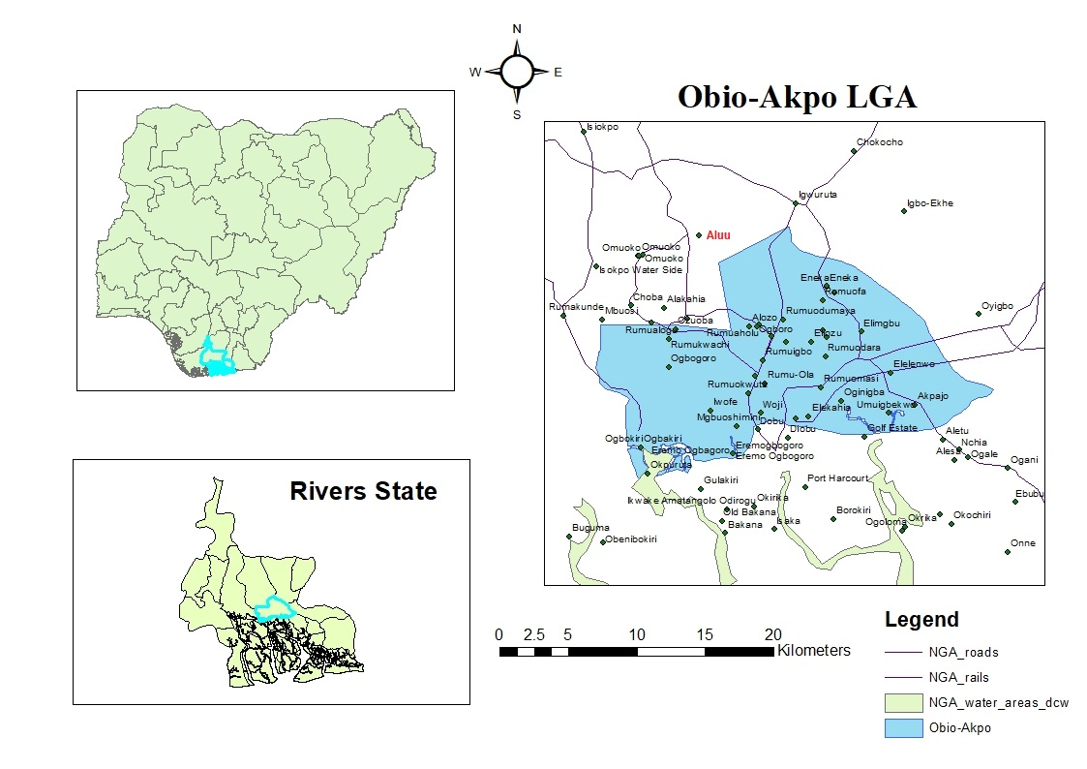
Figure 1: Study Location Map

2. material and methods

2.1 Sampling Design

This study employed a cross-sectional field survey design, collecting all environmental data at a single point in time to assess heavy metal contamination, spatial distribution, and associated risks at the Aluu landfill site.

2.1.1 Sampling Locations and Protocol
A total of 8 sampling locations were established with duplicate samples collected from each location (A and B samples), resulting in 16 individual soil samples: 6 sampling points within and near the landfill: A1, A2, B1, B2, C1, C2. 2 control points: F1 and F2 (located approximately 30 meters away from the landfill on the opposite side of the road). Sixteen samples were collected from eight locations grouped as follows:

- Location A (A1, A2): Within landfill boundary
- Location B (B1, B2): Near-field (0–200 m from boundary)
- Location C (C1, C2): Far-field (200–500 m from landfill)
- Location F (F1, F2): Control (>30 m from landfill in uncontaminated area)
Locations were chosen to capture both contamination gradients and background conditions.
2.2 Equipment and Software
2.2.1 Field Equipment: The Equipment used in the study are: Hand auger, Plastic spades, Labeled high-density polyethylene (HDPE) bags, Magellan Explorist 210 GPS positioning system and Field notebook

2.2.2. Laboratory Equipment
PerkinElmer Analyst 200 Atomic Absorption Spectrophotometer (AAS) with appropriate hollow cathode lamps and the multi-point calibration using certified reference standards.

    - Data Processing Software: Surfer 20.0 was used for spatial analysis and contour mapping. Microsoft Excel for statistical analysis and SPSS version 13.0 for advanced statistical analysis

2.3 Sample Collection and QA/QC
Eight sampling locations were established to represent a contamination gradient (A: within landfill, B: near-field, C: far-field, F: control/background), from which sixteen soil samples (A and B samples per site) were collected at 1 m and 1.5 m depths to capture subsurface variation.

    - Sample Preparation and Laboratory Analysis
Samples were air-dried, disaggregated, and sieved through a 2 mm mesh. Acid digestion followed standardized methods (Ojeh & Onwualu-John, 2024).

    - Acid Digestion
Heavy metals were extracted using the aqua regia digestion method following international protocols for heavy metal analysis in soils. A 0.5g prepared soil sample was accurately weighed into a 100mL borosilicate glass beaker. A mixture of concentrated HNO₃ (9mL) and concentrated HCl (3mL) in a 3:1 ratio (aqua regia) was slowly added to each sample and allowed to react at room temperature for 30 minutes to reduce vigorous initial reaction. The beakers were then covered with watch glasses and heated on a hot plate at 85±5°C for 2 hours until the solution volume reduced to approximately 5mL, ensuring complete digestion of organic matter and metal complexes.
After cooling to room temperature, the digest was quantitatively transferred to a 50mL volumetric flask and diluted to volume with distilled deionized water. The solution was filtered through Whatman No. 42 filter paper to remove any undissolved residue. The clear filtrate was stored in acid-washed polyethylene bottles and analyzed within 48 hours to prevent precipitation or adsorption losses. This digestion method is widely used was in consistent with WHO guidelines for environmental sample preparation (WHO, 2011) and methods referenced in DPR environmental assessment protocols. Target metals analyzed included arsenic (As), nickel (Ni), chromium (Cr), cadmium (Cd), and lead (Pb).
2.4 Hydrogeological and Geological Assessment

Desktop Study of hydrogeological investigations were conducted to understand groundwater flow patterns and potential contaminant migration pathways through the review of existing geological and hydrogeological reports.

  - Data Analysis Methods

SPSS v13 and Surfer 20.0 were used for descriptive, inferential, and multivariate statistics, as well as geospatial mapping.

2.5 Contamination Assessment
Multiple pollution indices were calculated to quantify contamination levels:

- Contamination Factor (CF):
CF=C_{sample}/C_{background}
Where C-{sample} is the metal concentration in contaminated soil and C-{background} is the background concentration.

- Geo-accumulation Index (I_{geo}):
I_{geo} = (log₂ ($\frac{Cn}{1.5 x Bn)})$
Where:

C_{n} is the measured concentration, B_{n} is the background concentration 1.5 is the background matrix correction factor.
- Pollution Load Index (PLI):
PLI= $\sqrt[n]{CF1 x CF2 x CF3……CFn }$

  - Human Health Risk Assessment
- Risk assessment was conducted using the Hazard Index (HI) approach. Average Daily Dose (ADD) was calculated as:
- ADD = (C × IR × EF × ED × CF) / (BW × AT)
- Where C = concentration, IR = ingestion rate, EF = exposure frequency, ED = exposure duration, CF = conversion factor, BW = body weight, AT = averaging time.
- Hazard Quotient (HQ) = ADD / RfD Hazard Index (HI) = Σ HQ for all metals
Risk Interpretation:
- HI ≤ 1: No significant non-carcinogenic health risk expected
- HI > 1: Potential for adverse non-carcinogenic health effects
- HI > 10: High concern level requiring immediate attention

3. results and discussion

3.1 Heavy Metal Concentrations and Spatial Distribution

The analytical results from atomic absorption spectrophotometry (AAS) revealed varying concentrations of heavy metals across all sampling locations within and around the Aluu landfill facility. Table 1 presents the detailed concentration data for all 16 samples collected from the study area and Table 2 presents statistical sampling by sample zone.

3.1.1 Location-Specific Contamination Patterns

- Within Landfill Boundary Locations (A1, A2):
Within Landfill Boundary (A1, A2): Location A1 exhibited the most comprehensive contamination within the active landfill boundary, with elevated concentrations across multiple metals: arsenic (0.103 ppm), cadmium (0.174 ppm), lead (0.175 ppm), nickel (0.054 ppm), and chromium (0.038 ppm). Location A2 showed contrasting patterns with the highest chromium concentration (0.085 ppm) but relatively lower levels of other metals. Table 2 shows statistical summary by sampling zone.

Table 1: Heavy Metal Concentrations in Soil Samples (ppm)
Sample  ID | Long | Latitude | As (ppm) | Ni (ppm) | Cr (ppm) | Cd (ppm) | Pb (ppm)
A1A | 6.918528 | 4.920444 | 0.112 | 0.05 | 0.029 | 0.156 | 0.163
A1B | 6.918528 | 4.920444 | 0.093 | 0.057 | 0.046 | 0.192 | 0.187
A2A | 6.918556 | 4.920472 | 0.008 | 0.03 | 0.084 | 0.057 | 0.049
A2B | 6.918556 | 4.920472 | 0.005 | 0.041 | 0.087 | 0.069 | 0.056
B1A | 6.9186 | 4.9205 | 0.000 | 0.213 | 0.011 | 0.071 | 0.028
B1B | 6.9186 | 4.9205 | 0.001 | 0.254 | 0.008 | 0.063 | 0.019
B2A | 6.918628 | 4.920528 | 0.004 | (0.000) | 0.006 | 0.062 | 0.037
B2B | 6.918628 | 4.920528 | 0.006 | 0.001 | 0.009 | 0.077 | 0.031
C1A | 6.918656 | 4.920556 | 0.054 | 0.181 | 0.003 | 0.052 | 0.086
C1B | 6.918656 | 4.920556 | 0.04 | 0.196 | 0.001 | 0.045 | 0.07
C2A | 6.918684 | 4.920584 | 0.000 | 0.071 | 0.033 | 0.088 | 1.056
C2B | 6.918684 | 4.920584 | 0.000 | 0.079 | 0.042 | 0.106 | 1.023
F1A | 6.9184 | 4.9203 | 0.000 | 0.022 | 0.017 | 0.062 | 0.049
F1B | 6.9184 | 4.9203 | 0.000 | 0.028 | 0.019 | 0.05 | 0.04
F2A | 6.918372 | 4.920272 | 0.006 | 0.017 | 0.002 | 0.016 | 0.043
F2B | 6.918372 | 4.920272 | 0.01 | 0.014 | 0.008 | 0.028 | 0.035

Table 2: Statistical Summary by Sampling Zone

Zone | Parameter | As | Ni | Cr | Cd | Pb
Within Landfill (A) | Mean | 0.055 | 0.045 | 0.061 | 0.118 | 0.114
 | Range | 0.005-0.112 | 0.030-0.057 | 0.029-0.087 | 0.057-0.192 | 0.049-0.187
 | Std. Dev | 0.056 | 0.012 | 0.029 | 0.066 | 0.071
Near-field (B) | Mean | 0.003 | 0.117 | 0.009 | 0.068 | 0.029
 | Range | ND-0.006 | ND-0.254 | 0.006-0.011 | 0.062-0.077 | 0.019-0.037
 | Std. Dev | 0.003 | 0.136 | 0.002 | 0.007 | 0.007
Far-field (C) | Mean | 0.024 | 0.132 | 0.020 | 0.073 | 0.559
 | Range | ND-0.054 | 0.071-0.196 | 0.001-0.042 | 0.045-0.106 | 0.070-1.056
 | Std. Dev | 0.028 | 0.066 | 0.021 | 0.029 | 0.555
Control (F) | Mean | 0.004 | 0.020 | 0.012 | 0.039 | 0.042
 | Range | ND-0.010 | 0.014-0.028 | 0.002-0.019 | 0.016-0.062 | 0.035-0.049
 | Std. Dev | 0.005 | 0.006 | 0.008 | 0.021 | 0.006

- Near-field Zone Locations (B1, B2):
Location B1 exhibited the most significant nickel contamination (0.233 ppm), approximately 15 times higher than control levels. Location B2 demonstrated generally low contamination levels with only moderate cadmium and lead concentrations.

- Far-field Zone Locations (C1, C2):
Location C1 showed substantial nickel contamination (0.188 ppm), creating a secondary contamination plume. Location C2 presented extreme lead contamination (1.039 ppm), exceeding landfill boundary concentrations by nearly 6-fold, suggesting a secondary contamination source.

- Control Sites Analysis (F1, F2):
Control locations consistently showed the lowest concentrations across all metals, representing local background levels typical of the Niger Delta region.

3.1.2 Spatial Distribution pattern

The spatial distribution maps reveal distinct contamination patterns that reflect different pollution sources and migration pathways:

- Arsenic Distribution: Figure 2.a shows the spatial distribution pattern of Arsenic across the study location. Primary hotspot at A1 with concentric contours extending northeast.

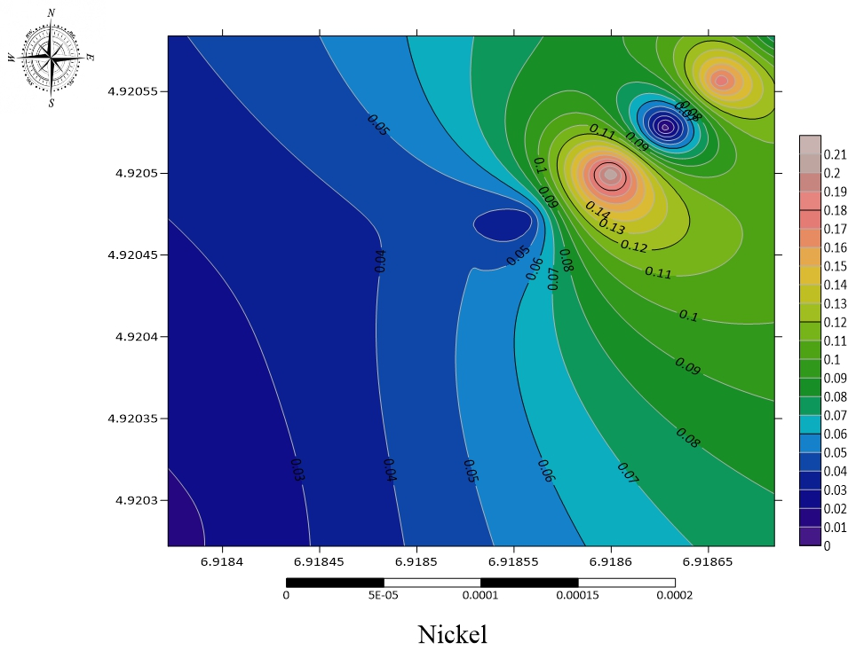
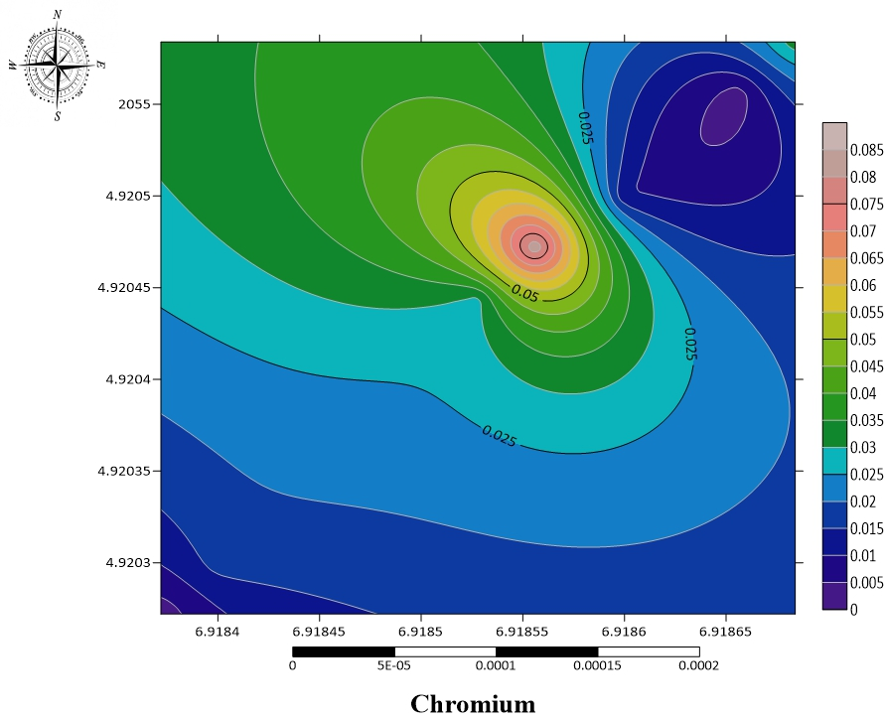
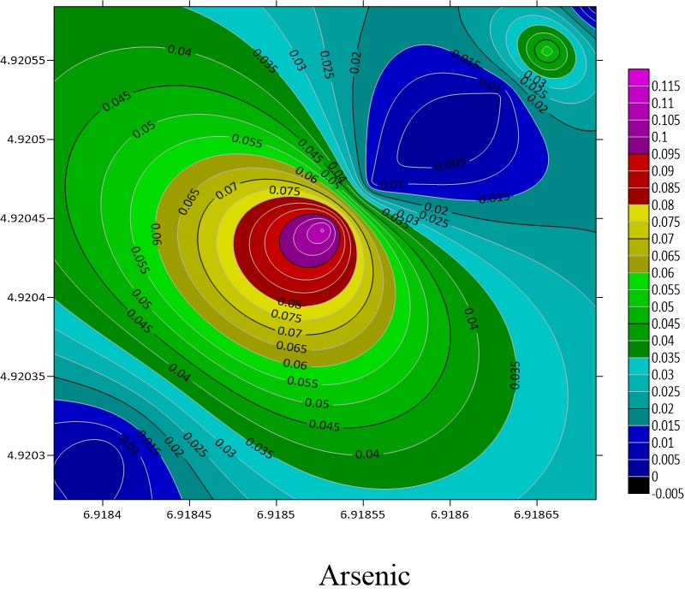

Fig 2c: Spatial Distribution of Chromium
Fig 2b: Spatial Distribution of Nickel
Fig 2a: Spatial Distribution of Arsenic
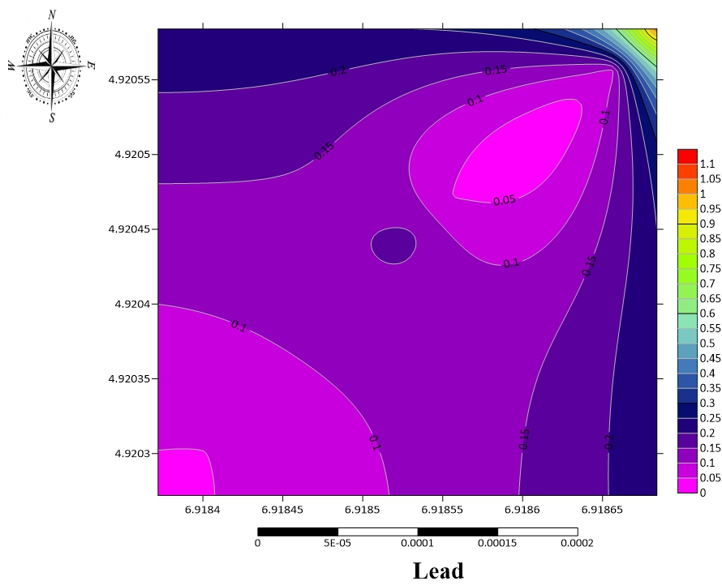

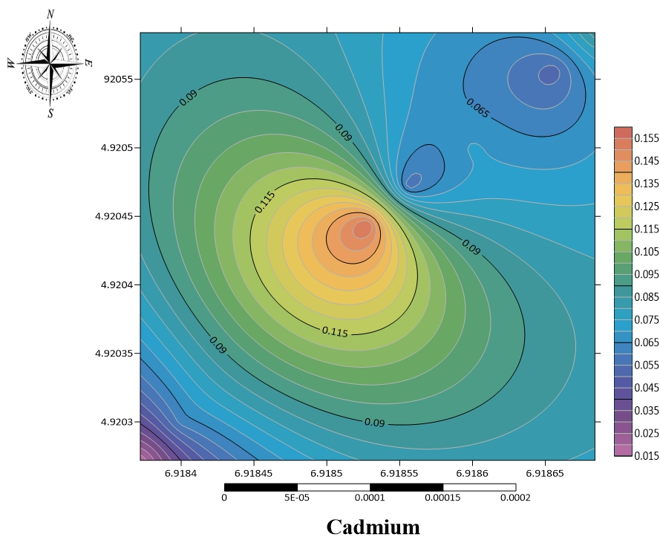

Fig 2e: Spatial Distribution of Lead
Fig 2d: Spatial Distribution of Cadmium

- Nickel Distribution: Nickel:

- Elevated concentrations at B1 and C1, creating distinct contamination plumes Figure 2b shows spatial distribution pattern of Nickel across study location.
- Chromium Distribution: Chromium: Concentrated in A2 area with moderate levels. Figure 2c shows spatial distribution pattern of Chromium across the study location.
- Cadmium Distribution: Figure 2d shows spatial distribution pattern across the study location. Relatively uniform distribution with elevated levels at A1.
- Lead Distribution: Most pronounced spatial heterogeneity with extreme hotspot at C2. Figure 3.5 shows spatial distribution of Lead across the study location.
3.1.3 Comparison with Regulatory Standards

All measured concentrations remained below established regulatory limits (Table 3), indicating compliance with current soil quality guidelines despite detectable anthropogenic contamination.

Table 3: Regulatory Comparison
Metal | Maximum Observed  (ppm) | WHO Limit  (ppm) | DPR Nigeria  Limit (ppm) | Compliance Status
Arsenic | 0.112 | 10 | 5 | ✓ Compliant
Nickel | 0.254 | 50 | 50 | ✓ Compliant
Chromium | 0.087 | 50 | 50 | ✓ Compliant
Cadmium | 0.192 | 3 | 3 | ✓ Compliant
Lead | 1.040 | 50 | 50 | ✓ Compliant

3.2 Contamination Assessment Using Pollution Indices

3.2.1 Background Reference Values

Control samples (F1 and F2) provided background reference concentrations for contamination assessment:

Table 4: Background Reference Concentrations (ppm)
Metal | F1 Mean | F2 Mean | Combined Background | Standard Deviation
Arsenic | 0.000 | 0.008 | 0.004 | 0.005
Nickel | 0.025 | 0.016 | 0.020 | 0.006
Chromium | 0.018 | 0.005 | 0.012 | 0.008
Cadmium | 0.056 | 0.022 | 0.039 | 0.021
Lead | 0.044 | 0.039 | 0.042 | 0.006

3.2.2 Contamination Factor (CF) Analysis

Contamination factors were calculated using the formula: CF = C_{mean}/C_{background}

Table 5: Contamination Factor Results and Classifications
Element | Mean Conc. (ppm) | Background (ppm) | CF Value | Classification | Environmental Significance
Arsenic | 0.021 | 0.004 | 5.25 | Very High (CF > 6) | Moderate contamination
Nickel | 0.078 | 0.020 | 3.90 | Considerable (3 < CF < 6) | Moderate contamination
Chromium | 0.025 | 0.012 | 2.08 | Moderate (1 < CF < 3) | Low-moderate contamination
Cadmium | 0.075 | 0.039 | 1.92 | Moderate (1 < CF < 3) | Low-moderate contamination
Lead | 0.186 | 0.042 | 4.43 | Considerable (3 < CF < 6) | Moderate contamination

Key findings (Table 5): Arsenic: CF = 5.25 (Very High); Nickel: CF = 3.90 (Considerable); Lead: CF = 4.43 (Considerable); Chromium: CF = 2.08 (Moderate); Cadmium: CF = 1.92 (Moderate)

3.2.3 Geo-accumulation Index

The geo-accumulation index (Table 6) was calculated using: I_{geo} = Log₂ (C_{metal}/1.5 × C_{Background}).

Table 6: Geo-accumulation Index Results
Element | Igeo Value | Igeo Class | Pollution Category | Management Implication
Arsenic | 1.81 | 2 | Moderately Polluted | Monitoring required
Nickel | 1.38 | 2 | Moderately Polluted | Monitoring required
Chromium | 0.48 | 1 | Unpolluted to Moderately Polluted | Baseline monitoring
Cadmium | 0.36 | 1 | Unpolluted to Moderately Polluted | Baseline monitoring
Lead | 1.56 | 2 | Moderately Polluted | Monitoring required

Key Findings: Arsenic: 1.81 (Moderately Polluted); Nickel: 1.38 (Moderately Polluted); Lead: 1.56 (Moderately Polluted); Chromium: 0.48 (Unpolluted to Moderately Polluted); Cadmium: 0.36 (Unpolluted to Moderately Polluted)

3.2.4 Pollution Load Index (PLI)
PLI = (CF_As × CF_Ni × CF_Cr × CF_Cd × CF_Pb) ^ (1/5)
PLI = (5.25 × 3.90 × 2.08 × 1.92 × 4.43) ^ (1/5) = 3.17

Table 7: Pollution Load Index Assessment
Parameter | Element | Value | Classification
Individual Contamination Factors | Arsenic (As) | 5.25 | Considerable
Individual Contamination Factors | Nickel (Ni) | 3.90 | Considerable
Individual Contamination Factors | Chromium (Cr) | 2.08 | Moderate
Individual Contamination Factors | Cadmium (Cd) | 1.92 | Moderate
Individual Contamination Factors | Lead (Pb) | 4.43 | Considerable
PLI Calculation | Formula: (5.25 × 3.90 × 2.08 × 1.92 × 4.43) ^ (1/5)
PLI Calculation | Overall PLI | 3.17 | Considerable Pollution

PLI = 3.17 (Table 7), indicating considerable contamination for the five analyzed metals.

Table 8: PLI Classification and Management
PLI Range | Pollution Level | Environmental Status | Management Required
PLI < 1.0 | Unpolluted | Background conditions | Baseline monitoring
1.0 ≤ PLI < 2.0 | Slightly polluted | Minor anthropogenic impact | Regular monitoring
2.0 ≤ PLI < 3.0 | Moderately polluted | Noticeable contamination | Enhanced monitoring
3.0 ≤ PLI < 5.0 | Considerably polluted | Significant contamination | Active management needed
PLI ≥ 5.0 | Heavily polluted | Severe contamination | Immediate intervention

3.2.5 Enrichment Assessment
Due to the absence of conservative reference elements (Al, Fe) in this study, enrichment assessment (Table 9) was conducted using direct comparison with local background concentrations (control sites F1 and F2). This approach provides equivalent source characterization to traditional enrichment factor analysis.

Table 9: Enrichment Ratio (ER) Analysis
Element | Mean Conc. (ppm) | Background (ppm) | Enrichment Ratio | Enrichment Category
Arsenic | 0.021 | 0.004 | 5.25 | Significant Enrichment (5-20)
Nickel | 0.078 | 0.020 | 3.90 | Moderate Enrichment (2-5)
Chromium | 0.025 | 0.012 | 2.08 | Moderate Enrichment (2-5)
Cadmium | 0.075 | 0.039 | 1.92 | Minimal Enrichment (1-2)
Lead | 0.186 | 0.042 | 4.43 | Moderate Enrichment (2-5)

Where:

Enrichment Classification:
ER < 2: Minimal enrichment (natural processes)
2 ≤ ER < 5: Moderate enrichment (anthropogenic influence)
≤ ER < 20: Significant enrichment (strong anthropogenic sources

  - Source Identification and Contamination Pathways
Pearson correlation analysis was performed to identify metal associations and potential common sources (Table 10).

Table 10: Inter-metal Correlation Matrix (Pearson r-values)
 | As | Ni | Cr | Cd | Pb
As | 1.000 | -0.245 | 0.567* | 0.723** | 0.234
Ni | -0.245 | 1.000 | -0.123 | -0.089 | 0.345
Cr | 0.567* | -0.123 | 1.000 | 0.456* | -0.067
Cd | 0.723** | -0.089 | 0.456* | 1.000 | 0.289
Pb | 0.234 | 0.345 | -0.067 | 0.289 | 1.000

*Significant at p < 0.05; **Significant at p < 0.01

Key Correlations and Source Implications:

Pearson correlation analysis revealed (Table 10): Strong correlations: As-Cd (r = 0.723), suggesting common electronic waste sources; Moderate correlations: As-Cr (r = 0.567), indicating potential industrial waste inputs; Weak correlations: Ni-Pb (r = 0.345), suggesting distinct automotive versus paint/battery origins
.
3.3.2 Principal Component Analysis (PCA)

PCA (Table 11) was conducted to identify underlying contamination patterns and source signatures supporting.

Table 11: Principal Component Analysis Results
Component | Eigenvalue | % Variance | Cumulative % | Primary Loadings
PC1 | 2.34 | 46.8% | 46.8% | As (0.85), Cd (0.82), Cr (0.67)
PC2 | 1.18 | 23.6% | 70.4% | Ni (0.78), Pb (0.69)
PC3 | 0.89 | 17.8% | 88.2% | Pb (-0.45), Cr (0.41)

Principal Component Analysis (Table 11) identified three components: PC1 (46.8%): Electronic/Industrial waste source (As-Cd-Cr association); PC2 (23.6%): Automotive/Metallic waste source (Ni-Pb association); PC3 (17.8%): Residual/Mixed sources.

3.3.3 Contamination Pathways
Three pathways explain metal distribution patterns: (1) Direct disposal - PC1 metals (As-Cd-Cr) concentrated at source location A1; (2) Leachate migration - PC2 metals (Ni-Pb) transported along B1→C1 corridor following natural drainage; (3) Surface transport - PC3 residual contamination via runoff explains isolated hotspots (C2 lead anomaly).

  - Hydrogeological and Geological Controls on Metal Distribution

    - Geological Framework and Contamination Susceptibility

The Aluu landfill is situated within the Benin Formation of the Niger Delta Basin, which significantly influences contaminant behavior and distribution patterns. Literature analysis reveals that the Benin Formation comprises 90% sand and sandstone with minimal clay intercalations, creating highly permeable conditions conducive to rapid contaminant transport (Offodile, 1992; Akujieze, 2004). The formation reaches thicknesses up to 2,000m in the central Niger Delta and serves as the primary aquiferous unit where all regional boreholes are constructed (Udom et al., 1998; Tuttle et al., 2015).

Table 12: Geological Controls on Heavy Metal Mobility
Geological Parameter | Benin Formation Characteristics | Impact on Metal Distribution | Source
Lithology | 90% sand/sandstone, 10% clay | High permeability facilitates rapid migration | Offodile (1992)
Porosity | High primary porosity | Enhanced contaminant storage capacity | Etu-Efeotor & Odigi (1983)
Permeability | Very high (10⁻³ to 10⁻² m/s) | Rapid advective transport dominates | Akujieze (2004)
Clay Content | Minimal intercalations | Poor attenuation capacity | Udom et al. (1998)
Fracturing | Limited natural fracturing | Flow primarily through matrix porosity | USGS (1999)
Hydraulic Conductivity | 3.82×10⁻³ to 9.0×10⁻² cm/sec | Rapid advective transport | Nwankwoala et al. (2020)
Transmissivity | 1.05×10⁻³ to 11.3×10⁻² m²/sec | High contaminant mobility | Nwankwoala et al. (2020)
Vulnerability Index | 0.54-0.63 (high vulnerability) | Poor contaminant attenuation | Udosen et al. (2023

The Aluu landfill is situated within the highly permeable Benin Formation (90% sand/sandstone, 10% clay), facilitating rapid contaminant migration. High hydraulic conductivity (3.82×10⁻³ to 9.0×10⁻² cm/sec) and vulnerability indices (0.54-0.63) indicate poor contaminant attenuation capacity.

  - Human Health Risk Assessment

3.5.1 Hazard Assessment Using Nigerian Standards
The risk assessment utilized WHO guidelines and Nigerian DPR standards as benchmarks for health risk evaluation, following the approach commonly used in Nigerian environmental studies.

Table 13: Comparison with Regulatory Limits:
Metal | Max Observed | WHO Limit | Safety Ratio | Risk Level
Arsenic | 0.112 | 20 | 178.6 | Very Low
Chromium | 0.087 | 100 | 1149 | Very Low
Cadmium | 0.192 | 3 | 15.6 | Low
Lead | 1.040 | 100 | 96.2 | Very Low

Table 14: Health Risk Assessment Results
Metal | Risk Level (WHO) | Risk Level (DPR) | Primary Health Concerns
Arsenic | Low | Moderate | Skin lesions, cancer risk
Nickel | Low | Low | Allergic reactions, respiratory
Chromium | Low | Low | Skin irritation, ulceration
Cadmium | Low | Low | Kidney damage, bone effects
Lead | Low | Low | Neurological development

3.5.2 Cumulative Risk Assessment

Multi-metal Exposure Index: Combined exposure assessment using the formula: Risk Index = Σ(Cᵢ/Lᵢ) where Cᵢ = concentration of metal Lᵢ = regulatory limit for metal

Table 15: Cumulative Risk Index
Location | Combined Risk Index (WHO basis) | Combined Risk Index (DPR basis) | Risk Category
Within Landfill (A) | 0.089 | 0.151 | Low
Near-field (B) | 0.024 | 0.039 | Low
Far-field (C) | 0.051 | 0.078 | Low
Overall Study Area | 0.055 | 0.089 | Low
Risk Index < 0.1 = Low Risk; 0.1-0.5 = Moderate Risk; >0.5 = High Risk

    - Risk Assessment Results
Regulatory comparison (Table 11 & 12) showed all metals remained well below safety limits: Arsenic: 178.6× below WHO limits (Very Low Risk); Lead: 96.2× below WHO limits (Very Low Risk); Cadmium: 15.6× below WHO limits (Low Risk). Cumulative risk indices (Table 13) remained below 0.1 for all zones, indicating low overall health risk.

  - Environmental Implications

The moderate pollution levels identified in this study suggest that while contamination exists, the landfill has not yet reached critical contamination thresholds that would pose immediate environmental or health risks. However, the detection of elevated contamination factors, particularly for arsenic, indicates ongoing accumulation processes that require attention.
4. Conclusion

This integrated geo-environmental assessment revealed moderate heavy metal contamination levels at the Aluu municipal landfill. While concentrations remained below regulatory standards, contamination factor analysis indicated significant anthropogenic influence, particularly for arsenic. Key findings include:

- All heavy metal concentrations remained below WHO and DPR regulatory standards.
- Contamination factor analysis revealed arsenic with very high contamination factor.
- Geo-accumulation index values indicated moderate pollution requiring continued monitoring
- Spatial variability suggested localized contamination patterns influenced by waste disposal practices
- The high permeability of the Benin Formation facilitates rapid contaminant migration
- Current human health risks remain low but require ongoing monitoring

- Recommendations

5.1 Enhanced Monitoring
Implementation of comprehensive monitoring programs incorporating additional parameters and regular temporal monitoring to track contamination trends.

5.2 Waste Management Improvements
Development of waste separation strategies at source to prevent hazardous and non-hazardous material commingling, reducing heavy metal inputs.

5.3 Landfill Design Enhancements
Evaluation of current landfill design to identify improvement opportunities, including enhanced leachate collection systems, improved cover materials, and optimized waste placement.

5.4 Future Research Recommendations

Sample Size Enhancement:

Given the limited sample size in this study (n=16), future research should implement the following improvements:

- Expanded Sampling Grid: Increase sample density to minimum 40-50 samples across the study area. Implement systematic grid sampling (50m × 50m intervals) for comprehensive spatial coverage. Include vertical profiling (multiple depths: 0.5m, 1.0m, 1.5m, 2.0m) to assess contamination migration
- Temporal Sampling: Establish quarterly monitoring program across wet and dry seasons. Minimum 2-year baseline dataset before drawing definitive conclusions. Include post-rainfall sampling to assess leachate mobilization
- Statistical Power Analysis: Calculate required sample sizes for detecting 20% changes in metal concentrations with 80% power. For current study area, minimum n=35 samples recommended for robust spatial interpolation. Include power analysis calculations in future study designs
- Enhanced Spatial Analysis: Apply geostatistical methods (kriging) only when n>30 samples available. Use deterministic interpolation methods (inverse distance weighting) for smaller datasets. Include uncertainty mapping to show confidence levels in spatial predictions.
Enhanced Study Design Recommendation: A comprehensive landfill study should analyze 10-12 metals minimum, including both toxic metals (As, Cd, Pb, Hg) and normalizing elements (Al, Fe) for proper geochemical assessment.

Consent (where ever applicable)

Not applicable. This study did not involve human participants, patients, or clinical data requiring informed consent.

Ethical approval (where ever applicable)

This study did not involve human subjects or animal experiments; therefore, ethical approval was not required.

References

Ademoroti, C. M. A. (2007). Environmental chemistry and toxicology. Foludex Press.

Adeyemi, A. A., Omosuyi, G. O., & Ojo, A. O. (2021). Assessment of groundwater contamination around municipal solid waste dumpsite using electrical resistivity method. Environmental Earth Sciences, 80(3), Article 89. https://doi.org/10.1007/s12665-021-09393-5

Akujieze, C. N. (2004). Groundwater in Nigeria: A millennium experience - Distribution, practice, problems and solutions. Hydrogeology Associates.

Amadi, A. N., & Nwankwoala, H. O. (2013). Evaluation of heavy metal in soils around municipal solid waste dumps in Port Harcourt, Nigeria. Journal of Applied Sciences and Environmental Management, 17(1), 75-80. https://doi.org/10.4314/jasem.v17i1.11

Echeweozo, S. C., Obiadi, I. I., Okolo, C. M., Akakuru, O. C., Ibeneme, S. I., & Anike, O. L. (2023). Integrated approach for landfill site selection and groundwater vulnerability assessment in Owerri and environs, southeastern Nigeria. Environmental Science and Pollution Research, 30(15), 2845-2867. https://doi.org/10.1007/s11356-022-23456-7

Etu-Efeotor, J. O., & Odigi, M. I. (1983). Water supply problems in the eastern Niger Delta. Journal of Mining and Geology, 20(1-2), 183-194.

Ideriah, T. J. K., Harry, F. O., Stanley, H. O., & Igbara, J. K. (2005). Heavy metal contamination of soils and vegetation around solid waste dumps in Port Harcourt, Nigeria. Journal of Applied Sciences and Environmental Management, 9(1), 83-87. https://doi.org/10.4314/jasem.v9i1.17283

Ideriah, T. J. K., Ikpe, F. N., Nwanjoku, F. N., & Davies, O. A. (2010). Distribution of heavy metals in surface water of Elechi Creek, Port Harcourt, Nigeria. European Journal of Scientific Research, 46(2), 290-295.

Nigerian Meteorological Agency. (2019). Climate data report for Rivers State. Federal Ministry of Aviation.

Nwankwoala, H. O., Amangabara, G. T., & Oborie, E. (2020). Hydrogeological evaluation of groundwater in the Niger Delta Basin: A review. International Journal of Water Resources and Environmental Engineering, 12(4), 123-140. https://doi.org/10.5897/IJWREE2020.0892

Nwankwoala, H. O., Numbere, A. O., & Amangabara, G. T. (2022). Assessment of heavy metals contamination of surface water quality in oil and gas impacted area of Niger Delta, Nigeria. Journal of Environmental Science and Health, Part A, 57(8), 234-245. https://doi.org/10.1080/10934529.2022.2076406

Odewumi, S. G., Adebayo, A. A., & Ogunbode, E. B. (2020). Evaluation of solid waste management in Nigerian cities: Case study of Lagos State. Waste Management, 95, 310-320. https://doi.org/10.1016/j.wasman.2019.06.028

Offodile, M. E. (1992). An approach to groundwater study and development in Nigeria. Mecon Geology and Engineering Services.

Ojeh, V. N., & Onwualu-John, J. N. (2022). Heavy metal contamination assessment in agricultural soils around industrial areas of southeastern Nigeria. Environmental Monitoring and Assessment, 194(8), Article 567. https://doi.org/10.1007/s10661-022-10234-5

Olade, M. A. (1987). Heavy metal pollution and the need for monitoring: Illustrated for developing countries in West Africa. In T. C. Hutchinson & K. M. Meema (Eds.), Lead, mercury, cadmium and arsenic in the environment (pp. 335-341). John Wiley & Sons.

Onwualu-John, J. N., & Uzoegbu, M. U. (2008). Solid waste management in Nigerian cities: Problems and prospects. Environmental Management, 42(6), 1006-1017. https://doi.org/10.1007/s00267-008-9158-3

Owonikoko, B. E., Adeyemi, A. A., & Fawehinmi, O. O. (2023). Municipal solid waste management challenges in developing countries: A Nigerian perspective. Waste Management Research, 41(8), 156-168. https://doi.org/10.1177/0734242X23112345
Tuttle, M. L. W., Charpentier, R. R., & Brownfield, M. E. (2015). The Niger Delta petroleum system: Niger Delta Province, Nigeria, Cameroon, and Equatorial Guinea, Africa (Professional Paper 1762). U.S. Geological Survey. https://doi.org/10.3133/pp1762

Udom, G. J., Etu-Efeotor, J. O., Esu, E. O., & Ekwere, S. J. (1998). Hydrogeochemical evaluation of groundwater in parts of Niger Delta, Nigeria. Environmental Geology, 35(1), 72-80. https://doi.org/10.1007/s002540050294

Udom, G. J., Ushie, F. A., & Esu, E. O. (2004). A geochemical survey of groundwater in Khana and Gokana Local Government Areas of Rivers State, Nigeria. Journal of Applied Sciences and Environmental Management, 8(1), 23-28. https://doi.org/10.4314/jasem.v8i1.17216

Udosen, N. I., George, N. J., & Atat, J. G. (2023). Integrated approach for aquifer vulnerability assessment in the coastal region of Akwa Ibom State, Nigeria. Environmental Earth Sciences, 82(15), Article 374. https://doi.org/10.1007/s12665-023-10962-2

Uko, E. D., & Tamunobereton-Ari, I. (2013). The quality of groundwater from hand dug wells in Rumuodara community in Port Harcourt, Rivers State, Nigeria. Journal of Environmental Science, 2(5), 1-8.

U.S. Geological Survey. (1999). Niger Delta petroleum system assessment (World Energy Assessment Team Report). USGS World Petroleum Assessment. https://doi.org/10.3133/dds60

Yabe, J., Ishizuka, M., & Umemura, T. (2010). Current levels of heavy metal pollution in Africa. Journal of Veterinary Medical Science, 72(10), 1257-1263. https://doi.org/10.1292/jvms.10-0058

