The contribution of ISO standards to Sustainable Development Goal 13

.
ABSTRACT

The United Nations (UN) Sustainable Development Goals (SDGs) initiative is an important aspect concerning all individuals and businesses around the world. People should follow the guidelines established by these goals to protect all humankind and the planet. ISO has issued numerous standards that contain guidelines for organizations to control their operations. These guidelines have also integrated many aspects of SDGs, attempting to provide additional support to organizations in similar efforts. An important part of the SDGs, is SDG13 which concerns climate change, covers many targets that should be fulfilled and are important to combat the impacts of climate change. In this study, we will try to collect all the information about these actions included in the International Organization for Standardization (ISO) standards, concerning SDG13. The main scope is to provide the organizations with the available material to deal with the issues of SDG13.

Keywords: SDGs, UN, ISO, Environment, Climate change

1. INTRODUCTION

Climate change is an important subject, and it is critical for humanity and the whole planet. Everyone needs to be alerted and willing to take action to confront it. Climate change concerns all activities which can affect the climate negatively and produce serious impacts, such as rising of the ocean levels and desertification [1]. In this regard, we can include all organizations that also produce potential threats to the climate, when they operate. This is the reason why many organizations are paying increasing attention to the potential negative environmental impacts of their practices [2] and [3]. Of course, sometimes there are already specific and strict rules imposed by governments, that they must follow to comply with such issues.
SDGs are an initiative created by the United Nations and attempted to introduce certain guidelines aiming to protect the planet and bring prosperity for all people. They are supposed to be fulfilled by 2030 and this can be done obviously, only through the cooperation of many organizations around the world. SDG 13 which concerns us in this article, is about actions to combat climate change and its impacts. It includes five targets to be achieved, which are: strengthen resilience and adaptive capacity to climate-related disasters, integrate climate change measures into policies and planning, build knowledge and capacity to meet climate change, implement the UN framework convention on climate change, and promote mechanisms to raise capacity for planning and management. In the context of these targets, some indicators have also been created to measure them, which are usually specific indices to measure the subjects.
However, climate change, increasing carbon dioxide emissions, continued natural disasters [4], and even the COVID-19 pandemic have disrupted the SDGs’ actions and have made it more challenging for companies and governments to achieve [5].

ISO standards are frameworks that provide guidelines for controlling and adjusting business operations. Some of them are generic and others are more specific and specialize in certain subjects, such as environment, food safety, risk analysis, etc. ISO having recognized the importance of the SDGs, has included in every standard it produces, information about the SDGs that are enhanced.
In this study, we will attempt to examine and present ISO standards that provide actions towards SDG13, which is the main goal for tackling the effects of climate change.
There are some other studies that have already been conducted that attempted to explore the connection of ISO standards with specific SDGS, such as the one from [6], which presents the ISO standards’ connection with the second SDG (regarding the subject of zero hunger). This study presented 77 ISO standards related to SDG2. Another study by [7] has mentioned the ISO standards for sustainable tourism regarding actions of accessibility and inclusivity. However, the literature in such subjects (the connection of ISO standards to specific SDGs) is quite limited.

2. Climate change and initiatives to confront it

Climate change can be considered as the long-term change in temperature and in weather patterns on the planet. It can be caused by physical phenomena or by human activities, which is the most probable cause.
The burning of fossil fuels releases gases, such as carbon dioxide, and methane, which create a layer around Earth. This layer captures the sun’s heat in the atmosphere, resulting in the rise of global temperature.
To address the challenges posed by global warming, international efforts have already been planned and executed to mitigate greenhouse gas emissions and reduce the impacts of climate change [8]. One of them is the UN Environment Programme, the UN Framework Convention on Climate Change, Agenda 21 and the Kyoto Protocol. The 21st Conference of the Parties (COP21) in 2015 was an important agreement to commitment in global warming limitation, which is called the Paris Agreement.
Of course, the goal to tackle climate change is very much associated with environmental issues and concerns, while many policies have been introduced for this reason. There have already been some propositions introduced for this phenomenon. For example, actions such as reducing greenhouse gas emissions, transitioning to renewable energy, being energy efficient, using other means of transportation, differentiating eating habits, reducing waste and restoring damaged ecosystems.

In many cases the environmental management standards such as ISO 14001 and EMAS seemed to be the solution to battle climate change, however in the study of [9] it was deduced that this is not the case, because they are not specific enough in terms of management of the climate-related risks.
There are also frameworks, concerning the performance of countries, regarding actions about climate change, that collect data and assess the performance towards such actions. One example is the Climate Change Statistics and Indicators Self-Assessment Tool (CISAT) [10]. It is an effort to gather statistics and produce indicators for the climate change issue, a practice that will help countries to evaluate their environmental performance and take appropriate actions.
In the rest of this section, we will attempt to present the initiatives that include actions towards the subject of climate change and of course, all these actions also improve the environmental performance of organizations.

2.1 Cleaner production

Cleaner production is a preventive, company-specific environmental protection initiative and it is intended to minimize waste and emissions and maximize product output [11]. This initiative can be implemented by all organizations, especially when some of their operations may have a direct effect on the environment. It includes actions such as the reuse of material, recycling staff and material recovery.

2.2 Green process

“Green processes” and “green products” have received growing interest from industries, governments, and researchers over the last years, in which the concept of sustainability has become a key point. Sustainability is the effort to develop, but in a way that preserves all the resources and makes future life viable for all people and the planet. A green process refers to the specific actions that allow for reducing the environmental impacts among all the processes involved in the manufacturing activities of a product [12].

2.3 Net zero guidelines

Net zero guidelines are specific instructions to achieve a net zero footprint, and they present a framework to reduce greenhouse gas emissions to the minimum level, while at the same time neutralizing residual emissions through carbon removal from the atmosphere. While net zero regulation and policy is increasing, many measures by governments are still nascent [13] and hence there many voluntary initiatives which play a critical role to define net zero integrity [14].

2.4 Circular economy (CE)

It is a concept that has as its main scope to minimize waste and attempts to minimize the waste in production, while retaining resources in use as long as they can last, to extract the maximum benefits. Certain practices of this concept are waste reduction, recycling, and resource efficiency, which can also help to reduce carbon emissions and environmental impact and in general, to promote a more sustainable society [15]. Circular economy is also a concept that promotes environmental justice [16], which refers to the development and enforcement of environmental legislation for all.

2.5 SDG 13 and other SDGs

SDG 13 seems directly relevant to specific SDGs, such as SDG 7 (energy), SDG 11 (cities), SDG 14 (oceans), SDG 15 (life on land) and of course, it can contribute to 1 (poverty reduction) and 3 (health).
SDG 13 is about practices to improve the climate on earth and to prevent the negative effects of climate change, which is evident in the last few decades. As referenced to, it includes actions to protect from climate-related disasters, to introduce climate change measures, to enhance knowledge about these issues and to improve management and planning of relevant subjects.
In a report of the United Nations Environment Programme (UNEP) [17], it was specifically stated that climate actions to address climate change may have the following impacts:
Climate action directly impacts poverty alleviation, protects livelihoods, and safeguards and restores ecosystems.
Climate action provides an opportunity for sustainable development by investing in renewable energy and clean technologies, which not only mitigates greenhouse gas emissions but also drives innovation and economic diversification.
Climate action and sustainable development require finance, investments and partnerships.
This report concludes that all actions taken to stop climate change can contribute to all seventeen SDGs.

3. ISO STANDARDS ABOUT SDG13

Climate action provides an opportunity for sustainable development by investing in renewable energy and clean technologies, which not only mitigates greenhouse gas emissions but also drives innovation and economic diversification.
Climate action and sustainable development require finance, investments and partnerships.
This report concludes that all actions taken to stop climate change can contribute to all seventeen SDGs.

First of all, ISO has introduced a strategy called the ‘’2030 Strategy’’, which is a statement of ISO’s vision, mission, goals and priorities in alignment with the UN Global Agenda for 2030, which is an initiative to achieve certain goals towards a sustainable future, and can be achieved through the collaboration of many factors. The London Declaration is another initiative introduced by ISO to promote climate considerations in the process of ISO’s standards design and it is mainly based on the goals set up by the Paris Agreement.
- ISO Guide 84 is a practical guide for technical committees of ISO when they produce standards and it supports the inclusion of climate considerations at every stage of the development.
- Climate finance is an initiative not generated but strongly supported by ISO, which includes funding activities at all levels to combat climate change.
- Environmental, Social, and Governance (ESG) reporting is the process by which organizations present information about their operations regarding their ESG considerations. It has been adopted by many enterprises as it can be considered as a robust framework for assessing corporate performance and fostering sustainable practices [18]. It is not an ISO product, however ISO has produced a relevant framework, ‘’IWA48:2024 framework for implementing ESG principles’’ to support it.

Below, we will present more practical contributions that are the specific standards, which try to incorporate some of the above aspects, guidelines and initiatives.
ISO standards are specific guidelines produced by experts in several fields (e.g. economists, engineers, environmentalists, etc). These guidelines are designed to provide structured frameworks to enterprises to enhance organizational performance. They could be for example, environmental-oriented, quality-oriented or risk-oriented. ISO 9001 is the most famous and implemented standard, as it is addressed to all organizations and concerns the function of a quality management system.
The second most widespread management system standard (MSS) is ISO 14001 [19]. ISO 14001 has proved to produce environmental impacts on businesses and environmental performance improves over time [20]. In a study reported in the same article, it was concluded that this standard has the potential to contribute to many SDGs (including SDG 13), if it is used as intended. It was also stated that SDG 13 is the most frequently cited SDG. Many academics agree that the implementation of ISO 14001 may lead to benefits such as improved environmental performance [21]. Other standards that belong to the same family of 14001, include:
- ISO 14004: Environmental management systems- General guidelines on implementation
- ISO 14006: Environmental management systems- Guidelines for incorporating eco-design
- ISO 14040: Environmental management-Life cycle assessment- Principles and framework
- ISO 14044: Environmental management-Life cycle assessment- Requirements and guidelines
There are also two standards aiming to quantify greenhouse gas (GHG) emissions, ISO 14064 and ISO 14065, providing a framework for measuring these emissions. One of the latest additions is ISO 14068, which is a standard concerning carbon neutrality, providing guidelines for companies and local authorities.

We will present more details about the ISO 14068-1:2023 ‘’Climate change management-Transition to net zero Part 1: Carbon neutrality’’, standard and we will present information (Figures 1 and 2) about the contribution of the standard and its SDGs contribution.

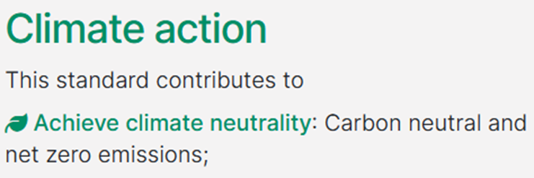
Fig.1. ISO 14068-1:2023 and its contribution (Source: https://www.iso.org/standard/43279.html, accessed 15 March 2026).

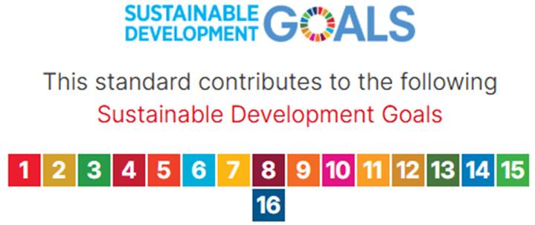
Fig.2. ISO 14068-1:2023 and its contribution to SDGs (Source: https://www.iso.org/standard/43279.html, accessed 15 March 2026).
In Figure 1, there is presented the contribution of this standard to the achievement of climate neutrality, while in Figure 2 we see that this standard can contribute to all the SDGs.

ISO has also produced some other standards that provide a more strategic approach to climate change aspects, such as ISO 14080 (GHG management and framework), ISO 14090, ISO 14091, and ISO 14092 (GHG management and related activities).
There are also standards about clean energy issues, such as ISO 14034, and ISO 50001. For example, 50001 is about energy management and provides guidelines for effective energy management and can be applied to organizations from all sectors.
Another relevant standard is ISO 14030, which concerns the environmental performance evaluation of organizations. We will also present in Figures 3 and 4, its contributions.

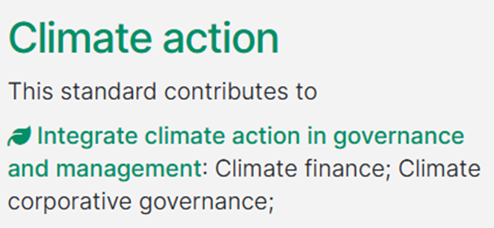
Fig.3. ISO 14034 and its contribution (Source: https://www.iso.org/standard/43254.html, accessed 15 March 2026).

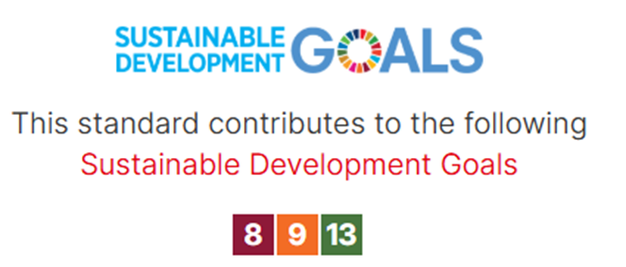
Fig.4. ISO 14034 and its SDGs’ contribution (Source: https://www.iso.org/standard/43254.html, accessed 15 March 2026).

ISO has also issued guidelines on Net Zero, which are called ‘’ISO Net Zero Guidelines-IWA 42:2022’’. This document provides guidance on what governance organizations and other organizations can do to effectively contribute to global efforts to limit warming to 1,5 °C by achieving net zero no later than 2050 [22].
Part of the content of this document includes:
- net zero guiding principles for all organizations;
- incorporating net zero into strategies and policies;
- actions to take to achieve these targets;
- greenhouse gas emission reductions within the value chain;
- nature protection and restoration;
- avoided emissions and other climate contributions beyond the value chain;
- monitoring, measuring and use of appropriate and consistent indicators;
- equity, empowerment, fair share and wider impact;
- transparent reporting and effective communication.

Other ISO standards that are related to GHS management, are:
ISO/AWI 14066, ISO 14067:2018, ISO/DTR 14069:2013, ISO/AWI TR 14082, ISO/DIS 14083, ISO/CD 14093, ISO 14097:2021, ISO 19694-1:2021.
In general, ISO standards for climate change, such as the ones referenced above, contribute directly to the UN SDG 13 on climate action [23].

If we want to categorize the support of the ISO standards to SDG 13, we can use the following categories:
- Measurement of emissions: ISO 14064, ISO 14067
- Reduction of emissions: ISO 14001, ISO 50001, ISO 14068,
- Report of emissions and measurements: ISO 14030, ISO 14064
- Dealing with climate risks: ISO 14090, ISO 14091
- Environmental strategy: ISO 14001, ISO 14004, ISO 14006, ISO 14040, ISO 14044.
Of course, many other standards can help in the efforts to combat climate change as they promote actions of sustainability and attempt to enhance the social, economic and environmental responsibility of the organizations.

4. discussion and conclusion

In this article, we have tried to present some ISO standards that contribute to achieving SDG 13 which was introduced by the UN, along with all the other SDGs. It was evident that many standards of ISO are suitable to produce solutions to the problem of climate change. There are also many more standards being developed and of course, the subject of climate change is an ongoing issue with parameters that may change. ISO standards provide the organizations tools and other assets to measure, manage, reduce and of course to report their impacts on the environment and climate change.
It is also a fact that companies face strong pressure from final consumers and governments and try to comply with environmentally sensitive issues and to be more proactive towards the SDGs, which could also be a form of gaining legitimacy [24]. As referenced in the same study, if companies incorporate the SDGs into their business targets, they are more likely to improve their environmental performance.
All the initiatives referred to above, are suggestions that organizations and regulators, should have in mind. In practice, they must choose which applies to their case, or/and they can use a combination of them.

All the above issues concern people (consumers), industry and regulators, which can be considered the stakeholders of matters concerning the environment and of course the climate change subject.
- People first of all care for the planet and secondly, they are consumers who need to be informed if the company they prefer to buy its products, is environmentally friendly and implements actions towards sustainability.
- Organizations must comply with the environmental legislation, understand their environmental responsibilities and present an environmentally friendly image to their customers. Of course, we have to be sure that their actions to be truthful and meaningful. We hope that they are not just a creation of a good image, and a marketing tool to increase their sales.
- Regulators should be able to take into consideration all aspects concerning environmental issues and to design and apply the appropriate legislation. They should be rightful and apply the law to all cases.

Limitations and implications
This article is a pure theoretical reference to aspects of combating climate change and the role of ISO standards in this issue. As realized, the bibliography about this subject is very scarce. This means that we are in an ongoing process and many things should be done to progress on the path to a sustainable environment and planet. Of course, there are many implications concerning this study. All the suggested actions towards the combat of climate change could be implemented firstly and afterwards we should assess the performance of the organizations on these matters. This is a way to check their usefulness and practical value and of course each organization should be able to select the appropriate tools for its case.

References

- Albino V., Balice, A., Dangelico, R.M., (2009), Environmental strategies and green product development: an overview on sustainability-driven companies, Business strategy and the environment 2 (18) (2009) 83–96, https://doi.org/10.1002/bse.638.
- Lozano R., Barreiro-Gen M., (2023), Organisations’ contributions to sustainability. An analysis of impacts on the Sustainable Development Goals, Business strategy and the environment 6 (32), 3371–3382, https://doi.org/10.1002/bse.3305.
- Mosgaard M.A., Kristensen, H.S., (2023), From certified environmental management to certified SDG management: new sustainability perceptions and practices, Sustainable Futures, Volume 6, 100144, ISSN 2666-1888, https://doi.org/10.1016/j.sftr.2023.100144.
- Ofosu-Adarkwa, J., Xie,N., Javed, S.A., 2020, Forecasting CO2 emissions of China's cement industry using a hybrid Verhulst-GM(1,N) model and emissions’ technical conversion, Renew. Sustain. Energy Rev., 130 (2020), Article 109945, 10.1016/j.rser.2020.109945.
- Ikram M., Zhang Q., Sroufe R., Ferasso M., (2021), Contribution of certification bodies and sustainability standards to sustainable development goals: An integrated grey systems approach, Sustainable Production and Consumption, Volume 28, 2021, Pages 326-345, ISSN 2352-5509, https://doi.org/10.1016/j.spc.2021.05.019.
- Zhao X., Castka P., Searcy C., ISO Standards: A Platform for Achieving Sustainable Development Goal 2, Sustainability, 12(22), 9332; DOI 10.3390/su12229332.
- Gianni, M., Gkarane, S., Papanikolaou, Z., Goulas, A., & Tsotsas, I. (2025). Standards for Sustainable Tourism: Insights on Accessibility and Inclusivity. International Conference on Economic Sciences and Management in the Changing World 2025, (pp. 138-146). Futurity Research Publishing. https://doi.org/10.5281/zenodo.17509694.
- Omri, A., & Boubaker, S. (2024). When do climate change legislation and clean energy policies matter for net-zero emissions? Journal of Environmental Management, 354, 120275. https://doi.org/10.1016/j.jenvman.2024.120275.
- Glatzner, L.; Loew, T. (2022) Environmental management systems and climate risks. Options for the further development of ISO 14001 and EMAS.
- United Nations Statistics Division, 2026 https://unstats.un.org/unsd/envstats/climate%20change/cisat.cshtml. accessed 10 March 2026.
- Ali Y., Fresner J., (2006). Half is Enough - An Introduction to Cleaner Production. Beirut, Lebanon: LCPC Press. ISBN 978-3-9501636-2-9.
- Mondello, G., Salomone, R., (2020), Assessing green processes through life cycle assessment and other LCA-related methods, Editor(s): Angelo Basile, Gabriele Centi, Marcello De Falco, Gaetano Iaquaniello, Studies in Surface Science and Catalysis, Elsevier, Volume 179, 2020, Pages 159-185, ISSN 0167-2991, ISBN 9780444643377, https://doi.org/10.1016/B978-0-444-64337-7.00010-0.
- Race to Zero (2022) The Pivot Point. Available at: https://climatechampions.unfccc.int/wpcontent/uploads/2022/09/R2Z-Pivot-Point-Report.pdf.
- McGivern, A., Axelsson, K., Straub, S. Craig, S. Steen, B. (2022), Defining Net Zero: How do climate criteria align across standards and voluntary initiatives? Smith School of Enterprise and the Environment.
- Garg, A., Raut, R.D., Kumar, M., Zhang, C., Gokhale, R.S., (2025), Does the circular economy transition aid to carbon neutrality? Examining net-zero policy and stakeholder impact from the environmental justice viewpoint, Journal of Cleaner Production, Volume 491, 144851, ISSN 0959-6526, https://doi.org/10.1016/j.jclepro.2025.144851.
- Besse, H., Rojas-Rueda D., 2025, Environmental justice mapping tools in the United States: a review of national and state tools, Sci. Total Environ., 962, Article 178449.
- United Nations Environment Programme (UNEP), 2024, https://www.unep.org/news-and-stories/statements/sdg-13-and-interlinkages-other-sdgs-climate-action#:~:text=Climate%20action%20can%20also:%20*%20**Drive%20innovation,clean%20technologies**%20*%20**Working%20to%20harness%20minerals**, accessed 21 March 2026).
- Chen, C-D., Su, C-H, Chen, M-H, 2022, Are ESG-committed hotels financially resilient to the COVID-19 pandemic? An autoregressive jump intensity trend model, Tourism Management, 93, Article 104581.
- Gueorguiev, T. and Kostadinova, I., (2021), ISO Standards Do Good: A New Perspective on Sustainable Development Goals. In Proceedings of the 13th International Joint Conference on Knowledge Discovery, Knowledge Engineering and Knowledge Management (IC3K 2021) - Volume 3: KMIS, pages 133-137, DOI: 10.5220/0010658000003064.
- Wiegmann, P. M., de Vries, H. J., & Eom, D. (2023). Measuring societal impact of standards. Technische Universiteit Eindhoven.
- Ciravegna Martins da Fonseca, L. (2015). ISO 14001:2015: An improved tool for sustainability. Journal of Industrial Engineering and Management, 8(1), 37-50. doi:https://doi.org/10.3926/jiem.1298.
- ISO (2022), IWA 42:2022, Net zero guidelines, https://www.iso.org/contents/data/standard/08/50/85089.html, accessed 15 March 2026.
- ISO (2018), ISO and climate change https://www.iso.org/files/live/sites/isoorg/files/store/en/PUB100067.pdf, accessed 15 March 2026.
- Nishitani, K., Nguyen, T.B.H., Trinh, T.Q., Wu, Q., Kokubu K., (2021), Are corporate environmental activities to meet sustainable development goals (SDGs) simply greenwashing? An empirical study of environmental management control systems in Vietnamese companies from the stakeholder management perspective, Journal of environmental management, 296, 113364, https://doi.org/10.1016/j.jenvman.2021.113364.

