Spatio-Temporal Variability of Climate Parameters in the Municipality of Za-Kpota (Benin, West Africa) during the Period 1995–2024

Abstract
The municipality of Za-Kpota, located in southern Benin, is highly dependent on climatic conditions due to the predominance of rain-fed agriculture, which constitutes the main livelihood for local populations. This study analyzes the spatio-temporal variability of climatic parameters in this municipality over the period 1995–2024. The methodological approach is based on the analysis of time series of climatic data, particularly rainfall and temperature, obtained from the Bohicon synoptic station. These data were subjected to statistical analyses, including trend tests and the calculation of climatic indices, in order to characterize the evolution of the studied parameters. The results show that the municipality of Za-Kpota is characterized by a bimodal rainfall regime, marked by two rainy seasons with a combined duration of approximately six months. The mean monthly temperature ranges from 25.8 °C in August to 29.5 °C in March. The months of February (29.2 °C), March (29.5 °C), and April (29.1 °C), corresponding to the hottest period of the year, are characterized by increased evaporation, which may affect water resource availability in the study area. Furthermore, the climatic water balance analysis reveals an annual water deficit of −171.3 mm. However, a water surplus is observed between May and June, with a cumulative value of +279.8 mm. Positive balances are also recorded during September and October, ranging from +29.8 mm to +190.8 mm and from +42.3 mm to +47.6 mm, respectively. These findings provide a scientific basis for the development of local strategies for climate change adaptation and sustainable natural resource management. They also highlight the importance of integrating climate information into territorial planning policies and agricultural development strategies in the municipality of Za-Kpota.
Keywords: climate variability, rainfall, temperature, water balance, Za-Kpota, Benin.

- Introduction
The evolution of climatic conditions, characterized by interannual and spatial variations in precipitation and temperature, currently represents one of the major environmental and socio-economic challenges at the global scale. These climatic fluctuations particularly affect rural regions of West Africa, where populations are highly dependent on natural resources and agricultural activities for their livelihoods. In this context, understanding the spatio-temporal variability of climatic parameters is essential for assessing the impacts of climate change at the local scale and for guiding adaptation strategies for the most vulnerable populations.
Precipitation and temperature are the primary determinants of climate and exert a strong influence on ecological, hydrological, and agricultural systems. Changes observed in these climatic parameters disrupt economic activities, particularly agropastoral systems, and hinder the achievement of the Sustainable Development Goals (SDGs) despite the development efforts undertaken by governments (Oyede et al., 2022). Since the 1970s and 1980s, which were marked by severe drought episodes in West Africa, rainfall variability has been characterized by a succession of extreme climatic events, including prolonged dry spells, recurrent flooding, delayed onset, and early cessation of rainy seasons (Tabou et al., 2021).
In the face of these climatic changes, developing countries appear particularly vulnerable to the impacts of environmental disturbances. This situation has led, since the major Sahelian drought of the 1970, to the implementation of numerous international and national research programs aimed at better understanding the mechanisms of climate variability and its impacts on socio-ecological systems (Sarr, 2009). In regions characterized by two cropping seasons, this variability is reflected in increasing uncertainty of the second growing season, often disrupted by early cessation of rainfall or, conversely, by intense precipitation events leading to destructive flooding of crops (Yabi et al., 2013).
In Benin, climate instability is also reflected in significant fluctuations in precipitation and temperature observed over several decades, resulting in marked regional climate variability that directly affects agricultural activities and natural resource management (Oyede et al., 2022). Furthermore, studies conducted in other parts of sub-Saharan Africa show that spatio-temporal analysis of climatic parameters, particularly rainfall and temperature anomalies, makes it possible to identify climate trends as well as areas highly exposed to climatic stress (Awode et al., 2025). These analytical approaches therefore constitute essential tools for supporting adaptation strategies and guiding territorial planning policies.
In this context, the present study analyzes the spatio-temporal variability of climatic parameters in the municipality of Za-Kpota, located in southern Benin, over the period 1995–2024. The objective is to highlight the local dynamics of key climatic variables, particularly rainfall and temperature, in order to better understand their implications for agricultural systems and sustainable natural resource management. The expected outcomes also aim to provide decision-support elements for the development of climate adaptation strategies and the promotion of sustainable rural development in the municipality of Za-Kpota.

2. Materials and Methods
2.1. Description of the Study Area
The municipality of Za-Kpota is located in the Zou Department, in the south-central part of the Republic of Benin. It lies between 07°07′50″ and 07°20′36″ North latitude and 02°05′04″ and 02°18′43″ East longitude. The municipality covers an area of approximately 600 km² and is bordered to the northwest by the municipality of Djidja, to the southwest by Bohicon, to the east by Covè, and to the southeast by Zogbodomey (Figure 1).
Administratively, Za-Kpota is divided into eight districts: Allahé, Assalin, Houngomey, Kpakpamè, Kpozoun, Za-Tanta, Zèko, and Za-Kpota (INSAE, 2016). These districts comprise a total of 56 villages and urban neighborhoods (Municipality of Za-Kpota, 2012). According to data from the National Institute of Statistics and Economic Analysis, the population of the municipality is estimated at 132,818 inhabitants, corresponding to an average population density of approximately 324.7 inhabitants/km² (INSAE, 2016). This relatively high population density constitutes an important asset in terms of agricultural labor availability, which represents the main economic activity of local populations.
From a climatic perspective, the municipality of Za-Kpota falls within the subequatorial climatic zone, which is characteristic of central and southern Benin. This climatic regime is defined by the alternation of two rainy seasons and two dry seasons. The major rainy season generally extends from mid-March to July, while the minor rainy season occurs between September and November (Municipality of Za-Kpota, 2024). These two rainy seasons are separated by a short dry period that typically spans the second half of July and the month of August. The major dry season extends from mid-November to March.
In terms of rainfall, the municipality records an average annual precipitation of approximately 1350.82 mm. However, observations over recent decades indicate significant interannual variability, reflecting climatic fluctuations that may influence agricultural activities and natural resource management in the area.
Regarding temperature, average values generally range between 24 °C and 34 °C throughout the year. The highest temperatures are typically recorded in March, whereas August corresponds to the coolest period of the year.
Thus, the geographical location and climatic characteristics of the municipality of Za-Kpota make it a particularly relevant area for analyzing the spatio-temporal variability of climatic parameters and their implications for local socio-economic systems, especially agricultural activities that are highly dependent on climatic conditions.
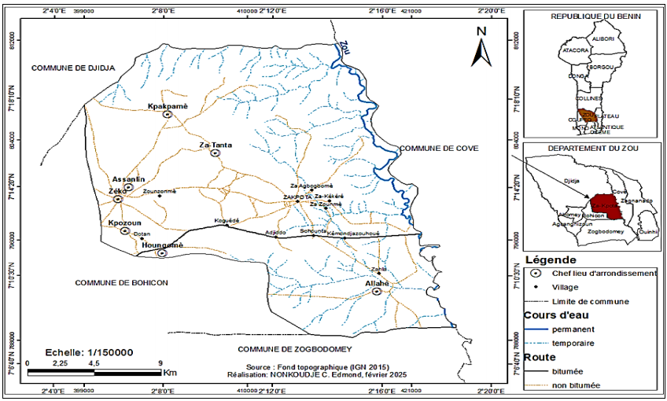

Fig 1. Geographic location of the municipality of Za-Kpota

2.2. Methodology
2.2.1. Data Collection
The analysis of the spatio-temporal variability of climatic parameters in the municipality of Za-Kpota is based on the use of climatic data related to precipitation and temperature. These data were obtained from the Bohicon synoptic station, provided by Météo-Benin. The study period covers 1995 to 2024, corresponding to a 30-year time series. This period was selected to ensure a sufficiently long dataset for robust climatic analysis. According to the recommendations of the World Meteorological Organization (WMO), a minimum period of thirty years is generally required for the calculation of climatic normals and the assessment of climate trends. These data served as the basis for analyzing the variability of key climatic parameters, particularly rainfall and temperature, in the municipality of Za-Kpota.
2.2.2. Data Analysis
The analysis of climatological data was conducted through several steps, combining statistical methods and climatic indices to characterize the spatio-temporal variability of climate in the study area.
a) Arithmetic Mean
The arithmetic mean was used to analyze temperature evolution over the study period. It allows the determination of the average value of a climatic parameter over a given period and is expressed as follows:
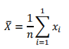

Where:
- (x_{i}) represents the value of the climatic parameter for year (i)
- (n) is the total number of years in the time series
b) Climatic Water Balance
The climatic water balance was used to assess hydrological conditions and identify periods favorable or unfavorable for vegetation growth in the municipality of Za-Kpota. According to Atidegla et al. (2017), the climatic water balance characterizes the temporal distribution of water surpluses and deficits at the monthly scale and helps define growing periods.
It is calculated as follows:
𝐵𝑃 = 𝑃 − 𝐸𝑇
Where:
- (P) represents precipitation
- (ETP) represents potential evapotranspiration
The interpretation is as follows:
- (P - ETP < 0): deficit water balance
- (P - ETP = 0) : equilibrium
- (P - ETP > 0): surplus water balance

c) Rainfall Sequence Analysis
Interannual rainfall variability was analyzed using the Lamb index (Lawin et al., 2011), which highlights wet and dry periods within the time series.
It is calculated as:
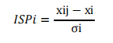

Where:
- (SP_{i}) is the standardized precipitation index for year (i)
- (𝑥𝑖𝑗) is the annual rainfall total
- (𝜘𝑖) is the mean annual rainfall at the station (i)
- (𝜎𝑖) is the standard deviation
According to this index:
- Normal year: ( −0,1 ≤ ISP ≤ +0,1)
- Wet year: (ISP > 0,1)
- Dry year: (ISP > 0,1)

d) Determination of Onset and Cessation of the Rainy Season
The onset and cessation dates of the rainy season were determined using the method proposed by Liebmann (2006) and adapted by Ramiharijafy et al. (2017). This method is based on the concept of Anomalous Accumulation, which compares observed cumulative daily rainfall with a theoretical mean accumulation.
This approach allows for the objective identification of:
- Start of the agricultural season (Onset Date – OD)
- End of the agricultural season (Cessation Date – CD)
e) Identification of Climate Extremes
Extreme climatic events were analyzed using indices defined by the ETCCDI (Expert Team on Climate Change Detection and Indices). Three indices were selected:

- Rx1day: Maximum daily precipitation 𝑅𝑥1𝑑𝑎𝑦 = 𝑚𝑎𝑥 (𝑃𝑖)
where (Pᵢ) represents the precipitation on day (i).
- R10 mm: Number of days with precipitation ≥ 10 mm
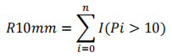

where (I=1) if (Pi > 10 mm), otherwise (I = 0)
- TXx : Annual maximum temperature. 𝑇𝑋𝑥 = 𝑚𝑎𝑥 (𝑇𝑚𝑎𝑥).
These indices allow the assessment of the intensity and frequency of extreme climatic events, which are critical for understanding their impacts on agricultural systems.
The indices were computed using RClimDex and ClimPACT2 software (Zhang et al., 2005).

f) Detection of Breakpoints in Climate Series
The stationarity of rainfall series was analyzed to detect potential climatic shifts. A breakpoint is defined as a significant change in the statistical distribution of a time series (Lubès Niel et al., 1994).
Break detection was performed using the following statistical tests:
- Pettitt test (1979)
- Hubert segmentation procedure (Hubert et al., 1998)
- Buishand test (1984)

g) Drought Analysis Using the SPI Index
Drought conditions were characterized using the Standardized Precipitation Index (SPI) proposed by McKee et al. (1993) and Hayes (1996).
It is calculated as:
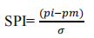

Where:
- (pi) is observed precipitation
- (pm) is mean precipitation
- (б) is the standard deviation

Table 1. SPI Classification (McKee et al., 1993; Hayes, 1996)
Value | Classification
≥ 2.0 | Extremely wet
1.5 to 1.99 | Very wet
1.0 to 1.49 | Moderately wet
-0.99 to 0.99 | Near normal
-1.0 to -1.49 | Moderately dry
-1.5 to -1.99 | Severely dry
≤ -2.0 | Extremely dry
(Source: Extract to Mckee et al., 1993 and Hayes, 1996)

3. Results and Discussion
3.1. Extreme Climatic Phenomena in the Municipality of Za-Kpota
Extreme climatic phenomena constitute one of the major manifestations of climate variability observed across many regions of West Africa. They are reflected in significant fluctuations in key climatic parameters such as precipitation, temperature, relative humidity, and wind speed, whose variations strongly influence environmental, agricultural, and public health systems.
In Benin, particularly in the municipality of Za-Kpota, these climatic variations can significantly affect agricultural production conditions, especially rice cultivation, as well as the health and well-being of local populations. The analysis of extreme climatic phenomena in the study area is based on several climatic indicators, including rainfall variability, annual rainfall trends, thermal regime, climatic water balance, hygrometric patterns, and wind speed dynamics. The examination of these parameters makes it possible to identify the climatic dynamics characterizing the study area over the 1993–2022 period, thereby providing insights into their potential implications for agricultural activities and local livelihoods.
3.1.1. Rainfall Variability in the Municipality of Za-Kpota
Rainfall trends in the municipality of Za-Kpota were analyzed using data from the Bohicon synoptic station. Figure 2 illustrates the evolution of the monthly rainfall regime over the study period.
The analysis reveals that Za-Kpota is characterized by a bimodal rainfall regime, marked by two distinct rainy seasons. The first rainy season generally extends from April to July, while the second occurs between October and November, resulting in a cumulative rainfall duration of approximately six months per year.
This seasonal distribution of rainfall provides relatively favorable hydrological conditions for agricultural activities, particularly for rain-fed crops. The month of June records the highest rainfall totals, reaching approximately 309.2 mm, making it a critical period for water availability and for key growth stages of crops, including rice flowering and development.
However, this rainfall regime is also characterized by the presence of two relatively pronounced dry seasons. The first corresponds to a short dry period between August and September, while the second, more extended dry season, generally spans from December to March. These periods of water deficit limit the potential for multiple cropping cycles and increase farmers’ dependence on rainfall availability.
In this context, the implementation of hydro-agricultural infrastructure, such as irrigation systems, drainage networks, and water storage facilities, appears essential to ensure agricultural production stability.
Furthermore, the analysis of interannual rainfall variability highlights considerable fluctuations throughout the study period. Annual rainfall totals range from a minimum of approximately 679.4 mm, which may compromise crop yields, to a maximum of 1542.42 mm, which can lead to flooding events and crop losses in certain areas. This pronounced interannual variability constitutes a key feature of climate variability in the municipality of Za-Kpota.
Nevertheless, trend analysis indicates a slight upward tendency in rainfall, as reflected by the slope of the regression line estimated at 5.14 mm/year. This trend suggests a gradual recovery in rainfall over recent decades. If sustained and accompanied by effective water resource management, this evolution could offer opportunities for improving agricultural productivity in the municipality.
These findings are consistent with the work of Dingkuhn et al. (2006), who emphasize the importance of aligning rainfall regimes with crop growth cycles, particularly for rice cultivation. They also corroborate the observations of Niang et al. (2014), which highlight the risks associated with interannual rainfall variability for agricultural production systems in West Africa.

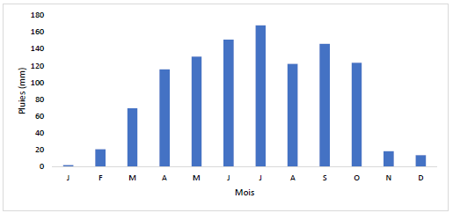

Fig 2. Monthly rainfall regime from 1993 to 2022 in Za-Kpota
(Source: Meteo-Benin, March 2025)
3.1.2. Annual Rainfall Trend
The analysis of the rainfall index provides insight into the temporal variability of precipitation in the municipality of Za-Kpota. Figure 3 illustrates the evolution of rainfall anomalies over the 1993–2022 period. Examination of this figure reveals a marked irregularity in rainfall, characterized by an alternation of deficit, normal, and surplus years.
During the period from 1995 to 2005, rainfall anomalies were predominantly negative, indicating generally drier-than-average conditions. This phase corresponds to a period of water deficit, which may have adversely affected agricultural systems highly dependent on rainfall. From 2006 onwards, anomalies became more frequently positive, suggesting a relative increase in rainfall, although some years continued to exhibit deficit conditions.
Trend analysis indicates a slightly positive evolution in rainfall over the study period. The linear regression equation (y = 0.0218x − 0.3382) reflects a gradual, albeit modest, increase in precipitation over time. However, the very low coefficient of determination (R² = 0.0357) indicates that this linear trend explains only about 3.57% of the total variability in rainfall anomalies. This finding highlights that rainfall dynamics in Za-Kpota remain largely dominated by strong interannual variability.
These results underscore the pronounced interannual variability of precipitation in the study area, a characteristic feature of tropical climatic regimes in West Africa. Such variability constitutes a critical factor for agricultural activities, as it directly influences water availability for crops and increases the risks associated with both drought events and excessive rainfall.

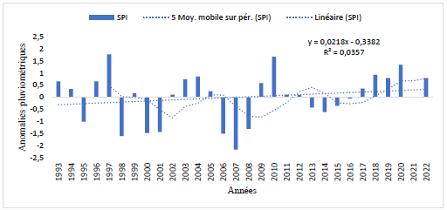

Fig 3. Evolution of rainfall anomalies in the study area over the period 1993–2022
(Source: Meteo-Benin, March 2025)

Table 2 presents a summary of the main statistical characteristics of rainfall variability in the study area.

Table 2. Summary of Deficit, Normal, and Surplus Years
Deficit years (SPI < -0,1) | Normal years  (-0,1≤ SPI ≤ +0,1) | Surplus years  (SPI > +0,1)
1995, 1998, 2000, 2001, 2006, 2007,2008, 2013, 2014, 2015, 2016 | 1999, 2002, 2011,2012, | 1993, 1994,1996 1997,2003, 2004, 2005,2009, 2010, 2017, 2018, 2019, 2020, 2021, 2022
36,6 % | 13,3 % | 50 %

The observed rainfall irregularity in the municipality of Za-Kpota is further confirmed by the distribution of the different categories of years over the study period. The analysis reveals that 36.6% of the years are deficit, 13.3% are near normal, and 50% are surplus, highlighting a pronounced interannual variability in precipitation.
This distribution emphasizes the relatively high frequency of above-normal rainfall years, while also indicating the persistence of deficit periods, which may adversely affect rain-fed agricultural activities.
To assess the potential existence of breakpoints in the rainfall time series, the Pettitt and Buishand statistical tests were applied. The results of these analyses are presented in Figure 4.

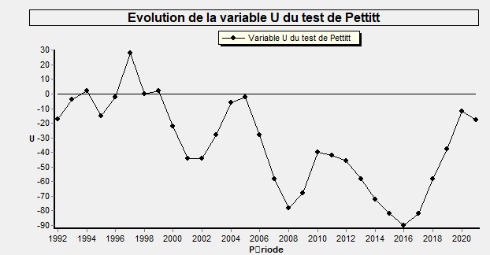 | 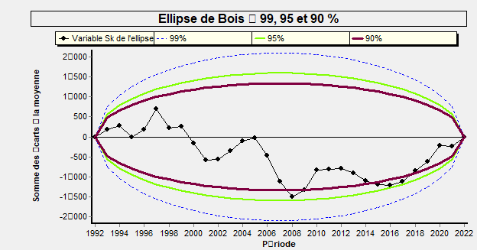
Fig 4. Breakpoint detection using Pettitt test (a) and Buishand test (b)
The analysis of the evolution of the U statistic derived from the Pettitt test (Figure 4a) reveals the existence of two distinct sub-periods, namely 1993–2016 and 2017–2022, suggesting a shift in the behavior of the rainfall time series during the recent period.
These findings are corroborated by the results of the Buishand test (Figure 4b), for which the hypothesis of a breakpoint is confirmed at the 95% significance level. The identification of this breakpoint indicates a change in rainfall dynamics within the study area, likely reflecting broader modifications in regional climatic conditions.
These results are consistent with the findings of Paturel et al. (1996), who reported a general decreasing trend in rainfall across the Sudano-Sahelian region. Although the municipality of Za-Kpota belongs to a subequatorial climatic zone, the observed rainfall fluctuations highlight a significant level of climate variability, which aligns with the broader climatic dynamics observed across West Africa.

3.1.3. Monthly and Interannual Temperature Regime over the Period 1993–2022
The analysis of the temperature regime in the municipality of Za-Kpota was carried out using monthly values of maximum, mean, and minimum temperatures recorded over the 1993–2022 period.
This approach provides insight into thermal variations and their potential implications for water availability and rice production in the study area (Figure 5).

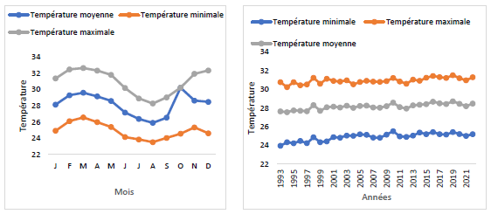
Fig 5. Mean monthly (a) and interannual (b) temperature regime from 1993 to 2022
(Source: Meteo-Benin, March 2025)
The analysis of Figure 5 indicates that the mean monthly temperature ranges from 25.8 °C in August to 29.5 °C in March. The months of February (29.2 °C), March (29.5 °C), and April (29.1 °C) correspond to the hottest period of the year.
During this period, increased temperatures enhance evaporation and evapotranspiration processes, which may reduce water availability within the watershed and affect the hydrological conditions required for crop development, particularly for rice cultivation.
The analysis of interannual temperature variability also reveals a general upward trend. Annual minimum temperatures increased from 23.95 °C in 1993 to 25.52 °C in 2010, representing an increase of approximately 1.56 °C. Similarly, annual maximum temperatures ranged from 30.24 °C in 1994 to 31.44 °C in 2016, corresponding to an increase of approximately 0.99 °C over the study period.
The mean annual temperature is estimated at 28.16 ± 0.3 °C, with a minimum of 27.5 °C recorded in 1994 and a maximum of 28.7 °C in 2019, indicating a variation of about 1.2 °C between these two years.
These results highlight a progressive warming trend, characterized by a simultaneous increase in both minimum and maximum temperatures over the study period. This rise in temperature is likely to influence evapotranspiration processes, thereby increasing pressure on water resources and altering crop growth conditions in the municipality of Za-Kpota.
Furthermore, the analysis of the temperature index (Figure 6) over the period 1993–2022 reveals an overall increasing trend, as indicated by the regression equation y = 0.0219x. However, the relatively low coefficient of determination (R² = 0.1511) suggests that this trend explains only a limited proportion of the observed variability.
This indicates that, despite a general warming trend, temperatures still exhibit significant interannual variability, influenced by various regional climatic factors.
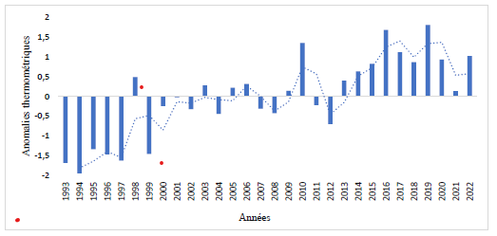

Fig 6. Temperature index in the municipality of Za-Kpota from 1993 to 2022
(Source: Meteo-Benin, March 2025)

3.1.4. Monthly Climatic Water Balance
The monthly climatic water balance makes it possible to assess the equilibrium between water inputs from precipitation and losses due to evapotranspiration.
In the municipality of Za-Kpota, the analysis of the climatic water balance reveals an alternation between deficit and surplus periods throughout the year (Figure 7).

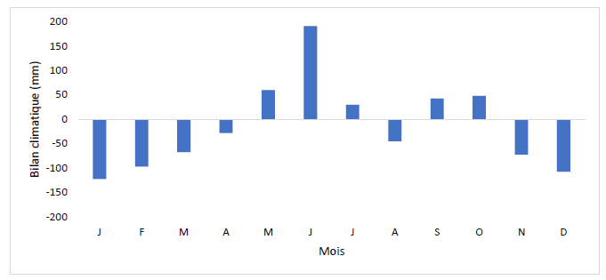

Fig 7. Evolution of the climatic water balance in the municipality of Za-Kpota from 1993 to 2022
(Source: Meteo-Benin, March 2025)
Between November and April, the study area is characterized by relatively high temperatures, associated with an increase in evaporative demand, resulting in significant water losses. This situation leads to a strongly negative water balance, reaching approximately –495.9 mm over this period, with monthly values ranging from –28.1 mm to –122.9 mm. These climatic conditions contribute to a reduction in soil water availability and may adversely affect agricultural activities dependent on water resources.
At the annual scale, the overall climatic water balance shows a deficit of –171.3 mm, indicating that water losses exceed precipitation inputs. However, certain periods of the year exhibit a significant water surplus, particularly between May and June, when the cumulative surplus reaches +279.8 mm, with monthly values ranging from +29.8 mm to +190.8 mm.
Another surplus period is observed between September and October, with a cumulative value of approximately +90 mm and monthly values ranging from +42.3 mm to +47.6 mm. In contrast, the month of August also exhibits a deficit water balance, reaching approximately –45.3 mm, corresponding to the short dry season characteristic of the subequatorial climatic regime.
These alternating periods of water surplus and deficit promote the formation and proliferation of mosquito breeding sites, thereby creating favorable conditions for the development of mosquito populations, which are the primary vectors of malaria. This may partly explain the observed increase in malaria cases in the study area during certain periods of the year.
In addition, these periods are characterized by generally warm atmospheric conditions, which may generate a sense of thermal comfort for some individuals, while causing thermal discomfort for others.
These findings are consistent with the conclusions of the IPCC (2014), which emphasize that variations in the climatic water balance, combined with increasing temperatures, can exacerbate existing health issues. These include more intense heatwaves, an increased risk of undernutrition due to reduced agricultural productivity, and a higher incidence of water- and food-borne diseases.

3.1.5. Hygrometric Patterns
Figure 8 presents the monthly and interannual variability of relative humidity in the municipality of Za-Kpota over the 1993–2022 period. The analysis shows that the mean monthly relative humidity ranges from 74% in February to 84% in August, reflecting a high level of atmospheric moisture characteristic of the subequatorial climate of the study area.
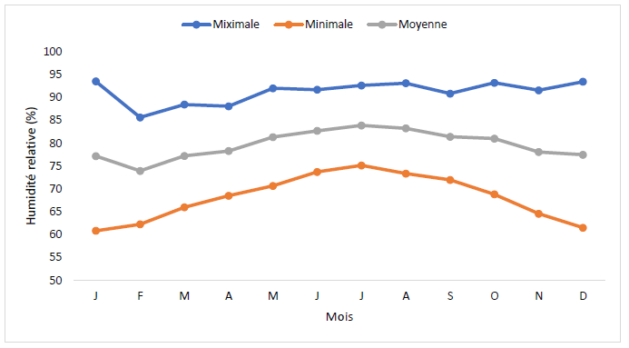

Fig 8. Evolution of monthly relative humidity at the Bohicon station from 1993 to 2022
(Source: Meteo-Benin, March 2025)
Maximum values of relative humidity are particularly high during the rainy season. They reach extreme levels of 94% in January, 92% in May and June, and 93% in July, August, October, and December. These high humidity conditions promote the formation and persistence of moist environments, which constitute favorable breeding grounds for mosquitoes, potentially leading to an increased proliferation of malaria vectors in the municipality of Za-Kpota.
Furthermore, the analysis of minimum relative humidity shows values ranging from 61% to 62% between December and January, while the highest minimum values, between 74% and 75%, are observed from June to July. These hygrometric variations contribute to changes in the thermal comfort conditions experienced by local populations.
Indeed, the thermal environment, resulting from the interaction between temperature and relative humidity, strongly influences comfort levels and may have implications for human health. The period between November (78%) and May (81%) is characterized by high temperatures combined with elevated humidity, which can lead to the appearance of heat rashes (commonly referred to as prickly heat). Under such conditions, some populations, particularly those with limited financial resources, adopt adaptive strategies such as partial undressing or increased body exposure due to the lack of ventilation or air-conditioning systems.
Beyond its effects on human health, relative humidity also plays a critical role in agricultural production systems. According to Condair (2017), relative humidity is a key factor in regulating crop physiological processes, particularly in rice production systems, where it influences plant transpiration, vegetative growth, and phytosanitary conditions.

3.1.6. Monthly and Annual Evolution of Wind Speed
The analysis of intermonthly wind speed variability in the municipality of Za-Kpota over the 1993–2022 period highlights a seasonal variation in wind intensity throughout the year (Figure 9).

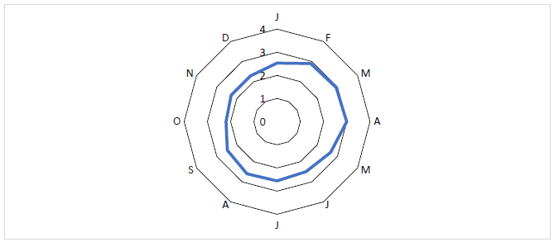

Fig 9. Intermonthly evolution of wind speed at the Bohicon station from 1993 to 2022
(Source: Meteo-Benin, March 2025)
The results indicate that the mean wind speed gradually increases from January (2.53 m/s) to reach a maximum of approximately 3 m/s in April. This period generally corresponds to the transition between the dry season and the progressive onset of the rainy season. After this peak, wind speed tends to stabilize or slightly decrease during the subsequent months.
These winds play a role in the dispersion of particles and pathogens in the environment, thereby facilitating the spread of certain vectors associated with dermatological conditions. They may also contribute to the contamination of uncovered food, representing a potential risk to household food safety.
Furthermore, variations in wind speed can have implications for agricultural production systems, particularly rice cultivation in the municipality of Za-Kpota. Indeed, relatively strong winds can influence microclimatic conditions within fields, notably by enhancing evaporation processes and promoting the dispersion of particles that may affect crop quality.

3.2. Variability of climatic parameters and environmental and agricultural implications in Southern Benin
The results obtained in the commune of Za-Kpota confirm that the climatic conditions of southern Benin fall within a subequatorial climate regime, characterized by bimodal rainfall: a major rainy season generally spanning April to July and a minor rainy season from September to November. This pattern is strongly influenced by the West African monsoon and the proximity of the Gulf of Guinea, which contribute to maintaining relatively high atmospheric humidity and annual mean temperatures around 27–28 °C. These climatic conditions support the development of dense vegetation and sustain agricultural systems, particularly lowland rice cultivation.
However, the analysis of climatic series from 1993 to 2022 reveals significant variability in climatic parameters, especially rainfall and temperature. The observed rainfall fluctuations in Za-Kpota, characterized by alternating deficit and surplus years, confirm the presence of interannual rainfall irregularity, which may impact agricultural systems dependent on precipitation. These observations are consistent with the findings of Kougbeagbede et al. (2017), who reported, through statistical trend analysis of rainfall, a significant decrease in precipitation at some coastal stations in southern Benin, with important implications for rainfed agriculture.
Similarly, the results align with the analyses of Lawin (2019) in the Ouémé basin, showing a trend of decreasing total rainfall accompanied by an increasing number of dry days since the 1970s. This climatic evolution enhances interannual rainfall variability and increases the frequency of prolonged dry spells in agricultural areas of southern Benin. In Za-Kpota, such variability could disrupt agricultural calendars and affect water availability for crop development.
Furthermore, the analysis of thermal parameters reveals a gradual increase in temperatures, with both minimum and maximum temperatures rising over the study period. This trend contributes to higher evapotranspiration, which may exacerbate water deficits during dry seasons. These findings are consistent with Mamadou (2014), who highlighted the importance of surface energy fluxes in cultivated areas of southern Benin. According to this author, the positive radiative balance in these regions results in high potential evapotranspiration, particularly during the dry season, emphasizing the role of ferralitic soils in regulating local hydric conditions.
Regional climatic conditions are also influenced by complex interactions between the atmosphere and the biosphere. Pacifico (2020) notes that biogenic emissions and atmospheric chemistry processes can modulate volatile organic compound concentrations, with seasonal variations linked to monsoon dynamics and anthropogenic activities. These interactions can influence air quality and, in some cases, modify precipitation formation processes through aerosol-mediated effects.
Moreover, hydrological projections for the region indicate an increased sensitivity of water resources to climate change. Bossa (2012), applied to the Ouémé basin, shows that future climate scenarios could lead to reduced river flows due to both decreased precipitation and increased evapotranspiration. Such changes could have direct consequences on water availability in agricultural areas of southern Benin.
Overall, these findings confirm that, despite generally favorable climatic conditions for agricultural activities, including lowland rice cultivation, regions in southern Benin, including Za-Kpota, remain vulnerable to intensified climate variability and extreme events. This situation underscores the need to strengthen climate monitoring systems and develop agricultural adaptation strategies to enhance the resilience of production systems in the face of climatic fluctuations.
4. Conclusion
The spatio-temporal analysis of climatic parameters in the commune of Za-Kpota reveals a marked climatic variability over the period 1995–2024, characterized by significant fluctuations in rainfall and temperature. The results show an irregular rainfall regime, alternating between deficit and surplus years, as well as a general increase in both maximum and minimum temperatures, consistent with trends observed at national and regional scales. The commune experiences periods of prolonged droughts and recurrent flooding events, with a notable rise in the number of days with heavy rainfall (>10 mm) and extreme temperatures frequently exceeding 36 °C during critical stages of the cropping cycle.
This spatio-temporal variability constitutes a major challenge for agricultural systems, particularly rice cultivation and rainfed crops, which are closely dependent on climatic conditions. It also increases the vulnerability of rural populations to climate hazards and associated risks, including decreased agricultural productivity, food insecurity, and heightened incidence of climate-related diseases.
The findings of this study provide a solid scientific basis to guide local adaptation strategies. It is strongly recommended that local authorities and development stakeholders:
- Integrate spatio-temporal climate data into agricultural and territorial planning to optimize cropping calendars and water management.
- Develop and promote resilient agricultural practices, such as appropriate irrigation, drainage, hydro-agricultural structures, and the use of drought-tolerant crop varieties.
- Strengthen climate monitoring and early-warning systems to anticipate extreme rainfall and temperature events and mitigate their impacts on populations and crops.
Ultimately, a better consideration of local climatic dynamics will enhance the resilience of socio-economic and environmental systems in Za-Kpota, contributing to sustainable rural development and food security in the face of climate change.

Reference
Awode, Ayoola Emmanuel, Adewumi, James Rotimi, Obiora-Okeke, Obinna, & Komolafe, Akinola Adesuji. (2025). Analysis of rainfall variability and extreme events in South-Western Nigeria: implications for water resource management and climate resilience. Bulletin of the National Research Centre, 49, 31.
Bossa, Aymar Yaovi, Diekkrüger, Bernd, Igué, Attanda Mouinou, & Gaiser, Thomas. (2012). Analyzing the effects of different soil databases on modeling of hydrological processes and sediment yield in Benin (West Africa). Geoderma, 173–174, 61–74.
Buishand, Utrecht P. (1984). Characteristics of drought events in the Netherlands. Royal Netherlands Meteorological Institute (KNMI) Scientific Report 84-4.
Hayes, Michael John. (1996). Drought indices. Proceedings of the 8th Conference on Applied Climatology, 179–184.
Hubert Jean, Carbonnel Philippe, Hubert Georges, Boursier Jean Paul, Rougier Jean Luc, & Houngninou Michel. (1998). Analysis of the characteristics of extreme floods in West Africa. Hydrological Sciences Journal, 43(6), 883–897.
INSAE, (2016), Third General Census of Population and Housing (RGPH4), Cotonou, Benin, 494 p.
Khaldi Abdelkrim. (2005). Contribution to the Study of the Hydrological Characteristics of Saharan Watersheds. Doctoral Dissertation, Houari Boumédiène University of Science and Technology, Algiers, Algeria.
Kougbéagbédé Hilaire, Houngninou Bonaventure et Moumouni Saliou (2017). Modeling Rain Rate Distribution Per Diameter Class from Disdrometer Data Collected in Northern Benin (AMMA Campaign): A New Relationship Between Radar Reflectivity and Rainfall Rate. International Journal of Research and Innovations in Earth Science, Volume 4, Issue 3, ISSN 2394 1375
Za-Kpota Town Hall (2012), Za-Kpota Communal Development Plan 2012–2016, Revised Version, GDL Consulting, Cotonou, 114 p.
Lawin, Agnidé Emmanuel, Hounguè, Roch, M’Po, Yannick N’Tcha, Hounguè, Noémi Roch, Attogouinon, Alphonse, & Afouda, Augustin Alou Adrien. (2019). Mid-century climate change impacts on Ouémé River discharge at Bonou outlet (Benin). Hydrology, 6(3), 72.
Lubès Niel, Hugues, Masson, Jean Marie, Servat, Éric, Paturel, Jean Emmanuel, Kouamé, Brou, & Boyer, Jean François. (1994). Characterization of Fluctuations in a Time Series through the Application of Statistical Tests. ORSTOM, Montpellier, France.
Mamadou, Ossénatou, Cohard, Jean-Marc, Galle, Sébastien, Awanou, Cyrille N., Diedhiou, Abdoulaye, Kounouhewa, Barnabé, & Peugeot, Christian. (2014). Energy fluxes and surface characteristics over a cultivated area in Benin: daily and seasonal dynamics. Hydrology and Earth System Sciences, 18, 893-914
McKee Thomas Bernard, Doesken Nolan Joseph, & Kleist John Robert. (1993). The relationship of drought frequency and duration to time scales. In Proceedings of the 8th Conference on Applied Climatology, Anaheim, California, USA, 17–22 January 1993, 179–184.
Niang, Isabelle, Ruppel, Oliver Charles, Abdrabo, Mohamed Abdelrahman, Essel, Ama, Lennard, Christopher, Padgham, Jonathan, Urquhart, Penny, & Descheemaeker, Kirsten Karen Elsbeth. (2014). Africa. In Barros, Virginia R., Field, Christopher B., Dokken, David J., Mastrandrea, Michael D., & Mach, Kathleen J. (Eds.), Climate Change 2014: Impacts, Adaptation and Vulnerability. Part B: Regional Aspects. Cambridge University Press.
Oyede M. I., Sylvie Hounzime, Isidore Agbokou, Agali Alhassane, Ibouraïma Yabi (2022); Spatio-temporal Characteristics of Climate Variability in Benin (West Africa), European Scientific Journal, ESJ, 18 (30), 240.
Pacific, Ricardo and Almeda, Frank. 2020. Microlicia morrensis (Melastomataceae): The third species of the genus Microlicia morrensis endemic to Morro do Chapéu, Bahia, Brazil. Phytotaxa 454(2): 137–144.
Paturel, Jean-Emmanuel, Servat, Eric, Kouamé, Brou, Lubès-Niel, Hélène, Ouedraogo, Mamadou & Masson, Jean-Marie. (1997). Climatic variability in humid Africa along the Gulf of Guinea: detailed analysis of the phenomenon in Côte d’Ivoire. Hydrological Sciences Journal.
Pettitt Anthony Noel. (1979). A non-parametric approach to the change-point problem. Journal of the Royal Statistical Society. Series C (Applied Statistics), 28, 126-135.
Ramiharijafy R., Rabeharisoa J.M., Ratiarison A., & Velo J. (2017). Studies and Impacts of Climate Variability on Seasonal Rainfall Regimes: The Case of the Andekaleka Hydroelectric Site in Madagascar. Afrique Science, 13(1), 1–17.
Sarr, Mamadou Adama (2009): Recent Evolution of Climate and Vegetation in Senegal (Case Study of the Ferlo Watershed). Doctoral Thesis in Geography, Cheikh Anta Diop University of Dakar (Senegal), 390 pp.
Tabou Talahatou, Edea Emile, Zakari Soufouyane, Wokou Guy, Yabi Ibouraïma (2021); Modeling the Seasonal Dynamics of Vegetation Water Stress in the Context of Rainfall Variability in the Far North of Benin, *Revue scientifique MIRD*, pp. 74–87.
Yabi Ibouraïma, Chabi Ayedegue Philippe, and Wokou Guy Cossi (2013): Rainfall Disturbances During the Second Agricultural Season in the Collines Department, Benin. Revue de Géographie de Lomé, p. 14.
Zhang, Yongqiang, Chen, Wei, Smith, Steven Leonard, Riseborough, David William, & Cihlar, Jan. (2005). Soil temperature in Canada during the twentieth century: Complex responses to atmospheric climate change. Journal of Geophysical Research, 110

