Assessment of the state of knowledge, risk prevention, and natural disaster management in the agrosylvopastoral areas of urban perimeter of Ngozi (2012–2024)

Abstract

The assessment of the state of knowledge, risk prevention, and natural disaster management in the agrosylvopastoral areas of the urban perimeter of Ngozi for the period 2012–2024 aimed to clarify the existing challenges and propose appropriate solutions.
The results show significant disparities in knowledge: only 28.6% of neighborhood leaders and 21.4% of agro-pastoralists are aware of the functions of local civil protection teams, compared to 85.7% of administrative staff and 75% of representatives of private organizations. Moreover, 100% of neighborhood leaders and agro-pastoralists are unaware of the existence of the Risk Prevention Plan, compared to a significantly lower proportion among administrative staff and representatives of private organizations (14.3% and 29.2% respectively).
These gaps are mainly explained by the limited dissemination of information about these plans, despite their importance.
In response to the identified threats, the surveyed population proposed several solutions, including the establishment of a rational urban land-use plan, the construction of masonry drainage channels for stormwater evacuation, and the adoption of agroforestry techniques. However, the implementation of these practices remains limited, and no solid or liquid waste management system has been initiated.
In conclusion, this study highlights an insufficient culture of risk prevention and natural disaster management in the urban area of Ngozi.
Keywords: Risks, disasters, risk prevention, disaster management.
1. Introduction

Faced with the imminent threat posed by climate change, disasters linked to the increasing vulnerability of urbanized societies have become a major concern. According to existing studies, more than half of the world’s population now lives in urban areas (UN-Habitat, 2010; Béatrice Quenau, 2013), and new cities are experiencing exponential population growth, thereby increasing the risks inherent in already exposed urban areas where multiple stakes are concentrated (populations, activities, material and immaterial assets, etc.).
Burundi appeared to be relatively less exposed to natural risks and disasters until fairly recently. However, over the past few decades, the country has experienced extreme weather events such as droughts, floods, storms, hail, and landslides. These events are often associated with torrential rains, which seem to occur more frequently and are potentially more dangerous and destructive than in the past.
In this problematic context, the urban perimeter of Ngozi Province in northern Burundi is not spared from these natural risks and disasters known worldwide. Indeed, Nyengayenge (2002) points out that the landscape of the urban center of Ngozi is dotted with hills rising at high altitudes, ranging from 1500 to 1900 meters from west to east. The terrain is therefore steep and structured as watersheds, which favors runoff phenomena. Consequently, soil erosion intensifies, particularly on soils with a soft and fragile geological structure.
The presence of a large population in the city of Ngozi also constitutes a factor that favors the occurrence and aggravation of natural disaster risks. Indeed, due to the absence of a well-defined and respected urban and peri-urban master development plan, the population often engages in inappropriate practices that trigger these natural disaster risks.
In this context, a study on the population’s perception and the challenges related to risk prevention and natural disaster management in the agrosylvopastoral areas of the urban perimeter of Ngozi was undertaken. The aim is to support the population involved in this environment by improving their understanding of the already identified risks and natural disasters. Furthermore, it seeks to help this population identify rational strategies for the prevention and management of these risks and natural disasters, based on the known situation covering the period 2012–2024.
2. Materials and methods
The methods used for data collection consisted of several distinct approaches, including documentary analysis and systemic analysis, as well as the application of a sampling method and the use of various data collection tools. Documentary analysis enabled a thorough review of scientific literature related to the prevention and management of natural risks and disasters.
Systemic analysis, on the other hand, was based on the interaction among all the elements studied, moving from the general to the specific. It involved field visits, observations, photographs, and map analysis in order to better understand the evolution of risks in the study area. The sampling method, based on a purposive selection of representative individuals, made it possible to establish a diversified sample across the seven geographical sites of the study area.
2.1. Documentary analysis
This consisted of analyzing scientific writings related to the theme of this research. It helped to understand the meaning of certain concepts related to the assessment of the level of knowledge regarding risk prevention and natural disaster management in urban environments.
2.2. Systemic analysis
Systemic analysis is a method based on the assumption that all the elements composing the reality under study interact with one another. The approach moves from the general to the particular. It includes several stages corresponding to increasingly detailed scales of analysis. Each stage raises a series of questions that can only be answered by changing the scale of analysis. The level of detail sought at each stage is therefore determined by the previous stage.
For this research topic, which focuses on assessing the current state of knowledge, risk prevention, and natural disaster management in the agrosylvopastoral zones of the urban perimeter of Ngozi (2012–2024), the issue is complex and requires an in-depth analysis of several interdependent aspects, from causes to effects. This involved conducting field visits, observations, measuring land areas, taking photographs, analyzing maps, and interviewing different key actors involved in this field in order to understand and master the problematic context and obtain information on the evolution of risks and disasters existing in the agrosylvopastoral zones of the urban perimeter of Ngozi from 2012 to 2024. For this reason, such a systemic analysis was adopted.
In addition, with the help of a guiding questionnaire, non-directive individual interviews and focus groups were organized with the main actors playing a key role in the field of risk prevention and natural disaster management in the agrosylvopastoral zones of the urban perimeter of Ngozi.
2.3. Sampling method
In order to establish a representative sample of the seven geographical sites within the urban perimeter of Ngozi, distributed in the east, west, north, south, and center, the purposive sampling method was adopted. This method consists of selecting “average” individuals considered representative of a group.
As mentioned above, four major groups corresponding to four categories of actors playing a key role in this field of study were used as a reference to determine the representative sample of the seven sites in the study area, namely the neighborhoods of Muremera, Rubuye, Rusuguti, Kanyami, Kinyami, Shikiro, and Gabiro.
This representative sample consisted of the following individuals:
- Community agropastoralists and neighborhood leaders from the seven sites, where a total of 175 people were surveyed through focus groups and individual interviews in order to obtain consensus-based results regarding this category of actors who belong to communities affected by natural disasters (including 7 neighborhood leaders and 168 community agropastoralists);
- Communal, provincial, and regional administrative officials a total of 7 representatives: the Provincial Planning Officer in Ngozi, the Director of the Provincial Office for Environment, Agriculture and Livestock in Ngozi, the Regional Head of OBPE in Ngozi, the Regional Head of OBUHA in Ngozi, the Provincial Advisor in charge of Development in Ngozi, the Communal Advisor in charge of Development in Ngozi, and the Head of the Civil Protection Police. All of them live and work in Ngozi and have knowledge of the situation in the seven sites within the framework of this research field. They were surveyed through a focus group in order to obtain consensus-based results regarding this category of actors.
2.4. Data collection methods
Various methods were used to facilitate data collection:
- Individual interviews :
- Focus groups bringing together respondents from each of the four categories;
- Map consultation: administrative maps were consulted in administrative offices;
- Taking photographs ;
- Field visits

2.5. Data collection tools
Data collection required the use of specific tools depending on the nature of the data to be collected and the effectiveness of the tools in providing rapid results:
- Use of a survey questionnaire as a guide for conducting interviews and focus groups
- A digital camera to capture images of sites exposed to risks and natural disasters in order to illustrate and better reflect field realities
- The KoboToolbox software for the digitalization of survey data collection
- A smartphone used to conduct the survey with a digitized questionnaire among the main actors involved in the field of risk prevention and natural disaster management.
2.6. Statistical analysis and presentation of the collected data
The statistical method made it possible to compile, process, and analyze the qualitative and quantitative data collected.
The other collected data were processed and analyzed using the following scale:
- For natural risks existing in the study area, their prioritization was carried out using a method in which the probability of a risk occurring, combined with its impact, produces the severity of the risk. the scale used is 5-4-3-2-1 for both the probability of occurrence and the impact of the risk.
- For natural disasters existing in the study area, their prioritization was carried out using a method in which the probability of the disaster occurring, combined with its impact, produces the severity of the disaster. The scale used is 5-4-3-2-1 for both the probability of the disaster and its impact.
Finally, in order to clearly indicate the level of natural disasters existing in the study area, photographs were used to illustrate the situation.

3. Results and discussion
3.1. Results
3.1.1. Assessment of the general level of knowledge of the population on risk prevention and natural disaster management
A significant gap was observed regarding knowledge of the roles and functions of local protection committee teams: 28.6% of neighborhood leaders and 21.4% of agro-pastoralists are aware of this, compared with 85.7% of provincial, communal, and regional administrative authorities and 75% of representatives of organizations who know the mission of these teams.
A large gap also exists regarding the question about knowledge of the Risk Prevention Plan affecting the urban perimeter of Ngozi: 100% of neighborhood leaders and 100% of agro-pastoralists stated that they are not aware of this plan, compared with 14.3% of provincial, communal, and regional administrative authorities and 29.2% of representatives of private organizations who also reported that they are not aware of this Risk Prevention Plan affecting the urban perimeter of Ngozi.
A large gap is also observed in response to the following question: in my family we are afraid because we do not know what to do at the time of a disaster
85.7% of neighborhood leaders and 70.2% of agro-pastoralists reported fear within their families, compared with 28.5% of provincial, communal, and regional administrative authorities and 29.1% of representatives of private organizations who also reported fear within their families because they do not know what to do at the time of a disaster.

3.1.2. Identification and prioritization by respondents of the causes of natural risks in the study area
Table 1. The respondents identified and prioritized the causes of natural risks. The following table shows the results obtained:
Causes of risks | Probability | Impact | Severity | Rank
Unplanned construction of residential houses/private service buildings; lack of a well-developed and well-known natural risk prevention and disaster management plan among the population; fragile soils | 5 | 5 | 25 | 1st
Problems related to water and waste evacuation structures using soak pits and septic tanks in residential and service areas | 5 | 4 | 20 | 2nd
Problems related to masonry drainage channels for rainwater in public areas | 4 | 4 | 16 | 3rd
Problems related to agroforestry; lack of fascines, infiltration ditches, and contour lines | 3 | 4 | 12 | 4th
Problems related to solid waste treatment units in the urban environment | 5 | 2 | 10 | 5th
Heavy rainfall | 4 | 2 | 8 | 6th
Destruction of vegetation cover | 3 | 2 | 6 | 7th
Delay in rainfall | 2 | 2 | 4 | 8th
Relief (thriggering factor) | 2 | 1 | 2 | 9th

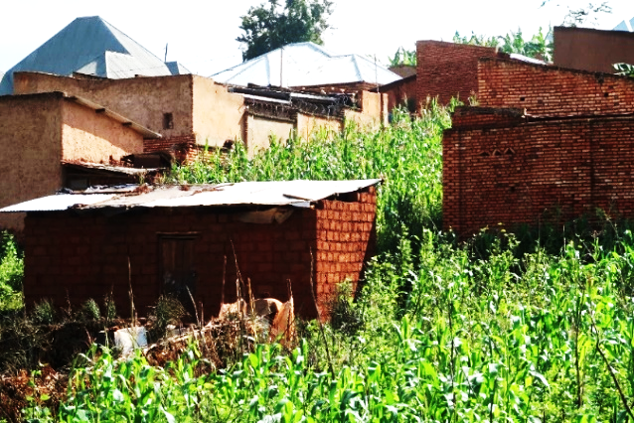
Photo 1: Unplanned construction of residential houses on steep slopes without respect for urban planning standards in KINYAMI I neighborhood of the study area (NDIKUMANA, October 2024)

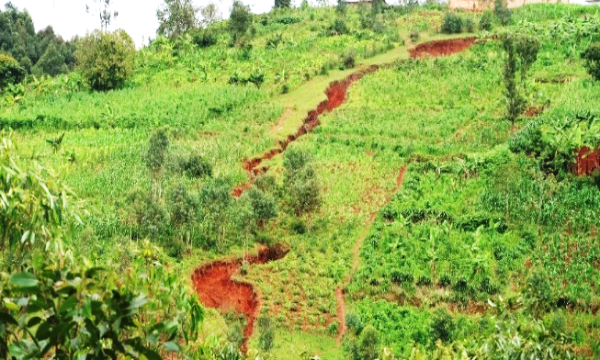
Photo 2: Watershed not protected by contour lines, infiltration ditches, soil-stabilizing grasses, anti-erosion hedges, or masonry drainage channels in the MUREMERA-SAMUTUKU neighborhood of the study area (NDIKUMANA, October 2024)
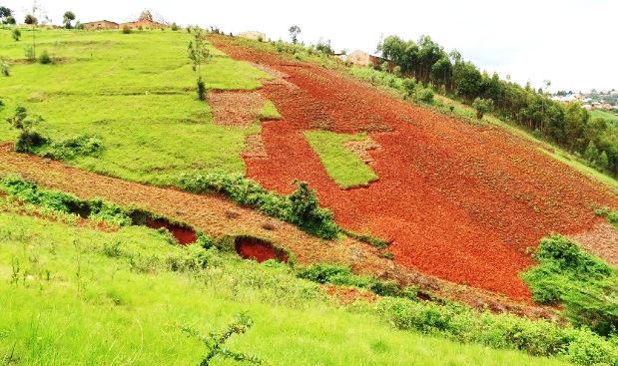
Photo 3 : Exploitations agricoles sur la zone à forte pente sans protection dans le quartier Muremera-sous colline de Nyabusorongo de la zone d’étude (NDIKUMANA, octobre 2024)
3.1.3. Prioritization by respondents of existing natural disasters in the study area
First, the respondents state that the loss of soil fertility leads to a decrease in agricultural yields and consequently causes famine within the community.
In second place, gully erosion occurs, which leads to the loss of agricultural land, the destruction of biodiversity, and damage to other immovable or movable property.

In third place, there is prolonged lack of rainfall, which causes drought affecting crops and vegetation and consequently leads to reduced agricultural yields and the emergence of famine.
Finally, in fourth place, there are torrential rains, which particularly damage crops and, more generally, biodiversity. They also cause soil erosion, contribute to the loss of soil fertility, lead to water pollution, and result in the destruction of movable and immovable property.
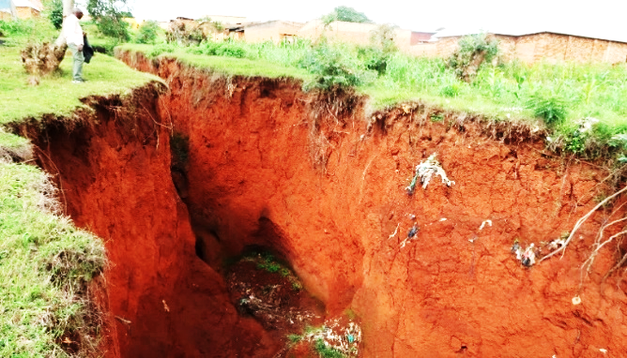
Photo 4: A large gully resulting from the lack of watershed protection through infiltration ditches, soil-stabilizing grasses, anti-erosion hedges, and masonry drainage channels in the RUSUGUTI neighborhood of the study area (NDIKUMANA, October 2024).
3.1.4. Identification and prioritization by respondents of mitigation and resilience strategies for natural risks and disasters in the study area
Thus, if the city land-use master plan is properly established and implemented, followed by the construction of masonry drainage channels for rainwater leading to the lowlands, the installation of soak pits intended for wastewater in residential and service areas, the establishment of contour lines, soil-stabilizing grasses, infiltration ditches, and fascines on steep slopes, the adoption of agroforestry practices in agricultural farms, the establishment of solid and liquid waste management units in the city, and finally the rapid control and elimination of gullies that occur, the current situation could improve. All these conditions would contribute to mitigating the risks that exist in the study area.
3.1.5. Determination of existing techniques for risk prevention and natural disaster management in the study area
There is a low level of implementation of good practices, such as the rational use of the urban perimeter of Ngozi based on an appropriate city land-use master plan, the construction of masonry drainage channels for rainwater leading to the lowlands, the installation of soak pits intended for wastewater in residential and service areas, the establishment of contour lines, soil-stabilizing grasses, infiltration ditches, and fascines on steep slopes, and the rapid control and elimination of gullies when they occur.
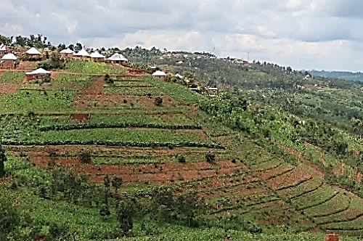
Furthermore, there is a moderate level of implementation of agroforestry practices in agricultural farms.
Photo 5: Contour lines with their vegetation on Muremera Hill
(NDIKUMANA, October 2024)

3.1.6. Detailed and quantified consequences related to natural disasters reported by respondents for the period 2012–2024 in the study area
In a very detailed and quantified manner, many unfortunate events corresponding to the susceptibility of the seven neighborhoods to natural risks and disasters were reported. These include heavy rainfall in the study area, which led to the formation of 24 gullies, some reaching 15 m in depth and 15 m in width. These gullies have already claimed 36 human lives, while 19 other people suffered severe accidents.
These 24 gullies, extending from north to south, east to west, and from the center of the urban perimeter of Ngozi, have already engulfed 19.2 hectares of agrosylvopastoral land.
Furthermore, between 2012 and 2024, 270 houses were destroyed by heavy rainfall, and 14 people were killed by lightning strikes that accompanied these rains in the study area. Fifteen domestic animals from these localities also became victims.
A significant loss of agrosylvopastoral production has been recorded in areas affected by these very long gullies. Some of them reach up to 1.9 km in length, 15 m in depth, and 15 m in width. Agricultural activities in these areas have largely been abandoned due to the invasion of these gullies, which could contribute to food insecurity among the populations living in these localities.
Since these gullies have developed in an urban environment, they have also led to a reduction in the size of land plots and building areas, especially in the context of the continuous expansion of the city and the growth of the village population.

4. Discussion of the results
All the results presented above are also consistent with those of Elodie (2011), who stated that soil cracking appears after a long period of drought. Along these cracks, water can flow and penetrate deeply. Elodie (2011) further indicates that degraded soils are generally found in highly anthropized areas, which suggests that human activities play a central role in soil degradation.
Regarding vulnerability to natural risks and disasters, VUSSC (2018) shows that all societies are vulnerable to disasters, whether natural or human-induced. The lack of satisfaction of basic needs such as physical safety, food security, and physical protection, combined with the fear of uncertainty, can lead to stress and trauma, resulting in a lack of emotional security.
Elodie (2011) also states that vegetation cover is a key element in protection against erosion.
Furthermore, the soils of the region, which are naturally poor and fragile, have difficulty resisting the effects of rainfall and runoff (FEODOROFF, 1965 in MIETTON, 1988).
HEITZ (2005) shows that risks and disasters of natural origin are linked to hazards that evolve slowly. They indirectly cause the majority of losses in human lives, property, and buildings. Moreover, natural risks and disasters are characterized by occurrences that are difficult to predict; their impacts may be amplified by unexpected dominant effects, and indirect impacts are frequent.
A confirmed disaster will have consequences on the territory. These consequences are reflected in human, economic, social, and ecological impacts, as well as in the disorganization of territories.
Regarding the existence of natural disasters in the study area, Abdessalem et al. (2016) indicate that disasters are recognized in the humanitarian and development sectors as situations involving a major and widespread disruption of life within a community or society, from which most people cannot recover without assistance from others, often from outside the affected community or society.
They generally involve significant losses of human lives, infrastructure, and other assets, and they affect the well-being, safety, health, and livelihoods of affected populations. Some disaster effects are immediate and may be worsened by the way populations respond to the situation and attempt to recover from it.
Conclusion
The population of the study area has a limited understanding of the concepts of risk prevention and natural disaster management, mainly due to the lack of education and awareness on these issues.
The surveyed population identified and ranked the causes of the natural risks prevailing in the study area, which helped clarify the situation. Unplanned construction of residential houses and private service buildings, as well as the lack of knowledge of the risk prevention and natural disaster management plan, which is not well developed or known by the population, appear to be the leading causes of the major risks responsible for the current situation.
By analyzing the results obtained, it appears that the culture of adopting techniques for the prevention and management of natural risks and disasters in the study area is not yet well developed within the local communities.

REFERENCES
ACF, 2012. EPVC Exercise. Action Against Hunger, Burkina Faso.
Ahmadou A.M., Sanoussi A., and Ilaria T. (eds.), 2019. Agricultural Risk Management: Theory and Applications in the Sahel and West Africa. Rome: PARM (Platform for Agricultural Risk Management) / IFAD. PARM (in collaboration with UCAD – Cheikh Anta Diop University – and the Regional Center (CRA), AGRHYMET CILSS – Permanent Inter-State Committee for Drought Control in the Sahel).
Benson C. et al., 2007. Tools for Integrating Disaster Risk Reduction: Guidance Notes for Development Organizations.
Bernard G., 2004. Challenges related to disaster prevention in metropolitan areas: the example of Givors in the Lyon metropolitan area (France).
D’Ercole R., Thouret J.C., Aste J.P., Dollfus O., Gupta A., 2015. Urban growth and natural risks: introductory presentation. Doctoral School No. 579. Mechanical and Energy Sciences, Materials and Geosciences (SMEMaG).
Gemenne F., Blocher J.M.D., De Longueville F. et al., 2019. Climate change, natural disasters, and population displacement in West Africa.
GIZ, 2017. Training Guide: Risk Prevention and Disaster Management at the Municipal Level in Burundi.
Le Gall M., 2016. Solid Earth: Geodynamics of the Upper Envelopes.
Marcin, 2023. Challenges for Disaster Response and Management.
United Nations, 2009. International Strategy for Disaster Reduction: Draft African Regional Strategy for Disaster Risk Reduction.
Nicolas V., 2018. Perception of risks and climate change in densely populated coastal areas. In Environment, Risks & Health.
Nyengayenge D., 2002. Case study of exemplary forest management in Central Africa: Participatory management of Magara Forest plantations in Burundi. Conservation and sustainable management of Central African tropical rainforest ecosystems

