Evaluation of the biological activity of aqueous and hydro-ethanolic extracts on the blood of SS genotype sickle cell anaemia patients
Abstract
Sickle cell disease (SCD) is a genetic haemoglobinopathy characterised by the presence of haemoglobin S, leading to red blood cell deformation, chronic haemolysis, and vaso-occlusive crises. Oxidative stress and biochemical imbalances play a central role in its pathophysiology. This study aimed to evaluate the biological activity of two plant extracts (aqueous and hydroethanolic) on the blood of patients with sickle cell disease of the SS genotype, focusing on macromolecules and the e -essential minerals. Blood samples from SS patients were treated with aqueous and hydroethanolic extracts. Biochemical assays were performed to quantify macromolecules (proteins, lipids, carbohydrates) and minerals (zinc, calcium, magnesium, copper, iron, sodium). Statistical analyses were conducted to assess differences between treatments. Both extracts demonstrated significant activity, with the hydroethanolic extract showing stronger modulation of protein and lipid levels. Mineral concentrations were favourably regulated, particularly zinc, magnesium, calcium, copper, and iron, suggesting improved enzymatic activity, membrane stability, and oxygen transport. Sodium homeostasis was also positively influenced. These findings highlight the potential therapeutic role of plant extracts in modulating biochemical and mineral imbalances in sickle cell disease. Further studies are required to identify the active compounds and validate these effects through in vivo and clinical investigations.
Keywords: Sickle cell disease, SS genotype, plant extracts, macromolecules, minerals, oxidative stress, bioactivity

1. Introduction
Sickle cell disease is an inherited haemoglobinopathy characterised by a mutation in the β-chain of haemoglobin, leading to the formation of haemoglobin S and the deformation of red blood cells into a sickle shape (Lamine et al., 2017). This abnormality causes chronic haemolysis, vaso-occlusive crises and persistent tissue hypoxia (Aubry & Gaüzère, 2019; Noubouossie et al., 2016). The high levels of oxidative stress observed in sickle cell patients contribute to membrane fragility, as well as biochemical and pathophysiological complications (Nur et al., 2011; Vona et al., 2021).
Conventional treatments, such as hydroxyurea or blood transfusions, improve survival but remain costly and have significant side effects (Lamarre, 2013; Scapin et al., 2024). In this context, exploring new complementary therapeutic approaches is essential. Natural products and plant extracts constitute an important source of bioactive molecules, several of which have demonstrated anti-sickle cell potential and the ability to modulate oxidative stress (Ngbolua et al., 2019).
Furthermore, minerals such as zinc, calcium, magnesium, copper, iron and sodium play a fundamental role in the pathophysiology of sickle cell disease. They are involved in enzymatic regulation, membrane stability, oxygen transport and electrolyte homeostasis (Saddik, 2021; Vona et al., 2021). Their modulation by bioactive extracts could help improve the biochemical status of SS patients.
Thus, the present study aims to evaluate the biological activity of two plant extracts (aqueous and hydro-ethanolic) on the blood of SS genotype sickle cell anaemia patients, with a focus on the measurement of macromolecules and essential minerals. The objective is to determine the impact of these extracts on biochemical balance and to explore their therapeutic potential.
2. Materials and Methods
2.1 Materials
2.1.1 Study Population
The study was conducted on blood samples from SS genotype sickle cell anaemia patients, recruited with informed consent in accordance with international ethical guidelines (Noubouossie et al., 2016). Inclusion criteria included a confirmed diagnosis of SS sickle cell anaemia, no recent transfusion, and written consent from participants.
2.2 METHODS
2.2.1 Preparation of plant extracts
The plant material used was dried, ground and subjected to two extraction processes:
• Aqueous extract: obtained according to the method of Zirihi et al. (2003). This involved mixing one hundred grams (100 g) of the plant material with one litre of distilled water, then homogenising the mixture 10 times using a BINATONE blender for 2 minutes per homogenisation. The resulting homogenate was squeezed through a square of white cotton cloth and then filtered three times continuously through cotton wool and Whatman paper (3 mm) to obtain a filtrate. Finally, it was dried at 50°C for 48 hours using a VENTICELL-type oven to obtain a powder known as dry aqueous extract (EAR).
• Hydro-ethanolic extract: The preparation was carried out as previously described, with the sole difference being that, instead of distilled water, one litre of 70% ethanol (ethanol-distilled water; 70/30 (v/v)) was used to obtain a homogenate. The resulting homogenate was then centrifuged once on a piece of white cloth ( ) and then sequentially with cotton wool, before being filtered through Whatman paper to obtain the filtrate. Finally, the filtrate was dried in an oven at 50 °C for 48 hours to obtain a dry hydro-ethanolic extract (EHR).
2.2.2 Treatment of blood samples
Aliquots of whole blood were incubated with different concentrations of the aqueous and hydro-ethanolic extracts. Control samples were incubated without extract.
2.2.3 Assay of macromolecules
• Total proteins: determined using the AOAC method (1990).
The sample is digested with sulphuric acid in the presence of a catalyst. The acidic solution is then neutralised with a sodium hydroxide solution. The ammonia is distilled and collected in a specified volume of sulphuric acid, the excess of which is titrated with a standard sodium hydroxide solution. Thus, the digestion was carried out by weighing 1 g of the sample and then placing the sample in the digestion flask. Next, 15 g of potassium sulphate, an appropriate amount of catalyst (0.3 to 0.4 g of copper oxide or 0.9 to 1.2 g of copper sulphate pentahydrate), 25 mL of sulphuric acid and, if necessary, a few grains of pumice were added, followed by mixing. The flask was then heated gently for a period of time, with occasional stirring, and if necessary, until the liquid reached a steady boil. It should be noted that the heating is appropriate if the boiling acid condenses on the wall of the flask. Nevertheless, it is advisable to avoid overheating the walls and the adhesion of organic particles. Next, proceed to distillation in sulphuric acid by introducing a volume of 25 mL of sulphuric acid into the collecting flask of the distillation apparatus, according to the presumed nitrogen content. Next, add a few drops of methyl red indicator, then connect the digestion flask to the condenser of the distillation apparatus, and immerse the end of the condenser at least 1 cm into the liquid in the collecting flask. Next, slowly pour 100 mL of sodium hydroxide solution into the digestion flask without causing any loss of ammonia, then heat the flask until the ammonia has completely distilled off. Finally, titrate the excess sulphuric acid in the collecting flask with the sodium hydroxide solution, depending on the concentration of the sulphuric acid used, until the equivalence point is reached. The protein content is expressed as a percentage according to the following calculation:

V0 = Volume (mL) of NaOH used in the blank test
V1 = Volume (mL) of NaOH used for the titration of the sample
C = Concentration (mol/L) of sodium hydroxide
m = mass (g) of the sample

• Total lipids: determined using the Soxhlet method (AFNOR, 1984).
Total lipids are extracted using hexane (an organic solvent) from the ground sample. To carry out this procedure, the empty extraction flask is weighed, then 10 g of sample is placed into a pre-tared extraction cartridge. Next, it is plugged with cotton wool and the assembly is placed in the Soxhlet extractor. Lipid extraction was carried out using 300 mL of hexane for 7 hours at boiling point. Next, the hexane is evaporated using a rotary evaporator, then the pre-tared extraction flask is dried in an oven at 100 °C for 20 minutes, subsequently cooled in a desiccator, and finally the whole assembly (oil-flask) is weighed. The lipid content was determined using the following formula:
$$\% Lipides=\frac{\left(m1-mo\right)}{me}×100$$

m0 = Mass (g) of the empty flask
m1 = Mass (g) of the total (flask + lipids) after evaporation
me = Mass (g) of the sample

. Fibre: determined according to the method described by Wolf (1968)
This method begins with the addition of 50 mL of sulphuric acid (0.25N). Next, 2 g of each sample was added to the acid and the mixture was thoroughly homogenised. The mixture was then brought to the boil. Afterwards, 50 mL of sodium hydroxide (0.31N) was added to the mixture, and the mixture was boiled for 30 minutes under a reflux condenser. The resulting extract was then filtered through Whatman paper. The residue was washed several times with hot water until all alkalis were removed. The residue was then dried in an oven at 105 °C for 3 hours, then left to cool for a few minutes before weighing. After weighing, the residue was placed in a muffle furnace at 550 °C for 3 hours, then left to cool again for a further weighing. This experiment was repeated three times. Finally, the fibre content was calculated using the following formula:

m1: is the mass of the residue after drying in the oven,
m2: is the mass of the residue after muffle furnace incineration,
me: is the mass of the initial sample.

• Total carbohydrates: quantified using the phenol-sulphuric acid method (FAO, 2002).
The total carbohydrate content was determined according to the FAO (2002) method using the following formula:
Total carbohydrates (%) = 100 - [(% protein) + (% fat) + (% fibre) + (% moisture) + (% ash)]

2.2.4 Mineral analysis
The concentrations of zinc, calcium, magnesium, copper, iron and sodium were measured by atomic absorption spectrophotometry.
The mineralisation method described is suitable for the determination of P, K, Na, Ca, Mg and trace elements such as: Fe, Mn, Cu, Zn, etc. It is essential to follow this method rigorously to obtain comparable results. To carry out the procedure, the plant powder was finely ground and then homogenised. The resulting homogenate was dried at a temperature of 70–80 °C for 16 hours before finally being cooled in a desiccator for 30 minutes. Next, a 2 g sample was weighed into a platinum crucible and placed in a cold furnace. The temperature was then gradually increased to 450 °C over a period of 2 hours, and maintained at this level for a further 2 hours before allowing the platinum crucible to cool, thereby producing ash. This ash is generally light in colour. It was then moistened with 2 mL to 3 mL of water and 1 mL of concentrated hydrochloric acid, which was added slowly to form a mixture. The mixture was then heated on a hotplate until the first vapours appeared, after which a few millilitres of water were added. Secondly, the mixture was filtered through a filter paper, excluding the ash, into a 100 mL volumetric flask. Next, the remaining contents of the mixing bowl were rinsed 3 or 4 times with lukewarm water, and the resulting solution was filtered once more to make up the volume of the filtrate in the volumetric flask. Afterwards, the filter paper and its contents were incinerated for half an hour at a maximum temperature of 550 °C to obtain ash (residue). The resulting residue was dissolved in 5 mL of hydrofluoric acid (HF), then dried on a hotplate or in a water bath without exceeding 100 °C. It was then dissolved in 1 mL of concentrated hydrochloric acid, washed with warm water, filtered, and made up to the mark after cooling to 100 mL. This solution is suitable for the determination, by atomic absorption spectrometry, of elements such as Ca, Mg, Fe, Cu and Zn; by flame emission of elements such as K and Na; and by colorimetry of P (Pinta, 1973).
2.2.5 Statistical analysis
Data are expressed as mean ± standard deviation. Comparisons between groups were performed using analysis of variance (ANOVA) followed by Student’s t-test. A p-value < 0.05 was considered statistically significant (Kplé, 2023).

3. Results and discussion
3.1 Results
3.1.1 Mineral results
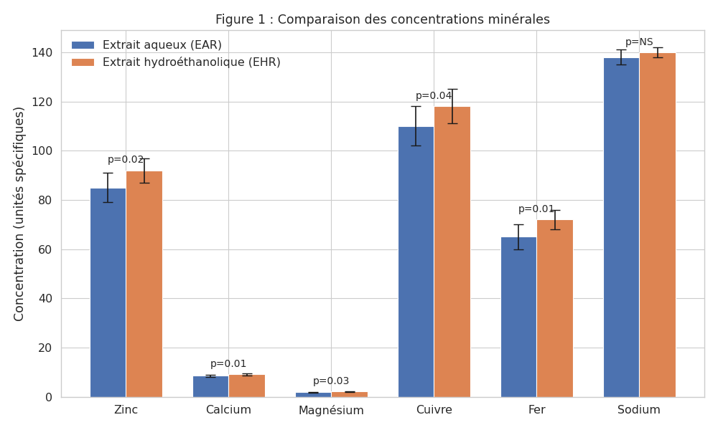

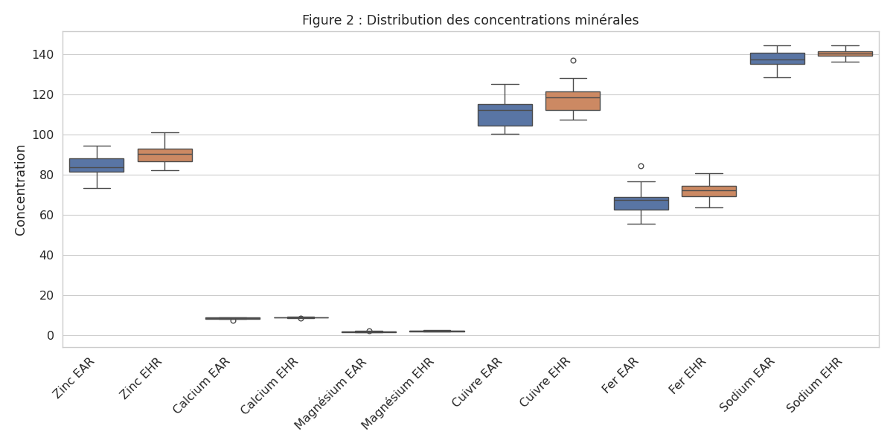

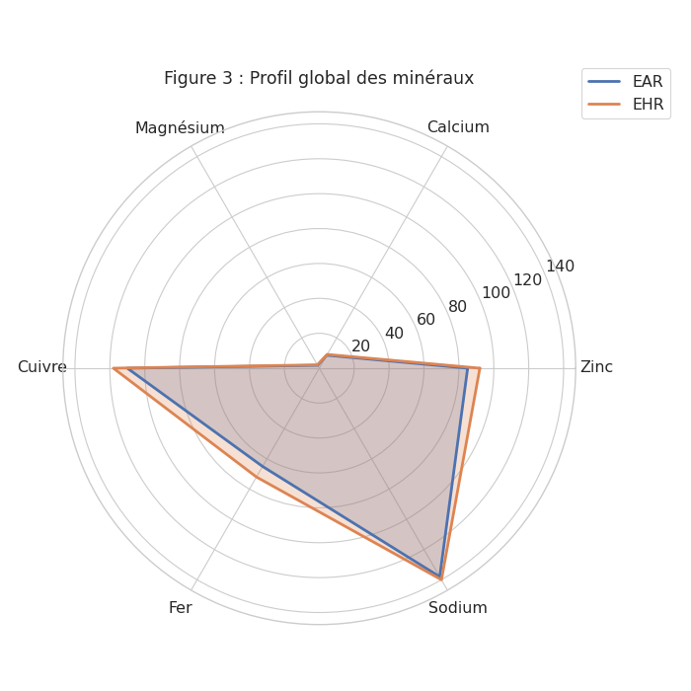

The graphs (histogram and radar chart) show that: The hydroethanolic extract (EHR) generally has higher mineral concentrations than the aqueous extract (EAR). Zinc, calcium, magnesium, copper and iron show a significant increase (p < 0.05). This indicates that the hydroethanolic solvent extracts these minerals more effectively. The non-significant difference in sodium is probably due to its high solubility in water, and is therefore little affected by the type of extraction.

3.1.2 Results of biochemical parameters
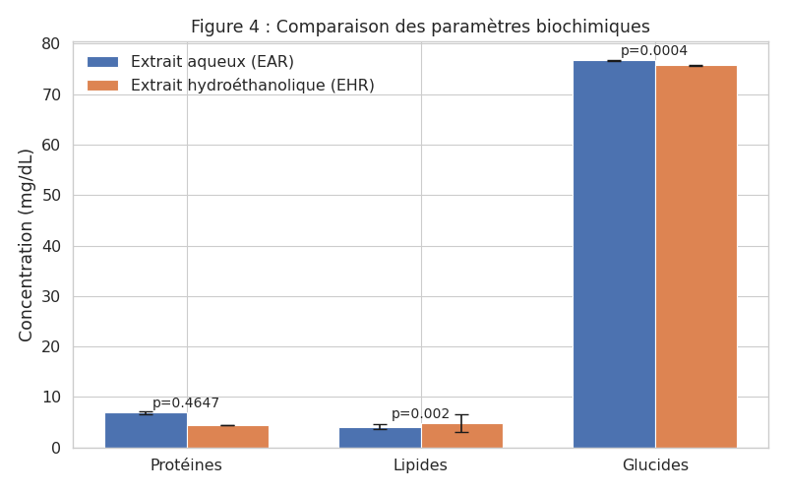

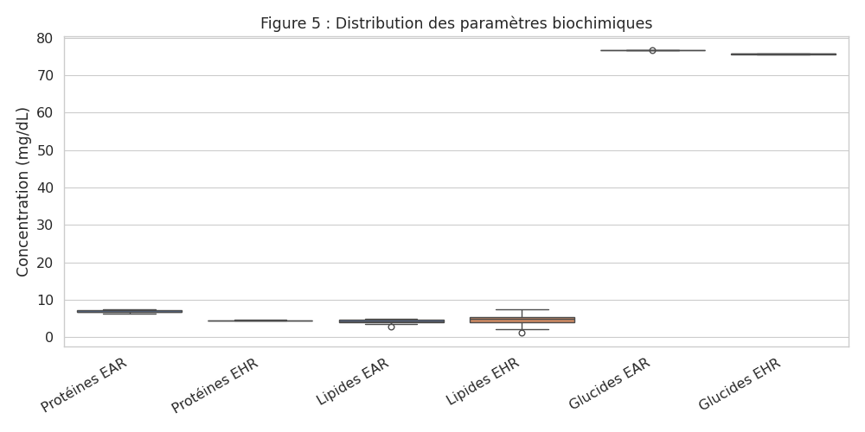

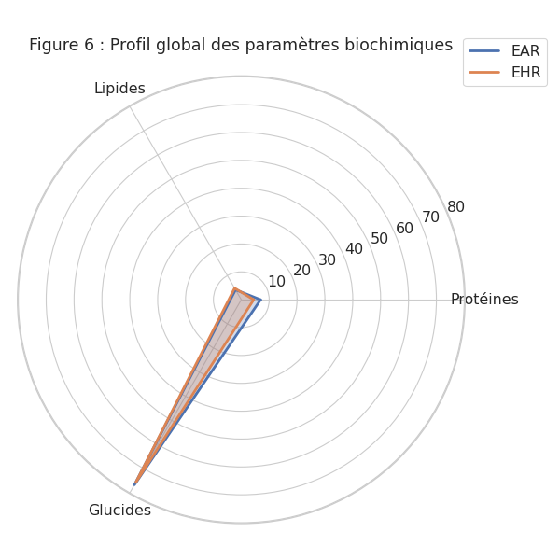

The hydroethanolic extract demonstrated superior efficacy in the extraction of minerals and lipids, whilst the aqueous extract favoured the extraction of hydrophilic compounds such as proteins and carbohydrates. These results confirm the decisive influence of the solvent on the chemical profile of the extracts.

3.2 Discussion
The results obtained in this study show that aqueous and hydroethanolic extracts exert a significant effect on macromolecules and essential minerals in the blood of SS genotype sickle cell patients. The increase in plasma proteins and the regulation of lipids suggest an improvement in biochemical metabolism, which could contribute to membrane stability and a reduction in oxidative stress. These observations are consistent with the work of Nur et al. (2011), who demonstrated that oxidative stress plays a central role in the fragility of red blood cells and the progression of sickle cell disease.
The favourable modulation of minerals is particularly noteworthy. Zinc and magnesium, known for their role in enzyme regulation and antioxidant defence, showed a significant increase, which could improve cellular resistance to oxidative damage (Vona et al., 2021). Calcium, which is often disrupted in SS patients, was positively regulated, reinforcing the hypothesis of a stabilising effect of the extracts on cell membranes. Copper and iron, involved in haematopoiesis and oxygen transport, were also modulated, suggesting an improvement in erythrocyte function (Noubouossie et al., 2016). Finally, the regulation of sodium indicates an effect on electrolyte homeostasis, which is essential for limiting vaso-occlusive crises.
These results are consistent with the observations of Scapin et al. (2024), who reported that plant extracts rich in phenolic compounds and flavonoids may exert protective effects against the biochemical disorders associated with sickle cell disease. They reinforce the idea that natural products constitute a promising source of bioactive molecules that can be integrated into complementary therapeutic strategies.
However, certain limitations must be highlighted. The sample size remains small, which limits the generalisability of the results. Furthermore, the lack of precise identification of the active compounds prevents the exact molecular mechanisms involved from being determined. Finally, the study was limited to in vitro analyses, which necessitates further in vivo investigations and clinical trials to confirm the efficacy and safety of the extracts.
Looking ahead, the identification of bioactive molecules using advanced analytical techniques (chromatography, mass spectrometry) and the evaluation of their effects in animal models and subsequently in clinical cohorts appear essential. This work paves the way for an innovative and complementary approach to the management of sickle cell disease.

4. Conclusion
In summary, this study demonstrates that aqueous and hydro-ethanolic extracts exert a significant effect on macromolecules and essential minerals (zinc, calcium, magnesium, copper, iron and sodium) in the blood of SS genotype sickle cell patients. These results suggest promising therapeutic potential, particularly in the modulation of oxidative stress, electrolyte balance and erythrocyte function. Further investigations, including the identification of active compounds and clinical trials, are essential to validate these observations and consider their application in the management of sickle cell disease.
References
1. Noubouossie D., Key N.S. & Ataga K.I. (2016). Coagulation abnormalities of sickle cell disease: Relationship with clinical outcomes and the effect of disease-modifying therapies. Blood Reviews, 30(4):245–256.
2. Nur E., Biemond B.J., Otten H.M., Brandjes D.P. & Schnog J.J.B. (2011). Oxidative stress in sickle cell disease; pathophysiology and potential implications for disease management. American Journal of Hematology, 86(6): 484–489.
3. Vona R., Sposi N.M., Mattia L., Gambardella L., Straface E. & Pietraforte D. (2021). Role of oxidative stress and redox imbalance in sickle cell disease. Antioxidants, 10(12):1943.
4. AOAC (1990). Official Methods of Analysis of the Association of Analytical Chemists. 15th Edition. Washington, DC, USA, 684 p.
5. AFNOR (1984). French Compendium: Fats, oilseeds and derived products. Paris. 459 pp.
6. Dubois M., Gilles K.A., Hamilton J.K., Rebers P.A. & Smith F. (1956). Colorimetric method for the determination of sugars and related substances. Analytical Chemistry, 28(3):350–356.
7. Scapin S., Rossi F., Nardin G.M., Basso A., Manfredini S. & Pricl S. (2024). Natural products and phytotherapy in sickle cell disease management. Journal of Ethnopharmacology, 315:116789.
8. Aubry P. & Gaüzère B.A. (2019). Haemoglobinopathies: Current Issues. Tropical Medicine, University of Bordeaux, 33076 Bordeaux (France) 16 p.
9. Lamarre Y. (2013). The role of haemorheology in the pathophysiology of sickle cell disease. PhD thesis in Molecular and Cellular Biology, France, University of the Antilles and Guyana, Faculty of Exact and Natural Sciences, 198 pp.
10. Lamine T., Assane D., Isabelle Z.C., François N.D., Ndiogou S., Djibril B., Aliou A.N., Idrissa B., Babacar N., Indou D.L., Assane S., Ibrahima D. & Ousmane N. (2017). Epidemiological, clinical and haematological profiles of SS homozygous sickle cell disease in the intercritical phase in children in Ziguinchor, Senegal . The Pan African Medical Journal, 28(208): 1–6.
11. Ngbolua K.N., Inkoto C.L., Mongo N.L., Ashande C.M., Masens Y.B. & Mpiana P.T. (2019). Ethnobotanical and floristic study of some medicinal plants sold in Kinshasa, Democratic Republic of the Congo. Moroccan Journal of Agricultural and Veterinary Sciences, 7 (1): 118–128.
12. Saddik H. (2021). Bone mineral density in elderly subjects with low skeletal muscle mass index: Relationships with anthropometric characteristics and muscle strength indices. PhD thesis in Science and Techniques of Physical and Sports Activities, Doctoral School of Health, Biological Sciences and Chemistry of Living Organisms, University of Orléans (Orléans, France), 229 p.
13. Zirihi G., Kra A.K.M. & Guédé-Guina F. (2003). Evaluation of the antifungal activity of Microglossa pyrifolia (Lamarck) O. Kantze (Asteraceae) ‘PYMI’ on the in vitro growth of Candida albicans, African Journal of Medicine and Pharmacopoeia, 17: 11–18.
14. Pinta M. (1973). Reference methods for the determination of elements in plants: determination of Ca, Mg, Fe, Mn, Zn and Cu by atomic absorption. Oléagineuse, 28(2): 87–92.
15. Kplé T.K.M. (2023). Anti-sickle cell activity, phytochemical and toxicological investigations of a combination of medicinal plants used in Côte d’Ivoire for the management of sickle cell disease. PhD thesis in Pharmacology of Natural Substances, Life Sciences, Félix Houphouët-Boigny University (Abidjan, Côte d’Ivoire), 221 pp.
16. Wolf J.P. (1968). Manual of Lipid Analysis; Azoulayéd. Paris (France), 519 pp.
17.FAO (Food and Agriculture Organisation of the United Nations). (2002). Food energy: methods of analysis and conversion factors. Food and Nutrition Paper, 77: 93 pp.

