Original Research Article

Elaeagnus angustifolia L. Fruits as a Source
of Bioactive Phenolic Compounds: Pharmacognostic and Nutraceutical Implications

.
ABSTRACT

Aims: The present study aimed to evaluate the phenolic composition of aqueous extracts obtained from Elaeagnus angustifolia fruits and to investigate the influence of extraction temperature on the distribution and stability of bioactive compounds.
Study design: This study represents an experimental phytochemical investigation focused on the effect of thermal extraction parameters. The study was carried out in a laboratory setting using plant material collected from the Romanian geographical area.
Methodology: Aqueous extracts of Elaeagnus angustifolia fruits were prepared under three thermal conditions: cold extraction, 50°C, and 80°C. The phenolic profile was analyzed, focusing on phenolic acids and flavonoids, in order to evaluate the effect of temperature on compound extractability and stability.
Results: The analysis revealed the presence of representative phenolic acids and flavonoids in all extracts. Significant variations were observed depending on extraction temperature. Higher temperatures led to increased concentrations of sinapic acid and gallic acid, while epicatechin content decreased under intense thermal conditions, indicating differences in thermal stability among phenolic compounds.
Conclusion: The results support the pharmacognostic value of Elaeagnus angustifolia fruits as a source of bioactive compounds with antioxidant and anti-inflammatory potential. The findings highlight the importance of optimizing extraction parameters to obtain standardized extracts suitable for nutraceutical, phytotherapeutic, and dermato-cosmetic applications, and emphasize the potential of Romanian plant resources.

Keywords: Elaeagnus angustifolia L., phenolic compounds, pharmacognostic and nutraceutical value, bioactive metabolites, extraction optimization, anti-inflammatory potential

1. INTRODUCTION

Elaeagnus angustifolia L. (Elaeagnaceae), commonly known as oleaster, sălcioară, or “Russian olive”, is a perennial shrub reaching heights between 5 and 12 m (Zouhar, 2005), adapted to arid and semi-arid conditions across Eurasia. The species is characterised by lanceolate silvery leaves, fragrant flowers, and edible ovoid fruits traditionally used both as food and in phytotherapy (Khadivi, 2018). Scientific interest in this species has increased significantly in recent decades, particularly due to its complex phytochemical composition and associated biological potential (Carradori et al., 2020).
From an ethno pharmacological perspective, different parts of the plant have been used for their astringent, antitussive, anti-inflammatory, and carminative properties (Hamidpour et al., 2017). Modern studies have confirmed multiple biological activities, including antioxidant, anti-inflammatory, antinociceptive, antiarrhythmic, hypolipidemic, wound-healing, antimicrobial, and gastroprotective effects, as well as antimutagenic and antitumour potential (Tehranizadeh et al., 2016; Farzaei et al., 2015; Okmen & Turkcan, 2013). In addition, certain therapeutic applications, such as the use in joint disorders, are supported by exploratory clinical data (Mahboubi, 2018; Karimifar et al., 2017), which further strengthens the relevance of this species in contemporary pharmacognostic research.
The phytochemical profile of E. angustifolia comprises secondary metabolites belonging to several chemical classes. Phenolic compounds represent one of the most extensively investigated groups (Zhang et al., 2022), being considered essential contributors to the pharmacognostic value of medicinal plants due to the diversity of their biological activities. Their involvement in the development of plant-derived pharmaceutical preparations is well documented (Sun & Shahrajabian, 2023). In addition to polyphenols, alkaloids, cardiotonic glycosides, sterols, terpenes, esters, ketones, phenyl ethers, pyrimidines, polysaccharides, and nutritional constituents such as amino acids, vitamins, and fatty acids have been identified in different plant organs (Sevindik et al., 2025; Farzaei et al., 2015).
Among flavonoids, aglycones and glycosides of isorhamnetin, kaempferol, and quercetin (including rutin) have been described (Carradori et al., 2020), while commonly reported phenolic acids include chlorogenic, caffeic, p-coumaric, and ferulic acids, with catechin and epicatechin completing the flavan-3-ol profile (Sevindik et al., 2025). Studies focusing on the fruits indicate a phenolic core comparable to that identified in leaves and flowers, but also a significant phytopharmaceutical contribution from the non-phenolic matrix: sugars, minerals, vitamins (vitamin C, tocopherols, carotenoids), and lipids (seed oil), which influence sensory and functional properties (Ayaz & Bertoft, 2001). The quantitative composition is influenced by geographical and pedoclimatic factors (Fakı et al., 2022; Simsek & Sufer, 2021), which justifies region-specific evaluations.
In the context of the development of functional foods and products with nutraceutical applicability, the fruits of E. angustifolia may represent a promising resource. Recent LC–MS analyses have identified more than 50 bioactive constituents in the fruits, including phenolic acids, flavonols and flavan-3-ols involved in anti-inflammatory mechanisms (Fu et al., 2025).
The correlation between phenolic composition and the reported biological activities supports the inclusion of this species within the category of products with functional value, positioned at the interface between food and medicine (Sahan et al., 2019; Öztürk et al., 2018).
A significant proportion of polyphenols is present in forms bound to the plant matrix through interactions with polysaccharides, lignin or proteins, which may limit their extractability by conventional methods (Shahidi & Hossain, 2023; Rocchetti et al., 2022). Consequently, extraction parameters — including solvent nature, solid:liquid ratio, temperature and contact time — may significantly influence the chemical profile obtained (Rocchetti et al., 2022; Ghandahari et al., 2019). Higher temperatures may facilitate the release of bound phenolic fractions, but may simultaneously accelerate the degradation of thermolabile compounds (Li et al., 2024).
Within the Romanian geographical area, existing research has focused predominantly on the vegetative organs of E. angustifolia or on volatile fractions (Bucur et al., 2007; Bucur et al., 2009), while data regarding the phenolic composition of fruits collected from the Black Sea coastal region remain limited. Considering the dependence of the phytochemical profile on ecotype and local environmental conditions, a specific characterization of plant material originating from this region was considered necessary.
On the other hand, analysis of the international literature indicates that research has mainly concentrated on antioxidant activity and the characterization of polyphenols, whereas the investigation of the influence of processing parameters on phenolic composition is less represented. Integrating a thematic analysis of research directions concerning E. angustifolia therefore allows the experimental results to be positioned within a broader scientific framework and highlights the contribution of the present study.
In this context, the objectives of the research were: the identification and quantification of selected phenolic compounds in fruits of Elaeagnus angustifolia L. collected from the Faleza Nord–Constanța area; the evaluation of the influence of extraction temperature on the phenolic profile; and the correlation of the experimental results with thematic research directions identified in the international literature. The adopted approach aims to substantiate the pharmacognostic value of the fruits and to provide reference points for optimizing extraction conditions for extracts intended for phytotherapeutic and nutraceutical applications.

2. Thematic analysis of research directions concerning the species Elaeagnus angustifolia

In order to contextualize the experimental results obtained in the present study and to evaluate their positioning within international research, a thematic analysis of the scientific literature on Elaeagnus angustifolia was conducted. A search of the Web of Science database using the terms “Elaeagnus angustifolia AND nutraceutical AND phenolic” generated a dataset of 100 publications, covering a period of approximately 50 years (1976–2026).
The co-occurrence analysis of keywords, performed using VOSviewer software, enabled the identification of the main thematic directions and the relationships among the dominant concepts within the field. This approach provides a synthetic overview of current scientific interests and facilitates the integration of the experimental results within the broader context of research concerning the nutraceutical and pharmacognostic potential of the species, as illustrated in Figure 1.
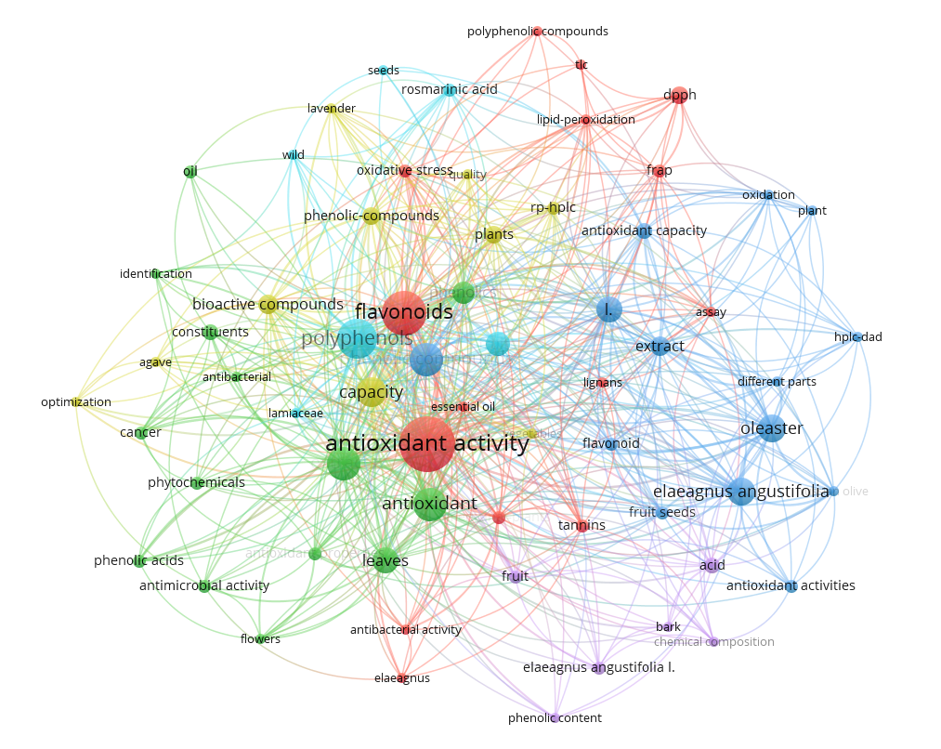
Figure 1. Co-occurrence analysis of the keywords “Elaeagnus angustifolia AND nutraceutical AND phenolic” in the Web of Science database

The co-occurrence analysis of keywords highlights a clear structuring of research on Elaeagnus angustifolia around four major thematic cores. Integrating these directions with the experimental results obtained in the present study allows the contextualization of our contribution. The keyword co-occurrence analysis revealed the existence of several distinct thematic clusters, reflecting the main research directions associated with the species Elaeagnus angustifolia. The central concept of the network is represented by the species name, around which terms such as “phenolic compounds”, “antioxidant activity”, “anti-inflammatory activity”, “extract”, and “bioactive compounds” are clustered. This distribution indicates a clear concentration of scientific interest on the biological potential of secondary metabolites, particularly polyphenols.
A first major cluster is associated with antioxidant activity, centered on terms such as “flavonoids”, “antioxidant activity”, “dpph”, “frap”, and “lipid peroxidation”, reflecting the dominant orientation of the literature towards evaluating the antioxidant capacity of extracts. The size and density of the connections around this core indicate that antioxidant activity represents the principal criterion for the valorization of the species. In this context, the identification and quantification of phenolic compounds according to temperature become relevant, as the variations observed in the content of sinapic acid and gallic acid may directly influence the antioxidant potential of the extracts.
A second cluster is centered on anti-inflammatory activity and therapeutic applications, bringing together terms such as “bioactive compounds”, “phytochemicals”, “phenolic acids”, “leaves”, and “antimicrobial activity”, indicating a broader phytochemical and biological approach. This structure suggests that the species is investigated both from the perspective of metabolic diversity and associated biological activities. Our results regarding the differentiated distribution of phenolic compounds depending on extraction conditions contribute to this direction by providing data on how technological parameters may influence the bioactive profile.
The third cluster (blue), organized around the terms “Elaeagnus angustifolia”, “oleaster”, “extract”, “hplc-dad”, and “different parts”, highlights the concern for compositional characterization and the analysis of different plant organs. The presence of this core confirms the interest in the standardization and identification of constituents; however, the relatively low connectivity of terms related to extraction process optimization suggests that this dimension remains insufficiently explored. The present study addresses this gap by evaluating the influence of temperature on the phenolic composition of the fruits.
The purple cluster, which includes “phenolic content”, “acid”, and “bark”, indicates a focus on the overall quantification of polyphenols and their distribution in different parts of the plant. Although this core is more limited, it underlines the importance of quantitative determinations in substantiating pharmacognostic value.
A notable aspect of the network is the absence of a distinct cluster explicitly associated with the term “nutraceutical”. This observation suggests that, although functional applications are implicitly linked to antioxidant activity and phenolic composition, the nutraceutical dimension has not yet been structured as an autonomous thematic direction. In this regard, our results may be considered a step towards strengthening this direction by providing relevant data for the standardization of extracts intended for use in products with functional value.
The integration of the experimental data with the identified thematic structure highlights that polyphenols represent the conceptual core of research on the species, while the optimization of extraction conditions has the potential to significantly influence the biological and nutraceutical applications of Elaeagnus angustifolia fruits. This correlation supports the pharmacognostic relevance of the study and indicates future research directions oriented towards standardization, complementary biological evaluations, and functional validation.

3. EXPERIMENTAL DETAILS

3.1. Plant material
Fruits of Elaeagnus angustifolia L. were collected from the Faleza Nord area, Constanța, Romania, during the period of physiological maturity. Species identification was performed based on morphological characteristics and by reference to existing botanical descriptions (Ciocârlan, 2000).
The analysed plant material consisted of the fruit pulp, manually separated from the seeds. The pulp was dried to constant weight in order to eliminate variations due to water content and subsequently finely ground to obtain a homogeneous powder.
For each experiment, 19.8 g of dried plant material (DW) were used, ensuring the constancy of the solid:liquid ratio in all extractions.

3.2. Chemicals and reference standards
The analytical standards used for the identification and quantification of phenolic compounds were: gallic acid, sinapic acid, chlorogenic acid, epicatechin, rutin, quercetin, and kaempferol.
Stock solutions were prepared in methanol at the following concentrations:
• gallic acid: 1 mg/mL
• kaempferol: 0.1 mg/mL
• sinapic acid: 0.2 mg/mL
• other compounds: 0.1–1 mg/mL, depending on solubility
Working solutions were obtained by successive dilutions in methanol or methanol:water so as to cover the linearity range of the method. All reagents used were of analytical grade.

3.3. Extraction method
Aqueous extracts were obtained using a constant solid:liquid ratio of 1:5 (g:mL), by adding 100 mL of distilled water to 19.8 g of dried plant powder.
The extractions were carried out under three distinct thermal conditions:
• cold extraction (2-8°C),
• extraction at 50°C,
• extraction at 80°C.
The extraction time was 30 minutes under controlled orbital agitation.
After completion of the process, the samples were cooled (where applicable), centrifuged and filtered through membranes with a pore size of 0.45 μm. The extracts were analysed either undiluted or subjected to an additional purification step depending on matrix interferences.

Solid-phase extraction (SPE) purification
In situations where the presence of sugars, organic acids or pigments affected the signal-to-noise ratio, solid-phase extraction was applied using C18 Supra-Clean cartridges (Perkin Elmer) (Solid-phase extraction was performed using C18 Supra-Clean™ cartridges (200 mg/3 mL, PerkinElmer, USA).) with an adsorbent bed of 200 mg/3 mL.
The procedure included:
• loading 12 mL of aqueous extract onto the cartridge,
• elution of the phenolic fraction,
• reconstitution to a final volume of 5 mL using a methanol:acetonitrile mixture (30:70, v/v),
• adjustment of the final volume to 100 mL.
The results were reported relative to the dry weight of the sample (µg/g DW).

3.4. Analytical determinations
The analysis of phenolic compounds was performed using an HPLC–PDA LC300 system (Simplicity Chrom), according to the methodology previously described (Chiriac et al., 2021).
Compound identification was carried out by comparing retention times and UV–Vis spectra with those of authentic standards. The wavelengths used were:
280 nm – epicatechin
325 nm – chlorogenic acid
330 nm – sinapic acid
356 nm – rutin
368 nm – quercetin and kaempferol
The chromatographic parameters of the standards are presented in the Results section.
Quantification was performed by external calibration using equations of the form:
y = a·x + b
where:
y = chromatographic peak area,
x = analyte concentration,
a = slope of the calibration curve,
b = intercept.
The concentration in the analysis vial (C_vial) was obtained by interpolation or by rearranging the calibration equation:
$$x=\frac{y-b}{a}$$
The results were expressed as µg/g dry plant material (DW), using the values provided by the instrument (mg/L or µg/mL) and taking into account the dilution factors and the volumes used.

For the case without an SPE step:
$$C_{DW}=\frac{\left(C_{extr}· DF · V_{extr}\right)}{m_{DW}}$$
where:
Vextr​=100 mL
DF = total dilution factor
M_{DW} =19.8 g
For the case involving an SPE step and reconstitution, the calculation included the ratio between the initial and final volumes, as well as the additional dilution factors.

3.5. Method validation
The analytical method was validated according to the ICH Q2(R2) guideline (Guideline, 2022). Validation of analytical procedures Q2 (R2). ICH: Geneva, Switzerland, 1. https://www.ich.org/page/quality-guidelines).
Calibration curves were constructed for each analyte using 5–7 concentration levels, obtaining determination coefficients (R²) ranging between 0.9996 and 0.99997, indicating excellent linearity.
The limits of detection (LOD) and limits of quantification (LOQ) were calculated using the following relationships:
$$LOD=\frac{3.3∙S_{y}}{a}$$
$$LOQ=\frac{10∙S_{y}}{a}$$
where:
Sᵧ = standard deviation of the residuals (RSE)
a = slope of the calibration curve
The LOD and LOQ values are presented in Table 1.

Table 1. Limits of detection (LOD) and quantification (LOQ) for the phenolic analytes

Analyte | LOD (µg/mL) | LOQ (µg/mL)
Gallic acid | 0.58 | 1.77
Sinapic acid | 0.051 | 0.15
Kaempferol | 0.051 | 0.15
Chlorogenic acid | 0.12 | 0.36
Epicatechin | 0.11 | 0.34
Quercetin | 0.12 | 0.35
Rutin | 0.42 | 1.26

3. results

The results regarding the identification and quantification of phenolic compounds detected in the fruits of Elaeagnus angustifolia revealed a structurally diverse profile from a phytochemical perspective, with direct implications for their potential applications.
HPLC–PDA analysis of aqueous extracts from E. angustifolia fruits revealed the presence of five major phenolic compounds: epicatechin, rutin, chlorogenic acid, gallic acid, and sinapic acid. Kaempferol was not detected in any sample, its value being below LOD/LOQ.
The concentrations in the extract (µg/mL) and those extrapolated to dry weight (µg/g DW) are presented in Table 2 (2a and 2b).
Table 2. Polyphenol content in aqueous extracts as a function of temperature
2a. Concentrations in the extract (µg/mL)
Temperature | Epicatechin | Rutin | Chlorogenic acid | Gallic acid | Sinapic acid
cold conditions | 3,5242 | 1,6028 | 0,8318 | 4,26 | 5,88
50°C | 3,1945 | 2,3949 | 0,8610 | 4,10 | 8,12
80°C | 2,4052 | 4,6375 | 1,1293 | 5,05 | 14,12
2b. Content in the plant (µg/g DW)
Temperature | Epicatechin | Rutin | Chlorogenic acid | Gallic acid | Sinapic acid
cold conditions | 17,8 | 8,09 | 4,20 | 21,5 | 29,7
50°C | 16,1 | 12,1 | 4,35 | 20,7 | 41,0
80°C | 12,1 | 23,4 | 5,70 | 25,5 | 71,3

To compare the phenolic profiles as a function of extraction temperature, aqueous extracts obtained under cold conditions, at 50°C and at 80°C were analyzed. The chromatograms recorded by HPLC–PAD are presented in Figures 2–4 and allow a direct comparison of the phenolic profile. The identification of each peak was carried out by correlating retention times and UV–Vis absorption maxima with the values determined for the analytical standards (Table 3), which enabled the selective confirmation of the compounds and the interpretation of signal variations according to the extraction temperature.

Table 3. Chromatographic parameters and PDA response for the analytical standardized for calibration
Nr.  crt. | Analyte | RT (min) | nm | Ref sol (µg/mL) | Peak area
1. | Chlorogenic acid | 8,76 | 325 | 50 | 3816,38
2. | Sinapic acid | 10,405 | 330 | 50 | 1509,00
3. | Gallic acid | 2,984 | 271 | 50 | 82,50
4. | Epicatechin | 9,606 | 280 | 50 | 626,64
5. | Rutin | 11,141 | 356 | 50 | 1228,43
6. | Quercetin | 12,373 | 368 | 50 | 2432,10
7. | Kaemferol | 13,00 | 368 | 50 | 1050,00

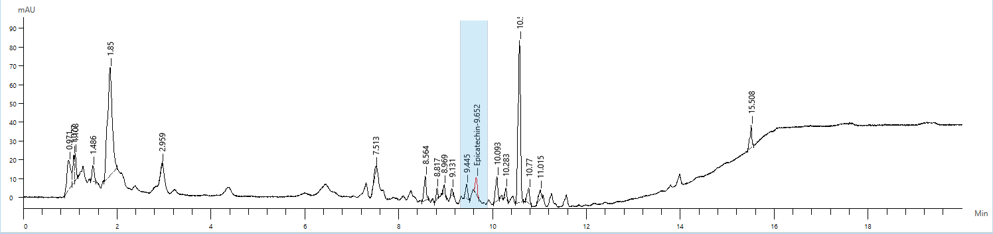
a. HPLC–PDA chromatogram, λ = 280 nm (Epicatechin), retention time – 9.652 min
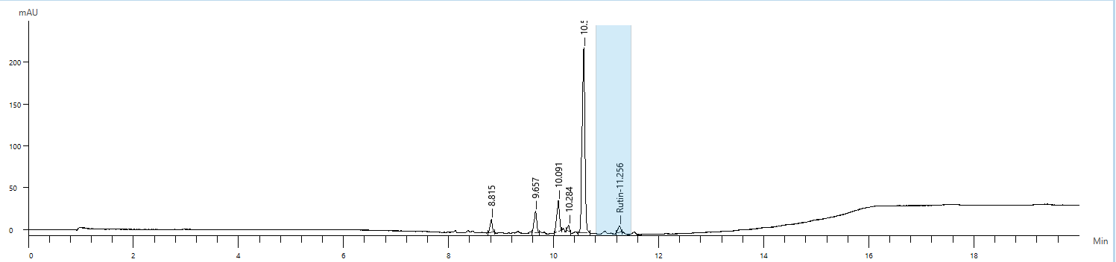
b. HPLC–PDA chromatogram, λ = 356 nm (Rutin), retention time – 11.256 min 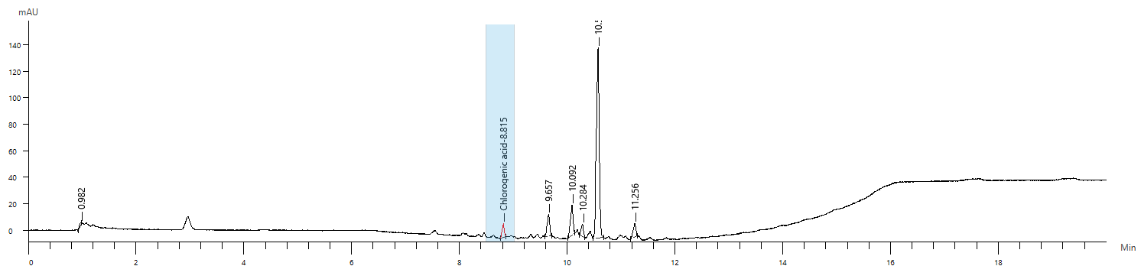
c. HPLC–PDA chromatogram, λ = 325 nm (Chlorogenic acid), retention time – 8.815 min
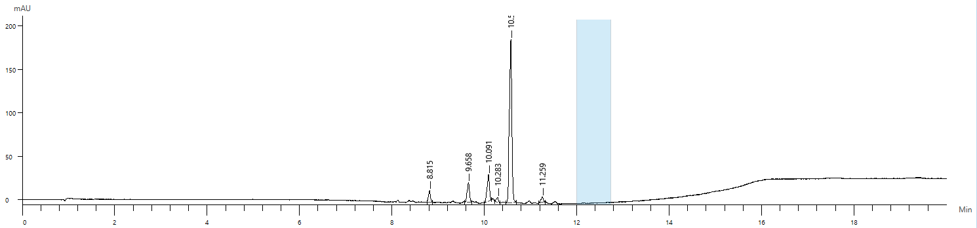
d. HPLC–PDA chromatogram, λ = 368 nm (Quercetin) – not detected 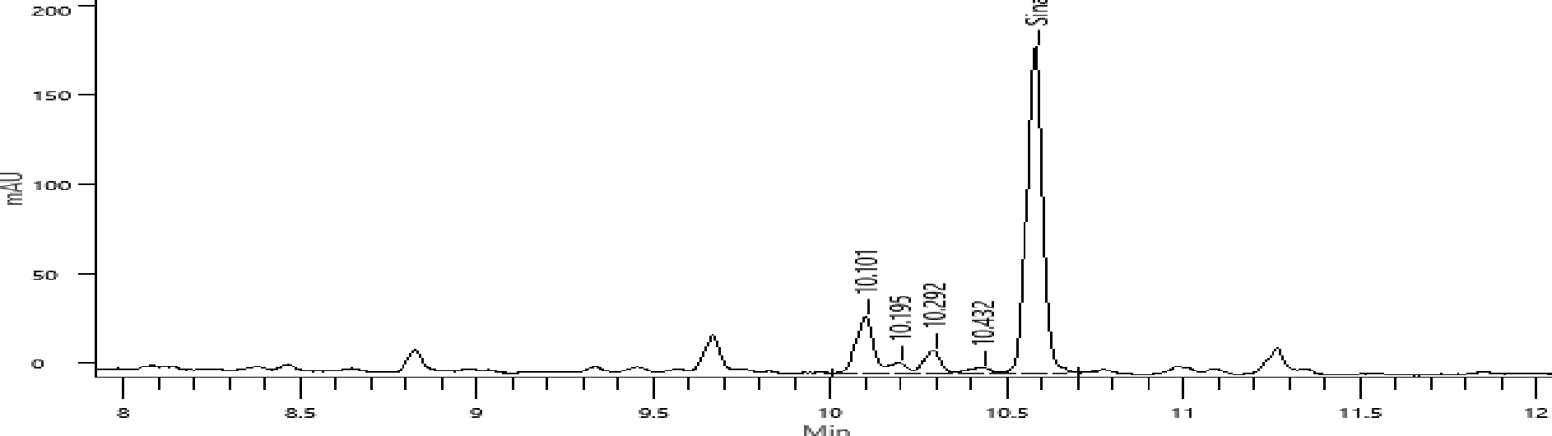
e. HPLC–PDA chromatogram, λ = 330 nm (Sinapic acid), retention time – 10.5 min

Figure 2a–e. Chromatograms of phenolic compounds in extracts obtained under cold extraction conditions

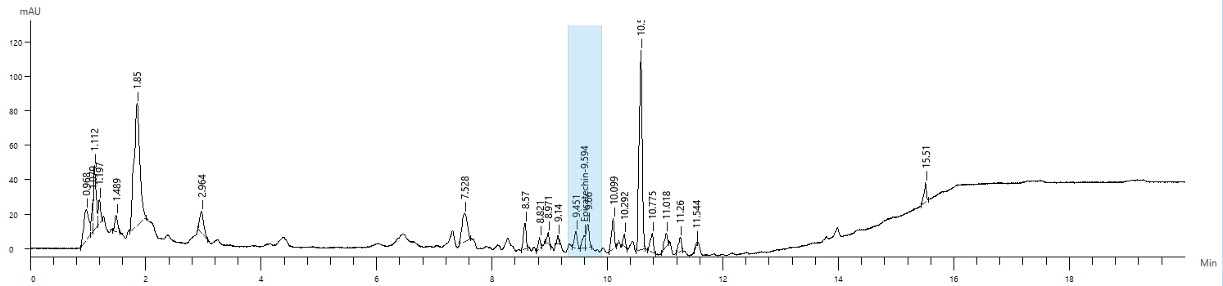
a. HPLC–PDA chromatogram, λ = 280 nm (Epicatechin), retention time – 9.594 min
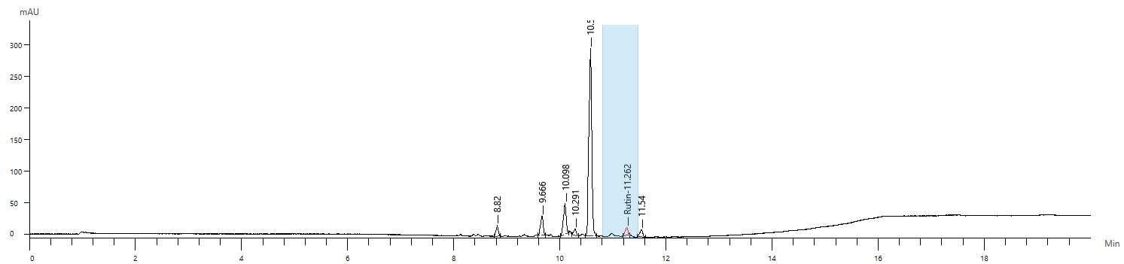
b. HPLC–PDA chromatogram, λ = 356 nm (Rutin), retention time – 11.262 min
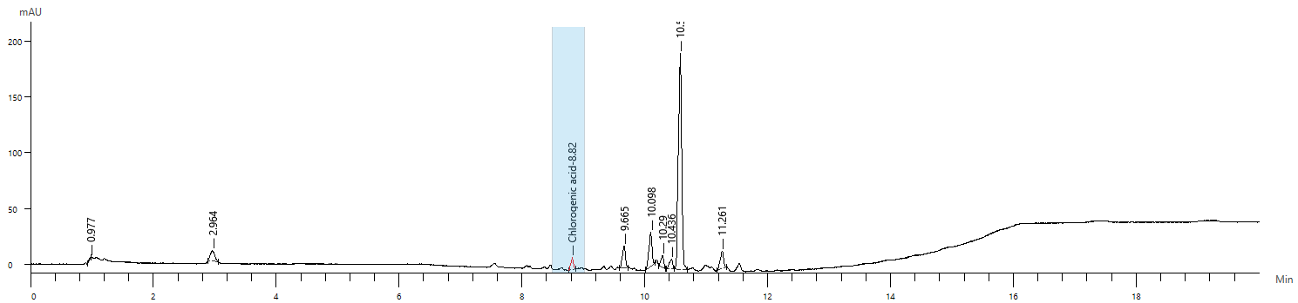
c. HPLC–PDA chromatogram, λ = 325 nm (Chlorogenic acid), retention time – 8.820 min
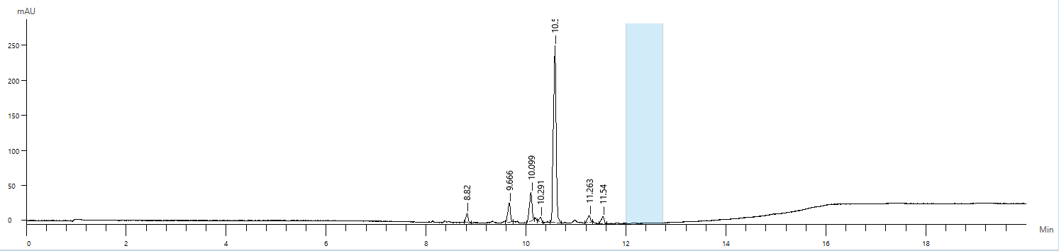
d. HPLC–PDA chromatogram, λ = 368 nm (Quercetin) – not detected
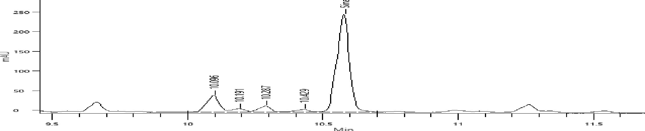
e. HPLC–PDA chromatogram, λ = 330 nm (Sinapic acid), retention time – 10.5 min

Figure 3a–e. Chromatograms of phenolic compounds in extracts obtained at 50°C
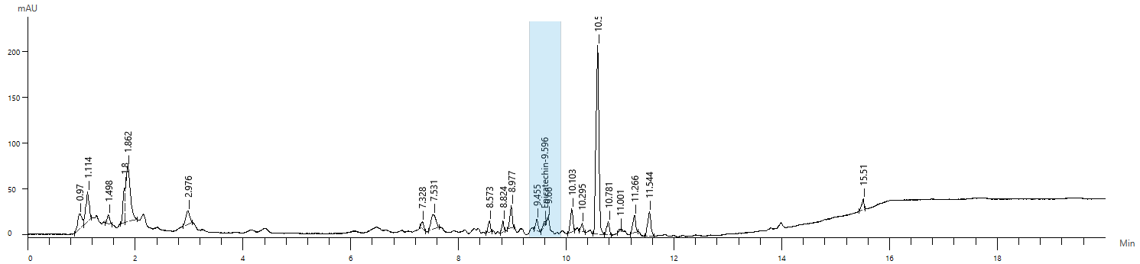
a. HPLC–PDA chromatogram, λ = 280 nm (Epicatechin), retention time – 9.596 min
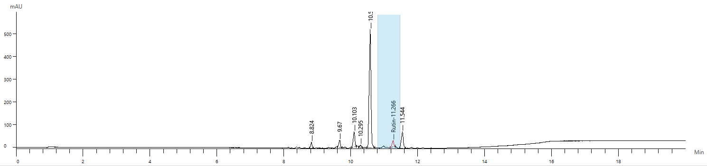
b. HPLC–PDA chromatogram, λ = 356 nm (Rutin), retention time – 11.266 min
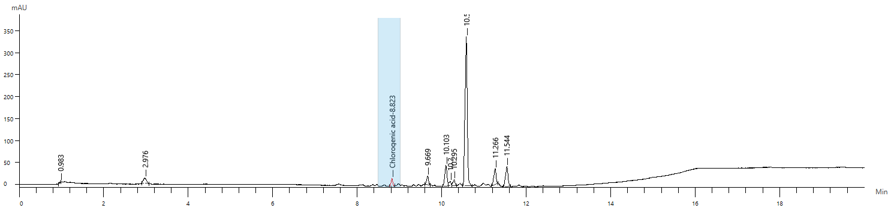
c. HPLC–PDA chromatogram, λ = 325 nm (Chlorogenic acid), retention time – 8.823 min
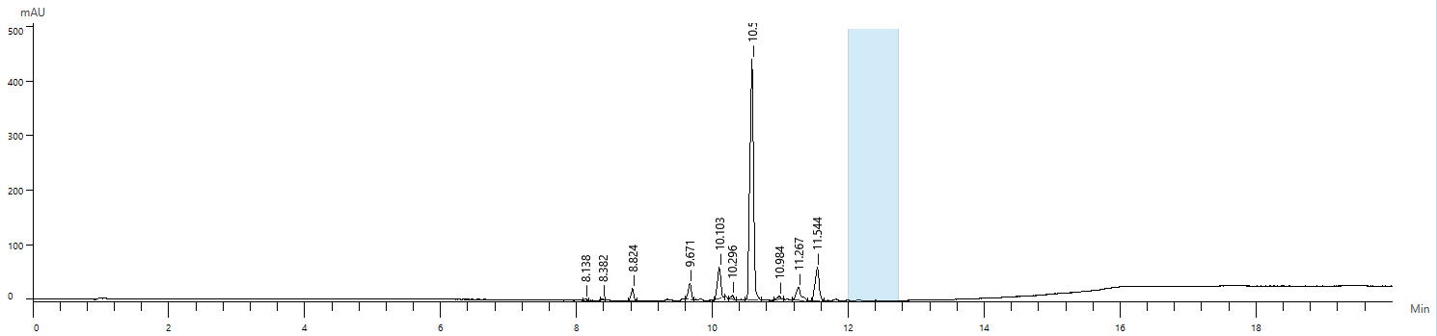
d. HPLC–PDA chromatogram, λ = 368 nm (Quercetin) – not detected
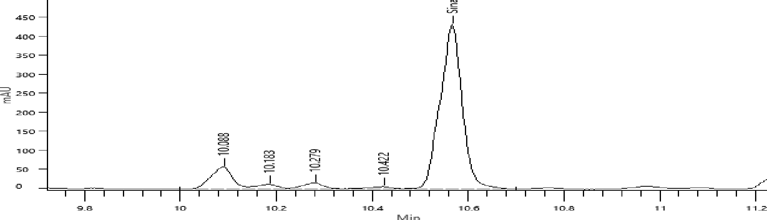
e. HPLC–PDA chromatogram, λ = 330 nm (Sinapic acid), retention time – 10.5 min

Figure 4a–e. Chromatograms of phenolic compounds in extracts obtained at 80°C

Overall, the superimposition of the chromatograms suggests three interpretative patterns. A significant number of analytes within the 8–11 min window increase in intensity with temperature, indicating less polar compounds or compounds more strongly bound to the matrix, whose release is facilitated by thermal input. For certain constituents, the maximum response observed at 50°C followed by a decrease at 80°C is compatible with thermolability, a phenomenon frequently reported for free phenols or sensitive glycosides. The persistence of the peak around ~15.5 min under all conditions, with proportional variations in amplitude, suggests a relatively thermostable compound (potentially useful as a marker of the less volatile fraction). Consequently, a temperature of 50°C appears, provisionally, to represent an optimal compromise between extraction yield (coherent intensification of many peaks) and the prevention of degradation phenomena observable at 80°C.
The obtained results demonstrate a significant influence of temperature on the phenolic composition of aqueous extracts from Elaeagnus angustifolia. Depending on their chemical structure, the analyzed compounds exhibited distinct behaviors in response to the thermal factor and possess well-documented biological mechanisms of action.
Sinapic acid and rutin contain a higher number of hydroxyl and methoxyl groups, which may be released more efficiently at higher temperatures through increased solubility in water, the disruption of bonds with polysaccharides in the matrix, and the release of bound phenolic fractions.
The extract obtained at 80°C contains more than 2.3 times more rutin and more than 2.4 times more sinapic acid than the extract obtained under cold conditions. These results are consistent with the specialized literature, which indicates that hydroxycinnamic acids and glycosidic flavonoids are efficiently recovered in hot aqueous media (Santos-Buelga et al., 2012).
Gallic acid is a thermally stable compound, which explains the moderate variations observed with temperature. However, at 80°C a slight increase is observed, possibly explained by improved solubilization and further disintegration of the cellular matrix.
Chlorogenic acid exhibits a similar behavior, but with much lower values, confirming its partially susceptible nature to degradation or transformation into derivative acids (e.g. caffeic acid).
Epicatechin decreases from 17.8 µg/g DW to 12.1 µg/g DW at higher temperatures. Thermal or oxidative degradation may justify this decrease, together with possible polymerization reactions.
Kaempferol, although present in other plant organs, was not detected in the fruits. According to the LOD/LOQ values, its concentration would be below 0.15 µg/mL, which confirms either its actual absence or its presence in strictly glycosylated forms that are not detectable under the current conditions.
When comparatively analyzing the two major categories of polyphenols, phenolic acids showed a constant increase in concentration with temperature, suggesting high thermal stability and more efficient extraction at higher temperatures. In contrast, flavonoids responded differently: rutin was more efficiently extracted at 80°C, while epicatechin, an oxidation-sensitive flavanol, showed a significant decrease.
These results confirm that optimization of the extraction temperature must be adapted to the class of compounds targeted: for phenolic acids, higher temperatures (≈80°C) are effective (Figure 5); for sensitive flavonoids, extraction at moderate temperatures (≤50°C) better preserves molecular integrity (Figure 6).

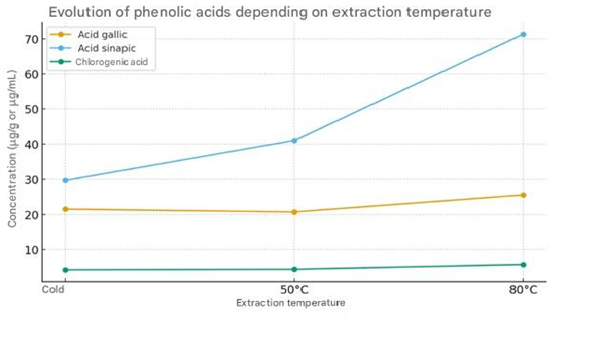
Figure 5. Evolution of phenolic acids as a function of extraction temperature
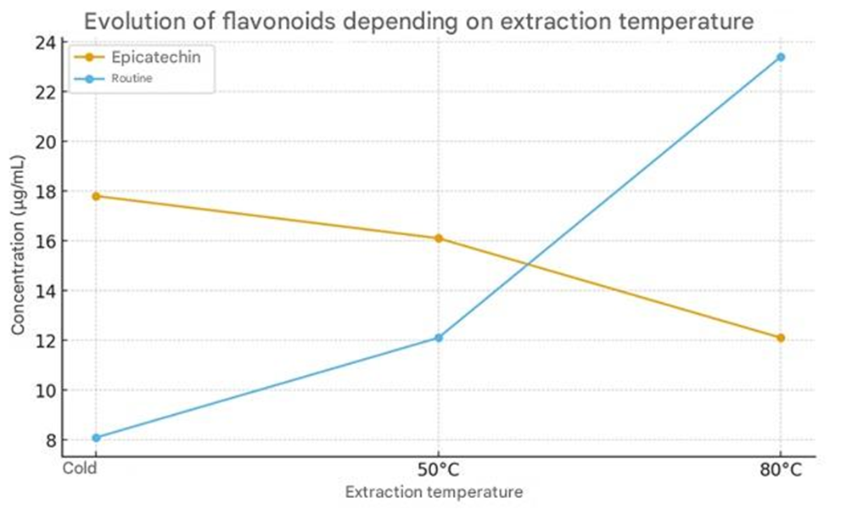
Figure 6. Evolution of flavonoids as a function of extraction temperature

3.1. Comparative analysis and correlation with anti-inflammatory activity
From the perspective of anti-inflammatory activity, the specialized literature indicates that both classes of phenolic compounds contribute to the inhibition of inflammatory mediators, although through slightly different mechanisms. Phenolic acids (e.g. gallic, sinapic, chlorogenic acids) act mainly by inhibiting the cyclooxygenase (COX) and lipoxygenase (LOX) enzymes, thereby reducing the synthesis of prostaglandins and leukotrienes (Rudrapal et al., 2025); by scavenging free radicals and reducing oxidative stress, an indirect anti-inflammatory mechanism (Hadidi et al., 2024); and by stabilizing cellular membranes and protecting protein structures during inflammation (Rudrapal et al., 2025). Flavonoids (epicatechin, rutin, quercetin, kaempferol) often act more broadly: they inhibit NF-κB and iNOS expression, thereby limiting the synthesis of pro-inflammatory cytokines (IL-6, TNF-α); reduce vascular permeability and edematous effects (Hämäläinen et al., 2007; Sun et al., 2024); and exhibit antioxidant–anti-inflammatory synergism at the cellular level (Rudrapal et al., 2025; Al-Khayri et al., 2022).
Therefore, in the context of the extracts obtained and the experimental conditions applied, phenolic acids are those that contribute most significantly to the overall anti-inflammatory potential of Elaeagnus angustifolia fruit extracts. This conclusion is supported by the quantitative dominance of phenolic acids in all extracts (particularly sinapic acid), their higher thermal stability compared with flavonoids, and the well-known direct correlation between sinapic acid and the inhibition of COX-2 and nitric oxide synthase.

4. DISCUSSION

In order to contextualize the pharmacognostic relevance of the identified compounds, Table 4 summarizes data from the recent literature regarding their biological mechanisms and associated therapeutic applications.

Table 4. Literature overview on the biological mechanisms and applications
of selected phenolic compounds

Compound | Authors (Year) | Title of the study | Main idea summary | Applied relevance
Gallic acid | Harwansh et al., 2024 | Recent Advancements in Gallic Acid-Based Drug Delivery: Applications, Clinical Trials, and Future Directions | The study summarises recent advances in nanocarrier-based delivery systems for gallic acid (liposomes, SLN, NLC, dendrimers, nanoemulsions), highlighting improvements in bioavailability, stability and therapeutic efficiency, as well as potential clinical applications. | Supports the development of modern pharmaceutical and nutraceutical formulations based on gallic acid through improved permeability and targeted delivery.
 | Hadidi et al., 2024 | The potential health benefits of gallic acid: Therapeutic and food applications | Analyses the antioxidant and anti-inflammatory mechanisms of gallic acid and its applicability in functional food products. | Antioxidant, antimicrobial and anti-inflammatory potential; applicable in nutraceutical and dermato-cosmetic products.
Sinapic acid | Chen, 2016 | Sinapic acid and its derivatives as medicine in oxidative stress-induced diseases and aging | Highlights the role of sinapic acid in reducing oxidative stress and inhibiting inflammatory mediators. | Promising compound for anti-inflammatory formulations and anti-ageing products.
 | Hameed et al., 2016 | Sinapic Acid: Is It Safe for Humans? | The study analyses the pharmacological properties, pharmacokinetics and safety profile of sinapic acid, highlighting antioxidant, anti-inflammatory, antimicrobial, neuroprotective and cardioprotective activities with low cytotoxicity at physiological concentrations. | Supports the use of sinapic acid as a promising ingredient in pharmaceutical and nutraceutical products due to its favourable safety profile and multiple validated biological mechanisms.
Chlorogenic acid | Sun & Shahrajabian, 2023 | Therapeutic Potential of Phenolic Compounds in Medicinal Plants | Discusses the role of phenolic acids in the regulation of carbohydrate metabolism and hepatic protection. | Applicability in supplements for metabolic control and liver health.
 | Huang et al., 2023 | Chlorogenic acid: a review on its mechanisms of anti-inflammation, disease treatment, and related delivery systems | Demonstrates that chlorogenic acid inhibits pro-inflammatory mediators through modulation of NF-κB/MAPK pathways and activation of Nrf2, showing cardiovascular and metabolic protective effects supported by modern delivery systems. | Supports the value of chlorogenic acid as a pharmacological and nutraceutical ingredient with translational potential and advanced formulation perspectives.
Quercetin | Hämäläinen et al., 2007 | Anti-inflammatory effects of flavonoids | Demonstrates inhibition of NF-κB and iNOS by flavonols. | Applicable in products with anti-inflammatory and immunomodulatory roles.
 | Aggarwal et al., 2025 | Anti-inflammatory potential of quercetin: From chemistry and mechanistic insight to nanoformulations | Highlights inhibition of TLR4/NF-κB and MAPK pathways and reduction of TNF-α, IL-1β and IL-6, emphasising the role of nanoformulations in improving bioavailability. | Supports the use of quercetin in anti-inflammatory pharmaceutical and nutraceutical formulations with improved delivery systems.
Kaempferol | Dong et al., 2025 | Kaempferol as a multifaceted immunomodulator: implications for inflammation, autoimmunity, and cancer | Systematic review highlighting the immunomodulatory role of kaempferol through regulation of T-cell activation (calcineurin, NF-κB, MAPK), macrophage polarisation (M1/M2), NLRP3 inhibition and modulation of inflammatory responses. | Supports the use of kaempferol as an anti-inflammatory and immunomodulatory agent with pharmacological and nutraceutical potential.
 | Shahbaz et al., 2023 | Anticancer, antioxidant, ameliorative and therapeutic properties of kaempferol | Review article highlighting the molecular anticancer mechanisms of kaempferol and discussing limitations related to bioavailability and the need for modern delivery systems. | Confirms the pharmacognostic value and nutraceutical potential of kaempferol as an antioxidant, anti-inflammatory and anticancer compound.
Rutin | Madkour et al., 2024 | Rutin: Chemical properties, Pharmacokinetic properties and Biological activities | Review summarising the antioxidant, hepatoprotective, neuroprotective, antidiabetic and anticancer properties of rutin, emphasising limitations in bioavailability. | Supports the use of rutin as a pharmacognostic phytocompound with broad therapeutic potential.
 | Iriti et al., 2023 | Bioactive Compounds in Health and Disease – Focus on Rutin | Analysis of bioavailability, safety and clinical evidence regarding the effects of rutin on metabolic status, inflammation and oxidative stress. | Highlights the nutraceutical potential of rutin and its integration into functional foods and adjuvant therapies.
Epicatechin | Azmat et al., 2025 | Exploring the Multifaceted Potential of Elaeagnus angustifolia L. | Presents the antioxidant and cardioprotective activities of flavanols found in the species. | Neuroprotective and cardioprotective potential in nutraceutical formulations.
 | Sevindik et al., 2025 | Elaeagnus angustifolia L.: A Comprehensive Review of Its Biological Activities, Phenolic and Chemical Constituents, and Applications | Review highlighting the presence of (-)-epicatechin in fruits and seeds and its role in the antioxidant, anti-inflammatory and antimicrobial activity of the species. | Supports the importance of epicatechin as a bioactive flavanol relevant for nutraceutical and phytopharmaceutical applications.

With regard to the results obtained in this research, they confirm that extraction temperature is a critical factor influencing both the qualitative composition and the biological potential of polyphenolic extracts, and they are consistent with the specialised literature, which consistently highlights the determining influence of temperature on the extractability and stability of polyphenolic compounds (Zagoskina et al., 2023; Antony & Farid, 2022; Ruenroengklin et al., 2008). In the review conducted by Antony & Farid (2022) on the effect of temperature on total polyphenol yield and on the behavior of thermolabile compounds versus those released at higher temperatures, it is reiterated that, in general, for traditional extraction methods, the total phenolic content (TPC) is highest at extraction temperatures of 60–80°C. Moderate to high temperatures (50–80°C) favour the production of extracts with a balanced bioactive profile, characterised by increased levels of stable phenolic acids and glycosidic flavonoids capable of exerting synergistic antioxidant and anti-inflammatory effects.
An increase in temperature favours the recovery of free compounds, but may simultaneously generate losses through oxidative degradation. For this reason, the establishment of an optimal protocol including controlled thermal conditions and, where appropriate, antioxidant protective agents is recommended. Chlorogenic acid, although less abundant, remains stable within the analyzed temperature range, confirming its resistance to oxidation and moderate thermal transformations. This stability recommends it as a potential marker of the quality of phenolic extracts obtained through controlled thermal methods. Quercetin and kaempferol were not detected, which may be attributed to very low concentrations or their conversion into more stable glycosylated forms. These observations are consistent with data from the specialized literature indicating that flavonoids exhibit structural stability dependent on glycosidic substitutions and that aglycone molecules are more susceptible to oxidative degradation under intense thermal conditions (Sun et al., 2024). This dual behavior is frequently reported in flavonoid-rich phytosystems (Hämäläinen et al., 2007) and justifies the selection of moderate extraction temperatures (≈50 °C) as a balance between yield and the preservation of the integrity of thermolabile compounds.
Furthermore, an important interpretation arises from the fact that the polyphenolic profile depends on the fruit matrix and the processing method, as also reported by other authors (Salazar-Orbea et al., 2023; Martins et al., 2022; Chiriac et al., 2021; Arfaoui, 2021). Increasing temperature favours the release of conjugated phenols and flavonoid glycosides from plant matrices, leading to higher concentrations of compounds such as rutin or sinapic acid, a phenomenon also observed in our data. At the same time, the decrease of certain thermolabile compounds, such as epicatechin, reproduces previously reported trends, demonstrating their susceptibility to thermal or oxidative degradation. Thus, the differentiated behavior of polyphenols depending on temperature supports the well-documented model of interactions between intrinsic chemical stability and extraction process efficiency, confirming the alignment of the present results with the experimental evidence reported in the specialized literature (Ameer et al., 2017; Shakeel et al., 2016; Ajila et al., 2011).
By correlating the experimental data with this information on pharmacological mechanisms, it can be stated that, in the case of extracts obtained from Elaeagnus angustifolia L. fruits, phenolic acids constitute the principal mediators of the anti-inflammatory effect, while flavonoids contribute in a complementary manner, particularly rutin, which through its antioxidant effects and its role in regulating the expression of pro-inflammatory cytokines enhances the overall anti-inflammatory response. Nevertheless, the decrease in epicatechin content indicates the need for optimization of extraction parameters in order to preserve the integrity of thermolabile compounds while maintaining the yield of phenolic acids.
This synergistic effect is also supported by recent studies indicating that phenols and flavonoids act in concert in reducing the expression of pro-inflammatory genes and stabilizing cellular redox status (Santangelo et al., 2007).
For sinapic acid, the specialized literature indicates a relevant systemic anti-inflammatory and antioxidant potential, supported by the ability of this compound to inhibit COX and LOX and to reduce oxidative stress, which supports interest in its use in nutraceutical products (Chen, 2016; Rudrapal et al., 2025).
Gallic acid is recognized for its antimicrobial and anti-inflammatory properties, exerted through free radical scavenging and modulation of inflammatory mediators, which recommends it for dermato-cosmetic and topical applications (Hadidi et al., 2024; Rahman et al., 2021).
Chlorogenic acid is known for its hypoglycaemic, hepatoprotective and antioxidant effects, its mechanisms being associated with the inhibition of glucose absorption and the protection of tissues against oxidative stress. These properties justify its inclusion in products intended for individuals at metabolic risk or with diabetes (Ayaz & Bertoft, 2001; Sun & Shahrajabian, 2023).
The identified flavonoids, rutin and epicatechin, contribute complementarily to the bioactive profile of the fruits. Rutin is also well documented for its vasoprotective, anti-edematous and antioxidant effects, associated with the stabilization of vascular walls and the reduction of capillary permeability (Choi et al., 2021; Hämäläinen et al., 2007, Chagas et al., 2022).
Epicatechin, a flavan-3-ol with neuro- and cardio protective activity, acts by reducing oxidative stress and modulating NF-κB pathways, but it is sensitive to thermal and oxidative degradation, which requires extraction at moderate temperatures in order to preserve molecular integrity (Azmat et al., 2025). The absence of kaempferol in the fruits, in contrast with its presence reported in leaves and flowers, indicates a phytochemical distribution dependent on plant organs, a phenomenon frequently reported in the specialized literature for this species. This specificity suggests the need for the selection of plant raw material according to the target compound, the fruits being more suitable for obtaining phenolic acids and glycosylated flavonoids such as rutin (Carradori et al., 2020; Sevindik et al., 2025).
The differentiated behavior of polyphenols depending on extraction temperature provides a solid basis for the optimization of technological processes. Higher temperatures favor the production of extracts rich in phenolic acids and glycosylated flavonoids with pronounced anti-inflammatory potential, while extraction at moderate temperatures allows the preservation of sensitive compounds such as epicatechin, maintaining a synergistic antioxidant balance (Antony & Farid, 2022; Santos-Buelga et al., 2012).
These results support the use of Elaeagnus angustifolia L. fruits as a versatile raw material for obtaining functional products. The extracts may be directed towards nutraceutical formulations with anti-inflammatory and antioxidant roles, standardized cosmetic ingredients with soothing and anti-ageing effects, or phytotherapeutic preparations intended to support vascular and metabolic health, the selection of extraction conditions being essential for obtaining a phytochemical profile appropriate to the intended application.

5. Conclusion

The analysis of the phenolic profile of Elaeagnus angustifolia L. fruits confirms the relevance of this organ as a phytopharmaceutical source, although it is less explored compared with leaves or flowers. The present study demonstrates that aqueous extracts obtained from Elaeagnus angustifolia L. fruits exhibit a diverse phenolic profile, with a quantitative and functional predominance of phenolic acids over flavonoids. Among these, sinapic and gallic acids are distinguished by high concentrations and superior thermal stability, suggesting a major contribution to the anti-inflammatory activity of the extracts. The results confirm that temperature is an essential factor in determining extraction efficiency, significantly influencing the concentration of each individual compound, and that the optimal temperature for obtaining an extract rich in hydroxycinnamic acids and glycosylated flavonoids is 80°C, whereas moderate temperatures (50°C) are favorable for sensitive compounds such as epicatechin.
From an applicative perspective, these findings support the valorization of E. angustifolia L. for developing an area as a local source of bioactive compounds with potential anti-inflammatory activity, relevant for the development of nutraceutical and dermato-cosmetic preparations. The profile obtained for the local plant material (Black Sea coast) may serve as a regional benchmark in comparative chemo metric analyses, facilitating the selection of raw material sources and the optimization of processes according to phenolic structure. The study makes an original contribution to documenting the relationship between process parameters and the distribution of phenolic compounds specific to the fruits, providing a useful scientific basis for the formulation of standardized extracts as a valuable phytotherapeutic source for the development of natural anti-inflammatory products and functional supplements.
The practical implications and future directions proposed include the continuation of studies aimed at confirming pharmacodynamics effects and establishing a well-founded dose–effect relationship.

References

Zouhar, K. (2005). Elaeagnus angustifolia. In: Fire Effects Information System, [Online]. U.S. Department of Agriculture, Forest Service, Rocky Mountain Research Station, Fire Sciences Laboratory (Producer), Available: https://www.fs.usda.gov/database/feis/plants/tree/elaang/all.html
Khadivi, A. (2018). Phenotypic characterization of Elaeagnus angustifolia using multivariate analysis. Industrial Crops and Products Journal, 120, 155–161.
Carradori, S., Cairone, F., Garzoli, S., Fabrizi, G., Iazzetti, A., Giusti, A. M., et al. (2020). Phytocomplex characterization and biological evaluation of powdered fruits and leaves from Elaeagnus angustifolia. Molecules, 25, 2021. https://doi.org/10.3390/molecules25092021
Hamidpour, R., Hamidpour, S., Hamidpour, M., Shahlari, M., Sohraby, M., Shahlari, N., et al. (2017). Russian olive (Elaeagnus angustifolia L.): From a variety of traditional medicinal applications to its novel roles as active antioxidant, an-ti-inflammatory, anti-mutagenic, and analgesic agent. Journal of Traditional and Complementary Medicine, 7, 24–29. https://doi.org/10.1016/j.jtcme.2015.09.004
Tehranizadeh, A. Z., Baratian, A., & Hosseinzadeh, H. (2016). Russian olive (Elaeagnus angustifolia) as a herbal healer. Bio Impacts, 6, 155–167. https://doi.org/10.15171/bi.2016.22
Farzaei, M. H., Bahramsoltani, R., Abbasabadi, Z., & Rahimi, R. (2015). Phytochemical and pharmacological aspects of Elaeagnus angustifolia L. Journal of Pharmacology, 67, 1467–1480. https://doi.org/10.1111/jphp.12442
Okmen, G. & Turkcan, O. (2013). A study on antimicrobial, antioxidant and antimutagenic activities of Elaeagnus angustifolia L. leaves. African Journal of Traditional, Complementary and Alternative Medicines, 11, 116–120. https://doi.org/10.4314/ajtcam.v11i1.17
Mahboubi, M. (2018). Elaeagnus angustifolia and its therapeutic applications in osteoarthritis. Industrial Crops and Products Journal, 121, 36–45. https://doi.org/10.1016/j.indcrop.2018.04.051
Karimifar, M., Soltani, R., Hajhashemi, V., & Sarrafchi, S. (2017). Evaluation of Elaeagnus angustifolia in knee osteoarthritis. Clinical Rheumatology, 36, 1849–1853. https://doi.org/10.1007/s10067-017-3603-z
Zhang, Y., Cai, P., Cheng, G., & Zhang, Y. (2022). A brief review of phenolic compounds identified from plants: Their extraction, analysis, and biological activity. Natural Product Communications, 17(1). https://doi.org/10.1177/1934578X211069721
Sun, W., & Shahrajabian, M. H. (2023). Therapeutic potential of phenolic compounds in medicinal plants—Natural health products for human health. Molecules, 28, 1845. https://doi.org/10.3390/molecules28041845
Sevindik, M., Krupodorova, T., Sevindik, E., Oğuzhan, K., İmran, U., & Orhan, U. (2025). Elaeagnus angustifolia L.: A comprehensive review of its biological activities, phenolic and chemical constituents, and applications. Applied Fruit Science, 67, 70. https://doi.org/10.1007/s10341-025-01294-x
Ayaz, F.A., & Bertoft, E. (2001). Sugar and phenolic acid composition of stored commercial oleaster fruits. Journal of Food Composition and Analysis, 14, 505–511. https://doi.org/10.1006/jfca.2001.1004
Fakı, R., Canbay, H. S., Gürsoy, O., & Yılmaz, Y. (2022). Antioxidant activity, physico-chemical and fatty acid composition of oleaster (Elaeagnus angustifolia L.) varieties naturally grown in the western Mediterranean region of Turkey. Academic Food Journal, 20, 329–335. https://doi.org/10.24323/akademik-gida.1224295
Simsek, M., & Sufer, Ö. (2021). Physical, bioactive and textural properties of oleaster (Elaeagnus angustifolia L.) fruit from different lo-cations in Turkey. Turkish Journal of Agriculture - Food Science and Technology, 9, 723–727. https://doi.org/10.24925/turjaf.v9i4.723-727.4025
Fu, Y., Ruan, J., Zhang, P., Zhang, W., Yang, D., Zhang, Y., et al. (2025). The bioactive constituents from the fruits of Elaeagnus angustifolia L. Phytochemistry, 230, 114334. https://doi.org/10.1016/j.phytochem.2024.114334
Sahan, Y., Aydin, E., Dundar, A. I., Altiner, D. D., Celik, G., & Gocmen, D. (2019). Effects of oleaster flour supplementation on total phenolic contents, antioxidant capacities, and their bioaccessibilities of cookies. Food Science. Biotechnology, 28, 1401–1408. https://doi.org/10.1007/s10068-019-00589-6
Öztürk, H. İ., Aydın, S., Sözeri, D., Demirci, T., Sert, D., & Akın, N. (2018). Fortification of set-type yoghurts with Elaeagnus angustifolia L. flours: Effects on physicochemical, textural, and microstructural characteristics. LWT, 90, 620–626. https://doi.org/10.1007/s10068-019-00589-6
Shahidi, F., & Hossain, A. (2023). Importance of insoluble-bound phenolic. Antioxidants, 12, 203. https://doi.org/10.3390/antiox12010203
Rocchetti, G., Gregorio, R.P., Lorenzo, J. M., Barba, F. J., Oliveira, P. G., Prieto, M. A., et al. (2022). Functional implications of bound phenolic compounds and phenolics–food interaction: A review. Comprehensive Reviews in Food Science and Food Safety, 21, 811–842. https://doi.org/10.1111/1541-4337.12921
Ghandahari Yazdi, A. P., Barzegar, M., Sahari, M. A., & Ahmadi Gavlighi, H. (2019). Optimization of the enzyme-assisted aqueous ex-traction of phenolic compounds from pistachio green hull. Food Sciences and Nutrition, 7, 356–366. https://doi.org/10.1002/fsn3.900
Li, L., Lv, J., Wang, X., Li, X., Guo, D., Wang, L., et al. (2024). Green Extraction of Polyphenols from Elaeagnus angustifolia L. Using Natural Deep Eutectic Solvents and Evaluation of Bioactivity. Molecules, 29, 2412. https://doi.org/10.3390/molecules29112412
Bucur, L., Stanciu, G., & Istudor, V. (2007). The GC–MS analysis of Elaeagnus angustifolia L. flowers essential oil. Revue Roumaine de Chimie, 58(11), 1027.
Bucur, L., Vlase, L., Istudor, V., & Popescu, A. (2009). HPLC–MS analysis of the polyphenols in two soft extracts of Elaeagnus angustifolia L. Farmacia, 57(6), 736–742.
Ciocârlan V. (2000). Illustrated Flora of Romania: Pteriodophyta et Spermatophyta, Ceres, Bucharest.
Chiriac, E. R., Chiţescu, C. L., Geană, E. I., Gird, C. E., Socoteanu, R.P., & Boscencu, R. (2021). Advanced analytical approaches for the analysis of polyphenols in plants matrices—A review. Separations, 8, 65. https://doi.org/10.3390/separations8050065
Guideline, IHT. (2022). Validation of analytical procedures Q2 (R2). ICH: Geneva, Switzerland, 1. https://www.ich.org/page/quality-guidelines).
Santos-Buelga, C., Gonzalez-Manzano, S., Dueñas, M., & Gonzalez-Paramas, A. M. (2012). Extraction and Isolation of Phenolic Compounds. In Natural Products Isolation, Sarker, S., Nahar, L., Eds., Methods in Molecular Biology, Vol. 864, Humana Press: New York, NY, USA,; pp. 427–464. https://doi.org/10.1007/978-1-61779-624-1_17
Rudrapal, M., de Oliveira, A. M., de Abreu, H. A., Rakshit, G., Tripathi, M. K., & Khan, J. (2025). Anti-inflammatory and antioxidant potential of plant-derived phenolic acids as triple COX, LOX, and NOX inhibitors: A computational approach. Chemistry and Biodiversity, 22, e03505. https://doi.org/10.1002/cbdv.202403505
Hadidi, M., Liñán-Atero, R., Tarahi, M., Christodoulou, M. C., & Aghababaei, F. (2024). The Potential Health Benefits of Gallic Acid: Therapeutic and Food Applications. Antioxidants, 13, 1001. https://doi.org/10.3390/antiox13081001
Hämäläinen, M., Nieminen, R., Vuorela, P., Heinonen, M., & Moilanen, E. (2007). Anti-inflammatory effects of flavonoids. Mediators of Inflammation, 45673. https://doi.org/10.1155/2007/45673
Sun, S., Liu, Z., Lin, M., Gao, N., & Wang, X. (2024). Polyphenols in health and food processing: Antibacterial, anti-inflammatory, and antioxidant insights. Frontiers in Nutrition, 11, 1456730. https://doi.org/10.3389/fnut.2024.1456730
Al-Khayri, J. M., Sahana, G. R., Nagella, P., Joseph, B. V., Alessa, F. M., & Al-Mssallem, M. Q. (2022). Flavonoids as potential anti-inflammatory molecules: A review. Molecules, 27, 2901. https://doi.org/10.3390/molecules27092901
Harwansh, R. K., Deshmukh, R., Shukla, V. P., Khunt, D., Prajapati, B. G., Rashid, S., et al. (2024). Recent advancements in gallic acid-based drug delivery: applications, clinical trials, and future directions. Pharmaceutics, 16(9), 1202, https://doi.org/10.3390/pharmaceutics16091202.
Chen, C. (2016). Sinapic acid and its derivatives as medicine in oxidative stress-induced diseases and aging. Oxidative Medicine and Cellular Longevity, 2016, 3571614. https://doi.org/10.1155/2016/3571614
Hameed, H., Aydin, S., & Başaran, N. (2016). Sinapic acid: is it safe for humans. Fabad Journal of Pharmaceutical Sciences, 41(1), 39-49.
Huang, J., Xie, M., He, L., Song, X., & Cao, T. (2023). Chlorogenic acid: A review on its mechanisms of anti-inflammation, disease treatment, and related delivery systems. Frontiers in Pharmacology, 14, 1218015, https://doi.org/10.3389/fphar.2023.1218015.
Aggarwal, D., Chaudhary, M., Mandotra, SK., Tuli, H. S., Chauhan, R., Joshi, N. C., et al. (2025). Anti-inflammatory potential of quercetin: From chemistry and mechanistic insight to nanoformulations. Current Research in Pharmacology and Drug Discovery, 8, 100217. https://doi.org/10.1016/j.crphar.2025.100217
Dong, H., Song, G., Wang, Z., Wu, X., Wang, Q., & Wang, Y. H. (2025). Kaempferol as a multifaceted immunomodulator: implications for inflammation, autoimmunity, and cancer. Frontiers in Immunology, 16, 1671519. https://doi.org/10.3389/fimmu.2025.1671519.
Shahbaz, M., Imran, M., Alsagaby, S. A., Naeem, H., Al Abdulmonem, W., Hussain, M., et al. (2023). Anticancer, antioxidant, ameliorative and therapeutic properties of kaempferol. International Journal of Food Properties, 26(1), 1140-1166. https://doi.org/10.1080/10942912.2023.2205040
Madkour, D. A., Ahmed, M., Elkirdasy, A. F., Orabi, S. H. & Mousa, A. A. (2024). Rutin: Chemical properties, Pharmacokinetic properties and Biological activities. Matrouh Journal of Veterinary Medicine, 4(1), 26-34. DOI: 10.21608/mjvm.2024.341806
Iriti, M., Varoni, E. M. & Vitalini, S. (2023). Bioactive Compounds in Health and Disease–Focus on Rutin. Bioactive Compounds in Health and Disease-Online ISSN: 2574-0334, 6(10), 235-242. DOI: https://doi.org/10.31989/bchd.v6i10.1145
Azmat, M. A., Shahzad, A., Shaban, M., Khan, A. A. & Shakoor, S. (2025). Exploring the Multifaceted Potential of Elaeagnus angustifolia L.: A Comprehensive Review of Its Nutritional, Pharmacological, and Environmental Significance. Food Science & Nutrition, 13(7), e70486. https://doi.org/10.1002/fsn3.70486
Zagoskina, N. V., Zubova, M. Y., Nechaeva, T. L., Kazantseva, V. V., Goncharuk, E. A., Katanskaya, V. M., et al. (2023). Polyphenols in plants: Structure, biosynthesis, abiotic stress regulation, and practical applications. International Journal of Molecular Sciences, 24, 13874. https://doi.org/10.3390/ijms241813874
Antony, A., & Farid, M. (2022). Effect of temperatures on polyphenols during extraction. Applied Sciences, 12, 2107. https://doi.org/10.3390/app12042107
Ruenroengklin, N., Zhong, J., Duan, X., Yang, B., Li, J., & Jiang, Y. (2008). Effects of different temperatures and pH values on the ex-traction yield of phenolic compounds from lci fruit pericarp tissue and the antioxidant activity of extracted anthocyanins. International Journal of Molecular Sciences, 9, 1333–1341. https://doi.org/10.3390/ijms9071333
Salazar-Orbea, G. L., García-Villalba, R., Bernal, M. J., Hernández, A., Tomás-Barberán, F. A., & Sánchez-Siles, L. M. (2023). Stability of phenolic compounds in apple and strawberry: Effect of different processing techniques in industrial set-up. Food Chemistry, 401, 134099. https://doi.org/10.1016/j.foodchem.2022.134099
Martins, C. C., Rodrigues, R. C., Mercali, G. D., & Rodrigues, E. (2022). New insights into non-extractable phenolic compounds analysis. Food Research International, 157, 111487. https://doi.org/10.1016/j.foodres.2022.111487
Arfaoui, L. (2021). Dietary plant polyphenols: Effects of food processing on their content and bioavailability. Molecules, 26, 2959. https://doi.org/10.3390/molecules26102959
Ameer, K., Shahbaz, H. M., & Kwon, J. H. (2017). Green extraction methods for polyphenols from plant matrices and their byprod-ucts: A review. Comprehensive Reviews in Food Science and Food Safety, 16, 295–315. https://doi.org/10.1111/1541-4337.12241
Shakeel, F., Haq, N., Raish, M., Anwer, M. K., & Al-Shdefat, R. (2016). Solubility and thermodynamic analysis of sinapic acid in vari-ous neat solvents at different temperatures. Journal of Molecular Liquids, 222, 167–171. https://doi.org/10.1016/j.molliq.2016.07.050
Ajila, C. M., Brar, S. K., Verma, M., Tyagi, R. D., Godbout, S., & Valéro, J. R. (2011). Extraction and analysis of polyphenols: recent trends. Critical Reviews in Biotechnology, 31, 227–249. https://doi.org/10.3109/07388551.2010.513677
Santangelo, C., Vari, R., Scazzocchio, B., Di Benedetto, R., Filesi, C., & Masella, R. (2007). Polyphenols, intracellular signaling and inflammation. Annali-istituto superiore di sanita, 43(4), 394 - 405.
Rahman, M. M., Rahaman, M. S., Islam, M. R., Rahman, F., Mithi, F. M., Alqahtani, T. et al. (2021). Role of phenolic compounds in human disease: Current knowledge and future prospects. Molecules, 27, 233. https://doi.org/10.3390/molecules27010233
Choi, S. S., Park, H. R., & Lee, K. A. (2021). Comparative study of rutin and rutin glycoside: Antioxidant activity and anti-inflammatory effects. Antioxidants, 10, 1696. https://doi.org/10.3390/antiox10111696
Chagas, M.D.S.S., Behrens, M. D., Moragas-Tellis, C. J., Penedo, G. X., Silva, A. R., & Gonçalves-de-Albuquerque, C. F. (2022). Flavonols and flavones as potential anti-inflammatory, antioxidant, and antibacterial compounds. Oxidative Medicine and Cellular Longevity, 9966750. https://doi.org/10.1155/2022/9966750

