Study of D+³He and T+³He reactions by using Double Folding Potential at astrophysical relevant energies

.
ABSTRACT:

Aims: The microscopic double folding potential is more superior over the conventional square-well potential as it more realistic to represents the nuclear interactions and the introduction of an imaginary potential provides an effective and compact way to model absorption in nuclear well.
Study design: The calculations of nucleus-nucleus potential are carried out in the framework of double folding model with DDM3Y-Reid and DDM3Y-Paris effective nucleon-nucleon (NN) interaction. Among different kind of the effective interaction, the so-called DDM3Y interaction was used in the double folding potential calculations.

Methodology: The study of the fusion cross-sections at astrophysical low energy is quite difficult because of the larger width of the Coulomb barrier, which results in a very small value of the reaction cross-section. Any improvement in the data on astrophysical S-factors for the light nuclei fusion may give a better picture of the elemental abundance in nucleosynthesis. In this work, we have theoretically investigated the energy dependence of astrophysical S-factors and nuclear fusion cross-sections for fusion reaction of light nuclei like D+³He and T+³He using complex nuclear potential plus the mutual Coulomb interaction of the interacting nuclei.
Results: The numerical computation of the observables is done in the framework of the selective resonant tunneling model approach. The results of our calculation are compared with those found in the literature.
Conclusion: Our theoretical computed results matched with the experimental results.

Keywords: [Double Folding Potential, Woods-Saxon Potential, VMC, DDM3Y }

1. INTRODUCTION:

Nuclear astrophysics is the intersection of nuclear physics and astrophysics. Nuclear physics plays a vital role in many important phenomena occurring in the core to the crust of astrophysical objects, this leads to the development of this ever-hot discipline of physics called nuclear astrophysics. We use deuteron nucleus as a projectile which is the simplest of the all nuclei and which consist of a proton and a neutron. There are several studies to reproduce the experimental measurements using the phenomenological Woods-Saxon (WS) optical potential as well as double folding (DF) potentials [1]. In double folding model, we use nucleon-nucleon interaction potential DDM3Y – type potential [2]. The double folding model potential is dependent on matter distribution of nuclear and is independent of nuclear charge and nuclear spin also. The double folding potential can describe the mean field interaction between the colliding nuclei. The double folding potential model provide the valuable information about the projectile and target nucleus. The basic inputs in the double folding model potential calculation are the nuclear densities of the colliding nuclei and the effective nucleon-nucleon interaction between the projectile nucleons and the target.

As double folding model potential is density dependent, we need to know the density distribution of the nucleus. The matter density distribution of target and projectile have many nature such as Fermi distribution, Gaussian distribution, Variational Monte Carlo(VMC) [3]. In double folding model calculation, we have use Gaussian matter distribution which is an exponentially decreasing in nature. Fermi matter distribution also has exponentially decreasing in nature. From various kind of effective interaction, we use DDM3Y-type interaction for the calculation of double folding model potential. The DDM3Y-type interaction is acting on a short range of the nuclear density and contains no explicit density dependence.

The interaction between two nuclei is one of the most important aspects in nuclear physics. An important step in investigating these-interaction is the calculation of ion-ion interaction potential that can help us to estimate the cross-section of the fusion reactions. In literature, the cross-section is a measure of the probability that a specific nuclear reaction will take place. The reaction cross-section are additionally considered. We studied the well-known Double Folding potential model to pay out the present investigation.

In this work, we have computed the fusion cross-section of ³He(D,P)⁴He, ³He(D,N+P)⁴He reactions and compared them with the experimental data found in literature. To explain the fusion cross-section, the compound nucleus model can be used, which is a two-step process, and later Li et al. introduced a selective resonant tunneling model (SRTM)14 which dominates over the compound nucleus model. As an improvement over the
earlier works, where authors have used constant square-well or phenomenological
space-varying potentials, in the present work, we adopt the density-dependent
double folding potential model16 for the computation of astrophysical S-factor and
fusion cross-section of few ³He-induced fusion reactions: ³He(D,P)⁴He, ³He(D,N+P)⁴He reactions.

In Sec. 2, we present the concept of a theoretical framework for the fusion cross-section calculation. This included the astrophysical S-factor and double-folding potential. The computed results and comparison with the experimental result are made in Sec. 3. We close with a summary and conclusion in Sec. 4.

2. METHODOLOGY
THEORETICAL FRAMEWORK

In astrophysics, stellar nucleosynthesis is the creation of chemical elements by nuclear fusion reactions within stars. Stellar nucleosynthesis has occurred since the original creation of hydrogen, helium and lithium during the Big Bang. Quantum tunneling is an essential phenomenon for nuclear fusion. The temperature in stellar cores is generally insufficient to allow atomic nuclei to overcome the mutual Coulomb barrier and achieve thermonuclear fusion. Quantum tunneling increases the probability of penetrating this barrier.

The fusion cross-section, far below the Coulomb barrier, is given in Eq. (1):
σ(E) = $\frac{\text{S(E)}}{\text{E}}$ · exp(-2πζ) (1)
where E is the projectile energy and S(E) is the astrophysical S-factor. The Sommerf parameter (ζ ) is defined in Eq. (2) as
ζ = $\frac{\text{(Z}\text{₁}\text{ Z}\text{₂}\text{ e²)}}{\text{(ħ v)}}$ (2)
For two approaching nuclei of charge numbers Z1;Z2, mass numbers A1 and A2, the height of Coulomb barrier is given by Eq. (3)
$V_{CB}$ = $\frac{\text{e²}}{\text{4πε}\text{₀}}$· $\frac{\text{Z}\text{₁}\text{ Z}\text{₂}}{\text{R}}$ = (1.44) · $\frac{Z_{1}Z_{2}}{R_{0}(A_{1}^{1/3}+A_{2}^{1/3})}$ (3)
where $R_{0}$ is the nuclear radius parameter and R is the touching distance between the centers of the interacting nuclei.
The cross-section for sub-barrier fusion for light nuclei can be calculated using the SRTM, assuming a complex nuclear potential of the following form:
V_{eff}(r) = V_{Coulomb}(r) + V_{centrifugal}(r) + V_{nuclear}(r) (4)
In this equation the Coulomb potential term (Satchler, 1983)[5] is owing to the interaction between the projectile and target in proton (charge) numbers over a sphere of radius R.
V_{Coulomb}(r) = 1.44 ($\frac{\text{Z}\text{1}\text{ Z}\text{2}}{\text{r}}$) , for r > R [MeV]
= 1.44 ($\frac{\text{Z}\text{1}\text{ Z}\text{2}}{\text{2R}}$) .(3 – $\frac{r^{2}}{R^{2}}$ ) , for r <= R [MeV] (5)
The centrifugal potential is given by

V_{centrifugal}(r) = $\frac{\text{ℏ}\text{2}\text{ l(l+1)}}{\text{2μr}\text{2}}$ (6)

Where μ is the reduced mass of the interaction and l is the angular momentum, r is the radial distance and h is planck constant respectively.

The final term of the total potential is the nuclear potential V_{nuclear}(r) derived by double folding process. This effective potential term for chosen V_{NN} as nucleon-nucleon interaction could be represented by equation (6).

V_{F} (r) = ∫ ∫ ρ₁(r₁) ρ₂(r₂) V_{NN}(s)d³r₁d³r₂ (7)

Where r is the distance between the nucleus of projectile and target and r₁ and r₂ are the distances measured from the centre of nuclei respectively. The equation (7) involves a six-dimensional integration. The angle between r₁ and r is θ₁ and that of r₂ and r is θ₂. The nucleon-nucleon distance (s) can be written in terms of r, r₁, r₂ and represented by the equation (7).

$\vec{s}$ = $\vec{r}$ – $\vec{r}$₁ + $\vec{r}$₂ (8)

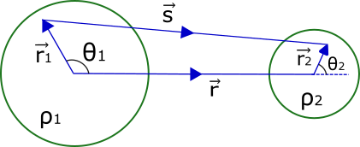

Figure 1: A schematic diagram of double folding potential.for the target and projectile nuclei

In double folding model, the density distributions of both the projectile and target nuclei are used. The typical Woods-Saxon distribution of nuclear density are given by equation (9)
ρ(r) = ρ_{o}/[1+exp(r-c)/a ] (9)

Where ρ_{o} = 2.607 (fm⁻³), c = $R_{0}A_{x}^{1/3} ;$x = t (for target) or p (for projectile), a = 0.486(fm)
In the folding calculation, we have used the most general one, the DDM3Y-Reid nucleon–nucleon realistic interaction represented by
$v_{NN}(r) =$ v(r) + $J_{00}$(E) δ (r) (10)
The Yukawa-type effective nucleon–nucleon interaction potential function v(r) consists of a short-range repulsive component and a relatively longer-range attractive component, as given by
v(r) = 7999$\frac{exp(-4r)}{4r} - 2134\frac{2.5r}{2.5r}$ (11)
The last term in Eq. (10) is J00, which has a linear energy dependence. This term represents the nucleon exchange term as in Eq. (12)
${ J}_{00}$(E) = -276[ 1- $\frac{0.005Elab}{Ap}$ ] Mev.${fm}^{3}$ (12)
Thus, $U_{N}$(r) may be expressed as
${ U}_{N}$(r) = $C_{r}$ $U_{DF}$(r) $+ iC_{i}$ $U_{iDF}$(r) (13)
where the imaginary component is introduced as
${ U}_{iDF}$(r) = -$\frac{1}{r} \frac{d}{dr} (U_{DF}$(r)) (14)
The Schrodinger equation for the total interaction potential of Eq. (4) is given by
(-$▽^{2}$ + $\frac{2μU(r)}{{\text{h}}^{2}}$ - $k^{2}$ )ψ(r) = 0 (15)
where k $\sqrt{\frac{2μE}{{\text{h}}^{2}}}$ ; E is the energy of the relative motion in the center-of-mass system; $μ$is the reduced mass of the nuclear system, ${\text{h}}^{2}$ is the reduced Planck's constant, and ψ(r) represents the sum of the nuclear and Coulomb wave function:
ψ(r) = ${\text{ψ}\text{(r)}}_{N}$ + ${\text{ψ}\text{(r)}}_{C}$ (16)
In Eq. (16), the second term, i.e., the Coulomb wave function, holds only the incoming wave, although in the asymptotic range the nuclear wave function appears for the outgoing wave. Equation (15) has been reduced to a r-dependent single differential equation represented by Eq. (17):
( -$\frac{d^{2}}{{dr}^{2}}$ + $\frac{l(l+1)}{r^{2}}$ + $\frac{2μU(r)}{{\text{h}}^{2}}$ - $k^{2}$) ψ(r) = 0 (17)
The general solution ψ(r,t) of the corresponding Schrodinger equation (17) for the interacting nuclei may be represented as Eq. (18):
ψ(r,t) = $\frac{1}{\sqrt{4πr}}$ ψ(r) exp(-$\frac{iEt}{h}$) (18)
Now, the reaction cross-section in terms of the phase shift, 0, introduced by the nuclear potential in the wave function at the low energy limit (where only the S-wave contributes) is given by Eq. (19):
σ(E) = $\frac{π}{k^{2}}$ (1 - ${|η|}^{2}$ ) (19)
where $η$ = $e^{2iδ_{0}}$ and k is the wave number corresponding to the relative motion. Since the chosen nuclear potential is a complex one, the corresponding phase shift $δ_{0}$ will also be a complex number and can be indicated as Eq. (20):
Cot($δ_{0}) = W_{r} + i$ $W_{i}$ (20)
where Wr and Wi are connected to the real and imaginary components of the complex wave number corresponding to the complex nuclear potential. The wave number corresponding to the complex nuclear potential can be expressed as
K(r) = $\sqrt{\frac{\text{2μ}}{\text{ħ²}}\text{ (U(r) - E) ]} }$
= $\sqrt{\frac{\text{2μ}}{\text{ħ²}}[\text{(}U_{C}\text{(r) + }U_{cent}\text{(r)+}U_{N}\text{(r) - E) ]} }$
= $\sqrt{ \frac{\text{2μ}}{\text{ħ²}}\text{[(}U_{C}\text{(r)+}C_{r}U_{DF}\text{(r)+ i}C_{i}U_{iDF}\text{(r)- E) ] }}$ [for l = 0] (21)
= $\sqrt{ \frac{\text{2μ}}{\text{ħ²}}[U_{C}\text{(r)+}C_{r}U_{DF}\text{(r)- E ]}}$ × $\sqrt{1+i\frac{C_{i}U_{iDF}\text{(r)}}{ [U_{C}\text{(r)+}C_{r}U_{DF}\text{(r)- E ]}}}$
≈ $\sqrt{ \frac{\text{2μ}}{\text{ħ²}}[U_{C}\text{(r)+}C_{r}U_{DF}\text{(r)- E ]}}$ + $\frac{i}{2}$ $\sqrt{\frac{\text{2μ}}{\text{ħ²}} \frac{C_{i}U_{iDF}\text{(r)}}{\sqrt{[U_{C}\text{(r)+}C_{r}U_{DF}\text{(r)- E]}}} }$
= K_{r}(r) + i K_{i}(r)
At r = R, KR = K_{r}R + iK_{i}R
which may be represented as Z ≡ Z_{r} + iZ_{i} for Z = KR, Z_{r} = K_{r}R, Z_{i} = K_{i}R.
In terms of real and imaginary parts of Z, the parameters Wr and Wi are designated as
$W_{r }= {\text{Ω}}^{2} \frac{Re Z_{r} sin(2Z_{r})+Z_{i} sin(2Z_{i})}{2[\sin^{2}(Z_{r}) +\sinh^{2}(Z_{i})]} - 2$ ${\text{Ω}}^{2}[ln(\frac{2R}{R_{c}})+2C+h(kR_{c})]$

$W_{i }= {\text{Ω}}^{2} \frac{Re Z_{r} sin(2Z_{r}) -Re Z_{i} sin(2Z_{i})}{2[\sin^{2}(Z_{r}) +\sinh^{2}(Z_{r})]}$ (22)
where R_{c} = ℏ² / Z₁Z₂μe² is the Coulomb unit of length and C ≅ 0.577 is Euler's constant.
The energy dependent function h(kR_{c}) is connected to the logarithmic derivative of the Γ function:

h(kR_{c}) ≡ Re[ψ(−i / kR_{c})] + log(kR_{c}); ψ(x) ≡ Γ′(x) / Γ(x)
where Γ(x) is the Gamma function, and
h(y) = $\frac{1}{y^{2}}$ $\sum_{s=1,2,..}{\frac{1}{(s^{2} + y^{-2})}}$ − C + ln(y) (23)
The fusion cross-section can then be expressed as
σ = $\frac{\text{π}}{\text{k}\text{2}}$ $\frac{-4W_{i}}{W_{r}^{2} +{(1-W_{i})}^{2} }$
= $\frac{\text{π}}{\text{k}\text{2}}$ $\frac{1}{{\text{Ω}}^{2}}$ $\frac{-4{\text{ω}}_{i}}{{\text{ω}}_{r}^{2} +{({\text{ω}}^{2}-\frac{1}{{\text{Ω}}^{2}})}^{2} }$ (24)
where the quantity Ω² = (exp(π/kr) − 1) / 2π is related to the Gamow penetration factor. The last factor in Eq. (24) within curly braces {} is called the astrophysical S-factor, which depends on the projectile energy, E, and the cross-section σ(E).
Thus, we have
S(E) = $\frac{K^{2}}{\text{π}}$ × Ω²σ(E) = − $\frac{-4{\text{ω}}_{i}}{{\text{ω}}_{r}^{2} +{({\text{ω}}^{2}-\frac{1}{{\text{Ω}}^{2}})}^{2} }$ (25)
where ω = ω_{r} + iω_{i} = W/Ω² = (W_{r} + iW_{i}) / Ω². The wave function inside the nuclear well (i.e., in the region r ≤ R) is controlled via the parameters c_{r} and c_{i} introduced in Eq. (13). The Coulomb wave function outside the nuclear well (r ≥ R) is determined by two other parameters: the real and the imaginary part of the complex phase shift δ_{r} and δ_{i}. A pair of convenient parameters, W_{r} and W_{i}, is introduced to make a linkage between the cross-section and the nuclear potential. This facilitates a clear understanding of the resonance and the selectivity in damping. The continuity of the wave function at the boundary (r = R) can be expressed by the matching of the logarithmic derivative of the wave function.

3. results and discussion

A star gets its shining power from the energy yield of a nuclear fusion reaction. At first, we have introduced the double folding potential with an additional term i.e. the complex potential. For the computation of the ³He(D,P)⁴He, ³He(D,N+P)⁴He reactions , we have used that space varying complex potential function in which lies the novelty of the present work because earlier such calculations have been performed using square well type nuclear potentials [6-8]. The quantum tunneling plays a crucial role for the fusion reaction in the astrophysical energy regime [9]. We have studied S(E) for the ³He(D,P)⁴He reaction at the astrophysical relevant energies lying in the sub-barrier range. Then, we have made comparisons of experimental results and computed data in figure 2. In this study, the theoretical calculation has been carried out at low energies of the 3He(3He,2p) 4He reaction. The values of the parameters used for the input channel ³He(D,P)⁴He is shown in the first row of Table 1. In this context, Figure 2(Lower panel) indicates that the computed data are in fair agreement with the experimentally observed data.

Table 1: Potential Parameters for the ³He(D,P)⁴He, ³He(D,N+P)⁴He reactions

Reactions | U_{DF} (R)(MeV) | Ui_{DF}(R) (MeV) | R₀ (fm) | Energy, Cross-section (keV, mili-barn)
D+³He | -8.40 | -0.20 | 3.8 | 589,792
T+³He | -5.00 | -0.15 | 3.821 | 886,70.8

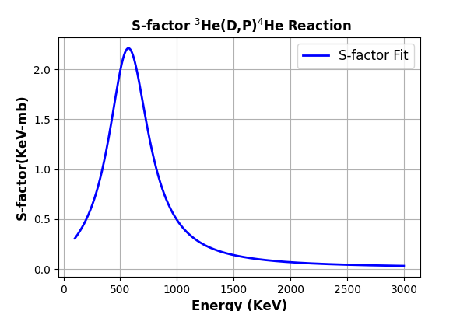

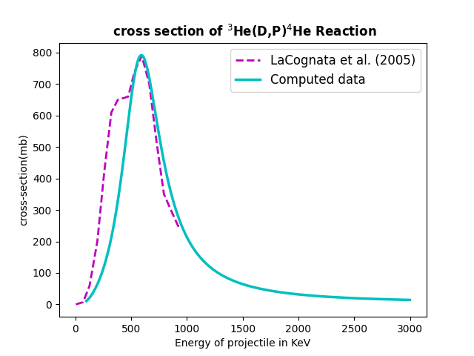

Figure 2: Upper Panel: Fitting of astrophysical S-factor by using Eq. (25). Lower Panel: Comparison between experimental data shown by broken line (cyan color) and computed data solid line for the ³He(D,P)⁴He, reaction. The experimental data are taken from works of LaCognata et al(2005)[10]
.

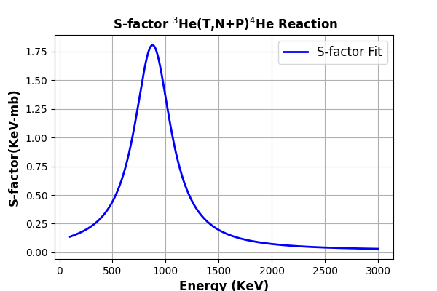

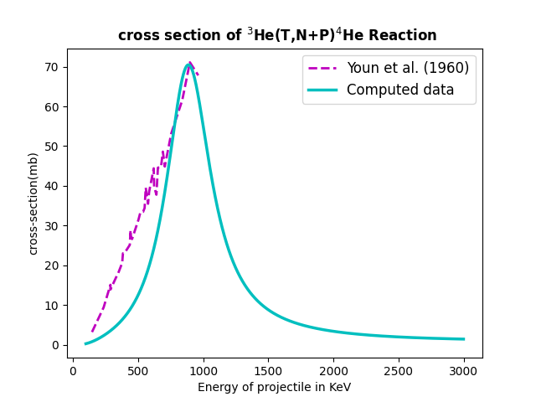

Figure 3: Upper Panel: Fitting of astrophysical S-factor by using Eq. (25). Lower Panel: Comparison between experimental data shown by broken line (cyan color) and computed data solid line for the ³He ³He(D,N+P) reaction. The experimental data are taken from works of Youyn et al(1960)[11]

Secondly, we have calculated the astrophysical S function for the ³He(D,P)⁴He nuclear system at the astrophysical relevant energies [36]. We have made a comparison between the computed data and experimental results of the ³He(D,N+P)⁴He system and presented the result in figure 3 and we have a good agreement between them. The values of parameters used for the input channel ³He(D,N+P)⁴He are depicted in the second row of Table 1.

4. Conclusion

One of the goals of this work was to determine the suitability of the DDM3Y interaction for colliding model description of light heavy-ion systems [13]. The interaction potential for ³He(D,P)⁴He, ³He(D,N+P)⁴He Double-Folding Potential was calculated. The double folding model was defined using the integration on the nucleon density distribution of the two colliding nuclei and nucleon-nucleon interaction potential [14]. The matter density distribution of target and projectile is Fermi & Gaussian distribution in nature.

As an illustration of the use of the double-folding potential, we take the particular interaction of ³He(D,P)⁴He, ³He(D,N+P)⁴He. In double-folding model, free parameter is the normalization constant. We kept this value as constant to examine the behavior of the double-folding potential model. The folded potential model is a well-known model for describing the mean field nuclear interaction between two colliding nuclei. It has been widely used in the literature since accepted as a more realistic approach than a phenomenological potential such as the well-known Woods-Saxon. Within the framework of our approach the nucleus-nucleus collision process is modelled as double-folding potential model.

COMPETING INTERESTS DISCLAIMER:
Authors have declared that they have no known competing financial interests OR non-financial interests OR personal relationships that could have appeared to influence the work reported in this paper.

References

- Sh. Hamada, B. Alshahrani, Abd Elrahman Elgamala, n. Darwish, I. Bondouk, Analysis of ⁶Li + ¹⁶O elastic scattering using different potentials, Rev. mex. Fis..66 ,3 (2020)
- Dao T. Khoa and W. von Oertzen, A nuclear matter study using the density dependent M3Y interaction, Physics Letters B 304 (1993) 8-16
- Yusuf SERT, Elastic Scattering with Double Folding Model: ⁸B + ²⁷Al, Journal of Science and Technology, 2021, 14(1), 241-248
- Double Folding Model, IAARJ, 1(1): 67-76,2019; Article no.IAARJ.53312
- G. R. Satchler, Direct Nuclear Reaction, International Series of Monographs on Physics (Oxford University Press, 1983).
- X.Z. Li, Fusion Sci Tech. 41, JAN 2002
- X.Z. Li, Q.M. Wei and B. Liu, Nucl. Fusion 48 (2008) 125003
- C.L. Liang, Z.M. Dong and X.Z. Li, Curr. Sci., 108, 4 (2015)
- E. Yildiz and I. H. Sarpun, A-Applied sci. Eng., 2020, 21(1), pp. 205 –209
- M. LaCongata et al., Bare-nucleus astrophysical factor of the He-3(d,p)He reaction via the Trojan horse` method, Phys. Rev. C,.72(2005)065802
- L.G.Youn et al., Zhurnal Eksperimental`noi i Teoret. Fiziki39(1960)225

