A Low-Cost IoT-Based Gas Sensor Approach for Real-Time Monitoring of Fruit Ripening and Spoilage in Storage Conditions

Abstract
Post-harvest losses of perishable fruits due to improper storage and delayed spoilage detection remain a major challenge in the food supply chain. This study presents the design and development of a low-cost, IoT-enabled gas sensor system for real-time monitoring of mango fruit freshness based on ethylene emission. The system integrates an Arduino Uno microcontroller with MQ-3 gas sensor, a DHT11 temperature–humidity sensor, and an infrared (IR) module for automated detection and analysis. Mango varieties Kesar and Banganapalli were used as model fruits to evaluate the system performance. Experimental results demonstrated a clear correlation between ethylene concentration and ripening stages. The highest ethylene concentration was recorded as 213 PPM and 241 PPM for Kesar and Benganapalli mangoes respectively. The developed system provides continuous monitoring and displays real-time data, enabling early detection of spoilage. This approach offers a cost-effective solution for warehouse management, reducing post-harvest losses and improving food quality assurance.
Keywords
IoT; Gas sensors; Fruit freshness; Ethylene detection; Arduino; Post-harvest storage; Mango
1. Introduction
Fruits are an essential component of a balanced diet due to their high content of vitamins, minerals, and bioactive compounds. However, their perishable nature leads to significant post-harvest losses during storage and transportation. It is estimated that improper storage conditions and lack of monitoring systems contribute substantially to fruit spoilage in supply chains (Kader, 2005; Vanin et al., 2009).
Among various indicators of fruit ripening, ethylene (C₂H₄) plays a crucial role as a plant hormone regulating physiological and biochemical changes in climacteric fruits such as mango (Zanoni et al., 1995; Baietto and Wilson, 2015). The emission of ethylene increases significantly during ripening and reaches peak levels during senescence and decay, making it a reliable indicator for freshness evaluation (Saltveit, 1999; Wills et al., 2007).
Traditional methods for assessing fruit quality rely on visual inspection or destructive testing, which are subjective and inefficient. Recent advances in sensor technologies and the Internet of Things (IoT) have enabled the development of smart monitoring systems for real-time detection of spoilage gases (Wang and Zhang, 2010; Liu et al., 2018). Gas sensors such as MQ-series sensors have been widely used for detecting volatile organic compounds (VOCs) associated with food degradation (Pereira et al., 2021; Ghasemi-Varnamkhasti et al., 2019).
Several studies have demonstrated the application of gas sensors and embedded systems for monitoring fruit freshness. For instance, Arduino-based systems integrated with gas and environmental sensors have been successfully employed for real-time quality assessment (Chhanwal and Anandharamakrishnan, 2012; Gubbi et al., 2013; Kodali et al., 2016). However, most existing systems lack continuous monitoring capabilities and integrated environmental analysis.
Therefore, the present study aims to develop an IoT-based gas sensor system capable of real-time monitoring of fruit ripeness and spoilage by integrating gas sensing with temperature and humidity measurements.
2. Materials and Methods
2.1 Experimental Setup
The experimental system was developed using an embedded platform integrating gas sensing and environmental monitoring modules. The setup consisted of an Arduino Uno microcontroller interfaced with MQ-3 gas sensor, DHT11 temperature–humidity sensor, IR sensor module, and a 16×2 LCD display. (Arduino, 2023)
The entire system was powered using a regulated 5 V DC supply. Data acquisition and processing were performed in real time using embedded C programming in Arduino IDE.
2.2 Hardware Description
2.2.1 Arduino Uno
The Arduino Uno functions as the central microcontroller unit of the system, interfacing with MQ-3 gas sensor. It is an open-source development board based on the ATmega328P microcontroller, featuring 14 digital input/output pins (including 6 PWM outputs) and 6 analog input pins. The board is programmable via the Arduino Integrated Development Environment (IDE) using a USB connection and can be powered either through USB or an external power supply (7–20 V). Its versatility and ease of integration make it suitable for sensor-based monitoring applications.
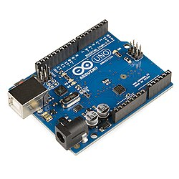 | 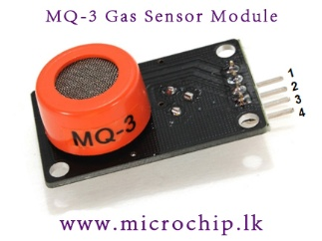
- Arduino Uno | - MQ3 Gas sensor
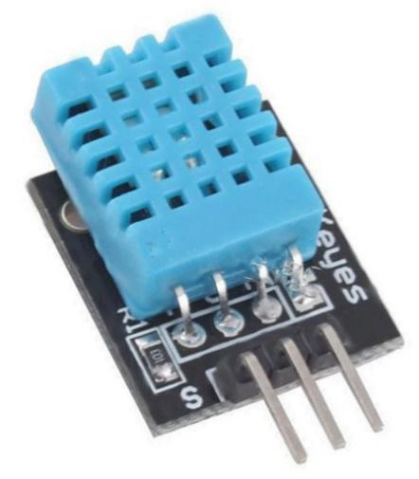 | 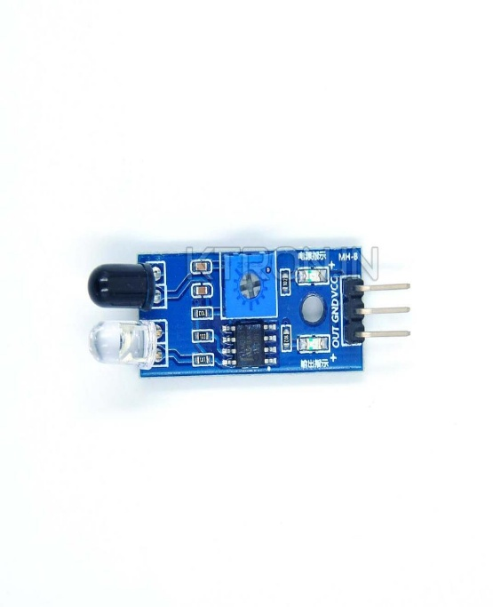
(c) DHT11 Sensor | (d) IR Sensor Module
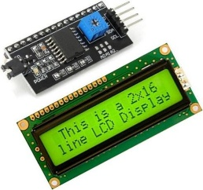 | 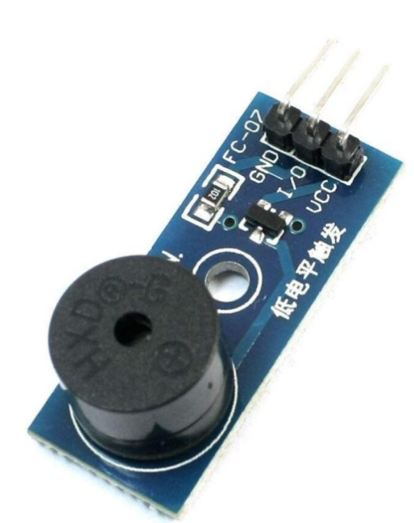
(e) LCD Display | (f) Buzzer
Fig. 1. Hardware components
2.2.2 MQ-3 Gas Sensor
The MQ-3 gas sensor, originally designed for detecting ethanol vapors, was utilized in this study for the detection of ethylene gas after appropriate calibration. The sensor operates on a 5V DC power supply, which also activates an internal heating element required to maintain stable sensing conditions. A load resistor (typically ~200 kΩ) is connected between the output and ground to regulate sensitivity and ensure a stable analog output signal.
The sensor functions effectively within a temperature range of −10°C to 70°C and at relative humidity levels below 95%. Before measurements, a preheating period of approximately 20 seconds is required to stabilize the sensor response and obtain consistent readings.
For ethylene detection, the sensor response was monitored after calibration against ethylene concentration levels, enabling relative measurement of ethylene evolution during storage. The MQ-3 sensor exhibited measurable sensitivity to ethylene within the experimental range used in this study, allowing it to be applied as a low-cost gas sensing approach for monitoring postharvest ripening changes.
2.2.3 DHT11 Sensor
The DHT11 is a digital temperature and humidity sensor operating within a temperature range of 0°C to 50°C and a relative humidity range of 20% to 90%. It employs a capacitive sensing element for humidity measurement and a thermistor for temperature detection. The sensor operates on a 3.3V–5V DC power supply with low power consumption (~2.5 mA), making it suitable for energy-efficient applications.
Communication is achieved through a single-wire serial interface, requiring only one data pin for transmission. The sensor provides direct digital output, eliminating the need for analog-to-digital conversion. It has a response time of approximately one second, enabling near real-time environmental monitoring.
2.2.4 IR Sensor Module
The IR sensor module consists of an infrared (IR) emitter LED and a receiver photodiode arranged in parallel. It includes three main pins: a 5V power input, a reference (ground) pin, and a digital output pin (D0). The module operates by continuously emitting an IR beam from the emitter. When an object enters the sensing range, the emitted radiation is reflected and detected by the receiver, causing the digital output (D0) to switch to a high state.
In this study, the IR module was utilized to detect the presence of fruits, thereby initiating the sensing and data acquisition process.
2.2.5 LCD Display
The Liquid Crystal Display (LCD) is an electronic display module widely used in embedded systems for visual output. In this study, a 16×2 LCD module, capable of displaying 16 characters across two rows, was employed. Compared to other display technologies such as seven-segment displays and LEDs, LCDs offer advantages including low cost, ease of programming, and the ability to display alphanumeric and custom characters. (Arduino, 2023)
The LCD is interfaced with a microcontroller through a display controller, which processes command and data signals to drive the display panel. In the proposed system, the LCD is used to present real-time output data, including sensor readings and system status.
2.2.6. Buzzer
A buzzer is an audio signalling device that converts electrical signals into sound and is commonly used in alarms, timers, and user feedback systems. It may be classified as active (with an internal oscillator) or passive (requiring an external driving signal). Predefined threshold values can be programmed to trigger alerts or initiate system responses.
2.3 Software Requirement
2.3.1 Embedded C
Embedded C is a widely used programming language for the development of embedded systems due to its efficiency, portability, and low-level hardware control (Barr, 2002). It is an extension of the C programming language tailored for programming microcontrollers and embedded devices.
An embedded system is a combination of hardware and software designed to perform a specific function. Common examples include household appliances such as washing machines, which integrate processors and programmed instructions to execute predefined tasks. Embedded C enables efficient interaction with hardware components, making it a preferred choice for real-time and resource-constrained applications.
2.3.2 Arduino IDE
Arduino is an open-source prototyping platform based on user-friendly hardware and software (Arduino, 2023).. The Arduino Integrated Development Environment (IDE) is used to write, compile, and upload code to the microcontroller board via a USB interface.
Arduino boards can read analog and digital signals from sensors and convert them into corresponding outputs, such as controlling actuators or displaying data. The Arduino IDE utilizes a simplified version of C/C++, allowing ease of programming and rapid development. Its integrated design eliminates the need for external programmers, making it highly accessible for embedded system development.
2.4 Working Principle
The proposed system operates by continuously monitoring key environmental parameters such as temperature, humidity, and gas concentration using integrated sensors. The DHT11 sensor measures ambient temperature and relative humidity and transmits the data to the Arduino microcontroller for processing. The analog output from the MQ-3 sensor is connected to an analog input pin of the Arduino (e.g., A0). The microcontroller reads this signal using an analog-to-digital conversion process, generating values in the range of 0–1023 corresponding to an input voltage of 0–5V. Higher gas concentrations produce higher output voltages and corresponding digital values.
The Arduino processes these sensor inputs and displays the results via an output interface as shown in Fig.2. Additionally, predefined threshold values can be used to trigger alerts or system responses. Thus, the system enables real-time monitoring and assessment of fruit freshness based on environmental and gas emission parameters.

Arduino Uno
Buzzer
LCD screen
Power Supply
IR Sensor
DHT 11
MQ-3 Gas sensor

Fig.2. Block diagram

- 2.5 Experimental Procedure for Fruit Freshness Detection
- 2.5.1 Procurement and Initial Assessment
Fresh mangoes of two varieties, Kesar and Banganapalli, were procured directly from a certified local farm (Tilothama Garden, Sangareddy, Telangana, India). Upon procurement, the fruits were subjected to a thorough visual inspection to identify any defects, bruises, or early signs of spoilage. Only healthy and uniformly matured mangoes were selected for further experimentation to ensure consistency in results.
- 2.5.2 Sensor Setup and Calibration
An MQ-3 gas sensor, known for its sensitivity to ethanol and ethylene vapors, was employed due to its cost-effectiveness, ease of integration with IoT systems, and suitability for detecting volatile organic compounds associated with fruit ripening.
Prior to experimental use, the sensor was calibrated under controlled conditions using known concentrations of ethylene gas. A calibration curve was generated to establish the relationship between sensor output and ethylene concentration (ppm). The calibration process involved exposing the sensor to standard gas mixtures and adjusting the output to ensure accurate measurements.
For each experimental batch, the MQ-3 sensor was placed inside a sealed but ventilated chamber containing the mangoes. The sensor position was standardized at a fixed distance of approximately 5 cm from the fruit surface to minimize variability due to airflow and uneven gas distribution.
- 2.5.3 Controlled Monitoring Environment
- The experiments were conducted in an enclosed indoor environment to minimize the influence of external factors such as airflow, dust, and direct sunlight. Along with ethylene concentration, ambient temperature and relative humidity were continuously monitored using calibrated digital sensors, as these parameters significantly influence the metabolic activity and ripening behavior of mangoes.
- During the experimental period, temperature was maintained between 32°C and 37°C, while relative humidity ranged from 65% to 88%, representing typical ripening conditions.
- 2.5.4 Data Collection Protocol
- The monitoring duration varied for the two mango varieties under study: Kesar was observed for 15 consecutive days, while Banganapalli was monitored for 20 consecutive days. Ethylene concentration measurements were recorded daily at a fixed time, preferably during morning hours, to maintain consistency and minimize diurnal variations. Prior to each measurement, the sensor was allowed to stabilize for approximately 5 minutes to ensure accuracy and reliability of the readings. In parallel with sensor-based measurements, physical observations were systematically conducted to evaluate ripening characteristics. These included changes in peel color (transition from green to yellow/orange), texture (from firmness to softness), and aroma development.
- All sensor outputs, along with relevant environmental parameters, were automatically logged using a microcontroller-based data acquisition system. The collected data were transmitted and stored in a cloud-based database, enabling real-time monitoring as well as efficient retrieval for subsequent analysis.
- 2.5.5 Data Analysis and Interpretation
- Ethylene concentration data were plotted against time (days) to analyze the climacteric ripening pattern characteristic of mangoes (Wills et al., 2007). The resulting curve typically exhibited an initial lag phase, followed by a rapid increase in ethylene production (climacteric peak), and a subsequent decline during overripening.
- Temperature and humidity data were analyzed alongside ethylene levels to evaluate their influence on ripening dynamics. Furthermore, physical observations were correlated with ethylene emission patterns, consistent with non-destructive sensing approaches (Pathange et al., 2006)
- 2.6 Working Algorithm
- The system operates in a sequential manner beginning with the detection of fruit using an IR sensor. Once the presence of fruit is identified, the system acquires gas concentration data using the MQ-3 sensor. Simultaneously, environmental parameters such as temperature and humidity are recorded using the DHT11 sensor. All the collected sensor data are then processed by the Arduino microcontroller, which acts as the central processing unit of the system. Finally, the processed information is displayed in real time on an LCD screen for user interpretation. A threshold-based classification approach was implemented to enhance monitoring efficiency and to trigger a buzzer alert to prevent food spoilage (Gubbi et al., 2013). Based on this classification, ethylene gas levels are categorized as Fresh when the concentration is less than 100 ppm, Ripening when it ranges between 100–200 ppm, and senescence stages starts when it exceeds 200 ppm.
3. Results and Discussion
3.1 Cost Analysis of the Fruit Freshness Detector
- The total cost of the developed fruit freshness detection system was approximately ₹2000, demonstrating its affordability and suitability for both research and practical applications. The system was constructed using readily available and cost-effective electronic components, including an Arduino Uno microcontroller, MQ-3 gas sensor, a DHT11 temperature and humidity sensor, and an LCD display module. The detailed cost distribution of individual components is presented in Table 1. The low-cost nature of the system highlights its potential for large-scale deployment in agricultural storage and supply chain monitoring.
- Table 1. cost of fruit freshness detector
S. No. | Components | Cost (Rs.)
1 | Arduino UNO | 470/-
2 | MQ-3 Sensor | 240/-
3 | DHT11 Module | 70/-
4 | IR Sensor Module | 150/-
5 | Buzzer | 30/-
6 | 12 V Battery | 800/-
7 | LCD Display | 190/-
8 | Connecting Wires | 50/-
TOTAL COST |  | 2000/-

3.2 Evolution of Gas Concentration in Kesar Mangoes
- The experimental results indicated a progressive increase in ethylene concentration during the ripening of Kesar mangoes, following a typical climacteric pattern as shown in Fig. 3. The measured ethylene levels increased from 76 ppm on Day 1 to a peak value of 213 ppm on Day 11, representing the maximum rate of ethylene production associated with peak ripening.

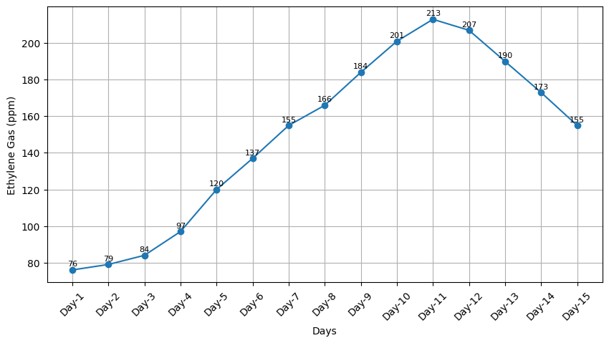
Fig. 3. Ethylene gas variation during kesar mangoes ripening

- During the initial phase (Day 1 to Day 5), ethylene concentration increased gradually from 76 ppm to 120 ppm, indicating the onset of ripening. This was followed by a rapid rise between Day 6 and Day 11, where values increased from 137 ppm to 213 ppm, corresponding to the climacteric phase characterized by intensified metabolic activity. As shown in Fig. 3 the mangoes colour is gradually changing from its green colour to yellowish colour
- After reaching the peak on Day 11, ethylene levels exhibited a gradual decline, decreasing to 207 ppm on Day 12 and further to 155 ppm by Day 15. On day 15, the mangoes are not in consumable position as they got spoiled due to self-decomposing ethylene enzyme due to senescence stage (Fig. 4). This decline signifies the transition from peak ripeness to the senescence phase, during which degradation processes dominate and fruit quality begins to deteriorate. The observed trend is consistent with previously reported studies on climacteric respiration and volatile organic compound (VOC) emissions (Vanin et al., 2009; Saltveit, 1999).
- 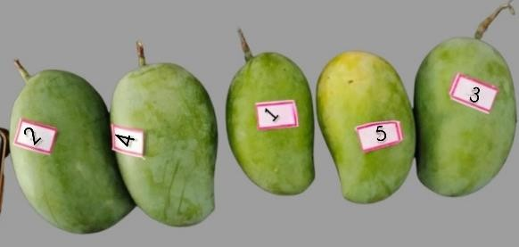
- (a) Day 1 (b) Day 3
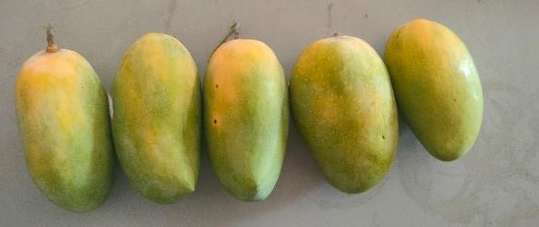

- (c) Day 5 (d) Day 7

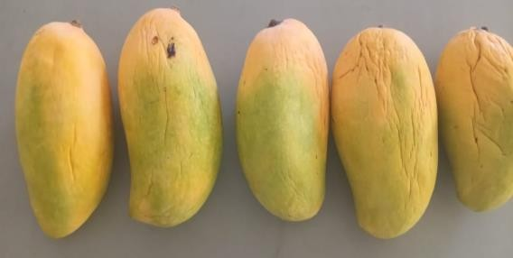
- (e) Day 9 (f) Day 11
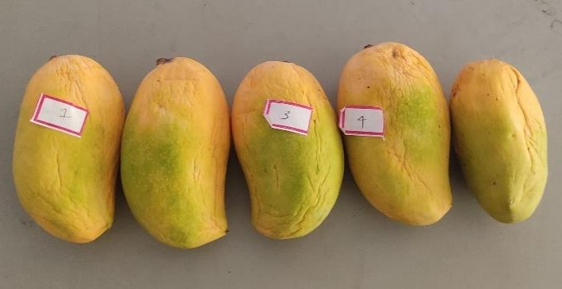
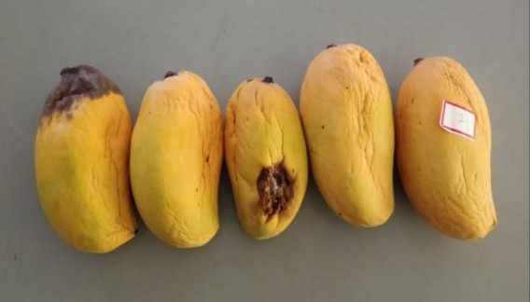
- (g) Day 13 (h) Day 15
- Fig.4. Day-wise Variation in Ripening of Kesar Mangoes
- Throughout the monitoring period, environmental conditions remained relatively stable, with temperature ranging from 32°C to 37°C and relative humidity between 80% and 90%. These conditions are favourable for mango ripening and contributed to the reliability of the sensor measurements. The results confirm the effectiveness of the MQ-3 sensor for non-invasive, real-time monitoring of ethylene during the ripening process.
3.3 Evolution of Gas Concentration in Banganapalli Mangoes
The analysis of ethylene concentration during the ripening of Banganapalli mangoes also demonstrated a characteristic climacteric pattern, marked by an initial increase followed by a gradual decline in gas concentration as shown in Fig. 5

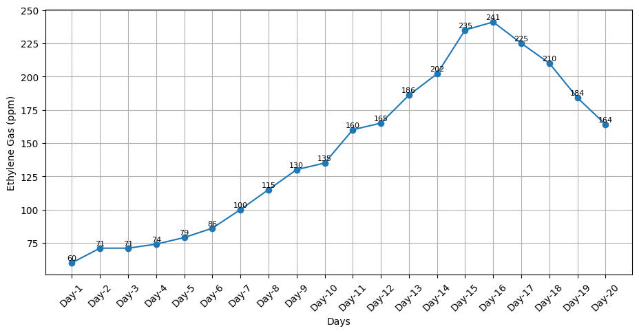
Fig. 5. Ethylene gas variation during Banganapalli mangoes ripening
In the early stage (Day 1 to Day 5), ethylene levels showed a steady increase, indicating the initiation of internal biochemical changes associated with ripening. During this phase, external physical changes were minimal, and environmental conditions remained stable.
A significant increase in ethylene concentration was observed between Day 6 and Day 13, representing the climacteric rise. This phase corresponds to enhanced metabolic activity, including rapid softening, development of characteristic aroma, and visible colour changes in the fruit as shown in Fig. 6.
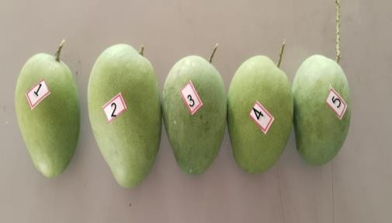  - Day 1 | 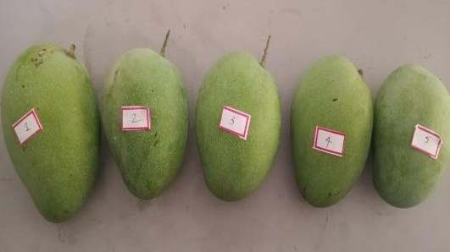  - Day 4
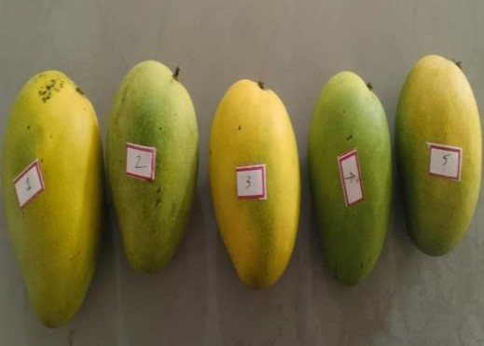  - Day 8 | 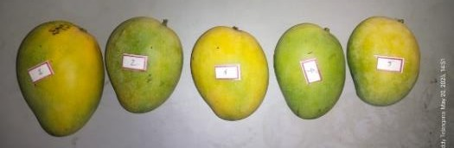  - Day10
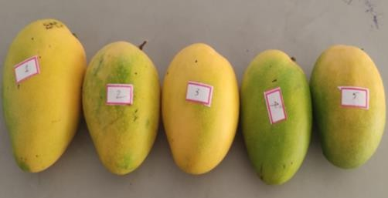  - Day 12 | 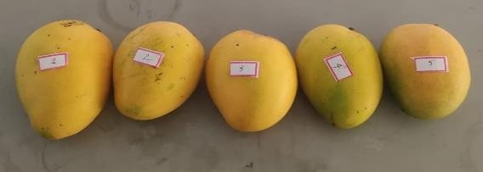  - Day 16
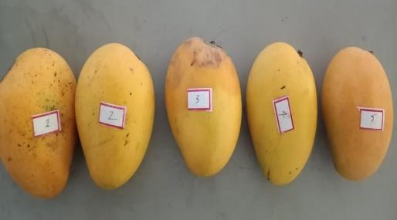  - Day 18 | 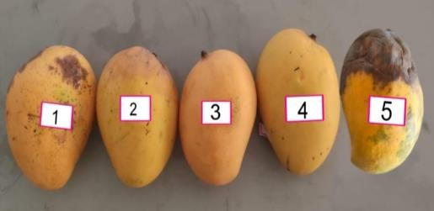  (h) Day 20
Fig. 6. Day-wise Variation in Ripening of Banganapalli Mangoes
The climacteric peak was reached around Day 15–16, indicating the stage of optimal ripeness suitable for consumption or market distribution. Beyond this point, ethylene levels began to decline, marking the onset of the post-climacteric or senescence phase. Although the fruit may remain consumable during this period, internal quality gradually deteriorates, leading to over-ripening and reduced shelf life. The analysis also demonstrated a characteristic climacteric pattern consistent with earlier studies (Zanoni et al., 1995; Wills et al., 2007).
Environmental conditions during the experiment were maintained within a favourable range, with temperature between 32°C and 37°C and relative humidity between 80% and 90%. These stable conditions facilitated accurate monitoring of ethylene emission patterns and supported natural ripening processes.
4. Conclusion
A low-cost Arduino-based system was developed for real-time monitoring of fruit freshness using ethylene gas detection. By integrating MQ-3 gas sensors with a DHT11 sensor, the system effectively tracked changes in ethylene concentration during mango ripening.
The results indicated that ethylene levels increased significantly during ripening, with values exceeding ~200 ppm marking the onset of spoilage. The system demonstrated reliable performance in continuously monitoring fruit quality and identifying freshness levels.
This approach provides a simple, economical, and non-invasive solution for reducing post-harvest losses and improving food quality management. The study highlights the potential of sensor-based technologies for practical applications in agriculture and supply chain monitoring.
References
Arduino. (2023). Arduino official documentation. Arduino, Italy.
Baietto, M., & Wilson, A.D. (2015). Electronic-nose applications for fruit identification, ripeness and quality grading. Sensors, 15(1), 899–931.
Barr, M. (2002). Programming embedded systems in C and C++. O’Reilly Media, USA.
Chhanwal, N., & Anandharamakrishnan, C. (2012). Electronic nose for food quality evaluation. Trends in Food Science and Technology, 26(1), 27–39.
Ghasemi-Varnamkhasti, M., et al. (2019). Electronic nose and its application in food analysis. Trends in Food Science and Technology, 86, 221–231.
Gubbi, J., Buyya, R., Marusic, S., & Palaniswami, M. (2013). Internet of Things (IoT): A vision, architectural elements, and future directions. Future Generation Computer Systems, 29(7), 1645–1660.
Kader, A.A. (2005). Increasing food availability by reducing postharvest losses of fresh produce. Postharvest Biology and Technology, 43(1), 1–3.
Kodali, R.K., et al. (2016). IoT-based smart storage system for agricultural products. In Proceedings of IEEE International Conference, IEEE.
Liu, Y., et al. (2018). Applications of gas sensors in food quality monitoring. Food Engineering Reviews, 10(3), 193–209.
Pathange, L.P., et al. (2006). Non-destructive evaluation of apple maturity using electronic nose. Journal of Food Engineering, 77(4), 1018–1023.
Pereira, T., et al. (2021). Gas sensors for detecting food spoilage: A review. Food Control, 121, 107805.
Saltveit, M.E. (1999). Effect of ethylene on quality of fresh fruits and vegetables. Postharvest Biology and Technology, 15(3), 279–292.
Vanin, S., et al. (2009). Modelling ethylene production during fruit ripening. Journal of Food Engineering.
Wang, J., & Zhang, T. (2010). A review of gas sensors for food quality monitoring. Sensors and Actuators B: Chemical, 144(1), 1–8.
Wills, R., McGlasson, B., Graham, D., & Joyce, D. (2007). Postharvest: an introduction to the physiology and handling of fruit and vegetables (5th ed.). CAB International, UK.
Zanoni, B., et al. (1995). Modelling of ethylene production in climacteric fruits. Journal of Food Engineering.

