Review Article
Decentralized Food Processing Technologies in Rural India: A Review of Technical Advancements and Socioeconomic Impacts

Abstract
The Indian food processing sector, a vital sunrise industry with a CAGR of 9.97% , faces a critical challenge where over 90% of agricultural production originates in rural areas yet suffers from annual post-harvest losses of approximately ₹90,000 crore due to a lack of village-level infrastructure. While centralized processing exists, a significant gap remains in the availability of affordable, decentralized, and energy-efficient technologies that allow primary producers to bypass intermediaries. This study addresses these systemic bottlenecks by evaluating the performance and socioeconomic impact of emerging innovations such as mini dal mills, solar tunnel dryers, and compact oil expellers. The review reveals that these technologies significantly enhance efficiency, such as achieving 80–84% pulse de-husking yields and extending the shelf life of perishables beyond one year. These technological interventions catalyse rural entrepreneurship and women’s empowerment through Self-Help Groups (SHGs) and Farmer Producer Organizations (FPOs). The integration of low-cost Industry and standardized quality-assurance frameworks is proposed as the essential path for transitioning rural producers into competitive participants in the global value chain.
Key words: Decentralized Units, Value Addition, Post-Harvest Loss, Agri-Business, Empowerment, Sustainability

- Introduction
Food processing refers to the transformation of raw ingredients such as harvested crops or animal driven products into edible, safe, and marketable food products (Rais, 2013). It involves operations like cleaning, grading, preservation, packaging, and value addition to enhance shelf life and consumer appeal. Globally considered a sunrise sector, food processing plays a vital role in income generation, waste reduction, foreign exchange earnings, and enhancing manufacturing competitiveness (Patients et al., 2012) (Adukia, 2024). According to a press release by the Press Information Bureau (PIB) Delhi dated August 5, 2022, the contribution of the food processing sector in India has shown consistent growth, with the Gross Value Added (GVA) increasing from ₹1.34 lakh crore in 2014-15 to ₹2.37 lakh crore in 2020-21, reflecting a compound annual growth rate (CAGR) of 9.97% (PIB, 2022). Forecasts suggest a sustained expansion trajectory, with the market size projected to reach US$ 1,274 billion by the year 2027. As of 2024, the food processing sector has emerged as a significant contributor to the national economy, accounting for approximately 8.80% of the Gross Value Added (GVA) within the manufacturing sector and 8.39% within the agriculture sector. Additionally, it constitutes around 13% of India's total exports and contributes 6% to the country’s overall industrial investment (India Food 2024 Report, Ministry of Food Processing Industries, 2024).
Despite India's status as a major producer of milk, fruits, and vegetables, the overall processing levels remain low According to the Food Processing Ingredients Annual- 2024 report published by the Foreign Agricultural Service, United States Department of Agriculture (USDA), the processing levels of food commodities in India remain relatively low compared to global standards. As per a Deloitte study cited in the report, the processing rate for fruits stands at approximately 4.5%, while vegetables are processed at a rate of 2.7%. In contrast, higher processing levels are observed in other categories such as milk (21.1%), meat (34.2%), and fishery products (15.4%) (USDA FAS, 2024, Report No. IN2024-0014).
Rural India, despite being the principal contributor to the nation's agricultural production, remains underdeveloped in terms of food processing infrastructure. A significant proportion of agricultural commodities are marketed in unprocessed form or are lost post-harvest due to the absence of affordable and scalable processing technologies at the village level(Manjunath & Kannan, 2015) (Suryavanshi, 2023). According to estimates by NITI Aayog, annual postharvest losses in India amount to approximately ₹90,000 crore (US$ 10.79 billion), showing the inefficiencies in the current post-harvest management of agricultural products (Ghosh, 2014). Structural challenges such as unreliable electrification, inadequate cold chain networks, and limited access to technical training further constrain the capacity for value addition at the grassroots level. Consequently, primary producers in rural areas are confined to low-margin activities and are heavily reliant on intermediaries, thereby limiting their integration into higher-value segments of the agro-value chain. Given that rural India accounts for over 90% of the agricultural Net Domestic Product (NDP) from 1970-71 to 2011-12(Chand et al., 2017), there is an urgent need to bridge this technological divide through the deployment of decentralized, energy-efficient, and economically viable food processing equipment to enhance rural income, reduce postharvest losses, and improve food and nutritional security.
According to a press release issued by the Press Information Bureau (PIB) on December 24, 2024, the Ministry of Food Processing Industries (MoFPI) has implemented several targeted initiatives to strengthen rural food processing infrastructure, particularly under the Pradhan Mantri Kisan Sampada Yojana (PMKSY) and the PM Formalisation of Micro Food Processing Enterprises (PMFME) scheme. As of January 2024, 143 new projects have been approved under PMKSY, contributing to a processing and preservation capacity of 14.41 lakh metric tonnes (MT), with 69 projects already operational. Overall, 1,087 out of 1,646 sanctioned projects are functional, collectively creating a capacity of 241.94 lakh MT and leveraging investments worth ₹22,778.60 crore. Cold chain projects under PMKSY have demonstrated waste reductions of up to 70% in fisheries and 85% in dairy. Additionally, initiatives are underway to establish 50 food irradiation units and 100 National Accreditation Board for Testing and Calibration Laboratories (NABL) accredited food-testing laboratories. These infrastructure developments, combined with the dissemination of low-cost, energy-efficient equipment developed by institutions such as ICAR, CSIR, and IITs, are catalysing rural value addition and enabling micro and small enterprises constituting approximately 74% of the sector to access processing capabilities and expand into new markets.
This review critically analyses emerging food processing equipment mainly useful for rural India, emphasizing the equipment’s acceptability and applicability. The review also evaluates how these technological interventions have improved farmers’ livelihoods and rural employment. The review synthesizes literature-based evidence on equipment adoption by farmers, farmer producer organizations (FPOs) and self-help groups (SHGs), and its impacts on rural employment, entrepreneurship, and food security. The findings aim to guide future research and policy directions in rural food processing technology development and dissemination.
- Emerging Equipment and Technological Innovations in food processing in rural India
By increasing productivity, lowering post-harvest losses, and raising the value of agricultural goods, recent developments in food processing machinery are revolutionizing rural India. Innovations like inexpensive solar dryers, small-scale oil expellers, pulse de-huskers, and compact rice mills have made it possible for rural business owners to process food locally with little energy input. These technologies are especially crucial in areas with erratic electrical supplies, where manually operated and solar-powered machinery guarantee constant functioning. The use of inexpensive packing equipment and better storage options, like community-level cold rooms and hermetic bags, has decreased spoilage and promoted year-round market availability (Sharshir et al., 2023).
As per government of India, 2022, the modernization of rural food processing systems is being accelerated by technological advancements supported by government programs and agri-tech entrepreneurs. Better product uniformity, traceability, and cleanliness have been made possible by the advent of IoT-enabled sensors for grain storage, mobile-based quality testing equipment, and small-scale automated flourmills(Sarkar & Fu, 2022). Together, these developments are boosting local economies, improving food security, and creating a more sustainable and inclusive food-processing ecosystem in rural India.
2.1 Ginger Processing Technologies and Their Socioeconomic Impact in Rural Assam
Ginger (Zingiber officinale Roscoe) is a high-value rhizomatous crop widely used in the food, beverage, and pharmaceutical industries (Ayustaningwarno et al., 2024; Srinivasan, 2017). To enhance its shelf life and marketability, ginger is subjected to a series of postharvest operations, transforming raw rhizomes into value-added products such as dehydrated ginger and essential oil. The process begins with the selection of mature, disease-free rhizomes, which are thoroughly cleaned using a rotary washer or water jet system to remove soil and contaminants. Peeling is carried out using a mechanical skin peeling machine, sometimes following lime water pre-treatment to improve microbial stability and appearance (Lahari et al., 2021). Uniform slicing is performed using a multipurpose vegetable cutter, facilitating efficient moisture removal.
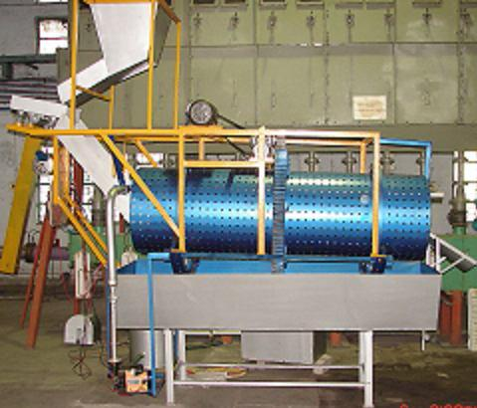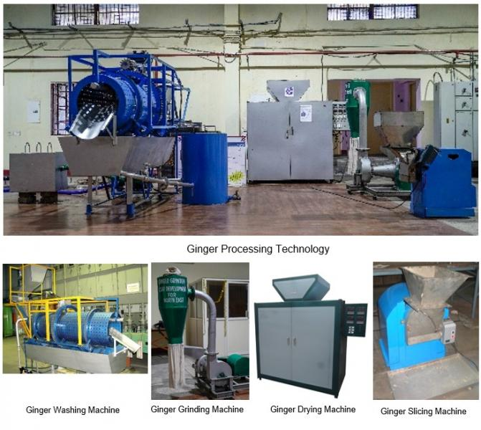
Fig. 1. Ginger processing technology and equipment used for primary processing showing (a) washing unit for removal of soil and foreign matter, (b) peeling machine for surface skin removal, (c) slicing machine for uniform thickness slices, and (d) mechanical dryer for moisture reduction and shelf-life improvement. Image source: CSIR-Central Food Technological Research Institute (CFTRI)
Drying is a vital postharvest operation in ginger processing, commonly performed using sun drying, solar cabinet dryers (200 kg capacity), or electrically operated tray dryers set at 60 °C to ensure optimal retention of essential oil constituents ( Jayashree et al., 2014). The dried ginger is ground using a pulveriser or spice grinder to the desired mesh size. For essential oil extraction, the dried or powdered ginger is loaded into a stainless steel distillation vessel, where steam generated from a baby boiler circulates through submerged coils. The oil–steam mixture is condensed in a water-cooled condenser and collected in a Florentine flask for separation. Re-distillation of the aqueous phase helps recover residual oils (Lahari et al., 2021). Final filtration is done through fine mesh filters, and packaging is completed using a heat sealing machine. Among the methods evaluated, sun and solar tunnel drying of whole ginger rhizomes demonstrated superior preservation of essential oil (13.9 mg/g) and oleoresin (45.2 mg/g), as well as key volatile (zingiberene, linalool) and non-volatile (gingerols, shogaols) bioactive compounds, with drying durations ranging from 14 to 24 hours depending on the dryer configuration(Osae et al., 2021). Additional tools like steam jacketed kettles and aluminium-topped working tables support thermal pre-treatment and hygienic handling. Ginger can be processed into various products such as fresh, dried (whole, split, or sliced), powdered or ground, preserved (pickled, crystallized/candied, or in brine/syrup), paste, syrup, essential oil, oleoresin, and used in food items like ginger bread, biscuits, cookies, cakes, as well as beverages including ginger drinks, ale, beer, wine, tea, and coffee.( Bag, 2018) The coordinated use of these scalable, semi-automated technologies makes ginger processing viable at the micro and small enterprise level in rural India.
The adoption of such integrated processing technologies comprising energy-efficient dryers, compact distillation units, and mechanized peelers has been instrumental in enabling rural producer organizations to transition from subsistence farming to commercially viable enterprises. These equipment solutions reduce postharvest losses, improve product shelf life and quality, and facilitate access to regional and international markets. In areas with poor infrastructure and limited market linkages, especially in north eastern India, the decentralization of processing capacity empowers local communities to capture a larger share of value addition. The following examples from Assam demonstrate how targeted equipment adoption, combined with institutional support, can deliver tangible socioeconomic benefits for farmer collectives.
One of the most notable cases is the Jirsong Agro Producer Company Ltd. in Karbi Anglong, Assam, which recorded ₹54.00 lakhs in ginger sales within a three-month period demonstrating the economic viability of localized processing and collective marketing in a logistically difficult region (Department of Biotechnology, 2021). Another successful model is the Padum Pathar Agro Organic Producer Company in Golaghat, which exported 10 metric tonnes of ginger to Dubai in March 2024. According to the Times of India (2024), this shipment was facilitated by the Directorate of Horticulture and built on the FPC’s earlier success of exporting 20 metric tonnes of turmeric to Saudi Arabia in 2021. A separate consignment of 10 metric tonnes of GI-tagged ginger from Karbi Anglong was also prepared for export. A new Ginger Processing Unit was inaugurated in Tyrso village, Ri Bhoi district, Meghalaya, in October 2024. This unit, established under the leadership of the Iakyrshan Cluster Farmer’s Producer Multipurpose Cooperative Society with financial support from the Meghalaya Basin Management Agency, is expected to significantly enhance livelihoods and empower local farmers, especially women. (Highland Post, 2024).
2.2 Honey processing Technologies and Their Socioeconomic Impact in Rural
Apiculture offers a sustainable and commercially significant alternative income source for rural Indian farmers, fuelled by increasing local and global demand for honey and its diverse by-products listed in Table 1, which are utilized across the food, pharmaceutical, nutraceutical, and cosmetic industries. However, raw honey is highly sensitive to environmental factors like moisture content and temperature, making it susceptible to quality deterioration through fermentation, crystallization, and colour change(Singh & Singh, 2018), which ultimately limit its shelf life and market value. Consequently, processing is essential to stabilize the product by regulating moisture, removing impurities, and ensuring uniformity in texture and flavour, thereby extending its storage stability and maximizing its economic viability(Rani et al., 2024).
Table 1. Different value added and by-products from honey
Category | Examples of Products
By-products | Beeswax, Propolis, Royal Jelly, Bee Pollen, Bee Venom, Comb Honey
Food Products | Honey spreads, baked goods, fruit preserves, flavored honey, honey powder
Beverages | Mead, honey wine, honey vinegar, honey-based juices, herbal teas
Nutraceuticals | Royal jelly supplements, propolis extracts, bee pollen capsules
Cosmetic/Pharma | Honey soap, creams, lip balm, wound ointments
Industrial Uses | Beeswax candles, polishes, food coatings, lubricants
Honey processing technique used in small scale rural area involves several integrated operations such as extraction, purification, dehumidification, liquefaction, heating, pasteurization, and packaging(Subramanian et al., 2007). In the conventional thermal process, honey is first extracted from combs using centrifugal force, usually in temperature-controlled rooms to facilitate flow. The extracted honey then undergoes purification through decanting and filtration to remove wax, air bubbles, and other impurities. In cases where moisture content exceeds 18.5%, dehumidification is carried out by circulating warm air (32-35°C) for 12-36 hours to reduce water activity and prevent fermentation. Novel techniques used in honey processing include microwave heating, infrared heating, ultrasound treatment, and membrane processing, which help preserve the natural quality and functional properties of honey (Baglio, 2018). Honey processing and related entrepreneurial initiatives have notably enhanced the socio-economic status of rural communities by providing sustainable employment and income opportunities. In Punjab, the establishment of the Tungwali Beekeepers Cooperative Society fig 2, a special purpose vehicle (SPV) partially funded through a central subsidy, began operations in September 2021 with a honey processing capacity exceeding four tonnes per day. The unit achieved a turnover of ₹1.50 crore, with a total project cost of ₹2.72 crore, comprising ₹68 lakh as private investment and the remainder through government support (Joshi, 2022). In North Chhattisgarh, women from the Raksha Self-Help Group, after receiving technical training in beekeeping, produced 90 kg of wild honey in two batches, generating ₹27,000 in revenue and fostering rural women’s empowerment (Beula & Anandhy, 2020). Similarly, in West Bengal, individual entrepreneurs, such as Chaya Mondal, have demonstrated the viability of beekeeping-based enterprises through the sale of honey and high-value bee products like beeswax and royal jelly (Roy, 2024). Cooperative models, including those in South 24 Parganas, further exemplify the potential of honey processing as a sustainable source of livelihood in rural economies.

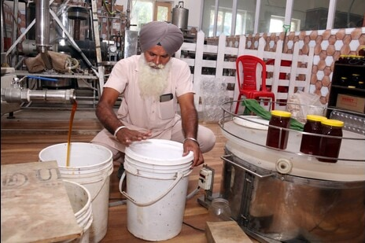
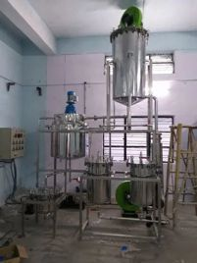
Fig 2. Honey processing Unit and honey processor of Punjab. Image source: Punjab State Cooperative Supply and Marketing Federation (Markfed).
  - Dal processing using mini Dal mill and their impact on rural India.
Pulse milling is a major food processing industry in India, second only to rice and wheat milling, converting an estimated 75% of the country's pulses into dhal (split cotyledons) (Wood & Development, 2017). The primary objective of milling is to remove the hull as cleanly as possible, which is challenging due to the specific bonding (often involving gums and mucilage) between the husk and the cotyledons. To loosen this bondage, pulses undergo pre-milling hydrothermal treatments, such as soaking and sun drying (wet method) or mixing with oil and subsequent drying (dry method). While traditional practices often result in low yields (65-74%) and significant material loss, improved technologies can achieve yields of 80-84% (Yaday et al., 2023). Pulse milling in rural regions poses significant challenges due to limited access to mechanized facilities, high dependency on centralized mills, and inefficient manual de-husking practices that result in lower yield and quality degradation. The process also demands precise control of de-husking forces to minimize cotyledon damage and reduce losses, which is difficult under traditional setups. The development of compact mini dal mills has effectively addressed these limitations by ensure uniform milling efficiency, higher recovery percentage, and improved product quality while making pulse processing feasible at the village level. Mini Dhal Mills are increasingly popular in India (Table 2) and are considered an ideal replacement for traditional village chakkies. These mechanized units significantly improve efficiency, offering recovery of head pulses in the range of 78–82% and de-husking efficiencies between 98% and 100%. Improved small-scale mills also feature lower breakage (0.5–2.0%) and reduced energy consumption compared to traditional large-scale mills (Visvanathan, 2016) (Dange & Bakane, 2024).
Table 2. Mini Dal Mills Developed by Research Institutions
S. No. | Mini Dal Mill Name/Developer | Capacity/Mechanism Detail | Reference
1. | ICRISAT mini dehulling mill | Portable, medium-volume (40kg per hour) dehulling mill. Milling section is like a horizontal burr mill (chakki). | (U. Singh, 1995)
2. | CFTRI mini dhal mill | Ideal unit for tiny and small scale sector. Run by a single-phase 1 hp motor, yields 77-80% dhal with 97-99% dehusking efficiency. Pulses dehusking unit consists of an emery coated cone. | (V. K. Singh, 2017)
3. | CIAE dhal mill | Medium capacity (100kg/h). Uses abrasive rollers rotating inside a perforated screen at 900 rpm. | (Mangaraj, S., & Singh, k.p. 2011)
4. | PKV mini dhal mill | Consists of four units: splitter, sieves, aspirator, and polisher. Run on a 2.0 hp single phase motor; uses two emery coated discs (one fixed, one rotating). | (Pimpalkar et al., 2021)
5. | IARI dhal mill | Has a cylinder concave set. Modified to suit hulling of pulses like gram, achieving 95% hulling efficiency and low broken percentage. | (Yaday et al., 2023)
6. | TNAU dhal mill | Developed for wet and dry milling of pulses. Uses a dhal mill-cum-dry grinding unit and a wet grinding unit, driven by a 0.50 hp electric motor. | (Visvanathan, 2016)
7. | Pantnagar dhal mill | Designed based on chemical pre-treatments (e.g., sodium bicarbonate). Uses a cylinder concave mechanism. | (Gurusamy et al., 2022)
8. | Emery Coated Inverted Cone Mill (CFTRI) | A hand-operated pulse-dehusking machine for small-scale users. Rotates an emery coated inverted metal cone inside a conical wire mesh screen. | (Singh, 2017)

The success of the mini dal mill enterprise is exemplified by the case of Smt. Jayashree Kolate Patil from Katgaon village, Latur district, Maharashtra. By establishing a small-scale pulse processing unit, she effectively utilized locally available pulses for value addition and income generation. The mini dal mill generated a net annual income of Rs. 3.24 lakh. Consequently, her overall socioeconomic status improved, with total annual earnings from farming and allied activities, including pulse processing, reaching Rs. 7–8 lakh. Additionally, she developed her own marketing strategies and branded her processed pulse products under the name “Single Horse,” demonstrating successful rural entrepreneurship and women-led agribusiness development (Singh, 2022).

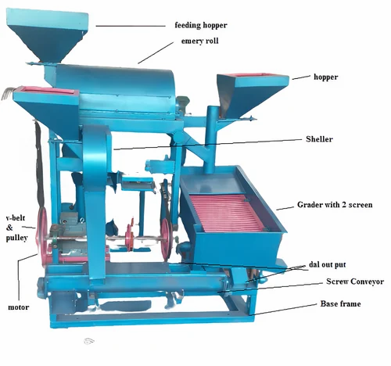
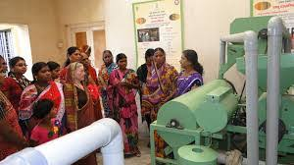

Fig 3. PKV dal mill; Dal processing using mini Dal mill. Image source: Krishi Vigyan Kendra, Dhule (Maharashtra)
2.4. Solar tunnel dryer and its impact on shelf-life extension of agriculture products in rural India.
A solar dryer is a thermal drying system that harnesses solar energy to generate controlled hot air for efficient and hygienic moisture removal from food and agricultural products (Fernandes, 2024). It operates by converting incident solar radiation into thermal energy that heats the inlet air and enhances its moisture-carrying capacity. In the air-heating section, solar energy is absorbed by a collector surface, elevating the air temperature and reducing its relative humidity (Kumar et al., 2023). The resulting hot, low-RH air is directed through the drying chamber, where it transfers heat to the product, accelerates surface and internal moisture evaporation, and becomes progressively moisture-laden. Efficient drying requires continuous removal of this humid air. In passive systems, buoyancy-driven flow (stack effect) enables natural convection, while forced-convection systems employ blowers to maintain controlled airflow rates. Indirect solar dryer configurations prevent direct solar exposure, thereby minimizing photo-degradation, colour loss, and microbial or environmental contamination (Lingayat et al., 2020; Nnamchi et al., 2025). Table 3 enlists the different types of solar dryers with their applications
Table 3. Types of Solar Dryers and Their Applications
Type of Solar Dryer | Principle (Mode of Heat Transfer) | Example Uses / Crops | Key Characteristics
Open Sun Drying (OSD) | Direct solar radiation heats the product; drying occurs via natural convection driven by wind and ambient conditions. | Tomato slices, red pepper, grapes, mint, ginger, paddy rice. | Pros: Lowest cost; no energy input. Cons: Exposure to animals, dust, insects; contamination risk; uncontrolled drying; UV-induced discoloration.
Direct Solar Dryer (DSD) | Solar radiation passes through a transparent cover and directly heats the product inside an enclosed chamber; moisture is removed by natural/forced airflow. | Grapes, mango, turmeric, anchovy, tomatoes, red banana. | Pros: Product protection; low-cost and energy-independent. Cons: Limited capacity; UV discoloration; condensation on cover reduces efficiency.
Indirect Solar Dryer (ISD) | Air is heated in a separate solar collector and directed into an opaque drying chamber; drying occurs through convective heat transfer and moisture exchange. | Leafy herbs, mango, apple, tomato, carrot, onion, bitter gourd, figs. | Pros: Better quality retention; prevents direct UV exposure; flexible design. Cons: Higher initial cost; slower drying in passive mode; requires higher temperatures.
Hybrid Solar Dryer (HSD) | Integrates solar (direct/indirect) heating with auxiliary sources (electric, biomass, gas, or PV-powered fans) to maintain continuous forced convection. | Tomato, mushrooms, pineapple, chili, dry fish, sugar-palm vermicelli, mint, carrot. | Pros: All-weather operation; shorter drying time; high efficiency. Cons: Additional running cost; larger environmental footprint if non-solar backup is used.

Solar drying technologies, particularly Local Tunnel Solar Dryers (LTSD), have demonstrated significant potential for strengthening rural agro-enterprises in India. Shri Madan Lal Deora of Pali, Rajasthan, employed a Local Tunnel Solar Dryer to reduce Aonla (Indian gooseberry) pulp moisture from 80.95 percent to 9.0 percent within two days, generating a net income of Rs 1,200 per batch from an initial investment of Rs 25,000 (Singh et al., 2010). In Dibrugarh, Assam, Mrs. Madhurima Gogoi utilized a Solar Dryer Machine provided by the Assam State Rural Livelihoods Mission (ASRLM) in 2019 to address raw material perishability, operating the system with negligible running costs and minimal maintenance while improving profitability in micro-scale food processing. Similarly, Sushma Rani of Udhampur, supported by the National Rural Livelihoods Mission (NRLM) and the Jammu & Kashmir Rural Livelihoods Mission (JKRLM), adopted solar drying and pickle-processing units to produce solar-dried fruits and vegetables with a shelf life exceeding one year, enabling her transition from unemployment to sustainable entrepreneurship (NRLM, 2022). Collectively, these case studies highlight that solar drying represents a low-cost, energy-efficient, and high-impact technology that enhances product shelf life, reduces postharvest losses, and supports resilient rural income generation.
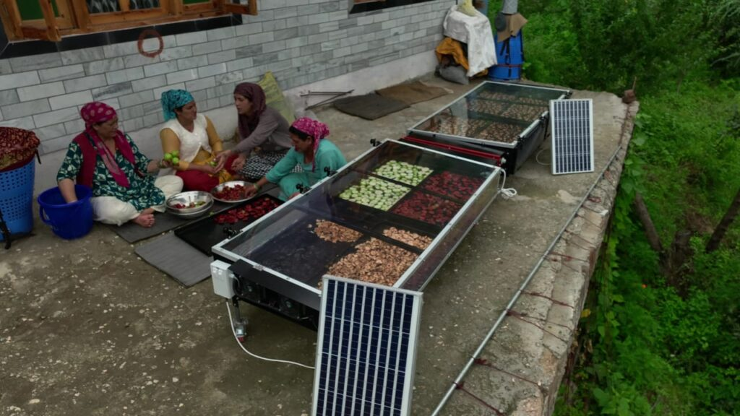
Fig 4. Solar drier used for drying of agricultural products in rural area. Image Source: Rudra Solar Website
2.5. Mini oil expellers and cold-press technology and its impact on rural India
A mini oil expeller is a compact machine used to extract oil from various seeds, nuts, and kernels, typically for domestic use, by feeding the material into a hopper where a rotating screw or auger progressively compresses it within a cylindrical barrel. This intense pressure and resulting friction force the oil to separate and seep out through fine slots, leaving behind a dry oil cake; while this process naturally generates heat (Patil et al., 2017), a cold press is a variant specifically engineered to maintain processing temperatures below 50º C to maximize nutrient and flavour retention (Rathod et al., 2025). The primary advantage of using a mini oil expeller or cold press is the ability to produce fresh, unrefined, and additive-free oil directly from the source material (Wandhekar, et al., 2022). Different types of oil expeller are discussed in (Table 4).
Table 4. Different types of oil expellers and their capacity
Developer | Developed Technology | Capacity
ICAR–CIPHET (Central Institute of Post-Harvest Engineering and Technology) | Mini oil expeller technology for decentralized processing | Small to medium scale, suitable for village-level Agro Processing Centres (APCs)
CSIR–CMERI | Modern multi-capacity oil expeller series | 1 TPD, 6 TPD, 10 TPD
IIFPT / NIFTEM (Indian Institute of Food Processing Technology / National Institute of Food Technology) | Model Detailed Project Reports (DPRs) for small-scale oil processing enterprises | Example scale: ~180,000 bottles per annum (small commercial units)
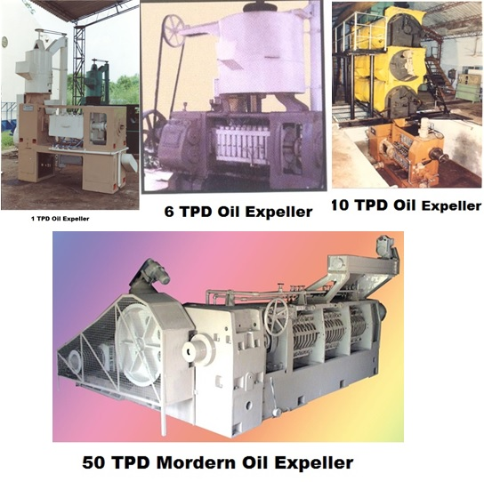

Fig 5. Mini oil expeller developed by Central Mechanical Engineering Research Institute
Project Parivartan’s mustard-expeller initiative in Hussaini village, Mathura, and the emergence of small-scale cold-pressed oil units in Tamil Nadu together illustrate the transformative potential of decentralized oil-processing systems in rural India. In Uttar Pradesh, the Shri Ji SHG established a mustard-expeller enterprise with an investment exceeding Rupee 7 lakh, enabling previously homebound women to earn Rupee 5,000 -13,000 per month and market 250 quintals of mustard oil under their own brand, thereby enhancing both economic agency and social standing (Brara, 2025). Likewise, Tamil Nadu’s

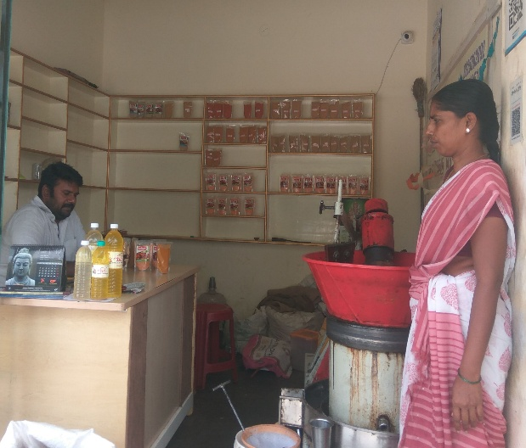
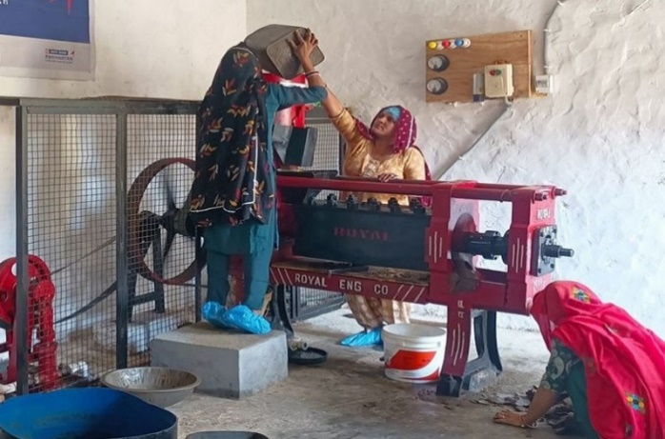
Fig 6. Mechanical oil expeller unit; Packaging and storage of extracted oil, image source: (Karthikeyan, 2020)
marachekkuennai units such as the Sathiyam Marachekku Ennai enterprise demonstrate strong consumer demand and viability, producing several thousand liters of cold-pressed oils monthly and contributing to localized value chains, employment generation, and healthier food systems (Karthikeyan, 2020). Together, these models underscore the broader socioeconomic benefits of localized, community-driven agro-processing initiatives.
- Discussion and Synthesis: Catalyzing Rural Transformation
The collective evidence drawn from decentralized processing interventions, including ginger processing in Assam, pulse milling in Maharashtra, and mustard oil expelling in Uttar Pradesh demonstrates that the diffusion of energy-efficient, small-scale food processing technologies serves as a significant catalyst for socioeconomic transformation in rural India. These technologies directly address entrenched structural constraints such as high post-harvest losses, dependence on intermediaries, and limited participation of producers in higher-value segments of the agri-food chain. Consequently, they enable a transition from low-margin subsistence activities to diversified income-generating enterprises.
3.1 Synthesis of Socioeconomic Impacts
3.1.1. Income Generation and Market Integration
Decentralized processing has markedly improved income stability and enhanced access to high-value markets. For instance, Jirsong Agro, an FPC in Karbi Anglong, achieved sales of ₹54 lakh within a three-month operational window, while the Tungwali Beekeepers Cooperative reported an annual turnover of ₹1.50 crore. The value addition has facilitated entry into export markets, as demonstrated by the shipment of processed ginger from Golaghat to Dubai. These outcomes are supported by the deployment of appropriate technological enablers, including integrated ginger processing lines, improved pulse milling systems (e.g., Mini Dal Mill), and certified honey-processing units.
3.1.2. Reduction of Post-Harvest Losses and Shelf-Life Enhancement
The introduction of energy-efficient processing and preservation technologies has substantially reduced physical and economic losses. Solar-assisted drying systems for aonla in Rajasthan achieve rapid moisture reduction within two days, yielding products with a shelf life exceeding one year. Such interventions directly mitigate the nation’s estimated annual post-harvest loss of ₹90,000 crore (US$ 10.79 billion). Complementary technologies solar tunnel dryers, community-level cold rooms, and cold-chain infrastructure established under the PMKSY have demonstrated waste reductions of up to 85% in perishable commodities such as milk.
3.1.3. Women’s Empowerment and Entrepreneurial Development
Local processing units have proven instrumental in strengthening women’s economic participation and leadership. The Shri Ji SHG in Mathura, operating a mustard expeller, enabled members to earn ₹5,000–13,000 per month and significantly increased their social visibility within traditionally male-dominated community spaces. Similarly, the adoption of the Mini Dal Mill by Smt. Jayashree Kolate Patil generated a net annual income of ₹3.24 lakh and facilitated product branding and market positioning. These advancements are supported by compact, mechanized, user-friendly equipment suitable for micro-entrepreneurs and women-led enterprises.
3.2 Addressing Technological and Institutional Bottlenecks
3.2.1. Technology Acceptance, Efficiency, and Maintenance
Adoption is strongly influenced by demonstrable efficiency gains. For example, the mini dal mill achieves recovery rates of 80-84%, significantly higher than the 65-74% typical of traditional milling. However, long-term efficacy requires consistent access to technical training, operation protocols, and maintenance services areas where institutional support remains uneven. National R&D institutions such as ICAR, CSIR, and IITs play a central role in designing affordable, energy-efficient technologies, yet localized service and repair ecosystems require strengthening to ensure operational continuity.
3.2.2. Energy Reliability and Functional Continuity
Processing systems such as honey pasteurizers, steam distillation units for ginger oil, and mechanized mills require uninterrupted energy supply, posing challenges in regions with unstable electrification. Consequently, solar-powered, hybrid, or manually operated systems remain essential in remote areas, both to ensure functional reliability and to minimize operating costs.
3.2.3. Quality Assurance and Standardization
As rural micro-enterprises increasingly target formal and export markets for example, the commercialization of GI-tagged ginger compliance with food safety and quality standards becomes imperative. National initiatives aimed at establishing 100 NABL-accredited laboratories under the Ministry of Food Processing Industries (MoFPI) are critical for enabling rural entrepreneurs to validate product quality and enhance brand credibility, as observed in enterprises such as the “Single Horse” brand.
3.3 Policy Recommendations and Future Directions
To accelerate sectoral growth, future policy interventions must systematically integrate technological innovation with institutional support mechanisms.
3.3.1. Promotion of Hybrid and Modular Processing Systems
Investment should prioritize hybrid solar dryers that combine solar energy with biomass or electric backup, thereby ensuring year-round operation and reducing downtime associated with weather-dependent systems. Such systems can mitigate supply-chain disruptions in regions with unreliable grid power.
3.3.2. Cluster-Based Financing and Infrastructure Development
Financial mechanisms must increasingly target collective entities such as FPOs and SHGs to facilitate acquisition of complete processing lines (e.g., the full ginger processing suite) rather than isolated equipment. Leveraging the PM Formalisation of Micro Food Processing Enterprises (PMFME) scheme can enable the establishment of multi-commodity rural processing hubs that improve economies of scale and resource optimization.
3.3.3. Digital Integration for Quality, Traceability, and Efficiency
Subsidizing the adoption of IoT-enabled storage sensors, mobile-based quality testing tools, and digital monitoring systems can significantly enhance traceability, quality assurance, and supply-chain transparency. Such interventions will strengthen consumer confidence in products emerging from rural micro and small enterprises.
Conclusion
This review establishes that the strategic introduction of decentralized, energy-efficient food processing technologies constitutes a pivotal intervention for accelerating socioeconomic development in rural India. Equipment such as solar tunnel dryers, mini dal mills, mini oil expellers, and integrated ginger processing lines enables primary producers to engage in value addition at the community level, thereby shifting their participation from low-margin subsistence roles to commercially competitive agro-enterprises. The evidence consistently demonstrates that these technologies substantially reduce post-harvest losses—reaching reductions of 70–85% in sectors supported by cold-chain systems—while simultaneously enhancing product quality, safety, and shelf life. Moreover, decentralized processing infrastructure catalyzes rural entrepreneurship and strengthens local economies, with notable impacts on women’s empowerment through Self-Help Groups (SHGs) and other community-based enterprises. These outcomes affirm the transformative potential of small-scale, energy-efficient food processing technologies and highlight their importance as an integral component of rural development strategies and future policy interventions.
Conflict of interest
The authors confirm that there are no known conflicts of interest associated with this publication among authors. There has been no significant financial support for this work that could have influenced its outcome.

References
Adukia, R. S. (2012). Food Processing Industry in India. Icrier.Org, 7(2), 1–98. https://icrier.org/pdf/food_processing_in_India.pdf
Ayustaningwarno, F., Anjani, G., Ayu, A. M., & Fogliano, V. (2024). A critical review of Ginger’s (Zingiber officinale) antioxidant, anti-inflammatory, and immunomodulatory activities. Frontiers in Nutrition, 11(June), 1–16. https://doi.org/10.3389/fnut.2024.1364836
B. Bag, B. (2018). Ginger Processing in India (Zingiber officinale): A Review. International Journal of Current Microbiology and Applied Sciences, 7(04), 1639–1651. https://doi.org/10.20546/ijcmas.2018.704.185
Baglio, E. (2018). Honey: Processing Techniques and Treatments. 15–22. https://doi.org/10.1007/978-3-319-65751-6_2
Beula, K., & Anandhy, A. (2020). A Study on Honey Production and Marketing by the Marthandam Beekeepers’ Co-Operative Society in Kanniyakumari District. Shanlax International Journal of Economics, 8(2), 33–40. https://doi.org/10.34293/economics.v8i2.1632
Chand, R., Srivastava, S. K., & Singh, J. (2017). Changing Structure of Rural Economy of India- Implications for Employment and Growth. National Institution for Transforming India ,NITI Aayog, 1–26. https://niti.gov.in/writereaddata/files/document_publication/Rural_Economy_DP_final.pdf
Dange, M. M., & Bakane, P. H. (2024). Adaptability of PKV mini dal mill for processing pulses. 8(6), 171–178.
E, J., R, V., & T, J. Z. (2014). Quality of dry ginger (Zingiber officinale) by different drying methods. Journal of Food Science and Technology, 51(11), 3190–3198. https://doi.org/10.1007/s13197-012-0823-8
Fernandes, L. (2024). A Review on Solar Drying Devices : Heat Transfer , Air Movement and Type of Chambers. 15–42.
Ghosh, N. (2014). An assessment of the extent of food processing in various food sub-sectors. … Submitted to the Ministry of Agriculture and Farmers …. http://www.mofpi.nic.in/sites/default/files/ieg_report_2014-11-n-1.pdf
Gurusamy, S., Vidhya, C. S., Yuvraj, B., & Shanmugam, A. (2022). Pulses for health and their varied ways of processing and consumption in India - A review. Applied Food Research, 2(2), 100171. https://doi.org/10.1016/j.afres.2022.100171
Joshi, V. (2022). Punjab ’ s maiden honey processing unit brings sweet rewards. 29–31.
Kumar, S., Tyagi, V. V, Chopra, K., Kalidasan, B., & Pandey, A. K. (2023). Energy , exergy , economic and environmental analyses of solar air heating systems with and without thermal energy storage for sustainable development : A systematic review. 59(July 2022), 106521.
Lahari, K., Naga, M., Sai, R., & Sai, G. (2021). Editor IJIEMR www.ijiemr.com To Secure Your Paper As Per UGC Guidelines We Are Providing A Electronic Bar Code. International Journal of Enginnering and Management Research, 10(08), 145–150. https://doi.org/10.48047/IJIEMR/V10/I04/95
Lingayat, A. B., Chandramohan, V. P., Raju, V. R. K., & Meda, V. (2020). A review on indirect type solar dryers for agricultural crops – Dryer setup, its performance, energy storage and important highlights. Applied Energy, 258(October 2019), 114005. https://doi.org/10.1016/j.apenergy.2019.114005
Mangaraj, S., & Singh, K. P. (2011). M. study of multiple pulses using C. dhal mill for optimal responses. (n.d.). No Title.
Manjunath, S., & Kannan, E. (2015). Effect of Rural Infrastructure on Agricultural Development : District Level Analysis in Karnataka Effect of Rural Infrastructure on Agricultural Development : District Level Analysis in Karnataka Soumya Manjunath Elumalai Kannan. 1, 1–16.
Nnamchi, O., Tom, C., Akpan, G., Umunna, M., Ubong, D., Ibeh, M., Linus–Chibuezeh, A., Akuwueke, L., Nnamchi, S., Ben, A., & Ndukwu, M. (2025). Solar dryers: A review of mechanism, methods and critical analysis of transport models applicable in solar drying of product. Green Energy and Resources, 3(2), 100118. https://doi.org/10.1016/j.gerr.2025.100118
Osae, R., Apaliya, M. T., Kwaw, E., Chisepo, M. T. R., Yarley, O. P. N., Antiri, E. A., & Alolga, R. N. (2021). Drying techniques affect the quality and essential oil composition of Ghanaian ginger (Zingiber officinale Roscoe). Industrial Crops and Products, 172, 114048. https://doi.org/10.1016/j.indcrop.2021.114048
Patients, S., in Solid Cancer, P. C., Hassan, B. A. R., Yusoff, Z. B. M., Othman, M. A. H., Bin, S., information is available at the end of the Chapter, A., & Http://dx.doi.org/10.5772/55358. (2012). We are IntechOpen , the world ’ s leading publisher of Open Access books Built by scientists , for scientists TOP 1 %. Intech, 13. http://dx.doi.org/10.1039/C7RA00172J%0Ahttps://www.intechopen.com/books/advanced-biometric-technologies/liveness-detection-in-biometrics%0Ahttp://dx.doi.org/10.1016/j.colsurfa.2011.12.014
Patil, A. A., Gaikwad, S. D., & Kulkarni, R. S. (2017). A Review on the Oil Expeller Screw Shaft. International Research Journal of Engineering and Technology(IRJET), 4(3), 1654–1657. https://irjet.net/archives/V4/i3/IRJET-V4I3370.pdf
Pimpalkar, R. D., Katole, R. T., Bhople, P. P., & Koshti, N. R. (2021). A case study : Impact of PKV mini Dal Mill on its owners. 10(1), 217–219.
Rais, M. (2013). FOOD PROCESSING INDUSTRY IN INDIA : S & T CAPABILITY , SKILLS AND. 32(4), 451–478.
Rani, J., Kamboj, H., Dhull, S. B., Rose, P. K., Bou-Mitri, C., Goksen, G., & Faliarizao, N. (2024). Effect of Different Processing Techniques and Storage Conditions on Honey Properties. In Honey in Food Science and Physiology (pp. 439–469). Springer Nature Singapore. https://doi.org/10.1007/978-981-97-3565-5_19
Rathod, M. L., Angadi, B. M., & Bhavi, I. G. (2025). A review on optimization of process parameters of cold pressed oil extraction for high output and for enhanced quality and retained nutrients. Food and Humanity, 5, 100698. https://doi.org/10.1016/j.foohum.2025.100698
Roy, A. (2024). This Bengal woman shows there ’ s money in. 1–5.
Sarkar, A., & Fu, B. X. (2022). Impact of Quality Improvement and Milling Innovations on Durum Wheat and End Products. Foods, 11(12), 1796. https://doi.org/10.3390/foods11121796
Sharshir, S. W., Joseph, A., Peng, G., Kandeal, A. W., Abdullah, A. S., Abdelaziz, G. B., Edreis, E. M. A., & Yuan, Z. (2023). Recent efforts in developing agricultural product drying processes using solar energy. Solar Energy, 257, 137–154. https://doi.org/10.1016/j.solener.2023.04.022
Singh, D.K., Meena, M., Chaudhary, M., Dayal, H., & Dudi, A. (2010). Success story of Local Tunnel Solar Drier for small scale Entrepreneurship in Rural India.
Singh, I., & Singh, S. (2018). Honey moisture reduction and its quality. Journal of Food Science and Technology, 55(10), 3861–3871. https://doi.org/10.1007/s13197-018-3341-5
Singh, K. (2022). Pulse Processing : Jayshree has solved the biggest problem of the farmers of Latur district of Maharasthra , often known as ‘ Bowl of Pulses ’ Fixed Benefit of ₹ 50000 *. April 2015, 3–5. https://eng.kisanofindia.com/agriculture-success-stories/pulse-processing-jayshree-problem-farmers-of-latur-maharasthra
Singh, U. (1995). Methods for Dehulling of Pulses : A Critical Appraisal. 32(2).
Singh, V. K. (2017). Testing and evaluation of CFTRI Dal mill for pigeonpea ( UPAS 120 ). 30(2), 83–86.
Srinivasan, K. (2017). Ginger rhizomes (Zingiber officinale): A spice with multiple health beneficial potentials. PharmaNutrition, 5(1), 18–28. https://doi.org/10.1016/j.phanu.2017.01.001
Subramanian, R., Hebbar, H. U., & Rastogi, N. K. (2007). Processing of honey: A review. International Journal of Food Properties, 10(1), 127–143. https://doi.org/10.1080/10942910600981708
Suryavanshi, M. (2023). Food Processing Industries In India: A Study For Increasing Rural Income. 11(4), 76–85.
Visvanathan, R. (2016). Development and Evaluation of Improved TNAU Mini Dhal Mill. August 2019.
Wandhekar, Sangram S.; Pawar, V.S.; Shinde, S.T.; Gangakhedkar, P. S. (2022). Extraction of oil from oilseeds by cold pressing: A review. Indian Food Industry Mag, 4(5), 63–39. https://www.researchgate.net/profile/Sugreev-Shinde/publication/371608331_Extraction_of_oil_from_oilseeds_by_cold_pressing_A_review/links/648c2c528de7ed28ba2ffca6/Extraction-of-oil-from-oilseeds-by-cold-pressing-A-review.pdf
Wood, J. A., & Development, R. (2017). Provided for non-commercial research and educational use only . Not for reproduction , distribution or commercial use . (Issue December 2011). https://doi.org/10.1016/B978-0-12-382018-1.00008-3
Yaday, B. K., Sharma, P. D., & Bihar, R. A. U. P. S. (2023). PERFORMANCE EVALUATION OF MINI DAL MILL College of Agricultural Engineering. May.

